SUPPORTING STATEMENT– PART A
IBM SKILLSBUILD TRAINING PROGRAM INTAKE APPLICATION
VA FORM 22-10282
OMB #2900-0922

Summary of Changes from Previously Approved Collection

- IBM SkillsBuild Training Program Intake Application
- There are changes to the form with this submission.
- The burden has increased since the previous approval. For this approval, the increase considers actual data for calendar year periods 2023, 2024 and 2025. This information collection request has therefore been entered into ROCIS as a “Revision” due to the increase in burden hours.
- One public comment was received during the 60-day comment period.

A. Justification

1. Explain the circumstances that make the collection of information necessary. Identify legal or administrative requirements that necessitate the collection of information.

The IBM SkillsBuild Training Program Application was created based on a White House Cyber Initiative which created an educational training program entitled “IBM SkillsBuild”. In collaboration with the IBM Corporation, this program allows the Department of Veterans Affairs to continue to seek ways to improve education and benefit programs for Veterans, their beneficiaries and caregivers.

This IBM-sponsored program provides no-cost online training in a variety of Information Technology (IT) areas. The online platform provides adult learners access to IT skills training and creates career pathways to fill “in-demand” technology jobs. With this program, IBM’s focus is providing STEM jobs training as part of its commitment to skill 30 million people worldwide by 2030, while addressing a longstanding technology skill shortage.

IBM also provides diagnostics, online coursework, resume-building credentials, and 1:1 mentoring to military members, Veterans, and dependents. Participants can earn IBM-branded digital credentials to certify their relevant skills in emerging technologies and related proficiencies to prepare them for successful careers in technology. Participants are provided the tools and resources to complete training within four months of starting the program, with a minimum commitment of 8-10 training hours per week. Employment assistance is provided through IBM upon successful completion.

As a result of this collaborative initiative, VA developed the IBM SkillsBuild Training Program Application, (VA Form 22-10282), which is the Intake form that allows beneficiaries to register and apply. The applicant must be a Veteran, Service member, spouse, child, or caregiver, and registration for this training opportunity is on a first-come, first-served basis.

2. Indicate how, by whom, and for what purposes the information is to be used; indicate actual use the agency has made of the information received from current collection.

The IBM SkillsBuild Training Program Application Intake Form, VA Form 22-10282 allows eligible candidates to register and apply to participate in the IBM SkillsBuild Training Program, which is an IBM-sponsored training program administered by VA to provide no-cost virtual Information Technology (IT) training. SkillsBuild is a no-cost online learning platform that provides adult learners with the opportunity to gain or improve IT skills that meet the needs of employers in the High-Technology industry. VA provides the opportunity for Veterans, Service members, spouses, children, and caregivers to access no-cost, self-paced, virtual training and credentials in Cybersecurity and Data Analytics. This virtual training in the field of Cybersecurity and Data Analytics is an enhanced resource for Veterans and transitioning Service members who are seeking job training and credentials to pursue a career in Technology.

3. Describe whether, and to what extent, the collection of information involves the use of automated, electronic, mechanical, or other technological collection techniques or other forms of information technology, e.g. Permitting electronic submission of responses, and the basis for the decision for adopting this means of collection. Also describe any consideration of using information technology to reduce burden.

The IBM SkillsBuild Training Program Application Intake Form (VA Form 22-10282) is now recently available exclusively online through the VA.gov webpage. To participate, individuals must first create an account on the IBM SkillsBuild website. When Veterans and other eligible users access the SkillsBuild website via the VA.gov webpage, they are automatically directed to the section dedicated to Veterans, service members, dependents, and caregivers.

4. Describe efforts to identify duplication. Show specifically why any similar information already available cannot be used or modified for use for the purposes described in Item 2 above.

The information obtained through this collection is unique and is not already available for use or adaptation from another cleared source.

5. If the collection of information impacts small businesses or other small entities, describe any methods used to minimize burden.

This information collection does not impose a significant economic impact on a substantial number of small businesses or entities.

6. Describe the consequences to Federal program or policy activities if the collection is not conducted or is conducted less frequently as well as any technical or legal obstacles to reducing burden.

If the information is not collected, qualified applicants will not be able to apply and participate in the IMB SkillsBuild program.

7. Explain any special circumstances that would cause an Information collection to be conducted more often than quarterly or require respondents to prepare written responses to a collection of information in fewer than 30 days after receipt of it; submit more than an original and two copies of any document; retain records, other than health, medical, government contract, grant-in-aid, or tax records for more than three years; in connection with a statistical survey that is not designed to produce valid and reliable results that can be generalized to the universe of study and require the use of a statistical data classification that has not been reviewed and approved by OMB.

This collection of information does not require collection to be conducted in a manner inconsistent with the guidelines delineated in 5 CFR 1320.5(d)(2).
8. If applicable, provide a copy and identify the date and page number of publication in the Federal Register of the sponsor's notice, required by 5 CFR 1320.8(d), soliciting comments on the information collection prior to submission to OMB. Summarize public comments received in response to that notice and describe actions taken by the sponsor in responses to these comments. Specifically address comments received on cost and hour burden.

A 60-Day Federal Register Notice (FRN) for the collection published on Monday, June 22, 2026. The 60-Day FRN citation is 91 FRN 37231.
One comment was received during the 60-day comment period.
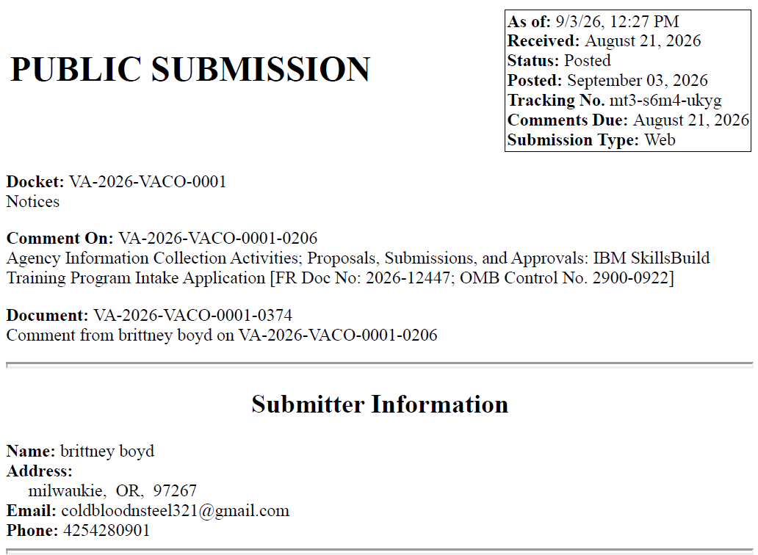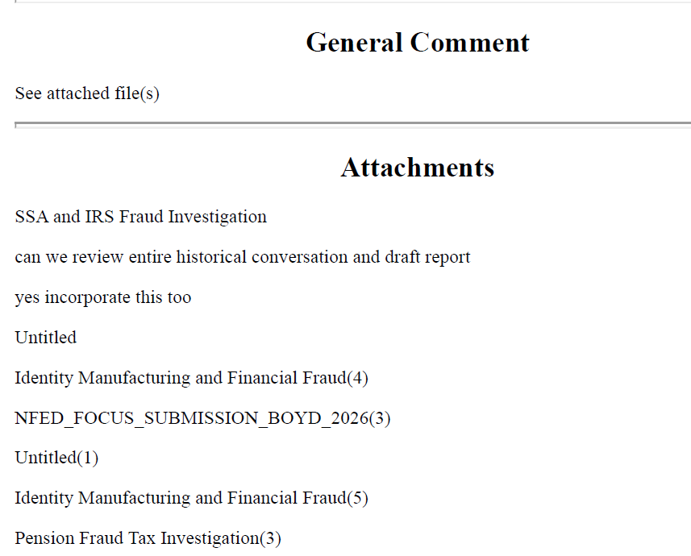
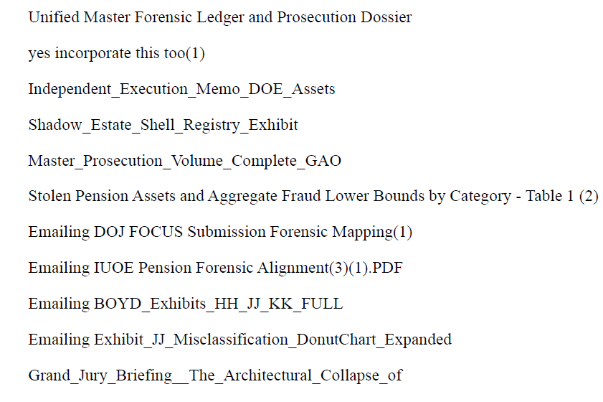
VA Response
Thank you for taking the time to submit your comment on VA Form 22-10282, IBM Skillsbuild Training Program Intake Application. We appreciate you reaching out but based on the content of your submission, it appears that your comment may have been intended for a different form, as it is not related to VA Form 22-10282 or the IBM Skillsbuild program. Because of this, we are unable to provide a response through this comment process.
We appreciate your support of our nation's Veteran community and thank you for taking the time to contact VA.

A 30-Day Federal Register Notice (FRN) for the collection published on Thursday, September 24, 2026. The 30-Day FRN citation is 91 FRN 60699.
9. Explain any decision to provide any payment or gift to respondents, other than remuneration of contractors or grantees.

No payments or gifts are being offered to respondents as an incentive to participate in the collection.
10. Describe any assurance of privacy, to the extent permitted by law, provided to respondents and the basis for the assurance in statute, regulation, or agency policy.

The records are maintained in the appropriate Privacy Act System of Records identified as Compensation, Pension, Education, and Veteran Readiness and Employment Records – VA (58VA/21/22/28), published at 74 FR 29275 on June 19, 2009, and last amended at 87 FR 8740 (February 16, 2022).
11. Provide additional justification for any questions of a sensitive nature (Information that, with a reasonable degree of medical certainty, is likely to have a serious adverse effect on an individual's mental or physical health if revealed to him or her), such as sexual behavior and attitudes, religious beliefs, and other matters that are commonly considered private; include specific uses to be made of the information, the explanation to be given to persons from whom the information is requested, and any steps to be taken to obtain their consent.

No questions considered sensitive are being asked in this collection.
12. Estimate of the hour burden of the collection of information. If this request for approval covers more than one form, provide separate hour burden estimates for each form, and aggregate the hour burdens in Item 13 of OMB 83-I. Provide estimates of annual cost to respondents for the hour burdens for collections of information. The cost of contracting out or paying outside parties for information collection activities should not be included here. Instead, this cost should be included in Item 14 of the OMB 83-I.
VA Form 22-10282
IBM SkillsBuild Training Program Application Intake Form

The estimated annual burden to the public for this information collection is 2,005 hours. This burden result is based on the average annual number of 12,029 submissions from respondents received for periods 2023, 2024 and 2025.

- Number of Respondents: 12,029.

- Frequency of Response: Once.

- Annual Burden Hours: 2,005 hours (12,029 X 10 minutes / 60 minutes).

- Estimated Completion Time for Respondent: 10 minutes.

e. The respondent population for VA Form 22-10282 is composed of Veterans, Service members, caregivers or dependents that register and apply to participate in this training opportunity on a first-come, first-served basis. An eligible individual does not have to have current or previous entitlement under a GI Bill program, and courses are for both beginners and advanced learners. VA cannot make any further assumptions about the population of respondents because of the variability of factors such as the educational background and wage potential of respondents. Therefore, VBA used general wage data to estimate the respondents’ costs associated with completing the information collection.

The Bureau of Labor Statistics (BLS) gathers information on full-time wage and salary workers. According to the latest available BLS data, the mean weekly earnings of full-time wage and salary workers are $1,341.60. Assuming a forty (40) hour work week, the mean hourly wage is $33.54 based on the BLS wage code – “00-0000 All Occupations.” $33.54 X 40 hours). This information was taken from the following website: https://data.bls.gov/oes/#/industry/000000, May 2025.
Legally, respondents may not pay a person or business for assistance in completing the information collection and a person or business may not accept payment for assisting a respondent in completing the information collection. Therefore, there are no expected overhead costs for completing the information collection. VBA estimates the total cost to all respondents to $67,247.70 (2,005 burden hours X $33.54 per hour).

13. Provide an estimate of the total annual cost burden to respondents or recordkeeping resulting from the collection of information. (Do not include the cost of any hour burden shown in Items 12 and 14).
There are no questions of a sensitive nature.
14. Provide estimates of annual cost to the Federal Government. Also, provide a description of the method used to estimate cost, which should include quantification of hours, operation expenses (such as equipment, overhead, printing, and support staff), and any other expense that would not have been incurred without this collection of information. Agencies also may aggregate cost estimates from Items 12, 13, and 14 in a single table.

Estimated Costs to the Federal Government: $49,559.48.
Grade | Step | Burden Time  Employee | Hourly Rate | Cost Per Response | Total Responses | Total
9 | 05 | 10 min | $24.72 | $4.12 | 12,029 | $49,559.48 (12,029 X $24.72 X 10min/60min)
Overhead at 100% Salary |  |  |  |  |  | $49,559.48
Overhead costs are 100% of salary and are the same as the wage listed above; and the amount is included in the total. |  |  |  |  |  | $49,559.48
Processing I Analyzing Costs |  |  |  |  |  | $49,559.48
Printing and Production Cost |  |  |  |  |  | $0
Total Cost to Government |  |  |  |  |  | $49,559.48

Note: The hourly wage information above is based on the hourly 2026 General Schedule (Base) Locality Pay Area for the Rest of USA. https://www.opm.gov/policy-data-oversight/pay-leave/salaries-wages/salary-tables/pdf/2026/RUS_h.pdf

15. Explain the reason for any burden hour changes since the last submission.

There is an increase in the burden, as the previous ICR estimated the number of applicants. The current burden is based on actual data collected for calendar years 2023, 2024 and 2025.

16. For collections of information whose results will be published, outline plans for tabulation and publication. Address any complex analytical techniques that will be used. Provide the time schedule for the entire project, including beginning and ending dates of the collection of information, completion of report, publication dates, and other actions.

The information collection is not for publication or tabulation use.

17. If seeking approval to not display the expiration date for OMB approval of the information collection, explain the reasons that display would be inappropriate.

We are not seeking approval to omit the display of the expiration date of the OMB approval on the collection instrument.

18. Explain each exception to the certification statement identified in Item 19, "Certification for Paperwork Reduction Act Submissions," of
OMB 83-1.

We are not requesting any exemptions to the provisions stated in 5 CFR 1320.9.

