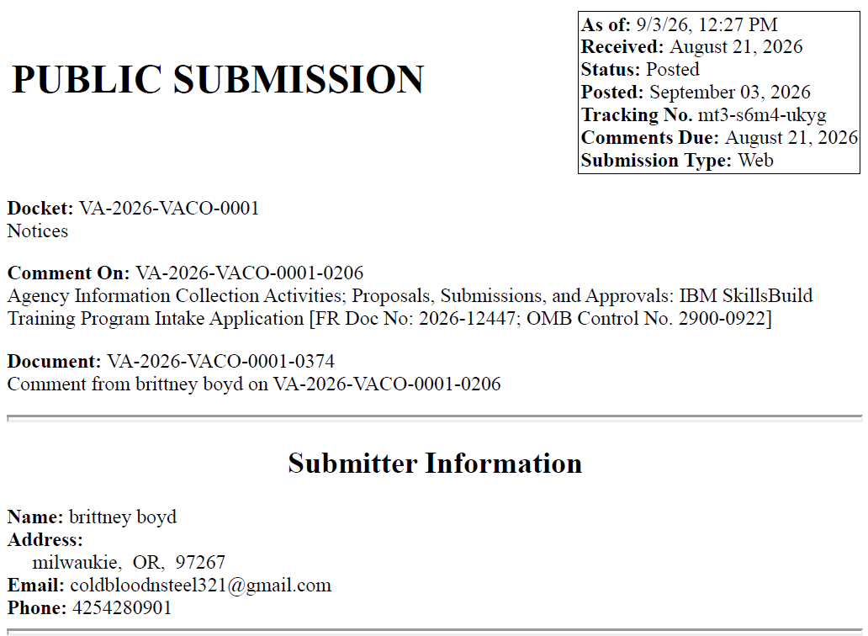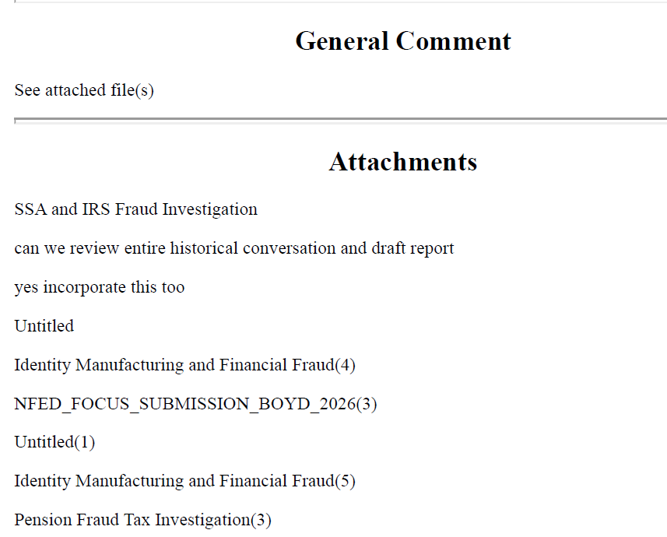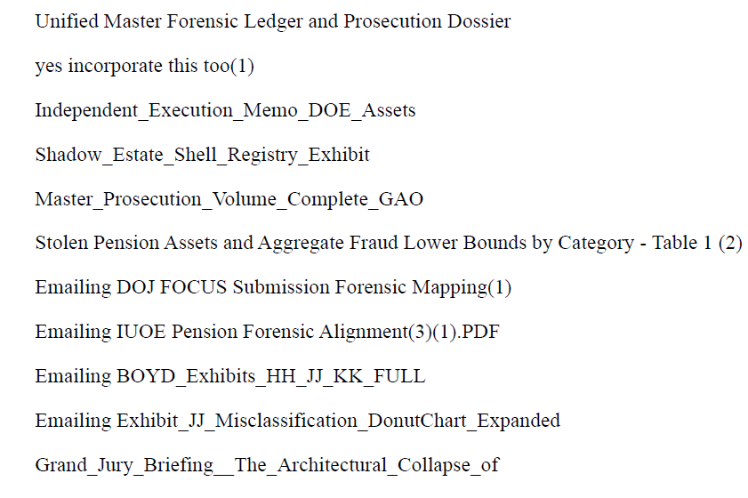
VA Response
Thank you for taking the time to submit your comment on VA Form 22-10282, IBM Skillsbuild Training Program Intake Application. We appreciate you reaching out but based on the content of your submission, it appears that your comment may have been intended for a different form, as it is not related to VA Form 22-10282 or the IBM Skillsbuild program. Because of this, we are unable to provide a response through this comment process.
We appreciate your support of our nation's Veteran community and thank you for taking the time to contact VA.

