SUPPORTING STATEMENT
Application for Assumption Approval and/or Release from
Personal Liability to the Government on a Home Loan
OMB 2900-0110
VA Form 26-6381

Summary of Changes:

The respondent count increased from 1,000 to 5,000, which also increased the annual burden hours from 167 hours to 835 hours. This was due to the increasing number of assumptions due to the availability of assumable low-interest rate loans in the currently high-interest rate environment.
- There have been no changes made to the information collection or VA Form 26-6381.
- 2 public comment was received during the 60-day comment period.

A. Justification

Explain the circumstances that make the collection of information necessary. Identify legal or administrative requirements that necessitate the collection of information.
VA Form 26-6381 is completed by Veterans who are selling their homes by assumption rather than requiring purchasers to obtain their own financing to pay off the VA-guaranteed loan. The data furnished on the form is essential to determinations for assumption approval, release of liability, and substitution of entitlement in accordance with 38 U.S.C. §§ 3713(a), 3714, and 3702(b)(2).

For loans for which a commitment was issued prior to March 1, 1988, Title 38 U.S.C. § 3713(a) provides that when a Veteran disposes of their interest in the property securing the loan, VA may, upon the Veteran’s request, release the original Veteran-borrower from personal liability to the Government only if three requirements are fulfilled. First, the loan must be current. Second, the purchaser must assume all the Veteran's liability to the Government and to the mortgage holder on the guaranteed loan. Third, the purchaser must qualify from a credit and income standpoint to the same extent as if they were a Veteran applying for a VA-guaranteed loan in the same amount, and with the same terms, as the loan being assumed.

For loans for which a commitment was made on or after March 1, 1988, and purchase transactions closing after January 1, 1989, Title 38 U.S.C. § 3714(a), provides that when a Veteran wishes to dispose of their interest in the property securing the loan through an assumption, they must apply to the loan holder to approve the transfer of ownership and release of liability. The loan holder shall approve the assumption application, releasing the Veteran-borrower from personal liability to the Government, if the holder determines that (1) the loan is current, (2) that the purchaser is obligated by contract to purchase the property and assume full liability for repayment of the balance of the loan, at the existing terms of the loan, and (3) that the purchaser qualifies from a credit and income standpoint, to the same extent as if they were a Veteran applying for a VA-guaranteed loan in the same amount, and with the same terms, as the loan being assumed. The Secretary is considered the holder if the actual holder is not an approved lender as described in 38 U.S.C. § 3702. If the holder denies an assumption application, they must notify the buyer and seller of the reason(s) for denial and their right to appeal the decision to VA. In such cases, the buyer or seller must make their appeal to VA within 30 days.

If the purchaser for an assumption application is an eligible Veteran, who meets the criteria above and certifies they will occupy the property as their home, they may also agree to “substitute” their entitlement for the same amount of entitlement the Veteran-seller used to obtain the VA-guaranteed loan. This Substitution of Entitlement allows the Veteran-seller to obtain a restoration of entitlement under Title 38 U.S.C. §3702(b)(2) for the entitlement originally used to guaranty the loan.

Most assumption and release of liability applications are processed by holders or their authorized servicing agents, rather than by the Department of Veterans Affairs (VA). However, VA may also use the form in the limited number of cases where VA staff is processing the request or the holder’s decision is appealed.

Indicate how, by whom, and for what purposes the information is to be used; indicate actual use the agency has made of the information received from current collection.
The information collected on VA Form 26-6381 is essential for VA or the holder to make credit underwriting decisions on assumption applications and for release of liability determinations as well as for substitution of entitlement cases as required in 38 U.S.C. 3710(b)(2) and (3).

3. Describe whether, and to what extent, the collection of information involves the use of automated, electronic, mechanical, or other technological collection techniques or other forms of information technology, e.g. permitting electronic submission of responses, and the basis for the decision for adopting this means of collection. Also describe any consideration of using information technology to reduce burden.
VA Form 26-6381 is available in a fillable electronic format on the VA Forms website at http://www.va.gov/vaforms. Due to the limited use of this form, an automated or electronic entry system is not cost beneficial to the government at this time. Holders, or their authorized servicing agent, may submit this form electronically though VA’s web-based origination system, webLGY, or VA’s servicing system, VALERI.

4. Describe efforts to identify duplication. Show specifically why any similar information already available cannot be used or modified for use for the purposes described in Item 2 above.
Program reviews were conducted to identify potential areas of duplication; however, none were found to exist. There is no known Department or Agency which maintains the necessary information, nor is it available from other sources within our Department.

5. If the collection of information impacts small businesses or other small entities, describe any methods used to minimize burden.
Small organizations are generally not involved.

6. Describe the consequences to Federal program or policy activities if the collection is not conducted or is conducted less frequently as well as any technical or legal obstacles to reducing burden.
The information collected on this form is completed by Veterans who are selling their VA-guaranteed, insured, or direct home loan by assumption. The data furnished on this form is essential to determinations for release of liability and substitution of entitlement in accordance with 38 U.S.C. §§ 3713(a), 3714, and 3702(b)(2). The collection is generally conducted only once.

7. Explain any special circumstances that would cause an information collection to be conducted more often than quarterly or require respondents to prepare written responses to a collection of information in fewer than 30 days after receipt of it; submit more than an original and two copies of any document; retain records, other than health, medical, government contract, grant-in-aid, or tax records for more than three years; in connection with a statistical survey that is not designed to produce valid and reliable results that can be generalized to the universe of study and require the use of a statistical data classification that has not been reviewed and approved by OMB.
There are no special circumstances that require the collection to be conducted in a manner that is inconsistent with the guidelines in 5 CFR 1320.6.

8. If applicable, provide a copy and identify the date and page number of publication in the Federal Register of the sponsor’s notice, required by 5 CFR 1320.8(d), soliciting comments on the information collection prior to submission to OMB. Summarize public comments received in response to that notice and describe actions taken by the sponsor in responses to these comments. Specifically address comments received on cost and hour burden.
A 60-Day Federal Register Notice for the collection published on Thursday, August 13, 2026. The 60-Day FRN citation is 91 FRN 52403.
1 public comment was received during the 60-day comment period.

Submitter Information

Name: Reggie Greenwood

Address:
Tampa, FL, 33612
Email: ReggieMG@icloud.com
Phone: 8137129647

General Comment
I respectfully submit the following comments regarding the Veterans Benefits Administration's proposed revision of 0MB Control No. 2900-0110, Application for Assumption Approval and/or Release from Personal Liability to the Government on a Home Loan.

- Necessity and Practical Utility

The collection appears necessary for VBA to evaluate assumption approvals, releases from personal liability, and substitution of VA loan entitlement under applicable statutory requirements. However, VBA should ensure that every requested data element is directly necessary to a specific eligibility, underwriting, liability, or entitlement determination. Information already available to VA through existing loan-guaranty systems, participating servicers, or other authoritative records should not be collected again from respondents unless necessary for verification or legal certification.

- Accuracy of the Burden Estimate

VBA estimates an average respondent burden of 10 minutes. Given the increase from 1,000 to 5,000 annual respondents, VBA should validate this estimate using current operational data rather than relying primarily on historical assumptions. The analysis should account for time required to locate loan information, understand instructions, obtain information from purchasers or servicers, complete required fields, correct errors, and submit supporting documentation.

VA RESPONSE

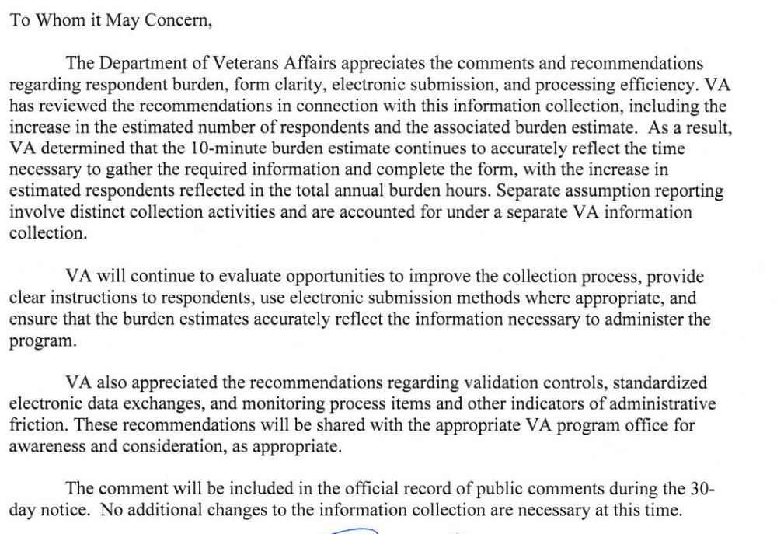

The fivefold increase in respondents is particularly significant. VBA should evaluate whether increased assumption activity has changed the complexity of transactions or generated additional interactions between Veterans, purchasers, servicers, and VA that are not adequately reflected in the current burden estimate.

- Quality, Utility, and Clarity

VA Form 26-6381 and its instructions should clearly identify which information is required, conditional, or optional; explain the purpose of material data elements; identify required supporting documentation; and provide clear instructions regarding assumption approval, release of liability, and substitution of entitlement.

VBA should also incorporate validation controls into electronic submissions to identify missing or inconsistent information before submission. This could reduce rejected applications, requests for additional information, processing delays, and unnecessary administrative burden.

- Minimizing Respondent Burden Through Technology

VBA should maximize secure electronic submission and, where technically and legally permissible, prepopulate information already maintained within VA systems. Electronic processes should permit respondents to save partially completed applications, upload supporting documents securely, receive confirmation of submission, monitor application status, and respond electronically to requests for additional information.

VBA should also assess whether standardized electronic data exchanges with approved loan servicers could eliminate duplicative manual entry while maintaining appropriate authentication, access controls, audit logging, privacy protections, and data-integrity safeguards.

Additional Recommendation

Because the projected respondent population has increased by 400 percent, VBA should monitor processing times, incomplete-application rates, requests for additional evidence, abandonment rates, and other indicators of administrative friction. Increased demand should not result in unnecessary delays in assumption approvals or releases of Veterans from personal liability.

I support collection of information that is demonstrably necessary to administer the VA Home Loan Guaranty program. I recommend that VBA use this revision as an opportunity to validate the burden estimate, eliminate duplicative collection, improve instructions and data quality, expand secure electronic processing, and establish measurable controls for handling the substantial increase in assumption activity.

A 30-Day Federal Register Notice for the collection published on Tuesday, October 20, 2026. The 30-Day FRN citation is 91 FRN 66406.

9. Explain any decision to provide any payment or gift to respondents, other than remuneration of contractors or grantees.
No payments or gifts to respondents have been made under this collection of information.

10. Describe any assurance of privacy to the extent permitted by law provided to respondents and the basis for the assurance in statute, regulation, or agency policy.

VA will not disclose information collected on this form to any source other than what has been authorized under the Privacy Act of 1974 or Title 38, Code of Federal Regulations 1.576 for routine uses identified in the VA system of records, 55VA26, Loan Guaranty Home, Condominium and Manufactured Home Loan Applicant Records, Specially Adapted Housing Applicant Records, and Vendee Loan Applicants Records – VA, and published in the Federal Register 2023.

11. Provide additional justification for any questions of a sensitive nature (Information that, with a reasonable degree of medical certainty, is likely to have a serious adverse effect on an individual's mental or physical health if revealed to him or her), such as sexual behavior and attitudes, religious beliefs, and other matters that are commonly considered private; include specific uses to be made of the information, the explanation to be given to persons from whom the information is requested, and any steps to be taken to obtain their consent.
There are no questions of a sensitive nature.

12. Estimate of the hour burden of the collection of information:
Description of Information Collection | Frequency of Response | Total Annual Responses | Hours per Response | Annual Burden Hours | Hourly Cost | Total Annual Cost
VA Form 26-6381 | 1 | 5,000 | .167 | 835 | $33.54 | $28,005.90

Estimate of Information Collection Burden:

a. Number of respondents is estimated at 5,000 per year.

b. Frequency of response is generally one time.

c. Annual burden is estimated at 835 hours.

d. The estimated response time of 10 minutes has been determined to be an average time spent to report the information requested and no wide variance is likely.

e. The respondent population is composed of Veterans or lender/servicers on behalf of Veterans. VBA cannot make further assumptions about the population of respondents because of the variability of factors such as the educational background and wage potential of respondents. Therefore, VBA used general wage data to estimate the respondents’ costs associated with completing the information collection.
The Bureau of Labor Statistics (BLS) gathers information on full-time wage and salary workers are $1,341.60, assuming a forty (40) hour work week. According to the latest available BLS data, the mean hourly wage is $33.54 based on the BLS wage code – “00-0000 All Occupations.” This information was taken from the following website: https://data.bls.gov/oes/#/industry/000000 May 2025.

Legally, respondents may not pay a person or business for assistance in completing the information collection. Therefore, there are no expected overhead costs for completing the information collection. VBA estimates the total cost to all respondents to be $28,005.90 (835 burden hours x $33.54 per hour).

13. Provide an estimate of the total annual cost burden to respondents or record-keepers resulting from the collection of information. (Do not include the cost of any hour burden shown in Items 12 and 14).
Grade | Step |  | Burden Time (min) | Fraction of Hour | Hourly Rate | Cost Per Response | Total Responses | Total
11 | 6 |  | 15 | 0.25 | $40.55 | $10.1375 | 5,000 | $50,687.00
 |  | Overhead at 100% salary
12 | 6 |  | 9 | 0.15 | $48.61 | $7.2915 | 500 | $3,645.00
 |  | Overhead at 100% salary
13 | 6 |  | 5 | 0.083333 | $57.80 | $4.816647 | 250 | $1,204.00
 |  | Overhead at 100% Salary
 |  | Processing / Analyzing Costs |  |  |  |  |  | $55,537.00
 |  | Printing and Production Cost |  |  |  |  |  | $0
 |  | Total Cost to Government |  |  |  |  |  | $55,537.00
This submission does not involve any recordkeeping costs.

14. Provide estimates of annual cost to the Federal Government. Also, provide a description of the method used to estimate cost, which should include quantification of hours, operation expenses (such as equipment, overhead, printing, and support staff), and any other expense that would not have been incurred without this collection of information. Agencies also may aggregate cost estimates from Items 12, 13, and 14 in a single table.

There are no printing costs. VA Form 26-6381 can be downloaded from the VA website and filled out (fillable form).

Estimated Costs to the Federal Government are accessible through this link: https://www.opm.gov/policy-data-oversight/pay-leave/salaries-wages/salary-tables/pdf/2026/RUS_h.pdf f
The processing time estimates above are based on the actual amount of time employees of each grade level spend to process to completion a claim received on this form. The within-grade step (6) of each employee represents the average experience of employees within each grade.

15. Explain the reason for any burden hour changes since the last submission.

The respondent count increased from 1,000 to 5,000, which also increased the annual burden hours from 167 hours to 835 hours. This was due to the increasing number of assumptions due to the availability of assumable low-interest rate loans in the currently high-interest rate environment.

16. For collections of information whose results will be published, outline plans for tabulation and publication. Address any complex analytical techniques that will be used. Provide the time schedule for the entire project, including beginning and ending dates of the collection of information, completion of report, publication dates, and other actions.
Information collection is not for tabulation or publication purposes.

17. If seeking approval to omit the expiration date for OMB approval of the information collection, explain the reasons that display would be inappropriate.
We are not seeking approval to omit the expiration date for OMB approval.

18. Explain each exception to the certification statement identified in Item 19, “Certification for Paperwork Reduction Act Submissions,” of OMB 83-I.
This submission does not contain any exceptions to the certification statement.

B. Collection of Information Employing Statistical Methods

VA does not collect information employing statistical methods.

