Example reminder electronic mail scheduled to email Jan. 8, 2027.

***************************
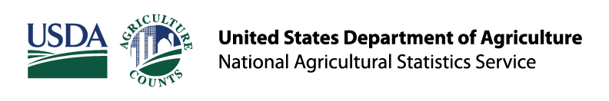
Your response is important!
The USDA National Agricultural Statistics Service (NASS) recently mailed you correspondence for the 2026 RMA Organic Prices Survey. If you have already responded online, thank you! If not, there is still time. Your response is important to ensure agricultural activities in your state are accurately represented.
Please respond online by January 29, 2027, at agcounts.usda.gov using your survey code on the correspondence mailed to you.
The information you provide will be used for statistical purposes only. Federal law requires that NASS keeps your identity and your answers confidential. The results of this survey will be published at www.nass.usda.gov/Publications/.
Thank you for your participation and your support of our programs and U.S. agriculture. If you have any questions, please contact us at 800-551-1014.

NASS is the federal statistical agency responsible for producing official data about U.S. agriculture and is committed to providing timely, accurate, and useful statistics in service to U.S. agriculture.
United States Department of Agriculture | National Agricultural Statistics Service
National Operations Center, 9700 Page Avenue Suite 400, St. Louis, Missouri 63132
USDA NASS Confidentiality Pledge
USDA is an equal opportunity provider, employer, and lender.
Unsubscribe to email reminders from USDA NASS.

