APPENDIX B.1a
CENSUS SURVEY INSTRUMENT SAMPLE SCREENSHOTS

APPENDIX F
NASS Comments and Fns response

2027 Farm to School Census Survey Instrument
Sample Screenshots of Web Survey

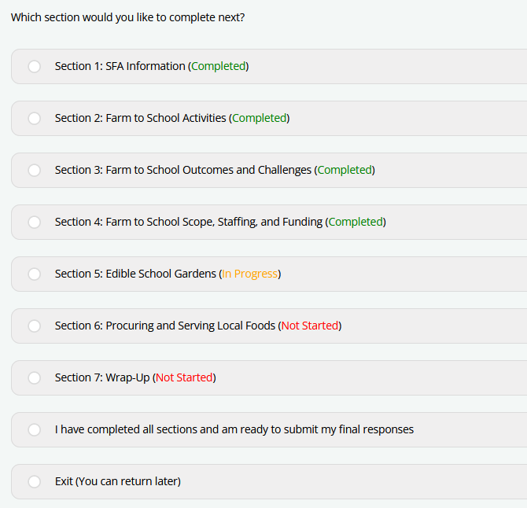
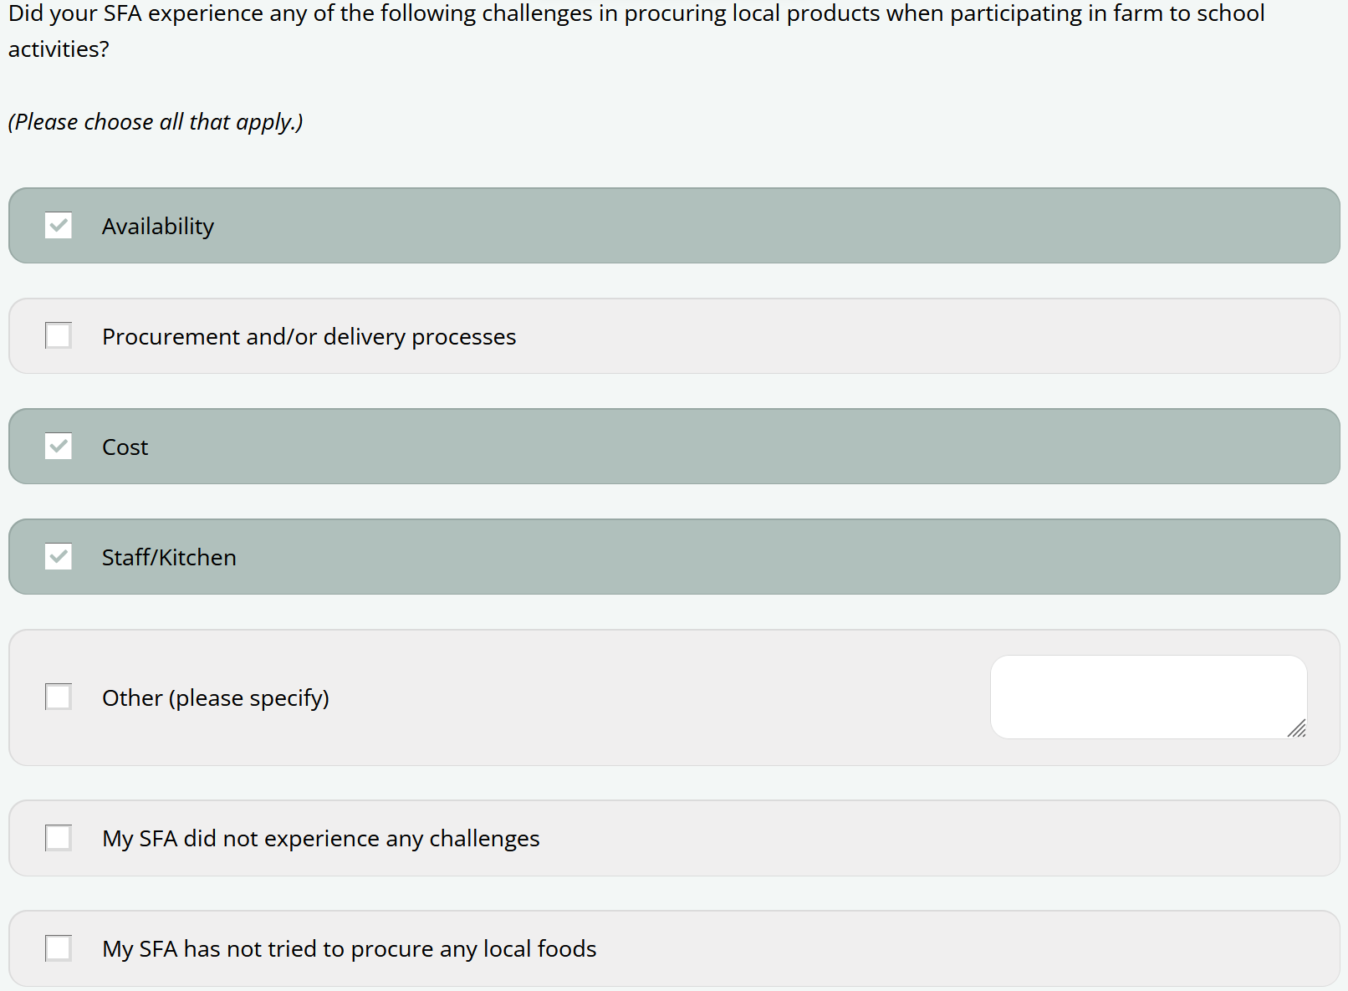

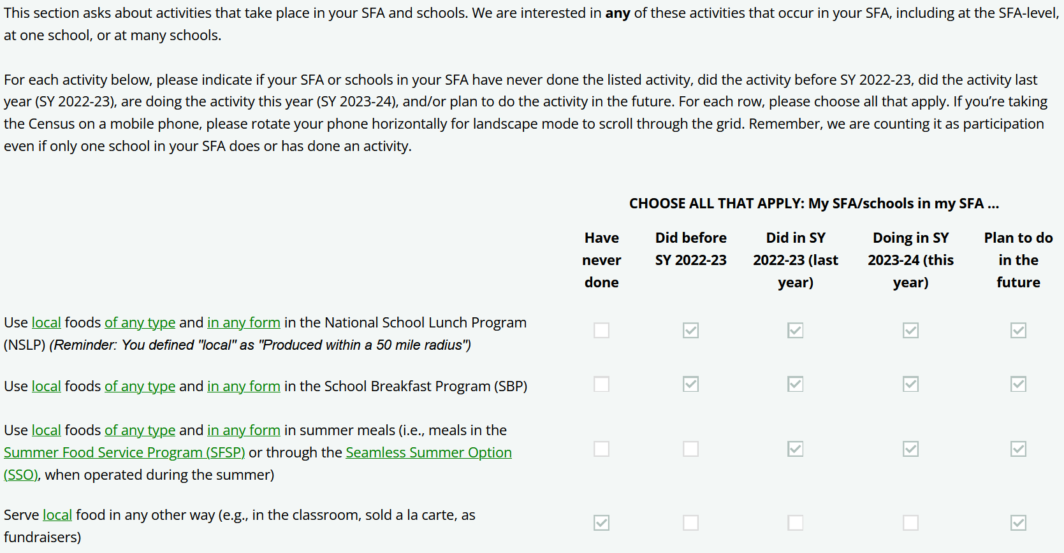

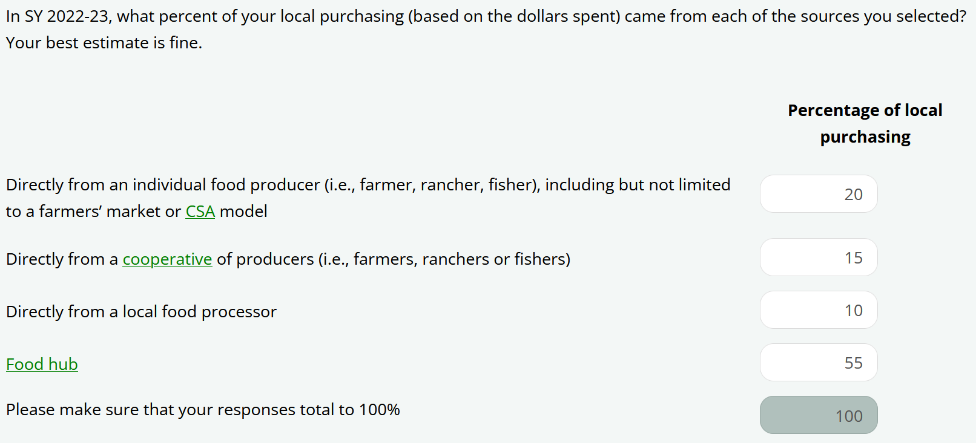

This information is being collected to assist the Food and Nutrition Service in understanding and tracking farm to school engagement. This is a mandatory collection and FNS will use the information to set priorities for USDA outreach and technical support. This collection does not request any personally identifiable information under the Privacy Act of 1974. According to the Paperwork Reduction Act of 1995, an agency may not conduct or sponsor, and a person is not required to respond to, a collection of information unless it displays a valid OMB control number. The valid OMB control number for this information collection is 0584-0646. The time required to complete this information collection is estimated to average 0.5 hours per response, including the time for reviewing instructions, searching existing data sources, gathering and maintaining the data needed, and completing and reviewing the collection of information. Send comments regarding this burden estimate or any other aspect of this collection of information, including suggestions for reducing this burden, to: U.S. Department of Agriculture, Food and Nutrition Service, Office of Policy Support, 1320 Braddock Place, 5th Floor, Alexandria, VA 22706 ATTN: PRA (0584-0646). Do not return the completed form to this address.

