2027SDRP_RespondentGuide
September 2026
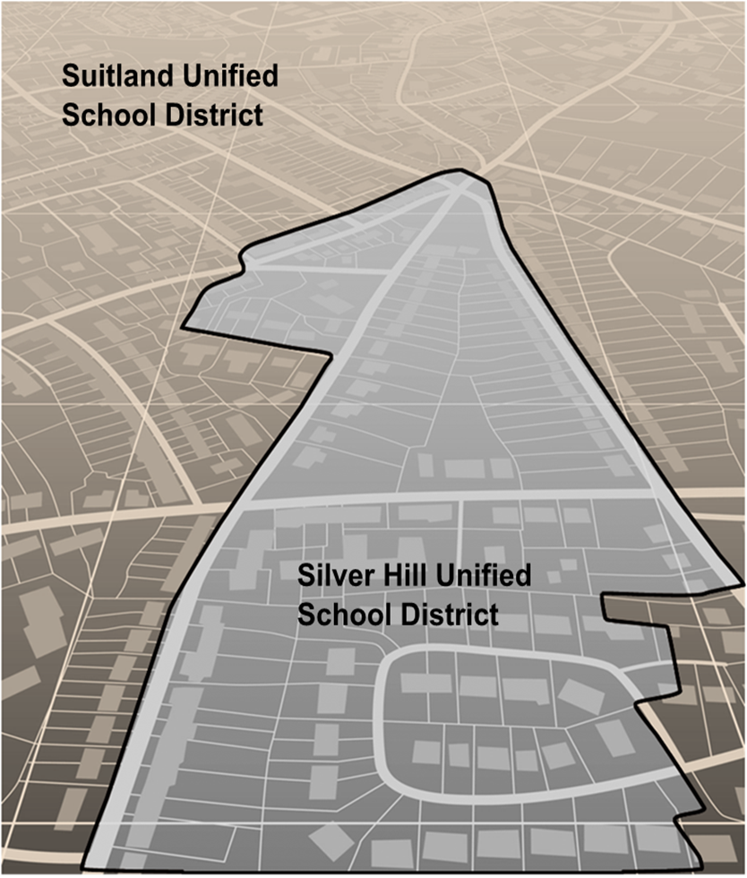

This page intentionally left blank.
Table of Contents
Introduction vii
A. School District Review Program vii
B. Mapping Coordinator Responsibilities viii
C. Types of School District Boundary Updates ix
D. Guidance for Boundary Changes xvii
E. Contact Information xvii
Part 1 What is the School District Review Program (SDRP) 1
Chapter 1 Overview 1
1.1 SDRP Schedule 1
1.2 SDRP Annotation Phase Materials 1
1.3 SDRP and GUPS Web Help 1
1.4 Description and Use of Listing Files 1
1.4.1 Inventory and Grade Range File (All States) 1
1.4.1.1 Submitting Updates to Information in the Inventory and Grade Range File 2
1.4.2 County Coverage File (All States) 2
1.4.3 Legal Government Coextensive Coverage File (Limited States) 3
1.4.4 School District to Geography (SD/GEO) Relationship File (Limited States) 3
1.4.5 Submitting Updates to Information in the “County Coverage,” “Legal Government Coextensive Coverage,” and/or “Relationship” Files 4
Part 2 How to Use the TIGERweb 5
Chapter 2 Using the TIGERweb Map Viewer for the SDRP 5
2.1 Locating a School District 6
2.2 Printing and Saving a Map 11
Part 3 How to Use the Submission Log 13
Chapter 3 Using the Submission Log for the SDRP 13
3.1 School District Name Change 13
3.2 Grade Range Change 13
3.3 SDLEA Code Change 14
3.4 Level Change 14
3.5 Simple and Complex Consolidation 14
3.6 Simple and Complex Dissolution 15
3.7 New District 16
3.8 Simple Spatial Update Using Whole MCDs or Incorporated Places 16
Part 4 How to Access the Geographic Update Partnership Software (GUPS) Web 18
Chapter 4 Getting Started 18
4.1 What is GUPS Web? 18
4.2 GUPS Web Hardware and Operating System Requirements 18
4.3 Invitation Email and Creating a GUPS Web Account 18
Part 5 How to Submit Files to the Census Bureau 22
Chapter 5 Using the Secure Web Incoming Module (SWIM) 22
Appendix A Financial Responsibility A-1
A1 Pseudo School Districts A-1
A2 Elementary PK/KG-12 School District A-3
Appendix B Data Dictionary for the Listing Files B-1
B1 Data Dictionary for the Inventory and Grade Range File B-1
B2 Data Dictionary for the County Coverage File B-1
B3 Data Dictionary for the Legal Government Coextensive Coverage File B-2
B4 Data Dictionary for the School District to Geography Relationship File B-3

List of tables
Table 1: Types of School District Updates ix
Table 2: Steps to Use SWIM 23
Table 3: Pseudo School Districts in the Inventory and Grade Range Listing File A-2
Table 4: Data Dictionary for the Inventory and Grade Range File B-1
Table 5: Data Dictionary for the County Coverage File B-2
Table 6: Data Dictionary for the Legal Government Coextensive Coverage File B-2
Table 7: Data Dictionary for the School District to Geography Relationship File B-3

List of Figures
Figure 1: Boundary Change Example (Update Using GUPS Web) xi
Figure 2: Complex Consolidation Example (Update Using Submission Log) xii
Figure 3: Complex Dissolution Example (Update Using Submission Log) xiii
Figure 4: New District Example (Update Using Submission Log) xiv
Figure 5: Simple Consolidation Example (Update Using the Submission Log) xv
Figure 6: Simple Dissolution Example (Update Using the Submission Log) xvi
Figure 7: Query Tool Button 6
Figure 8: Query Tool Window 6
Figure 9: Query Tool–Attribute Tab–Select Map 7
Figure 10: Query Tool–Query by GEOID 7
Figure 11: Task Results Tab with Query Results 8
Figure 12: Query Results–Info Panel 8
Figure 13: Map Display with Query Results 9
Figure 14: Query Tool–Query by Name 10
Figure 15: Query by Name Results 10
Figure 16: Map Display with Query Results 11
Figure 17: Print Tool Button 11
Figure 18: Print Tool Window 12
Figure 19: Example of a School District Name Change 13
Figure 20: Example of a School District Grade Range Change 14
Figure 21: Example of a SDLEA Code Change 14
Figure 22: Example of a Level Change 14
Figure 23: Example of a Simple Consolidation 15
Figure 24: Example of a Simple Dissolution 16
Figure 25: Example of a New District 16
Figure 26: Example of a Simple Spatial Update–Boundary Change 17
Figure 27: GUPS Web invitation email 18
Figure 28: GUPS Web home page 19
Figure 29: GUPS Web login page 20
Figure 30: GUPS Web dashboard 21
Figure 31: GUPS Web Help Center icon 21
Figure 32: Example of a Pseudo School District–Pulaski County, KY A-2

Introduction
This guide is divided into five parts.
- Part 1 What is the School District Review Program (SDRP)
- Part 2 How to Use the TIGERweb
- Part 3 How to Use the Submission Log
- Part 4 How to Access the Geographic Update Partnership Software (GUPS) Web
- Part 5 How to Submit Files to the Census Bureau
In addition, it has two appendices that provide supplemental information.
IMPORTANT: Images used in this guide may differ slightly from the finalized versions of software and materials. Regardless of any difference in images, the overall instruction, actions, and results that are illustrated within this document remain consistent with what is anticipated for the program.
- School District Review Program
The SDRP is a U.S. Department of Education National Center for Education Statistics (NCES) sponsored program conducted annually by the U.S. Census Bureau. It is of vital importance for the state’s allocation of federal funding under Title I of the Elementary and Secondary Education Act (ESEA) as amended by Every Student Succeeds Act of 2015, Public Law 114-95. The updated school district boundary information submitted through this program is used by the Small Area Income and Poverty Estimates (SAIPE) program in forming the Census Bureau’s estimates of the number of children aged 5 through 17 in families in poverty for each school district. These estimates are the basis of the Title I allocation for school districts in each state. School district boundaries are also used to develop estimates of social, economic, demographic, and housing conditions from the American Community Survey (ACS), and they provide essential geographic information to help education program administrators and researchers investigate location-based questions.
School districts are represented in the Census Bureau’s data according to financial responsibility. This means that the spatial representation and grade range of each school district indicate the school district that pays for the education of the students. For more information and examples of financial responsibility, see Appendix A.
The SDRP consists of two phases—Annotation and Verification. In the Annotation Phase, the Census Bureau provides mapping coordinators with current school district boundaries and associated information for their state. The Annotation Phase materials the mapping coordinator receives for the 2027 SDRP reflect the school district names, federally assigned school district local education agency (SDLEA) codes, and boundaries updated during the 2026 SDRP. Each state reviews their data and reports changes in the school district boundaries or attributes to the Census Bureau as they exist on January 1, 2027.
The review encompasses only Type 1, Type 2, and Type 3 school districts as defined by the NCES.
- Type 1 is a local school district that is not a component of a supervisory union.
- Type 2 is a local school district component of a supervisory union sharing a superintendent and administrative services with other local school districts.
- Type 3 is an education agency that performs administrative services for more than one school district, providing a common superintendent for participating districts.
After the Census Bureau incorporates changes submitted through the Annotation Phase into the Master Address File/Topologically Integrated Geographic Encoding and Referencing (MAF/TIGER) System, mapping coordinators will review these changes for accuracy and completeness during the Verification Phase.
- Mapping Coordinator Responsibilities
Each year, the NCES sends a letter to each state and the District of Columbia requesting they designate a mapping coordinator to be the primary liaison for the SDRP. It is the responsibility of the mapping coordinator to initiate and maintain contact throughout the program with local school district officials. The mapping coordinator must ensure that reviews and submissions are completed within the time frame of the SDRP.
When the mapping coordinator receives updates from local school district officials, they must review them for accuracy and completeness before submitting them to the Census Bureau. This review includes all types of updates submitted. For boundary updates, it is the responsibility of the mapping coordinator to confirm that a change is valid and all affected school districts agree to the change.
Note: The state mapping coordinators for Florida, Hawaii, Maryland, Nevada, West Virginia, or the District of Columbia, may not have any changes to submit for the SDRP. School districts in these states are all unified and county based. Unless the geographic relationship of school districts has changed in the state or a school district’s name was changed, the mapping coordinator does not have any changes to report for the 2027 SDRP. If the mapping coordinator has no changes to report, notify the SDRP team.
Once all the information is correct and in the proper format, submit this information to the Census Bureau to complete the Annotation Phase. After processing the Annotation Phase changes, the Census Bureau will create new materials for review. These new materials are reviewed as part of the Verification Phase. The mapping coordinator is responsible for reviewing and confirming the changes that appear in the verification materials and notifying the Census Bureau if there are any additional changes or corrections.
IMPORTANT: The Verification Phase is for reviewing changes submitted during the Annotation Phase and not for submitting new changes.
- Types of School District Boundary Updates
There are eleven types of school district updates within the SDRP as noted below in Table 1. The table includes links to examples of the types of updates and the submission method used to report them to the Census Bureau.
Table 1: Types of School District Updates
Type of Update | Update Description | Link to Examples | Submission Method
Boundary Change | Occurs when a school district adds or removes area from the same school district level or across school district levels. | Figure 1. Refer to sub-section Part 4 for details. | GUPS Web
Complex Consolidation | Occurs when two or more school districts merge to create a new school district with a new name and new SDLEA code, along with additional boundary changes. Note: The Census Bureau expects accompanying boundary changes for the new school district. | Figure 2. Refer to sub-section 3.5 for details. | Submission Log
Complex Dissolution | Occurs when a single school district dissolves its area between two or more existing school districts, with or without additional boundary changes. Complex dissolutions do not create new school districts, and the names and SDLEA code of the receiving school districts remain unchanged. | Figure 3. Refer to sub-section 3.6 for details. | Submission Log
SDLEA Code Change | Occurs when correcting an SDLEA code. | Refer to sub-section 3.3 for details. | Submission Log
Grade Range Change | Occurs when a school district changes the grades it covers; for example, changing from covering  9-12 to 7-12. | Refer to sub-section 3.2 for details. | Submission Log
Level Change | Occurs when a school district changes classification; for example, changing from elementary to unified. | Refer to sub-section 3.4 for details. | Submission Log
Name Change | Occurs when a school district changes its name; for example, changing from Oak Union Unified School District to Oak Union School District. | Refer to sub-section 3.1 for details. | Submission Log
New District | Occurs when transferring area from one or more existing school districts to form a completely new school district. | Figure 4. Refer to sub-section 3.7 for details. | Submission Log
Pseudo School District | Occurs when one school district pays for the educational services for a set of grades in a different geographic area than its own. | Refer to sub-appendix A1. | Contact  Census Bureau
Simple Consolidation | Occurs when two or more school districts merge to create a new school district with a new name and new SDLEA code, with no additional boundary changes. | Figure 5. Refer to sub-section 3.5 for details. | Submission Log
Simple Dissolution | Occurs when one or more existing school districts are entirely absorbed by one other existing school district. Note: Simple dissolutions retain the name and SDLEA code of the receiving school district, and do not create a new school district. | Figure 6. Refer to sub-section 3.6 for details. | Submission Log

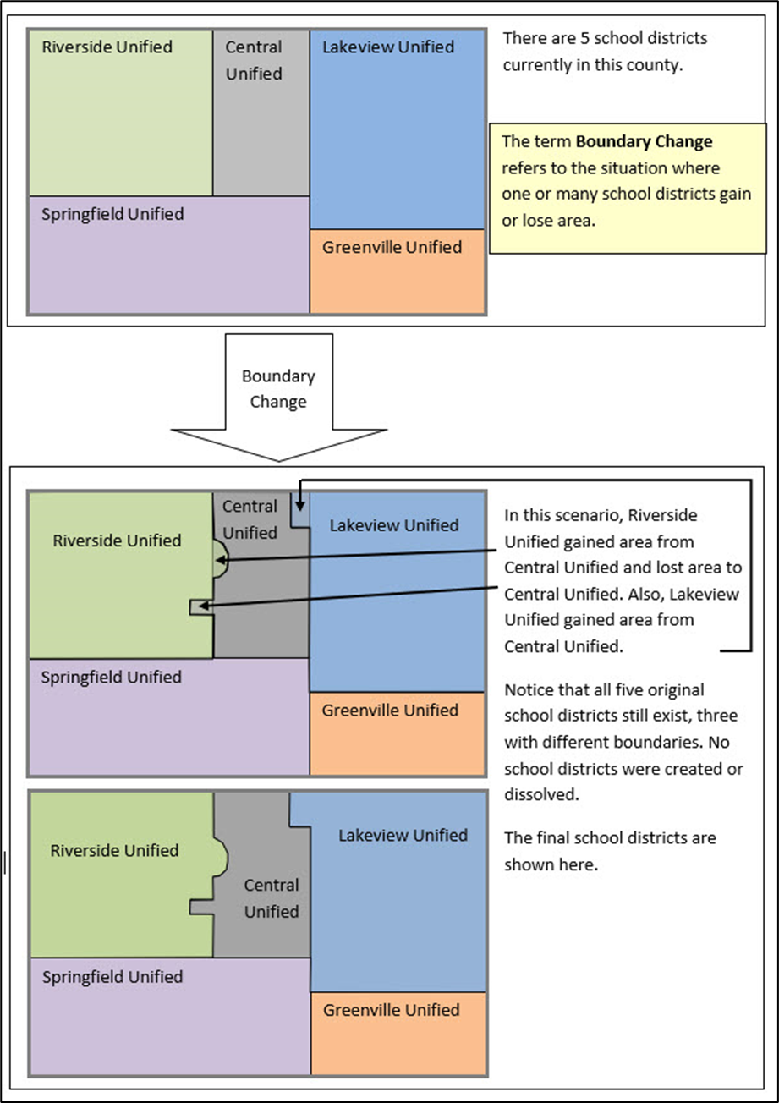
Figure 1: Boundary Change Example (Update Using GUPS Web)
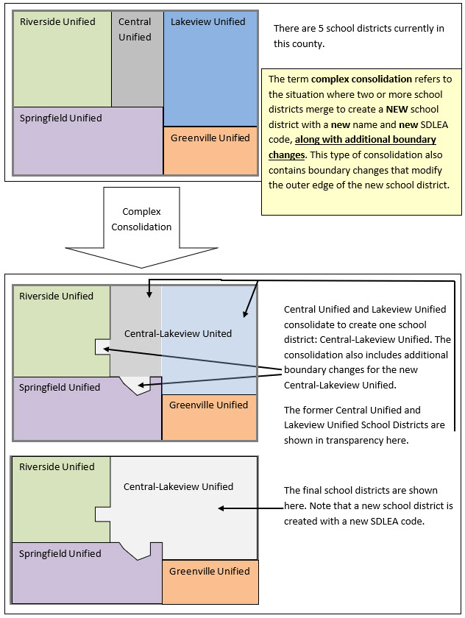
Figure 2: Complex Consolidation Example (Update Using Submission Log)
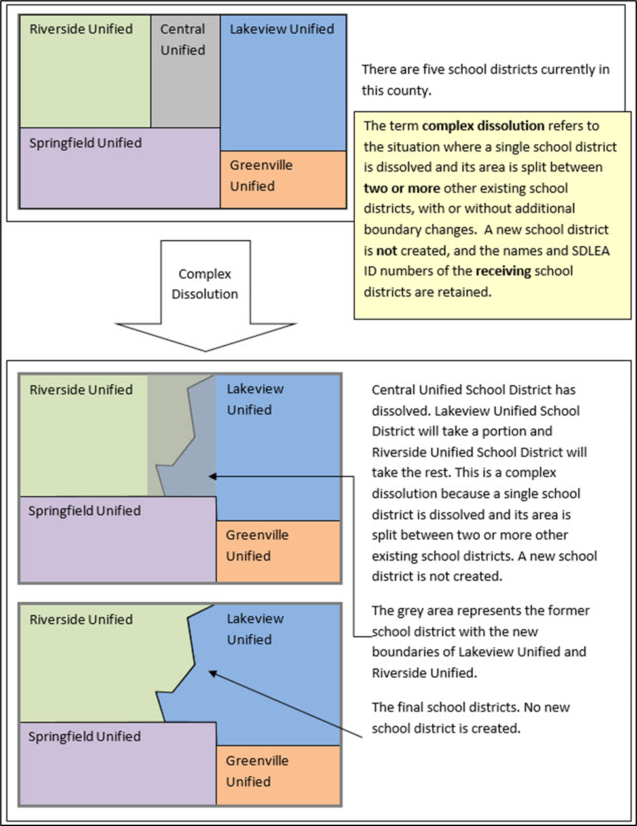
Figure 3: Complex Dissolution Example (Update Using Submission Log)
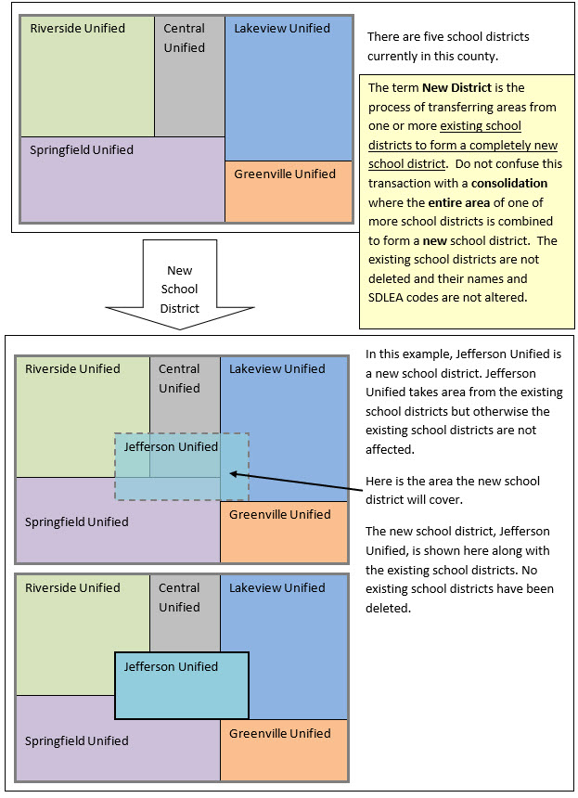
Figure 4: New District Example (Update Using Submission Log)
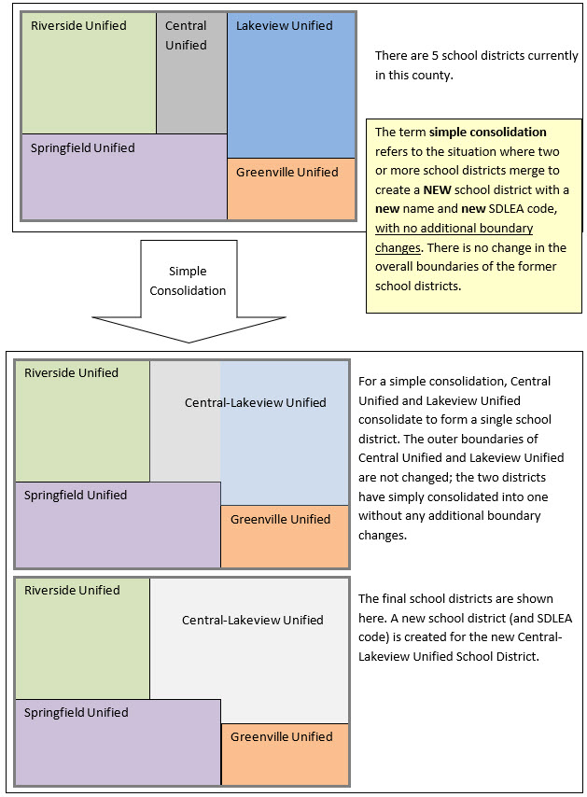
Figure 5: Simple Consolidation Example (Update Using the Submission Log)
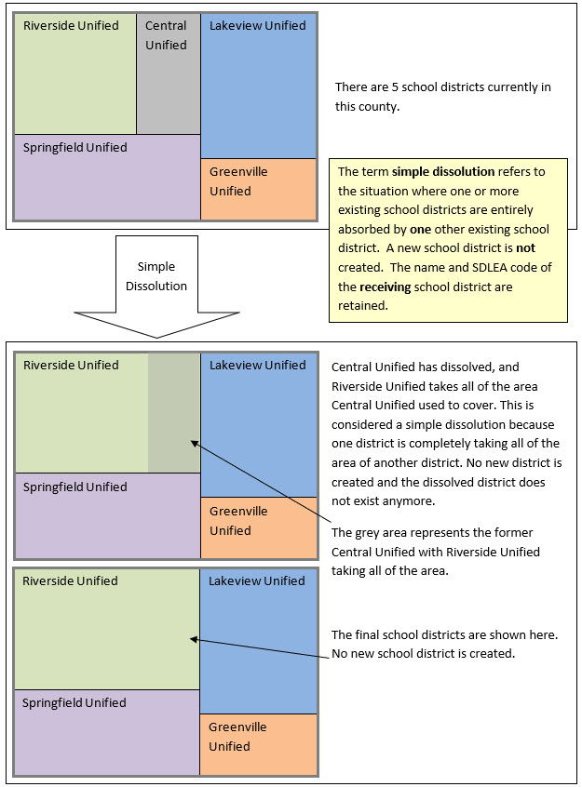
Figure 6: Simple Dissolution Example (Update Using the Submission Log)
- Guidance for Boundary Changes
When reviewing school district boundaries, the Census Bureau encourages the mapping coordinator to focus on updating large changes that affect housing units and population first and then move to smaller differences if there is time before the SDRP submission deadline. The goal of the SDRP is to obtain major changes that affect population rather than small spatial corrections of boundaries.
The Census Bureau generally does not accept boundary changes of less than 30 feet when the correction does not affect housing. In remote areas with sparse population, the Census Bureau considers a difference of 60-75 feet to not be significant if housing units are not present. When reviewing source boundaries against the Census Bureau’s boundaries, if the source shows a school district boundary on a road, then use the road as it appears in the Census Bureau’s shapefile, even if the road does not seem fully spatially accurate. Road realignments are not accepted as part of the SDRP.
If there are many spatial corrections of school district boundaries for the state, the Census Bureau may be able to make these updates outside of the SDRP cycle. Please contact the SDRP team for more information.
- Contact Information
For assistance in preparing an SDRP submission or if issues arise with the Geographic Update Partnership Software (GUPS) Web, contact the SDRP team at the Census Bureau at <geo.school@census.gov> or 1-301-763-1099.

- What is the School District Review Program (SDRP)
- Overview
  - SDRP Schedule
- September 2026—Notify the mapping coordinators by email that Annotation Phase materials are available to download and review.
- October 2026—Provide free training webinar on responding to the SDRP to mapping coordinators.
- December 31, 2026—Deadline for submission of updated school districts. All school district updates must be received by this date to participate in the 2027 SDRP Verification Phase. We encourage you to submit changes as soon as possible rather than waiting until the deadline.
- April 2027—Review of Verification Phase materials by mapping coordinators.
- December 2027—Release of preliminary poverty estimates based on the updated school districts.
  - SDRP Annotation Phase Materials
SDRP Annotation Phase materials are available for download from Annotation Phase Program Materials. Review the Quick Start Guide and this guide before starting work. These guides explain the guidelines and reporting tools that apply to the state’s updates.
  - SDRP and GUPS Web Help
The Census Bureau encourages mapping coordinators to contact the SDRP team with any questions related to the program or GUPS Web. Additionally, valuable information is located on the SDRP website, <www.census.gov/programs-surveys/sdrp.html>.
  - Description and Use of Listing Files
The Census Bureau creates four listing files provided in a Microsoft Excel® (.xlsx) format.
- Inventory and Grade Range File (All States)
- County Coverage File (All States)
- Legal Government Coextensive Coverage File (Limited States)
- School District to Geography (SD/GEO) Relationship File (Limited States)
Depending on the state’s school district geography and how the state participates in the SDRP, some listing files may not be included. The following sub-sections describe each of these listings in detail. Appendix B provides greater detail in the form of individual tables that provide a data dictionary for each of the listing files.
    - Inventory and Grade Range File (All States)
The Inventory and Grade Range listing file is named “<ST>_SD_Inventory_A.xlsx.” This file lists the school districts reported to the Census Bureau as of the 2026 SDRP, including the school district name, SDLEA code, level, type, and grade range. Details on this specific listing file are found in sub-appendix B1.
The official school district name is its legal name including any state-used descriptive wording, such as "Independent School District", "Consolidated School District", or "Supervisory Union." The grade ranges included in these files indicate the grade ranges for which each school district is financially responsible. Use this set of grades, based on financial responsibility, to assign the data for each child to exactly one school district. For information on financial responsibility see Appendix A.
Note: The Census Bureau requires complete school district coverage; therefore, the listings may contain school districts that are not Type 1, Type 2 or Type 3. These are flagged in the listings as follows: Pseudo (A), Department of Defense (B), Interstate (C), and Bureau of Indian Affairs [BIA] (D). These files also flag school districts within a state or county that have the same name but different SDLEA codes with an (E). In these situations, the SDLEA codes are the means to identify unique school districts that share the same name. See sub-appendix A1 for more information on pseudo school districts. In areas that are not covered by any school district (i.e., national park land, the Great Lakes) the Census Bureau creates a unified school district named “School District Not Defined” with SDLEA code of 99997.
      - Submitting Updates to Information in the Inventory and Grade Range File
Carefully review the information contained in this file and provide the Census Bureau with updates and/or corrections. List the updates to the school district name, SDLEA code, level, type, and grade range in the submission log, as described in Chapter 3, and submit the file using the Secure Web Incoming Module (SWIM) as described in Chapter 6.
IMPORTANT: If the mapping coordinator plans to submit more than 25 updates, contact the SDRP team before completing the submission log.
    - County Coverage File (All States)
The County Coverage listing file is named "<ST>_County_Coverage_A.xlsx.” This file lists school districts for each county, sorted by county. There is a separate record for each unique school district/county combination. Details on this specific listing file are found in sub-appendix B2.
The County Coverage file reflects the boundaries of the 2026 school districts as shown in the shapefiles and the TIGERweb map viewer. Use this file to locate each school district and to review the extent of the areas of each school district as they relate to counties.
Carefully review the information contained in this file and provide the Census Bureau with updates and/or corrections. Specifically review where a school district to county relationship should no longer be maintained, or where a new relationship should be created and maintained.
    - Legal Government Coextensive Coverage File (Limited States)
The Legal Government Coextensive Coverage listing file is named "<ST>_Coextensive_Coverage_A.xlsx." It is available for Alabama, Alaska, Georgia, Kentucky, Louisiana, Mississippi, North Carolina, South Carolina, Tennessee, Utah, and Virginia because some of their school districts are coextensive with general-purpose local governments such as counties or county equivalents and incorporated places. Details on this specific listing file are found in sub-appendix B3.
The Census Bureau maintains these coextensive relationships without the need for states to submit boundary changes for the listed school districts. All changes to counties or county equivalents and incorporated places are obtained through the Census Bureau's Boundary and Annexation Survey (BAS). If the mapping coordinator believes that a legal boundary is incorrect, please notify the Census Bureau at <geo.bas@census.gov>.
Carefully review the information contained in this file and provide the Census Bureau with updates and/or corrections. Specifically, review where a coextensive relationship should no longer be maintained or where a new relationship should be created and maintained.
    - School District to Geography (SD/GEO) Relationship File (Limited States)
In Connecticut, Maine, Massachusetts, New Hampshire, New Jersey, Pennsylvania, Rhode Island, and Vermont, school districts are commonly coextensive with one or more incorporated places and/or county subdivisions (towns, townships, boroughs, etc.). Review the relationships listed in the SD/GEO Relationship listing file, “<ST>_SD_GEO_Relationship_A.xlsx”, to ensure that the state school districts are maintaining the correct relationships with the general-purpose local governments.
Like the County Coverage file, this file contains records for each school district/incorporated place and school district/county subdivision coextensive relationship. It is sorted by SDLEA code for use in reviewing the geographic relationship between the general-purpose local governments (towns, townships, boroughs, etc.) and each school district. Details on this specific listing file are found in sub-appendix B4.
The Census Bureau maintains these relationships without the need for states to submit boundary changes for the listed school districts. All changes to incorporated places and county subdivisions are obtained through BAS. If the mapping coordinator believes that a legal boundary is incorrect, notify the Census Bureau at <geo.bas@census.gov>.
Carefully review the information contained in this file and provide the Census Bureau with updates and/or corrections. Specifically review where a relationship should no longer be maintained, or where a new relationship should be created and maintained.
Note: If the SD/GEO Relationship File and/or a Coextensive Coverage files are not available for download, and there are school districts in the state that are legally coextensive with general-purpose local governments, contact the SDRP team.
    - Submitting Updates to Information in the “County Coverage,” “Legal Government Coextensive Coverage,” and/or “Relationship” Files
Update the individual listing files with all changes, additions, and deletions making clear what changed by highlighting, changing text color, text bolding, adding, or crossing out the changes. Zip all the updated listing files into one .zip file and submit it to the Census Bureau using SWIM. For more information regarding SWIM, refer to Chapter 6.

- How to Use the TIGERweb
- Using the TIGERweb Map Viewer for the SDRP
The TIGERweb map viewer, reached by selecting the “TIGERweb Applications” tab once on the site, is available for state and local education officials to view the Census Bureau's school district information current as of January 1, 2026. In addition to school districts, TIGERweb also offers the ability to view:
- Roads, highways, and railroads.
- Rivers, lakes, streams and other “single-line” drainage.
- Boundaries for legal and statistical geographies.
- Selected special land use areas such as military reservations and national parks.
- Satellite imagery.
IMPORTANT: The TIGERweb User Guide is available from the TIGERweb Applications tab. Please utilize it for comprehensive details that may not be mentioned in this program specific guide.
To summarize the process, the mapping coordinators and other local education officials use the application to locate each school district and compare their boundary and attribution to a local source for school districts to determine if there is a need to make any changes. The mapping coordinator can provide boundary changes to the SDRP if the Census Bureau data does not correctly depict the school district boundary in effect as of January 1, 2027.
Note: Mapping coordinators, please provide local education officials with these TIGERweb instructions, which can be downloaded from Annotation Phase Program Materials.
To review the boundary of a school district, users need either the name of the school district or the seven-digit geographic identification code (i.e., GEOID) for the school district. The GEOID may be constructed by combining the two-digit state code and the five-digit SDLEA code from the Inventory and Grade Range File. This file is described in section 1.4.1 and detailed in appendix B1. TIGERweb uses the GEOID to zoom directly to the school district.
If a local education official determines that changes need to be reported for the 2027 SDRP, report the changes to a state SDRP mapping coordinator who will submit the changes to the Census Bureau. The mapping coordinator is the liaison between the state’s Department of Education and the Census Bureau. Find contact information for mapping coordinators on the SDRP website.
IMPORTANT: The Census Bureau will not accept school district boundary changes that are submitted by local education officials. The mapping coordinator must approve and submit all SDRP updates.
  - Locating a School District
TIGERweb allows users to quickly locate an entity visually using the Zoom scrollbar or by using the Query tool (Figure 7) to search for a school district by its name or unique GEOID. Additional details on the Query tool are found in section 1.3.6 of the TIGERweb User Guide.
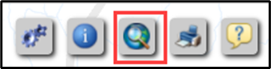
Figure 7: Query Tool Button
Figure 8 shows the resulting Query tool window that appears after selecting the button.
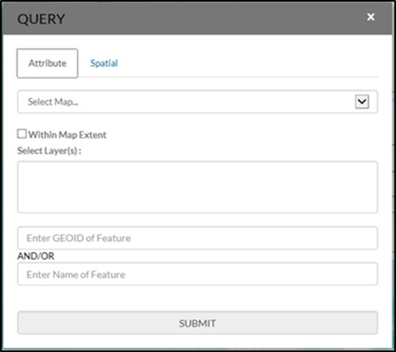
Figure 8: Query Tool Window
Select the Query tool from the toolbar. Select the Attribute tab from the Query tool window. From the Select Map drop-down menu, choose one of the following map services:
- States and Counties to locate a county.
- Places and County Subdivisions to locate a city, town, or township.
- School Districts to locate a unified, secondary, or elementary school district.
Key the GEOID, derived by combining the two-digit state code and five-digit SDLEA code in the Inventory and Grade Range Listing File, in the Enter GEOID of Feature box, or type all or part of the school district’s name in the Enter Name of Feature box. Enter a GEOID or a school district’s name, but not both. Searching by unique GEOID will take users directly to the entity. Searching by name may produce a list of school districts with the same or similar name.
Follow the steps below to locate unified school district West Prairie Community Unit School District 103, Illinois with GEOID 1700314.
- Select the Query tool and the Attribute tab.
- From the Select Map drop-down menu, choose School Districts (Figure 9).
- From the Select Layer(s) drop-down menu, choose Unified School Districts then enter 1700314 in the GEOID field (Figure 10).
- Choose SUBMIT to search for the unified school district.
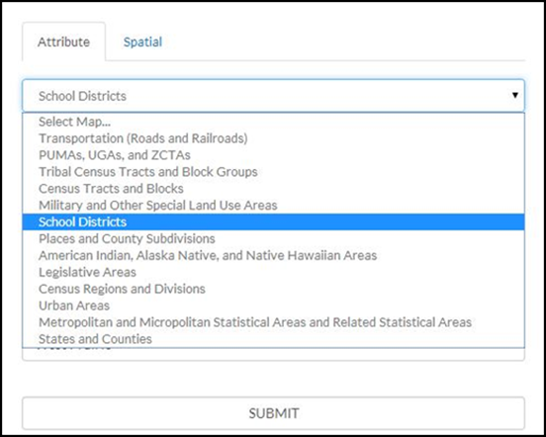
Figure 9: Query Tool–Attribute Tab–Select Map
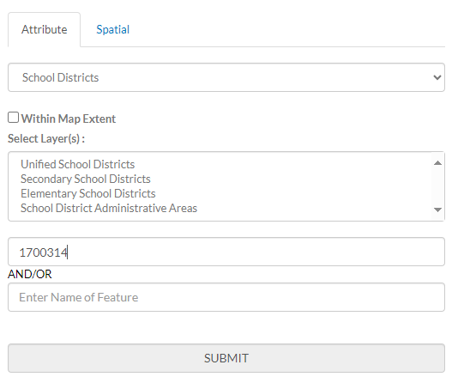
Figure 10: Query Tool–Query by GEOID
TIGERweb displays the query results under the Task Results tab to the left of the map
(Figure 11).
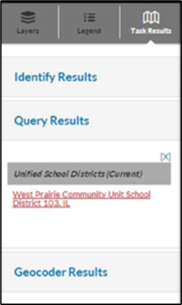
Figure 11: Task Results Tab with Query Results
TIGERweb also displays the Info panel containing attribute data for the entity (Figure 12) in a separate window. Minimize or close the Info panel by selecting the ‘-’ or ‘x’ symbol in the top right of the Info panel.
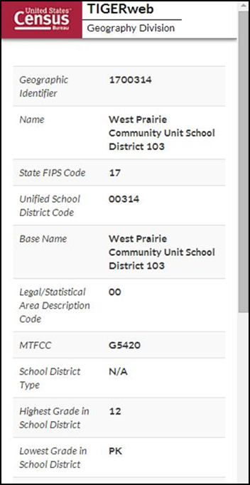
Figure 12: Query Results–Info Panel
Select the desired name from the results listed under the Unified School Districts heading of Query Results and TIGERweb will display the school district highlighted in the center of the map display (Figure 13). To start a new Query, select Clear Map (the ‘X’) above the Zoom scrollbar. The Query window reappears, and the located entity is no longer highlighted.
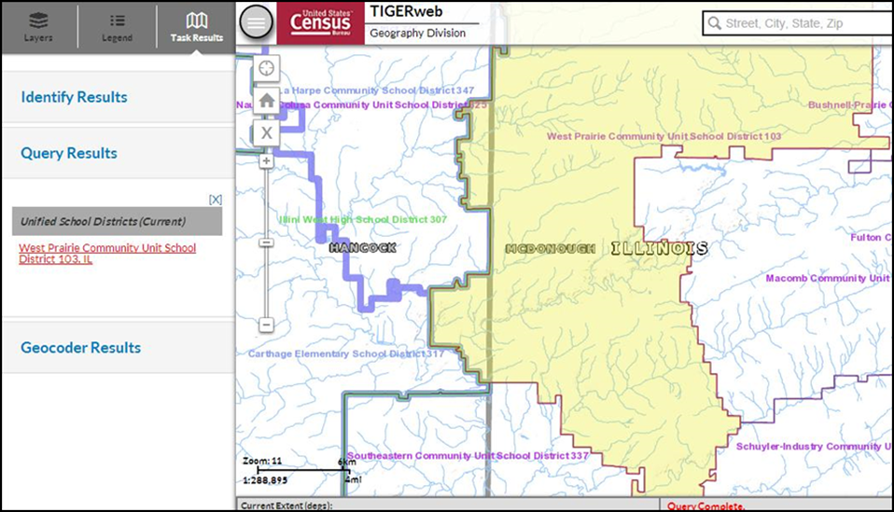
Figure 13: Map Display with Query Results
Follow the steps below to locate a school district named Bridgeport in Connecticut without knowing its school district level.
- Select the Query tool.
- From the Select Map drop-down menu, choose School Districts.
- From the Select Layer(s) drop-down menu, hold down the Control or Shift Key and choose Unified, Secondary, and Elementary. All three will display as highlighted (Figure 14) then enter Bridgeport in the Enter Name of Feature box.
- Choose SUBMIT to search.
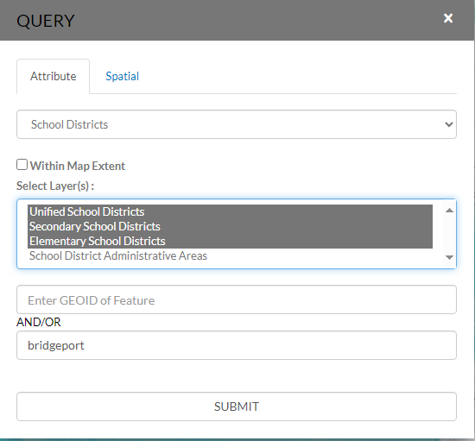
Figure 14: Query Tool–Query by Name
Searching by name could produce a list of school districts with the same or similar names, as shown in Figure 15; however, the results will include the state in which the entity is located to help choose the correct school district.
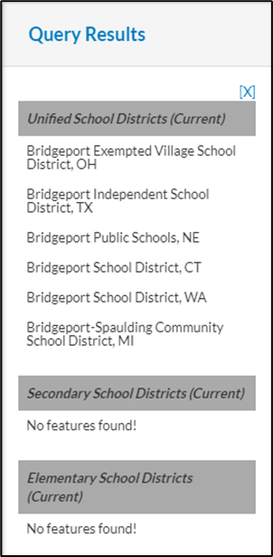
Figure 15: Query by Name Results
TIGERweb displays the selected entity highlighted in the center of the map display along with the Info panel containing attribute data for the entity. Minimize or close the Info panel to view the entire map and Query Results section (Figure 16).
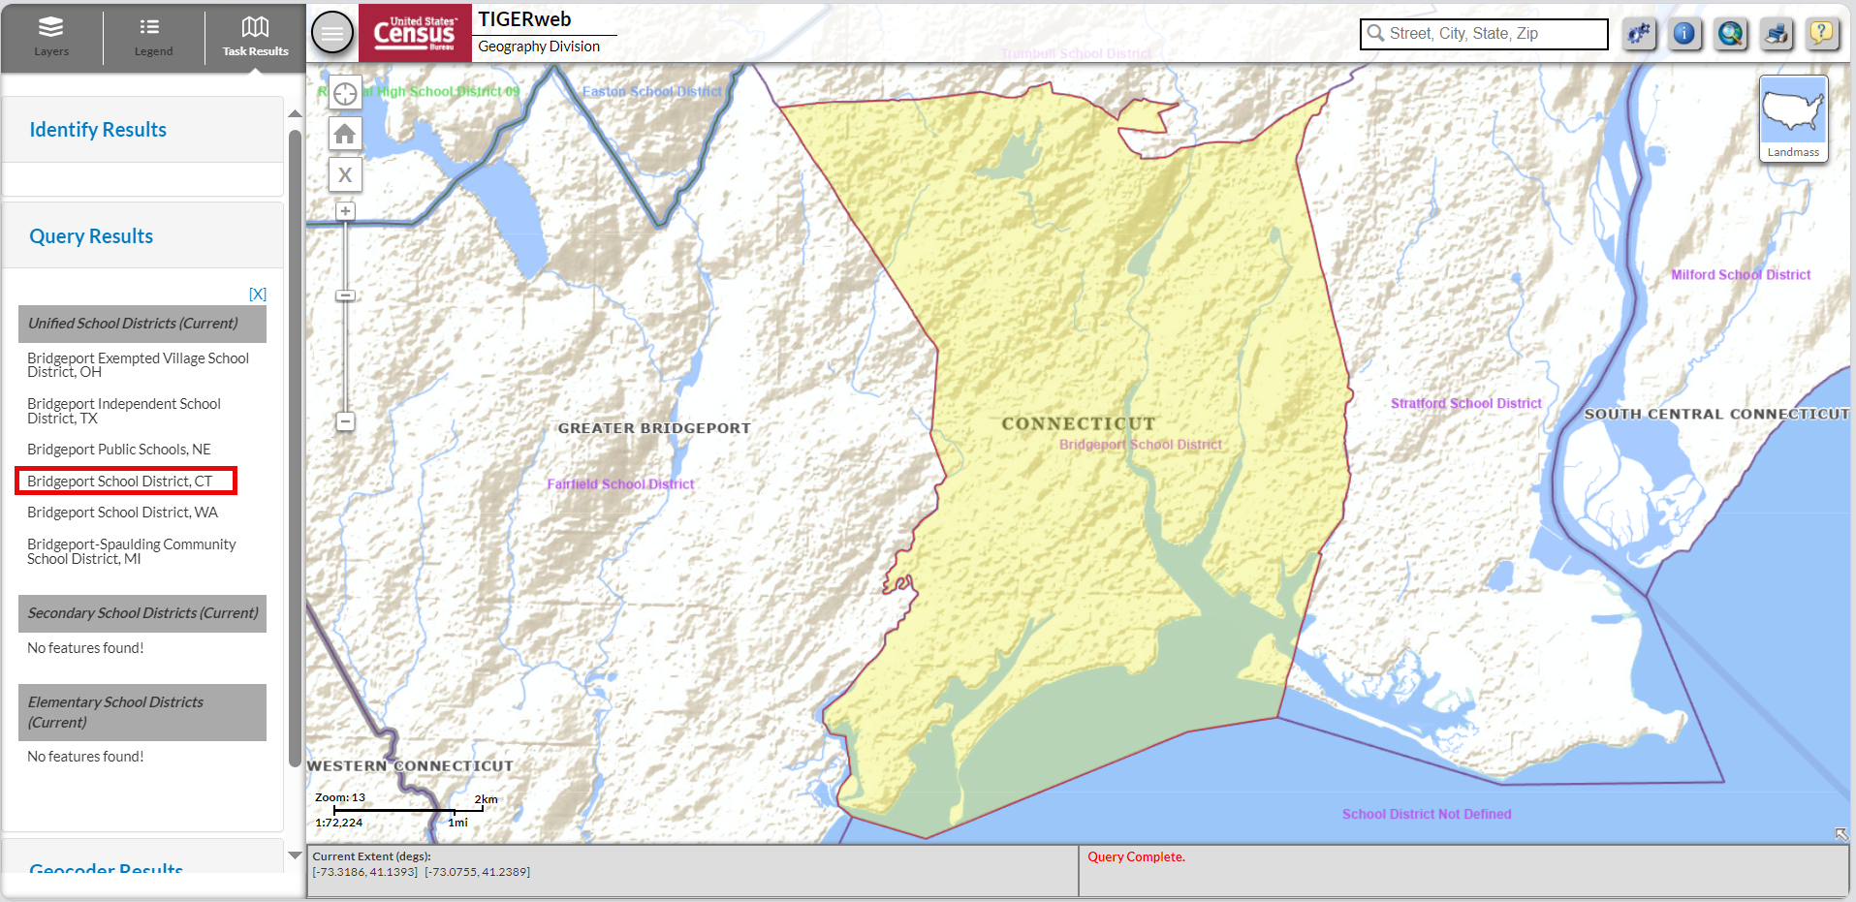
Figure 16: Map Display with Query Results
After using the Query tool to locate a school district, users can compare the TIGERweb map of the school district to a local source for the school district boundary. Provide boundary and/or attribute update information to the state mapping coordinator if the TIGERweb map does not correctly depict the school district boundary shown in a local source. Mapping coordinators prepare all school district updates for their respective states, following details in part 2 and/or 3 of this respondent guide, and submit the updates to the Census Bureau as described in part 5.
  - Printing and Saving a Map
TIGERweb has the functionality to save maps, print paper maps, or capture screen images of the areas where the boundary requires an update or annotate changes. This functionality is useful for a local education official to indicate to the mapping coordinator where a school district boundary change is needed. The local official can capture a screen image and annotate the change for the mapping coordinator to approve and submit to the Census Bureau.
Using the Print tool button from the upper right of the map display (Figure 17) opens the Print window (Figure 18). A table with detailed instructions for the options available in this window is found in section 1.3.7 of the TIGERweb User Guide.
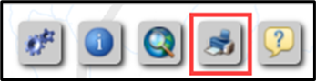
Figure 17: Print Tool Button
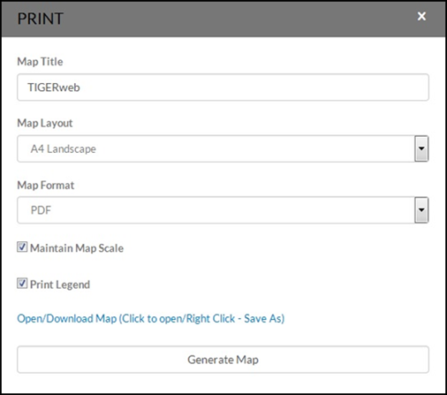
Figure 18: Print Tool Window

- How to Use the Submission Log
- Using the Submission Log for the SDRP
The submission log is an Excel spreadsheet used to report all updates except boundary changes. It is available for download from Annotation Phase Program Materials. Record each type of acceptable school district change as a separate record in this file.
The Census Bureau requires the use of the submission log for the following change types:
- School district name.
- Grade range.
- SDLEA code.
- Level (elementary, secondary, or unified).
- Simple and complex consolidation.
- Simple and complex dissolution.
- New district.
- Simple spatial update using whole MCDs or incorporated places.
Note: Not all fields in the submission log are displayed in the examples in this chapter.
  - School District Name Change
A school district name change is usually a result of a misspelling or legal school district name change. Figure 19 shows an example of the fields requiring information. They are the Type of Change, County code(s), SDLEA of Change, Old Name, and New Name fields. Contact the SDRP team if seeking to submit more than 25 name changes.
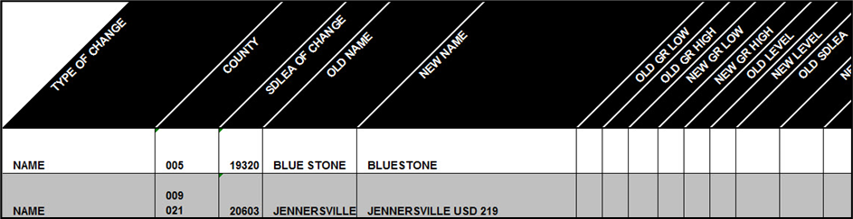
Figure 19: Example of a School District Name Change
  - Grade Range Change
A grade range change is the result of an incorrect grade range previously reported to the Census Bureau or a new change (e.g., changing from Kindergarten to Pre-Kindergarten). Gaps and overlaps in grade range coverage cannot exist. Grade range changes require information in the Type of Change, County code(s), SDLEA of Change, Old Grade Range Low, Old Grade Range High, New Grade Range Low, and New Grade Range High fields (Figure 20). Contact the SDRP team if seeking to submit more than 25 grade range changes.
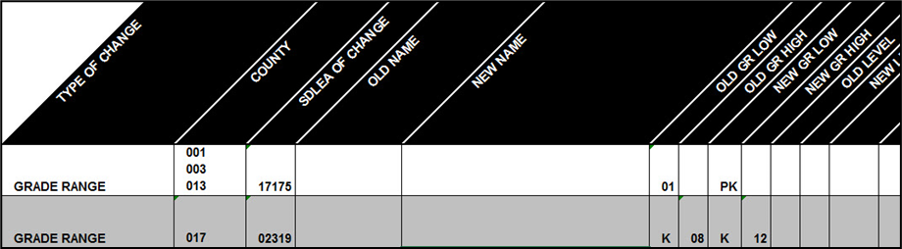
Figure 20: Example of a School District Grade Range Change
  - SDLEA Code Change
SDLEA code changes include a correction to the SDLEA code. SDLEA code changes require information in the Type of Change, County code(s), SDLEA of Change, Old SDLEA (same as SDLEA of Change), and New SDLEA fields (Figure 21).
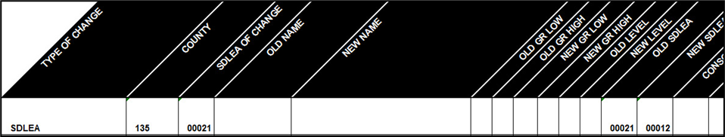
Figure 21: Example of a SDLEA Code Change
  - Level Change
A level change occurs when a school district changes classification; for example, changing from elementary to unified. Level changes require information in the Type of Change, SDLEA of Change, Old Level, and New Level fields (Figure 22).
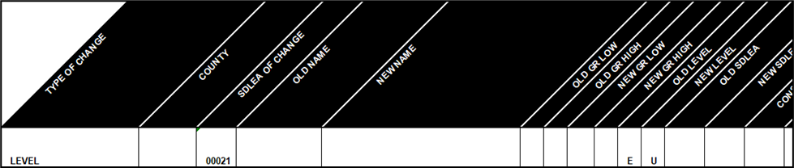
Figure 22: Example of a Level Change
  - Simple and Complex Consolidation
A consolidation occurs when two or more school districts merge, or consolidate, to create a new school district with a new name and new SDLEA code. Complex consolidations have additional boundary changes and simple consolidations do not.
Consolidations require information in the Type of Change, County code(s), New Name, New Grade Range Low, New Grade Range High, New Level, Consolidation 1 SDLEA (SDLEA code of first school district being merged), Consolidation 2 SDLEA (SDLEA code of other school district being merged), Consolidation New SDLEA (SDLEA code of newly formed school district, if known; otherwise place “unknown” in this field), and Narrative/Description fields (Figure 23). If the submission is a complex consolidation, additional documentation such as a shapefile or map indicating the location of the boundary changes is required.
Note: The fields for Consolidation 3 SDLEA and Consolidation 4 SDLEA only require information if three or more school districts are consolidating (merging). If five or more school districts are consolidating, enter the remaining SDLEA codes on the next row starting in the Consolidation SDLEA field.
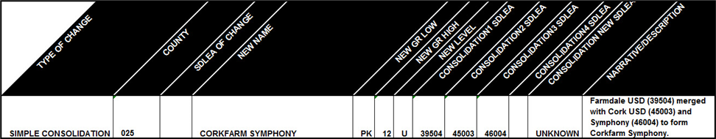
Figure 23: Example of a Simple Consolidation
  - Simple and Complex Dissolution
A simple dissolution occurs when one or more existing school districts entirely dissolve(s) into one other existing school district. A simple dissolution never results in the creation of a new school district. The receiving school district retains its name and SDLEA code. A Complex Dissolution occurs when a single school district dissolves its area between two or more existing school districts, with or without additional boundary changes.
Note: A separate entry is required for each school district that dissolves into the existing school district through this change.
Dissolutions require information in the Type of Change, County code(s), SDLEA of Change (SDLEA code of school district that is gaining area), Added Area SDLEA (same as SDLEA of Change), Deleted SDLEA (SLDEA code of school district being dissolved), and Narrative/Description (include county code(s)) and if applicable, the Old Grade Range Low, Old Grade Range High, New Grade Range Low, New Grade Range High, Old Level, and New Level fields (Figure 24). If the submission is a complex dissolution, additional documentation such as a shapefile or map that reflects the updated school district boundaries is required.

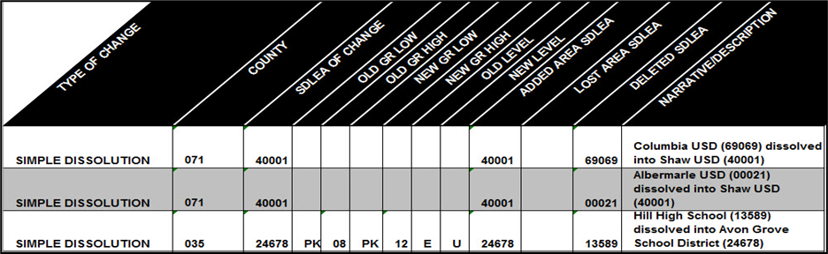
Figure 24: Example of a Simple Dissolution
  - New District
A new district occurs when transferring area from one or more existing school districts to form a completely new school district. New districts require information in the Type of Change, County code(s), New Name, New GR Low, New GR High, New Level, New SDLEA and Narrative/Description (Figure 25) . If the new school district is comprised of existing MCD(s) or place(s), then a description detailing those geographies is required in the narrative/description field. If the new district boundary is not coincident with an existing geography in the Census Bureau’s data, then additional documentation such as a shapefile or map that reflects the new district’s boundary is required.
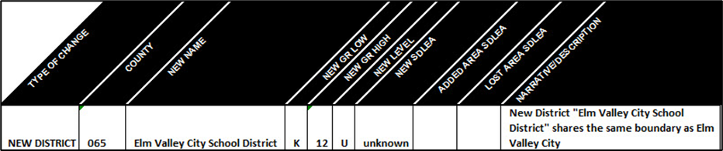
Figure 25: Example of a New District
  - Simple Spatial Update Using Whole MCDs or Incorporated Places
A simple spatial update occurs when the area that is being added to a school district is also an existing minor civil division (MCD) or incorporated place in the Census Bureau’s data. Simple spatial updates can include a change to the boundary of an existing school district or the creation of a new district. These updates may be submitted using the submission log since whole geographies are being moved to the school district.
Simple spatial updates involving school district boundary changes, shown in Figure 26, require information in the Type of Change, County code(s), Added Area SDLEA, Lost Area SDLEA, and Narrative/Description fields. The Narrative/Description field must contain the MCD(s) or incorporated place(s) that are being added to the school district.
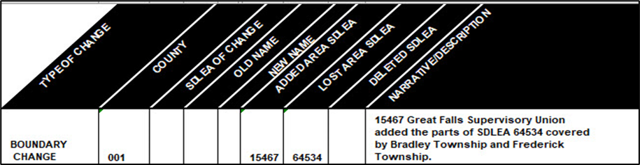
Figure 26: Example of a Simple Spatial Update–Boundary Change
Once all updates are complete, zip the submission log and submit it to the Census Bureau following instructions outlined in Chapter 6. Proceed to the next part of the guide to learn more about using GUPS Web for the SDRP.

- How to Access the Geographic Update Partnership Software (GUPS) Web
- Getting Started
  - What is GUPS Web?
The Census Bureau developed GUPS Web to simplify and modernize how state and local governments respond to the Census Bureau’s geographic partnership programs. As a web mapping application, GUPS Web is easily accessible online and includes tools for participants to review and submit updates to the Census Bureau.
  - GUPS Web Hardware and Operating System Requirements
GUPS Web does not have minimum hardware or operating system requirements. It is supported across all major web browsers including Microsoft Edge, Google Chrome, and Mozilla Firefox. The Census Bureau recommends using a laptop or desktop computer to guarantee full accessibility with the tools and features of GUPS Web.
  - Invitation Email and Creating a GUPS Web Account
At the start of the SDRP, the Census Bureau will send an invitation email to mapping coordinators nominated by their state’s department of education (Figure 27). This email grants access to a state project in GUPS Web and provides a link to register for a GUPS Web account. Below is an example of an invitation email.
Note: In cases where a technical lead is assigned to make SDRP updates instead of the mapping coordinator, the mapping coordinator should inform the Census Bureau by sending an email with the technical lead’s email and contact information. The Census Bureau will send an invitation email to the technical lead so they can create their own GUPS Web user account.
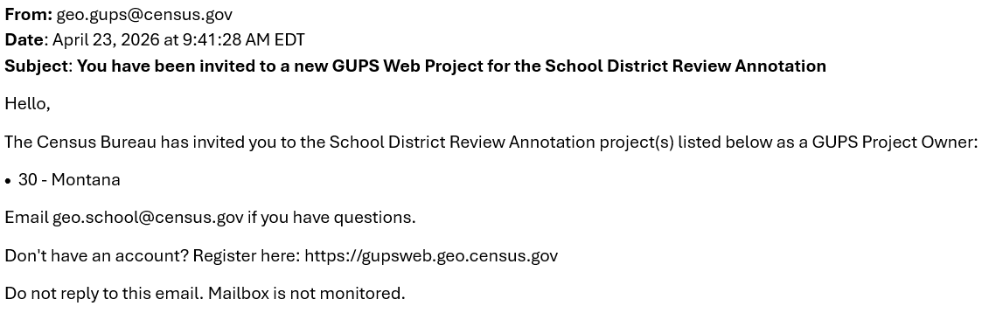
Figure 27: GUPS Web invitation email

To create an account, follow the steps below.
- From an internet browser, open <https://gupsweb.geo.census.gov/>. Select the Register button as shown in Figure 28.
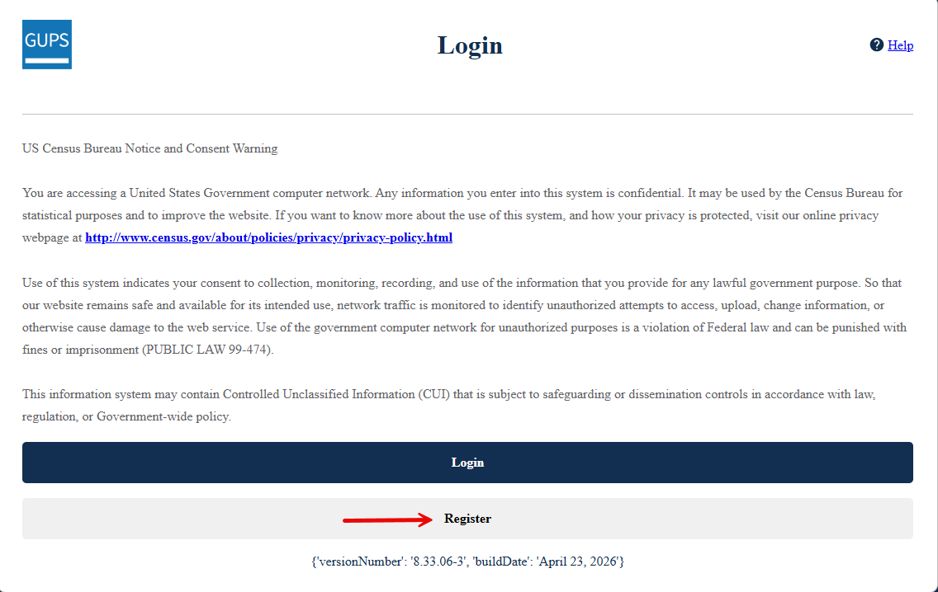
Figure 28: GUPS Web home page
- Complete the registration form, then select Submit. When the registration is completed, return to the GUPS Web home page and select Login. The Geographic Update Partnership Software login page will display as shown in Figure 29.

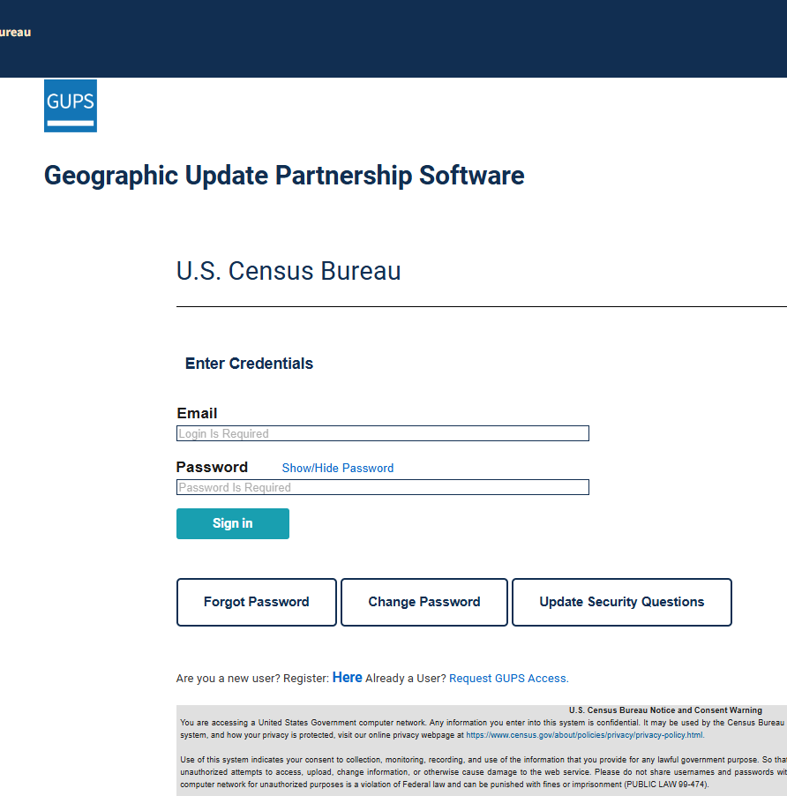
Figure 29: GUPS Web login page
- Type the Email and Password for the registered GUPS Web account and select Sign In. The GUPS Dashboard will open (Figure 30).

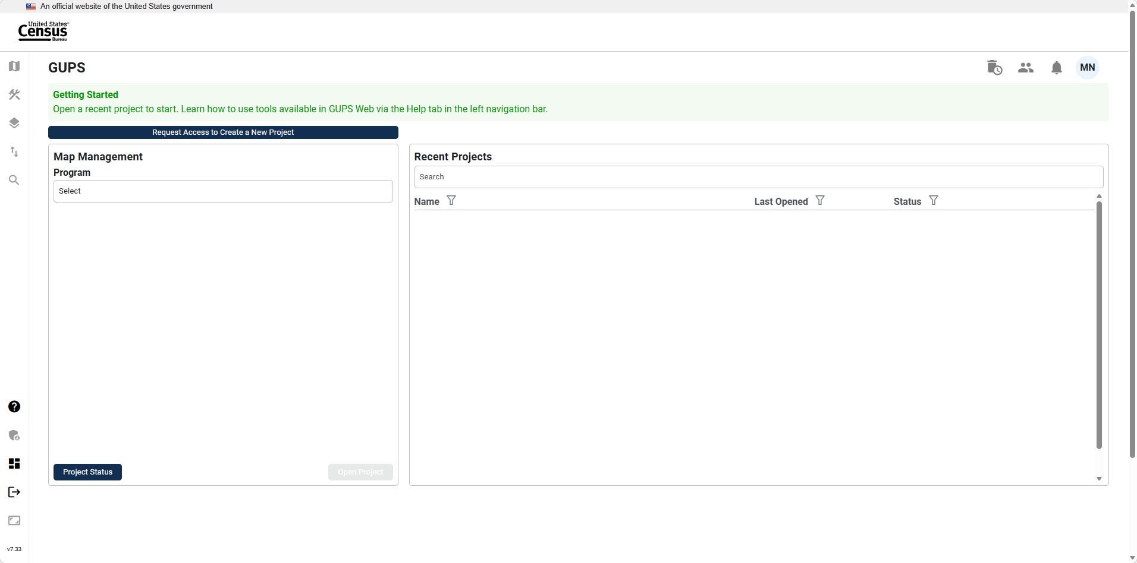
Figure 30: GUPS Web dashboard
- Further information about how to use GUPS Web can be found in the Help Center by clicking on the Help Center icon in the navigation bar as shown in Figure 31. In the Help Center, select Program Area Support then School District Review Program for additional information about using GUPS Web for the SDRP.

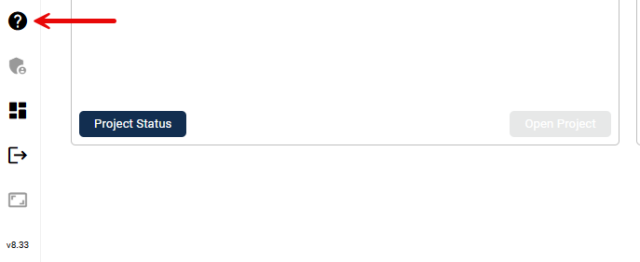
Figure 31: GUPS Web Help Center icon

- How to Submit Files to the Census Bureau
- Using the Secure Web Incoming Module (SWIM)
There are two methods to submit updates to the Census Bureau. Boundary changes created in GUPS Web are automatically transmitted to the Census Bureau when the “Submit to Census” option is used in the application. Submission Logs and supporting documentation such as images, shapefiles and PDFs must be sent to the Census Bureau using SWIM. SWIM requires files to be contained within a .zip file (sub-folder zip files are not supported) and cannot be larger than 250 megabytes.
Use the instructions in this chapter to establish or access a SWIM account.
Some mapping coordinators may have an existing SWIM account. If so, submit the state’s SDRP submission using that existing account. For mapping coordinators without an established account, contact the SDRP team to request a registration token. Once a SWIM token has been assigned, create a SWIM account.
To check for the existence of a SWIM account or to reset a password on an established account, choose “Forgot your password?” on the main SWIM page and enter the email address in question to check for the existence of an account. If SWIM locates an account, it asks the established security question for the account, for which the answer is not case-sensitive, and sends an email to reset the forgotten password. If SWIM does not locate an account associated with the email address, it returns the following message, “No account registered for this email address. The email address associated with the account is case sensitive. Try again with the proper case or go to Account Registration to register for a SWIM account.” Choosing the Account Registration link opens another window to establish a SWIM account; however, the person must have a registration token to proceed.
Note: The components of both the email address and the password of SWIM accounts are case-sensitive. Make note of the format used when establishing the SWIM account (e.g., jane@anytown.org or Jane@anytown.org or JANE@ANYTOWN.ORG.)
SWIM allows four attempts to login before it temporarily locks the account for 15 minutes. After the lock expires, try to login again or reset the password using the aforementioned “Forgot your password?” link on the login page. Once reset and logged into SWIM, account holders may modify their password and security answer by selecting “Change Security” link along the top, right side of the window. If problems occur with SWIM, contact the SDRP team because it may be necessary to create a new SWIM account.

Table 2: Steps to Use SWIM
Step | Action and Result
Step 1 | Open a new browser window and enter the URL: <https://respond.census.gov/swim>. The SWIM login screen opens.  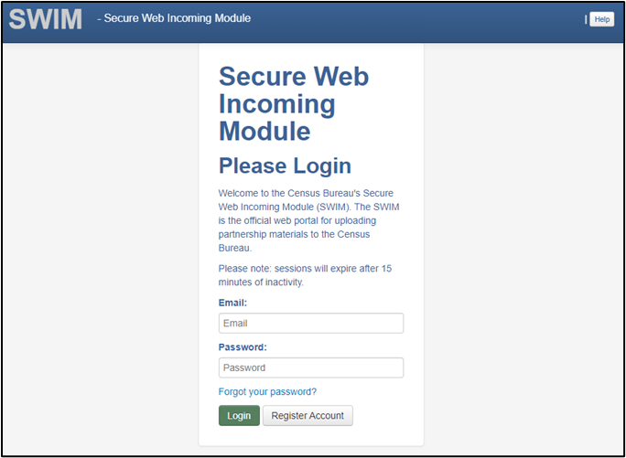
Step 2 | For users that already have a SWIM account enter the email address and password. The email and password are case sensitive. Select the Login button. Skip to Step 7.
Step 3 | Users without a SWIM account must register. Select the Register Account button. The Account Registration screen opens. All fields on the Account Registration screen are required.
 | While working in SWIM obtain help by selecting the Help button on any screen. A screen opens with links to help resources.  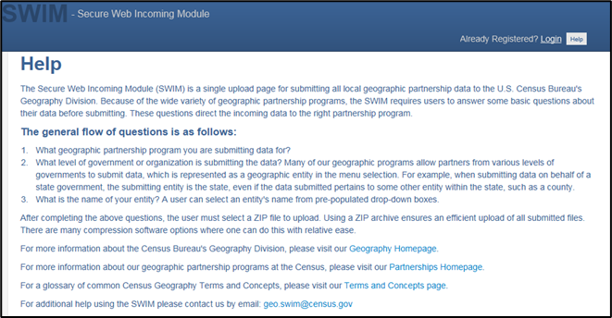
Step 4 | On the Account Registration screen, enter the 12-digit token provided by the Census Bureau, then enter contact name, agency, and email in the appropriate fields.
Step 5 | Create a password. The passwords must meet the five criteria below:  - It must be 8 characters in length.  - It must have at least one upper case character.  - It must have at least one lower case character.  - It must have at least one number.  - It must have at least one special character (valid special characters are: #, !, $, *, &, ?, ~).  Note: The commas shown immediately above are to separate the special characters listed. A comma is not a valid character for the password
Step 6 | Set up a security question (choose the arrow on the right of the Security Question box and select a question in the drop-down list, then enter an answer in the Answer box). When finished, select the Submit button. A screen opens to confirm that the account has been successfully registered.  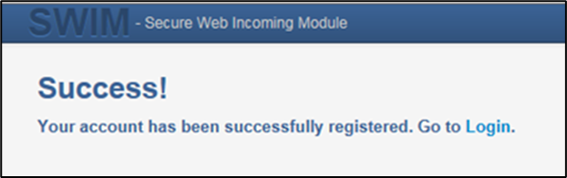  Choose Login to return to the SWIM Login screen to enter the newly established account login and password information.
Step 7 | Enter the account login and password information and choose the Login button.  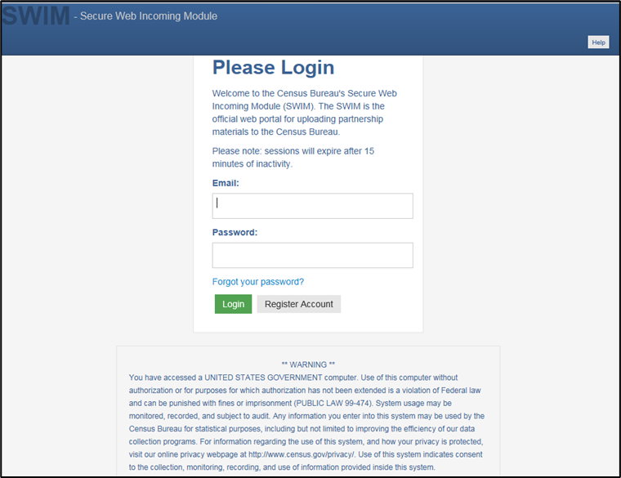
Step 8 | With a valid login and password, the Welcome screen opens. To begin the submission process, choose the Start New Upload button.  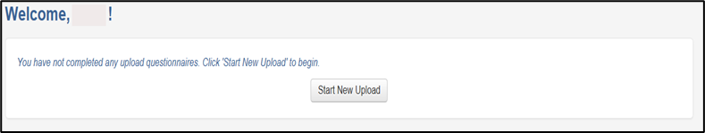
Step 9 | The “What Census program are you reporting data for?” window opens. Select the School District Review Program radio button, and then choose Next at the bottom of the screen.  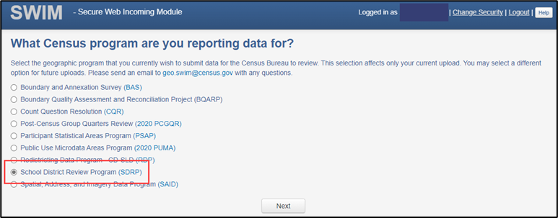
Step 10 | The Select a State window opens asking which state is being reported. Select the radio button next to the appropriate state and then choose the Next button to continue.  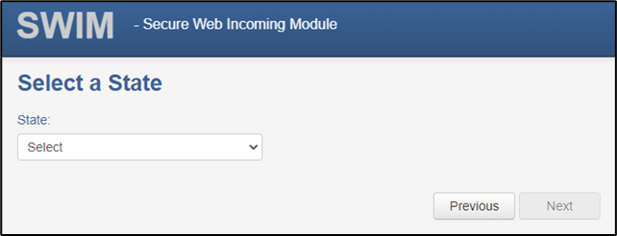
Step 11 | The Select a .zip file to upload screen opens.  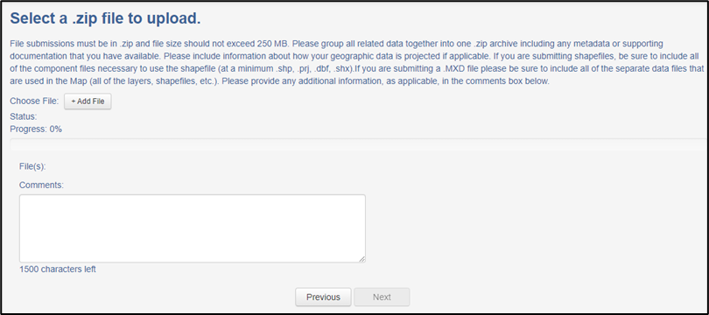
Step 12 | To upload a .zip file, select the + Add File button on the screen to open a window that allows the user to navigate to the .zip file’s location.  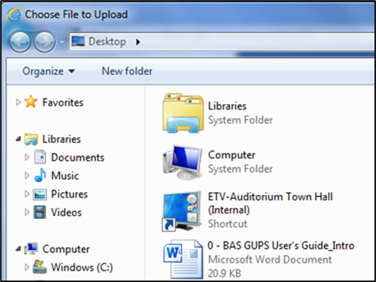
More than one .zip file can be added for upload in the SWIM session by repeating use of the
+ Add File button to locate and select each .zip file to upload. Or users can upload the individual .zip files separately. Please include Comments detailing what files are included in the SWIM upload and whether more files are expected.
Step 13 | Locate the .zip file(s) to upload and then double-click the left mouse button to add it to the window for upload. The Progress field on the Select a .zip file to upload screen shows the progress of the upload. Once the upload is complete, the Status field shows Success, and the name of the file appears in the File(s) field.  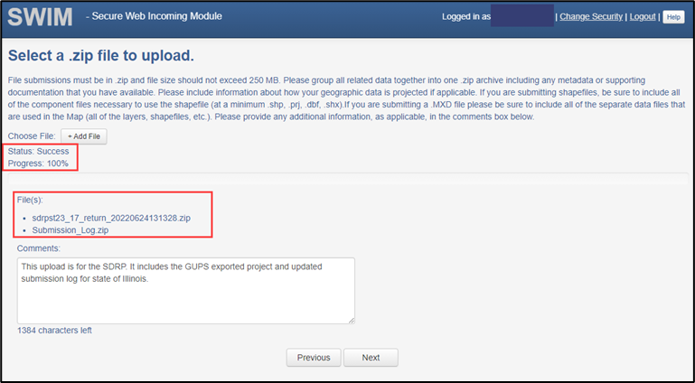
Step 14 | Type any comments in the Comments field. Select the Next button.  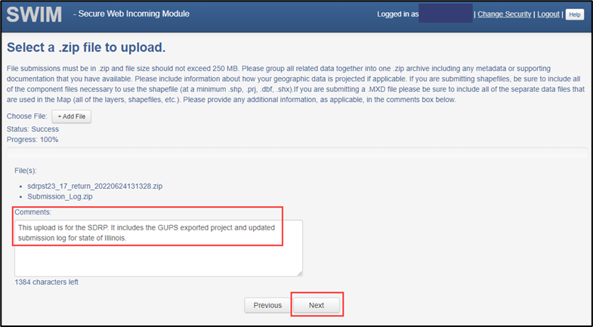
Step 15 | The Thank You page confirms the receipt of the submission. To add additional files, choose the upload form link in the phrase You may Log Out or return to the upload form, to submit more files. This choice returns to the Welcome screen. Otherwise, to log out, select Log Out.  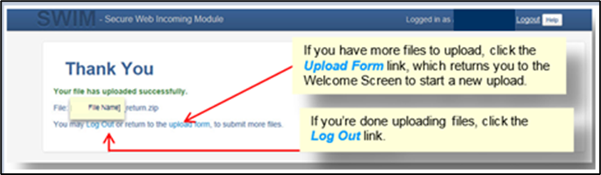
 | Be aware SWIM sessions deactivate after 15 minutes of inactivity.

Appendices

Financial Responsibility
The Census Bureau categorizes school districts based on the grade ranges for which the school district is financially responsible. These may or may not be the same as the grade ranges that a school district operates. The grade range that reflects financial responsibility is important for the allocation of Title I funds. Following are examples of how the Census Bureau represents financial responsibility.
  - Pseudo School Districts
When a school district is financially responsible for providing education for one set of grades in one geographic area and financially responsible for a different set of grades in a different geographic area, the Census Bureau may create a pseudo school district to properly allocate Title I funds. For example, a school district that is financially responsible for grades K-12 in one geographic area is also financially responsible to educate students in grades 9-12 from a neighboring district covering a different geographic area. The Census Bureau creates a pseudo school district to identify the financially responsible district for grades 9-12 covering the geographic area of the neighboring district. The pseudo district is associated with the regular district so that the regular district is given “credit” for the additional financial responsibility. Consider the example of Science Hill Independent School District.
The Science Hill Independent School District has very few children in grades 9-12, so those children attend school in the Pulaski County School District (Figure 32). Pulaski County School District is financially responsible for educating children in grades 9-12 who live in the Science Hill Independent School District and Pulaski County School District is financially responsible for educating children in grade ranges K-12 within Pulaski County, outside of the Science Hill Independent School District. Therefore, the Census Bureau created the pseudo district “Pulaski County School District for Science Hill” using the same boundaries as the Science Hill Independent School District and assigned grades 9-12 to “Pulaski County School District for Science Hill.” The Science Hill Independent School District is assigned grades K-8 while the Pulaski County School District maintains its grades K-12.
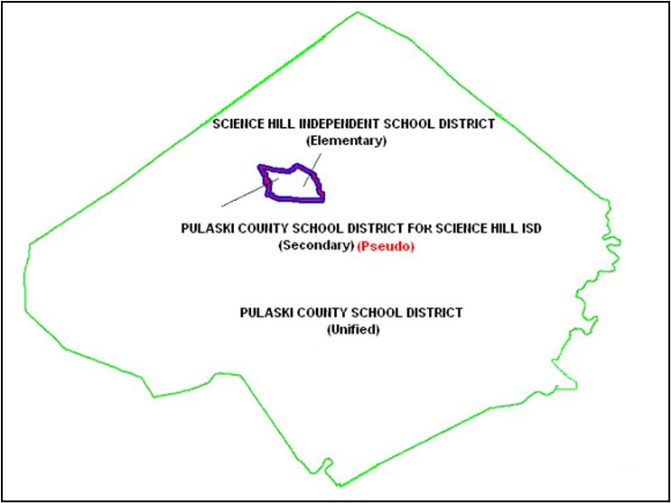
Figure 32: Example of a Pseudo School District–Pulaski County, KY
These pseudo districts are identified in the Inventory and Grade Range file by a flag with a value of "A." In the School District Boundary shapefiles, pseudo districts are identified by an SDTYPE of “A.”
Additionally, the Census Bureau assigns them a pseudo SDLEA code and a school district name that is slightly different from the official name of the school district. They appear in the Inventory and Grade Range Listing as shown in Table 3.
Table 3: Pseudo School Districts in the Inventory and Grade Range Listing File
STATE CODE | SDLEA | LOGRADE | HIGRADE | SDLEVEL | SDTYPE | NAME
21 | 04950 | PK | 12 | U | -- | Pulaski County School District
21 | 21002 | 09 | 12 | S | A | Pulaski County School District for Science Hill ISD
21 | 05220 | PK | 08 | E | -- | Science Hill Independent School District
When submitting a pseudo school district, provide the following information:
- Official school district name and SDLEA code.
- Alternate grade range.
- Service area of alternate grade range.
Currently, the Census Bureau has defined pseudo school districts in California, Georgia, Illinois, Kentucky, Massachusetts, Minnesota, New Jersey, Tennessee, Texas, and Vermont. To discuss school districts that fit the above description, contact the SDRP team.
  - Elementary PK/KG-12 School District
When a school district is financially responsible for all grades, but only operates schools with elementary grades, the Census Bureau classifies this as a PK/KG-12 Elementary School District. For example, a school district operates schools for children in grades Kindergarten (KG)-8 and pays a neighboring school district to educate children in grades 9–12. The first school district is operationally responsible for grades KG-8, but financially responsible for grades KG-12. If an elementary school district is financially responsible for grades KG-12 or Pre-Kindergarten (PK)–12, there will be no secondary school district represented for that area. In cases where an elementary school district is financially responsible for only lower grades, there is generally a secondary school district that is financially responsible for providing educational services for the upper grades.

Data Dictionary for the Listing Files
The Census Bureau produces Excel files for the Annotation Phase. The listing file names will be followed by “_A”; e.g., <ST>_SD_Inventory_A.xlsx where <ST> = two-digit state code. Use the information in the sub-appendices to learn about the attributes contained in each listing.
Note: The NCESID, and variations of it in the NCES data, is a seven-digit identification code that is composed of the two-digit state code and five-digit SDLEA code. Each of the tables in this appendix contain these two fields.
  - Data Dictionary for the Inventory and Grade Range File
These files follow the naming convention of <ST>_SD_Inventory_A.xlsx. Table 4 describes the fields in the file, their length, data type, a brief description of the field, and the valid value ranges.
Table 4: Data Dictionary for the Inventory and Grade Range File
Attribute Field | Length | Type | Description | Value/Range
STATE CODE | 2 | VARCHAR | State code | 01, 02, 04-06, 08-13, 15-42, 44-51, 53-56
SDLEA | 5 | VARCHAR | School district local education agency code | 00001-99998
LOGRADE | 2 | VARCHAR | School district low grade | PK, KG, 01-11
HIGRADE | 2 | VARCHAR | School district high grade | PK, KG, 01-12
SDLEVEL | 1 | VARCHAR | School district level | E=Elementary; S=Secondary; U=Unified; A=Administrative Area
SDTYPE | 1 | VARCHAR | School district type | A=Pseudo; B=Dept. of Defense; C=Interstate; D=Bureau of Indian Affairs; E=Same Name
NAME | 100 | VARCHAR | School district name | Not Blank
  - Data Dictionary for the County Coverage File
These files follow the naming convention <ST>_County_Coverage_A.xlsx. Table 5 describes the fields in the file, their length, data type, a brief description of the field, and the valid value ranges.

Table 5: Data Dictionary for the County Coverage File
Attribute Field | Length | Type | Description | Value/Range
STATE CODE | 2 | VARCHAR | State code | 01, 02, 04-06, 08-13, 15-42, 44-51, 53-56
COUNTY CODE | 3 | VARCHAR | County code | 001-840
COUNTY NAME | 100 | VARCHAR | County name | Not Blank
SDLEA | 5 | VARCHAR | School district local education agency code | 00001-99998
NAME | 100 | VARCHAR | School district name | Not Blank
  - Data Dictionary for the Legal Government Coextensive Coverage File
These files follow the naming convention <ST>_Coextensive_Coverage_A.xlsx. Table 6 describes the fields in the file, their length, data type, a brief description of the field, and the valid value ranges.
Table 6: Data Dictionary for the Legal Government Coextensive Coverage File
Attribute Field | Length | Type | Description | Value/Range
STATE CODE | 2 | VARCHAR | State code | 01, 02, 04-06, 08-13, 15-42, 44-51, 53-56
COUNTY CODE | 3 | VARCHAR | County code | 001-840
COUNTY NAME | 100 | VARCHAR | County name | Not Blank
SDLEA | 5 | VARCHAR | School district local education agency code | 00001-99998
SDLEVEL | 1 | VARCHAR | School district level | E=Elementary; S=Secondary; U=Unified; A=Administrative Area
SDNAME | 100 | VARCHAR | School district name | Not Blank
COEXTWITH | 100 | VARCHAR | Name of government the school district is coextensive with | Not Blank
FIPS55 CODE | 5 | VARCHAR | Federal Information Processing Series (FIPS) code (formerly FIPS 55) of the place the school district is coextensive with. This field is only populated when the coextensive government is a place. | 00001-89999
  - Data Dictionary for the School District to Geography Relationship File
These files follow the naming convention <ST>_SD_GEO_Relationship_A.xlsx. Table 7 describes the fields in the file, their length, data type, a brief description of the field, and the valid value ranges.
Table 7: Data Dictionary for the School District to Geography Relationship File
Attribute Field | Length | Type | Description | Value/Range
SDLEA | 5 | VARCHAR | School district local education agency code | 00001-99998
SDLEVEL | 1 | VARCHAR | School district level | E=Elementary; S=Secondary; U=Unified; A=Administrative Area
SDNAME | 100 | VARCHAR | School district name | Not Blank
COUNTY SUBDIVISION ‘PART’ FLAG | 1 | VARCHAR | School district partially covers county subdivision part flag | P
STATE CODE | 2 | VARCHAR | State code | 01, 02, 04-06, 08-13, 15-42, 44-51, 53-56
COUNTY CODE | 3 | VARCHAR | County code | 001-840
COUNTY SUBDIVISION CODE | 5 | VARCHAR | County subdivision code | 00000-98999
COUNTY SUBDIVISION NAME | 100 | VARCHAR | County subdivision name | Not Blank
COUNTY SUBDIVISION NAME SUFFIX | 50 | VARCHAR | County subdivision name suffix | Barrio, borough, CCD, census subarea, census subdistrict, city, county, district, precinct, gore, grant, location, municipality, plantation, barrio-pueblo, purchase, town, township, UT, village, charter township, reservation, no suffix exists
PLACE ‘PART’ FLAG | 1 | VARCHAR | School district partially covers incorporated place part flag | P
PLACE CODE | 5 | VARCHAR | Place code | 00001-89999
PLACE NAME | 100 | VARCHAR | Place name | Not Blank
PLACE SUFFIX | 50 | VARCHAR | Incorporated place name suffix | Borough, city, metro township, municipality, town, village, city and borough, consolidated government, corporation, metropolitan government, urban county, unified government, no suffix exists

Refer to Appendix B for additional information.

