OMB No.: 0920-XXXX
National Center for Health Statistics Expiration Date: XX/XX/XXXX
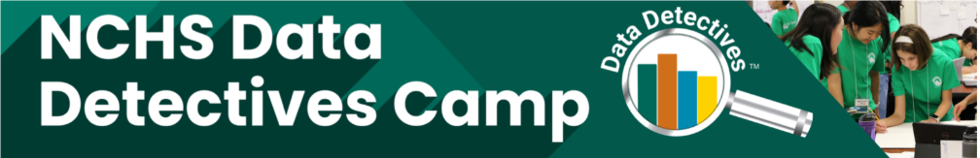 Teacher Recommendation Form

Camp Applicant Section

Applicant name:_______________________ ______________________________
last name first name

Give this form to a math teacher who knows you well enough to assess your ability to participate in the Data Detectives Summer Camp. The information we receive from your teacher will be kept private and not shared with anyone.

Recommender Section
This section is to be completed by the student’s math teacher
Our camp is a summer program for all students who are interested in math and statistics and will be entering grades 6 or 7. Recommendations may not be submitted by family members.

- How long have you known the applicant, and what is your relationship to the applicant

- Please rate the applicant in areas a–h according to the rubric below:

1 = Below average 2 = Average 3 = Above Average 4 = Excellent N/A = Unable to judge

  - Academic achievement ____
  - Interest in math ____
  - Level of maturity ____
  - Willingness to accept direction or supervision ____
  - Sensitivity to needs and feelings of others ____
  - Ability to get along with others ____
  - Commitment to his or her education ____
  - Behavior on a typical day ____

- What do you consider to be the applicant’s relative weakness or area that needs improvement as a potential participant in NCHS Data Detectives Camp?

- What do you consider to be the applicant’s relative strength as a potential participant in NCHS Data Detectives Camp?

- Please select one option below:
_____I do not recommend this applicant for admission.
_____I think the applicant’s qualifications are marginal, but if admitted, the
applicant would greatly benefit from participating in the program.
_____I recommend this applicant for admission, without reservation.

_____________________________ ____________________________
Teacher name (first and last) Title

_______________________________________________________________________
School name

______________________________ ____________________________
Phone number Email address

Signed: __________________________________ Date: _______ /______ /_______
(Signature of teacher) (Month) (Day) (Year)

Although not required, you may attach a letter with this form to provide additional information about the applicant.

After completing this form, email it along with any attachment(s) to datadetectives@cdc.gov, using your school email address. Forms submitted from personal email accounts will not be accepted. If you are unable to send it via email, or would prefer to send it via postal mail, please contact us at datadetectives@cdc.gov.

Information about Data Detectives Camp is available at www.cdc.gov/nchs/data-detectives-camp/about. If you have questions about the camp, email datadetectives@cdc.gov.

From the Office of Management and Budget (OMB No. 0920-XXXX, Expiration Date: XX/XX/20XX):
NOTICE–Public reporting burden of this collection of information is estimated to average 30 minutes, including the time for reviewing instructions, searching existing data sources, gathering and maintaining the data needed, and completing and reviewing the collection of information. An agency may not conduct or sponsor, and a person is not required to respond to, a collection of information unless it displays a currently valid OMB control number. Send comments regarding this burden estimate or any other aspect of this collection of information, including suggestions for reducing this burden to: CDC/ATSDR Information Collection Review Office; 1600 Clifton Road, MS H21-8, Atlanta, GA 30333, ATTN: PRA (0920- XXXX)

