OMB No.: 0920-XXXX
National Center for Health Statistics Expiration Date: 

Camper Information Form (For Parents of Accepted Students)
Any information you provide is voluntary and will be maintained by the National Center for Health Statistics in accordance with federal laws, including the Privacy Act of 1974 (5 U.S.C. 552a).
Camper’s first and last name: Name of parent / guardian who will be picking up camper from camp:
Last name First name
Relationship to camper Phone number
Optional: Name of second person who will be picking up camper from camp:
Last name First name
Relationship to camper Phone number

Alternative contact:
In the event of an emergency, I authorize the following individuals to pick up my child from camp:
Name Relationship Phone number
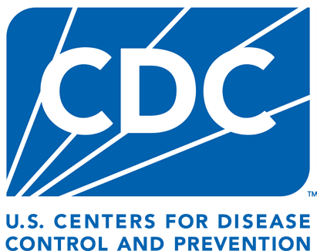
Please provide any additional information that camp instructors should know about your child, including any special needs, important medical history, behavioral issues, or any needed accommodations. Please be sure to include specific allergies (food or medication) and any medication use required by your child at the camp.
Photography and Media Release
I give permission for staff to photograph and/or record my child during camp activities. I understand that these images or videos may be used for:
- Camp documentation
- Promotional materials (e.g., brochures, websites, social media)
- Educational or informational purposes
I agree that these materials may be used without further notification, review, or approval and without any financial compensation. I also understand that others may copy, print, or distribute these materials.
My child’s name will not be included in any materials without my additional consent.
By signing below, I confirm that I have read, understood, and agree to these terms.
Parent/guardian name:
Signature:
Date:

Acceptable Behavior Policy
It is important that all campers receive a positive and rewarding experience while attending our program. To ensure a safe and fun environment for all campers, all participants are expected to behave in an acceptable manner and use appropriate language. Any behavior deemed to be detrimental to or in violation of camp standards will be addressed by staff. Unacceptable behaviors include, but are not limited to, any form of intended harm to another camper or staff member, bullying, or any form of aggression.
I have read and will abide by the camp rules. I understand that camp staff have the right to remove any person from the program that does not abide by these rules.
Parent/guardian signature Camp participant signature
From the Office of Management and Budget (OMB No. 0920-XXXX, Expiration Date: XX/XX/20XX):
NOTICE–Public reporting burden of this collection of information is estimated to average 30 minutes, including the time for reviewing instructions, searching existing data sources, gathering and maintaining the data needed, and completing and reviewing the collection of information. An agency may not conduct or sponsor, and a person is not required to respond to, a collection of information unless it displays a currently valid OMB control number. Send comments regarding this burden estimate or any other aspect of this collection of information, including suggestions for reducing this burden to: CDC/ATSDR Information Collection Review Office; 1600 Clifton Road, MS H21-8, Atlanta, GA 30333, ATTN: PRA (0920- XXXX)

