Rural Health Transformation (RHT) Program:
OBligated and Spent Funds Reporting Guide

_______

Table of Contents
Introduction 1
Overview 2
Entering First-Tier Entities 2
Summary Columns 3
Use of Funds Tab 5
Overview 5
Obligation Aggregation and Splitting 6
Program-Specific Limitations 10
Use of Funds Tab Glossary 12
Downstream Obligations Tab 13
Overview 13
Structure 13
Reporting Instructions 14
Distribution Reporting 19
Overview 19
Structure 19
Reporting Instructions 20
Considerations for Future Reporting Periods 21
Appendix A: Recording a New Obligation or Spend Event 22
Appendix B: Conditional Formatting Rules 23
First-Tier Entities Tab 23
Use of Funds Tab 24
Downstream Obligations Tab 26
Distribution Reporting Tab 28
Appendix C: Table of Figures 30

Introduction
The Obligated and Spent Funds Reporting section of the Excel Reporting Template includes four tabs that must all be completed and submitted for each Annual and Quarterly Report: First-Tier Entities, Use of Funds, Downstream Obligations, and Distribution Reporting. The Entity Type Guidance tab is for reference only, to support categorization of subrecipients and contractors. This document provides guidance on how to complete these reporting requirements.
General Guidance
On the Obligated and Spent Funds Reporting tabs, States should only fill in editable cells. Light blue cells are protected because they contain formulas, so States do not need to edit them for any reason. For all Obligated and Spent Funds Reporting tabs, the State is expected to fill in information for all unprotected (white) cells for each row of information, except as noted below.
The reporting for a given expense should be completed in the order that the tabs appear in the Excel Reporting Template. Some information will be automatically populated in subsequent tabs. For example, the user must list relevant subrecipient and contractor names on the First-Tier Entities tab for them to appear in the dropdown on the Use of Funds tab. Users must also define the initial obligations to each first-tier entity on the Use of Funds tab before they may be allocated in more detail on the Downstream Obligations tab. The amount of dollars spent against the obligations listed on the First-Tier Entities or Downstream Obligations tabs must be populated to record further distribution of those dollars on the Distribution Reporting Tab.
Throughout the guide, “entity” is used to broadly refer to the subrecipients and contractors that receive obligated or spent funds related to the RHT Program. For the purposes of the Obligated and Spent Funds Reporting process, both subrecipients and contractors are treated the same way in terms of the State awardee’s reporting requirements. This guide uses “tier” to distinguish between entities with different numbers of degrees of separation from the State awardee in terms of their financial relationship with respect to RHT Program funds. For example, a “first-tier entity” would be entity that is allocated obligated or spent funds directly from the State awardee. If a first-tier entity either acts as a pass-through entity to obligate funds to a subrecipient or spends money on a contractor, that subrecipient or contractor would be a “second-tier entity”, etc.
When a new financial relationship pertaining to RHT Program obligated or spent funds is created or identified by the State awardee, it must be reflected in the Obligated and Spent Funds Reporting section of the Excel Reporting Template. Appendix A includes a detailed process that States may reference to help determine where the information should be captured.
First-Tier Entities Tab

Overview
This tab captures key information about first-tier entities and serves two functions. First, the State must list all of their first-tier entities in column C and assign an entity type for each one in column D. The list of first-tier entities provided in column C of the First-Tier Entities tab will then populate a dropdown list in the Use of Funds tab. Second, the remaining columns on this tab will be automatically populated to display information about the first-tier entities based on the other tabs in the Obligated and Spent Funds Reporting section that may be used by States and CMS.

Entering First-Tier Entities
In column C, enter the name of every entity that directly received funds from the State awardee and then use the dropdown in column D to select the most appropriate entity type for the first-tier entity. Use the descriptions on the Entity Type Guidance tab to assist in determining the most appropriate entity type.
Many types of organizations and entities may be a first-tier entity, including specific agencies within the State Health and Human Services Department, other government agencies, specific healthcare providers or health systems, contractor organizations, etc. See Figure 1 for the list of example first-tier entities of State XY that will be referenced throughout the remainder of this document.
Figure 1: First-Tier Entity Data Entry
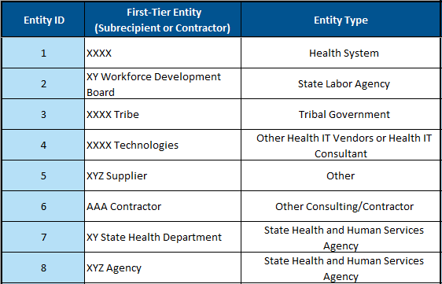
When a first-tier entity name is populated, it will automatically be assigned an Entity ID. These Entity IDs are used on the Downstream Entities and Distribution Reporting tabs.
First-tier entities should be entered in sequential rows (do not leave blank rows) and should not be re-ordered or removed. Since the Entity IDs are dynamically assigned, moving or deleting an entity from this list could create issues for the data on other linked tabs. A State may enter a first-tier entity on this tab even if no funds have yet been provided to the entity or if funding has been retracted after an obligation is made.
The First-Tier Entities tab supports up to 300 line items; States should contact their PO for additional guidance if they exceed this number of first-tier entities.

Summary Columns
The remaining light blue (protected) columns on this tab provide summary information for each first-tier entity based on the data that is entered on other linked tabs. This information is automatically populated and for reference only; States may find this information helpful for completing the Downstream Obligations tab or validating the disaggregated information entered on the Use of Funds tab.
Figure 2: First-Tier Entities Funds Received
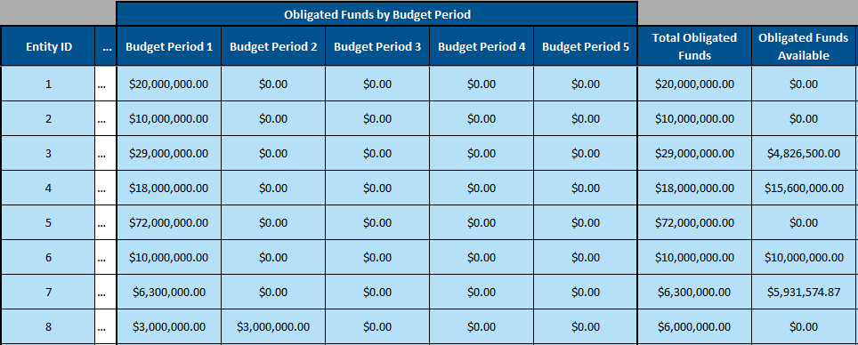
The first six columns (E through H) of this section display the sum of funds that have been obligated to the first-tier entity in each budget period as well as the sum across all budget periods. The Obligated Funds Available column amount of funds that are available for the entity to transfer to a downstream entity via a sub-obligation. This is calculated as the total funds obligated to the first-tier entity, less any funds that are already sub-obligated to a downstream entity (reported on the Downstream Obligations tab) and less any funds that have already been spent on the entity by the State awardee.
Obligated Funds Available = Total Obligated Funds – Sum of Downstream Sub-Obligations
– Sum of Spent Funds Against Obligation
Note: These Obligated Funds Available could be either funds that the entity has yet to sub-obligate to a downstream entity at the time of reporting or could be funds for which the first-tier entity is the terminal entity, but not all obligations from the State have been fulfilled, such as a contractor working directly with the State awardee. This column is meant to be a useful tool for the States to determine how much funding is eligible to the sub-obligated by the first-tier entity on the Downstream Obligations tab. Several example scenarios for State XY are described below:
- Entity #1 is a Health System that was obligated $20 million. State XY has added the full $20 million to its general ledger and the health system has received the funds, making them spent funds. Because the spend event has already occurred in this example, any distributions that the health system makes to its component hospitals will be made on the Distribution Reporting tab and XXXX Health System will not have any sub-obligations on the Downstream Obligations tab.
- Entity #2 is a State Labor Agency that was obligated $10 million and has already sub-obligated the entire sum based on entries on the Downstream Obligations tab. Entity #2 therefore has $0 of Obligated Funds Available.
- Entity #3 is XXXX Tribe, a Tribal Government entity that was obligated $32 million.
- In contrast to Entity #2, XXXX Tribe has only obligated $24.08 million of its obligation on the Downstream Obligations tab.
- Additionally, XXXX Tribe has set aside $200,000 of its obligation to be spent internally on program administration expenses on the Use of Funds tab. At the time of reporting, $93,500 has been spent by State XY, added to the State’s general ledger, and sent directly to XXXX Tribe for these administrative costs.
- Altogether, XXXX Tribe therefore has Obligated Funds Available of $32 million – $24.08 million – $93,500 = $4,826,500. This is a combination of the remaining $106,000 that they expect to receive as Spent Funds from State XY (to cover administrative expenses) and the remaining $4.72 million that they intend to sub-obligate to downstream entities, but those sub-obligations have not been defined at the time of reporting.
- Entity #4 is a health technology contractor that will be the terminal entity of those funds (i.e., no sub-obligations will be created). In this example, State XY will spend funds as it pays XXXX Technologies’ invoices, increasing the value of the Funds Spent Against Obligation column over time. At the time of reporting $2.4 million has been spent against the $18 million obligation (indicated on the Use of Funds tab), resulting in Obligated Funds Available of $15.6 million.
- Entity #7 is the State Health Agency itself. In order to track funds that are spent internally within the State awardee organization (such as on new staff hired to provide RHT Program oversight activities), it must be entered as a separate entity. The total amount budgeted (obligated) for this purpose is $6.3 million and $368,425.13 has been spent by State XY (on wages, etc.) for this purpose at the time of reporting (indicated on the Use of Funds tab), resulting in Obligated Funds Available of $5,931,574.87.
The final two columns of the First-Tier Entities tab display the initiatives and use of funds categories for which the first-tier entity has received funding, as shown in Figure 3. These columns are automatically populated based on information provided by the State on the Use of Funds tab.
Figure 3: First-Tier Entities Initiatives and Use of Funds Categories
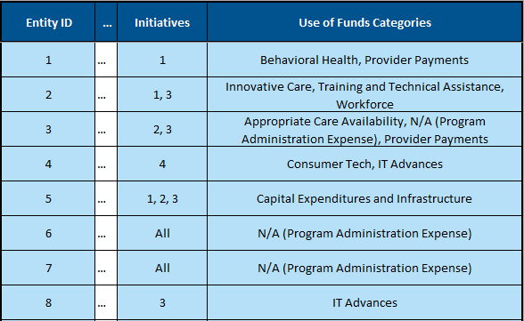

Use of Funds Tab

Overview
Line items in the Use of Funds tab represent aggregated, split, or exact obligations that the State has made to their first-tier entities. Obligations in the Use of Funds tab can be aggregated or split on four variables: first-tier entity (selectable from a dropdown that is populated based on the First-Tier Entities tab), initiative number, budget period, and use of funds category.
If multiple obligations are made using one budget period’s award to the same first-tier entity, initiative, and use of funds category, then those obligations can be aggregated into one line item. Conversely, if one obligation is split among multiple first-tier entities, initiatives, budget period awards, or use of funds categories then it should be split into multiple line items. Examples of aggregating and splitting obligations into line items can be found in the Obligation Aggregation and Splitting section.
Additionally, the Use of Funds tab has fields for the dollar value of the obligation that is attributable to program-specific limitations (administrative costs, capital expenditure and infrastructure, provider payments, EMR replacement, and rural tech catalyst fund). For each line item, States should enter the amount that is attributable to each program-specific limitation or attest that no program-specific limitations apply. Examples of attributing funds to program-specific limitations can be found in the Program-Specific Limitations section.
Note that the Obligation ID column is not editable and is pre-populated. The Obligation IDs are the State’s two-letter abbreviation followed by a whole number; each Obligation ID is unique to a line item. The Obligation ID is not used elsewhere in the Excel Reporting Template.
Entries in the Use of Funds tab should be entered in sequential rows (do not leave blank rows). The Use of Funds tab supports up to 2,500 line items. States should contact their PO for additional guidance if they are at risk of exceeding this number of line items.
A glossary of each field in the Use of Funds tab can be found in the Use of Funds Glossary section.

Obligation Aggregation and Splitting
The examples below demonstrate how to split obligations to each first-tier entity by initiative number, budget period, and use of funds category. Note that obligations submitted for the first Annual Report will all be tied to the first budget period’s award as a State may not obligate funds from awards that they have not received.
- Similar Obligations
If two $1.5 million obligations were made using the first budget period’s award for Initiative #3 to the same entity (XYZ Agency) and only one use of funds category applies (IT Advances), then these obligations could be combined into one line as follows:
Figure 4: Similar Obligations Example
- Multiple Initiatives
If a $72 million obligation was made using the first budget period’s award to one entity (XYZ Supplier) and only one use of funds category applies (Capital Expenditures and Infrastructure) but the obligation will be spread between three initiatives, then the obligation should be split into three lines according to how much money is attributable to each initiative. If $38 million is budgeted for Initiative #1, $10 million for Initiative #2, and $24 million for Initiative #3, the three lines would be as follows:
Figure 5: Multiple Initiatives Example
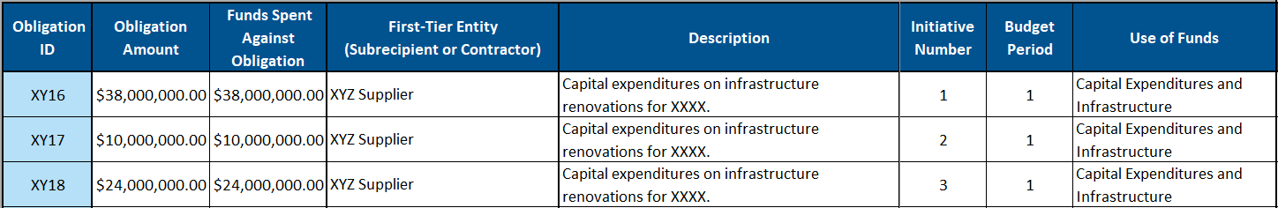
- Multiple Use of Funds Categories
If a $20 million obligation was made using the first budget period’s award to one entity (Health System XXXX) for Initiative #1 and applies to two use of funds categories (Provider Payments and Behavioral Health), then the obligation should be split into two lines according to how much money is budgeted to be spent on activities relating to each use of funds category. If State XY works with Health System XXXX to determine that $16 million will go towards Provider Payments with the remainder budgeted for Behavioral Health, then the two lines would be as follows:
Figure 6: Multiple Use of Funds Categories Example
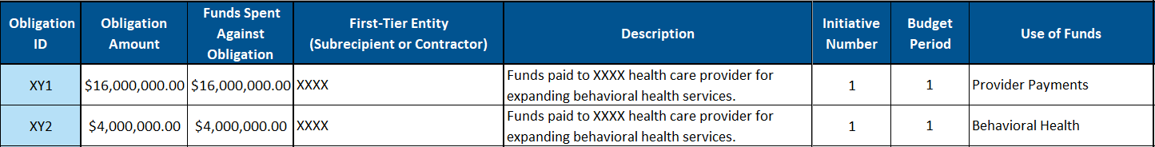

- Multiple Initiatives and Use of Funds Categories
If a $10 million obligation was made using the first budget period’s award to XY Workforce Development Board that is to be split between two initiatives and three use of funds categories (Training and Technical Assistance, Workforce, and Innovative Care), then the obligation should be split into six lines according to how much money is budgeted for each unique combination of initiative number and use of funds category. Here the State determines that (1) 60% of the funds are attributable to the Workforce use of funds category and the remaining 40% is evenly divided between Innovative Care and Training and Technical Assistance, and (2) that the funds should be evenly divided between initiatives #1 and #3, so the six lines could look as follows:
Figure 7: Multiple Initiatives and Use of Funds Categories Example
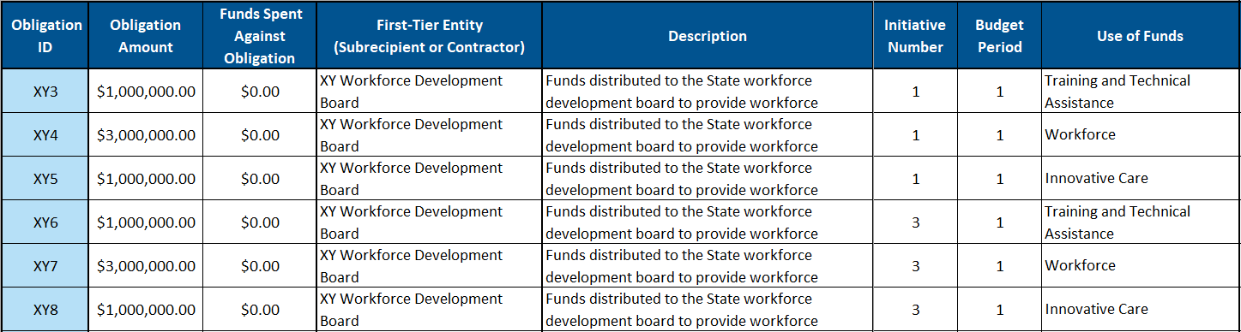
For each budget period, the obligation should always be split into as many lines as required to cover the unique combinations of initiative number and use of funds for each first-tier entity. If a State has any doubt, it is better to split an obligation into more specific line items.
For future reports in which funds from multiple budget periods are available, the budget period variable must also be a unique variable. Therefore, a unique combination of the four variables of first-tier entity, initiative number, budget period, and use of funds category is required for each line item. Importantly, the budget period variable indicates the budget period award from which funds that have been or will be spent to fulfill an obligation are drawn, not the date the payment was made. For example, a payment made to fulfill an obligation during the second budget period timeframe could have been budgeted as part of the first budget period award and therefore the obligation should be marked as budget period one on the Use of Funds tab. Additionally, an obligation may include funds from multiple budget period awards and then should be split into multiple line items (see the example below).
- Multiple Budget Periods
In budget period two, if a $6 million obligation with one entity (XYZ Agency) for Initiative #3 is budgeted to be drawn equally from State XY’s budget period one awards and only one use of funds category applies (IT Advances), then the obligation should be split into two lines as follows:
Figure 8: Multiple Budget Periods Example
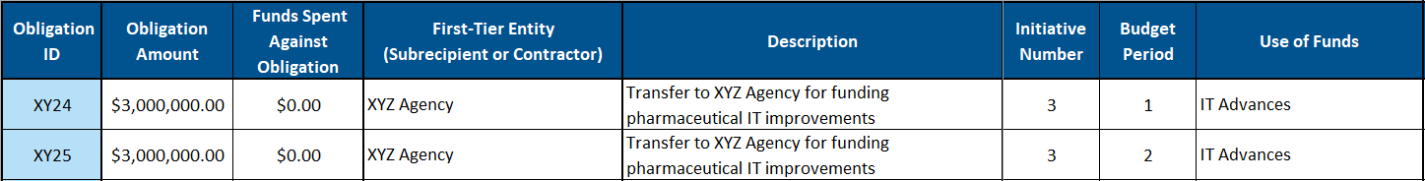
Additional Examples:
There is an “N/A (Program Administration Expense)” option within the use of funds dropdown. This option may be selected if the State determines no use of funds categories apply to the obligation because it is a purely administrative expense. If this use of funds category is selected for the line item, then the Obligation Amount should also be entered in the Administrative Costs program-specific limitation field (see the Program-Specific Limitations section of this document for more details).
- “N/A (Program Administration Expense)” Use of Funds
If a $10 million obligation was made from the first budget period’s award to one entity (AAA Contractor) for administrative expenses to support Initiatives #1, #2, #3, and #4, no other use of funds categories applies, and the State determines that Initiative #1 will require twice as much administrative support as each of the other initiatives, then the obligation could be written as follows:
Figure 9: “N/A (Program Administration Expense)” Use of Funds Example
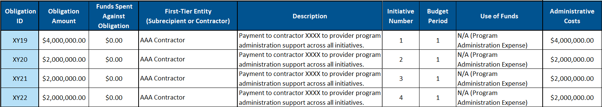
Additionally, there is an “All” option within the initiative number dropdown. This “All” initiatives option may be selected if an obligation (or part of a split obligation) applies to all of the State’s initiatives. Since State XY only has four initiatives, if the State instead did not wish to define a precise distribution of funds across the initiatives for the AAA Contractor example above, the obligation could be written in one line as follows:
Figure 10: Initiative Number “All” Option Example
- Funds Remaining Within the Awardee Agency
If $6.3 million from the first budget period funding is allocated by the State for personnel costs within the awardee agency, this should be recorded as an obligation using the “N/A (Program Administration Expense)” and should capture the State agency as the first-tier entity. The State could choose to allocate personnel costs more precisely between their initiatives using multiple line items, but if the State chooses to use “All” for the initiative number to divide the funds evenly across all of its initiatives, the obligation could be written in one line as follows:
Figure 11: Funds Remaining Within the Awardee Agency Example

Program-Specific Limitations
Program-specific limitations are outlined in the Notice of Funding Opportunity (NOFO). The limitations are summarized in Figure 12.
Figure 12: Program-Specific Limitations and Amount of Award
Program-Specific Limitation | Amount of Award
Administrative Costs | 10%
Provider Payments (Category B) | 15%
Capital Expenditures and Infrastructure (Category J) | 20%
EMR Replacement | 5%
Rural Tech Catalyst Fund | 10% or $20 million, whichever is less

Each program-specific limitation has a corresponding column in the Use of Funds tab. For each line item, enter the amount of funds that should be counted towards each program specific limitation (blanks are treated as zero). It is possible that no program-specific limitations apply to the line item; in that case, column N in the Use of Funds tab should be used to attest that no program-specific limitation applies. The State may fill out multiple program-specific limitation fields for a single line item, but funds should not be double-counted across multiple program-specific limitations; each dollar may be assigned to at most one program-specific limitation. The funds assigned to program-specific limitation categories should therefore sum to no greater than the total line item amount.

Two of the program-specific limitations overlap with use of funds categories: Provider Payments and Capital Expenditures and Infrastructure. The full Obligation Amount of a line item must be assigned to either the respective program-specific limitation field or the Administrative Costs program-specific limitation field if one of those use of funds categories is selected. Similarly, if “N/A (Program Administration Expense)” is selected as the use of funds category, then the full Obligation Amount must be populated in the Administrative Costs program-specific limitation field.

Program-Specific Limitation Examples:

- One Program-Specific Limitation Applies
If a $1 million line item had $50,000 attributable to Administrative Costs and no other program-specific limitation applies to the line item, then $50,000 should be entered in the Administrative Costs column and the rest of the program-specific limitations should be left blank (including the confirmation cell).
Figure 13: One Program-Specific Limitation Example
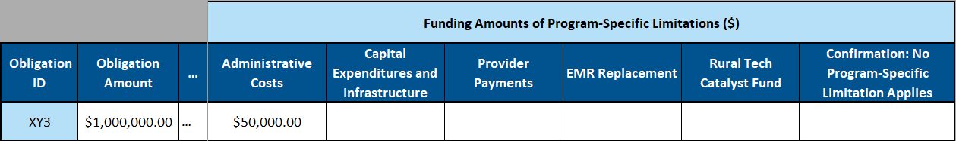

- Multiple Program-Specific Limitations Apply
If a $16 million line item to Health System XXXX had $600,000 attributable to Administrative Costs and $15.4 million attributable to Provider Payments, then each of those respective columns should be populated and the rest of the program-specific limitations should be left blank (including the confirmation cell).
Figure 14: Multiple Program-Specific Limitations Example
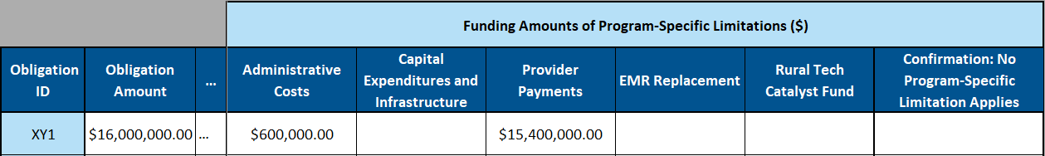

- No Program-Specific Limitations Apply
If a line item had no funds attributable to program-specific limitations, then all program-specific limitation columns should be left blank and the confirmation column dropdown of “No limitation applicable” should be selected.
Figure 15: No Program-Specific Limitations Example
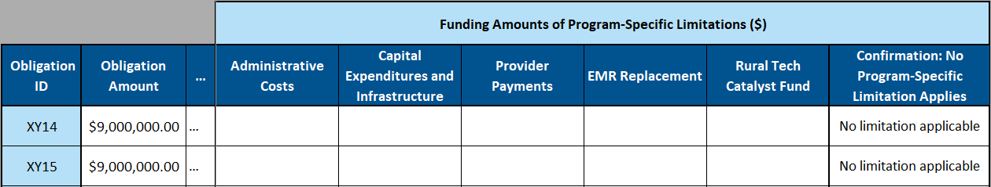

Use of Funds Tab Glossary
A description of each field in the Use of Funds tab is provided below:
- Obligation ID: An ascending line item ID composed of the State abbreviation followed by a whole number. This number will continue counting throughout each Quarterly/Annual Report for the duration of the program.
- Obligation Amount: The amount attributed to the line item, which may have been split/aggregated across the First-Tier Entity, Initiative Number, Budget Period, and Use of Funds fields.
- Spent Funds Against Obligation: The amount of funds that have been spent by the State on the first-tier entity to partially or completely satisfy the obligation listed in the Obligation Amount column.
- First-Tier Entity: The name of the entity associated with the line item. This column contains a dropdown that is populated using the entities listed on the First-Tier Entities tab.
- Description: A description of the line item provided by the State.
- Initiative Number: The initiative number associated with the line item.
- Budget Period: The budget period award from which the line item was obligated.
- Use of Funds: The use of funds category associated with the line item.

Funding Amounts of Program-Specific Limitations:
- Administrative Costs: The amount of the line item attributable to the Administrative Costs program-specific limitation. This field must be populated with the full Obligation Amount if “N/A (Program Administration Expense)” is selected as the use of funds category.
- Capital Expenditures and Infrastructure: The amount of the line item attributable to the Capital Expenditures and Infrastructure program-specific limitation as described in the NOFO. If “Capital Expenditures and Infrastructure” is selected as the use of funds category, the full Obligation Amount of the line item must be distributed between this field and the Administrative Costs field.
- Provider Payments: The amount of the line item attributable to the Provider Payments program-specific limitation as described in the NOFO. If “Provider Payments” is selected as the use of funds category, the full Obligation Amount of the line item must be distributed between this field and the Administrative Costs field.
- EMR Replacement: The amount of the line item attributable to the EMR Replacement program-specific limitation as described in the NOFO.
- Rural Tech Catalyst Fund: The amount of the line item attributable to the Rural Tech Catalyst Fund program-specific limitation as described in the NOFO.
- Confirmation: No Program-Specific Limitation Applies: Select “No limitation applicable” if no program-specific limitation is attributable to the line item. This field must be left blank if any of the program-specific limitations are populated.

Downstream Obligations Tab

Overview
The goal of the Downstream Obligation tab is to provide CMS with greater visibility into how RHT Program funds are distributed across entity types over time. Each line item is a record of an obligation from one entity to another and indicates the quantity of funds that have been spent to satisfy those obligations. States should work with their downstream entities to ensure visibility into how their funds are being obligated. Additional rows of data and updates to the Obligation Amount and Spent Funds Against Obligation values should be made on the Downstream Obligations tab as new information is available to the State through their monitoring of entities.
Note that once funds are spent, no more obligations or sub-obligations may be created based on those funds from the perspective of CMS. Any additional distribution of funds after they have been spent (such as a health system receiving funding from a State agency and then distributing it among its owned rural healthcare facilities or a contractor using funds it received from the State to pay a sub-contractor) would instead be recorded on the Distribution Reporting tab.

Structure
As with other tabs in the Obligated and Spent Funds Reporting section of the Excel Reporting Template, only the unprotected (white) cells will be populated by the State. The protected (light blue) cells are determined by formulas. Figure 16 displays the columns that are used on the Downstream Obligations tab.
Figure 16: Downstream Obligations Tab Headers
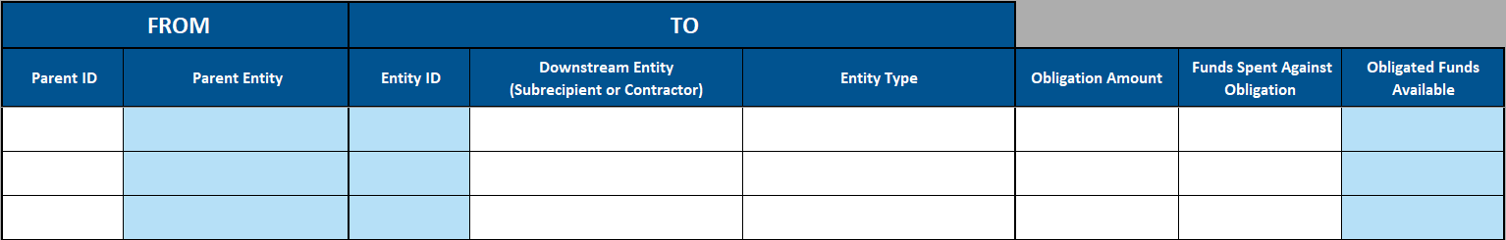
As each row represents a sub-obligation, the table is laid out such that the columns B and C display the Parent ID and Parent Entity from which the obligation is made, while columns D–F define the new Entity ID, Name, and Entity Type of the entity to which funds are being obligated. Columns G–I are analogous to the columns of the same names on the Use of Funds or First-Tier Entities tabs: Columns G quantifies the obligation represented by the line item, column H is a space for the State to record the amount of funds that have been spent to satisfy the sub-obligation defined by the line item, and column I is a calculated field that displays the obligation amount less the sum of downstream obligations and the funds that have been spent to satisfy the obligation.

Reporting Instructions
This section of the guide begins with a step-by-step example of filling out the downstream obligation information for XY Workforce Development Board to familiarize the user with how to use the tab. Following this step-by-step example are additional considerations and a description of the conditional formatting rules that exist to help users accurately fill out the required information.
The data entry process consists of the following steps:
- Enter the first Parent ID in column B. The parent entity is the entity that is choosing to sub-obligate some or all of their obligated funds. This value should be an existing Entity ID. For the first line items, the only existing Entity IDs that the State may enter as Parent IDs will be those assigned in column B of the First-Tier Entities tab.

This example will cover the distribution of XY Workforce Development Board’s obligated funds. Figure 17 shows State XY entering “2” in the Parent ID column as that is the Entity ID that was assigned to the XY Workforce Development Board. The Parent Entity in column C of the Downstream Obligations tab automatically populates with the entity name.
Figure 17: Entering First-Tier Entity as Parent ID
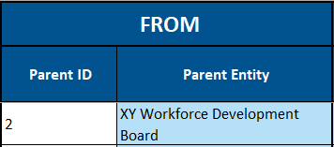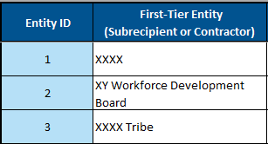

The file will also automatically populate a new Entity ID generated by this obligation. Because this is the first entry denoting an obligation from Entity #2, the downstream entity is defined as Entity ID 2.1.
Figure 18: Downstream Entity ID Automatic Population
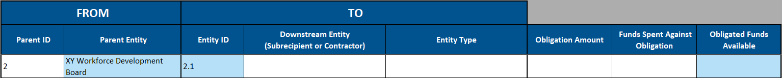
- Enter Downstream Entity Name and Entity Type. In this example, the XY Workforce Development Board is fulfilling its role in Initiatives #1 and #3 by arranging for funds to be made available to regional workforce development boards that operate in rural areas of State XY. The first obligation made is to obligate $5 million to Regional Workforce Development Board 1. The State enters the Downstream Entity and Entity Type, using the descriptions on the Entity Type Guidance tab to assist in determining the most appropriate entity type. In this case, Regional Workforce Development Board 1 fits best in the “Other Local Government” category.
Figure 19: Populating Downstream Entity and Entity Type
- Enter the Obligation Amount. XY Workforce Development Board chooses to budget $5 million for Regional Workforce Development Board 1 and enters this value in column G. Since no funds have been spent at this point, $0 is entered in column H, completing the row.
Figure 20: Entering Obligation Amount
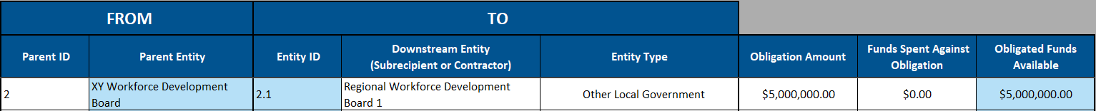
Note that the Obligated Funds Available column automatically populates with full $5 million Obligation Amount. If funds are spent against this obligation or if additional downstream entities are added that use “2.1” as the Parent ID, those spent funds of sub-obligations will reduce the 2.1 Obligated Funds Available by the same amount.
- Complete the remaining second-tier entities. XY Workforce Development Board is not the terminal entity of any of the RHT Program funds. It was obligated $10 million total on the Use of Funds tab and obligates the remaining $5 million to Regional Workforce Development Board 2 and XY Tribal Training Program.
Figure 21: Populating Additional Second-Tier Entities
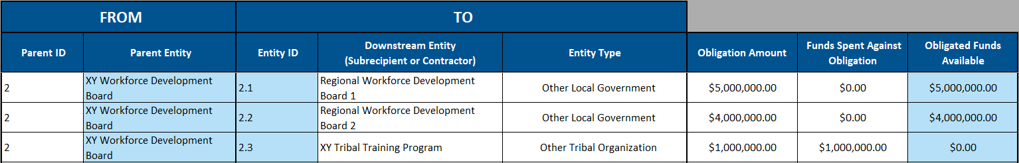
For both line items, State XY enters “2” as the Parent ID as these funds are being obligated by XY Workforce Development Board. This causes the Entity IDs to automatically populate as 2.2 and 2.3. Each of these is then assigned to a Downstream Entity and Entity Type and the remaining $5 million are distributed between 2.2 and 2.3 in the Obligation Amount column. Unlike 2.1 and 2.2, the $1 million budgeted for 2.3 is transferred to an account owned by XY Tribal Training Program, so State XY also enters that $1 million has been disbursed as spent funds against the $1 million sub-obligation. This leaves XY Tribal Training Program with $0 in Obligated Funds Available.
To confirm that all of XY Workforce Development Board’s obligated funds have been obligated to downstream entities, the First-Tier Entity tab can be used to confirm that it has $0 remaining of the $10 million in funding that it received.
Figure 22: First-Tier Entities tab Remaining Funds
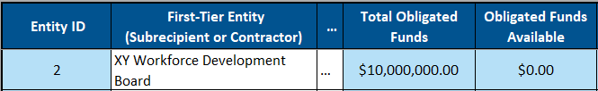
- Populate additional tier(s) of entities. The Downstream Obligations tab can support any number of tiers of entities. In this example, each of the Regional Workforce Development Boards (Subrecipients 2.1 and 2.2) have additional downstream entities. To populate the rows, State XY enters “2.1” or “2.2” as the Parent ID and the new Entity IDs (2.1.1, 2.2.1, and 2.2.2) are automatically populated. In this example, the rows are sequential, but this is not required. The Entity IDs will be assigned in the order that a given Parent ID is entered, regardless of the number of rows between such entries.
Figure 23: Entity #2 Downstream Entities Population Example
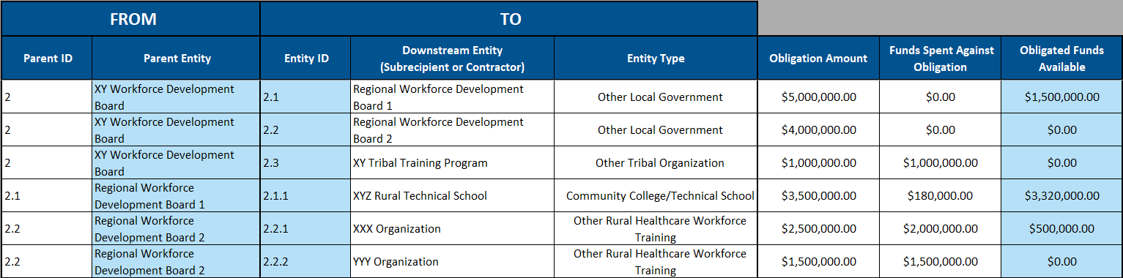
These downstream obligations are subtracted from the Obligated Funds Available for 2.1 and 2.2. Because Regional Workforce Development Board 2 sub-obligated all $4 million that it received to XXX Organization and YYY Organization, it has $0 in Obligated Funds Available. In contrast, Regional Workforce Development Board 1 sub-obligated only $3.5 million of the $5 million that it received, so it has $1.5 million in Obligated Funds Available. In future reports, these $1.5 million could be (1) transferred to an account owned by Regional Workforce Development Board 1 and added to the Spent Funds Against Obligation, (2) added to the Obligation Amount that they are sub-obligating to 2.1.1., or (3) could be sub-obligated to a different downstream entity by adding one or more rows with 2.1 as the Parent ID.
The State also fills in the spent funds information, which are the quantities of funding that have been actually disbursed to 2.1.1, 2.2.2, and 2.2.2. In the case of 2.2.2, Regional Workforce Development Board 2 spent $1.5 million and disbursed the full amount to YYY Organization, meaning that there is $0 in Obligated Funds Available. For 2.1.1 and 2.2.1, the downstream entities have entered into contracts with the regional boards and funds will be spent as needed to pay XYZ Rural Technical School and XXX Organization for engaging in initiative implementation activities.
All funds that are obligated to XY Tribal Training Program have already been paid out as spent funds. Therefore, XY Tribal Training Program cannot create any additional sub-obligations to downstream entities. If XY Tribal Training Program reports a downstream entity, such as a partner workforce development organization to which it pays $200,000 of RHT Program funds, that information would be reported on the Distribution Reporting tab rather than the Downstream Obligations tab.
Additional Considerations
- Any number of tiers of sub-obligations may be reported. While the preceding step-by-step example only progressed to a third tier of entities, the State may continue to populate additional levels of Entity IDs in the Parent ID column to generate additional tiers of entities. If Subrecipient 2.1.1 XYZ Rural Technical School enters into a contractual with a community-based organization to implement RHT Program initiative activities, State XY could add 2.1.1 as the Parent ID to generate Entity ID 2.1.1.1, and so on. For more complex initiatives or downstream entity organizational structures, additional tiers could be created following the same recursive process. The State should work with its downstream entities to report the obligations made between its downstream entities as accurately and completely as possible in each reporting period.
- Downstream entities do not need to all be listed sequentially. While it is required that the Parent ID is assigned either on the First-Tier Entities tab or in an earlier (lower row number) row on the Downstream Obligations tab, the State does not need to establish all second-tier entities before progressing to third-tier entities, etc. In Figure 24, State XY defines all of Entity #2’s downstream sub-obligations in a different order than in Figure 23 (previous page), but the calculations and functionality remain the same.
Figure 24: Downstream Obligations Row Order Flexibility
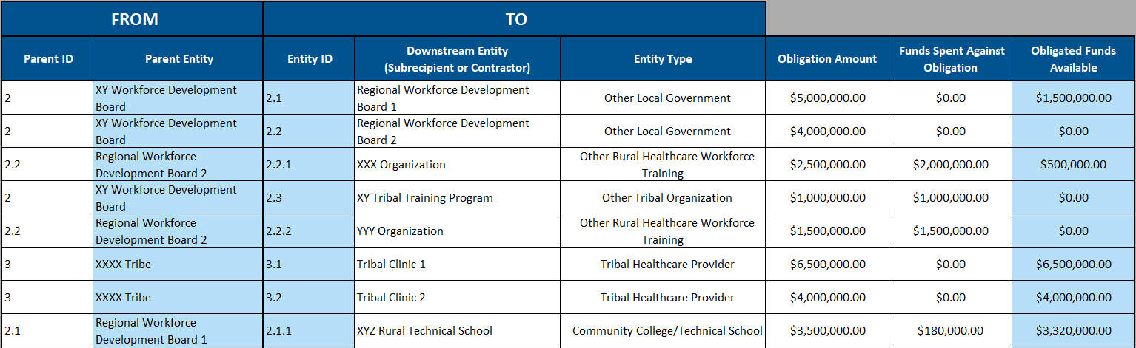
- The values in the Obligated Funds Available column in the Downstream Obligations tab are tied specifically to the line item. If Regional Workforce Development Board 1 were to receive an additional $1 million from a different first-tier entity as a separate line item, the Obligated Funds Available for each row would be tracked separately. There is no aggregation across line items with the same Downstream Entity in the Downstream Obligations tab. This makes the Obligated Funds Available column on this tab slightly distinct from the Obligated Funds Available column on the First-Tier Entities tab, which does aggregate across all inflows and outflows.

Distribution Reporting

Overview
The goal of the Distribution Reporting tab is to provide CMS visibility into how spent funds are further distributed across entity types over time. The tab operates very similarly to the Downstream Obligations tab. The only distinction is that the Downstream Obligations tab tracks obligations between downstream entities until the funds are spent to satisfy the obligation, while the Distribution Reporting tab is used to track transfers of funds to downstream entities after they have been spent. To avoid repetition, this section of the guide will explain the Distribution Reporting tab primarily by comparison with the Downstream Obligations tab.

Structure
The first five columns of the Distribution Reporting tab (B–F) operate almost identically to the Downstream Obligations tab: the user enters the Parent ID in column B, the Parent Entity is automatically populated in column C, a new Entity ID is defined in column D, and the user enters the entity’s name and type in column F. The only distinction, as displayed in Figure 25, is that Entity IDs on the Distribution Reporting tab begin with a “D” before the decimalized notation. Note: this means it is possible, for example, for there to be an Entity ID #1.1 defined on the Downstream Obligations tab and Entity ID #D1.1 on the Distribution Reporting tab that are assigned to two different organizations.
Figure 25: Distribution Reporting Tab Structure and Entity ID Assignment
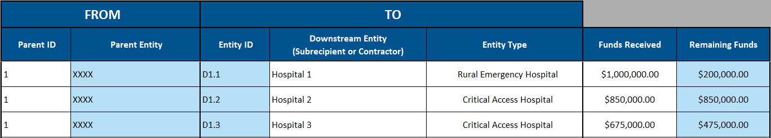
The primary operational distinction between the two tabs is that, because funds have already been spent, there is only one dollar-denominated column: Funds Received. This is the value of the spent funds that have been transferred from the parent entity to the entity defined in the line item. A transfer between entities may take several forms. For example, both a health system distributing disbursed funds to its owned hospitals and a contractor paying a subcontractor to perform a service using disbursed funds would be reported in the same way.
The final column is Remaining Funds. This is the funds received minus the sum of any transfers to downstream entities. In Figure 25 (above), Hospital 1 (D1.1) received $1 million from XXXX health system and has transferred $800,000 downstream, leaving it with $200,000 of remaining funds. In contrast, Hospital 2 (D1.2) received $850,000 and has not transferred any downstream. This may change in future reporting periods in Hospital 2, for example, transfers funds to a clinic or pharmacy that it owns, but it may also be the case that Hospital 2 will be the terminal recipient of those funds.

Reporting Instructions
The Parent ID entered in a line item must meet two conditions (1) it must be previously defined (similar to the Downstream Obligations tab) and (2) it must be associated with an entity that has access to spent funds. This means that the Parent ID may be an Entity ID defined in one of three locations:
- A first-tier entity that has received Spent Funds Against Obligation in the Use of Funds Tab. In Figure 26, this includes the payments from XYZ Supplier (ID #5) to its three sub-contractors in D5.1, D5.2, and D5.3, and its payment to Quality Organization ABC in D5.4.
- A downstream entity of any tier that has received Spent Funds Against Obligation in the Downstream Entities tab. In Figure 26, this includes the distribution of funds from Health System 1 (B.4) to two of its owned hospitals as well as the transfers from Health System 2 (B.5) to two of its owned pharmacies.
- A downstream entity of any tier that has positive Remaining Funds in a previous row on the Distribution Reporting tab. In Figure 26, this includes both the transfers from Pass-through Hospitals 1 and 2 (D8.4.1 and D8.4.2) to their owned pharmacies as well as the payments from Sub-contractor 2 (D5.2) to its four sub-sub contractors.
Figure 26: Distribution Reporting Tab Example
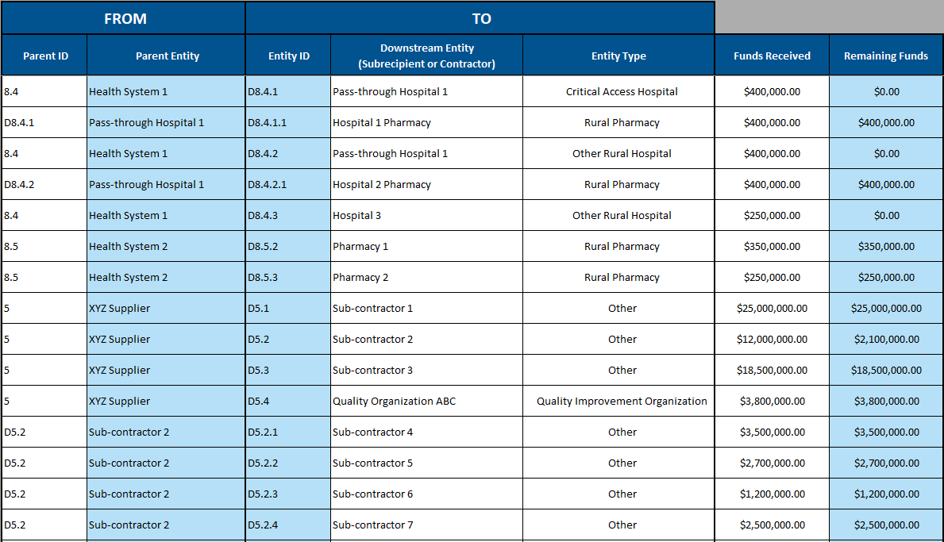
Note that, while the D8.4.1 and D8.4.2 are operating entirely as passthrough entities by transferring 100% of the funds they received from Health System 1 to their owned pharmacies, Sub-contractor 2 is the remaining recipient of $2.1 million of the $12 million that it received from XYZ supplier.

Considerations for Future Reporting Periods
The Obligated and Spent Funds Reporting tabs will continue to be completed and submitted by States in each Annual and Quarterly Report for the duration of the program. Below are considerations for how each tab will change over time.
First-Tier Entities: As States continue to implement their initiatives and receive additional funding in future budget periods, new first-tier entities may be identified and added to the list. This tab also displays the funds that were obligated to each first-tier entity received in each budget period as well as their obligated funds available, which can be used by POs and the State to track spending and guide monitoring activities.
Use of Funds: Because line items on this tab must be unique based on first-tier entity name, initiative number, budget period, and use of funds category, future budget periods will necessitate the creation of additional line items. Additionally, the program-specific limitations are tracked for each budget period. States will continue to populate new rows on this tab throughout the program.
Downstream Obligations: There are four types of changes that will occur between reporting periods:
- The State may establish new first-tier entities to continue their initiative implementation. If any of those new first-tier entities create sub-obligations, it will result in additional line items.
- A State’s existing downstream entities may establish additional sub-obligations and report them to the State, which will also result in additional line items.
- The Obligated Amount of an existing row may increase if additional funds are obligated to a given downstream entity from the same parent entity, especially if the parent entity receives additional obligated funds from a new budget period award.
- As funds are spent, the State will update the Spent Funds Against Obligation column for whichever obligation is partially or completely fulfilled by the expenditure.
Distribution Reporting: There are three types of changes that will occur between reporting periods, which parallel the first three types of changes on the Downstream Obligations tab:
- The State may establish new first-tier entities to continue their initiative implementation. If any of those new first-tier entities or their downstream entities further transfer any spent funds, it will result in additional line items.
- A State’s existing downstream entities may transfer spent funds to new entities, which will also result in additional line items.
- The Funds Received of an existing row may increase if additional funds are transferred to a given downstream entity from the same parent entity, especially if the parent entity receives additional spent funds from a new budget period award.

Appendix A: Recording a New Obligation or Spend Event
- Is the entity allocated obligated or spent funds directly from the State awardee?
  - This information is recorded on the Use of Funds tab. If this is the first time that the entity is allocated obligated or spent funds directly from the State awardee, the entity’s name and type should first be added to the First-Tier Entities tab.
  - If the entity has already been allocated obligated or spent funds directly from the State awardee for the same budget period, initiative number, and use of funds category, the State may update the Obligation Amount, Funds Spent Funds Against Obligation, and Funds Amount of Program-Specific Limitations columns on the Use of Funds tab to reflect the changed amount. Otherwise, the State should add a new line item on the Use of Funds tab.
- If “no” to question #1, does the new financial relationship relate only to obligated funds, such as via a pass-through entity?
  - This information is recorded on the Downstream Obligations tab. All obligations of RHT Program funds other than allocations to first-tier entities must be recorded on this tab.
  - If the entity has already been allocated obligated funds from the same parent entity, the State should update only the Obligation Amount column for the existing line item for this financial relationship.
  - Otherwise, the State should create a new line item on the Downstream Obligations tab to record the obligation.
- If “no” to question #2, does this new financial relationship relate to the State spending funds (including to partially or completely satisfy an existing obligation) and adding an item to the State’s general ledger?
  - This information is recorded in the Downstream Obligations tab. All spending of RHT Program funds other than spending on first-tier entities must be recorded on this tab.
  - If the entity has already received obligated funds from the same parent entity and spending is occurring to partially or completely satisfy the obligation, the State should update only the Funds Spent Against Obligation column for the existing line item for this financial relationship.
  - Otherwise, the State should create a new line item on the Downstream Obligations tab and include the amount of spent funds in both the Obligation Amount and Funds Spent Against Obligation columns.
- If “no” to question #3, does the new financial relationship relate to a further distribution, transfer, or payment of already spent RHT Program funds to a different entity?
  - This information is recorded on the Distribution Reporting tab.
  - If the entity has already received a distribution, transfer or payment of spent funds from the same parent entity, the State should update only the Funds Received column for the existing line item for this financial relationship.

Appendix B: Conditional Formatting Rules
All of the data entry tabs in the Obligated and Spent Funds Reporting section have conditional formatting rules to assist with data entry. Cells will highlight yellow based on a variety of rules pertaining to either missing or incorrect values. The conditional formatting rules for each tab are described below.

First-Tier Entities Tab
- The Entity Type dropdown may not be used to select a category label. The State should only use the indented entity types in the dropdown list; the category labels are only an organizational tool. In Figure 27, State XY incorrectly set XXXX’s Entity Type as “Healthcare Providers”, which is a category label rather than an entity type. This should be updated to “Health System”, which is a valid selection.
Figure 27: First-Tier Entities Conditional Formatting – Entity Type
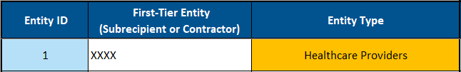
- Obligated Funds Available cannot be negative. In Figure 28, State XY has entered a higher sum of $11 million in transfers from XY Workforce Development Board to downstream entities in the Downstream Obligations tab, but only assigned a sum of $10 million in transfers from the State XY to XY Workforce Development Board on the Use of Funds tab.
Figure 28: First-Tier Entities Conditional Formatting – Remaining Funds
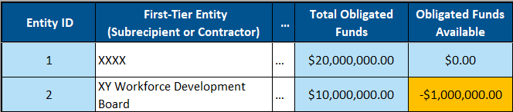

Use of Funds Tab
- If the spent funds against obligation amount is greater than the obligation amount, the spent funds field will highlight yellow.
Figure 29: Use of Funds Conditional Formatting – Spent Funds Exceeds Obligation
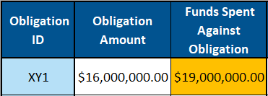
- A numeric value must be entered into the Spent Funds Against Obligation column. Once a value has been added to Obligation Amount, a value must also be entered to show the portion of that obligation that has been spent to satisfy the obligation. In Figure 30, State XY should enter a 0 in the cell if none of the $16 million obligation has been spent at the time of reporting.
Figure 30: Use of Funds Conditional Formatting – Spent Funds Value Missing
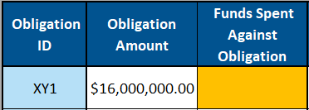
- If an amount is entered into the Capital Expenditures and Infrastructure or Provider Payments Program-Specific Limitations fields and the use of funds category does not align, the use of funds field will highlight yellow.
Figure 31: Use of Funds Conditional Formatting – Use of Funds/Program-Specific Limitation Misaligned
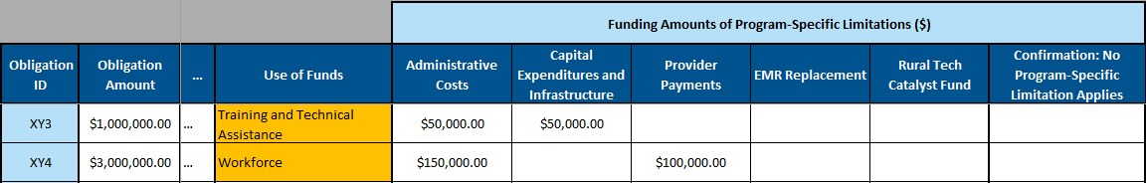
- If no program-specific limitations apply, the confirmation field must be populated with “No limitation applicable”; otherwise, the confirmation cell will highlight yellow and should be filled with “No limitation applicable”.
Figure 32: Program-Specific Limitations Conditional Formatting – Confirmation Needed
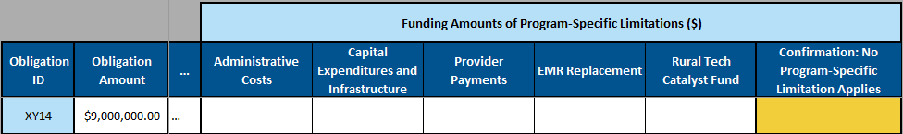

- If an amount is entered in a program-specific limitation field and the confirmation field is populated as “No limitation applicable”, then the confirmation field will highlight yellow and either the amount should be removed from the program-specific limitation field or the confirmation of “No limitation applicable” should be removed.
Figure 33: Program-Specific Limitations Conditional Formatting – Errant Confirmation
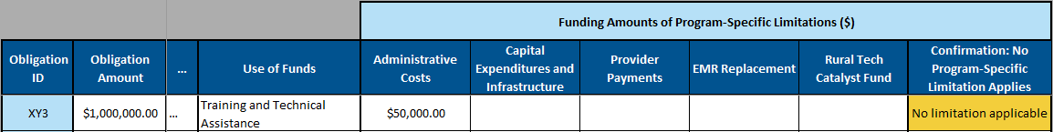
- If amounts attributed to program-specific limitations sum to greater than the Obligation Amount in the line item, then all program-specific limitation fields will highlight yellow and the amounts should be edited to be no greater than the obligated funds in the line item.
Figure 34: Program-Specific Limitations Conditional Formatting – Sum Exceeds Obligated Funds
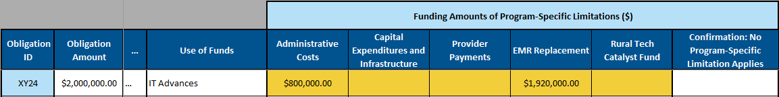
- If the “N/A (Program Administration Expense)” use of funds category is selected for the line item, then the program-specific limitation Administrative Costs field will highlight yellow until the full Obligation Amount is entered.
Figure 35: Program-Specific Limitations Conditional Formatting – Administrative Costs
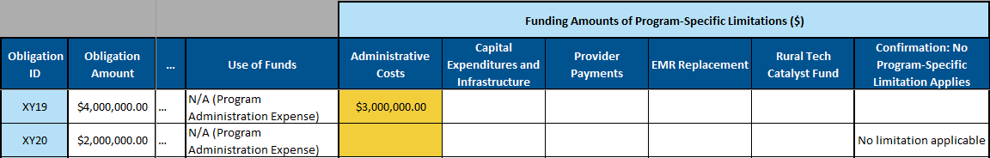
- If the Provider Payments use of funds category is selected for the line item, then the program-specific limitation Provider Payments field will highlight yellow until the full Obligation Amount is accounted for between the Provider Payments and Administrative Costs fields.
Figure 36: Program-Specific Limitations Conditional Formatting – Provider Payments
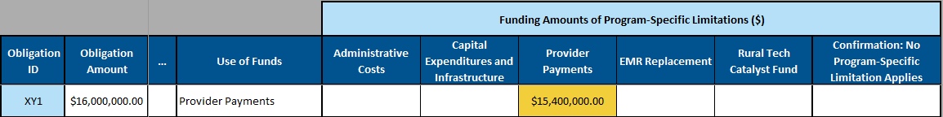
- If the Capital Expenditures and Infrastructure use of funds category is selected for the line item, then the program-specific limitation Capital Expenditures and Infrastructure field will highlight yellow until the full Obligation Amount is accounted for between the Capital Expenditures and Infrastructure and Administrative Costs fields.
Figure 37: Program-Specific Limitations Conditional Formatting – Capital Expenditures and Infrastructure
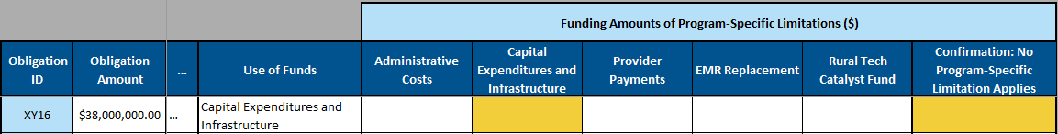

Downstream Obligations Tab
- The Parent ID must be an Entity ID defined on either the First-Tier Entities tab or in an earlier row on the Downstream Obligations tab. In Figure 38, neither 10 nor 2.1.2 are defined and are therefore the Parent ID field is highlighted yellow. State XY only defined eight first-tier entities, so ID #10 has not yet been defined and in the example above, 2.1 and 2.1.1 were defined, but because there was only one downstream transfer from 2.1 (to 2.1.1), 2.1.2 was never defined.
Figure 38: Downstream Obligations Conditional Formatting – Parent ID
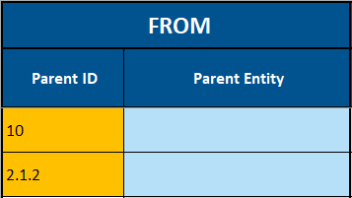
- A sub-obligation may not result in the parent entity’s Obligated Funds Available being negative. In Figure 39, the Obligation Amounts in 2.2.1 and 2.2.2 have been modified to sum to $4.5 million, while the entity 2.2 line item only has an Obligation Amount of $4 million. Both the negative Obligated Funds Available field and the Obligation Amounts of all immediately downstream entities are highlighted yellow.
Figure 39: Downstream Obligations Conditional Formatting – Downstream Sum Exceeds Parent 1
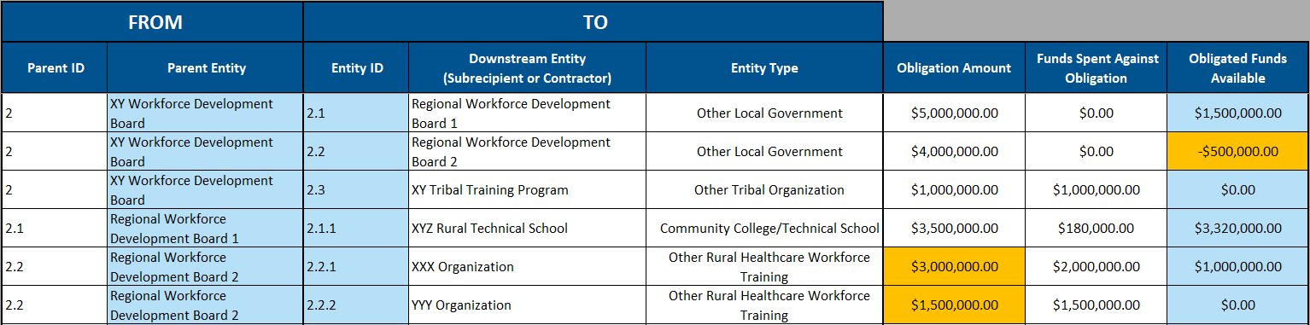
This also applies to the first-tier entity. If the 2.1 Obligation Amount is instead changed to $6 million, the sum of 2.1, 2.2, and 2.3 would be $11 million, which is greater than the $10 million that was obligated to XY Workforce Development Board. This total amount obligated to each first-tier entity (e.g. $10 million for XY Workforce Development Board) is reported on the First-Tier Entities tab based on entries in the Use of Funds tab.
Figure 40: Downstream Obligations Conditional Formatting – Downstream Sum Exceeds Parent 2
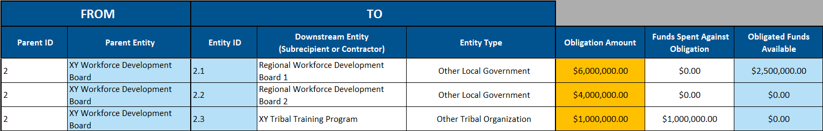
- The Entity Type dropdown may not be used to select a category label. The State should only use the indented entity types in the dropdown list; the category labels are only an organizational tool. In Figure 41, State XY incorrectly set Subrecipient 2.1’s Entity Type as “Local Government Agencies”, which is a category label rather than an entity type.
Figure 41: Downstream Obligations Conditional Formatting – Entity Type
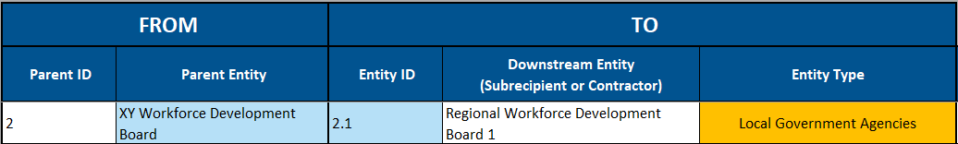
- A numeric value must be entered into the Spent Funds Against Obligation column. Once a value has been added to Obligation Amount, a value must also be entered to show the portion of that obligation that has been spent to satisfy the obligation. In Figure 42, State XY should enter a 0 in the cell if none of the $5 million obligation has been spent at the time of reporting.
Figure 42: Downstream Obligations Conditional Formatting – Spent Funds Value
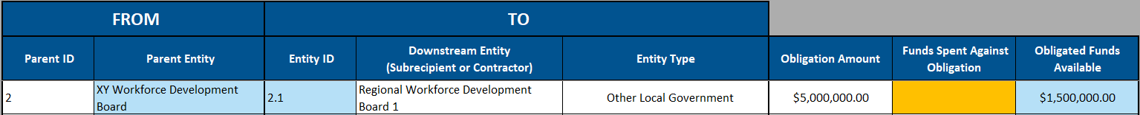

Distribution Reporting Tab
- The Parent ID must be an Entity ID defined on the First-Tier Entities tab, Downstream Obligations tab, or in an earlier row on the Distribution Reporting tab. In Figure 43, neither 10 nor 2.1.2 are defined and therefore the Parent ID field is highlighted yellow. State XY only defined eight first-tier entities, so ID #10 has not yet been defined and in the example above, 2.1 and 2.1.1 were defined, but because there was only one downstream transfer from 2.1 (to 2.1.1), 2.1.2 was never defined.
Figure 43: Distribution Reporting Conditional Formatting – Parent ID
- A transfer may not result in the parent entity’s Remaining Funds being negative. In Figure 44, Funds Received by D5.2.1 has been changed from $3.5 million to $6.5 million, making the sum of Funds Received by all immediate downstream entities of D5.2 $12.9 million, while the D5.2 line item only has a Funds Received of $12 million. Both the negative Remaining Funds field and the Funds Received fields of all immediately downstream entities are highlighted yellow.
Figure 44: Distribution Reporting Conditional Formatting – Downstream Sum Exceeds Parent 1
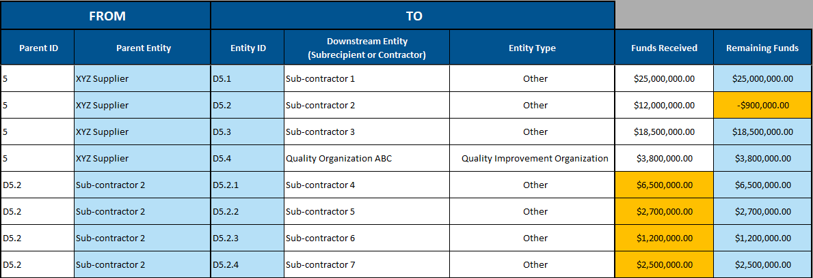
- A transfer may not result in the sum of a parent entity’s transfers exceeding its Spent Funds Against Obligation. In Figure 45, the Funds Received by Quality Organization ABC was entered at $38 million instead of $3.8 million, resulting in the sum of D5.1–D5.4 exceeding the $72 million that State XY has disbursed to XYZ supplier, as recorded on the Use of Funds tab. The Funds Received fields of all immediately downstream entities are highlighted yellow.
Figure 45: Distribution Reporting Conditional Formatting – Downstream Sum Exceeds Parent 2
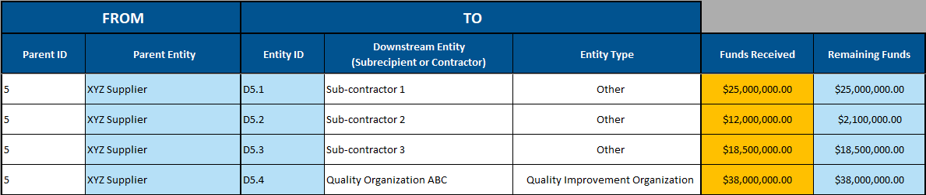
- The Entity Type dropdown may not be used to select a category label. The State should only use the indented entity types in the dropdown list; the category labels are only an organizational tool. In Figure 46, State XY incorrectly set Subrecipient D5.4’s Entity Type as “Other Entity Types”, which is a category label rather than an entity type.
Figure 46: Distribution Reporting Conditional Formatting – Entity Type
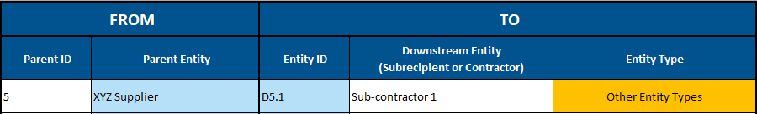

Appendix C: Table of Figures
Figure 1: First-Tier Entity Data Entry 2
Figure 2: First-Tier Entities Funds Received 3
Figure 3: First-Tier Entities Initiatives and Use of Funds Categories 5
Figure 4: Similar Obligations Example 6
Figure 5: Multiple Initiatives Example 7
Figure 6: Multiple Use of Funds Categories Example 7
Figure 7: Multiple Initiatives and Use of Funds Categories Example 8
Figure 8: Multiple Budget Periods Example 8
Figure 9: “N/A (Program Administration Expense)” Use of Funds Example 9
Figure 10: Initiative Number “All” Option Example 9
Figure 11: Funds Remaining Within the Awardee Agency Example 10
Figure 12: Program-Specific Limitations and Amount of Award 10
Figure 13: One Program-Specific Limitation Example 11
Figure 14: Multiple Program-Specific Limitations Example 11
Figure 15: No Program-Specific Limitations Example 11
Figure 16: Downstream Obligations Tab Headers 13
Figure 17: Entering First-Tier Entity as Parent ID 14
Figure 18: Downstream Entity ID Automatic Population 15
Figure 19: Populating Downstream Entity and Entity Type 15
Figure 20: Entering Obligation Amount 15
Figure 21: Populating Additional Second-Tier Entities 16
Figure 22: First-Tier Entities tab Remaining Funds 16
Figure 23: Entity #2 Downstream Entities Population Example 17
Figure 24: Downstream Obligations Row Order Flexibility 18
Figure 25: Distribution Reporting Tab Structure and Entity ID Assignment 19
Figure 26: Distribution Reporting Tab Example 20
Figure 27: First-Tier Entities Conditional Formatting – Entity Type 23
Figure 28: First-Tier Entities Conditional Formatting – Remaining Funds 24
Figure 29: Use of Funds Conditional Formatting – Spent Funds Exceeds Obligation 24
Figure 30: Use of Funds Conditional Formatting – Spent Funds Value Missing 24
Figure 31: Use of Funds Conditional Formatting – Use of Funds/Program-Specific Limitation Misaligned 24
Figure 32: Program-Specific Limitations Conditional Formatting – Confirmation Needed 25
Figure 33: Program-Specific Limitations Conditional Formatting – Errant Confirmation 25
Figure 34: Program-Specific Limitations Conditional Formatting – Sum Exceeds Obligated Funds 25
Figure 35: Program-Specific Limitations Conditional Formatting – Administrative Costs 26
Figure 36: Program-Specific Limitations Conditional Formatting – Provider Payments 26
Figure 37: Program-Specific Limitations Conditional Formatting – Capital Expenditures and Infrastructure 26
Figure 38: Downstream Obligations Conditional Formatting – Parent ID 27
Figure 39: Downstream Obligations Conditional Formatting – Downstream Sum Exceeds Parent 1 27
Figure 40: Downstream Obligations Conditional Formatting – Downstream Sum Exceeds Parent 2 27
Figure 41: Downstream Obligations Conditional Formatting – Entity Type 28
Figure 42: Downstream Obligations Conditional Formatting – Spent Funds Value 28
Figure 43: Distribution Reporting Conditional Formatting – Parent ID 28
Figure 44: Distribution Reporting Conditional Formatting – Downstream Sum Exceeds Parent 1 29
Figure 45: Distribution Reporting Conditional Formatting – Downstream Sum Exceeds Parent 2 29
Figure 46: Distribution Reporting Conditional Formatting – Entity Type 29

Notice of Funding Opportunity pg. 19.
Note that two Use of Funds Categories (Provider Payments and Capital Expenditures and Infrastructure) have specific reporting requirements based on the Program-Specific Limitations.
Section 71401 of Public Law 119-21, NOFO pg.42

