Eligibility Processing Reports:

Data collection instrument screenshots and proposed changes

- Current data collection instrument screenshots

  - Report instructions and header
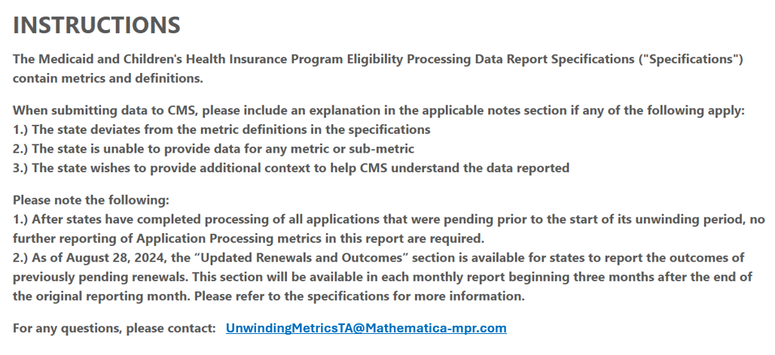
ALT TEXT: This is a screenshot of the instructions at the top of the monthly instrument. The instructions read as follows: The Medicaid and Children’s Health Insurance Program Eligibility Processing Data Report Specifications (“Specifications”) contain metrics and definitions. When submitting data to CMS, please include an explanation in the applicable notes section if any of the following apply: 1.) The state deviates from the metric definitions in the specifications, 2.) The state is unable to provide data for any metric or sub-metric, 3.) The state wishes to provide additional context to help CMS understand the data reported. Please note the following: 1.) After states have completed processing of all applications that were pending prior to the start of its unwinding period, no further reporting of the Application Processing metrics in this report are required. 2.) As of August 28, 2024, the “Updated Renewals and Outcomes” section is available for states to report the outcomes of previously pending renewals. This section will be available in each monthly report beginning three months after the end of the original reporting month. Please refer to the specifications for more information. For any questions, please contact: UnwindingMetricsTA@Mathematica-mpr.com.
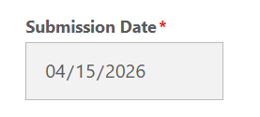
ALT TEXT: This is a screenshot of the header field at the top of the instrument. The field is a Submission Date field, which is denoted as required and is automatically populated in an MM/DD/YYYY format.

  - “Application Processing” tab
Metrics 1 and 1a
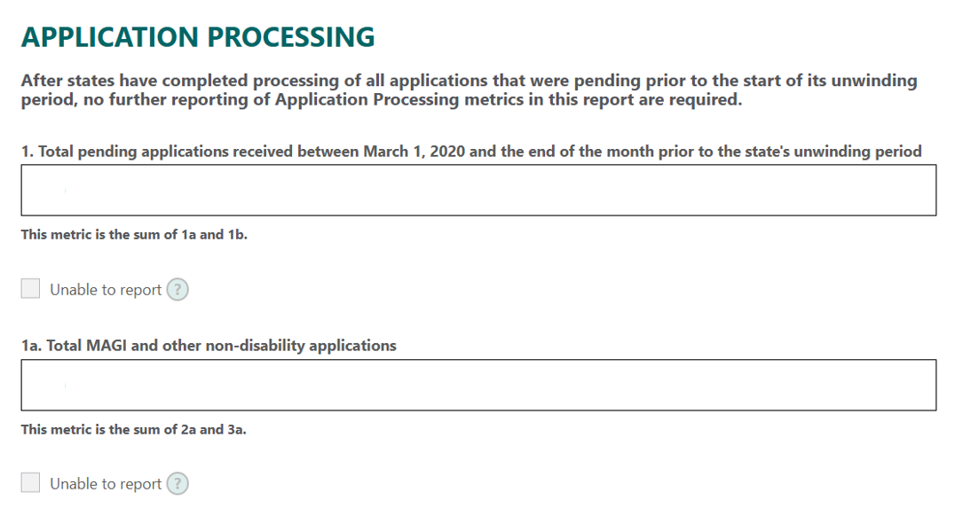
ALT TEXT: This is a screenshot of a portion of the Application Processing tab of the monthly instrument, showing metrics 1 and 1a. This screenshot includes the following: instructions indicating that after states have completed processing of all applications that were pending prior to the start of its unwinding period, no further reporting of Application Processing metrics in this report are required; a free-text field for Metric 1 (Total pending applications received between March 1, 2020 and the end of the month prior to the state’s unwinding period); instructions for Metric 1 indicating that this metric is the sum of 1a and 1b; an unable to report checkbox for Metric 1; a free-text field for Metric 1a (Total MAGI and other non-disability applications); instructions for Metric 1a indicating that this metric is the sum of 2a and 3a; and an unable to report checkbox for Metric 1a.

Metrics 1b and Metric 1 Notes
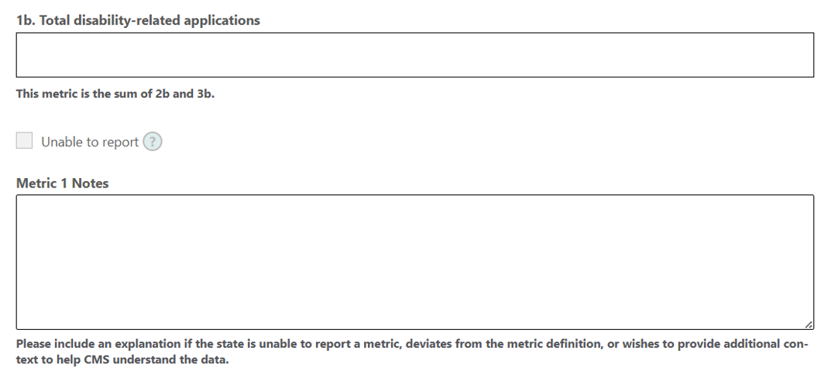
ALT TEXT: This is a screenshot of a portion of the Application Processing tab of the monthly instrument, showing Metric 1b and Metric 1 Notes. This screenshot includes the following: a free-text field for Metric 1b (Total disability-related applications); instructions for Metric 1b indicating that this metric is the sum of 2b and 3b; an unable to report checkbox for Metric 1b; a Metric 1 notes free-text field; and instructions for Metric 1 notes free-text field, indicating to please include an explanation if the state is unable to report a metric, deviates from the metric definition, or wishes to provide additional context to help CMS understand the data.
Metrics 2, 2a, and 2b
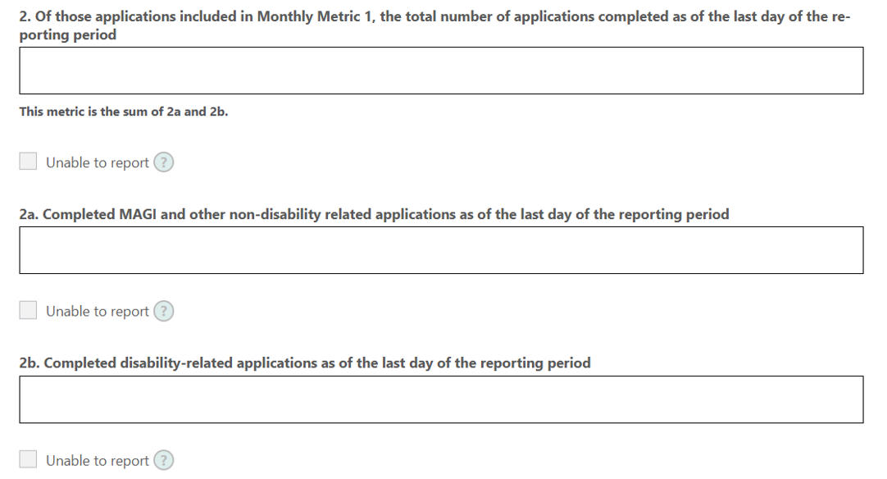
ALT TEXT: This is a screenshot of a portion of the Application Processing tab of the monthly instrument, showing Metrics 2, 2a, and 2b. This screenshot includes the following: a free-text field for Metric 2 (Of those applications included in Monthly Metric 1, the total number of applications completed as of the last day of the reporting period); instructions for Metric 2 indicating that this metric is the sum of 2a and 2b; an unable to report checkbox for Metric 2; a free-text field for Metric 2a (Completed MAGI and other non-disability related applications as of the last day of the reporting period); an unable to report checkbox for metric 2a; a free-text field for Metric 2b (Completed disability-related applications as of the last day of the reporting period); and an unable to report checkbox for Metric 2b.
Metric 2 Notes
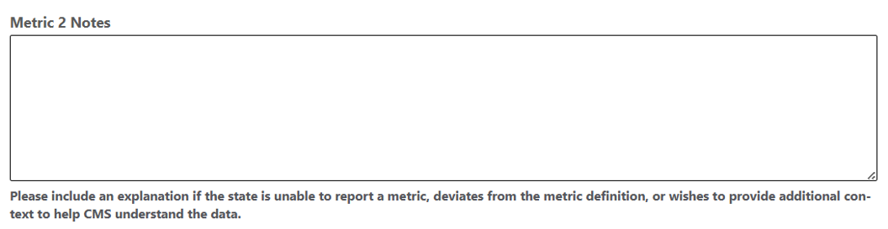
ALT TEXT: This is a screenshot of a portion of the Application Processing tab of the monthly instrument showing Metric 2 Notes. This screenshot includes the following: a Metric 2 notes free-text field; and instructions for Metric 2 free-text field notes, indicating to please include an explanation if the state is unable to report a metric, deviates from the metric definition, or wishes to provide additional context to help CMS understand the data.
Metrics 3, 3a, and 3b
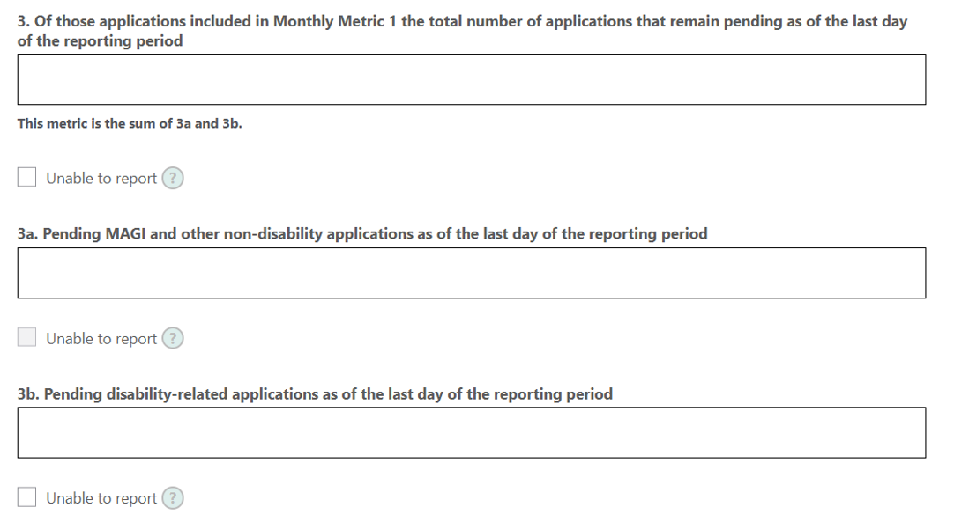
ALT TEXT: This is a screenshot of a portion of the Application Processing tab of the monthly instrument, showing Metrics 3, 3a, and 3b. This screenshot includes the following: a free-text field for Metric 3 (Of those applications included in Monthly Metric 1 the total number of applications that remain pending as of the last day of the reporting period); instructions for Metric 3 indicating that this metric is the sum of 3a and 3b; an unable to report checkbox for Metric 3; a free-text field for Metric 3a (Pending MAGI and other non-disability applications as of the last day of the reporting period); an unable to report checkbox for Metric 3a; a free-text field for Metric 3b (Pending disability-related applications as of the last day of the reporting period); and an unable to report checkbox for Metric 3b.
Metric 3 Notes
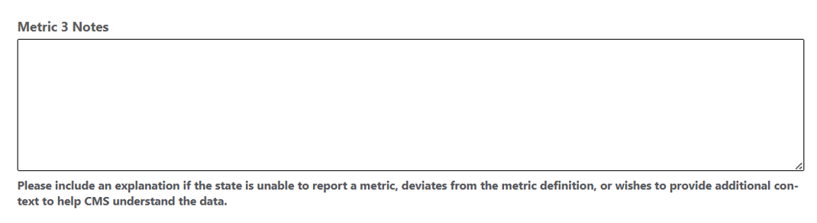
ALT TEXT: This is a screenshot of a portion of the Application Processing tab of the monthly instrument showing Metric 3 Notes. This screenshot includes the following: a Metric 3 notes free-text field; and instructions for Metric 3 notes free-text field, indicating to please include an explanation if the state is unable to report a metric, deviates from the metric definition, or wishes to provide additional context to help CMS understand the data.
  - “Renewals Initiated” tab
Metric 4
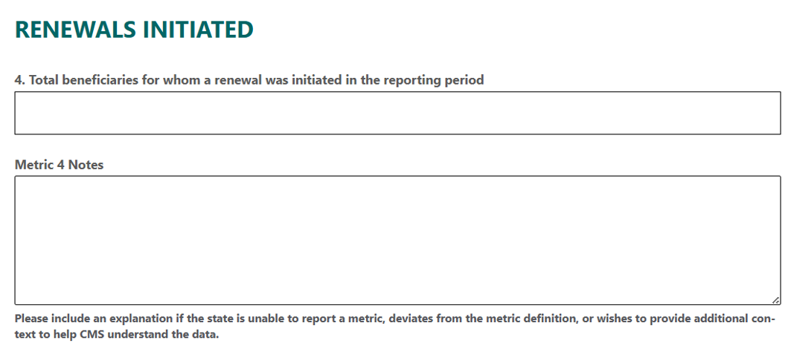
ALT TEXT: This is a screenshot of the Renewals Initiated tab of the monthly instrument which includes one metric, Metric 4. This screenshot includes the following: a free-text field for Metric 4 (Total beneficiaries for whom a renewal was initiated in the reporting period); a Metric 4 notes free-text field; and instructions for Metric 4 notes free-text field, indicating to please include an explanation if the state is unable to report a metric, deviates from the metric definition, or wishes to provide additional context to help CMS understand the data.

  - “Renewals and Outcomes” tab
Metric 5
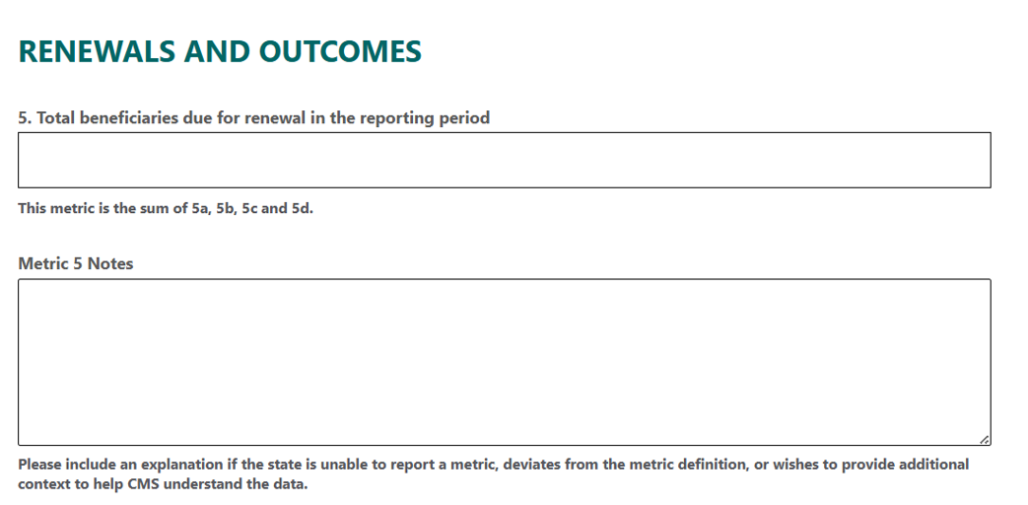
ALT TEXT: This is a screenshot of Metric 5 in the “Renewals and Outcomes” tab of the instrument. This screenshot includes the following: a free-text field for Metric 5 (Total beneficiaries due for renewal in the reporting period); instructions for Metric 5 indicating that this metric is the sum of 5a, 5b, 5c and 5d; a Metric 5 Notes free-text field; and instructions for Metric 5 Notes free-text field, indicating to please include an explanation if the state is unable to report a metric, deviates from the metric definition, or wishes to provide additional context to help CMS understand the data.

Metric 5a
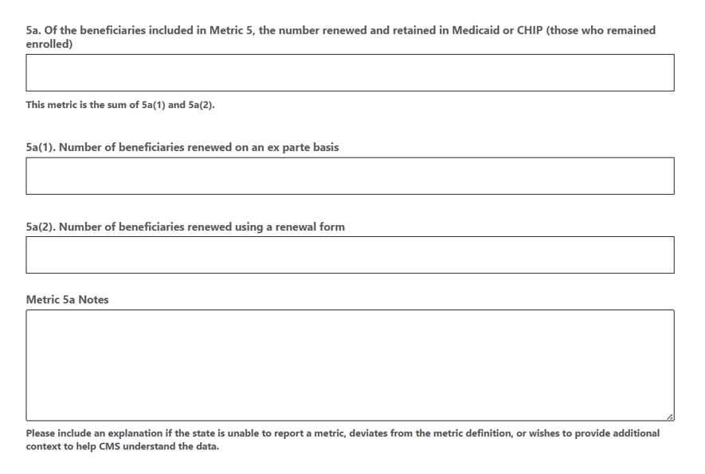
ALT TEXT: This is a screenshot of Metric 5a in the “Renewals and Outcomes” tab of the instrument. This screenshot includes the following: a free-text field for Metric 5a (Of the beneficiaries included in Metric 5, the number renewed and retained in Medicaid or CHIP (those who remained enrolled)); instructions for Metric 5a indicating that this metric is the sum of 5a(1) and 5a(2); a free-text field for Metric 5a(1) (Number of beneficiaries renewed on an ex parte basis); a free-text field for Metric 5a(2) (Number of beneficiaries renewed using a renewal form); a Metric 5a Notes free-text field; and instructions for Metric 5a Notes free-text field, indicating to please include an explanation if the state is unable to report a metric, deviates from the metric definition, or wishes to provide additional context to help CMS understand the data.

Metric 5b
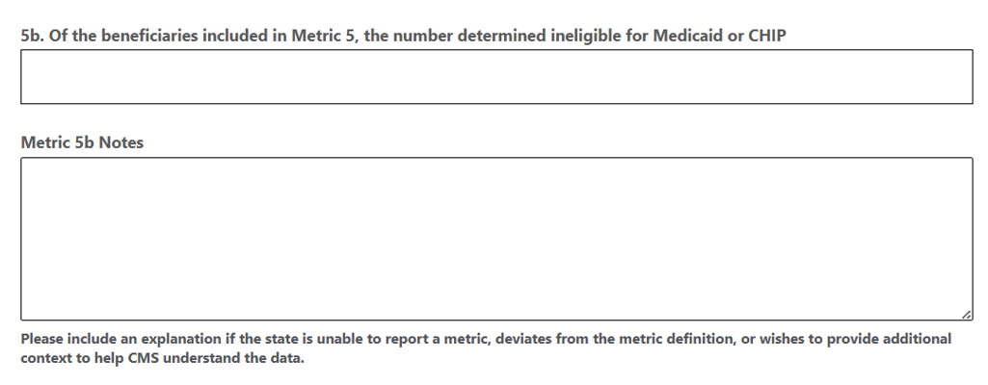
ALT TEXT: This is a screenshot of Metric 5b in the “Renewals and Outcomes” tab of the instrument. This screenshot includes the following: a free-text field for Metric 5b (Of the beneficiaries included in Metric 5, the number determined ineligible for Medicaid or CHIP ); a Metric 5b Notes free-text field; and instructions for Metric 5b Notes indicating to please include an explanation if the state is unable to report a metric, deviates from the metric definition, or wishes to provide additional context to help CMS understand the data.
Metric 5c
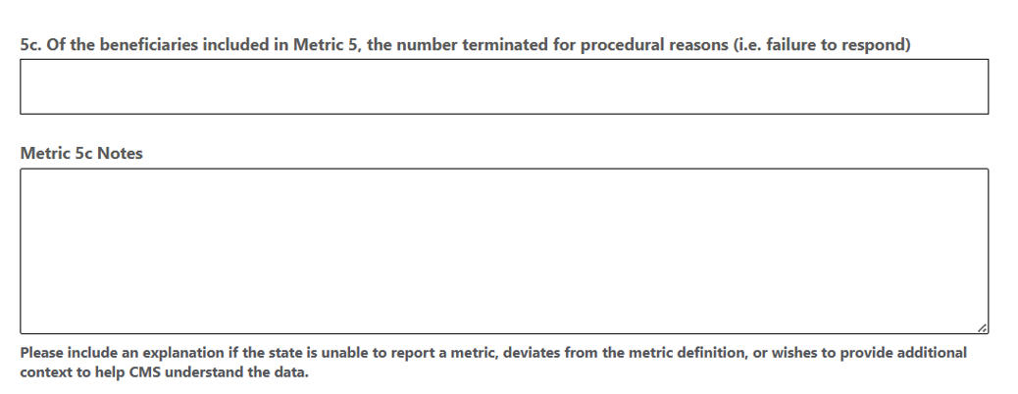
ALT TEXT: This is a screenshot of Metric 5c in the “Renewals and Outcomes” tab of the instrument. This screenshot includes the following: a free-text field for Metric 5c (Of the beneficiaries included in Metric 5, the number terminated for procedural reasons (i.e. failure to respond)); a Metric 5c Notes free-text field; instructions for Metric 5c Notes free-text field, indicating to please include an explanation if the state is unable to report a metric, deviates from the metric definition, or wishes to provide additional context to help CMS understand the data.

Metrics 5d and 6
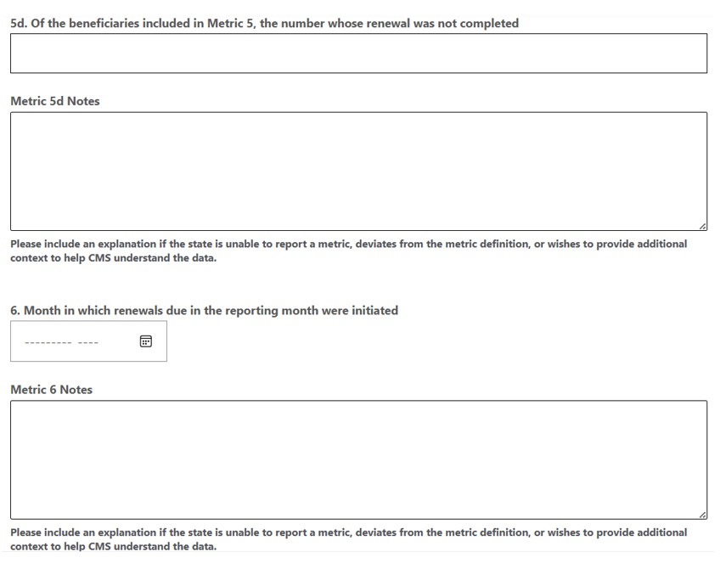
ALT TEXT: This is a screenshot of Metrics 5d and 6 in the “Renewals and Outcomes” tab of the instrument. This screenshot includes the following: a free-text field for Metric 5d (Of the beneficiaries included in Metric 5, the number whose renewal was not completed); a Metric 5d Notes free-text field; instructions for Metric 5d Notes free-text field, indicating to please include an explanation if the state is unable to report a metric, deviates from the metric definition, or wishes to provide additional context to help CMS understand the data; a calendar picker for Metric 6 (Month in which renewals due in the reporting month were initiated); a Metric 6 Notes free-text field; instructions for Metric 6 Notes free-text field, indicating to please include an explanation if the state is unable to report a metric, deviates from the metric definition, or wishes to provide additional context to help CMS understand the data.

Metric 7
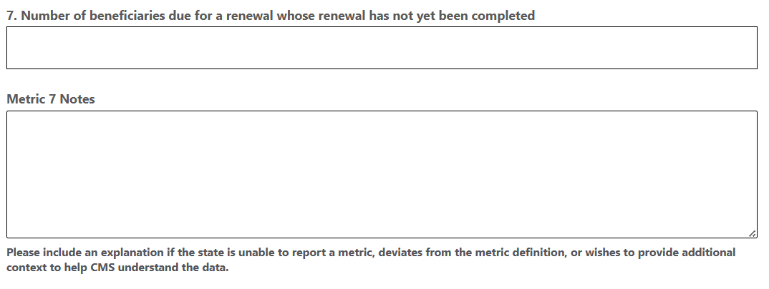
ALT TEXT: This is a screenshot of Metric 7 in the “Renewals and Outcomes” tab of the instrument. This screenshot includes the following: a free-text field for Metric 7 (Number of beneficiaries due for a renewal whose renewal has not yet been completed); a Metric 7 Notes free-text field; instructions for Metric 7 Notes free-text field, indicating to please include an explanation if the state is unable to report a metric, deviates from the metric definition, or wishes to provide additional context to help CMS understand the data.
  - “Medicaid Fair Hearings” tab
Metric 8
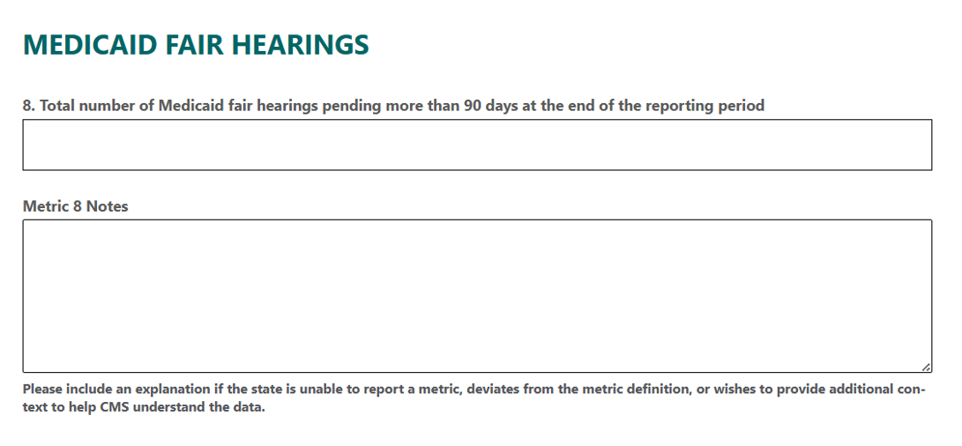
ALT TEXT: This is a screenshot of the Medicaid Fair Hearings tab of the monthly instrument which includes one metric, Metric 8. This screenshot includes the following: a free-text field for Metric 8 (Total number of Medicaid fair hearings pending more than 90 days at the end of the reporting period); a Metric 8 Notes free-text field; and instructions for Metric 8 notes free-text field, indicating to please include an explanation if the state is unable to report a metric, deviates from the metric definition, or wishes to provide additional context to help CMS understand the data.
  - “Updated Renewals and Outcomes” tab
Instructions and header fields
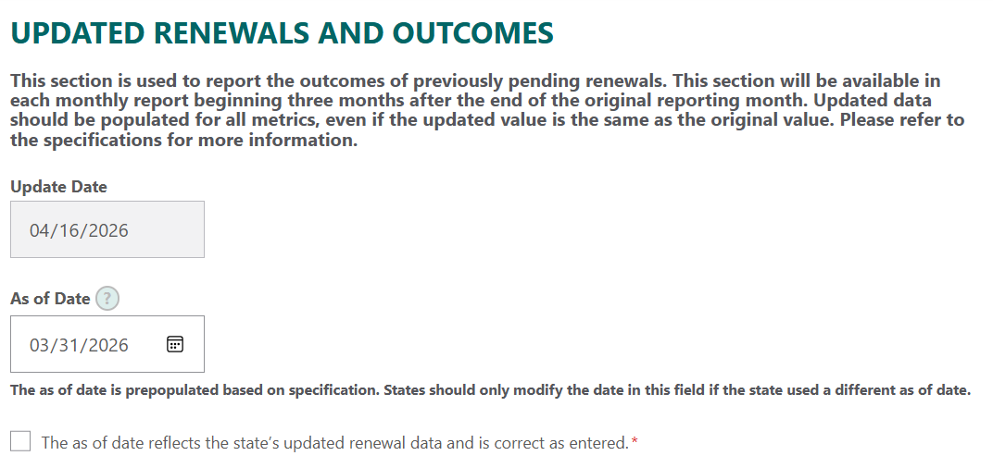
ALT TEXT: This is a screenshot of the instructions and header fields at the top of the “Updated Renewals and Outcomes” report tab. The instructions state that “This section is used to report the outcomes of previously pending renewals. This section will be available in each monthly report beginning three months after the end of the original reporting month. Updated data should be populated for all metrics, even if the updated value is the same as the original value. Please refer to the specifications for more information.” Below the instructions there are two date fields; the first field is the “Update Date” field, which is automatically populated in an MM/DD/YYYY format. The second field is an “As of Date” field, which is prepopulated based on specification in an MM/DD/YYYY format. Instructions under the “As of Date” field indicate that “The as of date is prepopulated based on specification. States should only modify the date in this field if the state used a different as of date.” A check box, denoted as required, appears below the “As of Date” field and the instructions next to the check box state that, “The as of date reflects the state’s updated renewal data and is correct as entered.”
Metric 5 (Updated)
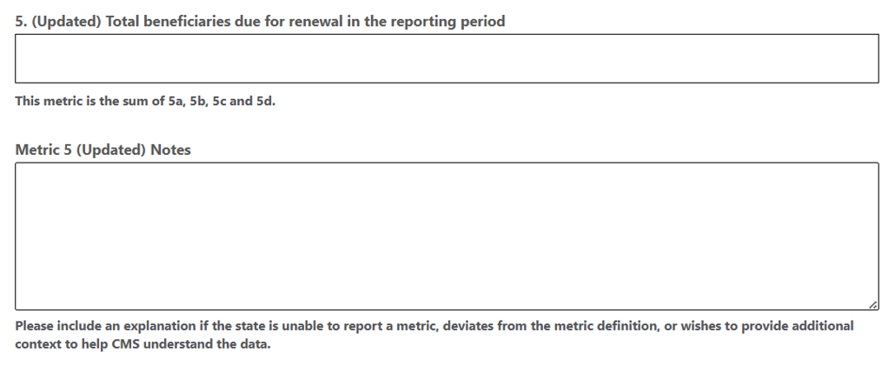
ALT TEXT: This is a screenshot of Metric 5 (Updated) in the “Updated Renewals and Outcomes” tab of the instrument. This screenshot includes the following: a free-text field for Metric 5 (Updated) (Total beneficiaries due for renewal in the reporting period); instructions for Metric 5 (Updated) indicating that this metric is the sum of 5a, 5b, 5c and 5d; a Metric 5 (Updated) Notes free-text field; and instructions for Metric 5 (Updated) Notes free-text field, indicating to please include an explanation if the state is unable to report a metric, deviates from the metric definition, or wishes to provide additional context to help CMS understand the data.
Metric 5a (Updated)
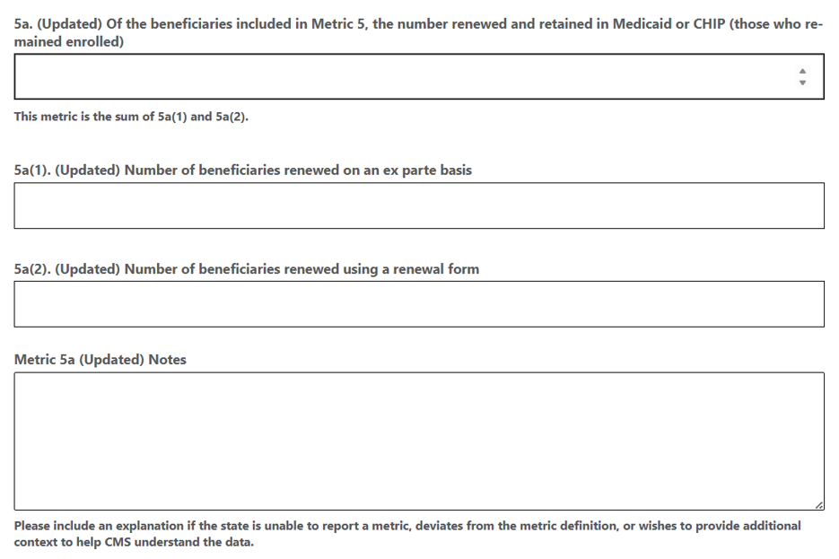
ALT TEXT: This is a screenshot of Metric 5a (Updated) in the “Updated Renewals and Outcomes” tab of the instrument. This screenshot includes the following: a free-text field for Metric 5a (Updated) (Of the beneficiaries included in Metric 5, the number renewed and retained in Medicaid or CHIP (those who remained enrolled)); instructions for Metric 5a (Updated) indicating that this metric is the sum of 5a(1) and 5a(2); a free-text field for Metric 5a(1) (Updated) (Number of beneficiaries renewed on an ex parte basis); a free-text field for Metric 5a(2) (Updated) (Number of beneficiaries renewed using a renewal form); a Metric 5a (Updated) Notes free-text field; and instructions for Metric 5a (Updated) Notes free-text field, indicating to please include an explanation if the state is unable to report a metric, deviates from the metric definition, or wishes to provide additional context to help CMS understand the data.

Metric 5b (Updated)
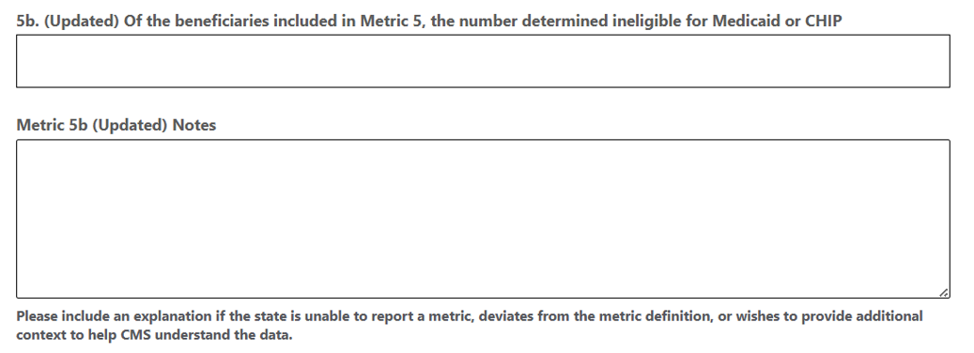
ALT TEXT: This is a screenshot of Metric 5b (Updated) in the “Updated Renewals and Outcomes” tab of the instrument. This screenshot includes the following: a free-text field for Metric 5b (Updated) (Of the beneficiaries included in Metric 5, the number determined ineligible for Medicaid or CHIP); a Metric 5b (Updated) Notes free-text field; and instructions for Metric 5b (Updated) Notes indicating to please include an explanation if the state is unable to report a metric, deviates from the metric definition, or wishes to provide additional context to help CMS understand the data.
Metric 5c (Updated)
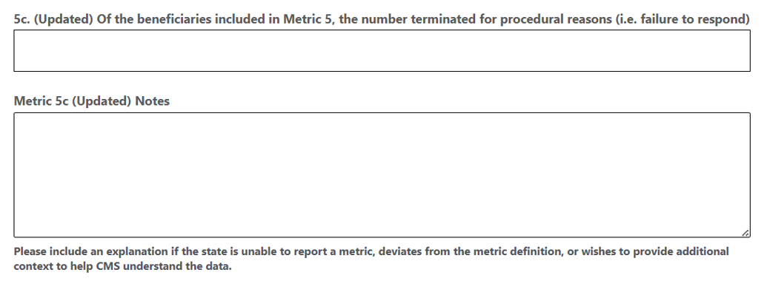
ALT TEXT: This is a screenshot of Metric 5c (Updated) in the “Updated Renewals and Outcomes” tab of the instrument. This screenshot includes the following: a free-text field for Metric 5c (Updated) (Of the beneficiaries included in Metric 5, the number terminated for procedural reasons (i.e. failure to respond)); a Metric 5c (Updated) Notes free-text field; instructions for Metric 5c (Updated) Notes free-text field, indicating to please include an explanation if the state is unable to report a metric, deviates from the metric definition, or wishes to provide additional context to help CMS understand the data.

Metric 5d (Updated)
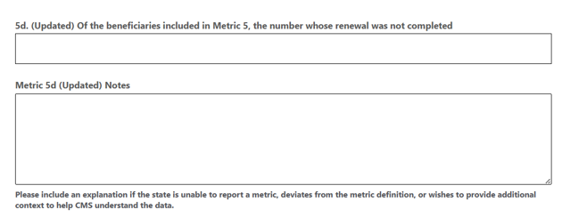ALT TEXT: This is a screenshot of Metric 5d (Updated) in the “Updated Renewals and Outcomes” tab of the instrument. This screenshot includes the following: a free-text field for Metric 5d (Updated) (Of the beneficiaries included in Metric 5, the number whose renewal was not completed); a Metric 5d (Updated) Notes free-text field; and instructions for Metric 5d (Updated) Notes free-text field, indicating to please include an explanation if the state is unable to report a metric, deviates from the metric definition, or wishes to provide additional context to help CMS understand the data.
- Proposed updates to the data collection instrument

  - PRA disclosure statement
The Centers for Medicare & Medicaid Services (CMS) is collecting this mandatory report under the authority in sections 1902(a)(4)(A), 1902(a)(6) and 1902(a)(75) of the Act to ensure proper and efficient administration of the Medicaid program and section 2101(a) of the Act to promote the administration of the Children's Health Insurance Program (CHIP) in an effective and efficient manner. Under the Privacy Act of 1974 any personally identifying information obtained will be kept private to the extent of the law. According to the Paperwork Reduction Act of 1995, no persons are required to respond to a collection of information unless it displays a valid OMB control number. The valid OMB control number for this information collection is 0938-1148 (CMS-10398 #66). The time required to complete this information collection is estimated to average 14 hours per response, including the time to review instructions, search existing data resources, gather the data needed, and complete and review the information collection. If you have comments concerning the accuracy of the time estimate(s) or suggestions for improving this form, please write to: CMS, 7500 Security Boulevard, Attn: PRA Reports Clearance Officer, Mail Stop C4-26-05, Baltimore, Maryland 21244-1850.
  - Instructions

INSTRUCTIONS
The Medicaid and Children's Health Insurance Program Eligibility Processing Data Report Specifications ("Specifications") contain metrics and definitions.
When submitting data to CMS, please include an explanation in the applicable notes section if any of the following apply:
1.) The state deviates from the metric definitions in the specifications
2.) The state is unable to provide data for any metric or sub-metric
3.) The state wishes to provide additional context to help CMS understand the data reported
Please note the following:
1.) After states have completed processing of all applications that were pending prior to the start of its unwinding period, no further reporting of Application Processing metrics in this report are required.
2.) The “Updated Renewals and Outcomes” section is available for states to report the outcomes of previously pending renewals. This section will be available in each monthly report beginning three months after the end of the original reporting month. Please refer to the specifications for more information.
3.) The “Renewals and Outcomes (Community Engagement)” section is available for states to report additional detail about the outcomes of renewals for beneficiaries enrolled on a basis subject to community engagement. Please refer to the specifications for more information.
For any questions, please contact: CMSEligEnrollSupport@cms.hhs.gov.

  - Renewals and Outcomes

Metric 5c
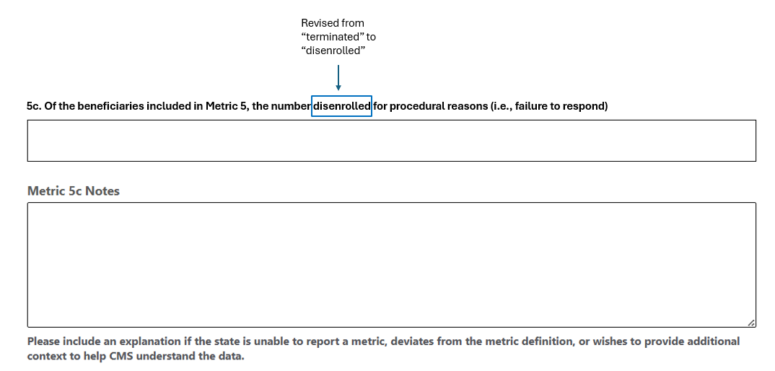
ALT TEXT: This is a mockup of the revised Metric 5c section of the “Renewals and Outcomes” tab of the instrument showing changes. This mockup includes the following: a free-text field for Metric 5c (Of the beneficiaries included in Metric 5, the number disenrolled for procedural reasons (i.e. failure to respond)); a Metric 5c Notes free-text field; instructions for Metric 5c Notes free-text field, indicating to please include an explanation if the state is unable to report a metric, deviates from the metric definition, or wishes to provide additional context to help CMS understand the data. A blue box and note indicate the revised metric name - “terminated” was revised to “disenrolled.” The blue box and note are provided for clarity and will not be a part of the instrument.

  - Renewals and Outcomes (Community Engagement)

Note: This is a new tab to be added to the data collection instrument.
Metric 9
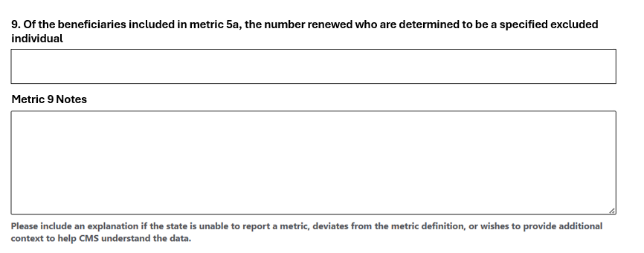
ALT TEXT (to be added for 508 compliance): This is a mockup of new Metric 9 within the new “Renewals and Outcomes (Community Engagement)” tab of the instrument. This mockup includes the following: a free-text field for Metric 9 (Of the beneficiaries included in metric 5a, the number renewed who are determined to be a specified excluded individual); a Metric 9 Notes free-text field; and instructions for Metric 9 Notes free-text field, indicating to please include an explanation if the state is unable to report a metric, deviates from the metric definition, or wishes to provide additional context to help CMS understand the data.
Metric 10
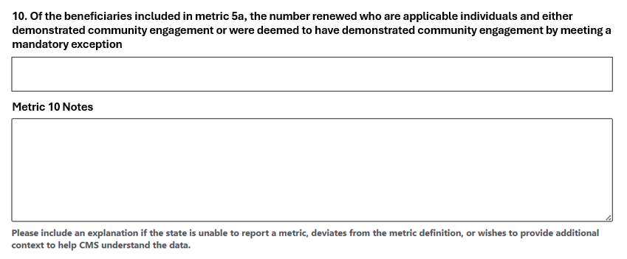
ALT TEXT (to be added for 508 compliance): This is a mockup of new Metric 10 within the new “Renewals and Outcomes (Community Engagement)” tab of the instrument. This mockup includes the following: a free-text field for Metric 10 (Of the beneficiaries included in metric 5a, the number renewed who are applicable individuals and either demonstrated community engagement or were deemed to have demonstrated community engagement by meeting a mandatory exception); a Metric 10 Notes free-text field; and instructions for Metric 10 Notes free-text field, indicating to please include an explanation if the state is unable to report a metric, deviates from the metric definition, or wishes to provide additional context to help CMS understand the data.

Metric 11
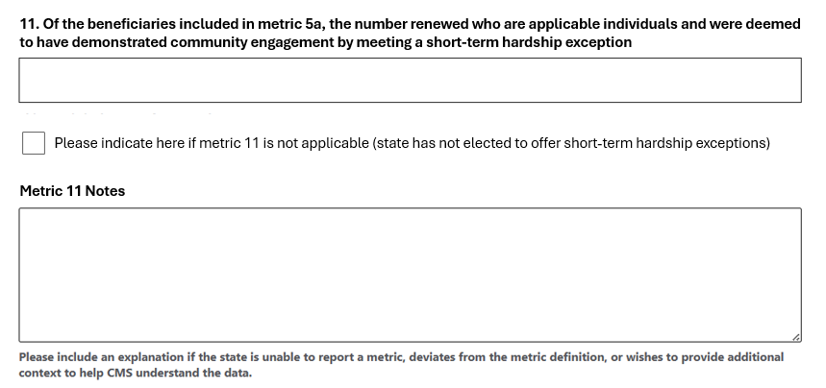
ALT TEXT (to be added for 508 compliance): This is a mockup of new Metric 11 within the new “Renewals and Outcomes (Community Engagement)” tab of the instrument. This mockup includes the following: a free-text field for Metric 11 (Of the beneficiaries included in metric 5a, the number renewed who are applicable individuals and were deemed to have demonstrated community engagement by meeting a short-term hardship exception); a Metric 11 Notes free-text field; a check box with the instructions “Please indicate here if metric 11 is not applicable (state has not elected to offer short-term hardship exceptions)”; and instructions for Metric 11 Notes free-text field, indicating to please include an explanation if the state is unable to report a metric, deviates from the metric definition, or wishes to provide additional context to help CMS understand the data.
Metric 12
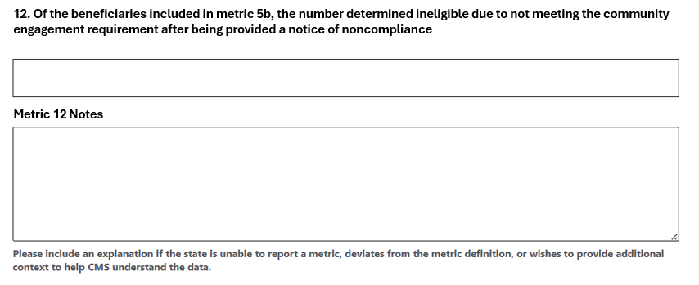
ALT TEXT (to be added for 508 compliance): This is a mockup of new Metric 12 within the new “Renewals and Outcomes (Community Engagement)” tab of the instrument. This mockup includes the following: a free-text field for Metric 12 (Of the beneficiaries included in metric 5b, the number determined ineligible due to not meeting the community engagement requirement after being provided a notice of noncompliance); a Metric 12 Notes free-text field; and instructions for Metric 12 Notes free-text field, indicating to please include an explanation if the state is unable to report a metric, deviates from the metric definition, or wishes to provide additional context to help CMS understand the data.
Metric 13
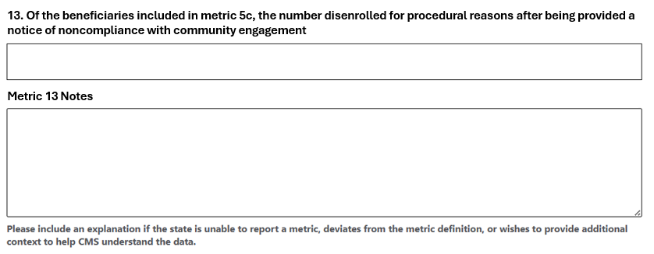
ALT TEXT (to be added for 508 compliance): This is a mockup of new Metric 13 within the new “Renewals and Outcomes (Community Engagement)” tab of the instrument. This mockup includes the following: a free-text field for Metric 13 (Of the beneficiaries included in metric 5c, the number disenrolled for procedural reasons after being provided a notice of noncompliance with community engagement); a Metric 13 Notes free-text field; and instructions for Metric 13 Notes free-text field, indicating to please include an explanation if the state is unable to report a metric, deviates from the metric definition, or wishes to provide additional context to help CMS understand the data.

  - Updated Renewals and Outcomes tab

Metric 5c (Updated)
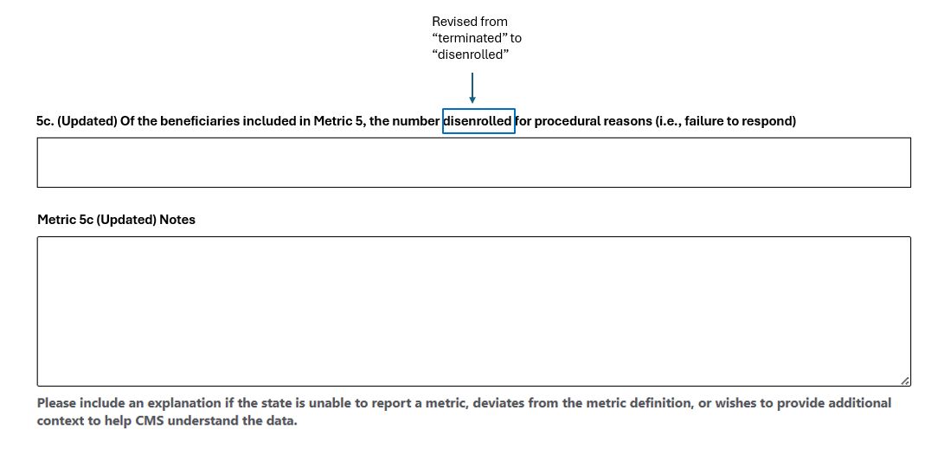
ALT TEXT: This is a mockup of the revised Metric 5c (Updated) section of the “Updated Renewals and Outcomes” tab of the instrument with proposed changes. This mockup includes the following: a free-text field for Metric 5c (Updated) (Of the beneficiaries included in Metric 5, the number disenrolled for procedural reasons (i.e. failure to respond)); a Metric 5c (Updated) Notes free-text field; instructions for Metric 5c (Updated) Notes free-text field, indicating to please include an explanation if the state is unable to report a metric, deviates from the metric definition, or wishes to provide additional context to help CMS understand the data. A blue box and note indicate the revised metric name - “terminated” was revised to “disenrolled.” The blue box and note are provided for clarity and will not be a part of the instrument.
Metric 9 (Updated)
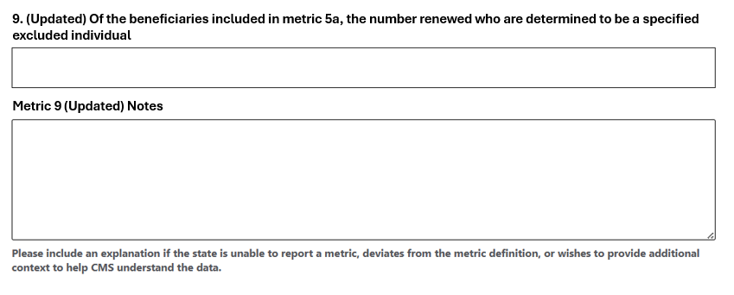
ALT TEXT (to be added for 508 compliance): This is a mockup of new Metric 9 (Updated) within the “Updated Renewals and Outcomes” tab of the instrument. This mockup includes the following: a free-text field for Metric 9 (Updated) (Of the beneficiaries included in metric 5a, the number renewed who are determined to be a specified excluded individual); a Metric 9 (Updated) Notes free-text field; and instructions for Metric 9 (Updated) Notes free-text field, indicating to please include an explanation if the state is unable to report a metric, deviates from the metric definition, or wishes to provide additional context to help CMS understand the data.
Metric 10 (Updated)
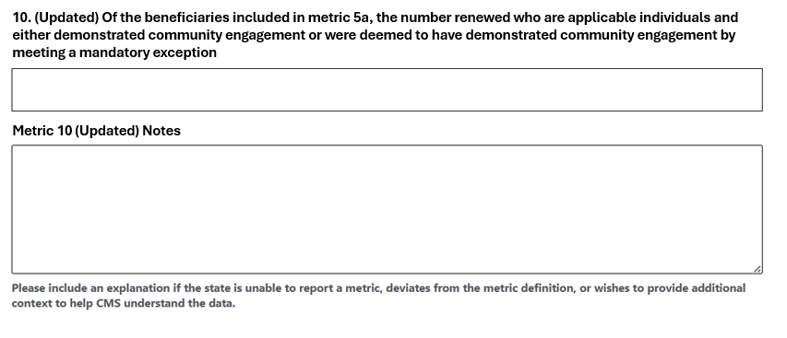
ALT TEXT (to be added for 508 compliance): This is a mockup of new Metric 10 (Updated) within the “Updated Renewals and Outcomes” tab of the instrument. This mockup includes the following: a free-text field for Metric 10 (Updated) (Of the beneficiaries included in metric 5a, the number renewed who are applicable individuals and either demonstrated community engagement or were deemed to have demonstrated community engagement by meeting a mandatory exception); a Metric 10 (Updated) Notes free-text field; and instructions for Metric 10 (Updated) Notes free-text field, indicating to please include an explanation if the state is unable to report a metric, deviates from the metric definition, or wishes to provide additional context to help CMS understand the data.
Metric 11 (Updated)
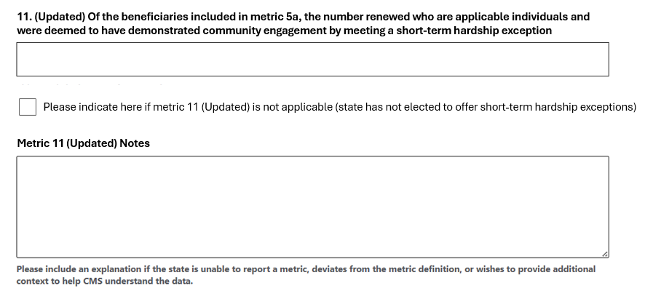

ALT TEXT (to be added for 508 compliance): This is a mockup of new Metric 11 (Updated) within the “Updated Renewals and Outcomes” tab of the instrument. This mockup includes the following: a free-text field for Metric 11 (Updated) (Of the beneficiaries included in metric 5a, the number renewed who are applicable individuals and were deemed to have demonstrated community engagement by meeting a short-term hardship exception); a Metric 11 (Updated) Notes free-text field; a check box with the instructions “Please indicate here if metric 11 (Updated) is not applicable (state has not elected to offer short-term hardship exceptions)”; and instructions for Metric 11 (Updated) Notes free-text field, indicating to please include an explanation if the state is unable to report a metric, deviates from the metric definition, or wishes to provide additional context to help CMS understand the data.

Metric 12 (Updated)
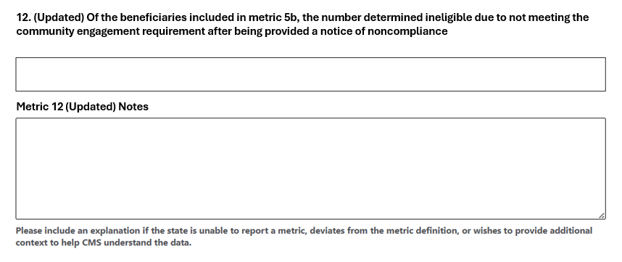
ALT TEXT (to be added for 508 compliance): This is a mockup of new Metric 12 (Updated) within the “Updated Renewals and Outcomes” tab of the instrument. This mockup includes the following: a free-text field for Metric 12 (Updated) (Of the beneficiaries included in metric 5b, the number determined ineligible due to not meeting the community engagement requirement after being provided a notice of noncompliance); a Metric 12 (Updated) Notes free-text field; and instructions for Metric 12 (Updated) Notes free-text field, indicating to please include an explanation if the state is unable to report a metric, deviates from the metric definition, or wishes to provide additional context to help CMS understand the data.
Metric 13 (Updated)
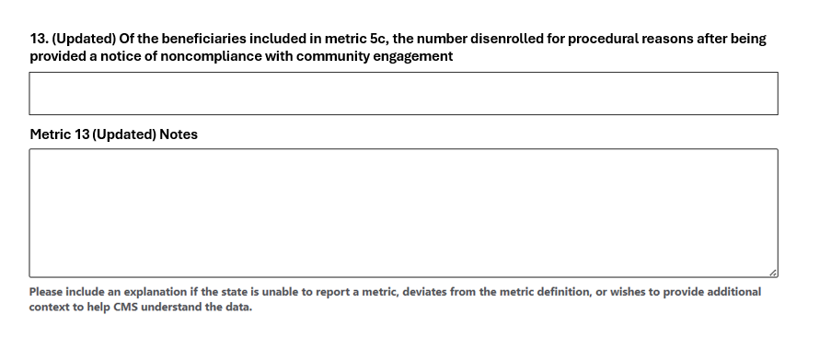
ALT TEXT (to be added for 508 compliance): This is a mockup of new Metric 13 (Updated) within the “Updated Renewals and Outcomes” tab of the instrument. This mockup includes the following: a free-text field for Metric 13 (Updated) (Of the beneficiaries included in metric 5c, the number disenrolled for procedural reasons after being provided a notice of noncompliance with community engagement); a Metric 13 (Updated) Notes free-text field; and instructions for Metric 13 (Updated) Notes free-text field, indicating to please include an explanation if the state is unable to report a metric, deviates from the metric definition, or wishes to provide additional context to help CMS understand the data.

