OMB 0960-0783 (SSA-263) – Screen shots from the Upload Documents
- Complete Form SSA-263 Online:

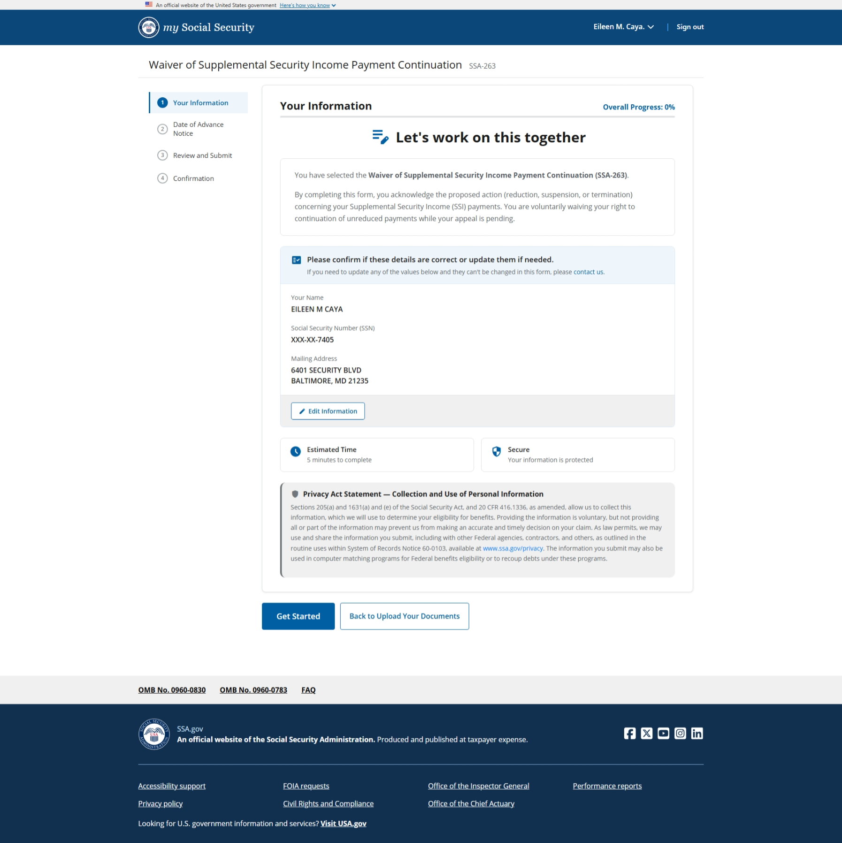
See Revised Privacy Act Statement Attached
[Grab your reader’s attention with a great quote from the document or use this space to emphasize a key point. To place this text box anywhere on the page, just drag it.]
[Grab your reader’s attention with a great quote from the document or use this space to emphasize a key point. To place this text box anywhere on the page, just drag it.]
[Grab your reader’s attention with a great quote from the document or use this space to emphasize a key point. To place this text box anywhere on the page, just drag it.]
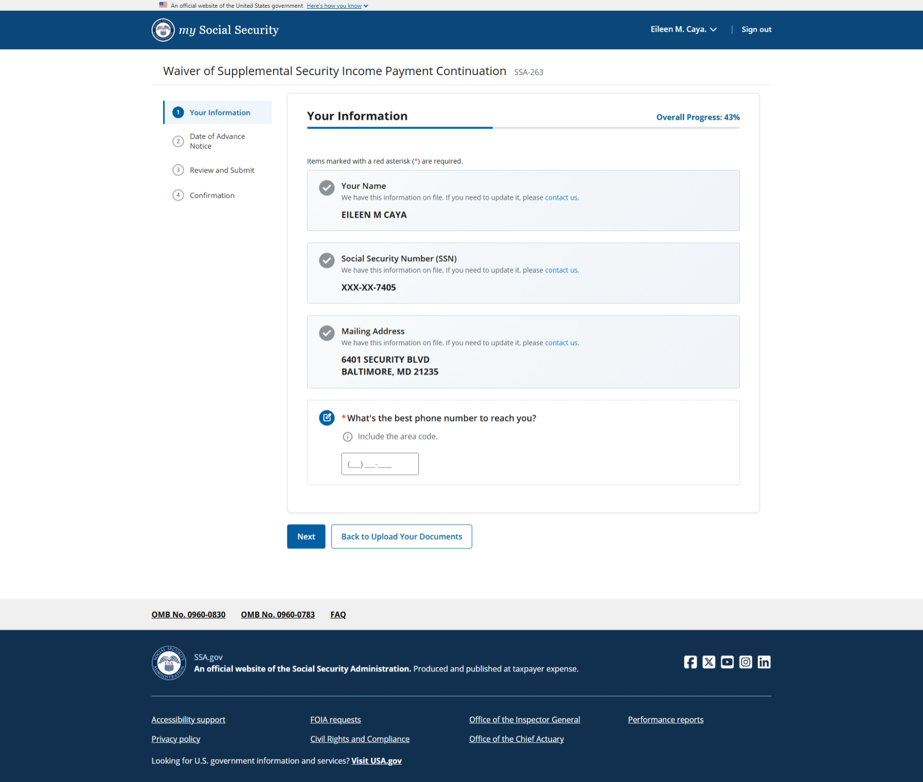
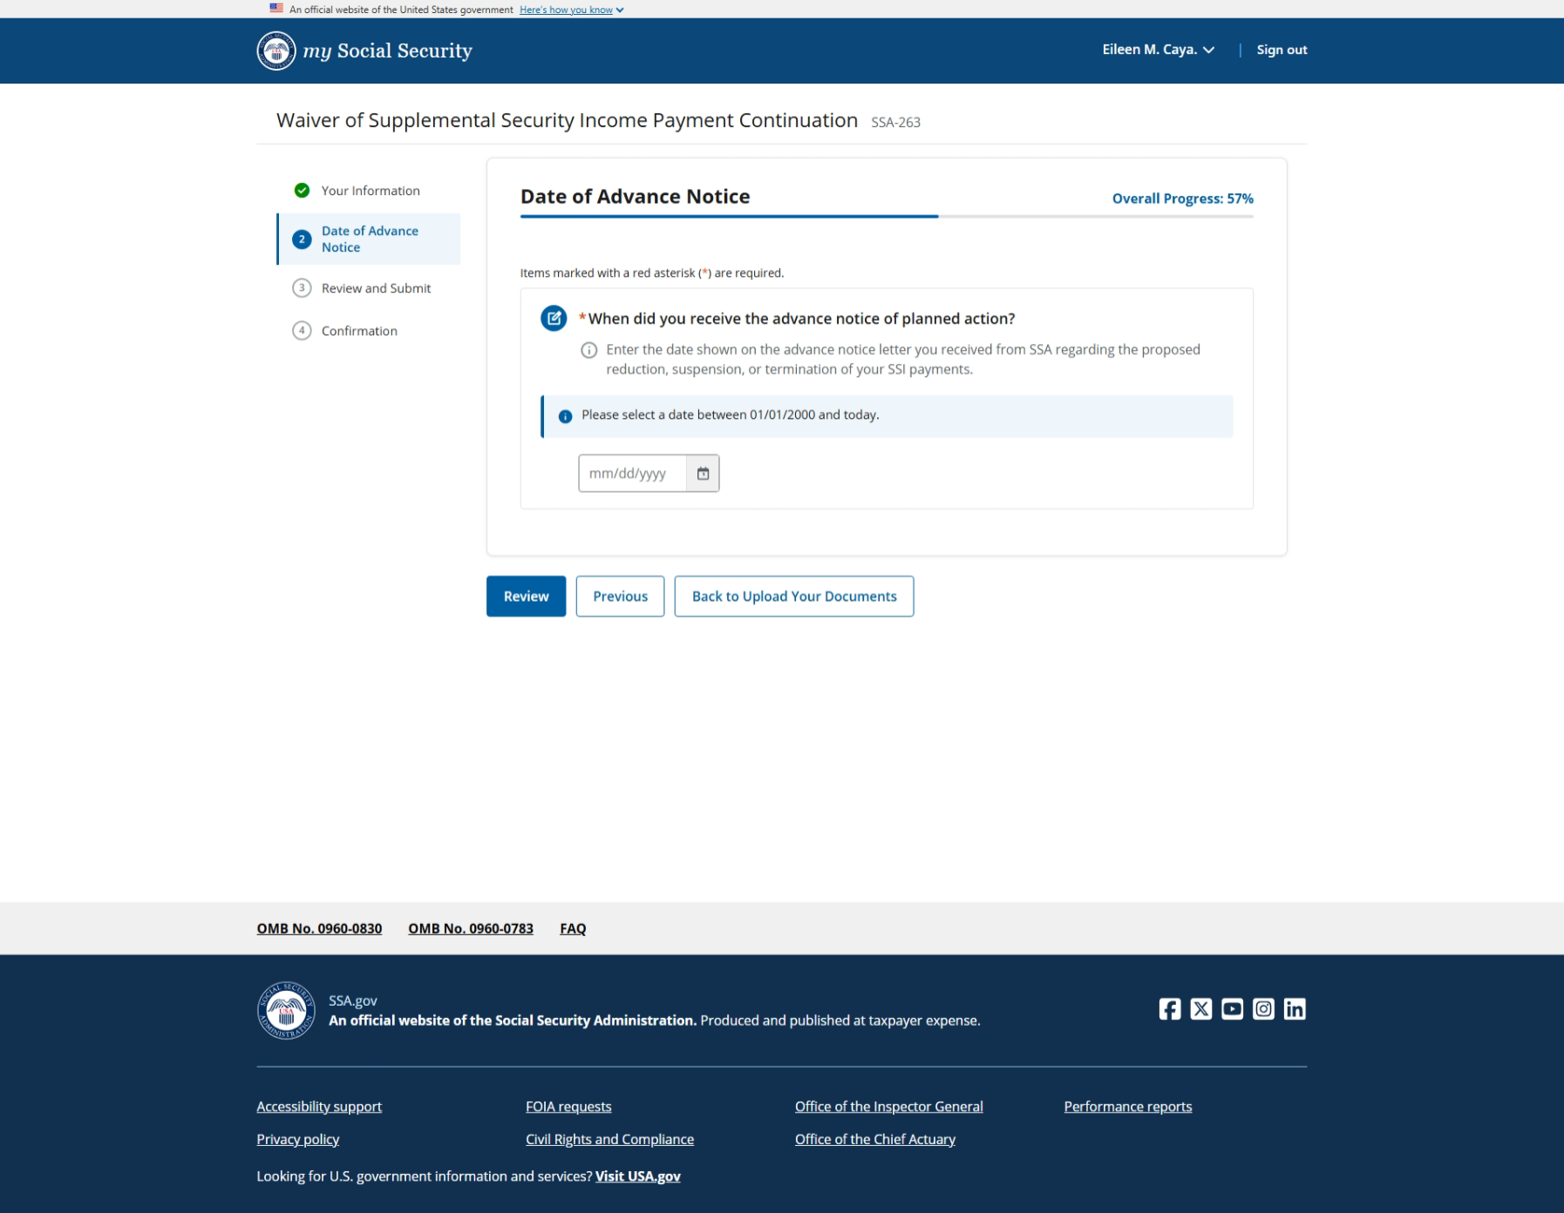
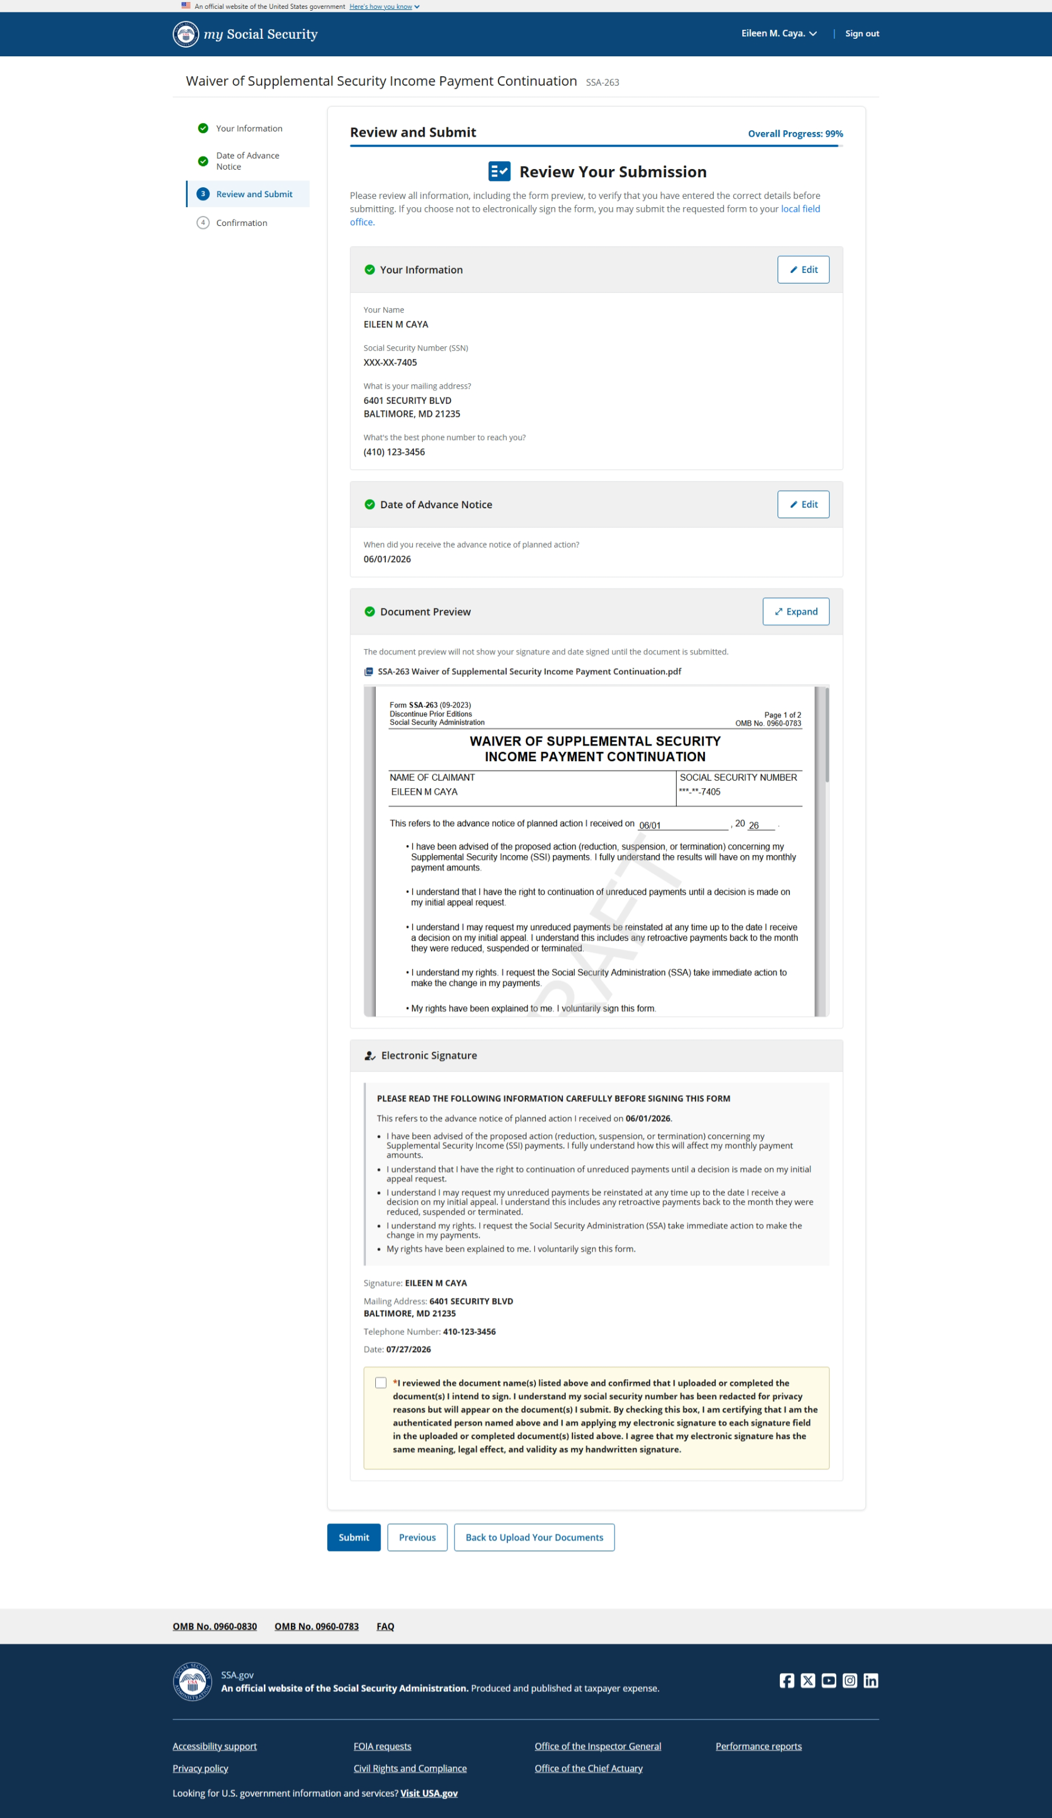.
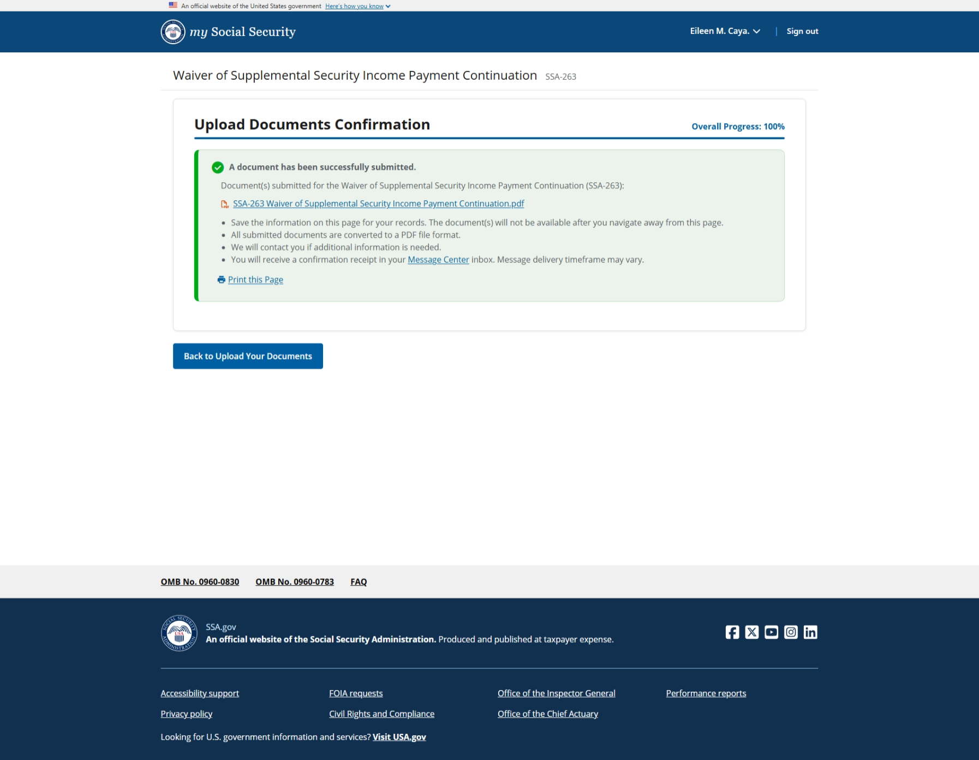

- Prepare and upload Form SSA-263 using Upload Documents:
