Iowa Child Support Services’ comments to the Notice of Proposed Rulemaking
Information Collection Activity; Income Withholding for Support
OMB# 0970-0154
Federal Register Vol. 91, No. 47, Page 11979

Income Withholding for Support - Instructions

- Page 1, 1d. Termination of IWO. We suggest removing the unnecessary “then” in the first sub-bullet.

- Page 1, 1f. Optional checkboxes: We suggest providing clarification on who is responsible for completing these checkboxes and the purpose of these boxes. The NPRM states, “OCSE revised the IWO form to add checkboxes pertaining to detail for the respondent to check, if applicable;”. The NPRM also provides the definition of respondent as, “Courts, private attorneys, custodial parties, or their representatives, employers, and other entities that provide income to noncustodial parents.” The IWO Instructions provide instructions about these boxes under the “I. Sender Information: (Completed by the Sender) Check one box for fields 1a – 1d. section.

As written, it is unclear if the IV-D agency is responsible for completing these boxes or if the income provider is responsible for completing the boxes. If the boxes are intended for the IV-D agency to complete before issuing the income withholding notice (IWN) so the income provider can better route the IWN to their Payroll Department/Human Resources personnel (for Employees) or their Accounts Payable personnel (for Independent Contractors), we suggest this explanation be added. Some states, like the Iowa IV-D agency, are not required to receive this information prior to issuing the IWN, therefore without the explanation of their purpose is confusing. Below is a possible language suggestion:

1f. Employee vs Independent Contractor (Optional for the sender): The sender may choose to check the appropriate box (when the information is available) to indicate the notice should be forwarded/processed by the Payroll Department/Human Resources personnel (for Employees) or the Accounts Payable personnel (for Independent Contractors). If no boxes are checked, the sender either does not know the employment status of the payor or has not programed the checkboxes.

The responsibility remains on the income provider to determine if the IWO is for an employee or an independent contractor. IWOs are applicable to employees and non-employees(contractors)

- Page 1, NOTE TO EMPLOYER/INCOME WITHHOLDER: We suggest fixing the spacing error.

- Page 2, 1h. State/Tribe/Territory. We suggest correcting the reference at the end of the paragraph. It says 1i but we believe it should be 1j.

- Page 2 We suggest fixing the spacing errors throughout the page. For example:
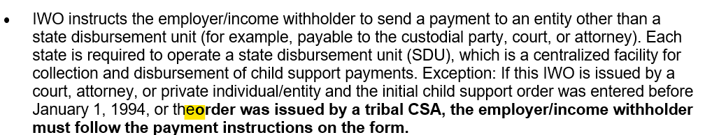
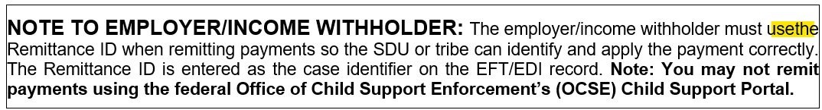

Page 4, Note to Employer/Income Withholder: The last sentence references AT 16-04. However, that Action Transmittal has been archived. In addition, the message at https://acf.gov/archive/css/policy-guidance/correctly-withholding-child-support-weekly-and-biweekly-pay-cyclesstates the content is no longer current. We suggest adding the appropriate language to the form or correcting the message at https://acf.gov/archive/css/policy-guidance/correctly-withholding-child-support-weekly-and-biweekly-pay-cycles to clarify whether the information is or is no longer current.
We also suggest adding information to explain to income providers how to calculate the amount to withhold for multiple daily pay periods (e.g., payor is paid daily and works 3 days in a row). In this particular example it is unclear whether the income provider should calculate the amount to withhold using the weekly method or the daily method multiplied by the number of workdays for which the noncustodial parent was paid.

- Throughout the document we suggest the links be expanded to show the full website address instead of the name of the web page [See below for examples]. This form is often mailed to income providers and non-custodial parents. Providing the name of the document instead of the actual web address is useless because the income provider and noncustodial parent are unable to click on the link to access the information in a paper copy.

- Change Dos and don’ts to: https://acf.gov/css/training-technical-assistance/using-income-withholding-support-form-dos-and-donts
- Change State Income Withholding Contacts and Program Requirements to https://acf.gov/css/contact-information/state-income-withholding-contacts-and-program-requirements
- Change Federal Agency Income Withholding Contacts and Program Information to https://acf.gov/css/contact-information/federal-agency-iwo-and-medical-contact-information
- Change State Income Withholding Contacts and Program Requirements to https://acf.gov/css/contact-information/state-income-withholding-contacts-and-program-requirements
- Change Tribal Leaders Directory to https://www.bia.gov/service/tribal-leaders-directory
- Change Tribal Child Support Agency Contacts to https://acf.gov/css/training-technical-assistance/tribal-child-support-agency-contacts
- Change OCSE AT-17-07: Interstate Child Support Payment Processing to https://acf.gov/css/policy-guidance/interstate-child-support-payment-processing

Income Withholding for Support- Sample form

- Page 2,Section V. Remittance Information: In the “Remit payment to” box, the wording and placement of the “Note” language is different in the Income Withholding for Support - Sample form and the actual Income Withholding for Support (IWO) form. We suggest clarification on which wording and placement is correct and make them the same on both versions. See below for example:

Snippet from Income Withholding for Support – Sample Form
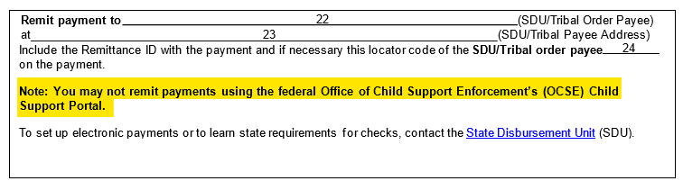

Snippet from “Income Withholding for Support (IWO)” form – Actual Form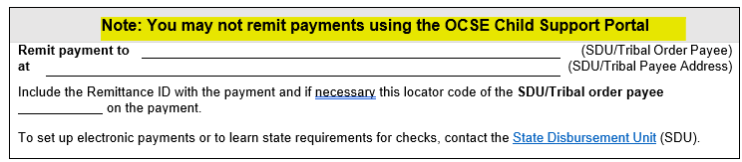

- Page 3, VI. Additional Information for Employers/Income Withholders: Language between the Income Withholding for Support - Sample form and the actual Income Withholding for Support (IWO) form is not consistent. We suggest clarification on whether the:
- Heading should be "Lump Sum Payments" or "Report Lump Sums". [See yellow highlight]
- Second sentence of the paragraph should say "lump sums" or "lump sum payments.” [See green highlight]
- Sentence "Child support payments may not be made through the OCSE Child Support Portal" should be:
  - Added at the end of this paragraph or if it was intentionally moved from the Payments: heading where it is today
  - “may not” or cannot”. [See blue highlight]

Snippet from Income Withholding for Support – Sample Form
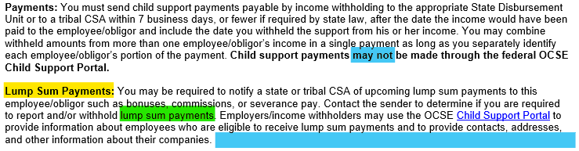

Snippet from “Income Withholding for Support (IWO)” form – Actual Form
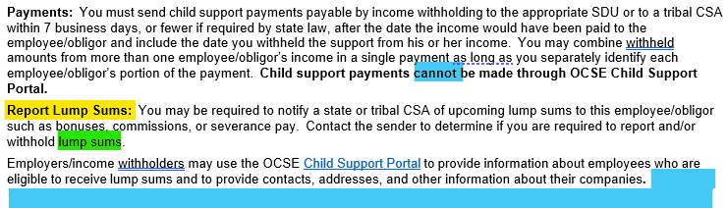

- Page 4, PAPERWORK REDUCTION ACT OF 1995 This section is found on the Income Withholding for Support - Sample form, but is missing from the actual Income Withholding for Support (IWO) form We suggest providing clarification on whether this section should be added to the actual form since it is included on the Sample form.

Snippet from Income Withholding for Support – Sample Form
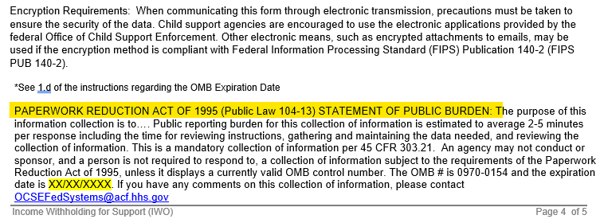

Snippet from “Income Withholding for Support (IWO)” form – Actual Form
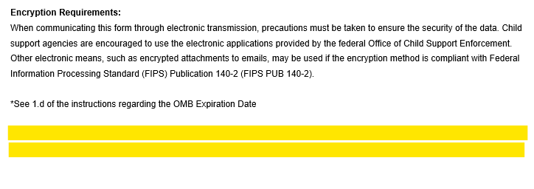
- Throughout the document we suggest the links be expanded to show the full website address instead of the name of the web page [See below for examples]. This form is often mailed to income providers and non-custodial parents. Providing the name of the document instead of the actual web address is useless because they are unable to click on the link to access the information in a paper copy.

- Change IWO Instructions to: https://acf.gov/css/form/income-withholding-support-iwo-form-instructions-sample
- Change State-specific withholding limit information to: https://acf.gov/css/contact-information/state-income-withholding-contacts-and-program-requirements
- Change Tribal Child Support Agency Contacts to: https://acf.gov/css/training-technical-assistance/tribal-child-support-agency-contacts
- Change Tribal Leaders Directory to: https://www.bia.gov/service/tribal-leaders-directory
- Change State Income Withholding Contacts and Program Requirements to: https://acf.gov/css/contact-information/state-income-withholding-contacts-and-program-requirements
- Change Child Support Portal to: https://ocsp.acf.hhs.gov/csp/

Income Withholding for Support (IWO) – Actual form

- See comment included in the Sample form Section (above)

