Justification for No Material or Nonsubstantive Change to Currently Approved Collection

AGENCY: Pension Benefit Guaranty Corporation (PBGC)

TITLE: Termination of Single Employer Plans (29 CFR part 4041)

STATUS: OMB control number 1212-0036; expires 09/30/2028

CONTACT: Abigail Davidow (202-229-6418)

The Pension Benefit Guaranty Corporation (PBGC) is making changes, as a non-material change request, to the approved instructions for the standard termination of a single-employer, Title IV-covered pension plan. The applicable OMB Control Number 1212-0036 is scheduled to expire on September 30, 2028.

Under section 4041 of the Employee Retirement Income Security Act of 1974, as amended (ERISA), a single-employer pension plan may terminate voluntarily only if it satisfies the requirements for either a standard or a distress termination. Pursuant to section 4041(b) of ERISA and PBGC’s termination regulation (29 CFR part 4041), a plan administrator wishing to terminate a plan in a standard termination is required to submit specified information to PBGC in support of the proposed termination and to provide specified information regarding the proposed termination to third parties (participants, beneficiaries, alternate payees, and employee organizations).

PBGC needs, and has routinely used, the information required to be submitted to determine whether the statutory and regulatory requirements for a standard termination have been met. The plan administrator must provide PBGC with summary information relating to the benefits distributed and certain information regarding residual assets, and must provide certain additional information to third parties, including a notice of plan benefits (NOPB).

PBGC is proposing to revise its Standard Termination Filing Instructions to provide clarification to practitioners regarding the NOPB requirement. Specifically, the proposed revisions clarify that:

- NOPBs do not all have to be issued at the same time. For example, if a participant elects to receive a lump sum payment shortly after the plan termination date, the plan administrator may issue that participant’s NOPB at the same time the lump sum payment goes out, not afterwards. The plan administrator would still retain the option to issue other participants’ NOPBs later.

- An NOPB may be issued at the same time as, and mailed out with, the notice of intent to terminate (NOIT).

- An NOPB is not required to be written in any particular format. It must only meet the timing and content requirements under ERISA section 4041(b)(2)(B) and related guidance. Plan administrators can easily conform other routine benefit explanations to the NOPB requirements.

The purpose of these clarifications is to minimize confusion among practitioners and thus prevent them from imposing restrictions related to NOPBs where there are none.

These changes will not increase the hour or cost burden for this information collection.

The changes to the instructions are as follows:

Page 2: PBGC is revising the page numbers in the Table of Contents to align with the changes in the body of the instructions.

Page 5: PBGC is revising the diagram to clarify when NOPBs may be issued.

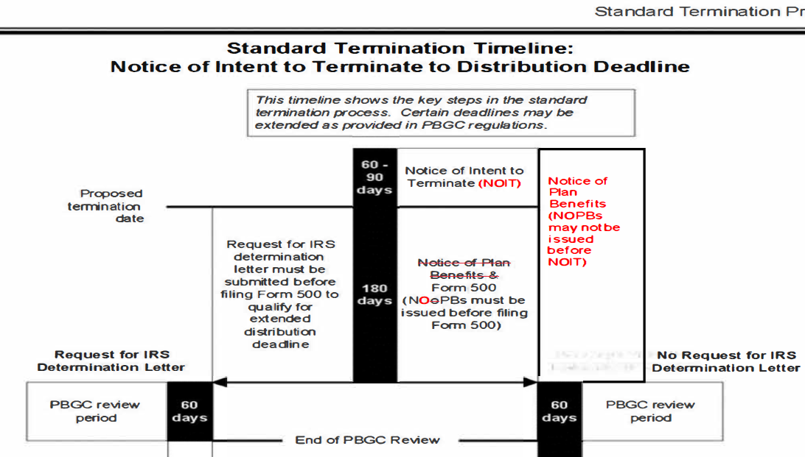

Page 11: PBGC is adding a note to the bulleted list in the subsection, “Contents of NOIT.”

* * *
► One of the following statements concerning the cessation of accruals under the plan, whichever applies:
• Benefit accruals will cease as of the termination date, but will continue if the plan does not terminate;
• A plan amendment has been adopted under which benefit accruals will cease, in accordance with ERISA section
204(h), as of [insert either the proposed termination date or a specified date before the proposed termination date, whichever applies], whether or not the plan is terminated; or
• Benefit accruals ceased, in accordance with ERISA section 204(h), as of [insert specified date before the NOIT was issued].
► Statement that each affected party entitled to plan benefits will receive a written notification regarding his or her benefits.
Note: The plan administrator may simply provide the NOPB with the NOIT rather than including this statement in the NOIT.
► Statement explaining how an affected party entitled to receive the latest updated summary plan description (SPD) under ERISA § 104(b) can obtain it.
Note: The plan administrator may simply provide a copy of the SPD with the NOIT rather than including this statement in the NOIT. The plan administrator may impose a reasonable charge to cover the cost of furnishing the SPD to the extent allowed under regulations issued by the Department of Labor (see 29 CFR § 252 0.104b-30) . Some affected parties (e.g., a union) are not entitled to receive a copy of the SPD under ERISA section 104. The plan administrator may, but need not, include this statement in the NOIT issued to any such affected parties.

Pages 13-14: PBGC is removing language in the first paragraph of Section D, “Notice of Plan Benefits (NOPB),” and adding it to the new subsection, “Timing of NOBP.” PBGC is also adding a note under this new subsection.

D. Notice of Plan Benefits (NOPB) (see 29 CFR § 4041.24)
The plan administrator must issue a NOPB to each affected party who is, as of the proposed termination date, a participant (including participants with a $0 benefit), a beneficiary of a deceased participant, or an alternate payee under an applicable qualified domestic relations order., no later than the time the plan administrator files the standard termination notice with PBGC (see section ILE). Copies of sample NOPBs issued to each category of participants (actives, retirees, separated vested, and separated non-vesteds) must be attached to the Form 500 submitted to PBGC.
Note: A NOPB must also be issued to a person who becomes a beneficiary of a deceased participant or an alternate payee after the proposed termination date and on or before the distribution date. (The NOPB will be saved from being untimely, provided the "after-discovered affected parties" requirements described in section 11.A.2 are satisfied.)
Timing of NOPB. Every NOPB must be issued no later than the time the plan administrator files the standard termination notice with NOPB (see section II.E), but not before the plan administrator issues the NOIT. An NOPB may be issued at the same time as, and mailed out with, the NOIT.
Note: The NOPBs do not all have to be issued at the same time. For example, if several participants elect to receive lump sum payments shortly after the termination date, the plan administrator may choose to issue their NOPBs at the same time as the benefit election materials are sent, or at the time the payment goes out, while issuing other participants' NOPBs at a later date (as long as that date is before the standard termination notice is filed).

Page 15: PBGC is adding a note to the bottom of the bulleted list in the subsection, “Contents of NOPB.”

* * *
► Amount and form of plan benefits, if any, payable to a beneficiary upon the participant's death and the name of the beneficiary.
► Amount and date of any increase or decrease in the benefit that has already occurred or is scheduled to occur after the proposed termination date and an explanation of the increase or decrease, including, where applicable, a reference to the pertinent plan provisions.
Note: An NOPB is not required to be written in any particular format and may be consolidated with other communications, including a NOIT, with respect to some but not all participants (i.e., each recipient need not receive an NOPB in exactly the same format as each other recipient). An NOPB must only meet the timing and content requirements and be written in such a manner as is likely to be understood by a participant or beneficiary. See ERISA section 4041(b)(2)(B). Using plain language to describe key aspects (e.g., whether a benefit is owed or not, whether it has already been paid or not, how much the benefit is worth, how it was calculated, etc.) tends to enhance understandability. Additionally, including a phone number, email address, or online portal in the NOPB where a participant or beneficiary may submit inquiries may help address misunderstandings in the event they arise.

