Change Required:
To enable more effective and efficient support to US citizens requesting assistance leaving Israel, we need to make a non-substantive change to the Consular Crisis Intake Form. The specific change we would like to make involves adding 1 additional option to an existing question – we’d like to add “I am seeking US government departure assistance only” as an option to the “Additional Assistance” section. Visualization below:
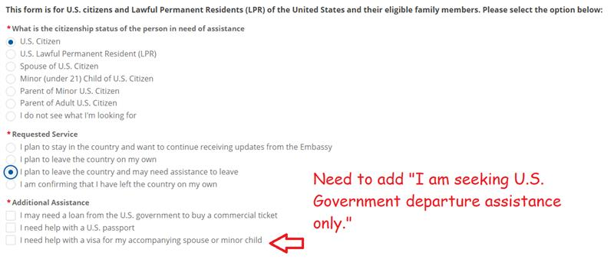
Additional Background Context:
The crisis intake form lacks an option for users who need assistance leaving a country but do not require a loan, passport, or visa. This omission has led to confusion and abandonment of the form, resulting in a flood of redundant communications to embassies, support organizations, and Congressional offices. Additionally, incorrect categorization of US citizens needs impacts data integrity, which could delay coordinated evacuations. Clear and accurate language is essential to minimize ambiguity and ensure efficient assistance during crises. Fast track approval for an updated form is urgently needed to address these issues.
This change we are requesting is a non-substantive change request to a response set in a question in an already approved form; this update does not change the nature of the data collection or significantly increase the time that it takes for responses (burden).

