Key:
- Incidents on campus
- Incidents in on-campus housing facilities
- Incidents in noncampus building or properties
- Incidents on public property
- Incidents reported by local police

Variation 1 – a,b,c,d,e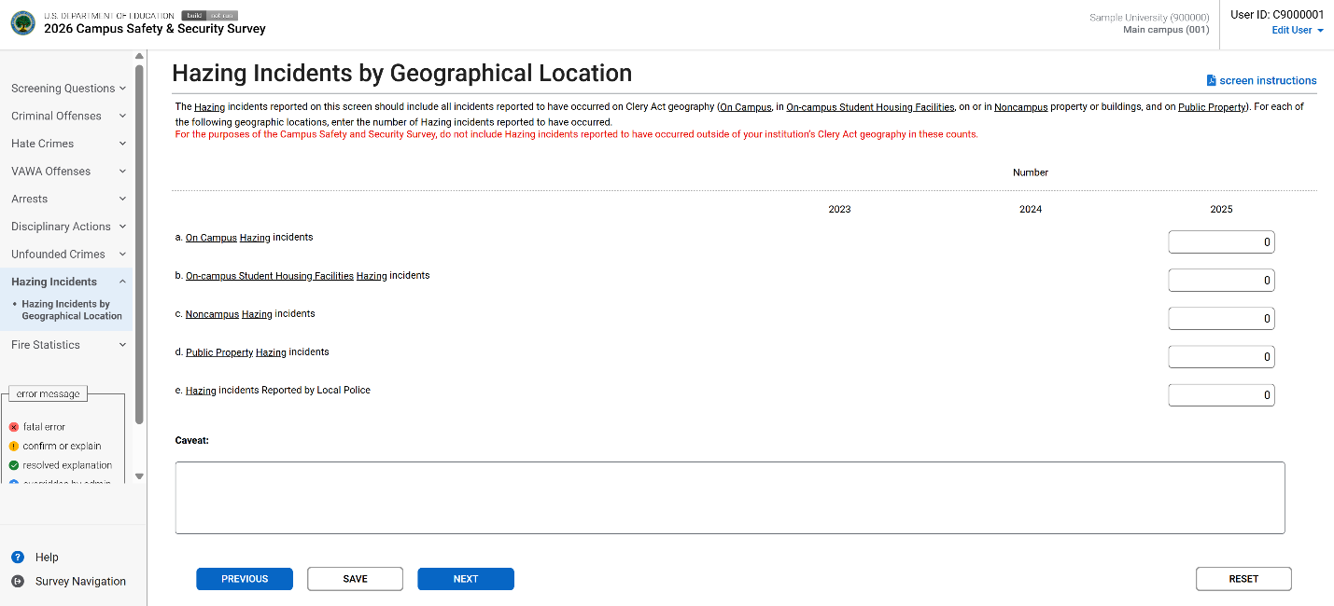

Variation 2 – a,d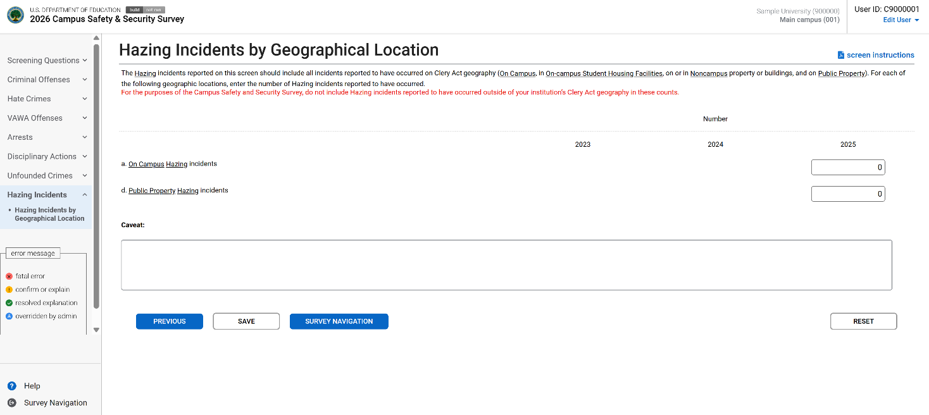

Variation 3 – a,b,c,d
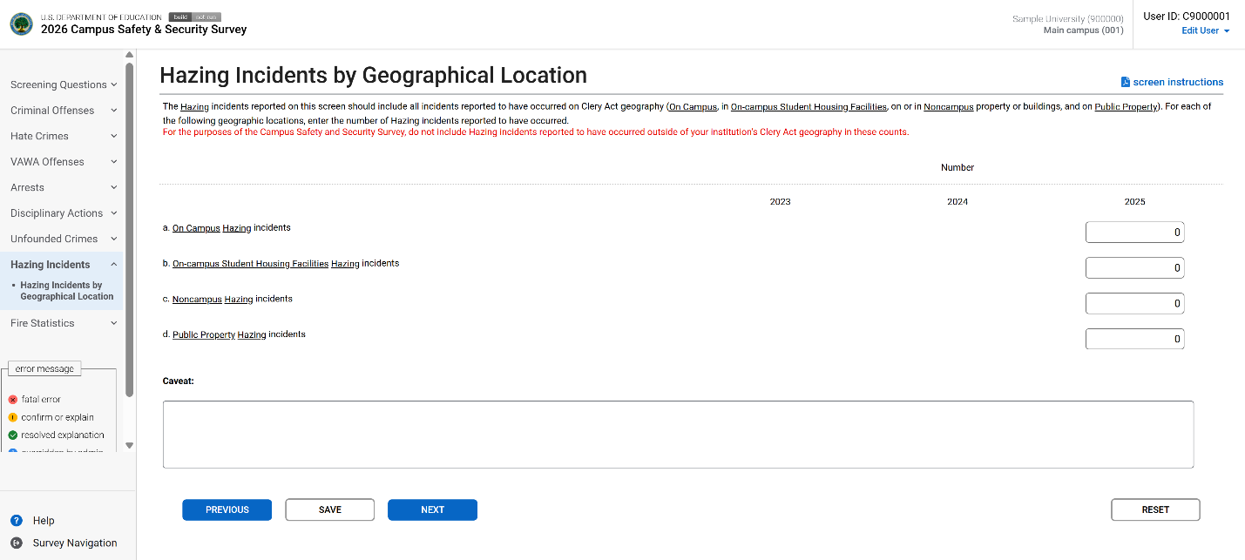

Variation 4 – a,b,d,e
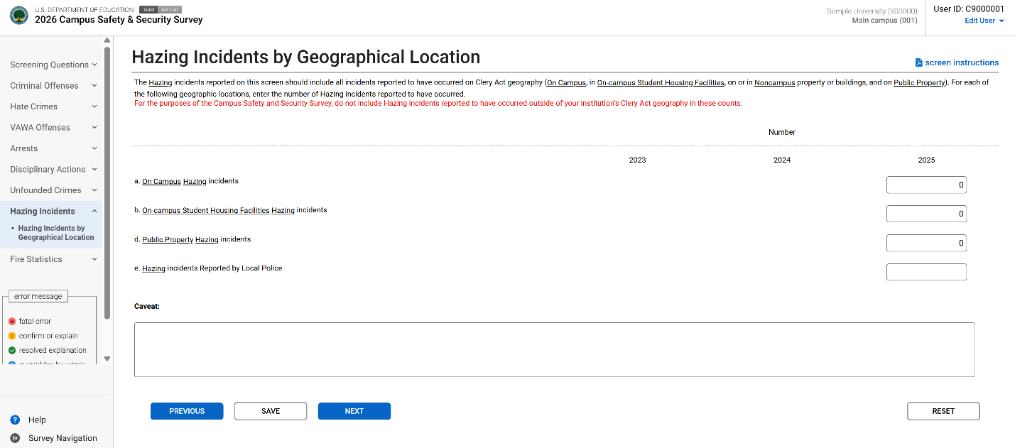

Variation 5 – a,b,d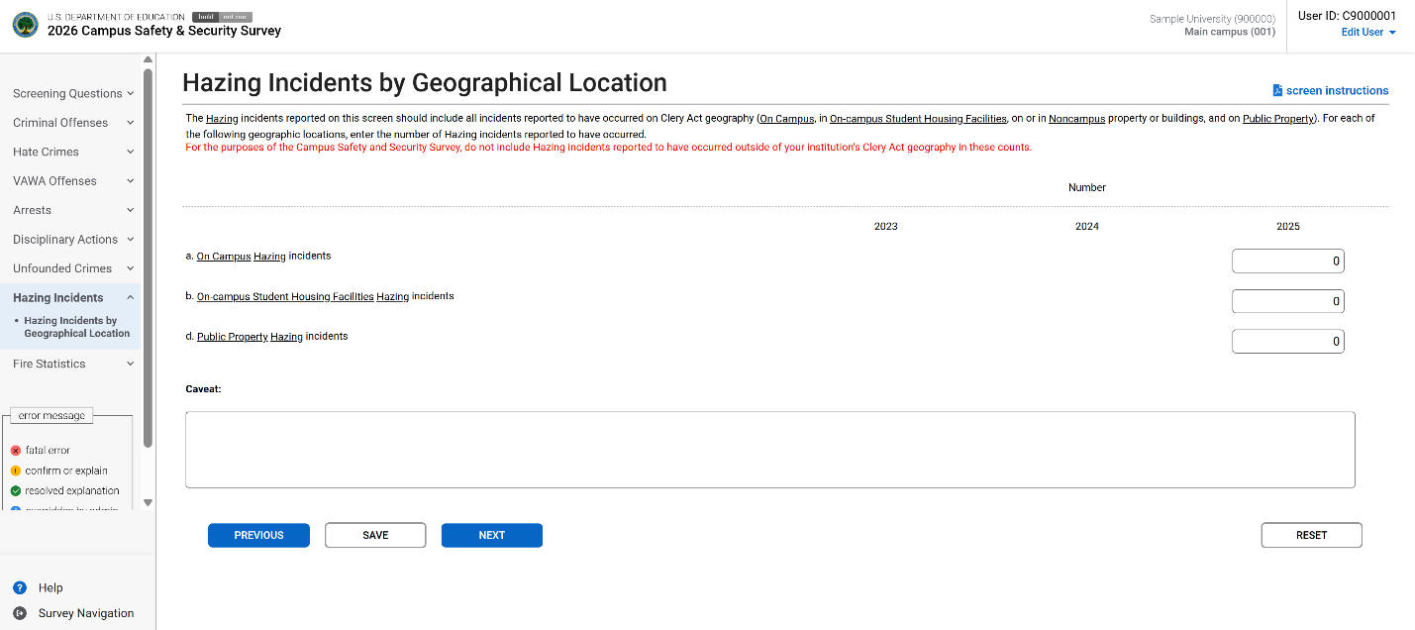

Variation 6 – a,c,d,e
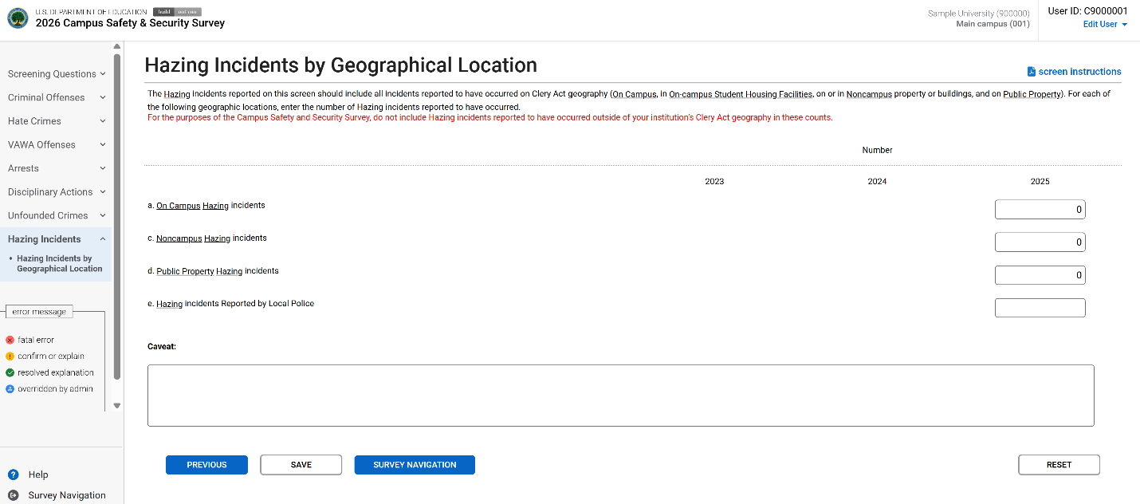

Variation 7 – a,c,d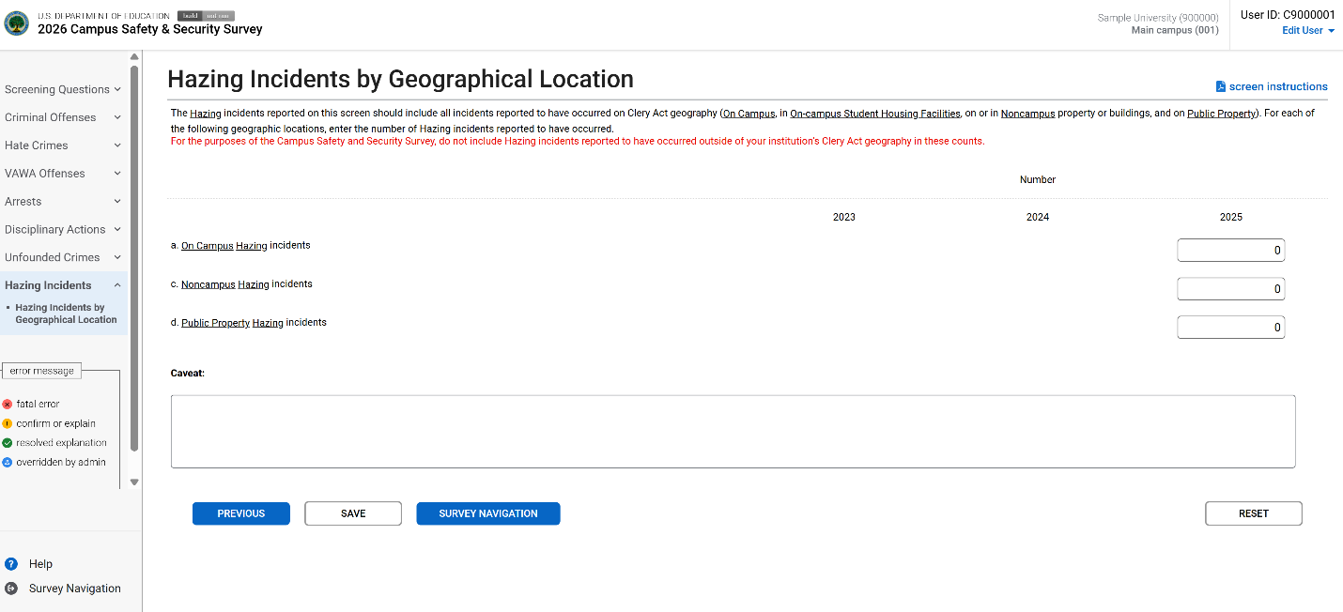

Variation 8 – a,d,e