NATIONAL CENTER FOR EDUCATION STATISTICS
NATIONAL ASSESSMENT OF EDUCATIONAL PROGRESS

National Assessment of Educational Progress (NAEP) 2027

Appendix B
NAEP 2024 Weighting Procedures

OMB# 1850-0928 v.40

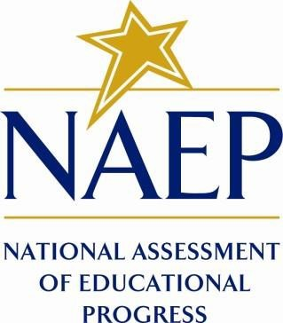

July 2026

Please note, in 2024, the term “gender” was used in the weighting procedures. In 2027, the term “sex” will be used.

NAEP 2024 Weighting Procedures are available on NAEP’s public website:
https://nces.ed.gov/nationsreportcard/tdw/weighting/2024/weighting_procedures_for_the_2024_assessment.aspx

