National Center for Education Statistics
National Assessment of Educational Progress

National Assessment of Educational Progress (NAEP) 2027

Appendix I
2027 Assessment Management System Materials

OMB# 1850-0803 v.40



July 2026

AMS materials are included in Appendix I for the 2027 Amendment submission. Drafts have been replaced with final versions and are marked as “(NEW)” in the header.
The table below shows the administration window and subject.
Activity | Window | Grade | Subjects
2027 NAEP Science Pilot | January-March 2027 | 8 | Science

Table of Contents
Appendix I1: 2027 AMS Login Screens (NEW) 4
Appendix I2: 2027 Paperwork Reduction Act Statement (NEW) 7
Appendix I3: 2027 NAEP Data Security Agreement (NEW) 8
Appendix I4: 2027 AMS Account Activation Email All District/School Roles (except SD/EL Specialist (NEW) 10
Appendix I5: 2027 AMS Account Activation Email SD/EL Specialist Role (NEW) 11
Appendix I6: 2027 AMS Account Activation Instructions and FAQ (NEW) 12
Appendix I7: 2027 AMS Account Activation Home Page (NEW) 29
Appendix I8: 2027 Assessment Logistics (NEW) 32
Appendix I9: 2027 AMS School and Teacher Questionnaire Emails (NEW) 46
Appendix I10: 2027 School Coordinator Email Communication, Linking Forms (NEW) 52
Appendix I11: 2027 Device Readiness Checks and Other Specify Emails (NEW) 56
Appendix I12: 2027 District Summary Page (NEW) 59
Appendix I13: 2027 Manage Questionnaires (NEW) 65
Appendix I14: 2027 Non-Disclosure Agreement (NEW) 74
Appendix I15: 2027 Notify Parents/Guardians Notification (NEW) 76
Appendix I16: 2027 Provide School Characteristics and Manage Team Tile (NEW) 84
Appendix I17: 2027 Provide Student Information-Student Information, Student Demographics (NEW) 94
Appendix I18: 2027 Provide Student Information-Student Information, SD/EL (NEW) 99
Appendix I19: 2027 Request Help (NEW) 124
Appendix I20: 2027 Schedule Assessment Planning Meetings (NEW) 125
Appendix I21: 2027 School Summary Page (NEW) 126
Appendix I22: 2027 School Technology Survey 132
Appendix I23: 2027 Support Assessment Activities (NEW) 158
Appendix I24: 2027 Technical Logistics (NEW) 167
Appendix I25: 2027 Import Student Lists (NEW) 189
Appendix I26: 2027 Schools Lists (NEW) 248
Appendix I27: 2027 Import Student Lists, Instructions (NEW) 249
Appendix I28: 2027 Tutorial: Assessment Logistics (NEW) 255
Appendix I29: 2027 Tutorial: Notify Parents/Guardians (NEW) 257
Appendix I30: 2027 Tutorial: Provide Student Information-Demographics (NEW) 258
Appendix I31: 2027 Tutorial: Provide Student Information-SD/EL (NEW) 259
Appendix I32: 2027 Tutorial: Technical Logistics (NEW) 262
Appendix I33: 2027 Tutorial: Manage Questionnaires (NEW) 264
Appendix I34: 2027 NAEP Account Activation Guide (NEW) 266

Appendix I1: 2027 AMS Login Screens (NEW)

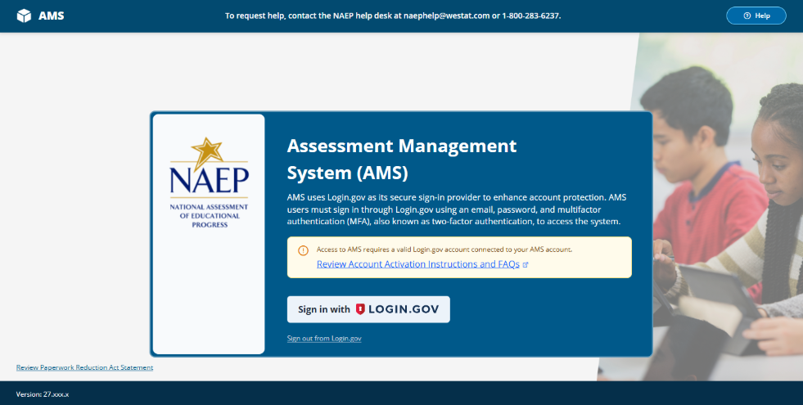

Error messaging will be displayed on the AMS sign in screen when applicable:
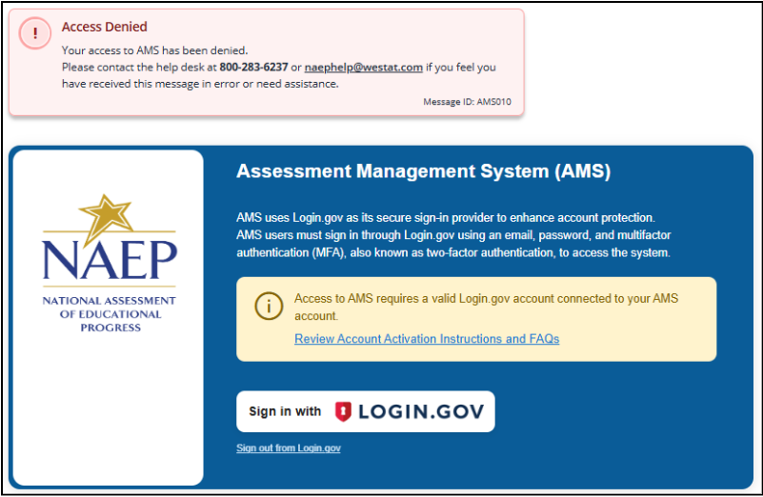

The table below identifies the error messages that may appear on the sign in screen. The message ID’s are included to support Help Desk team members resolve user sign in issues:
AMS Code | Message
AMS005 | Sign In Error  An issue was encountered while signing you in to the AMS. Please try signing in again.  If the issue persists, contact the NAEP help desk at 800-283-6237 or naephelp@westat.com.  Message ID: AMS005
AMS007 | System Error  An unexpected error occurred. Please retry signing in to the AMS.  If the issue persists please contact the help desk at 800-283-6237 or naephelp@westat.com  Message ID: AMS007
AMS010 | Access Denied  Your access to AMS has been denied.  Please contact the help desk at 800-283-6237 or naephelp@westat.com if you feel you have received this message in error or need assistance.  Message ID: AMS010
AMS012 | Sign In Error  An issue was encountered while signing you in to the AMS. Please try signing in again.  If the issue persists, contact the NAEP help desk at 800-283-6237 or naephelp@westat.com.  Message ID: AMS012
AMS013 | Internet Connection  An issue has been detected with the internet connection. Please check your WiFi or network settings.  If the issue persists, contact the NAEP help desk at 800-283-6237 or naephelp@westat.com.  Message ID: AMS013
AMS014 | Sign in Error  You could not be connected to Login.gov at tis time Please try signing in again.  If this issue persists, contact the NAEP help desk at 800-283-6237 or naephelp@westat.com.  Message ID: AMS014
AMS016 | Access Denied  Your access to AMS has been denied.  Please contact the help desk at 800-283-6237 or naephelp@westat.com if you feel you have received this message in error or need assistance.  Message ID: AMS016
AMS017 | Sign In Error  An issue was encountered while signing you in to the AMS. Please try signing in again.  If the issue persists, contact the NAEP help desk at 800-283-6237 or naephelp@westat.com.  Message ID: AMS017
AMS018 | Sign In Error  An issue was encountered while signing you in to the AMS. Please try signing in again.  If the issue persists, contact the NAEP help desk at 800-283-6237 or naephelp@westat.com.  Message ID: AMS018
AMS019 | Sign In Error  An issue was encountered while signing you in to the AMS. Please try signing in again.  If the issue persists, contact the NAEP help desk at 800-283-6237 or naephelp@westat.com.  Message ID: AMS019

Appendix I2: 2027 Paperwork Reduction Act Statement (NEW)

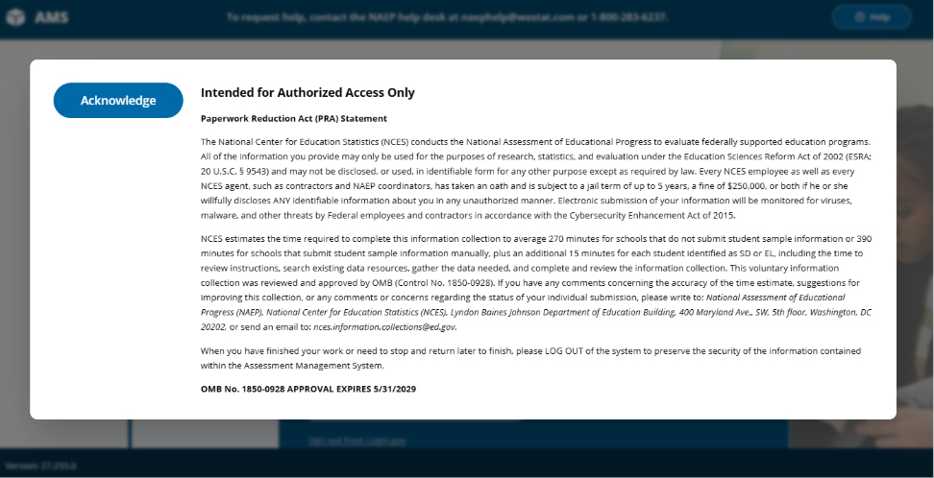

Paperwork Reduction Act (PRA) Statement

The National Center for Education Statistics (NCES) conducts the National Assessment of Educational Progress to evaluate federally supported education programs. All of the information you provide may only be used for the purposes of research, statistics, and evaluation under the Education Sciences Reform Act of 2002 (ESRA; 20 U.S.C. § 9543) and may not be disclosed, or used, in identifiable form for any other purpose except as required by law. Every NCES employee as well as every NCES agent, such as contractors and NAEP coordinators, has taken an oath and is subject to a jail term of up to 5 years, a fine of $250,000, or both if he or she willfully discloses ANY identifiable information about you in any unauthorized manner. Electronic submission of your information will be monitored for viruses, malware, and other threats by Federal employees and contractors in accordance with the Cybersecurity Enhancement Act of 2015.

NCES estimates the time required to complete this information collection to average 270 minutes for schools that do not submit student sample information or 390 minutes for schools that submit student sample information manually, plus an additional 15 minutes for each student identified as SD or EL, including the time to review instructions, search existing data resources, gather the data needed, and complete and review the information collection. This voluntary information collection was reviewed and approved by OMB (Control No. 1850-0928). If you have any comments concerning the accuracy of the time estimate, suggestions for improving this collection, or any comments or concerns regarding the status of your individual submission, please write to: National Assessment of Educational Progress (NAEP), National Center for Education Statistics (NCES), Lyndon Baines Johnson Department of Education Building, 400 Maryland Ave., SW, 5th floor, Washington, DC 20202, or send an email to: nces.information.collections@ed.gov.
When you have finished your work or need to stop and return later to finish, please LOG OUT of the system to preserve the security of the information contained within the Assessment Management System.
OMB No. 1850-0928 APPROVAL EXPIRES 5/31/2029

Appendix I3: 2027 NAEP Data Security Agreement (NEW)
The AMS Data Security Agreement is displayed to authenticated users upon first time attempt to access the AMS. Users must ensure that all required fields are completed and click “Agree and Submit” to successfully access the AMS.
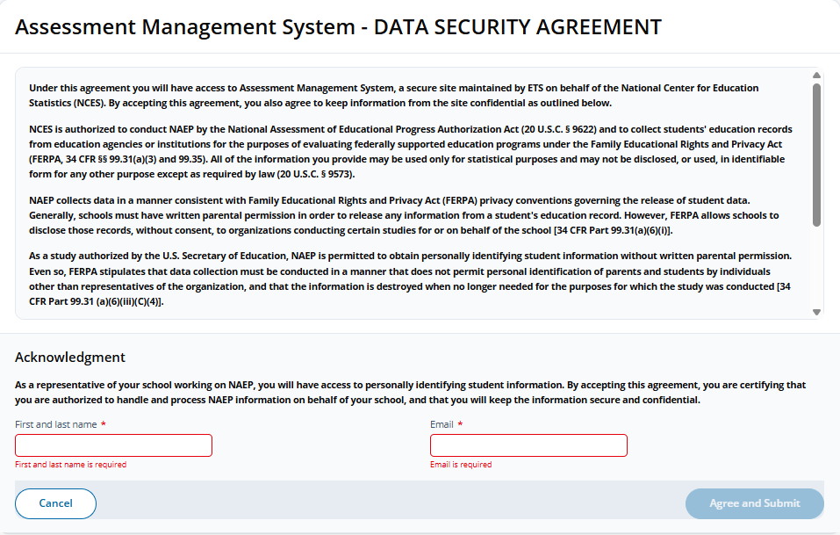
Note. A user’s first and last name auto populates based on the name provided in the user’s role profile.
Data Security Agreement (English)
Assessment Management System - DATA SECURITY AGREEMENT
Under this agreement you will have access to Assessment Management System, a secure site maintained by ETS on behalf of the National Center for Education Statistics (NCES). By accepting this agreement, you also agree to keep information from the site confidential as outlined below.
NCES is authorized to conduct NAEP by the National Assessment of Educational Progress Authorization Act (20 U.S.C. § 9622) and to collect students’ education records from education agencies or institutions for the purposes of evaluating federally supported education programs under the Family Educational Rights and Privacy Act (FERPA, 34 CFR §§ 99.31(a)(3) and 99.35). All of the information you provide may be used only for statistical purposes and may not be disclosed, or used, in identifiable form for any other purpose except as required by law (20 U.S.C. § 9573).
NAEP collects data in a manner consistent with Family Educational Rights and Privacy Act (FERPA) privacy conventions governing the release of student data. Generally, schools must have written parental permission in order to release any information from a student’s education record. However, FERPA allows schools to disclose those records, without consent, to organizations conducting certain studies for or on behalf of the school [34 CFR Part 99.31(a)(6)(i)].
As a study authorized by the U.S. Secretary of Education, NAEP is permitted to obtain personally identifying student information without written parental permission. Even so, FERPA stipulates that data collection must be conducted in a manner that does not permit personal identification of parents and students by individuals other than representatives of the organization, and that the information is destroyed when no longer needed for the purposes for which the study was conducted [34 CFR Part 99.31 (a)(6)(iii)(C)(4)].
NAEP fully conforms to the requirements of the Family Educational Rights and Privacy Act of 1974 (FERPA) [20 U.S.C. 1232g; 34 CFR Part 99]. The NAEP procedures and data collection are FERPA compliant. FERPA compliance is ensured through stringent confidentiality requirements governing data transmission, cloud data storage, and personnel protocols, all designed to safeguard personally identifiable information (PII) in accordance with federal regulations. Data is encrypted during transmission using SSL/TLS 1.2 or higher, and data at rest is protected using AES-256 encryption and other advanced encryption standards within a FedRAMP-compliant cloud infrastructure that adheres to FISMA security controls. Access to data is tightly controlled through multi-factor authentication (MFA) and role-based access control (RBAC) to ensure that only authorized users can access sensitive information. In alignment with FERPA guidelines, all individuals, including contractors and school personnel are required to sign confidentiality assurances, pledging to maintain the privacy and security of education records and to exercise reasonable care to prevent unauthorized access to information in their possession.
Acknowledgment
As a representative of your school working on NAEP, you will have access to personally identifying student information. By accepting this agreement, you are certifying that you are authorized to handle and process NAEP information on behalf of your school, and that you will keep the information secure and confidential.
First and last name
Email

Appendix I4: 2027 AMS Account Activation Email All District/School Roles (except SD/EL Specialist (NEW)

The NAEP Assessment Management System (AMS) invitation-based secured web application uses Login.gov to authenticate AMS users. District and school AMS users receive a NAEP AMS Account Activation email, automatically sent out of the AMS, when they are first invited (assigned a role within the AMS). Users must activate their NAEP AMS account to gain access to the AMS.

From: naep-ams@naepnpd.org
Subject: Account Activation for NAEP AMS – Time Sensitive

Dear [First name] [Last name],

You were identified to support the National Assessment of Educational Progress (NAEP) as [Role] for [School/District Name]. Please activate your NAEP Assessment Management System (AMS) account to begin using the AMS. The AMS will be your main resource for preparing for the upcoming NAEP assessment.

Important: This Activate AMS Account link in this email is unique to your AMS account activation. Please do not forward or share this email with others.

Thank you in advance for your support.
Select the Activate AMS Account button below to review additional instructions and complete your NAEP AMS account activation.
Activate AMS Account
This link expires in 30 days.
If you have questions or need assistance, please contact the NAEP help desk at 1-800-283-6237 or naephelp@westat.com.
This is an automatically generated message from the NAEP Assessment Management System (AMS). Replies to this email are not monitored.

<link>National Assessment of Educational Progress (NAEP)

<link> Assessment Management System (AMS)

Appendix I5: 2027 AMS Account Activation Email SD/EL Specialist Role (NEW)
Given the specialized nature and work of the SD/EL Specialist Role, the SD/EL Specialist has a modified version of the AMS Account Activation email.

From: naep-ams@naepnpd.org
Subject: NAEP AMS Account Activation Instructions for SD/EL Specialists

Dear [SD/EL Specialist First name] [SD/EL Specialists Last name],

You were identified to support the National Assessment of Educational Progress (NAEP) as a Students with Disabilities and/or English Learners Specialist for [School Name]. Specialists provide information and determine how selected students with disabilities (SD) and/or English learners (EL) participate. To ensure that NAEP reflects the educational progress of all students, these students must be included to the fullest extent possible.

Please activate your NAEP Assessment Management System (AMS) account to begin using the AMS. Once you have activated your account, sign in to the AMS to review the NAEP Inclusion Policy. After you have reviewed the policy, select manage on the Students with Disabilities (SD) and English Leaners (EL) section to provide information about how SD and/or EL students will participate on NAEP.

Important: This Activate AMS Account link in this email is unique to your AMS account activation. Please do not forward or share this email with others.

Thank you in advance for your support.
Select the Activate AMS Account button below to review additional instructions and complete your NAEP AMS account activation.
Activate AMS Account
This link expires in 30 days.
If you have questions or need assistance, please contact the NAEP help desk at 1-800-283-6237 or naephelp@westat.com
This is an automatically generated message from the NAEP Assessment Management System (AMS). Replies to this email are not monitored.

<link>National Assessment of Educational Progress (NAEP)

<link> Assessment Management System (AMS)

Appendix I6: 2027 AMS Account Activation Instructions and FAQ (NEW)

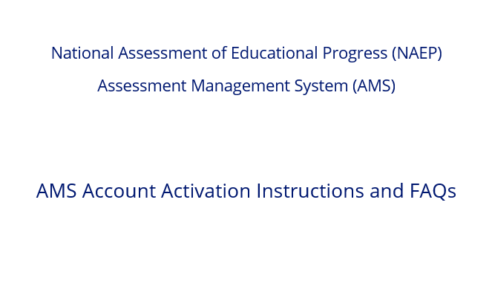
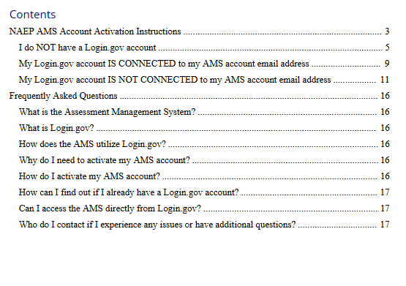

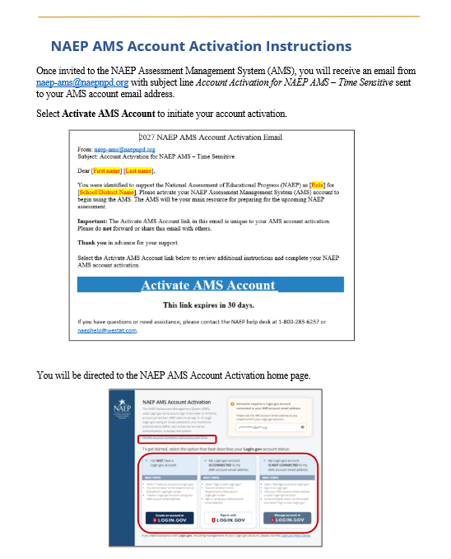

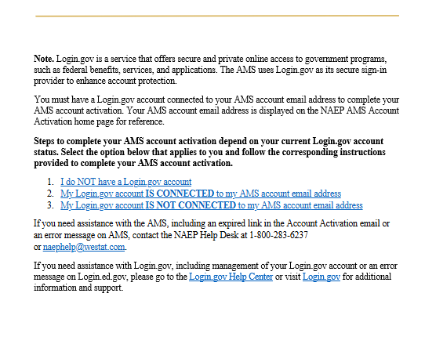

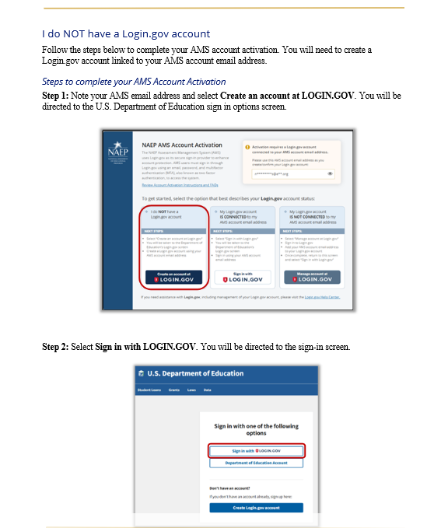

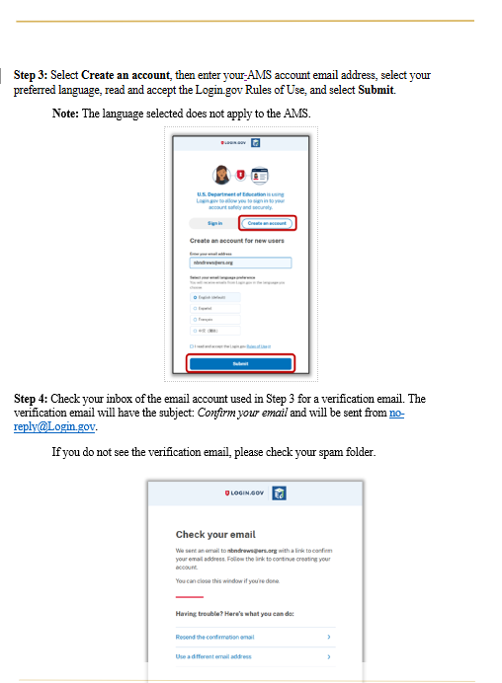

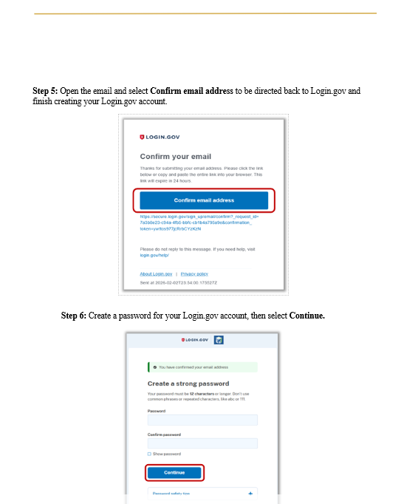

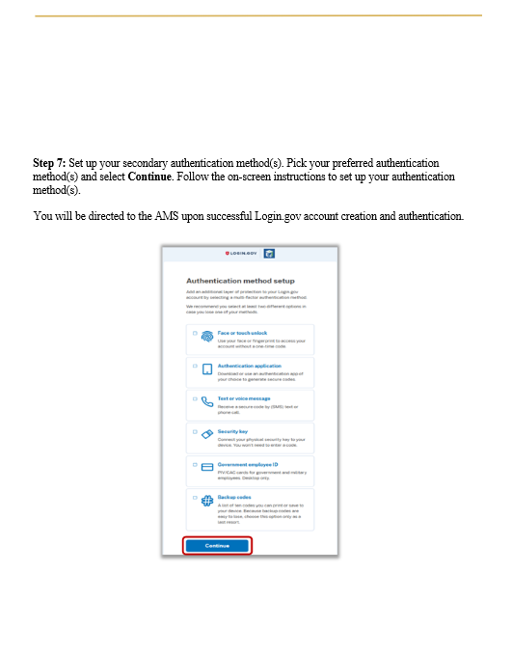

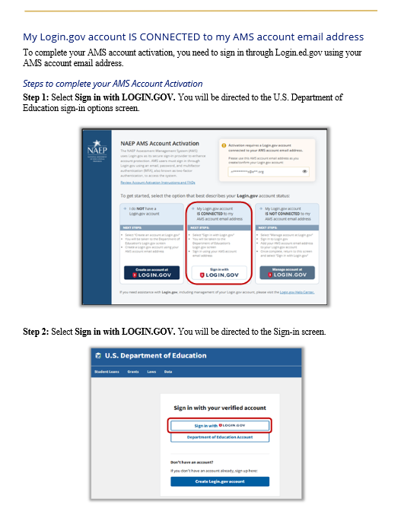

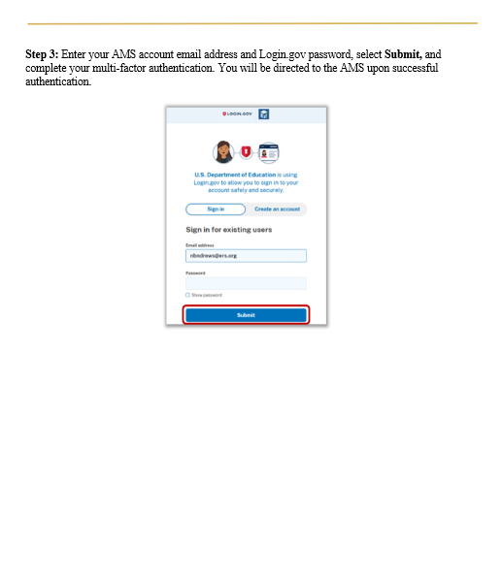

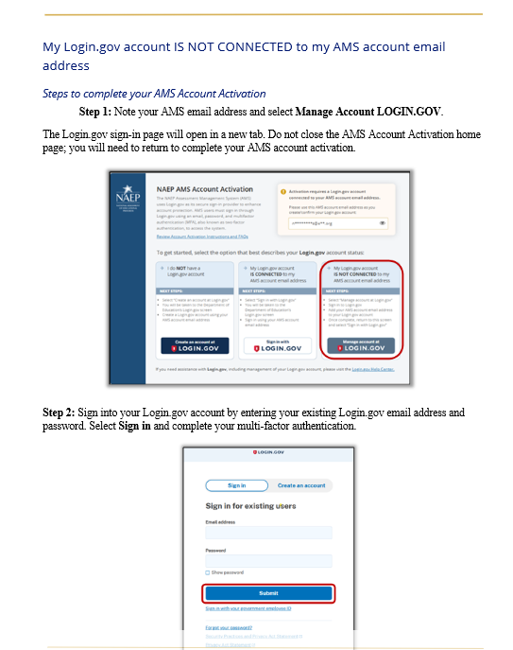

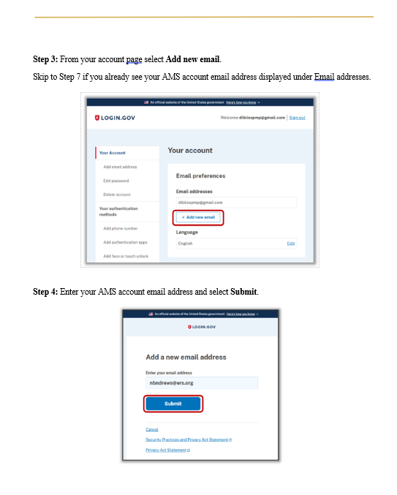

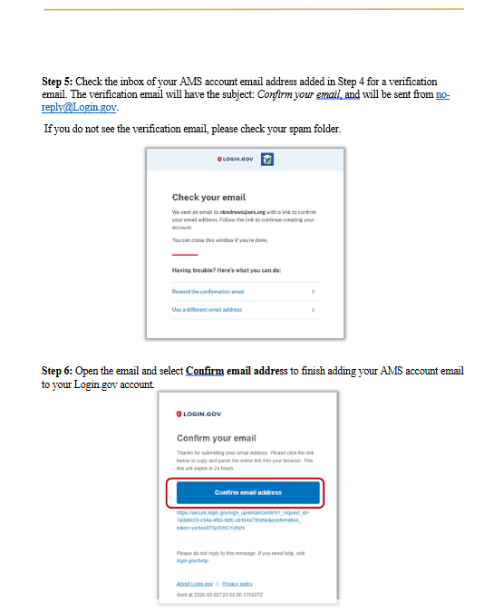

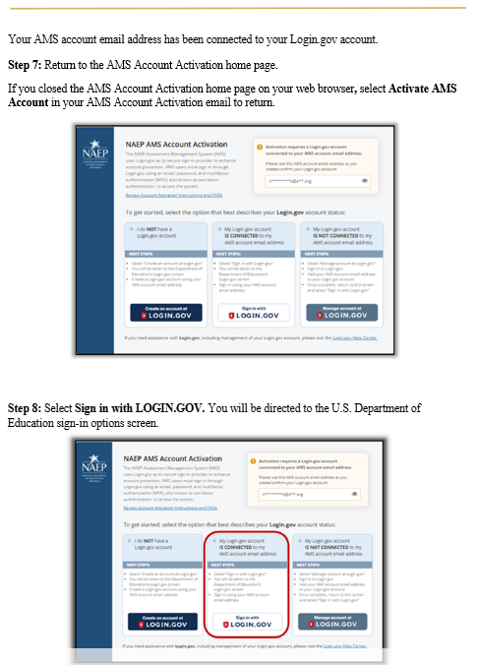

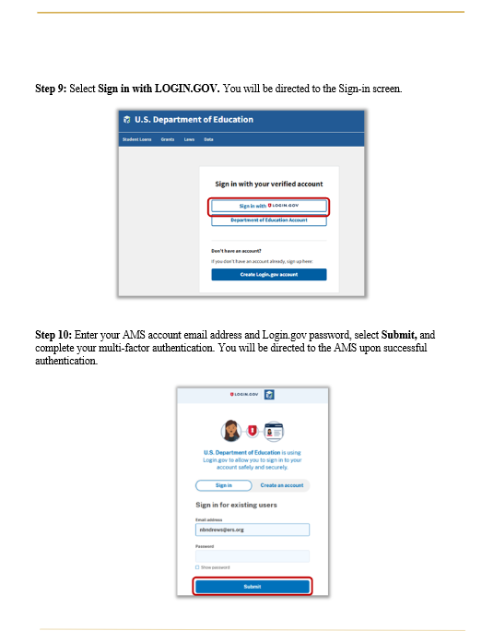

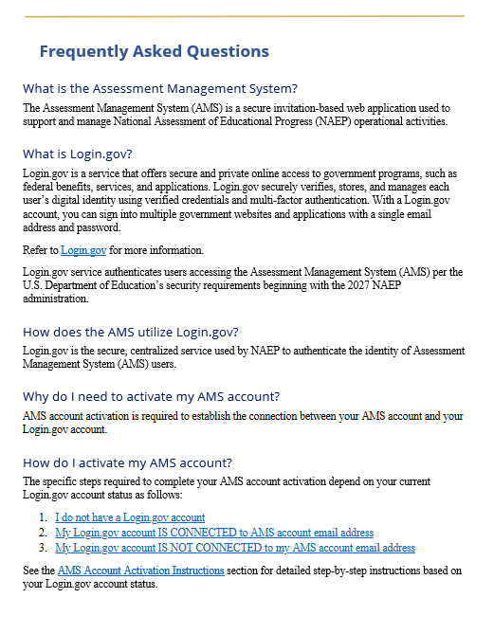

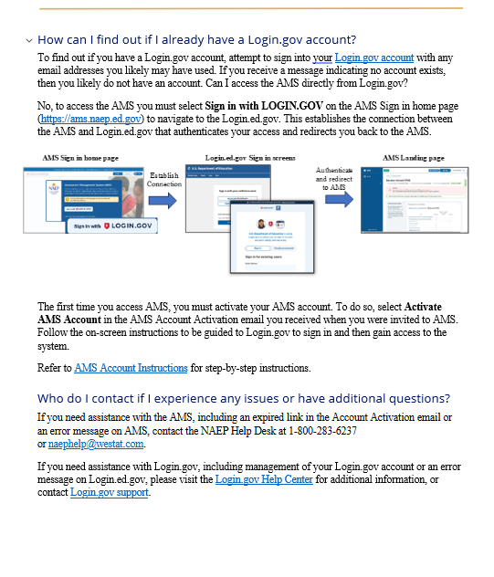

Appendix I7: 2027 AMS Account Activation Home Page (NEW)
Upon selecting the AMS Account Activation link in the NAEP AMS Account Activation email, users are directed to the NAEP AMS Account Activation home screen.
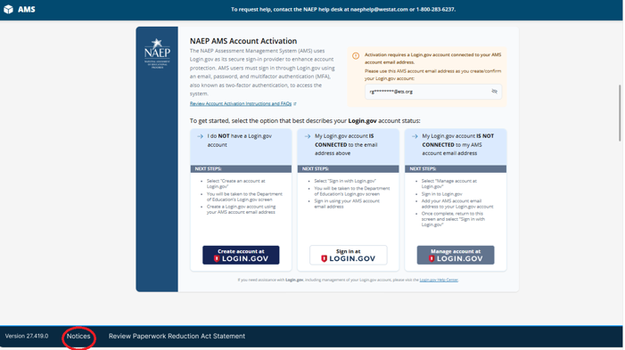
Users must have a Login.gov account that is connected with their AMS account email address. Steps to complete AMS account activation depend on the user’s current Login.gov account status. Instructions outlining NAEP AMS account activation process with detailed step by step instructions (based on a user’s Login.gov account status) and Frequently Asked Questions (FAQs) are available for download from the NAEP AMS Account Activation home screen.
In certain instances, users may receive an error message upon selecting the AMS Account Activation link in the NAEP AMS Account Activation email or attempting to navigate directly (not via link in email) to the NAEP AMS Account Activation home screen.
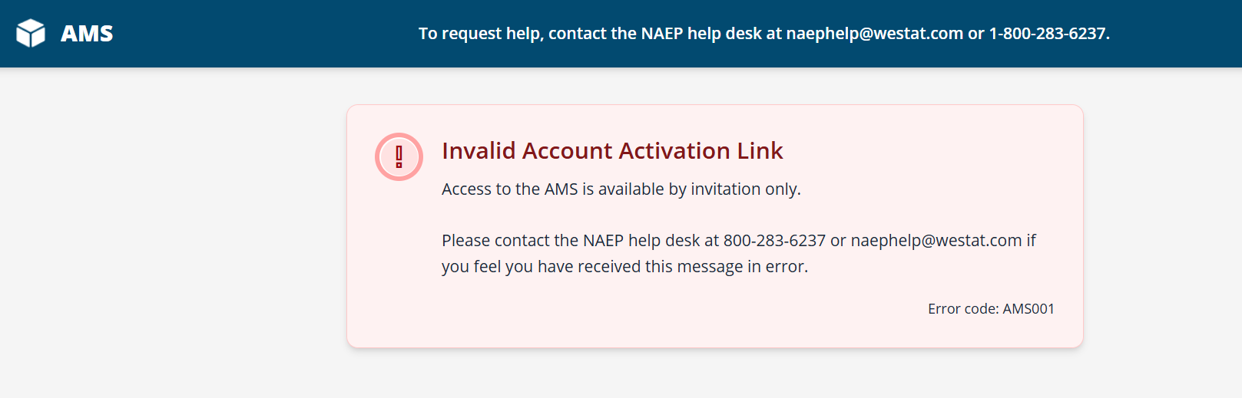
The table below identifies the error messages that may appear to a user. The message ID’s are included to support Help Desk team members resolve user issues:
AMS Code | Message
AMS001 | Invalid Account Activation Link  Access to the AMS is available by invitation only.  Please contact the NAEP help desk at 800-283-6237 or naephelp@westat.com if you feel you have received this message in error.  Message ID: AMS001
AMS003 | Invalid Account Activation Link  This AMS Account Activation Link has expired.  Please contact the help desk at 800-283-6237 or naephelp@westat.com for assistance.  Message ID: AMS003
AMS004 | Invalid Account Activation Link  This AMS Account Activation Link is no longer valid.  Please contact the help desk at 800-283-6237 or naephelp@westat.com if you feel you have received this message in error or need assistance.  Message ID: AMS004
AMS006 | Invalid Account Activation Link  This AMS Account Activation Link is no longer valid.  Please contact the help desk at 800-283-6237 or naephelp@westat.com if you feel you have received this message in error or need assistance.  Message ID: AMS006
AMS007 | System Error  An unexpected error occurred. Please retry clicking the Account Activation Link in your invitation email.  If the issue persists please contact the help desk at 800-283-6237 or naephelp@westat.com  Message ID: AMS007
AMS013 | Internet Connection  An issue has been detected with the internet connection. Please check your WiFi or network settings.  If the issue persists please contact the help desk at 800-283-6237 or naephelp@westat.com  Message ID: AMS013

Appendix I8: 2027 Assessment Logistics (NEW)

Assessment Logistics
From the school summary page, schools will access the assessment logistics section by selecting the Manage button on the Assessment Logistics tile. An Info required tag will display until all required information is provided throughout the Assessment Logistics section, at which point the label will convert to “Completed”.
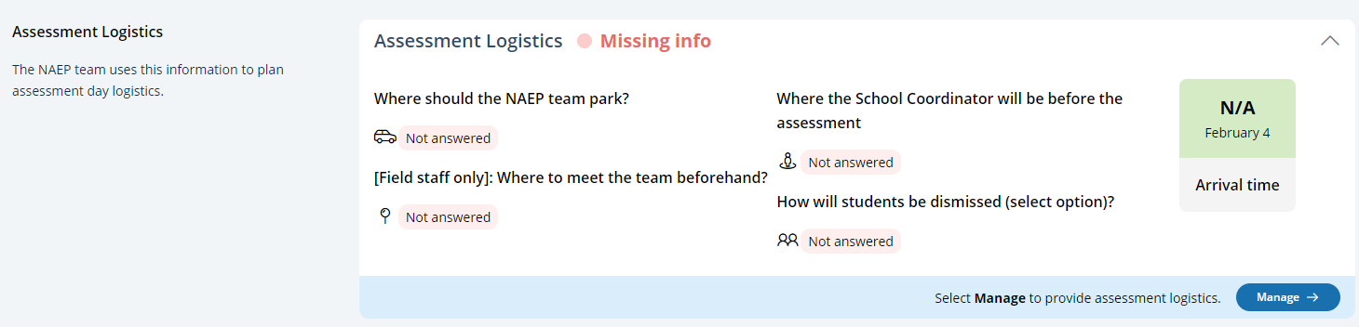

In the Assessment Logistics section, schools will provide details to support NAEP field staff representatives on assessment day that include:
- School start and end time
- Assessment Groups
- Schedule Groups
- Student Group Details
- Health and Safety Protocols
- Parking and arrival
- Checking In
- Classroom Protocols
- Special Circumstances
- After the Assessment

A tutorial video (see Appendix I28) is provided to support users with completing the Assessment Logistics section. Additionally, a “Room layouts for NAEP assessments” resource is also available in the Assessment Logistics section for review.
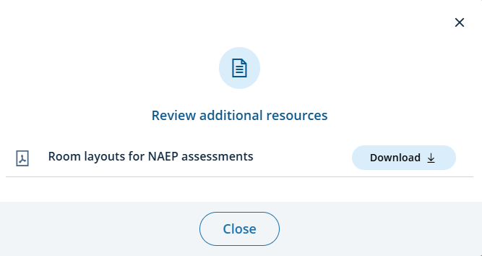

Note. The AMS is undergoing a redesign to standardize the user interface (UI). The content shown in the screenshots and supporting narrative aligns with 2027 NAEP administration requirements. The 2027 NAEP administration is a pilot administration specific to Grade 8 Science. Any screenshots referencing “Main”, Grade 4, and/or any subject other than Science, will display “Pilot”, “Grade 8”, and “Science” respectively in the AMS for the 2027 NAEP Administration.

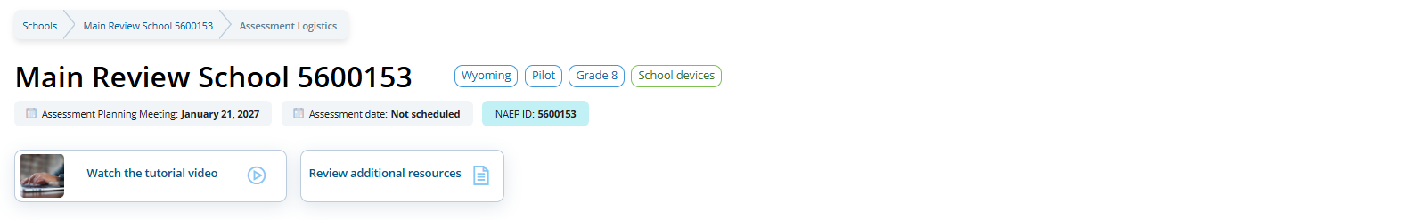
Assessment Logistics (Manage Mode)
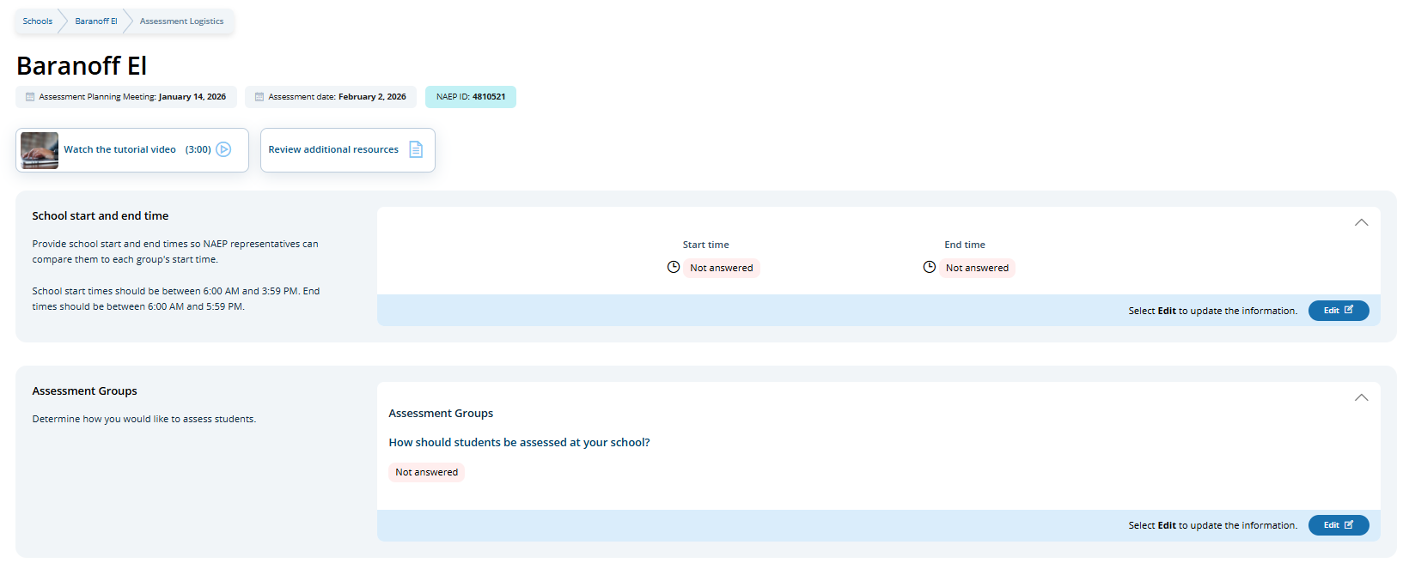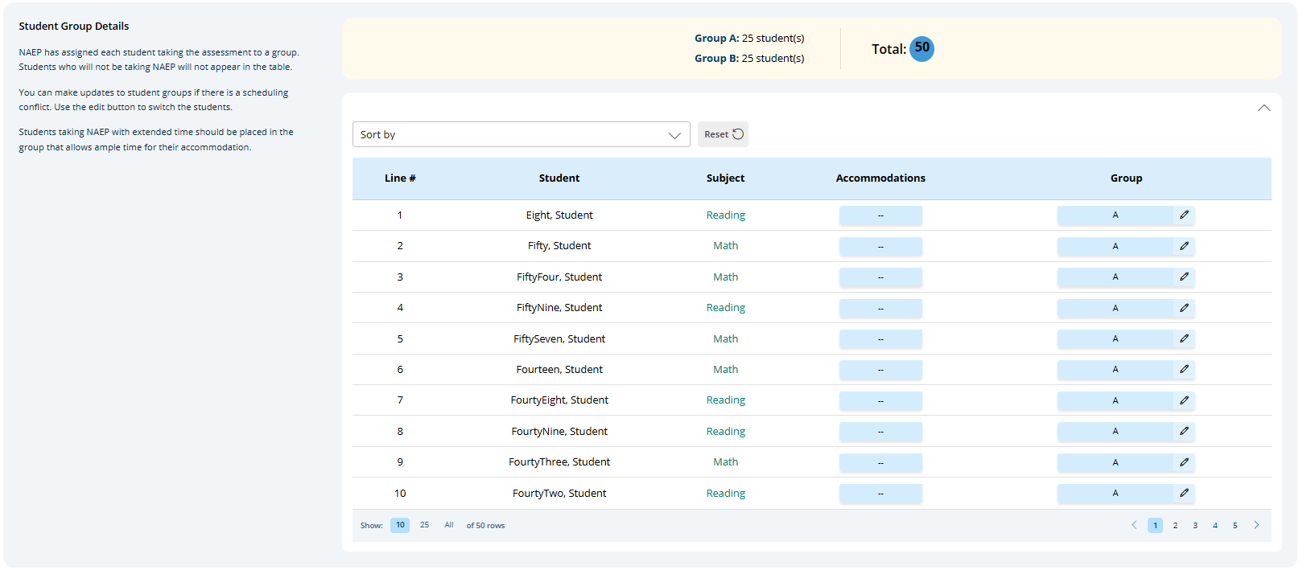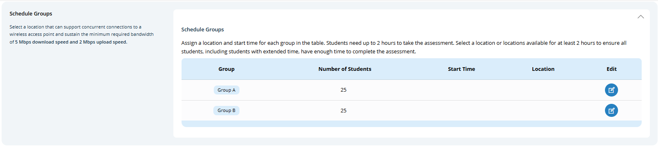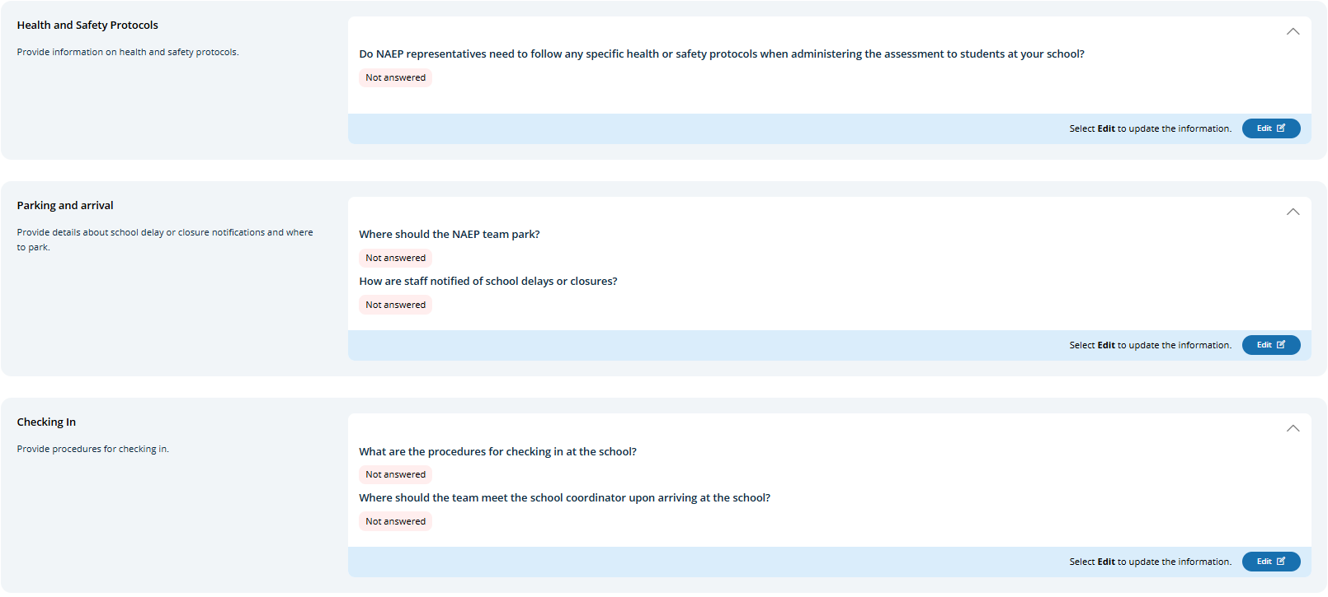
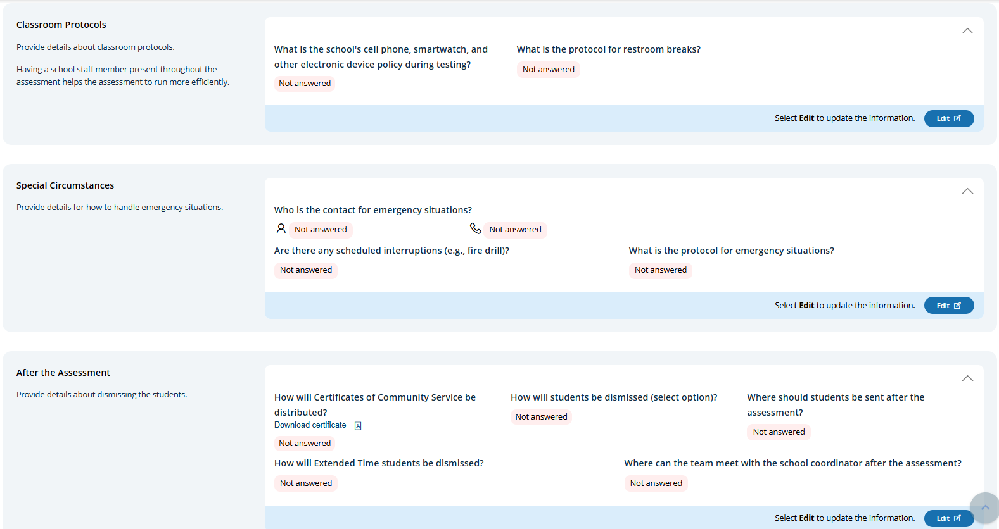

School start and end time
Users select edit on the School start and end time to provide the start and end time for the school using the time selection dropdowns.
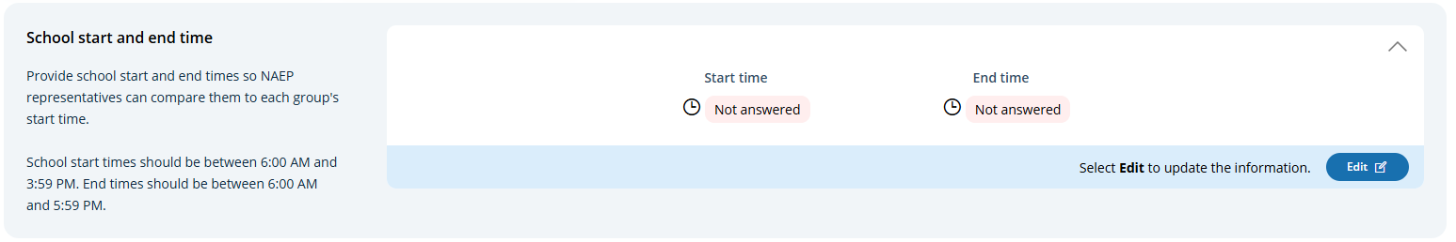
Edit Mode
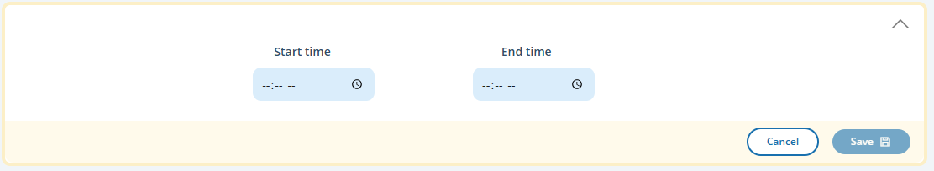
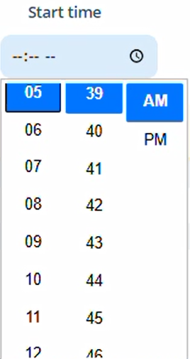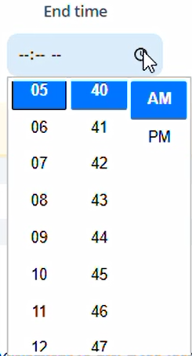

Assessment Groups
The Assessment Groups tile is where school staff identify how students will be grouped for the NAEP assessment. User’s select the Edit button to enter details.
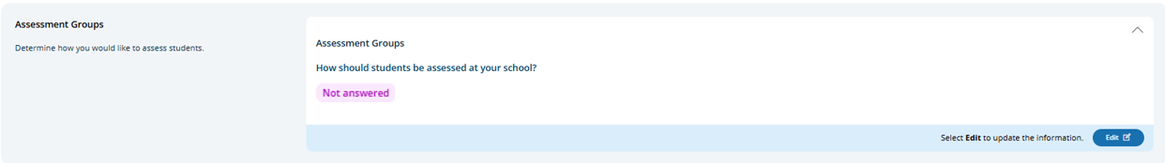
Schools participating with school devices (Edit Mode)
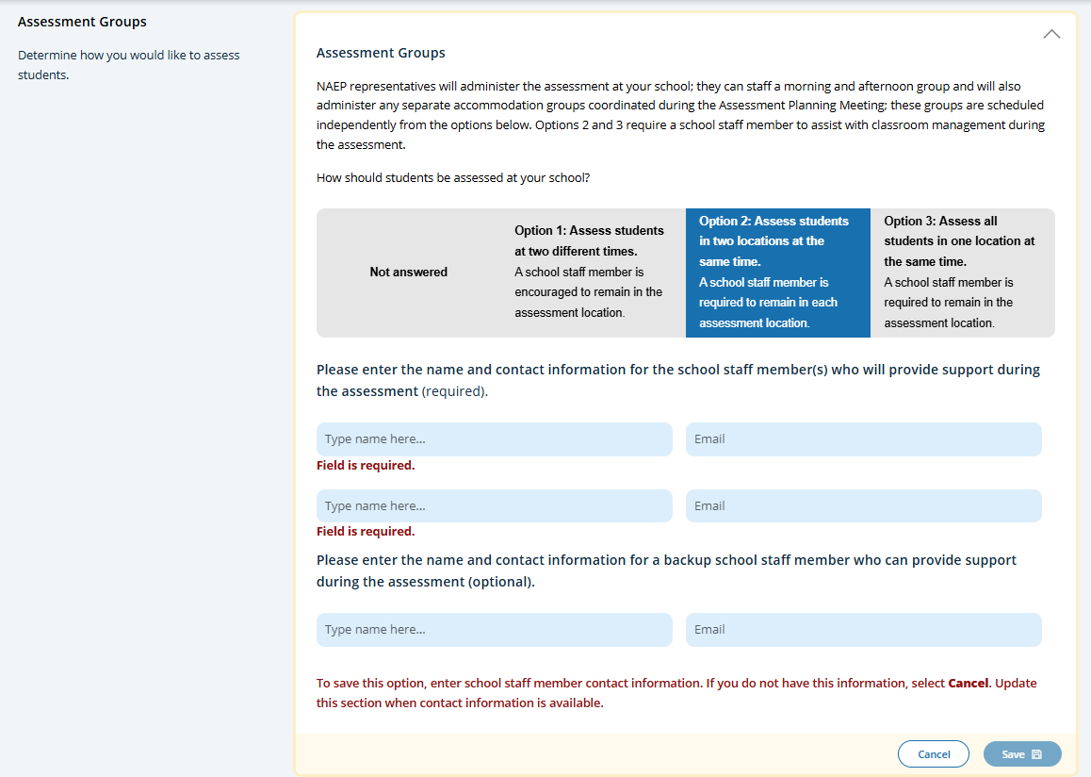
This tile only appears for schools participating in NAEP with school devices. It describes the three different grouping options and outlines the requirements of school staff support on assessment day. Grouping options are as follows:
- Option 1: Assess students at two different times. A school staff member is encouraged to remain in the assessment location.
- Option 2: Assess students in two locations at the same time. A school staff member is required to remain in each assessment location.
- Option 3: Assess all students in one location at the same time. A school staff member is required to remain in the assessment location.
Name and contact information of school staff to be available to provide support is entered. The number of support staff required depends on the group.
Schedule Groups
The Schedule Groups tile is where users enter start times and locations for each group, and add groups as needed. Users select the icon in the Edit column to enter group start time and location. Selecting the Add another group button populates another group in the table view.
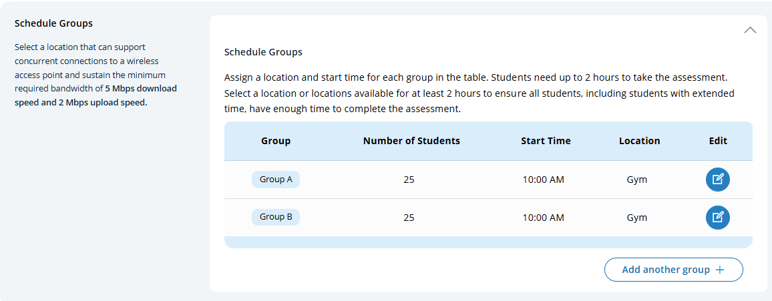
Schools assigned to NAEP Devices have additional instructions about the time needed between groups.
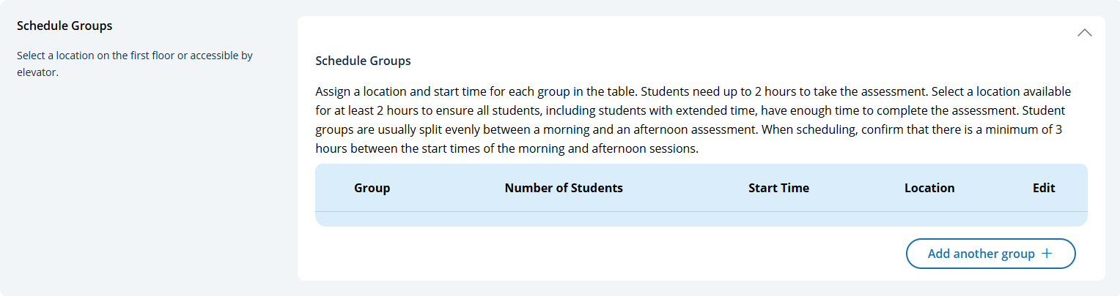
Edit Mode - Schedule groups pop-up:
The Save button becomes enabled once all required information is provided. Selecting the Delete button deletes the group. Note. Any students previously assigned to a group that is deleted are automatically reassigned to a different group.
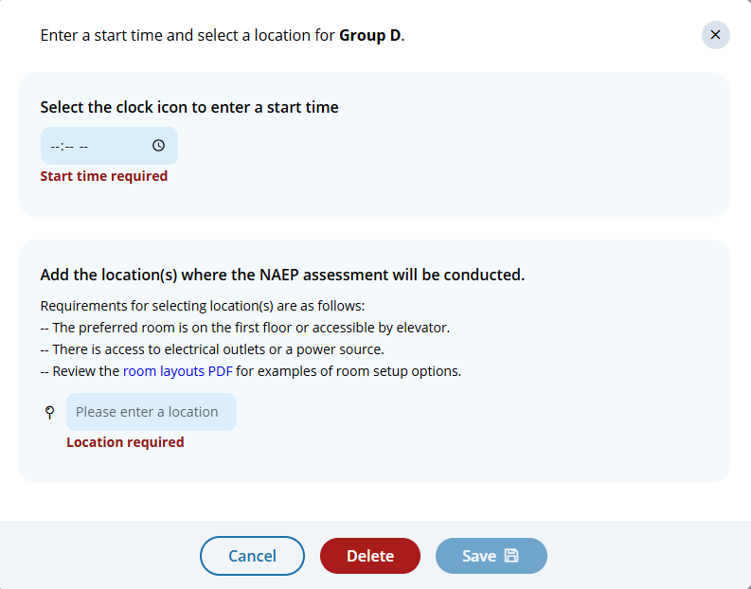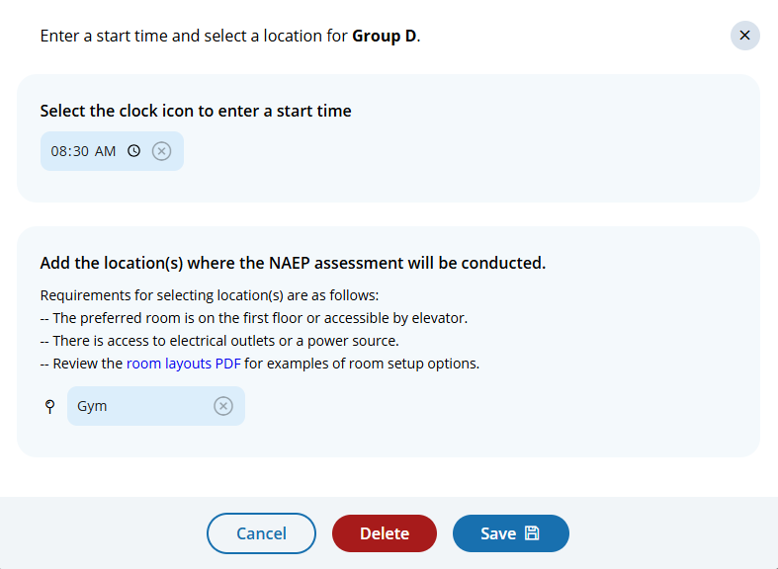
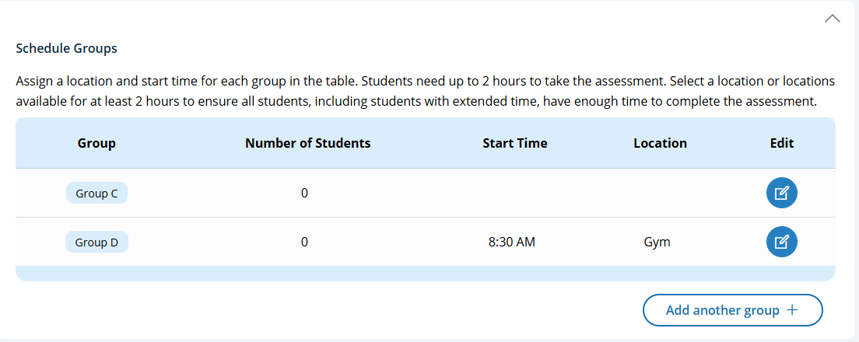

Student Group Details
By default sampled students are assigned to groups, which the school can modify as needed in the Student Group Details section.
Edit Mode - Student Group Details pop-up:
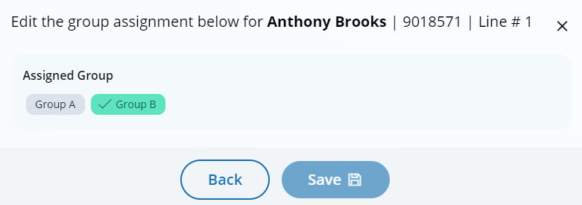

Health and Safety Protocols
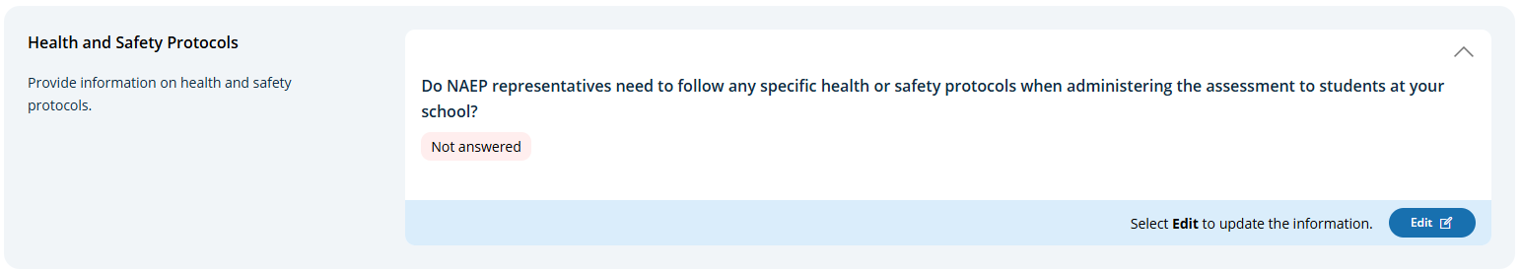
Health and Safety Protocols (Edit Mode)
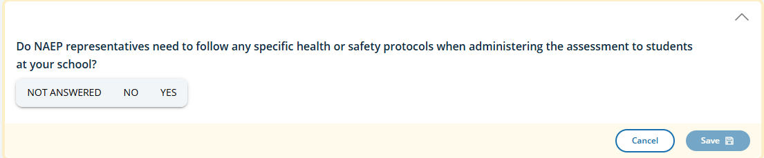
If yes is selected, then an additional text box appears for the school to provide specific details:
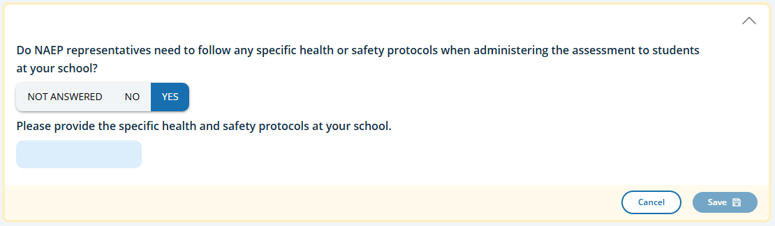
Parking and arrival
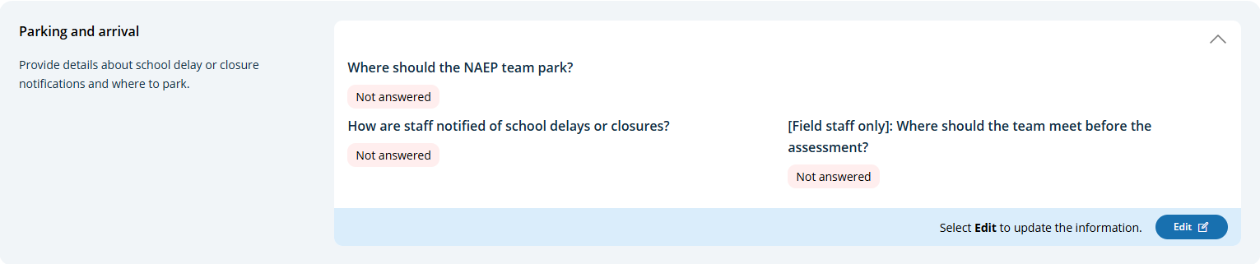
Parking and arrival (Edit Mode)
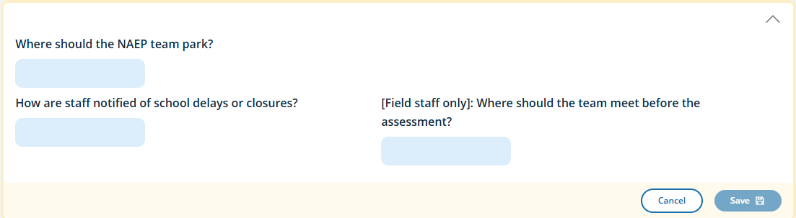
Checking In
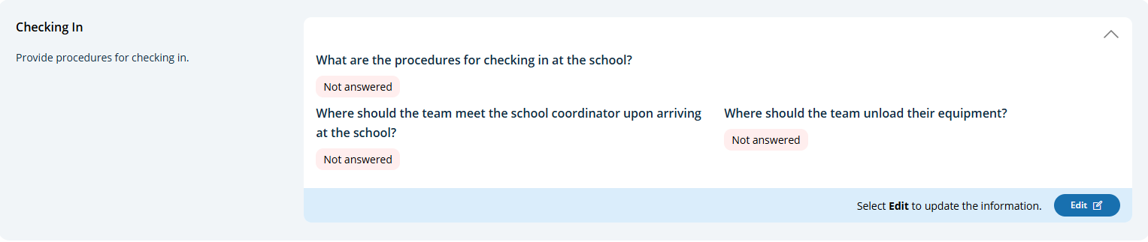
Parking and arrival (Edit Mode)
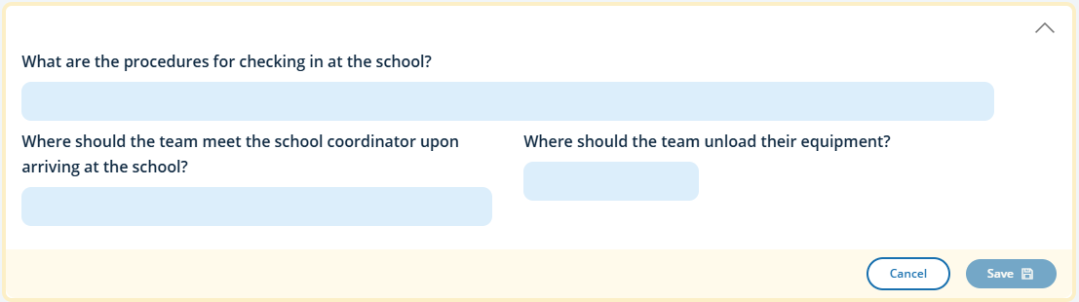
Classroom Protocols
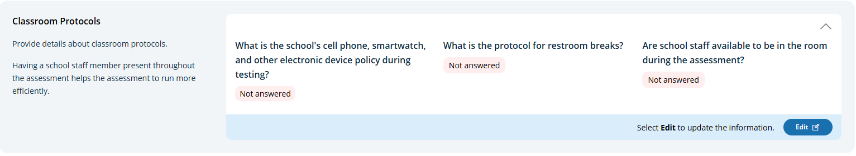
Classroom Protocols (Edit Mode)
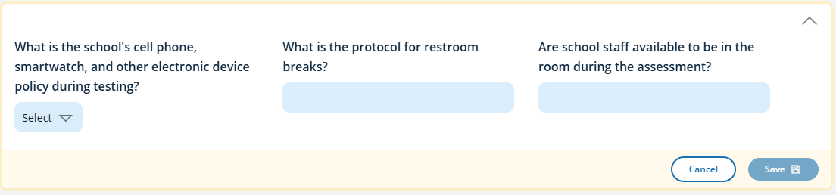
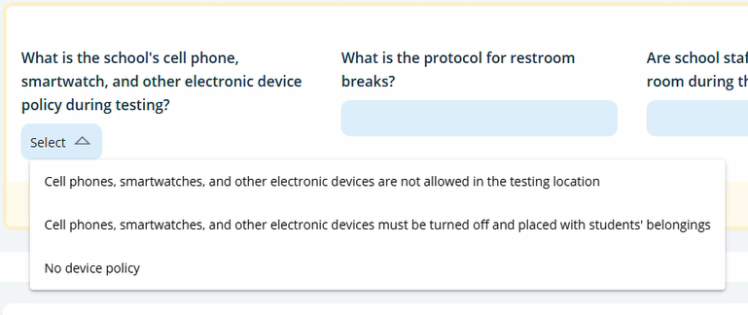

Special Circumstances
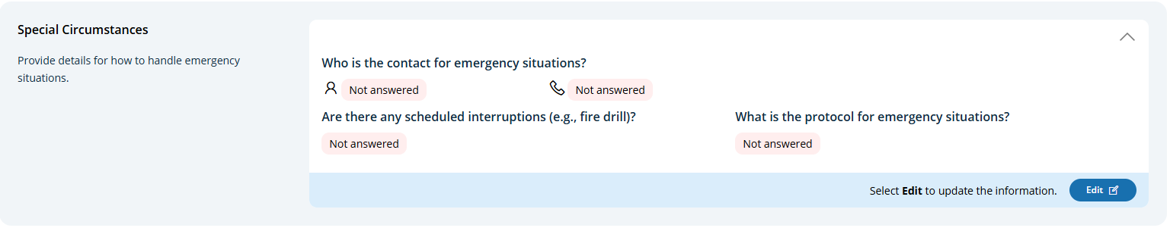
Special Circumstances (Edit Mode)
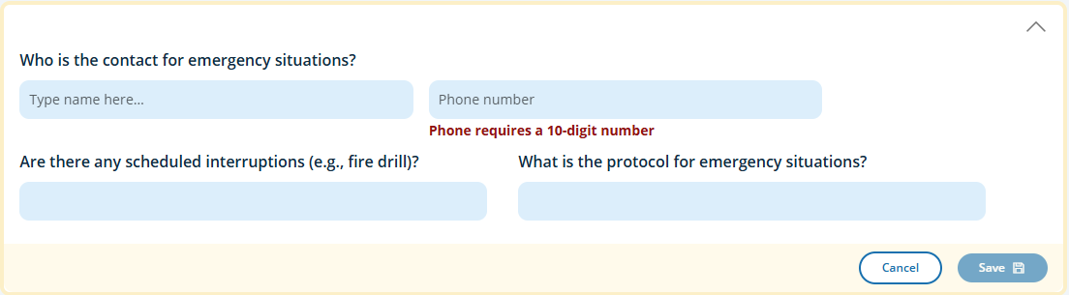
After the Assessment
In the After the Assessment section, schools can select from the following options for distributing Certificates of Community Service and student dismissal. A Download of the Certificate of Community Service is also available.
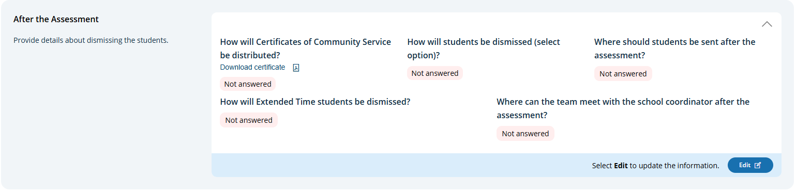
After the Assessment (Edit Mode)
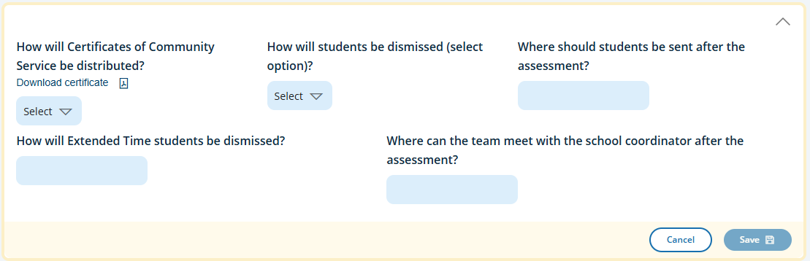
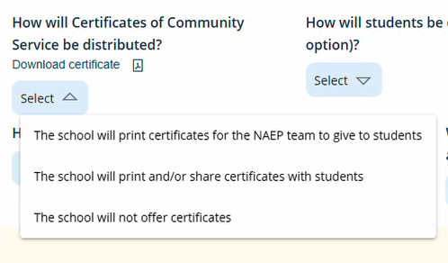
- Certificates of Community Service dropdown menu options:
  - The School will print certificates for the NAEP team to give to students
  - The school will print and/or share certificates with students
  - The school will not offer certificates

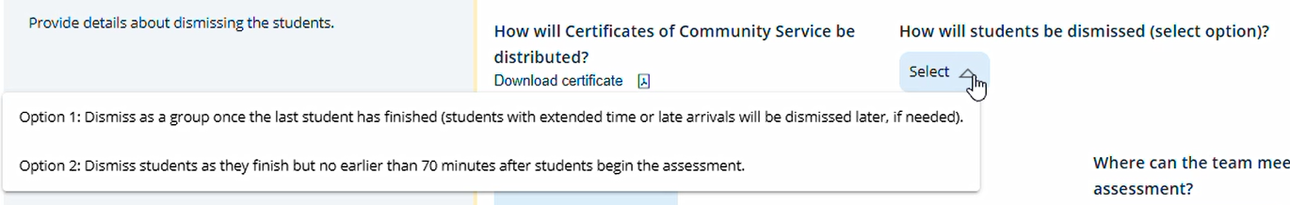
- Dismissal dropdown menu options:
  - Option 1: Dismiss as a group once the last student has finished (students with extended time or late arrivals will be dismissed later, if needed).
  - Option 2: Dismiss students as they finish but no earlier than 70 minutes after students begin the assessment.

Certificate of Community Service (Download)
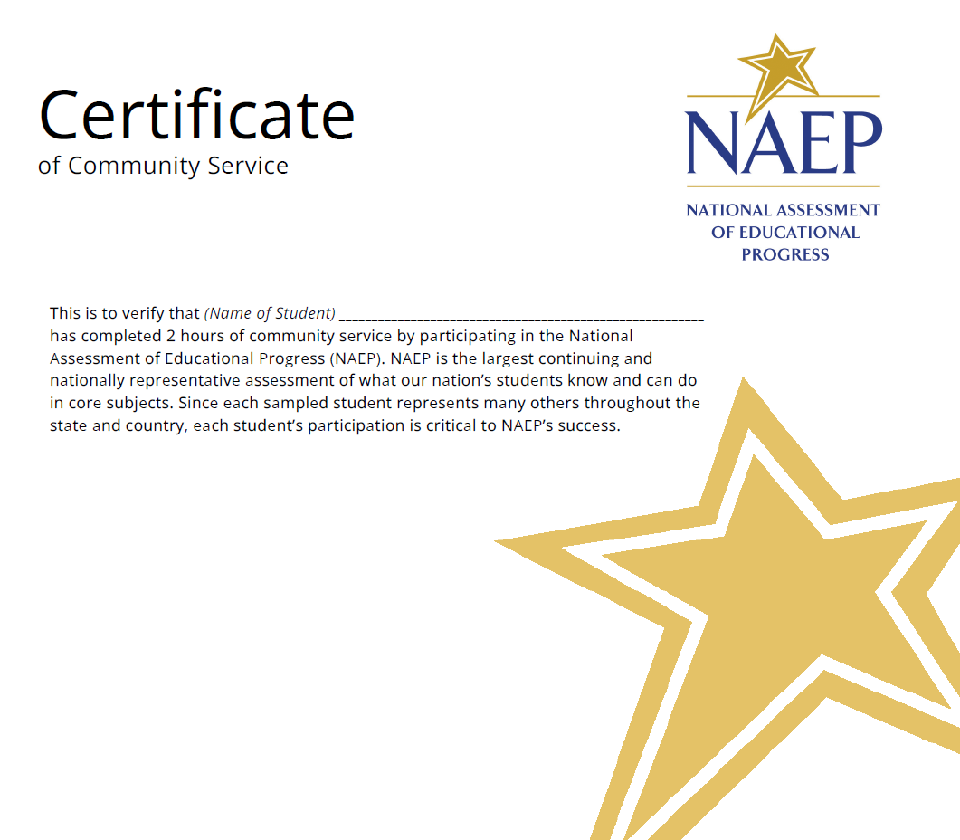

Appendix I9: 2027 AMS School and Teacher Questionnaire Emails (NEW)
Email with NAEPQ URL (SQ version)
To: NAEP SQ Respondent
Subject: NAEP School Questionnaire – Link

Dear [SQ Respondent First Name] [SQ Respondent Last Name],
[Grade/Age] students at [school name] will take [science] assessments on [assessment date]. The National Assessment of Educational Progress (NAEP) is the only ongoing assessment of what our nation’s students know and can do in a variety of subjects.
In addition to conducting assessments, NAEP gathers information on school policies and characteristics by using a school questionnaire. [School coordinator name] has identified you as the appropriate individual to complete the questionnaire. Your responses will provide important information for educators, policymakers, and researchers to better understand the context in which students learn. This enhanced understanding can help improve education in our nation's classrooms. To complete the questionnaire:
- Select the questionnaire link below or copy/paste into your browser.
- See separate email for the access code, the subject is NAEP School Questionnaire – Access Code.
- Please complete the questionnaire before [assessment date]. It takes approximately [Grade 8 =20] minutes to complete, and does not have to be completed in one visit.

[NAEPq link]
Questionnaire URL: <URL Link>

For technical assistance, contact the NAEP help desk at <phone number> or naephelp@westat.com.
Visit https://nces.ed.gov/nationsreportcard/experience/survey_questionnaires.aspx to view PDFs of the questionnaires and explore how your responses contribute to reportable NAEP results that show what our nation’s students know and can do.
National Assessment of Educational Progress (NAEP)

Email with NAEPQ Access Code (SQ version)

To: NAEP SQ Respondent
Subject: NAEP School Questionnaire – Access Code

Dear [SQ Respondent First Name] [SQ Respondent Last Name],
Thank you for supporting the National Assessment of Educational Progress (NAEP).
You should have a separate email with the NAEP School Questionnaire link for [school name]. The Access Code is available below.
[Access Code]
For technical assistance, contact the NAEP help desk at <phone number> or naephelp@westat.com.
National Assessment of Educational Progress (NAEP)

Email NAEP School Questionnaire - Reminder (SQ version)
To: NAEP SQ Respondent
CC: School coordinator
Subject: NAEP School Questionnaire – Reminder

Dear [SQ Respondent First Name] [SQ Respondent Last Name],
Thank you for supporting the National Assessment of Educational Progress (NAEP). Recently, you received an email asking you to complete the NAEP School Questionnaire for [school name]. Please disregard this email if you have already completed the questionnaire.
If you have not already completed the questionnaire, please follow the instructions below to complete the questionnaire.
- Select the questionnaire link below or copy/paste into your browser.
- See separate email for access code, the subject is NAEP School Questionnaire – Access code.
- Your school’s NAEP representative is monitoring questionnaire progress. It takes approximately [Grade 8 =20] minutes to complete, and does not have to be completed in one visit.

[NAEPq link]
Questionnaire URL: <URL Link>

For technical assistance, contact the NAEP help desk at <phone number> or naephelp@westat.com.
Visit https://nces.ed.gov/nationsreportcard/experience/survey_questionnaires.aspx to view PDFs of the questionnaires and explore how your responses contribute to reportable NAEP results that show what our nation’s students know and can do.
National Assessment of Educational Progress (NAEP)

Email with NAEPQ URL (TQ version)
To: NAEP TQ Respondent
Subject: NAEP Teacher Questionnaire – Link

Dear [TQ Respondent First Name] [TQ Respondent Last Name],
[Grade/Age] students at [school name] will take a [science] assessment on [assessment date]. The National Assessment of Educational Progress (NAEP) is the only ongoing assessment of what our nation’s students know and can do in a variety of subjects.
In addition to conducting assessments, NAEP uses a teacher questionnaire to gather information concerning instructional practices, classroom organization, and teacher background and training. [School coordinator name] has identified you as a teacher whose students have been selected to participate in the NAEP assessment. Your responses will provide important information for educators, policymakers, and researchers to better understand the context in which students learn. This enhanced understanding can help improve education in our nation's classrooms. To complete the questionnaire:
- Select the questionnaire link below or copy/paste into your browser.
- See separate email for the access code, the subject is NAEP Teacher Questionnaire – Access Code.
- Please complete the questionnaire before [assessment date]. It takes approximately [grade 8 =20] minutes to complete, and does not have to be completed in one visit.

[NAEPq link]
Questionnaire URL: <URL Link>
For technical assistance, contact the NAEP help desk at <phone number> or naephelp@westat.com.
Visit https://nces.ed.gov/nationsreportcard/experience/survey_questionnaires.aspx to view PDFs of the questionnaires and explore how your responses contribute to reportable NAEP results that show what our nation’s students know and can do.
National Assessment of Educational Progress (NAEP)

Email with NAEPQ Access Code (TQ version)

To: NAEP TQ Respondent
Subject: NAEP Teacher Questionnaire – Access Code


Dear [TQ Respondent First Name] [TQ Respondent Last Name],Thank you for supporting the National Assessment of Educational Progress (NAEP).
You should have a separate email with the NAEP Teacher Questionnaire link for [school name]. The Access Code is available below.
[Access Code]

For technical assistance, contact the NAEP help desk at <phone number> or naephelp@westat.com.
National Assessment of Educational Progress (NAEP)

Email NAEP Teacher Questionnaire - Reminder

To: NAEP Teacher Questionnaire Respondent
CC: School coordinator
Subject: NAEP Teacher Questionnaire – Reminder

Dear [TQ Respondent First Name] [TQ Respondent Last Name],
Thank you for supporting the National Assessment of Educational Progress (NAEP). Recently, you received an email asking you to complete the NAEP Teacher Questionnaire for [school name]. Please disregard this email if you have already completed the questionnaire.
If you have not already completed the questionnaire, please follow the instructions below to complete the questionnaire.
- Select the questionnaire link below or copy/paste into your browser.
- See separate email for access code, the subject is NAEP Teacher Questionnaire – Access code.
- Your school’s NAEP representative is monitoring questionnaire progress. It takes approximately [Grade 8 =20] minutes to complete, and does not have to be completed in one visit.

[NAEPq link]
Questionnaire URL: <URL Link>
For technical assistance, contact the NAEP help desk at <phone number> or naephelp@westat.com.
Visit https://nces.ed.gov/nationsreportcard/experience/survey_questionnaires.aspx to view PDFs of the questionnaires and explore how your responses contribute to reportable NAEP results that show what our nation’s students know and can do.
National Assessment of Educational Progress (NAEP)

Appendix I10: 2027 School Coordinator Email Communication, Linking Forms (NEW)
2027 School Coordinator Feedback Forms
Assessment Planning Feedback Form
The Assessment Planning Feedback Form is made available to school coordinators after the Assessment Planning Meeting has been completed with the purpose of collecting information about their experience working with their NAEP representative and preparing for the administration. An email is sent with a link to access the survey. Respondents may exit the survey and return at a later time to complete.
Assessment Planning Feedback Email:
Subject: NAEP Assessment Planning Feedback
To: School Coordinator
CC:
BCC: None
From: naep-ams@naepnpd.org

Your feedback helps us improve the NAEP experience!
Please take a few minutes to complete a short survey about your experience planning the NAEP assessment for [school name].
This survey [Survey Link] gathers feedback and the information will help us continue to improve our administration of NAEP.
Note: you do not have to complete this survey all at once. You can close the survey and finish later.
Take Survey [Survey Link]
<Survey URL: [AMS URL]/survey-page/napf/[necsschpin]>
Thank you for your participation in NAEP!
If you need assistance, contact the NAEP help desk at <phone number> or by email at NAEPHelp@westat.com.
For more information, visit:
https://nces.ed.gov/nationsreportcard
Assessment Management System (AMS) National Assessment of Educational Progress (NAEP)
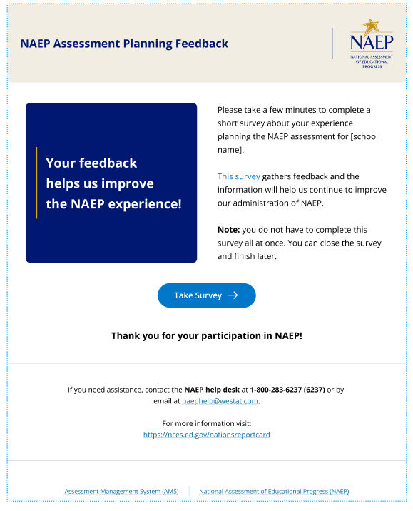

Assessment Day Feedback Form
The Assessment Day Feedback Form is made available to school coordinators after the assessment has been completed at their school with the purpose of collecting information about their assessment day experience and logistics. An email is sent with a link to access the survey. Respondents may exit the survey and return at a later time to complete.
Note. Survey content is included in Appendix E
Assessment Day Feedback Email
Subject: NAEP Assessment Day Feedback
To: School Coordinator
CC:
BCC: None
From: naep-ams@naepnpd.org

Your feedback helps us improve the NAEP experience!
Please take a few minutes to complete a short survey about the overall NAEP testing day experience for [school name].
This survey [AMS URL]/survey-page/napf/[necsschpin] gathers feedback and the information will help us continue to improve our administration of NAEP.
Note: you do not have to complete this survey all at once. You can close the survey and finish later.
Take Survey [Survey Link]
<Survey URL: [AMS URL]/survey-page/napf/[necsschpin]>
Thank you for your participation in NAEP!
If you need assistance, contact the NAEP help desk at <phone number> or by email at NAEPHelp@westat.com.
For more information, visit:
https://nces.ed.gov/nationsreportcard

Assessment Management System (AMS) National Assessment of Educational Progress (NAEP)

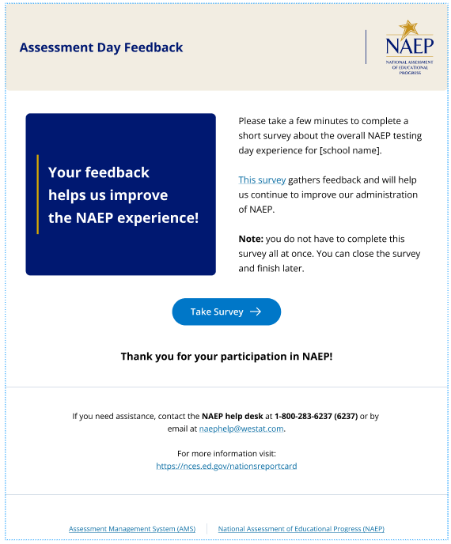

Appendix I11: 2027 Device Readiness Checks and Other Specify Emails (NEW)
2027 Device Readiness Checks email
Purpose: Ensure school coordinators/technology coordinators complete device readiness checks before the assessment.
Device Readiness Checks email (Content)
To: School Coordinator
CC: School Technology Coordinator (if entered in AMS)
BCC: None
From: naep-ams@naepnpd.org
Subject: Ensure Devices Are Ready for NAEP on [Assessment Date]
Dear [School coordinator first name] [School coordinator last name],
The NAEP assessment is scheduled at [school name] in 5 business days on [Assessment Date]. To ensure a smooth assessment experience in your school, it is important that the Device Readiness Check is completed on at least [estimated number of required devices from the device readiness tile] devices.
As of now, [number of verified devices] devices have been verified using your school’s unique NAEP verification code.
The Device Readiness Check confirms the devices that will be used for the assessment, including spare devices, have the NAEP Assessment application installed and meet the device requirements.
To complete the Device Readiness Check, please follow the steps below:
- Locate the NAEP Assessment application on student devices that will be used for the assessment, including spare devices:
- Chromebooks: Check the Apps tile on the sign-in screen.
- Windows devices: Look for the application on the desktop.
- If the NAEP Assessment application has not been installed, instructions for installation can be found on the NAEP Download Center website [link].
- Launch the NAEP Assessment application.
- Select "Get ready for NAEP."
- Enter the verification code below to confirm the device’s readiness:
- Verification Code for your school: VC-[XXXX]
- Track completion of the Device Readiness Check:
- Visit the Assessment Management System (AMS): https://ams.naep.ed.gov/
- Navigate to Technical Logistics and select the Manage button.
- In the Confirm Device Readiness tile, view the number of devices which passed the device readiness check.
- To help increase the Number of devices ready, additional resources can be downloaded from the Confirm Device Readiness tile:
- Instructions to assist students or staff in confirming device readiness.
- A Troubleshooting Guide is included in the staff instructions to help with resolving error messages.

If you have questions or need assistance, please contact the NAEP help desk at <phone number> or naephelp@westat.com.

2027 Other Specify Accommodations Email
Purpose: This automated email helps state/TUDA coordinators ensure that schools notify parents/guardians at least 7 days before the scheduled assessment date.
Other Specify Accommodations email (Content)

To: School coordinator, if no school coordinator goes to principal
CC: Assessment Coordinator, Supervisor
From: naep-ams@naepnpd.org
Subject: NAEP Additional Accommodations for ID [NAEP ID] [School name]

Dear [School Coordinator First Name] [School Coordinator Last Name],

Thank you for completing the Students with Disabilities (SD) and English Learners (EL) section of the Assessment Management System (AMS) for your school, [school name]. NAEP ID [NAEP ID]. A decision has been made regarding other (specify) accommodations for the following grade [sampled grade] student(s).

- Accommodations with a “Not Allowed” decision require additional follow-up.
- Please log in to the AMS (https://naep.ams.naepnpd.org/) and go to the Students with Disabilities (SD) and English Learners (EL) tab found in the Provide Student Information section.
- Select the edit pencil for the student. Select continue to navigate to the confirmation screen.
- Answer whether the student can take NAEP with only NAEP-allowed accommodations. An example is available here.
- Contact your NAEP State or TUDA Coordinator at [NSC or NTC email] if you have any questions.

Student line # | SD/EL classification | Subject | Other specify text box entry | Decision
[Line number] | [Classification] | [Subject] | [text box entry] | [final decision]

Appendix I12: 2027 District Summary Page (NEW)
District Summary Page – Provide District Information
The District Summary page consists of “tiles” (primary sections), each containing certain information for viewing/editing data and/or features for completing specific NAEP operational tasks. Tiles become operational at the opening of the assessment cycle for a given NAEP administration year and remain available through the end of assessment cycle.
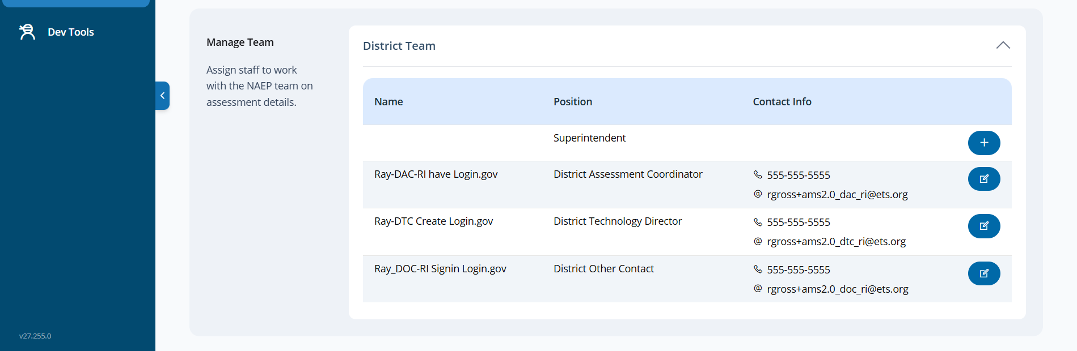
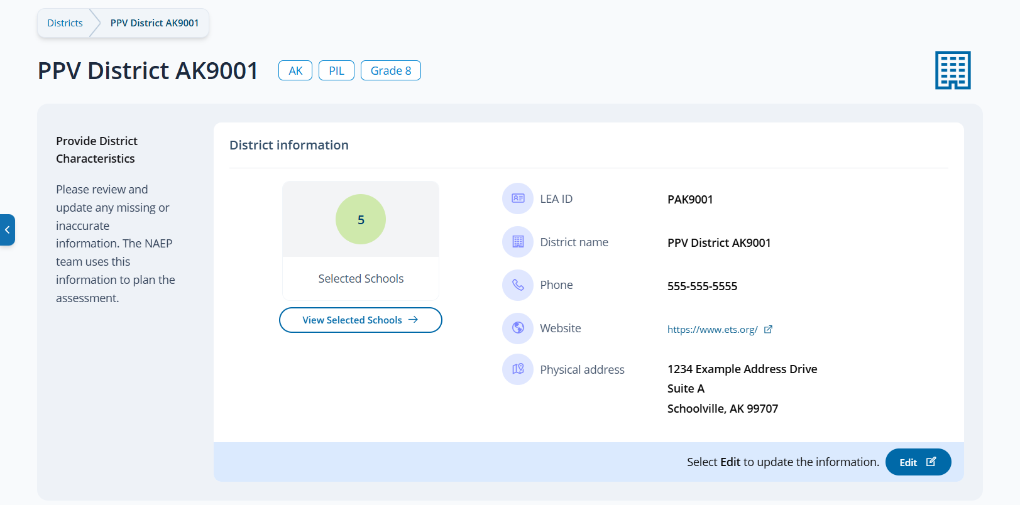
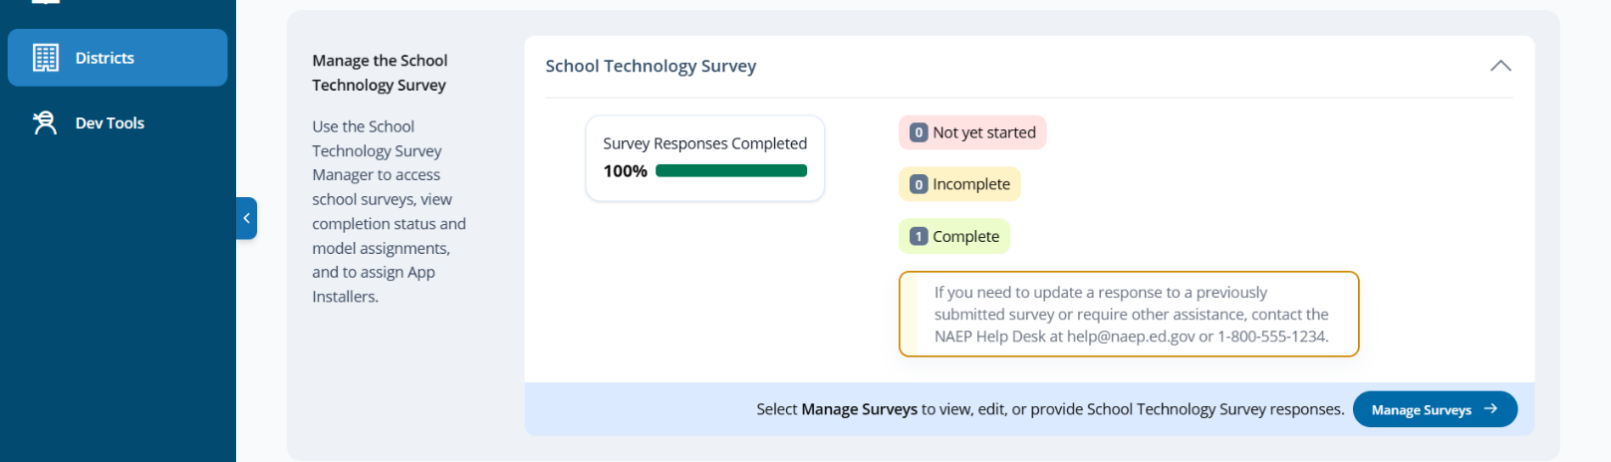

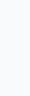
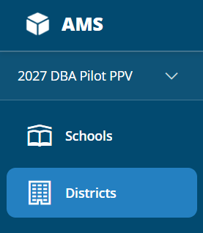

Provide District Characteristics
The Provide District Characteristics tile displays important district information including district name, address, phone, and website information, which authorized district users should review and update as needed as they begin their assessment preparation activities. The tile also displays the number of schools selected (sampled) to participate in the NAEP administration. Users are directed to the Schools list (table) by selecting the “View Selected Schools” button. The corresponding schools listed are limited to the selected schools within the district.
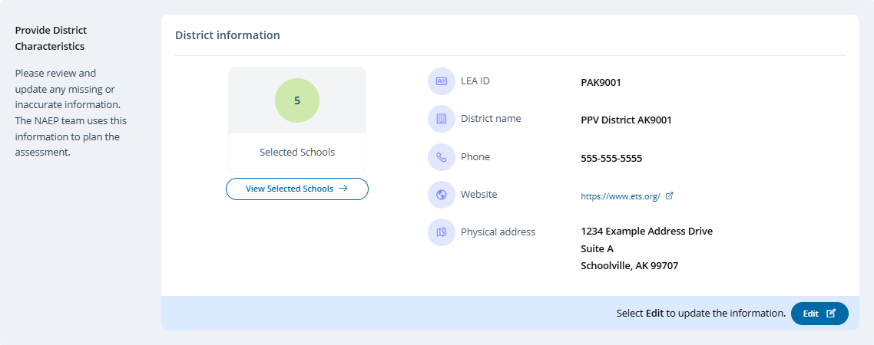
District Information (Edit Mode)
District Name, Phone and Address are prepopulated based on data provided in the School Sample file – Common Core Data. School or District staff are responsible for ensuring the accuracy and updating accordingly. The Save button is enabled when an existing value is changed.
Note. The LEA ID is not an editable field.
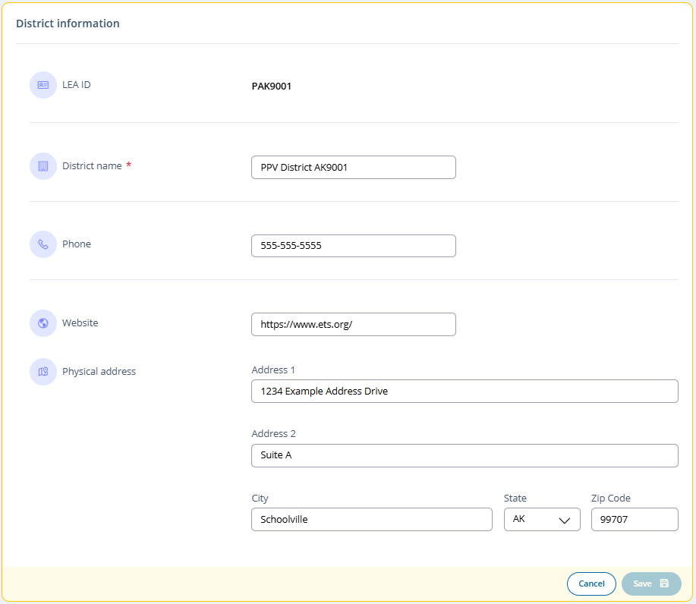
Manage the School Technology Survey
The Manage the School Technology Survey tile is used to view School Technology Survey (STS) completion statuses and access the School Technology Survey (STS) Manager where district users can select one or more school surveys to complete, review or edit (prior to submission) , review STS statuses and assessment model assignments by school, and assign application installers/send application installer notifications.
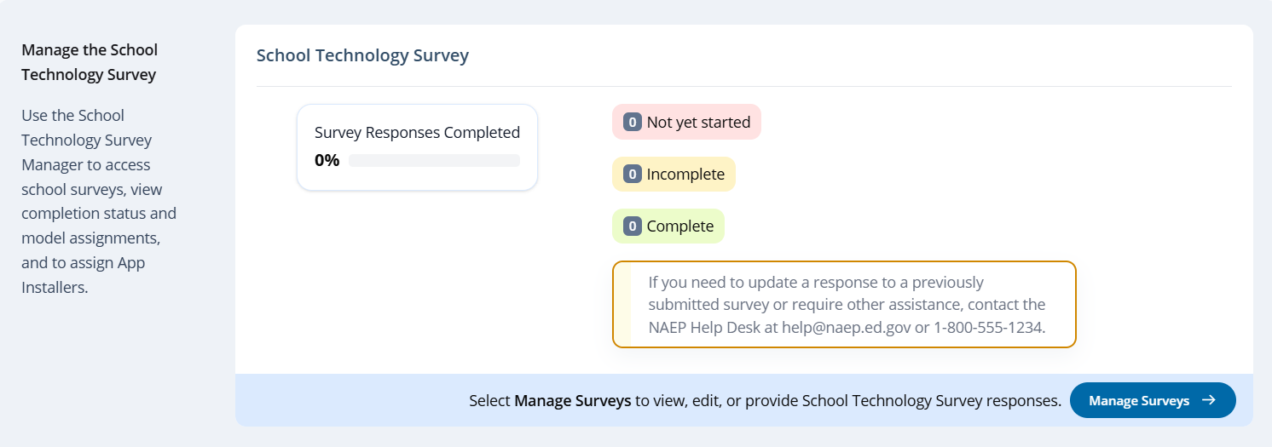

Manage Team
The Manage Team tile serves two purposes. The first is to assign staff to district roles and send invitations/notifications. The second is to monitor and edit the district team, as needed. Only authorized district users (in addition to internal NAEP staff [e.g., State Coordinators] can manage (invite/edit) district users.
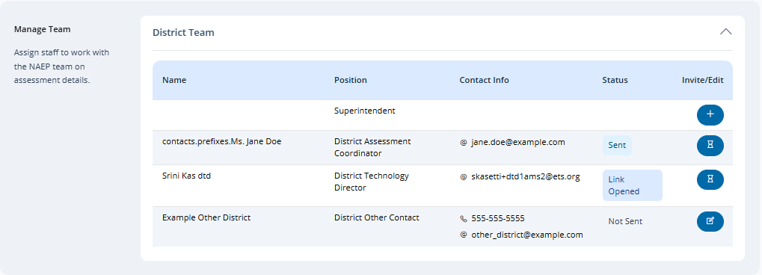
Note. The Superintendent role does not have access to the AMS. Therefore, the Invite Team Member and Edit Team member modals do not include an option to send/resend invitation (AMS Account Activation email), whereas all other district roles are invited to the AMS and receive an AMS Account Activation email.
Manage Team (Invite/Edit Mode)
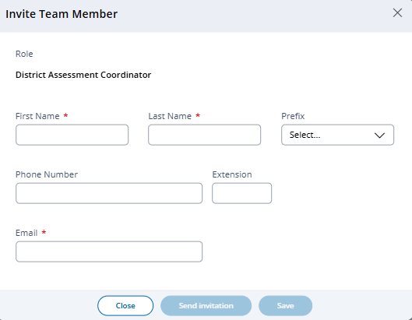
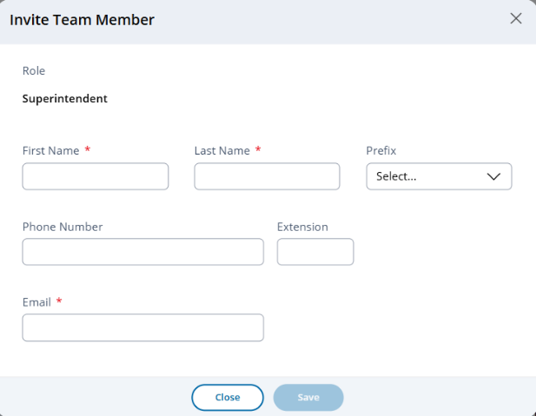

Button changes to “Resend invitation” (all roles except Superintendent) after initial send and prior to user activating account. Button removed once user has activated their account.
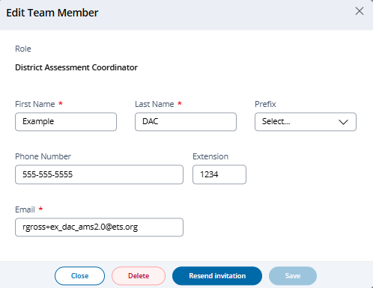
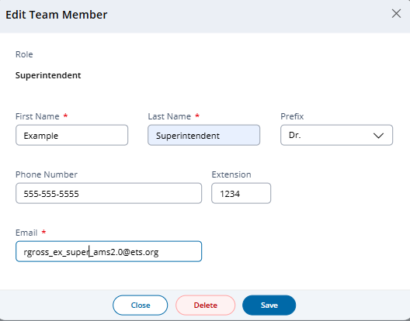

Note. Icons/options in The School Team tile edit column change depending on state of invitation/notification.

Add user – Displayed when role has not been assigned.

Edit user – Displays when user role has been assigned and saved, and when account has been activated.
Invitation pending – Appears once invitation has been sent and continues to display until invitee has activated their AMS account.
The Status column displays the current status of the invitation with the following possible values shown:
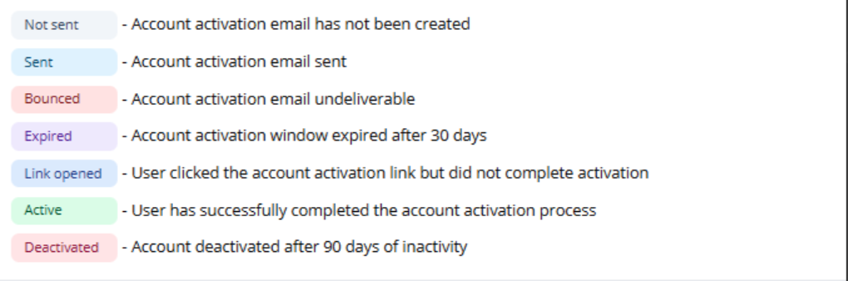
Manage Team – In system messaging:

Upon Delete:
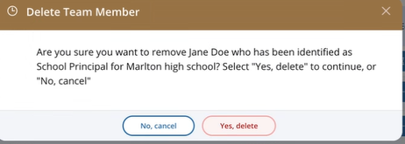
Upon saving after change of email address:
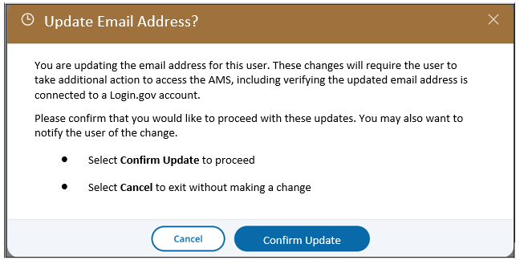

Appendix I13: 2027 Manage Questionnaires (NEW)

Manage Questionnaires
From the school summary page, schools will access and update this section by selecting Manage.
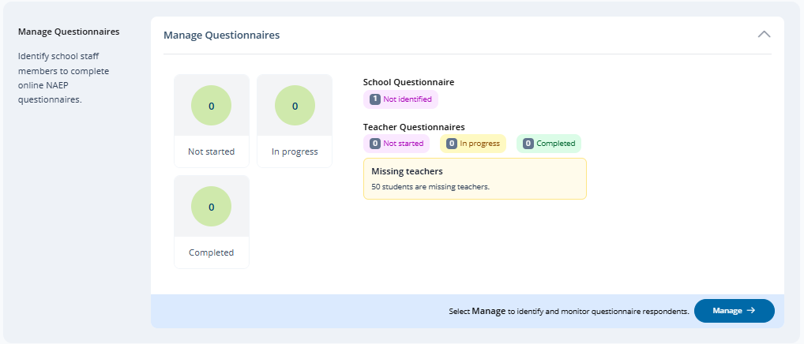
Note. “Not identified” may display as “Info required” where seen throughout the screenshots – final implementation decision TBD.
The Manage Questionnaires section of the AMS is used by authorized users to identify teacher and school questionnaire recipients, match sampled students with their teachers, send questionnaires (emails containing link and access code) to recipients and monitor the completion status of each questionnaire sent.
A tutorial video (see Appendix I33) is provided to support users working throughout Manage Questionnaires. Additional resources are also available for download in the Manage Questionnaires section for review:
- NAEP Survey Questionnaires 101
- Facts for Teachers
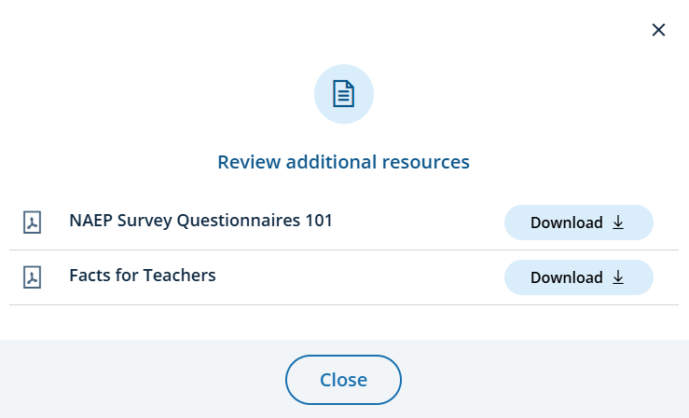

Manage Questionnaires (Manage Mode)
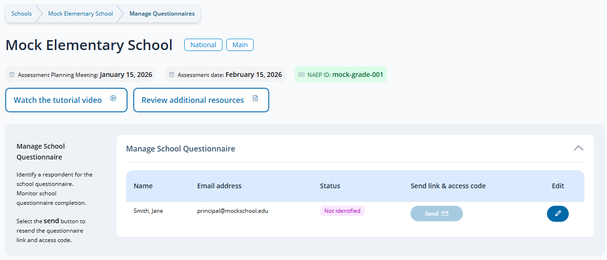
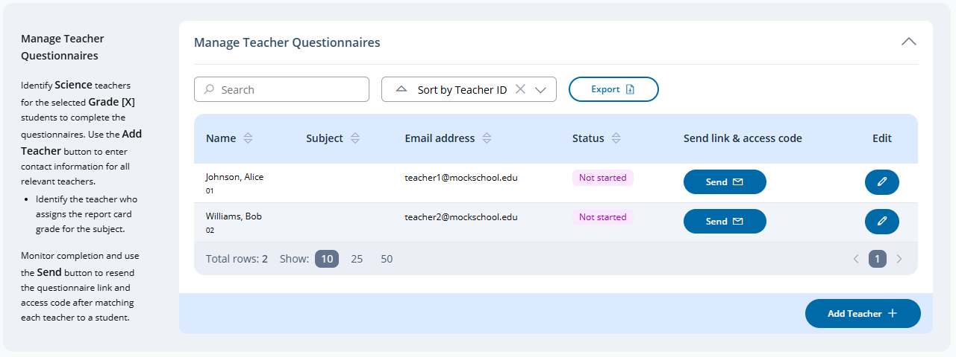
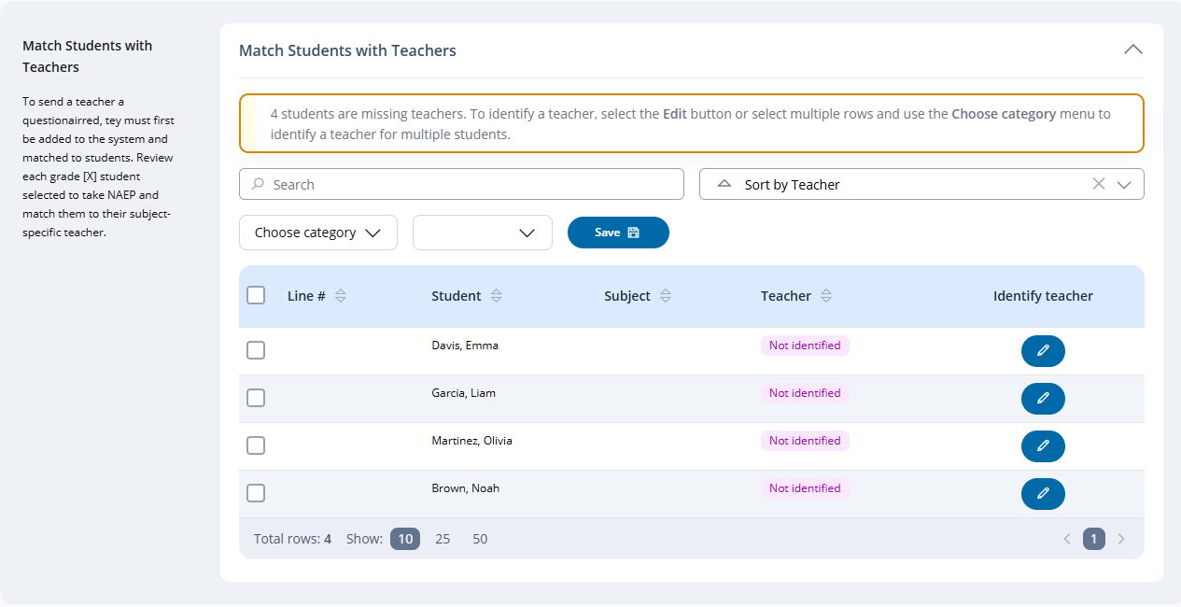

Manage School Questionnaires
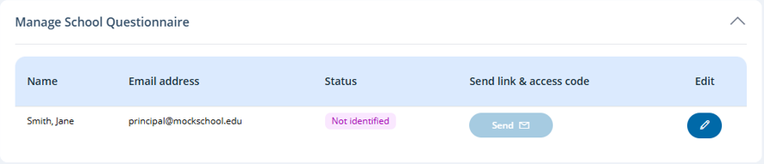
Statuses that may appear are:
- Not sent
- Not started
- Bounced
- Email Queued
- Refusal
- In progress
- Completed



Manage Teacher Questionnaires
Possible statuses and options/messaging that may appear in the Send Link & Access Code fields are shown below
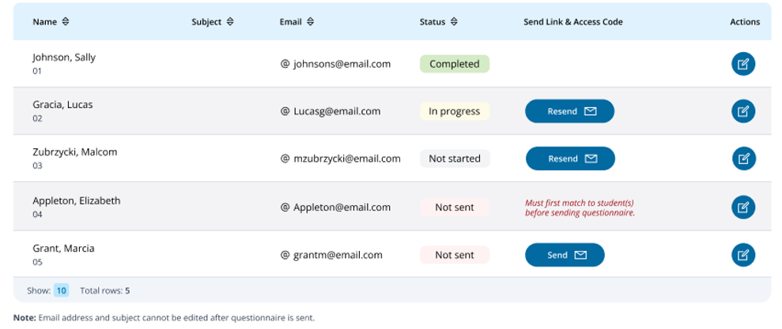
Statuses that may appear are:
- Not identified
- Not sent
- Not started
- Bounced
- Email Queued
- Refusal
- In progress
- Completed

Add a teacher questionnaire respondent
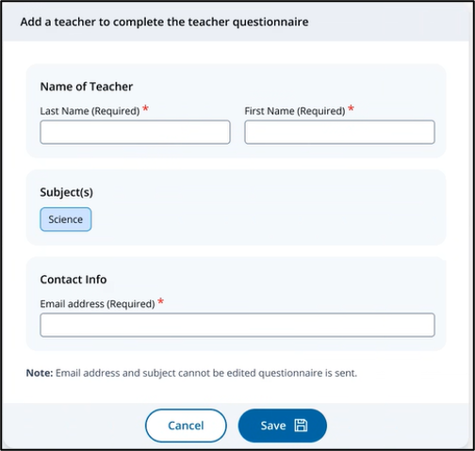
Note. Only Science is offered for the 2027 NAEP administration. All applicable subjects are shown in years where more than one subject applies.

Edit a teacher questionnaire respondent
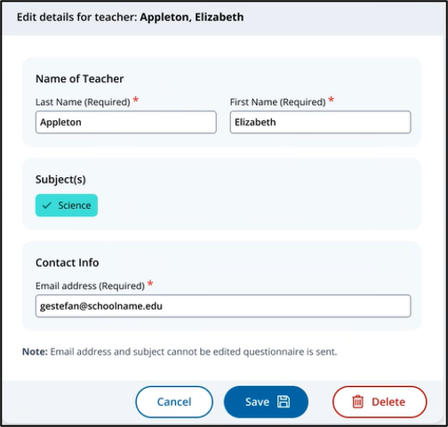
Note. For 2027 new functionality and rules have been established to allow users to delete a Teacher Questionnaire respondent as part of the edit process.
Edit a teacher questionnaire respondent (Not matched with student)
All fields may be edited. Delete button is enabled.
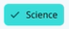
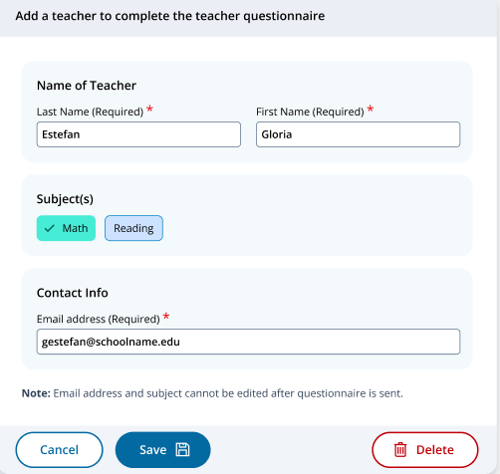

Edit a teacher questionnaire respondent (Matched with student and Survey not yet sent)
All fields may be edited. Delete button is disabled.

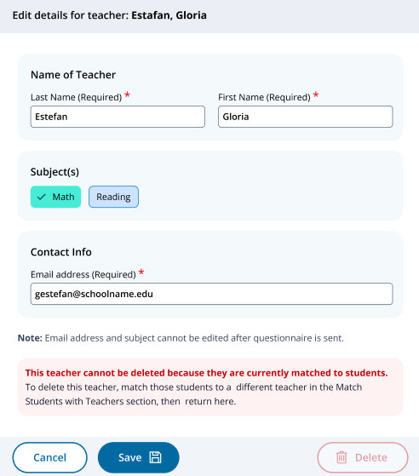
Edit a teacher questionnaire respondent (Questionnaire sent but not started)
Only Last Name and First Name fields may be edited. Delete button is disabled.
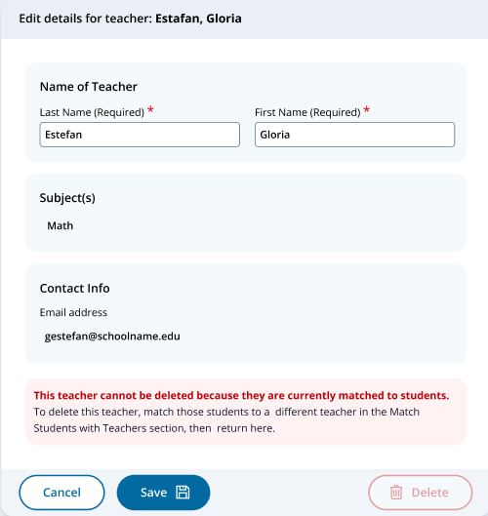
Edit a teacher questionnaire respondent (Questionnaire started)
Only Last Name and First Name fields may be edited. Delete button not available.
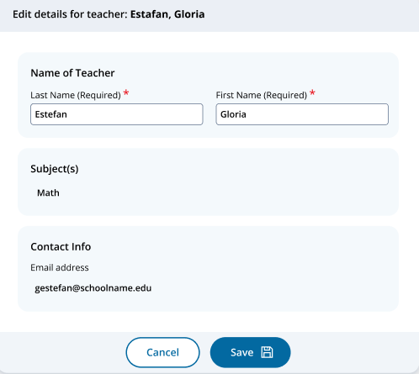

View a teacher questionnaire respondent (Questionnaire completed)
View only option once a teacher questionnaire has been completed.
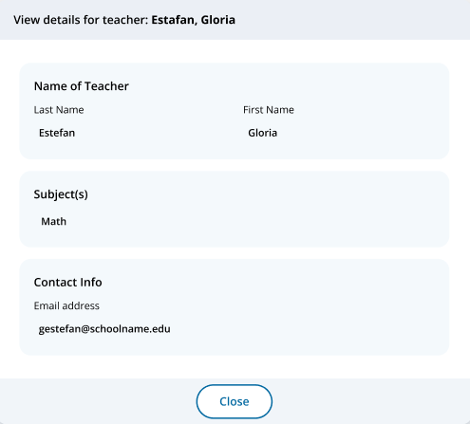

Match students with teachers

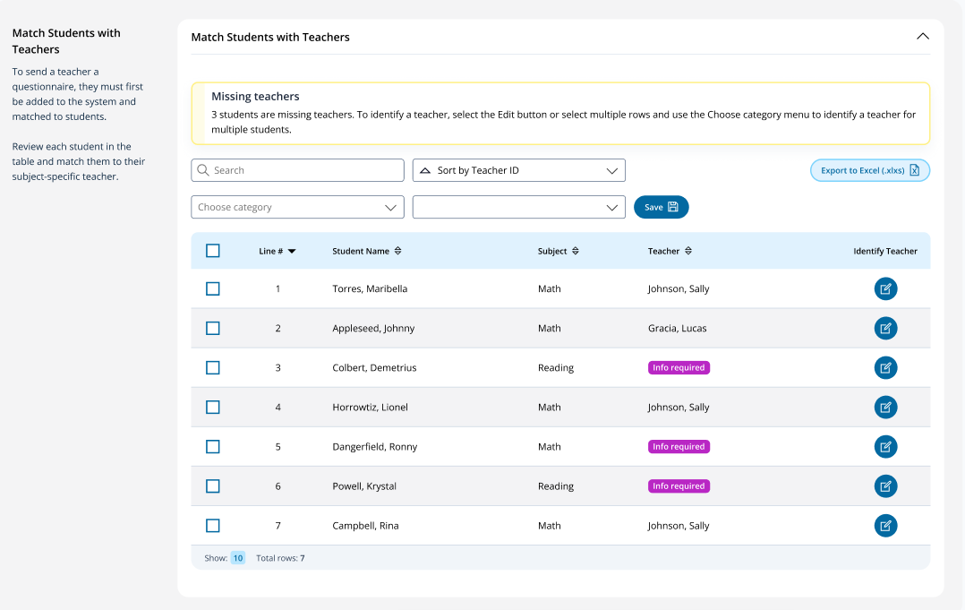
Clicking the edit icon in the Identify Teacher column opens the identify teacher modal.
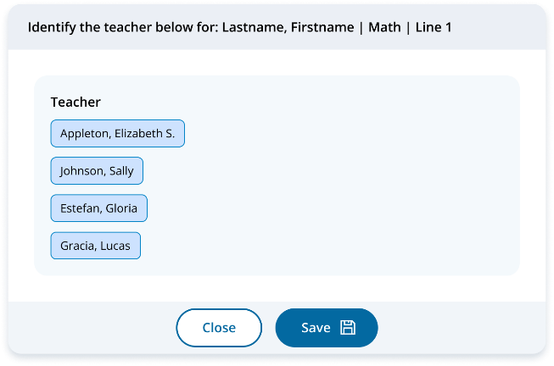

A warning is displayed if a teacher is deselected (unmatched from student):
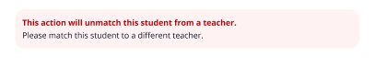

Appendix I14: 2027 Non-Disclosure Agreement (NEW)
We welcome you to the NAEP assessment
NAEP NON-DISCLOSURE AGREEMENT
The National Assessment of Educational Progress (NAEP) is often referred to as The Nation’s Report Card. NAEP monitors what U.S. students know and can do in key subject areas at the elementary, middle, and high school levels and provides reliable student achievement profiles to educators and the public. NAEP is the largest continuing and nationally representative assessment to chart trends in student achievement across our nation. Since 1969, NAEP has been successful because of the support of teachers and school staff whose students participated in the assessment.
By being present and/or assisting during the assessment, you will help emphasize to the students the importance of their taking the assessment seriously. You have the advantage of knowing some or all of the students and the protocols of the school. The NAEP representative may ask for your assistance in these areas.
We respectfully ask for your cooperation in following these important guidelines while participating in NAEP to ensure the validity of the assessment.
NAEP representatives are thoroughly trained to administer the tests to students to ensure the highest level of validity of the test results. They have a script they must read to the students verbatim to maintain the consistency of the instructions to students across the nation. NAEP representatives have been directed not to answer any questions the students may ask about the assessment questions but to encourage the students to do the best they can. In talking to a student about his or her assessment, you may be inadvertently compromising the results.
Any conversation during the assessment could be disruptive to students and may affect their ability to concentrate.
The security of the assessment items is a very important part of NAEP. No one other than the student is to read the questions. NAEP representatives have signed a security affidavit and, since you have access to the assessment items, we ask the same of you. You are welcome to view sample questions at The NAEP Questions Tool (nationsreportcard.gov) which provides examples of assessment questions asked in previous years in all NAEP subjects.
You may also download Sample Question Booklets online at Sample Booklets - Experience an Assessment | NAEP (ed.gov), which includes assessment directions as well as links to sample NAEP assessment questions and survey questionnaires that explore students’ activities and characteristics related to education and the subject being assessed.
If assisting with an accommodation session, you may
- encourage students to review their answers upon completion of a section; and
- answer student questions according to the guidelines provided by the NAEP representative.
If assisting with an accommodation session, you may not
- provide assistance on assessment items. (Students may seek validation on certain items; you may not indicate verbally or nonverbally your recommendations. Instead you are encouraged to remind students to answer the questions to the best of their ability.) Or,
- allow any student to use accommodations/adaptations on the assessment that are not indicated in the student’s IEP/Section 504 Plan or that are not normally used by the student during testing.
Affidavit of Nondisclosure
I do solemnly swear (or affirm) that when given access to the subject NCES database or file, I will not
- use or reveal any individually identifiable information furnished, acquired, retrieved, or assembled by me or others, including secure assessment booklets or items, under the provisions of Sections 408 and 411 of the National Education Statistics Act of 1994 (20 U.S.C. 9001 et seq.) for any purpose other than statistical purposes specified in the NCES survey, project, or contract;
- make any disclosure or publication whereby a sample unit or survey respondent could be identified or the data furnished by or related to any particular person under this section can be identified; or
- permit anyone other than the individuals authorized by the Acting Commissioner of the National Center for Education Statistics to examine the individual reports.
(The penalty for unlawful disclosure is a fine of not more than $250,000 under 18 U.S.C. 3571 or imprisonment for not more than 5 years under 18 U.S.C. 3559, or both.)
First and last name: _________________________________________________
Email: _____________________________________________________

Appendix I15: 2027 Notify Parents/Guardians Notification (NEW)

Notify Parents/Guardians
The Notify Parents/Guardians tile is used by school staff to document parent/guardian notification details, download documents and certify having sent the notification to parents/guardians. The Info Required label is displayed until all required tasks have been completed, at which point it switches to completed.
Note. The Add New Students task is not being executed for the 2027 NAEP administration. For administration where Add New Students is applicable a “May require updates after Add New Students” label is displayed instead of a completed status.

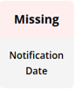
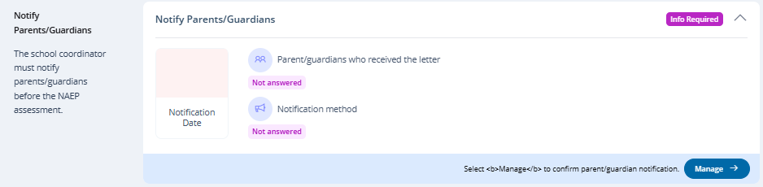
After selecting Manage on this page, schools will indicate how they notified parents and guardians, who was notified, and what date they were notified prior to the assessment. Schools will then download a PDF of the parent notification letter (English and/or Spanish) to distribute to parents and guardians. Schools are also able to download a translation notice to provide to parents or guardians as needed.
The Notify Parents/Guardians section consists of 4 tiles:
- Contact Information
- Download letter
- Certify parent/guardian notification
- Parent/guardian notification details

Manage Mode
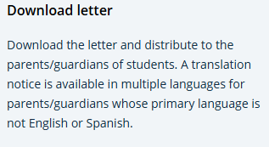
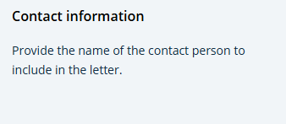
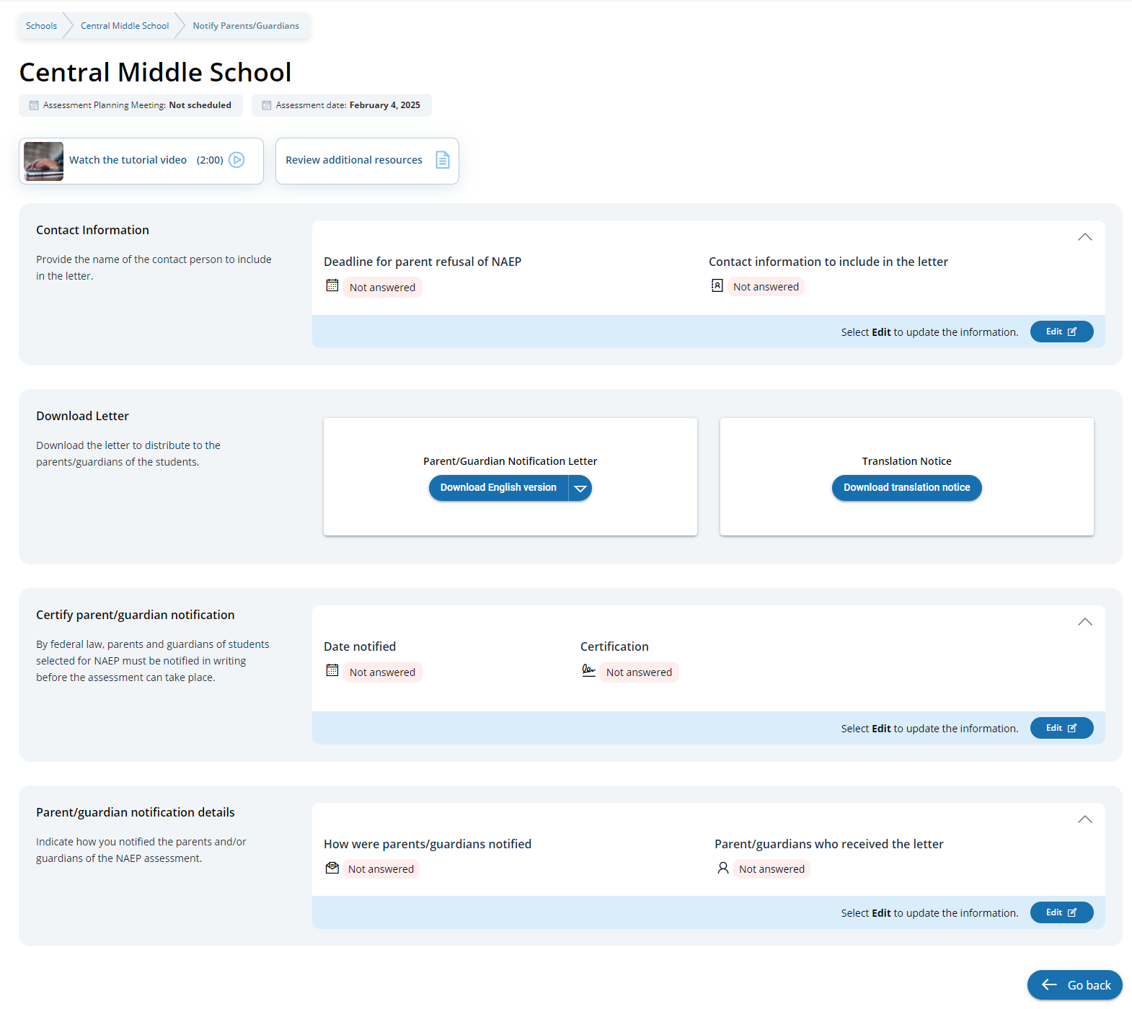
A tutorial (see Appendix I33) is available to assist users along with additional resources to review.
Upon selecting the Review additional resources, a pop-up modal appears:
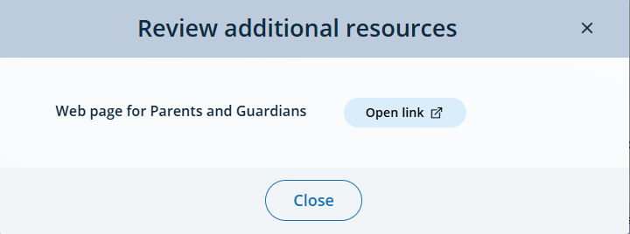

Contact Information
In the Contact information section, schools can select the contact information to include in the letter from the following options:
- Contact information to include in the letter
  - Principal’s contact information
  - School coordinator’s contact information

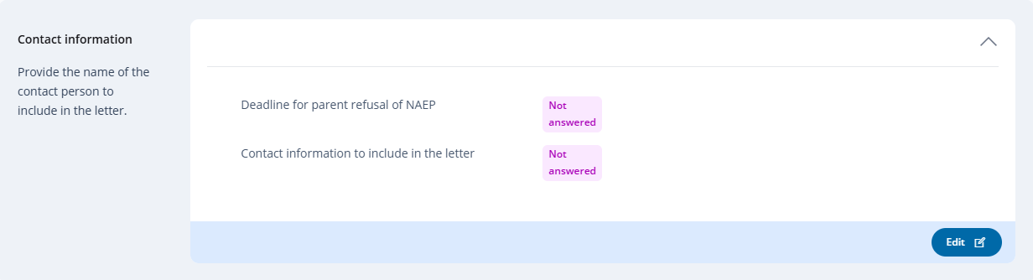
Edit Mode
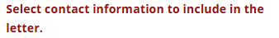
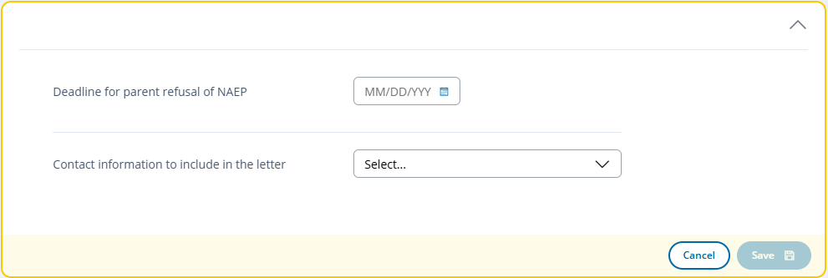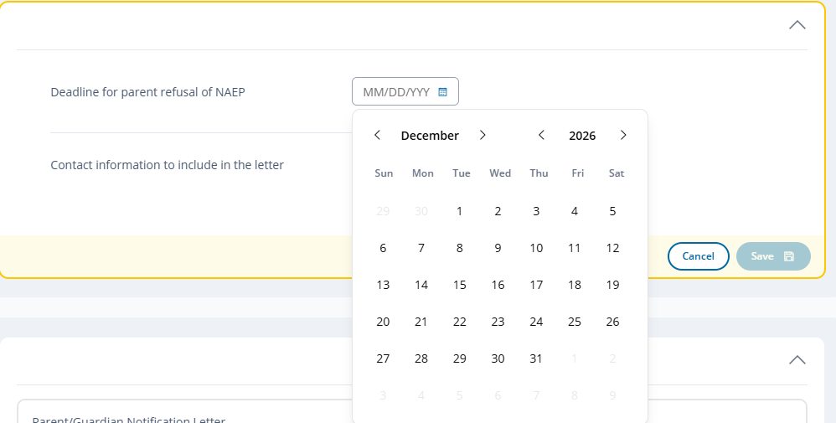
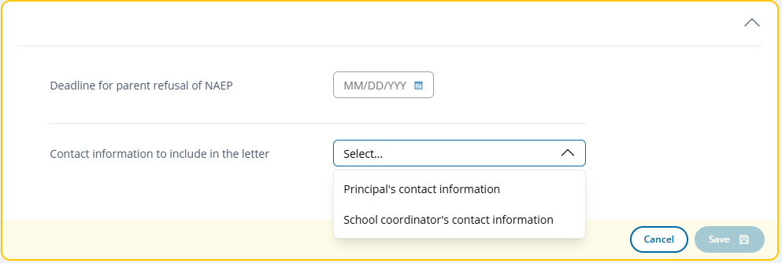

Download Letter
The download letter section is where users can download versions of the Parent/Guardian notifications in Spanish and English and download a translation notice.
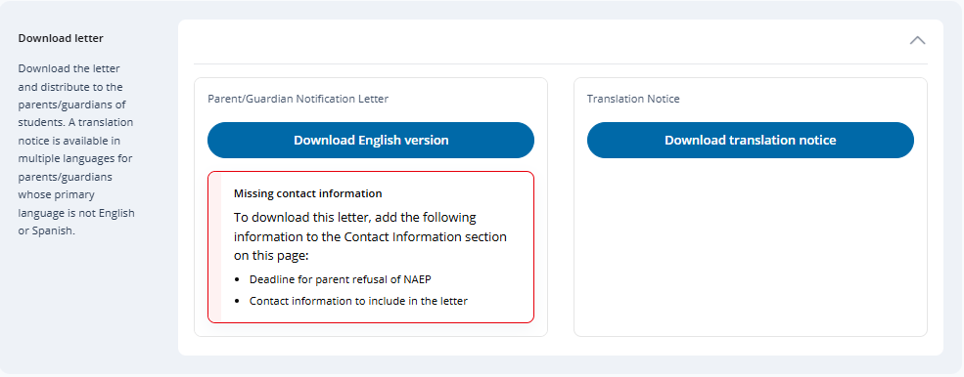
User’s select the down arrow toggle to switch between English or Spanish versions for download:
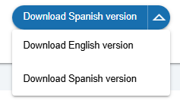



Certify parent/guardian notification
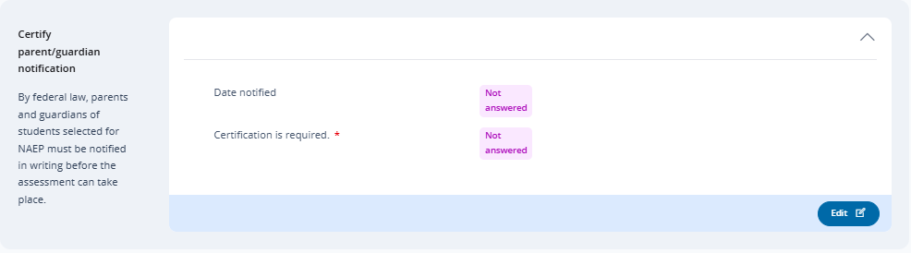
Edit Mode
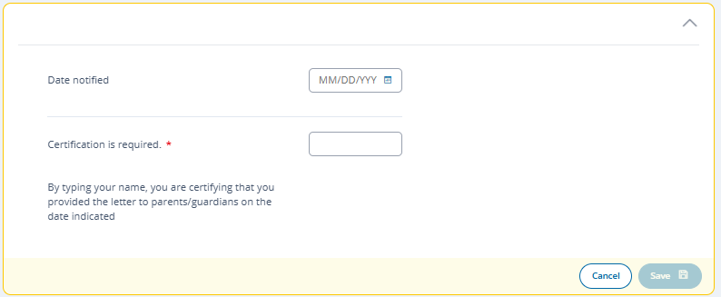
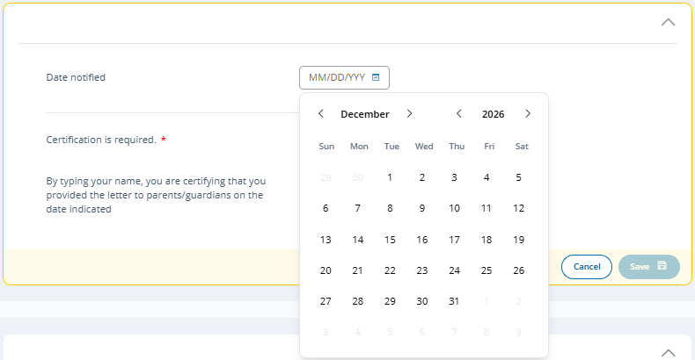
Parent/guardian notification details
In the parent/guardian notification details section, schools can select from the following options for “How were parent/guardians notified” and “Parent/guardians who received the letter:”
- How were parent/guardians notified
  - Mailed letter
  - Emailed letter
  - Letter sent home with students
  - Posted notice in newsletter
  - Other
- Parent/guardians who received the letter
  - Parent/guardians of sampled students only
  - Parent/guardians of all grade [X] students
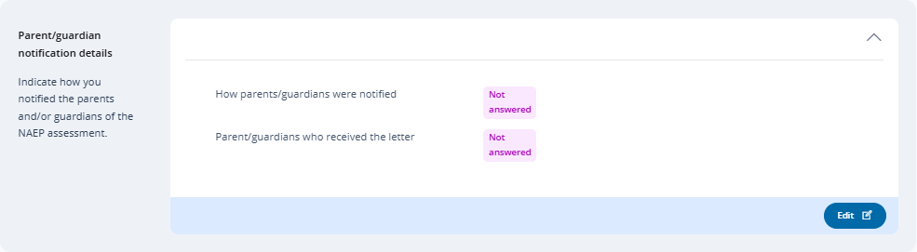

Edit Mode
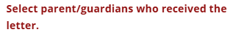
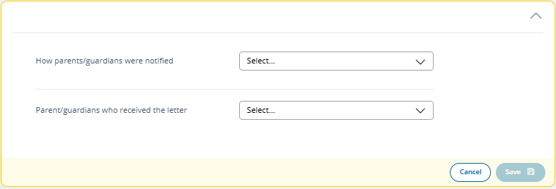

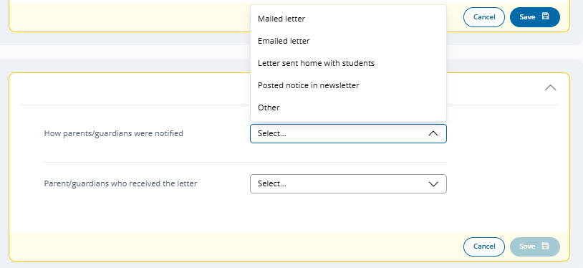

If “Other” Selected a Please Specify open ended text response is presented:
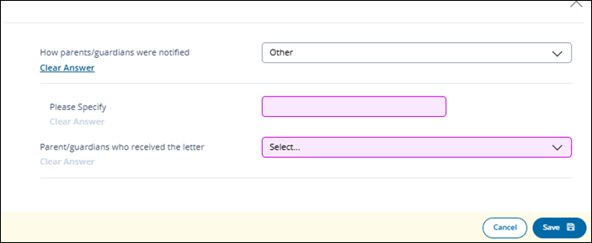

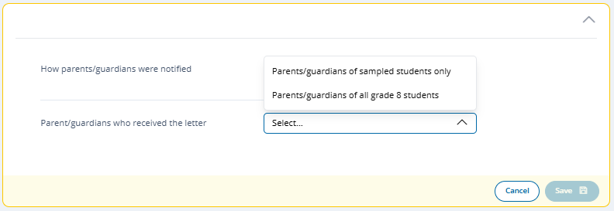

Appendix I16: 2027 Provide School Characteristics and Manage Team Tile (NEW)

Provide School Characteristics
The school summary page – provide school characteristics section organizes all information that the school should review and provide as they begin assessment activities. Schools will use the provide school characteristics section to confirm their address, provide enrollment numbers and important dates, and update student attendance.
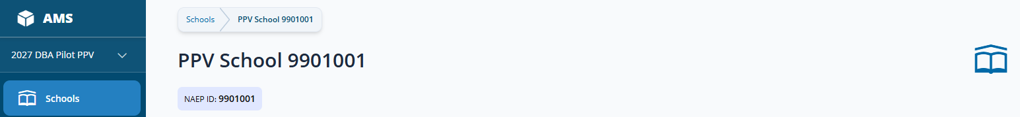
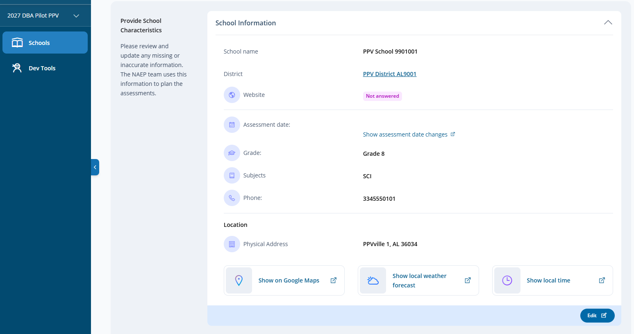
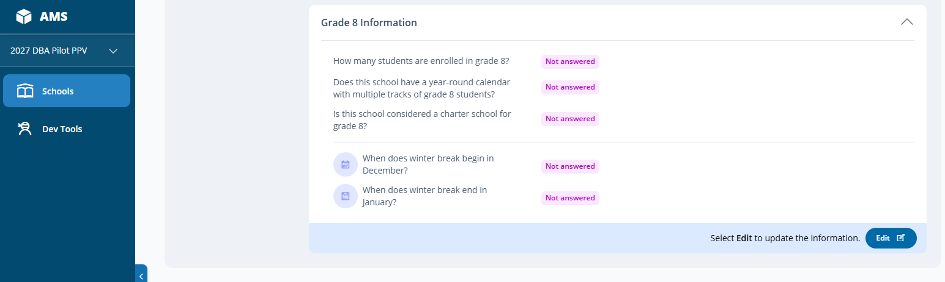

Not available

School Information (Edit Mode)
School Name, Phone and Address are prepopulated based on data provided in the School Sample file – Common Core Data. School or District staff are responsible for ensuring the accuracy and updating accordingly.
Grade Information (Edit Mode)
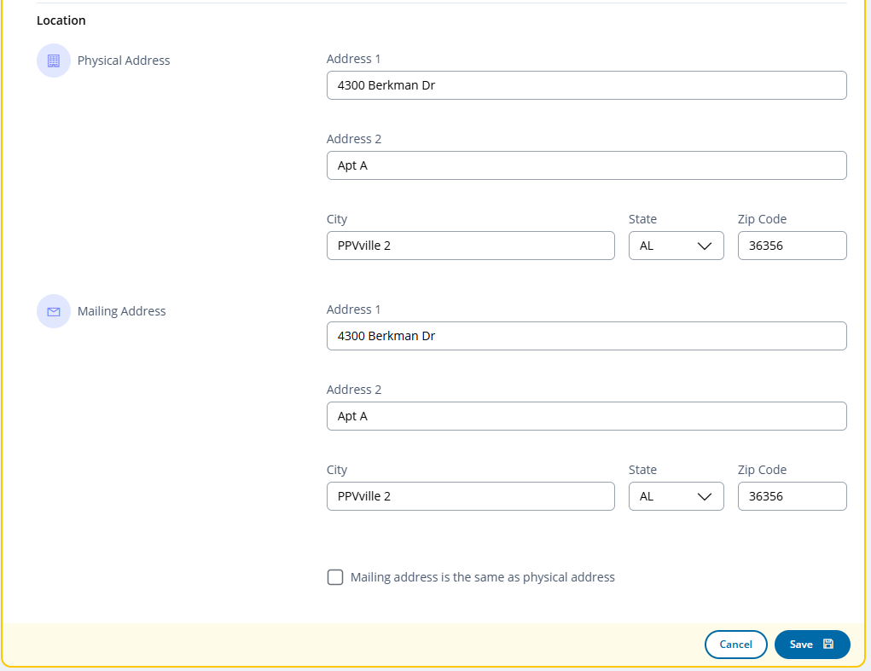
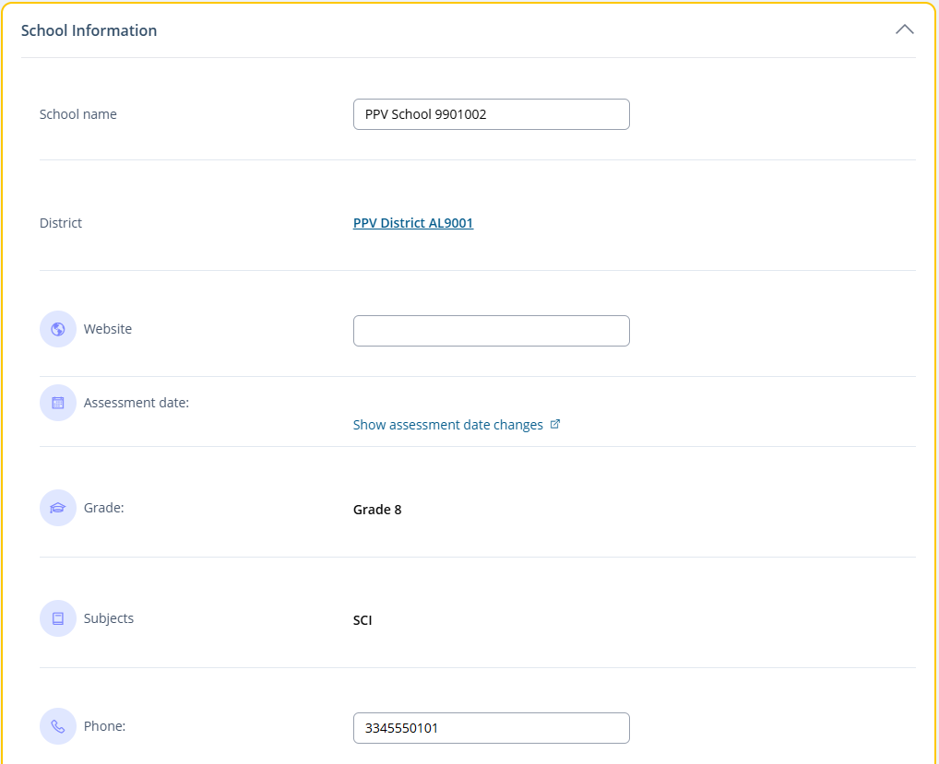
Not available

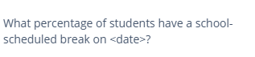
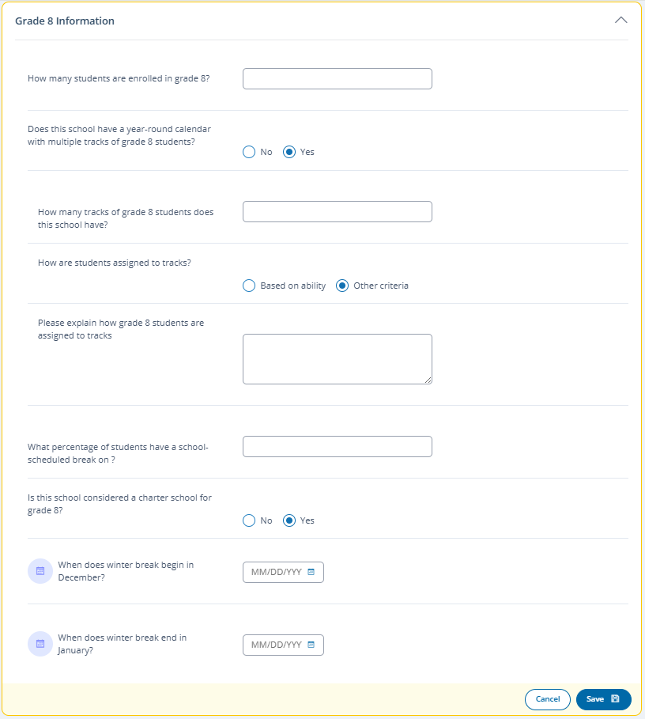
Note. Follow up questions/response fields dynamically appear in edit mode based on selected response to questions and are shown on main tile upon save as applicable. Any applicable question not responded to will display “Not answered” if not previously responded to and saved.
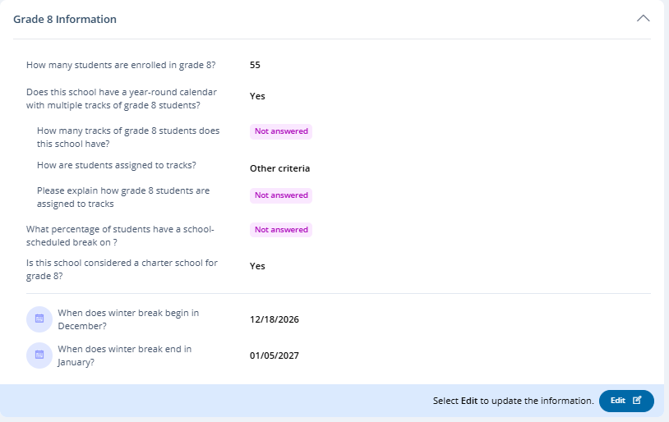

Calendar – Date selection Popup:
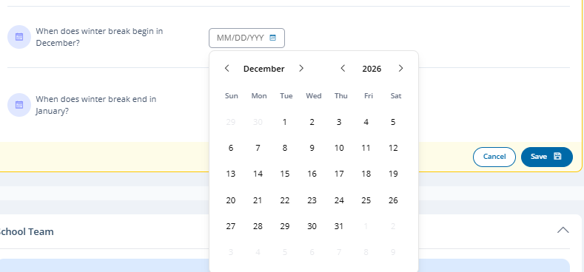

Manage Team
The Manage Team tile serves two purposes. The first is to assign staff to district roles and send invitations/notifications. The second is to monitor and edit the school team, as needed, and view NAEP Team members supporting the school. Only authorized school and district users (in addition to NAEP internal staff [e.g., State Coordinators]) can manage (invite/edit) school users. NAEP Team members are displayed as view only.

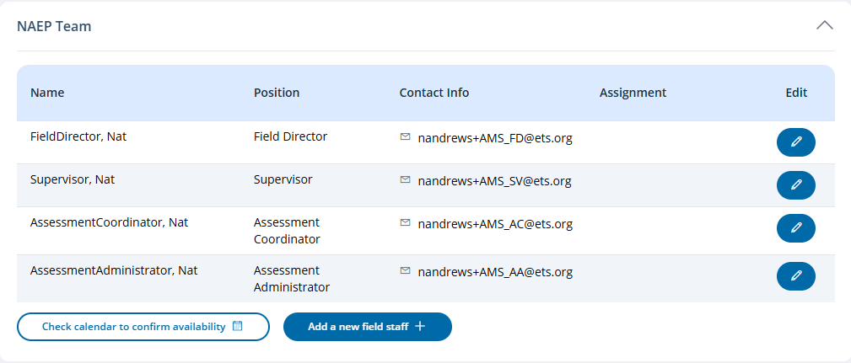
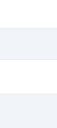
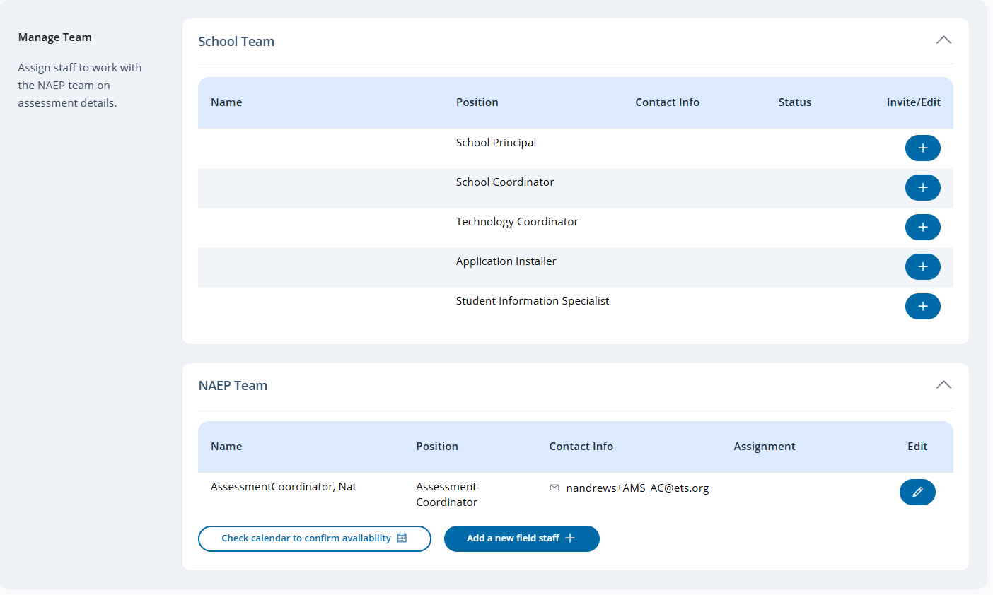

Note. Icons/options in the School Team tile edit column change depending on state of invitation/notification.
Add user – Displayed when role has not been assigned.
Edit user – Displays when user role has been assigned and saved, and when account has been activated.
Invitation pending – appears once invitation has been sent and continues to display until invitee has activated their AMS account.
The Status column displays the current status of the invitation with the following possible values shown:
Note. The Assignment field in the NAEP Teams table is identified when a field staff role is assigned, with the following possible values:
- Conduct APM
- Conduct Assessment
- Conduct Makeup
- Lead AC
- Support AC
- Administer Group
- Separate accommodation group
- Special circumstance
- Administer makeup group
Manage Team (Invite/Edit Mode)
Users are initially invited - assigned to a role - by clicking the in the edit column of the Manage Teams tile. Required fields are denoted with a red asterisk. Field validation messaging is also shown when applicable
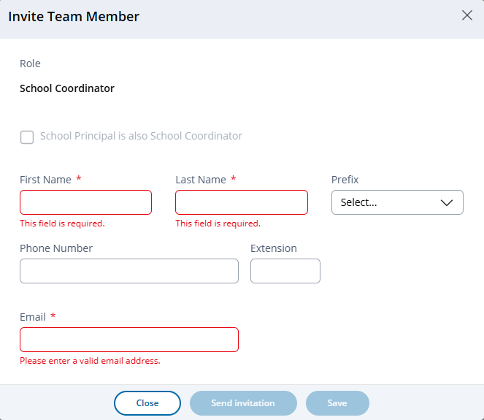
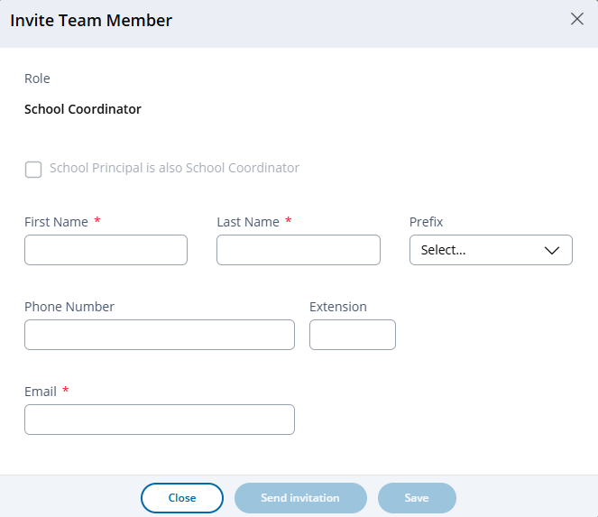

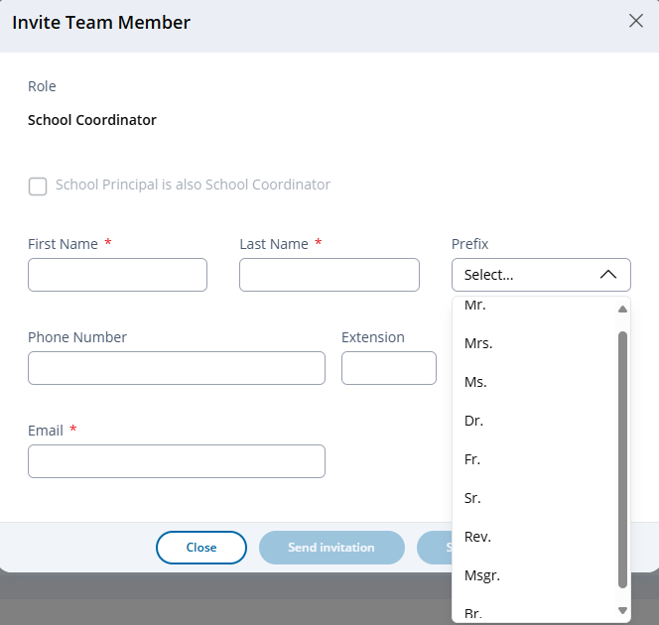
The Send invitation and Save buttons become enabled once all required fields have been provided.
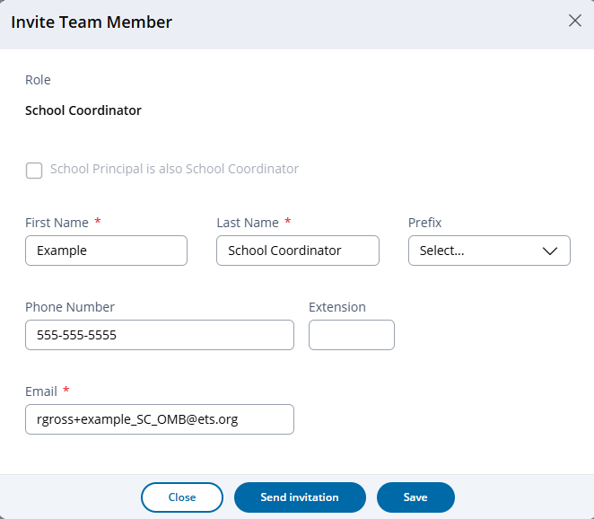
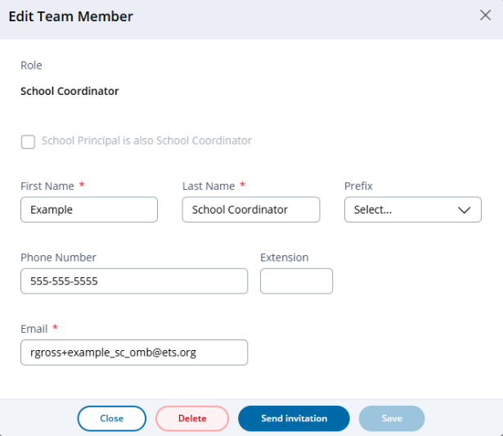
After saving or sending invitation, the delete button is introduced and Send invitation label changed to Resend invitation if invite already sent.
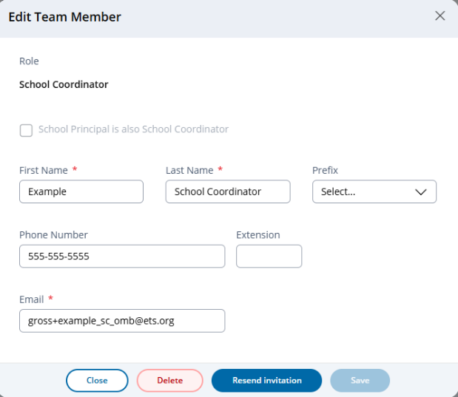

The school Principal role includes a selectable option to indicate the School Principal is also the School Coordinator. Selecting this option automatically populates the information provided for the School Principal for the School Coordinator role, and the School Coordinator role becomes view only when attempted to edit directly. Editing, sending/resending invitation, saving and deleting are only available from Principal role. The save button becomes enabled when any change to the record is applied.
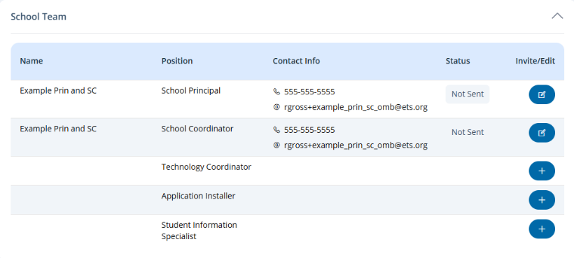
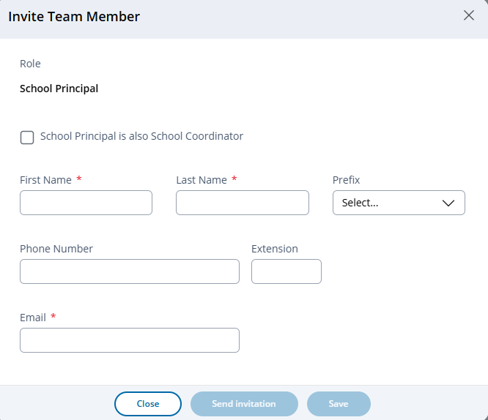

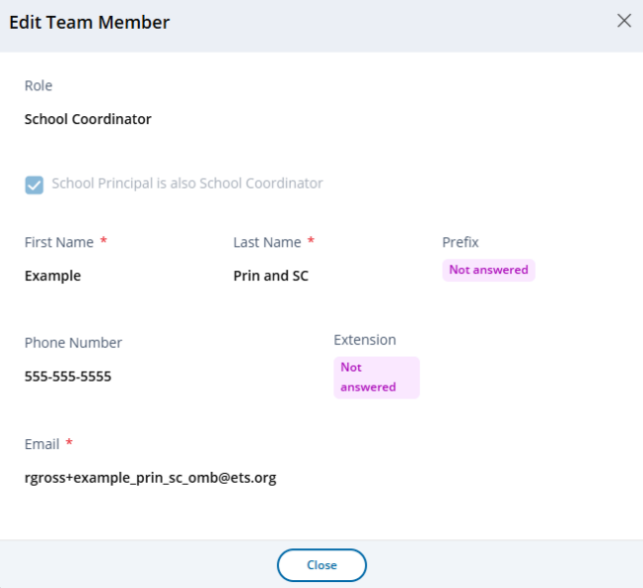
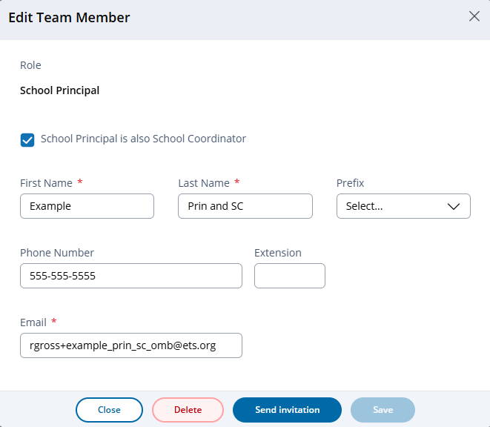

The Application Installer role differs from other school level roles as it does not provide access to the AMS, therefore management of the Application Installer does not include an invitation component, but is used for purposes of identifying and sending/resending the Application Installer notification.
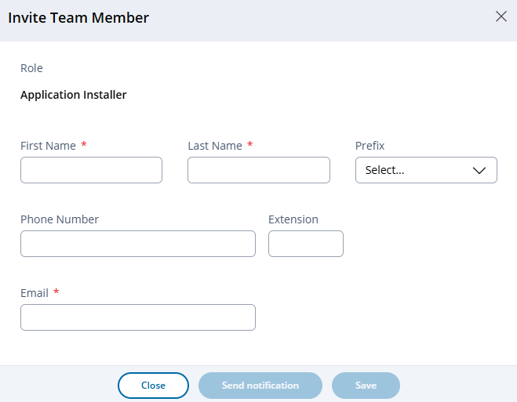
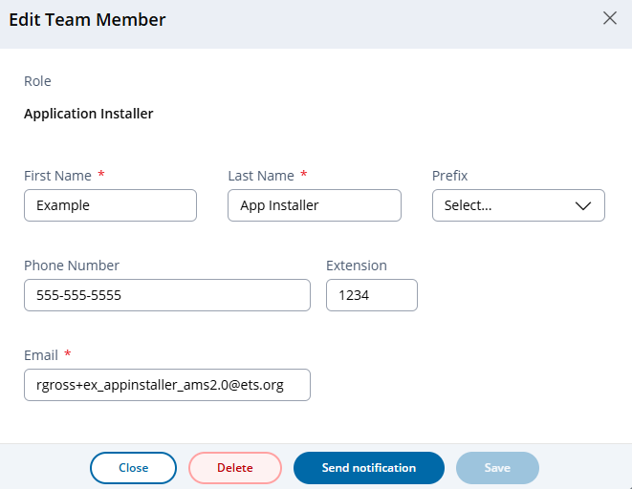

Send notification button changes to Resend notification after notification initially sent.
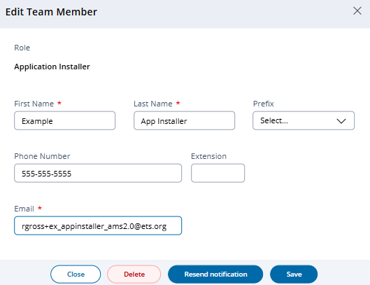

Manage Team – In system messaging:
Upon Delete:
Upon saving after changing email address:

Appendix I17: 2027 Provide Student Information-Student Information, Student Demographics (NEW)

Provide Student Information – Student Demographics
The Provide Student Information – Student Demographics tile becomes available for use after student lists have been imported and student sampling completed. Authorized system users, use the tile to make corrections and updates to sampled students’ information and identify non participating students and select corresponding reason for non participation.
The tile displays summary information including the number of selected (sampled) student, count of students marked as non-participants, and count of students with missing information. The tile additionally includes access to additional instructional documents to support user’s completion of the student demographics section of the system. Providing student demographics is a required task that is considered complete (Info required label changes to “Completed”) when all required information has been provided (no students with missing information).
Authorized users access the student demographic section by selecting the Manage button from the main tile.

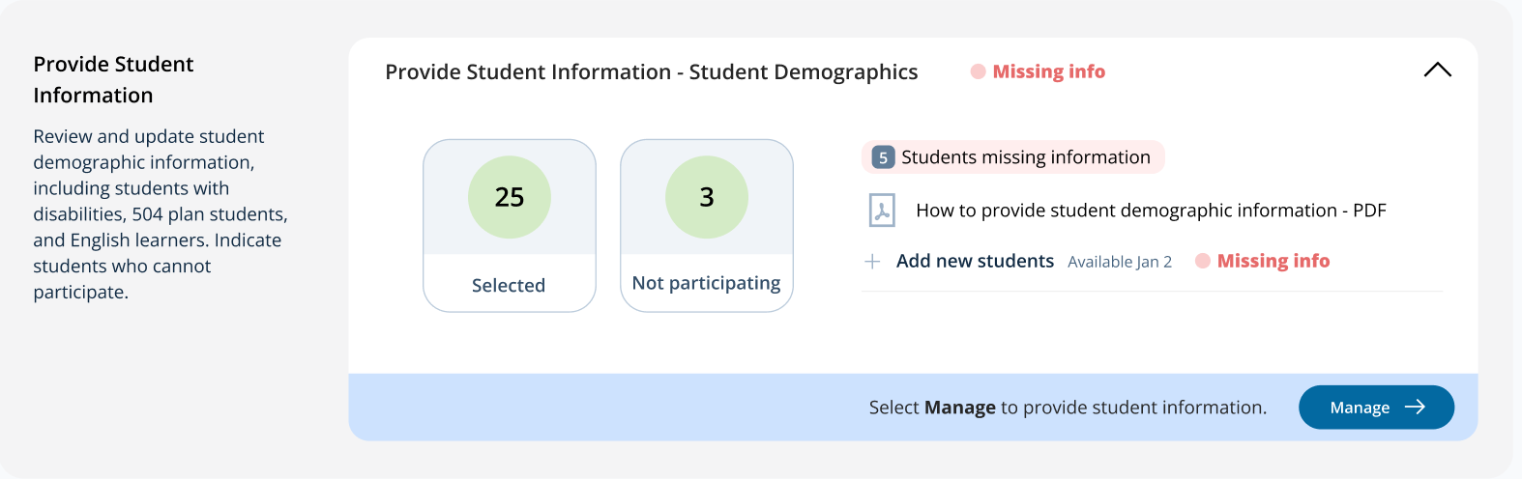

Provide Student Information (Manage Mode)
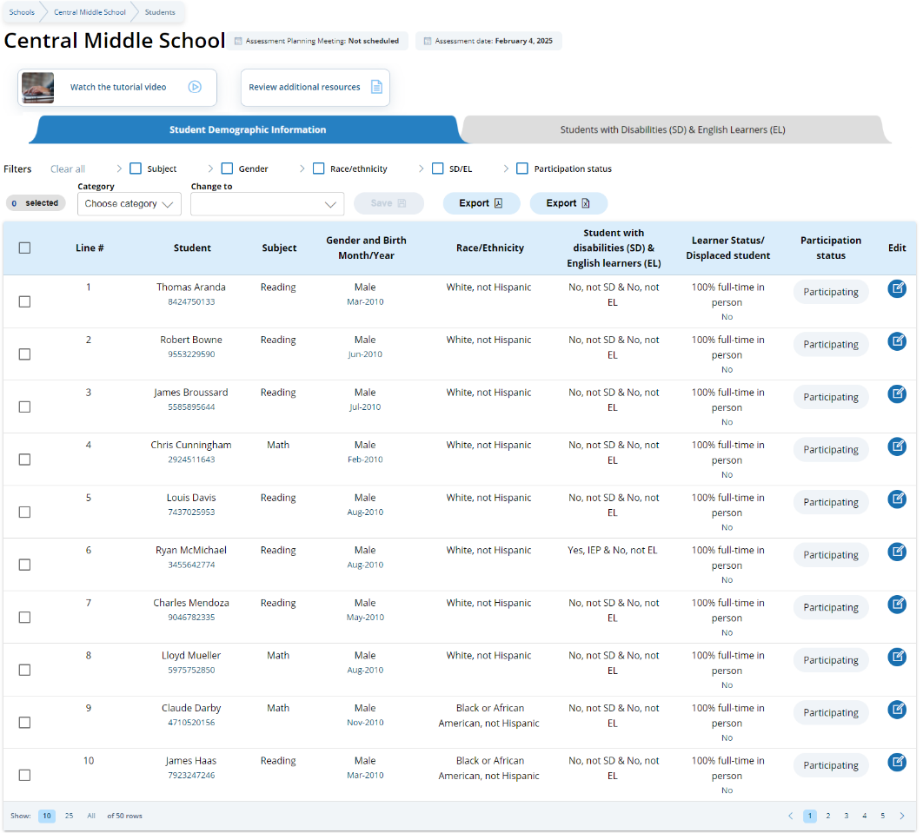

Upon selecting the Manage button, users are navigated to the Provide Student Information table – Student Demographics tab, from which they can review and edit student information.

Note. An Economically Disadvantaged field may also appear in the Student Demographics Information table. Display of this field is dependent on settings applied by State/TUDA coordinators in the Jurisdiction section of the AMS.
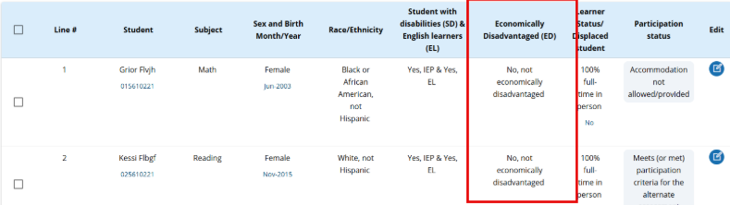

A tutorial video (see Appendix I30) is provided to support users working throughout student demographics section. Additional resources are also available for download via the Review Additional Resources button:
- How to provide student demographic information
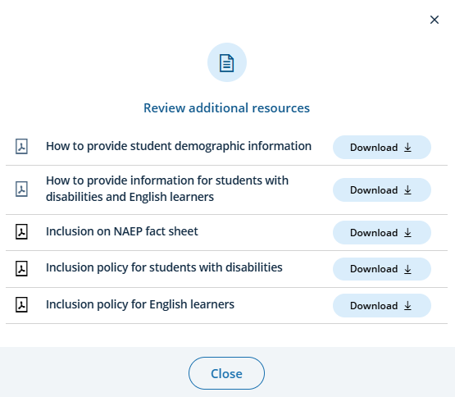
- How to provide information for students with disabilities and English learners

Note. Screenshot provided for reference purposes. Specific names and resources included are subject to change.
School users are expected to review student demographic data and update any inaccurate information or provide missing information. The “Economically disadvantaged status” column may be hidden from this table if the state and/or TUDA does not require the school to submit this data.
Authorized users may also access the Students with Disabilities (SD) and English Learners (EL) tab, which contains a list of students that are identified as Yes - IEP, Yes – 504, or Yes – EL in the student demographics tab.
From the Student Demographics tab, users can make single or multiple student edits. To make multiple student edits, users select the number of students from the left-hand column, then use the Category and Change to drop-down menus to apply the changes. Single student edits are made by selecting the edit icon in the row of the student whose information is to be edited. A single student edit modal screen appears.

Single Student Edit Modal Screen
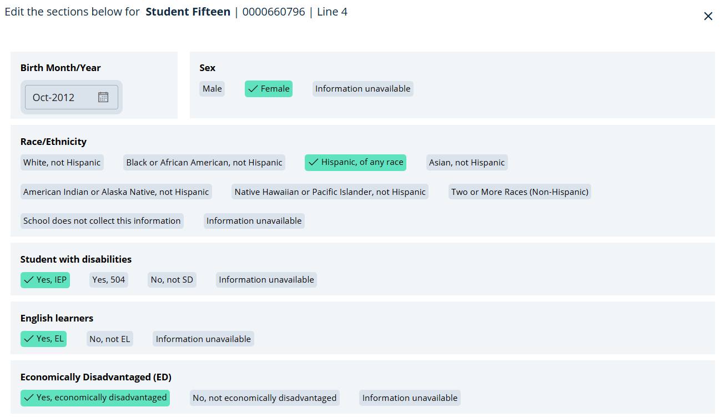

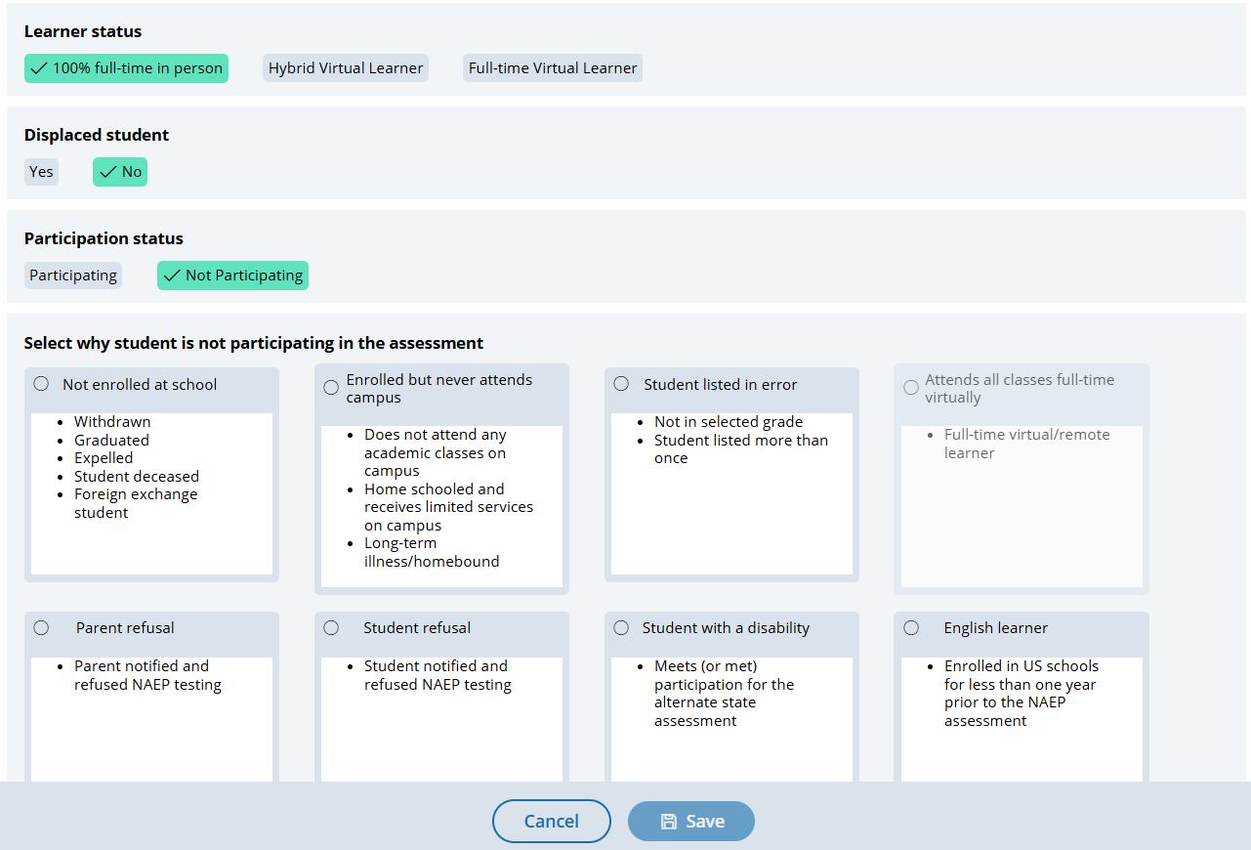

Boxes that appear in the “Select why student is not participating in the assessment” section are dynamically displayed depending on prior student information provided.
Not participating options are as follows:
- Not enrolled at the school
- Enrolled but never attends campus
- Student listed in error
- Attends all classes full-time virtually
- Parent refusal
- Student refusal
- Students with a disability (students who are SD only: Meets (or met) participation for alternative state assessment)
- English Learner (students who are EL only: Enrolled in U.S. schools for less than 1 year prior to the NAEP assessment)

Note. Schools in Hawaii will also see an additional option for Hawaiian Immersion Student

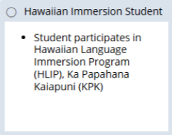

Appendix I18: 2027 Provide Student Information-Student Information, SD/EL (NEW)
Students with Disabilities (SD) and English Learners (EL)
The Students with Disabilities and English Learners tile is a companion section to the Provide Student Information – Student Demographics section of the system, and consists of two separate required tasks:
- Acknowledgement of State Inclusion Policies - where users can download their state specific inclusion policies and confirm having read (acknowledgement only required by school staff member to be considered completed).
- Students with Disabilities (SD) and English Learners (EL) Details – where users identify whether students will participate with accommodations and the accommodations needed, without accommodations, or do not test. This task is considered complete when all required information has been provided for each student.

The tile displays summary information including the number of selected (sampled) students identified as SD, EL or SD and EL, count of excluded students, and count of students with missing information. The tile additionally includes access to additional instructional documents and a tutorial (see Appendix I31) to support user’s completion of the student demographics section of the system. Both acknowledgement of state inclusion policies and providing student accommodation information are required tasks that are considered complete (info required label changes to “Completed”) when all required information has been provided.
Authorized users access the student demographic section by selecting the Manage button from the main tile.
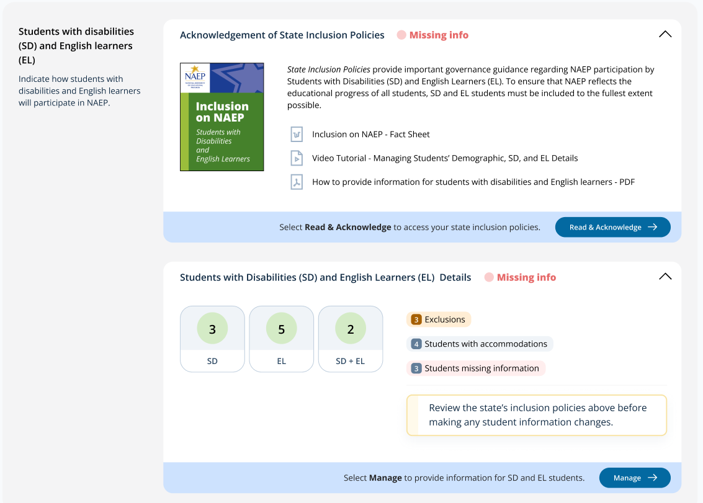

Acknowledgement of State Inclusion Policies Screens
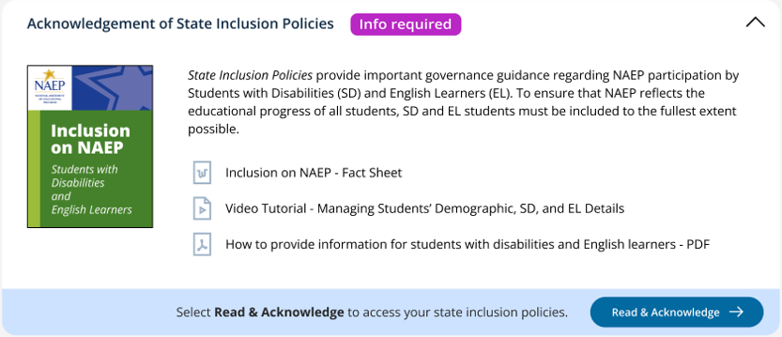
Upon selecting the Read & Acknowledge button, users are navigated to the Required Reading – State Inclusion Policies screen where they can download and acknowledge having read their state inclusion policies.
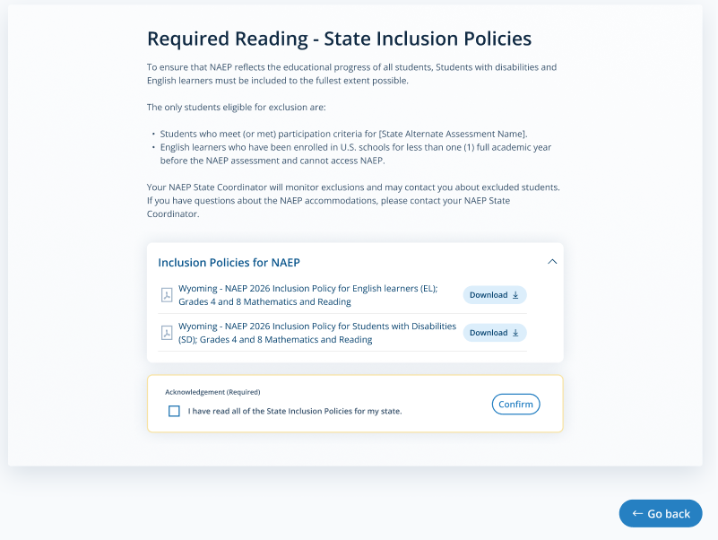
Note. While the expectation is that all authorized AMS school users entering student accommodations read the state inclusion policies, only one individual is required to acknowledge to complete the task. A user selects the check box next to “I have read all of the State Inclusion Policies for my state” and selects the “Confirm” button to complete the acknowledgement.
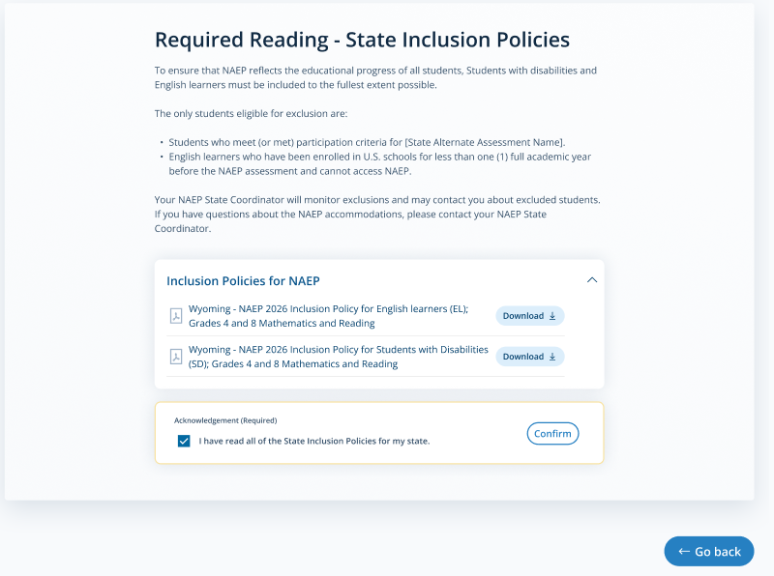
Once acknowledged, the individual’s name and time stamp of when completed the acknowledgement task is displayed and the Confirm button disabled and changed to “Confirmed”.
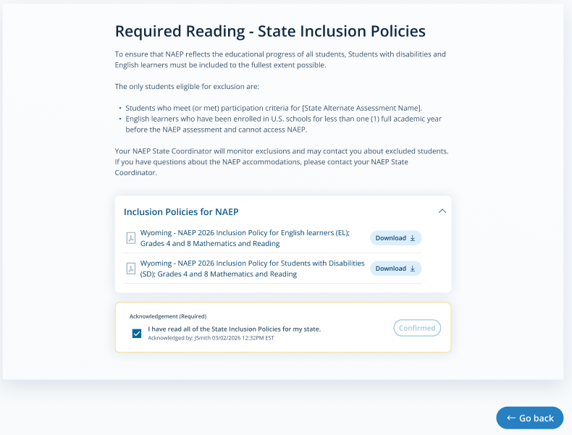
Student with a disability and English Learners
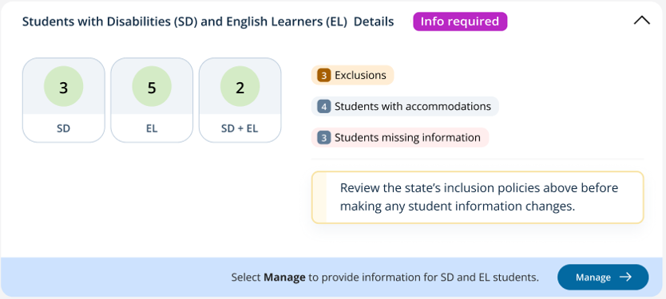
Upon selecting the Manage button, users are navigated to the Provide Student Information table – Students with Disabilities (SD) and English Learners (EL) tab.

Students with a Disability (SD) and English Learners (EL) (Manage Mode)
From this tab schools provide How to Take NAEP and other corresponding information (e.g. accommodations) for students identified as students with disabilities and/or English Learners.
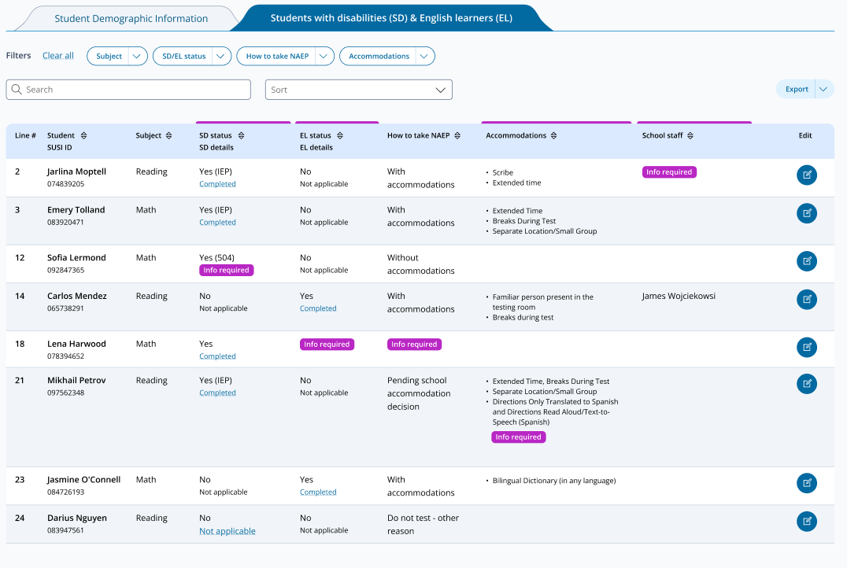

A tutorial video (see Appendix I31) and additional resources for download are also provided to support users working throughout student accommodations. Additional resources available include:
- Inclusion on NAEP fact sheet
- Inclusion policy for students with disabilities
- Inclusion policy for English learners

Note. Specific names of resources included in the Review additional resources may change per program requirements.
Single student edits are made by selecting the edit icon in the row of the student whose accommodations information is to be established or updated. A single student edit modal screen appears.
Single Student Edit - SD/EL Modal Screens
To begin, users select how the student is to take NAEP. Depending on the selection, different sets of screens appear for the user to work through and view.
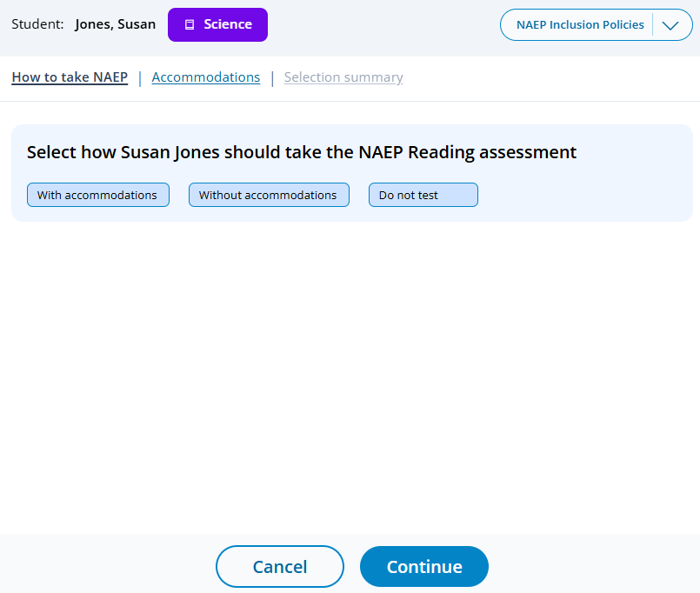

With Accommodations
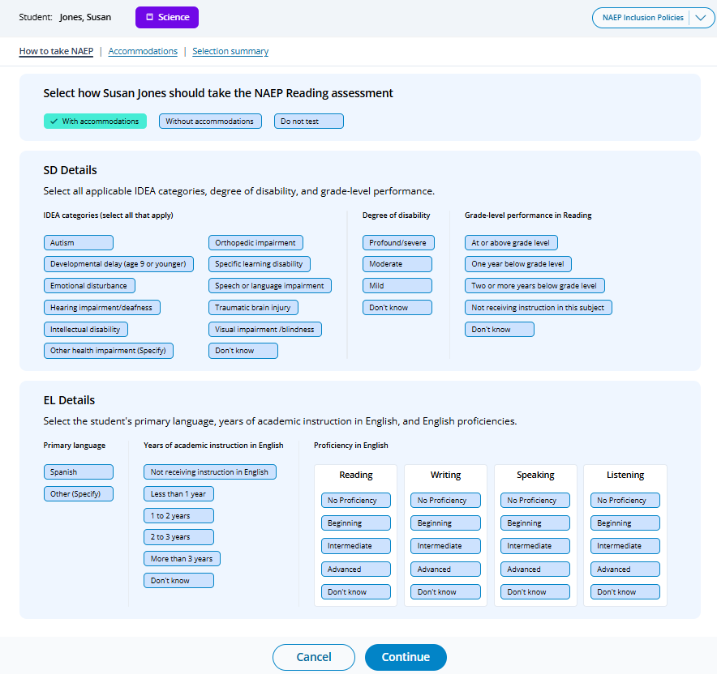

If “Other health impairment (Specify)” is selected for SD Details, a text box appears for additional information input:
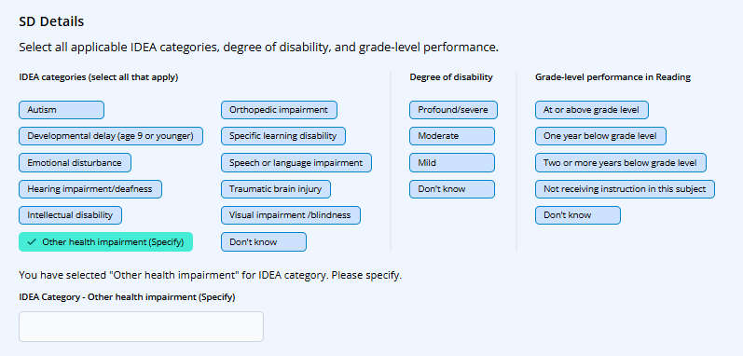
If “Other (Specify)” is selected for EL Details, a text box appears for additional information input:
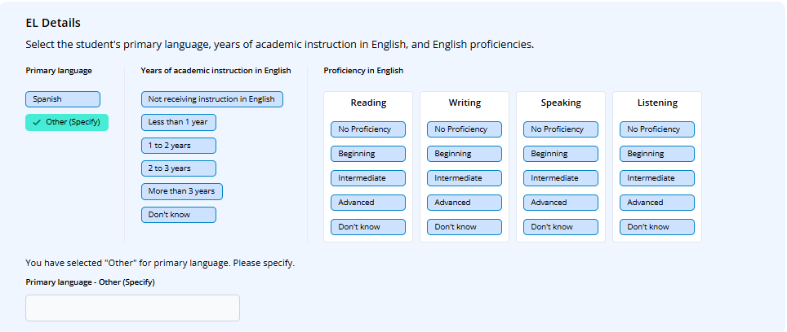
Upon selecting the “Continue” button, the user is navigated to the Accommodations selection screen.
Note. The AMS screensots do not reflect the specific Universal Design Elements (UDEs) and Accommodations available for the 2027 NAEP Science Pilot administration. Tables following the system screenshots include the list of 2027 approved UDE and Accommodations that are to be shown within the AMS along with corresponding default description text.

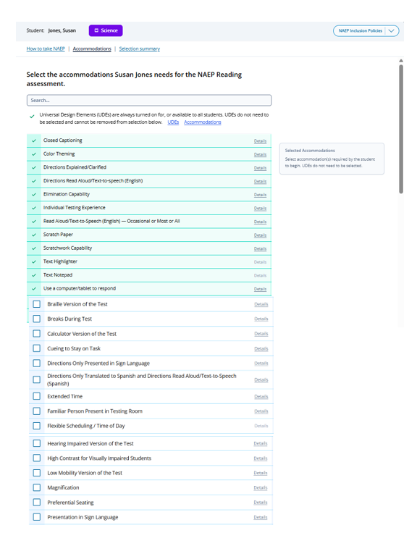

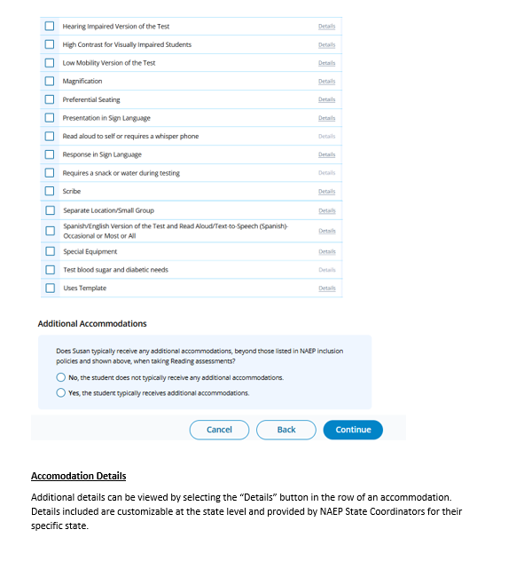

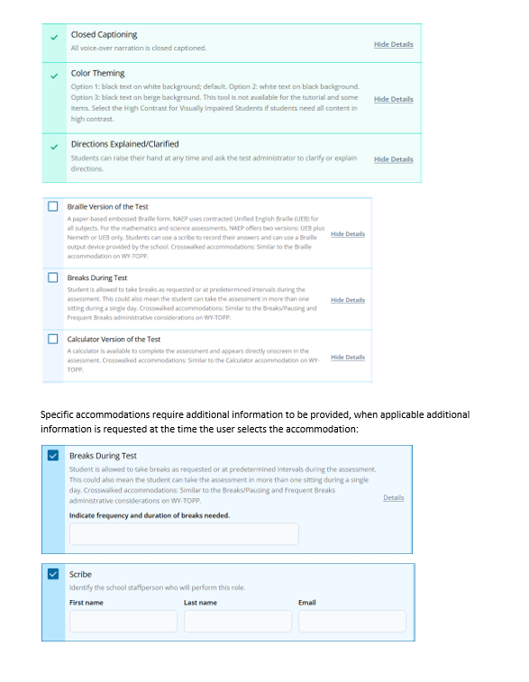

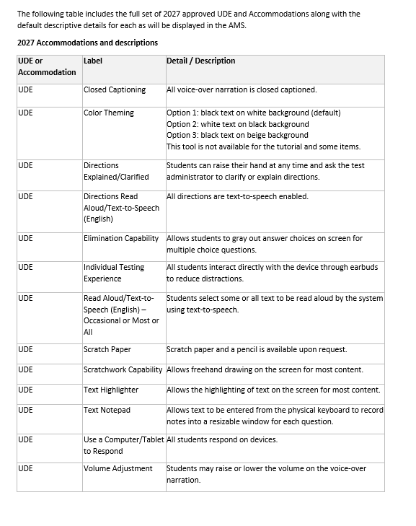

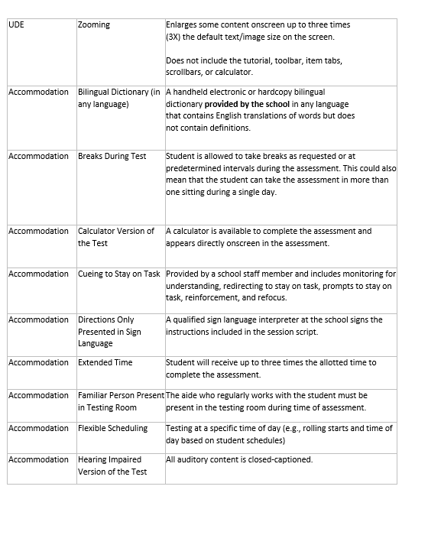

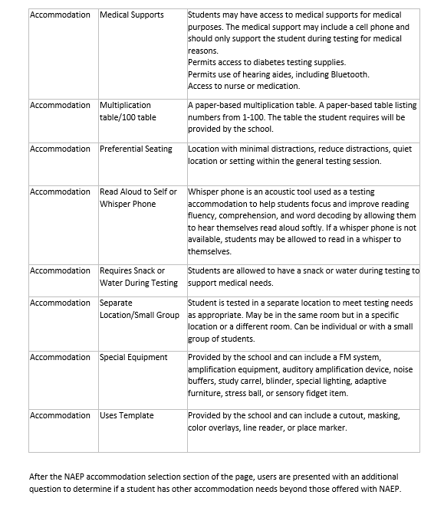

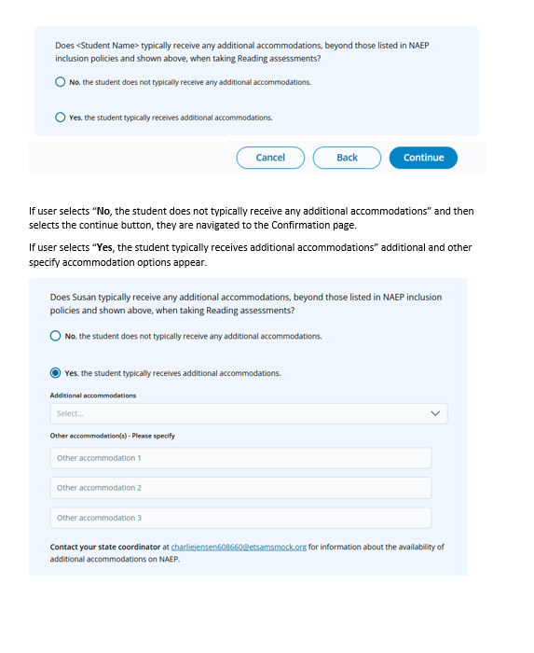

Additional Accomodation dropdown:
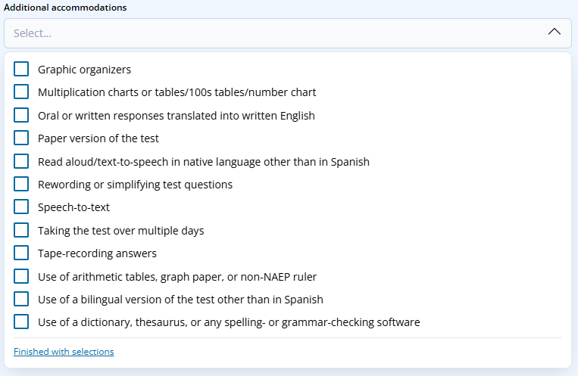
Note. The additional (not allowed) accomodations listed in the screenshot are for reference purposes. The table below identiies the specific additional accomodations that will be shown in system for the 2027 NAEP administration. Descriptions are not provided in system for additional accommodations.
Additional Accommodation | Label | Detail / Description
Accommodation (Not allowed) | Graphic organizers | Not applicable
Accommodation (Not allowed) | Paper version of the test | Not applicable
Accommodation (Not allowed) | Read aloud/Text-to-speech in native language other than in Spanish | Not applicable
Accommodation (Not allowed) | Rewording or simplifying test questions | Not applicable
Accommodation (Not allowed) | Spanish/English Version of the Test | Not applicable
Accommodation (Not allowed) | Speech-to-text | Not applicable
Accommodation (Not allowed) | Taking the test over multiple days | Not applicable
Accommodation (Not allowed) | Use of a bilingual version of the test other than in Spanish | Not applicable
Accommodation (Not allowed) | Use of a dictionary, thesaurus, or any spelling- or grammar-checking software | Not applicable

Selected additional accommodations are displayed to the user as they are selected.
Note. All other accommodations – please specify entries require review and approval by a NAEP representative. A tag labeled “Requires review and approval” is displayed next to the other Specify accomodation until a decision is made.
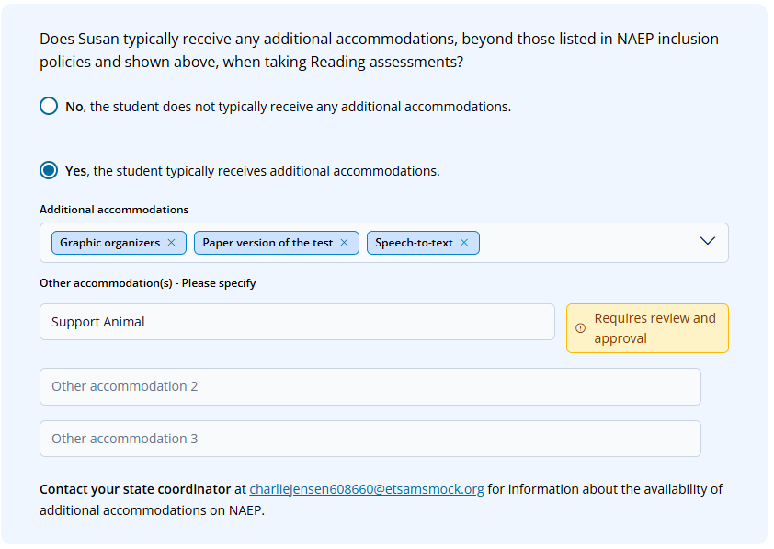
The tag for other specify accomodation is updated accordingly once a decision has been applied by a NAEP representative.
NAEP Representative Other Specify Decisions:
- Allowed – Label changed to “Allowed” – no further action needed by school - Other Specify accommodation noted in Selected Accommodation section on the Confirmation/Sumary page
- Not allowed – Label changed to “Not Allowed” – follow required by school on the Confirmation/Summary page to indicate if student can take NAEP without the accommodations
- Upcode – Label changed to “Upcode” – no further action needed by school – Upcoded accommodation will appear in the Selected Accomodation section on the Confirmation/Summary page
- Delete – Label change to “Delete” then no further action needed by school
- Ignore – Label changes to “Ignore” then no further action needed by school
Once a user has selected a student’s accommodations and entered other specify accommodations and selected the Continue button, they are navigated to the Confirmation/Summary page.

Confirmation/Summary page
The Confirmation/Summary page allows users to view:
- How to take NAEP responses and identify any additional informational requirements.
- Additional accommodations selected (not allowed) that have additional information required to identify if the student can take NAEP without the non-allowed accommodation(s).
- Accommodations pending NAEP review
- Selected accommodations and correspondiing additional information as applicable that was provided or still needed.
- Universal Designe Elements
Additional features and elements of the page include:
- “Info required” label identifes any section where user has not responded to required questions and/or information requests.
- Ability to download state specific Inclusion Policy documents via the NAEP Inclusion Policies dropdown.
- Edit buttons to return to specific pages within the SD/EL selection process.
- User ability to Save and exit without all required inormation completed.
- Selecting a “Completed” label display specific responses provided in a pop-up.
All subsequent users editing a student’s SD/EL information are returned to the Confirmation/Summary page from which they can provide any additional required information and/or select the edit button of the corresponding section to return to a specific section to update responses and selections.
The Confirmation/Summary page is dynamic with information shifting as additional information is provided. For example other specify accomodations “Pending NAEP decision” are moved to the Selected accommodations” if marked as “Allowed” by a NAEP representative, or moved to the Not allowed section with additional action required by school user if marked as Not Allowed by a NAEP represetative.
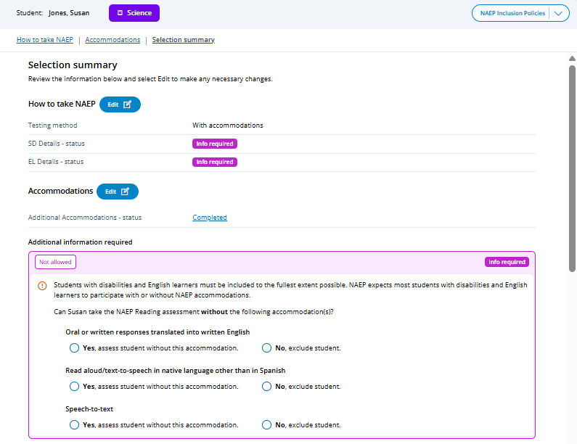
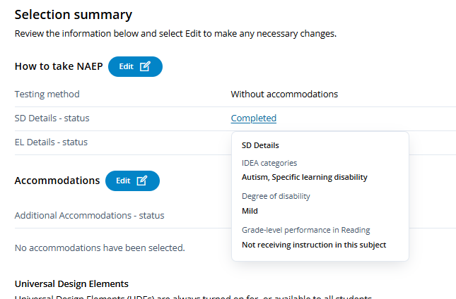
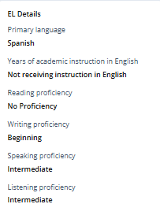
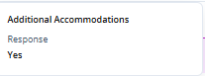
Selecting a “Completed” status opens corresponding pop-up displaying provided responses

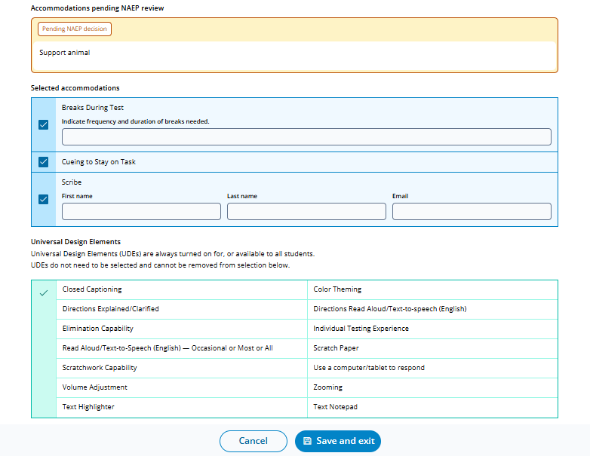

Additional system messaging is included in the event that the information provided results in a student being excluded from the NAEP assessment.
Upon selecting Save and exit, users are returned to the Students with Disabilties (SD) and English Learners (EL) tab.
If any SD/EL students have been identified for exclusion from the NAEP assessment a warning banner will appear above the table for both the Student Demographics Information and Students with Disabilities (SD) & English Learners (EL) views (tabs). User may select the Filter table to view excluded students button to limit the view of students in the table to the excluded students only.
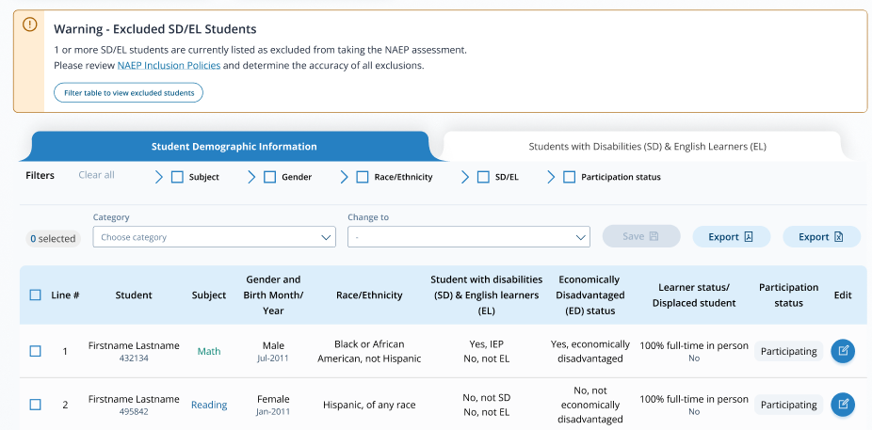

Without Accommodations
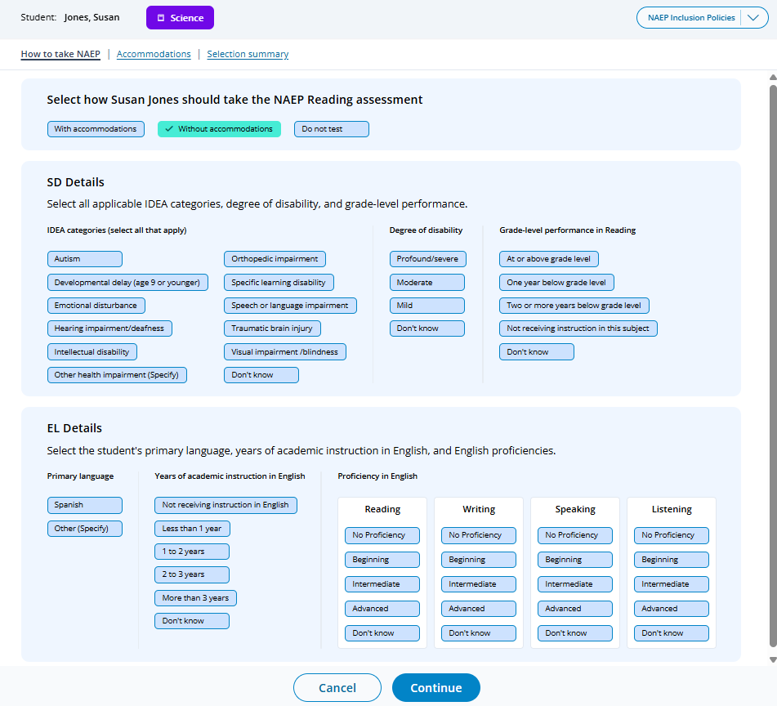
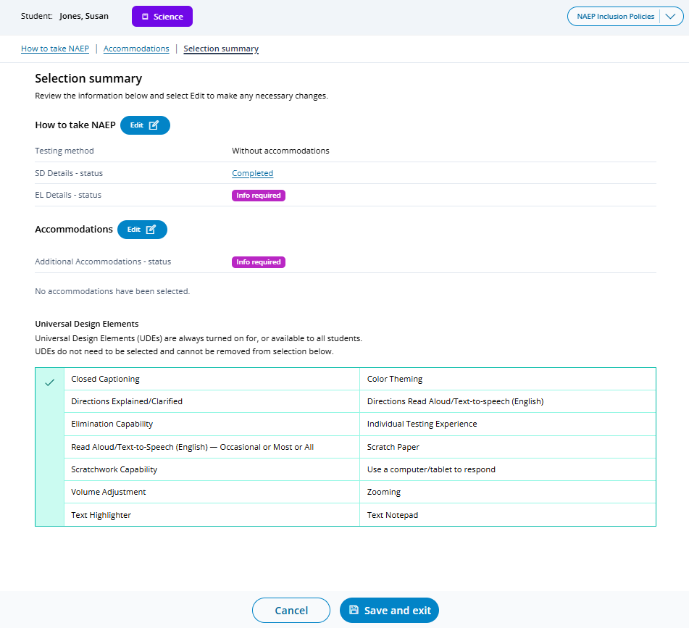
Not applicable

Do Not Test
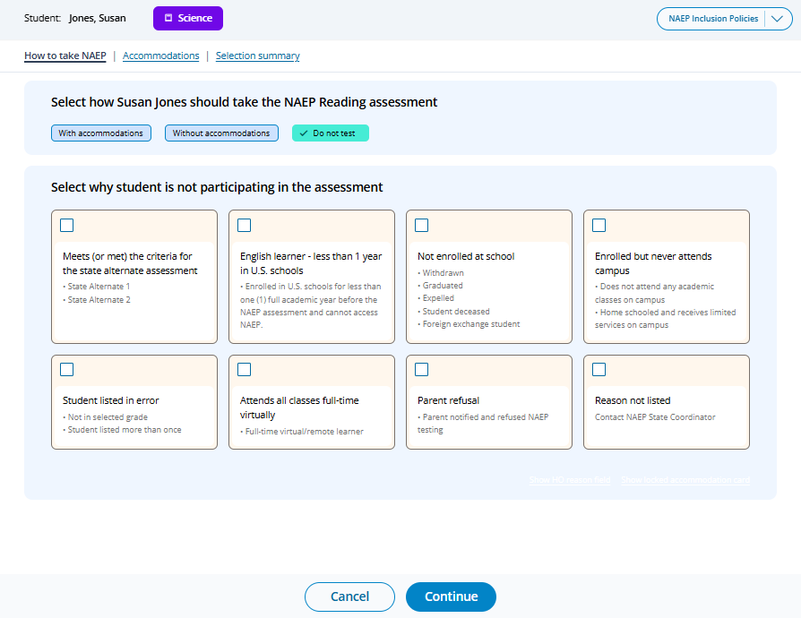
Note. Schools in the Hawaii Jurisdiction will also see an additional option for Hawaiian Immersion Student

If Meets (or met) the criteria for the state alternate assessment or English learner - less than 1 year in U.S. schools is selected SD and/or EL details appear:
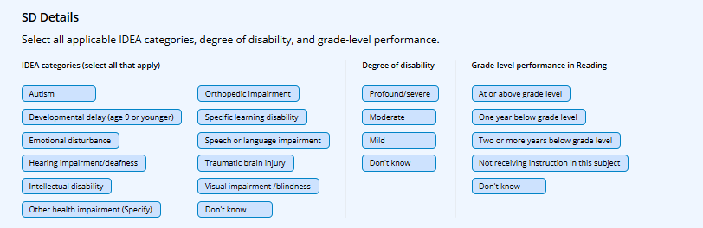
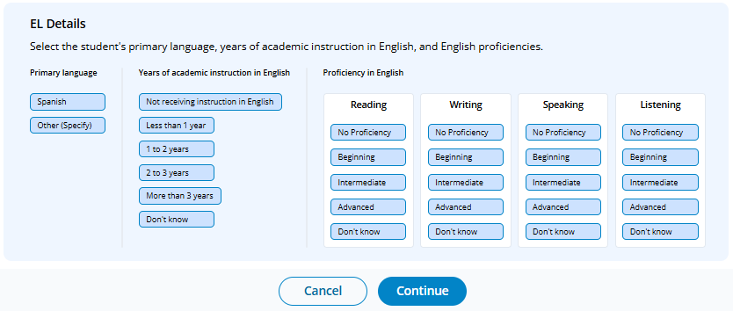
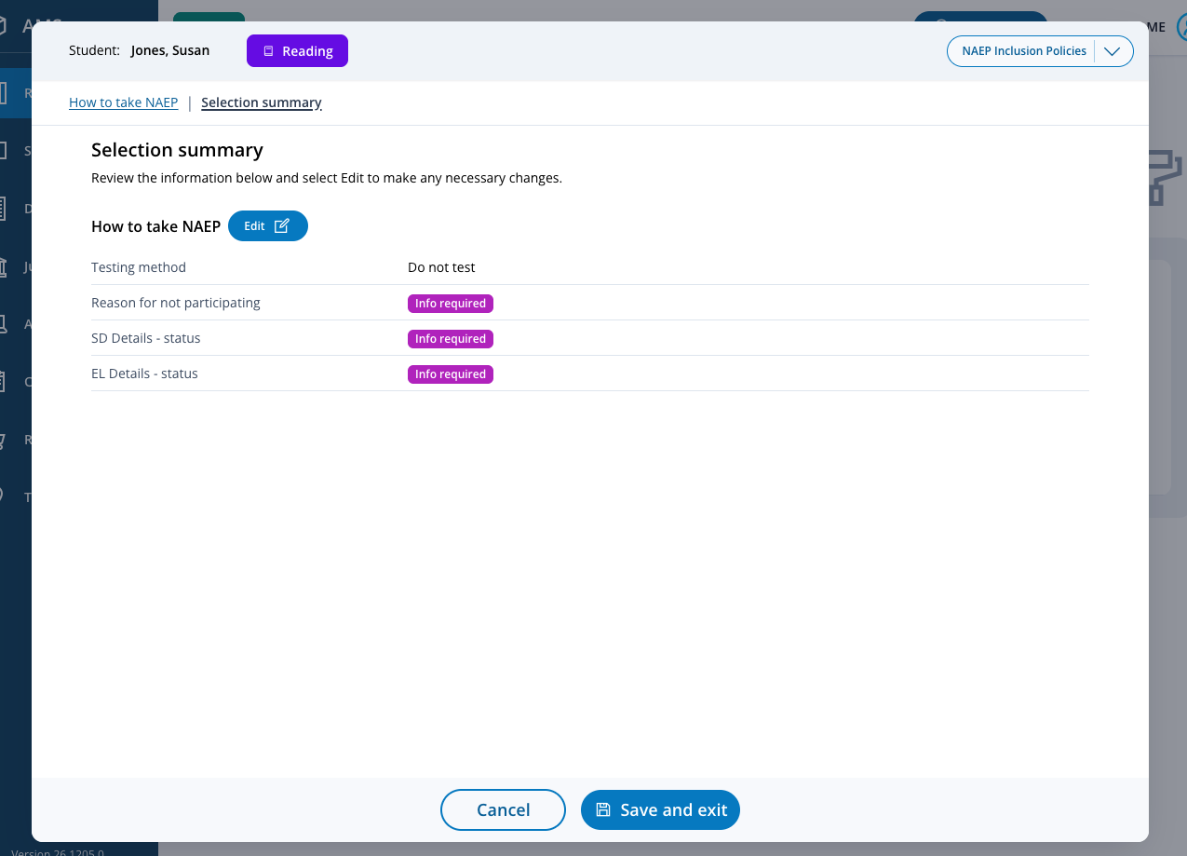

Appendix I19: 2027 Request Help (NEW)
Users can access and view the contact information for the NAEP help desk by clicking the Help button in the top Menu bar.
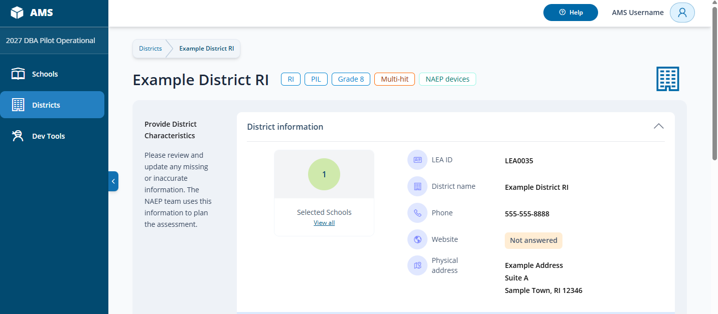
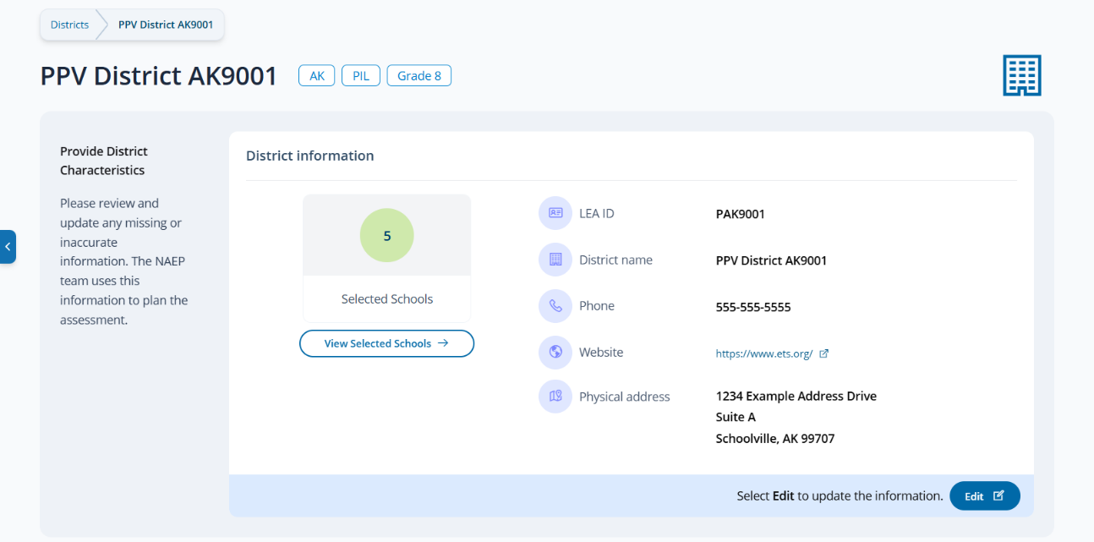


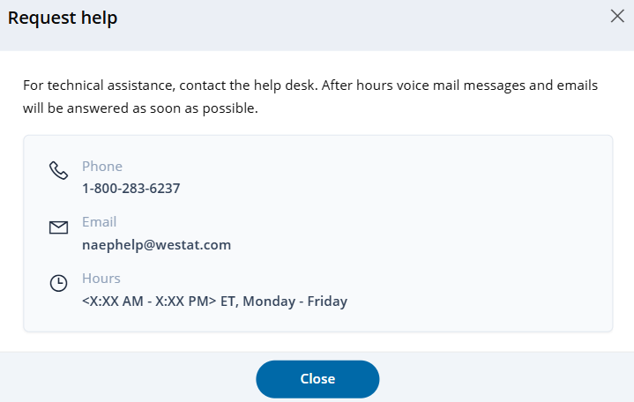
Note. Help desk hours vary throughout the assessment cycle.

Appendix I20: 2027 Schedule Assessment Planning Meetings (NEW)

Schedule Assessment Planning Meeting
The Schedule Assessment Planning Meeting (APM) tile is used to schedule/reschedule an APM, view scheduled APM date, access meeting link, identify whether meeting occurred and schedule a follow-up as needed. Functionality available to school/district users is limited to Scheduling/Rescheduling an APM. All other functionality available in the tile is limited to and the responsibility of internal NAEP staff (e.g., Field staff).
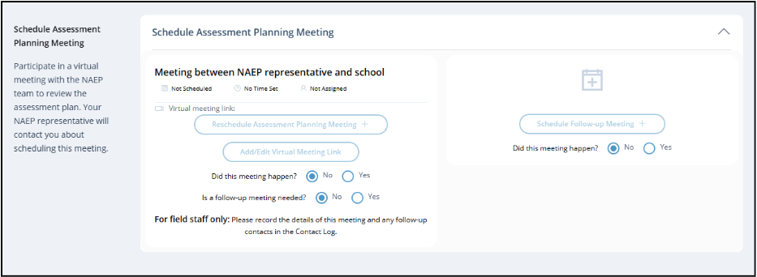

On the modal pop-up, the school coordinators will be able to select a date and time that their NAEP representative is available and schedule the assessment planning meeting to review and confirm school information prior to assessment day.

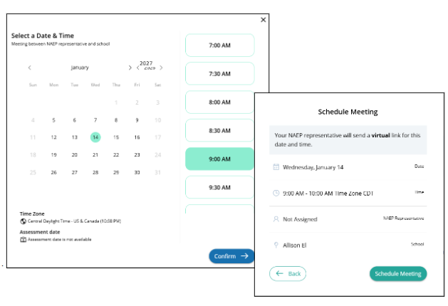

Appendix I21: 2027 School Summary Page (NEW)
Appendix [insert letter & #]: NAEP 2027 School Summary Page
The School Summary page consists of “tiles” (primary sections), each containing certain information for viewing/editing data and/or features for completing specific NAEP operational tasks as follows:
- Provide School Characteristics
- School information
- Grade information
- Manage Team
- Take the School Technology Survey
- Import Students
- Schedule Assessment Planning Meeting
- Provide Student Information – Student Demographics
- Students with Disabilities (SD) and English Learners (EL)
  - Acknowledgement of State Inclusion Policies
  - Students with Disabilities (SD) and Englis Learners (EL) Details
- Assessment Logistics
- Technical Logistics (appears for School Device Model schools only)
- Notify Parents/Guardians
- Manage Questionnaires
- Support Assessment Activities
Tiles become operational at different points throughout the administration cycle in support of, and alignment with, school recruitment, student sampling, preassessment readiness activities, and school and teacher questionnaire management. The School Summary page features badges and banners to display important reference information at the top of the page to support system users that conditionally appear, change or are removed at different points in time. A Task List navigation menu is also provided on the School Summary page.
Note. The AMS is undergoing a redesign to standardize the user interface (UI). The content shown in the screenshots and supporting narrative aligns with 2027 NAEP administration requirements. The 2027 NAEP administration is a pilot administration specific to Grade 8 Science. Any screenshots referencing “Main”, Grade 4, and/or any subject other than Science, will display “Pilot”, “Grade 8”, and “Science” respectively in the AMS for the 2027 NAEP Administration.

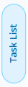



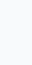

Badges
Badges are provided to provide uses with quick at-a-glance reference to key dates, statuses and information. The following badges appear in the system:

School Technology Survey (STS)
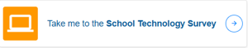
Note. Interactive badge displayed during the STS window until the school’s survey is submitted (completed).

- Possible statuses include:
- Not started
- In progress
- Completed
Note. Status displayed in STS badge changes after the close of the STS Window.

- Possible statuses include:
- Not started – Closed
- In progress – Closed
- Completed – Closed
Assessment Planning Meeting (APM) and Scheduled Assessment Dates:
Note. Display “Not Scheduled” prior to dates being established.
Verification code:
Note. Verification codes are unique to each school, and used when validating devices as part of device readiness checks.
Banners
Banners are used to display important information to users. The following banners appear in the system.
Assessment Model Assignment
Either of the following two banners will appear at the time the STS is completed for a school or at the close of the STS window for surveys not yet started or in progress.
Assessment
The following banner appears one day prior to a school’s scheduled assessment date.
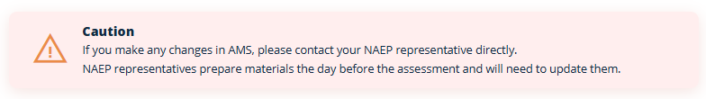
System Messaging
The AMS contains several standard messaging universally applied throughout the application where and when applicable.
System Modal/Toast Messaging:
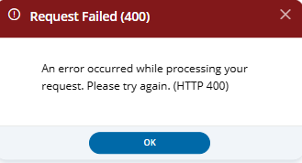
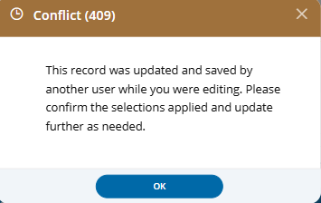
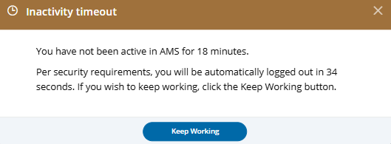
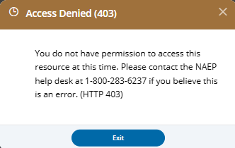

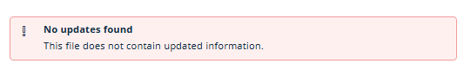

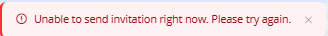
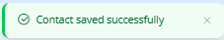
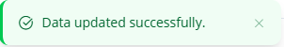
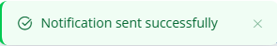
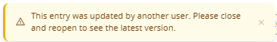
Task List
The Task List is an expandable/collapsable tab that serves as a shortcut to navigate users to a specific tile. Menu options are dynamically populated based on the tiles available to the user.
Note. Not all tiles appear to all users and are dependent on State Coordinator designations of whether the school, district, or state is responsible for importing student lists and add new students, or school, district, state refusals of school and teacher questionnaires. Additionally, the Technical Logistics tile does not appear (not applicable) for schools assigned to NAEP Device Model. The Task list is dynamically populated based on the specific tiles available to the user. Below is the full set of possible options that may appear.

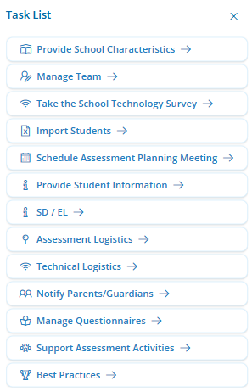
Preassessment Activities
The Preassessment Activities tile appears in the AMS at the opening of the preassessment activities, after the Import Student List initial window has closed and student sampling is completed. It provides a visual summary status of preassessment task completion by section (tile). The tasks listed double as hyperlinks to facilitate user navigation to a specific tile. The Task List is dynamically populated based on the corresponding activities applicable to the schools (e.g., Technical Logistics does not appear for NAEP Device Model schools). Additional messaging is displayed depending on completion of student demographic information.
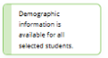
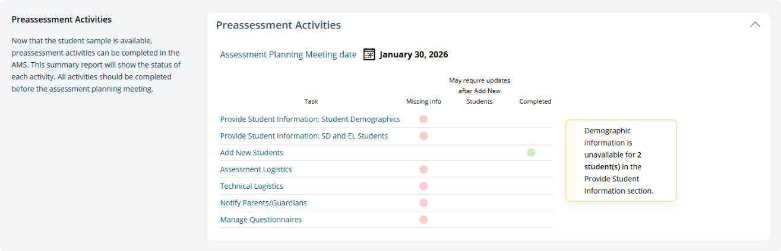
_{Info required}
Acknowledgement of State Inclusion Policies Policy
<Date>
Note. Beginning with the 2027 NAEP administration, a new task for acknowledgement of state inclusion policies will be introduced and included as a task in the list with a corresponding completion status.

Appendix I22: 2027 School Technology Survey
The School Technology Survey (STS) is used to determine assessment model assignments (School Device, NAEP Device) for individual schools.
Notes:
- District respondents may complete surveys for one or more schools within a single session or across multiple sessions anytime during the survey response window. District and state respondents select the school(s) they wish to respond to from the School Technology Survey Manager.
- School level respondents are limited to responding to a single school survey only and may complete the survey within a single session or across multiple sessions anytime during the survey response window.
- Responses are automatically saved as a respondent navigates through the survey (e.g., advances to a different question via Save and Continue button).
- Respondents may return to previous question via the Previous Question button. Responses are not automatically saved as a response is provided or when a prior response is changed. When navigating to a previous question, respondents will be provided with two options for proceeding if they have made a change to a response (single school survey) or one or more responses (multi school survey): Save and Continue, Cancel.

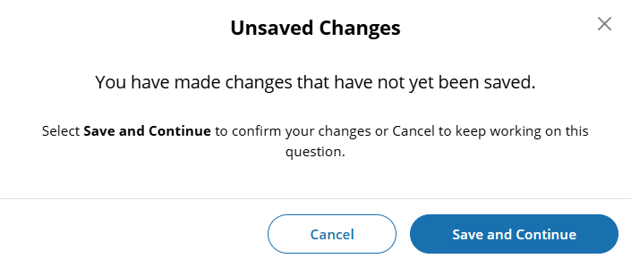

- Ability to Exit Survey is provided on each question. Upon clicking Exit Survey, respondents are provided three options for proceeding: Save and Exit, Keep Working, Exit without Saving.

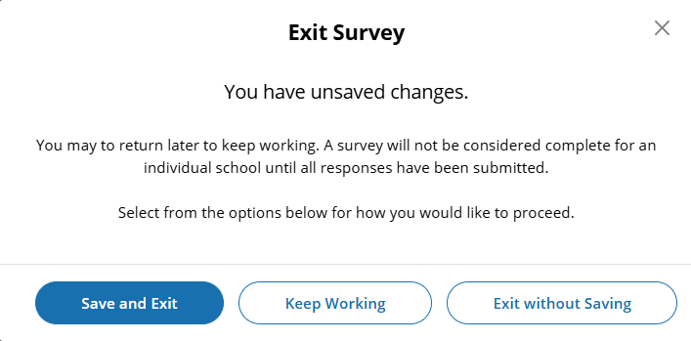

- (Multi School) Respondents have the ability to “Save” work in progress on a question by selecting the Save button. Responses up to that point saved and user remains on current question.
- (Single and Multi School) – Responses are automatically saved when respondent clicks Save and continue button and user is navigated to the next question.
- An option to clear responses is provided for selected response questions. Clear response does not apply to open ended text box responses.
  - (Single School) – Clear response button removes response provided on the question.
  - (Multi School) – Clear response button provided for each school listed - removes response for a specific school.
- Questions 1-5 are School Device eliminating questions:
  - (Single School) If a response is provided that eliminates the option for using School Devices, a “Submit Survey” confirmation pop up will appear upon clicking the Save and continue button.

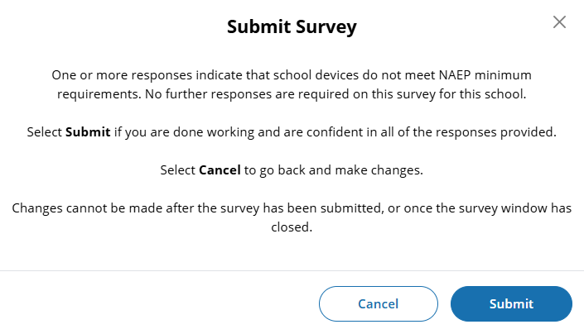

  - (Multi School) - Schools for which an eliminating response is provided on any of questions 1-5, the school will remain shown on subsequent questions but will be disabled (greyed out) and will not require additional responses to be provided. If an eliminating response is provided for all selected schools a “Submit Survey” confirmation pop up will appear upon clicking the Save and continue button.

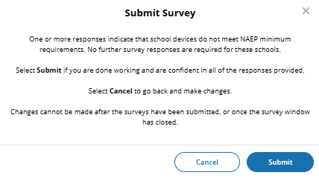

Prior responses may be changed prior to submission of the survey by any permissioned user with editing rights. Users changing existing responses will be shown a pop-up providing two options for proceeding: Cancel and Continue.

(Single and Multi School)
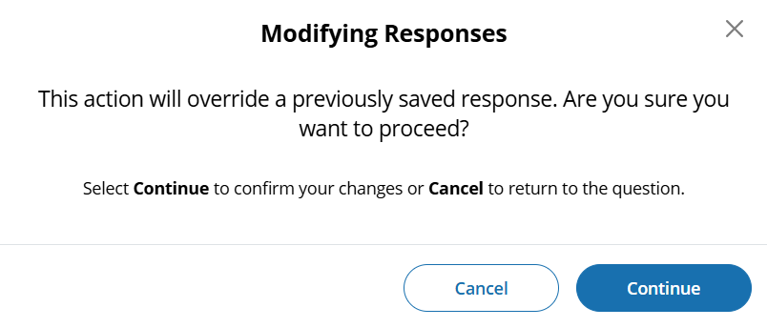
- Respondents may advance to the next question without making a selection for multiple choice and open-ended text box questions. If responses are missing, a message will be displayed alerting respondent of missing responses upon clicking the Submit button at the end of the survey. School surveys may not be “submitted” without a response provided for each question.

(Single School) – Submit Survey: No Incomplete Responses

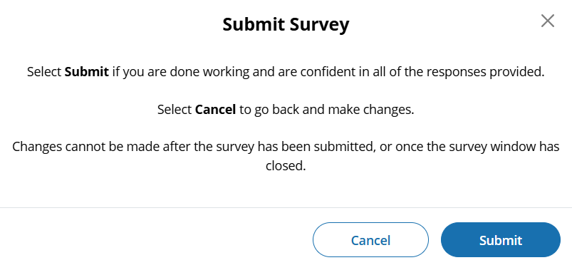

(Multi School) – Submit Survey: No Incomplete Responses

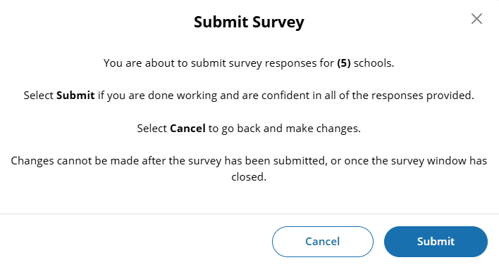

(Single School) – Submit Survey: Incomplete Responses
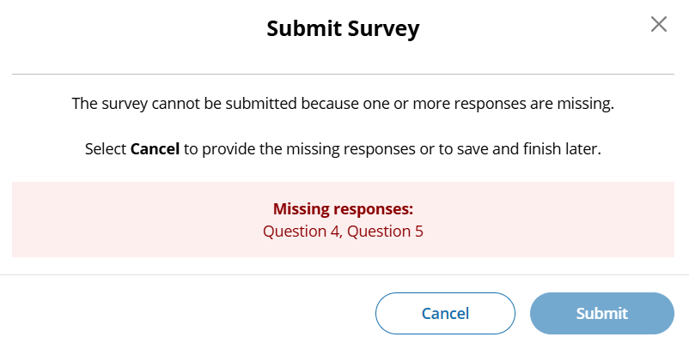

(Multi School) – Submit Survey: Incomplete Responses for some schools

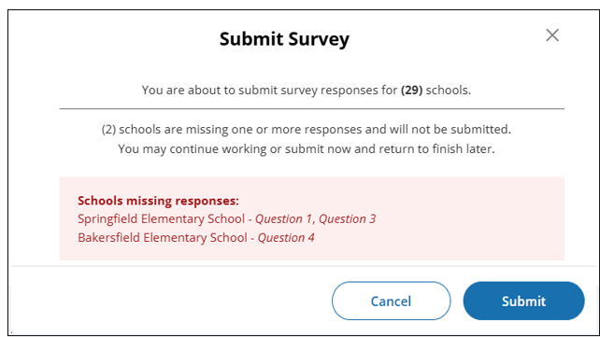

(Multi School) – Submit Survey: Incomplete Responses for all schools

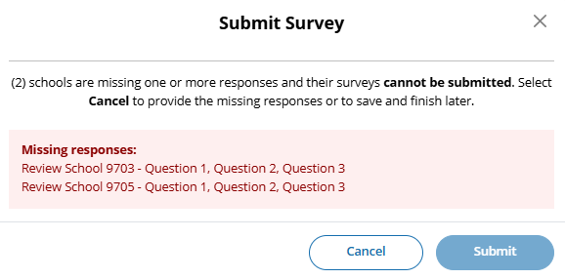
Note. Submit button is disabled

- For multi school survey submissions, any schools with a complete set of responses will be successfully submitted and classified as “Complete”. Schools identified as missing responses in the message will not be submitted and will be classified as “Incomplete”. School surveys in incomplete status will remain open for completion any time during STS window.
- Once a school survey is submitted it is locked for further editing by District or School staff. Staff needing support must contact the NAEP Help Desk or their NAEP State or TUDA Coordinator to make further edits during the survey window.
- Once the survey window has closed no further editing is permitted.
- eNAEP Download Center URL((https://enaep.naep.ed.gov/download-center/resources/index.html) can be accessed via hyperlinks on the STS introduction page and within each question:

School Technology Survey Manager
(Multi School Only)

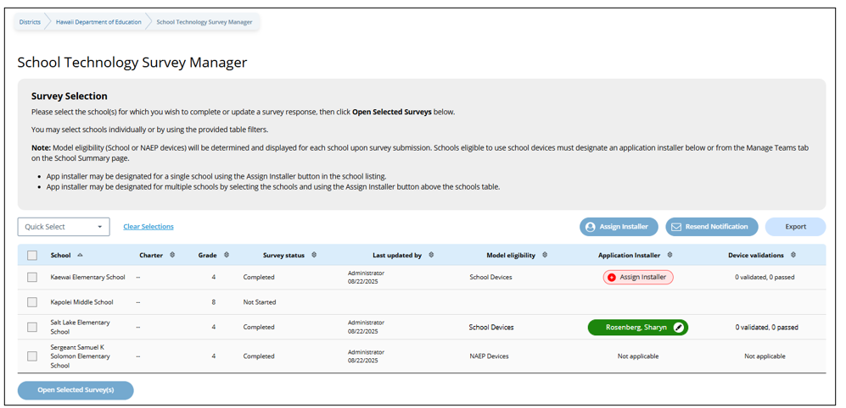

Survey Text:
Survey Selection
Please select the school(s) for which you wish to complete or update a survey response, then click Open Selected Surveys below.
You may select schools individually or by using the provided table filters.
Note: Model eligibility (School or NAEP devices) will be determined and displayed for each school upon survey submission. Schools eligible to use school devices must designate an application installer below or from the Manage Teams tab on the School Summary page.
- App installer may be designated for a single school using the Assign Installer button in the school listing.
- App installer may be designated for multiple schools by selecting the schools and using the Assign Installer button above the schools table.

Notes:
- Application installer name (with green tag) identified in Application Installer column if Application Installer information previously provided via Team Management tile in Schools summary section of AMS or via the STS Manager.
- Schools in “Completed” status and identified for “NAEP Device” are shown with “Not Applicable” in Application Installer column.
- Schools in “Completed” status and identified for “School Device” model with no Application Installer previously identified have “Assign Installer” (red tag) shown in Application Installer column
- Click on “Assign Installer” (red tag) or name of App Installer (green tag - if previously provided) – opens pop-up to enter/edit App installer information.
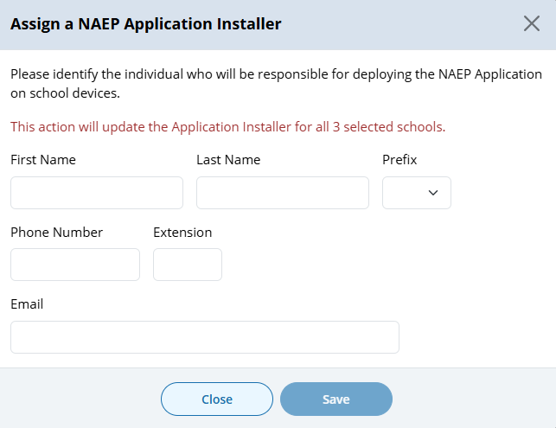
- Application Installer may be identified/entered for one or more selected schools via the Assign Installer button
- Click on Export button provides report in (XLXS format) – matched to any school selection criteria applied.
- Click on Resend Notification button sends App Installer Instruction email (a.k.a., eNAEP Download Center Notification) to App Installer identified at selected schools. Pop-up confirmation is shown to confirm intent to send email.
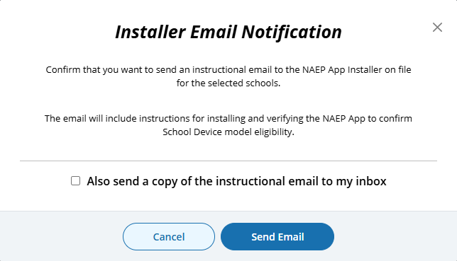
- Open Selected Survey(s) button navigates user to survey introduction.

Introduction
(Single and Multi School)
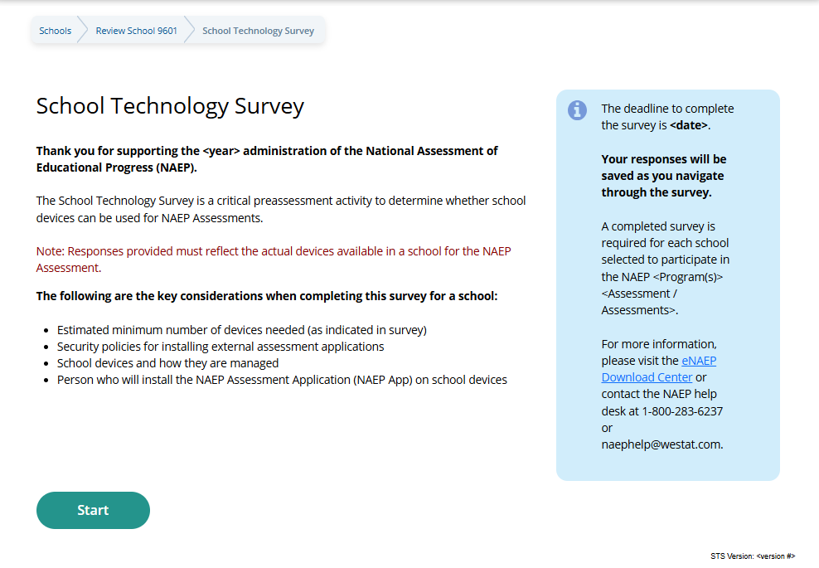

.

Confirm Operating System Requirements
(Single School)
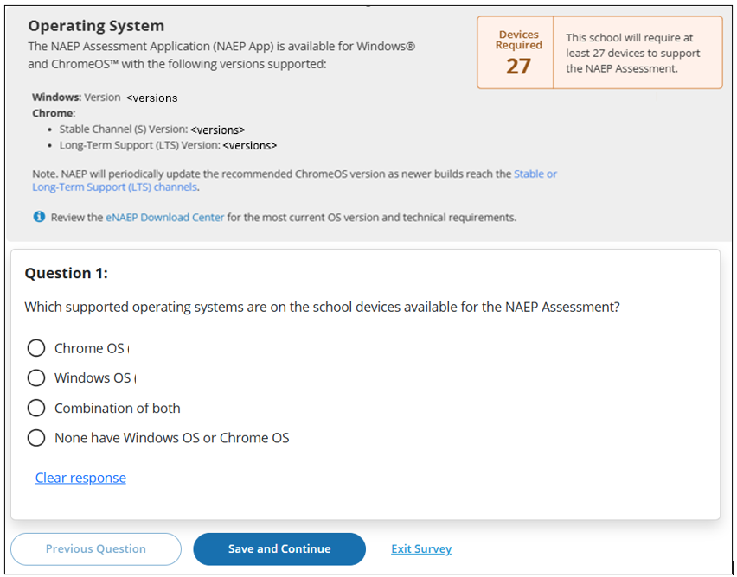
<versions>

Respondents selecting “None have Window OS or Chrome OS” are displayed and additional question (required response) on the page.
Question 1a:
(Required) Select the operating system(s) of devices the school has available. Select all that apply.
- macOS
- iOS (iPad)
- Other

(Multi School)
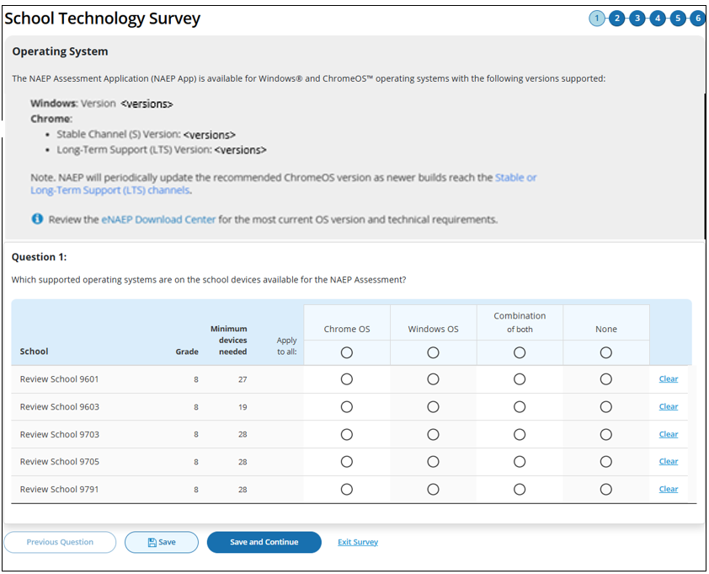

If “None” selected an additional question (Question 1a - required response) becomes available within a modal on the page via the “Add Details” button that appears. The button label converts to “View/Edit” once the question has been responded to.
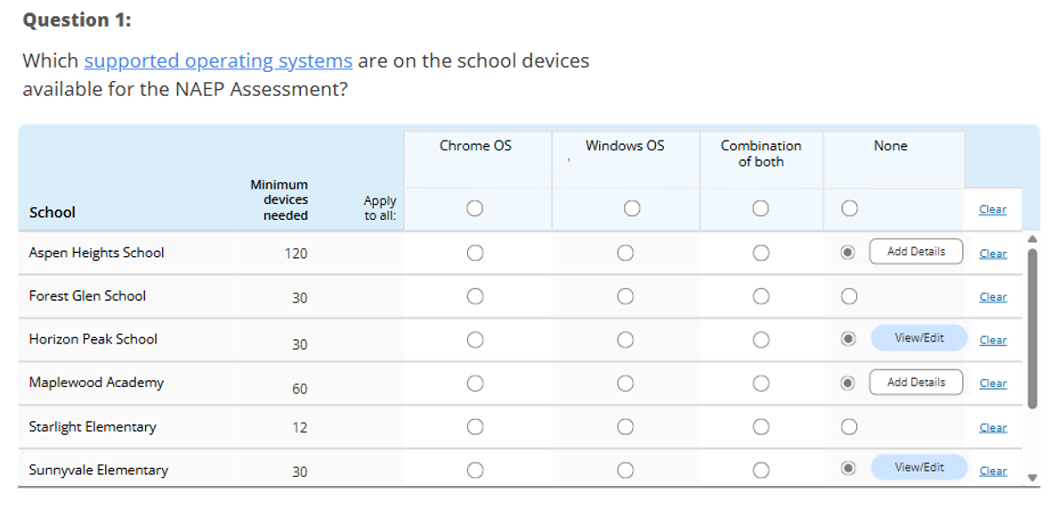

Question 1a: Pop-up Modal (when applied to a single school)
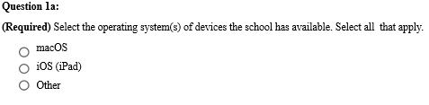


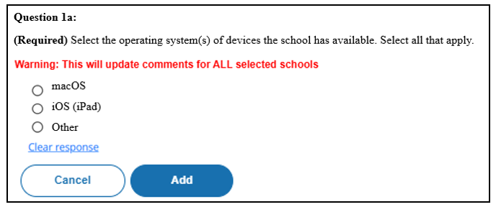
Question 1a: Pop-up Modal (when applied to All Schools)

Confirm Physical Keyboard Requirements
(Single School)

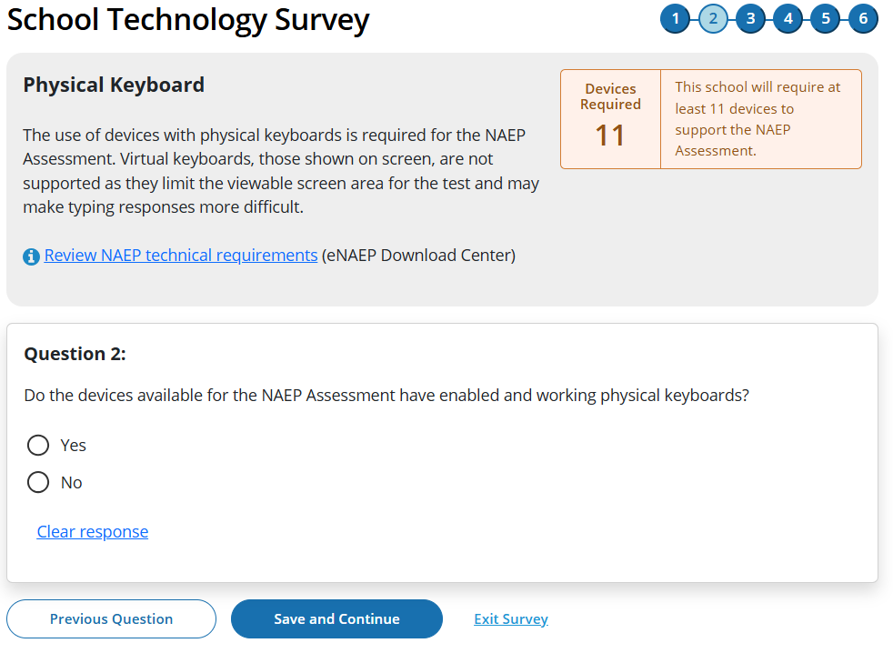

(Multi School)

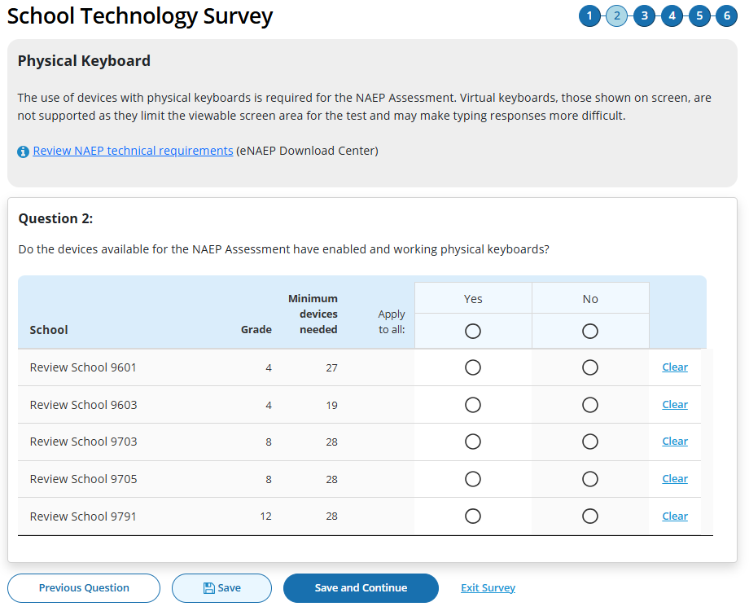

Confirm Device Availability
(Single School)

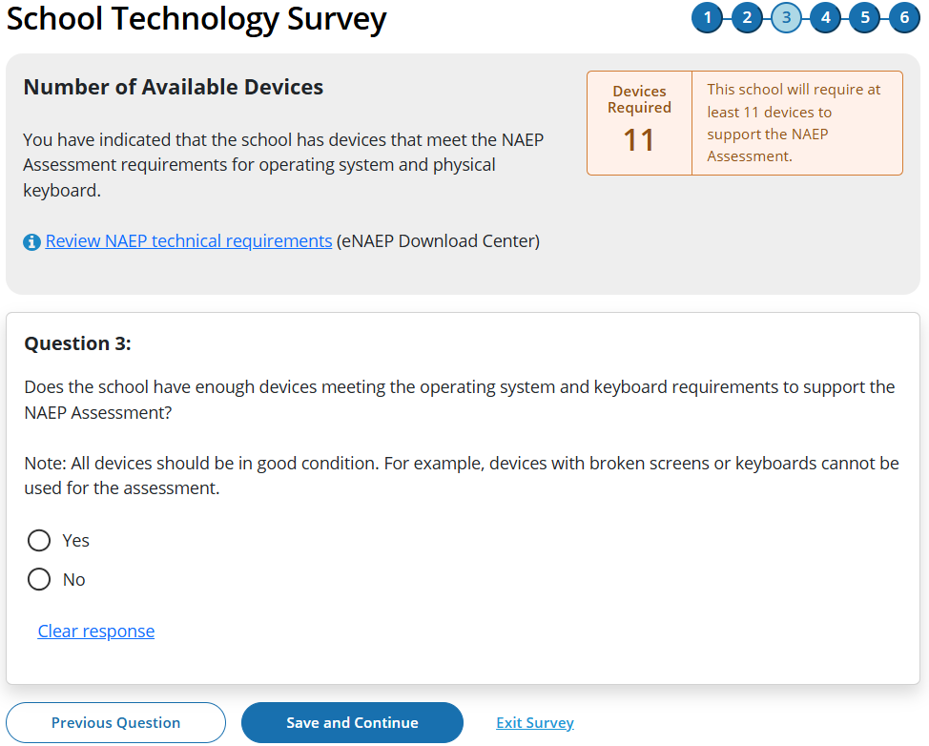

(Multi School)
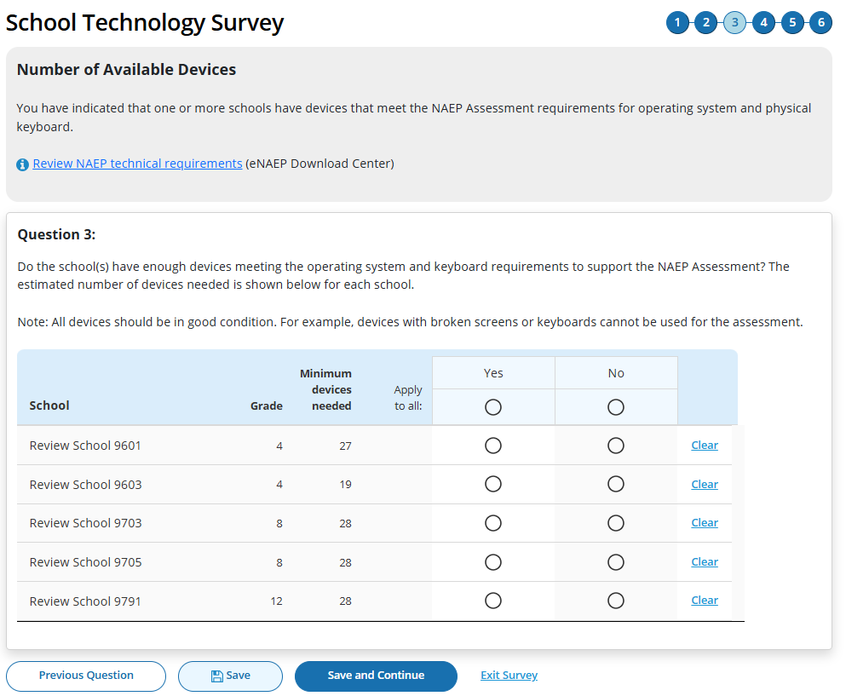

Device Management
(Single School)

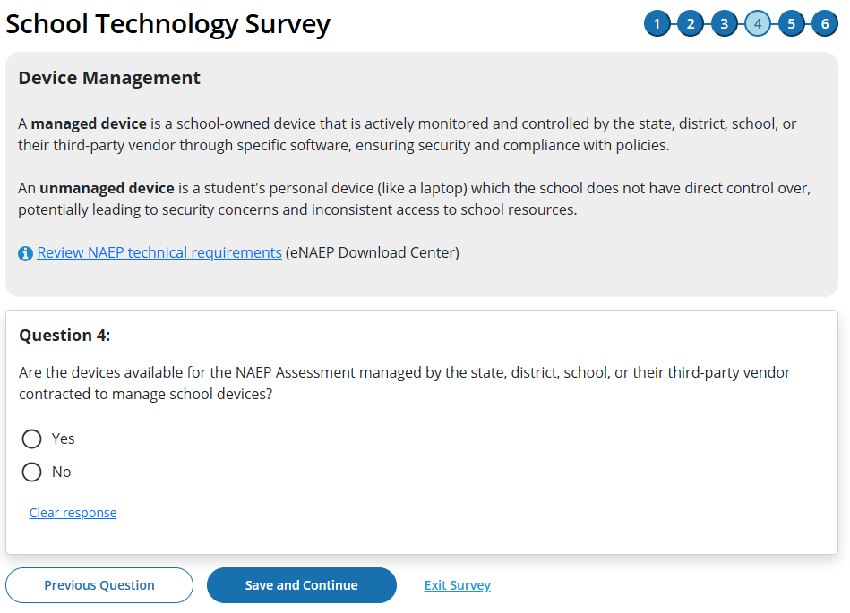

(Multi School)

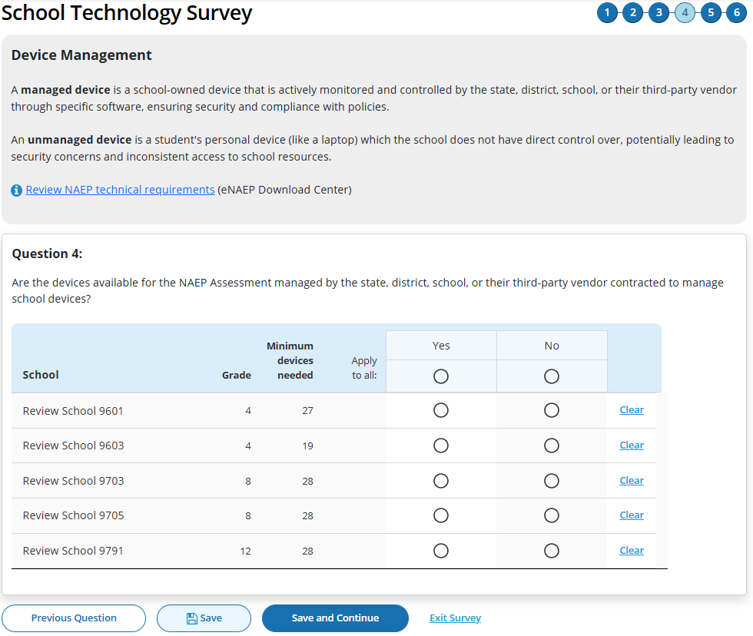

Security Policies
(Single School)

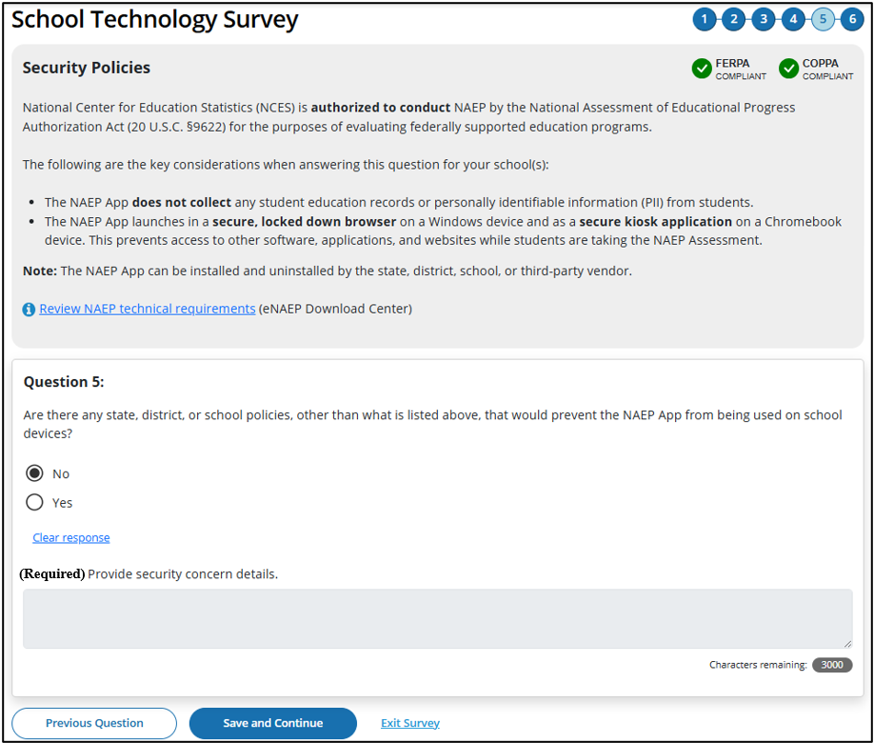
If yes response selected open-ended text box (required response) becomes enabled
(Required) Provide security concern details.
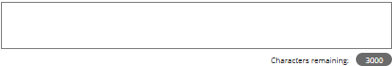

(Multi School)

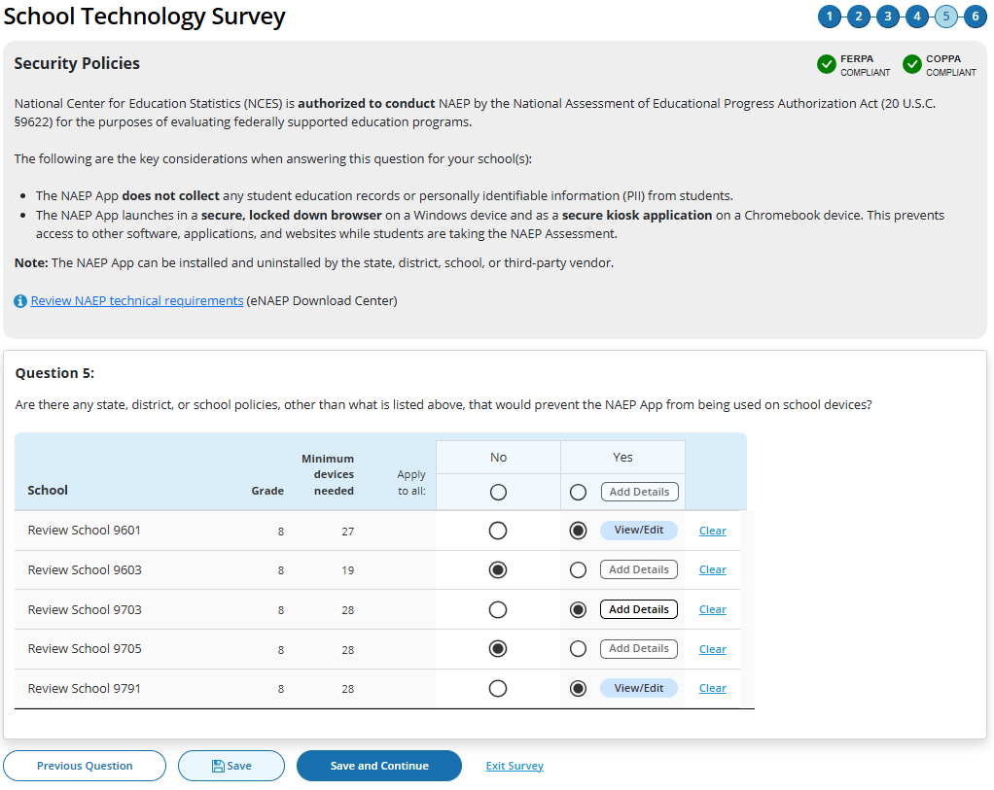
If “Yes” selected an additional prompt (open ended response) becomes available within a modal on the page via the “Add Details” button that appears. The button label converts to “View/Edit” once the prompt has been responded to.
Add comment box (when applied to a single school)
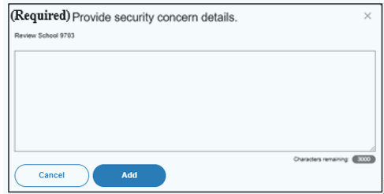

Add comment box (when applied to All Schools)
(Required)
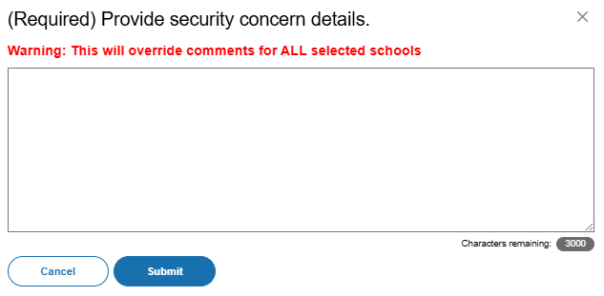

Upon clicking “Submit” on last question respondent navigated to end of survey “Submit Survey” message.

Ready to submit Pop-Up
(Single School)

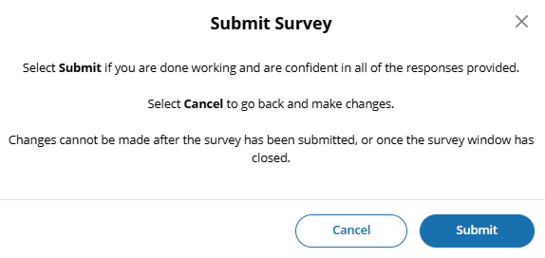

(Multi School)
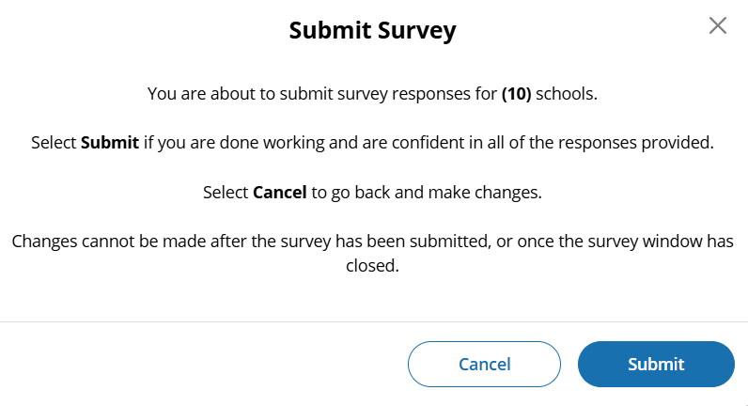

Thank You
(Single School)

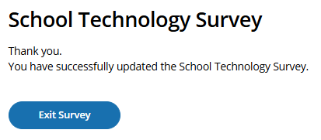
STS Manager After Close of STS Window
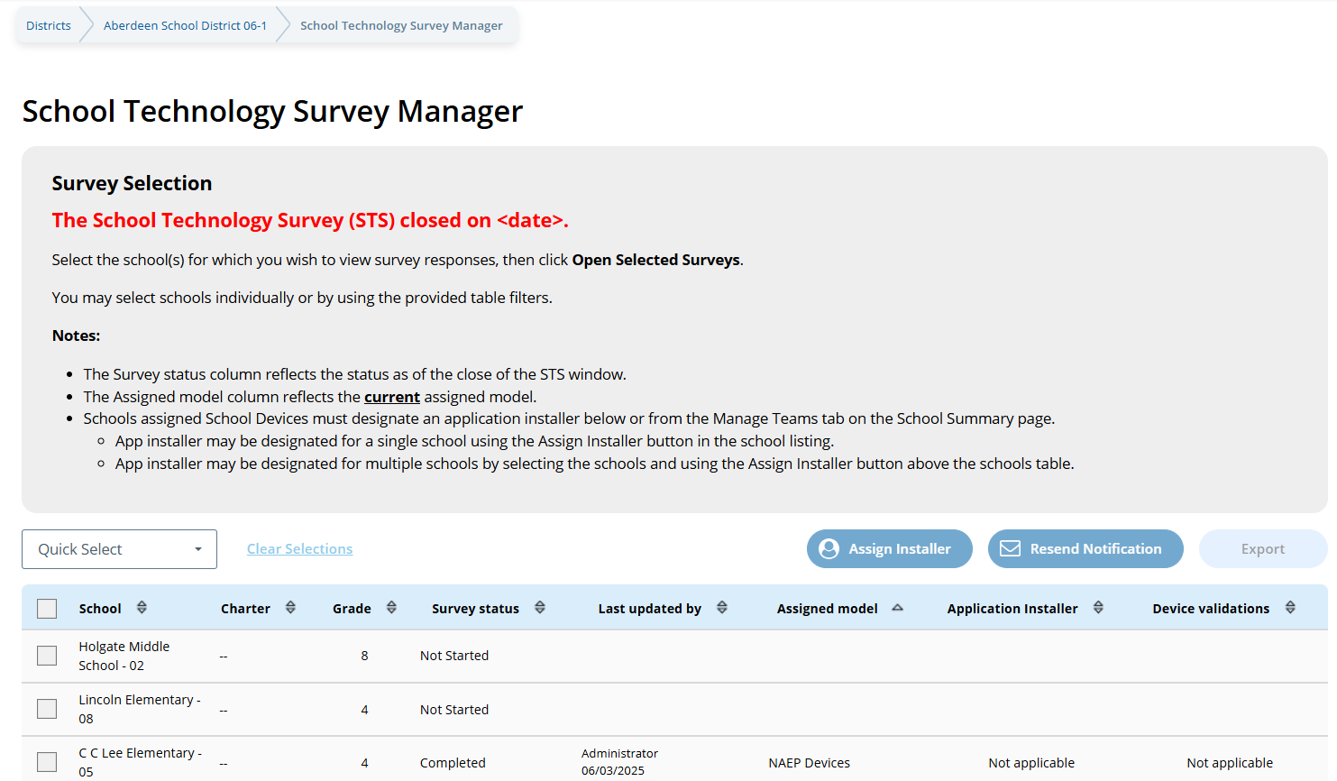

The School Technology Survey (STS) is closed on <date>.
Select the school(s) for which you wish to view survey responses, then click Open Selected Surveys.

You may select schools individually or by using the provided table filters.

Notes:

- The Survey status column reflects the status as of the close of the STS window.
- The Assigned model column reflects the current assigned model.
- Schools assigned School Devices must designate an application installer below or from the Manage Teams tab on the School Summary page.
  - App Installer may be designated for a single school using the Assign Installer button in the school listing.
  - App installer may be designated for multiple schools by selecting the schools and using the Assign Installer button above the schools table.

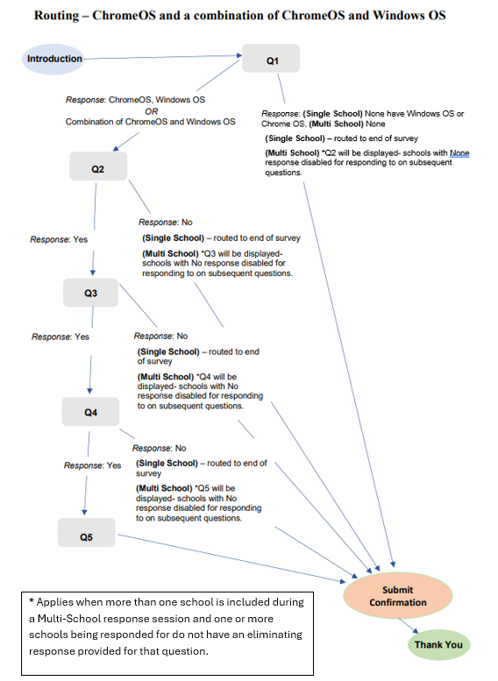

Appendix I23: 2027 Support Assessment Activities (NEW)

Support Assessment Activities
From this section, schools can download documents such as the Teacher Notification Letter, List of Participating Students, and Student Appointment Cards to help support assessment activities.
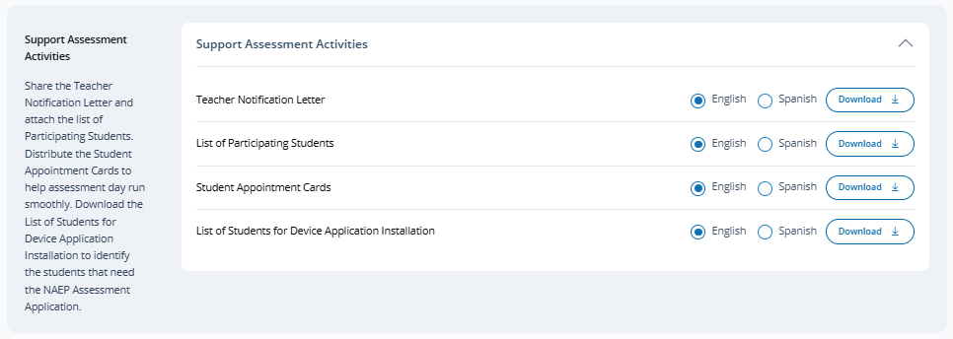
The following documents will be available for download for the 2027 NAEP administration:
- “Teacher Notification Letter”
- “List of Participating Students”
- “Student Appointment Cards - NAEP Devices” (conditionally visible)
- "Student Appointment Cards - School Devices" (conditionally visible)
- “List of Students for Device App Installation” (conditionally visible)
- “Certificates of Community Service”

Teacher Notification Letter Example
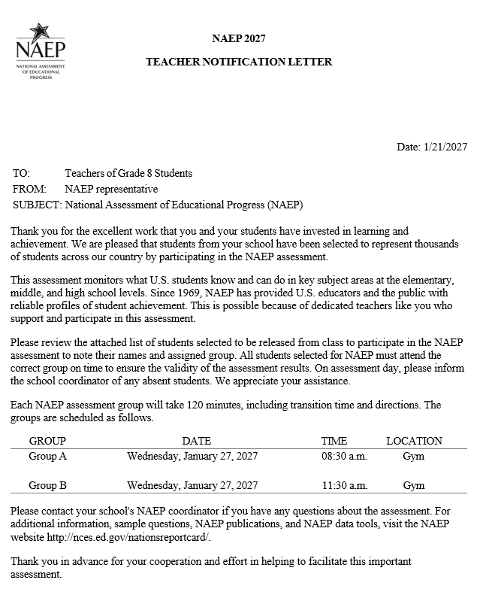
List of Participating Students
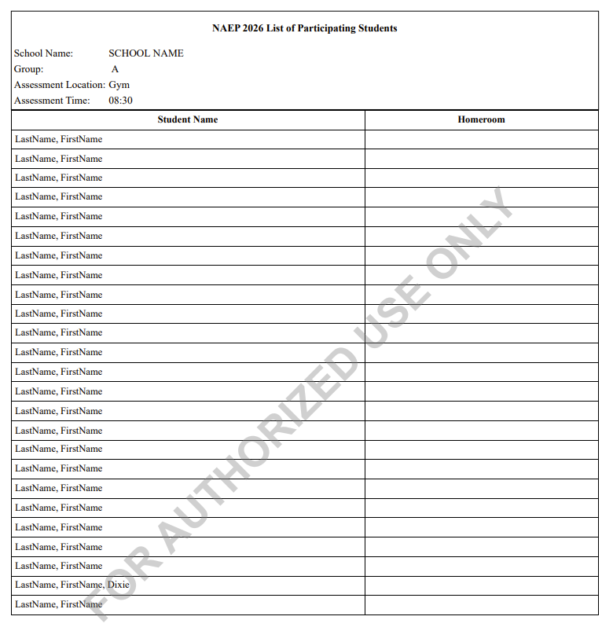
2027

List of Participating Students

NAEP 2027 List of Participating Students
School Name
Group
Assessment Location
Assessment Time
(Table Column Headers)
- Student Name
- Homeroom
Diagonal watermark text: FOR AUTHORIZED USE ONLY

Student Appointment Cards – NAEP Device Schools (text only)
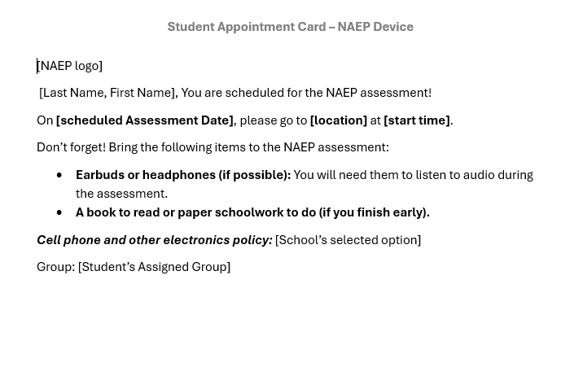
Student Appointment Cards – School Device Schools (text only)
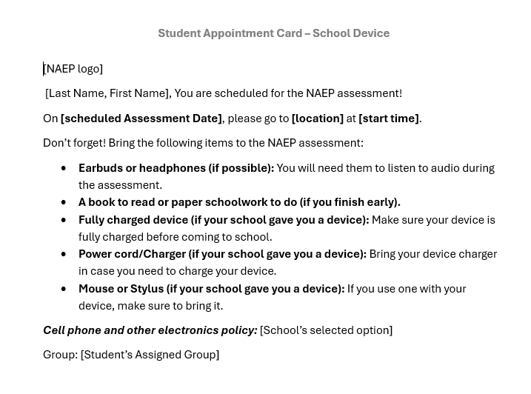

Group Appointment Cards – NAEP Device Schools (text only)
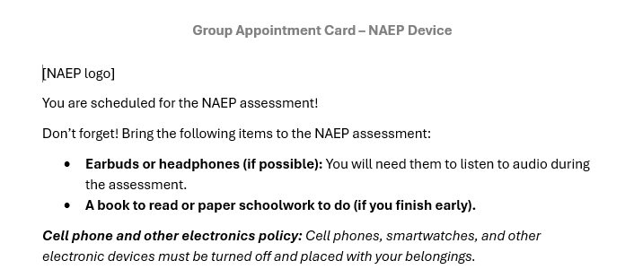
Group Appointment Cards – School Device Schools (text only)
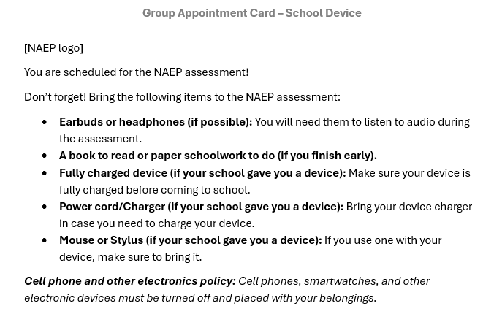

List of Students for Device Application Installation
Schools assigned School Device model are provided an additional download (spreadsheet) in the Support Assessment Activities tile.
Excel File example
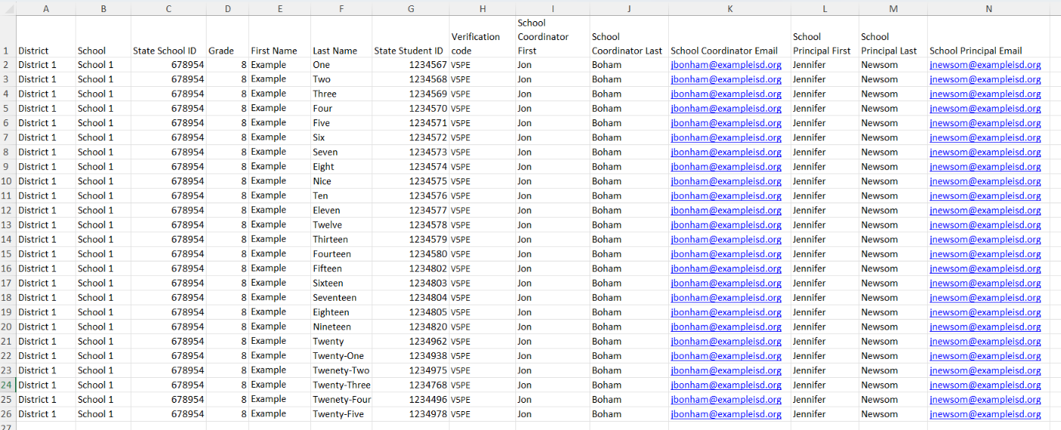
List of Students for Device Application Installation (English)
Column Headers:
- District
- School
- State School ID
- Grade
- First Name
- Last Name
- State Student ID
- Verification code
- School Coordinator First
- School Coordinator Last
- School Coordinator Email
- School Principal First
- School Principal Last
- School Principal Email

Certificate of Community Service
Certificates of Community Service have been added to the downloads available from the Support Assessment Activities tile for 2027.
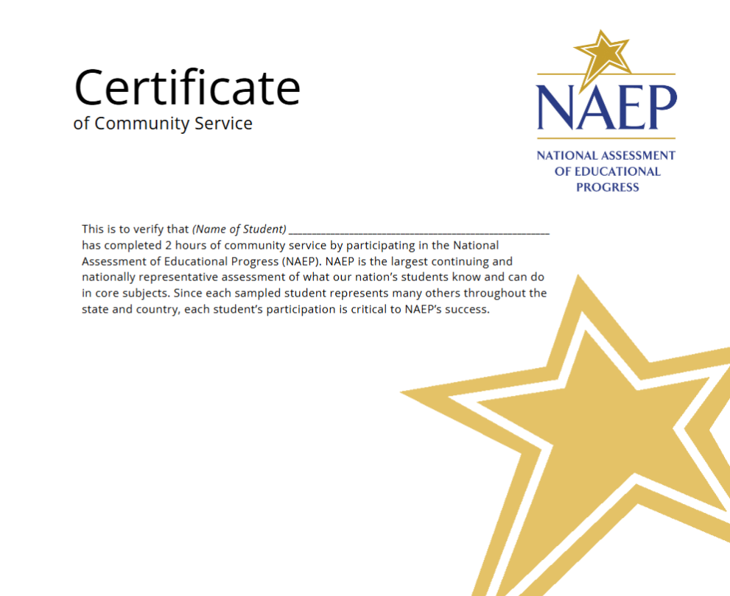

Appendix I24: 2027 Technical Logistics (NEW)
Technical Logistics
The Technical Logistics tile appears on the School Summary page for schools assigned to School Device model. The Technical Logistics tile contains general summary information regarding validated devices and how devices will be set up. An Info required tag will appear on the tile if any outstanding Technical Logistic data collection requirements have yet to be completed. Tag switches to Completed once all related required tasks are done.

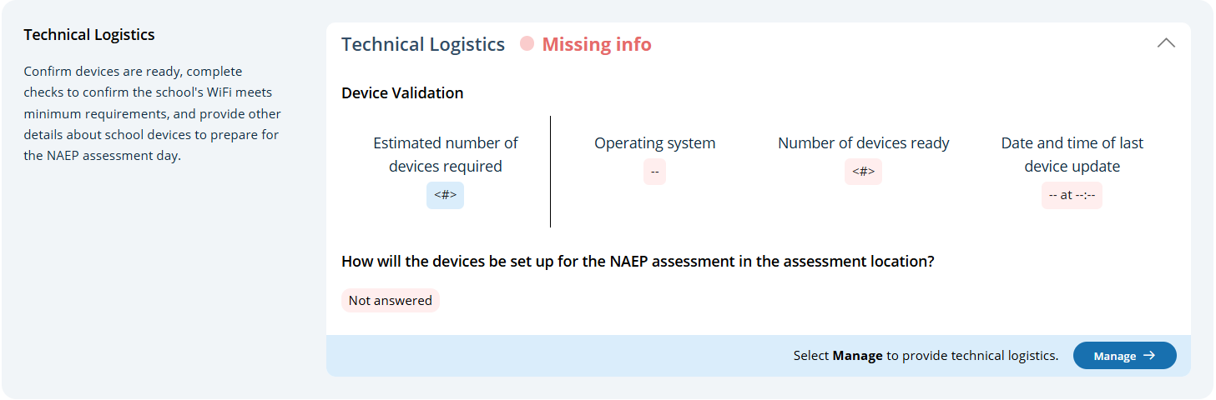
Users select the Manage button to open up the Technical Logistics section. After selecting the Manage button where they will run the network diagnostic tool, answer questions about device setup, assessment location setup, spare devices, charging, and headphones. The schools will also identify a school staff member to provide technical support throughout the assessment in the Technical Logistics section. The Technical Logistics section consists of 7 tiles:
- Take/Review the School Technology Survey
- Confirm Device Readiness
- Confirm the Bandwidth, Safelisting, and Wireless Access Points
- Device Setup
- Assessment Location Setup
- Spare Devices, Charging, and Headphones

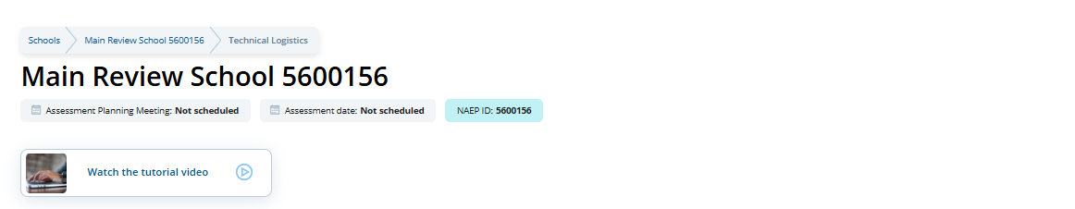
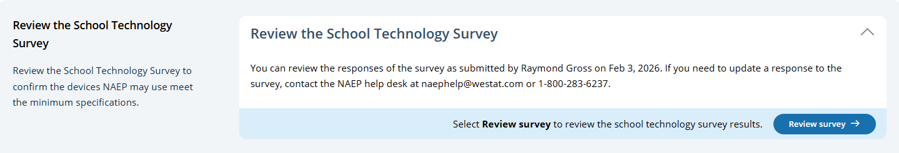

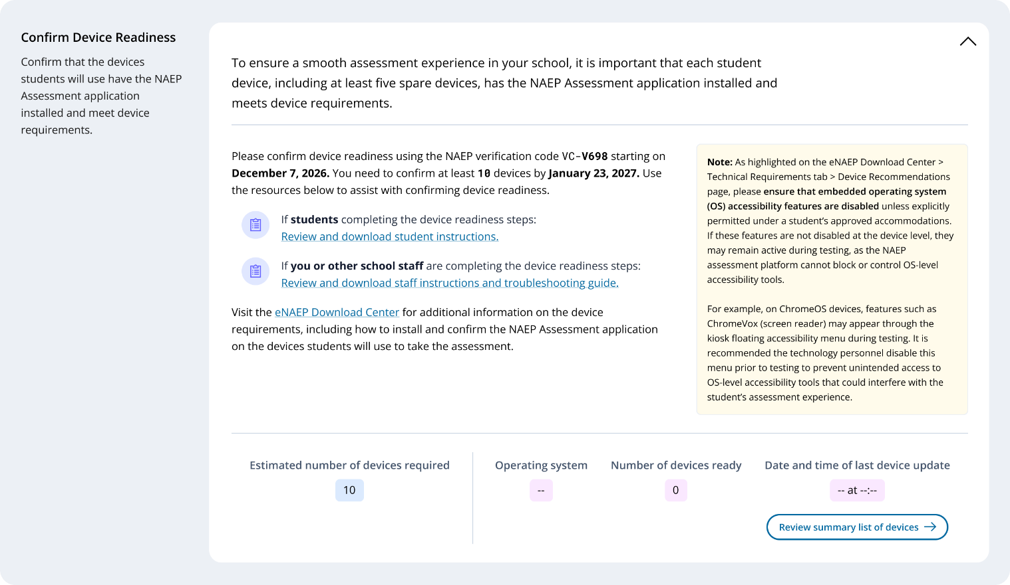
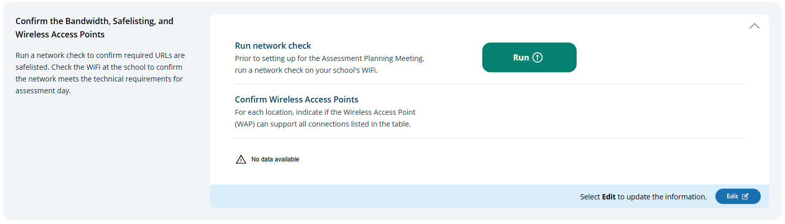

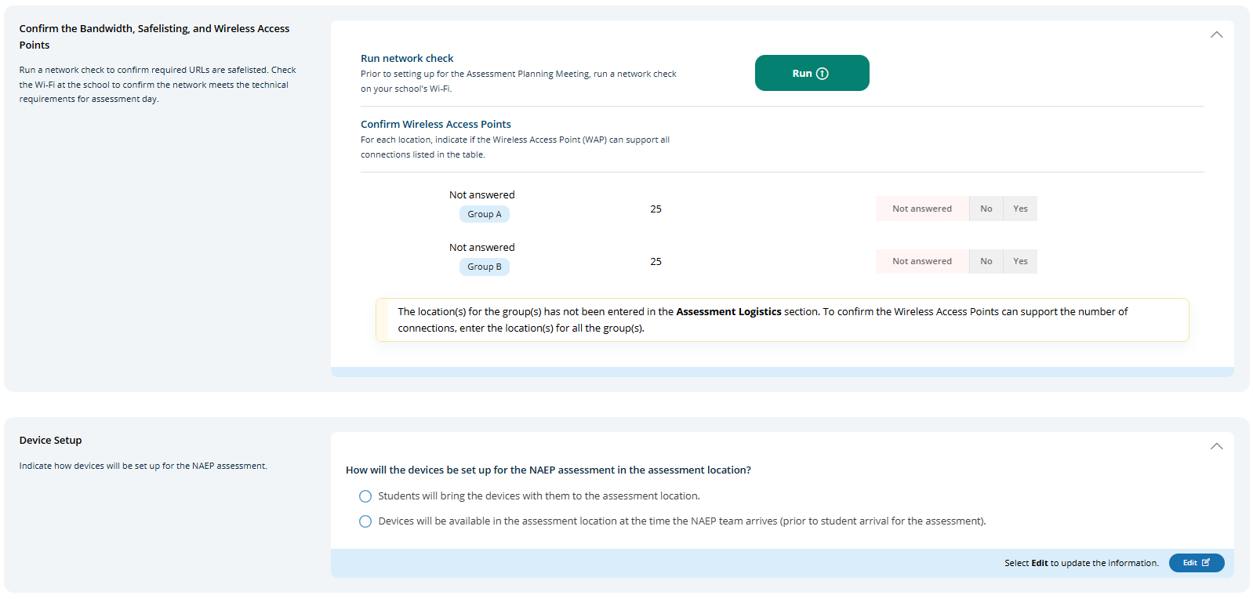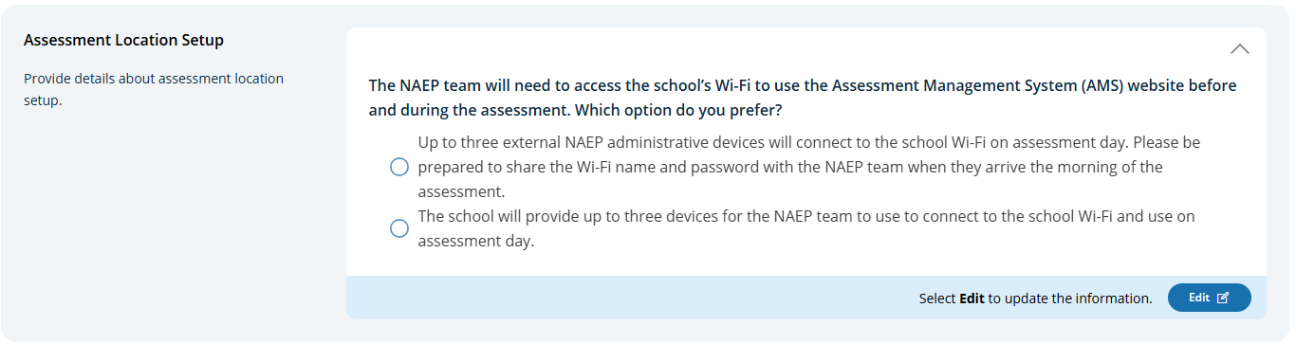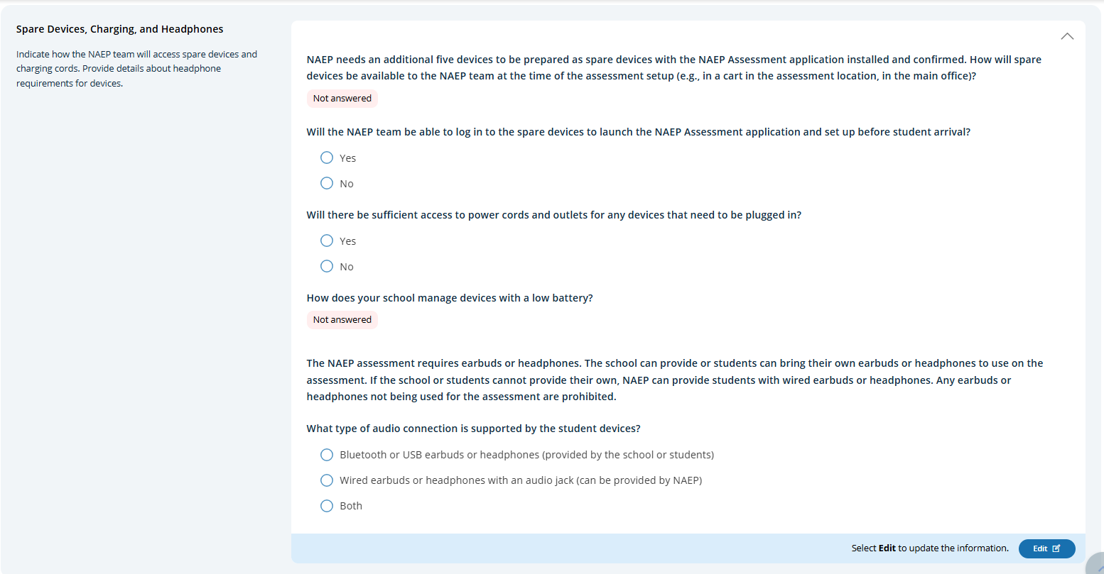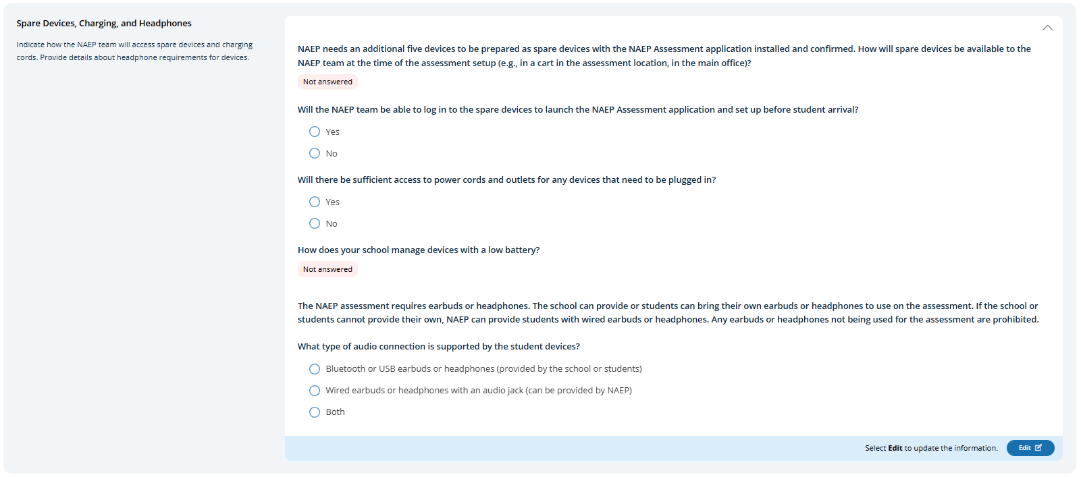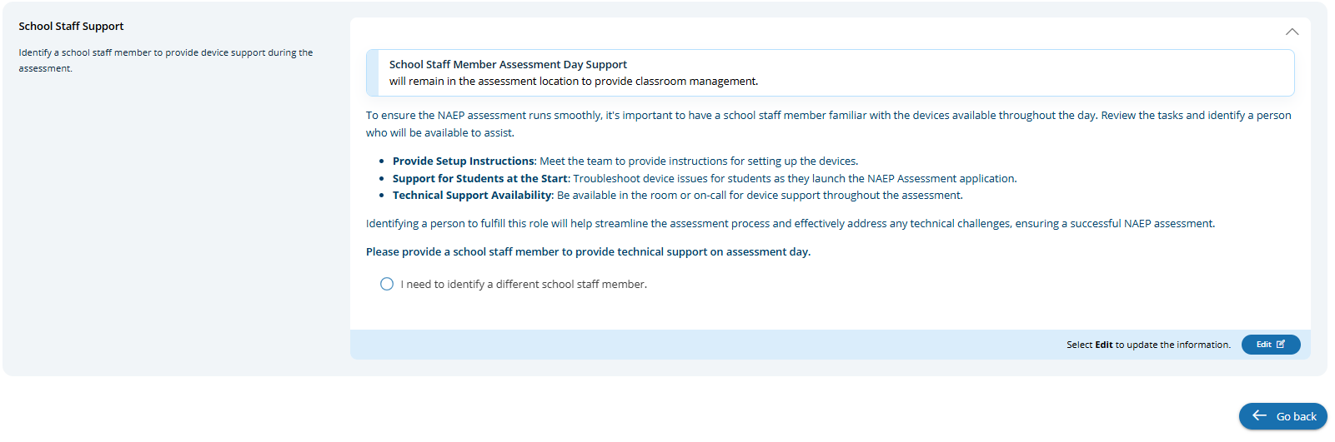

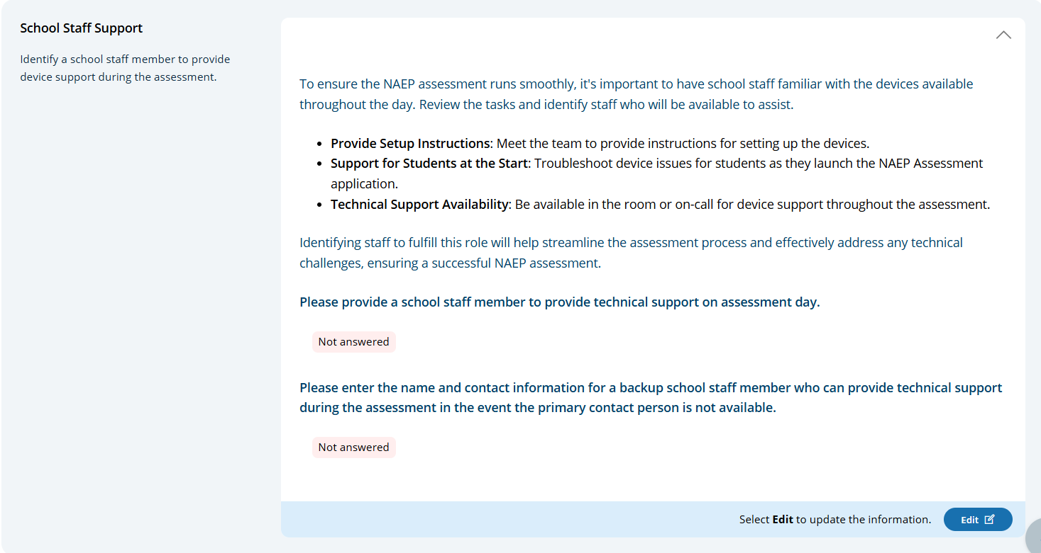
Review the School Technology Survey
Users click on the Review Survey button to review survey responses provided for the school (See Appendix I22).
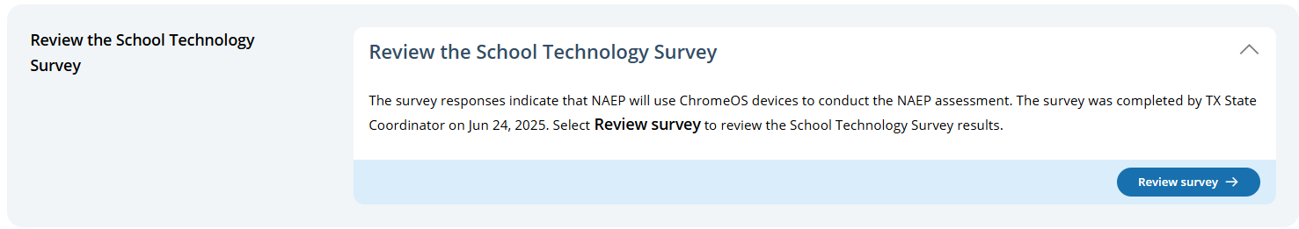

Confirm Device Readiness (English)
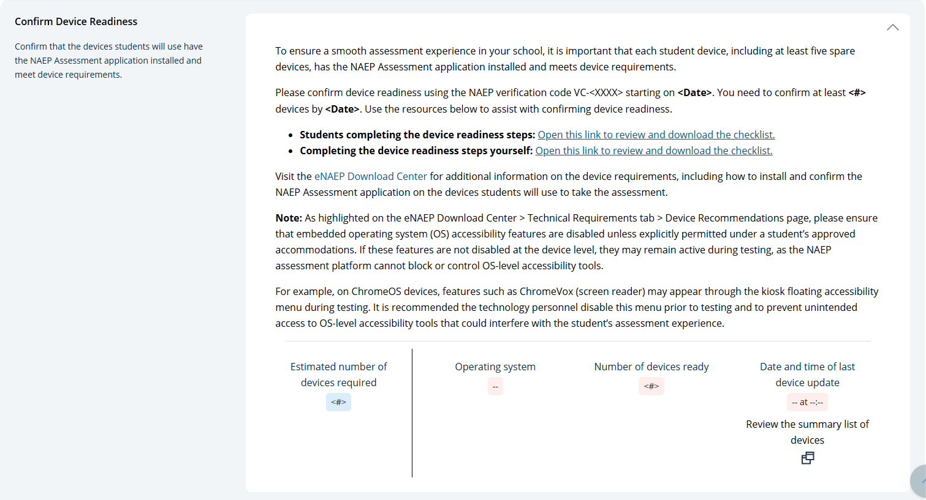
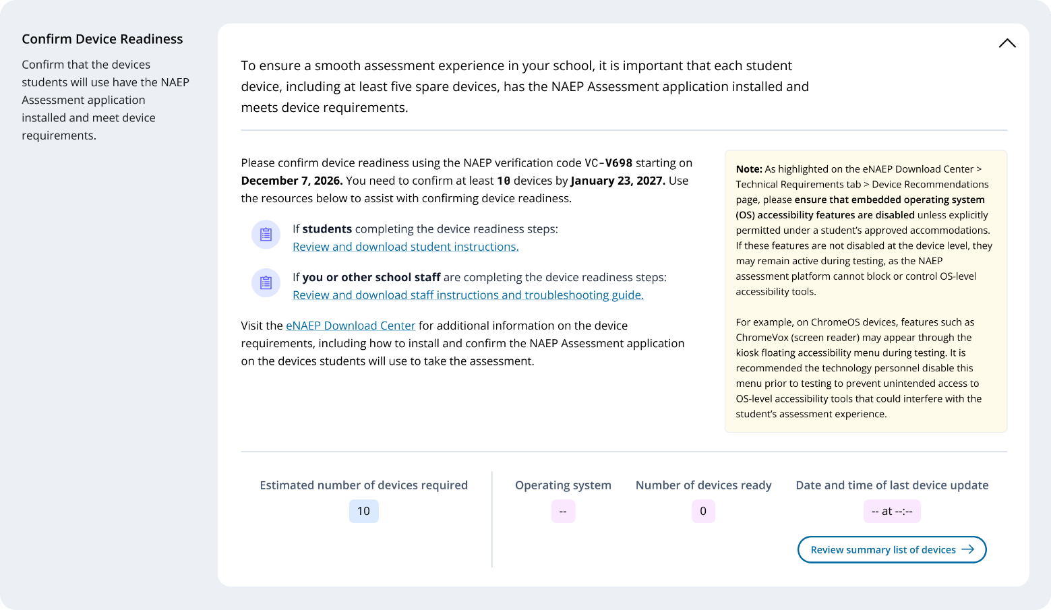

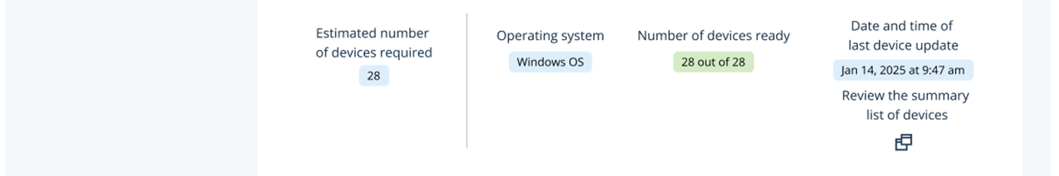
Example with populated data
Example with no data
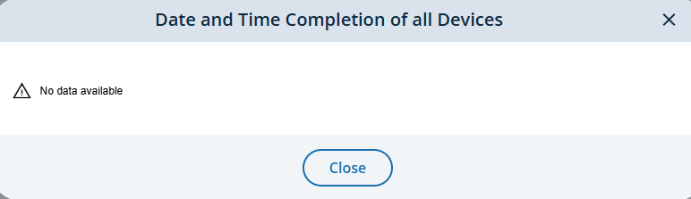

Student checklist
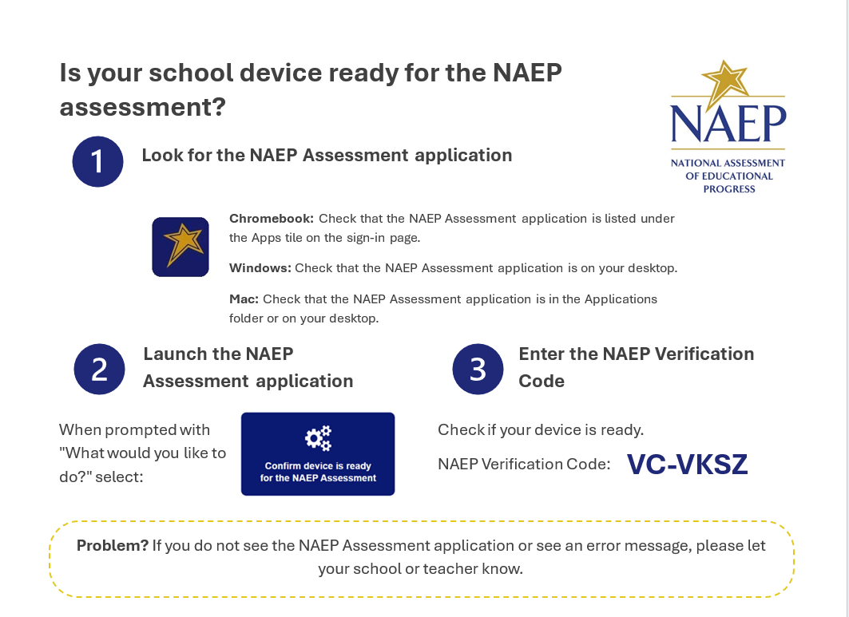
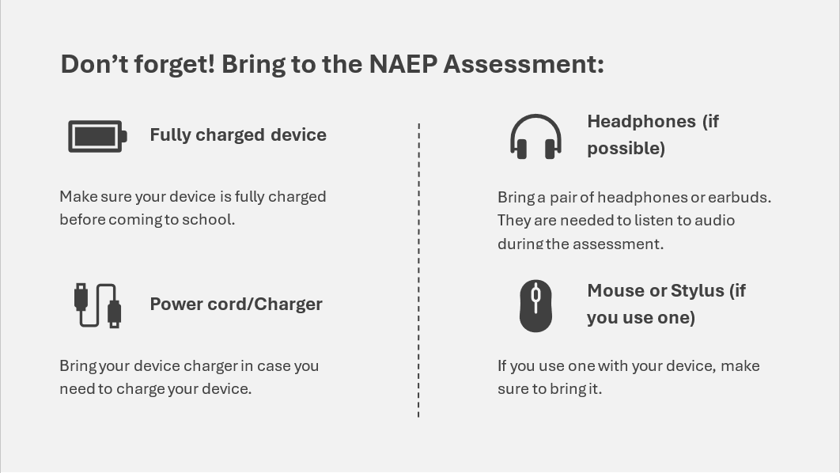

School checklist
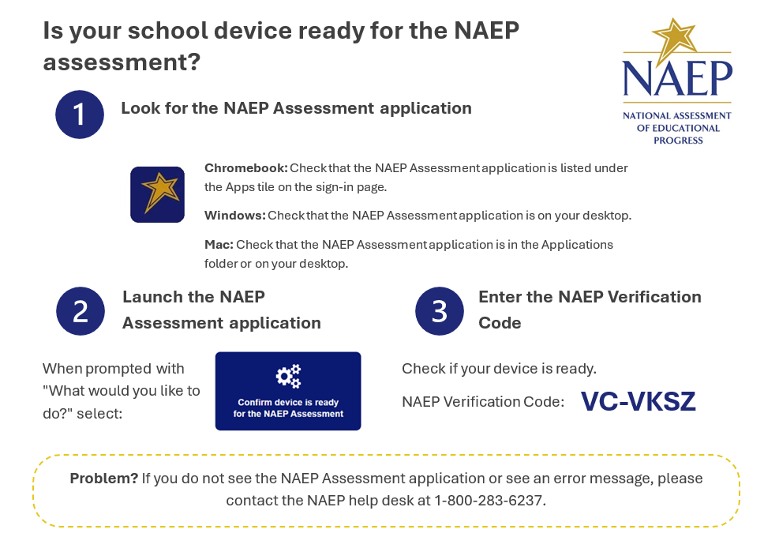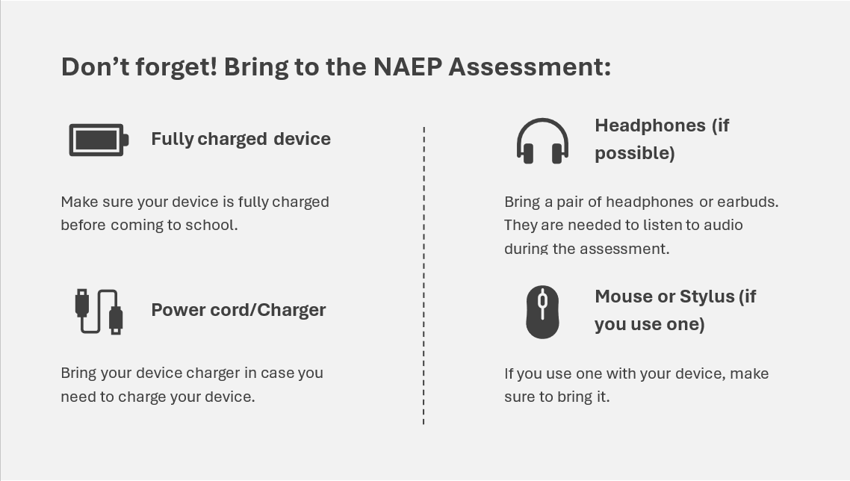
NAEP Assessment Application Troubleshooting Guide
If you encounter any of the following error messages during the device validation process performed by the NAEP Assessment application, please follow the steps below to resolve the issue.
Error Message | Resolution
RAM is below minimum 4GB | What it means: The device does not have the required minimum of 4GB of RAM (Memory) to run the NAEP Assessment application effectively.  Action: Swap this device for one with at least 4GB of RAM.
Available storage is below minimum 2 GB | What it means: The device does not have the required minimum of 2GB of available storage space to run the NAEP Assessment application effectively. Insufficient storage can prevent the application from functioning properly.  Action:  • Contact your school's IT department for assistance in cleaning up storage space.  • If cleaning is not possible, swap the device for one that meets the minimum storage requirement.
Adjust screen resolution or Screen resolution is incompatible | What it means: The device's screen resolution is set below the minimum required for the NAEP assessment, or the display scale is configured to a lower resolution.  Requirements:  • Minimum resolution: 1366 x 768  • Display scale: 100%  Action:  • Chromebook: Press Ctrl + Shift + 0 (zero), then refresh the application by using the refresh button. If this step does not resolve the issue, contact your school's IT department for assistance with adjusting screen resolution.  • Windows and Mac: Contact your school's IT department for assistance with adjusting screen resolution.  • If adjustments cannot be made, swap your device for one that meets the minimum requirements.
Single monitor check | What it means: The device is connected to one primary monitor and one or more additional monitors.  Action: Disconnect all extra monitors from the device.
Operating system check | What it means: The device is either running an unsupported operating system or does not meet the minimum required OS version.  Requirements:  ChromeOS™:  • Stable Channel (S) Version 142 and above  • Long-Term Support (LTS) Version 138 and above  Windows® OS: Version 10 and above  macOS®: Version 13 and above  Action:  • Contact your school's IT department for assistance with upgrading to a supported operating system.  • If an upgrade is not possible, swap the device for one that meets the minimum OS version requirement.
Chrome extension not available | What it means: The NAEP Assessment application is missing the necessary configuration to operate efficiently.  Action:  • Close and restart the app.  • Chromebook: If unresolved, contact your school's IT department to ensure the Chrome extension is configured per the Download Center guidelines.  • Windows and Mac: If unresolved, swap the device.
Error - Update Error / Incorrect version | What it means: The NAEP Assessment application was not able to update to the latest software version.  Action:  • Close and restart the app.  • If unresolved, contact the NAEP help desk at 1-800-283-6237 or naephelp@westat.com.
System date/time incorrect | What it means: The device's date and time are either ahead of or behind the expected time.  Action:  • Close the app.  • Verify the device is connected to the Internet.  • Relaunch the app.  • If unresolved, contact your school's IT department.  • If still unresolved, contact the NAEP help desk at 1-800-283-6237 or naephelp@westat.com.
Failed to connect: Error code 004 | What it means: The device is not connected to the Internet.  Action:  • Close the app and connect the device to the school's network.  • Restart the app.
Failed to connect: Error code 003 | What it means: The device is unable to communicate with the eNAEP servers.  Action:  • Close the app and verify the device is connected to the Internet.  • Restart the app.  • If the device is connected but the issue persists, contact your school's IT department to ensure the eNAEP URL is safelisted per the Download Center guidelines.

Note: If no devices are available that pass the validation checks, please contact the NAEP help desk at 1-800-283-6237 or naephelp@westat.com for guidance on the next steps.

Confirm the Bandwidth, Safelisting and Wireless Access Points (English)
School staff are expected to run a network check and confirm wireless access points prior to the school’s scheduled assessment date. Users can run the network check and confirm wireless access points by selecting the Edit button. 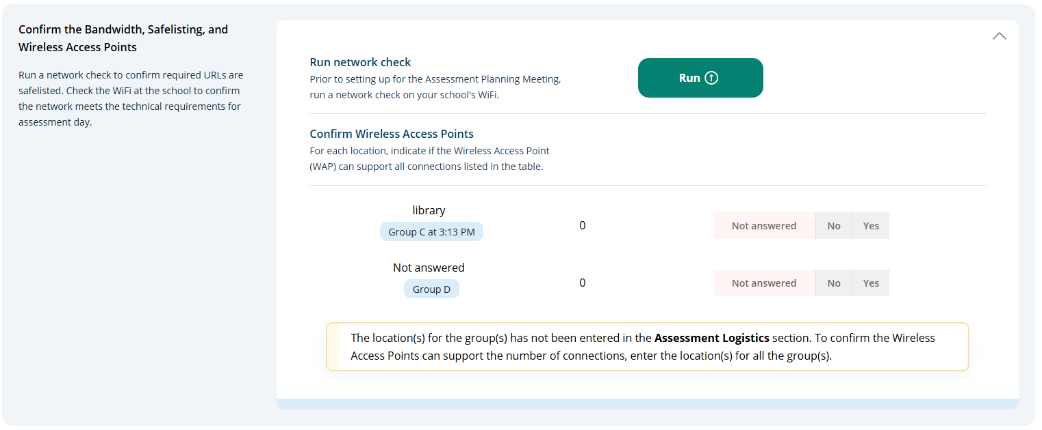
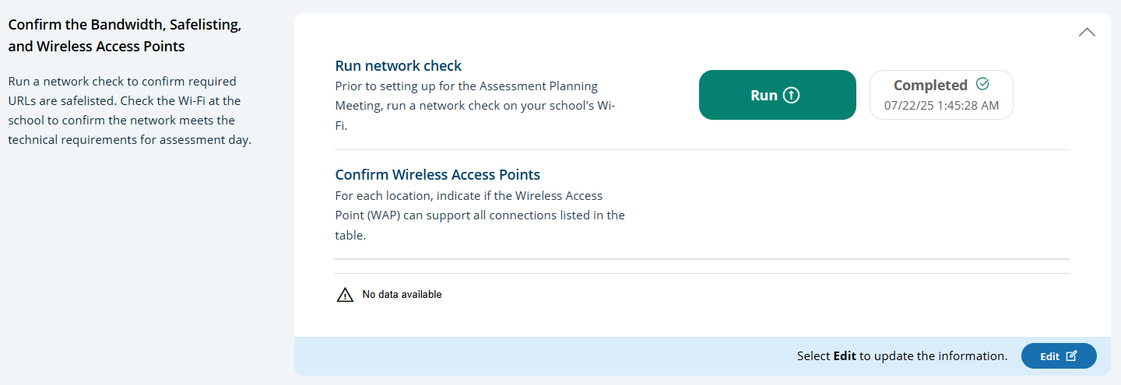
Run Network Check Results Screen
Users click the Run button to execute the network check via the Network Diagnostic Tool (NDT). NDT results are displayed to the user once the check is complete (up to two minutes).
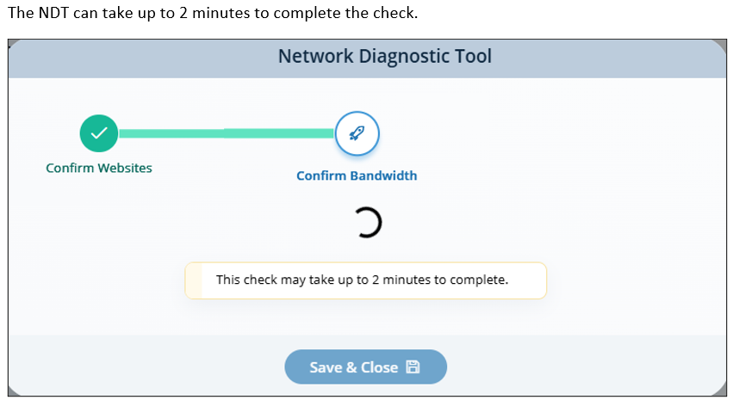
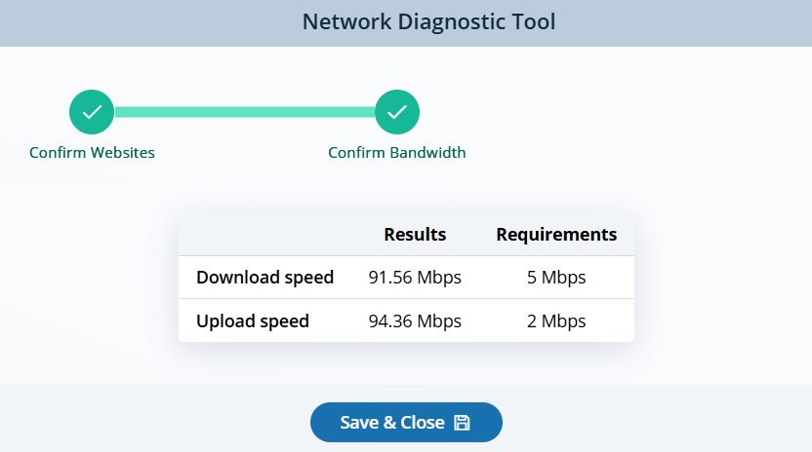

Device Setup:
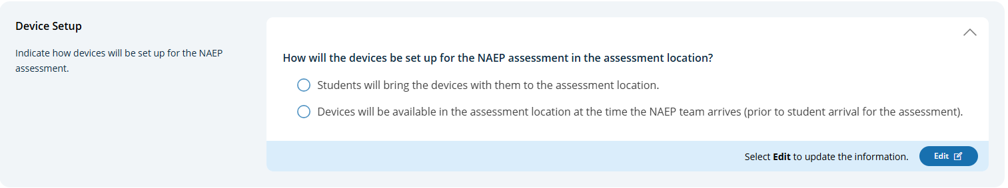
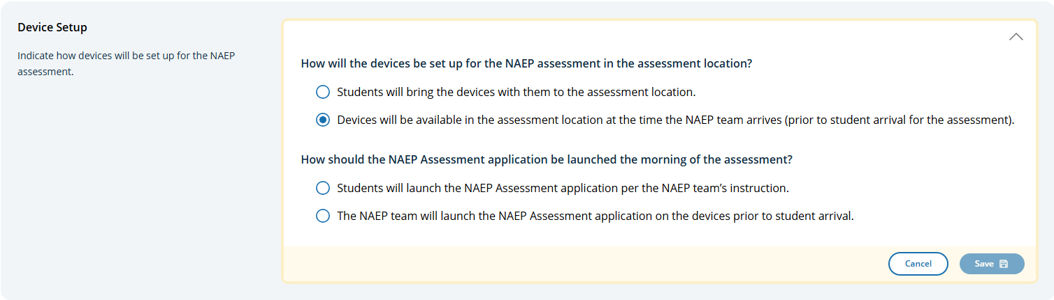
Assessment Location Setup:
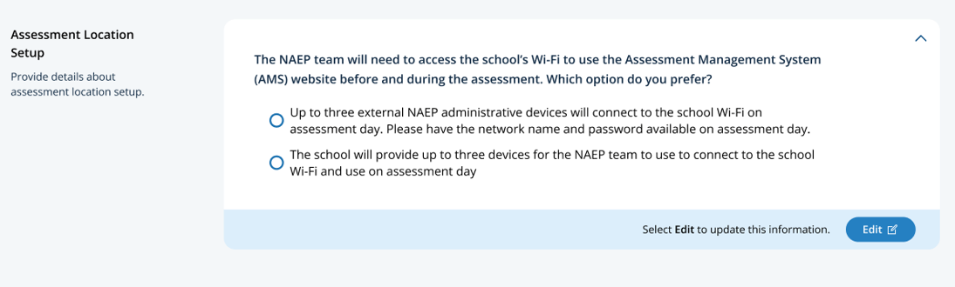

Edit Mode
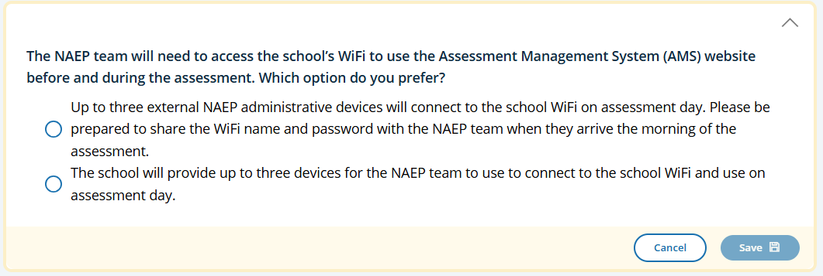
Spare Devices, Charging, and Headphones

Edit Mode
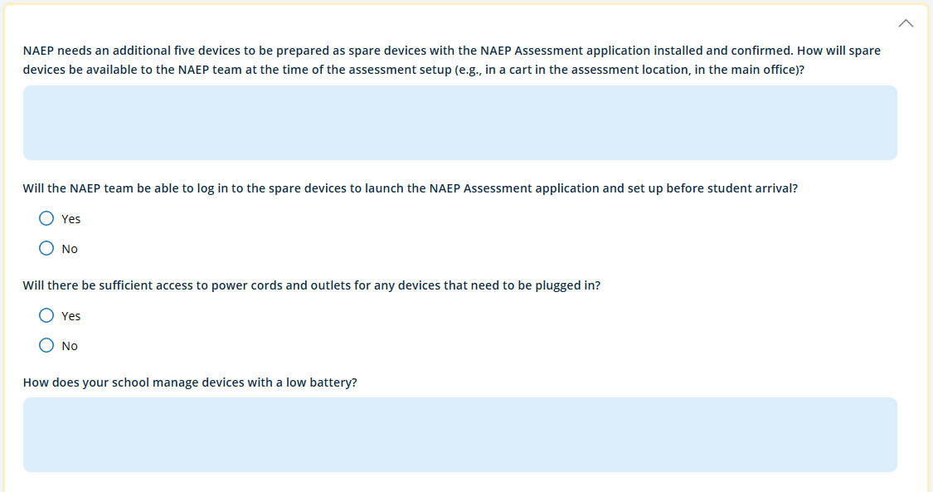
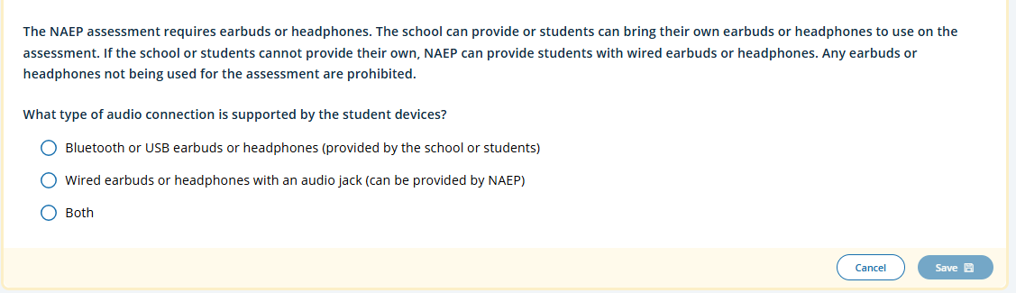
Additional question appears upon selecting response option to “What type of audio connection is supported by the student devices?” – text in response options for newly displayed question is dependent on response selected to “What type of audio connection is supported by the student devices?”
If select “Bluetooth or USB earbuds or headphones (provided by the school or students)” or “Both”
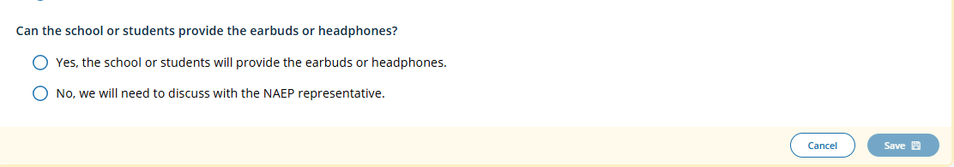
If select “Wired earbuds or headphones with an audio jack (can be provided by NAEP)”
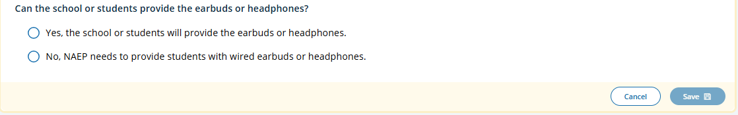
If select “Yes, the school or students will provide the earbuds or headphones.” And selected select “Bluetooth or USB earbuds or headphones (provided by the school or students)” or “Both” on prior question additional text entry box appears.
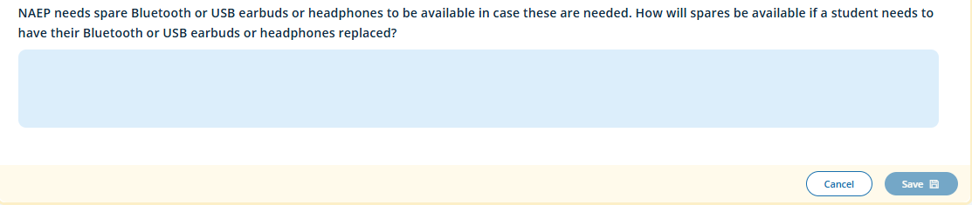

School Staff Support

Edit Mode 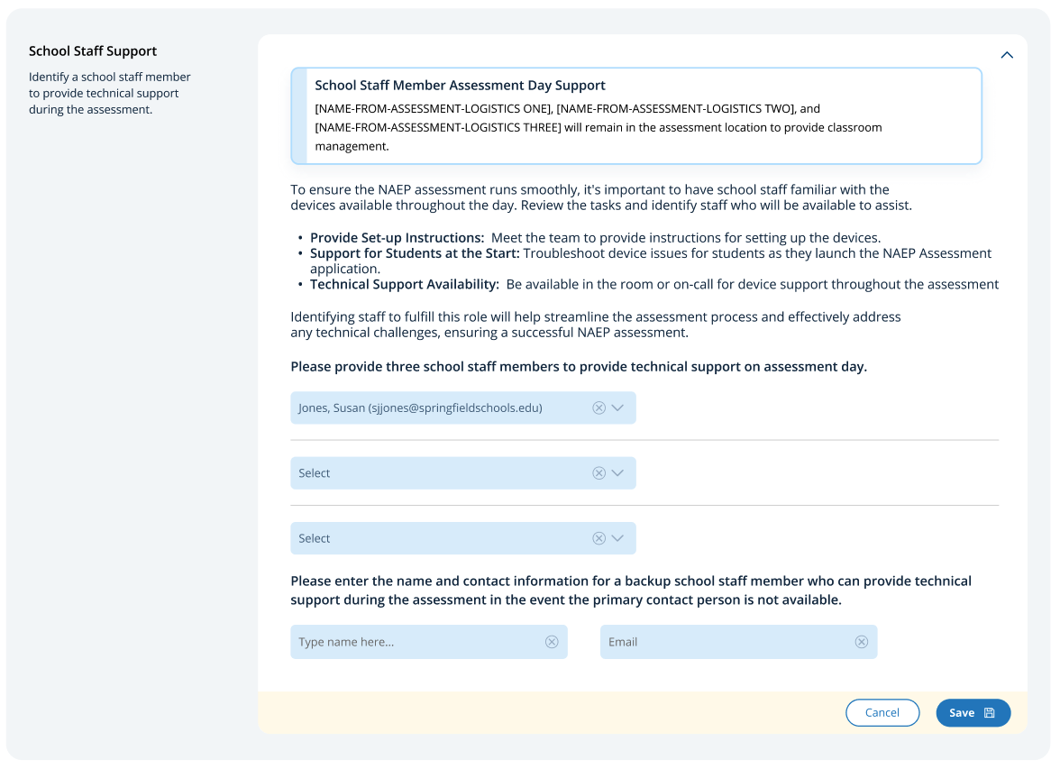

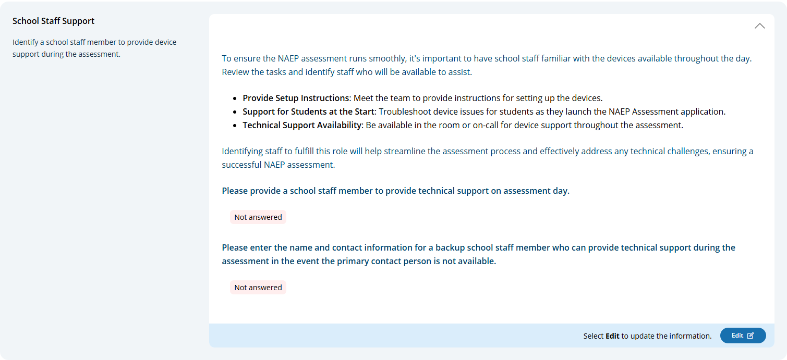
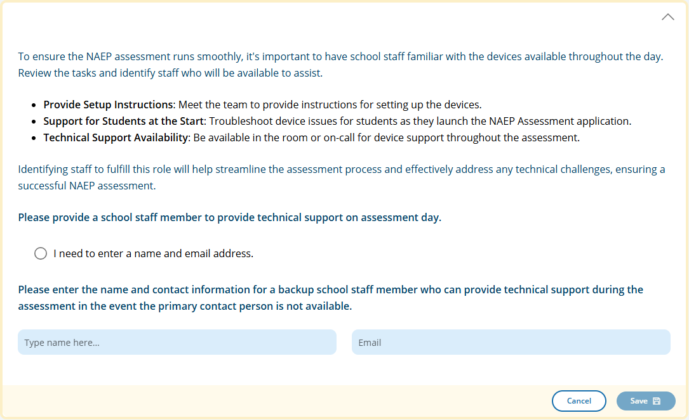
If select “I need to enter a name and email address” addition entry field appears:
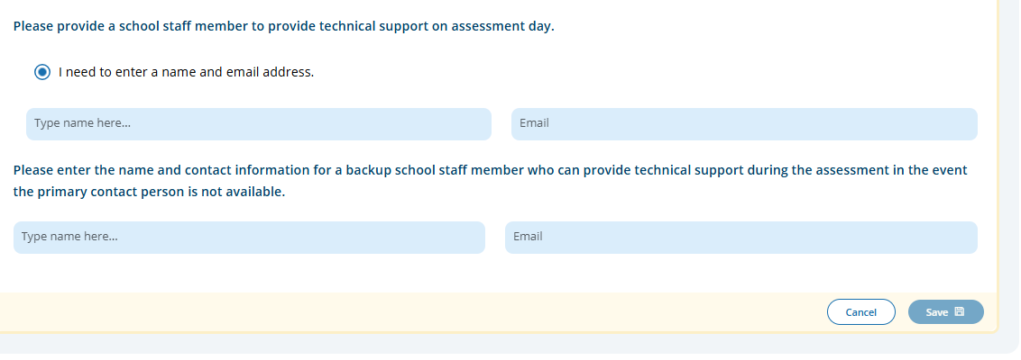

Appendix I25: 2027 Import Student Lists (NEW)

Import Students
State/TUDA coordinators, district staff, and school staff import lists of students in the selected grade/age cohort. This list is used for student sampling, and should include all demographic variables NAEP collects. Sampled students appear in the Provide Student Information tile. This means that the Import Students activity must be completed before the preassessment activities open (DATE) on the School Summary page.
- Schools, districts and field staff use the School Summary page to access Import Students.
- Field staff perform this task on behalf of private schools.
- State and TUDA coordinators use the Jurisdictions > Manage Student Imports to access Import Students
  - State and TUDA coordinators designate who will import students, and the due date.
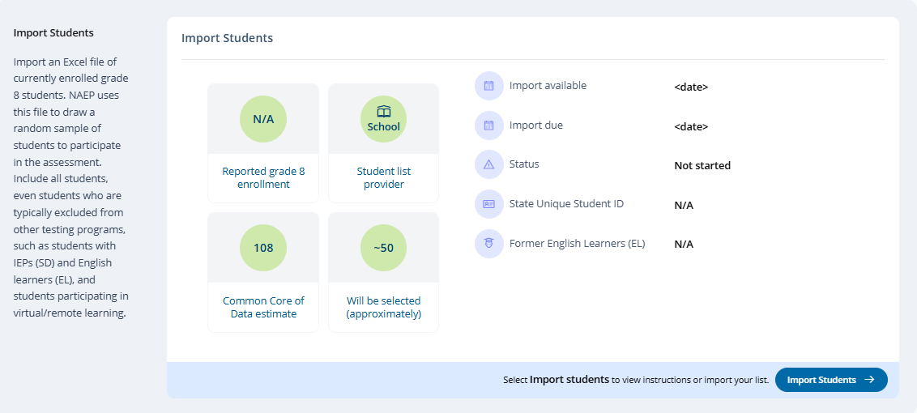
System transition screen upon clicking Import Students button:
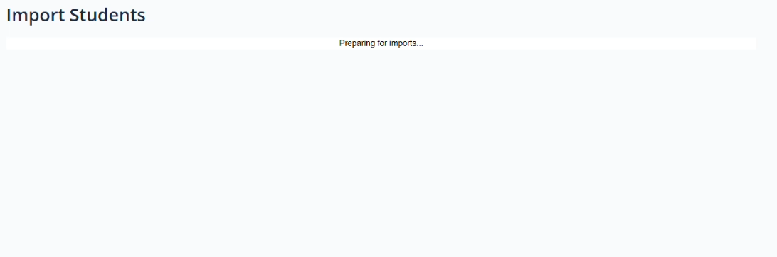

Step 1 (Prepare File)
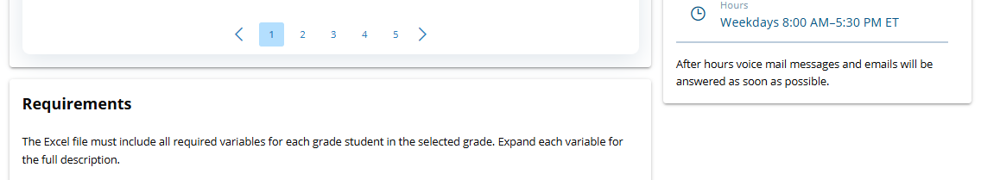
This page contains all the information to create an import file. There are links to three Excel files that have headers that are known to the AMS and PDF sheet of instructions. There is a set of accordion elements (Requirements) with the data definitions. Users click Step 2 Upload button to proceed with file upload (step 2), mapping content (step 3), check for errors and warnings (step 4), and confirmation of student data provided (step 5).
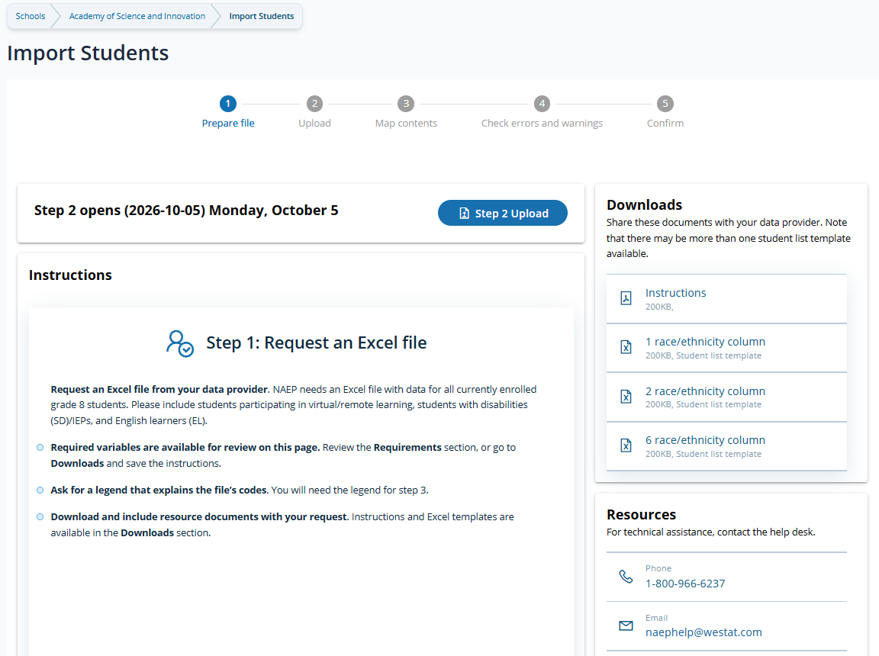

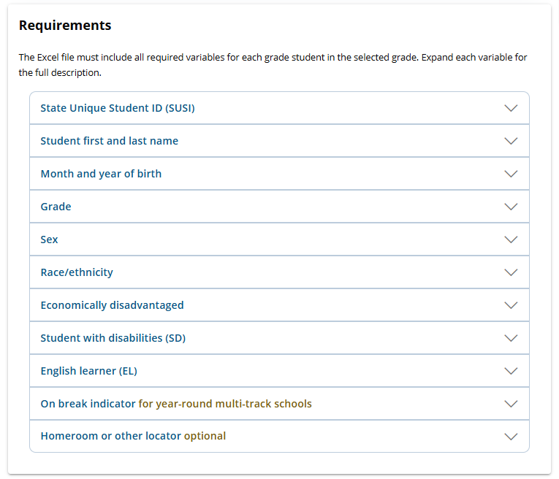
1-800-283-6237
Instructions – Steps
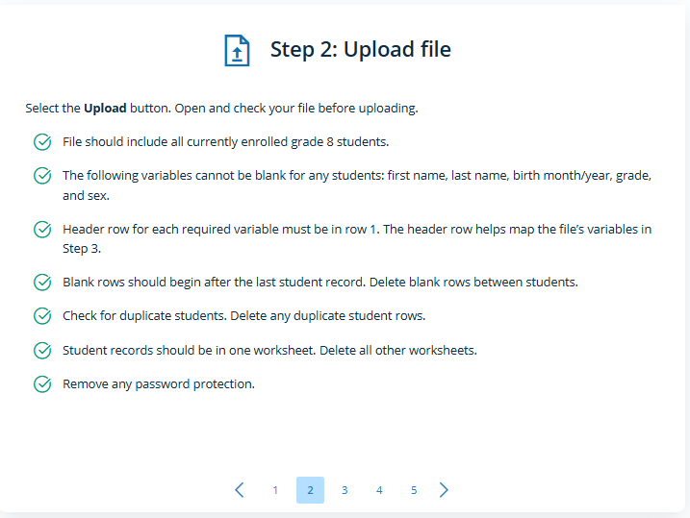
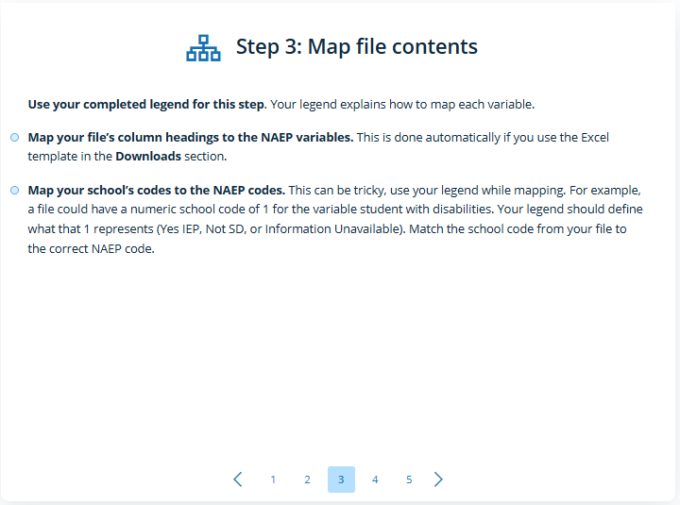
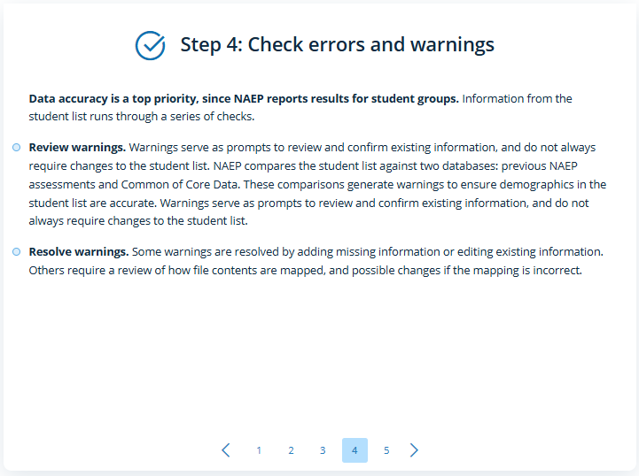
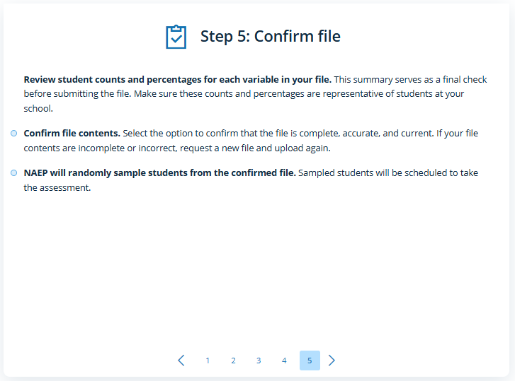
Requirements- Expanded accordians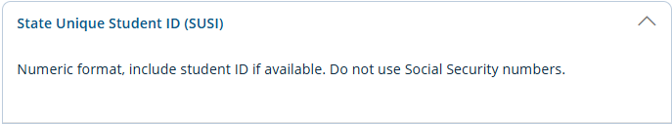
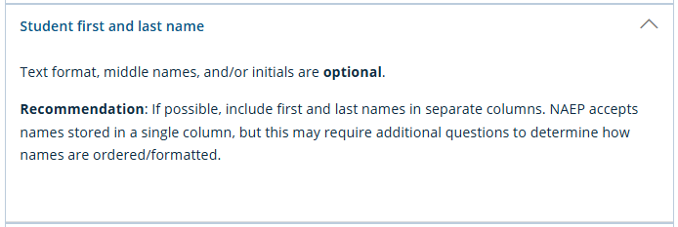
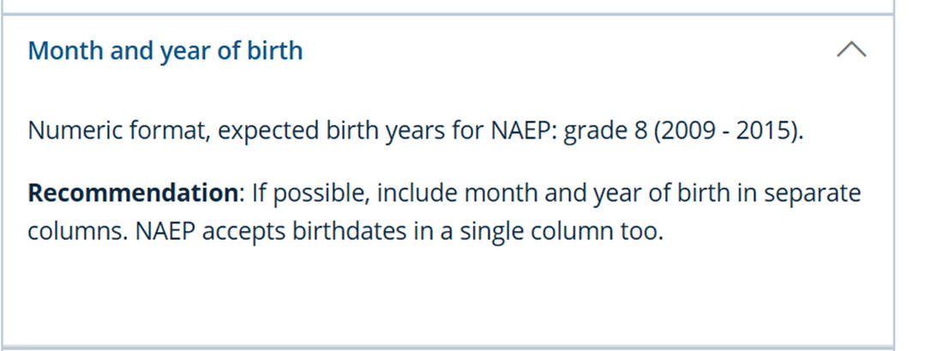
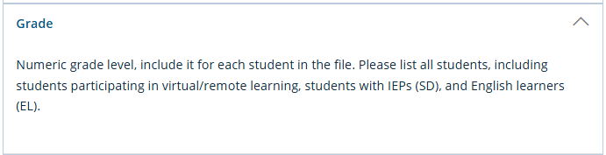
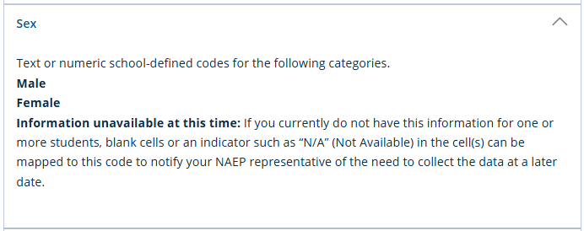
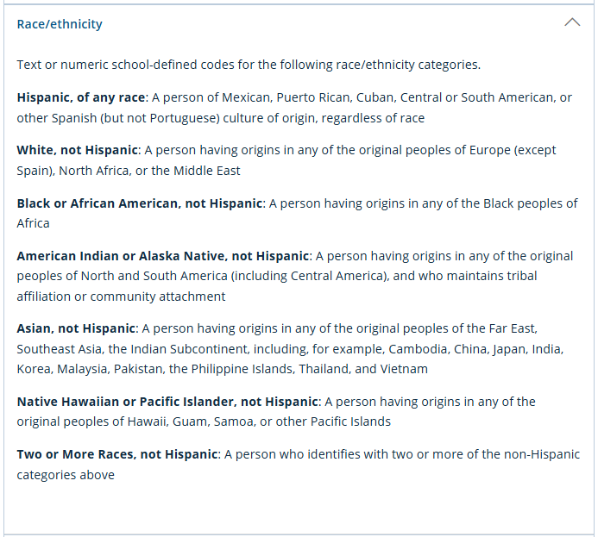

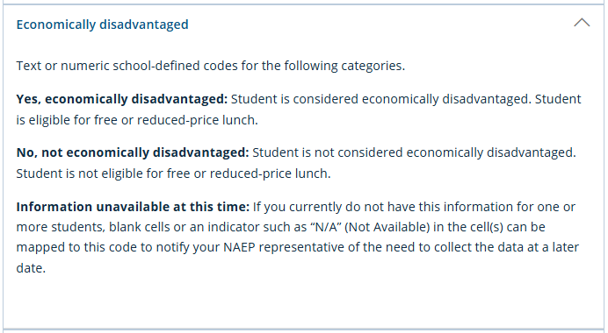
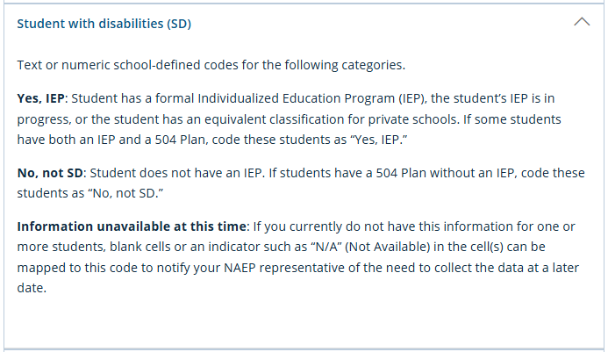
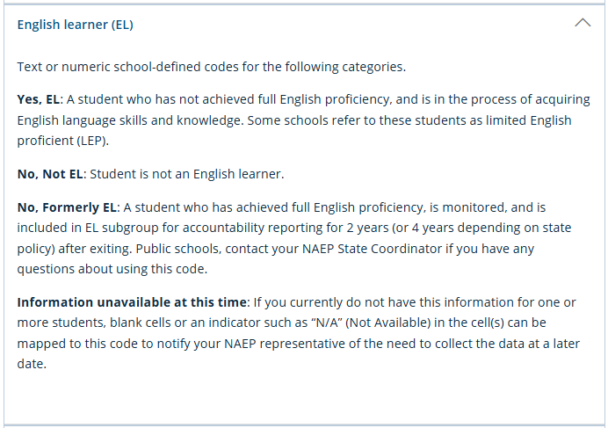
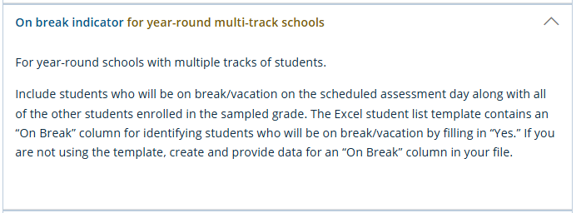
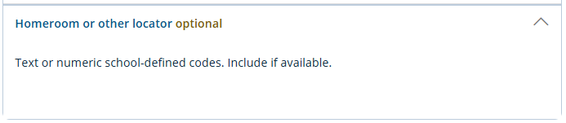
Step 2 (Upload)
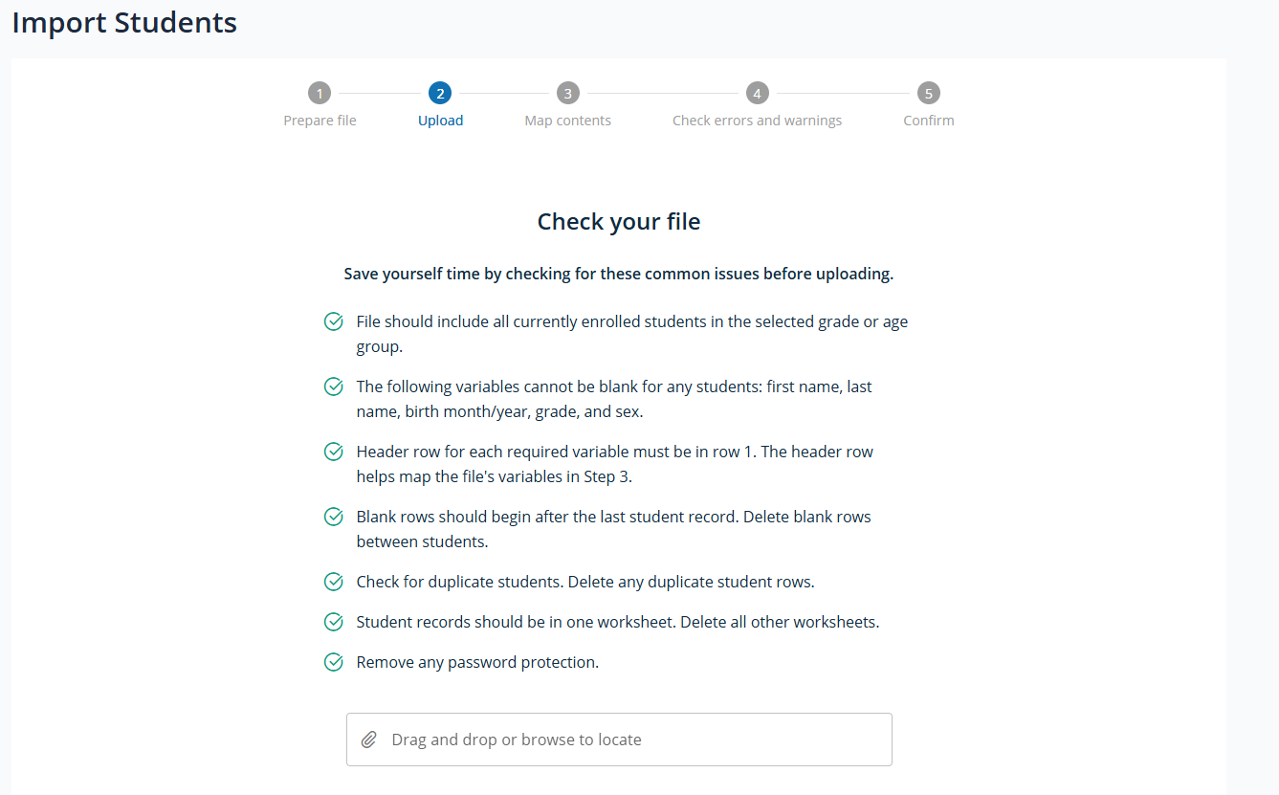
After upload, additional information is displayed to user, including # of students (records in file) and whether file passed initial checks.
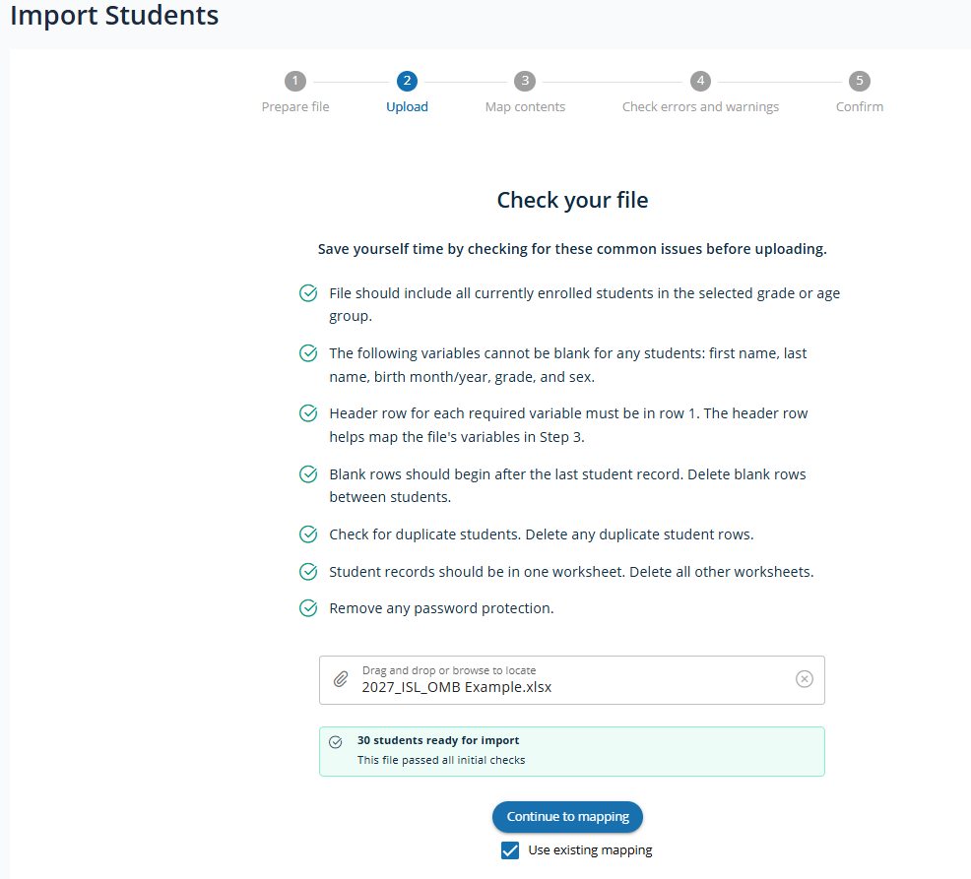

- If uncheck “Use existing mapping” a warning is provided

Step 3 (Map contents)
The mapping process consists of a series of screens that allow the user to confirm and map the fields and values included in their imported file to NAEP requirements.
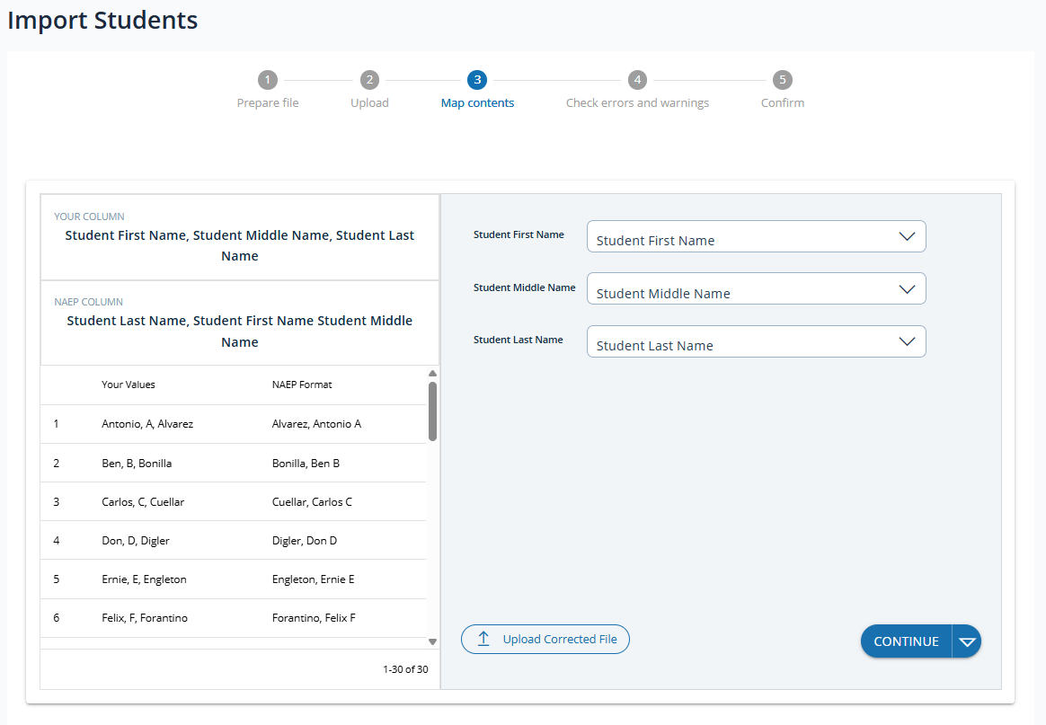
A set of common features apply to each screen throughout the mapping process:
- Upload corrected file
- Variable dropdown menus
- Navigation
Upload Corrected File
Allows user to re-upload a new file at any point throughout the import student list process.
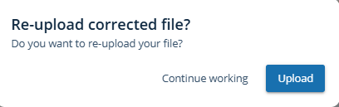
- Continue working - closes pop up returns to step 3
- Upload – return to step 2
Variable dropdown menu
A dropdown menu used to select the correct variable a field in the uploaded student list file should be mapped to is available. The dropdown menu contains a list of all applicable fields included in the upload file.
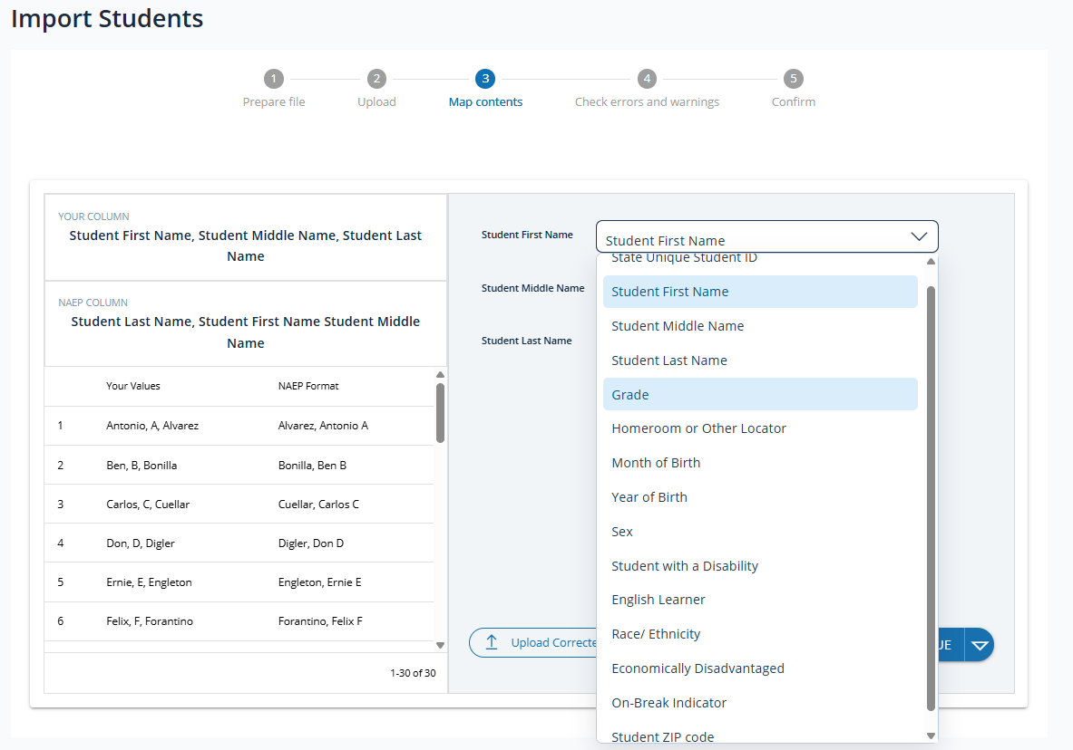
When a “No” response is provided to a mapping question and a variable selected from the dropdown, additional dropdowns appear (as applicable) to allow mapping of specific values in the uploaded student list file to NAEP values corresponding with the variable indicated the column contains.
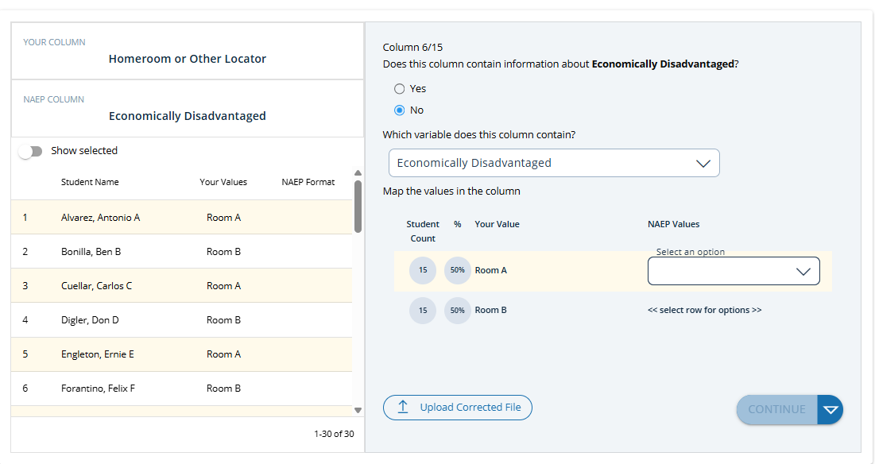
Navigation
The Continue button advances to the next mapping screen. The drop-down list option on the Continue button displays all previously visited mapping screens and can be used to navigate back.
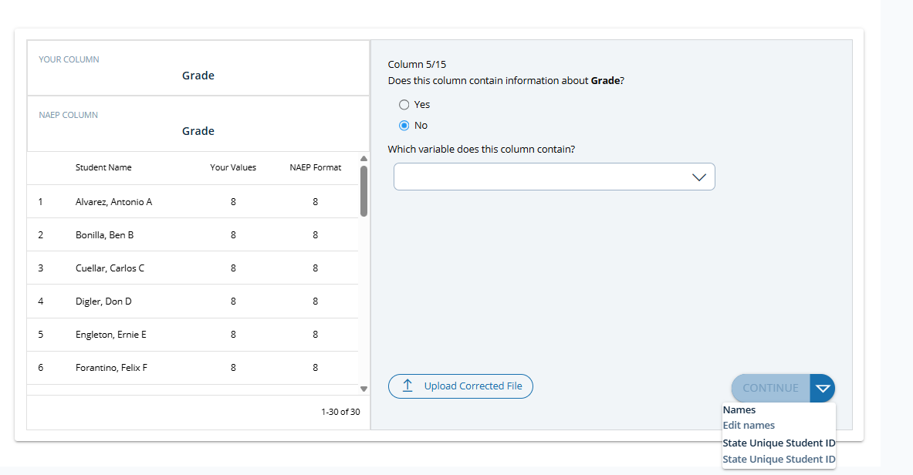
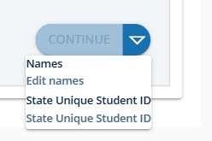
Mapping screens

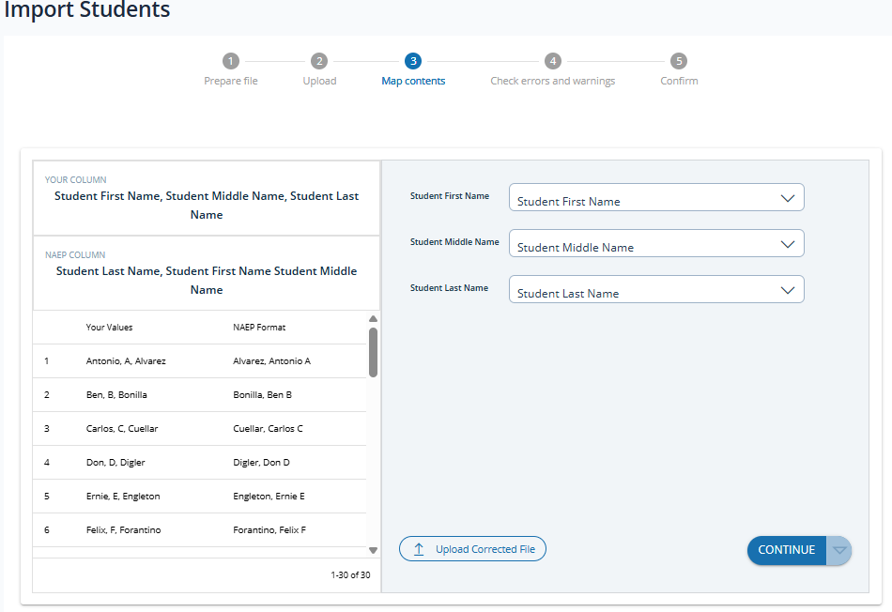
Note. If the student name is provided in one column in the uploaded student list file, or student name column(s) could not be identified, a different initial mapping question is displayed.
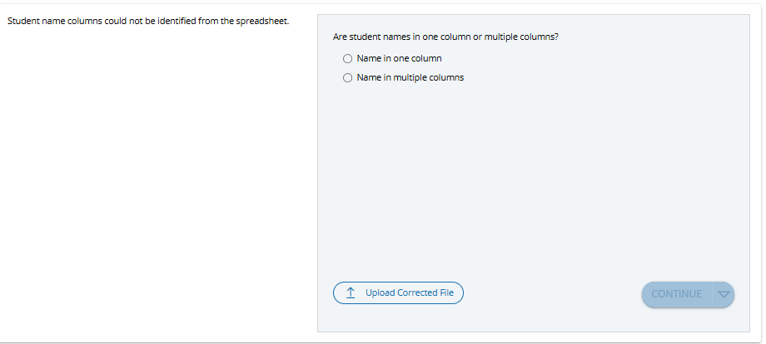
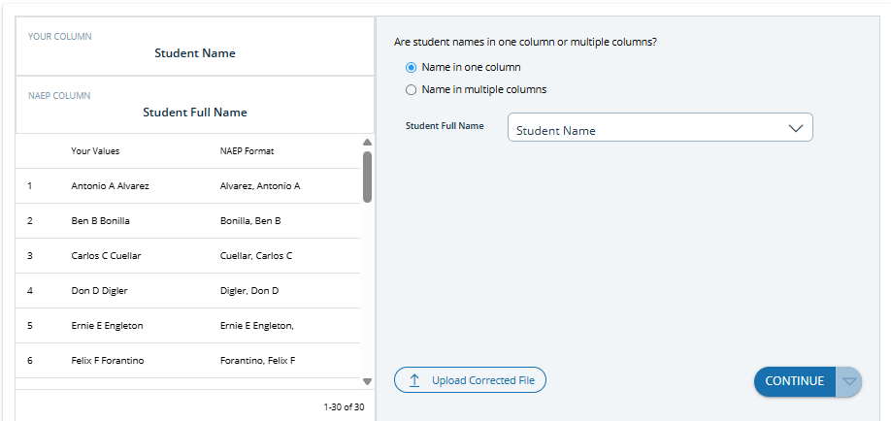
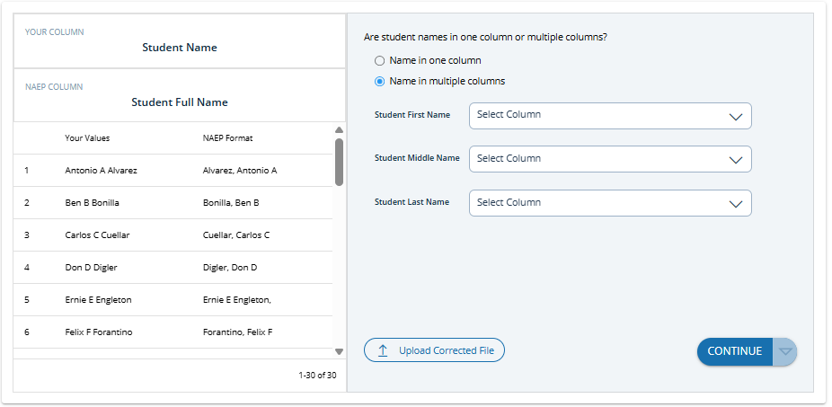
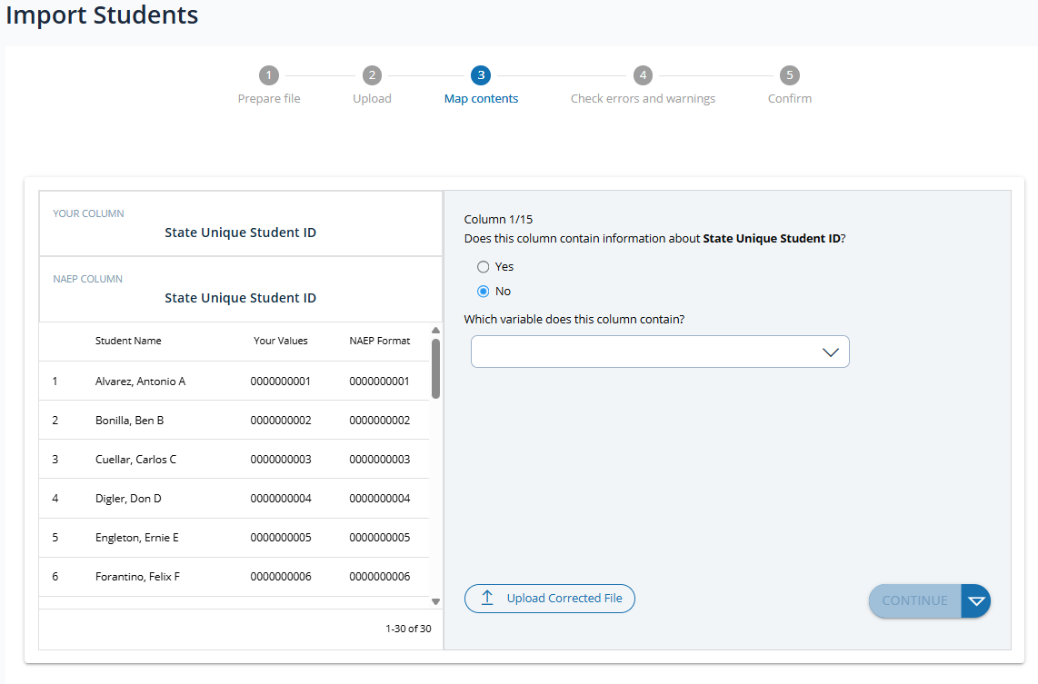
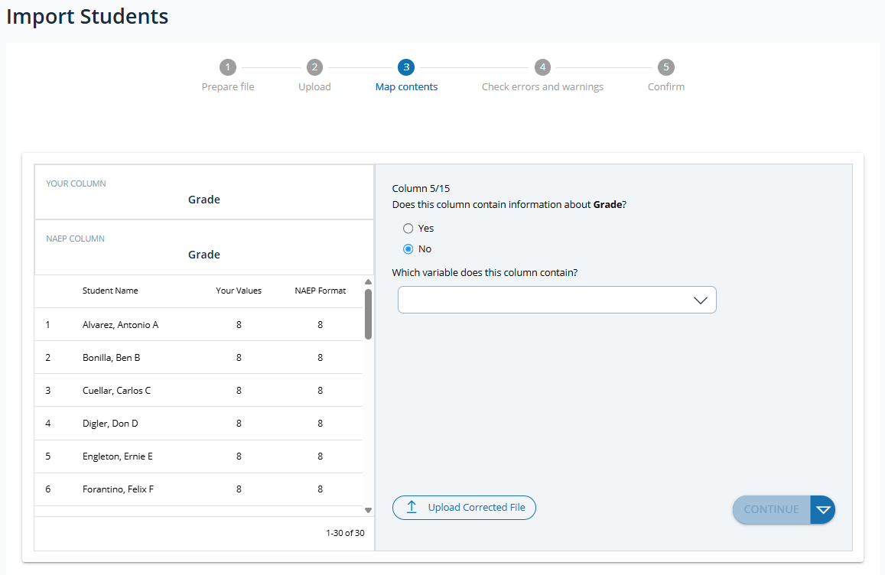
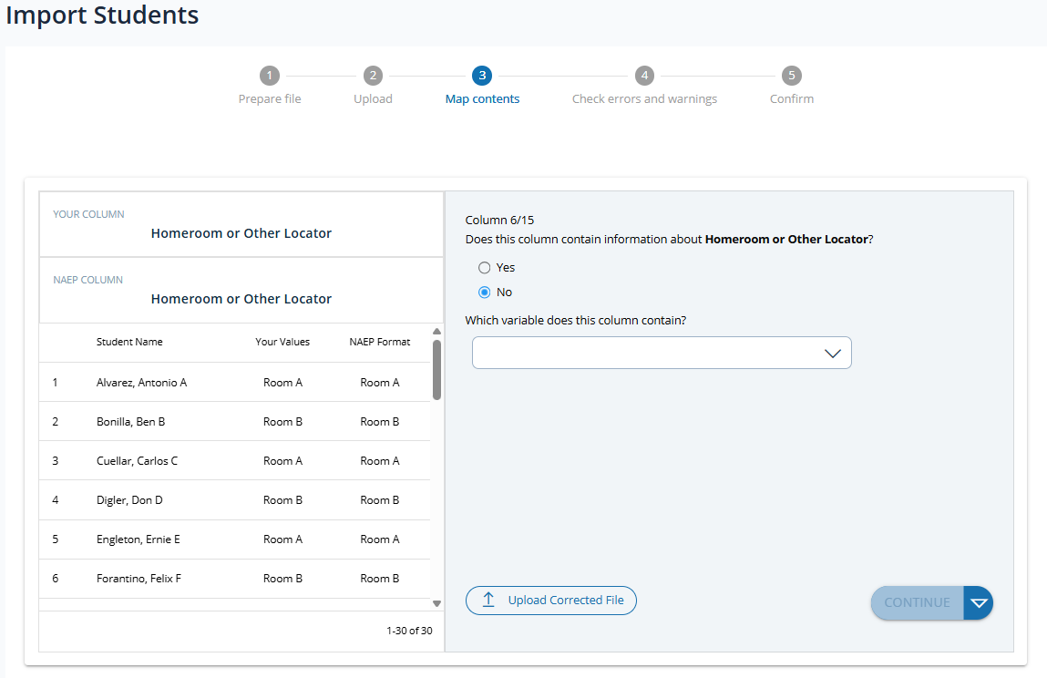
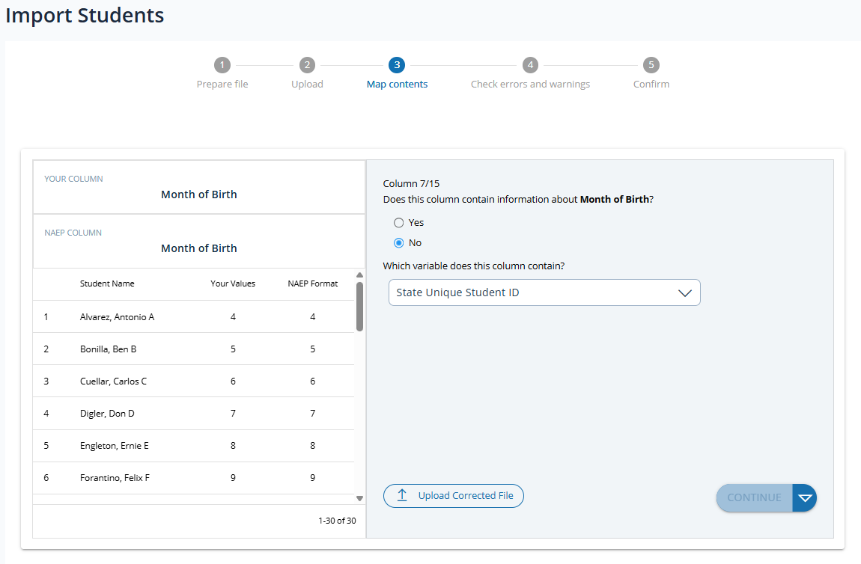
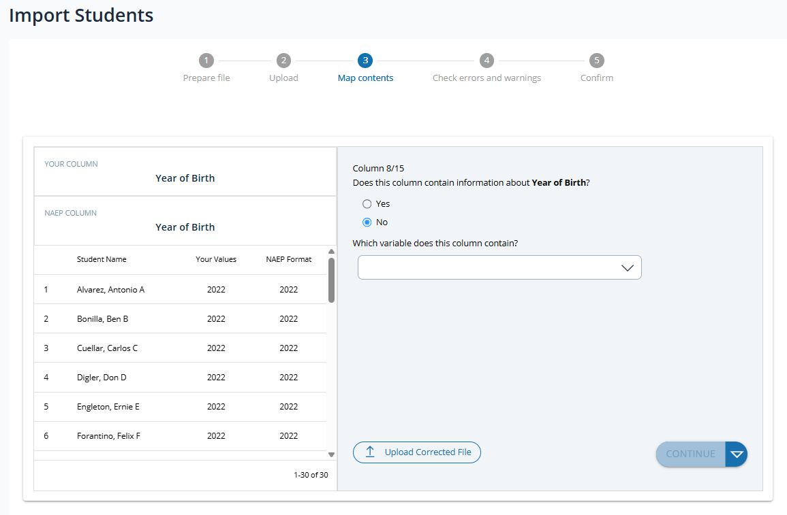
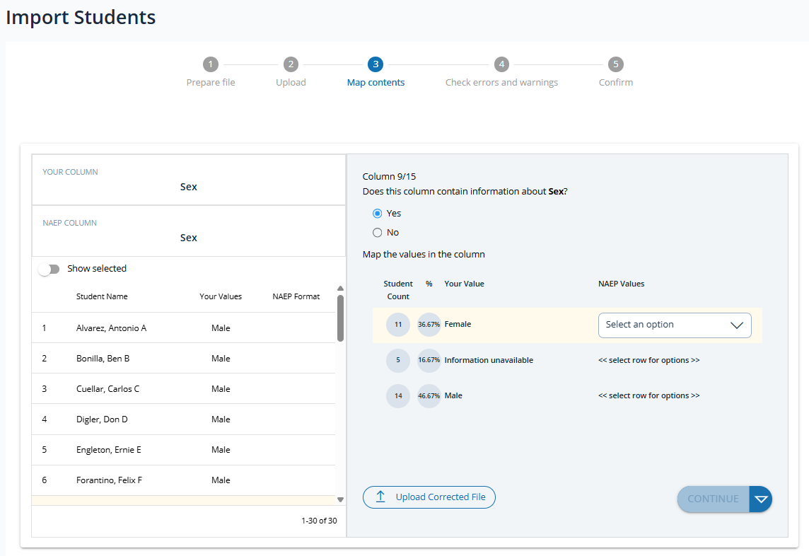
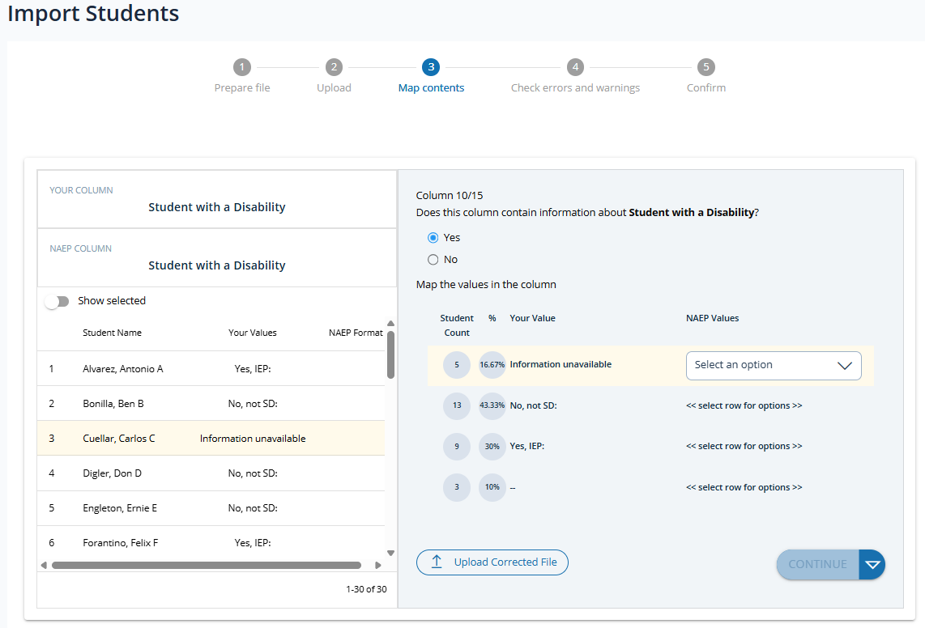
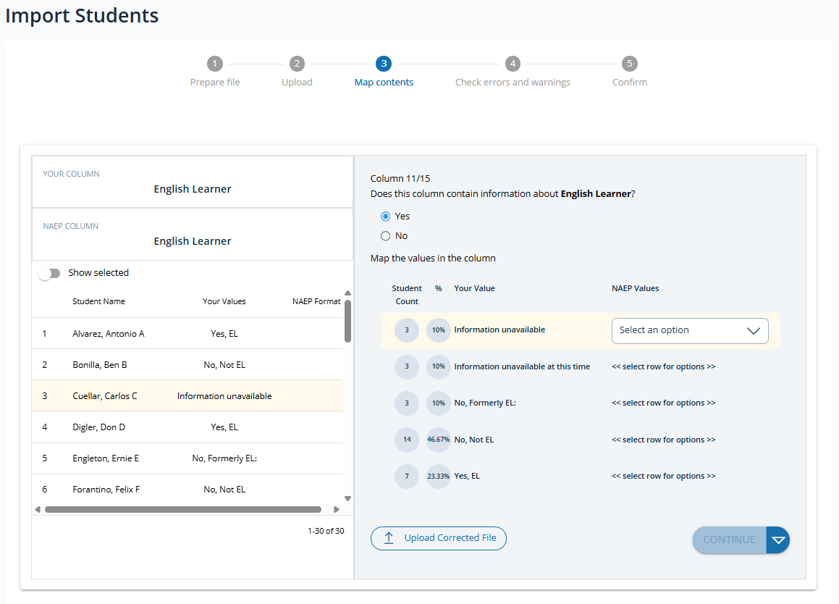
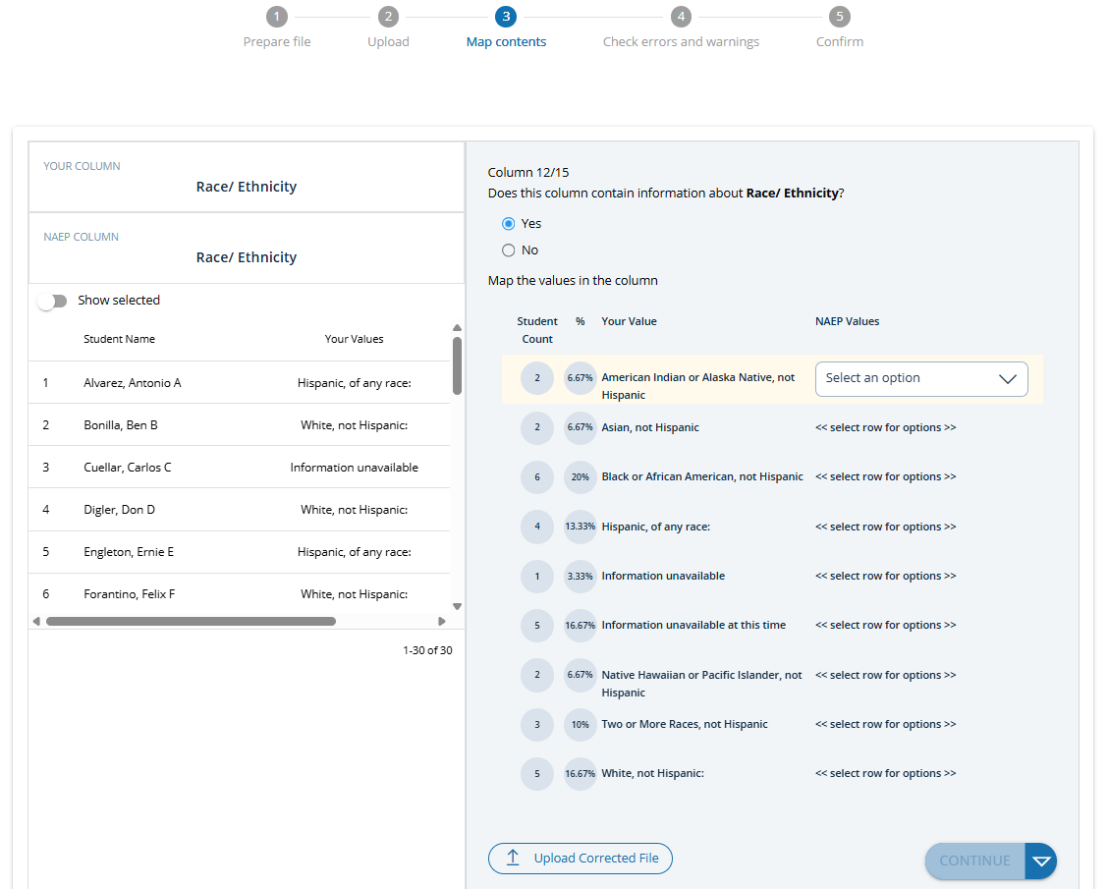
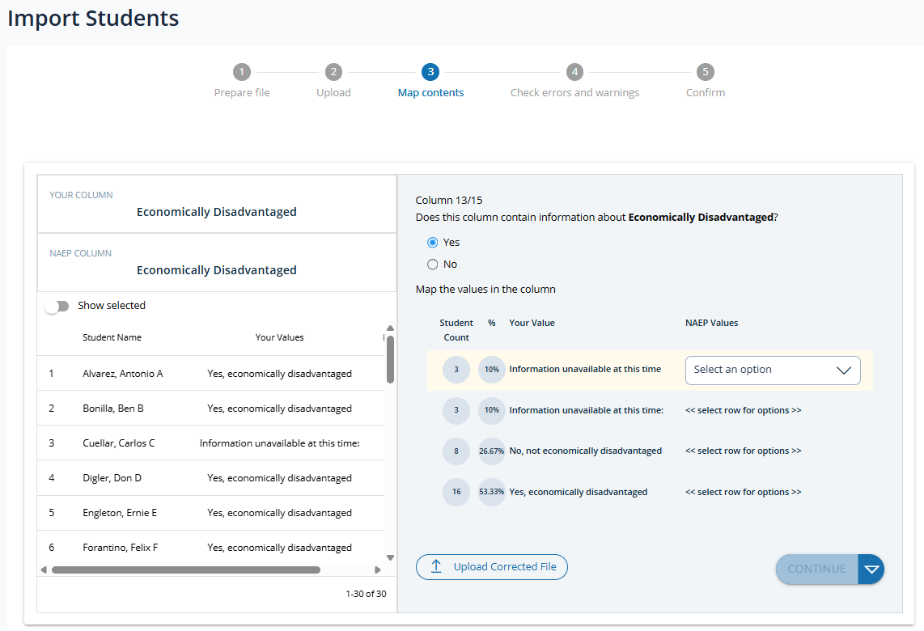
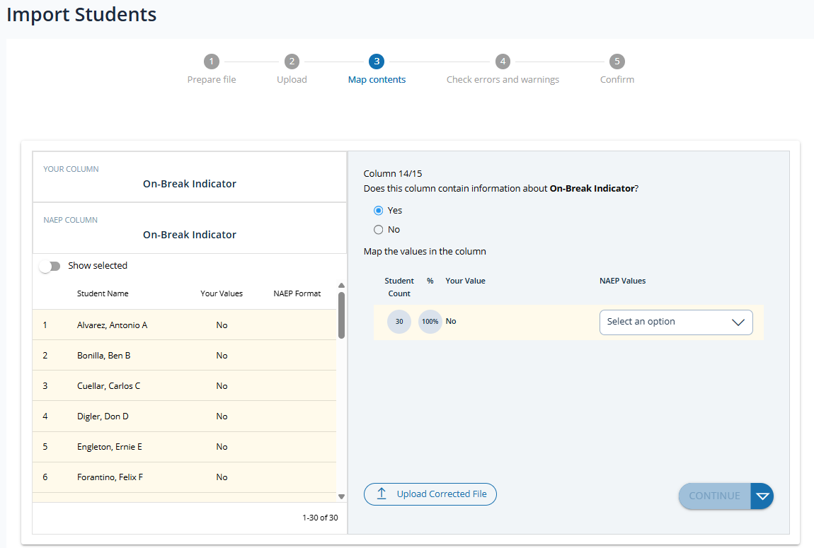
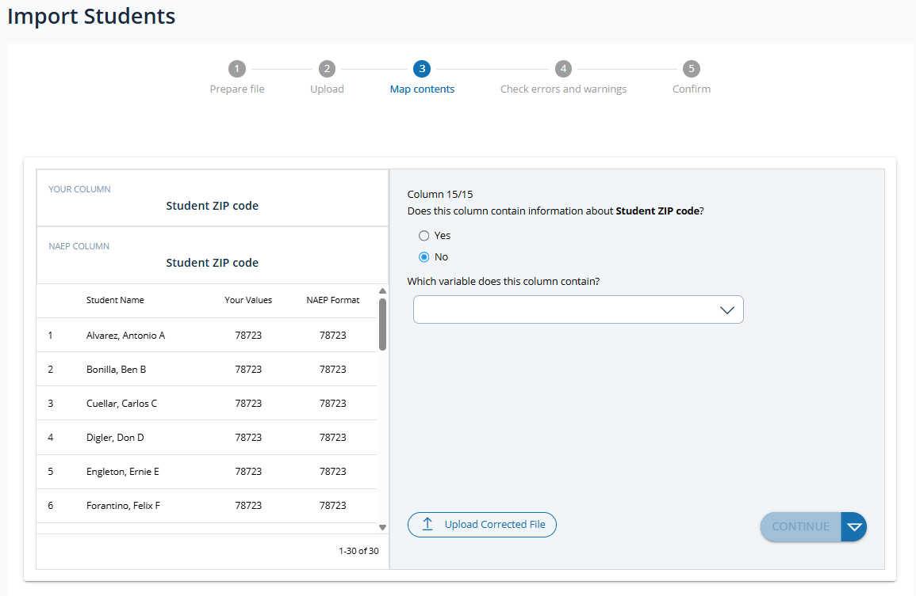
Step 4 (Check errors and warnings)
After completing the mapping process, the AMS generates errors or warnings based on preestablished criteria. Users must resolve all errors and warning before continuing to step 5 and completing the Import Student List process. The error and warning screen displays all errors and warnings generated and includes additional options for user to:
- Return to mapping screens to make corrections as needed
- Upload a corrected file to make corrections as needed
- Export the errors and warning list to an excel file (see example below)
- Search, sort and filter errors and warnings by category
Example errors and warning export file:
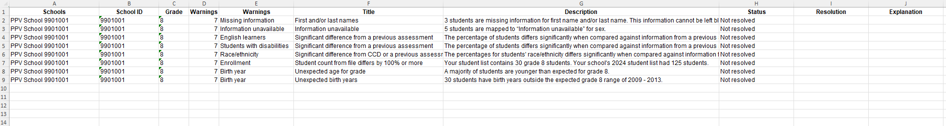

Errors and Warning Screens
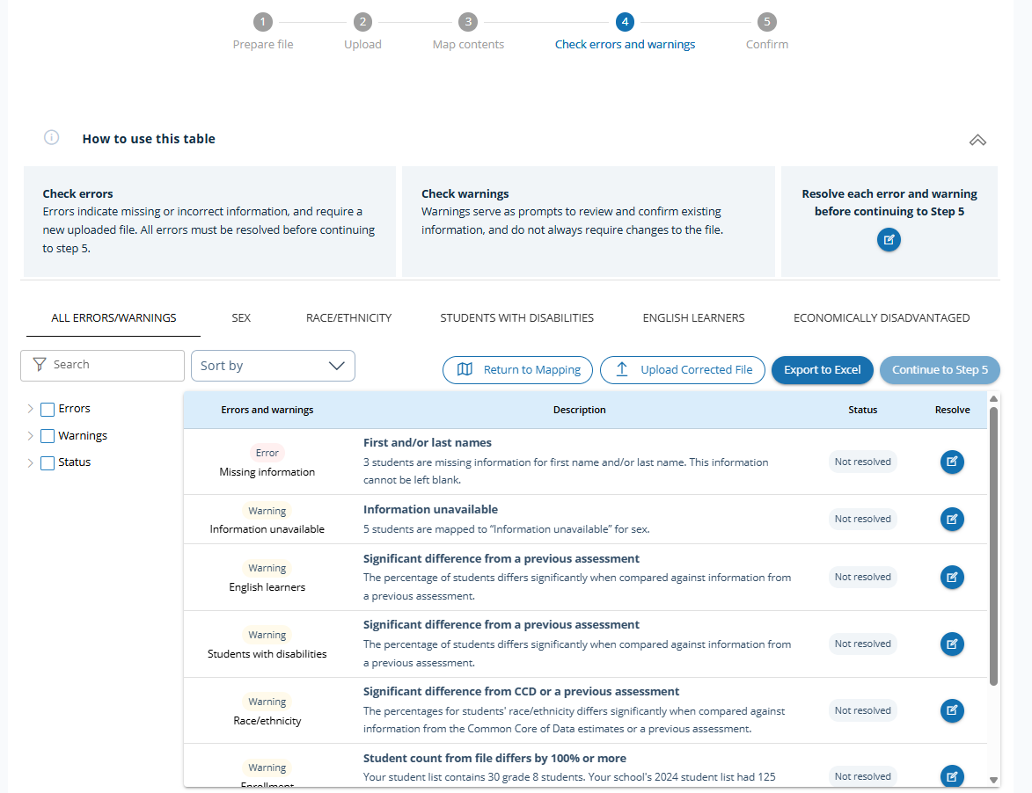

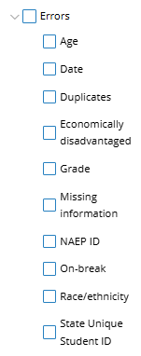
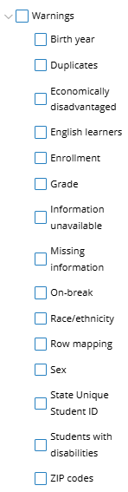
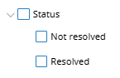
Filter options

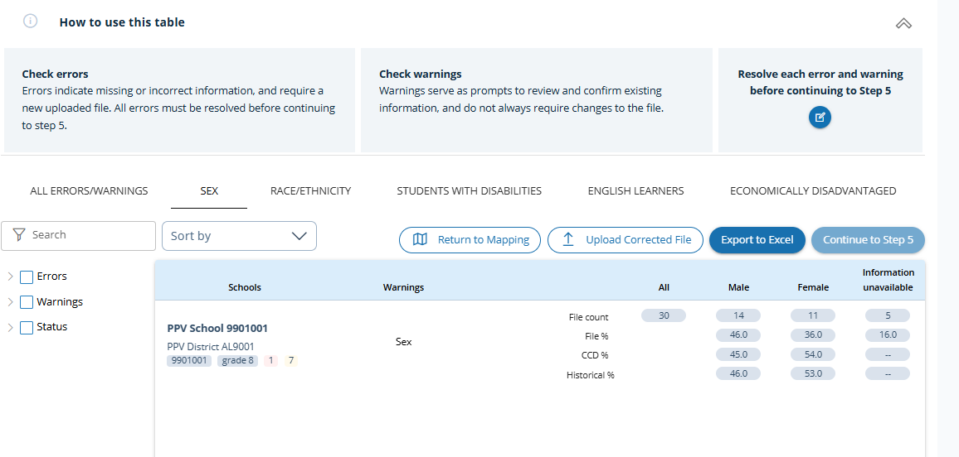

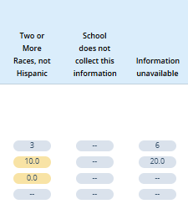
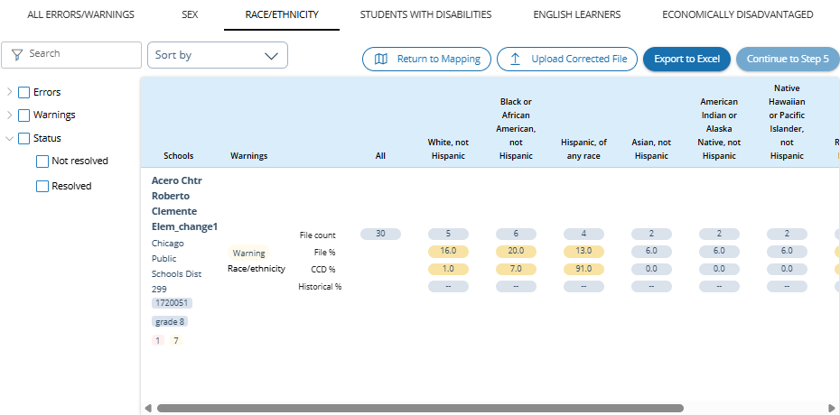

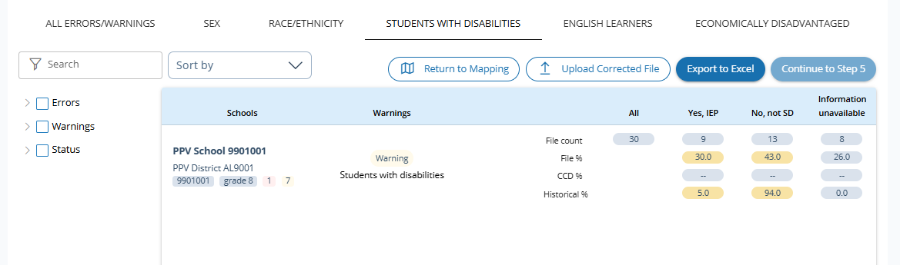
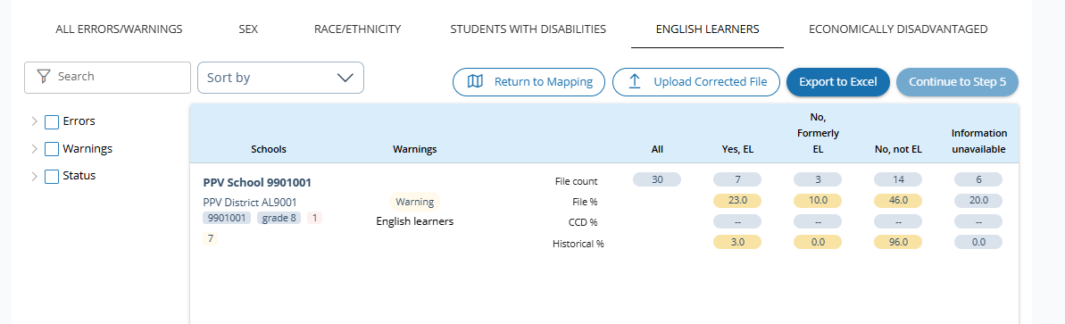
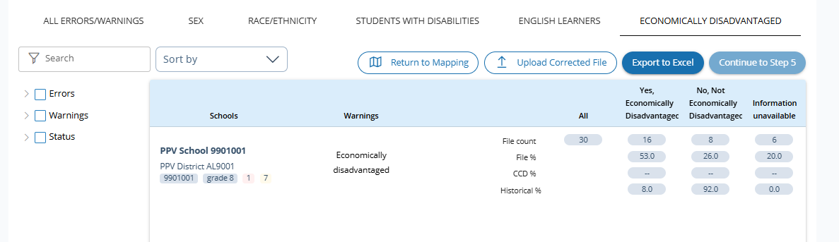
Resolve Warnings Screens
Users resolve error and warnings by selecting the icon in the Resolve column in the Errors and Warnings table for the error or warning to be resolved.
Upon selecting the icon in the Resolve column, users are navigated to the corresponding error or warning resolution screen which includes additional details regarding the error or warning, additional questions displayed to be answered and/or additional instruction provided in order to resolve. Users may navigate back to prior errors and warning or proceed to next error/warning using the Back and Next buttons respectively or select the Back to overview button to return to the Errors and Warning table. The “Resolve this warning” button will appear once all required additional information or corrections have been applied.
Each error and warning resolution screen contains specific information, questions and/or instructions specific to the warning.
Example resolution screens
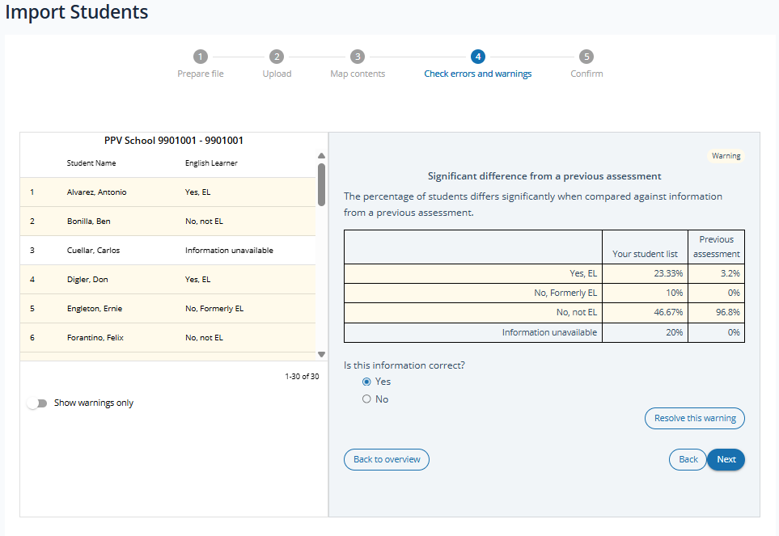
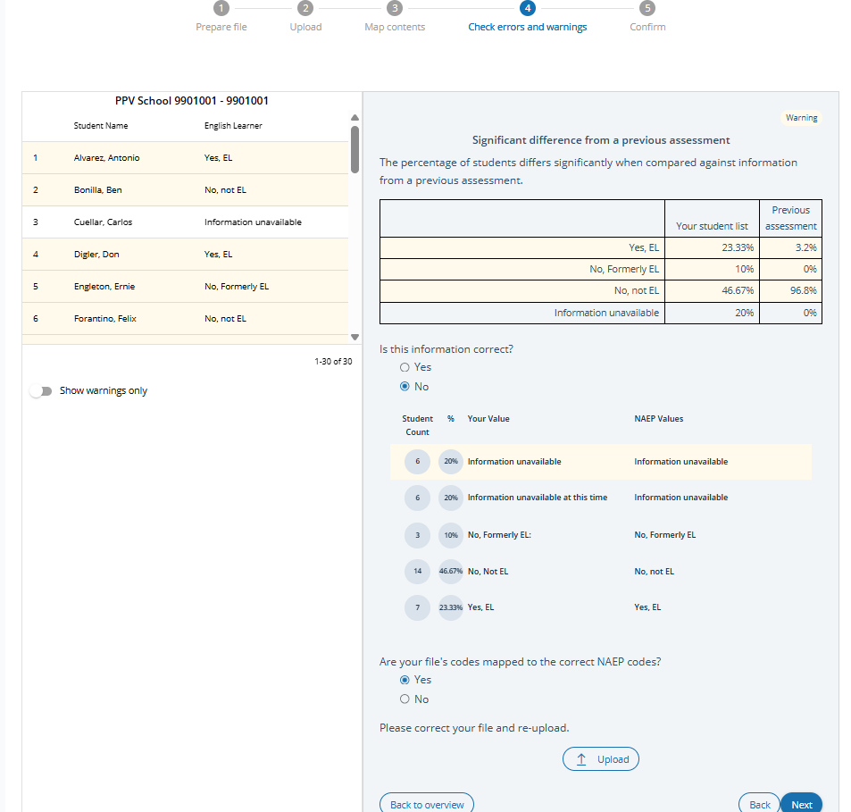

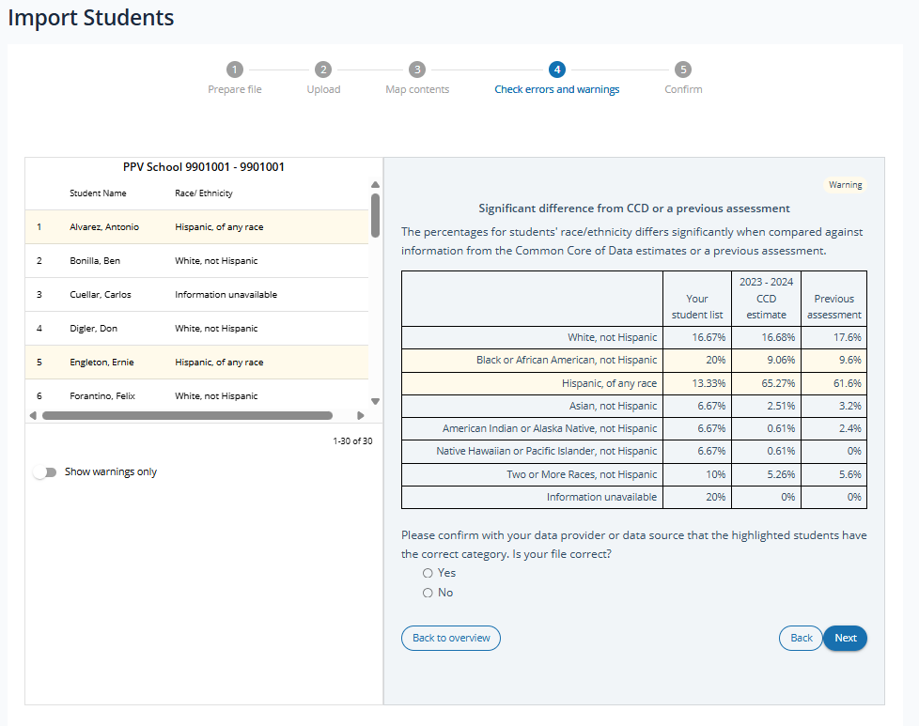

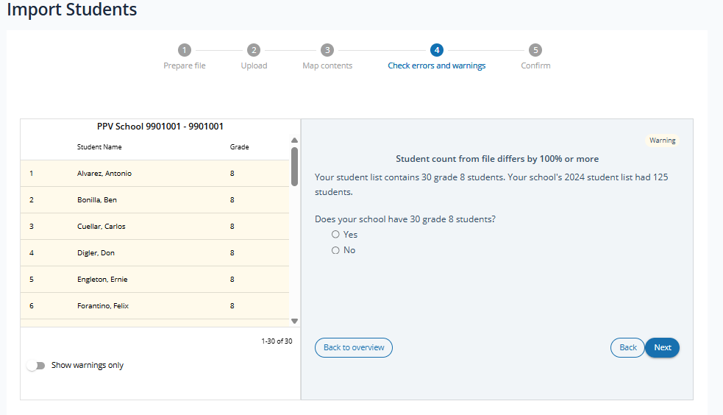
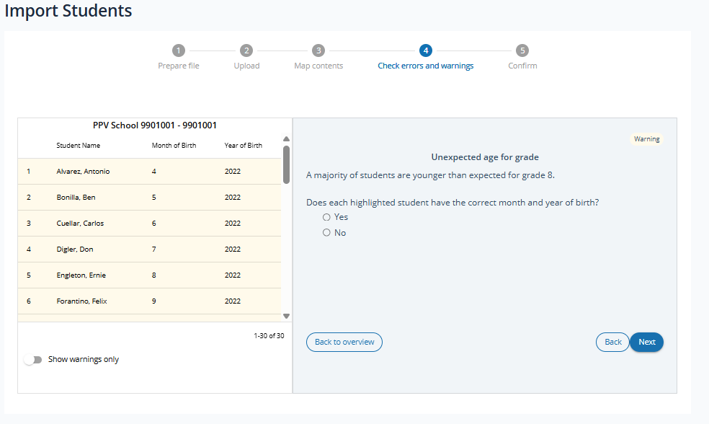
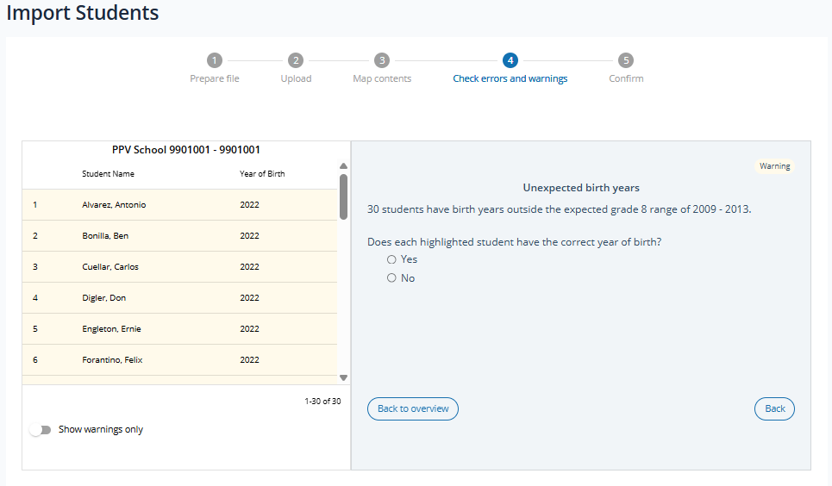
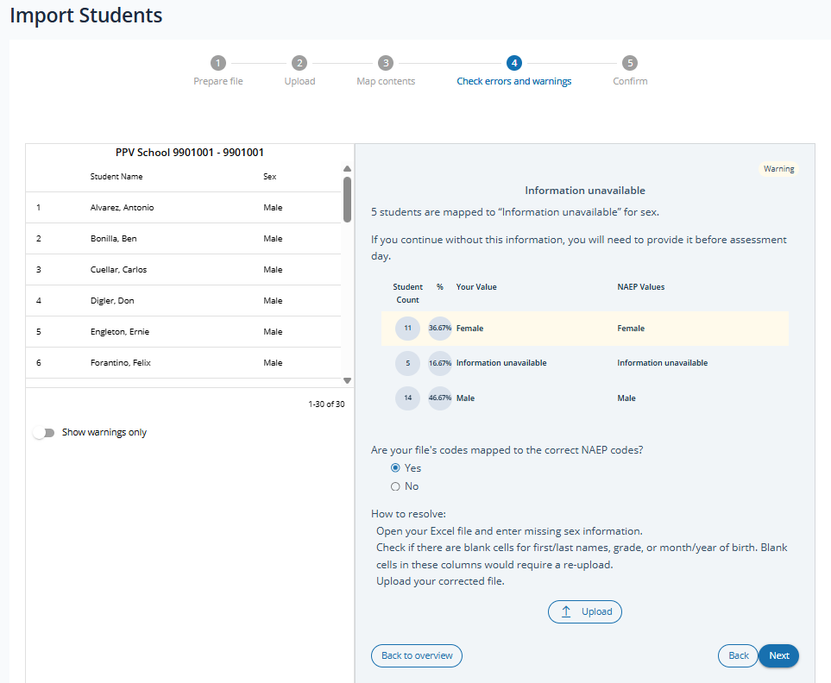
Errors and Warnings Screens:
Following are the rules and content for the complete set of all possible errors and warning screens a user may see.
Error message in Import Students Step 4: Check errors and warnings.  Error requires a new file, prompts list importer to re-upload. | Required columns  Your file is missing required columns for: <first and/or last name, month and/or year of birth, sex, grade, race/ethnicity, or on break>.  How to resolve:  - Open your Excel file and add the missing columns.  - Check if there are blank cells for required columns. Blank cells in these columns could require a re-upload.  - Upload your corrected file.  <Upload button>

Error message in Import Students Step 4: Check errors and warnings.  Error requires a new file, prompts list importer to re-upload. | Required columns  Your file is missing required columns for: <first and/or last name, month and/or year of birth, sex, grade, race/ethnicity, or on break>.  How to resolve:  - Open your Excel file and add the missing columns.  - Check if there are blank cells for required columns. Blank cells in these columns could require a re-upload.  - Upload your corrected file.  <Upload button>

Warning message in Import Students Step 4: Check errors and warnings.  Warning asks for new file, prompts list importer to re-upload. | Missing columns  Your file is missing columns for: <Students with disabilities, English learners, or economically disadvantaged>.  How to resolve:  - If you continue without this information, you will need to provide it before assessment day.  - Open your Excel file and add the missing columns.  - Upload your corrected file.  <Upload button>

Error message in Import Students Step 4: Check errors and warnings.  Error requires a new file, prompts list importer to re-upload. | First and/or last names  <#> students are missing information for first name and/or last name. This information cannot be left blank.  How to resolve:  - Open your Excel file and enter missing student names.  - Check if there are blank cells for month/year of birth, grade, sex, or race/ethnicity. Blank cells in these columns would require a re-upload.  - Upload your corrected file.  <Upload button>

Error message in Import Students Step 4: Check errors and warnings.  Error requires a new file, prompts list importer to re-upload. | Month and/or year of birth  <#> students are missing information for month and/or year of birth. This information cannot be left blank.  How to resolve:  - Open your Excel file and enter missing months/years of birth.  - Check if there are blank cells for first/last names, grade, or sex. Blank cells in these columns would require a re-upload.  - Upload your corrected file.  <Upload button>

Data check failure: | 0% < PCT_MISSING <= 10%
Warning message in Import Students Step 4: Check errors and warnings.  Warning asks for new file, prompts list importer to re-upload. | Month and/or year of birth  <#> students are missing information for month and/or year of birth. This information cannot be left blank.  How to resolve:  - Open your Excel file and enter missing months/years of birth.  - Check if there are blank cells for first/last names, grade, or sex. Blank cells in these columns would require a re-upload.  - Upload your corrected file.  <Upload button>

Error message in Import Students Step 4: Check errors and warnings.  Error requires a new file, prompts list importer to re-upload. | Invalid date of birth  <#> students have an invalid student birth date. Birth date must either be an Excel date field or a text field in one of these formats: MMDDYYYY or MM/DD/YYYY.  How to resolve:  - Open your Excel file and correct any invalid or missing student birthdates.  - Upload your corrected file.  - If your birth dates appear to be correct, please contact the NAEP help desk at 1-800-283-6237 or naephelp@westat.com.  <Upload button>

Error message in Import Students Step 4: Check errors and warnings.  Error requires a new file, prompts list importer to re-upload. | Invalid month of birth  <#> students have an invalid month of birth. Month of birth must be in a numeric format.  How to resolve:  - Open your Excel file and correct any invalid or missing student birth months.  - Upload your corrected file.  - If your birth months appear to be correct, please contact the NAEP help desk at 1-800-283-6237 or naephelp@westat.com.  <Upload button>

Error message in Import Students Step 4: Check errors and warnings.  Error requires a new file, prompts list importer to re-upload. | Invalid year of birth  <#> students have an invalid year of birth. Year of birth must be in a 4 digit numeric format.  How to resolve:  - Open your Excel file and correct any invalid or missing student birth years.  - Upload your corrected file.  - If your birth years appear to be correct, please contact the NAEP help desk at 1-800-283-6237 or naephelp@westat.com.  <Upload button>

Warning message in Import Students Step 4: Check errors and warnings.  Warning asks for list importer to confirm correct mapping. If incorrect, prompts list importer to return to mapping in Step 3.  If mapping is correct, the warning asks list importer if information is correct. If incorrect, prompts list importer to re-upload. | Information unavailable  <#> students are mapped to “Information unavailable” for sex. If you continue without this information, you will need to provide it before assessment day.  Are your file’s codes mapped to the correct NAEP codes?  <Yes/No choices, if answer is No the following will appear>  Please correct your code mapping in step 3.  <Return to step 3 button>  <if answer to previous question is Yes, the following will appear>  How to resolve:  1. Open your Excel file and enter missing sex information.  2. Check if there are blank cells for first/last names, grade, or month/year of birth. Blank cells in these columns would require a re-upload.  3. Upload your corrected file.  <Upload button>

Error message in Import Students Step 4: Check errors and warnings.  Error requires a new file, prompts list importer to re-upload. | Unexpected grades  NAEP will assess grade X students at <school name>. <#> out of <total #> students have a different number for grade. If your file only includes grade X students, then all students should have the same value for grade. Please delete any students who are not in grade X from your file and re-upload.  <Upload button>

Warning message in Import Students Step 4: Check errors and warnings.  Warning asks for list importer to confirm correct mapping. If incorrect, prompts list importer to return to mapping in Step 3.  If mapping is correct, warning asks list importer if information is correct. If incorrect, prompts list importer to re-upload. | Percentage of students on-break  <Percent ranges estimate from # of tracks> of students are expected to be on-break at the time of the assessment. <% of on-break students from file > of students in the file are classified as on-break.  Are your file’s codes mapped to the correct NAEP codes?  <Yes/No choices, if answer is No the following will appear>  Please correct your code mapping in step 3.  <Return to step 3 button>  <if answer to previous question is Yes, the following will appear>  Will <% of on-break students from file > be on-break at the time of the assessment?  <Yes/No choices, if answer is No the following will appear>  Please correct your file and re-upload.  <Upload button>

Warning message in Import Students Step 4: Check errors and warnings.  Warning asks for list importer to confirm correct mapping. If incorrect, prompts list importer to return to mapping in Step 3.  If mapping is correct, warning asks list importer if information is correct. If incorrect, prompts list importer to re-upload. | Percentage of students on-break  <On-break percentage from School Characteristics> of students are expected to be on-break at the time of the assessment. <% of on-break students from file > of students in the file are classified as on-break.  Are your file’s codes mapped to the correct NAEP codes?  <Yes/No choices, if answer is No the following will appear>  Please correct your code mapping in step 3.  <Return to step 3 button>  <if answer to previous question is Yes, the following will appear>  Will <% of on-break students from file > be on-break at the time of the assessment?  <Yes/No choices, if answer is No the following will appear>  Please correct your file and re-upload.  <Upload button>

Warning message in Import Students Step 4: Check errors and warnings.  Warning asks for list importer to confirm out of range birth, if incorrect, prompts list importer to re-upload. | Unexpected birth years  <#> students have birth years outside the expected grade <4, 8, 12> range of <20##> – <20##>.  Does each highlighted student have the correct year of birth?  <Yes/No choices, if answer is No the following will appear>  Please correct your file and re-upload.  <Upload button>

Warning message in Import Students Step 4: Check errors and warnings.  Warning asks for list importer to confirm out of range birth years. If incorrect, prompts list importer to re-upload. | Unexpected age for grade  A majority of students are (older or younger) than expected for grade <4, 8, 12>.  Does each highlighted student have the correct year of birth and grade?  <Yes/No choices, if answer is No the following will appear>  Please correct your file and re-upload.  <Upload button>

Error message in Import Students Step 4: Check errors and warnings.  Error requires a new file, prompts list importer to re-upload. | Duplicate students  <#> of students have identical first/last names, sex, and month/year of birth. Unique information is required for each student.  Please correct your file and re-upload.  <Upload button>

Warning message in Import Students Step 4: Check errors and warnings.  Warning asks for list importer to confirm unique students. If incorrect, prompts list importer to re-upload. | Duplicate students  <#> students have identical first/last names, sex, and month/year of birth.  Do the highlighted records represent individual, unique students?  <Yes/No choices, if answer is No the following will appear>  Please remove any duplicate students from your file and re-upload.  <Upload button>

Warning message in Import Students Step 4: Check errors and warnings.  Warning asks for list importer to confirm information. If incorrect, prompts list importer to re-upload. | 5 or more race/ethnicity categories  <#> students are coded with every or almost every race/ethnicity category.  Is this information correct?  <Yes/No choices, if answer is No the following will appear>  Please correct your file and re-upload.  <Upload button>

Error message on upload/coding page. Error results in user not being allowed to continue. | Student identifiers are not unique  Two or more students on the file you submitted have identical student IDs. Each student is required to have a unique student ID.  Please correct these student IDs and re-upload.  <Upload button>

Warning message in Import Students Step 4: Check errors and warnings.  Warning prompts list importer to confirm if student ID is SSN. | Social Security Numbers  The student IDs in your file look like Social Security Numbers (SSNs). NAEP cannot accept SSNs.  Are the student IDs included in your file also SSNs?  <Yes/No choices, if answer is Yes the following will appear>  Please remove the student IDs from your file and re-upload.  <Upload button>

Warning message in Import Students Step 4: Check errors and warnings.  Warning asks for list importer to confirm information. If incorrect, prompts list importer to re-upload. | File might not include all grade <x> students  It appears your file provides only a sample of grade X students. NAEP requires a list of all grade X students so that the sample can be drawn using random sampling methods.  Does your school have <# from E-File> grade X students?  <Yes/No choices, if answer is No the following will appear>  Please upload a new student list that includes all grade X students.  <Upload button>

Warning message in Import Students Step 4: Check errors and warnings.  Warning asks for list importer to confirm information. If incorrect, prompts list importer to re-upload. | Student count from file differs by 10% or more  Your student list contains <#> grade X students, but the reported fall enrollment from the school summary page is <#> grade X students.  Does your school have <# from E-File> grade X students?  <Yes/No choices, if answer is No the following will appear>  Please upload a new student list that includes all grade X students.  <Upload button>

Warning message in Import Students Step 4: Check errors and warnings.  Warning asks for list importer to confirm correct mapping. If incorrect, prompts list importer to return to mapping in Step 3.  If mapping is correct, warning asks list importer if information is correct. If incorrect, prompts list importer to re-upload. | All students mapped to same category  100% of the students you provided information for are mapped to the same category, <value>.  Are your file’s codes mapped to the correct NAEP codes?  <Yes/No choices, if answer is No the following will appear>  Please correct your code mapping in step 3.  <Return to step 3 button>  <If answer is Yes the following will appear>  Is this information correct?  <Yes/No choices, if answer is No the following will appear>  Please correct your file and re-upload.  <Upload button>

Warning message in Import Students Step 4: Check errors and warnings.  Warning asks for list importer to confirm correct mapping. If incorrect, prompts list importer to return to mapping in Step 3.  If mapping is correct, warning asks list importer if information is correct. If incorrect, prompts list importer to re-upload. | All students mapped to same category  100% of the students you provided information for are mapped to the same category, <value>.  Are your file’s codes mapped to the correct NAEP codes?  <Yes/No choices, if answer is No the following will appear>  Please correct your code mapping in step 3.  <Return to step 3 button>  <If answer is Yes the following will appear>  Is this information correct?  <Yes/No choices, if answer is No the following will appear>  Please correct your file and re-upload.  <Upload button>

Error message in Import Students Step 4: Check errors and warnings.  Error results in user not being allowed to continue until they resolve the mapping or update the school’s NSLP participation status. | Provision 2 or 3, All Students  Currently, records indicate that this school participates in the National School Lunch Program with Provision 2 or 3, All Students. Schools with this provision should classify every student as economically disadvantaged.  How to resolve:  - If your school participates with Provision 2 or 3 – All Students, then you should map every economically disadvantaged code to "Yes, economically disadvantaged."  - Contact the NAEP help desk at naephelp@westat.com or 1-800-283-6237 if this school does not participate in Provision 2 or 3 – All Students.  - Return to step 3 and correct your mapping for economically disadvantaged.  <Return to step 3 button>

Warning message in Import Students Step 4: Check errors and warnings.  Warning asks for list importer to confirm correct mapping. If incorrect, prompts list importer to return to mapping in Step 3.  If mapping is correct, the warning asks list importer if information is correct. If incorrect, prompts list importer to re-upload. | Community Eligibility Provision (CEP)/Provision 2 or 3 – Direct Certification  Less than 25% of students are classified as economically disadvantaged, which is unusual.  Are your file’s codes mapped to the correct NAEP codes?  <Yes/No choices, if answer is No the following will appear>  Please correct your code mapping in step 3.  <Return to step 3 button>  <if answer to previous question is Yes, the following will appear>  Is this information correct?  <Yes/No choices, if answer is Yes the following will appear>  Please correct your file and re-upload.  <Upload button>

Warning message in Import Students Step 4: Check errors and warnings.  Warning asks for list importer to confirm correct mapping. If correct, prompts list importer to return to mapping in Step 3.  If mapping is correct, warning asks list importer if information is correct. If incorrect, prompts list importer to re-upload. | Community Eligibility Provision (CEP)/Provision 2 or 3 – Direct Certification Plus  Less than 25% of students are classified as economically disadvantaged, which is unusual.  Are your file’s codes mapped to the correct NAEP codes?  <Yes/No choices, if answer is No the following will appear>  Please correct your code mapping in step 3.  <Return to step 3 button>  <if answer to previous question is Yes, the following will appear>  Is this information correct?  <Yes/No choices, if answer is Yes, the following will appear>  Please correct your file and re-upload.  <Upload button>

Error results in user not being allowed to continue until they resolve the mapping or update the school’s NSLP participation status. | Community Eligibility Provision (CEP) – All  Currently, records indicate that your school participates in the National School Lunch Program with Community Eligibility Provision (CEP) – All. Schools with this provision should classify every student as economically disadvantaged.  How to resolve:  - If your school participates with CEP – All, then you should map every economically disadvantaged code to "Yes, economically disadvantaged."  - Contact the NAEP help desk at naephelp@westat.com or 1-800-283-6237 if this school does not participate in the CEP – All provision.  - Return to step 3 and correct your mapping for economically disadvantaged.  <Return to step 3 button>

Warning message in Import Students Step 4: Check errors and warnings.  Warning asks for list importer to confirm the school’s NSLP participation. If correct, prompts list importer to return to mapping in Step 3. | Universal Feeding Program  Currently, records indicate that your school participates in a universal feeding program. Schools with these programs should classify every student as economically disadvantaged.  How to resolve:  - If your school participates in a universal feeding program, then you should map every economically disadvantaged code to "Yes, economically disadvantaged."  - Contact the NAEP help desk at naephelp@westat.com or 1-800-283-6237 if this school does not participate in a universal feeding program.  - Return to step 3 and correct your mapping for economically disadvantaged.  <Return to step 3 button>

Error message on upload/coding page. Error results in user not being allowed to continue: | School does not collect race/ethnicity information  __ % of the students are classified as “School does not this collect this information” for race/ethnicity. Please do not use this code if your school collects race/ethnicity information for one or more students.  How to resolve:  - If your school collects race/ethnicity information, then you should not map any codes to "School does not this collect this information."  - Map any students who do not have race/ethnicity information to “Information unavailable.”  - Return to step 3 and correct your mapping for race/ethnicity.

Warning message in Import Students Step 4: Check errors and warnings.  Warning asks for list importer to confirm correct mapping. If incorrect, prompts list importer to return to mapping in Step 3.  If mapping is correct, warning asks list importer if information is correct. If incorrect, prompts list importer to re-upload. | All students mapped to same category  100% of the students you provided information for are mapped to the same category, <value>.  Are your file’s codes mapped to the correct NAEP codes?  <Yes/No choices, if answer is No the following will appear>  Please correct your code mapping in step 3.  <Return to step 3 button>  <If answer is Yes the following will appear>  Is this information correct?  <Yes/No choices, if answer is No the following will appear>  Please correct your file and re-upload.  <Upload button>

Warning message on checks page: | All students mapped to same category  100% of the students are classified as “School does not this collect this information” for race/ethnicity. Information from previous assessments indicates that this school collected race/ethnicity information in the past.  How to resolve:  - If your school collects race/ethnicity information, please include this information in your file and re-upload.  - No action is needed if your school does not collect race/ethnicity information.

Warning message in Import Students Step 4: Check errors and warnings.  Warning asks for list importer to confirm correct mapping. If incorrect, prompts list importer to return to mapping in Step 3.  If mapping is correct, warning asks list importer if information is correct. If incorrect, prompts list importer to re-upload. | Significant difference from <CCD or PSS> or a previous assessment  The percentage of <race/ethnicity categories> students differs significantly when compared against <CCD or PSS> estimates or a previous assessment.  list categories, list percentage, and Frame percentage  Are your file’s codes mapped to the correct NAEP codes?  <Yes/No choices, if answer is No the following will appear>  Please correct your code mapping in step 3.  <Return to step 3 button>  <If answer is Yes the following will appear>  Is this information correct?  <Yes/No choices, if answer is No the following will appear>  Please correct your file and re-upload.  <Upload button>

Warning message on checks page: | Significant difference from <CCD or PSS> or a previous assessment  The percentage of <sex categories> students differs significantly when compared against <CCD or PSS> estimates or a previous assessment.  list categories, student list percentage, and Frame percentage  Are your file’s codes mapped to the correct NAEP codes?  <Yes/No choices, if answer is No the following will appear>  Please correct your code mapping in step 3.  <Return to step 3 button>  <If answer is Yes the following will appear>  Please confirm with your data provider or data source that the highlighted students have the correct sex. Is your file correct?  <Yes/No choices, if answer is No the following will appear>  Please correct your file and re-upload.  <Upload button>

Warning message in Import Students Step 4: Check errors and warnings.  Warning asks for E-Filer to confirm correct mapping. If incorrect, prompts E-filer to return to mapping in Step 3.  If mapping is correct, warning asks E-Filer if information is correct. If incorrect, prompts E-filer to re-upload. | Significant difference from <CCD or PSS> or a previous assessment  The percentage of students that are economically disadvantaged differs significantly when compared against <CCD or PSS> estimates or a previous assessment.  list categories, e-file percentage, and Frame percentage  Are your file’s codes mapped to the correct NAEP codes?  <Yes/No choices, if answer is No the following will appear>  Please correct your code mapping in step 3.  <Return to step 3 button>  <If answer is Yes the following will appear>  Is this information correct?  <Yes/No choices, if answer is No the following will appear>  Please correct your file and re-upload.  <Upload button>

Warning message appears on Checks Page: | Student count from file differs by 100% or more  Your student list contains XX grade X students. Your school’s 20XX student list had <# from previous E-File> students.  Does your school have <# from E-File> grade X students?  <Yes/No choices, if answer is No the following will appear>  Please upload a new student list that includes all grade X students.  <Upload button>

Warning message in Import Students Step 4: Check errors and warnings.  Warning asks for list importer to confirm correct mapping. If incorrect, prompts list importer to return to mapping in Step 3.  If mapping is correct, warning asks list importer if information is correct. If incorrect, prompts list importer to re-upload. | All students mapped to same category  100% of students you provided information for are mapped to the same category, <"Yes, SD” OR “Information unavailable”>.  Are your file’s codes mapped to the correct NAEP codes?  <Yes/No choices, if answer is No the following will appear>  Please correct your code mapping in step 3.  <Return to step 3 button>  <If answer is Yes the following will appear>  Is this information correct?  <Yes/No choices, if answer is No the following will appear>  Please correct your file and re-upload.  <Upload button>

Warning message in Import Students Step 4: Check errors and warnings.  Warning asks for list importer to confirm correct mapping. If incorrect, prompts list importer to return to mapping in Step 3.  If mapping is correct, warning asks list importer if information is correct. If incorrect, prompts list importer to re-upload. | All students mapped to same category  100% of students you provided information for are mapped to the same category, <"Yes, English learner” OR “Information unavailable”>.  Are your file’s codes mapped to the correct NAEP codes?  <Yes/No choices, if answer is No the following will appear>  Please correct your code mapping in step 3.  <Return to step 3 button>  <If answer is Yes, the following will appear>  Is this information correct?  <Yes/No choices, if answer is No the following will appear>  Please correct your file and re-upload.  <Upload button>

Warning message in Import Students Step 4: Check errors and warnings.  Warning asks for list importer to confirm correct mapping. If incorrect, prompts list importer to return to mapping in Step 3.  If mapping is correct, warning asks list importer if information is correct. If incorrect, prompts list importer to re-upload. | School does not collect race/ethnicity information  100% of students are classified as “School does not collect this information” for race/ethnicity. Information from a previous assessment indicates that your school submitted race/ethnicity information in the past.  Are your file’s codes mapped to the correct NAEP codes?  <Yes/No choices, if answer is No the following will appear>  Please correct your code mapping in step 3.  <Return to step 3 button>  <If answer is Yes the following will appear>  Is this information correct?  <Yes/No choices, if answer is No the following will appear>  Please correct your file and re-upload.  <Upload button>

Warning message in Import Students Step 4: Check errors and warnings.  Warning asks for list importer to confirm correct mapping. If incorrect, prompts list importer to return to mapping in Step 3.  If mapping is correct, warning asks list importer if information is correct. If incorrect, prompts list importer to re-upload. | Significant difference from previous assessment  The percentage of students differs significantly when compared against information from a previous assessment.  <list categories, student list percentage, and Historical percentage>  Are your file’s codes mapped to the correct NAEP codes?  <Yes/No choices, if answer is No the following will appear>  Please correct your code mapping in step 3.  <Return to step 3 button>  <If answer is Yes the following will appear>  Is this information correct?  <Yes/No choices, if answer is No the following will appear>  Please correct your file and re-upload.  <Upload button>

Step 5 (Confirm)
Upon resolving all errors and warning, AMS users may proceed to the confirmation screen which contains three tabs that provide an overall summary details of student information, the file columns and data provided in the imported student list file, and the final mapped file columns and data respectively. Users may return to the errors and warning screen or upload a corrected file as needed before confirming the information is correct. To complete the Import Student List task, the user must check the “Information is Correct” checkbox and Submit.

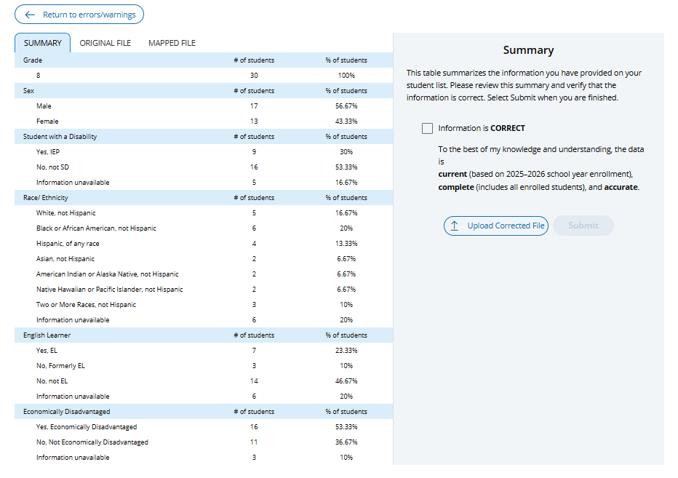
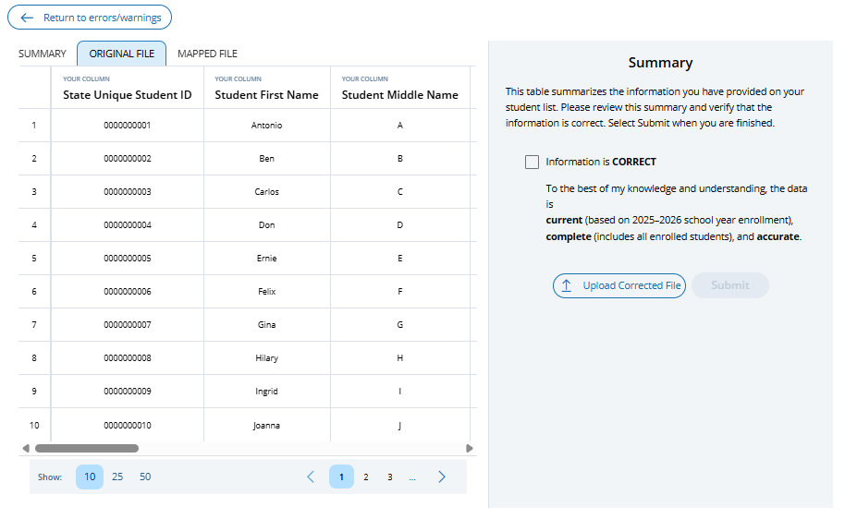
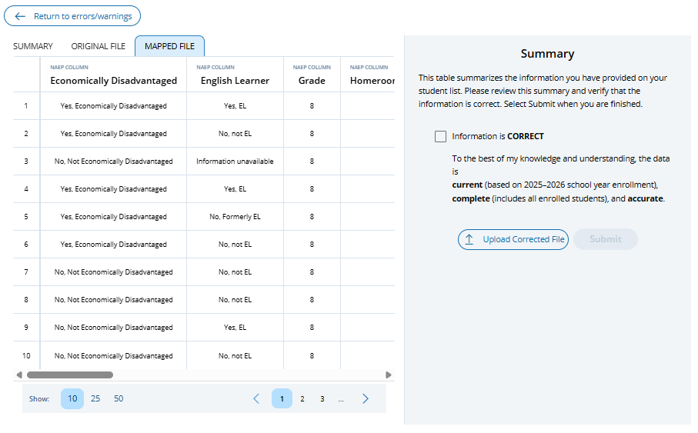

Appendix I26: 2027 Schools Lists (NEW)
2027 Schools List
The Schools list consists of a table displaying all schools within a user’s jurisdictional authority. District users can access the Schools list from the View Selected School button on the District Summary page > District Characteristics tile or by selecting the Schools tab from the left menu bar. School users who are assigned to more than one school may also access the Schools list table via the Schools tab from the left menu bar. The Schools list contains general school information and is used to navigate to a specific school’s summary page by clicking the arrow icon in the Go column.
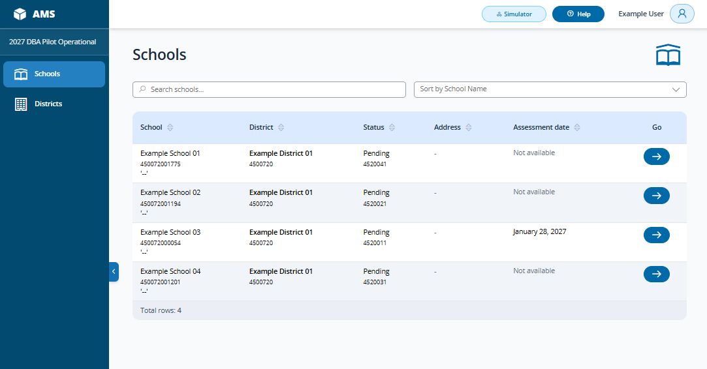
The sort by feature allows users to sort schools based on the following categories included in the dropdown menu:
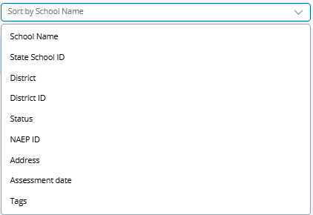

Appendix I27: 2027 Import Student Lists, Instructions (NEW)
Instructions for Preparing and Importing a Student Excel file
Requirements
NAEP needs a complete Excel file of students enrolled during the year-year school year for the selected grade at your school. NAEP uses this student list to draw a random sample of students to participate in the assessment. Include all students in the selected grade, even students who are typically excluded from other testing programs, such as students with IEPs (SD) and English Learners (EL), and students participating in virtual/remote learning.
NAEP recommends using a Student List Template, which is available on the Assessment Management System website. If you create your own Excel file, use the same or similar header names. If you cannot submit your student data in an Excel file, contact the NAEP help desk at 1-800-283-6237 or naephelp@westat.com.
The Excel file must contain the following information for each student:
Excel Header Name | Format | Notes
State unique Student ID | Numeric | If available, do not use Social Security numbers
First name | Text | Recommendation: If possible, include first and last names in separate columns. NAEP accepts names stored in a single column, which requires answering questions to determine how names are ordered/formatted.
Last name | Text
Middle name or initial optional | Text
Grade in School | 8 | Include all students in the selected grade
Homeroom/other locator optional | Text or Numeric | Optional, include if available
Month of Birth | Numeric | Recommendation: If possible, include month and year of birth in separate columns. NAEP accepts birthdates in a single column too. Expected birth years for NAEP: grade 8 2009–2015.
Year of Birth | Numeric
Sex | School-defined code | Map school-defined codes to NAEP definitions. See pages 2-4.
Race/Ethnicity | School-defined code | Map school-defined codes to NAEP definitions. See pages 2-4.
Economically Disadvantaged | School-defined code | Map school-defined codes to NAEP definitions. See pages 2-4.
Students with Disabilities (SD) | School-defined code | Map school-defined codes to NAEP definitions. See pages 2-4.
English Learner (EL) | School-defined code | Map school-defined codes to NAEP definitions. See pages 2-4.
On-Break Indicator | School-defined code | Only required for year-round schools
NAEP Codes and Definitions
You will need to map your file’s school-defined codes to NAEP’s definitions for the following variables: Sex, Race/Ethnicity, Economically Disadvantaged, Students with Disabilities (SD), English Learner (EL). See NAEP definitions below.

Sex
Map your school’s codes to the following categories.
- Male
- Female
- Information unavailable at this time: If you currently do not have this information for one or more students, blank cells or an indicator such as “N/A” (Not Available) in the cell(s) can be mapped to this code to notify your NAEP representative of the need to collect the data at a later date.

Race/Ethnicity Map your school’s codes to the following categories
NAEP offers three student list templates to accommodate different race/ethnicity formats. Your NAEP State Coordinator has designated the preferred template for your state. See the Downloads section of Step 1 Import Students.
Race/ethnicity in one column – Use when all race/ethnicity information is included in a single column.
Race/ethnicity in two columns – Use when ethnicity (Hispanic, of any race) is included in a single column. Other race information is included in a separate column.
Race/ethnicity in six columns – Use when each of the six categories below have a dedicated column: Hispanic (of any race), White (not Hispanic), Black or African American (not Hispanic), Asian (not Hispanic), American Indian or Alaska Native (not Hispanic), and Native Hawaiian or Pacific Islander (not Hispanic). Responses from these six categories will determine the Two or More Races, not Hispanic category.
NAEP accepts race/ethnicity information in other formats. The formats above are the most common.

- Hispanic, of any race: A person of Mexican, Puerto Rican, Cuban, Central or South American, or other Spanish (but not Portuguese) culture of origin, regardless of race
- White, not Hispanic: A person having origins in any of the original peoples of Europe (except Spain), North Africa, or the Middle East
- Black or African American, not Hispanic: A person having origins in any of the Black peoples of Africa
- Asian, not Hispanic: A person having origins in any of the original peoples of the Far East, Southeast Asia, the Indian Subcontinent, including, for example, Cambodia, China, Japan, India, Korea, Malaysia, Pakistan, the Philippine Islands, Thailand, and Vietnam
- American Indian or Alaska Native, not Hispanic: A person having origins in any of the original peoples of North and South America (including Central America), and who maintains tribal affiliation or community attachment
- Native Hawaiian or Pacific Islander, not Hispanic: A person having origins in any of the original people of Hawaii, Guam, Samoa, or other Pacific Islands
- Two or More Races, not Hispanic: A person who identifies with two or more of the non-Hispanic categories above.
- Information unavailable at this time: If you currently do not have this information for one or more students, blank cells or an indicator such as “N/A” (Not Available) in the cell(s) can be mapped to this code to notify your NAEP representative of the need to collect the data at a later date.
- School does not collect this information: Available to nonpublic schools only. When used, this code must be applied to all students.

Economically Disadvantaged
Map your school’s codes to the following categories.
- Yes, economically disadvantaged
- No, not economically disadvantaged
- Information unavailable at this time: If you currently do not have this information for one or more students, blank cells or an indicator such as “N/A” (Not Available) in the cell(s) can be mapped to this code to notify your NAEP representative of the need to collect the data at a later date.

English Learner (EL)
Map your school’s codes to the following categories.
- Yes, EL
- No, Not EL
- No, Formerly EL: If a student who has achieved full English proficiency, is monitored, and is included in EL subgroup for accountability reporting for 2 years (or 4 years depending on state policy) after exiting. Public schools, contact your NAEP State Coordinator if you have any questions about using this code.
- Information unavailable at this time: If you currently do not have this information for one or more students, blank cells or an indicator such as “N/A” (Not Available) in the cell(s) can be mapped to this code to notify your NAEP representative of the need to collect the data at a later date.

Students with Disabilities (SD)
Map your school’s codes to the following categories:

Yes, IEP: Student has a formal Individualized Education Plan (IEP), the student’s IEP is in progress, or the student has an equivalent classification for private schools. If some students have both an IEP and a 504 Plan, code these students as “Yes, IEP.”
No, not SD: Student does not have an IEP. If students have a 504 Plan without an IEP, code these students as “No, not SD.”
- Information unavailable at this time: If you currently do not have this information for one or more students, blank cells or an indicator such as “N/A” (Not Available) in the cell(s) can be mapped to this code to notify your NAEP representative of the need to collect the data at a later date.

On-Break Indicator
For year-round schools only: Include students who will be on break/vacation on the scheduled assessment day along with all of the other students enrolled in the sampled grade. The Student List Template contains an “On Break” column for identifying students who will be on break/vacation by filling in “Yes.” If you are not using the template, create and provide data for an “On Break” column in your file.

Instructions for importing the student list
See the steps below for importing the student list.
Step 1: Prepare the Excel file and a legend
The legend should explain the file’s codes. The following NAEP variables involve school-defined codes:
- Sex
- Race/Ethnicity
- Economically Disadvantaged
- Students with Disabilities (SD)
- English Learner (EL)

In the example below, a school uses five different codes for the Students with Disabilities variable. The legend explains how to “map” school codes to NAEP definitions.
School codes for Students with Disabilities
IEP
IEP + 504
504
No
Blank (no data in cell)

NAEP Definitions
Legend
IEP =
IEP + 504 =
504 =
No =

Blank =
Yes, IEP
No, not SD
Information unavailable
Yes, IEP
Information unavailable
Yes, IEP
No, not SD
No, not SD

Step 2: Check your file, then upload
Prevent upload failures by resolving these common problems first.
- Student records should be in one worksheet. Delete all other worksheets.
- File should include all currently enrolled students in the selected grade. Delete any students that are not in the selected grade.
- Include all required NAEP variables (see page 1 for full list). The following cannot be blank for any students: first name, last name, birth month/year, grade, and sex. Blanks for other variables are acceptable; you will add missing information later.
- Check for duplicate students. Delete any duplicate student rows.
- Header row for each required variable must be in row 1.
- Blank rows should begin after the last student record. Delete blank rows between students.
- Remove password protection. NAEP cannot process protected files.
Go to the Import Students section on your school’s AMS page. Select Upload file.
Step 3: Map file contents
Use the completed legend for this step. The legend explains how to map each variable.
- Map your file’s column headings to NAEP variables. This step is done automatically if you use NAEP’s Excel template or the same variable/header row names.
  - The field names used by your database system may not have the same names as the NAEP variable. In this case, match the names of your columns to the names of the NAEP variables.

- Map your school’s codes to NAEP definitions. In the repeated example below, the school code “IEP” is mapped to NAEP’s definition “Yes, IEP”, and so on.
School codes for Students with Disabilities
IEP
IEP + 504
504
No
Blank (no data in cell)

NAEP Definitions
Legend
IEP =
IEP + 504 =
504 =
No =

Blank =
Yes, IEP
No, not SD
Information unavailable
Yes, IEP
Information unavailable
Yes, IEP
No, not SD
No, not SD

Step 4: Check warnings
Information from the student list runs through a series of checks.
- Review errors and warnings. NAEP compares the student list against two databases: previous NAEP assessments and Common of Core Data. Common Core of Data (CCD) is the Department of Education’s primary database on public elementary and secondary education in the United States. These comparisons generate errors and warnings to ensure demographics in the student list are accurate. Errors indicate a data issue that must be addressed. Warnings serve as prompts to review and confirm existing information, and do not always require changes to the student list. There are additional warnings that identify missing information and possible mapping problems.
- Resolve errors and warnings. An error requires that a change be made to the student list that resolves the issue. After the change is made, the file needs to be resubmitted. Some warnings are resolved by adding missing information or editing existing information. Others require a review of how file contents are mapped, and possible changes if the mapping is incorrect.

Step 5: Confirm file
Review student counts and percentages for each variable in your file. This summary serves as a final check before submitting the file. Make sure these counts and percentages are representative of students in the selected grade at your school.

Appendix I28: 2027 Tutorial: Assessment Logistics (NEW)
Order | 2027 Script
The Assessment Logistics section is where you will provide all the logistical information needed for assessment day. This section contains details on:

- arriving at the school,
- start time and location for each assessment group,
- student group assignments,
- classroom procedures during the assessment, and
- dismissal procedures at the end of the assessment.

 | On the Assessment Logistics page, you will update each tile available. Not all the tiles are visible to everyone—AMS hides the tiles that aren’t needed for your school’s assessment.
The School start and end time tile helps with scheduling the group start times to make sure the last scheduled group ends before the end of the school day.

Click on the Edit button, enter or update the times, and click on the Save button.

The Assessment Groups tile is where you indicate if your students will take the assessment at the same or different times and in one or more locations.

Click on the Edit button, select how students will be assessed, provide school assessment support contact information, and click on the Save button.

The Schedule Groups tile is where you update group start times and locations.

Click on the Edit button for a group, update the time and location, and click on the Save button.

Enter this information for each group. You will discuss the group times and
locations with your NAEP representative.

The Student Group Details tile is where you review student group assignments.

To assign a student’s group:
- use the Sort by filter to find a student,
- click on the pencil icon in the Group column associated to the student,
- select the correct group, and
- click on the Save button.

On the remaining tiles, the more detailed the responses,
the better prepared the NAEP team will be
before arriving at your school for assessment day.
The Health and Safety Protocols tile is where you provide specific health and safety protocols.

Click on the Edit button, enter or update protocols, and click on the Save button.

In the Parking and arrival tile, indicate where the NAEP team should park and how you will notify them of school closures, etc.

Click on the Edit button, enter or update the information, and click on the Save button.

The Checking In tile is where you provide the NAEP Team with check-in procedures and where they will meet the school coordinator.

Click on the Edit button, enter or update the information, and click on the Save button.

The Classroom Protocols tile is where you provide policies to be followed during the assessment.

Click on the Edit button, select an electronic device policy option, enter the restroom break policy, indicate if staff are available to help, and click on the Save button.
In the Special Circumstances tile, enter the emergency contact and protocols.

Click on the Edit button, provide a contact and phone number, indicate known interruptions and emergency protocols, and click on the Save button.
The After the Assessment tile is where you indicate how end of the assessment tasks should be performed.

Click on the Edit button, provide responses for each item, and click on the Save button.

After the assessment, you can access the certificate of community service here.
 | If you have any questions about completing your AMS assessment logistics tasks, please contact your NAEP representative or the NAEP Help Desk.

Appendix I29: 2027 Tutorial: Notify Parents/Guardians (NEW)

Order | 2027 Script
 | The Notify Parent or Guardians section is where you confirm that parents or guardians have been notified of the NAEP assessment at their school. All parents or guardians of sampled students must be notified before the NAEP team can conduct the assessment. This can be through letter, email, or notice in the school newsletter. In this section it is important that you certify that the Parent or Guardian notifications have been sent.
The Contact information tile is where you enter the deadline for when parents and guardians need to inform you that their child will not be participating in NAEP.

First, review and add or update the preferred contact on the school summary page, manage teams tile, school team section. Their name, phone, and email will prefill in the letter you download and distribute, so the information must be up-to-date.

Then, on the Contact information tile, click on the Edit button, select the date and preferred contact, and then click on the Save button to save your work.
The Download Letter tile is where you download the customized letter.

Click on the button to download the letter in English, then
in Spanish if needed, and also the translation notice.
The Certify parent or guardian notification tile is where you certify the parent or guardian letters have been sent.

Click on the Edit button, then enter the date for the distribution of the notification letters.

Enter your name to certify you distributed them on the date indicated. Click on the Save button.
The Parent or guardian notification details tile documents how the notifications were sent and who received the letters.

Click on the Edit button. Choose a notification method and who received the letters. Click on the save button.

 | If you have any questions about completing your tasks within the Notify Parents or Guardians section of the Assessment Management System, please contact your NAEP representative or the NAEP Help Desk.

Appendix I30: 2027 Tutorial: Provide Student Information-Demographics (NEW)

Order | 2027 Script
1. | In the Student Demographic Information tab, you will review and update student data to ensure it is accurate and complete. You will also identify any student with an IEP, Section 504 plan, or English Learner status who will require accommodations.
2. | Highlighting in the table indicates missing data.  To help with your review:  - Select the Review Additional Resources button for detailed instructions on providing student demographic information.  - Select the Export button in the highlighted tab to download student data in PDF or XLS format.  You can also use the filters.  - Select a filter and expand it, select a value, such as "Missing info" to see all the students that have missing information.  - Select Clear all to remove all filters, or deselect a single filter by selecting the X to remove only that filter.
3. | On the Student Demographic Information tab, you can edit one student at a time or in bulk (several at a time).  To edit a student, select the edit button, enter any missing information or make necessary revisions, and select the Save button.  To make the same update to multiple students at the same time, select the box to the left of each student name you want to update. Next, select a variable from the Choose Category box (for example: Race/Ethnicity), then choose the value (for example: Hispanic of any race), and select the Save button.
4. | If you have any questions about completing the tasks in the AMS Provide Student Information section, please contact your NAEP representative or the NAEP Help Desk.

Appendix I31: 2027 Tutorial: Provide Student Information-SD/EL (NEW)
Order | 2027 Script
1. | For Students with Disabilities (SD) and English Learners (EL), you will review students identified as SD and/or EL and provide information on how the student will take the NAEP assessment and what accommodations they may require. Before you begin, please review and acknowledge the inclusion policies on the Acknowledgement of State Inclusion Policies tile.
2. | The inclusion policies contain guidance for selecting NAEP accommodations and determining student inclusion for the NAEP assessment based on your state’s policies.  Formal acknowledgement that the inclusion policies have been read is only required by one staff member to complete the task; however, all staff responsible for entering student accommodations are expected to read the policies before beginning their work.  On the Acknowledgement of State Inclusion Policies tile, select the Read & Acknowledge button, download and review the policy documents, and then confirm as needed.
3. | The Students with Disabilities (SD) and English Learners (EL) Details  tile contains summary information, including counts of students identified as SD and or EL, and the number of student with accommodations, missing information, and or who have been excluded.  Once all required information has been provided the Info Required status for the task will change to Task completed.  Select the Manage button to navigate to the Provide Student Information page – Students with disabilities (SD) & English learners (EL) tab where you will edit or update student information.  Highlighting in the table indicates missing data.  To help with your review:  - Select the Review Additional Resources button for detailed instructions on providing student SD and EL information.  - Select the Export button to download the student data in PDF or XLS format.  You can also use the filters.  - Select a filter and expand, select a value, such as "Info required" to see all the students with missing information.  - Select Clear all to remove all filters, or deselect a single filter by selecting the X to remove only that filter.
4. | There are three options for how SD and EL students take the NAEP assessment:  - With accommodations. The school provides the student’s SD and/or EL details and selects accommodations.  - Without accommodations. The school provides the student’s SD and/or EL details and the student is assessed with Universal Design Elements or UDEs only.  - Do not test. The school indicates the student cannot take the assessment and provides the students SD and EL details, if needed.  Now, let’s review each option in more detail.
5. | First, let’s update a student’s information to indicate they will take the NAEP assessment with accommodations.  - From the table, select the Edit button associated with the student.  - Select the With accommodations button.  - Select the details that best describe the student.  - Select the Continue button to go to the Accommodations selection page.  - The Accommodations selection page has features and resources available to assist with selecting the appropriate accommodations.  - NAEP Inclusion Policies are available at the top of the page. Select the link to review the inclusion policy documents.  - A search bar is available above the listed accommodations. Enter key words to quickly filter the list of UDEs and accommodations matching your search criteria.  - A box in the right-hand margin will display accommodations as you select them. Accommodations can be deleted from the main list or either of these list boxes.  - Review the list of UDEs and accommodations. Select the Details to display more information about the UDE or accommodation.  - Select the box next to each accommodation needed to select it. Provide additional information, if requested. To deselect an accommodation, click the box again.  - Verify the selections.  - At the bottom of the page, indicate if the student typical receives any additional accommodations not listed above. Contact your NAEP State or TUDA coordinator, or NAEP representative, about the availability of additional accommodations.  - Select the Continue button to go to the Confirmation page once all accommodations have been selected.  - The Confirmation page displays:  - Any additional information that is needed, including confirmation whether the student can take NAEP with only NAEP allowed accommodation.  - Any accommodations requests that are pending NAEP review.  - The accommodations selected for the student.  - Available UDEs.  - After reviewing, select the Submit button.
6. | Now let’s edit a student’s information that will be taking the assessment without accommodations. Return to the SD/EL table.  - Click the Edit button associated with the student.  - Click the Without accommodations button.  - Select the details that best describe the student.  - Select the Continue button to go to the Confirmation page.  - The Confirmation page displays the available UDEs and indicates the student will take NAEP without accommodations.  - Select the Submit button.
7. | Finally, let’s edit a student’s information to indicate they cannot take the NAEP assessment. Return to the SD/EL table.  - Select the Edit button associated with the student.  - Select the Do not test button.  - Select the reason why the student cannot take the assessment.  - Select the details that best describe the student, if applicable  - Select the Continue button to go to the Confirmation page.  - The Confirmation page displays the selected reason the student cannot take the NAEP assessment.  - Select the Submit button.
8. | To ensure students are not excluded unnecessarily, a warning appears if any students are marked as excluded.  - To review these students, click the Filter table in the warning and select the "review excluded students” button to display only the excluded students. Review each student to confirm their exclusion.  - When you have finished your review, select the Clear all button to display all the SD and EL students. Please note, your NAEP State Coordinator may reach out to discuss excluded students.
9. | When all information has been provided, the SD/EL task will show as complete.
10. | If you have any questions about completing the tasks in the AMS Students with Disabilities (SD) and English Learners (EL) tab, please contact your NAEP State or TUDA coordinator, NAEP representative, or the NAEP Help Desk.

Appendix I32: 2027 Tutorial: Technical Logistics (NEW)
Order | 2027 Script
1. | The Technical Logistics section is where you will respond to questions about school devices, monitor device readiness, and work with the NAEP representative to prepare the devices and assessment location for assessment day.  If needed, you can identify and invite a technology coordinator in the Manage Teams tile to complete this section.
2. | The Review the School Technology Survey tile is where you can see the name of the person who completed the survey and the date it was completed. You can also review the survey responses, which were used to determine if your school’s devices can support NAEP.  Click on the Review Survey button to review the read-only survey responses.
3. | The Confirm Device Readiness tile provides a summary of the school devices that have successfully had the NAEP Assessment Application (NAEP App) downloaded and confirmed. Confirm device readiness on at least twenty percent of the devices (including spares) to be used for NAEP assessments.  You or another designated school staff member can complete the device readiness steps on the student devices or, you can allow the students to complete these steps on their devices.  Click on the Review and download student instructions link for a downloadable checklist for students.  Click on the Review and download staff instructions and troubleshooting guide link for a downloadable checklist and Troubleshooting Guide for the person installing the application.  For additional information, click on the eNAEP Download Center link.  The total number of devices confirmed with the NAEP App are listed by operating system. To see a list of the devices that have been tested and passed (ready) or failed (not ready), click on the double box icon.  Your NAEP representative will discuss details of completing this confirmation during the Assessment Planning Meeting.
4. | The Confirm the Bandwidth, Safelisting, and Wireless Access Points tile is where you will perform a network check and confirm the school wireless access points.  Perform the network check before the scheduled Assessment Planning Meeting.  To run the network check:  - Verify the device you’re using is on the school network that will be used for the assessment.  - Click on the Run button for the Network check. It will take a few minutes to complete.  To confirm the wireless access points:  - Verify that each assessment group has a location entered. If there is no location for an assessment group, return to the Assessment Logistics, Schedule Groups tile and enter this information.  Click on the Edit button and enter or update the information. Then, click on the Save button.
5. | In the Device Setup tile, indicate if the students will bring their devices to take the assessment, or if the devices will be set up in the location before they arrive.  Click on the Edit button, enter or update the information, and click on the Save button.
6. | In the Assessment Location Setup tile, indicate if the NAEP team may connect NAEP-provided administrative devices to the school Wi-Fi during the assessment, or if the school would prefer to provide devices to them.  Click on the Edit button, enter or update the information, and click on the Save button.
7. | The Spare Devices, Charging, and Headphones tile is where you provide details about spare devices, earbuds, headphones, and device battery management.  Accurate responses to these questions will ensure your NAEP representative has the necessary details about setting up the devices and assessment location on assessment day.  Click on the Edit button, enter or update the information, and click on the Save button.
8. | In the School Staff Support tile, indicate which school staff member, familiar with the devices, will be available throughout the day to provide technical support to ensure the NAEP assessment runs smoothly.  The school staff identified to provide classroom management support  in the Assessment Logistics - Assessment Groups tile can also provide technical support and are listed here. You also have the option to identify a different school staff member to provide this support.  Click on the Edit button, select or enter staff members to provide support on assessment day, and click on the Save button.
9. | If you have any questions about completing your tasks within the Technical Logistics section of the AMS, please contact your NAEP representative or the NAEP Help Desk.

Appendix I33: 2027 Tutorial: Manage Questionnaires (NEW)
Order | 2027 Script
 | NAEP school and teacher questionnaires are administered online. The Manage Questionnaires section is where you will provide the names and email addresses of questionnaire recipients, send the questionnaire link and access codes, and monitor the completion of the questionnaires. This is also where you will match students taking the assessment with their teachers in grade 4 and 8 schools only.
There are 8 statuses for school and teacher questionnaires:
- Not identified – You need to identify the person who will complete the questionnaire and send them a link and access code.
- Email not sent – Respondent has been identified but email with link and access code has not been sent.
- Email queued – AMS is preparing to send the email.
- Email bounced – Email could not be sent. Verify the email address and resend it.
- Not started – The person you identified has the link and access code, but they haven’t started the questionnaire.
- In progress – They have the link and are working to complete the questionnaire.
- Competed – They have completed the questionnaire.
- Refusal – They will not complete the questionnaire.

You may need to follow up with respondents to ensure they complete the questionnaire. You can resend the link and access code to them again, if needed, by selecting the Send button.
In the Manage School Questionnaire tile, you identify a respondent for the school questionnaire, send that person a link and access code to the questionnaire, and monitor their status. The respondent is usually the school principal, but you can designate a different school administrator, if needed.

Click on the Edit button, enter the name and contact information, and click on the Save button.

Click on the Send button to email them the link and access code to the questionnaire. Monitor their progress until the questionnaire is completed.

 | The remaining tiles are for the teacher questionnaire which is only applicable for grade 4 and 8 schools.
In the Manage Teacher Questionnaires tile, you identify the teachers and the subjects they teach to the students taking the assessment. Only add teachers whose students are taking the assessment.

To add a teacher, click on the Add Teacher button below the table, enter the name, subject, and contact information, and click on the Save button.

To edit an existing teacher, click on the Edit button associated with the teacher, update the information, and click on the Save button.

The Match Students with Teachers tile is where you match each student with the teacher who teaches the subject indicated.

If the student's teacher does not appear in the list of teachers, add the teacher in the Manage Teacher Questionnaire tile above.

You can match students to their teacher one at a time or in bulk (several at a time). Note that a student can only be matched to a teacher if the subject the student is being assessed on matches the subject the teacher teaches.

To match a student to a teacher, click on the Edit button associated with the student, select the teacher, and click on the Save button.

To match students in bulk, several at a time, click the box to the left of each student's name you wish to match. In the Choose category box, select teacher. In the box to the right of that select the teacher. Then click on the save button.

Once teachers have been added and matched to students, you will return to the Manage Teacher Questionnaires tile to send emails with a link and access code to the questionnaire, and to monitor their status.

Click on the Send button associated with the teacher to email the link and access code to the questionnaire.

After you send the first email, click on the button again if you change a teacher's matches, or the teacher requests another email.

If a teacher must be removed, first remove any matches that teacher has in the Match Students with Teachers tile. Second: Match those students to another teacher.

Then, in the Manage Teacher Questionnaires tile, click on the Edit button associated with the teacher, and click on the Delete button.

If you have not removed all student matches to the teacher, a warning message will appear, and you will be required to remove the matches before you can delete the teacher.
If you have any questions about completing your tasks within the Manage Questionnaires section of the AMS, please contact your NAEP representative or the NAEP Help Desk.

Thank you.

Appendix I34: 2027 NAEP Account Activation Guide (NEW)

NAEP Assessment Management System
2027 Account Activation Guide
The NAEP Assessment Management System (AMS) is an invitation-based secured web application for the National Assessment of Educational Progress (NAEP) that uses Login.gov (Department of Education) to authenticate AMS users. Upon invitation to the AMS, all invitees will receive a NAEP AMS Account Activation email from naep-ams@naepnpd.org with subject line “Account Activation for NAEP AMS – Time Sensitive”. The email contains a unique link specific to the intended recipient to initiate the NAEP AMS account activation process and corresponding Login.gov account setup.
This guide provides an overview of the NAEP AMS account activation process to orient users with their account activation. Additional guidance and instructions are available once account activation has been initiated.
- NAEP AMS Account Activation Email
When you have been invited to the NAEP AMS, you receive an automated NAEP AMS Account Activation email used to initiate your account activation.
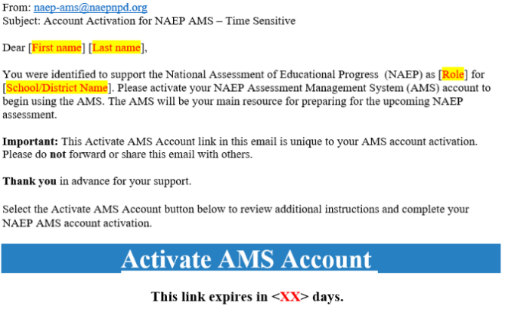
Select the “Activate AMS Account” link to initiate and complete your account activation.
This invitation expires <XX> days after the email is received. Please contact the NAEP help desk at 1-800-283-6237 or naephelp@westat.com if your link expires and you need a new account activation email to be sent.
Note. Each account activation email is unique to the intended recipient and should not be shared with others.

- NAEP AMS Account Activation
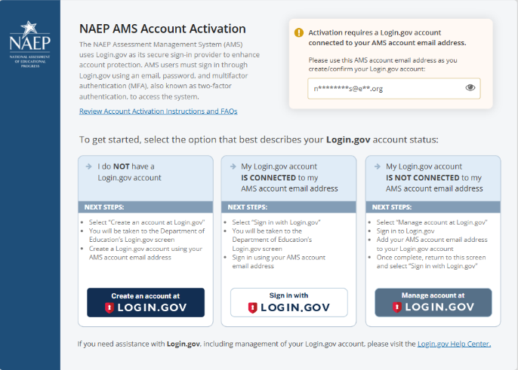
You must have a Login.gov account that is connected with your NAEP AMS account email address in order to complete your account activation.

Steps to complete your NAEP AMS account activation are dependent on your current Login.gov account status:
- If you do not have a Login.gov account, you will need to create one using your NAEP AMS account email address.
- If you have an existing Login.gov account that is connected with your NAEP AMS account email address, you are all set. Follow the instructions to sign in with Login.gov (Department of Education) using your NAEP AMS account email address.
- Your NAEP AMS account email address is connected with your Login.gov account if either:
- Your email address used to create your Login.gov account is the same as your NAEP AMS account email address.
- Your NAP AMS account email address is added to your Login.gov account
- If you already have a Login.gov account that is not linked with your AMS account email address, you will first need to add your NAEP AMS account email address to your existing Login.gov account and return to complete your account activation.
Note. Additional instructions are available from the NAEP AMS Account Activation screen detailing steps to complete your account setup based on your current Login.gov account status.

- Complete your NAEP AMS account activation
To complete your NAEP AMS account activation, follow the instructions provided on the Account Activation screen and sign in to the AMS through Login.gov (Department of Education) using your NAEP AMS account email address.
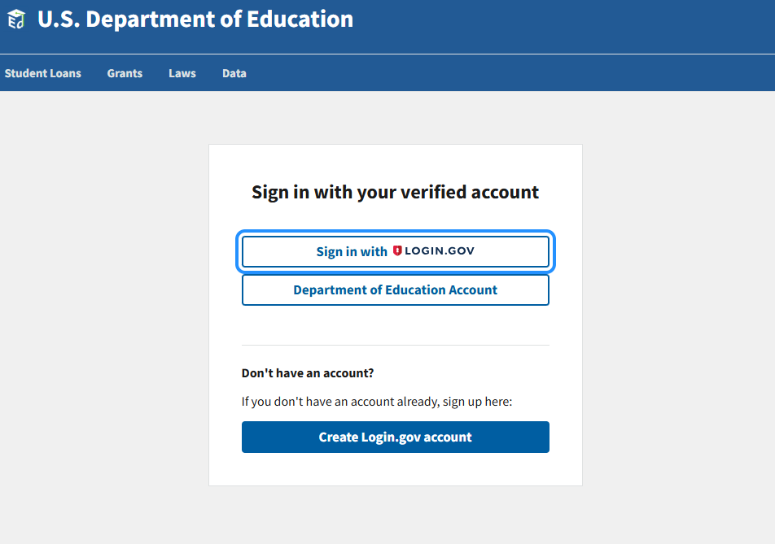
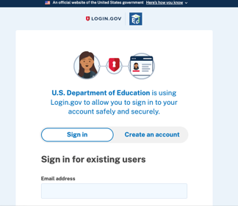

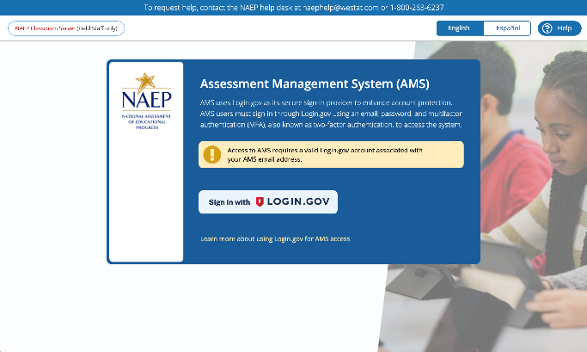
- NAEP AMS access on subsequent visits (after account activation)
After completing your AMS account activation (Steps 1-3), you must access the NAEP AMS on subsequent visits via https://ams.naep.ed.gov (NAEP AMS sign in page).
From the NAEP AMS sign in page, select “Sign in with Login.gov” and use your NAEP AMS account email address to sign in through the Login.gov (Department of Education) sign in screen.
Note. Upon successful authentication you will be automatically directed to the NAEP AMS.

