NATIONAL CENTER FOR EDUCATION STATISTICS
NATIONAL ASSESSMENT OF EDUCATIONAL PROGRESS

National Assessment of Education Progress (NAEP) 2027

Appendix D

NAEP Communications and Recruitment Materials

OMB# 1850-0928 v.40

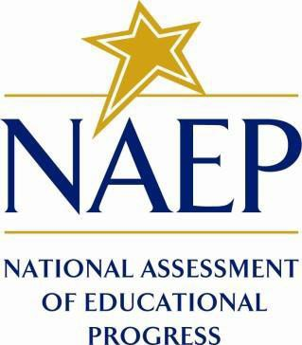

July 2026

All final communication and recruitment materials are included in Appendix D for this 2027 Amendment submission. Previously submitted and approved materials are marked by “Approved v.39” in the header. Drafts that have been replaced with final versions are marked by “(NEW)” in the header. The table below shows the administration window and subject.
Of note, the term “Trends in Urban Districts Assessment (TUDA)” is now used in communications rather than “Trial Urban District Assessment (TUDA).” The previously approved versions of the Facts for Districts and Facts for Principals documents have this updated naming convention reflected in this appendix.
Activity | Window | Grade | Subjects
2027 NAEP Science Pilot | January-March 2027 | 8 | Science

Table of Contents
Table of Contents 3
Appendix D-1: NAEP 2027 Notification Letter from Chief State School Officer to District Superintendent (Approved v.39) 5
Appendix D-2: NAEP 2027 Initial School Notification Letter from NAEP State Coordinator to School Principal (Approved v.39) 6
Appendix D-3: NAEP 2027 Facts for Districts (Approved v.39) 8
Appendix D-4: NAEP 2027 Facts for Principals (Approved v.39) 11
Appendix D-5: NAEP 2027 Initial School Technology Survey Notification Letter from NAEP State Coordinator to School Technology Survey Recipient (Approved v.39) 14
Appendix D-6: NAEP 2027 School Technology Summary Auto-Email - AMS to School Technology Survey Respondent (Approved v.39) 16
Appendix D-7: NAEP 2027 eNAEP Download Center (NEW) 17
Appendix D-8: NAEP 2027 eNAEP Download Center Notification, Auto email to School or District Application Installer (Approved v.39) 86
Appendix D-9: NAEP 2027 District Model Assignment Notification (Approved v.39) 88
Appendix D-10: NAEP 2027 Parent-Guardian Notification Letter, Public School (Approved v.39) 89
Appendix D-11: NAEP 2027 Parent-Guardian Notification Letter, Bilingual Spanish Public Schools (Approved v.39) 90
Appendix D-12: NAEP 2027 Parent-Guardian Notification Letter, Private Schools (Approved v.39) 91
Appendix D-13: NAEP 2027 Parent-Guardian Notification Letter, Bilingual Spanish Private Schools (Approved v.39) 92
Appendix D-14: NAEP 2027 Assessment Details Notification Letter to Principal, NAEP Device Model (Approved v.39) 93
Appendix D-15: NAEP 2027 Assessment Details Notification Letter to School Coordinator, NAEP Device Model (Approved v.39) 95
Appendix D-16: NAEP 2027 Assessment Details Letter to Principal, School Device Model (Approved v.39) 98
Appendix D-17: NAEP 2027 Assessment Details Letter to School Coordinator, School Device Model (Approved v.39) 101
Appendix D-18: NAEP 2027 NAEP in your School-NAEP Device, Grade 8 Science (Approved v.39) 104
Appendix D-19: 2027 NAEP in your School-School Device, Grade 8 Science (Approved v.39) 107
Appendix D-20: 2027 NAEP in your Private School-NAEP Device, Grade 8 Science (Approved v.39) 110
Appendix D-21: NAEP 2027 NAEP in your Private School-School Device, Grade 8 Science (Approved v.39) 112
Appendix D-22: NAEP 2027 Save-the-Date (Approved v.39) 114
Appendix D-23: NAEP 2027 Endorsement Letters to Private School Administrator (Approved v.39) 115
Appendix D-24: NAEP 2027 Preassessment Notification, School Device Model (NEW) 118
Appendix D-25: NAEP 2027 Preassessment Responsibilities Guide, School Device Model (NEW) 120
Appendix D-26: NAEP 2027 Preassessment Notification, NAEP Device Model (NEW) 124
Appendix D-27: NAEP 2027 Preassessment Responsibilities Guide, NAEP Device Model (NEW) 125
Appendix D-28: NAEP 2027 macOS Support Letter, NAEP State Coordinator to [Decision Maker] (NEW) 128
Appendix D-29: NAEP 2027 Preassessment Responsibilities Guide-Private Schools, School Device Model (NEW) 129
Appendix D-30: NAEP 2027 Manage Questionnaire Emails (NEW) 133
Appendix D-31: NAEP 2027 Preassessment Responsibilities Guide-Private Schools, NAEP Device Model (NEW) 141
Appendix D-32: NAEP 2027 School Staff Assistance email templates (NEW) 144
Appendix D-33: NAEP 2027 Facts for Teachers (NEW) 147
Appendix D-34: NAEP 2027 An Overview of NAEP Brochure (NEW) 151
Appendix D-35: NAEP 2027 Inclusion Guidelines for English Learners (NEW) 154
Appendix D-36: NAEP 2027 Inclusion Guidelines for Students with Disabilities (NEW) 157
Appendix D-37: NAEP 2027 School Staff Assistance Guidelines (NEW) 161
Appendix D-38: NAEP 2027 Identify Application Installer Reminder (School Device), From NAEP State Coordinator to District or School Staff (Approved v.39) 163
Appendix D-39: NAEP 2027 Data Tools and Resources Brochure (NEW) 164

Appendix D-1: NAEP 2027 Notification Letter from Chief State School Officer to District Superintendent (Approved v.39)

NAEP 2027 Notification Letter From
CSSO TO DISTRICT SUPERINTENDENT
Red text should be customized before mail merge: highlighted text represents mail merge fields

Dear District Superintendent name,

Thank you for all you do to support education in state name. I am writing to notify you that number schools in your district have been selected to participate in the 2027 administration of the National Assessment of Educational Progress (NAEP). NAEP is the largest nationally representative and continuing assessment of what students in the United States know and can do in various subjects. NAEP is administered by the National Center for Education Statistics (NCES), within the U.S. Department of Education. Selected schools represent schools across the nation, and their participation provides an accurate picture of student performance. School District will play an important role by participating, and your full support will help make this a positive experience for your schools and students.

Selected schools will be notified soon, so principals can include the NAEP assessment on their calendars and incorporate it into the planned school program. Schools may work with the NAEP State Coordinator on the assessment date as needed.

NAEP representatives will reach out to schools or districts about using school devices and Internet.

NAEP 2027 Program Overview

The NAEP 2027 program will include a pilot assessment in science at grade 8. Students will be assessed between January 25 and March 19, 2027. The attached list contains the schools in your district selected for NAEP.

NCES will not release results from the pilot assessment but will use the results to inform future NAEP assessments.

Next Steps

Please include the NAEP assessment window (January 25 to March 19, 2027) on your district test calendar.

Information about NAEP can be found in the enclosures/attachments listed below and at http://nces.ed.gov/nationsreportcard. Name, our NAEP State Coordinator, will contact your district and school staff with additional information about next steps.

Thank you for supporting this important assessment and helping us accomplish our goal of 100 percent participation.

Sincerely,

Name of Chief State School Officer

Enclosures/Attachments: List of district schools selected for NAEP
Facts for Districts

CC: State Testing Director
District Assessment Coordinator
NAEP State Coordinator

The National Center for Education Statistics (NCES) conducts the National Assessment of Educational Progress to evaluate federally supported education programs. All of the information you provide may only be used for the purposes of research, statistics, and evaluation under the Education Sciences Reform Act of 2002 (ESRA; 20 U.S.C. § 9543) and may not be disclosed, or used, in identifiable form for any other purpose except as required by law. Every NCES employee as well as every NCES agent, such as contractors and NAEP coordinators, has taken an oath and is subject to a jail term of up to 5 years, a fine of $250,000, or both if he or she willfully discloses ANY identifiable information about you in any unauthorized manner. Electronic submission of your information will be monitored for viruses, malware, and other threats by Federal employees and contractors in accordance with the Cybersecurity Enhancement Act of 2015.

Appendix D-2: NAEP 2027 Initial School Notification Letter from NAEP State Coordinator to School Principal (Approved v.39)

NAEP 2027 Initial School Notification Letter
From NSC to Principal
Red text should be customized before mail merge; highlighted text represents mail merge fields

Dear Principal,

Thank you for all you do to support education in state name. I am writing to inform you that school name
has been selected to represent schools across the nation by participating in the 2027 administration of the National Assessment of Educational Progress (NAEP).

Assessment Overview for Your School

- Subjects: Science pilot assessment
- Students to be assessed: Grade 8
- Assessment window: January 25–March 19, 2027
- Assessment duration: About 120 minutes (including transition time, instructions, and
completion of survey questions)
- Assessment administrators: NAEP representatives

What you need to know

- I will identify and contact a district or school person to complete a School Technology Survey, which will be used to determine whether your school will use school or NAEP devices.
- NAEP representatives will provide significant support to your school before and during the assessment.
- The National Center for Education Statistics will not release results from the pilot but will use the results to inform future NAEP assessments.

Next steps

- In [time of year], I will send you an assessment date. You may work with me on the assessment date as needed.
- I will ask you to identify a school coordinator to serve as the main point of contact, provide a student list, and submit additional information.

Additional information about NAEP can be found in the enclosed/attached copy of Facts for Principals and at http://nces.ed.gov/nationsreportcard. If you have questions, please contact me at NSC/NTC telephone number or via email at NSC/NTC email address.

Our chief state school officer, name, and your district superintendent, name, support NAEP and look forward to your school’s participation. We know that we can count on you to help us reach our goal of 100 percent participation.

Sincerely,

NAEP State Coordinator

Enclosure (or link for electronic mailing): Facts for Principals

CC: District Assessment Coordinator

The National Center for Education Statistics (NCES) conducts the National Assessment of Educational Progress to evaluate federally supported education programs. All of the information you provide may only be used for the purposes of research, statistics, and evaluation under the Education Sciences Reform Act of 2002 (ESRA; 20 U.S.C. § 9543) and may not be disclosed, or used, in identifiable form for any other purpose except as required by law. Every NCES employee as well as every NCES agent, such as contractors and NAEP coordinators, has taken an oath and is subject to a jail term of up to 5 years, a fine of $250,000, or both if he or she willfully discloses ANY identifiable information about you in any unauthorized manner. Electronic submission of your information will be monitored for viruses, malware, and other threats by Federal employees and contractors in accordance with the Cybersecurity Enhancement Act of 2015.

Appendix D-3: NAEP 2027 Facts for Districts (Approved v.39)

2027 Facts for Districts

“NAEP is the only assessment providing half a century of performance data to measure what students know and can do. The state and national trends inform local, state, and national program and policy discussions that improve teaching and learning.”
– David Atherton, EdD, Former Principal, Clear Creek Middle School, Gresham, OR

What is NAEP?
The National Assessment of Educational Progress (NAEP) is an integral measure of academic progress across the nation and over time. It is the largest nationally representative and continuing assessment of what our nation’s students know and can do in various subjects such as civics, mathematics, reading, science, and U.S. history. The program also provides valuable insights into students’ educational experiences and opportunities to learn in and outside of the classroom.

NAEP is a congressionally mandated program administered by the National Center for Education Statistics (NCES), within the U.S. Department of Education’s Institute of Education Sciences.

The National Assessment Governing Board—an independent, bipartisan organization made up of governors, state legislators, state school superintendents, teachers, researchers, and representatives of the general public—sets policy for NAEP.

What NAEP assessments will be administered in 2027?
The 2027 program will include
- a grade 8 science pilot assessment; and
- survey questionnaires for participating students, teachers, and school administrators to provide a better understanding of students’ educational experiences.

NCES will administer the assessment between January 25 and March 19, 2027.

NCES will not release results from the pilot assessment but will use the results to inform future assessments.

Why should my district participate in NAEP?
Your district’s participation is vitally important for several reasons.
- The Governing Board adopted a new framework for the science assessment that will be implemented in 2028. Updating assessment frameworks in regular intervals ensures that NAEP remains relevant to how and what students are learning in the classroom. By participating in the 2027 pilot assessment, your district will help ensure the new assessment questions are valid and a reliable measure of student achievement.
- Schools and students selected to participate in NAEP represent schools and students across the nation. Each school’s participation is critical and contributes to the understanding of students’ educational progress across the United States.

What will students in my district do?
Students participating in the 2027 pilot assessment will complete
- assessment items in science; and, if applicable,
- survey questionnaires that provide valuable information about their educational experiences and opportunities to learn both in and outside of the classroom.

Students are given approximately 2 hours to complete the assessment unless accommodations are provided. The 2-hour assessment window includes time for students to transition to and from the assessment location, receive directions, and complete survey questionnaires. A broad range of accessibility supports are provided for students with disabilities and English learners.

Students will take the assessment using school devices or NAEP devices. NAEP representatives will contact your district in the coming months with more information.

Do teachers need to prepare students for the assessment?
Teachers do not need to prepare their students to take the assessment but should encourage them to do their best.

Who will administer NAEP? What do schools need to provide on the day of the assessment?
NAEP representatives will administer the assessment and provide significant support to schools on assessment day. Schools will need to provide space for students to take the assessment, desks or tables, and an adequate number of electrical outlets in the assessment location.
- In schools where the assessment will be administered using school devices, school and/or district staff who have experience with the devices and technology used by the school will be asked to be available during the testing session(s).
- In schools where the assessment will be administered using NAEP devices, NAEP representatives will bring all necessary materials and equipment to assess the students.

How were schools in my district selected for NAEP?
Schools were selected as part of a carefully designed sampling process that ensures NAEP-selected schools and students are representative of the nation. Learn more at https://nationsreportcard.gov/focus_on_naep/assessment_literacy/#/sampling.

How can school administrators and teachers use NAEP data to help our students?
School administrators and teachers can view NAEP data online at https://nationsreportcard.gov. Through NAEP data, you can examine the relationships between student performance and factors such as demographics, school location, instructional practices, and more.

Questions from previous NAEP assessments can also be used as a helpful educational resource in the classroom. Teachers can use the NAEP Questions Tool (https://nces.ed.gov/nationsreportcard/nqt) to see how their students’ performance compares to peers across the nation. Released NAEP questions come with a scoring guide, sample student responses, and performance data.

How long has NAEP been around?
NAEP was first administered in 1969 to measure student achievement nationally. In 1990, NAEP was administered at the state level for the first time. The NAEP Trends in Urban Districts Assessment (TUDA) program, which measures student achievement in some of the nation’s large urban districts, began in 2002.

Where can I find more information?
Learn more about the NAEP program at https://nces.ed.gov/nationsreportcard, and explore the latest NAEP results at https://nationsreportcard.gov.

You can also find NAEP on: <Facebook logo> <Instagram logo> <LinkedIn logo> <X logo> <YouTube logo>

The National Center for Education Statistics (NCES) conducts the National Assessment of Educational Progress to evaluate federally supported education programs. All of the information you provide may only be used for the purposes of research, statistics, and evaluation under the Education Sciences Reform Act of 2002 (ESRA; 20 U.S.C. § 9543) and may not be disclosed, or used, in identifiable form for any other purpose except as required by law. Every NCES employee as well as every NCES agent, such as contractors and NAEP coordinators, has taken an oath and is subject to a jail term of up to 5 years, a fine of $250,000, or both if he or she willfully discloses ANY identifiable information about you in any unauthorized manner. Electronic submission of your information will be monitored for viruses, malware, and other threats by Federal employees and contractors in accordance with the Cybersecurity Enhancement Act of 2015.

This publication was prepared for the National Assessment of Educational Progress by Manhattan Strategy Group under contract 91990018C0001 to the National Center for Education Statistics, U.S. Department of Education.

Appendix D-4: NAEP 2027 Facts for Principals (Approved v.39)

NAEP 2027
Facts for Principals
Grade 8 Science Pilot

Page One Sidebar
NAEP is an integral part of education in the United States.
- Elected officials, policymakers, and educators all use NAEP results to inform ways to improve education.
- Originating in 1969, NAEP is a congressionally mandated program administered by the National Center for Education Statistics (NCES), within the U.S. Department of Education’s Institute of Education Sciences.
- NAEP serves a different role than state assessments. While states have their own unique assessments with different content standards, the same NAEP assessment is administered across the country, providing a common measure of student achievement.
- Depending on the type of NAEP assessment that is administered, NAEP data are available for the nation, your state, districts that participate in the Trends in Urban Districts Assessment (TUDA), and student groups. NAEP is not designed to report results for individual students, classrooms, or schools.
- Students, teachers, and principals who participate in NAEP are asked to complete survey questionnaires to provide a better understanding of educational experiences and factors that may be related to students’ learning.

Page One Body
“NAEP is the only assessment providing half-a-century of performance data to measure what students know and can do. The state and national trends inform local, state, and national program and policy discussions that improve teaching and learning.”
- David Atherton, EdD, Former Principal, Clear Creek Middle School, Gresham, OR

What is NAEP?
The National Assessment of Educational Progress (NAEP) is the largest nationally representative and continuing assessment of what our nation’s students know and can do in various subjects such as civics, mathematics, reading, science, and U.S. history. NAEP results are released as The Nation’s Report Card.

NAEP is a congressionally mandated program administered by the National Center for Education Statistics (NCES), within the U.S. Department of Education’s Institute of Education Sciences.

The National Assessment Governing Board—an independent, bipartisan organization made up of governors, state legislators, state school superintendents, teachers, researchers, and representatives of the general public—sets policy for NAEP.

What NAEP assessments will be administered in 2027?
The 2027 program will include
- a grade 8 science pilot assessment; and
- survey questionnaires for participating students, teachers, and school administrators to provide a better understanding of students’ educational experiences.

NCES will administer the pilot assessment between January 25 and March 19, 2027.

NCES will not release results from the pilot assessment but will use the results to inform future assessments.

Why should my school and students participate in NAEP?
Your participation is vitally important for several reasons.
- The Governing Board adopted a new framework for the science assessment that will be implemented in 2028. Updating assessment frameworks in regular intervals ensures that NAEP remains relevant to how and what students are learning in the classroom. By participating in the 2027 pilot assessment, your school will help ensure the new assessment questions are valid and a reliable measure of student achievement.
- Schools and students selected to participate in NAEP represent schools and students across the country. Each school’s participation is critical and contributes to the understanding of students’ educational progress across the United States.

For more information about NAEP, visit https://nces.ed.gov/nationsreportcard.

Page Two Body

What is involved for principals and teachers in 2027?
As principals, you make an important contribution to the program by selecting and empowering a NAEP school coordinator, meeting with teachers and participating students, and encouraging your students to participate and do their best. You are essential partners in NAEP. Each school’s participation is critical and contributes to the understanding of students’ educational progress across the United States.

NAEP representatives will provide significant support to your school on assessment day. They will administer the assessment on school devices or NAEP devices and will contact your school in the coming months to provide more information and organize assessment activities.

Schools will need to provide space for students to take the assessment, desks or tables, and an adequate number of electrical outlets in the assessment location.

Teachers do not need to prepare their students to take the assessment but should encourage them to do their best.

The school principal and grade 8 teachers of the sampled students will be asked to complete a questionnaire designed to provide contextual information for the assessment results.

What is involved for students?
The assessment will be administered during regular school hours. The time commitment for students taking the assessment is approximately 2 hours, which includes time for students to transition to and from the assessment location, receive directions and review tutorials, and complete survey questions.

How are schools and students selected for NAEP?
A carefully designed sampling process ensures that NAEP-selected schools and students are representative of all schools and students in across the United States. To ensure that the sample represents all students in the nation’s schools, a broad range of accessibility supports are allowed for students with disabilities and English learners.

How can educators use NAEP resources to help students?
Released NAEP items can be used as a helpful educational resource in the classroom. Teachers and district staff can use the NAEP Questions Tool (https://nces.ed.gov/nationsreportcard/nqt) to create a test and see how your students’ performance compares nationally on specific items. Released NAEP items come with a scoring guide, sample student responses, and performance data.

Where can I find more information?
Learn more about the NAEP program at https://nces.ed.gov/nationsreportcard, and explore the latest NAEP results at https://nationsreportcard.gov.

The National Center for Education Statistics (NCES) conducts the National Assessment of Educational Progress to evaluate federally supported education programs. All of the information you provide may only be used for the purposes of research, statistics, and evaluation under the Education Sciences Reform Act of 2002 (ESRA; 20 U.S.C. § 9543) and may not be disclosed, or used, in identifiable form for any other purpose except as required by law. Every NCES employee as well as every NCES agent, such as contractors and NAEP coordinators, has taken an oath and is subject to a jail term of up to 5 years, a fine of $250,000, or both if he or she willfully discloses ANY identifiable information about you in any unauthorized manner. Electronic submission of your information will be monitored for viruses, malware, and other threats by Federal employees and contractors in accordance with the Cybersecurity Enhancement Act of 2015.

Page Two Footer
Find us on: [insert social media icons]

This publication was prepared for the National Assessment of Educational Progress by Manhattan Strategy Group under contract 91990018C0001 to the National Center for Education Statistics, U.S. Department of Education.

Appendix D-5: NAEP 2027 Initial School Technology Survey Notification Letter from NAEP State Coordinator to School Technology Survey Recipient (Approved v.39)

NAEP 2027 – School Technology Survey Notification Letter
NAEP STATE COORDINATOR TO SCHOOL TECHNOLOGY SURVEY RECIPIENT
Red text should be customized before mail merge; highlighted text represents mail merge fields.

:Do not distribute until notified that the AMS/STS are ready for school and district user access:

Dear [District Technology Director/District Assessment Coordinator/Principal/School Coordinator/ Technology Coordinator]:

Thank you for all you do to support education in state name. I am writing to notify you that one or more schools in your district have been sampled for the 2027 administration of the National Assessment of Educational Progress (NAEP). NAEP will be administered on school devices or Chromebooks provided by NAEP.

To determine each school’s ability to support the administration of NAEP using school devices, we need to understand the technical specifications of the devices used for testing at [School Name]. / the following schools:
- School 1
- School 2
- School 3, etc.

Your role will be to do the following:
- Activate your NAEP Assessment Management System (AMS) account using the link provided in the email [email subject] from [registration email domain].
- Complete the School Technology Survey in the AMS for each school listed above by [Due date], which requires knowledge of
  - the device operating system and available hardware for each sampled school, and
  - district or school device management and security policies.
- Designate an Application Installer in the AMS for each sampled school assigned to administer NAEP on school devices; do this after you complete the School Technology Survey. The individual designated as the Application Installer will be responsible for deploying the NAEP Assessment application to school devices.

*Note, if you would like to designate someone to complete the survey on your behalf, please send their name and email address to [NSC/NTC name] at [NSC/NTC email address].

The NAEP Assessment Application is COPPA and FERPA compliant and does not collect any student education records or personally identifiable information (PII) from students. Visit the [eNAEP Download Center hyperlink] to access the application and review additional technical details about taking NAEP assessments on school or district devices.

You will receive more details about how each school will be assessed and information on the next steps after you complete the School Technology Survey.

What is NAEP?
NAEP is the largest nationally representative and continuing assessment of what our nation’s students know and can do in various subjects. NAEP is administered by the National Center for Education Statistics (NCES), within the U.S. Department of Education.

What will NAEP assess in 2027?
In 2027, NCES will administer a pilot assessment in science at grade 8 on school devices or Chromebooks provided by NAEP.

What if I have questions?
If you have questions about the School Technology Survey, please contact the NAEP help desk at 1-800-283-6237 or naephelp@westat.com. If you have other questions about NAEP, please contact me at NSC/NTC telephone number or NSC/NTC email address.

Again, thank you for your assistance with this very important assessment.

Sincerely,

NAEP State/TUDA Coordinator

Attachments:
School Technology Survey questions PDF (optional)

The National Center for Education Statistics (NCES) conducts the National Assessment of Educational Progress to evaluate federally supported education programs. All of the information you provide may only be used for the purposes of research, statistics, and evaluation under the Education Sciences Reform Act of 2002 (ESRA; 20 U.S.C. § 9543) and may not be disclosed, or used, in identifiable form for any other purpose except as required by law. Every NCES employee as well as every NCES agent, such as contractors and NAEP coordinators, has taken an oath and is subject to a jail term of up to 5 years, a fine of $250,000, or both if he or she willfully discloses ANY identifiable information about you in any unauthorized manner. Electronic submission of your information will be monitored for viruses, malware, and other threats by Federal employees and contractors in accordance with the Cybersecurity Enhancement Act of 2015.

Appendix D-6: NAEP 2027 School Technology Summary Auto-Email - AMS to School Technology Survey Respondent (Approved v.39)

NAEP 2027 – School Technology Survey Summary Auto-Email
AMS to School Technology Survey Respondent

From: AMS email address
To: School Technology Survey Respondent

Subject: NAEP 2027 School Technology Survey

Thank you for completing the School Technology Survey for the 2027 administration of the National Assessment of Educational Progress (NAEP).

NAEP will be administered using school devices (e.g., desktops, laptops, tablets with keyboards) for the following schools. The NAEP Assessment application will need to be deployed or installed on the school devices before [date].
School Name | Sampled Grade | NAEP Application Installer
School 1 | 8 | Missing
School 2 | 8 | Missing
School 3 | 8 | John Doe

Schools assigned to take NAEP on school devices must designate a district- or school-level staff member to oversee the installation of the NAEP Assessment application on the devices. The name of the staff member must be entered into the Assessment Management System (AMS). If you have not already designated a NAEP Application Installer, please do so via the AMS. Enter the staff member’s name in the Manage Team section as the designated NAEP Application Installer. The NAEP Application Installer will receive additional information about how to access and deploy/install the application and confirm device readiness.
NAEP will be administered for the following schools using Chromebooks provided by NAEP. The following schools will receive additional information about next steps in [time of year].
School Name | Sampled Grade
School 1 | 8
School 2 | 8
School 3 | 8

The National Center for Education Statistics (NCES) conducts the National Assessment of Educational Progress to evaluate federally supported education programs. All of the information you provide may only be used for the purposes of research, statistics, and evaluation under the Education Sciences Reform Act of 2002 (ESRA; 20 U.S.C. § 9543) and may not be disclosed, or used, in identifiable form for any other purpose except as required by law. Every NCES employee as well as every NCES agent, such as contractors and NAEP coordinators, has taken an oath and is subject to a jail term of up to 5 years, a fine of $250,000, or both if he or she willfully discloses ANY identifiable information about you in any unauthorized manner. Electronic submission of your information will be monitored for viruses, malware, and other threats by Federal employees and contractors in accordance with the Cybersecurity Enhancement Act of 2015.

Appendix D-7: NAEP 2027 eNAEP Download Center (NEW)

Getting Started > Preparing for Assessment > Preassessment Tools (Landing Page)
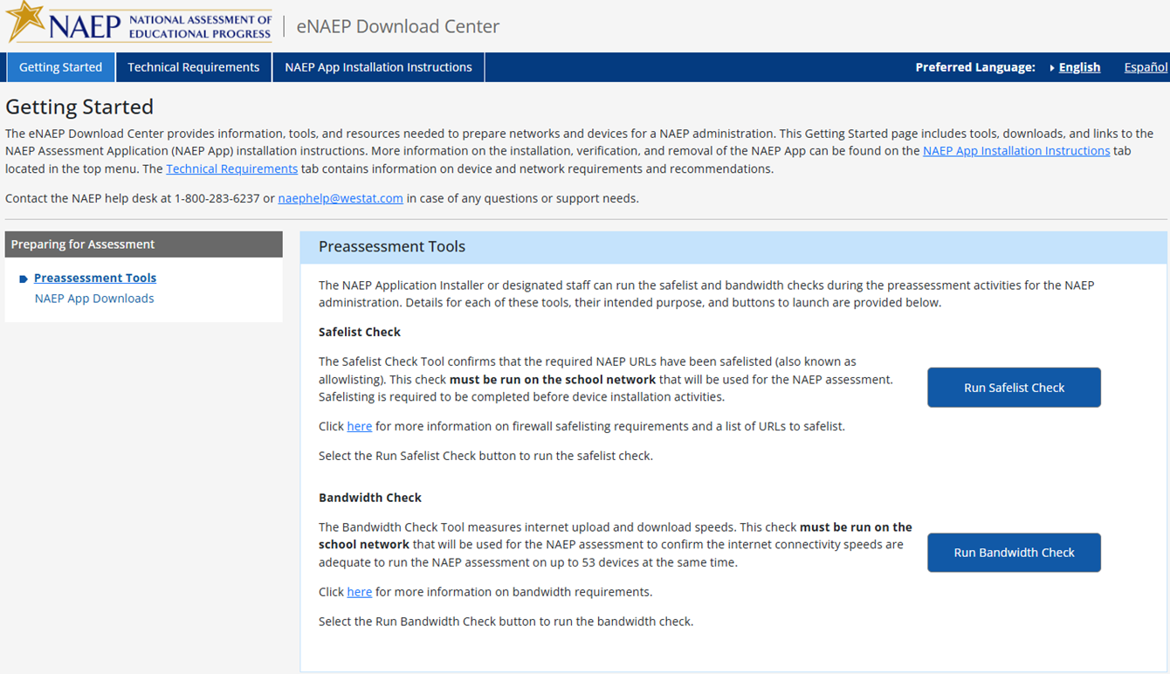
The following are the Safelisting Results messages that will appear depending on the school’s network conditions.
Safelist check passes.
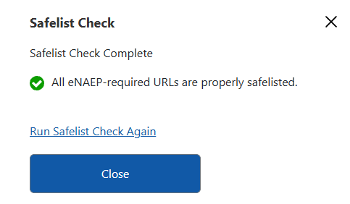
Safelist check fails.
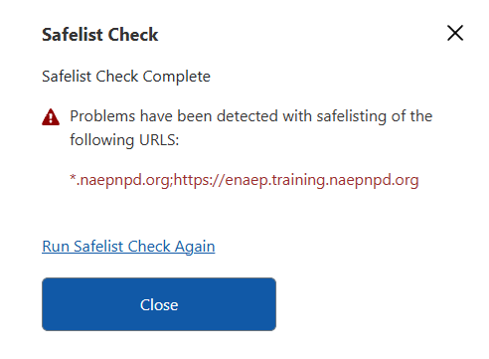
Safelist check passes but not all NAEP content was safelisted (content filters may block the NAEP assessment content).
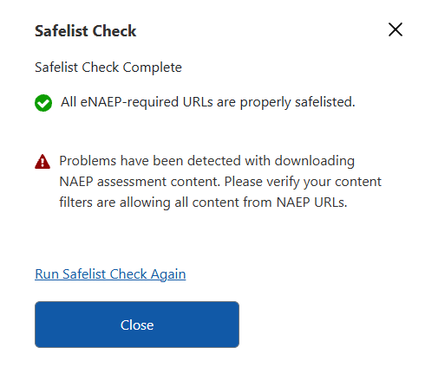

Getting Started > Preparing for Assessment > NAEP App Downloads
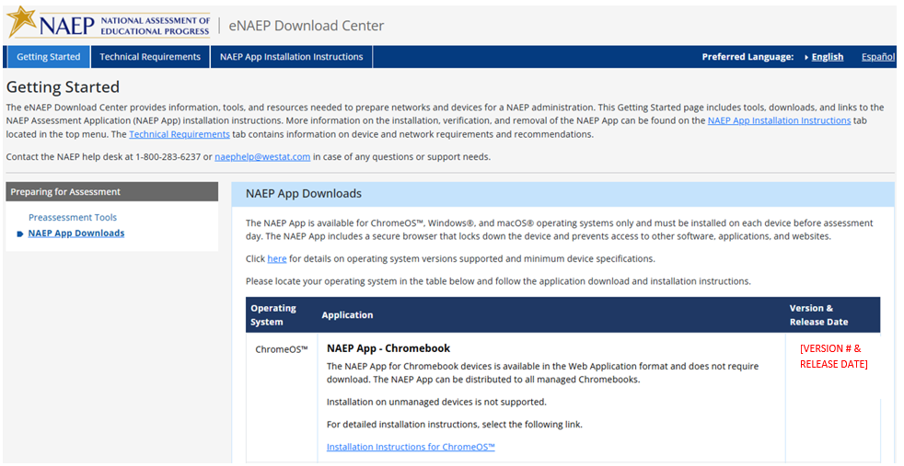

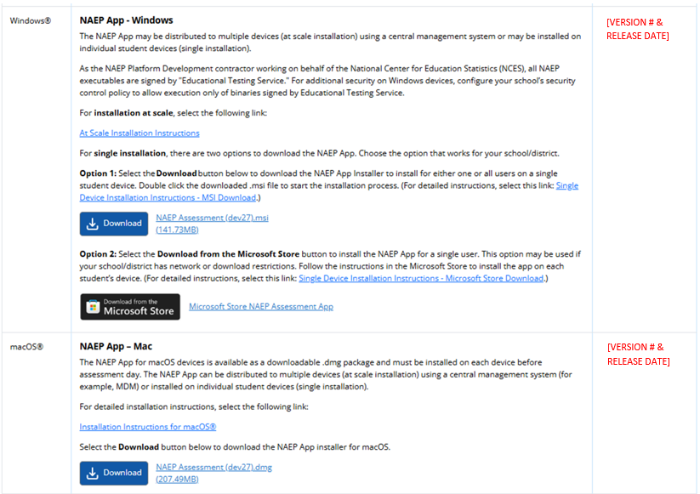
Note: The Version # and Release Date in the last column changes when the NAEP Assessment Application is updated for use during the development process and then when the application is utilized during the NAEP Administration.

Technical Requirements > System Requirements > OS & Hardware Requirements
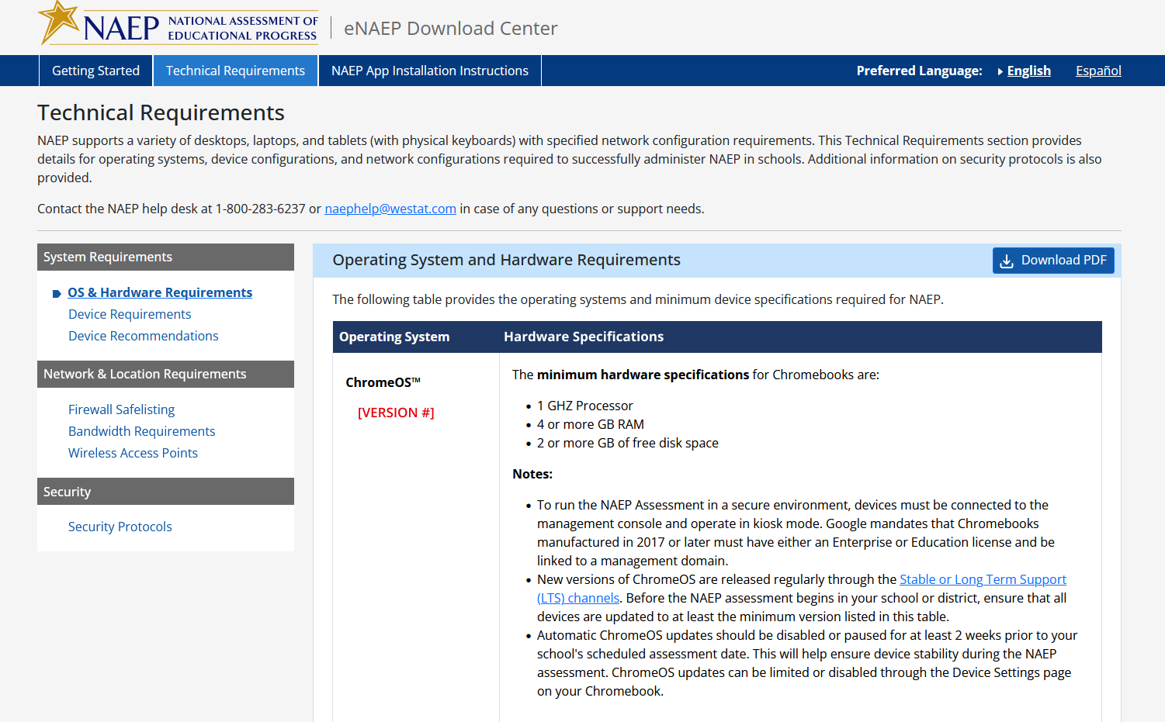

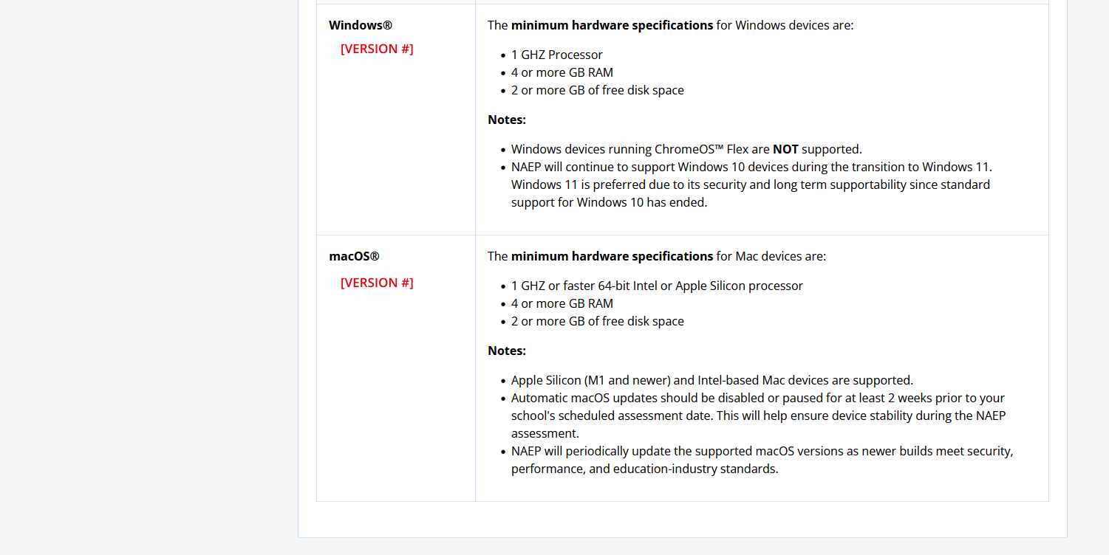
Note: The operating system version # in the first column may change as Google, Microsoft or Apple may release new versions. The versions will be tested first and discussed with NCES before version # changes are updated and utilized for an upcoming NAEP Administration.

Technical Requirements > System Requirements > Device Requirements

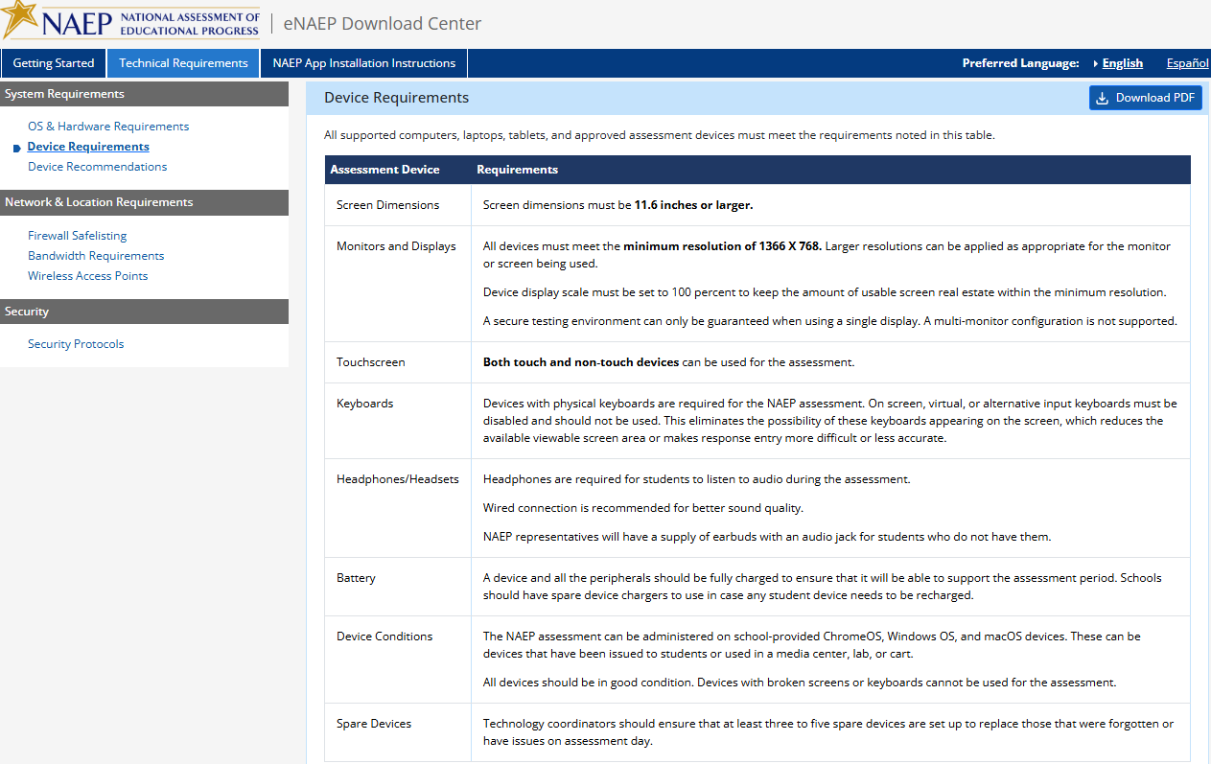

Technical Requirements > System Requirements > Device Recommendations
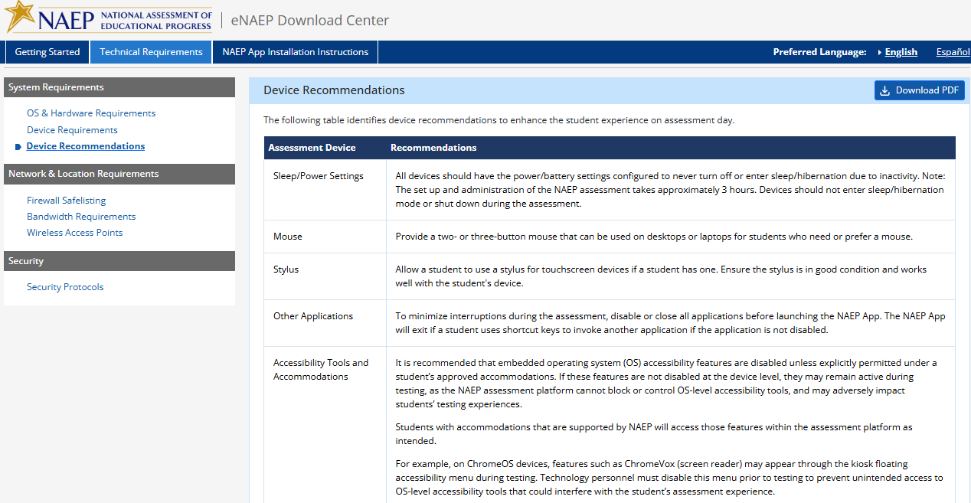

Technical Requirements > Network & Location Requirements > Firewall Safelisting
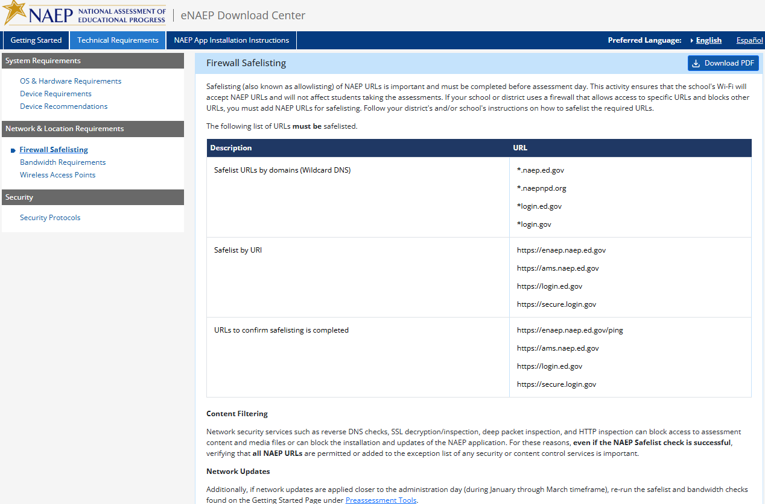

Technical Requirements > Network & Location Requirements > Bandwidth Requirements
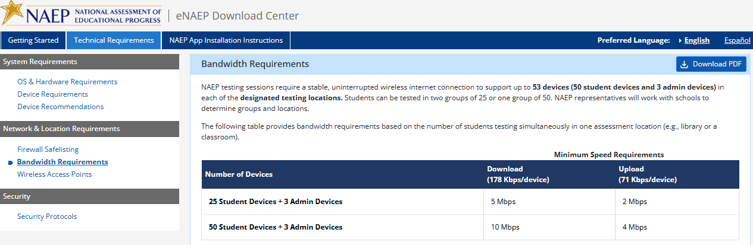

Technical Requirements > Network & Location Requirements > Wireless Access Point
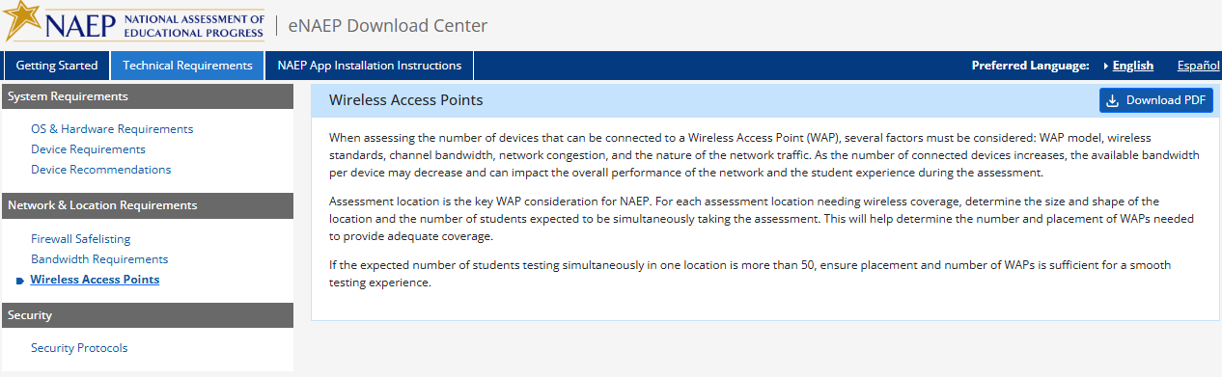

Technical Requirements > Security > Security Protocols
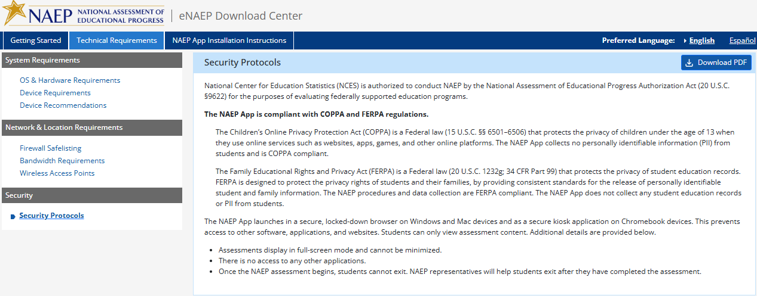

NAEP App Installation Instructions > ChromeOS > Installation Instructions
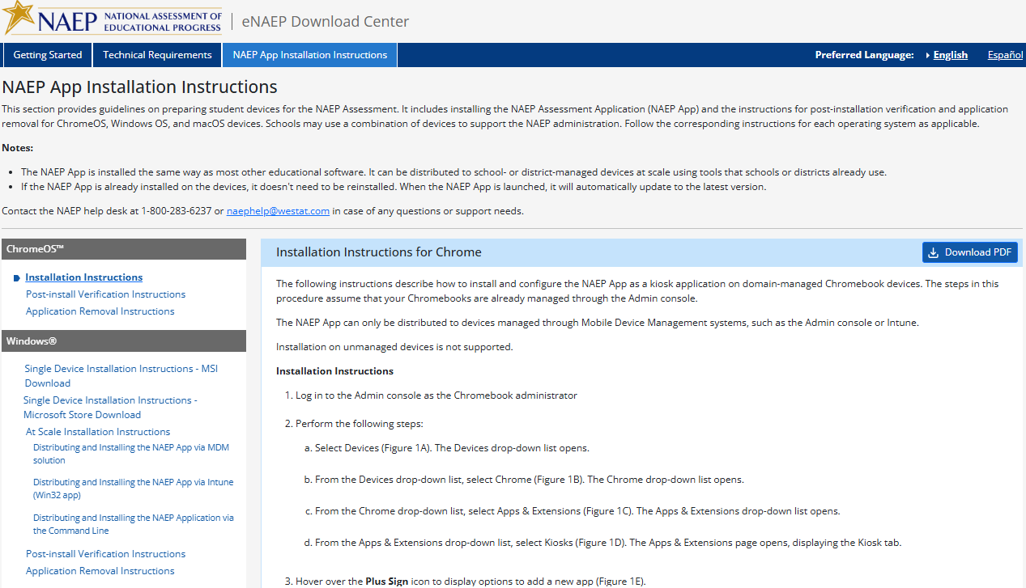
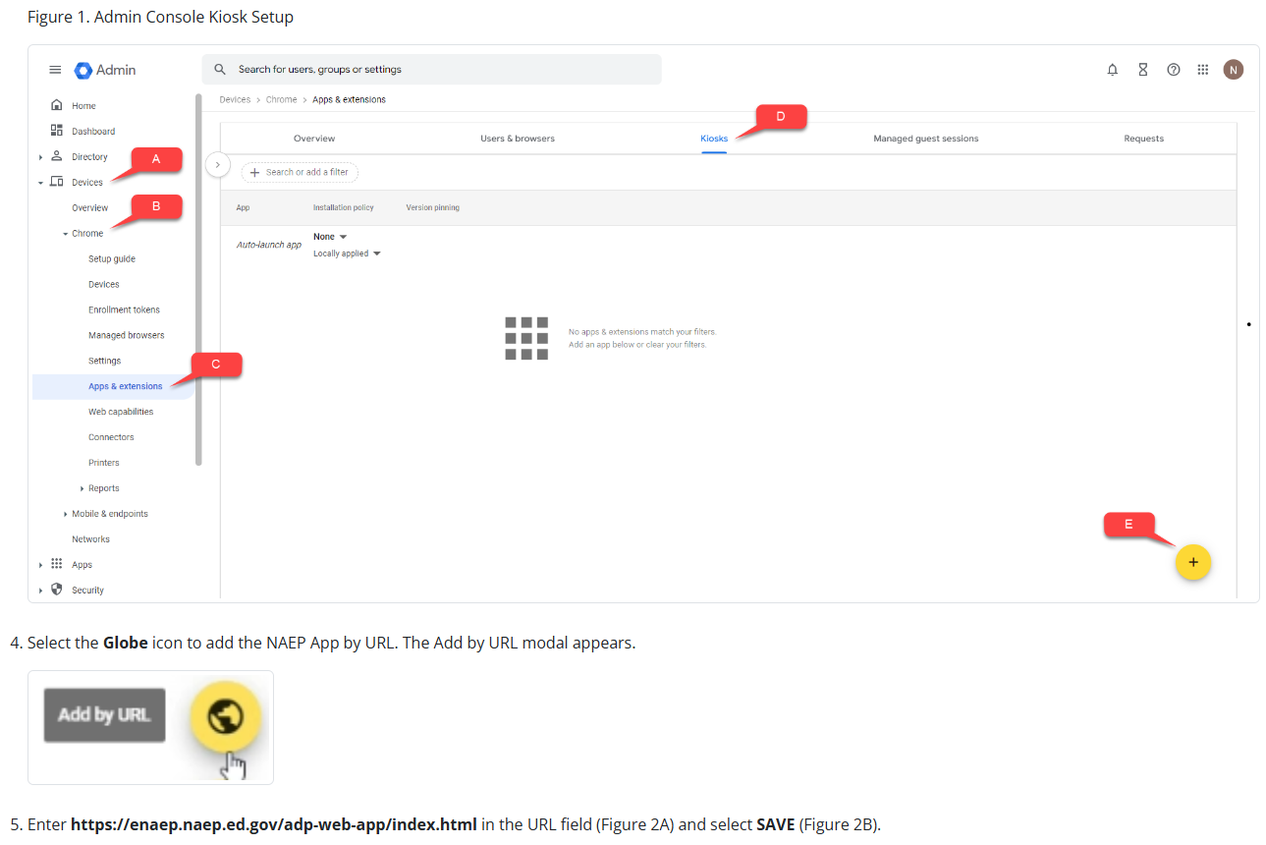

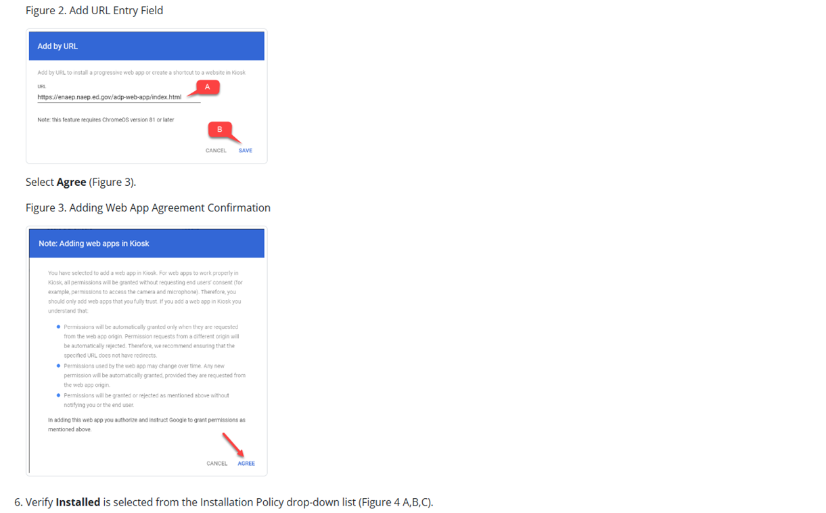
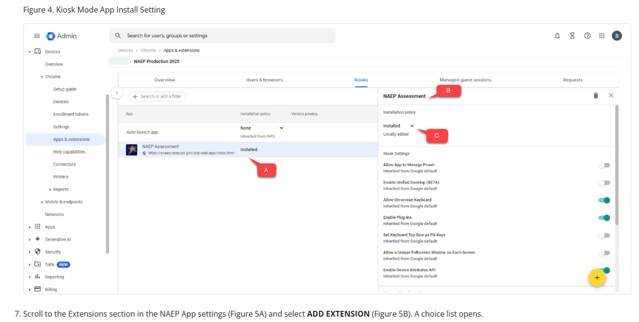
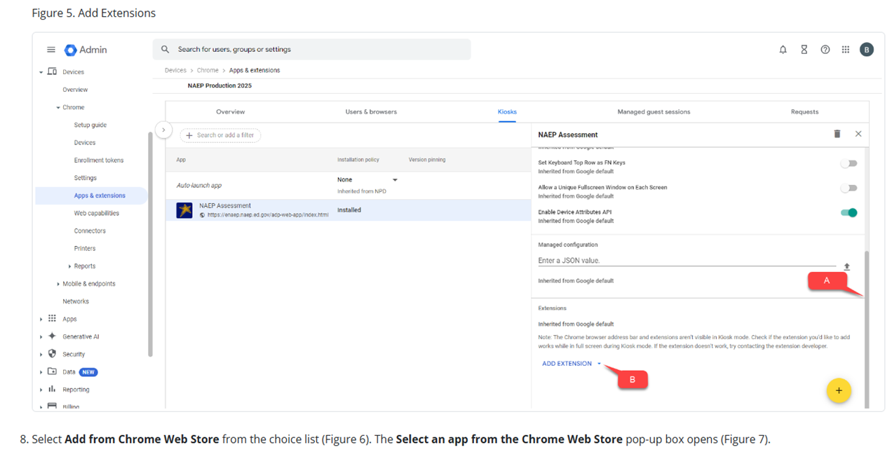
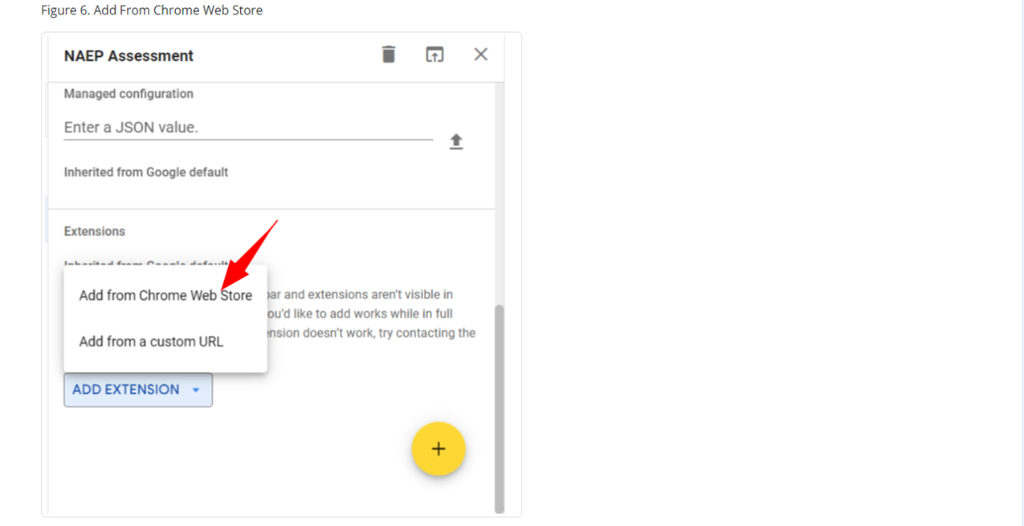
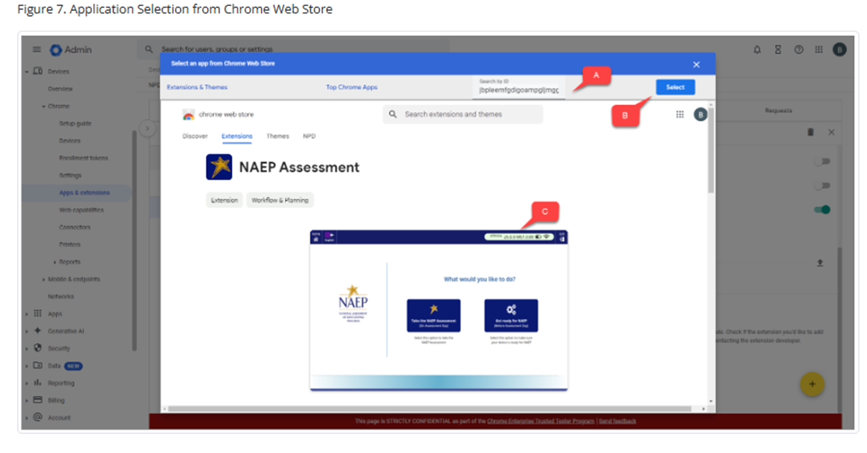
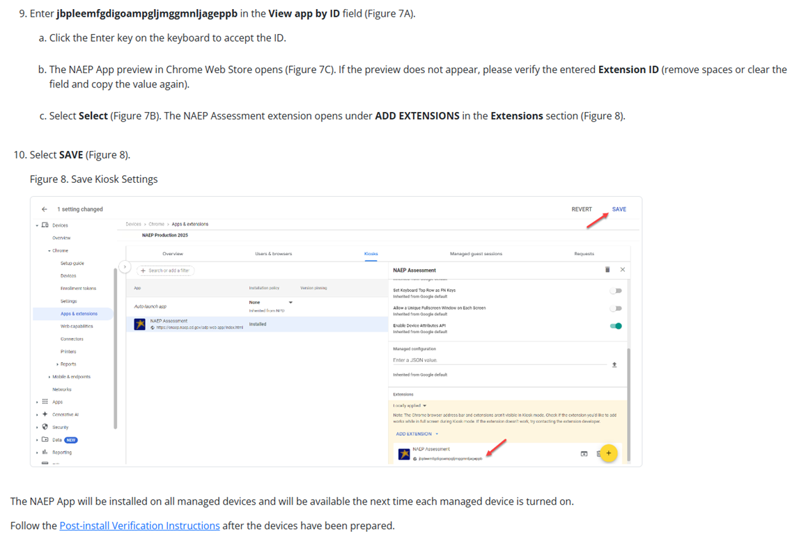

NAEP App Installation Instructions > ChromeOS > Post-install Verification Instructions

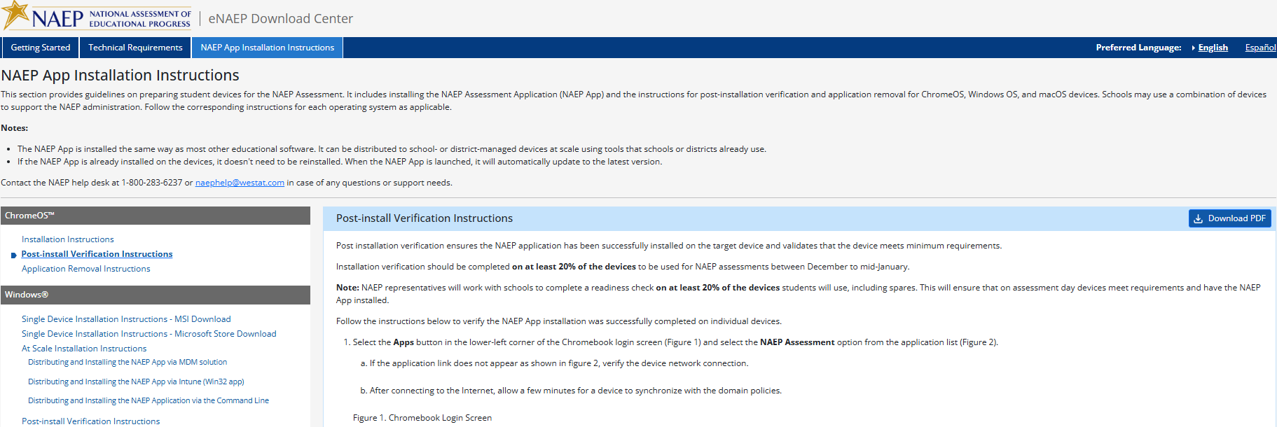
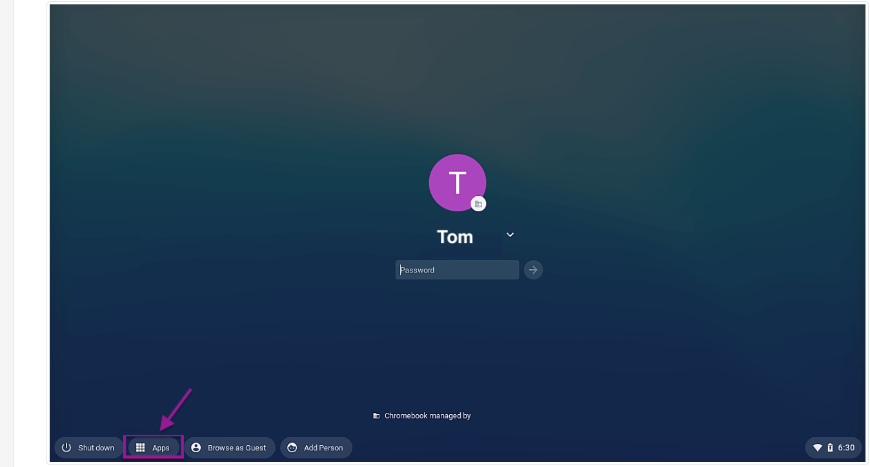
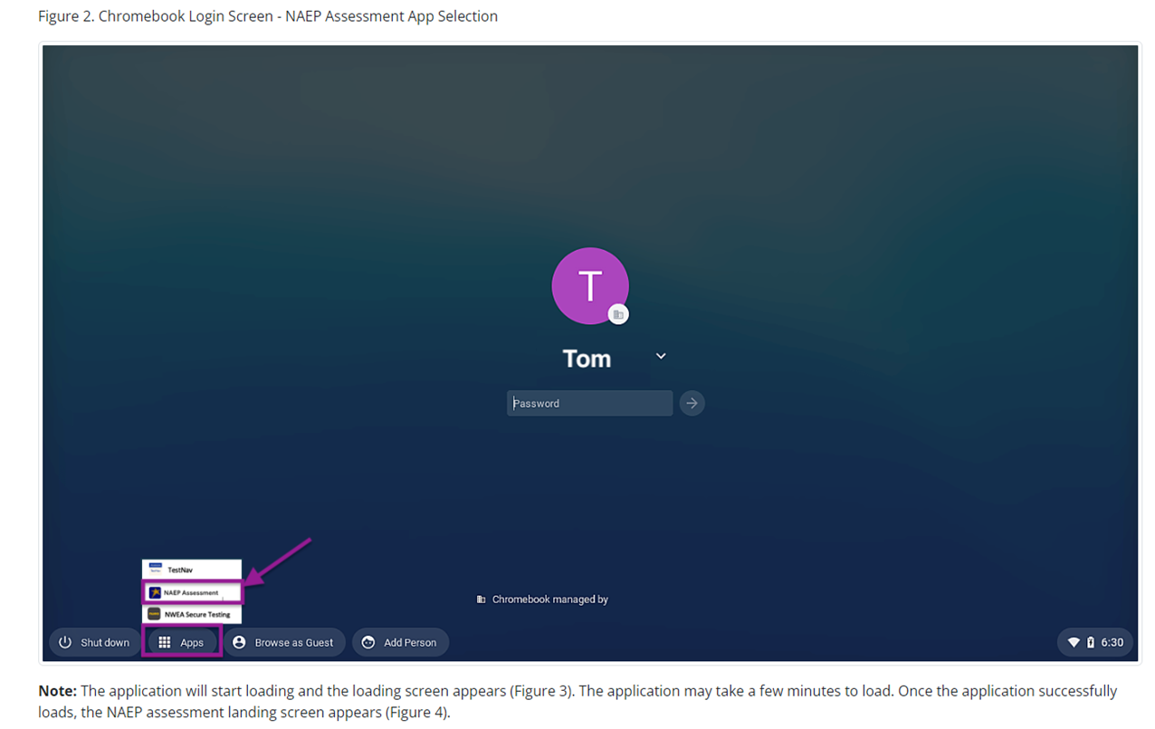
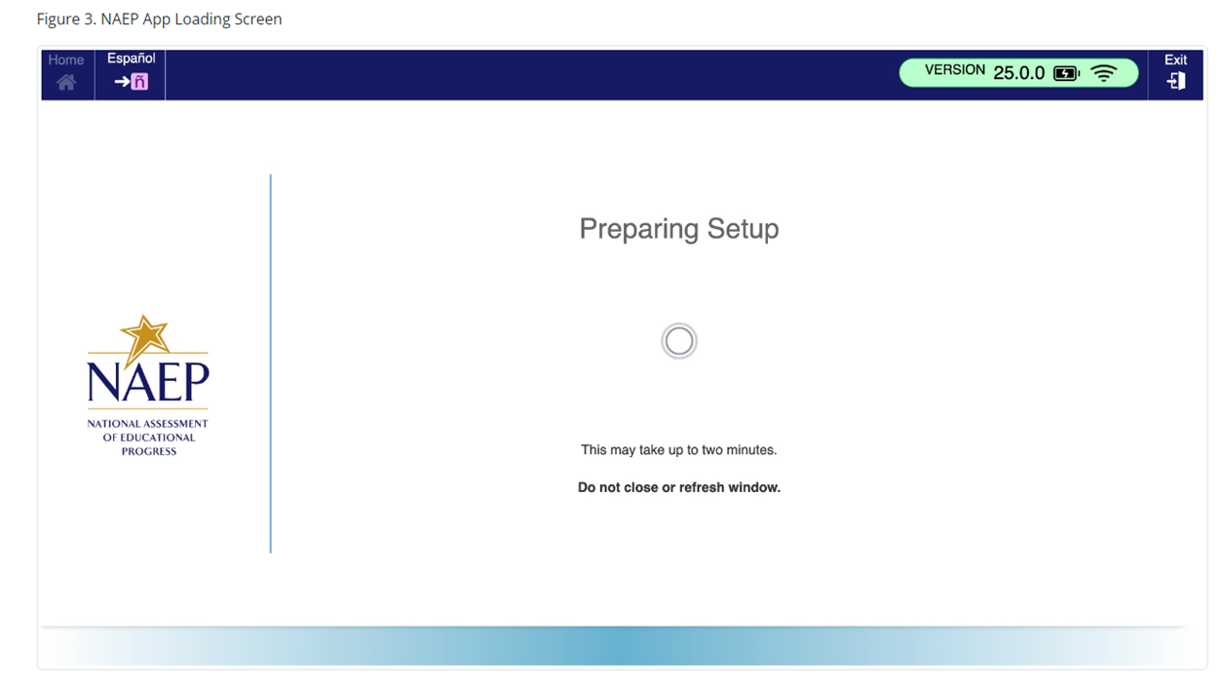
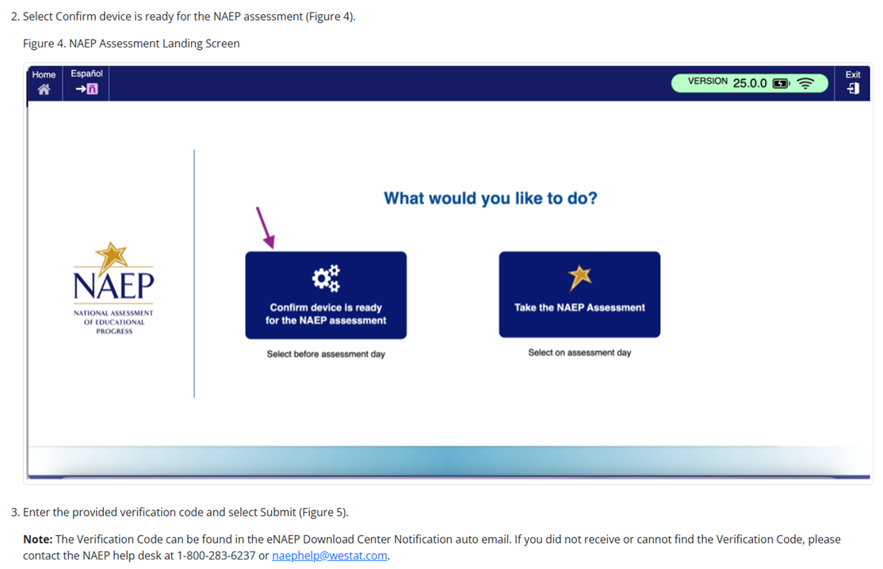

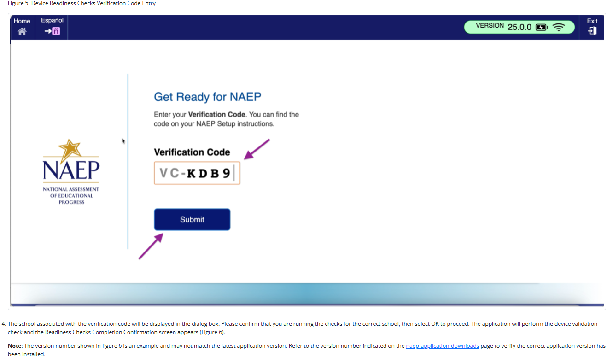

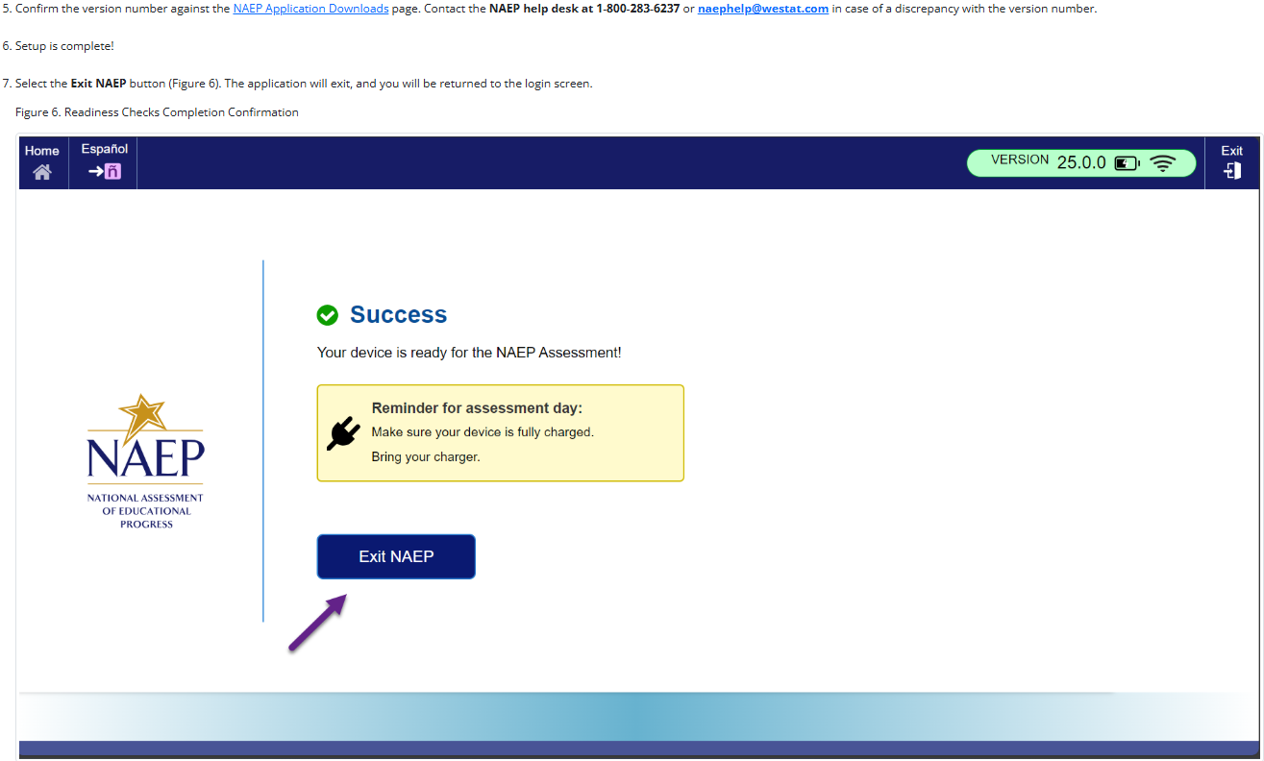

NAEP App Installation Instructions > ChromeOS > Application Removal Instructions
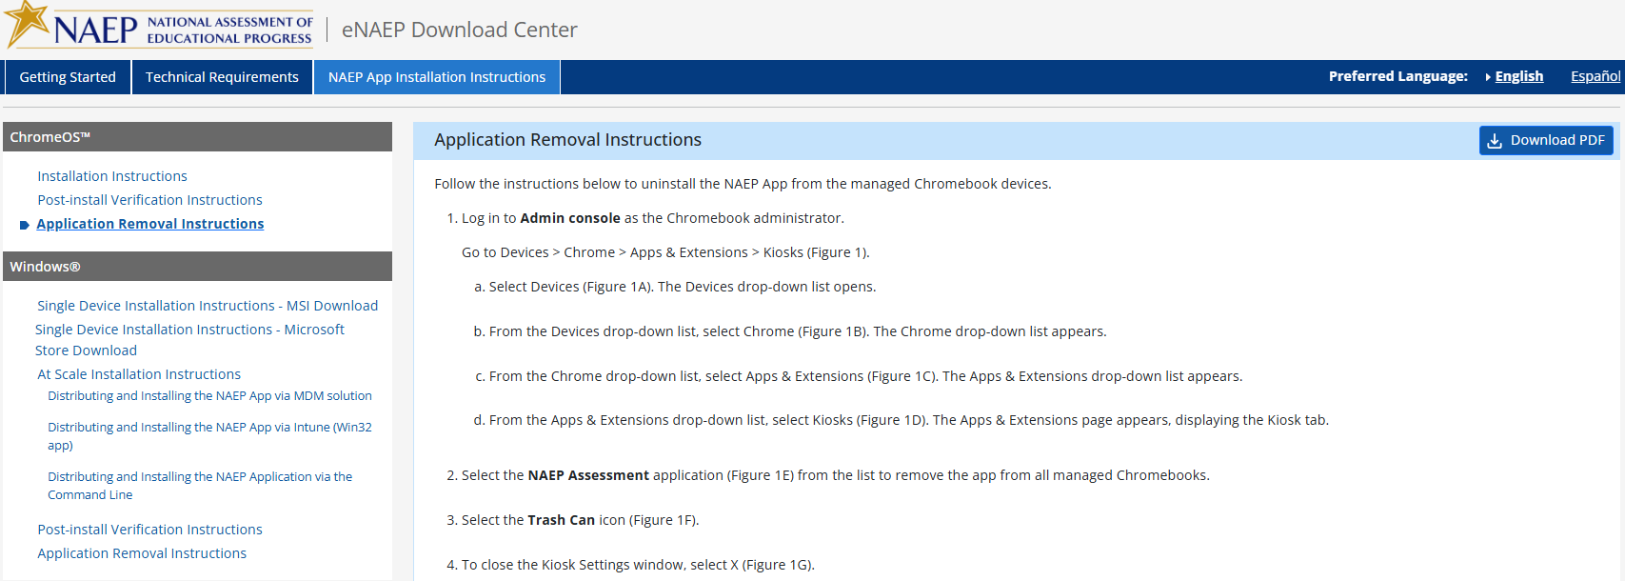
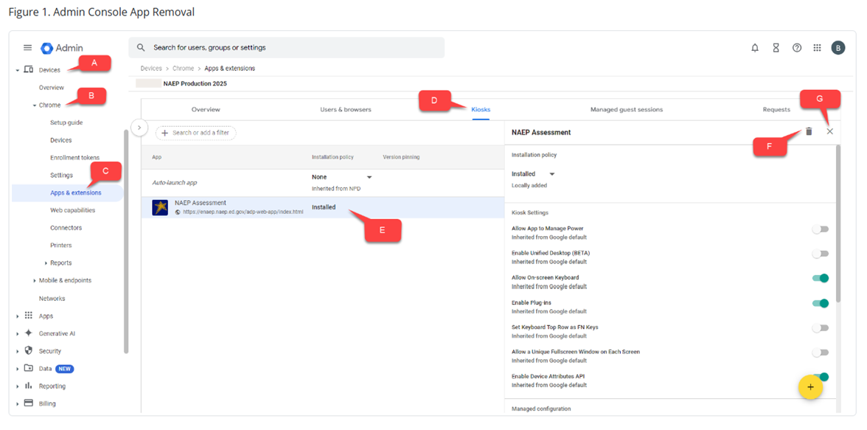

NAEP App Installation Instructions > Windows > Single Device Installation Instructions – MSI Download
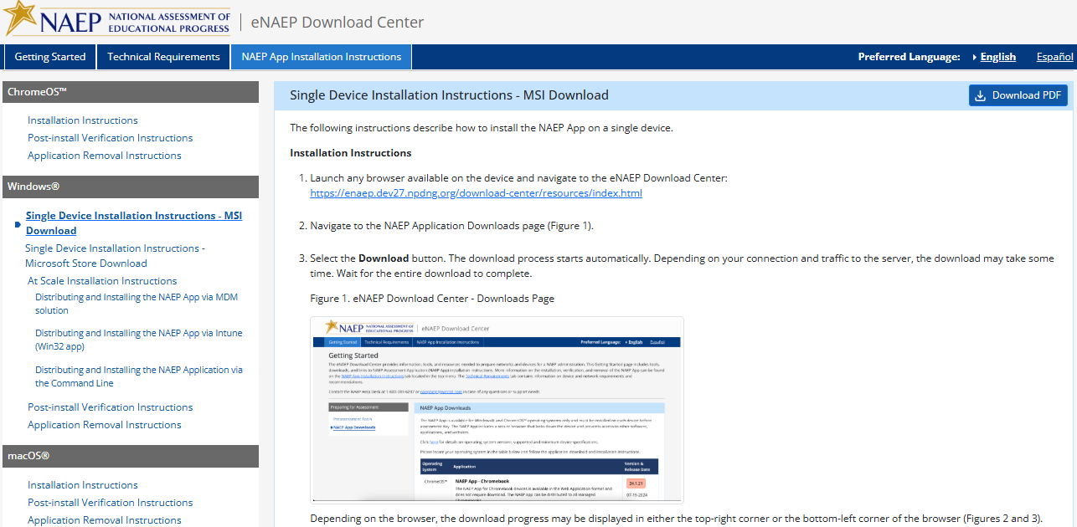
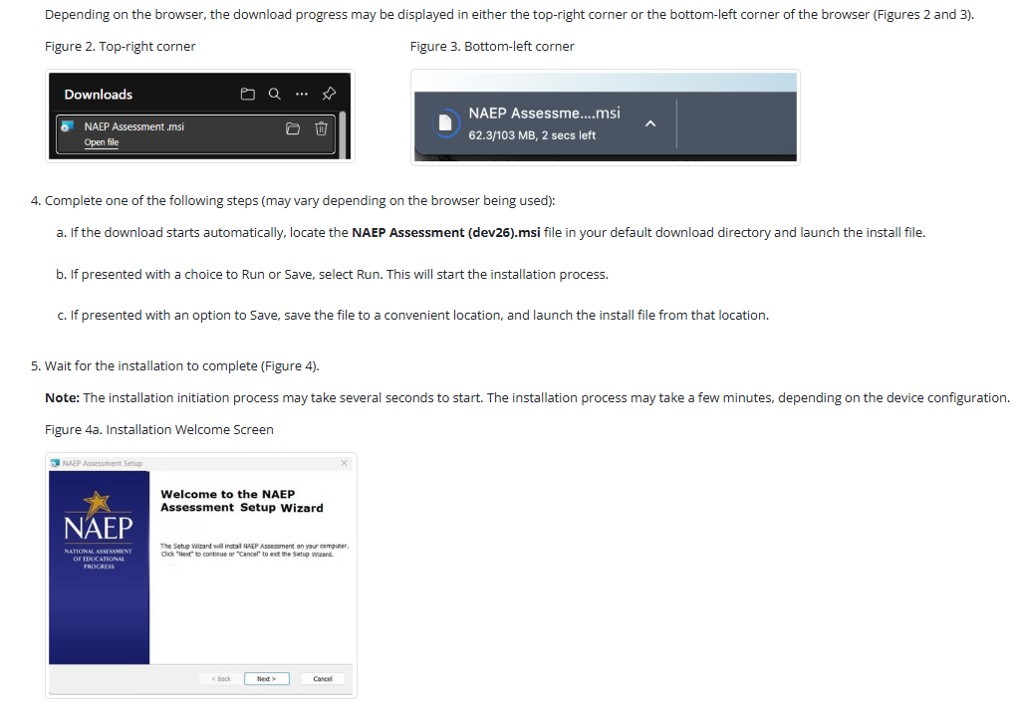
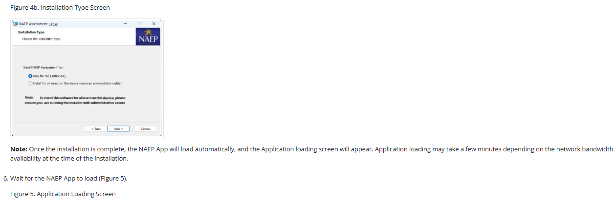
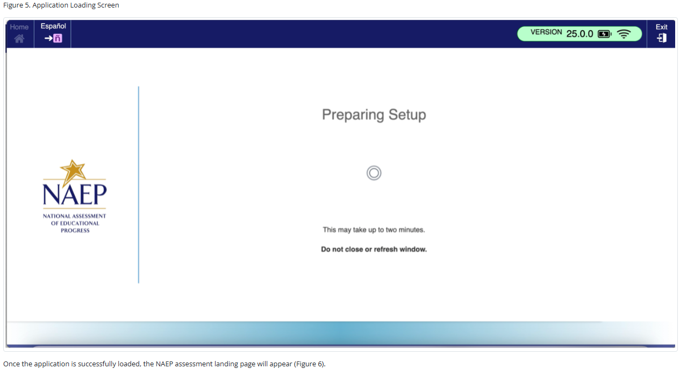
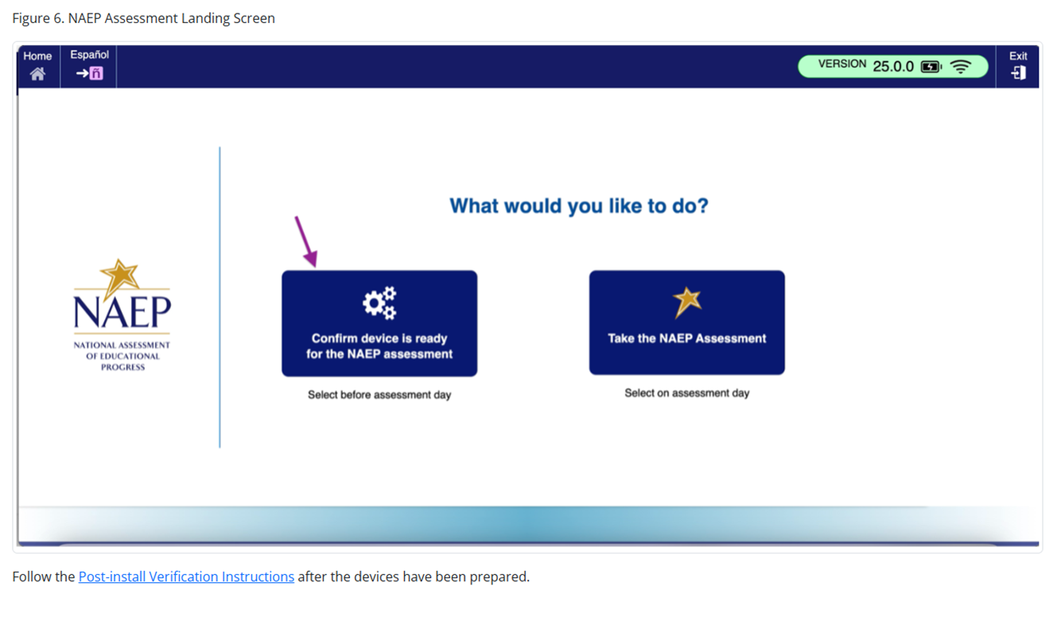

NAEP App Installation Instructions > Windows > Single Device Installation Instructions – Microsoft Store Download
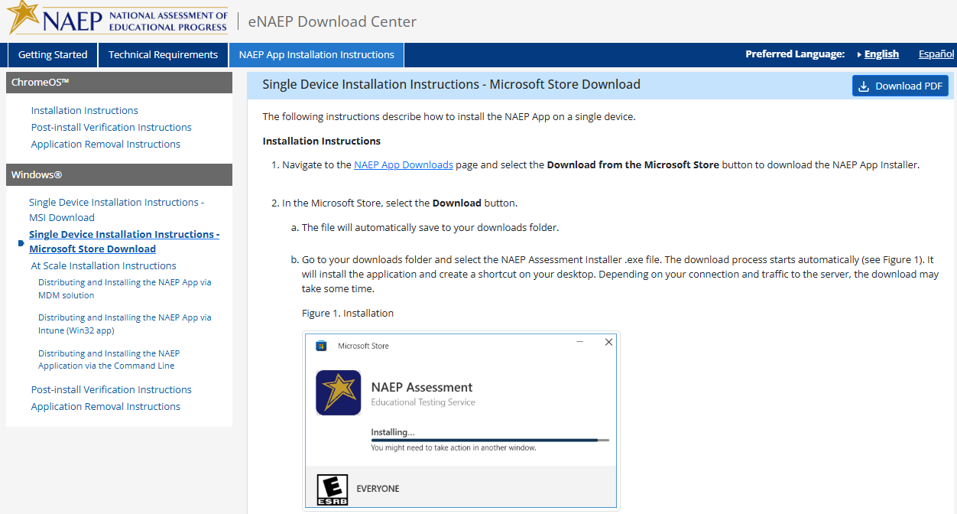

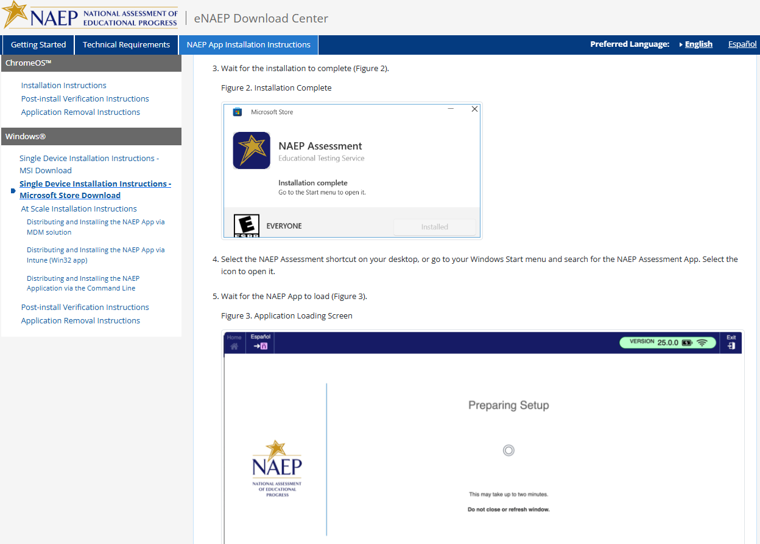
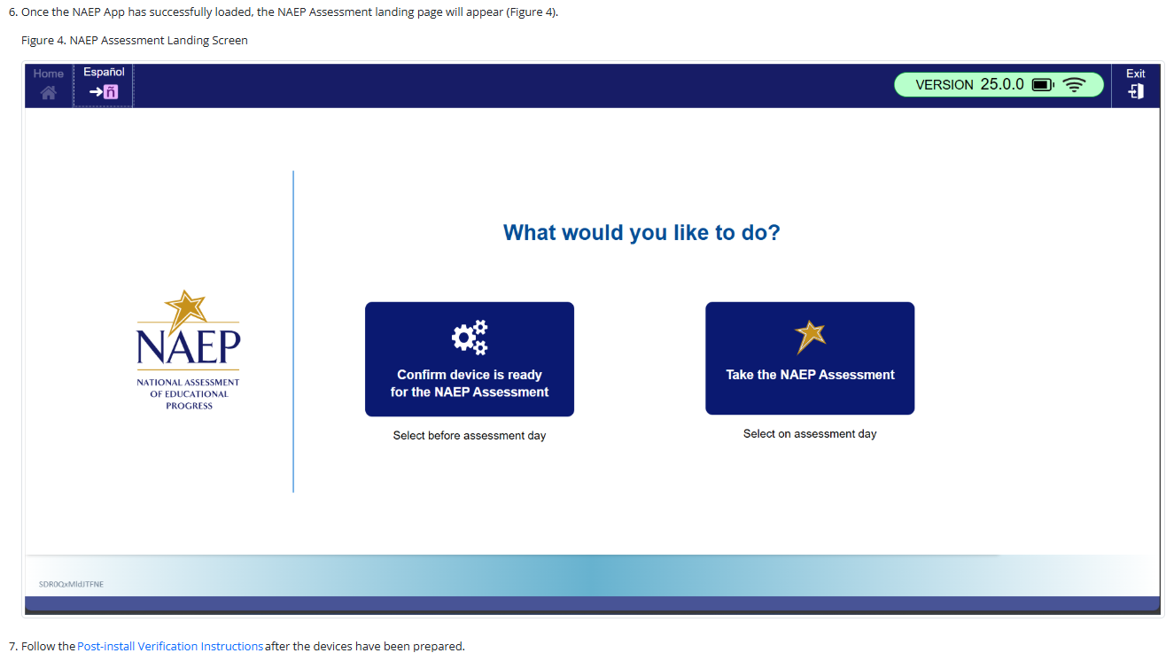

NAEP App Installation Instructions > Windows > At Scale Installation Instructions
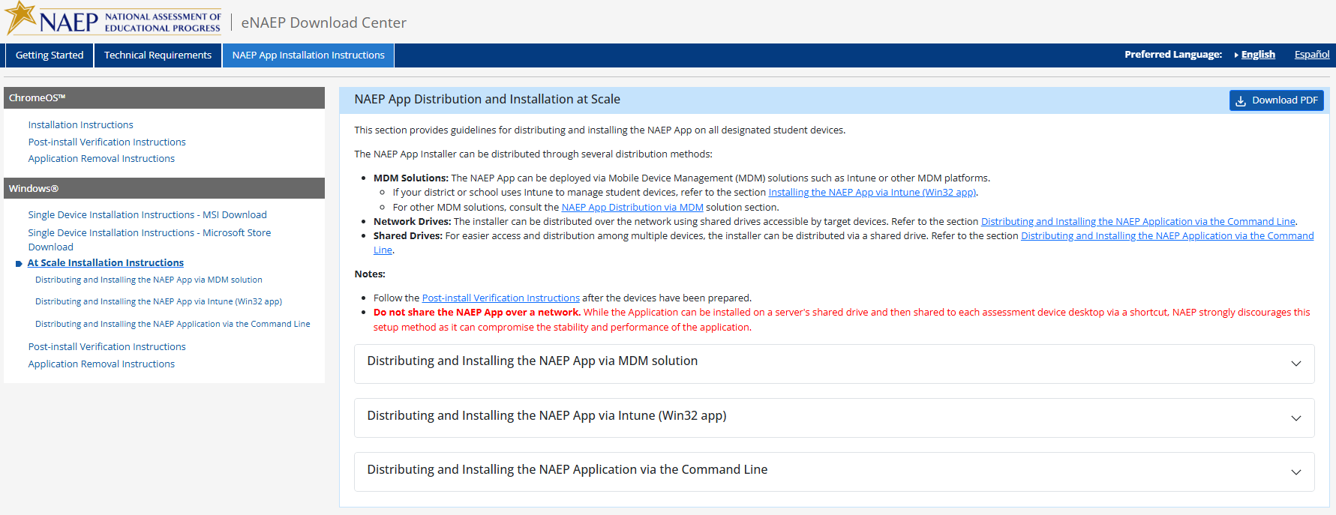

NAEP App Installation Instructions > Windows > At Scale Installation Instructions > Distributing and Installing the NAEP App via MDM Solution

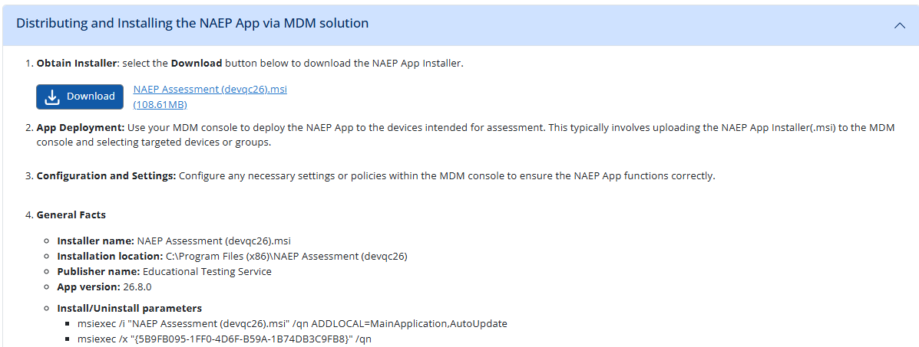

NAEP App Installation Instructions > Windows > At Scale Installation Instructions > Distributing and Installing the NAEP App via Intune (Win32 app)
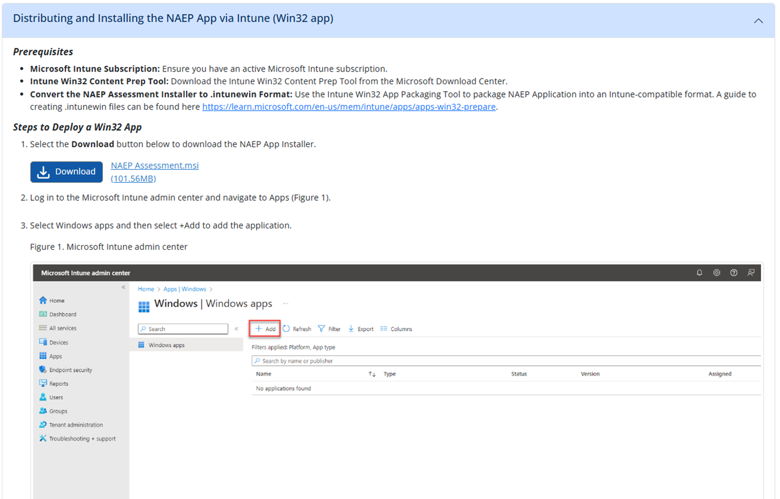
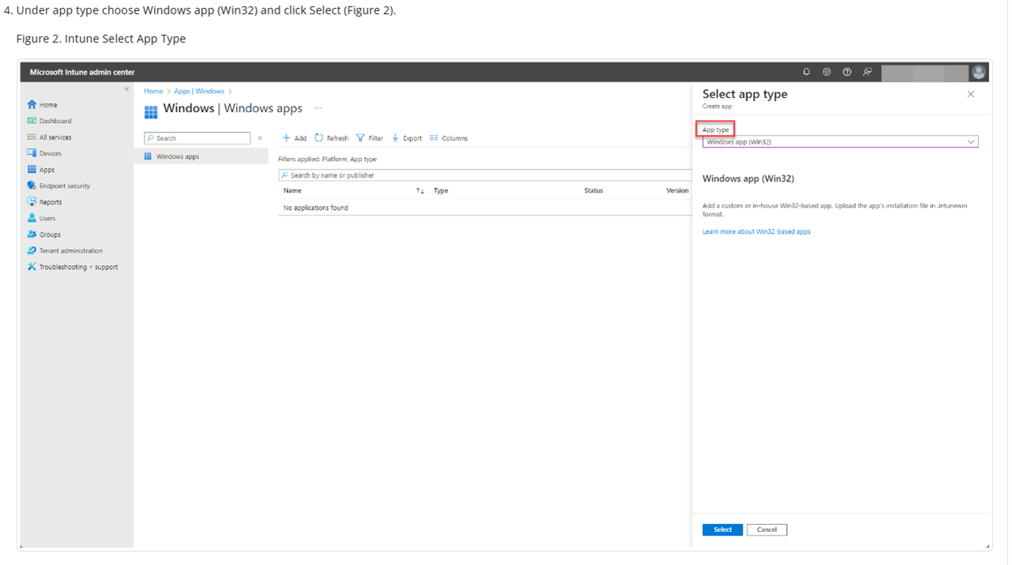
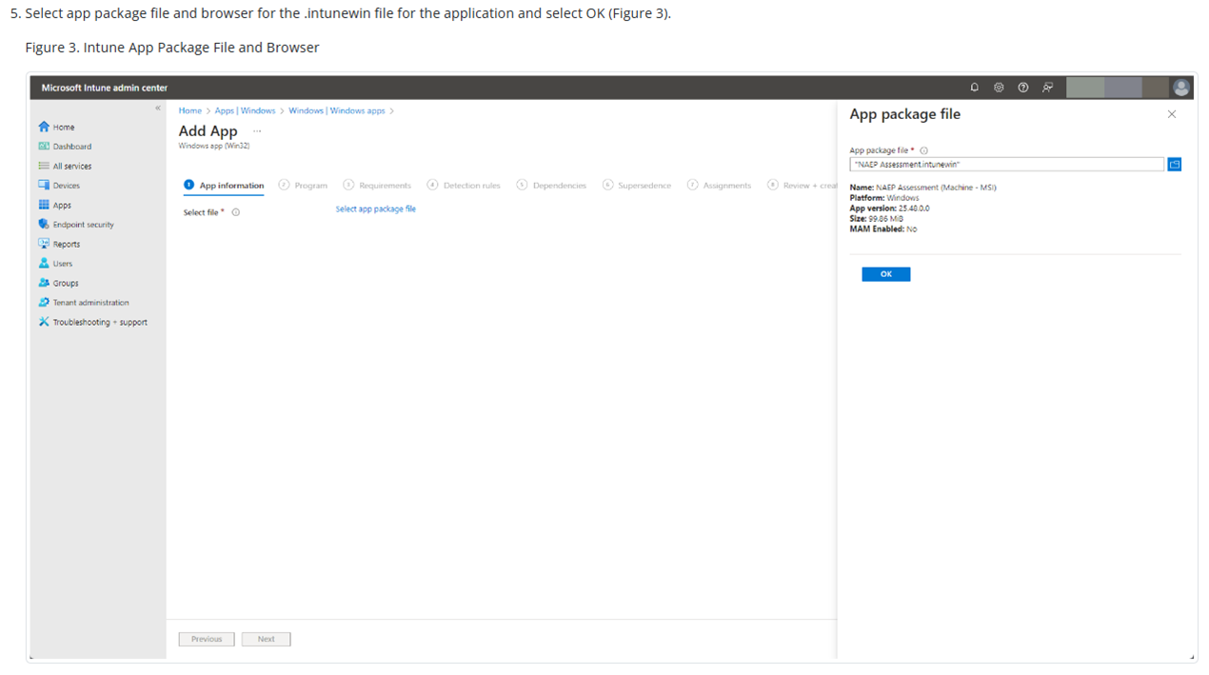
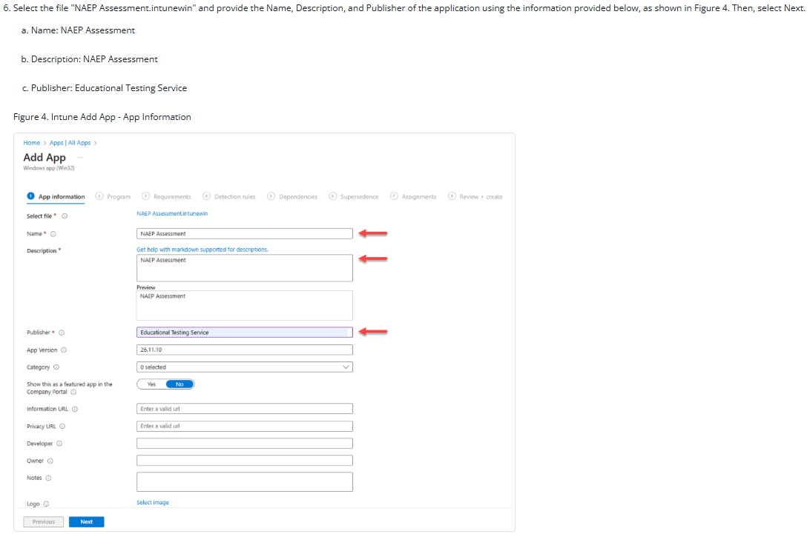
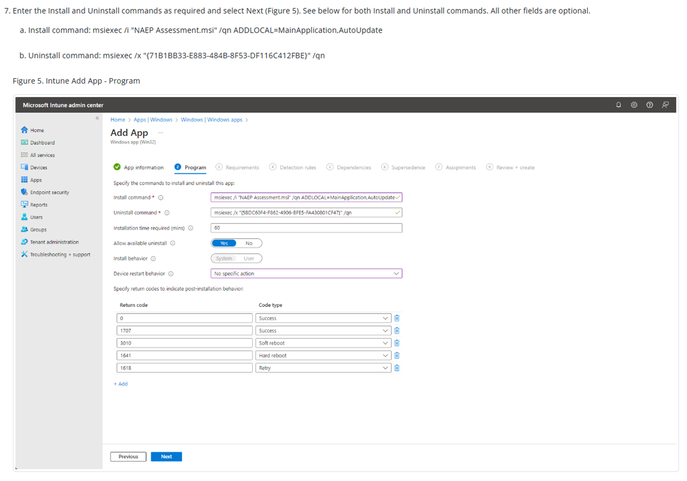
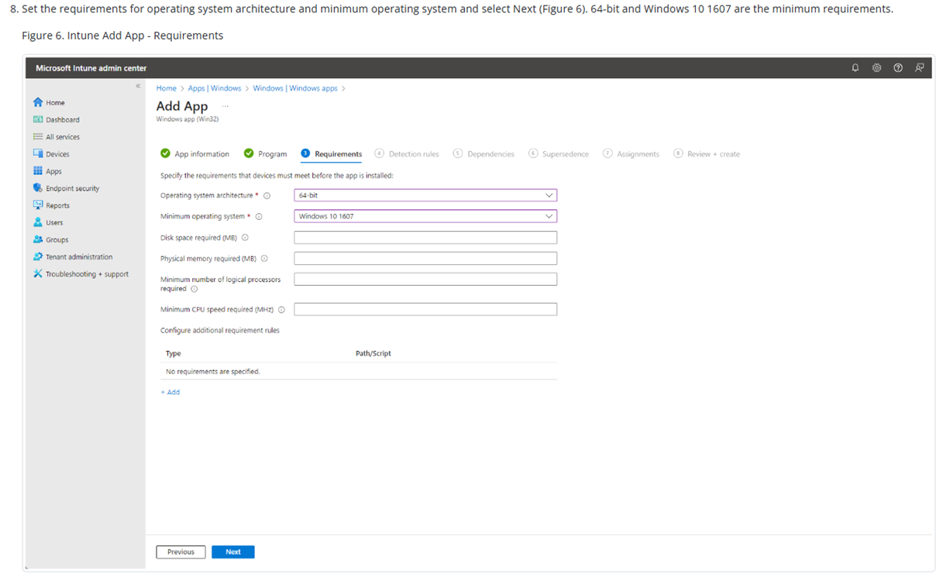
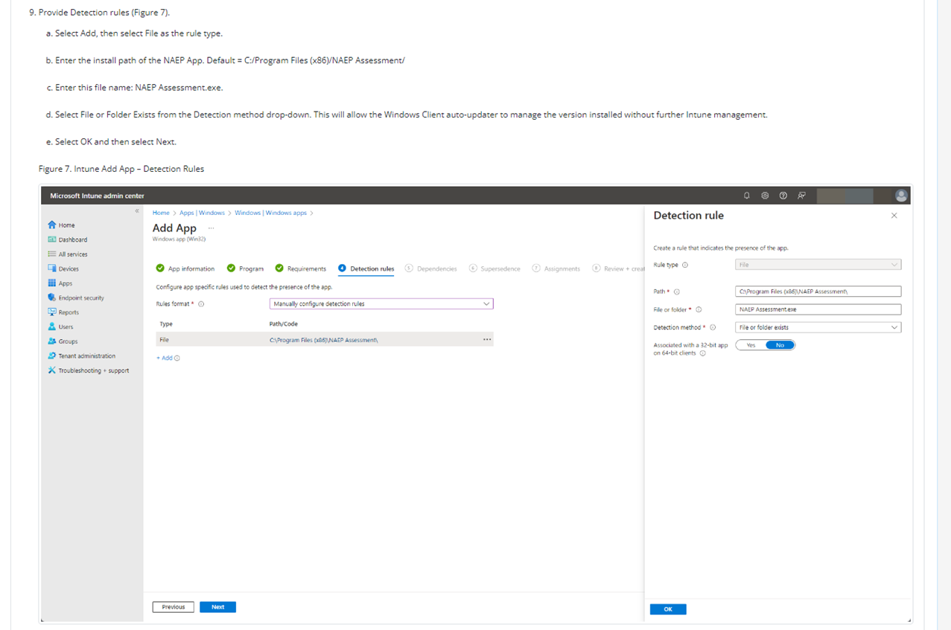
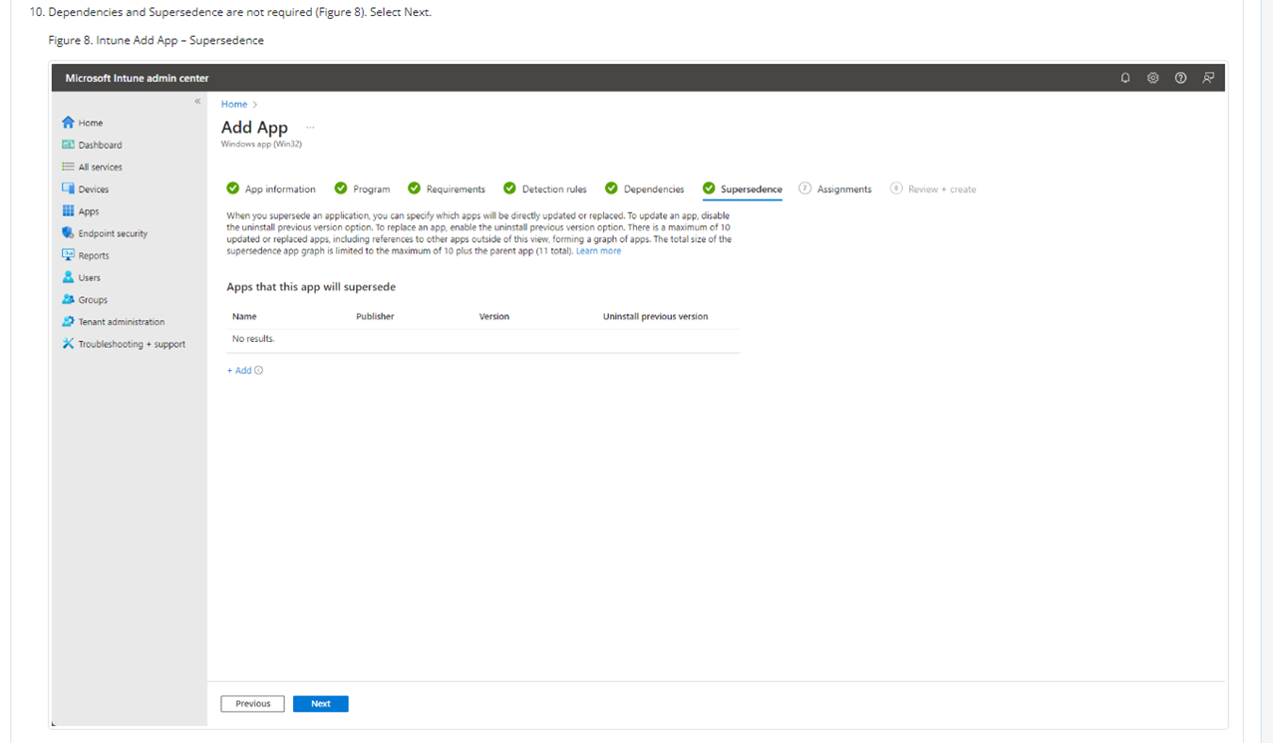
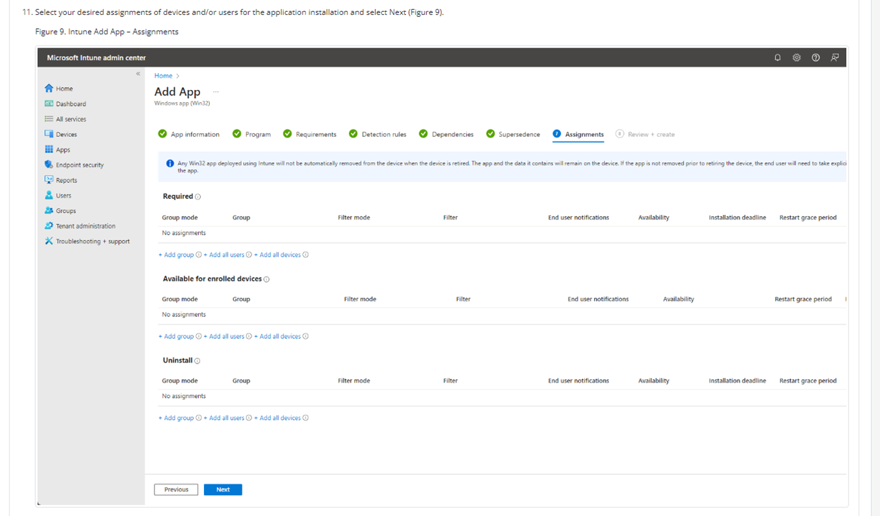
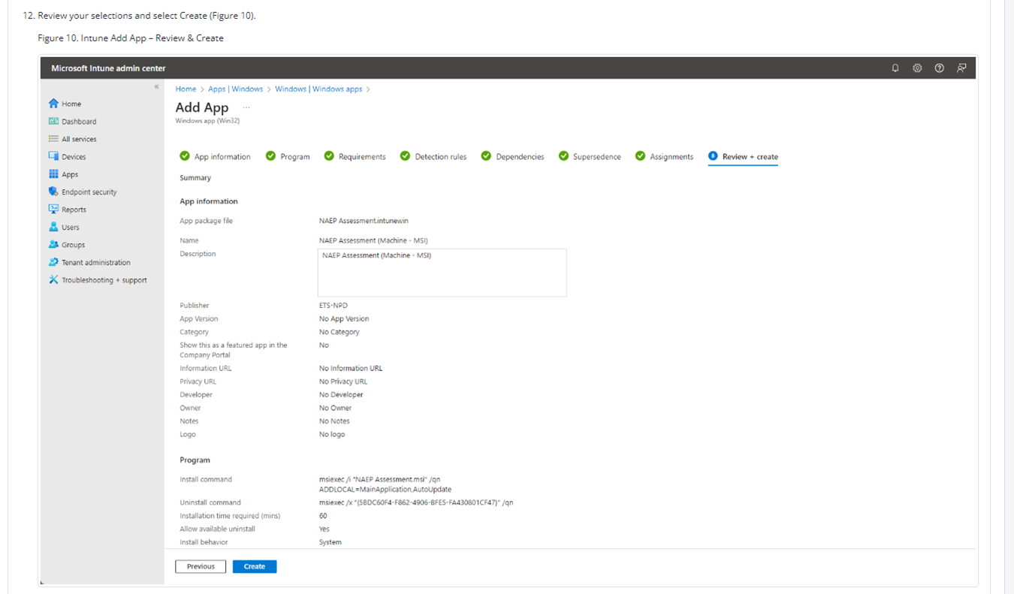
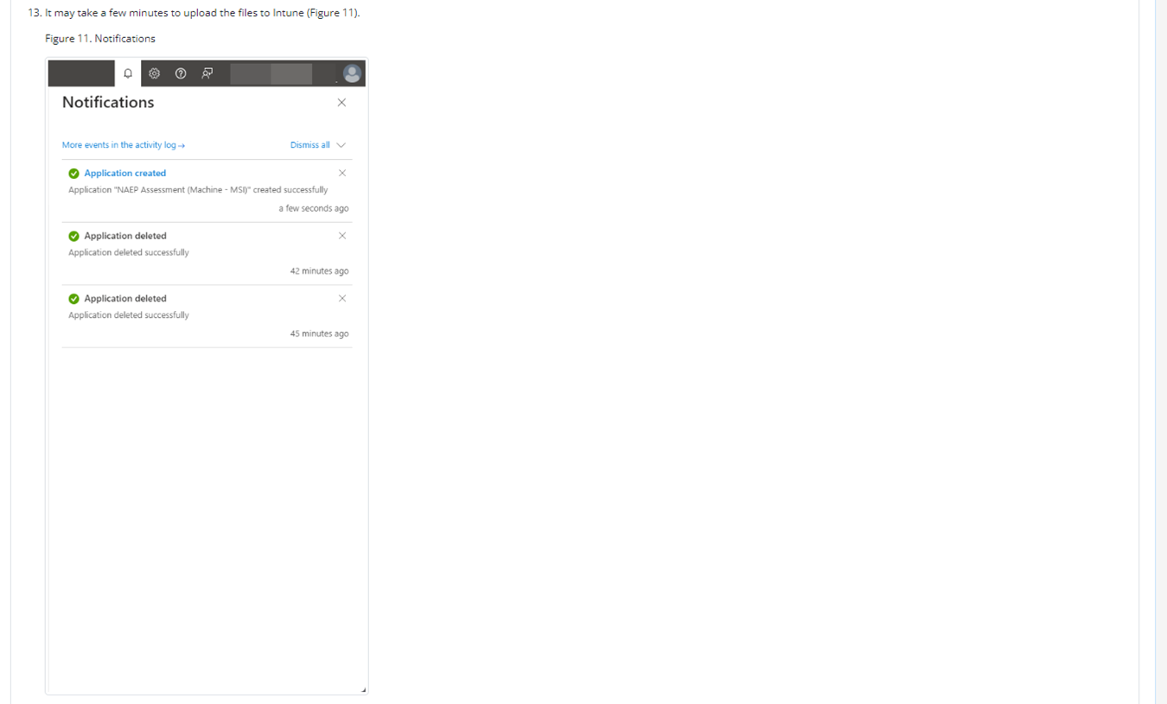
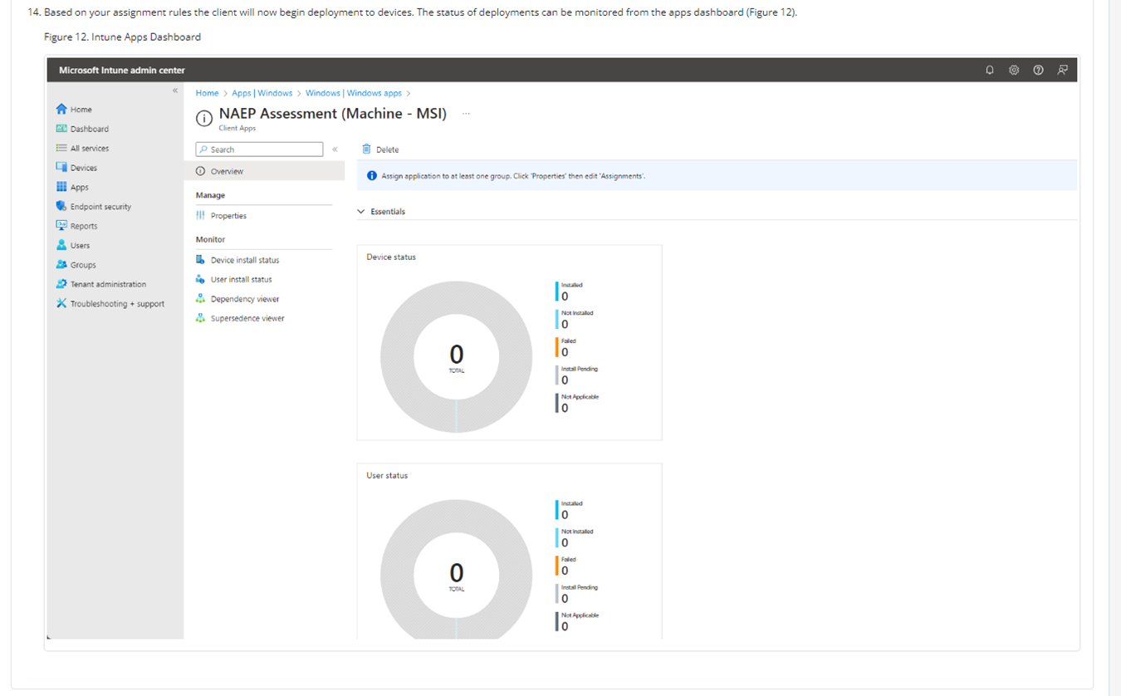

NAEP App Installation Instructions > Windows > At Scale Installation Instructions > Distributing and Installing the NAEP App via the Command Line
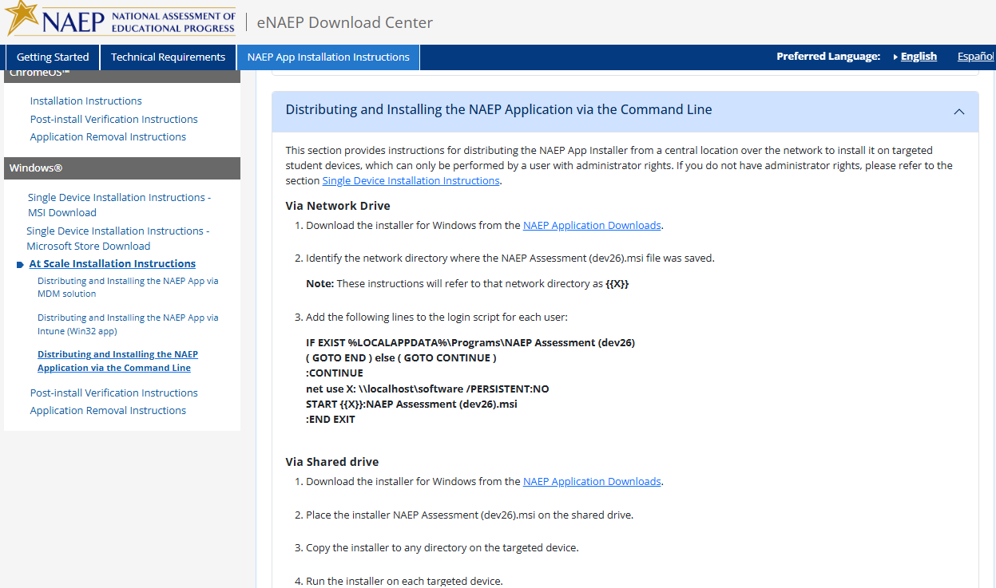

NAEP App Installation Instructions > Windows > Post-Install Verification Instructions
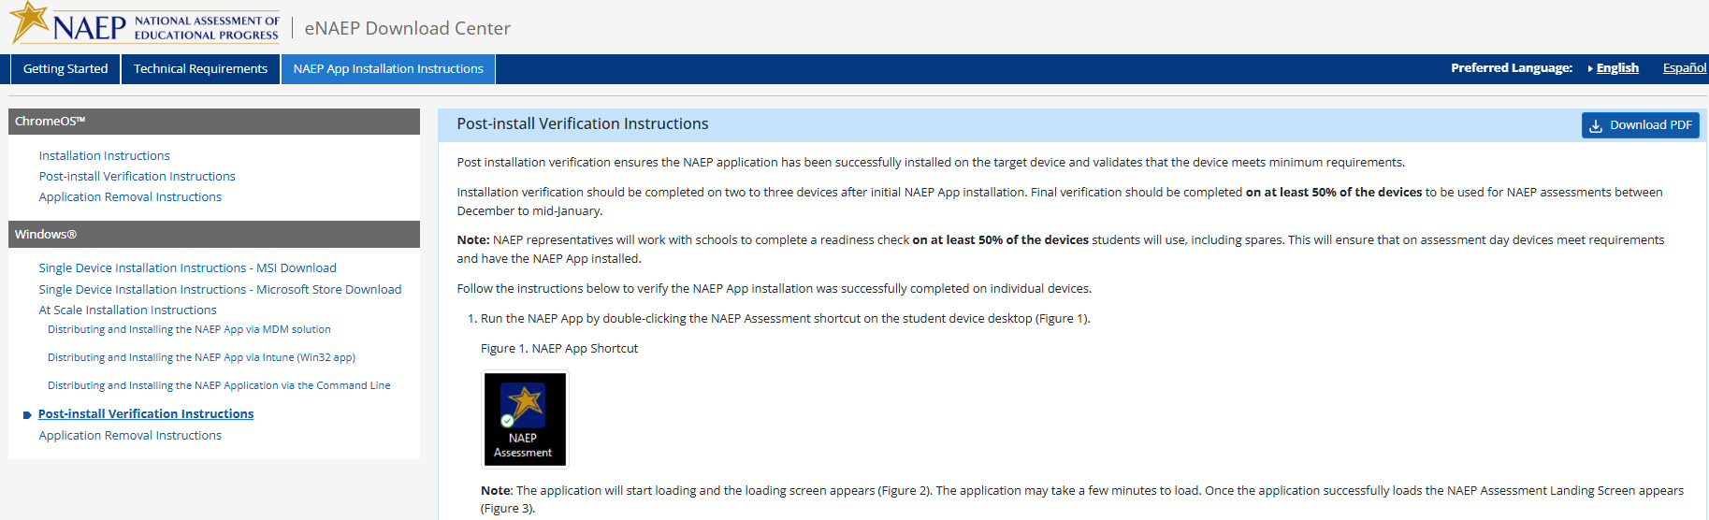
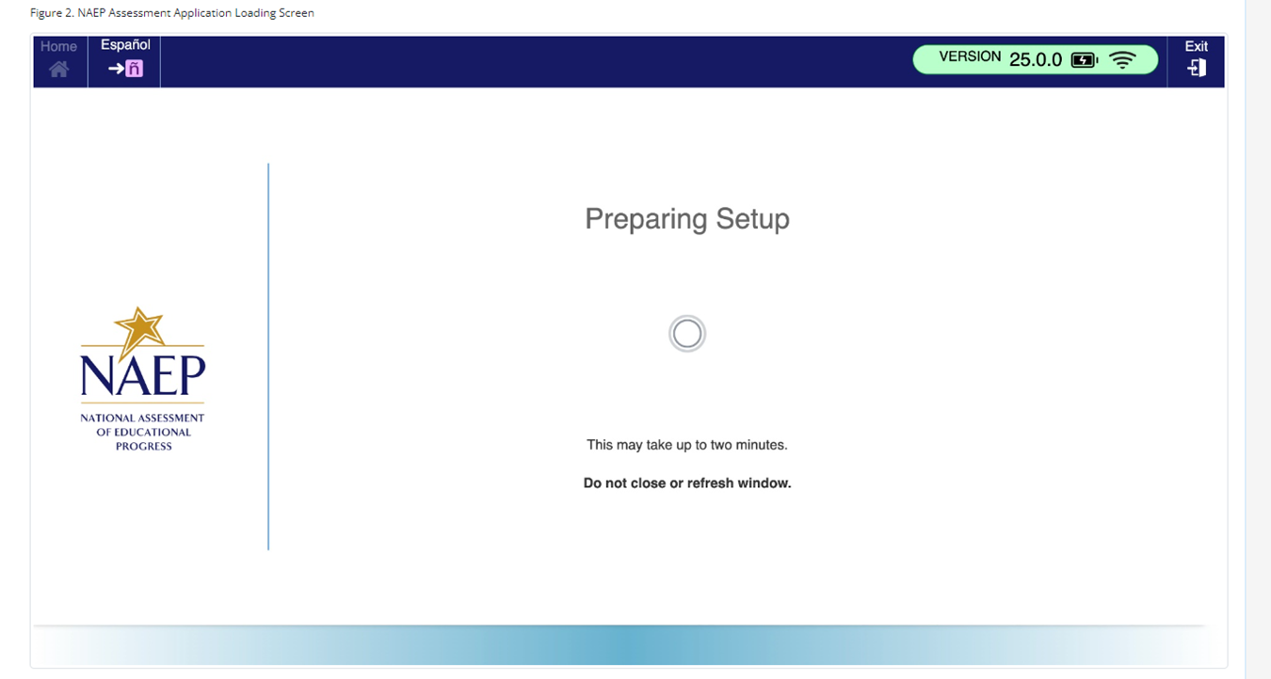
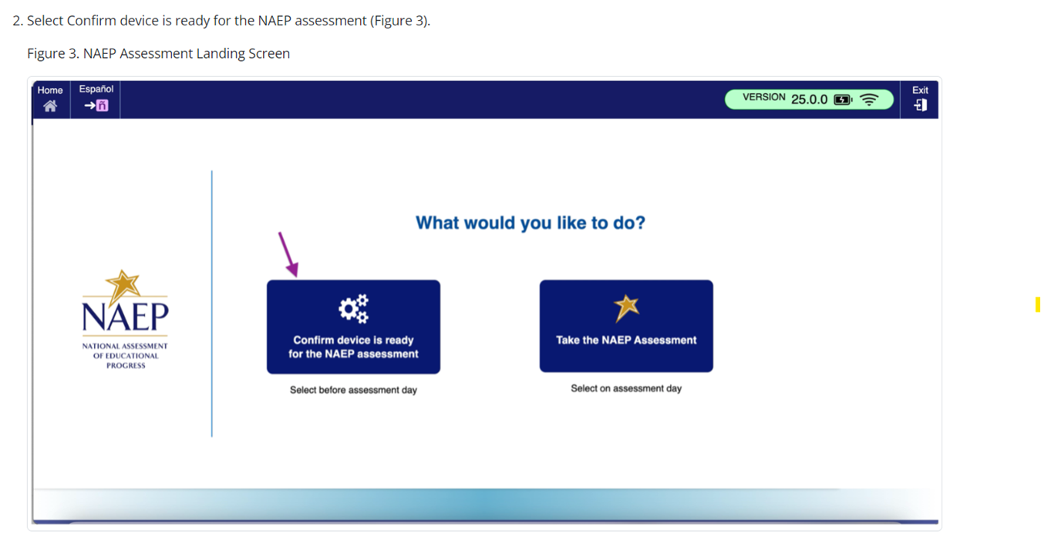
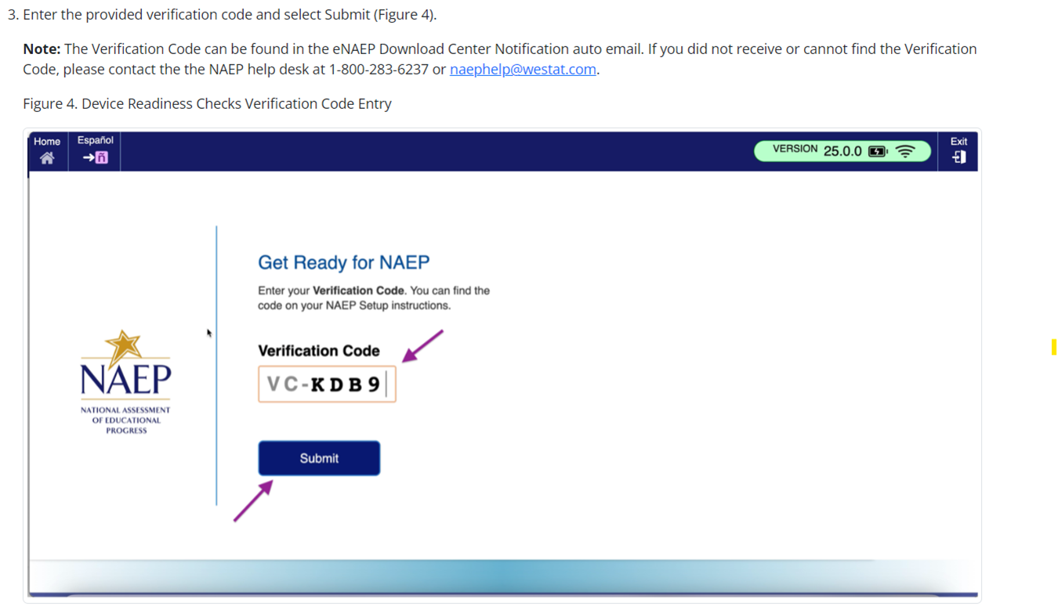

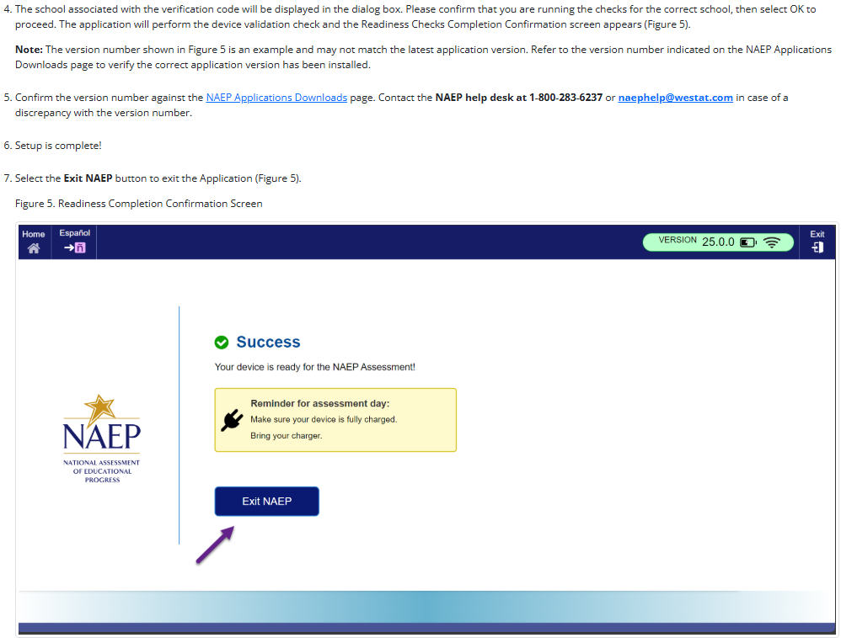

NAEP App Installation Instructions > Windows > Application Removal Instructions
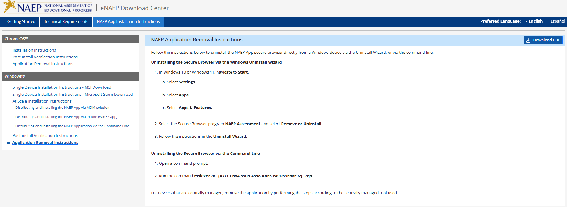

NAEP App Installation Instructions > Mac > Installation Instructions
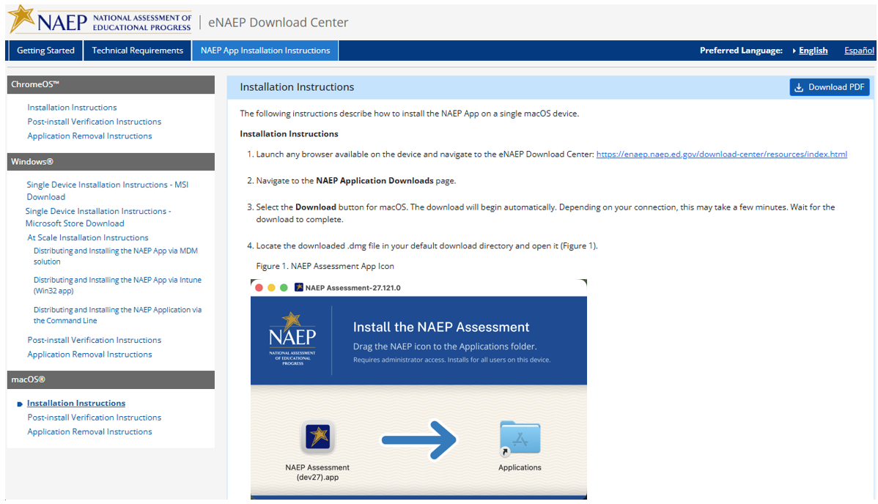
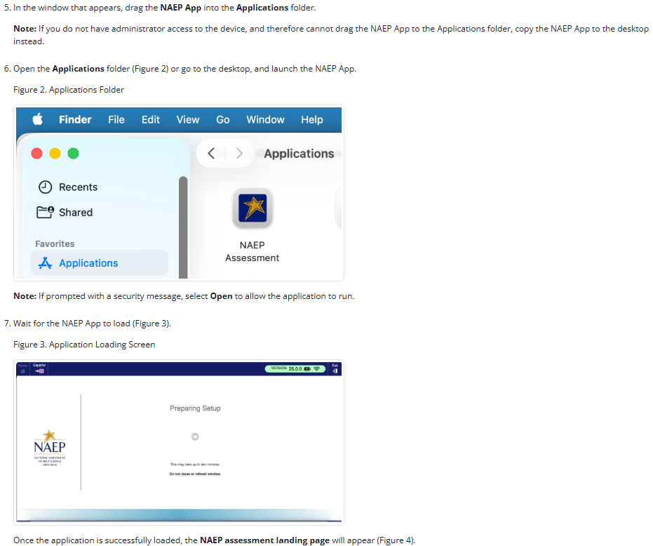
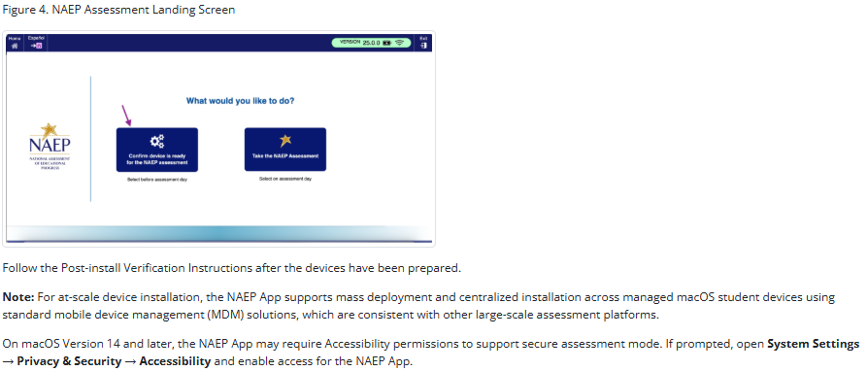

NAEP App Installation Instructions > Mac > Post-install Verification Instructions
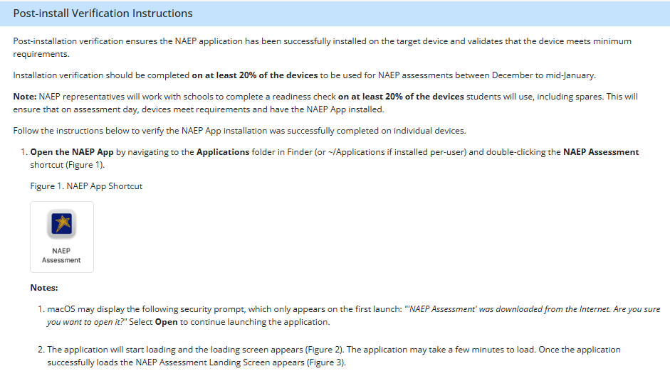

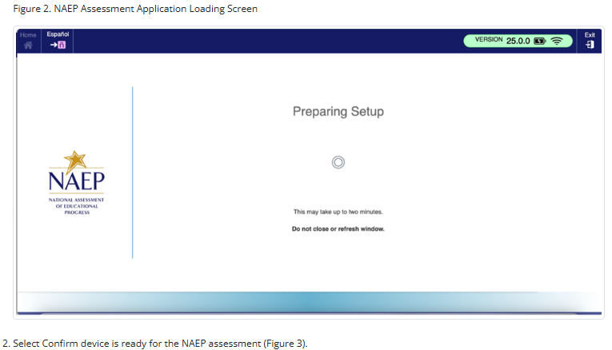

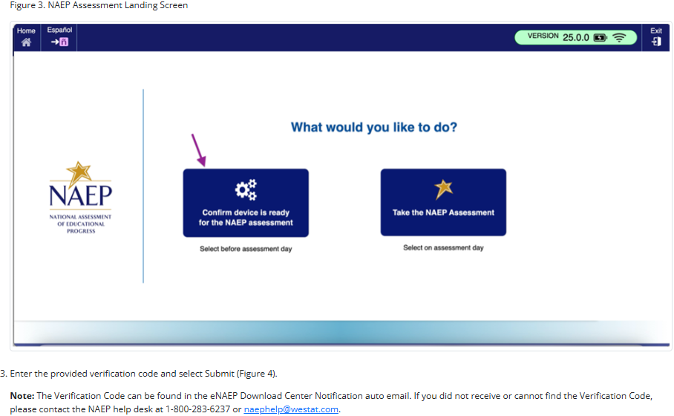

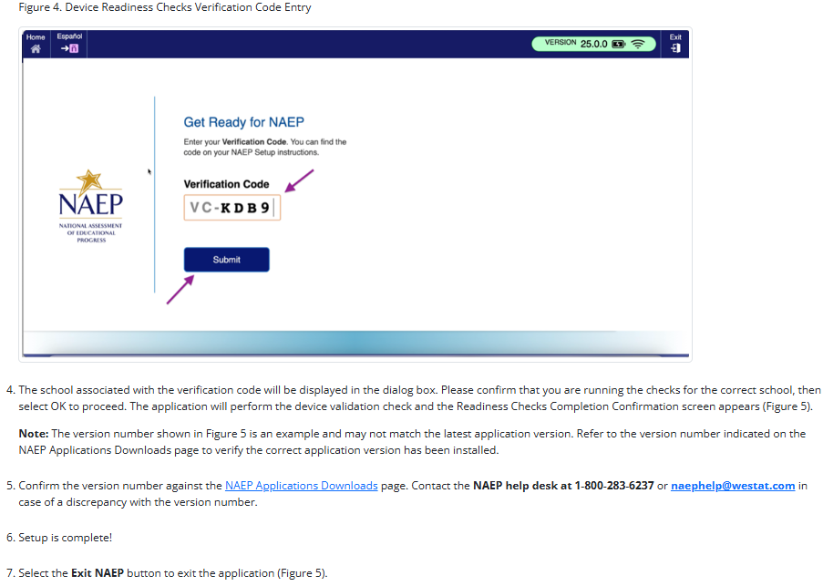
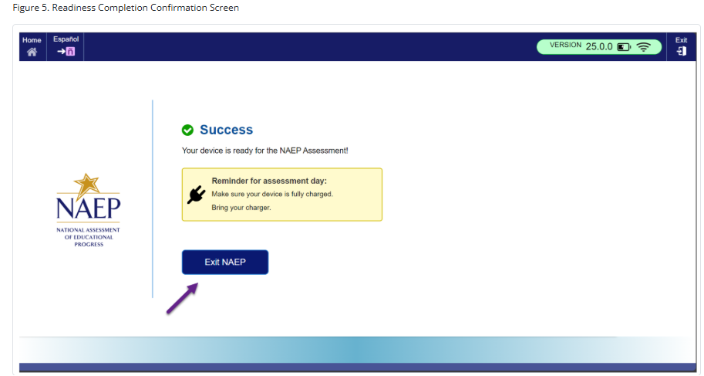
NAEP App Installation Instructions > Mac > Application Removal Instructions
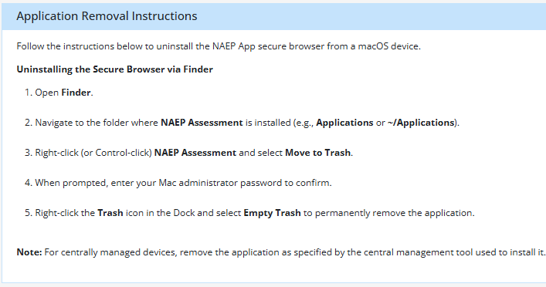

Maintenance Page - English
The maintenance page below was displayed to users who accessed the eNAEP Download Center when it was not yet available. It is inactive when the School Technology Survey is available in the AMS.
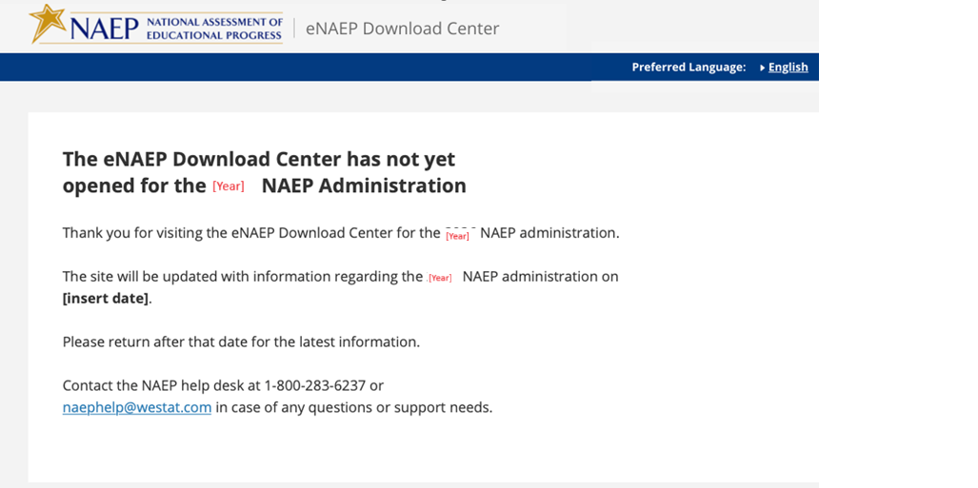

Page Not Found Error Page – English
A user will see the below page if the user attempts to access a link for the eNAEP Download Center that is not valid (e.g., mistype the link).
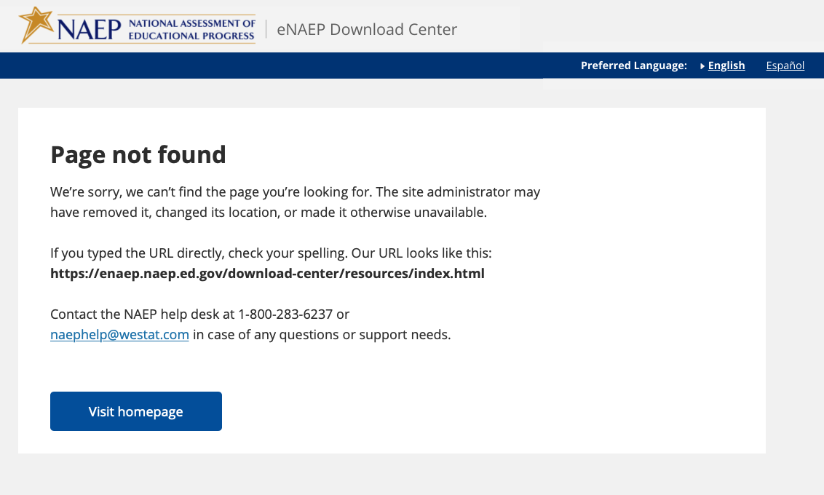

Appendix D-8: NAEP 2027 eNAEP Download Center Notification, Auto email to School or District Application Installer (Approved v.39)

NAEP 2027 – eNAEP Download Center Notification
AUTO EMAIL TO SCHOOL OR DISTRICT APPLICATION INSTALLER
Highlighted text represents merge fields.

Subject: Instructions for School or District NAEP Assessment Application Installer
To: [Application Installer Email]

Dear [Application Installer Firstname] [Application Installer Lastname]:

Your school or district has been selected to participate in the 2027 administration of the National Assessment of Educational Progress (NAEP). You have been identified as the person best suited to prepare the school devices (e.g., desktops, laptops, tablets with keyboards).

You can find important information via the [eNAEP Download Center hyperlink], including the following:
- detailed instructions for installing and uninstalling the NAEP Assessment application on one device or multiple devices operating on Windows or ChromeOS;
- specifications for the types of devices that can be used for the NAEP assessment, and other technical requirements; and
- tools that can be used to confirm the safelisting of NAEP assessment URLs or to conduct bandwidth checks.

Please complete the following activities by [date].

- Prepare for NAEP Assessment Application Installation
Review the Getting Started and Technical Requirements tabs via the eNAEP Download Center for more detailed instructions.
  - Confirm that safelisting is completed using the Safelist Check tool. The check must be run on the school network.
    - Safelist the NAEP URLs provided in Firewall Safelisting section under the Technical Requirements tab if they are not already safelisted.
    - (Optional) Confirm whether the school can support the required bandwidth on the network that will be used for the NAEP assessment using the Bandwidth Check tool.
  - Identify devices that meet the technical requirements to be used to conduct the NAEP assessment.
    - If you plan to install the application only on devices used by students who will take NAEP, please contact your NAEP State or TUDA Coordinator for access to a secure list of sampled students in [month].

- Install the NAEP Assessment Application
The table below lists the school(s) that need the NAEP Assessment application installed on school devices for the sampled grade level. Review the NAEP App Installation Instructions tab via the eNAEP Download Center for detailed instructions. Install the NAEP Assessment application at scale or individually to all school devices to be used on assessment day.

District Name | School Name | Grade

- (Optional) Uninstall the NAEP Assessment Application
Once the NAEP assessment concludes, you may uninstall the NAEP Assessment application as directed by the detailed instructions found on the NAEP App Installation Instructions tab.

Starting in [month], NAEP representatives will work with schools to complete a device readiness check on [XX] percent of the total number of devices students will use to take the assessment, including spares. This will ensure that on assessment day each device meets the technical requirements and has the NAEP Assessment application installed.

What if I have questions?
If you have questions about these tasks, please contact the NAEP help desk at 1-800-283-6237 or naephelp@westat.com. If you have other questions about NAEP, please contact your NAEP State or TUDA Coordinator at [NSC or NTC email].

Thank you again for your assistance with this very important assessment.

Appendix D-9: NAEP 2027 District Model Assignment Notification (Approved v.39)

NAEP 2027 – District Model Assignment Notification
NAEP State Coordinator to District Assessment Coordinator
Red text should be customized before mail merge: highlighted text represents mail merge fields

Dear District Assessment Coordinator,

Thank you for all that you do to support education in state name. I am writing to inform you that administrative model assignments have been made for a school/schools in your district selected to participate in the 2027 administration of the National Assessment of Education Progress (NAEP).

I will reach out to selected schools with details about their administrative model assignment for NAEP and next steps.

Administrative Model Assignments

NAEP will be administered using school devices (e.g., desktops, laptops, tablets with keyboards) for the following school(s).
- School 1 Name, Grade, and Assessed Subjects
- School 2 Name, Grade, and Assessed Subjects
- Etc.

NAEP will be administered using Chromebooks provided by NAEP for the following school(s).
- School 1 Name, Grade, and Assessed Subjects
- School 2 Name, Grade, and Assessed Subjects
- Etc.

Again, thank you for your assistance with this very important assessment of our nation’s students. If you have questions, please contact me at telephone number or via email at email address.

Sincerely,

NAEP State Coordinator

The National Center for Education Statistics (NCES) conducts the National Assessment of Educational Progress to evaluate federally supported education programs. All of the information you provide may only be used for the purposes of research, statistics, and evaluation under the Education Sciences Reform Act of 2002 (ESRA; 20 U.S.C. § 9543) and may not be disclosed, or used, in identifiable form for any other purpose except as required by law. Every NCES employee as well as every NCES agent, such as contractors and NAEP coordinators, has taken an oath and is subject to a jail term of up to 5 years, a fine of $250,000, or both if he or she willfully discloses ANY identifiable information about you in any unauthorized manner. Electronic submission of your information will be monitored for viruses, malware, and other threats by Federal employees and contractors in accordance with the Cybersecurity Enhancement Act of 2015.

Appendix D-10: NAEP 2027 Parent-Guardian Notification Letter, Public School (Approved v.39)

NAEP 2027 PARENT-GUARDIAN NOTIFICATION LETTER
Grade 8 Science Pilot
(School Letterhead)
(Insert Date Here)

Dear Parent or Guardian:

(School name) will participate in the National Assessment of Educational Progress (NAEP) on (date). NAEP is the largest nationally representative and continuing assessment of what students know and can do in various subjects. NAEP is administered by the National Center for Education Statistics, within the U.S. Department of Education. NAEP is different from our state assessments because it is a common measure of achievement across the country.

Your child (will/may) take a science assessment. In addition to subject-area questions, students voluntarily complete NAEP survey questions. These questions provide valuable information about participating students’ educational experiences and opportunities to learn both in and outside of the classroom. More information about NAEP survey questions is available at https://nces.ed.gov/nationsreportcard/parents under the section “Survey Questionnaires & Your Student: What You Need to Know.”

The assessment takes about 120 minutes for most students, which includes transition time, directions, and completion of survey questions.

The information collected is used for statistical purposes only.
- Your child’s grades will not be affected.
- Students may be excused for any reason, are not required to complete the assessment, and may skip any question.
- Although the assessment is voluntary, NAEP depends on student participation. Policymakers, educators, the media, and the educational assessment community use NAEP results to develop ways to improve and report on education. If you do not want your child to participate, please notify me in writing by (date).

There is no need to study in preparation for NAEP, but please encourage your child to do their best. Contact (name) at (telephone number) or at (email address) if you have any questions.

We are excited that our school is participating in NAEP. We know that (school name)’s students will show what our nation’s students know and can do.

Sincerely,
(School Principal’s Name)

The National Center for Education Statistics (NCES) conducts the National Assessment of Educational Progress to evaluate federally supported education programs. All of the information you provide may only be used for the purposes of research, statistics, and evaluation under the Education Sciences Reform Act of 2002 (ESRA; 20 U.S.C. § 9543) and may not be disclosed, or used, in identifiable form for any other purpose except as required by law. Every NCES employee as well as every NCES agent, such as contractors and NAEP coordinators, has taken an oath and is subject to a jail term of up to 5 years, a fine of $250,000, or both if he or she willfully discloses ANY identifiable information about you in any unauthorized manner. Electronic submission of your information will be monitored for viruses, malware, and other threats by Federal employees and contractors in accordance with the Cybersecurity Enhancement Act of 2015.

Appendix D-11: NAEP 2027 Parent-Guardian Notification Letter, Bilingual Spanish Public Schools (Approved v.39)

CARTA DE NOTIFICACIÓN A LOS PADRES O TUTORES SOBRE NAEP DE 2027
Evaluación Piloto de Ciencias para 8.º grado
(Membrete de la escuela)
(Coloque la fecha aquí)
Estimado(a) padre, madre o tutor:

(Nombre de la escuela) participará en la Evaluación Nacional del Progreso Educativo (NAEP, por sus siglas en inglés) el (fecha). NAEP es la evaluación continua y nacionalmente representativa más grande acerca de lo que los estudiantes saben y pueden hacer en diferentes materias. NAEP es administrada por el Centro Nacional de Estadísticas de la Educación (NCES, por sus siglas en inglés), parte del Departamento de Educación de Estados Unidos. NAEP es diferente de nuestras evaluaciones estatales ya que ofrece una medida común de los logros en todo el país.

Su hijo(a) (tomará/posiblemente tome) una evaluación de ciencias. Además de las preguntas sobre la materia, los estudiantes contestan preguntas de contexto de NAEP de manera voluntaria. Las preguntas proporcionan información valiosa acerca de las experiencias y oportunidades de aprendizaje dentro y fuera del salón de clases de los estudiantes participantes. Puede encontrar más información acerca de las preguntas de NAEP en https://nces.ed.gov/nationsreportcard/parents/spanish.aspx en la sección “Cuestionarios de contexto y su estudiante: Lo que debe saber.”

La evaluación toma unos 120 minutos para la mayoría de los estudiantes, incluyendo el tiempo de transición, instrucciones y el contestar las preguntas de contexto.

La información recopilada se utiliza únicamente con fines estadísticos.
- Las calificaciones de su hijo(a) no se verán afectadas.
- Los estudiantes pueden ser excusados por cualquier motivo, no están obligados a completar la evaluación y pueden dejar de responder cualquier pregunta.
- Aunque la evaluación es voluntaria, NAEP depende de la participación de los estudiantes. Los legisladores, los educadores, los medios de comunicación y la comunidad de evaluaciones educativas utilizan los resultados de NAEP para desarrollar maneras para mejorar e informar sobre la educación. Si no desea que su hijo(a) participe, por favor, notifíqueme por escrito antes de (fecha).

No es necesario estudiar en preparación para NAEP, pero anime a su hijo(a) a que haga su mejor esfuerzo. Si tiene alguna pregunta, comuníquese con (nombre) llamando al (número de teléfono) o por correo electrónico escribiendo a (correo electrónico).

Nos entusiasma que nuestra escuela participe en NAEP. Sabemos que los estudiantes de (nombre de la escuela) mostrarán lo que los estudiantes de nuestro país saben y pueden hacer.

Atentamente,
(Nombre del director(a) de la escuela)

El Centro Nacional para Estadísticas de la Educación (NCES, por sus siglas en inglés) administra la Evaluación Nacional del Progreso Educativo para evaluar programas de educación apoyados por el Gobierno federal. Toda la información que proporciones podrá usarse únicamente con fines de investigación, estadísticas y evaluación en virtud de la Ley de Reforma de las Ciencias Educativas de 2002 (ESRA; 20 U.S.C. § 9543) y no podrá darse a conocer o usarse ni para identificarte ni para cualquier otro propósito salvo aquel requerido legalmente. Todos los empleados de NCES al igual que todos los representantes del mismo, como contratistas y coordinadores de NAEP, han hecho un juramento y están sujetos a una pena de prisión de hasta 5 años, una multa de hasta $250,000 o ambas cosas, si dan a conocer intencionalmente CUALQUIER información que te identifique de manera no autorizada. El envío de tu información por vía electrónica será monitoreado por empleados y contratistas federales para detectar virus, programas maliciosos (malware) y otras amenazas conforme a la Ley de Mejoramiento de la Seguridad Cibernética de 2015.

Appendix D-12: NAEP 2027 Parent-Guardian Notification Letter, Private Schools (Approved v.39)

NAEP 2027 PARENT/GUARDIAN NOTIFICATION LETTER PRIVATE SCHOOL
Grade 8 Science Pilot
(School Letterhead)
(Insert Date Here)

Dear Parent or Guardian:

We are pleased to notify you that (school name) has been selected to represent private schools across the nation by participating in the National Assessment of Educational Progress (NAEP) on (date). NAEP is the largest nationally representative and continuing assessment of what students in public and private schools know and can do in various subjects. NAEP is different from state and school assessments because it provides a common measure of student achievement across the country. NAEP is administered by the National Center for Education Statistics, within the U.S. Department of Education.

Your child (will/may) take a science assessment. In addition to subject-area questions, students voluntarily complete NAEP survey questions. The questions provide valuable information about participating students’ educational experiences and opportunities to learn both in and outside of the classroom. More information is available at https://nces.ed.gov/nationsreportcard/parents under the section “Survey Questionnaires & Your Student: What You Need to Know.”

The assessment takes about 120 minutes for most students, including transition time, directions, and completion of the survey questions.

The information collected is used for statistical purposes only.
- Your child’s grades will not be affected.
- Students may be excused for any reason, are not required to complete the assessment, and may skip any question.
- Although the assessment is voluntary, NAEP depends on student participation. Policymakers, educators, the media, and the educational assessment community use NAEP results to develop ways to improve and report on education. If you do not want your child to participate, please notify me in writing by (date).

There is no need to study in preparation for NAEP, but please encourage your child to do their best. Contact (name) at (telephone number) or at (email address) if you have any questions. To learn more about private school participation in NAEP, visit https://nces.ed.gov/nationsreportcard/participating/private_nonpublic.aspx.

We are excited that our school is participating in NAEP. We know that (school name)’s students will show what our nation’s private school students know and can do.

Sincerely,

(School Principal’s Name)

The National Center for Education Statistics (NCES) conducts the National Assessment of Educational Progress to evaluate federally supported education programs. All of the information you provide may only be used for the purposes of research, statistics, and evaluation under the Education Sciences Reform Act of 2002 (ESRA; 20 U.S.C. § 9543) and may not be disclosed, or used, in identifiable form for any other purpose except as required by law. Every NCES employee as well as every NCES agent, such as contractors and NAEP coordinators, has taken an oath and is subject to a jail term of up to 5 years, a fine of $250,000, or both if he or she willfully discloses ANY identifiable information about you in any unauthorized manner. Electronic submission of your information will be monitored for viruses, malware, and other threats by Federal employees and contractors in accordance with the Cybersecurity Enhancement Act of 2015.

Appendix D-13: NAEP 2027 Parent-Guardian Notification Letter, Bilingual Spanish Private Schools (Approved v.39)
CARTA DE NOTIFICACIÓN A LOS PADRES O TUTORES SOBRE NAEP DE 2027
ESCUELAS PRIVADAS
Evaluación Piloto de Ciencias para 8.º grado
(Membrete de la escuela)
(Coloque la fecha aquí)
Estimado(a) padre, madre o tutor:

Nos complace notificarle que (nombre de la escuela) ha sido seleccionada para representar a las escuelas privadas de todo el país en la Evaluación Nacional del Progreso Educativo (NAEP, por sus siglas en inglés) el (fecha). NAEP es la evaluación continua y nacionalmente representativa más grande acerca de lo que los estudiantes en las escuelas públicas y privadas saben y pueden hacer en diferentes materias. NAEP es diferente de nuestras evaluaciones estatales ya que ofrece una medida común de los logros en todo el país. NAEP es administrada por el Centro Nacional de Estadísticas de la Educación (NCES, por sus siglas en inglés), parte del Departamento de Educación de Estados Unidos.

Su hijo(a) (tomará/posiblemente tome) una evaluación de ciencias. Además de las preguntas sobre la materia, los estudiantes contestan preguntas de contexto de NAEP de manera voluntaria. Las preguntas proporcionan información valiosa acerca de las experiencias educativas y oportunidades de aprendizaje dentro y fuera del salón de clases de los estudiantes participantes. Puede encontrar más información en https://nces.ed.gov/nationsreportcard/parents/spanish.aspx en la sección “Cuestionarios de contexto y su estudiante: Lo que debe saber.”

La evaluación toma unos 120 minutos para la mayoría de los estudiantes, incluyendo el tiempo de transición, instrucciones y el contestar las preguntas de contexto.

La información recopilada se utiliza únicamente con fines estadísticos.
- Las calificaciones de su hijo(a) no se verán afectadas.
- Los estudiantes pueden ser excusados por cualquier motivo, no están obligados a completar la evaluación y pueden dejar de responder cualquier pregunta.
- Aunque la evaluación es voluntaria, NAEP depende de la participación de los estudiantes. Los legisladores, los educadores, los medios de comunicación y la comunidad de evaluaciones educativas utilizan los resultados de NAEP para desarrollar maneras para mejorar e informar sobre la educación. Si no desea que su hijo(a) participe, por favor, notifíqueme por escrito antes de (fecha).

No es necesario estudiar en preparación para NAEP, pero anime a su hijo(a) a que haga su mejor esfuerzo. Si tiene alguna pregunta, comuníquese con (nombre) llamando al (número de teléfono) o por correo electrónico escribiendo a (correo electrónico). Para saber más sobre la participación de las escuelas privadas en NAEP, visite https://nces.ed.gov/nationsreportcard/participating/private_nonpublic.aspx (en inglés).

Nos entusiasma que nuestra escuela participe en NAEP. Sabemos que los estudiantes de (nombre de la escuela) mostrarán lo que los estudiantes de las escuelas privadas de nuestro país saben y pueden hacer.

Atentamente,
(Nombre del director(a) de la escuela)

El Centro Nacional para Estadísticas de la Educación (NCES, por sus siglas en inglés) administra la Evaluación Nacional del Progreso Educativo para evaluar programas de educación apoyados por el Gobierno federal. Toda la información que proporciones podrá usarse únicamente con fines de investigación, estadísticas y evaluación en virtud de la Ley de Reforma de las Ciencias Educativas de 2002 (ESRA; 20 U.S.C. § 9543) y no podrá darse a conocer o usarse ni para identificarte ni para cualquier otro propósito salvo aquel requerido legalmente. Todos los empleados de NCES al igual que todos los representantes del mismo, como contratistas y coordinadores de NAEP, han hecho un juramento y están sujetos a una pena de prisión de hasta 5 años, una multa de hasta $250,000 o ambas cosas, si dan a conocer intencionalmente CUALQUIER información que te identifique de manera no autorizada. El envío de tu información por vía electrónica será monitoreado por empleados y contratistas federales para detectar virus, programas maliciosos (malware) y otras amenazas conforme a la Ley de Mejoramiento de la Seguridad Cibernética de 2015.

Appendix D-14: NAEP 2027 Assessment Details Notification Letter to Principal, NAEP Device Model (Approved v.39)

NAEP 2027 Assessment Details Notification Letter (NAEP Device) From
NAEP STATE COORDINATOR TO SCHOOL PRINCIPAL
Red text should be customized before mail merge; highlighted text represents mail merge fields

Dear Principal,

Thank you for all that you do to support education in state name. This [Time of Year], I notified [school name] of its selection to participate in the 2027 administration of the National Assessment of Educational Progress (NAEP). I am following up to provide additional information about preparing for the upcoming assessment, which begins with you designating a school coordinator.

NAEP is the largest nationally representative and continuing assessment of what students in the United States know and can do in various subjects and is administered by the National Center for Education Statistics (NCES), within the U.S. Department of Education.

Assessment Overview for Your School
- Subject: | Science pilot assessment
- Grade: | 8
- Assessment window: | January 25–March 19, 2027
- Assessment sessions: | Up to two sequential sessions of about 25 students each
- Student time: | Approximately 120 minutes (including transition time, directions, and completion of a survey questionnaire)
- Assessment administrators: | NAEP representatives

What you need to know

- Students will respond to science questions, then complete a NAEP survey with questions that provide valuable information about students’ educational experiences and opportunities to learn in and outside the classroom.
- NAEP representatives will provide significant support to your school before and during the assessment. They will administer the assessment and bring all necessary materials and equipment.
  - The presence of a school staff member as an observer during each assessment session is appreciated. It can have a positive impact on students’ motivation.
- Students will complete the assessment using Chromebooks provided by NAEP.

Next steps
- Designate a NAEP school coordinator to serve as the main point of contact, provide a student list, and submit additional information.
- Review the school coordinator’s responsibilities and give the enclosed/attached documents to your designated NAEP school coordinator.
- Your school coordinator should
  - know how to access student information, such as birth date, demographic information, and enrollment status;
  - be comfortable using a computer, because all assessment preparation activities will be completed online; and
  - be familiar with how students participate in statewide assessments.
- Work with school or district technology staff as necessary to safelist the domain naepnpd.org and the NAEP Assessment Management System (AMS) URLs https://ams.naep.ed.gov, https://login.ed.gov/ and https://secure.login.gov/ to ensure you receive important emails and can access the AMS.
- {Use this bullet if following Option 1: Principal activates their AMS account and invites school coordinator} Activate and sign in to your AMS account for NAEP using the link provided in the email [email subject] from [activation email domain].
- {Use this bullet if following Option 1: Principal activates their AMS account and invites school coordinator} In the Manage Team section under the School Coordinator role for your school, enter the designated school coordinator’s name and contact information. Then select Send invitation.
- {Use this bullet if following Option 2: NSC invites the school coordinator, principal not expected to activate an AMS account} Send the designated school coordinator’s name and email address to me using the email address provided below.

In [Time of Year], I will send your assessment date to you and your designated NAEP school coordinator. If necessary, we will work together to identify an alternate date.

Again, I would like to express my appreciation for your assistance with this very important assessment
of our nation’s students. Our Chief State School Officer name supports NAEP and encourages your students’ participation.

Additional information about NAEP can be found in the enclosed documents/attachment and at http://nces.ed.gov/nationsreportcard. If you have questions, please contact me at telephone number or via email at email address.

Sincerely,

NAEP State Coordinator

Enclosure/Attachment (or link for electronic mailing):
NAEP in Your School
Assessment Details notification to your school coordinator
Student List Submission Instructions
Parent/Guardian notification
AMS Account Activation Guide

The National Center for Education Statistics (NCES) conducts the National Assessment of Educational Progress to evaluate federally supported education programs. All of the information you provide may only be used for the purposes of research, statistics, and evaluation under the Education Sciences Reform Act of 2002 (ESRA; 20 U.S.C. § 9543) and may not be disclosed, or used, in identifiable form for any other purpose except as required by law. Every NCES employee as well as every NCES agent, such as contractors and NAEP coordinators, has taken an oath and is subject to a jail term of up to 5 years, a fine of $250,000, or both if he or she willfully discloses ANY identifiable information about you in any unauthorized manner. Electronic submission of your information will be monitored for viruses, malware, and other threats by Federal employees and contractors in accordance with the Cybersecurity Enhancement Act of 2015.

Appendix D-15: NAEP 2027 Assessment Details Notification Letter to School Coordinator, NAEP Device Model (Approved v.39)

NAEP 2027 Assessment Details Notification Letter (NAEP Device) From
NAEP STATE COORDINATOR TO SCHOOL COORDINATOR
Red text should be customized before mail merge; highlighted text represents mail merge fields

Dear School Coordinator,

Welcome to the 2027 administration of the National Assessment of Educational Progress (NAEP). I look forward to working with you to coordinate NAEP in your school. NAEP is the largest nationally representative and continuing assessment of what students in the United States know and can do in various subjects. NAEP is administered by the National Center for Education Statistics (NCES), within the U.S. Department of Education.

Assessment Overview for Your School
- Subject: | Science pilot assessment
- Grade: | 8
- Assessment window: | January 25–March 19, 2027
- Assessment sessions: | Up to two sequential sessions of about 25 students each
- Student time: | Approximately 120 minutes (including transition time, directions, and completion of a survey questionnaire)
- Assessment administrators: | NAEP representatives

As the school coordinator, you have several responsibilities critical to making NAEP a success. The Assessment Management System (AMS) [AMS URL] will be your primary resource for completing assessment planning tasks online for the upcoming assessment. The following timeline indicates when you will need to complete specific assessment planning tasks in the AMS.

- [August–September]:
  - Work with school or district technology staff to safelist the domain naepnpd.org to ensure you receive important emails.
  - Safelist the NAEP AMS URLs https://ams.naep.ed.gov, https://login.ed.gov/ and https://secure.login.gov/ AMS to ensure you can access the AMS.
  - Activate and sign in to your NAEP AMS account using the link provided in the AMS account activation email [email subject] from [activation email domain].
  - Answer the questions in the Provide School Characteristics section by [date].
- [October 5–November 20]: Prepare a list of all grade 8 students and submit the list electronically by [date]. Please see the enclosed instructions.
- [Time of Year]: I will send you an assessment date. If necessary, we will work together to identify an alternate date.
- [Early December]: An assigned NAEP representative responsible for administering the assessment will contact you to introduce themselves and coordinate the scheduling of an Assessment Planning Meeting (APM). The NAEP representative can review how to complete the NAEP planning tasks outlined below upon request.
  - Review the student sample and identify any students who cannot take the assessment. Provide or update any demographic information that is missing or inaccurate.
  - Provide information about students with disabilities (SD) and English learners (EL) so NAEP representatives can plan appropriate testing accommodations. If needed, invite your school’s SD/EL specialists to the AMS to assist with this task. Please note that school staff may need to assist with certain accommodations (e.g., cueing to stay on task).
  - Notify parents/guardians that their children were selected for the assessment. A sample parent/guardian notification letter is enclosed/attached and will be available on the AMS for you to download and print.
  - Schedule the assessment sessions and reserve space at your school. The NAEP team will transport heavy cases of tablets and other materials; please select a location that is on the first floor or accessible by elevator.
  - Identify and provide email addresses for the science teachers of sampled students so they can access and complete the teacher questionnaire. Manage the completion of questionnaires by school staff.
  - Participate in a virtual Assessment Planning Meeting with your NAEP representative. During this virtual meeting, school coordinators will review and confirm assessment details and information entered in the AMS.
- One week before the assessment: Print student appointment cards and notify teachers in advance so they will know when to release students.
- During the assessment: A school staff observer is appreciated during each assessment session. It can positively impact students’ motivation and performance.
- After the assessment: Destroy any hardcopy documents containing student names according to school protocol. Complete a short survey on your experience with NAEP.

What you need to know

- Students will complete the assessment on Chromebooks provided by NAEP.
- NAEP representatives will provide significant support to your school before and during the assessment. They will administer the assessment and bring all necessary materials and equipment.
- Students will respond to science questions, then complete a NAEP survey with questions that provide valuable information about students’ educational experiences and opportunities to learn in and outside the classroom.

Additional information about NAEP can be found at http://nces.ed.gov/nationsreportcard.

Thank you in advance for your cooperation and effort in helping to coordinate this important assessment. If you have any questions, please contact me at telephone number or email address.

Sincerely,

NAEP State Coordinator

Enclosure/Attachment:
NAEP in Your School
Student List Submission Instructions
Parent/Guardian Notification
AMS Account Activation Guide

The National Center for Education Statistics (NCES) conducts the National Assessment of Educational Progress to evaluate federally supported education programs. All of the information you provide may only be used for the purposes of research, statistics, and evaluation under the Education Sciences Reform Act of 2002 (ESRA; 20 U.S.C. § 9543) and may not be disclosed, or used, in identifiable form for any other purpose except as required by law. Every NCES employee as well as every NCES agent, such as contractors and NAEP coordinators, has taken an oath and is subject to a jail term of up to 5 years, a fine of $250,000, or both if he or she willfully discloses ANY identifiable information about you in any unauthorized manner. Electronic submission of your information will be monitored for viruses, malware, and other threats by Federal employees and contractors in accordance with the Cybersecurity Enhancement Act of 2015.

Appendix D-16: NAEP 2027 Assessment Details Letter to Principal, School Device Model (Approved v.39)

NAEP 2027 Assessment Details Notification Letter (School Device) From
NAEP STATE COORDINATOR TO SCHOOL PRINCIPAL
Red text should be customized before mail merge; highlighted text represents mail merge fields

Dear Principal,

Thank you for all that you do to support education in state name. This [Time of Year], I notified [school name] of its selection to participate in the 2027 administration of the National Assessment of Educational Progress (NAEP). I am following up to provide additional information about preparing for the upcoming assessment, which begins with you designating a school coordinator.

NAEP is the largest nationally representative and continuing assessment of what students in the United States know and can do in various subjects and is administered by the National Center for Education Statistics (NCES), within the U.S. Department of Education.

Assessment Overview for Your School
- Subject: | Science pilot assessment
- Grade: | 8
- Assessment window: | January 25–March 19, 2027
- Assessment sessions: | Two groups of up to 25 students each, or one group of up to 50 students in one or two rooms
- Student time: | Approximately 120 minutes (including transition time, instructions, and completion of a survey questionnaire)
- Assessment administrators: | NAEP representatives

What you need to know

- Students will complete the assessment using school devices.
  - A school or district staff member should be available on the day of the assessment in case challenges arise using the school’s devices for NAEP.
- NAEP representatives will administer the assessment and provide significant support to your school before and during the assessment.
  - A staff member’s presence throughout the assessment can have a positive impact on students’ motivation and performance. If assessing all students at the same time in one or two locations, the presence of a school staff member is required at each assessment location to help support classroom management.
- Students will respond to science questions, then complete a NAEP survey with questions that provide valuable information about students’ educational experiences and opportunities to learn in and outside the classroom.

Next steps
- Designate a NAEP school coordinator to serve as the main point of contact, provide a student list, and submit additional information.
- Review the school coordinator’s responsibilities and give the enclosed/attached documents to your designated NAEP school coordinator.
- Your school coordinator should
  - know how to access student information, such as birth date, demographic information, and enrollment status;
  - be comfortable using a computer because all assessment preparation activities will be completed online;
  - be familiar with how students participate in statewide assessments; and
  - have access to the school devices and Internet that will be used on assessment day to help ensure your school is prepared to administer NAEP on school devices.
    - Your school coordinator should review the technology requirements for administering NAEP on school devices.
    - You or the school coordinator may designate a technology coordinator to help complete the technical tasks leading up to the assessment.
- Work with school or district technology staff as necessary to safelist the domain naepnpd.org and the NAEP Assessment Management System (AMS) URLs https://ams.naep.ed.gov, https://login.ed.gov/ and https://secure.login.gov/ to ensure you receive important emails and can access the AMS.
- {Use this bullet if following Option 1: principal activates their AMS account and invites school coordinator} Activate and sign in to your AMS account for NAEP using the link provided in the email [email subject] from [activation email domain].
- {Use this bullet if following Option 1: principal activates their AMS account and invites school coordinator} In the Manage Team section under the School Coordinator role for your school, enter the designated school coordinator’s name and contact information. Then select Send invitation.
- {Use this bullet if following Option 2: NSC invites the school coordinator, principal not expected to activate an AMS account} Send the designated school coordinator’s name and email address to me using the email address provided below.

In [Time of Year], I will send your assessment date to you and your designated NAEP school coordinator. If necessary, we will work together to identify an alternate date.

Again, I would like to express my appreciation for your assistance with this very important assessment
of our nation’s students. Our Chief State School Officer name supports NAEP and encourages your students’ participation.

Additional information about NAEP can be found in the enclosed documents/attachments and at http://nces.ed.gov/nationsreportcard. If you have questions, please contact me at telephone number or via email at email address.

Sincerely,

NAEP State Coordinator

Enclosure/Attachment (or link for electronic mailing):
NAEP in Your School
Assessment Details notification to your school coordinator
Student List Submission Instructions
Parent/Guardian notification
AMS Account Activation Guide

The National Center for Education Statistics (NCES) conducts the National Assessment of Educational Progress to evaluate federally supported education programs. All of the information you provide may only be used for the purposes of research, statistics, and evaluation under the Education Sciences Reform Act of 2002 (ESRA; 20 U.S.C. § 9543) and may not be disclosed, or used, in identifiable form for any other purpose except as required by law. Every NCES employee as well as every NCES agent, such as contractors and NAEP coordinators, has taken an oath and is subject to a jail term of up to 5 years, a fine of $250,000, or both if he or she willfully discloses ANY identifiable information about you in any unauthorized manner. Electronic submission of your information will be monitored for viruses, malware, and other threats by Federal employees and contractors in accordance with the Cybersecurity Enhancement Act of 2015.

Appendix D-17: NAEP 2027 Assessment Details Letter to School Coordinator, School Device Model (Approved v.39)

NAEP 2027 Assessment Details Notification Letter (School Device) From
NAEP STATE COORDINATOR TO SCHOOL COORDINATOR
Red text should be customized before mail merge; highlighted text represents mail merge fields

Dear School Coordinator,

Welcome to the 2027 administration of the National Assessment of Educational Progress (NAEP). I look forward to working with you to coordinate NAEP in your school. NAEP is the largest nationally representative and continuing assessment of what students in the United States know and can do in various subjects. NAEP is administered by the National Center for Education Statistics (NCES), within the U.S. Department of Education.

Assessment Overview for Your School
- Subjects: | Science pilot assessment
- Grade: | 8
- Assessment window: | January 25–March 19, 2027
- Assessment sessions: | Two groups of up to 25 students each, or one group of up to 50 students in one or two rooms
- Student time: | Approximately 120 minutes (including transition time, directions, and completion of a survey questionnaire)
- Assessment administrators: | NAEP representatives

As the school coordinator, you have several responsibilities critical to making NAEP a success. The Assessment Management System (AMS) [AMS URL] will be your primary resource for completing assessment planning tasks online for the upcoming assessment. The following timeline indicates when you will need to complete specific assessment planning tasks in the AMS.

- [August-September]:
  - Work with school or district technology staff to safelist the domain naepnpd.org to ensure you receive important emails.
  - Safelist the NAEP AMS URLs https://ams.naep.ed.gov, https://login.ed.gov/ and https://secure.login.gov/ to ensure you receive important emails and can access the AMS.
  - Activate and sign in to your NAEP AMS account using the link provided in the AMS account activation email [email subject] from [activation email domain].
  - Students will complete the assessment using school devices. Review the responses in the School Technology Survey section/the technical requirements at the eNAEP Download Center to ensure your school’s devices can support the NAEP assessment. If you have any questions about using your school’s devices to administer NAEP, please contact me. My contact information is provided in the last paragraph of this letter.
  - Answer the questions in the Provide School Characteristics section by [date].
- [October 5–November 20]: Prepare a list of all grade 8 students and submit the list electronically by [date]. Please see the enclosed instructions.
- [Time of Year]: I will send you an assessment date. If necessary, we will work together to identify an alternate date.
- [Early December]: An assigned NAEP representative responsible for administering the assessment will contact you to introduce themselves and coordinate the scheduling of an Assessment Planning Meeting (APM). The NAEP representative can review how to complete the NAEP planning tasks outlined below upon request.
  - Review the student sample and identify students who cannot take the assessment. Provide or update any demographic information that is missing or inaccurate.
  - Provide information about students with disabilities (SD) and English learners (EL) so NAEP representatives can plan appropriate testing accommodations. If needed, invite your school’s SD/EL specialists to the AMS to assist with this task. Please note that school staff may need to assist with certain accommodations (e.g., cueing to stay on task).
  - Notify parents/guardians that their children were selected for the assessment. A sample parent/guardian notification letter is enclosed/attached and will be available on the AMS for you to download and print.
  - Schedule the assessment sessions and reserve space at your school.
    - Students may be assessed in two sequential sessions of up to 25 students each or all students at one time in one or two locations. If you select to assess all students at the same time in one or two locations, school staff presence is required at each location to help support classroom management.
  - Provide technical logistics to ensure school devices are ready for the assessment day. If needed, invite a technology coordinator to the AMS to assist with the following tasks:
    - Review responses to the School Technology Survey.
    - Run safelist and bandwidth checks.
    - Confirm that the NAEP Assessment Application is installed by completing a device check on [XX] percent of the school devices that will be used on assessment day.
    - Identify a school or district staff member who can be available on assessment day to resolve any technical issues that may arise with launching the NAEP assessment on school devices.
  - Identify and provide email addresses for the science teachers of sampled students so they can access and complete the teacher questionnaire. Manage the completion of questionnaires by school staff.
  - Participate in the Assessment Planning Meeting with your assigned NAEP representative. During this virtual meeting, school coordinators will review and confirm assessment details and information entered in the AMS.
- One week before the assessment: Print student appointment cards and notify teachers in advance so they will know when to release students.
- During the assessment:
  - A school or district staff member will need to be available on assessment day at the beginning of the testing session to resolve any technical issues that may arise with launching the NAEP assessment on school devices.
  - A school staff member’s presence throughout the assessment can have a positive impact on students’ motivation and performance. If assessing all students at the same time in one or two locations, the presence of a school staff member is required at each location to help support classroom management.
- After the assessment: Destroy any hardcopy documents containing student names according to school protocol. Complete a short email survey on your experience with NAEP.

What you need to know

- Students will complete the assessment on school devices.
- NAEP representatives will provide significant support to your school and administer the assessment.
- Students will respond to science questions, then complete a NAEP survey with questions that provide valuable information about students’ educational experiences and opportunities to learn in and outside the classroom.

Additional information about NAEP can be found at http://nces.ed.gov/nationsreportcard.

Thank you in advance for your cooperation and effort in helping to coordinate this important assessment. If you have any questions, please contact me at telephone number or email address.

Sincerely,

NAEP State Coordinator

Enclosure/Attachment:
NAEP in Your School
Student List Submission Instructions
Parent/Guardian notification
AMS Account Activation Guide

The National Center for Education Statistics (NCES) conducts the National Assessment of Educational Progress to evaluate federally supported education programs. All of the information you provide may only be used for the purposes of research, statistics, and evaluation under the Education Sciences Reform Act of 2002 (ESRA; 20 U.S.C. § 9543) and may not be disclosed, or used, in identifiable form for any other purpose except as required by law. Every NCES employee as well as every NCES agent, such as contractors and NAEP coordinators, has taken an oath and is subject to a jail term of up to 5 years, a fine of $250,000, or both if he or she willfully discloses ANY identifiable information about you in any unauthorized manner. Electronic submission of your information will be monitored for viruses, malware, and other threats by Federal employees and contractors in accordance with the Cybersecurity Enhancement Act of 2015.

Appendix D-18: NAEP 2027 NAEP in your School-NAEP Device, Grade 8 Science (Approved v.39)

NAEP 2027 in Your School – NAEP Device
Grade 8 Science Pilot

Sidebar Page One

What is NAEP?

The National Assessment of Educational Progress (NAEP) is an essential measurement of student achievement in the United States.

- Originating in 1969, NAEP is the largest continuing and nationally representative assessment of what our nation’s students know and can do in various subjects such as civics, mathematics, reading, science, and U.S. history.
- The schools and students participating in NAEP represent schools and students across the country.
- NAEP is considered the gold standard of assessments because of its high technical quality. Elected officials, policymakers, and educators all use NAEP results to inform ways to improve education.
- NAEP is a common measure of academic progress across the nation and over time.

Body Page One

The National Center for Education Statistics (NCES) will administer a NAEP pilot assessment in science to a sample of eighth-grade students between January 25 and March 19, 2027.

NCES will not release results from the pilot assessment but will use the results to inform future NAEP assessments.

What is involved?
NAEP representatives will administer the assessment in your school, using NAEP-provided Chromebooks.

Each student will be assessed in science. It takes approximately 120 minutes for students to complete the assessment, including transition time, directions, and completion of survey questions. NAEP survey questionnaires aim to get a better understanding of students’ educational experiences and opportunities to learn both inside and outside of the classroom.

The school principal and grade 8 teachers of the sampled students will also complete a questionnaire designed to provide contextual information for the assessment results.

To ensure that the sample represents all students in the nation’s schools, a broad range of accessibility supports are allowed for students with disabilities and English learners.
For more information about NAEP, visit www.nces.ed.gov/nationsreportcard.

Body Page Two

Roles and Responsibilities for Coordinating and Administering NAEP

Who will be responsible for coordinating and administering NAEP?
Your NAEP State Coordinator, NAEP representatives, and school staff will work together to coordinate and administer the assessment. Your school will need to assign a staff member to serve as the school coordinator and be the primary contact for the assessment.

The NAEP State Coordinator works at your state department of education and will be responsible for
- working with schools to confirm the assessment date;
- communicating with principals about the importance of NAEP and student participation;
- providing schools with instructions for preparing a list of eighth-grade students (if requested) and information about notifying parents/guardians of participating students;
- providing guidance for including students with disabilities and English learners; and
- responding to questions from the school community throughout the assessment period.

NAEP representatives employed by a U.S. Department of Education contractor to work directly with schools will be responsible for
- working with the school coordinator to finalize assessment logistics;
- participating in a virtual Assessment Planning Meeting with the school coordinator;
- bringing all assessment materials to the school on the scheduled day; and
- administering the assessment.

Each principal will be responsible for
- assigning a school staff member to serve as school coordinator;
- including the NAEP assessment date on the school calendar;
- empowering the designated school coordinator to work with the NAEP representative and NAEP State Coordinator to prepare for the assessment; and
- informing school staff and students about NAEP and why student participation is critically important.

The school coordinator will be responsible for
- activating an account on registering the Assessment Management System (AMS), which will serve as the primary resource and action center throughout the NAEP assessment process;
- confirming the scheduled assessment date with the NAEP State Coordinator;
- providing information about the school;
- if requested, overseeing the submission of an electronic list of all students in the selected grade;
- being familiar with how students participate in statewide assessments;
- using the AMS to collect and enter student information;
- notifying parents/guardians of the assessment;
- communicating with the NAEP representative and participating in a virtual Assessment Planning Meeting to finalize assessment preparations;
- reserving space for the assessment, including room(s), desks or tables, and an adequate number of electrical outlets in the assessment location; and
- collaborating with school staff to ensure a high rate of student participation.

Detailed information about the school coordinator’s responsibilities will be sent at the beginning of the school year.

The National Center for Education Statistics (NCES) conducts the National Assessment of Educational Progress to evaluate federally supported education programs. All of the information you provide may only be used for the purposes of research, statistics, and evaluation under the Education Sciences Reform Act of 2002 (ESRA; 20 U.S.C. § 9543) and may not be disclosed, or used, in identifiable form for any other purpose except as required by law. Every NCES employee as well as every NCES agent, such as contractors and NAEP coordinators, has taken an oath and is subject to a jail term of up to 5 years, a fine of $250,000, or both if he or she willfully discloses ANY identifiable information about you in any unauthorized manner. Electronic submission of your information will be monitored for viruses, malware, and other threats by Federal employees and contractors in accordance with the Cybersecurity Enhancement Act of 2015.

Page Two Footer

Find us on: [insert social media icons]

This publication was prepared for the National Assessment of Educational Progress by Manhattan Strategy Group under contract 91990018C0001 to the National Center for Education Statistics, U.S. Department of Education.

Appendix D-19: 2027 NAEP in your School-School Device, Grade 8 Science (Approved v.39)

NAEP 2027 in Your School – School Device
Grade 8 Science Pilot

Sidebar Page One

What is NAEP?

The National Assessment of Educational Progress (NAEP) is an essential measurement of student achievement in the United States.

- Originating in 1969, NAEP is the largest continuing and nationally representative assessment of what our nation’s students know and can do in various subjects such as civics, mathematics, reading, science, and U.S. history.
- The schools and students participating in NAEP represent schools and students across the country.
- NAEP is considered the gold standard of assessments because of its high technical quality. Elected officials, policymakers, and educators all use NAEP results to inform ways to improve education.
- NAEP is a common measure of academic progress across the nation and over time.

Body Page One

The National Center for Education Statistics (NCES) will administer a NAEP pilot assessment in science to a sample of eighth-grade students between January 25 and March 19, 2027.

NCES will not release results from the pilot assessment but will use the results to inform future NAEP assessments.

What is involved?
NAEP representatives will administer the assessment in your school, using school devices and Internet.

Each student will be assessed in science. It takes approximately 120 minutes for students to complete the assessment, including transition time, directions, and completion of survey questions. NAEP survey questionnaires aim to get a better understanding of students’ educational experiences and opportunities to learn both inside and outside of the classroom.

The school principal and grade 8 teachers of the sampled students will also complete a questionnaire designed to provide contextual information for the assessment results.

To ensure that the sample represents all students in the nation’s schools, a broad range of accessibility supports are allowed for students with disabilities and English learners.

For more information about NAEP, visit www.nces.ed.gov/nationsreportcard.

Body Page Two

Roles and Responsibilities for Coordinating and Administering NAEP

Who will be responsible for coordinating and administering NAEP?
Your NAEP State Coordinator, NAEP representatives, and school staff will work together to coordinate and administer the assessment. Your school will need to assign a staff member to serve as the school coordinator and be the primary contact for the assessment.

The NAEP State Coordinator works at your state department of education and will be responsible for
- working with schools to confirm the assessment date;
- communicating with principals about the importance of NAEP and student participation;
- providing schools with instructions for preparing a list of eighth-grade students (if requested) and information about notifying parents/guardians of participating students;
- providing guidance for including students with disabilities and English learners; and
- responding to questions from the school community throughout the assessment period.

NAEP representatives employed by a U.S. Department of Education contractor to work directly with schools will be responsible for
- verifying information that the school coordinator has provided;
- working with the school coordinator to finalize assessment logistics;
- participating in a virtual Assessment Planning Meeting with the school coordinator; and
- administering the assessment.

Each principal will be responsible for
- assigning a school staff member to serve as school coordinator;
- including the NAEP assessment date on the school calendar;
- empowering the designated school coordinator to work with the NAEP representative and NAEP State Coordinator to prepare for the assessment; and
- informing school staff and students about NAEP and why student participation is critically important.

The school coordinator will be responsible for
- activating an account on the Assessment Management System (AMS), which will serve as the primary resource and action center throughout the NAEP assessment process;
- confirming the scheduled assessment date with the NAEP State Coordinator;
- providing information about the school;
- if requested, overseeing the submission of an electronic list of all students in the selected grade;
- being familiar with how students participate in statewide assessments;
- being familiar with the devices students will use to take the NAEP assessment and complete technical tasks before and during the administration, including confirming that the NAEP Assessment application has been successfully deployed on school devices before assessment day;
- using the AMS to collect and enter student information;
- notifying parents/guardians of the assessment;
- communicating with NAEP representatives and participating in a virtual Assessment Planning Meeting to finalize assessment preparations;
- reserving space for the assessment, including room(s), desks or tables, and an adequate number of electrical outlets in the assessment location;
- ensuring the availability of a school or district staff member on assessment day to address any technical issues; and
- collaborating with school staff to ensure a high rate of student participation.

Detailed information about the school coordinator’s responsibilities will be sent at the beginning of the school year.

The National Center for Education Statistics (NCES) conducts the National Assessment of Educational Progress to evaluate federally supported education programs. All of the information you provide may only be used for the purposes of research, statistics, and evaluation under the Education Sciences Reform Act of 2002 (ESRA; 20 U.S.C. § 9543) and may not be disclosed, or used, in identifiable form for any other purpose except as required by law. Every NCES employee as well as every NCES agent, such as contractors and NAEP coordinators, has taken an oath and is subject to a jail term of up to 5 years, a fine of $250,000, or both if he or she willfully discloses ANY identifiable information about you in any unauthorized manner. Electronic submission of your information will be monitored for viruses, malware, and other threats by Federal employees and contractors in accordance with the Cybersecurity Enhancement Act of 2015.

Page Two Footer

Find us on: [insert social media icons]

This publication was prepared for the National Assessment of Educational Progress by Manhattan Strategy Group under contract 91990018C0001 to the National Center for Education Statistics, U.S. Department of Education.

Appendix D-20: 2027 NAEP in your Private School-NAEP Device, Grade 8 Science (Approved v.39)
NAEP 2027 in Your Private School
Grade 8 Science

Sidebar Page One

What is NAEP?

The National Assessment of Educational Progress (NAEP) is an essential measurement of student achievement in the United States.

- Originating in 1969, NAEP is the largest continuing and nationally representative assessment of what our nation’s students know and can do in various subjects such as civics, mathematics, reading, science, and U.S. history.
- The schools and students participating in NAEP represent schools and students across the country.
- NAEP is considered the gold standard of assessments because of its high technical quality. Elected officials, policymakers, and educators all use NAEP results to inform ways to improve education.
- NAEP is a common measure of academic progress across the nation and over time.

Body Page One

The National Center for Education Statistics (NCES) will administer a NAEP pilot assessment in science to a sample of eighth-grade students between January 25 and March 19, 2027.

NCES will not release results from the pilot assessment but will use the results to inform future NAEP assessments.

What is involved?
Each student will be assessed in science. It takes approximately 120 minutes for students to complete the assessment, including transition time, directions, and completion of survey questions. NAEP survey questionnaires aim to get a better understanding of students’ educational experiences and opportunities to learn both inside and outside of the classroom.

The school principal and grade 8 science teachers will also complete a questionnaire designed to provide contextual information for the assessment results, as well as information about factors that may be related to students’ learning.

To ensure that the sample represents all students in the nation’s schools, a broad range of accessibility supports are allowed for students with disabilities and English learners.

Learn more about the NAEP program at https://nces.ed.gov/nationsreportcard/participating/private_nonpublic.aspx and explore the latest NAEP results at nationsreportcard.gov.

Body Page Two
Roles and Responsibilities for Coordinating and Administering NAEP

Who will be responsible for coordinating and administering NAEP?
Your NAEP representatives and school staff will work together to coordinate and administer the assessment. Your school will need to assign a member of your school’s staff to serve as the school coordinator and be the primary contact for the assessment.

Each principal will be responsible for
- assigning a school staff member to serve as school coordinator;
- including the NAEP assessment date on the school calendar;
- empowering the designated school coordinator to work with the NAEP representatives to prepare for the assessment; and
- informing school staff and students about NAEP and why student participation is critically important.

The school coordinator will be responsible for
- activating an account on the Assessment Management System (AMS), which will serve as the primary resource and action center throughout the NAEP assessment process;
- confirming the suggested assessment date works with the school calendar;
- providing information about the school;
- providing a list of eligible students from which a random sample will be selected for participation in the assessment (student and school names will not be included in any reports);
- being familiar with how students participate in assessments;
- using the AMS to collect and enter student information;
- notifying parents/guardians of the assessment;
- communicating with NAEP representatives and participating in a virtual Assessment Planning Meeting to finalize assessment preparations;
- reserving space for the assessment, including room(s), desks or tables, and an adequate number of electrical outlets in the assessment location;
- ensuring the availability of a school staff member on assessment day to address any technical issues; and
- collaborating with school staff to ensure a high rate of student participation.

Detailed information about the school coordinator’s responsibilities will be sent at the beginning of the school year.

The National Center for Education Statistics (NCES) conducts the National Assessment of Educational Progress to evaluate federally supported education programs. All of the information you provide may only be used for the purposes of research, statistics, and evaluation under the Education Sciences Reform Act of 2002 (ESRA; 20 U.S.C. § 9543) and may not be disclosed, or used, in identifiable form for any other purpose except as required by law. Every NCES employee as well as every NCES agent, such as contractors and NAEP coordinators, has taken an oath and is subject to a jail term of up to 5 years, a fine of $250,000, or both if he or she willfully discloses ANY identifiable information about you in any unauthorized manner. Electronic submission of your information will be monitored for viruses, malware, and other threats by Federal employees and contractors in accordance with the Cybersecurity Enhancement Act of 2015.

Find us on: [insert social media icons]

Appendix D-21: NAEP 2027 NAEP in your Private School-School Device, Grade 8 Science (Approved v.39)

NAEP 2027 in Your Private School
Grade 8 Science

Sidebar Page One

What is NAEP?

The National Assessment of Educational Progress (NAEP) is an essential measurement of student achievement in the United States.

- Originating in 1969, NAEP is the largest continuing and nationally representative assessment of what our nation’s students know and can do in various subjects such as civics, mathematics, reading, science, and U.S. history.
- The schools and students participating in NAEP represent schools and students across the country.
- NAEP is considered the gold standard of assessments because of its high technical quality. Elected officials, policymakers, and educators all use NAEP results to inform ways to improve education.
- NAEP is a common measure of academic progress across the nation and over time.

Body Page One

The National Center for Education Statistics (NCES) will administer a NAEP pilot assessment in science to a sample of eighth-grade students between January 25 and March 19, 2027.

NCES will not release results from the pilot assessment but will use the results to inform future NAEP assessments.

What is involved?
NAEP representatives will administer the assessment in your school, using school devices and Internet.

Each student will be assessed in science. It takes approximately 120 minutes for students to complete the assessment, including transition time, directions, and completion of survey questions. NAEP survey questionnaires aim to get a better understanding of students’ educational experiences and opportunities to learn both inside and outside of the classroom.

The school principal and grade 8 science teachers will also complete a questionnaire designed to provide contextual information for the assessment results, as well as information about factors that may be related to students’ learning.

To ensure that the sample represents all students in the nation’s schools, a broad range of accessibility supports are allowed for students with disabilities and English learners.

Learn more about the NAEP program at https://nces.ed.gov/nationsreportcard/participating/private_nonpublic.aspx and explore the latest NAEP results at nationsreportcard.gov.

Body Page Two

Roles and Responsibilities for Coordinating and Administering NAEP

Who will be responsible for coordinating and administering NAEP?
Your NAEP representatives and school staff will work together to coordinate and administer the assessment. Your school will need to assign a member of your school’s staff to serve as the school coordinator and be the primary contact for the assessment.

Each principal will be responsible for
- assigning a school staff member to serve as school coordinator;
- including the NAEP assessment date on the school calendar;
- empowering the designated school coordinator to work with the NAEP representatives to prepare for the assessment; and
- informing school staff and students about NAEP and why student participation is critically important.

The school coordinator will be responsible for
- activating an account on the Assessment Management System (AMS), which will serve as the primary resource and action center throughout the NAEP assessment process;
- confirming the suggested assessment date works with the school calendar;
- providing information about the school;
- providing a list of eligible students from which a random sample will be selected for participation in the assessment (student and school names will not be included in any reports);
- being familiar with how students participate in assessments;
- being familiar with the devices students will use to take the NAEP assessment to complete technical tasks before and during the administration, including confirming that the NAEP Assessment application has been successfully installed on school devices before assessment day;
- using the AMS to collect and enter student information;
- notifying parents/guardians of the assessment;
- communicating with NAEP representatives and participating in a virtual Assessment Planning Meeting to finalize assessment preparations;
- reserving space for the assessment, including room(s), desks or tables, and an adequate number of electrical outlets in the assessment location;
- ensuring the availability of a school staff member on assessment day to address any technical issues; and
- collaborating with school staff to ensure a high rate of student participation.

Detailed information about the school coordinator’s responsibilities will be sent at the beginning of the school year.

The National Center for Education Statistics (NCES) conducts the National Assessment of Educational Progress to evaluate federally supported education programs. All of the information you provide may only be used for the purposes of research, statistics, and evaluation under the Education Sciences Reform Act of 2002 (ESRA; 20 U.S.C. § 9543) and may not be disclosed, or used, in identifiable form for any other purpose except as required by law. Every NCES employee as well as every NCES agent, such as contractors and NAEP coordinators, has taken an oath and is subject to a jail term of up to 5 years, a fine of $250,000, or both if he or she willfully discloses ANY identifiable information about you in any unauthorized manner. Electronic submission of your information will be monitored for viruses, malware, and other threats by Federal employees and contractors in accordance with the Cybersecurity Enhancement Act of 2015.

Find us on: [insert social media icons]

Appendix D-22: NAEP 2027 Save-the-Date (Approved v.39)

NAEP 2027 Save-the-Date Letter From
NAEP STATE COORDINATOR TO SCHOOL PRINCIPAL – For All Sampled Schools
Red text should be customized before mail merge; highlighted text represents mail merge fields

Save the date!

Dear Principal:

I previously notified you that school name was selected to participate in the 2027 administration of the National Assessment of Educational Progress (NAEP).
When is your NAEP assessment date?

- Your school’s grade 8 students will take the assessment on (assessment date). Please place the NAEP assessment date on your 2026–2027 school calendar.

What you need to know

- About (estimated student sample) students from your school will be selected to participate, but the exact number will be determined by your fall 2026 student enrollment.
- The assessment will take about 120 minutes for most students, including transition time, instructions, and completion of survey questions.
- NAEP representatives will provide significant support to your school for the assessment.

If you have questions about the scheduled assessment date, please contact me at telephone number or email address by date.

Sincerely,

NAEP State Coordinator

CC: District Assessment Coordinator
School Coordinator

The National Center for Education Statistics (NCES) conducts the National Assessment of Educational Progress to evaluate federally supported education programs. All of the information you provide may only be used for the purposes of research, statistics, and evaluation under the Education Sciences Reform Act of 2002 (ESRA; 20 U.S.C. § 9543) and may not be disclosed, or used, in identifiable form for any other purpose except as required by law. Every NCES employee as well as every NCES agent, such as contractors and NAEP coordinators, has taken an oath and is subject to a jail term of up to 5 years, a fine of $250,000, or both if he or she willfully discloses ANY identifiable information about you in any unauthorized manner. Electronic submission of your information will be monitored for viruses, malware, and other threats by Federal employees and contractors in accordance with the Cybersecurity Enhancement Act of 2015.

Appendix D-23: NAEP 2027 Endorsement Letters to Private School Administrator (Approved v.39)

NAEP 2027 Sample Endorsement Letter
From Private School Organization to Non-Religious Private School Administrator
Red text should be customized and letter should be finalized on organization letterhead

Spring 2026

Dear Administrator:

I am writing to encourage your school to participate in the 2027 National Assessment of Educational Progress (NAEP). Your school's participation in NAEP is an opportunity to contribute to the development of future NAEP assessments and ensuring that private schools have a voice in the national education conversation.

First administered in 1969, NAEP is the largest continuing and nationally representative measure of student achievement in private and public schools across the country.

NAEP is different from other assessments.

- NAEP is administered at no cost to schools.
- NAEP representatives provide significant support to schools before and during the assessment day.
- Participating students and schools spend far less time on NAEP than typical large scale assessments require. NAEP is not designed to report results at the school or student level.

For the benefit of the private school community and to provide the most accurate information about student achievement in the United States, I strongly urge you to participate.

More information about private school participation in NAEP can be found at https://nces.ed.gov/nationsreportcard/participating/private_nonpublic.aspx.

If you have questions about NAEP, please contact [private school organization contact person and contact information] OR [NAEP Private School Recruiter, Contact Information].

Sincerely,

[Name]
Private School Organization
Title

NAEP 2027 Sample Endorsement Letter
From Private School Organization to Religious Private School Administrator
Red text should be customized and letter should be finalized on organization letterhead

Spring 2026

Dear Administrator:

I am writing to encourage your school to participate in the 2027 National Assessment of Educational Progress (NAEP). Your school's participation in NAEP is an opportunity to contribute to the development of future NAEP assessments and ensuring that private schools have a voice in the national education conversation.

First administered in 1969, NAEP is the largest continuing and nationally representative measure of student achievement in private and public schools across the country.

NAEP is different from other assessments.

- NAEP is administered at no cost to schools.
- NAEP representatives provide significant support to schools before and during the assessment day.
- Participating students and schools spend far less time on NAEP than typical large scale assessments require. NAEP is not designed to report results at the school or student level.

For the benefit of the private school community and to provide the most accurate information about student achievement in the United States, I strongly urge you to participate. Participation in NAEP can become one of your building blocks for motivating students to contribute to the greater good as they model productive and faith-based lives.

More information about private school participation in NAEP can be found at https://nces.ed.gov/nationsreportcard/participating/private_nonpublic.aspx.

If you have questions about NAEP, please contact [private school organization contact person and contact information] OR [NAEP Private School Recruiter, Contact Information].

Sincerely,

[Name]
Private School Organization
Title

NAEP 2027 Sample Endorsement Letter
From Council for American Private Education (CAPE) to Private School Administrator
Red text should be customized and letter should be finalized on CAPE letterhead

Spring 2026

Dear Administrator:

I am writing to encourage your school to participate in the 2027 National Assessment of Educational Progress (NAEP). CAPE considers NAEP an essential measure of student achievement in the United States.

Private schools represent about 23 percent of schools in the nation and educate about 9 percent of all students. With your support, private schools can achieve excellent participation and contribute to the development of future NAEP assessments.

NAEP is different from other assessments.

- NAEP is administered at no cost to schools.
- NAEP representatives provide significant support to schools before and during the assessment day.
- Participating students and schools spend far less time on NAEP than typical large scale assessments require. NAEP is not designed to report results at the school or student level.

For the benefit of the private school community and to provide the most accurate information about student achievement in the United States, I strongly urge you to participate.

More information about private school participation in NAEP can be found at https://nces.ed.gov/nationsreportcard/participating/private_nonpublic.aspx.

If you have questions about NAEP, please contact [private school organization contact person and contact information] OR [NAEP Private School Recruiter, Contact Information].

Sincerely,

[Name]
Council for American Private Education
Title

Appendix D-24: NAEP 2027 Preassessment Notification, School Device Model (NEW)

NAEP 2027 Preassessment Notification (School Device)
NAEP STATE COORDINATOR TO
SCHOOL COORDINATOR
Red text should be customized before mail merge; [highlighted text] represents mail merge fields.
Dear [school coordinator name] and [technology coordinator name]:
Thank you for supporting the National Assessment of Educational Progress (NAEP). I look forward to working with you to coordinate NAEP in your school. The following timeline indicates when you will need to complete specific assessment planning tasks.
- December–January:
    - Complete the following preassessment activities in the Assessment Management System:
      - Schedule a virtual Assessment Planning Meeting (APM) with your NAEP representative.
      - Review the list of selected students and provide student information.
      - Provide assessment day details, schedule assessment groups, and reserve space to administer the assessment at your school.
      - Provide details about administering the assessment on school devices and run a network check.
      - Verify that device readiness checks are completed on XX percent of the school devices that will be used for the assessment.
- January:
  - Attend the virtual APM with your NAEP representative.
- At least one week before the scheduled assessment:
- Notify parents and guardians of selected students.
- Print and share resources to support assessment activities.
- Remind students to charge their devices and bring their headphones or earbuds on assessment day.
- On assessment day: [assessment date]
    - A school or district staff member will need to be available at the beginning of the assessment session in case any technical issues arise while launching the NAEP assessment on the school’s devices.
    - School staff presence in the assessment location is encouraged to help support classroom management. If you select the option to assess all students at the same time in one or two locations, school staff presence is required at each location.

I have attached a copy of the Preassessment Responsibilities Guide, which provides more information about the tasks you are responsible for completing to prepare for the assessment.

Thank you in advance for your cooperation and effort in helping to coordinate this important assessment.

Sincerely,

NAEP State Coordinator

Attachments:
Preassessment Responsibilities Guide
Facts for Teachers
NAEP Inclusion Policies

The National Center for Education Statistics (NCES) conducts the National Assessment of Educational Progress to evaluate federally supported education programs. All of the information you provide may only be used for the purposes of research, statistics, and evaluation under the Education Sciences Reform Act of 2002 (ESRA; 20 U.S.C. § 9543) and may not be disclosed, or used, in identifiable form for any other purpose except as required by law. Every NCES employee as well as every NCES agent, such as contractors and NAEP coordinators, has taken an oath and is subject to a jail term of up to 5 years, a fine of $250,000, or both if he or she willfully discloses ANY identifiable information about you in any unauthorized manner. Electronic submission of your information will be monitored for viruses, malware, and other threats by Federal employees and contractors in accordance with the Cybersecurity Enhancement Act of 2015.

Appendix D-25: NAEP 2027 Preassessment Responsibilities Guide, School Device Model (NEW)

2027 Preassessment Responsibilities Guide (School Device)
Thank you for supporting the National Assessment of Educational Progress (NAEP). We look forward to working with you to make NAEP a positive experience at your school. The Assessment Management System (AMS) will be your primary resource for completing the assessment planning tasks online for the upcoming assessment.
This guide outlines the tasks you will complete along with available resources to make assessment day successful.
NAEP Activity Timeline
December–January:
- Complete Preassessment Activities
January:
- Attend Assessment Planning Meeting
At least one week before the assessment:
- Notify Parents and Guardians
- Support Assessment Activities
January 25–March 19:
- NAEP 2027 Assessment Window
After the assessment:
- Complete Postassessment Activities
You will need to complete the following activities:
- Complete Preassessment Activities
Complete the following preassessment activities in the AMS when the student sample is released in December.
  - Schedule Assessment Planning Meeting
    - Select a date and time (1-hour block) to schedule the Assessment Planning Meeting with your NAEP representative in the AMS. Upon request, your NAEP representative can review how to complete the planning tasks outlined below.
  - Provide Student Information
    - Review the student sample and identify any students who cannot take the assessment.
    - Review the demographic information and update any information that is missing or inaccurate.
    - Provide information about students with disabilities (SD) and English learners (EL) so NAEP assessment administrators can plan appropriate testing accommodations.
      - You can invite your school’s SD and EL specialists to the AMS to assist with this task.
      - School staff may need to assist with certain accommodations (e.g., cueing to stay on task). You will need to provide the contact information for the school staff who will assist with these accommodations on assessment day.
  - Assessment Logistics
    - Record school start and end times.
    - Select the desired assessment grouping option
      - Students can either be assessed in two sequential sessions or all students at one time in one or two locations.
        - If you select the option to assess students in two sequential sessions, school staff presence in the assessment location is encouraged to help support classroom management.
        - If you select the option to assess all students at the same time in one or two locations, school staff presence is required at each location.
    - Schedule the assessment groups and reserve space to administer the assessment at your school.
    - Review the assigned assessment group for each sampled student and update students’ group assignments as needed.
    - Provide assessment day details, including
      - procedures for arriving and checking in on assessment day;
      - classroom protocols;
      - who to contact in case of emergency; and
      - how you would like students to be dismissed after the assessment.
  - Technical Logistics
    - Confirm the bandwidth, safelisting, and wireless access points.
      - Run a network check to confirm required URLs are safelisted.
      - Check the Wi-Fi at the school to confirm the network meets the technical requirements for assessment day.
      - Confirm that wireless access points can support the required number of device connections
    - Confirm device readiness
      - A district or school staff member was identified to manage the installation of the NAEP Assessment application on identified devices for your school. It is important that all student and spare devices have the application installed and meet device requirements.
      - To ensure the devices are ready, a device check is required for XX percent of the school devices that will be used on assessment day.
      - Complete the Device Readiness Check by launching the NAEP Assessment application on the device and entering the school device verification code. The verification code and instructions for completing this check are available in the Technical Logistics section of the AMS.
        - School staff or students may assist with completing the Device Readiness Check.
    - Record how the school devices and assessment location will be set up for the NAEP assessment.
    - Provide details about the available spare devices, charging, and the earbuds/headphones students will use during the assessment.
    - Identify a school staff member to provide technical support on assessment day.
  - Manage Questionnaires
    - Identify respondents and provide contact information for the school and teacher questionnaires.
    - Match students to their subject-specific teacher in the AMS.
    - Monitor school staff completion of the questionnaires.
- Attend Assessment Planning Meeting
- Attend the 1-hour virtual planning meeting with your NAEP representative to review and confirm the information entered in the AMS.
  - An additional meeting can be scheduled with a technology coordinator to review and confirm technical logistics, if needed.
- Notify Parents and Guardians
- Download and distribute the Parent/Guardian Notification Letter from the Notify Parents and Guardians section in AMS.
  - By law, parents and guardians of students selected to participate in NAEP must be notified in writing of their child’s selection prior to the administration of the assessment.
- Certify in the AMS that these notifications have been sent.
- Support Assessment Activities
- Download and print resources from the Support Assessment Activities section in the AMS to remind teachers and students about the assessment.
  - Share the Teacher Notification Letter and List of Participating Students.
  - Distribute the Student Appointment Cards.
- Remind students to charge their devices and bring their headphones or earbuds on assessment day.
- On Assessment Day
- A school or district staff member will need to be available on assessment day at the beginning of the assessment session in case any technical issues arise while launching the NAEP assessment on the school’s devices.
- Having a school staff member present during the assessment is appreciated and can have a positive impact on students’ motivation and performance. If all students will be assessed at the same time in one or two locations, the presence of a school staff member is required at each assessment location to help support classroom management.
- If the attendance of sampled students is less than 80 percent, a makeup session will be necessary, and the NAEP representative will schedule another date to administer the assessment to the absent students.
- If the assessment cannot be administered due to technical issues, the NAEP representative will work with your school to reschedule the assessment.
- After the Assessment
- Destroy any hardcopy documents containing student names according to school protocol.
- Complete a short email survey on your experience with NAEP.
- Once the NAEP assessment concludes, you may uninstall the NAEP Assessment application. Please follow your school or district procedures for uninstalling applications on school devices.
  - Instructions for uninstalling the NAEP Assessment application can be found at the eNAEP Download Center.
If you need assistance with the AMS, including an expired link in the Account Activation email or an AMS error message, contact the NAEP help desk at 1-800-283-6237 or naephelp@westat.com.
If you need assistance with Login.gov, including management of your Login.gov account or an error message on Login.ed.gov, please go to the Login.gov Help Center at https://login.gov/help/ or visit Login.gov for additional information and support.
Online Resources for Selected Schools
Information for Selected Schools | http://nces.ed.gov/nationsreportcard/participating/schools.aspx
Sample Questions Booklets | http://nces.ed.gov/nationsreportcard/about/booklets.aspx
NAEP Questions Tool | http://nces.ed.gov/nationsreportcard/nqt
Information for Parents and Guardians | http://nces.ed.gov/nationsreportcard/parents
Assessment Frameworks | https://www.nagb.gov/naep-frameworks/frameworks-overview.html
Digitally Based Assessments | https://nces.ed.gov/nationsreportcard/dba
eNAEP Download Center | https://enaep.naep.ed.gov/download-center/resources/index.html

For more information about NAEP, visit https://nces.ed.gov/nationsreportcard/.
Find us on: [Facebook, Instagram, LinkedIn, X, and YouTube logos]

The National Center for Education Statistics (NCES) conducts the National Assessment of Educational Progress to evaluate federally supported education programs. All of the information you provide may only be used for the purposes of research, statistics, and evaluation under the Education Sciences Reform Act of 2002 (ESRA; 20 U.S.C. § 9543) and may not be disclosed, or used, in identifiable form for any other purpose except as required by law. Every NCES employee as well as every NCES agent, such as contractors and NAEP coordinators, has taken an oath and is subject to a jail term of up to 5 years, a fine of $250,000, or both if he or she willfully discloses ANY identifiable information about you in any unauthorized manner. Electronic submission of your information will be monitored for viruses, malware, and other threats by Federal employees and contractors in accordance with the Cybersecurity Enhancement Act of 2015.

Appendix D-26: NAEP 2027 Preassessment Notification, NAEP Device Model (NEW)

NAEP 2027 Preassessment Notification (NAEP Device)
NAEP STATE COORDINATOR TO SCHOOL COORDINATOR
Red text should be customized before mail merge; [highlighted text] represents mail merge fields.

Dear [school coordinator name]:
Thank you for supporting the National Assessment of Educational Progress (NAEP). I look forward to working with you to coordinate NAEP in your school. The following timeline indicates when you will need to complete specific assessment planning tasks.
- December–January:
    - Complete the following preassessment activities in the Assessment Management System:
      - Schedule a virtual Assessment Planning Meeting with your NAEP representative.
      - Review the list of selected students and provide student information.
      - Provide assessment day details, schedule assessment groups, and reserve space to administer the assessment at your school.
- January:
    - Attend the virtual Assessment Planning Meeting with your NAEP representative.
- At least one week before the scheduled assessment:
    - Notify parents and guardians of selected students.
    - Print and share resources to support assessment activities.
- On assessment day: [assessment date]
    - School staff presence in the assessment location is encouraged to help support classroom management.

I have attached a copy of the Preassessment Responsibilities Guide, which provides more information about the tasks you are responsible for completing to prepare for the assessment.

Thank you in advance for your cooperation and effort in helping to coordinate this important assessment.

Sincerely,

NAEP State Coordinator

Attachments:
Preassessment Responsibilities Guide
Facts for Teachers
NAEP Inclusion Policies

The National Center for Education Statistics (NCES) conducts the National Assessment of Educational Progress to evaluate federally supported education programs. All of the information you provide may only be used for the purposes of research, statistics, and evaluation under the Education Sciences Reform Act of 2002 (ESRA; 20 U.S.C. § 9543) and may not be disclosed, or used, in identifiable form for any other purpose except as required by law. Every NCES employee as well as every NCES agent, such as contractors and NAEP coordinators, has taken an oath and is subject to a jail term of up to 5 years, a fine of $250,000, or both if he or she willfully discloses ANY identifiable information about you in any unauthorized manner. Electronic submission of your information will be monitored for viruses, malware, and other threats by Federal employees and contractors in accordance with the Cybersecurity Enhancement Act of 2015.

Appendix D-27: NAEP 2027 Preassessment Responsibilities Guide, NAEP Device Model (NEW)

NAEP 2027 Preassessment Responsibilities Guide (NAEP Device)
Thank you for supporting the National Assessment of Educational Progress (NAEP). We look forward to working with you to make NAEP a positive experience at your school. The Assessment Management System (AMS) will be your primary resource for completing the assessment planning tasks online for the upcoming assessment.
This guide outlines the tasks you will complete along with available resources to make assessment day successful.
NAEP Activity Timeline
December–January:
- Complete Preassessment Activities
January:
- Attend Assessment Planning Meeting
At least one week before the scheduled assessment:
- Notify Parents and Guardians
- Support Assessment Activities
January 25–March 19:
- NAEP 2027 Assessment Window
After the assessment:
- Complete Postassessment Activities
You will need to complete the following activities:
- Complete Preassessment Activities
Complete the following preassessment activities in the AMS when the student sample is released in December.
- Schedule Assessment Planning Meeting
  - Select a date and time (1-hour block) to schedule the Assessment Planning Meeting with your NAEP representative in the AMS. Upon request, your NAEP representative can review how to complete the planning tasks outlined below.
- Provide Student Information
  - Review the student sample and identify any students who cannot take the assessment.
  - Review the demographic information and update any information that is missing or inaccurate.
  - Provide information about students with disabilities (SD) and English learners (EL) so assessment administrators can plan appropriate testing accommodations.
    - You can invite your school’s SD and EL specialists to the AMS to assist with this task.
    - School staff may need to assist with certain accommodations (e.g., cueing to stay on task). You will need to provide the names and contact information for school staff who will assist with these accommodations on assessment day.
- Assessment Logistics
  - Record school start and end times.
  - Schedule the assessment groups and reserve space to administer the assessment at your school.
    - School staff presence in the assessment location is encouraged to help support classroom management.
  - Review the assigned assessment group for each sampled student and update students’ group assignments as needed.
  - Provide assessment day details, including
    - procedures for arriving and checking in on assessment day;
    - classroom protocols;
    - who to contact in case of emergency; and
    - how you would like students to be dismissed after the assessment.
- Manage Questionnaires
  - Identify respondents and provide the names and contact information for the school and teacher questionnaires.
  - Match students to their subject-specific teacher in the AMS.
  - Monitor school staff completion of the questionnaires.
- Attend Assessment Planning Meeting
- Attend the 1-hour virtual planning meeting with your NAEP representative to review and confirm the information entered in the AMS.
- Notify Parents and Guardians
- Download and distribute the Parent/Guardian Notification Letter from the Notify Parents and Guardians section in the AMS.
  - By law, parents and guardians of students selected to participate in NAEP must be notified in writing of their child’s selection prior to the administration of the assessment.
- Certify in the AMS that these notifications have been sent.
- Support Assessment Activities
- Download and print resources from the Support Assessment Activities section in the AMS to remind teachers and students about the assessment.
  - Share the Teacher Notification Letter and List of Participating Students.
  - Distribute the Student Appointment Cards.
- On Assessment Day
- The school coordinator and the teachers of selected students are encouraged to remain in the room during the assessment to support classroom management. Having a school staff member present during the assessment is appreciated and can have a positive impact on students’ motivation and performance.
- If the attendance of sampled students is less than 80 percent, a makeup session will be necessary, and the NAEP representative will schedule another date to administer the assessment to the absent students.
- After the Assessment
- Destroy any hardcopy documents containing student names according to school protocol.
- Complete a short email survey on your experience with NAEP.
If you need assistance with the AMS, including an expired link in the Account Activation email or an AMS error message, contact the NAEP help desk at 1-800-283-6237 or naephelp@westat.com.
If you need assistance with Login.gov, including management of your Login.gov account or an error message on Login.ed.gov, please go to the Login.gov Help Center at https://login.gov/help/ or visit Login.gov for additional information and support.
Online Resources for Selected Schools
Information for Selected Schools | http://nces.ed.gov/nationsreportcard/participating/schools.aspx
Sample Questions Booklets | http://nces.ed.gov/nationsreportcard/about/booklets.aspx
NAEP Questions Tool | http://nces.ed.gov/nationsreportcard/nqt
Information for Parents and Guardians | http://nces.ed.gov/nationsreportcard/parents
Assessment Frameworks | https://www.nagb.gov/naep-frameworks/frameworks-overview.html
Digitally Based Assessments | https://nces.ed.gov/nationsreportcard/dba

For more information about NAEP, visit https://nces.ed.gov/nationsreportcard/.
Find us on: [Facebook, Instagram, LinkedIn, X, and YouTube logos]

The National Center for Education Statistics (NCES) conducts the National Assessment of Educational Progress to evaluate federally supported education programs. All of the information you provide may only be used for the purposes of research, statistics, and evaluation under the Education Sciences Reform Act of 2002 (ESRA; 20 U.S.C. § 9543) and may not be disclosed, or used, in identifiable form for any other purpose except as required by law. Every NCES employee as well as every NCES agent, such as contractors and NAEP coordinators, has taken an oath and is subject to a jail term of up to 5 years, a fine of $250,000, or both if he or she willfully discloses ANY identifiable information about you in any unauthorized manner. Electronic submission of your information will be monitored for viruses, malware, and other threats by Federal employees and contractors in accordance with the Cybersecurity Enhancement Act of 2015.

Appendix D-28: NAEP 2027 macOS Support Letter, NAEP State Coordinator to [Decision Maker] (NEW)

NAEP 2027 – macOS Support Letter
NAEP STATE COORDINATOR TO [DECISION MAKER]
Red text should be customized before mail merge; highlighted text represents mail merge fields.

Dear [Decision Maker]:

Thank you for all that you and your staff are doing to prepare for the 2027 administration of the National Assessment of Educational Progress (NAEP) at your school. Due to expanding capabilities, the NAEP assessment can now be administered on devices that use Mac operating systems (macOS). That means students at your school may be able to take the assessment on devices they are most familiar with, and if there are enough eligible devices, you will have the flexibility to choose to have all your students assessed at one time. To find out more about using macOS devices for the NAEP assessment, visit the eNAEP Download Center.

Please contact me at [telephone number] or [email address] to discuss the possibility of using macOS devices for NAEP 2027 so your school can begin preparing these devices for the upcoming assessment. Again, thank you for your support. I look forward to answering any questions you have.

Sincerely,

NAEP State/TUDA Coordinator

CC: Principal
School Coordinator
District Assessment Coordinator
District Technology Director
Technology Coordinator
Application Installer
District Other Contact

The National Center for Education Statistics (NCES) conducts the National Assessment of Educational Progress to evaluate federally supported education programs. All of the information you provide may only be used for the purposes of research, statistics, and evaluation under the Education Sciences Reform Act of 2002 (ESRA; 20 U.S.C. § 9543) and may not be disclosed, or used, in identifiable form for any other purpose except as required by law. Every NCES employee as well as every NCES agent, such as contractors and NAEP coordinators, has taken an oath and is subject to a jail term of up to 5 years, a fine of $250,000, or both if he or she willfully discloses ANY identifiable information about you in any unauthorized manner. Electronic submission of your information will be monitored for viruses, malware, and other threats by Federal employees and contractors in accordance with the Cybersecurity Enhancement Act of 2015.

Appendix D-29: NAEP 2027 Preassessment Responsibilities Guide-Private Schools, School Device Model (NEW)

NAEP 2027 Private School Preassessment Responsibilities Guide (School Device)
Thank you for your support of the National Assessment of Educational Progress (NAEP). We look forward to working with you to make NAEP a positive experience at your school. The Assessment Management System (AMS) will be your primary resource for completing the assessment planning tasks online for the upcoming assessment.
This guide outlines the tasks you will complete along with available resources to make assessment day successful.
NAEP Activity Timeline
December–January:
- Complete Preassessment Activities
January–February:
- Attend Assessment Planning Meeting
At least one week before the scheduled assessment:
- Notify Parents and Guardians
- Support Assessment Activities
January 25–March 19:
- NAEP 2027 Assessment Window
After the assessment:
- Complete Postassessment Activities
You will need to complete the following activities:
- Complete Preassessment Activities
Complete the following preassessment activities in the AMS when the student sample is released in December.
- Schedule Assessment Planning Meeting
  - Select a date and time (1-hour block) to schedule the Assessment Planning Meeting with your NAEP representative in the AMS. Upon request, your NAEP representative can review how to complete the planning tasks outlined below.
- Provide Student Information
  - Review the student sample and identify any students who cannot take the assessment.
  - Review the demographic information and update any information that is missing or inaccurate.
  - Provide information about students with disabilities (SD) and English learners (EL) so NAEP assessment administrators can plan appropriate testing accommodations.
    - You can invite your school’s SD and EL specialists to register for the AMS to assist with this task.
    - School staff may need to assist with certain accommodations (e.g., cueing to stay on task, scribe). You will need to provide the names and contact information for school staff who will assist with these accommodations on assessment day.
- Assessment Logistics
  - Record school start and end times.
  - Select the desired assessment grouping option.
    - Students can either be assessed in two sequential sessions or all students at one time in one or two locations.
      - If you select the option to assess students in two sequential sessions, school staff presence is in the assessment location is encouraged to help support classroom management.
      - If you select the option to assess all students at the same time in one or two locations, school staff presence is required at each location.
  - Schedule the assessment groups and reserve space to administer the assessment at your school.
  - Review the assigned assessment group for each sampled student and update students’ group assignments as needed.
  - Provide assessment day details, including
    - procedures for arriving and checking in on assessment day;
    - classroom protocols;
    - who to contact in case of emergency; and
    - how you would like students to be dismissed after the assessment.
- Technical Logistics
  - Confirm the bandwidth, safelisting, and wireless access points.
    - Run a network check to confirm required URLs are safelisted.
    - Check the Wi-Fi at the school to confirm the network meets the technical requirements for assessment day.
    - Confirm that wireless access points can support the required number of device connections.
  - Confirm device readiness
    - A school staff member was identified to manage the installation of the NAEP Assessment application on identified devices for your school. It is important that all student and spare devices have the application installed and meet device requirements.
    - To ensure the devices are ready, a device check is required for XX percent of the school devices that will be used on assessment day.
    - Complete the Device Readiness Check by launching the NAEP Assessment application on the device and entering the school device verification code. The verification code and instructions for completing this check are available in the Technical Logistics section of the AMS.
      - School staff or students may assist with completing the Device Readiness Check.
  - Record how the school devices and assessment location will be set up for the NAEP assessment.
  - Provide details about the available spare devices, charging, and the earbuds/headphones students will use during the assessment.
  - Identify a school staff member to provide technical support on assessment day.
- Manage Questionnaires
  - Identify respondents and provide the names and contact information for the school and teacher questionnaires.
  - Match students to their subject-specific teacher in the AMS.
  - Monitor school staff completion of the questionnaires.
- Attend Assessment Planning Meeting
- Attend the 1-hour virtual planning meeting with your NAEP representative to review and confirm the information entered into the AMS.
  - An additional meeting can be scheduled with a technology coordinator to review and confirm technical logistics, if needed.
- Notify Parents and Guardians
- Download and distribute the Parent/Guardian Notification Letter from the Notify Parents and Guardians section in the AMS.
  - By law, parents and guardians of students selected to participate in NAEP must be notified in writing of their child’s selection prior to the administration of the assessment.
- Certify in the AMS that these notifications were sent.
- Support Assessment Day Activities
- Download and print resources from the Support Assessment Day section in the AMS to remind teachers and students about the assessment.
  - Share the Teacher Notification Letter and List of Participating Students.
  - Distribute the Student Appointment Cards.
- Remind students to charge their devices and bring their headphones or earbuds on assessment day.
- On Assessment Day
- A school staff member will need to be available on assessment day at the beginning of the assessment session in case any technical issues arise while launching the NAEP assessment on the school’s devices.
- Having a school staff member present during the assessment is appreciated and can have a positive impact on students’ motivation and performance. If all students will be assessed at the same time in one or two locations, the presence of a staff member is required at each assessment location to help support classroom management.
- If the attendance of sampled students is less than 80 percent, a makeup session will be necessary, and the NAEP representative will work with you to schedule another date to administer the assessment to the absent students.
- If the assessment cannot be administered due to technical issues, the NAEP representative will work with your school to reschedule the assessment.
- After the Assessment
- Destroy any hardcopy documents containing student names according to school protocol.
- Complete a short email survey on your experience with NAEP.
- Once the NAEP assessment concludes, you may uninstall the NAEP Assessment application. Please follow your school procedures for uninstalling applications on school devices.
  - Instructions for uninstalling the NAEP Assessment application can be found at the eNAEP Download Center.

If you need assistance with the AMS, including an expired link in the Account Activation email or an AMS error message, contact the NAEP help desk at 1-800-283-6238 or naephelp@westat.com.
If you need assistance with Login.gov, including management of your Login.gov account or an error message on Login.ed.gov, please go to the Login.gov Help Center at https://login.gov/help/ or visit Login.gov for additional information and support.
Online Resources Information for selected schools
Information for Selected Schools | https://nces.ed.gov/nationsreportcard/participating/private_nonpublic.aspx
Sample Questions Booklets | http://nces.ed.gov/nationsreportcard/about/booklets.aspx
NAEP Questions Tool | http://nces.ed.gov/nationsreportcard/nqt
Information for Parents and Guardians | http://nces.ed.gov/nationsreportcard/parents
Assessment Frameworks | https://www.nagb.gov/naep-frameworks/frameworks-overview.html
Digitally Based Assessments | https://nces.ed.gov/nationsreportcard/dba
eNAEP Download Center | https://enaep.naep.ed.gov/download-center/resources/index.html

For more information about NAEP, visit https://nces.ed.gov/nationsreportcard/.
Find us on: [Facebook, Instagram, LinkedIn, X, and YouTube logos]

The National Center for Education Statistics (NCES) conducts the National Assessment of Educational Progress to evaluate federally supported education programs. All of the information you provide may only be used for the purposes of research, statistics, and evaluation under the Education Sciences Reform Act of 2002 (ESRA; 20 U.S.C. § 9543) and may not be disclosed, or used, in identifiable form for any other purpose except as required by law. Every NCES employee as well as every NCES agent, such as contractors and NAEP coordinators, has taken an oath and is subject to a jail term of up to 5 years, a fine of $250,000, or both if he or she willfully discloses ANY identifiable information about you in any unauthorized manner. Electronic submission of your information will be monitored for viruses, malware, and other threats by Federal employees and contractors in accordance with the Cybersecurity Enhancement Act of 2015.

Appendix D-30: NAEP 2027 Manage Questionnaire Emails (NEW)

Automated Questionnaire Emails

NAEP 2027

Table of Contents
Email With NAEPq URL (School Questionnaire) 2
Email With NAEPq Access Code (School Questionnaire) 3
NAEP School Questionnaire – Reminder 4
Email With NAEPq URL (Teacher Questionnaire) 5
Email With NAEPq Access Code (Teacher Questionnaire) 6
NAEP Teacher Questionnaire – Reminder 7
NAEP Questionnaire Status Report 8

Email With NAEPq URL (School Questionnaire)
To: NAEP School Questionnaire Respondent
Subject: NAEP School Questionnaire – Link
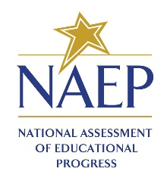
NAEP School Questionnaire
Custom link enclosed

Dear [SQ Respondent First Name] [SQ Respondent Last Name],
[Grade/Age] students at [school name] will take [science] assessments on [assessment date]. The National Assessment of Educational Progress (NAEP) is the only ongoing assessment of what our nation’s students know and can do in a variety of subjects.

In addition to conducting assessments, NAEP gathers information on school policies and characteristics by using a school questionnaire. [School coordinator name] has identified you as the appropriate individual to complete the questionnaire. Your responses will provide important information for educators, policymakers, and researchers to better understand the context in which students learn. This enhanced understanding can help improve education in our nation's classrooms. To complete the questionnaire:

- Select the questionnaire link below or copy/paste it into your browser.
- See separate email for the access code; the subject is NAEP School Questionnaire – Access Code.
- Please complete the questionnaire before [assessment date]. It takes approximately [Grade 8 = 20] minutes to complete, and it does not have to be completed in one visit.

[NAEPq link]

For technical assistance, contact the NAEP help desk at 1-800-283-NAEP (6237) or naephelp@westat.com.

Visit https://nces.ed.gov/nationsreportcard/experience/survey_questionnaires.aspx to view PDFs of the questionnaires and explore how your responses contribute to reportable NAEP results that show what our nation’s students know and can do.

Email With NAEPq Access Code (School Questionnaire)
To: NAEP School Questionnaire Respondent
Subject: NAEP School Questionnaire – Access Code
NAEP School Questionnaire
Access Code

Dear [SQ Respondent First Name] [SQ Respondent Last Name],
Thank you for supporting the National Assessment of Educational Progress (NAEP).

You should have a separate email with the NAEP School Questionnaire link for [school name]. The Access Code is available below.

[Access Code]

For technical assistance, contact the NAEP help desk at 1-800-283-NAEP (6237) or naephelp@westat.com.

NAEP School Questionnaire – Reminder
To: NAEP School Questionnaire Respondent
CC: School coordinator
Subject: NAEP School Questionnaire – Reminder
NAEP School Questionnaire
Reminder

Dear [SQ Respondent First Name] [SQ Respondent Last Name],
Thank you for supporting the National Assessment of Educational Progress (NAEP). Recently, you received an email asking you to complete the NAEP School Questionnaire for [school name]. Please disregard this email if you have already completed the questionnaire.
If you have not already completed the questionnaire, please follow the instructions below to complete the questionnaire.
- Select the questionnaire link below or copy/paste it into your browser.
- See separate email for the access code; the subject is NAEP School Questionnaire – Access code.
- Your school’s NAEP representative is monitoring questionnaire progress. It takes approximately [Grade 8 = 20] minutes to complete, and it does not have to be completed in one visit.

[NAEPq link]

For technical assistance, contact the NAEP help desk at 1-800-283-NAEP (6237) or naephelp@westat.com.
Visit https://nces.ed.gov/nationsreportcard/experience/survey_questionnaires.aspx to view PDFs of the questionnaires and explore how your responses contribute to reportable NAEP results that show what our nation’s students know and can do.

Email With NAEPq URL (Teacher Questionnaire)
To: NAEP Teacher Questionnaire Respondent
Subject: NAEP Teacher Questionnaire – Link
NAEP Teacher Questionnaire
Custom link enclosed

Dear [TQ Respondent First Name] [TQ Respondent Last Name],
[Grade/Age] students at [school name] will take a [science] assessment on [assessment date]. The National Assessment of Educational Progress (NAEP) is the only ongoing assessment of what our nation’s students know and can do in a variety of subjects.

In addition to conducting assessments, NAEP uses a teacher questionnaire to gather information concerning instructional practices, classroom organization, and teacher background and training. [School coordinator name] has identified you as a teacher whose students have been selected to participate in the NAEP assessment. Your responses will provide important information for educators, policymakers, and researchers to better understand the context in which students learn. This enhanced understanding can help improve education in our nation's classrooms. To complete the questionnaire:

- Select the questionnaire link below or copy/paste it into your browser.
- See separate email for the access code; the subject is NAEP Teacher Questionnaire – Access Code.
- Please complete the questionnaire before [assessment date]. It takes approximately [Grade 8 = 20] minutes to complete, and it does not have to be completed in one visit.

[NAEPq link]

For technical assistance, contact the NAEP help desk at 1-800-283-NAEP (6237) or naephelp@westat.com.

Visit https://nces.ed.gov/nationsreportcard/experience/survey_questionnaires.aspx to view PDFs of the questionnaires and explore how your responses contribute to reportable NAEP results that show what our nation’s students know and can do.

Email With NAEPq Access Code (Teacher Questionnaire)
To: NAEP Teacher Questionnaire Respondent
Subject: NAEP Teacher Questionnaire – Access Code
NAEP Teacher Questionnaire
Access Code

Dear [TQ Respondent First Name] [TQ Respondent Last Name],
Thank you for supporting the National Assessment of Educational Progress (NAEP).

You should have a separate email with the NAEP Teacher Questionnaire link for [school name]. The Access Code is available below.

[Access Code]

For technical assistance, contact the NAEP help desk at 1-800-283-NAEP (6237) or naephelp@westat.com.

NAEP Teacher Questionnaire – Reminder
To: NAEP Teacher Questionnaire Respondent
CC: School coordinator
Subject: NAEP Teacher Questionnaire – Reminder
NAEP Teacher Questionnaire
Reminder

Dear [TQ Respondent First Name] [TQ Respondent Last Name],
Thank you for supporting the National Assessment of Educational Progress (NAEP). Recently, you received an email asking you to complete the NAEP Teacher Questionnaire for [school name]. Please disregard this email if you have already completed the questionnaire.
If you have not already completed the questionnaire, please follow the instructions below to complete the questionnaire.
- Select the questionnaire link below or copy/paste it into your browser.
- See separate email for the access code; the subject is NAEP Teacher Questionnaire – Access code.
- Your school’s NAEP representative is monitoring questionnaire progress. It takes approximately [Grade 8 = 20] minutes to complete, and it does not have to be completed in one visit.

[NAEPq link]

For technical assistance, contact the NAEP help desk at 1-800-283-NAEP (6237) or naephelp@westat.com.
Visit https://nces.ed.gov/nationsreportcard/experience/survey_questionnaires.aspx to view PDFs of the questionnaires and explore how your responses contribute to reportable NAEP results that show what our nation’s students know and can do.

NAEP Questionnaire Status Report
To: School Coordinator
CC: Principal
Subject: NAEP Questionnaire Status Report
NAEP Questionnaire Status Report

Dear [School Coordinator First Name] [School Coordinator Last Name],

Thank you for supporting the National Assessment of Educational Progress (NAEP). Below is a report showing the status of the NAEP questionnaires for [school name]. Please encourage these respondents to complete their questionnaires before [assessment date].

Respondent Name | Questionnaire Type | Status
[Respondent First Name] [Respondent Last Name] | NAEP School | [questionnaire status]
[Respondent First Name] [Respondent Last Name] | NAEP Teacher | [questionnaire status]

For technical assistance, contact the NAEP help desk at 1-800-283-NAEP (6237) or naephelp@westat.com.

Appendix D-31: NAEP 2027 Preassessment Responsibilities Guide-Private Schools, NAEP Device Model (NEW)

NAEP 2027 Private School Preassessment Responsibilities Guide (NAEP Device)
Thank you for your support of the National Assessment of Educational Progress (NAEP). We look forward to working with you to make NAEP a positive experience at your school. The Assessment Management System (AMS) will be your primary resource for completing the assessment planning tasks online for the upcoming assessment.
This guide outlines the tasks you will complete along with available resources to make assessment day successful.
NAEP Activity Timeline
December–January:
- Complete Preassessment Activities
January–February:
- Attend Assessment Planning Meeting
At least one week before the scheduled assessment:
- Notify Parents and Guardians
- Support Assessment Activities
January 25–March 19:
- NAEP 2027 Assessment Window
After the assessment:
- Complete Postassessment Activities
You will need to complete the following activities:
- Complete Preassessment Activities
Complete the following preassessment activities in the AMS when the student sample is released in December.
- Schedule Assessment Planning Meeting
  - Select a date and time (1-hour block) to schedule the Assessment Planning Meeting with your NAEP representative in the AMS. Upon request, your NAEP representative can review how to complete the planning tasks outlined below.
- Provide Student Information
  - Review the student sample and identify any students who cannot take the assessment.
  - Review the demographic information and update any information that is missing or inaccurate.
  - Provide information about students with disabilities (SD) and English learners (EL) so NAEP assessment administrators can plan appropriate testing accommodations.
    - You can invite your school’s SD and EL specialists to register for the AMS to assist with this task.
    - School staff may need to assist with certain accommodations (e.g., cueing to stay on task, scribe). You will need to provide the names and contact information for school staff who will assist with these accommodations on assessment day.
- Assessment Logistics
  - Record school start and end times.
  - Schedule the assessment groups and reserve space to administer the assessment at your school.
    - School staff presence in the assessment location is encouraged to help support classroom management.
  - Review the assigned assessment group for each sampled student and update students’ group assignments as needed.
  - Provide assessment day details, including
    - procedures for arriving and checking in on assessment day;
    - classroom protocols;
    - who to contact in case of emergency; and
    - how you would like students to be dismissed after the assessment.
- Manage Questionnaires
  - Identify respondents and provide the names and contact information for the school and teacher questionnaires.
  - Match students to their subject-specific teacher in the AMS.
  - Monitor school staff completion of the questionnaires.
- Attend Assessment Planning Meeting
- Attend the 1-hour virtual planning meeting with your NAEP representative to review and confirm the information entered into the AMS.
- Notify Parents and Guardians
- Download and distribute the Parent/Guardian Notification Letter from the Notify Parents and Guardians section in the AMS.
  - By law, parents and guardians of students selected to participate in NAEP must be notified in writing of their child’s selection prior to the administration of the assessment.
- Certify in the AMS that these notifications were sent.
- Support Assessment Day Activities
- Download and print resources from the Support Assessment Day section in the AMS to remind teachers and students about the assessment.
  - Share the Teacher Notification Letter and List of Participating Students.
  - Distribute the Student Appointment Cards.
- On Assessment Day
- The school coordinator and the teachers of selected students are encouraged to remain in the room during the assessment to support classroom management. Having a school staff member present during the assessment is appreciated and can have a positive impact on students’ motivation and performance.
- If the attendance of sampled students is less than 80 percent, a makeup session will be necessary, and the NAEP representative will work with you to schedule another date to administer the assessment to the absent students.
- After the Assessment
- Destroy any hardcopy documents containing student names according to school protocol.
- Complete a short email survey on your experience with NAEP.

If you need assistance with the AMS, including an expired link in the Account Activation email or an AMS error message, contact the NAEP help desk at 1-800-283-6238 or naephelp@westat.com.
If you need assistance with Login.gov, including management of your Login.gov account or an error message on Login.ed.gov, please go to the Login.gov Help Center at https://login.gov/help/ or visit Login.gov for additional information and support.
Online Resources Information for selected schools
Information for Selected Schools | https://nces.ed.gov/nationsreportcard/participating/private_nonpublic.aspx
Sample Questions Booklets | http://nces.ed.gov/nationsreportcard/about/booklets.aspx
NAEP Questions Tool | http://nces.ed.gov/nationsreportcard/nqt
Information for Parents and Guardians | http://nces.ed.gov/nationsreportcard/parents
Assessment Frameworks | https://www.nagb.gov/naep-frameworks/frameworks-overview.html
Digitally Based Assessments | https://nces.ed.gov/nationsreportcard/dba

For more information about NAEP, visit https://nces.ed.gov/nationsreportcard/.
Find us on: [Facebook, Instagram, LinkedIn, X, and YouTube logos]

The National Center for Education Statistics (NCES) conducts the National Assessment of Educational Progress to evaluate federally supported education programs. All of the information you provide may only be used for the purposes of research, statistics, and evaluation under the Education Sciences Reform Act of 2002 (ESRA; 20 U.S.C. § 9543) and may not be disclosed, or used, in identifiable form for any other purpose except as required by law. Every NCES employee as well as every NCES agent, such as contractors and NAEP coordinators, has taken an oath and is subject to a jail term of up to 5 years, a fine of $250,000, or both if he or she willfully discloses ANY identifiable information about you in any unauthorized manner. Electronic submission of your information will be monitored for viruses, malware, and other threats by Federal employees and contractors in accordance with the Cybersecurity Enhancement Act of 2015.

Appendix D-32: NAEP 2027 School Staff Assistance email templates (NEW)

[Technical Support Only]
Subject: NAEP Assessment School Staff Support (Technical Support)
To: School staff person identified to assist with technology
CC: School Coordinator, Backup Technical Support person
Attachments: “NAEP 2027 School Staff Assistance Guidelines.pdf” and NAEP Non-Disclosure Agreement

Dear [SCHOOL STAFF PERSON FIRST NAME LAST NAME],
You have been selected by your school to support the NAEP assessment with school technology. Because of your familiarity with the school’s devices, your support is essential and greatly appreciated.

I look forward to seeing you on [ASSESSMENT DAY OF WEEK], [ASSESSMENT DATE]. I’ve attached the NAEP School Staff Assistance Guidelines, which provide more detail about your role.

Your support on assessment day
- Meet me and the NAEP team at [ARRIVAL TIME].
  - Assist with setting up the school’s devices (including spare devices).
  - Provide the school’s Wi-Fi network name and credentials (a guest network is fine).
  - Help troubleshoot device and network issues as the NAEP Assessment Application is launched.
- Plan to remain in the assessment location until students have started the assessment. However, you are encouraged to stay for the duration of the assessment.
- If you need to leave at any time, please let me know so another staff member can be available to assist with technical support.

Important Assessment Guidelines
Please follow these guidelines to ensure the validity of the assessment results:

- Please do not answer any questions students may have about the assessment.
- Please avoid conversations during the session, including conversations with me, or other NAEP staff, unless necessary.
- Please do not view students’ screens while they are taking the assessment.

On assessment day, you will be asked to digitally sign an electronic copy of the NAEP Non-Disclosure Agreement (NDA) before the assessment starts. A copy of the NDA is attached for your reference.
A backup support person from your school is copied on this email in case you are unavailable.
Please call or email me if you have any questions. Thank you again for your support!
Thank you,
[NAEP Representative Name]
NAEP Representative
[NAEP Representative Email address]
[Phone]

[Classroom Management Support Only]
Subject: NAEP Assessment School Staff Support (Classroom Support)
To: School staff person identified to assist with classroom support
CC: School Coordinator, Backup Classroom Management Support person
Attachments: “NAEP 2027 School Staff Assistance Guidelines.pdf” and NAEP Non-Disclosure Agreement

Dear [SCHOOL STAFF PERSON FIRST NAME LAST NAME],
You have been selected by your school to support the NAEP assessment with classroom management. Your support is essential and greatly appreciated.

I look forward to seeing you on [ASSESSMENT DAY OF WEEK], [ASSESSMENT DATE]. I’ve attached the NAEP School Staff Assistance Guidelines, which provide more detail about your role.

Your support on assessment day
- Please arrive at the same time as the students at [GROUP START TIME].
- Plan to remain in the assessment location for the full session to support classroom management.
- If you need to leave at any time, please let me know so another staff member can be available to assist.

Important Assessment Guidelines
Please follow these guidelines to ensure the validity of the assessment results:

- Please do not answer any questions students may have about the assessment.
- Please avoid conversations during the session, including conversations with me, or other NAEP staff, unless necessary.
- Please do not view students’ screens while they are taking the assessment.

On assessment day, you will be asked to digitally sign an electronic copy of the NAEP Non-Disclosure Agreement (NDA) before the assessment starts. A copy of the NDA is attached for your reference.
A backup support person from your school is copied on this email in case you are unavailable.
Please call or email me if you have any questions. Thank you again for your support!
Thank you,
[NAEP Representative Name]
NAEP Representative
[NAEP Representative Email address]
[Phone]

[Technical Support and Classroom Management Support]
Subject: NAEP Assessment School Staff Support (Classroom and Technical Support)
To: School staff person identified to assist with technology and classroom support
CC: School Coordinator, Backup School Staff person (for both technology and classroom support)
Attachments: “NAEP 2027 School Staff Assistance Guidelines.pdf” and NAEP Non-Disclosure Agreement

Dear [SCHOOL STAFF PERSON FIRST NAME LAST NAME],
You have been selected by your school to support the NAEP assessment with school technology and classroom management. Because of your familiarity with the school’s devices, your support is essential and greatly appreciated.

I look forward to seeing you on [ASSESSMENT DAY OF WEEK], [ASSESSMENT DATE]. I’ve attached the NAEP School Staff Assistance Guidelines, which provide more detail about your role.

Your support on assessment day
- Meet me and the NAEP team at [ARRIVAL TIME].
  - Assist with setting up the school’s devices (including spare devices).
  - Provide the school’s Wi-Fi network name and credentials (a guest network is fine).
  - Help troubleshoot device and network issues as the NAEP Assessment Application is launched.
- During the assessment, plan to remain in the assessment location for the full session to support classroom management.
- If you need to leave at any time, please let me know so another staff member can be available to assist with classroom management and technical support.

Important Assessment Guidelines
Please follow these guidelines to ensure the validity of the assessment results:

- Please do not answer any questions students may have about the assessment.
- Please avoid conversations during the session, including conversations with me, or other NAEP staff, unless necessary.
- Please do not view students’ screens while they are taking the assessment.

On assessment day, you will be asked to digitally sign an electronic copy of the NAEP Non-Disclosure Agreement (NDA) before the assessment starts. A copy of the NDA is attached for your reference.
A backup support person from your school is copied on this email in case you are unavailable.
Please call or email me if you have any questions. Thank you again for your support!
Thank you,
[NAEP Representative Name]
NAEP Representative
[NAEP Representative Email address]
[Phone]

Appendix D-33: NAEP 2027 Facts for Teachers (NEW)

NAEP 2027 Facts for Teachers

What is NAEP?
The National Assessment of Educational Progress (NAEP) is an integral measure of academic progress across the nation and over time. It is the largest nationally representative and continuing assessment of what our nation’s students know and can do in various subjects, such as civics, mathematics, reading, science, and U.S. history. The program also provides valuable insights into students’ educational experiences and opportunities to learn in and outside the classroom. Elected officials, policymakers, and educators use NAEP results to develop ways to improve education.

NAEP is a congressionally mandated program administered by the National Center for Education Statistics (NCES), within the U.S. Department of Education and the Institute of Education Sciences.

The National Assessment Governing Board—an independent, bipartisan organization made up of governors, state legislators, state school superintendents, teachers, researchers, and representatives of the general public—sets policy for NAEP.

What NAEP assessments will be administered in 2027?
The 2027 program will include
- a grade 8 science pilot assessment; and, if applicable,
- survey questionnaires for participating students, teachers, and school administrators to provide a better understanding of students’ educational experiences.

NCES will administer the pilot assessment between January 25 and March 19, 2027.

NCES will not release results from the pilot assessment but will use the results to inform future assessments.
“As a teacher, my constant focus is to help students make progress in the classroom. NAEP helps with this mission by creating a common measure of student achievement across the country.”
— Iris Garcia, Teacher, Biscayne Elementary Community School, Miami Beach, Florida

What can teachers and students expect?

Students are given approximately 2 hours to complete the assessments unless accommodations are provided. This includes transition time, directions, and completion of survey questionnaires. A broad range of accommodations are provided for students with disabilities and English learners.

Teachers do not need to prepare their students to take the assessment, but should encourage students to do their best.

Who will administer NAEP? What do schools need to provide on the day of the assessment?
NAEP representatives will administer the NAEP assessment and provide significant support to schools on assessment day. Schools will need to provide space for students to take the assessment, desks or tables, and an adequate number of electrical outlets in the assessment location.
- In schools where the assessment will be administered using school devices, district and/or school staff who have experience with the devices will be required to be available during the assessment session(s).
- In schools where the assessment will be administered using NAEP devices, NAEP representatives will bring all necessary materials and equipment to assess the students.

How are schools and students selected for NAEP?
Schools are selected as part of a carefully designed sampling process that ensures NAEP-selected schools and students are representative of the nation.

How is NAEP different from our state assessment?
NAEP serves a different role than state assessments. While states have their own unique assessments with different content and performance standards, the same NAEP assessment is administered across the nation, providing a common measure of student achievement.

NAEP and Teachers
How are teachers essential partners in NAEP?
Schools and students selected to participate in NAEP represent schools and students across the country. Teachers make an important contribution by encouraging their students to participate and to give their best effort; this helps ensure that NAEP results provide the most accurate measure possible of student achievement across the country. To learn more about NAEP and view FAQs for teachers, visit https://nces.ed.gov/nationsreportcard/educators/.

Why are students, teachers, and principals asked to complete survey questionnaires?
In addition to subject-area questions, students participating in NAEP are asked to complete a survey questionnaire. Results from the questionnaire help put student achievement results in context, allow for meaningful comparisons between student groups, and offer important insights to help educators, policymakers, and researchers better understand U.S. students’ educational experiences.

Teachers of students participating in NAEP are also asked to complete a survey questionnaire. The NAEP teacher survey questionnaire gathers information on teacher training and instructional practices. The questionnaire will be delivered via an online format.

Principals or school administrators of students participating in NAEP are asked to complete a survey questionnaire that provides information about school policies and characteristics. This questionnaire will also be delivered via an online format.

To learn more about NAEP survey questionnaires and view student, teacher, and school questionnaires from previous years, visit https://nces.ed.gov/nationsreportcard/survey_questionnaires.aspx.

How can teachers use NAEP resources and data to help students?
Use the NAEP Questions Tool (https://nces.ed. gov/nationsreportcard/nqt) to view released NAEP items and create customized assessments for your classroom. Teachers can compare students’ performance with the performance of their peers in the state and across the nation. Teachers, students, and parents can access released items and compare results for various demographic groups. Most released items include a scoring guide, sample student responses, and performance data.

Use the NAEP Data Explorer (https://www.nationsreportcard.gov/ndecore) to examine the relationships between student performance and factors like instructional practices, school resources, and more.

How can teachers use the online dashboards to explore NAEP results, and more?
Use the Achievement Gaps dashboard to explore score differences between two student groups of choice (e.g., by school location or economically disadvantaged status). Teachers can view the results for their state or select urban districts that participate in the Trends in Urban Districts Assessment (TUDA) program. To examine the latest national results in all the NAEP subjects and data about students’ educational experiences by school type, use the Public, Private, and Charter Schools Dashboard.

The Achievement Gaps Dashboard is available at https://www.nationsreportcard.gov/dashboards/achievement_gaps.aspx.

The Public, Private, and Charter Schools Dashboard is available at https://www.nationsreportcard.gov/dashboards/schools_dashboard.aspx.

How long has NAEP been around?
NAEP was first administered in 1969 to measure student achievement nationally. In 1990, NAEP was administered at the state level for the first time. The NAEP TUDA program, which measures student achievement in some of the nation’s large urban districts, began in 2002. The program has come to be recognized as the gold standard of large-scale assessments due to its high technical quality and rigorous design and methodology.

NAEP Results
NAEP results are released as The Nation’s Report Card. Depending on the assessment, NAEP results are available for the nation, states, and TUDA districts. Results are also available for different student groups based on factors such as race/ethnicity, sex, school location, and more. NAEP is not designed to report results for individual students, classrooms, or schools. Within a school, just some of the student population participates, and student responses are combined with those from students in other participating schools to produce the results.

Explore NAEP results at www.nationsreportcard.gov.

Students in grades 4 and 8 are assessed at the national and state levels in mathematics and reading every 2 years. Under the Elementary and Secondary Education Act, districts and states that receive Title I funds are required to participate in these biennial assessments. Other subjects and grade 12 students are assessed periodically. NAEP long-term trend assessments allow the performance of today’s students to be compared with students since the early 1970s and are administered periodically to 9-, 13-, and 17-year-olds.

2024 NAEP Science Assessment at Grade 8
In 2024, the average science score for eighth-graders decreased by 4 points compared to 2019. Scores for lower-performing students at the 10th and 25th percentiles were lower than in 2009, the start of a new trendline marking the first administration of the assessment with the 2009 science framework.

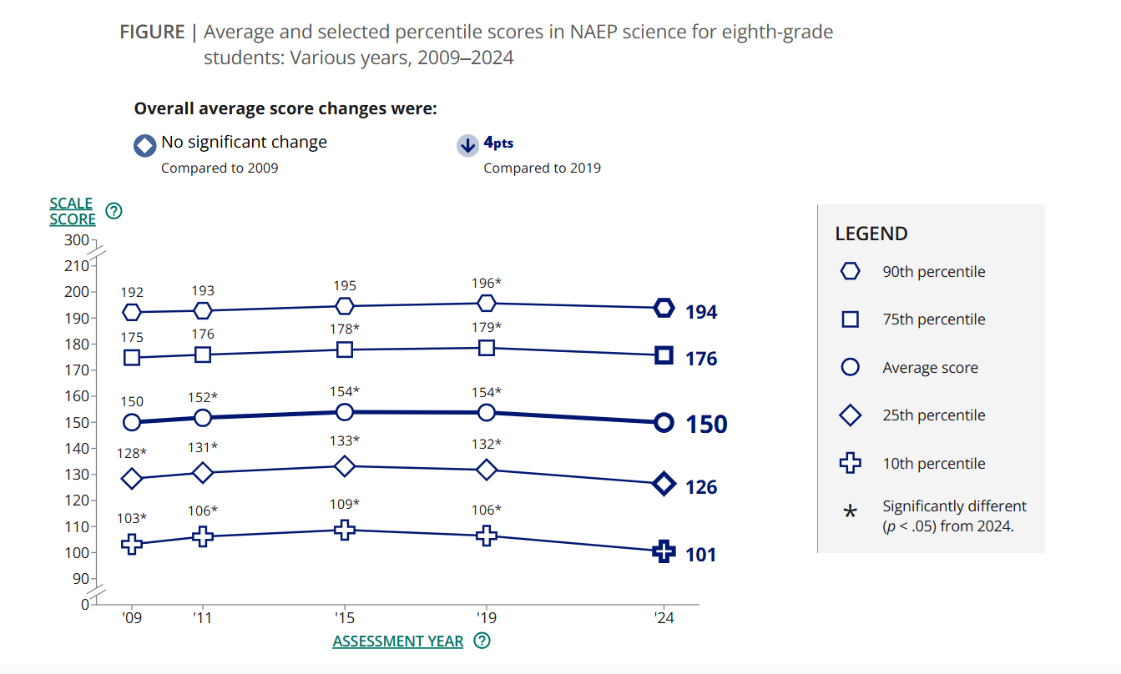

More About NAEP
To learn about upcoming NAEP assessments, download NAEP reports, and access sample questions, visit https://nces.ed.gov/nationsreportcard. Explore the latest NAEP results at https://nationsreportcard.gov.

To hear teachers share their thoughts about why NAEP results are important, watch the video Introducing NAEP to Teachers at https://nces.ed.gov/nationsreportcard/participating/schools.aspx.

To find your NAEP State Coordinator’s contact information, visit https://nces.ed.gov/nationsreportcard/states and select your state or jurisdiction from the drop-down menu.

“The NAEP team that arrived at our school made the assessment process painless. Everyone on the team previously worked as an educator and interacted well with all of our students.”
—Kimberly Wilborn, Guidance Counselor, Sandburg Middle School, Fairfax County Public Schools, Alexandria, Virginia

The National Center for Education Statistics (NCES) conducts the National Assessment of Educational Progress to evaluate federally supported education programs. All of the information you provide may only be used for the purposes of research, statistics, and evaluation under the Education Sciences Reform Act of 2002 (ESRA; 20 U.S.C. § 9543) and may not be disclosed, or used, in identifiable form for any other purpose except as required by law. Every NCES employee as well as every NCES agent, such as contractors and NAEP coordinators, has taken an oath and is subject to a jail term of up to 5 years, a fine of $250,000, or both if he or she willfully discloses ANY identifiable information about you in any unauthorized manner. Electronic submission of your information will be monitored for viruses, malware, and other threats by Federal employees and contractors in accordance with the Cybersecurity Enhancement Act of 2015.

This publication was prepared for the National Assessment of Educational Progress by Manhattan Strategy Group under contract 91990018C0001 to the National Center for Education Statistics, U.S. Department of Education.

Appendix D-34: NAEP 2027 An Overview of NAEP Brochure (NEW)

An Overview of NAEP

What is NAEP?
The National Assessment of Educational Progress (NAEP) provides essential information about academic achievement and learning experiences of students in public and private schools across the United States. Also known as The Nation’s Report Card, NAEP has shed light on student achievement to inform education policy and practice since 1969.

Who conducts NAEP?
NAEP is required by Congress and carried out by the National Center for Education Statistics (NCES), which is part of the U.S. Department of Education’s Institute of Education Sciences. The Commissioner of Education Statistics leads the organization and executes the measurement and reporting of NAEP.

An independent, bipartisan board—called the National Assessment Governing Board (Governing Board)—sets policy for NAEP. The board includes governors, state legislators, state school superintendents, teachers, researchers, and members of the general public.

How is NAEP different from state assessments?
NCES administers NAEP across the country, allowing for apples-to-apples comparisons of mathematics and reading achievement over time and for all 50 states and more than 20 select urban districts that participate in the Trends in Urban Districts Assessment (TUDA) program. State tests measure how individual students perform on each state’s specific content standards, and they vary across the country.

What subjects does NAEP assess?
NCES conducts NAEP to assess student performance in mathematics, reading, science, civics, U.S. history, and other subjects as resources allow and as specified by the National Assessment Governing Board.

How often is NAEP administered?
As required by Congress, NCES conducts the NAEP mathematics and reading assessments for students in grades 4 and 8 every 2 years. Assessments in other subjects and for students in grade 12 are administered periodically, often in 4-year intervals.

The NAEP long-term trend assessments in mathematics and reading are also administered periodically for students who are 9, 13, and 17 years old.

The Governing Board determines when each subject is tested, which grades are included, and if results will be available for the nation, states, and/or urban districts.

How does NAEP provide information about students’ learning experiences?
Participating schools, teachers, and students answer survey questions as part of the NAEP assessments. Responses to these questions help educators, policymakers, and researchers better understand the context in which students learn.
- Student questionnaires ask about student demographics and how they learn in and outside of school.
- Teacher questionnaires ask about teacher demographics, school expectations and resources, professional development opportunities, and instructional practices.
- School questionnaires ask about school policies, resources, and characteristics.

How are schools and students selected for NAEP?
NCES carefully selects schools for NAEP via a sampling process that ensures participating students represent the characteristics of their district, state, or the entire nation. Students from each selected school are then randomly chosen to participate and represent similar students across the United States.

What is it like to participate in NAEP?
- Students complete NAEP assessments on digital devices, except for long-term trend assessments. Students complete long-term trend assessments in a paper booklet. NAEP representatives set up and supervise both types of assessments.
- The assessment is administered during regular school hours and lasts up to 120 minutes. During that time, students answer questions in one subject area and complete the student questionnaire.
- NCES provides accommodations, as allowed, for students with disabilities and English learners.

How does NCES report NAEP results?
Depending on the assessment, NCES reports NAEP results for the nation, states, and/or TUDA districts. NCES also reports results for various student groups, based on factors such as socioeconomic status, school type, and school location. These results allow for comparisons over time and between student groups. NCES does not report NAEP results for individual students or schools.

Achievement results are reported as average scale scores, selected percentile scores, and the percentage of students reaching the NAEP achievement levels—NAEP Basic, NAEP Proficient, and NAEP Advanced. NAEP achievement levels, set by the Governing Board, differ from those used on state assessments and do not represent grade-level performance.

[Callout box]
Educators, researchers, and policymakers can use the data to answer questions such as:
- How have students’ skills and knowledge in different subjects changed over time?
- How do student achievement and experiences in my state or district compare to other jurisdictions?
- Are there instructional, resource, or academic support differences between higher- and lower-performing students?

Why should schools and students participate in NAEP?
Each school and student selected to participate in NAEP represents similar schools and students across the country. When schools and students participate in NAEP, they are contributing to an accurate and complete picture of academic achievement and students’ learning experiences—providing valuable insights into the condition of education systems throughout the country.

How can principals and teachers use NAEP?
NAEP has tools and resources for educators to explore data about educational experiences and achievement in their state, district, or nationwide. Educators can use NAEP tools and resources to
- learn how many students in their jurisdiction performed at or above the NAEP Basic and NAEP Proficient achievement levels;
- create tests using questions from previous NAEP assessments to see how their students’ performance compares with student performance in their state or nationwide;
- explore NAEP survey data to get a better understanding of their students’ educational experiences in and outside of school; and
- see how students, on average, performed on specific NAEP questions.

[Footer]
See recent results, sample questions, and more on the NAEP websites.
<QR code to linktree>

The National Center for Education Statistics (NCES) conducts the National Assessment of Educational Progress to evaluate federally supported education programs. All of the information you provide may only be used for the purposes of research, statistics, and evaluation under the Education Sciences Reform Act of 2002 (ESRA; 20 U.S.C. § 9543) and may not be disclosed, or used, in identifiable form for any other purpose except as required by law. Every NCES employee as well as every NCES agent, such as contractors and NAEP coordinators, has taken an oath and is subject to a jail term of up to 5 years, a fine of $250,000, or both if he or she willfully discloses ANY identifiable information about you in any unauthorized manner. Electronic submission of your information will be monitored for viruses, malware, and other threats by Federal employees and contractors in accordance with the Cybersecurity Enhancement Act of 2015.

This publication was prepared for the National Assessment of Educational Progress by Manhattan Strategy Group under contract 91990018C0001 to the National Center for Education Statistics, U.S. Department of Education.

Appendix D-35: NAEP 2027 Inclusion Guidelines for English Learners (NEW)

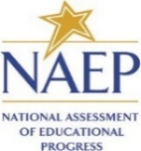

State
NAEP 2027 Inclusion Policy for English learners (EL)
Grade 8 Science

The State Department of Education expects that most English learners will be included on the National Assessment of Educational Progress (NAEP). Only English learners who have been enrolled in U.S. schools for less than one (1) full academic year before the NAEP assessment and cannot access NAEP may be excluded from any NAEP assessment. All other English learners should participate in NAEP with or without NAEP accommodations. If you have questions about the NAEP accommodations, please contact name, NAEP State Coordinator at email.
Several accommodations provided on the state assessments are not necessary for the NAEP assessments because they are available for all students through universal design elements. The chart below is divided into two sections: (1) universal design elements that are available to all students, (2) accommodations. NAEP accommodations are only allowed for English learners.

Please keep in mind that NAEP does not report results for individual students or schools, unlike state assessments. In other words, NAEP carries no consequences for students or schools; its purpose is solely to provide a national and state-level picture of educational performance and progress.

It is also important to remember that not all assessments are designed to measure the same constructs. Because NAEP is developed for a specific purpose, it may not allow or support all accessibility features or accommodations available on state assessments.

When making inclusion decisions for NAEP, please consider the following:
- Students who receive multiple-day testing on the state assessments should take the NAEP assessments in 1 day with breaks as needed. NAEP is much shorter than most state assessments, so multiple-day testing is not supported.
- Graphic organizers are not allowed on the NAEP assessment.

Table 1: NAEP Universal Design Elements available to all students
Grade 8 Science-- Digitally Based Assessment on Device
Universal Design Element | Description
Closed Captioning¹ | All voice-over narration is closed-captioned.
Color Theming¹ | Option 1: black text on white background (default)  Option 2: white text on black background  Option 3: black text on beige background  - This tool is not available for the tutorial and some items.
Directions Explained/Clarified² | Students can raise their hand at any time and ask the test administrator to clarify or explain directions.
Directions Read Aloud/Text-to-Speech (English)¹ | All directions in the assessment are text-to-speech enabled, including general directions, directions within the assessment, Tutorial, Help, and Student Questionnaire screens.
Elimination Capability¹ | Students can gray out answer choices for multiple-choice items. This tool is not available for constructed-response items.
Individual Testing Experience² | Read Aloud and other UDE and accommodations are provided through the device and will not distract other students in the room.  - Students have earbuds to reduce distractions.  - Students interact directly with device.  - Tested with other selected students.  - Refer to the accommodation Preferential Seating to minimize distractions for testing with other students.
Read Aloud/Text-to- Speech (English) – Occasional or Most or All¹ | Students select some or all text to be read aloud by the system using text-to- speech.
Scratch Paper² | Administrators inform students that scratch paper (and pencil) is available upon request.
Scratchwork Capability¹ | Allows freehand drawing on the screen for most content.
Text Highlighter¹ | Allows the highlighting of text on the screen for most content.
Text Notepad¹ | Allows text to be entered from the physical keyboard to record notes into a resizable window for each question.
Use a Computer/Tablet to Respond² | All students respond on devices.
Volume Adjustment² | Students can raise or lower voice-over volume using the device’s volume buttons.
Zooming¹ | Enlarges some content onscreen up to three times (3X) the default text/image size on the screen while preserving clarity, contrast, and color.  Does not include the tutorial, toolbar, item tabs, scrollbars, or calculator.
¹ embedded
² non-embedded
³ school provides

Table 2: NAEP accommodations
Grade 8 Science-- Digitally Based Assessment on Device
Accommodation | Description
Bilingual Dictionary (in any language)^{2,3} | A handheld electronic or hardcopy bilingual dictionary provided by the school in any language that contains English translations of words but does not contain definitions.
Breaks During Test² | Students are allowed to take breaks as requested or at predetermined intervals during the assessment. Students can take the assessment in more than one sitting during a single day.
Cueing to Stay on Task^{2,3} | - Monitor for understanding, monitor placement of responses.  - Redirect to stay on task, reminders to stay on task, prompts to stay on task.  - Provide verbal encouragement, reinforcement, refocus.  - Track test items.
Extended Time¹ | Students are given up to three times (3X) the allotted time to complete the assessment.  - If state test is untimed, students may or may not require extended time on NAEP.  - Most students are able to complete the NAEP cognitive sections in the time allowed.
Familiar Person Present in Testing Room^{2,3} | The aide who regularly works with the student must be present in the testing room during time of assessment.  - Only trained NAEP staff may conduct the assessment session.
Flexible Scheduling² | Testing at a specific time of day (e.g., rolling starts and time of day based on student schedules).
Medical Supports^{2,3} | Students may have access to medical supports for medical purposes. The medical support may include a cell phone and should only support the student during testing for medical reasons.  - Permits access to diabetes testing supplies.  - Permits use of hearing aides, including Bluetooth.  - Access to nurse or medication.
Preferential Seating² | - Seating to reduce distractions within the general testing session.  - Front of the class, close to the test administrator, etc.
Read Aloud to Self or Whisper Phone^{2,3} | Whisper phone is an acoustic tool used as a testing accommodation to help students focus and improve reading fluency, comprehension, and word decoding by allowing them to hear themselves read aloud softly. If a whisper phone is not available, students may be allowed to read in a whisper to themselves.
Requires Snack or Water During Testing^{2,3} | Students are allowed to have a snack or water during testing to support medical needs.
Separate Location/Small Group² | Student is tested in a separate location to meet testing needs as appropriate.  - Refer to the UDE Individual Testing Experience and accommodation Preferential Seating to determine if separate location/small group is needed.  - May be in the same room but in a specific location or a different room.  - Can be individual or with a small group of students.
Special Equipment^{2,3} | - FM system, amplification equipment, auditory amplification device.  - Noise buffers, study carrel, blinder, special lighting, adaptive furniture.  - Stress ball or sensory fidget item.
Uses Template^{2,3} | - Cutout, masking, color overlays, line reader, or place marker.
Other (specify) | Any accommodation not listed above. Please check with your NAEP Coordinator to see if other accommodations are allowed on NAEP.
¹ embedded
² non-embedded
³ school provides

Appendix D-36: NAEP 2027 Inclusion Guidelines for Students with Disabilities (NEW)
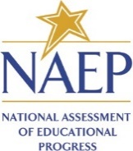

State
NAEP 2027 Inclusion Policy for Students with Disabilities (SD)
Grade 8 Science

The State Department of Education expects that most students with disabilities will be included on the National Assessment of Educational Progress (NAEP). Only students who meet (or met) participation criteria for [State Alternate Assessment Name] may be excluded from any NAEP assessment. All other students with disabilities should participate in NAEP with or without NAEP accommodations. If you have questions about the NAEP accommodations, please contact name, NAEP State Coordinator at email.
Several accommodations provided on the state assessments are not necessary for the NAEP digitally based assessments because they are available for all students through universal design elements. The chart below is divided into two sections: (1) universal design elements that are available to all students, (2) accommodations. NAEP accommodations are only allowed for a student on an Individualized Education Program (IEP) or Section 504 Plan.
Please keep in mind that NAEP does not report results for individual students or schools, unlike state assessments. In other words, NAEP carries no consequences for students or schools; its purpose is solely to provide a national and state-level picture of educational performance and progress.
It is also important to remember that not all assessments are designed to measure the same constructs. Because NAEP is developed for a specific purpose, it may not allow or support all accessibility features or accommodations available on state assessments.
When making inclusion decisions for NAEP, please consider the following:
- Students who receive multiple-day testing on the state assessments should take the NAEP assessments in 1 day with breaks as needed. NAEP is much shorter than most state assessments, so multiple-day testing is not supported.
- Graphic organizers are not allowed on the NAEP assessment.

Table 1: NAEP Universal Design Elements available to all students.
Grade 8 Science -- Digitally Based Assessment on Device
Universal Design Element | Description
Closed Captioning¹ | All voice-over narration is closed-captioned.
Color Theming¹ | Option 1: black text on white background (default)  Option 2: white text on black background  Option 3: black text on beige background  This tool is not available for the tutorial and some items.
Directions Explained/Clarified² | Students can raise their hand at any time and ask the test administrator to clarify or explain directions.
Directions Read Aloud/Text-to-Speech (English)¹ | All directions in the assessment are text-to-speech enabled, including general directions, directions within the assessment, Tutorial, Help, and Student Questionnaire screens.
Elimination Capability¹ | Students can gray out answer choices for multiple-choice items. This tool is not available for constructed-response items.
Individual Testing Experience² | Read Aloud and other UDE and accommodations are provided through the device and will not distract other students in the room.  - Students have earbuds to reduce distractions.  - Students interact directly with device.  - Tested with other selected students.  - Refer to the accommodation Preferential Seating to minimize distractions for testing with other students.
Read Aloud/Text-to- Speech (English) – Occasional or Most or All¹ | Students select some or all text to be read aloud by the system using text-to- speech.
Scratch Paper² | Administrators inform students that scratch paper (and pencil) is available upon request.
Scratchwork Capability¹ | Allows freehand drawing on the screen for most content.
Text Highlighter¹ | Allows the highlighting of text on the screen for most content.
Text Notepad¹ | Allows text to be entered from the physical keyboard to record notes into a resizable window for each question.
Use a Computer/Tablet to Respond² | All students respond on devices.
Volume Adjustment² | Students can raise or lower voice-over volume using the device’s volume buttons.
Zooming¹ | Enlarges some content onscreen up to three times (3X) the default text/image size on the screen while preserving clarity, contrast, and color.  - Does not include the tutorial, toolbar, item tabs, scrollbars, or calculator.
¹ embedded
² non-embedded
³ school provides

Table 2: NAEP accommodations
Grade 8 Science -- Digitally Based Assessment on Device
Accommodation | Description
Breaks During Test² | Students are allowed to take breaks as requested or at predetermined intervals during the assessment. Students can take the assessment in more than one sitting during a single day.
Calculator Version of the Test¹ | A calculator is available to complete the assessment and appears directly onscreen in the assessment.
Cueing to Stay on Task^{2,3} | - Monitor for understanding, monitor placement of responses.  - Redirect to stay on task, reminders to stay on task, prompts to stay on task.  - Provide verbal encouragement, reinforcement, refocus.  - Track test items.
Directions Only Presented in Sign Language^{2,3} | A qualified sign language interpreter at the school signs the instructions included in the session script.
Extended Time¹ | Students are given up to three times (3X) the allotted time to complete the assessment.  - If state test is untimed, students may or may not require extended time on NAEP.  - Most students are able to complete the NAEP cognitive sections in the time allowed.
Familiar Person Present in Testing Room^{2,3} | The aide who regularly works with the student must be present in the testing room during time of assessment.  - Only trained NAEP staff may conduct the assessment session.
Flexible Scheduling² | Testing at a specific time of day (e.g., rolling starts and time of day based on student schedules).
Hearing Impaired Version of the Test¹ | All auditory content is closed-captioned.
Medical Supports^{2,3} | Students may have access to medical supports for medical purposes. The medical support may include a cell phone and should only support the student during testing for medical reasons.  - Permits access to diabetes testing supplies.  - Permits use of hearing aides, including Bluetooth.  - Access to nurse or medication.
Multiplication table/100 table^{2,3} | A paper-based multiplication table. A paper-based table listing numbers from 1-100. The table the student requires will be provided by the school.
Preferential Seating² | - Seating to reduce distractions within the general testing session.  - Front of the class, close to the test administrator, etc.
Read Aloud to Self or Whisper Phone^{2,3} | Whisper phone is an acoustic tool used as a testing accommodation to help students focus and improve reading fluency, comprehension, and word decoding by allowing them to hear themselves read aloud softly. If a whisper phone is not available, students may be allowed to read in a whisper to themselves.
Requires Snack or Water During Testing^{2,3} | Students are allowed to have a snack or water during testing to support medical needs.
Separate Location/Small Group² | Student is tested in a separate location to meet testing needs as appropriate.  - Refer to the UDE Individual Testing Experience and accommodation Preferential Seating to determine if separate location/small group is needed.  - May be in the same room but in a specific location or a different room.  - Can be individual or with a small group of students.
Special Equipment^{2,3} | - FM system, amplification equipment, auditory amplification device.  - Noise buffers, study carrel, blinder, special lighting, adaptive furniture.  - Stress ball or sensory fidget item.
Uses Template^{2,3} | - Cutout, masking, color overlays, line reader, or place marker.
Other (specify) | Any accommodation not listed above. Please check with your NAEP Coordinator to see if other accommodations are allowed on NAEP.
¹ embedded
² non-embedded
³ school provides

Appendix D-37: NAEP 2027 School Staff Assistance Guidelines (NEW)

NAEP 2027 School Staff Assistance Guidelines

Welcome to the team! Thank you for your assistance with the NAEP assessment.

Your support is essential to helping students understand the importance of the NAEP assessment and ensuring the validity of the assessment results.

NAEP representatives are fully trained to administer the assessment and address student questions. As school staff, your role is vital to supporting the NAEP assessment. Please refer to the school staff support email sent to you to confirm your assigned role(s).

You may be assigned to support
  - classroom management during the assessment;
  - school technology (see page 2); or
  - both.

Your school may either assign one person to handle both roles or designate a different person for each role.

Guidelines for Classroom Management Support Staff
Your school coordinator can provide you with information on how students in your school will be grouped during the assessment. In situations where a large group of students or multiple smaller groups of students are assessed at the same time, your support with classroom management is critical.
Once students are actively taking the assessment, we respectfully ask you to follow these important guidelines while participating in NAEP to ensure the validity of the assessment results.

- We ask that any school staff members who will be present during the NAEP assessment digitally sign an electronic Non-Disclosure Agreement before the assessment starts.

- Please do not answer any questions that students ask you about their assessment.
NAEP representatives are highly trained to administer the assessments consistently, using a script that they read verbatim. They do not answer student questions about the assessment and instead encourage students to do the best they can. By talking to a student about their assessment, you may inadvertently compromise the results.

- Please refrain from having conversations with anyone during the assessment, including the NAEP representatives.
Unnecessary conversations and other noise could be disruptive to students and affect their ability to concentrate on the assessment.

- Please do not look at students’ screens while they are taking the assessment.
No one other than the student is permitted to read the questions. NAEP representatives have signed a security affidavit.

Responsibilities of the School Technology Support Staff
- Prepare the school’s devices (including spares) for the assessment: The devices should be ready for the assessment (functional screens/physical keyboards, up-to-date systems, fully charged, NAEP Assessment Application installed). If you have questions, your school coordinator can provide you with more information.
- Provide Wi-Fi access: Be prepared to share the school’s Wi-Fi network name and credentials with NAEP staff when they arrive.
- Handle technical issues: Troubleshoot device and network problems as needed. NAEP representatives are trained to work with you to set up the devices, but any school equipment issues should be resolved by you.
Please be in the assessment location when the NAEP representatives arrive at the school. Remain in the assessment location until students begin the assessment. If you need to step away after students begin the assessment, share your contact information in case technical support is needed.

About NAEP

The National Assessment of Educational Progress (NAEP), often referred to as The Nation’s Report Card, measures what U.S. students know and can do in key subject areas at the elementary, middle, and high school levels and provides reliable student achievement profiles to educators and the public. NAEP is the largest continuing and nationally representative assessment to chart trends in students’ achievement across our nation. Since 1969, NAEP has been successful because of the support of teachers and school staff whose students participated in the assessment.

NAEP Participation Resources
https://nces.ed.gov/nationsreportcard/participating/
What you need to know about participating in NAEP 2027, including sample assessment questions and survey questionnaires

Sample NAEP questions https://www.nationsreportcard.gov/nqt/searchquestions
Examples of assessment questions from previous years in all NAEP subjects

Appendix D-38: NAEP 2027 Identify Application Installer Reminder (School Device), From NAEP State Coordinator to District or School Staff (Approved v.39)

NAEP 2027 Identify Application Installer Reminder (School Device)
From NAEP State Coordinator to district or school staff
Red text should be customized before mail merge; highlighted text represents mail merge fields

Dear DAC, DTD, principal, school coordinator, technology coordinator,

Thank you for all that you do to support education in State Name.
Earlier this year, the School Technology Survey for the National Assessment of Educational Progress (NAEP) determined that School Name/the following schools will use school devices to participate in the 2027 administration.
- School 1
- School 2
I am requesting your help with designating a NAEP Application Installer, who will be responsible for coordinating the installation of the NAEP Assessment application to school devices. The NAEP Application Installer must have administrative permissions for the school devices to install the NAEP Assessment application. For more information about the NAEP Assessment Application, visit the [eNAEP Download Center hyperlink].

Next Steps:
- Option 1: Use this bullet if the district or school staff will enter the installer’s name in AMS.
Please sign in to the Assessment Management System and enter the NAEP Application Installer’s name and contact information. This can be done from the School Technology Survey Manager or from the Manage Teams section on the school summary page.
- Option 2: Use this bullet if the NSC will enter the installer’s name in the AMS
Please send the designated NAEP Application Installer’s name and email address to me using the email address provided below.
Questions?
- Additional information about NAEP can be found at http://nces.ed.gov/nationsreportcard.
- If you have questions, please contact me at telephone number or via email at email address.

Sincerely,

NAEP State Coordinator

The National Center for Education Statistics (NCES) conducts the National Assessment of Educational Progress to evaluate federally supported education programs. All of the information you provide may only be used for the purposes of research, statistics, and evaluation under the Education Sciences Reform Act of 2002 (ESRA; 20 U.S.C. § 9543) and may not be disclosed, or used, in identifiable form for any other purpose except as required by law. Every NCES employee as well as every NCES agent, such as contractors and NAEP coordinators, has taken an oath and is subject to a jail term of up to 5 years, a fine of $250,000, or both if he or she willfully discloses ANY identifiable information about you in any unauthorized manner. Electronic submission of your information will be monitored for viruses, malware, and other threats by Federal employees and contractors in accordance with the Cybersecurity Enhancement Act of 2015.

Appendix D-39: NAEP 2027 Data Tools and Resources Brochure (NEW)

NAEP Data Tools and Resources
nationsreportcard.gov

Do you want to know
- if student performance is improving over time?
- how students are performing across the nation?
- how your state is doing compared to other states?
- what types of skills and knowledge students have at the NAEP Proficient level?
- how to find NAEP sample questions?

Whether you’re an educator, a member of the media, a parent/guardian, a student, a policymaker, or a researcher, there are many resources available from the National Assessment of Educational Progress (NAEP) to help answer your questions!

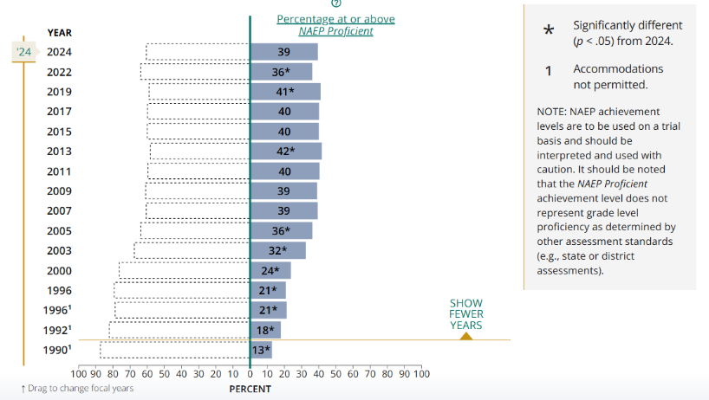
NAEP results provide the following:
- A high-level overview of how student performance changes over time for the nation, states, and participating districts
  - For example, you’ll see that the percentage of fourth-graders reaching or exceeding the NAEP Proficient achievement level in math grew from 13 percent in 1990 to 39 percent in 2024.
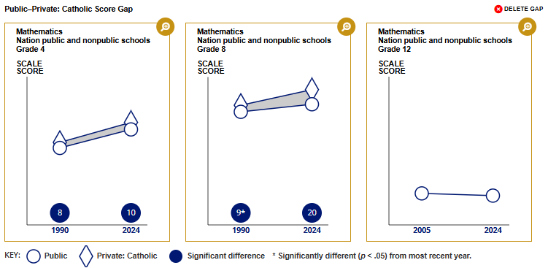
- A comparison of performance across different student groups, based on factors such as school type or student socioeconomic status
  - For example, from 1990 to 2024 the score gap between public and Catholic schools in eighth-grade mathematics grew from 9 to 20 points.
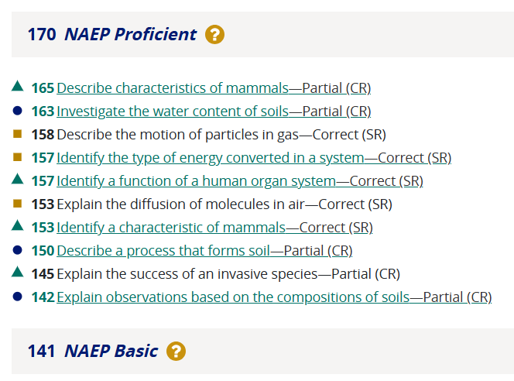
- Insights into the knowledge and skills students demonstrate at the NAEP Basic, NAEP Proficient, and NAEP Advanced achievement levels
  - For example, on the 2024 eighth-grade science assessment, students scoring at the NAEP Basic achievement level were likely able to identify a function of a human organ system.

NAEP web tools and resources include the following:

Achievement Gaps Dashboard
Shows the differences in the performance between two groups of students over time, such as rural and city students, by selected jurisdictions. https://www.nationsreportcard.gov/dashboards/achievement_gaps.aspx

Data Explorer
Allows users to analyze decades of assessment results and factors from student, teacher, and school questionnaires. https://www.nationsreportcard.gov/ndecore/landing

Item Maps
Help users understand student performance by mapping example assessment questions on the NAEP scale by subject and difficulty to illustrate students’ knowledge and skills across NAEP achievement levels. https://www.nationsreportcard.gov/itemmaps/

Questions Tool
Houses more than 3,000 released NAEP assessment questions and allows users to search for questions by subject, grade, difficulty, and other characteristics; view actual student responses for available questions; and create quizzes for students. https://nces.ed.gov/nationsreportcard/nqt/

State and District Profiles
Provide key information about performance trends and demographics for each participating jurisdiction, including downloadable snapshot reports for direct comparisons of results.
- State Profiles: https://www.nationsreportcard.gov/profiles/stateprofile
- District Profiles: https://www.nationsreportcard.gov/profiles/districtprofile

Public, Private, and Charter Schools Dashboard
Displays the latest national results for students in all NAEP subjects, by school type. https://www.nationsreportcard.gov/dashboards/schools_dashboard.aspx

Racial/Ethnic Score Gap Tool
Demonstrates how factors such as sex and socioeconomic status relate to average score gaps between racial/ethnic student groups. https://www.nationsreportcard.gov/dashboards/regression/

Socioeconomic Status (SES) Index Dashboard
Summarizes results of public school students in the low, middle, or high SES categories by jurisdiction, using the NAEP socioeconomic status index. https://www.nationsreportcard.gov/dashboards/sesindex/

NAEP Data Service API
Provides NAEP results in a machine-readable format, making it easy to integrate NAEP data into custom web applications, data visualizations, and analytics tools. https://www.nationsreportcard.gov/api_documentation.aspx

The National Assessment of Educational Progress (NAEP) is the largest nationally representative and continuing assessment of what the nation’s students know and can do in various subject areas. Also known as The Nation’s Report Card, it has provided important information about how the nation’s students are performing academically since 1969. NAEP is administered by the National Center for Education Statistics (NCES), within the U.S. Department of Education.

Looking for more detailed data?
Restricted-use datasets are available and include respondent-level data from NAEP and other NCES assessments and surveys. Qualified researchers can obtain a restricted-use data license from NCES to view these data. As part of the license, researchers are legally required to protect the confidentiality of the data.

If you have questions, please contact the Institute of Education Sciences (IES) Data Security Office:
IES Data Security Office
Department of Education/IES/NCES
550 12th Street, SW, Room 4060
Washington, DC 20202
202-245-7674
IESData.Security@ed.gov

The National Center for Education Statistics (NCES) conducts the National Assessment of Educational Progress to evaluate federally supported education programs. All of the information you provide may only be used for the purposes of research, statistics, and evaluation under the Education Sciences Reform Act of 2002 (ESRA; 20 U.S.C. § 9543) and may not be disclosed, or used, in identifiable form for any other purpose except as required by law. Every NCES employee as well as every NCES agent, such as contractors and NAEP coordinators, has taken an oath and is subject to a jail term of up to 5 years, a fine of $250,000, or both if he or she willfully discloses ANY identifiable information about you in any unauthorized manner. Electronic submission of your information will be monitored for viruses, malware, and other threats by Federal employees and contractors in accordance with the Cybersecurity Enhancement Act of 2015.

[Footer]

Visit nationsreportcard.gov for more!
Follow us on: <Facebook> <Instagram> <LinkedIn> <X> <YouTube>

<IES logo>
<ED logo>
<NAEP logo>

