NATIONAL CENTER FOR EDUCATION STATISTICS NATIONAL ASSESSMENT OF EDUCATIONAL PROGRESS

National Assessment of Educational Progress (NAEP) 2027

Appendix J1
2027 Student Questionnaires

OMB# 1850-0928 v.40



July 2026

Please note, the items will be appropriately numbered when they appear in the platform for the respondent.

Table of Contents
Student Questionnaires
2027 Student Login Screen 2
Appendix J1-1: 2027 Grade 8 Student (Core) 5
Appendix J1-2: 2027 Grade 8 Student (Debrief) 10
Appendix J1-3: 2027 Grade 8 Student Sequence 1 (Science Pilot) 11
Appendix J1-4: 2027 Grade 8 Student Sequence 2 (Science Pilot) 16

2027 Student Login Screen
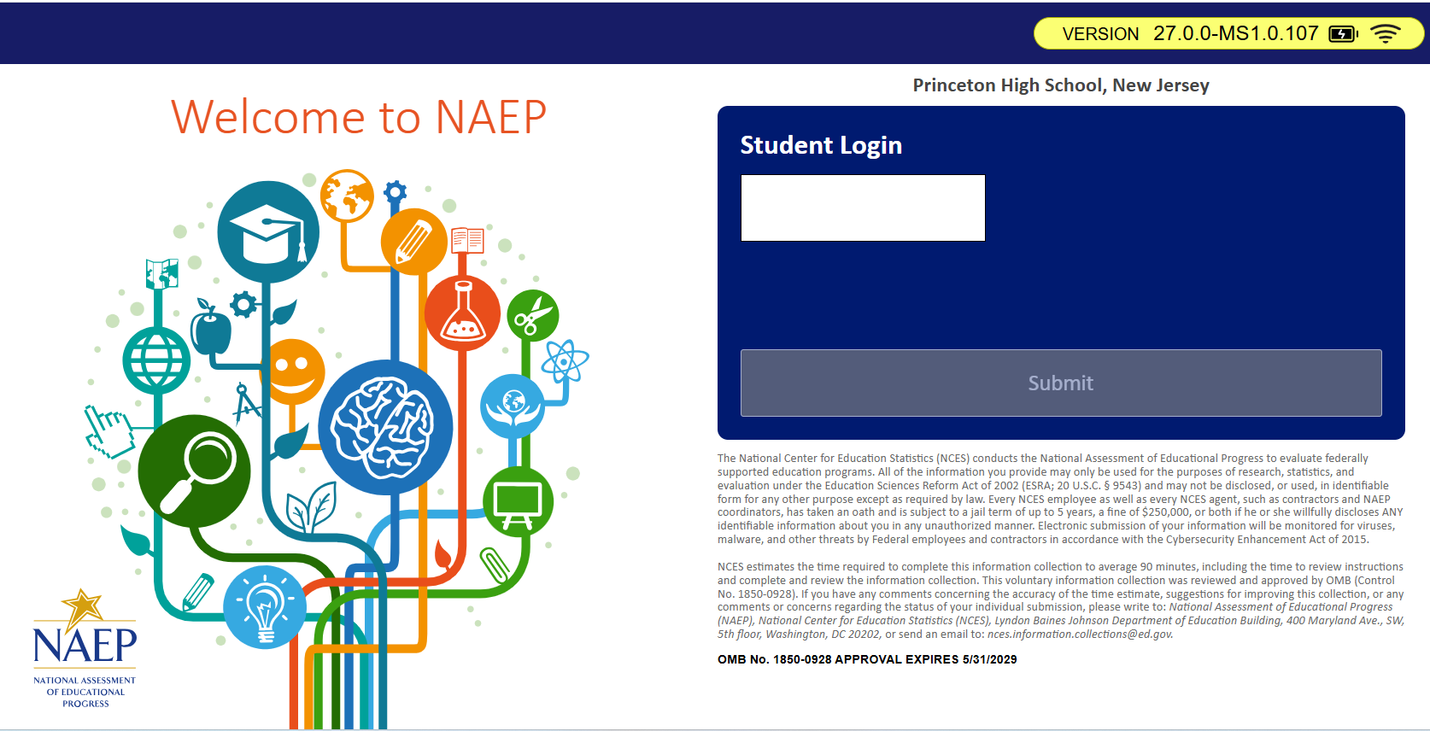

Appendix J1-1: 2027 Grade 8 Student (Core)

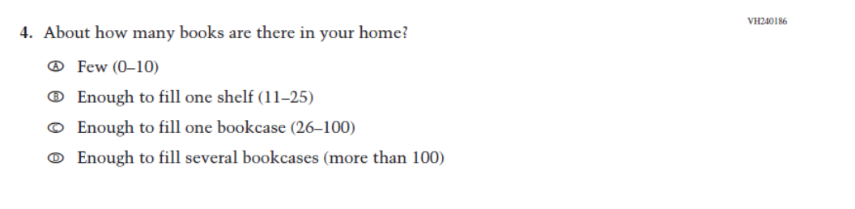
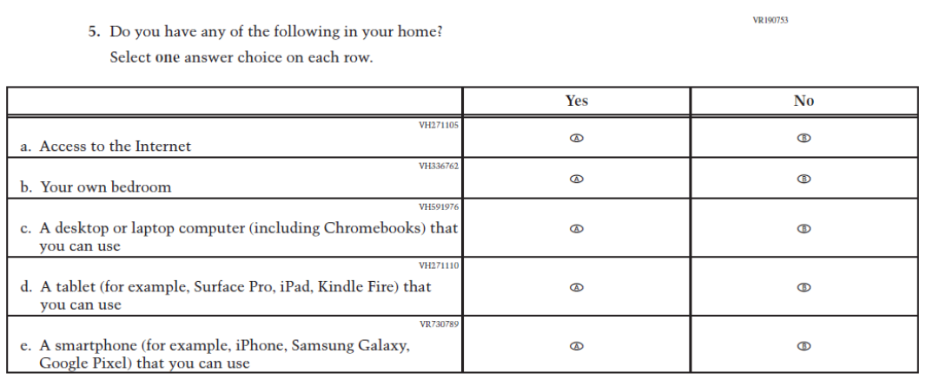
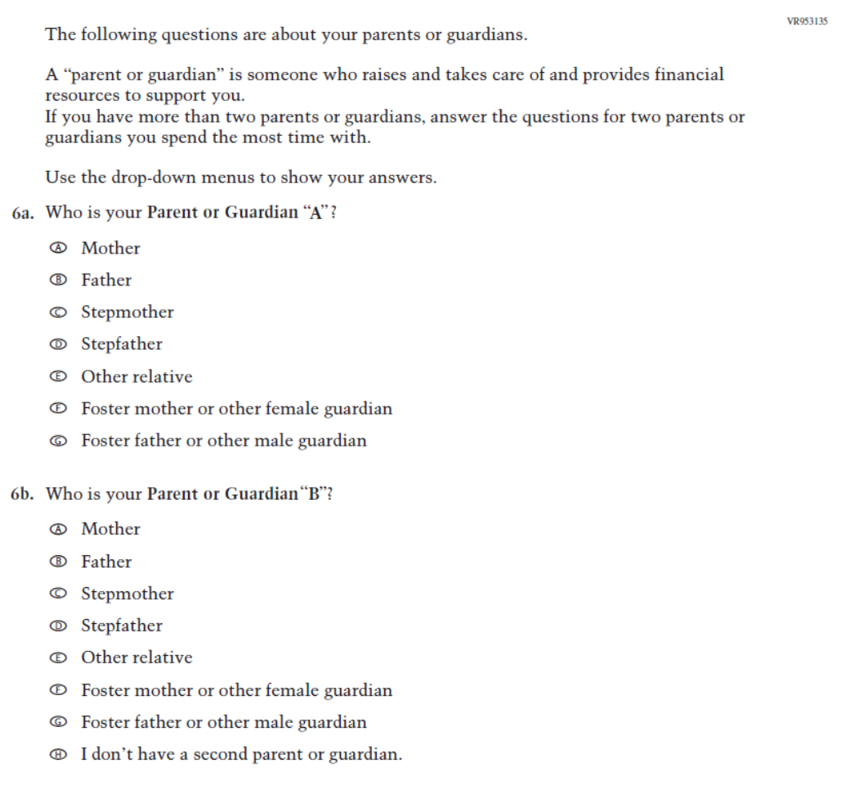
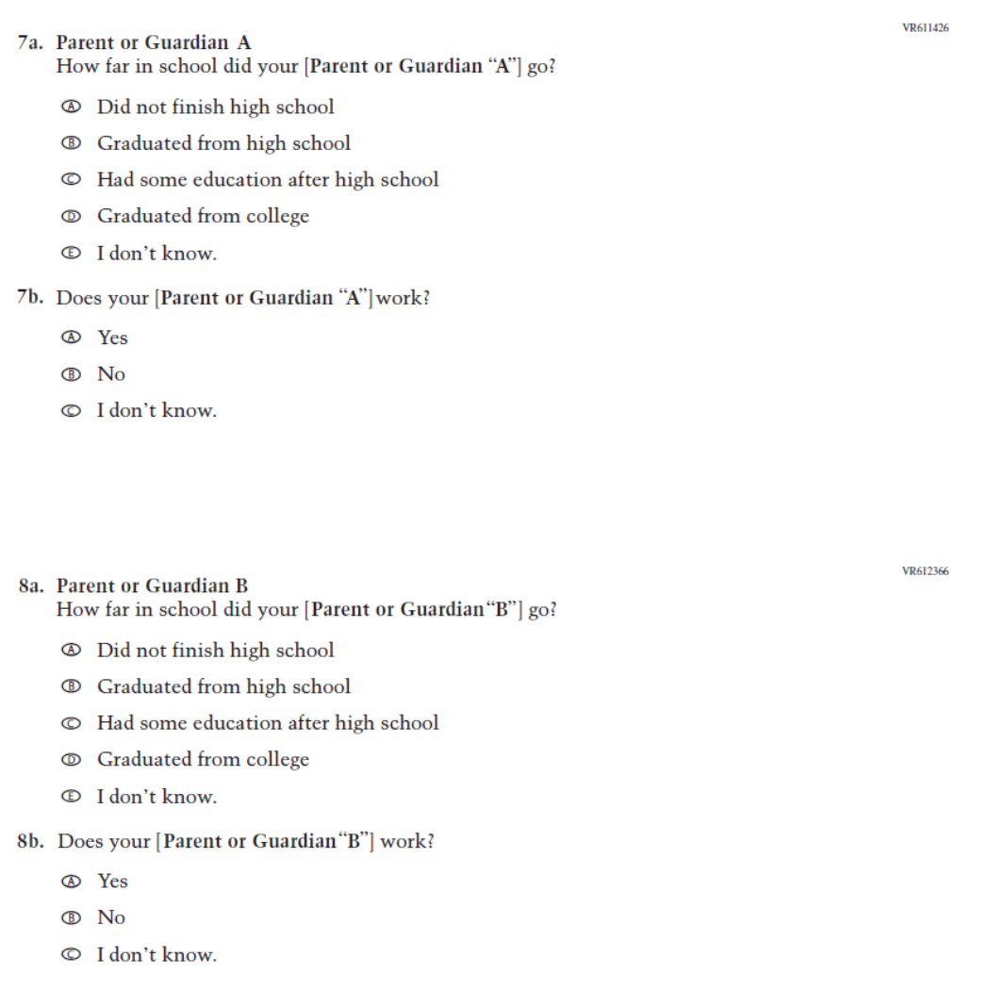
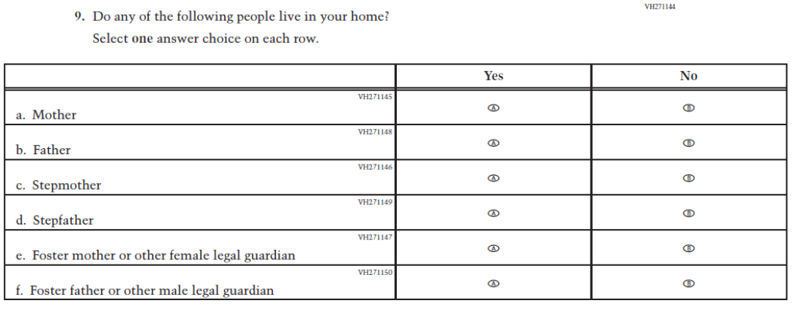
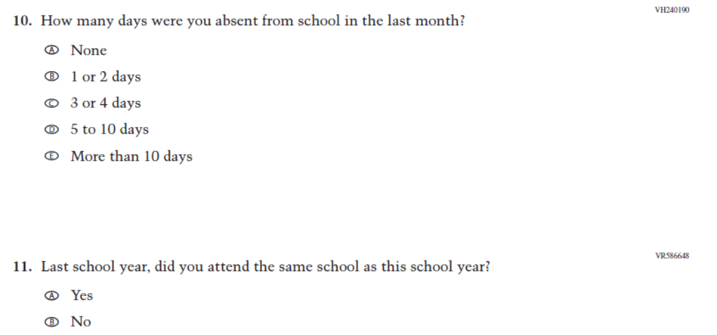
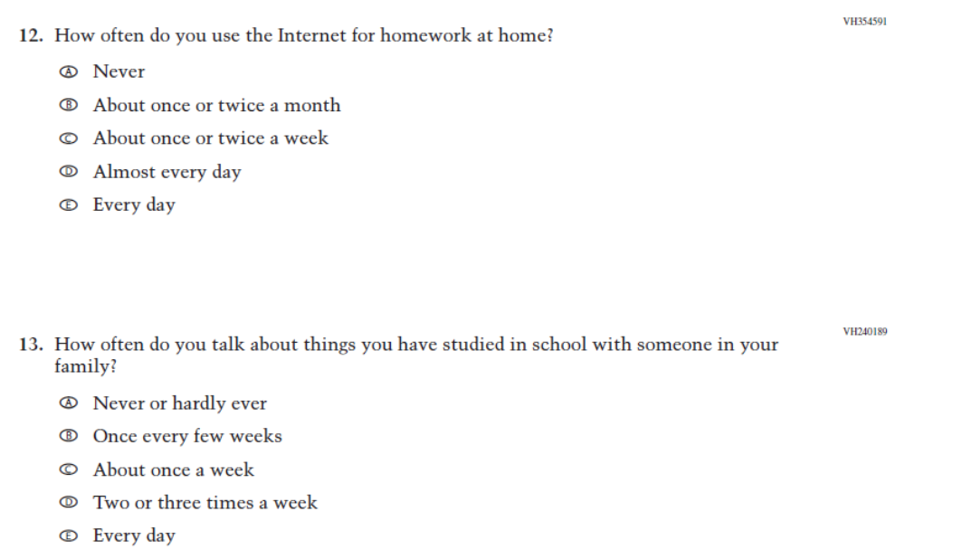
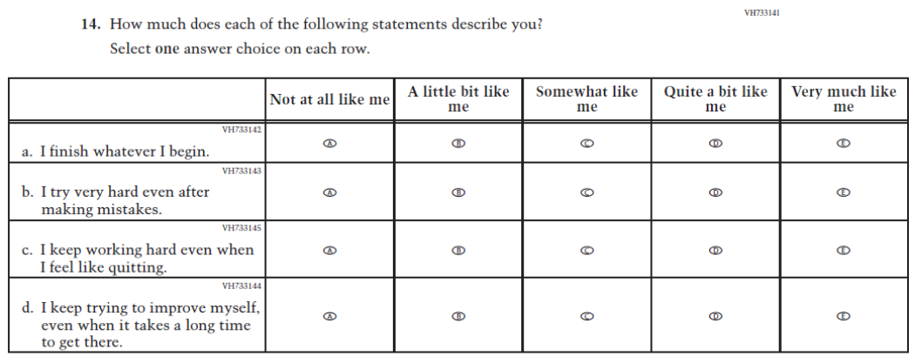
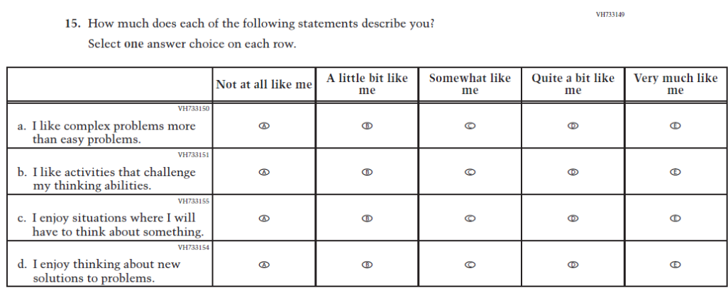
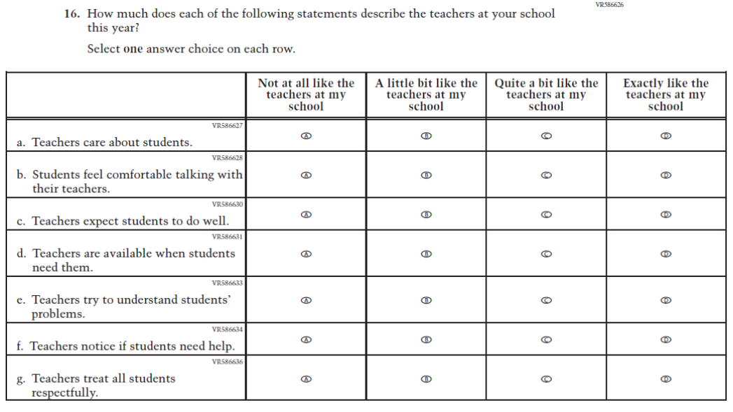

Appendix J1-2: 2027 Grade 8 Student (Debrief)

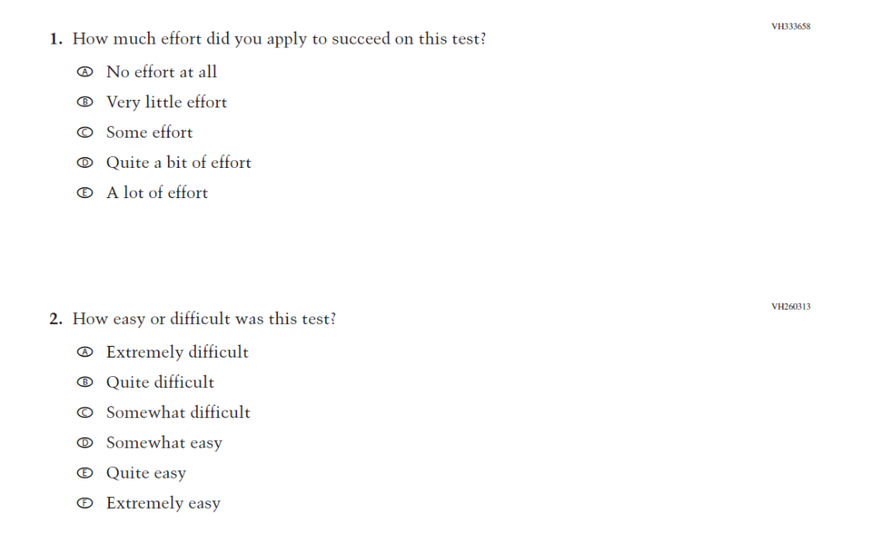
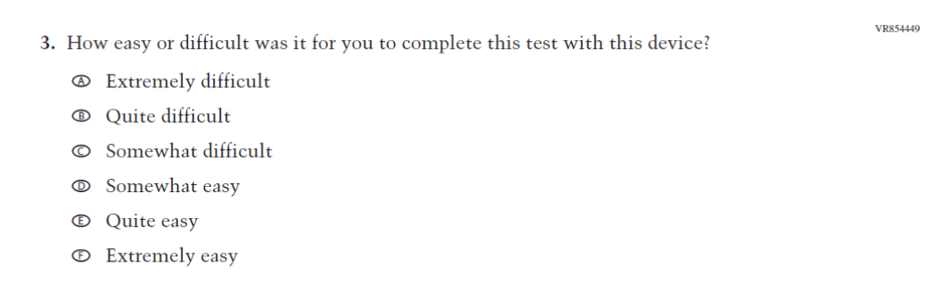

Appendix J1-3: 2027 Grade 8 Student Sequence 1 (Science Pilot)
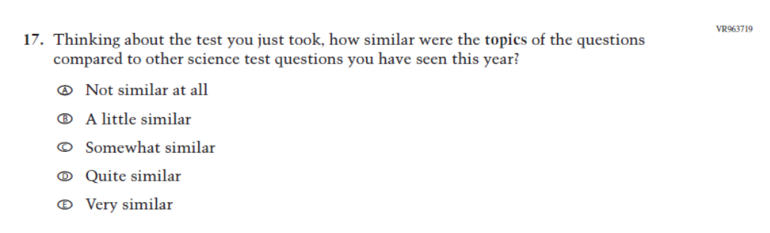
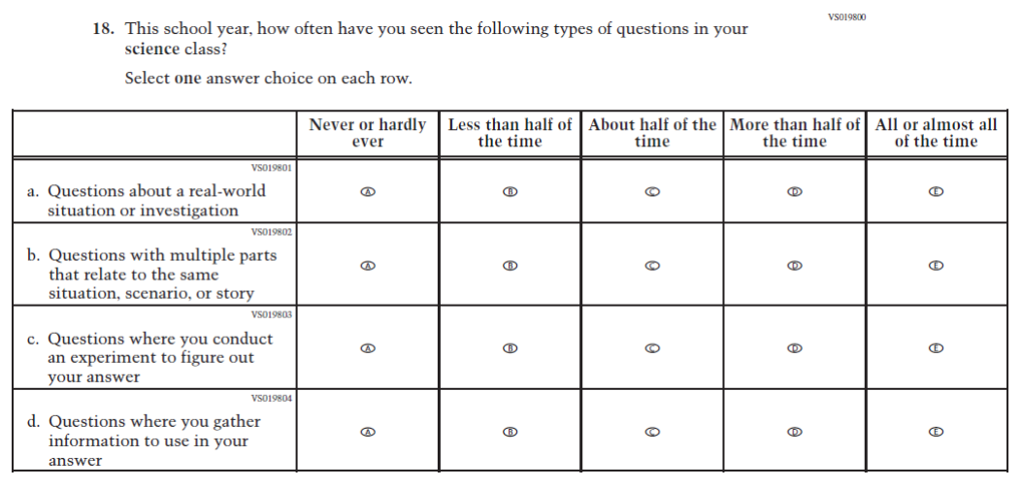
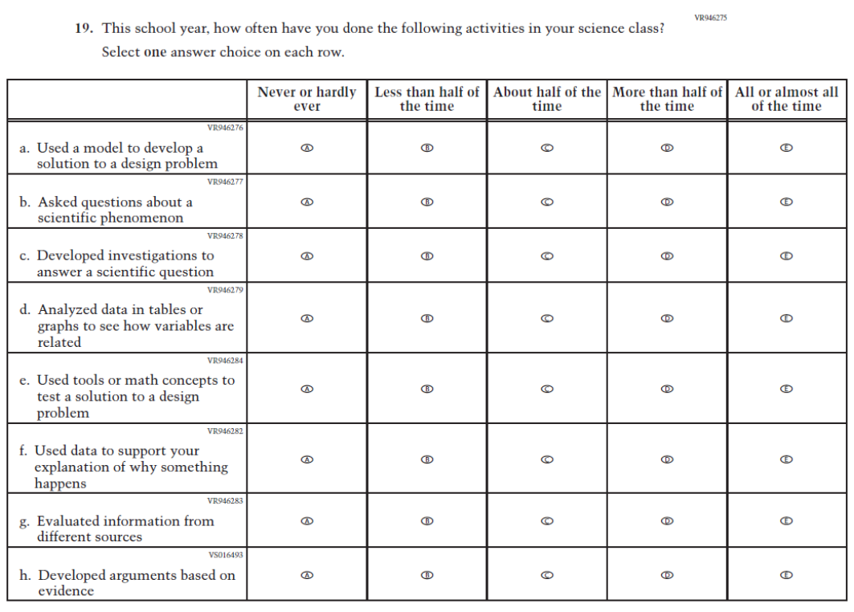
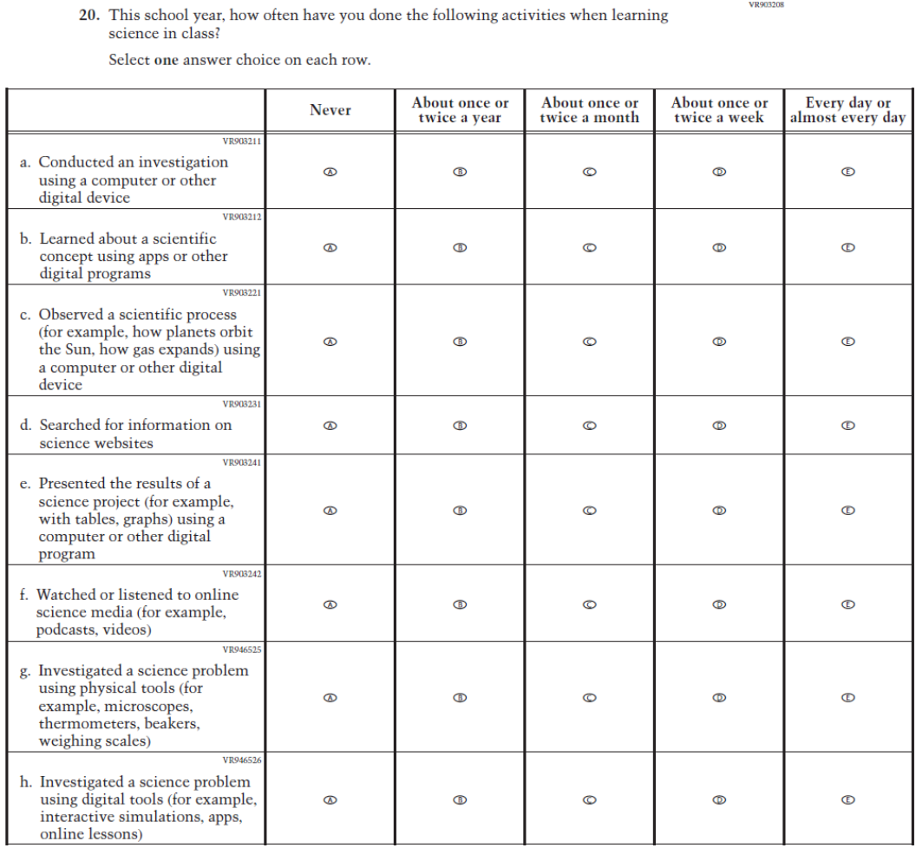
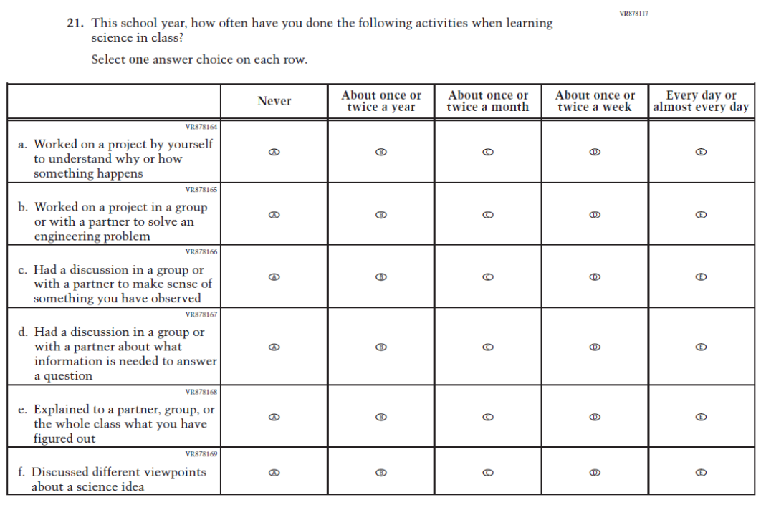
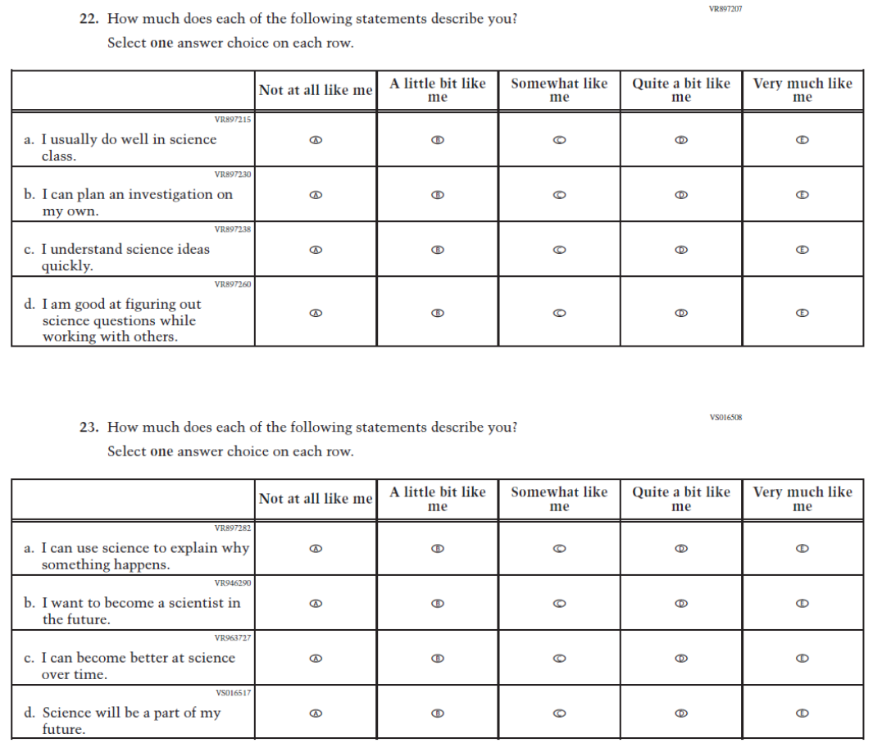

Appendix J1-4: 2027 Grade 8 Student Sequence 2 (Science Pilot)
