NATIONAL CENTER FOR EDUCATION STATISTICS NATIONAL ASSESSMENT OF EDUCATIONAL PROGRESS

National Assessment of Educational Progress (NAEP) 2027

Appendix J2
2027 Teacher Questionnaires

OMB# 1850-0928 v.40



July 2027

Please note, the items will be appropriately numbered when they appear in the platform for the respondent.
Table of Contents
Teacher Questionnaires
2027 Teacher and School Questionnaire Login Screen 3
Appendix J2-1: 2027 Grade 8 Teacher (Core) 4
Appendix J2-2: 2027 Grade 8 Teacher (Science Pilot) 7

2027 Teacher and School Questionnaire Login Screen
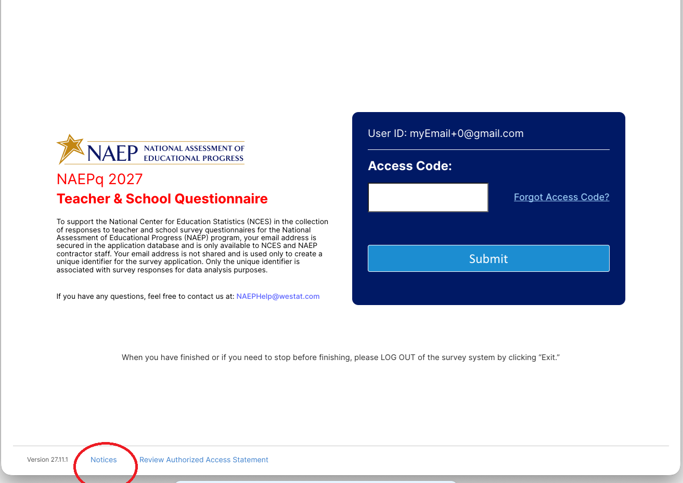

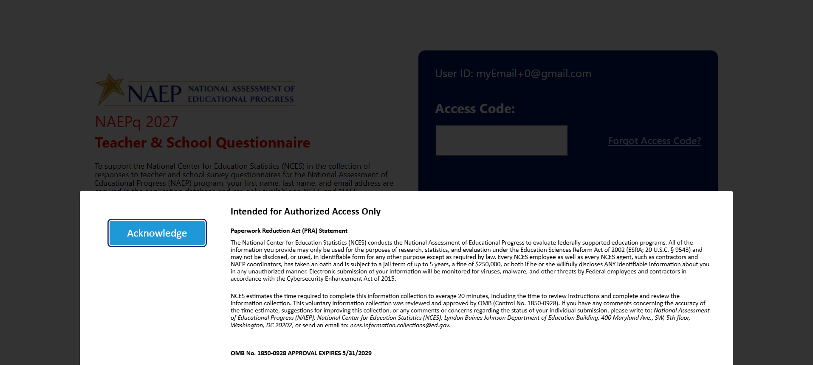

Appendix J2-1: 2027 Grade 8 Teacher (Core)
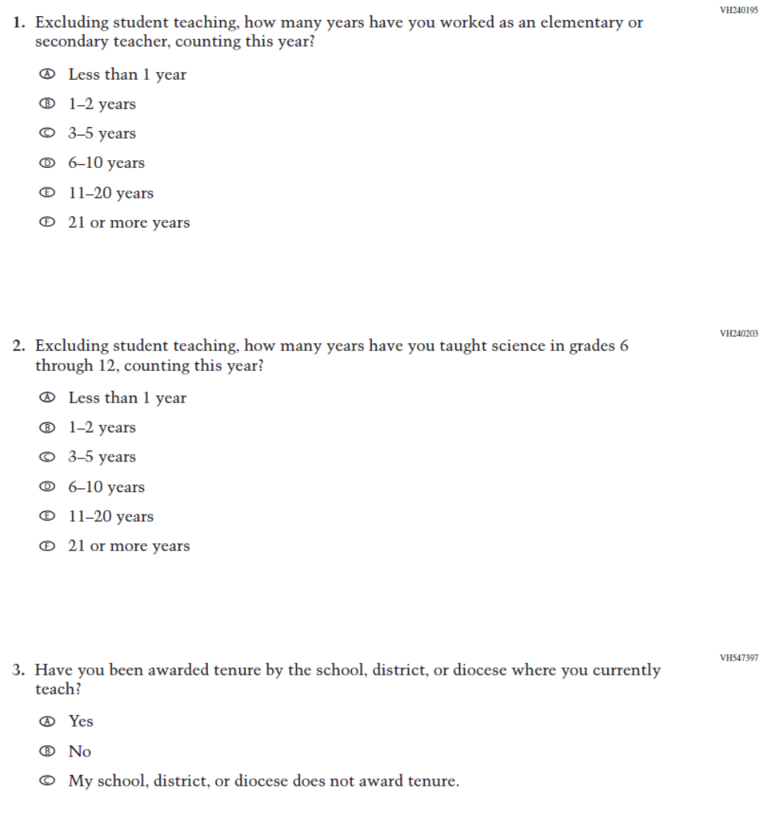
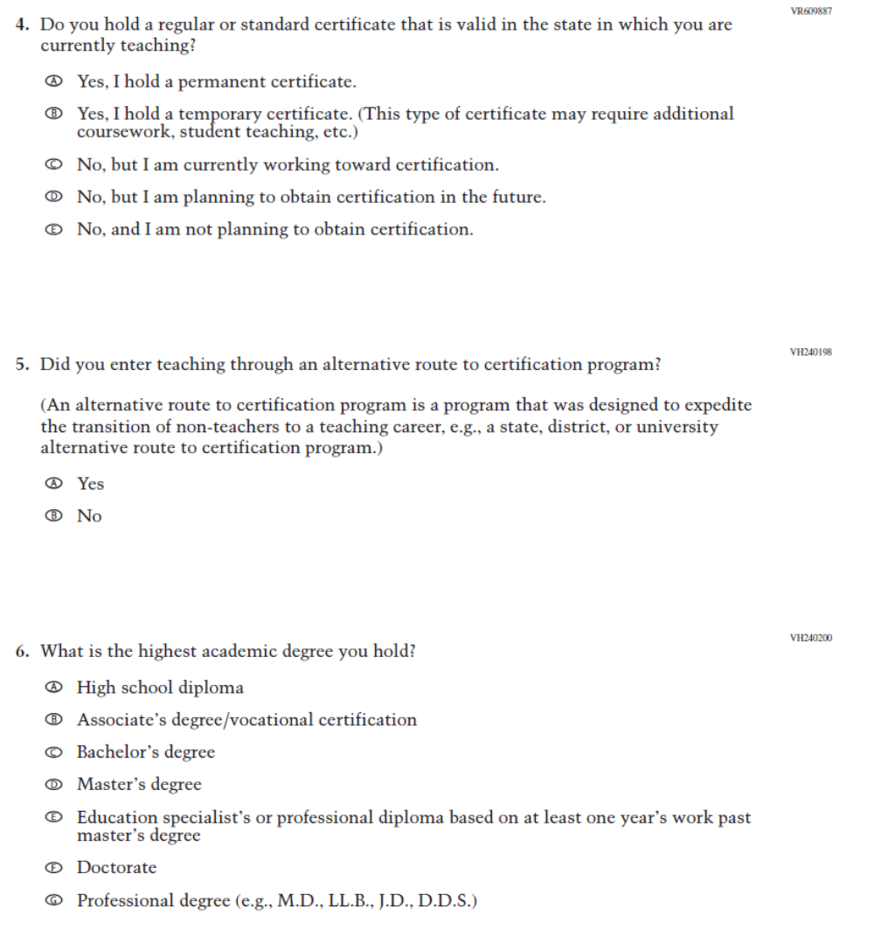
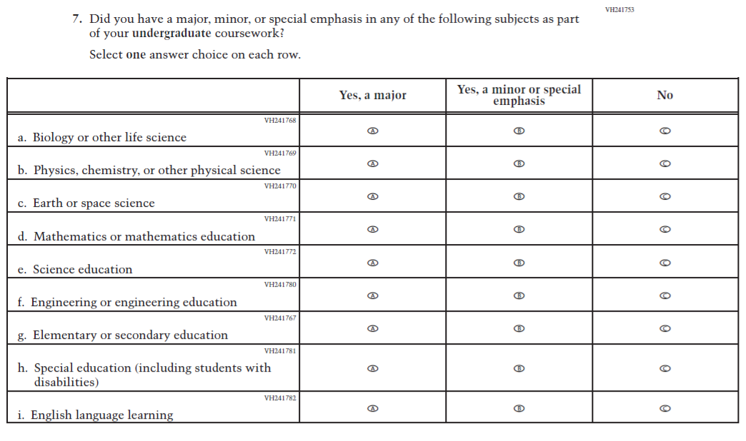
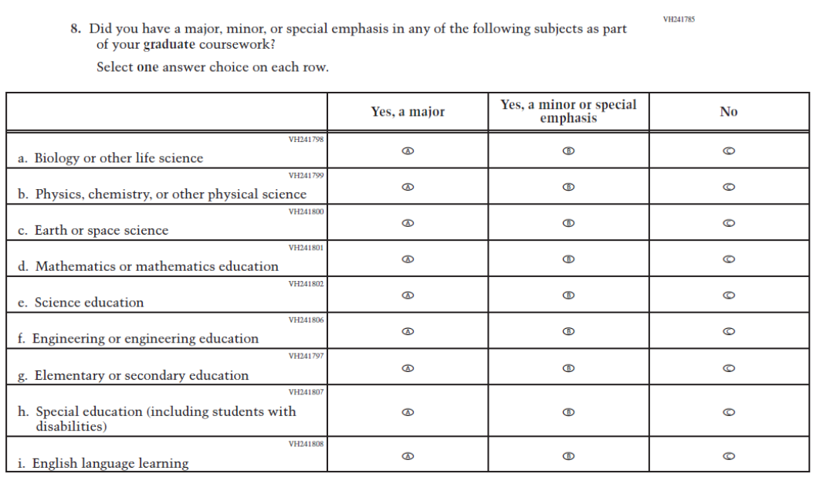

Appendix J2-2: 2027 Grade 8 Teacher (Science Pilot)

