SRF Data System – CWSRF Screenshots

Home page
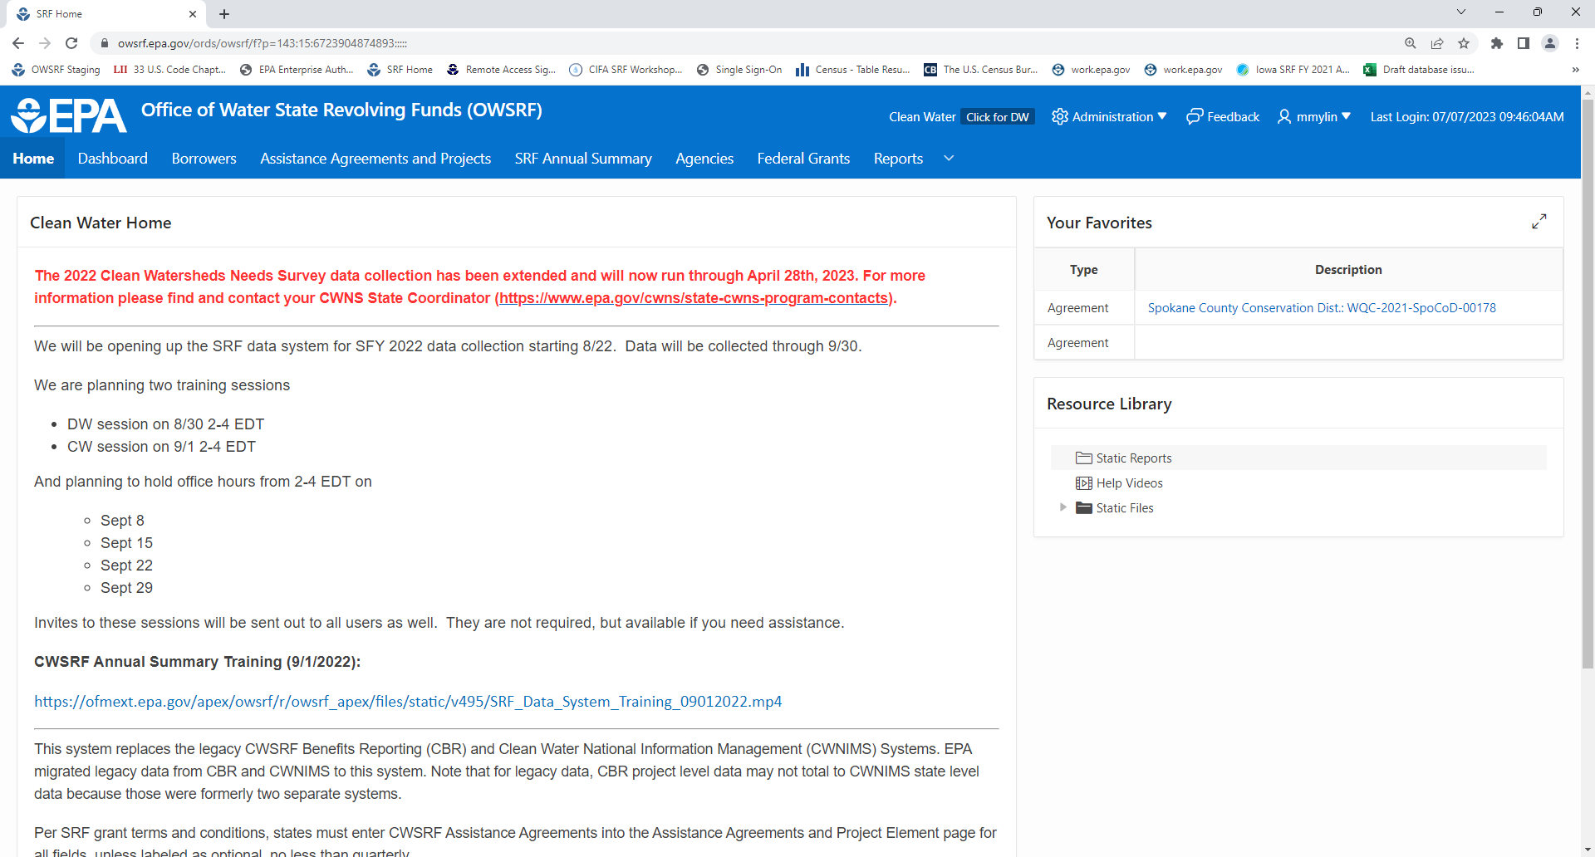

Borrowers
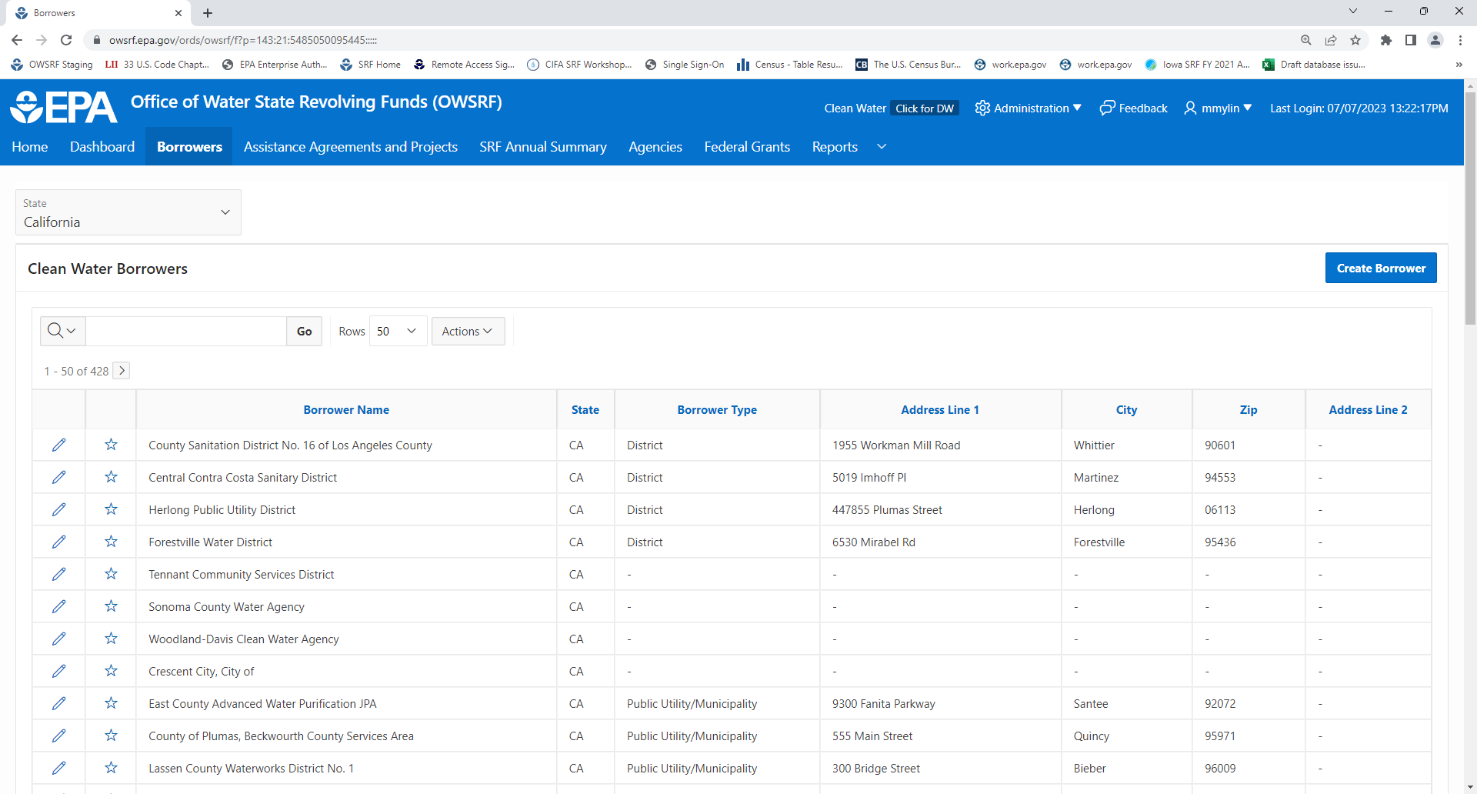

Borrowers – Create New
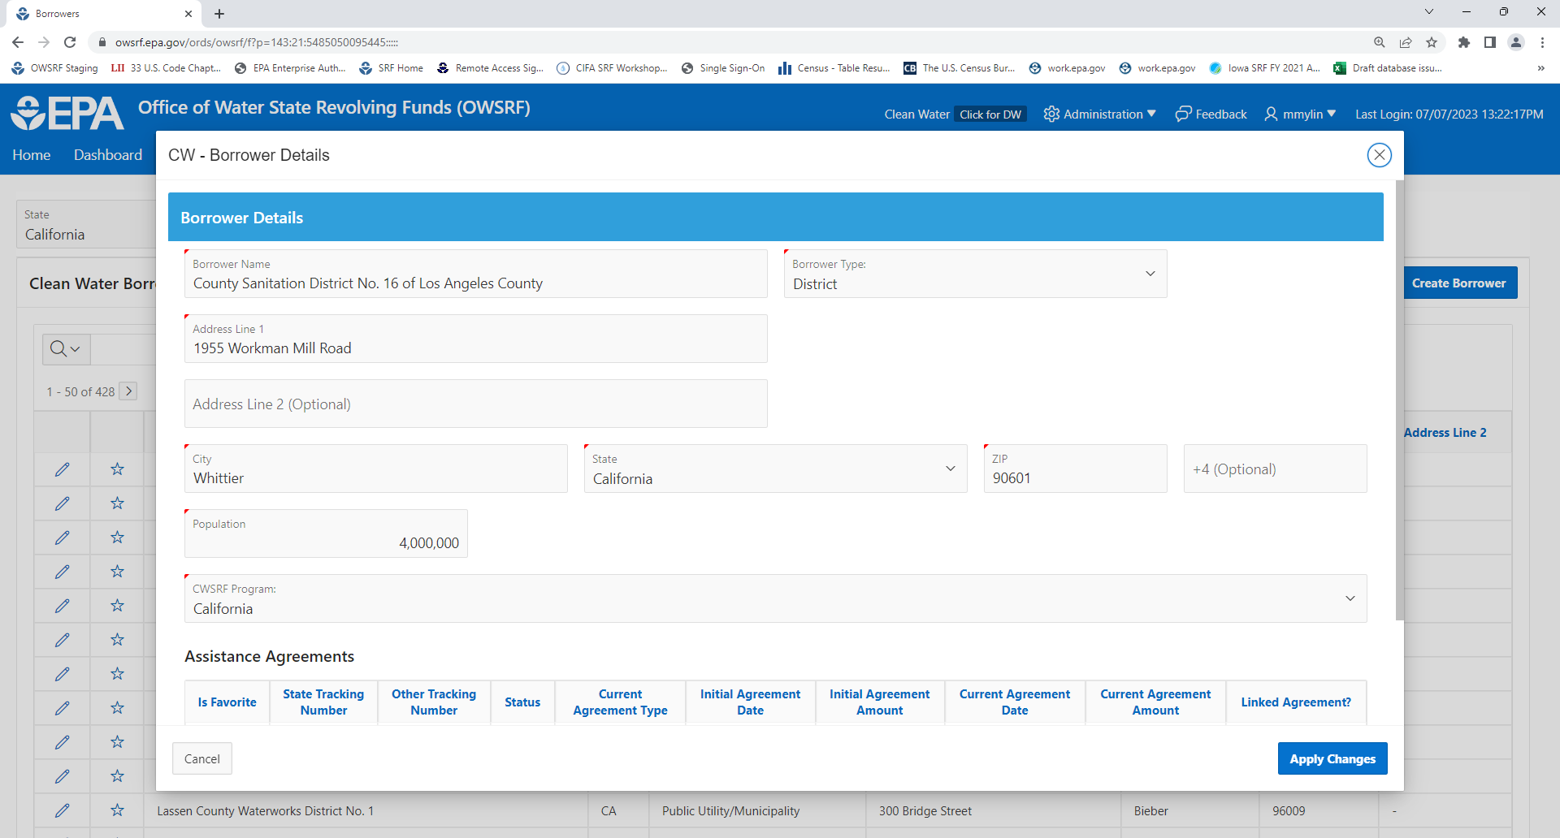

Assistance Agreements/Projects
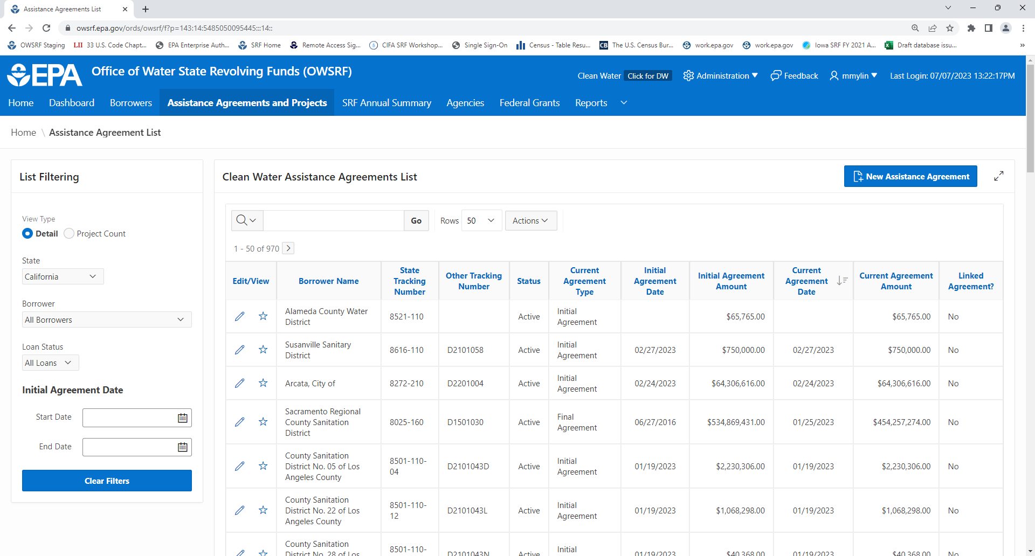

Assistance Agreement – New Assistance Agreement
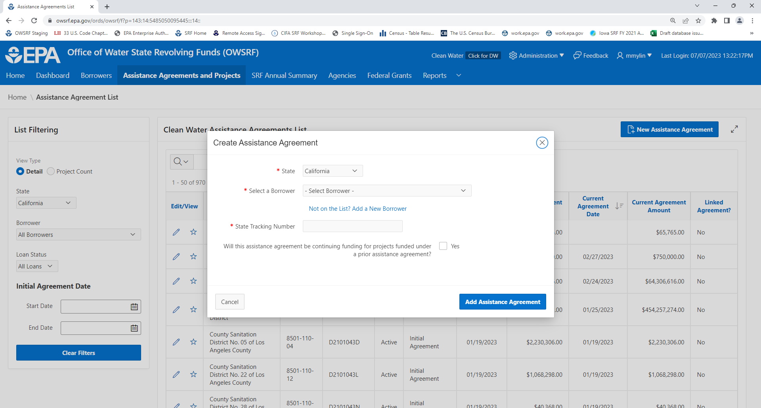
Assistance Agreement and Project Details – Borrower Information
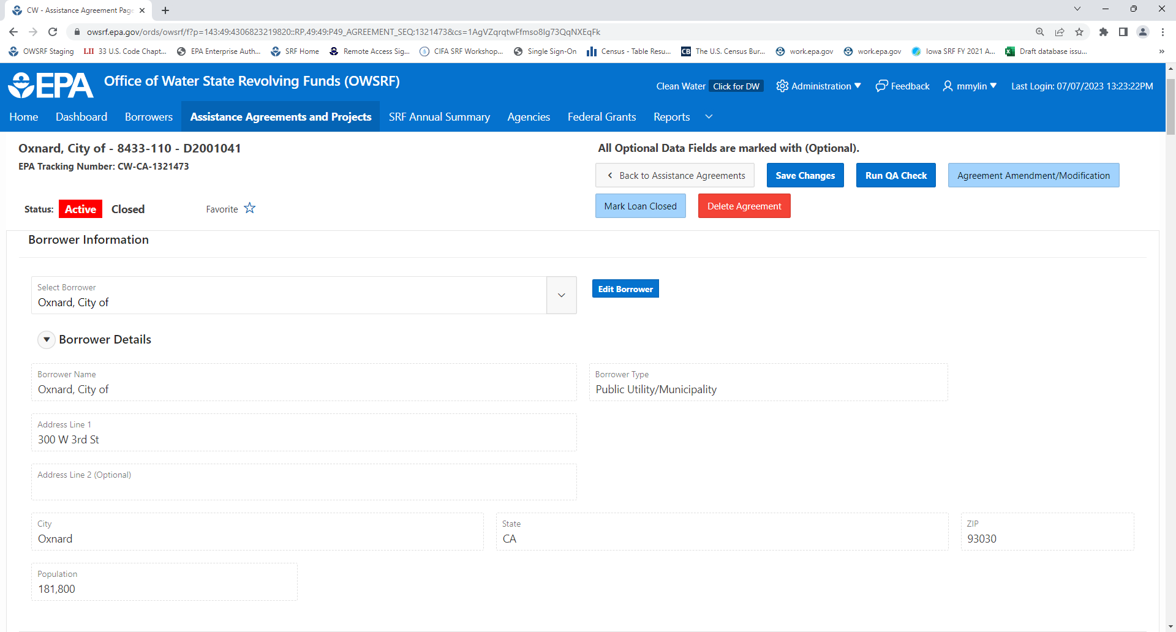

Assistance Agreement and Project Details – Assistance Agreement Information
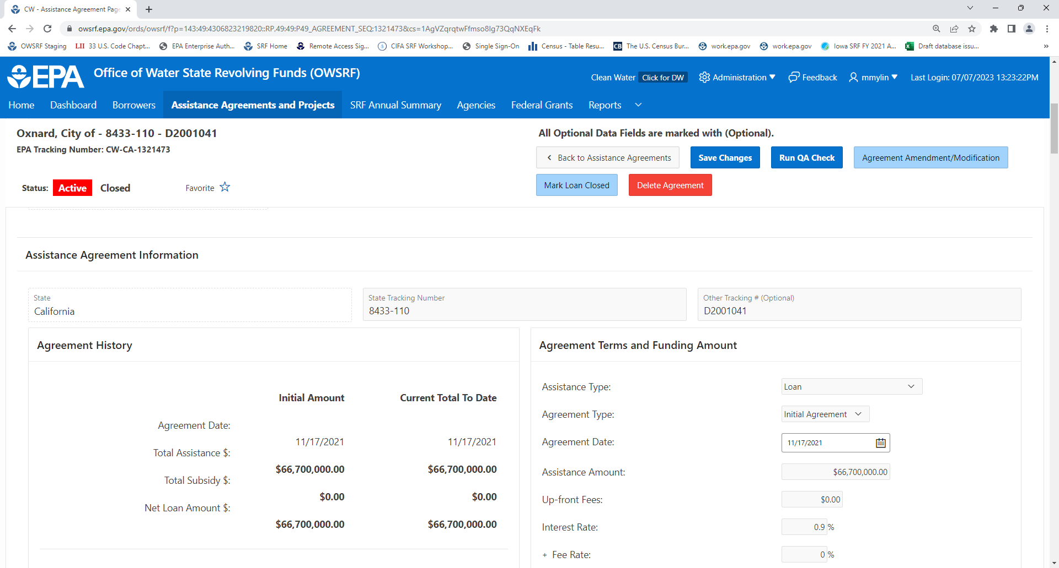

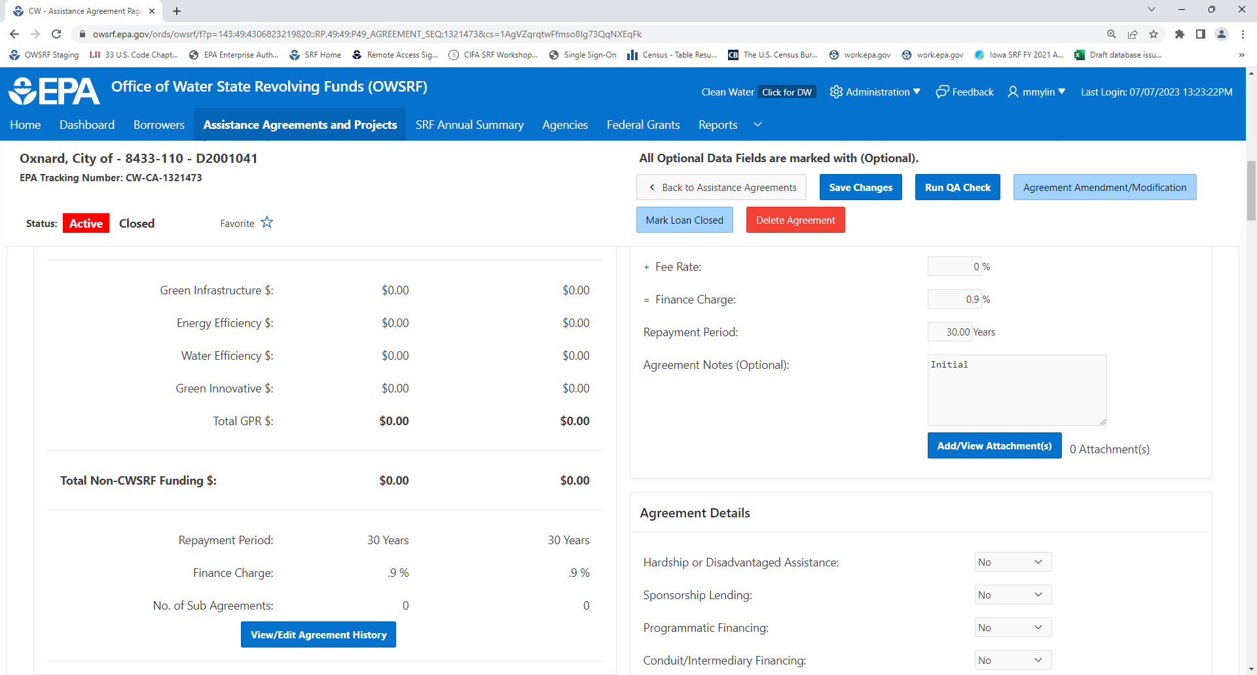

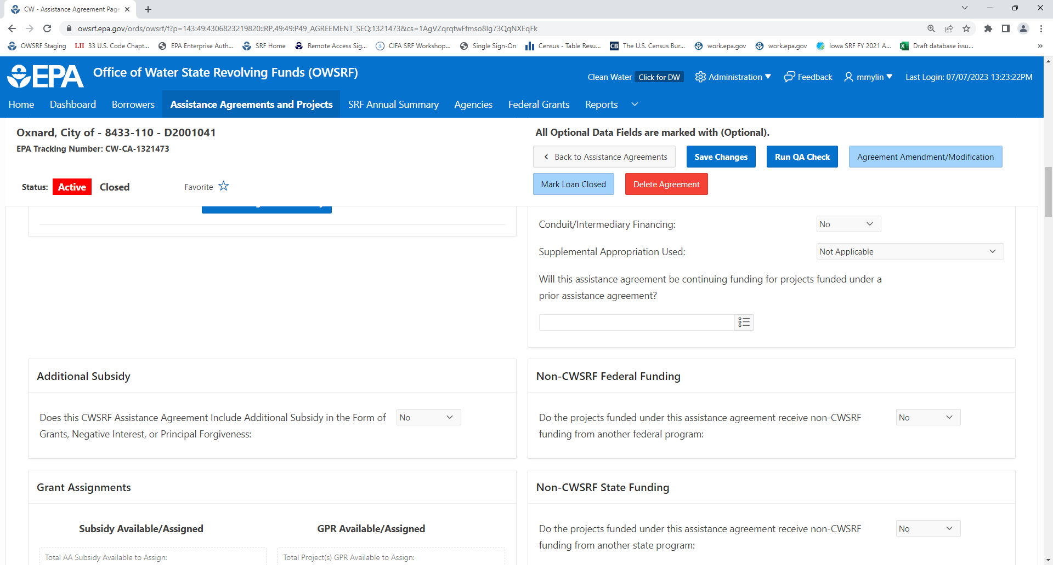

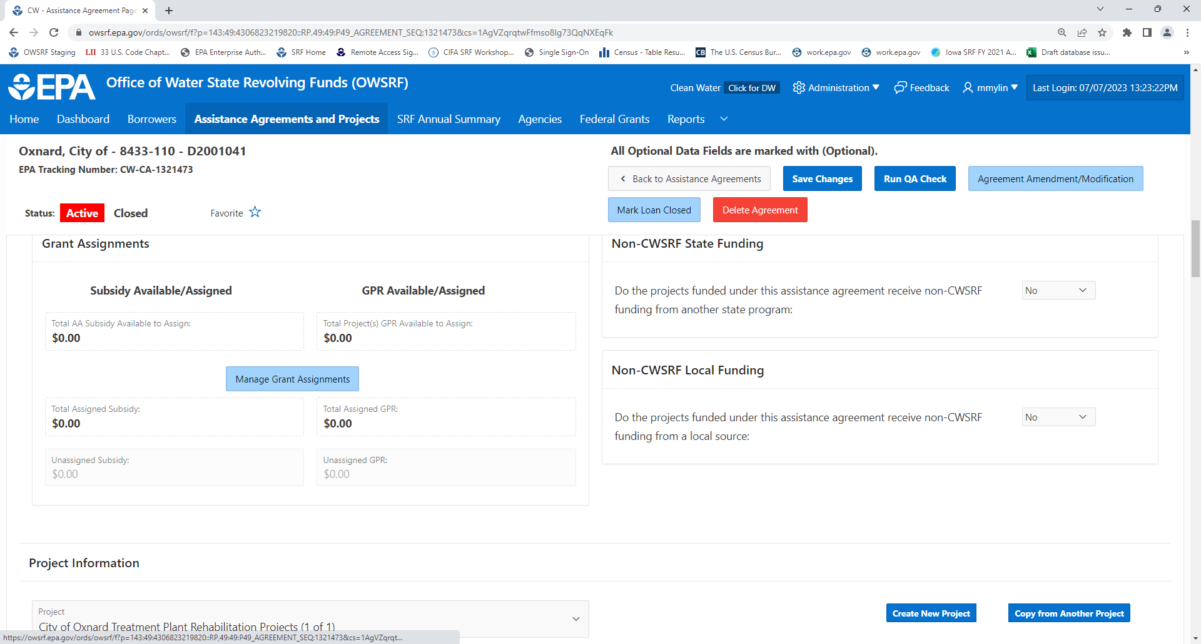

Assistance Agreement and Project – Manage Grant Assignment
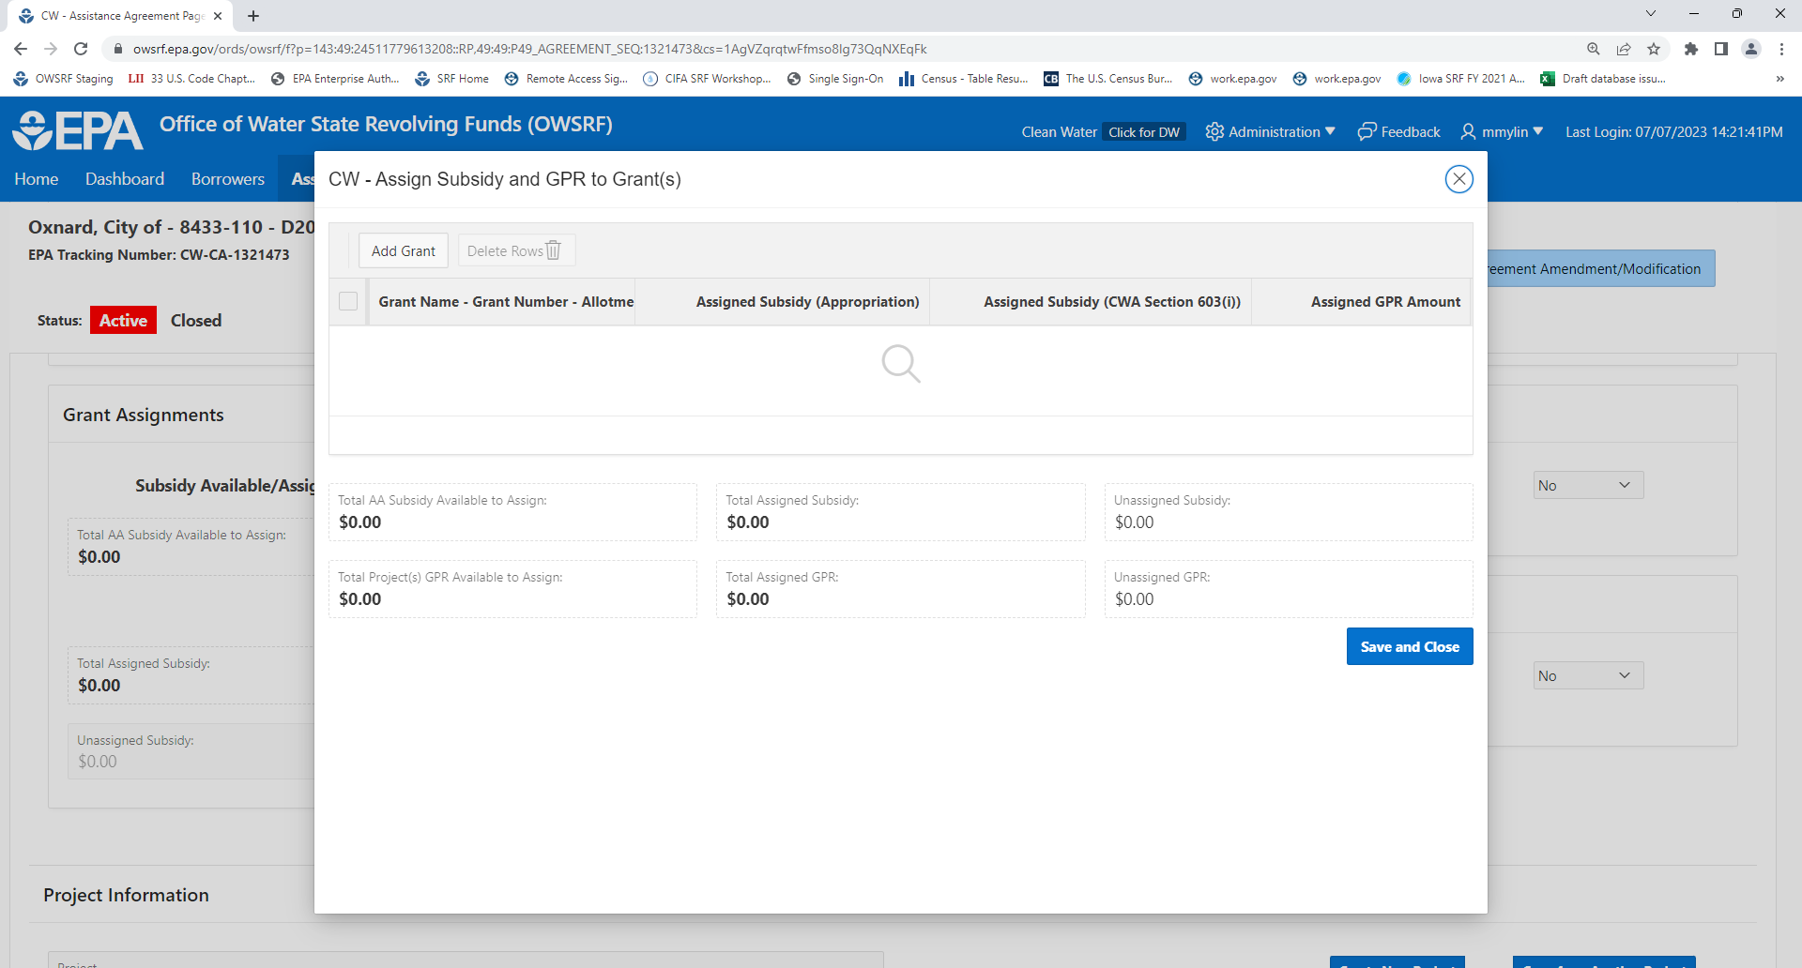

Assistance Agreement and Project Details – Create New Project
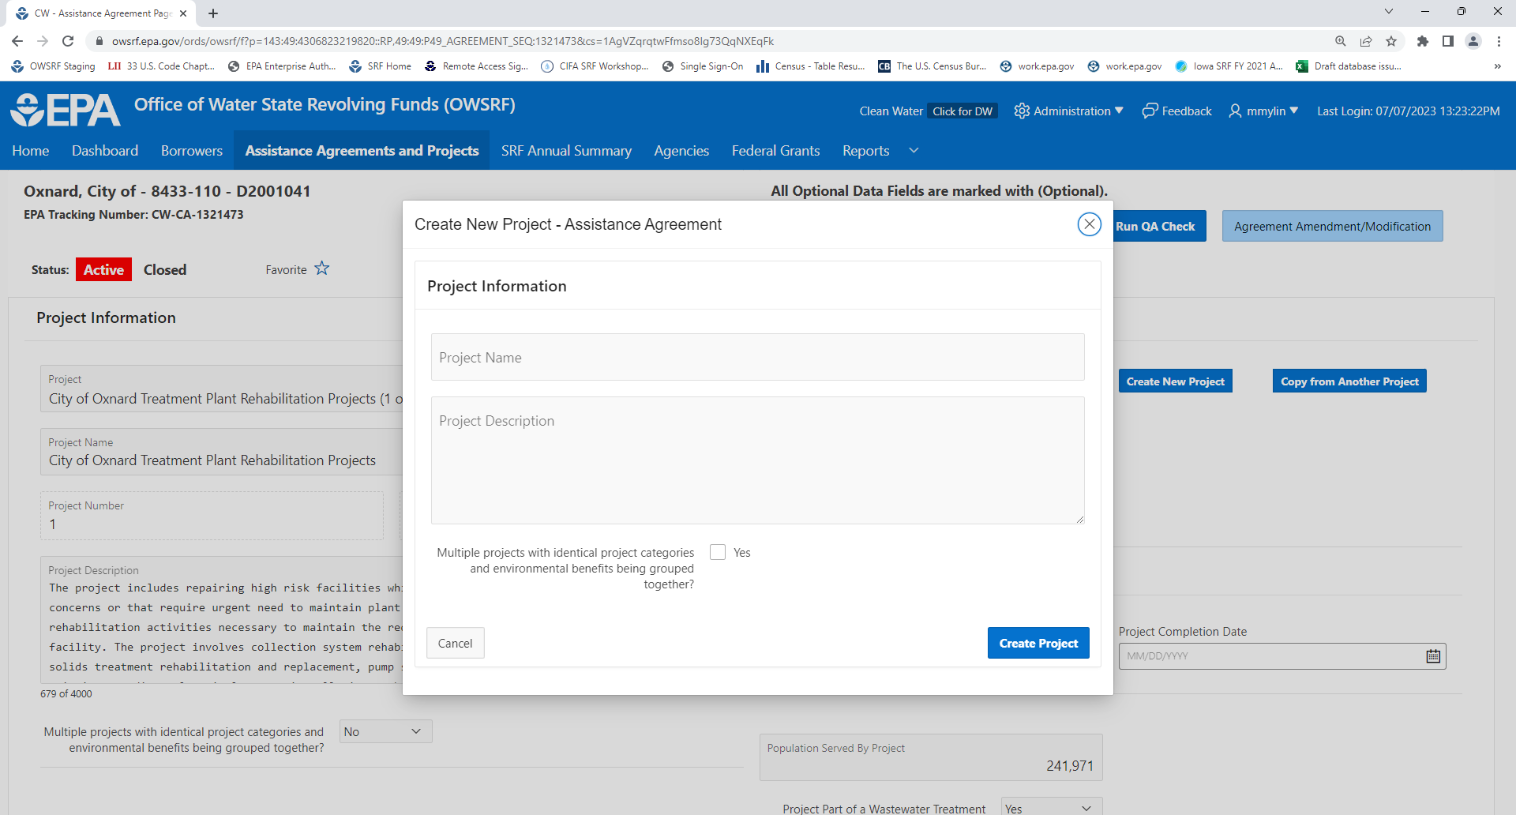

Assistance Agreement and Project Details – Project Information
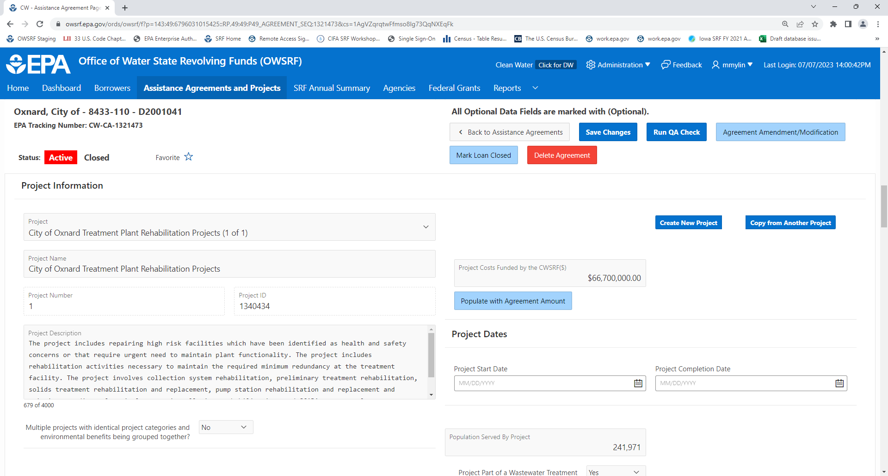

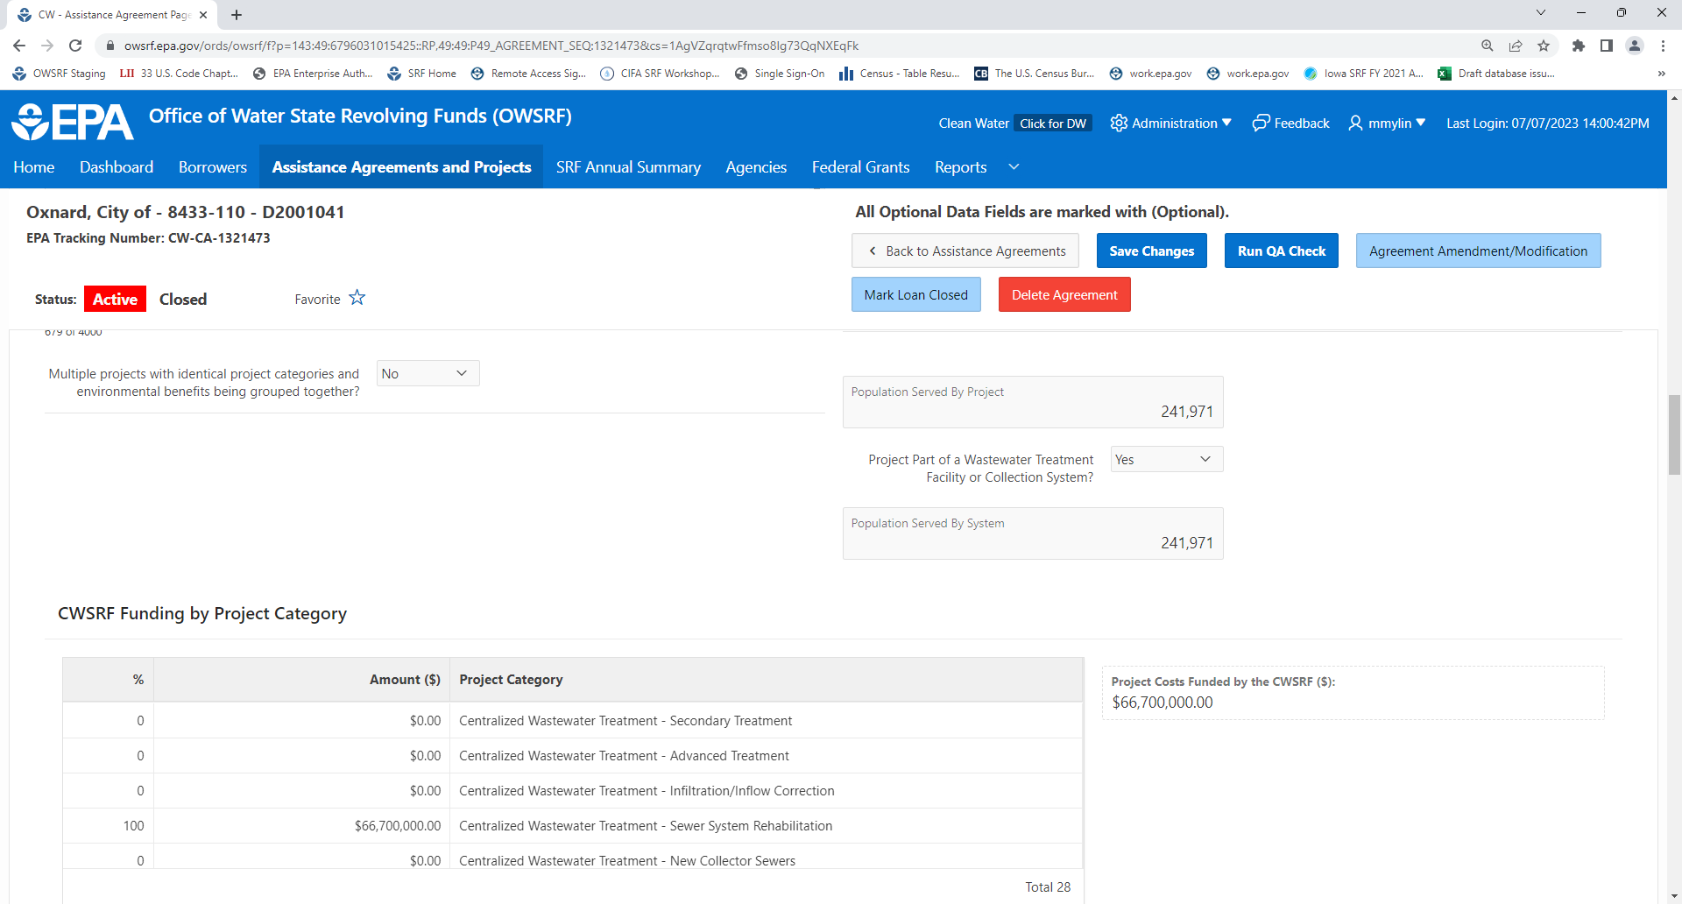

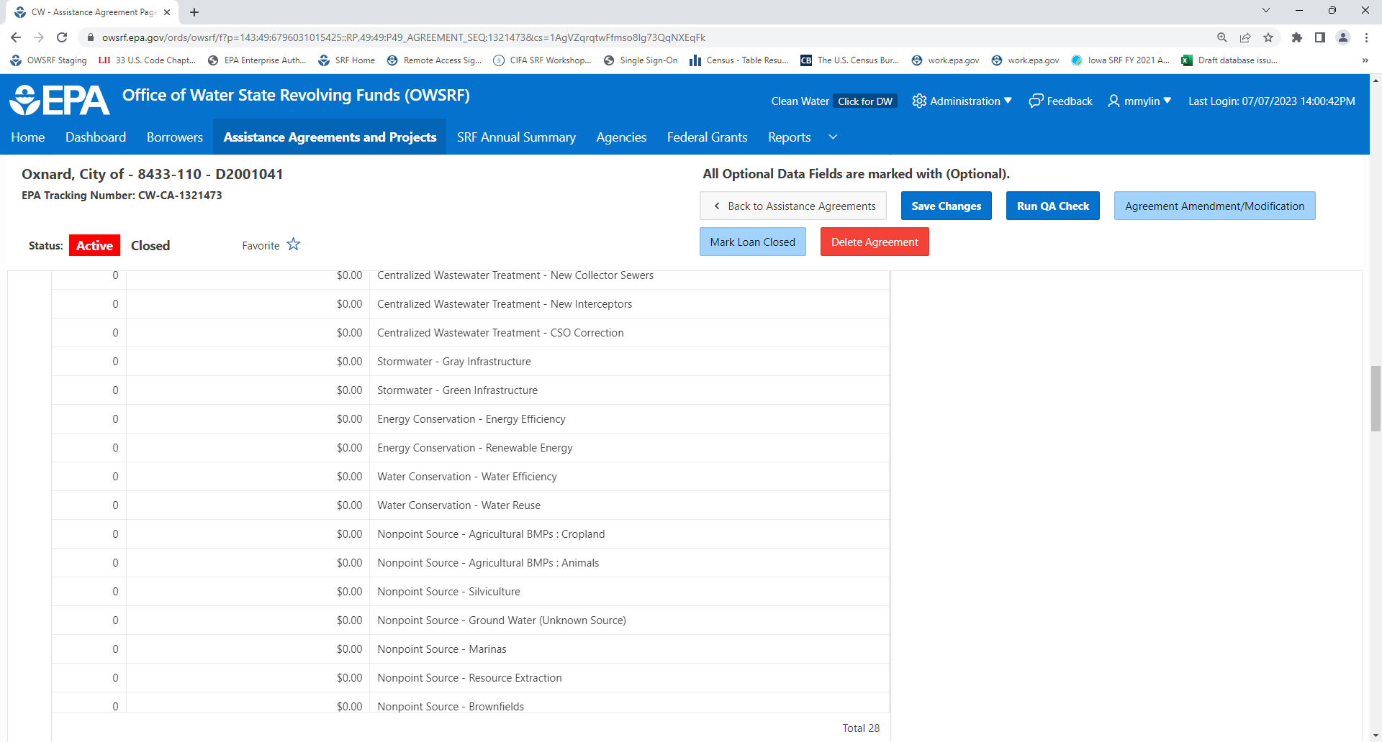

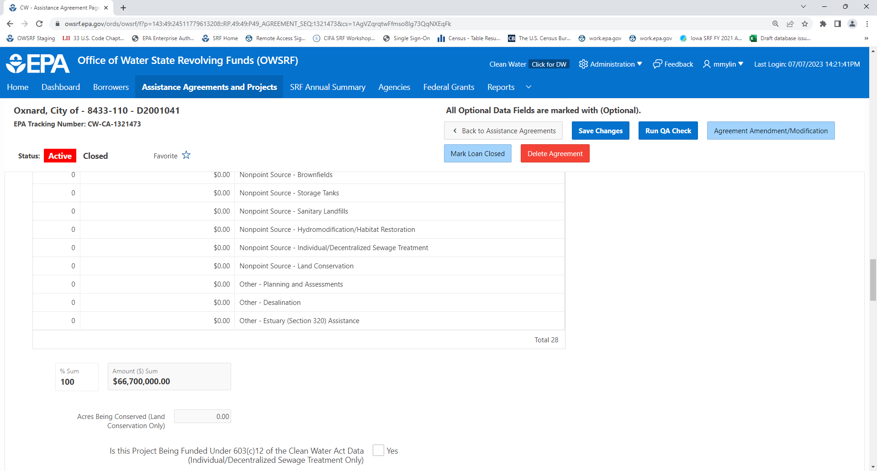

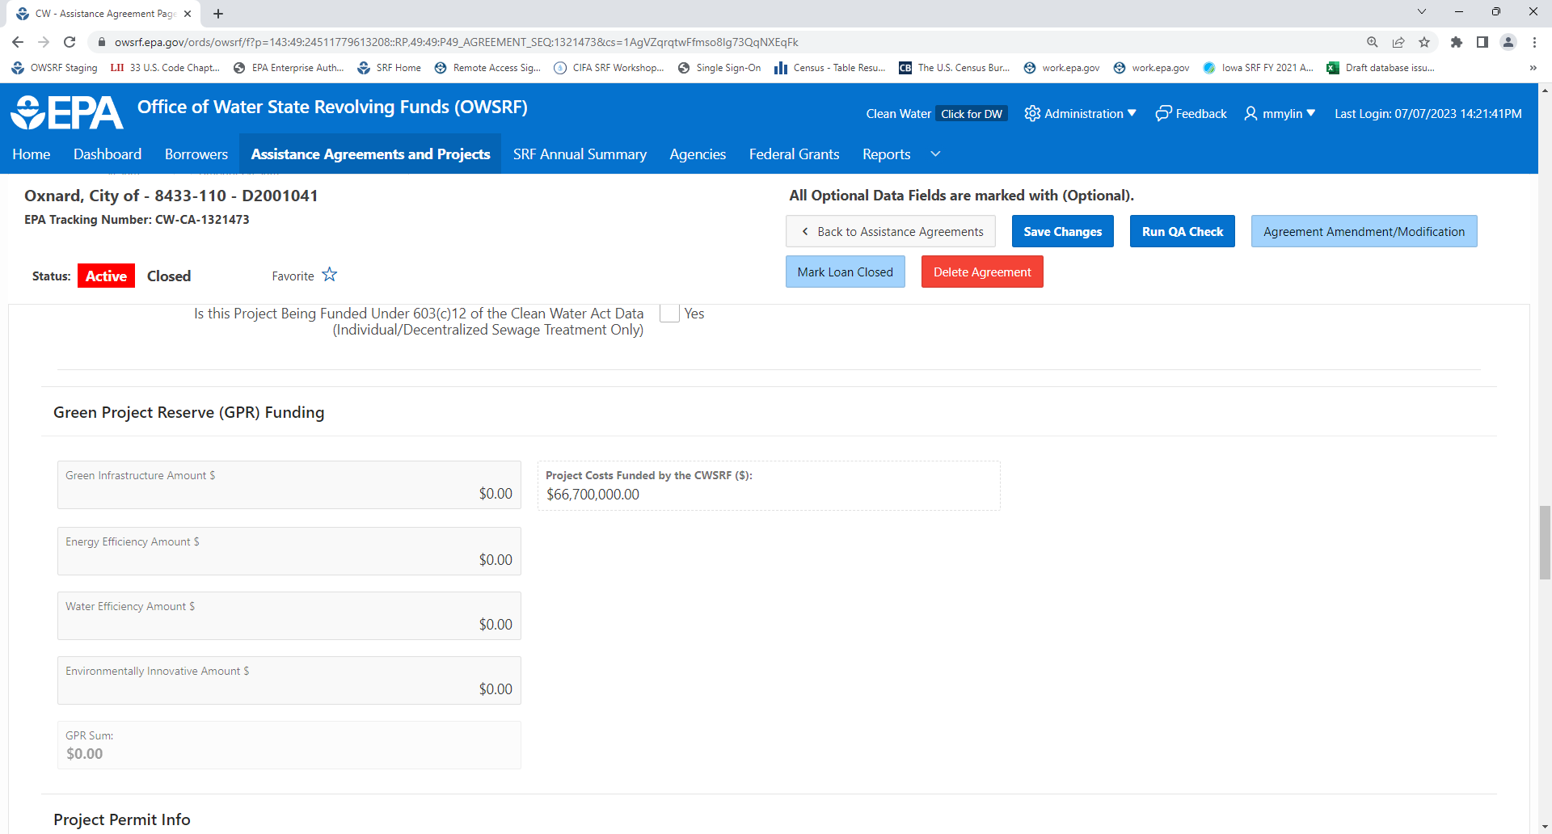

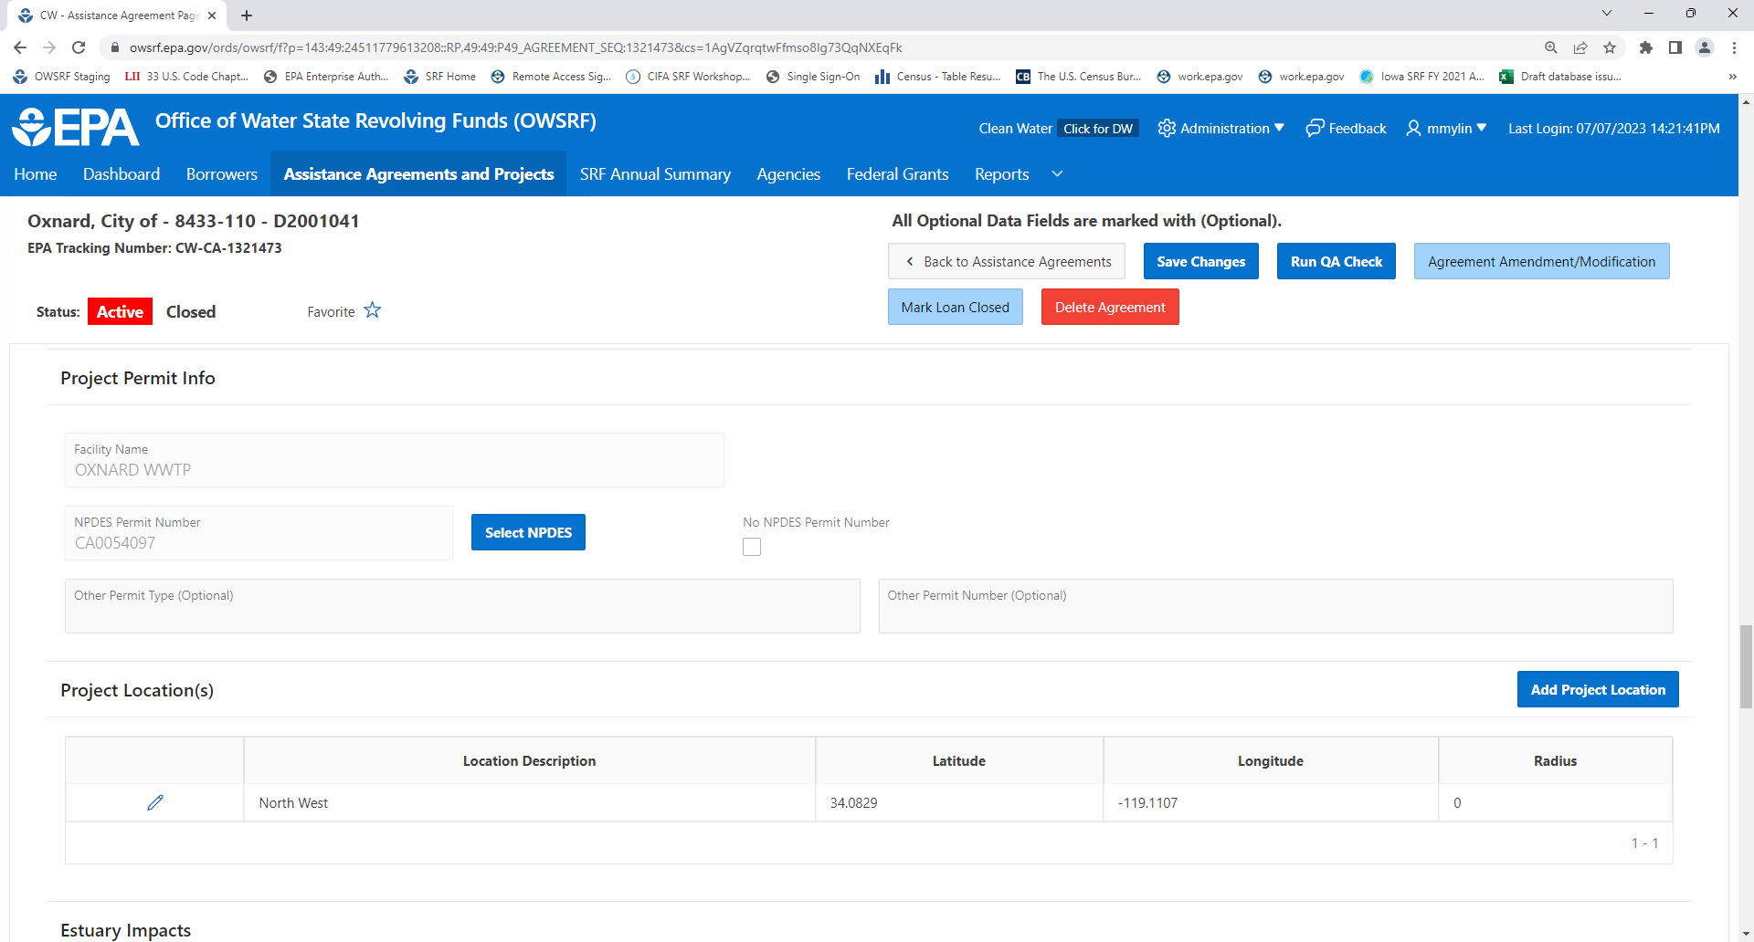

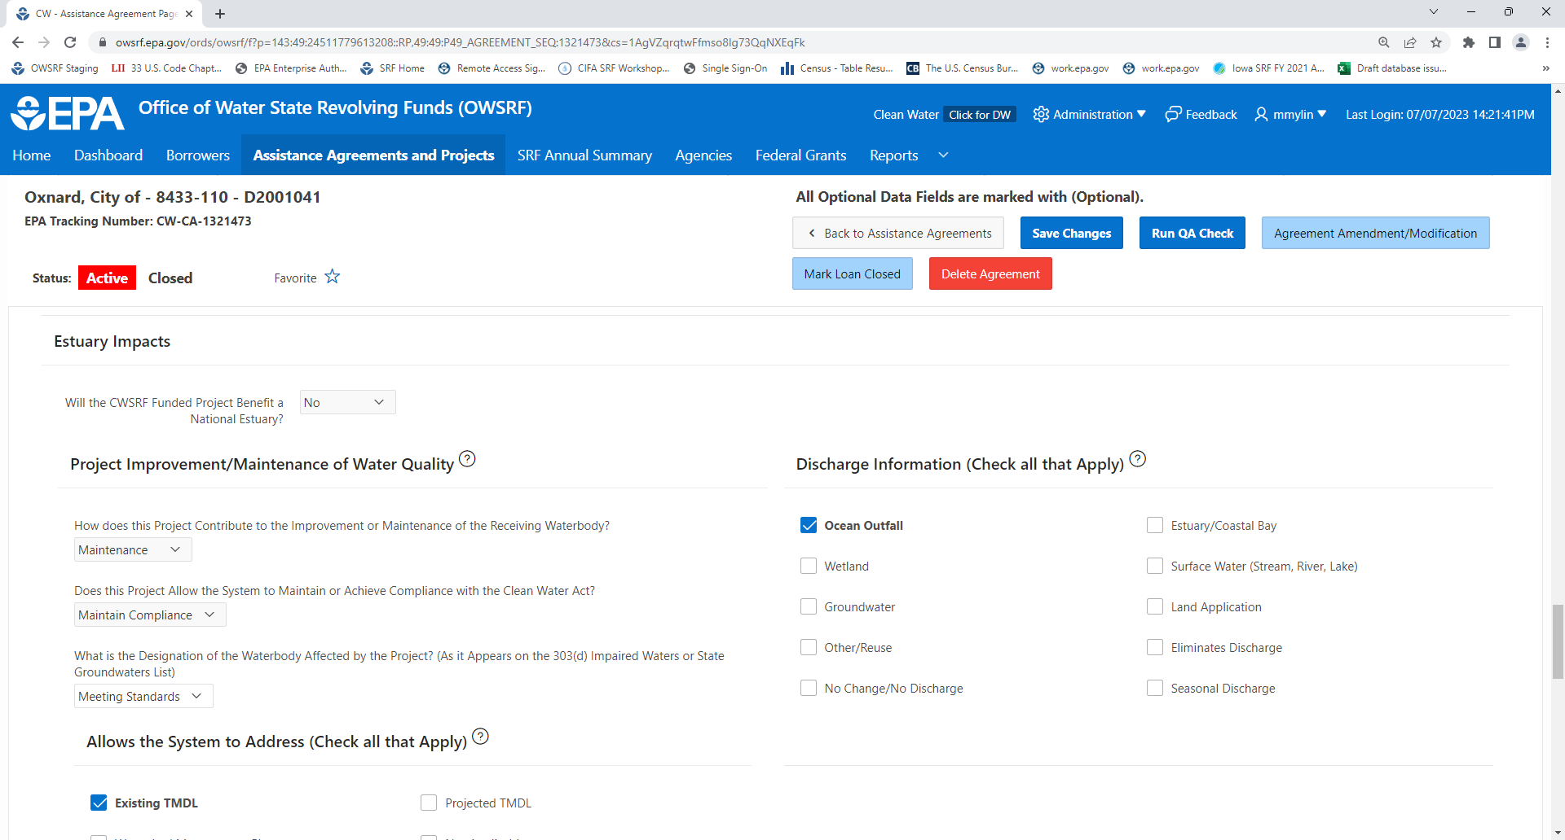

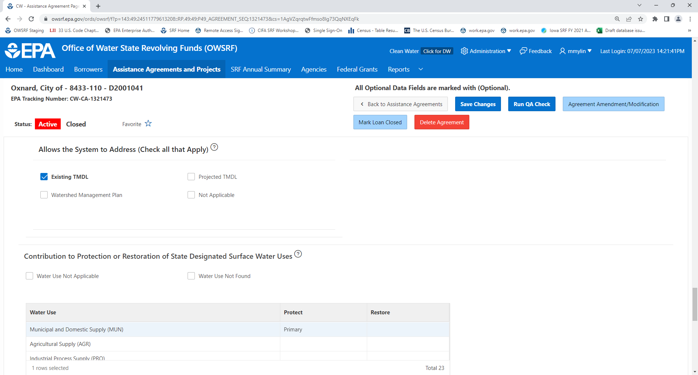

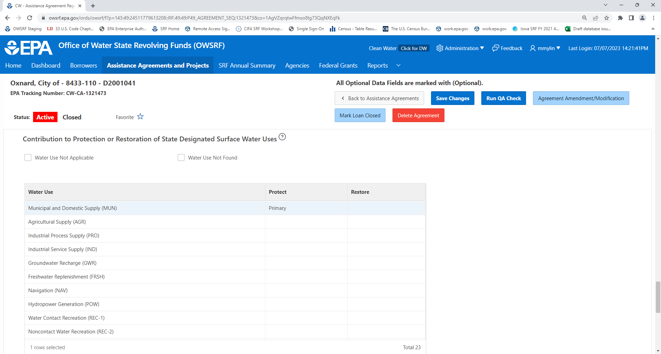

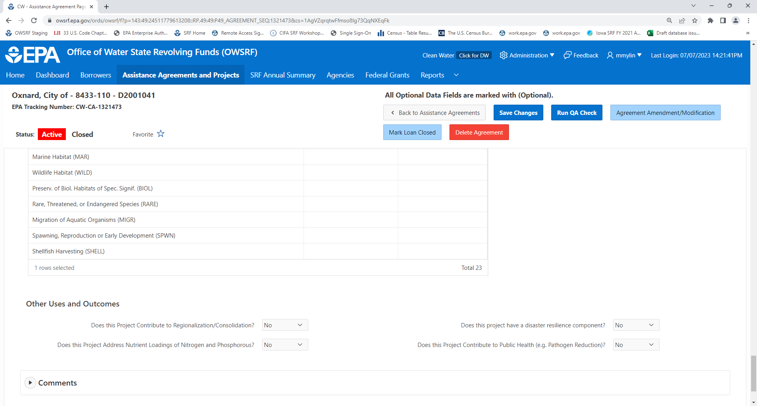

SRF Annual Summary Data: Grant and State Match - Grants and Transfers
Bolded Data Fields: Data fields do not require direct state entry because they are either being auto-populated by EPA or have been retired.
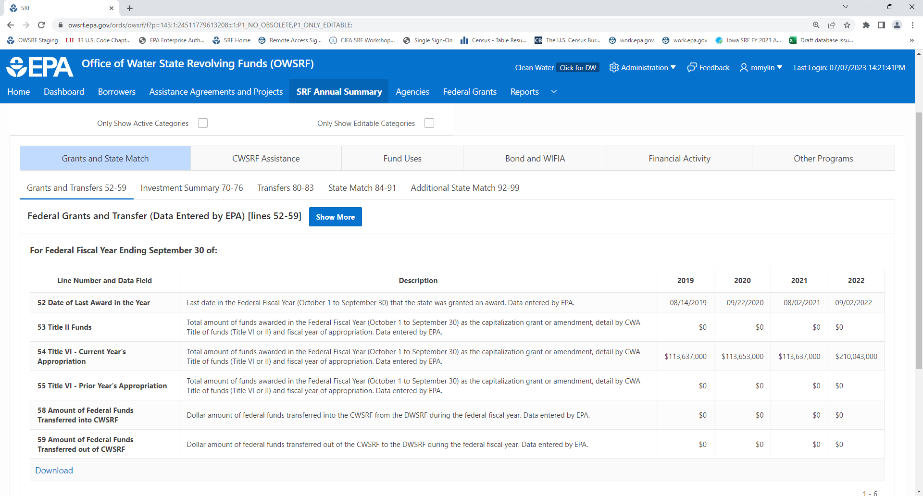

SRF Annual Summary Data: Grant and State Match – Investment Summary
Bolded Data Fields: Data fields do not require direct state entry because they are either being auto-populated by EPA or have been retired.
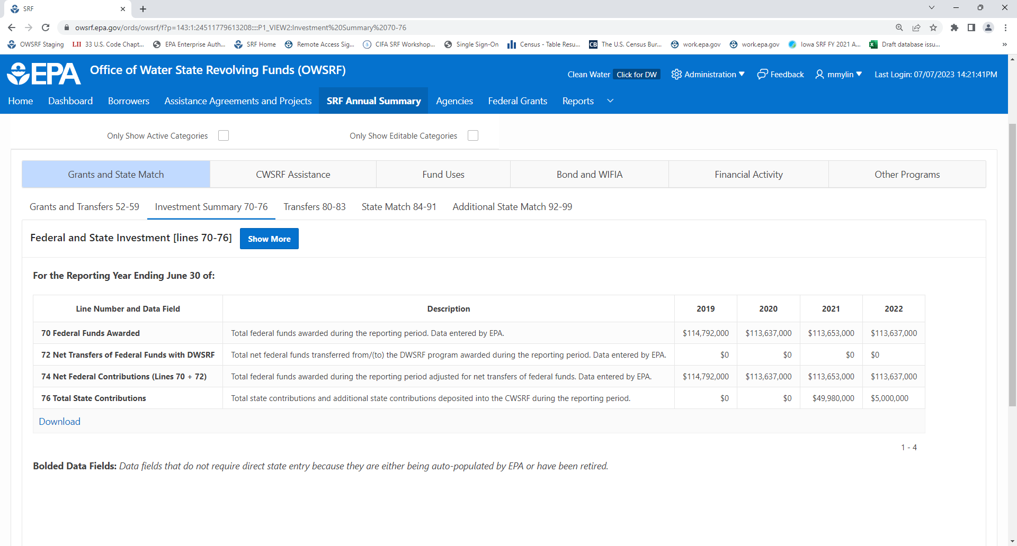

SRF Annual Summary Data: Grant and State Match – Transfers
Bolded Data Fields: Data fields do not require direct state entry because they are either being auto-populated by EPA or have been retired.
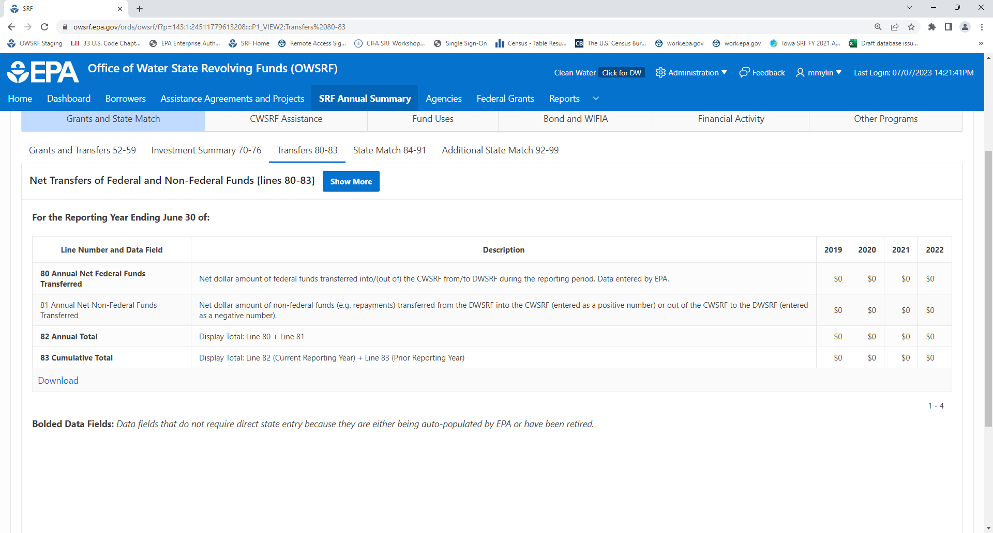

SRF Annual Summary Data: Grant and State Match – State Match
Bolded Data Fields: Data fields do not require direct state entry because they are either being auto-populated by EPA or have been retired.
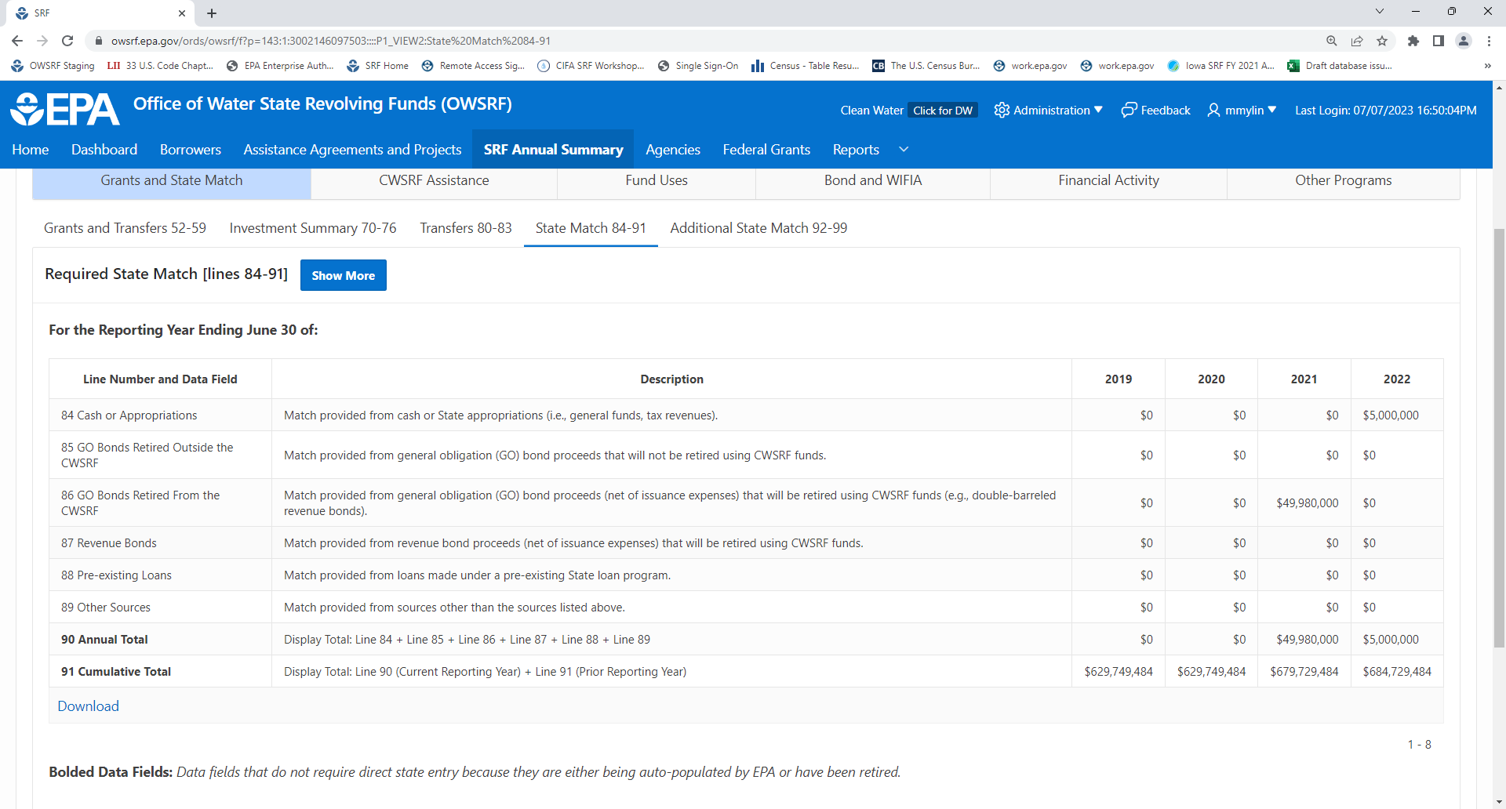

SRF Annual Summary Data: Grant and State Match – Additional State Match
Bolded Data Fields: Data fields do not require direct state entry because they are either being auto-populated by EPA or have been retired.
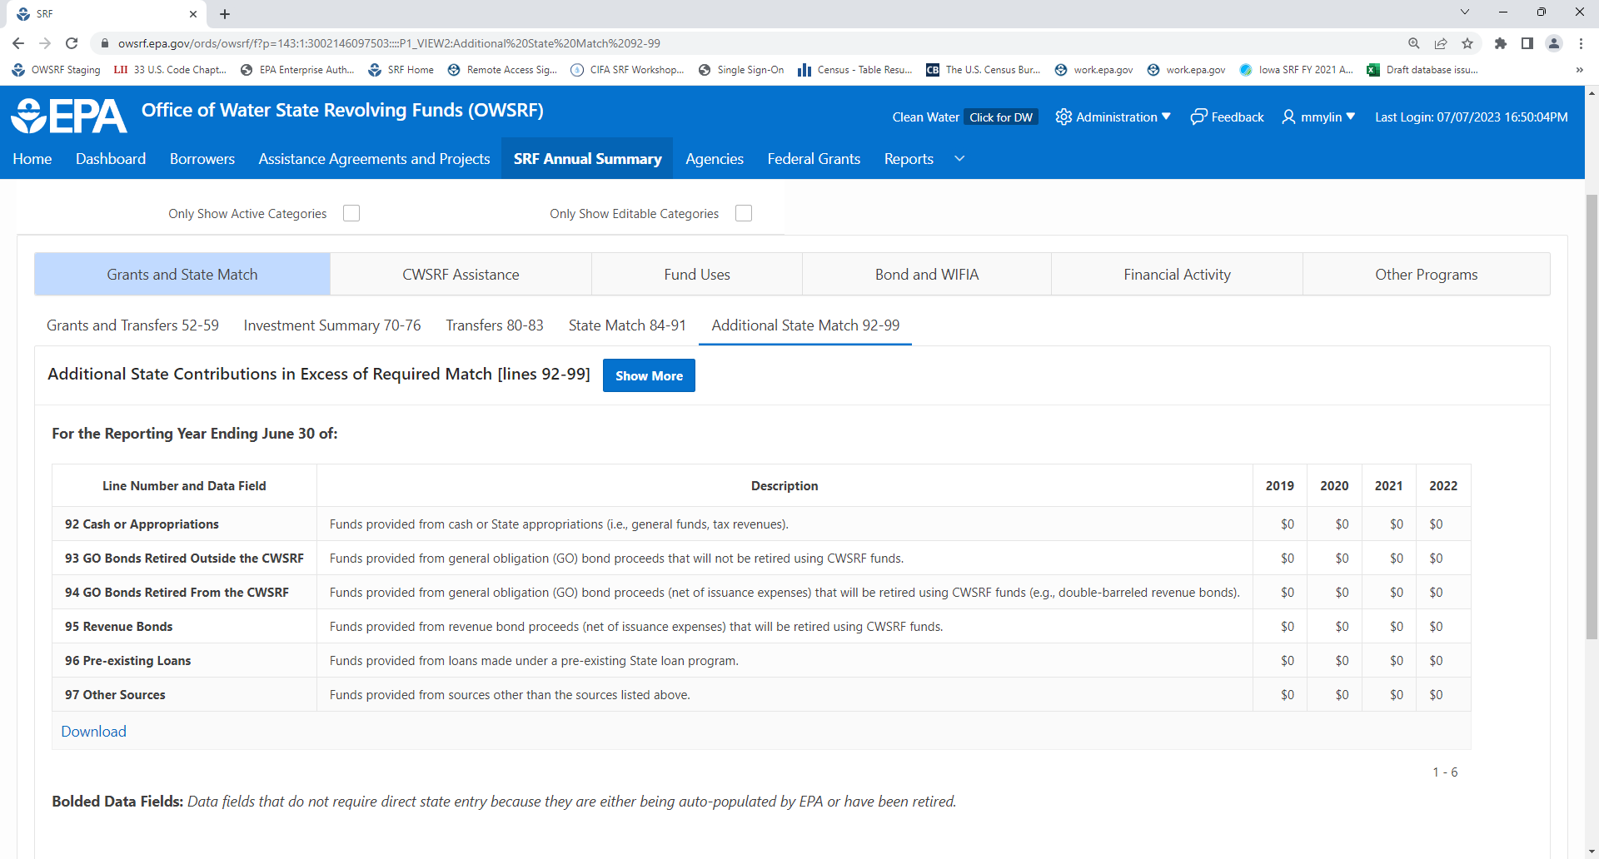

SRF Annual Summary Data: CWSRF Assistance – Binding Commitments
Bolded Data Fields: Data fields do not require direct state entry because they are either being auto-populated by EPA or have been retired.
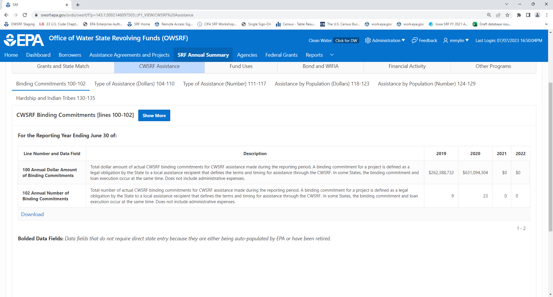

SRF Annual Summary Data: CWSRF Assistance – Type of Assistance (Dollars)
Bolded Data Fields: Data fields do not require direct state entry because they are either being auto-populated by EPA or have been retired.
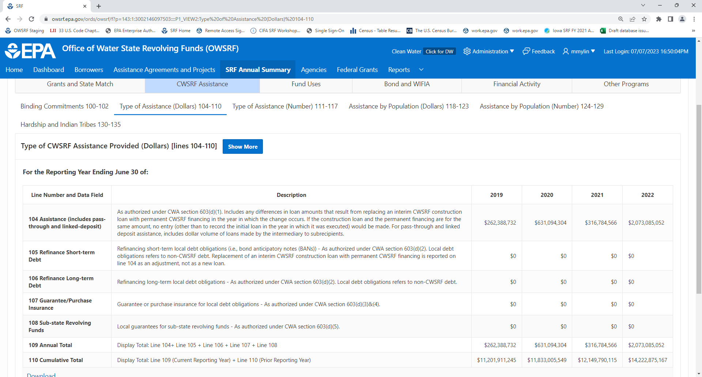

SRF Annual Summary Data: CWSRF Assistance – Type of Assistance (Numbers)
Bolded Data Fields: Data fields do not require direct state entry because they are either being auto-populated by EPA or have been retired.
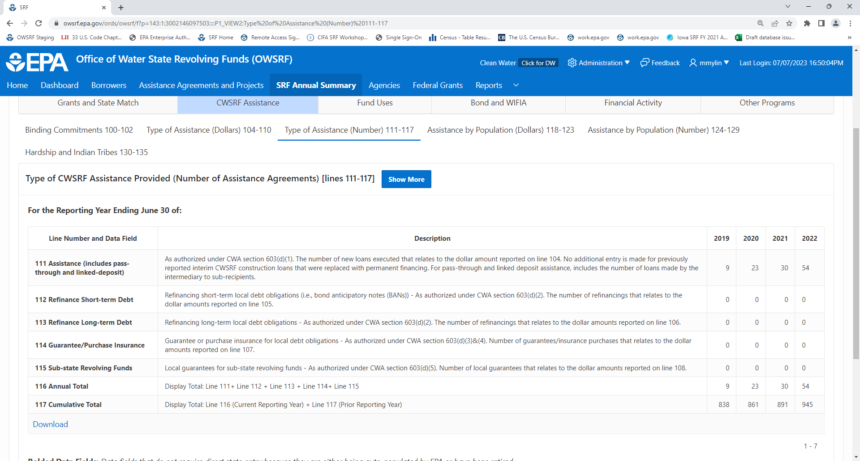

SRF Annual Summary Data: CWSRF Assistance – Assistance by Population (Dollars)
Bolded Data Fields: Data fields do not require direct state entry because they are either being auto-populated by EPA or have been retired.
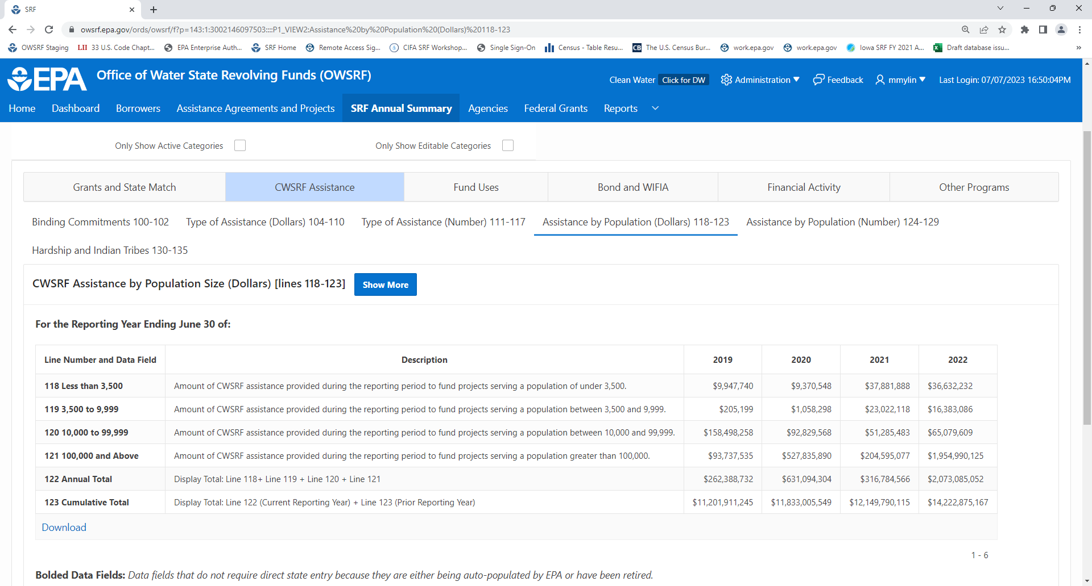

SRF Annual Summary Data: CWSRF Assistance – Assistance by Population (Numbers)
Bolded Data Fields: Data fields do not require direct state entry because they are either being auto-populated by EPA or have been retired.
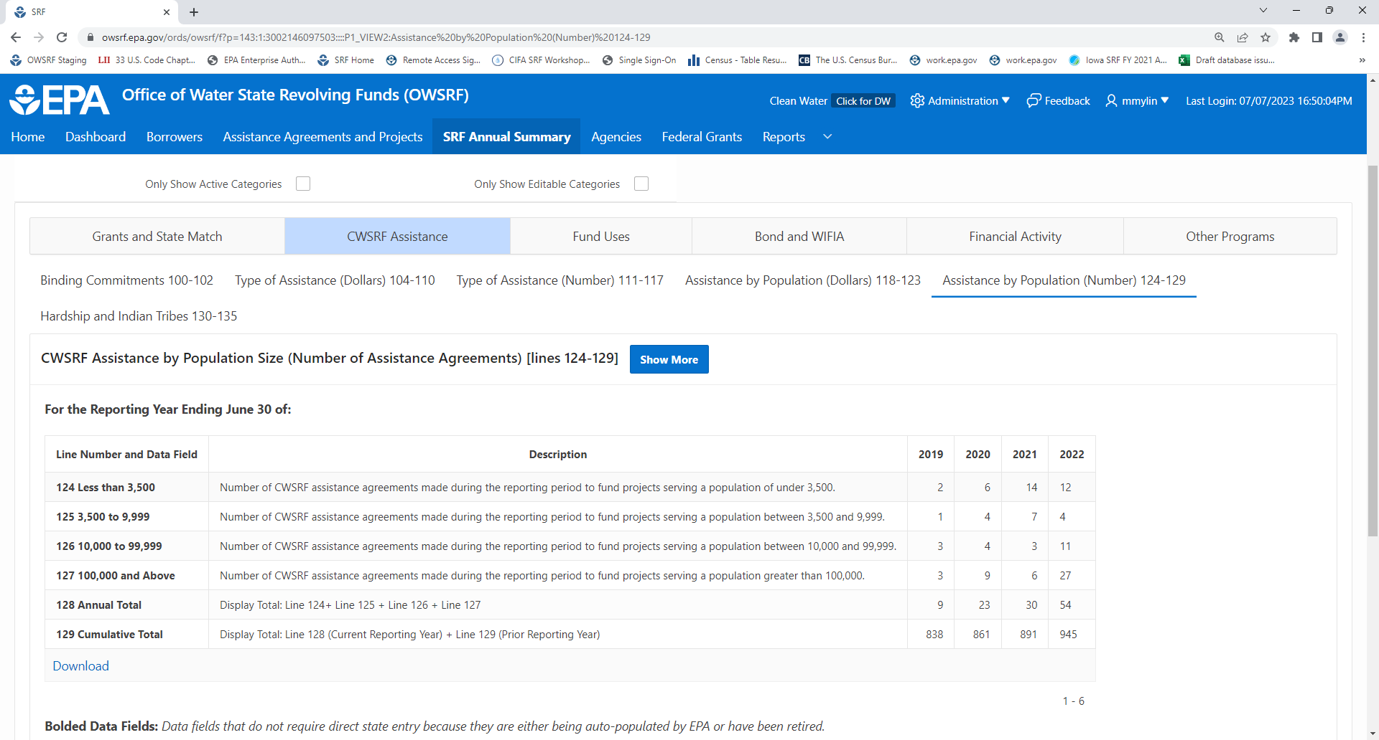

SRF Annual Summary Data: CWSRF Assistance – Hardship and Indian Tribes
Bolded Data Fields: Data fields do not require direct state entry because they are either being auto-populated by EPA or have been retired.
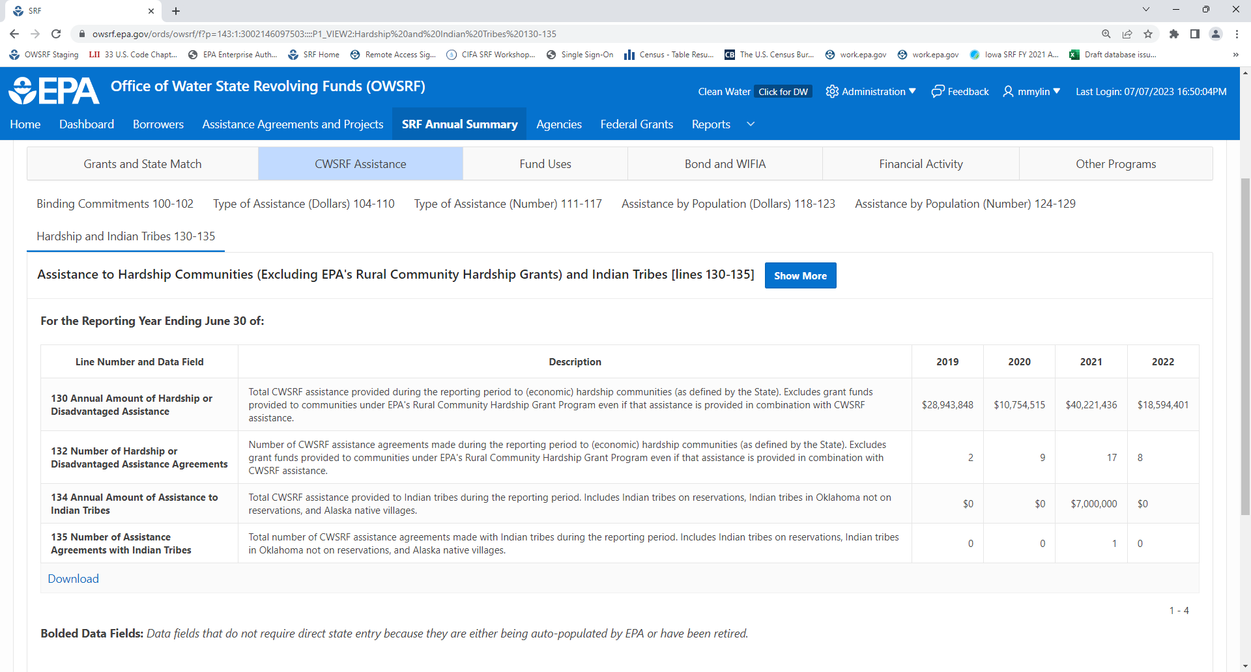

SRF Annual Summary Data: Fund Uses – NIMS Project Categories (Dollars)
Bolded Data Fields: Data fields do not require direct state entry because they are either being auto-populated by EPA or have been retired.
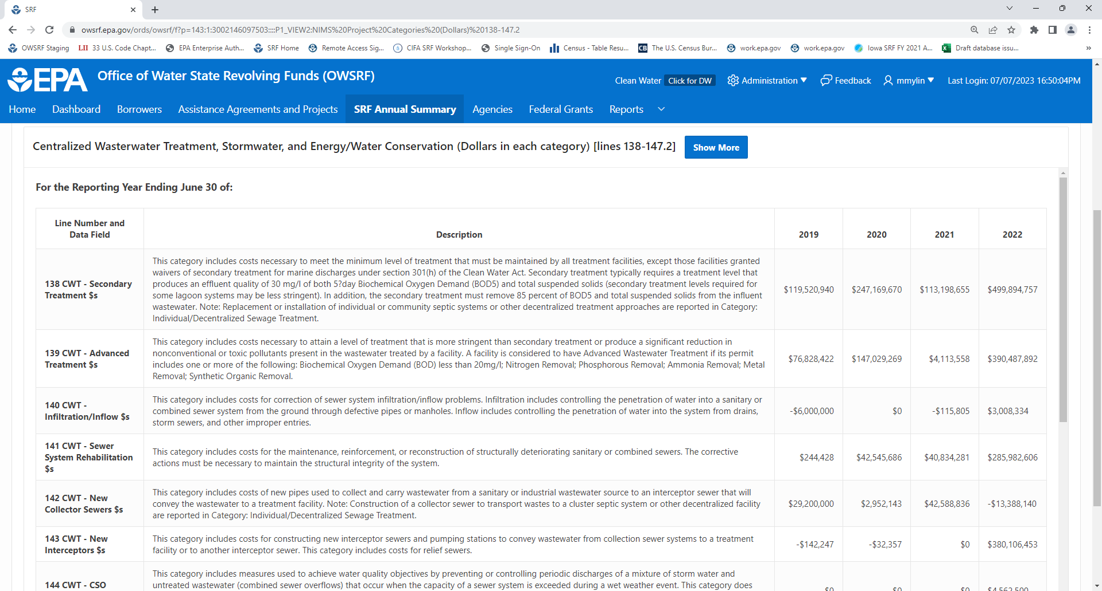

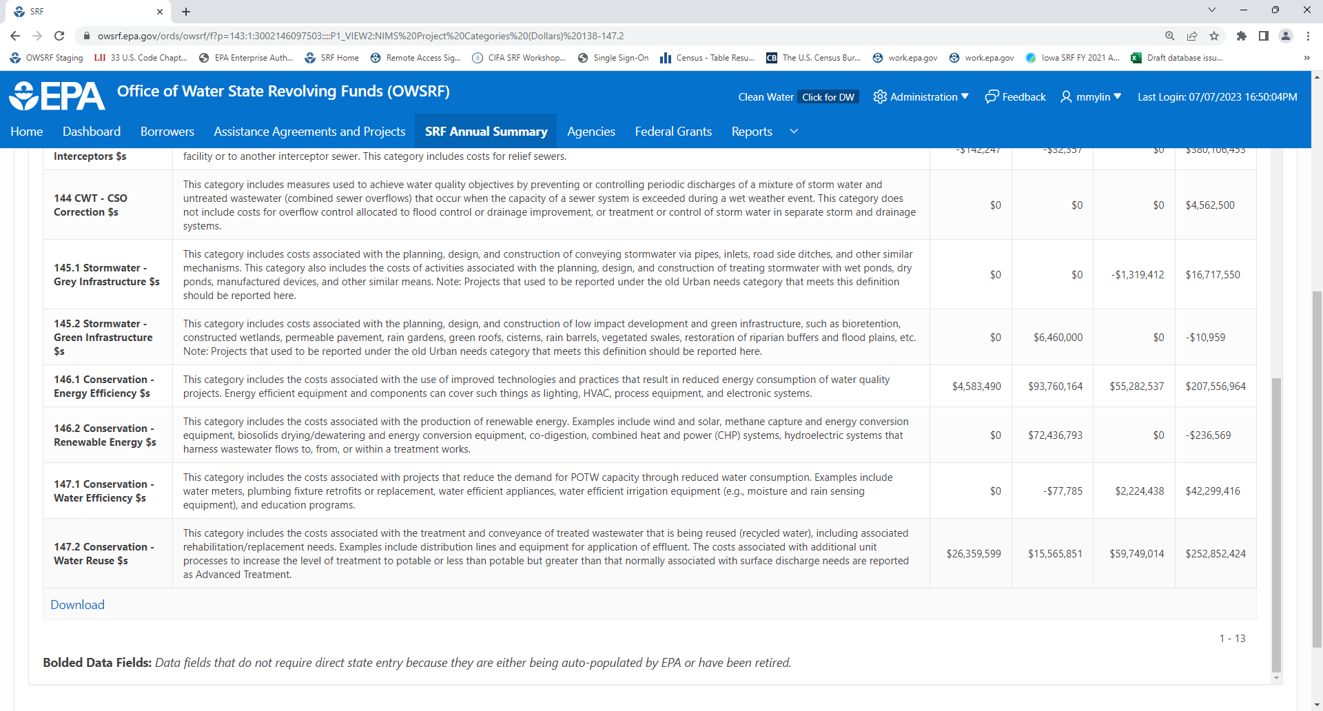

SRF Annual Summary Data: Fund Uses – NIMS Project Categories (Numbers)
Bolded Data Fields: Data fields do not require direct state entry because they are either being auto-populated by EPA or have been retired.
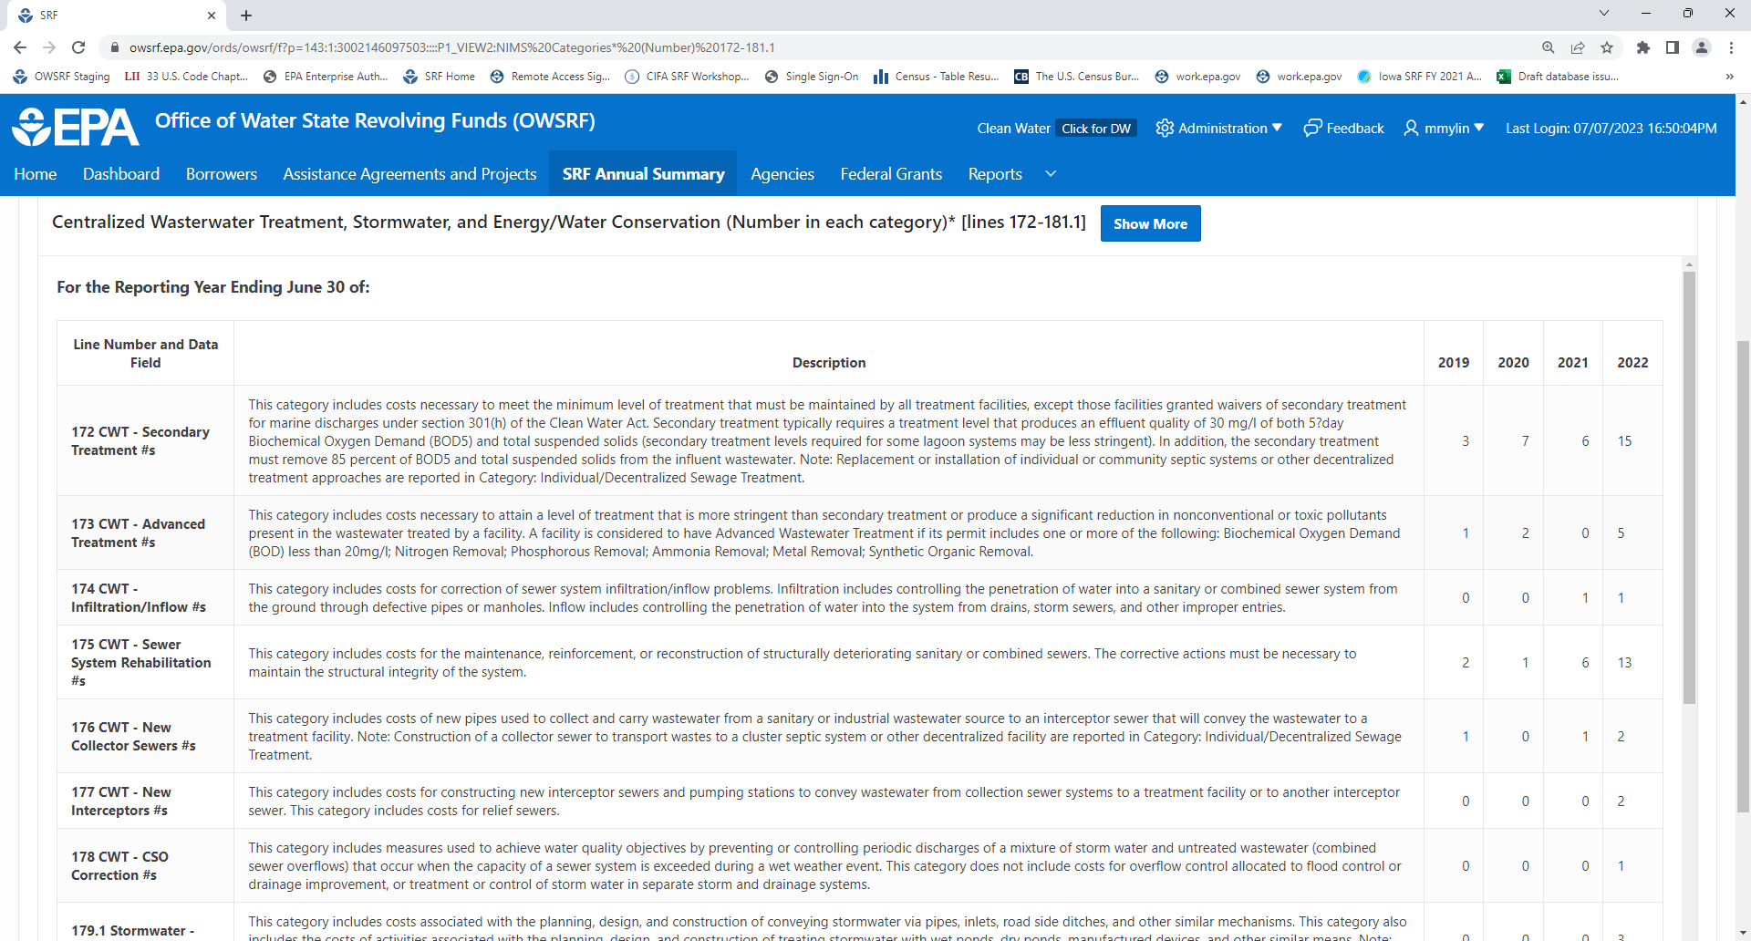

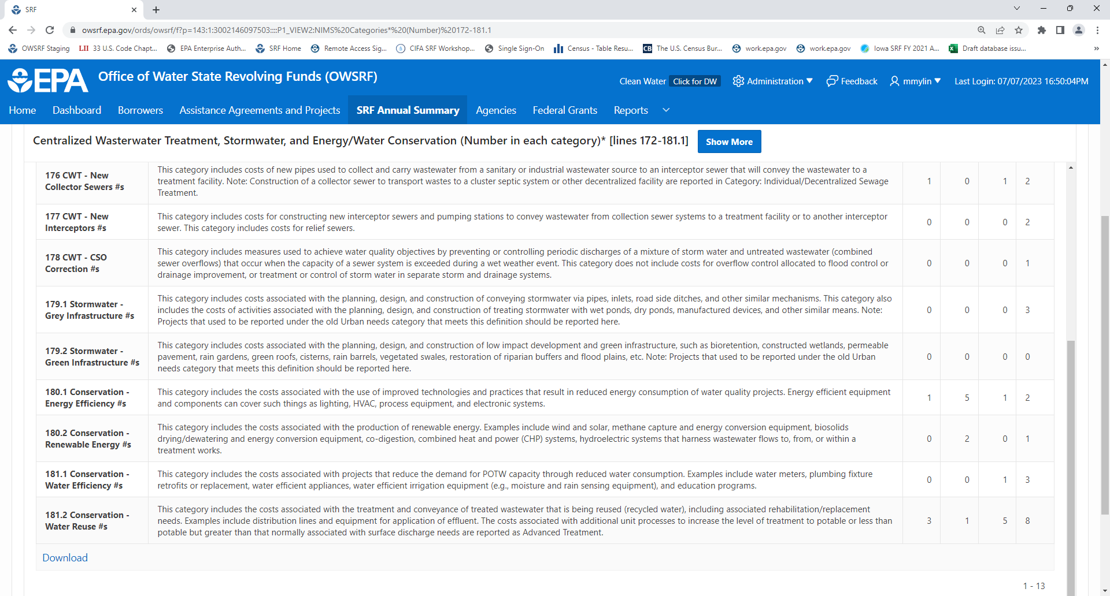
SRF Annual Summary Data: Fund Uses – NIMS Project Categories Continued (Dollars)
Bolded Data Fields: Data fields do not require direct state entry because they are either being auto-populated by EPA or have been retired.
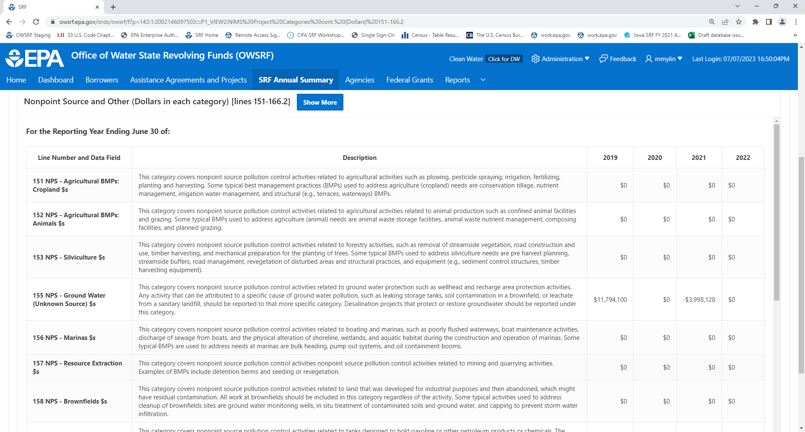

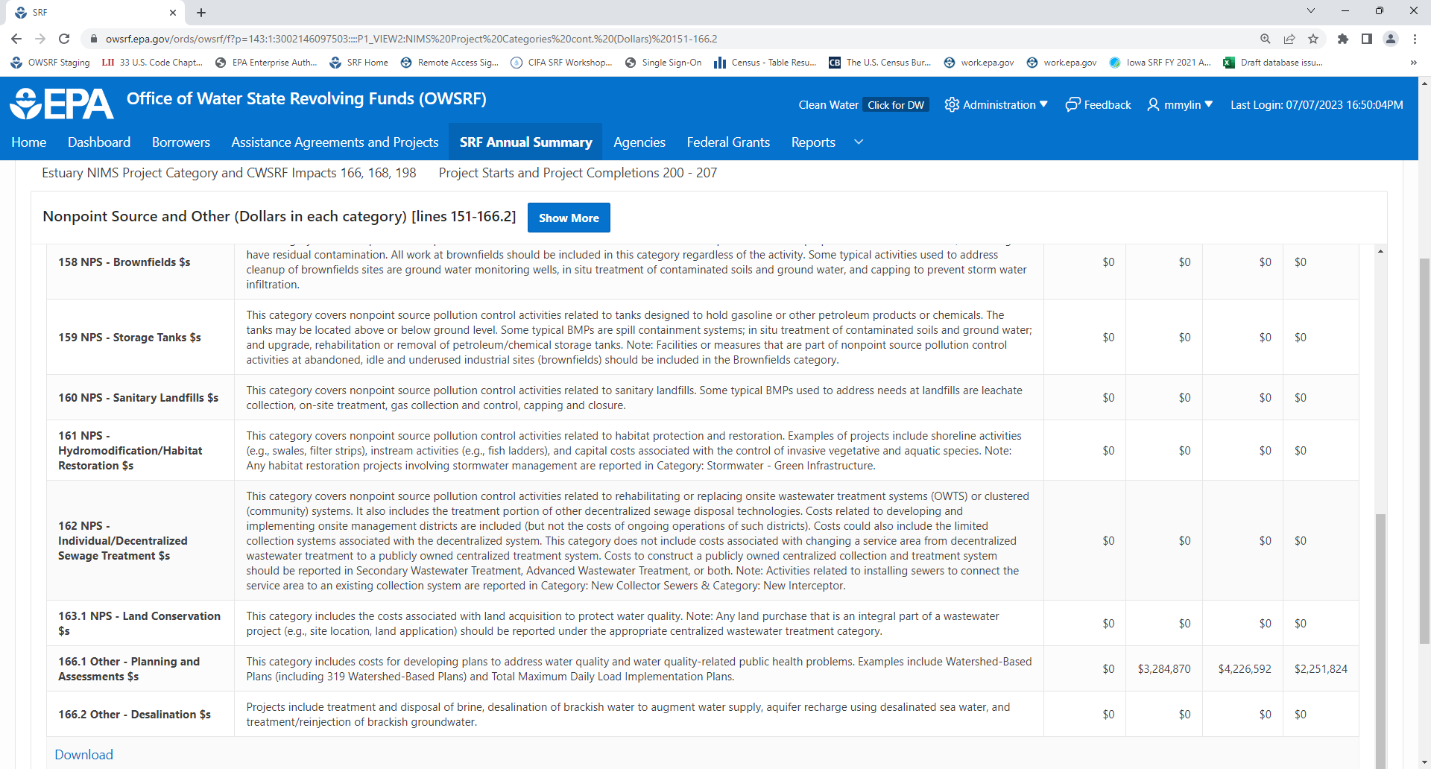

SRF Annual Summary Data: Fund Uses – NIMS Project Categories Continued (Numbers)
Bolded Data Fields: Data fields do not require direct state entry because they are either being auto-populated by EPA or have been retired.
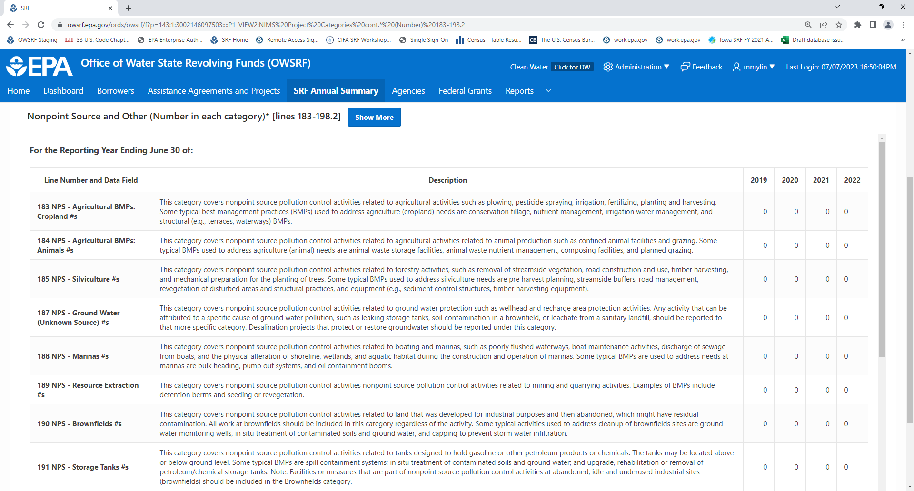

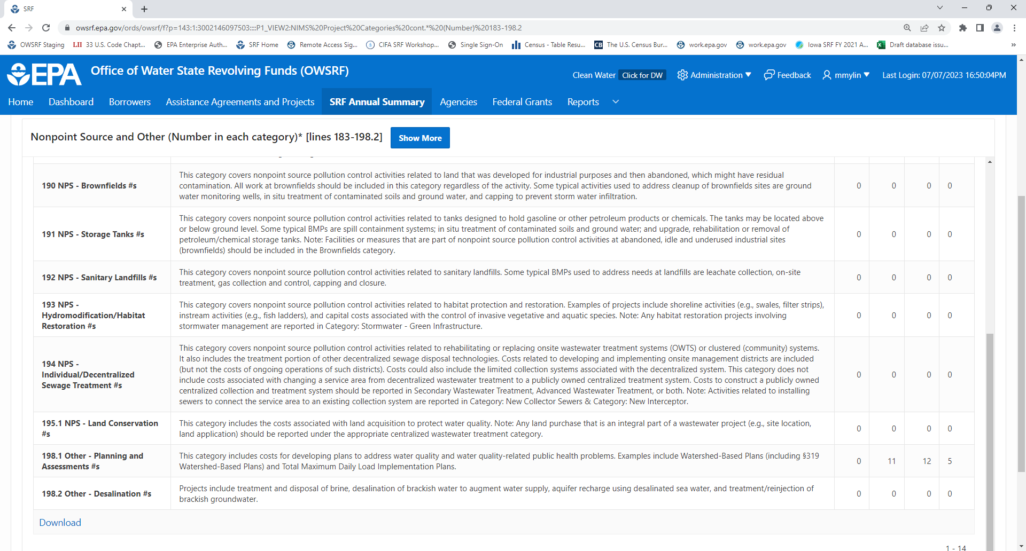
SRF Annual Summary Data: Fund Uses – Estuary Assistance NIMS Category and CWSRF Impacts
Bolded Data Fields: Data fields do not require direct state entry because they are either being auto-populated by EPA or have been retired.
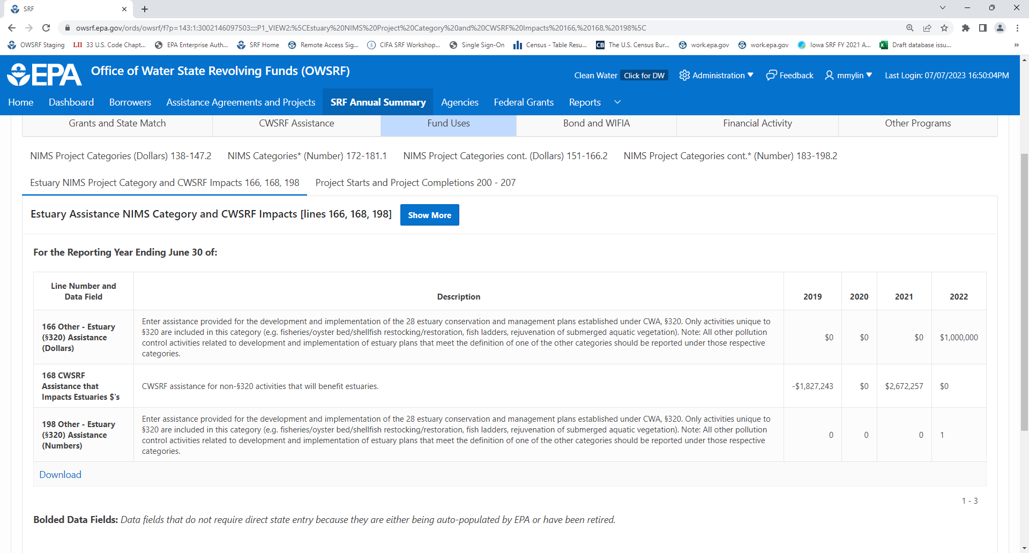

SRF Annual Summary Data: Fund Uses – Project Starts and Project Completions
Bolded Data Fields: Data fields do not require direct state entry because they are either being auto-populated by EPA or have been retired.
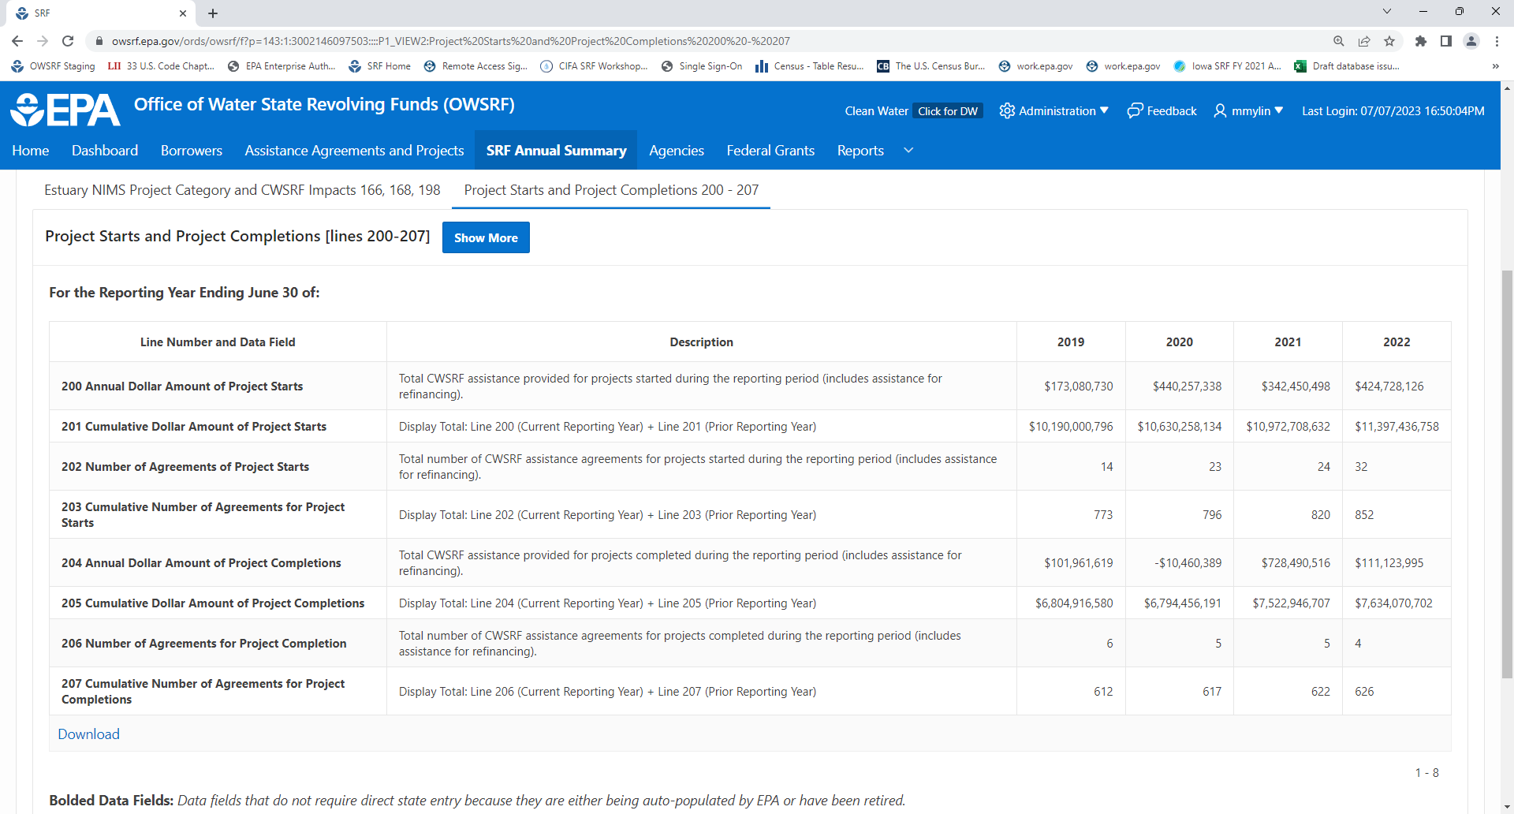

SRF Annual Summary Data: Bond and WIFIA – Leveraged Bonds and WIFIA
Bolded Data Fields: Data fields do not require direct state entry because they are either being auto-populated by EPA or have been retired.
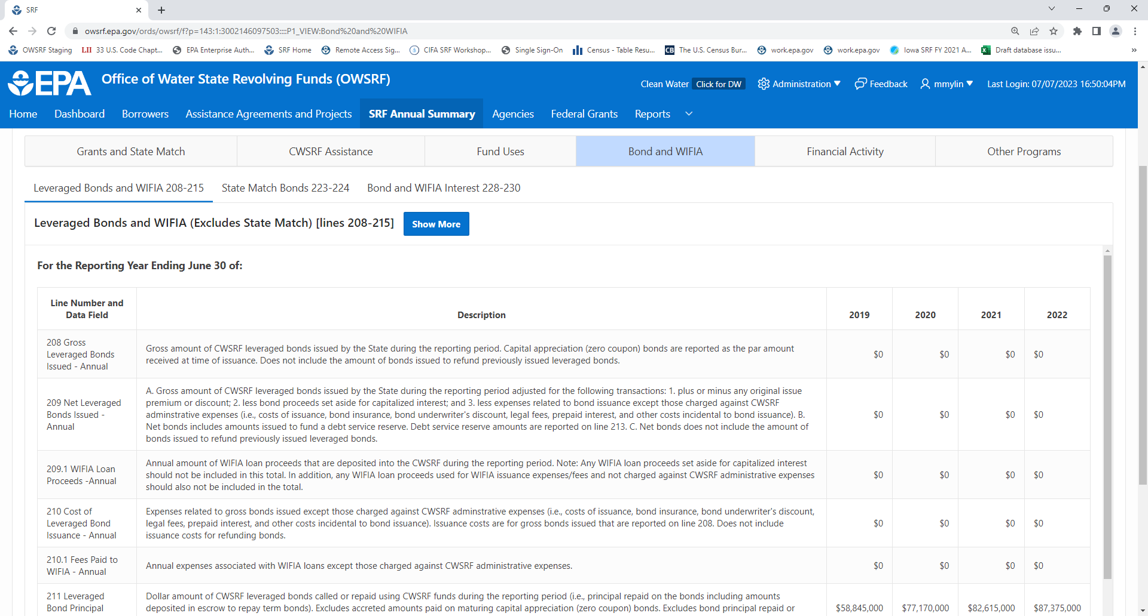

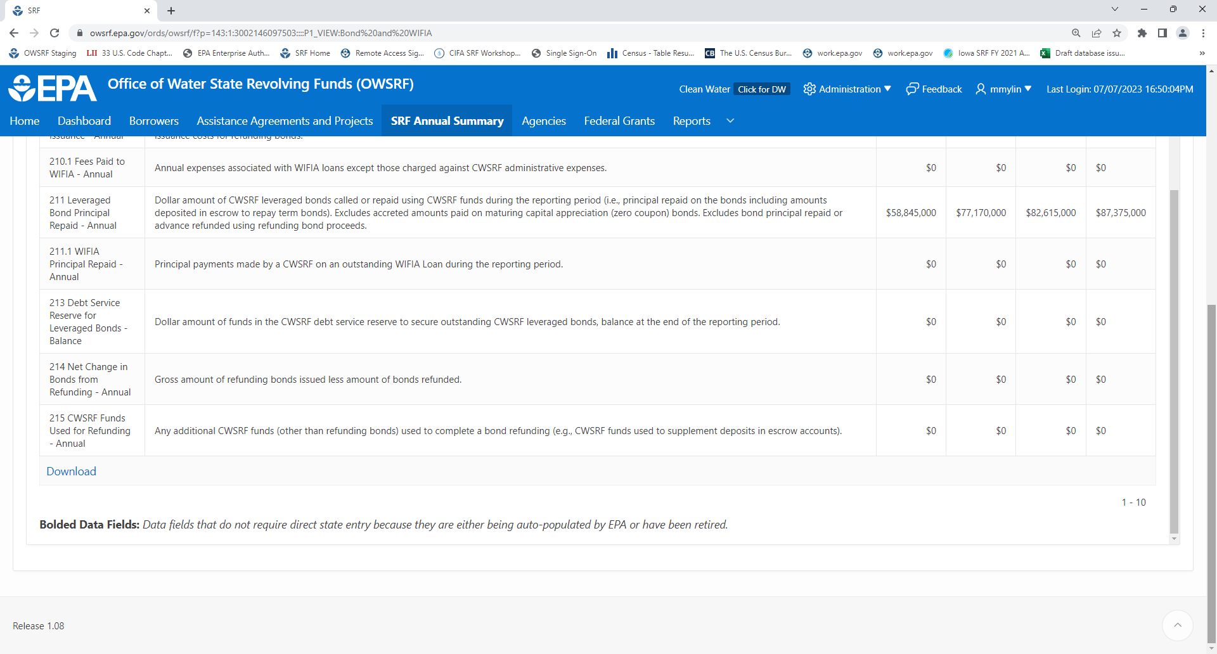

SRF Annual Summary Data: Bond and WIFIA – State Match Bonds
Bolded Data Fields: Data fields do not require direct state entry because they are either being auto-populated by EPA or have been retired.
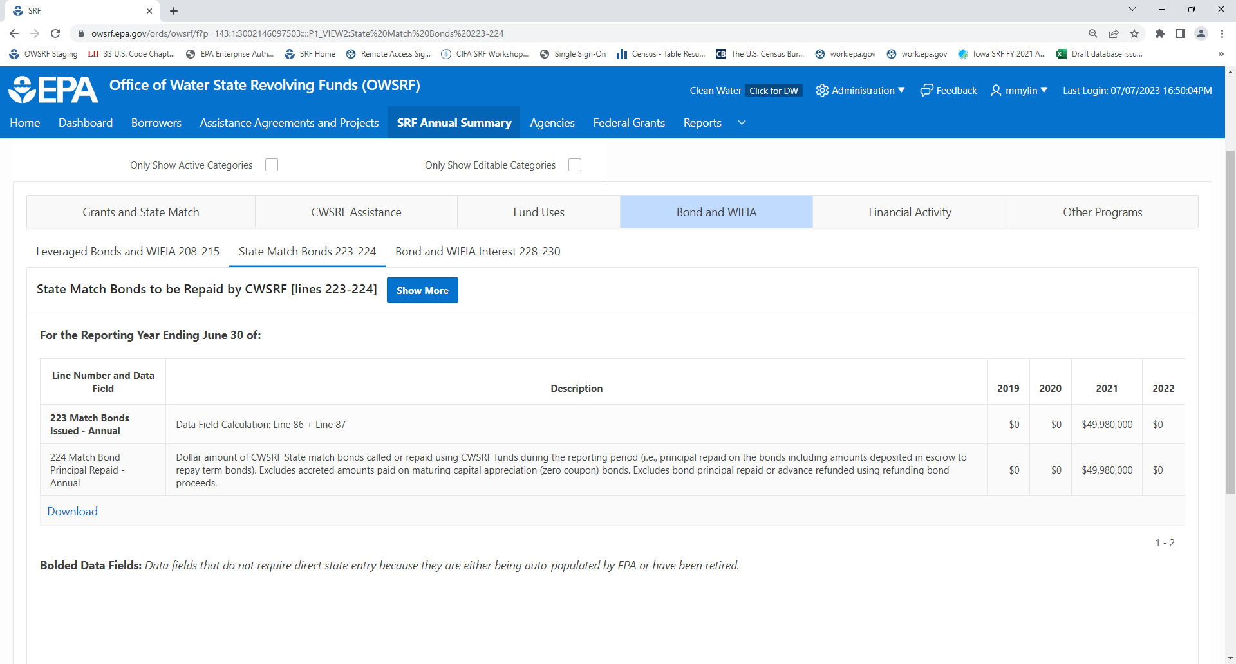

SRF Annual Summary Data: Bond and WIFIA – Bond and WIFIA Interest
Bolded Data Fields: Data fields do not require direct state entry because they are either being auto-populated by EPA or have been retired.
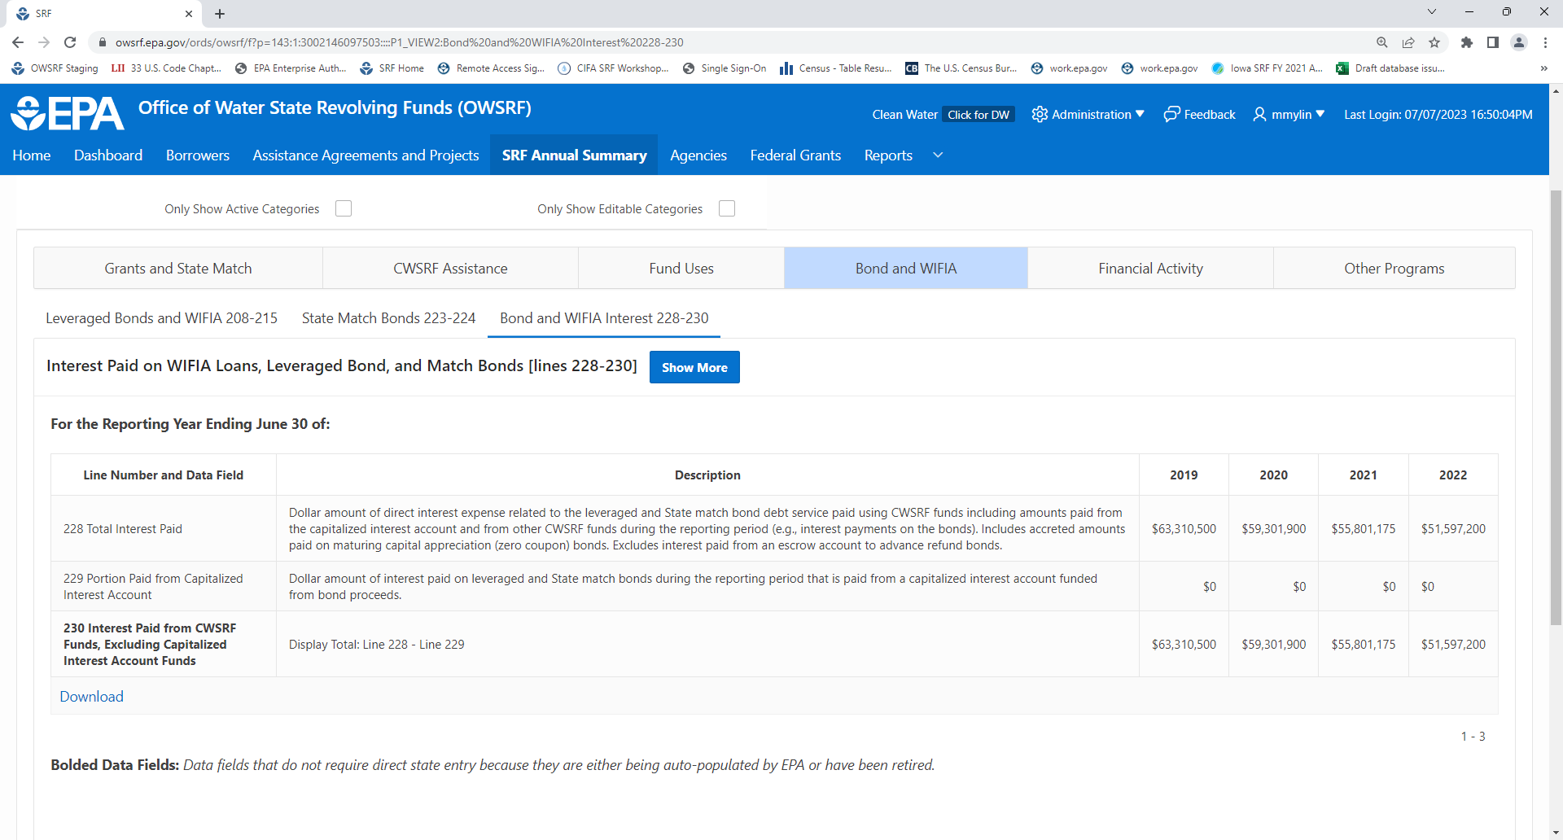
SRF Annual Summary Data: Financial Activity – Assistance Activity
Bolded Data Fields: Data fields do not require direct state entry because they are either being auto-populated by EPA or have been retired.
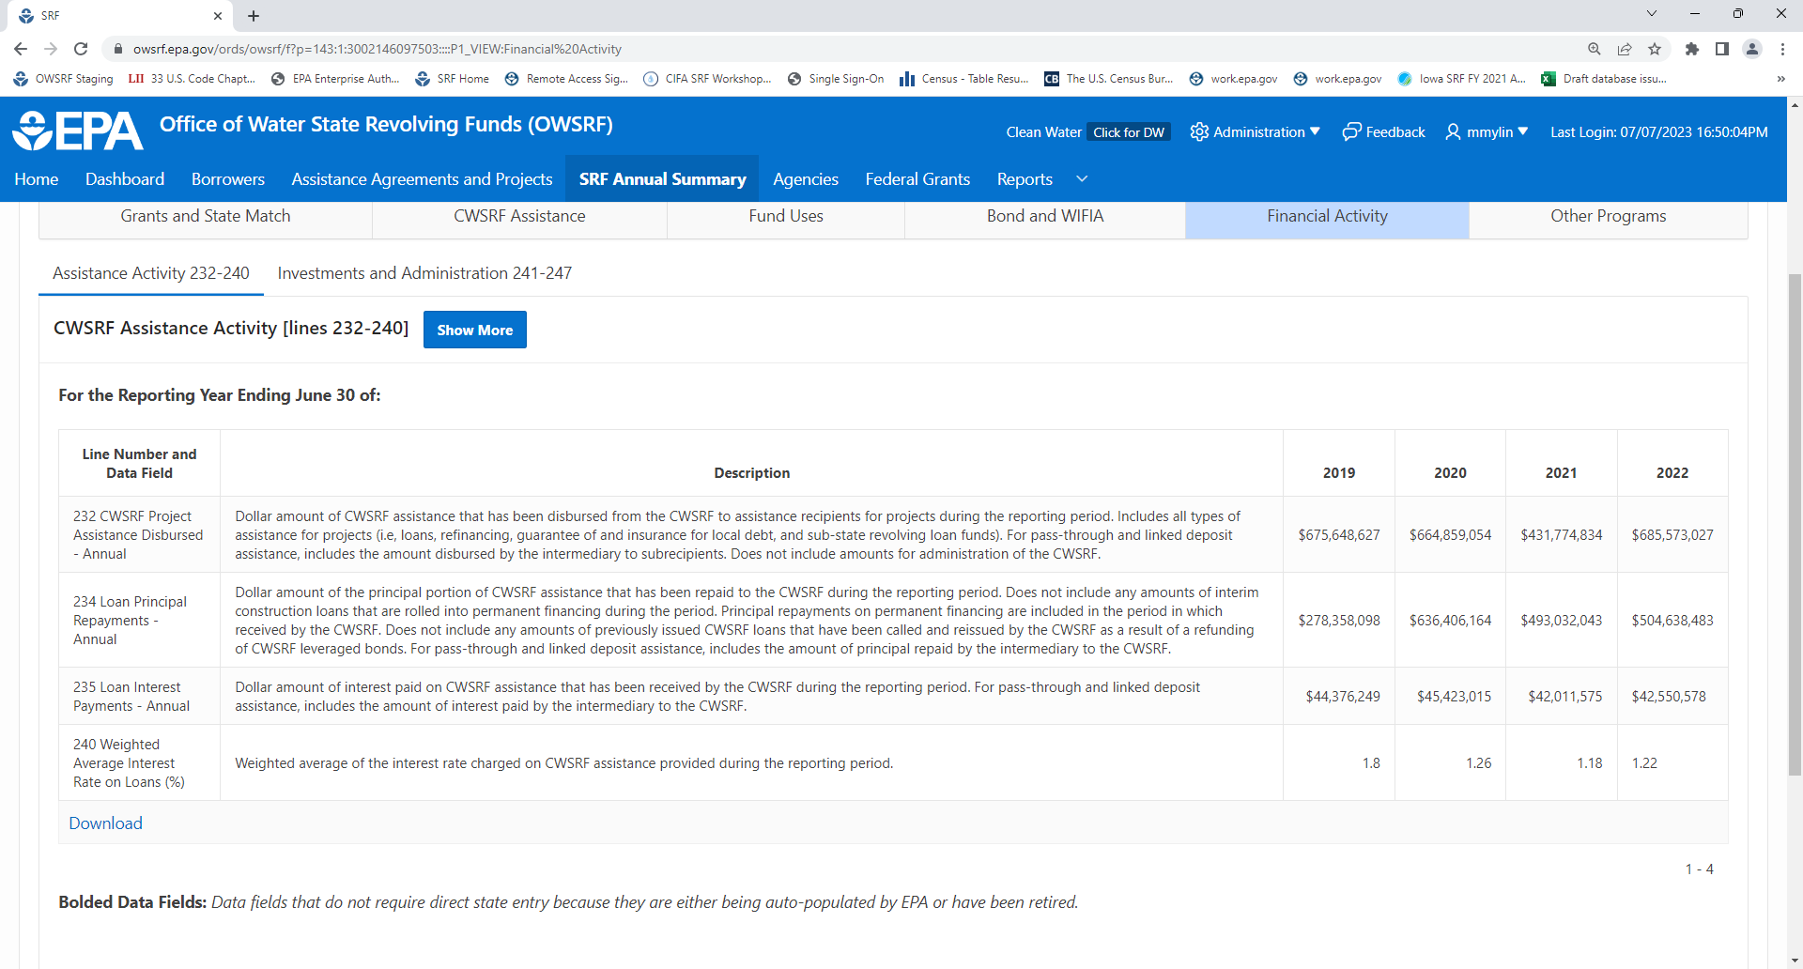

SRF Annual Summary Data: Financial Activity – Investment and Administration
Bolded Data Fields: Data fields do not require direct state entry because they are either being auto-populated by EPA or have been retired.
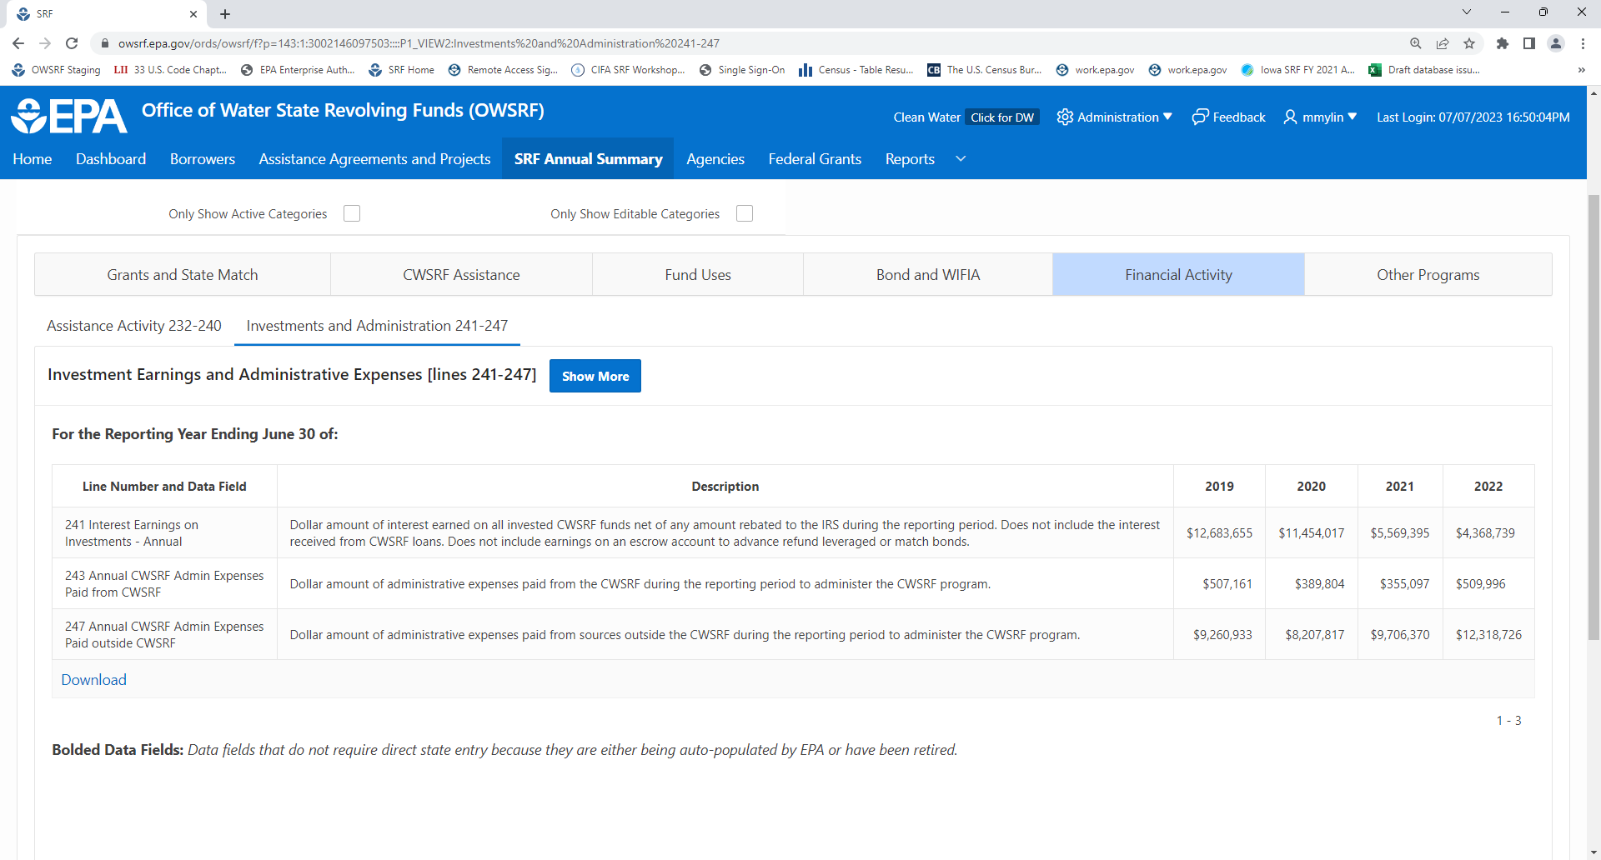

SRF Annual Summary Data: Other Programs – State Funded Loan and Grant Programs (Separate from CWSRF)
Bolded Data Fields: Data fields do not require direct state entry because they are either being auto-populated by EPA or have been retired.
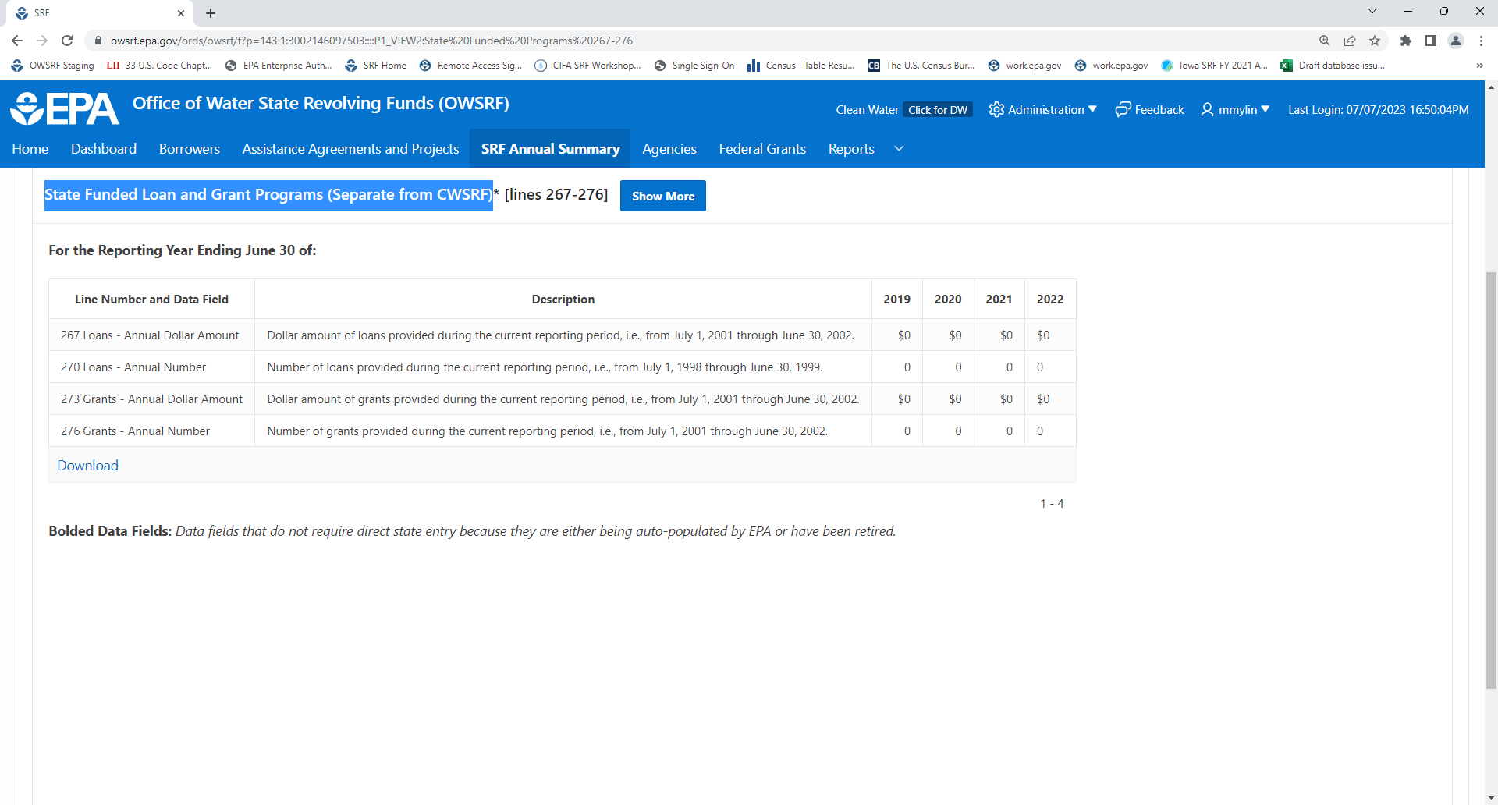

Agency Information
