"Community Support Requirements"

OMB Number 2590-0005

Justification for Non-substantive Change to the Information Collection

FHFA is requesting a non-substantive change to the information collection titled, “Community Support Requirements.” This clearance was renewed May 5, 2026.

FHFA is seeking to change how it asks for Community Reinvestment Act (CRA) data. Currently, a member that is subject to the CRA must record its most recent CRA rating and the year of that rating. With the proposed change, FHFA will provide the most recent CRA rating and year we have on file, and ask the member to confirm and update, if necessary. This will reduce the burden on the members.

Current form:

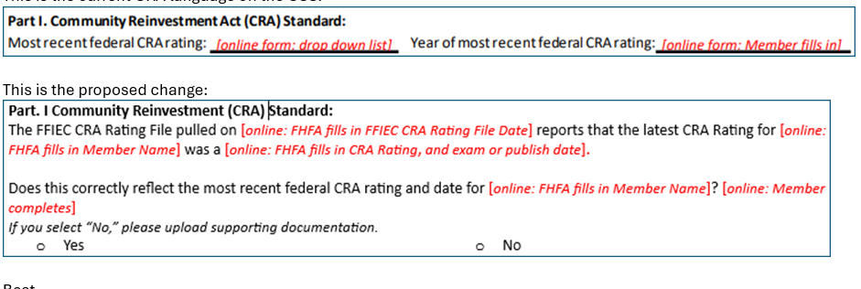

Proposed change:

