Supporting Statement A

National Aeronautics and Space Administration
Safety and Health Measures and Mishap Reporting
OMB Control No. 2700-0160

Type of information collection: Revision of a previously approved collection.

Abstract: National Aeronautics and Space Administration (NASA) requires contractors to immediately report mishaps or close calls, and quarterly report lost‑time injury rate, the number of injuries that caused lost work time, total work hours, and the dollar value of any accidents or incidents.

Summary of Changes:
- NASA Federal Acquisition Regulation Supplement (NFS) clause updates.
- NFS clause was removed from the title of this collection.
- New method of submission via NASA Mishap Information System (NMIS).
- The number of respondents reduced from 924 to 798.
- Annual time burden decreased from 4,315 to 2,394 hours.
- Respondents’ costs decreased from $232,848 to $162,792; federal government costs increased from $70,055 to $75,238.

- Need for the Information Collection.

NASA collects this information to meet the requirements of Occupational Safety and Health Administration (OSHA) 29 CFR 1960.28–30 “Basic Program Elements for Federal Employee Occupational Safety and Health Programs and Related Matters” (found online at https://www.ecfr.gov/current/title-29/subtitle-B/chapter-XVII/part-1960 ).The information collection under the NASA Federal Acquisition Regulation Supplement (NFS) clause, 48 CFR 1852.226-71 (currently enforced via NASA Procurement Class Deviation PCD 25-17A / 26-03B), formerly entitled “Safety and Health Measures and Mishap Reporting” (legacy 48 CFR 1852.223-70), Under NFS clause 48 CFR 1852.223‑70 has been relocated and updated as NFS 1852.226-71, pursuant to NASA PCD 26-03B under the Revolutionary Federal Acquisition Regulation (FAR) Overhaul (RFO).

NASA contractors must immediately notify the contracting officer of any mishap (Types A–D or Close Call). NPR 8621.1 “NASA Procedural Requirements for Mishap and Close Call Reporting, Investigating, and Recordkeeping”
(found online at https://nodis3.gsfc.nasa.gov/displayDir.cfm?t=NPR&c=8621&s=1D), defines the criteria for each type. Contractors must provide basic incident details, including location, date and time, known fatalities or hospitalizations, injury or damage type, contact information, and a brief incident description. The NFS clause also requires quarterly reports from contractors that report number of mishaps, specifying lost time frequency rate, number of lost time injuries, exposure, and accident/incident dollar losses.

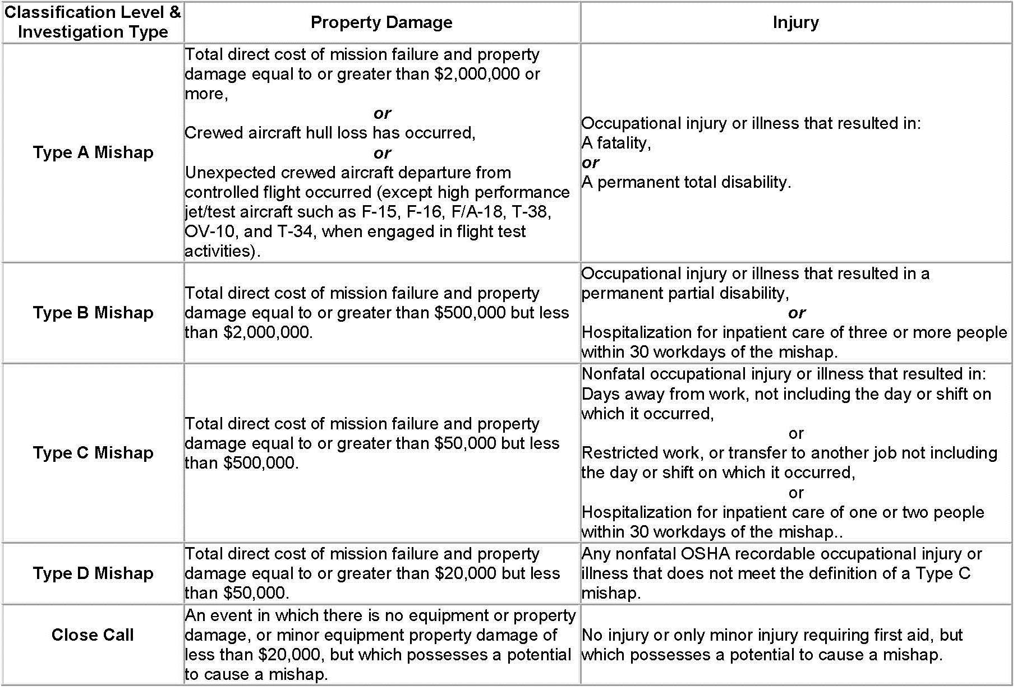

2. Purpose and Use of the Information Collection.

Mishap notifications and quarterly reports, under the NASA clause, are used by NASA mishap investigators and NASA officials to determine potential causes for mishaps, mitigate hazards, develop lessons learned and recommendations to prevent recurrence, evaluate Agency mishap trends, and ultimately improve the safety of its workforce and high-value assets and reduce the risk to its missions.

- Use of Technology.

Contractor data is submitted electronically via NMIS. (https://nmis.sma.nasa.gov/)

- Duplication of Information.

This information request is specific to NASA and does not duplicate any other federal requirement. OSHA focuses on workplace injuries, illnesses, and fatalities involving people. NASA’s reporting requirements go further, requiring contractors to report, investigate, analyze all mishaps, including those that damage or destroy property, and share lessons learned to prevent future mishaps and improve operations.

5. Burden on Small Businesses.

The burden on small businesses is the minimum consistent with legal and regulatory obligations and prudent business practices.

6. Consequences of Not Conducting Collection.

If this information was not collected, or collected less frequently, NASA would have less information to protect people and high value assets. This would result in potential for:
- Increased risk of occupational injury or fatality to contractors or NASA personnel.
- Increased risk of catastrophic damage to NASA property and mission essential equipment.
- Increased cost and schedule burden to NASA associated with employee lost time or mission schedule impact due to mishap.
- Increased risk of injury or fatality to the general public.

7. Special Circumstances.

There are no special circumstances. The collection of information is conducted in a manner consistent with the guidelines in 5 CFR 1320.6.

8. Consultations with Persons Outside the Agency and Public Comments.
60-day Federal Register Notice (FRN): 91 FR 22867 published on 04/28/2026. No comments were received.
30-day FRN: 91 FR 48436 published on 07/31/2026

9. Payment or Gifts.

No payments or gifts are provided to respondents. Remuneration is limited solely to compensation provided to contractors or grantees for work performed under their respective agreements.

10. Confidentiality.

NASA does not provide any assurance of confidentiality. Mishap investigation information is handled in accordance with NASA’s privacy and information security policies. A Privacy Impact Assessment has been completed. NASA Center mishap reporting processes are coordinated by the NASA Office of Safety and Mission Assurance representatives trained in information security.

Legal and public affairs advisors confirm that any privileged, proprietary, or Privacy‑Act‑protected information is correctly marked as non‑releasable, and that publicly releasable portions are appropriately designated.

Public release of Type A, Type B, and high‑visibility mishap reports occurs through the Freedom of Information Act (FOIA) process. When public interest is significant, full reports may be released after legal and public‑affairs concurrence; when proprietary or export‑controlled information prevents full release, the Investigating Authority and its public affairs advisor prepare a separate publicly releasable summary of findings. For Type C and Type D mishaps, the Approving Official and public affairs advisor determine the release process. Even when a report is marked publicly releasable, release still requires proper endorsements, authorization, and a FOIA request.

NASA mishap investigation records are retained in accordance with NASA Records Retention Schedule (NRRS) 1441.1. Schedule 01/121.5 (Found online at: https://nodis3.gsfc.nasa.gov/NPR_attachments/NRRS_1441.1_09032025.pdf)

11. Questions of Sensitive Nature.

Questions of a sensitive nature are not found in this information collection.

12. Burden of Information Collection.
NASA estimates that contractors spend about three hours preparing each mishap notification and three hours preparing each quarterly safety report, including information gathering, supervisory review, and verification by Occupational Health and Safety Specialists before submission to the contracting officer. With roughly 133 contract actions annually, this results in about 266 mishap notifications and 532 quarterly reports—798 total responses each year—generally equating to two mishap notifications and four quarterly reports per contractor. These reporting requirements ensure timely, accurate data on mishap details, lost-time injuries, exposure hours, and accident-related costs across NASA facilities.

The table below summarizes the estimates of the hour burden of the collection of information.

Reporting Requirement | Respondents | Responses per Respondent | Total Responses | Hours per Response | Hours Estimated
1. Notification of a Type A, B, C, or D Mishap, or close call. | 133 | 2 | 266 | 3 | 798
2. Quarterly reports Quarterly reports specifying lost-time frequency rate, number of lost-time injuries, exposure, and accident/incident dollar losses. | 133 | 4 | 532 | 3 | 1596
Total |  | 6 | 798 | 3* | 2,394

*This is an average for the total number of hours (2,394) divided by the total number of responses (798) resulting in 3.0 total hours per response.

13. Annual Cost to Respondents.

Generally, two labor categories will be involved in the requirements of this information collection: Occupational Health and Safety Specialist and a company supervisor or manager. The Occupational Health and Safety Specialist is estimated to be equivalent to the midpoint (step 5) of the General Schedule (GS) GS-12 with an hourly rate of $41.52 (from the 2026 OPM GS Salary Table). The manager/supervisor is estimated to be equivalent to the midpoint for a GS-14 at an hourly rate of $58.35. For both labor categories, the overhead/burden rate of 36.25%, based on the OMB-mandated burden rate for A-76 public-private competitions, is added (e.g., GS 12, Step 5 $41.52/hour x 1.3625 = $56.57 burdened hourly rate. For a manager/supervisor at a rate of $58.35, the burdened hourly rate is $79.50. (e.g., $58.35/hour x 1.3625= $79.50. Average rate per hour $56.57+ $79.50 divided by 2= $68.

Labor Category | Mishap Notification/year |  |  | Quarterly Report/year
Labor Category | Time (hours) | Hourly Rate | Total Cost | Time (hours) | Hourly Rate | Total Cost
Occupational Health and Safety Specialist | 7 | $56.57 | $396.00 | 10 | $56.57 | $565.70
Manager | 1 | $79.50 | $79.50 | 2 | $79.50 | $159.00
Total | 8 | $136.07 | $475.50 | 12 | $136.07 | $724.70

Estimated Summary of Annual Total Cost to respondents of Information Collection Reporting Burden:

 | Number of respondents |  | 133
 | Responses per respondent |  | 6
 | Total annual responses |  | 798
 | Average number of hours per response |  | 3
 | Total hours  Rate per hour (average) |  | 2,394  68
Total annual cost to respondents |  | $162,792

14. Cost to the Federal Government.

NASA estimates a total cost to the government of approximately $75,238. This estimated cost is comprised of the effort required to review notifications and accident rate reports and complete a trend analysis. The preponderance of the review effort will be made by NASA’s safety and occupational health official, usually a GS-12.

Total Estimated Summary of the Annual Cost to the Government for Information Collection Reporting and Recordkeeping Burdens

Clause Requirement | Responses | Hours per Response | Gov’t Hours | $/Hr. | Gov’t $
Mishap Notification | 266 | 1 | 266 | $56.57 | $15,048
Quarterly Report | 532 | 2 | 1,064 | 56.57 | $60,190
Total annual Gov’t. cost |  |  | 1,330 |  | $75,238

* The Government used a rate equivalent to a GS-12

- Reasons for Change in Burden.

The burden changed due to implementation of the new NMIS submission method and a reduction in respondents from 924 to 798. Consequently, the annual time burden decreased from 4,315 to 2,394 hours, respondents’ costs dropped from $232,848 to $162,792, while federal government costs increased from $70,055 to $75,238.

16. Publication of Results.

This data collection will not be published. The data is used internally to improve safety of NASA programs and operations.

17. Display of OMB Approval Date.

NASA seeks OMB approval not to display the PRA Statement with the associated expiration date. The Mishap Reporting Clause is an instrument in the information collection and allows the collection of mishap information. OMB control number 2700-0160 is included in the NFS clause 1801.105: found online at https://www.hq.nasa.gov/office/procurement/regs/NFS.pdf

18. Exceptions to Certification for Paperwork Reduction Act Submissions.

NASA certifies the collection of information encompassed by this request complies with 5 CFR 1320.9, with the exception of the provision of CFR 1320.8(b)(3)(vi).

