FDIC.gov User Experience Survey

Audience: FDIC.gov users (Bankers, Non-Bankers, Regulatory Users, students, banking customers, unbanked), n<.5% of site users.
Introduction:
FDIC.gov has been in production for more than 20 years and utilized by bankers, regulators, and third parties that conduct business with the FDIC, as well as bank customers and the unbanked (people without traditional bank accounts). Over that course of time, its look-and-feel and capabilities have not kept pace with the quickly evolving digital experience that consumers now expect. In keeping with OMB M-23-22, we intend to modernize and streamline FDIC.gov, as well as follow on with progressive updates in an ongoing manner, to provide a digital environment that positively represents FDIC’s brand identity and enables users to seamlessly access the tools and applications needed to perform their missions in a consistent and intuitive manner.
Website Questions:
- How satisfied are you with your visit to the website today?
Question type = Likert scale / multiple-choice
  - Satisfied
  - Somewhat satisfied
  - Neutral
  - Somewhat dissatisfied
  - Dissatisfied

- Please indicate your level of agreement with the following statements:
Question type = Likert scale / matrix table / random order
  - I understood the information on the website today.
  - It took a reasonable amount of time to find or complete what I needed to today.
  - It was easy to find or complete what I needed to today.
  - The visit increased my confidence in the website.
  - I was able to find or complete what I needed to today.
With available responses:
  - Strongly agree
  - Agree
  - Neither agree nor disagree
  - Disagree
  - Strongly disagree
- Please share any additional feedback you have about your visit to the website today, or just click “Next.”
  - Question type = open ended / text entry

API Questions:
- How satisfied are you with your visit to the website today?
Question type = Likert scale / multiple-choice
  - Satisfied
  - Somewhat satisfied
  - Neutral
  - Somewhat dissatisfied
  - Dissatisfied
- Which API are you providing feedback on?
  - Question type = open ended / text entry
- Please share any feedback you have about the API’s functionality today.
  - Question type = open ended / text entry

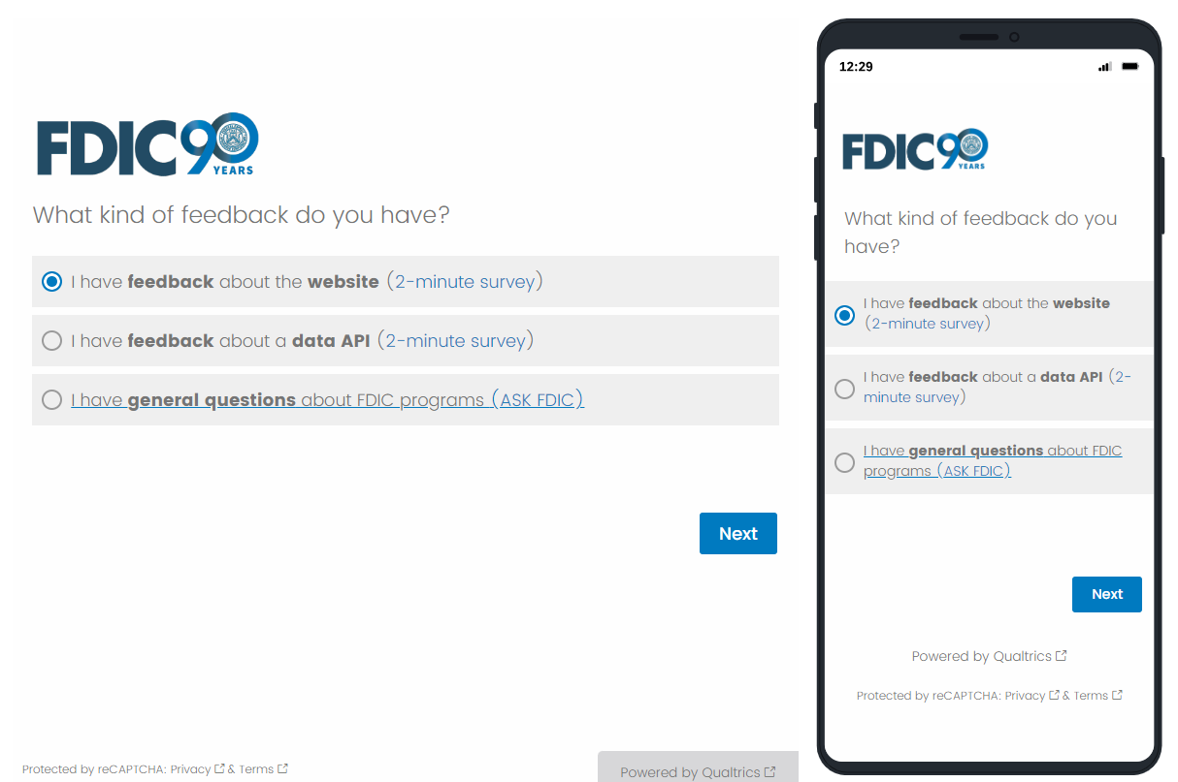

OMB Control Number: 3064-0127
Expiration Date: July 31, 2026

BURDEN STATEMENT

Public reporting burden for this collection of information is estimated to average 2 minutes per response, including the time for reviewing instructions, searching existing data sources, gathering and maintaining the data needed, and completing and reviewing the collection of information. Send comments regarding this burden estimate or any other aspect of this collection of information, including suggestions for reducing this burden to, the Paper Reduction Act Clearance Officer, Legal Division, Federal Deposit Insurance Corporation, 550 17th St. NW, Washington, D.C. 20429; and to the Office of Management and Budget, Paperwork Reduction Project (3064-0127), Washington, D.C. 20503. An agency may not conduct or sponsor, and a person is not required to respond to, a collection unless it displays a currently valid OMB control number.

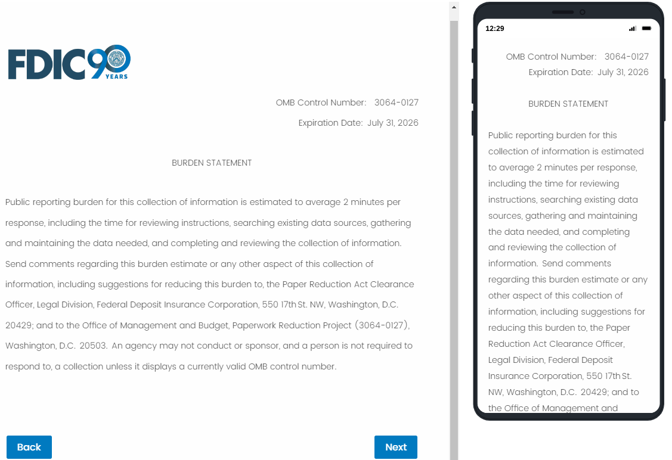
Website questions:
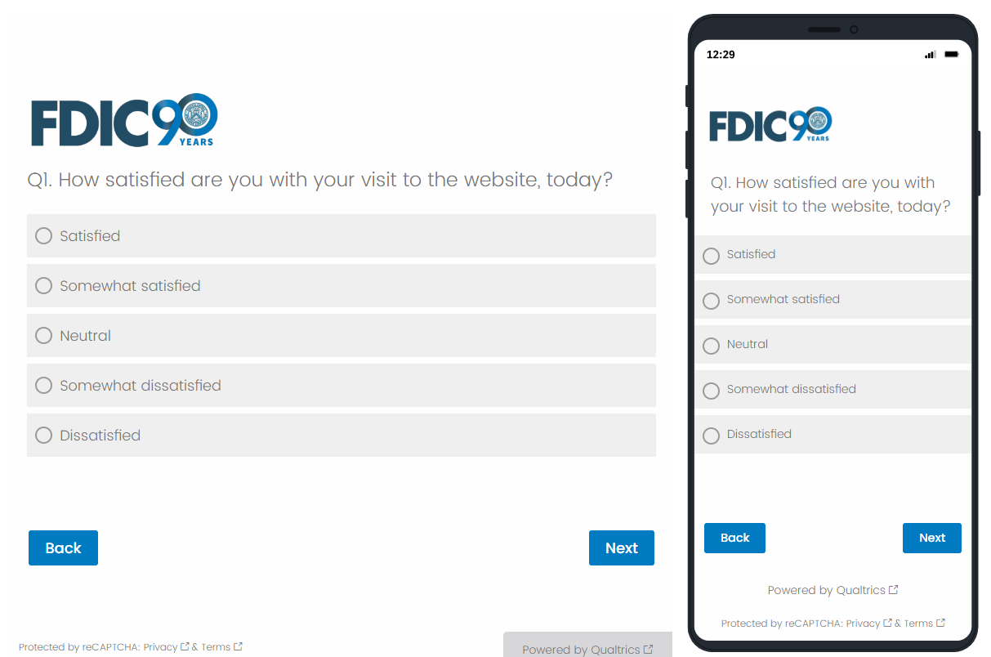

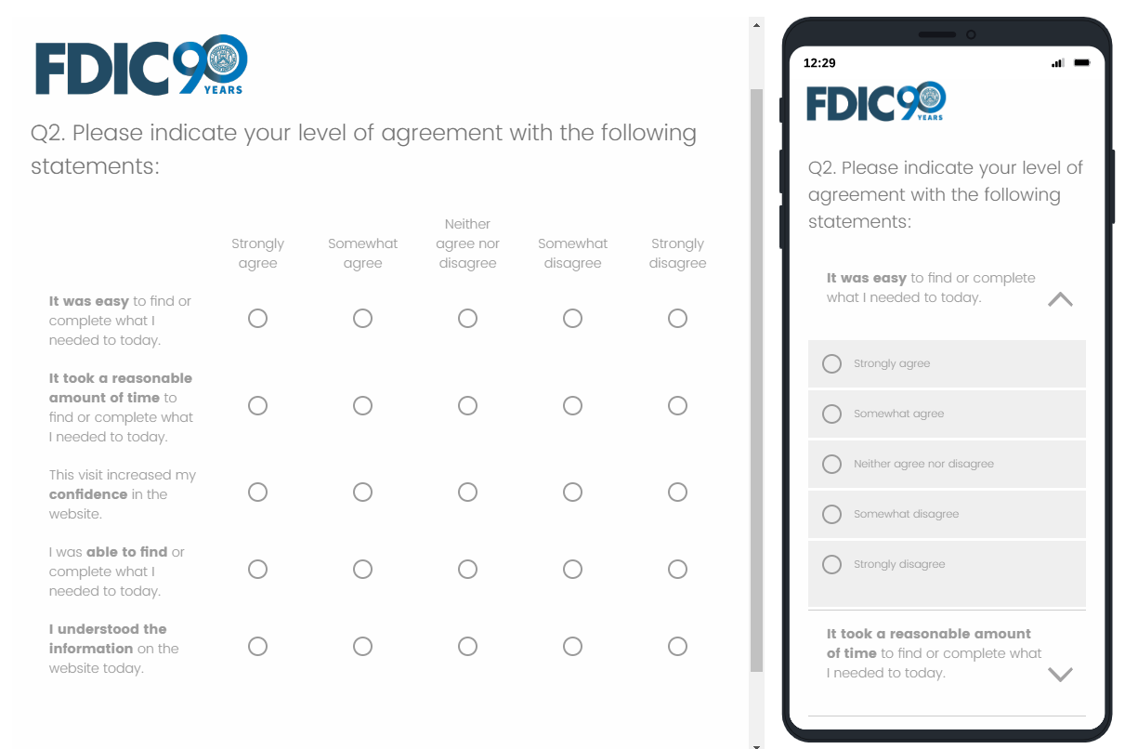
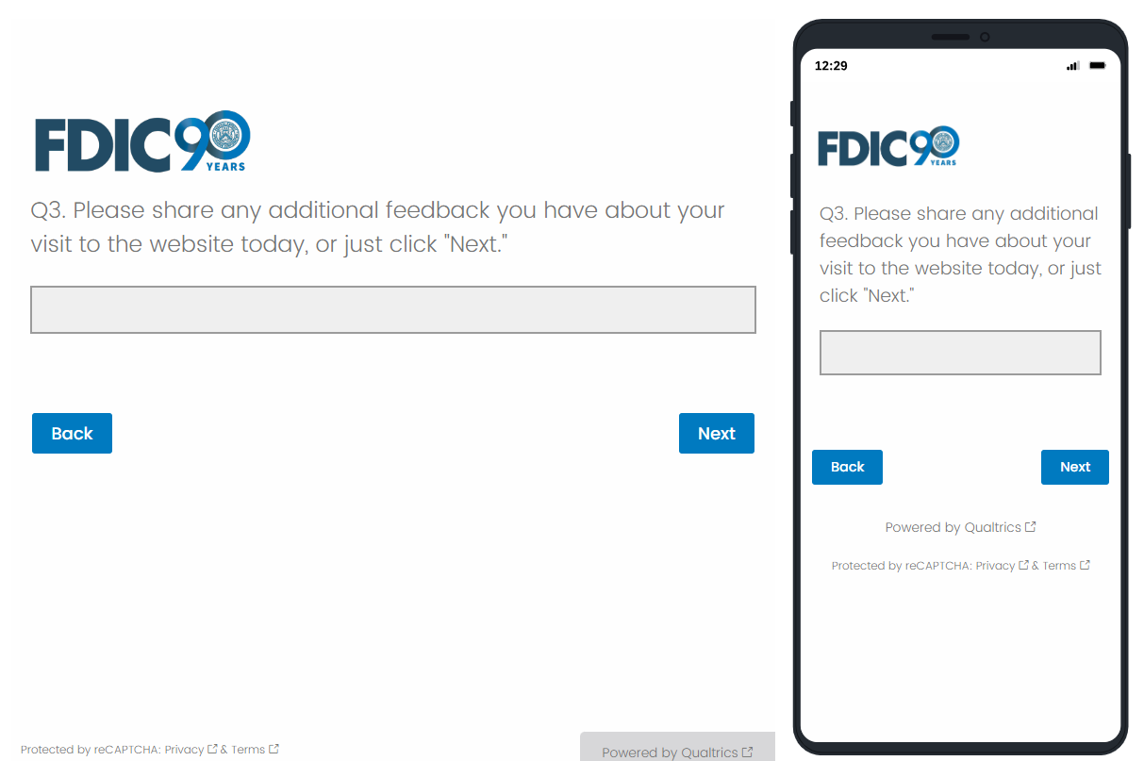

OMB Control Number: 3064-0127
Expiration Date: July 31, 2026

BURDEN STATEMENT

Public reporting burden for this collection of information is estimated to average 2 minutes per response, including the time for reviewing instructions, searching existing data sources, gathering and maintaining the data needed, and completing and reviewing the collection of information. Send comments regarding this burden estimate or any other aspect of this collection of information, including suggestions for reducing this burden to, the Paper Reduction Act Clearance Officer, Legal Division, Federal Deposit Insurance Corporation, 550 17th St. NW, Washington, D.C. 20429; and to the Office of Management and Budget, Paperwork Reduction Project (3064-0127), Washington, D.C. 20503. An agency may not conduct or sponsor, and a person is not required to respond to, a collection unless it displays a currently valid OMB control number.

API questions:
