SUPPORTING STATEMENT - PART A for
OMB Control Number 0535-0002:
Field Crops Production

ICR Author: Struther Van Horn
USDA, National Agricultural Statistics Service
1400 Independence Avenue S.W.
Washington, D.C. 20250

Supporting Statement - Part A

FIELD CROPS PRODUCTION

OMB No. 0535-0002

The National Agricultural Statistics Service (NASS) is requesting a substantive change to a currently approved information collection, Field Crops Production. This revision adds two questions to the January and June Sugarcane Inquiry questionnaires, to more accurately capture sugarcane production changes. NASS is also requesting to use text message and email reminders for respondents who have opted to receive these messages, which results in an increase in 483 burden hours. There are no other changes to the survey methodology or procedures previously approved.

A. JUSTIFICATION

- Explain the circumstances that make the collection of information necessary. Identify any legal or administrative requirements that necessitate the collection. Attach a copy of the appropriate section of each statute and regulation mandating or authorizing the collection of information.

There are no changes from the original approval for this substantive change request.

The primary functions of the National Agricultural Statistics Service (NASS) are to prepare and issue State and national estimates of crop and livestock production, disposition, and prices and to collect information on related environmental and economic factors. NASS conducts probability surveys where possible, as documented in OMB docket No. 0535-0213 (the Agricultural Surveys Program for the major crop commodities such as corn, soybeans, and wheat). Most of the more specialized field crops such as potatoes, tobacco, dried beans, and mint are included in this docket. Because of unique field crop characteristics, such as concentration of a crop in localized geographical areas or the relative importance of the crop, the use of supplemental follow-on surveys is needed. The surveys in this docket use a combination of data collection modes that include mail, telephone, internet, and personal interviews. This data collection approach helps ensure that NASS is publishing accurate, timely data.

Commodity-specific surveys for alfalfa seed, dry beans, dry peas, lentils, mint, special oilseeds, sunflowers (non-oil), popcorn, potatoes, sugarbeets, sugarcane, and tobacco are used in those States where better coverage of localized growing areas is needed. Results are published in the next monthly Crop Production release. In some States and with certain commodities, it has proven to be more effective if we include commodity price information, stocks and some processing questions on the production questionnaires. This has helped to reduce the frequency at which individual operators are contacted to collect data.

Variety surveys are conducted in several States to estimate acreage planted by wheat, barley, and potato variety. These variety surveys are conducted as part of State cooperative agreements.

The County Agricultural Production Surveys (CAPS) or County Estimates Surveys are conducted each year at the end of the growing season to help estimate field crops acreage harvested and final production at county levels. In item A.12. NASS has identified two separate county estimate surveys, small grains and row crops. The small grains survey covers bread and cereal grains. These crops are harvested in the summer months (May – July), so we conduct a county estimate survey following harvest to minimize memory bias. The row crops (corn, soybeans, etc.) are harvested in the fall or early winter, so this data is collected in December and January. The two samples are pulled independently, so it is possible that a farmer could receive both questionnaires if they produce both types of crops.

The weekly Crop Progress and Condition Survey, published in Crop Progress, provides timely information about the development and condition of crops between issues of the monthly Crop Production release. Questions concerning soil moisture content, insect or disease presence, and the stages of crop production are also asked to better inform farmers of conditions in their region as well as other parts of the country.

The annual Cash Rent Survey samples farmers who have rented land historically on a cash basis. These data will be used to satisfy the requirement originally specified in the 2008 Farm Bill to publish county level cash rent data for both crop land and pasture land.

The annual Wildlife Damage Survey is a reimbursable survey that targets farmers who operate land in the reference year. The objective of the survey is to 1) estimate crop damage by species, 2) determine what control methods were used for deer, and 3) determine their attitudes toward deer on their property. These surveys are critical in understanding damage caused to crops, deer control measures, and farm operator’s perceptions of deer populations. Information provided by farm operators will be used to manage wildlife population at a level that is appropriate for multiple stakeholders.

General authority for these data collection activities is granted under U.S. Code Title 7, Section 2204. This statute specifies that "The Secretary of Agriculture shall procure and preserve all information concerning agriculture which he can obtain ... by the collection of statistics ... and shall distribute them among agriculturists."

2. Indicate how, by whom, and for what purpose the information is to be used. Except for a new collection, indicate the actual use the agency has made of the information received from the current collection.

There are no changes from the original approval for this substantive change request.

Crop forecasts published in the monthly Crop Production report and other releases, are used by farmers, agribusinesses, and many government agencies in analyzing the nation's production and marketing of field crops and grains. The Secretary of Agriculture uses estimates of crop production to administer farm program legislation and import and export programs.

The weekly crop progress and condition inquiry, published in the Crop Progress report every Monday, provides an efficient way for the Department of Agriculture to closely monitor agricultural developments across the country which may affect the nation's food supply. Numerous briefing reports are prepared for the Secretary of Agriculture on crop condition, phenological development, and harvest progress. The reporting of insect and disease damage can alert farmers in other areas to take preventive measures, thus minimizing possible damage. Information on soil moisture and extremes in temperatures can be used to predict potential crop yields. This information is very useful to farmers who are deciding on the appropriate time to sell their crops (through futures markets or through cash sales).

County estimates for field crops are needed by the Farm Service Agency (FSA) and the Risk Management Agency to carry out their respective legislative mandates. Their primary use of the data is to determine average yields by county, used in determining participating farmers’ compensation payments. The county-level cash rent survey data enables FSA program payment rates to better reflect market conditions. The information is useful to the Natural Resources Conservation Service (NRCS) for administering programs. The information will also benefit the agricultural sector more generally by enabling the rental market for cropland to operate more competitively.

Variety surveys are used by the Agricultural Research Service (ARS), plant breeders, researchers, and growers to determine the acreage by variety and measure acceptance of new varieties. The impact of insect or disease outbreaks can be measured from variety surveys after the tolerance of a particular variety is determined. Varietal data on wheat are used for determining production and available supplies by class. Class data are of great importance to government analysts and exporters in planning the disposition of U.S. wheat crops since exports comprise approximately one-half of total use.

3. Describe whether, and to what extent, the collection of information involves the use of automated, electronic, mechanical, or other technological collection techniques or other forms of information technology, e.g. permitting electronic submission of responses, and the basis for the decision for adopting this means of collection. Also describe any consideration of using information technology to reduce burden.

There are no changes from the original approval for this substantive change request.

Nearly all of NASS information collections have been converted to Web-based data collection, Computer-Aided Self-Administered Interview (CASI). Most of the survey instruments for the following commodities have been converted: dry beans, mint, special oilseeds, potatoes, sugarcane, non-oil sunflower, sweet potatoes, tobacco, and the weekly crop progress and condition report. The remaining instruments that will not be converted are either too infrequent or too impractical to use that mode of data collection. The current proportion of survey responses that were made by Web is at 100.0 percent for crop progress, 4.3 percent for row crop county estimates, 2.2 percent for small grain county estimates, the tobacco price surveys were at 17.0 percent and about 2 percent for the remaining information collections that are available on the internet. This results in an overall Web response rate of 26.4 percent for all surveys included in this information collection request.

While web reporting is offered to nearly all of our survey respondents, the majority of our respondents do not reply to our surveys using the internet. The Crop Progress survey is an exception due to the target population. Crop Progress targets people who are knowledgeable of the agriculture in their county or district and can report to this survey on a weekly basis. The majority of the people sampled by this survey are County, State, or Federal employees; Agricultural teachers at local schools; or NASDA field enumerators who are also farmers. Since these people have a relatively short time frame in which to respond (weekly) and tend to have convenient access to the internet, they prefer to respond online. With many of our other surveys, farmers may only be selected to conduct a survey once every couple of years and may not have easy access or be familiar with the internet, so they would rather just fill out the paper questionnaire and mail it back in.

Some surveys are conducted on a weekly or monthly basis. NASS will mail out a questionnaire to the respondent with instructions on how to respond by internet or return the questionnaire by mail. If we have not received their response within a few days we must switch over to either phone or personal enumeration. On the majority of our monthly and quarterly surveys the data collection period is limited to approximately 10 days. Using the intense modes of data collection that NASS relies on is the only way in which we can achieve one of our primary directives – the collection and publication of quality data in a timely and useful manner.

The main portal for our on-line surveys is http://www.agcounts.usda.gov. Once there, the respondents have to enter the valid survey code and the user ID printed on the label of the questionnaire mailed to them. We do not want anyone other than the selected respondent to access the survey web pages

4. Describe efforts to identify duplication. Show specifically why any similar information already available cannot be used or modified for use for the purposes described in Item 2 above.

There are no changes from the original approval for this substantive change request.

NASS cooperates with State Departments of Agriculture and land grant universities to conduct agricultural surveys. These surveys meet both State and Federal needs, thus eliminating duplication and minimizing reporting burden on the agricultural industry. Occasionally some of NASS’s Regional Field Offices will ask to have a few additional questions added to their questionnaires to accommodate the needs of their State cooperators and eliminate the need for a separate survey for some of these specialty crops. There is no duplication of questions that are included in the questionnaires attached to this docket except for the quarterly Agricultural surveys (OMB# 0535-0213). The County Agricultural Production Surveys (CAPS) collect data from additional operations on acres planted and harvested along with production data. This supplemental sample is combined with the quarterly data to allow NASS to be able to publish county level data. The samples are carefully composed to ensure there is no overlap.

5. If the collection of information impacts small businesses or other small entities (Item 5 of OMB Form 83-I), describe any methods used to minimize burden.

There are no changes from the original approval for this substantive change request.

Information requested on surveys included in this docket can be provided with a minimum of difficulty by respondents, generally without having to consult their record books.

Out of the estimated sample size of 532,853, approximately 84% or 447,597 are estimated to be classified as small operations.

- Describe the consequence to Federal program or policy activities if the collection is not conducted or is conducted less frequently, as well as any technical or legal obstacles to reducing burden.

There are no changes from the original approval for this substantive change request.

Collecting data less frequently would eliminate information needed to keep the U.S. Department of Agriculture abreast of changes at the State and national level. Timing and frequency of the various reports have evolved to meet the needs of Department clients, including producers, agribusinesses, and government agencies, yet minimize burden on the reporting public.

- Explain any special circumstances that would cause an information collection to be conducted in a manner inconsistent with the general information guidelines in 5CFR 1320.5.

There are no changes from the original approval for this substantive change request.

There are no other special circumstances that would cause the information collection to be conducted in a manner inconsistent with the general information guidelines in 5CFR1320.5.

8. Provide a copy and identify the date and page number of publication in the Federal Register of the agency's notice, required by 5 CFR 1320.8 (d), soliciting comments on the information collection prior to submission to OMB. Summarize public comments received in response to that notice and describe actions taken by the agency in response to these comments.

There are no changes from the original approval for this substantive change request.

The Federal Register Notice soliciting comments was published on September 22, 2022 on pages 57864 - 57865. One public comment was received from Dr. Dennis Fixler in support of the continuation of this group of surveys. It is attached to this renewal package.

Describe efforts to consult with persons outside the agency to obtain their views on the availability of data, frequency of collection, the clarity of instructions and recordkeeping, disclosure, or reporting format (if any), and on the data elements to be recorded, disclosed, or reported.

There are no changes from the original approval for this substantive change request.

Consultations with plant breeders, researchers, growers, industry associations, and other government agencies such as FSA and NRCS are carried out to ensure that data collected reflect all varieties and the proper timing to obtain accurate information.

Throughout the year, numerous NASS statisticians and managers attend private industry and producer’s association meetings around the country. They take note of changes within the various industries and update our data collection instruments when possible, to keep our data current and useful to all data users.

John Newton, Ph.D., Chief Economist
American Farm Bureau Federation
202-406-3729 w 502-641-4636 c
www.fb.org
jnewton@fb.org

Colorado Potato Variety
David G. Holm, Ph.D.
Professor – Department of Horticulture and Landscape Architecture
Colorado State University
San Luis Valley Research Center
0249 East Road 9 North
Center, CO 81125
Phone: 719-754-3494, ext. 14
E-mail: David.Holm@colostate.edu

Montana Wheat & Barley Variety
Sam Anderson
Market Development Manager, Montana Wheat Barley Committee
Email: samuel.anderson@mt.gov
Phone: 952-452-4362

Hawaii Seed Crop Survey
Alan Takemoto, Representative of seed crop industry in Hawaii
P.O. Box 11863
Honolulu HI 96828
Phone: (808) 685-8371
Email address: alan.takemoto@bayer.com

9. Explain any decision to provide any payment or gift to respondents.

There are no changes from the original approval for this substantive change request.

There are no payments or gifts to respondents.

10. Describe any assurance of confidentiality provided to respondents and the basis for the assurance in statute, regulation, or agency policy.

Questionnaires include a statement that individual reports are confidential. U.S. Code Title 18, Section 1905; U.S. Code Title 7, Section 2276; and the Confidential Information Protection and Statistical Efficiency Act of 2018, Title III of Pub. L. No. 115-435, codified in 44 U.S.C. Ch. 35 and other applicable Federal laws. All employees of NASS and all enumerators hired and supervised under a cooperative agreement with the National Association of State Departments of Agriculture (NASDA) must read the regulations and sign a statement of compliance.

The following CIPSEA Pledge statement will appear on all future NASS questionnaires.

The information you provide will be used for statistical purposes only. Your responses will be kept confidential and any person who willfully discloses ANY identifiable information about you or your operation without your consent is subject to a jail term, a fine, or both. This survey is conducted in accordance with the Confidential Information Protection and Statistical Efficiency Act of 2018, Title III of Pub. L. No. 115-435, codified in 44 U.S.C. Ch. 35 and other applicable Federal laws. For more information on how we protect your information please visit: https://www.nass.usda.gov/confidentiality.

All individuals who may access these confidential data for research are also covered under Titles 18 and CIPSEA and must complete a Certification and Restrictions on Use of Unpublished Data (form ADM-043) agreement.

11. Provide additional justification for any questions of a sensitive nature.

There are no changes from the original approval for this substantive change request.

There are no questions of a sensitive nature.

12. Provide estimates of the hour burden of the collection of information. The statement should indicate the number of respondents, frequency of response, annual hour burden, and an explanation of how the burden was estimated.

For this substantive change request, NASS acknowledges that adding two questions to the Sugarcane Inquiry survey could impact respondent burden, but NASS believes this change in burden would be minimal, as it is only for two questions in two months of the data collection, so the overall burden is not being revised upward for that change. Two minutes of burden time is being to all the Field Crops surveys, to account for additional burden of adding email or text reminders, for those respondents who have opted-in to receive such messaging.

The following table contains the estimated annual burden hours for this group of surveys. Cost to the public for completing the questionnaire is assumed to be comparable to the hourly rate of those requesting the data. Average annual reporting time of 140,289 hours is multiplied by $46.06 per hour for a total annual cost to the public of $6,461,711.34.

NASS uses the Bureau of Labor Statistics’ Occupational Employment Statistics (most recently published on May 15, 2026 for the previous May) to estimate an hourly wage for the burden cost. The May 2025 mean wage for bookkeepers was $25.75 The mean wage for farm managers was $47.99. The mean wage for farm supervisors was $30.16. The mean wage of the three is $34.63. To calculate the fully loaded wage rate (includes allowances for Social Security, insurance, etc.) NASS will add 33% for a total of $46.06 per hour.

Average completion time per questionnaire is based on time required for other surveys of similar length. Calculation of burden hours is shown in the table below. Estimated response counts are based on an 80% target response rate and minutes per response shown are the average times for all questionnaires used for the commodity.

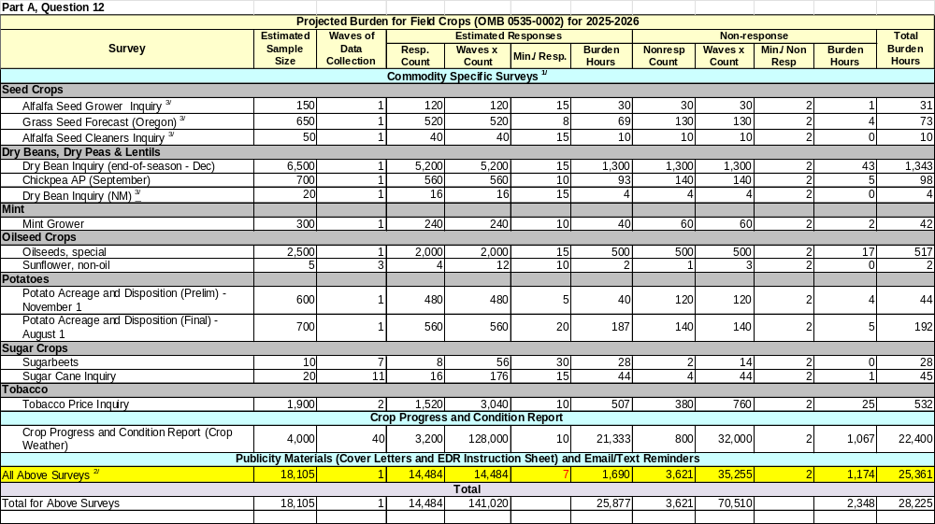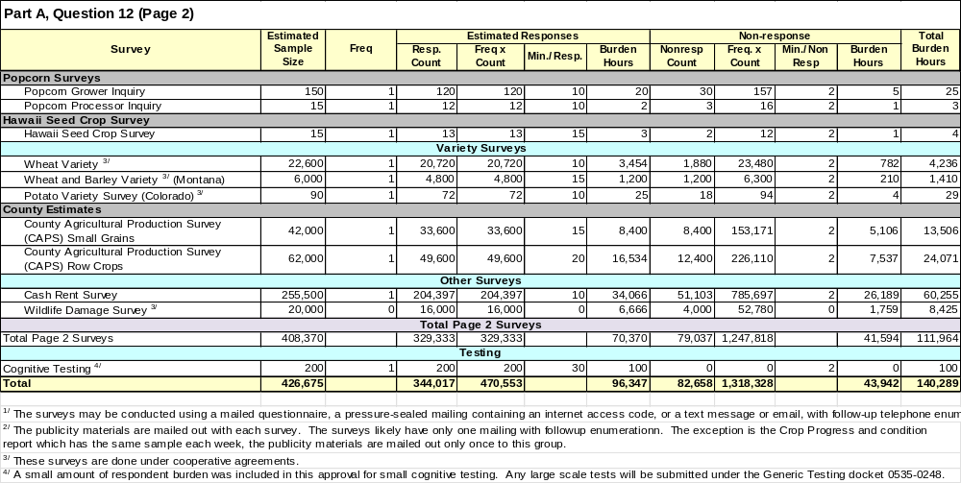
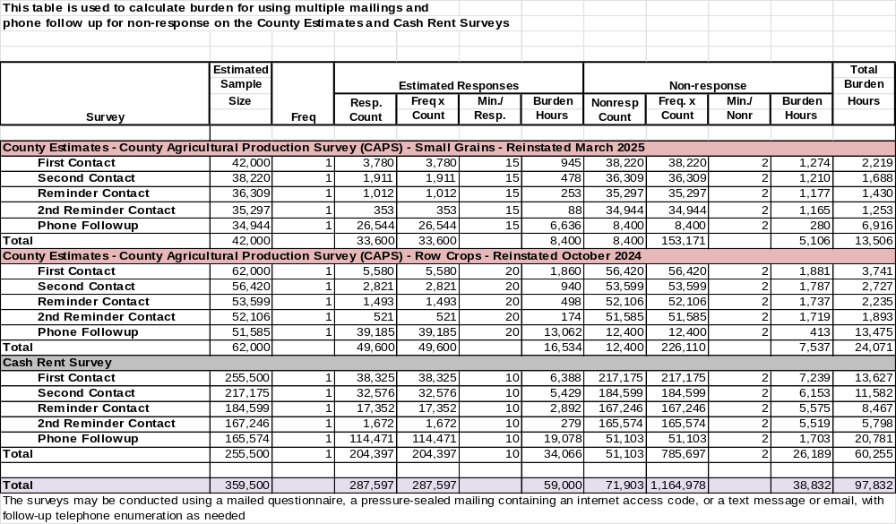

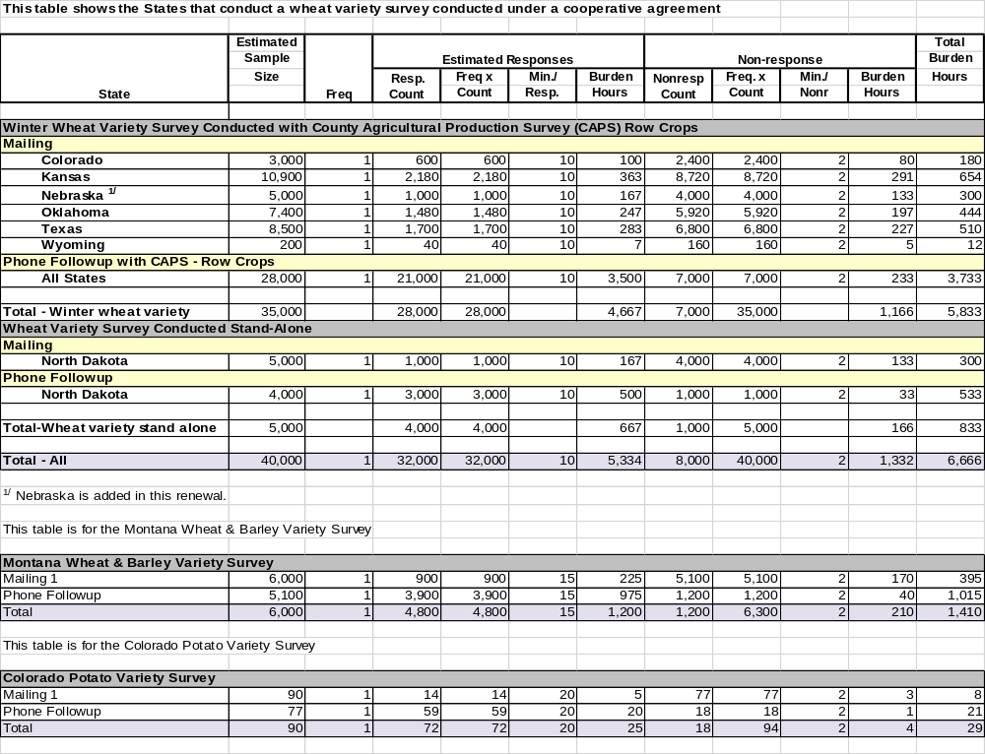
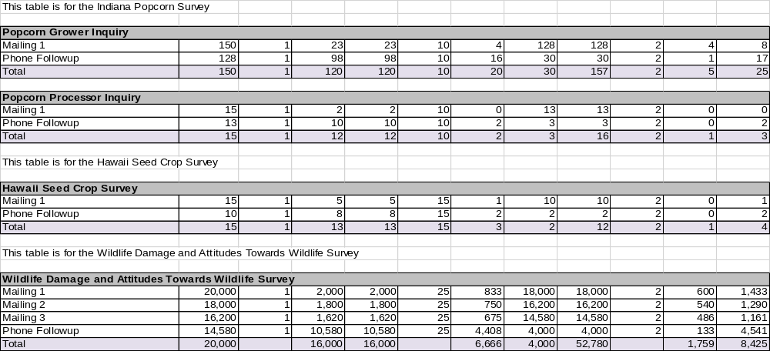

13. Provide an estimate of the total annual cost burden to respondents or record keepers resulting from the collection of information.

There are no changes from the original approval for this substantive change request.

There is no cost burden to respondents.

14. Provide estimates of annualized cost to the Federal government; provide a description of the method used to estimate cost which should include quantification of hours, operational expenses (equipment, overhead, printing, and staff), and any other expense that would not have been incurred without this collection of information.

There are no changes from the original approval for this substantive change request.

The total cost to the Federal government to conduct field crop surveys and prepare estimates is estimated to cost approximately $12.5 million per year for the next three years, most of which is staff cost.

15. Explain the reasons for any program changes or adjustments reported in Items 13 or 14 of the OMB Form 83-I (reasons for changes in burden).

The total burden of 140,289 hours is an increase of 483 hours from the current inventory of 139,806 hours. This increase in burden hours is to account for adding text messages and email reminders for respondents who have opted to receive these messages.

16. For collections of information whose results will be published, outline plans for tabulation and publication. Address any complex analytical techniques that will be used. Provide the time schedule for the entire project, including beginning and ending dates of the collection of information, completion of report, publication dates, and other actions.

There are no changes from the original approval for this substantive change request.

Questionnaires are mailed out to each person in the target samples for the surveys included in this data collection request. Respondents who do not return their questionnaires by mail or internet will be attempted by phone enumeration. On surveys such as the weekly Crop Progress survey, we encourage the respondents to use the internet to complete the questionnaires due to the very short data collection period. The data are reviewed for reasonableness prior to data processing for editing and summarization. They are summarized by crop reporting districts and the indications are weighted for the State, based on the relative importance of the commodity in the district. State indications are plotted on time series charts which typically comprise 10 years of survey indications and final estimates. Three primary indicators are obtained for each crop: an identical comparison of current year acreage to the previous year acreage, acreage as a percent of total farmland, and average yield for respondents reporting.

Crop production estimates are issued from Headquarters in Washington, D.C. in the monthly Crop Production reports, the January annual summary, June acreage report, or specialty releases as shown in the table below. Crop progress and condition data are published in the weekly Crop Progress. State-funded cooperative survey reports may be released from the individual Field Offices as well as in Headquarters publications. The Weekly Weather and Crop Bulletin is prepared in cooperation with the National Weather Service Meteorologists, USDA's Cooperative Extension Service, and World Agricultural Outlook Board.

2022 Field Crops Production Surveys
Survey | Data Collection  Period | Publication
Survey | Data Collection  Period | Publication Name | Release Date
Alfalfa/Grass Seed | Jan | FO monthly release | Feb - Mar
Dry Beans | Nov - Dec | Annual Summary | January
Mint | Nov | Annual Summary | January
Oilseeds, Special | Nov - Dec | Annual Summary | January
Potatoes | Nov | Crop Production | 12th of month
Potatoes |  | Potatoes | Sep 28
Sugar beets | Mar, Jun, Aug-Nov | Crop Production | 12th of month
Sugarcane | Jun; Aug-Mar | Crop Production | 12th of month
Sunflower, Non-oil | Mar, Jun, Dec | Prospective Planting and Acreage | Annual
Tobacco - Price | Feb & May | Ag Prices | End of month
Variety Surveys: Wheat | Jan | Variety Summaries | Feb
Crop Progress | weekly Apr-Nov | Crop Progress | Mondays

All NASS publications are available on-line immediately after release at:

https://www.nass.usda.gov/Publications/.

Once there, you can select publications by date, subject, keyword, title, release date, etc. Here are links to some of the reports covered by this docket renewal.

National Crop Progress and Condition Reports:

https://usda.library.cornell.edu/concern/publications/8336h188j

Crop Production Releases:

https://usda.library.cornell.edu/concern/publications/tm70mv177

Potatoes Annual Summaries:

https://usda.library.cornell.edu/concern/publications/fx719m44h

Agricultural Land Values:

https://usda.library.cornell.edu/concern/publications/pn89d6567

Statistics by State for specialty commodities:

https://www.nass.usda.gov/Statistics_by_State/index.php

17. If seeking approval to not display the expiration date for OMB approval of the information collection, explain the reasons that display would be inappropriate.

There are no changes from the original approval for this substantive change request.

There is no request for approval of non-display of the expiration date.

18. Explain each exception to the certification statement identified in Item 19, “Certification for Paperwork Reduction Act Submissions” of OMB Form 83-I.

There are no changes from the original approval for this substantive change request.

There are no exceptions to the certification statement.

September 2026

