Request for Nonsubstantive Change
ICR 0560-0237
August 4, 2026

FSA conducted a review of form FSA-2313 “Notification of Loan Approval and Borrower Responsibilities” and requests approval for a nonsubstantive change.

The changes include terminology and adding a form field for the respondent to identify the chosen training vendor. The change merges a field from form FSA-2371 “Agreement to Complete Training” which will become obsolete. Therefore, the changes do not affect response time or burden.

FORM: FSA-2313 (Notification of Loan Approval and Borrower Responsibilities) (1 change)

Change 1: Language regarding borrower training is modified in Part C, Item 1 in the paragraph labeled “Borrower Training”.

CURRENT
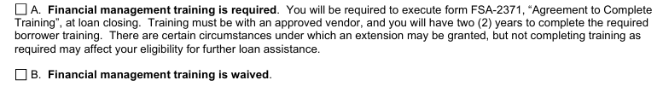

CHANGE
