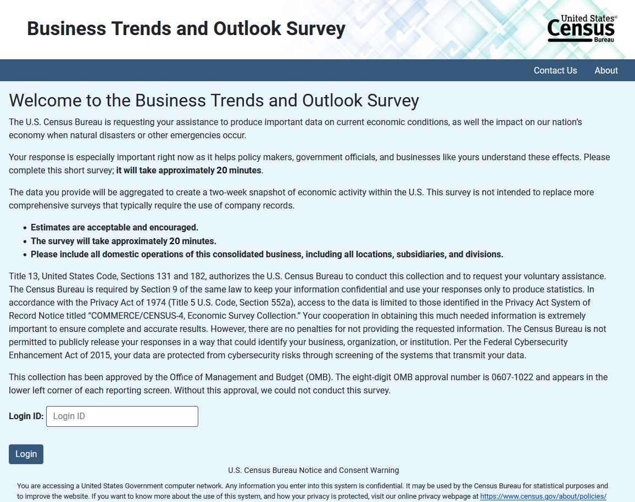
Above: Instrument Landing Page during AI Supplement (Cycle 2)
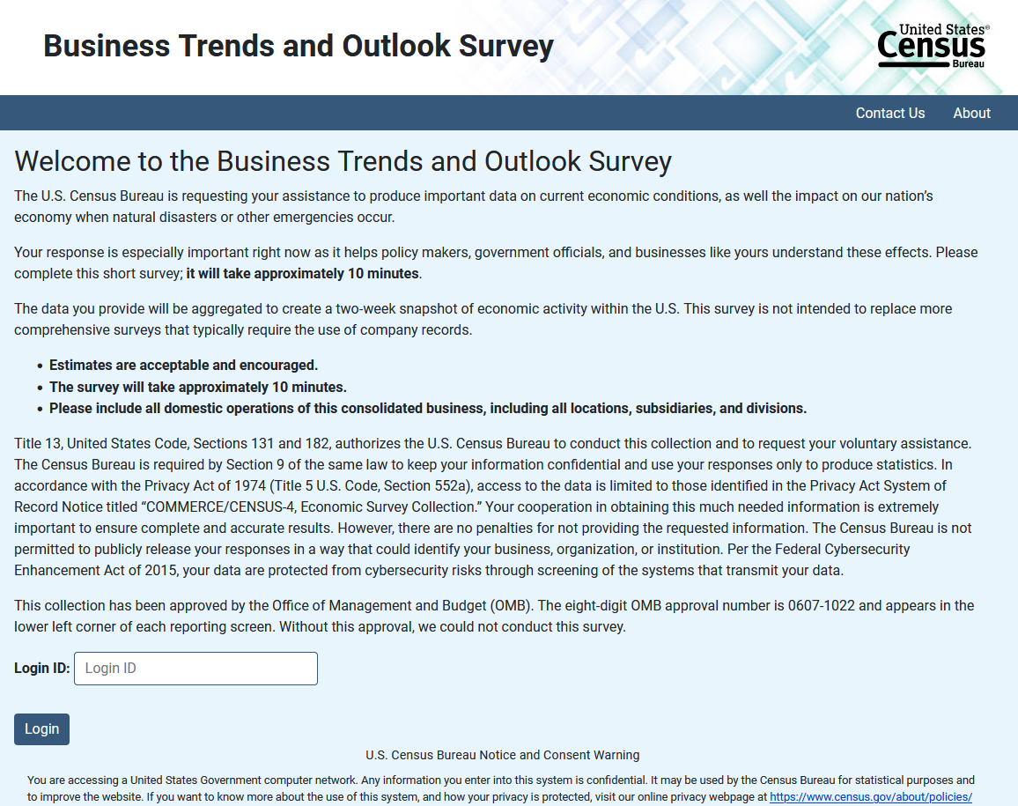Above: Instrument Landing Page during core content (Cycles 1, 3, and 4)

