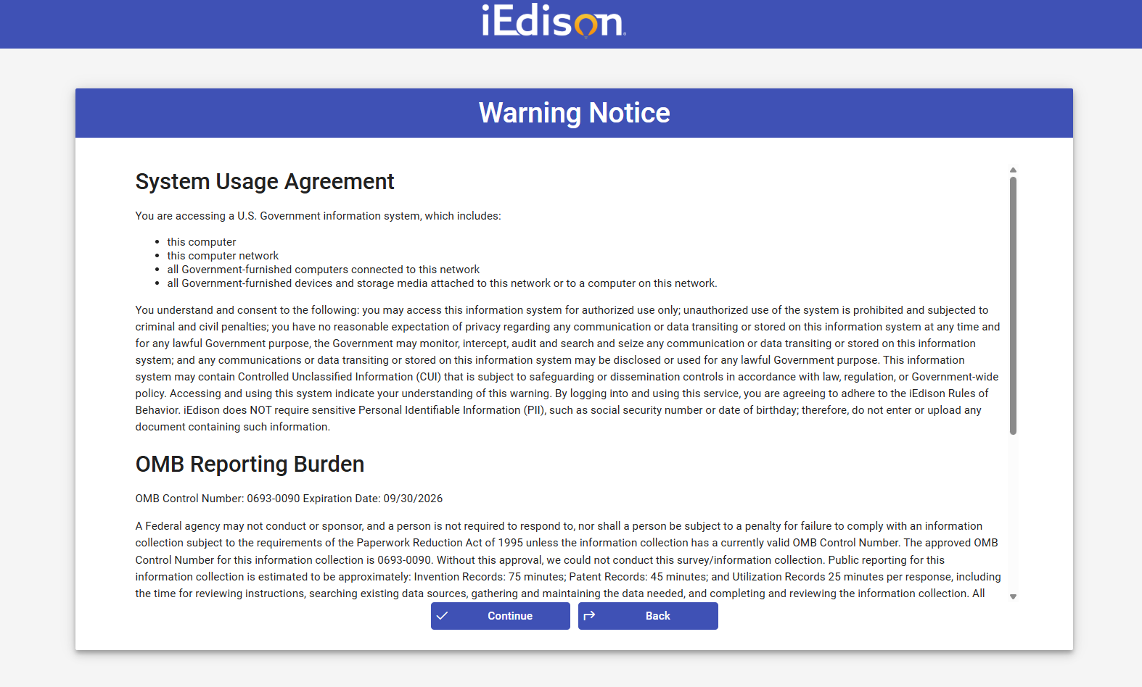
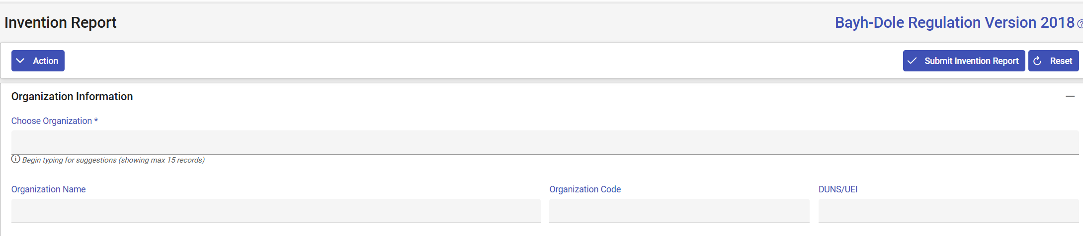

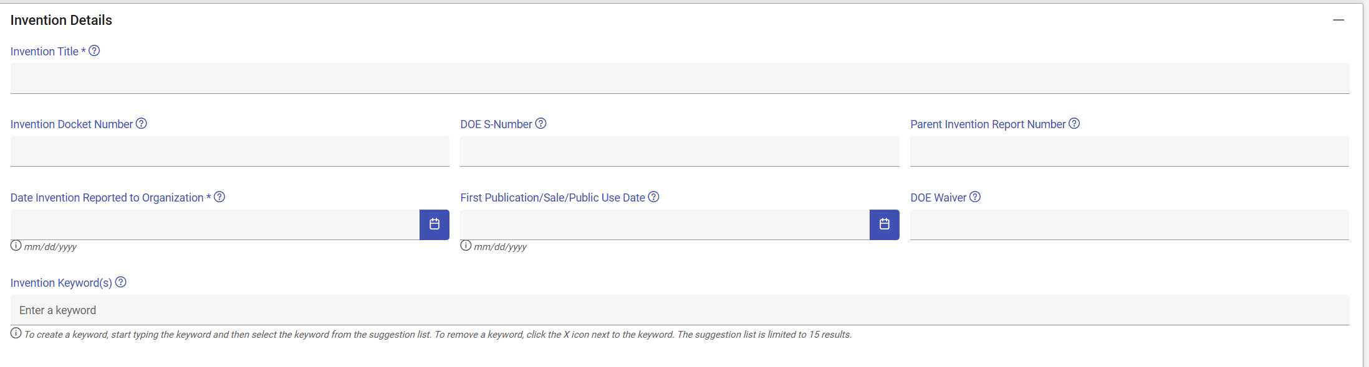
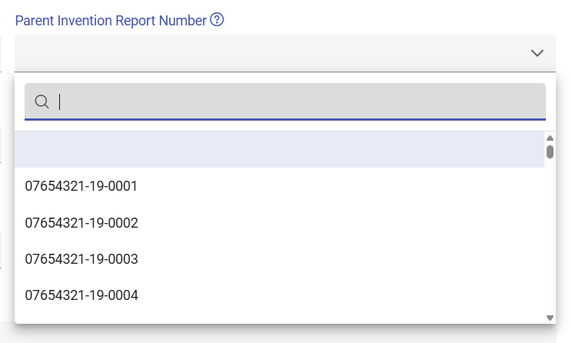
Please note that Parent Invention Report Number will vary by organization, depending on inventions submitted. This is an example of how the dropdown looks. The options vary by organization.
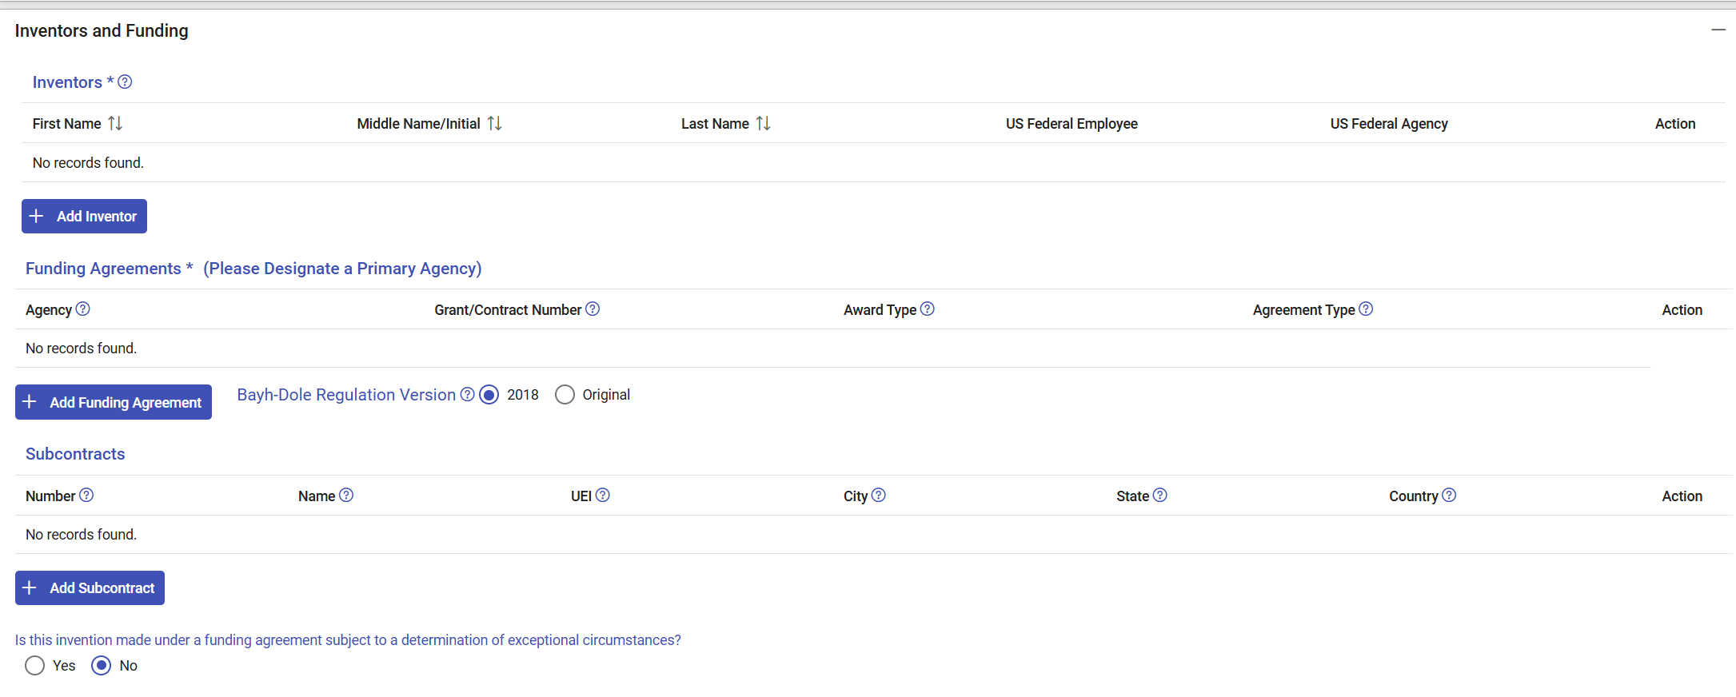
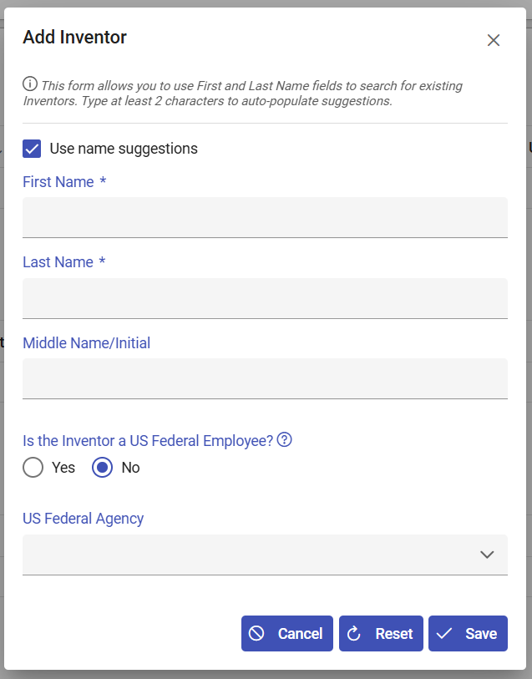
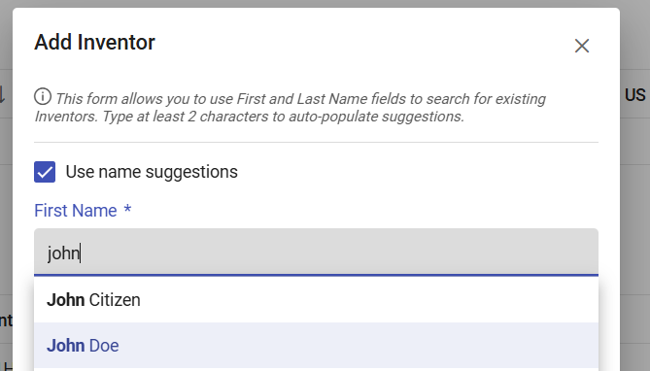
Please note that the names populated will vary by organization. The system saves previous inventor names, so the organization user can select from previously reported inventor names.
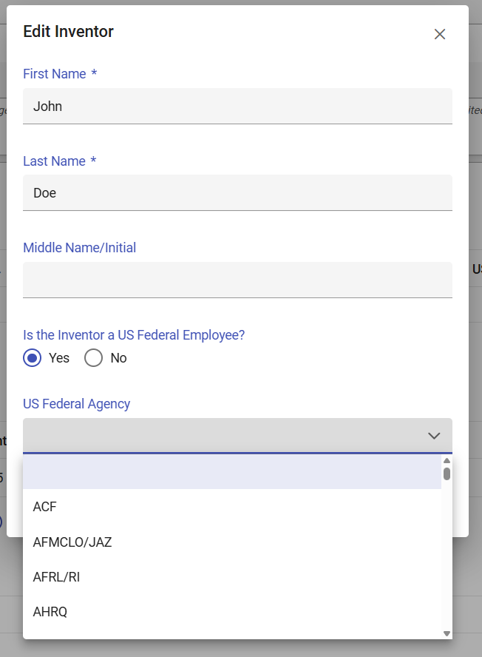
Below is the full list of US Federal Agency:
ACF | CIA | DOD-NAVY | HHS/FDA | MDA | NRS | SBA | VOA
DOD-AF/AFMCLO | CISA | DOD/DARPA | FDIC | MSHA | NSA | SEC | WHD
DOD-AF/AFRLRI | CMS | DOD/DMEA | FEMA | NARA | NSC | SSA
HHS/AHRQ | CNCS | DOD/DTRA | FHA | NASA | NSCEP | SSS
AMTRAK | CNPP | DOE | FHEO | DOD-NAVY/ONR | NSF | TSA
DOD-ARMY/ARL | COPS | DOI | FLETC | NCI | NTIA | US CERT
DOD-ARMY/ARO | CPSC | DOJ | FLRA | NCUA | NTSB | DOD-ARMY/USACE
DOD-ARMY/FUZE | DOC/Census | DOL | FMCSA | NEA | OCC | DOD-AF/AFOSR
DOD-ARMY/SMDC | DEA | DOS | FRA | NHIC | ODEP | USAID
DOD-ARMY/SSC | DFAS | DOT | FTA | NHTSA | OGE | USBR
HHS/ARPA-H | DOD-DHA/MRDB | DSCA | FTC | NIAID | OMB | USCIS
ATF | DHS | DTIC | FWS | NIDCR | ONDCP | USDA
HHS/ATSDR | DHS/ST | EAC | GSA | NIDILRR | OPM | USDA/AMS
HHS/BARDA | DIA | EBSA | HHS | HHS/NIH | OSERS | USDA/ARS
BEA | DISA | ED | HUD | NIJ | OSHA | USDA/FS
BEP | DLA | EDPUBS | IAQ | DOC/NIST | OTHER | USDA/NIFA
BIS | DOC | EEOC | ICE | NLRB | OVW | USGS
BLM | DOC/EDA | EERE | IER | DOE/NNSA | PBGC | USPS
BOP | DOC/ITA | EPA | HHS/IHS | DOC/NOAA | PCLOB | VA
BSEE | DOD | FAA | IRS | NPS | RFA | VBA
HHS/CDC | DOD-AF | FBI | LINCS | NRC | RFE/RL | VETS
CFTC | DOD-ARMY | FCC | MARAD | DOD-NAVY/NRL | RRB | VHA

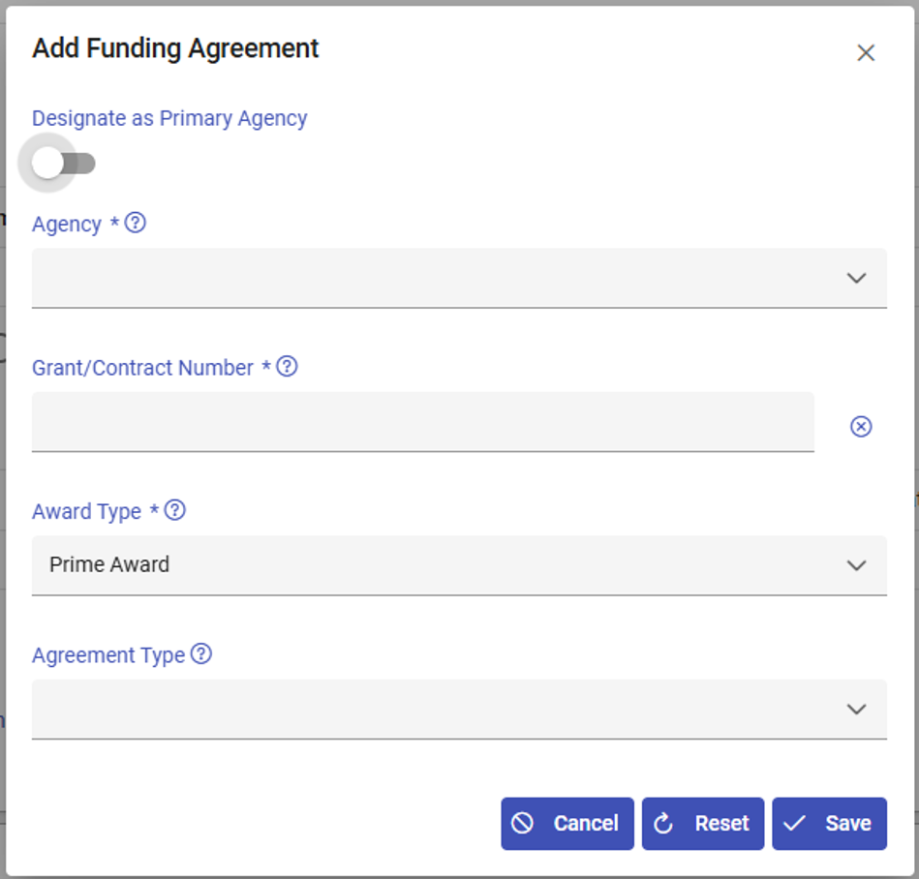
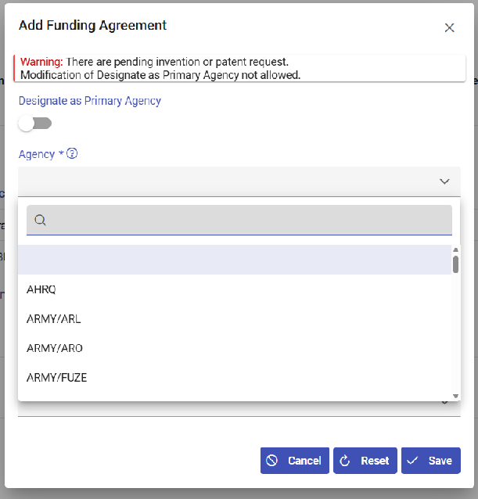
Please note that the Agency field is a subset of agencies of the list above. The active list of agencies in iEdison changes, as we are onboarding new agencies.
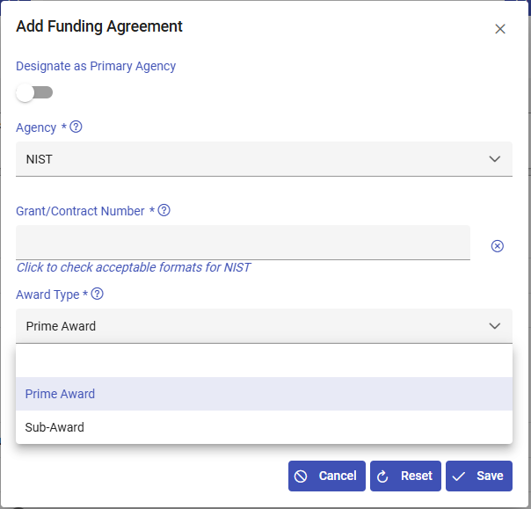
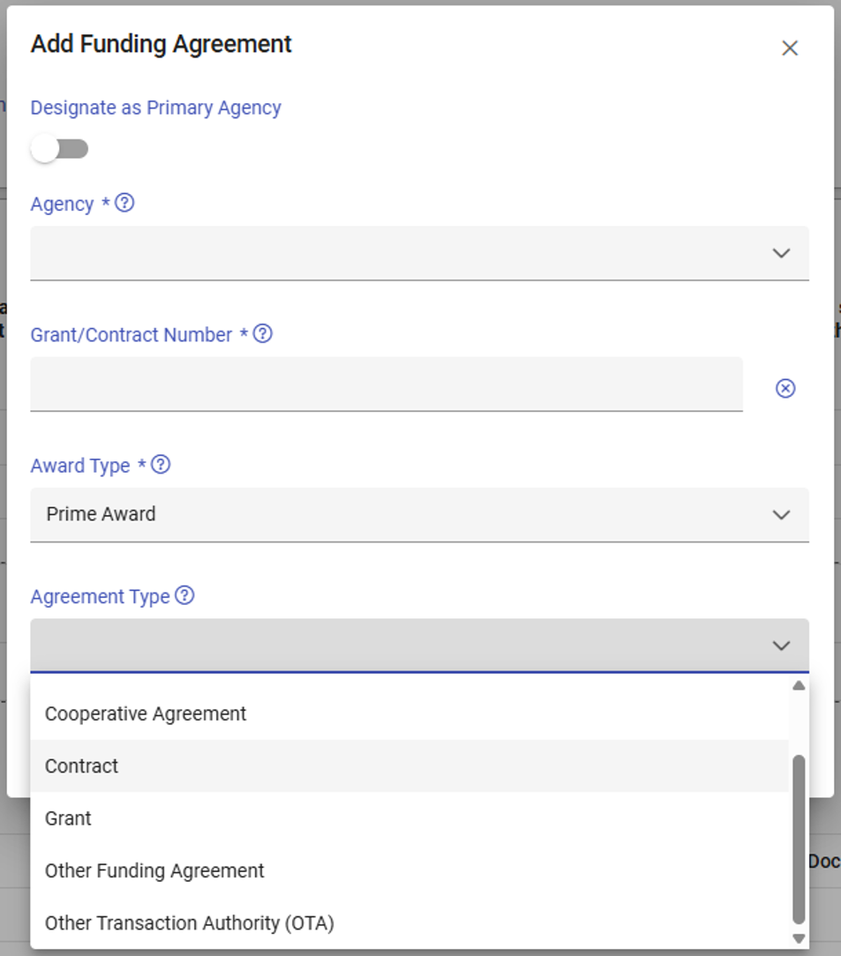
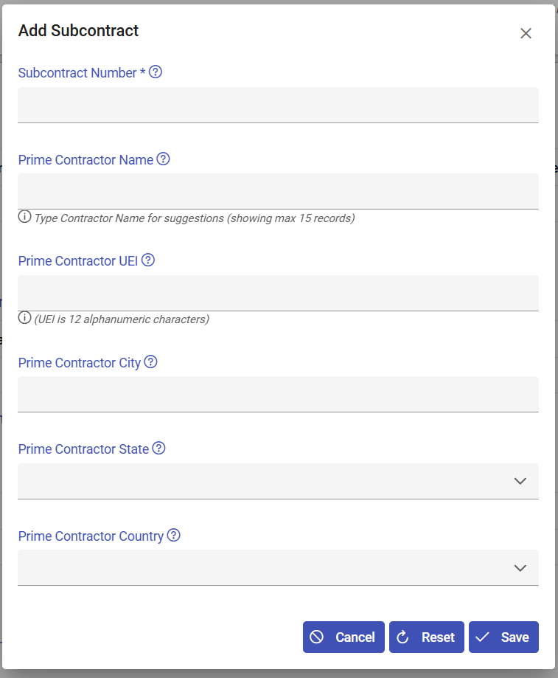
Below is a list of “Prime Contractor State:”
ALABAMA | MARYLAND | SOUTH CAROLINA | ALBERTA | PALMYRA ATOLL
ALASKA | MASSACHUSETTS | SOUTH DAKOTA | BR. COLUMBIA | MIDWAY ISLANDS
ARIZONA | MICHIGAN | TENNESSEE | MANITOBA | TRUST TER PACF
ARKANSAS | MINNESOTA | TEXAS | NEW BRUNSWICK | WAKE ISLAND
CALIFORNIA | MISSISSIPPI | UTAH | NW TERRITORIES | NEWFOUNDLAND
COLORADO | MISSOURI | VERMONT | NOVA SCOTIA
CONNECTICUT | MONTANA | VIRGINIA | ONTARIO
DELAWARE | NEBRASKA | WASHINGTON | PR. EDWARD ISL
DIST OF COL | NEVADA | WEST VIRGINIA | QUEBEC
FLORIDA | NEW HAMPSHIRE | WISCONSIN | SASKATCHEWAN
GEORGIA | NEW JERSEY | WYOMING | YUKON
HAWAII | NEW MEXICO | AMERICAN SAMOA | QUEBEC
IDAHO | NEW YORK | FED MICRONESIA | AP0/FP0 S AMER
ILLINOIS | NORTH CAROLINA | GUAM | AP0/FP0 EUROPE
INDIANA | NORTH DAKOTA | MARSHALL IS | AP0/FP0 OT PAC
IOWA | OHIO | NORTHN MARIANA | NAVASSA ISLAND
KANSAS | OKLAHOMA | PALAU | BAKER ISLAND
KENTUCKY | OREGON | PUERTO RICO | HOWARD ISLAND
LOUISIANA | PENNSYLVANIA | US MINOR OUTLY | JOHNSTON ATOLL
MAINE | RHODE ISLAND | VIRGIN ISLANDS | KINGMAN REEF

Below is a list of Prime Contractor Country:
AFGHANISTAN | BERMUDA | CHINA | FALKLAND ISS | GUYANA | KIRIBATI | MALTA
ALBANIA | BHUTAN | TAIWAN | FIJI | HAITI | KOREA PEO REP | MAURITANIA
ALGERIA | BOLIVIA | COLOMBIA | FINLAND | HONDURAS | KOREA REP OF | MAURITIUS
ANDORRA | BOSNIA/HERZEG | COMOROS | FRANCE | HONG KONG | KUWAIT | MOLDOVA
ANGOLA | BOTSWANA | CONGO | FRENCH POLYNES | HUNGARY | KYRGYZSTAN | MEXICO
ANGUILLA | BRAZIL | COSTA RICA | DJIBOUTI | ICELAND | LAOS | MONACO
ANTIGUA/BARBUD | BRITISH VI ISS | CROATIA | GABON | INDIA | LEBANON | MONGOLIA
ARMENIA | BRUNEI | CUBA | GEORGIA | INDONESIA | LESOTHO | MONTSERRAT
ARGENTINA | BULGARIA | CYPRUS | GAMBIA | IRAN | LIBERIA | MONTENEGRO
ARUBA | MYANMAR | CZECH REPUBLIC | GAZA STRIP | IRAQ | LIBYA | MOROCCO
AUSTRALIA | BURUNDI | DENMARK | GERMANY | IRELAND | LIECHTENSTEIN | MOZAMBIQUE
AUSTRIA | BELARUS | DOMINICA | GHANA | ISRAEL | LITHUANIA | NAURU
AZERBAIJAN | CAMBODIA | DOMINICAN REP | GIBRALTAR | ITALY | LUXEMBOURG | NEPAL
BAHAMAS | CAMEROON | ECUADOR | GREECE | COTE D'IVOIRE | MACAU | NETHERLANDS
BAHRAIN | CANADA | EGYPT | GREENLAND | JAMAICA | NORTH MACEDONIA | VANUATU
BANGLADESH | CABO VERDE | EL SALVADOR | GRENADA | JAPAN | MADAGASCAR | NEW ZEALAND
BARBADOS | CAYMAN ISLANDS | EQUATOR GUINEA | GUATEMALA | JERSEY | MALAWI | NICARAGUA
BELGIUM | CENTRAL AFR R | ESTONIA | GUERNSEY | JORDAN | MALAYSIA | NIGER
BELIZE | CHAD | ERITREA | GUINEA | KAZAKHSTAN | MALDIVES | NIGERIA
BENIN | CHILE | ETHIOPIA | GUINEA-BISSAU | KENYA | MALI | NORWAY
OMAN | SERBIA | TANZANIA U REP | WEST BANK | CORAL SEA ISS | REUNION
PAKISTAN | SEYCHELLES | THAILAND | SAMOA | EUROPA ISLAND | ST PIERRE/MIQU
PANAMA | SIERRA LEONE | TOGO | YEMEN | FAROE ISLANDS | WESTERN SAHARA
PAPUA N GUINEA | SINGAPORE | TONGA | YUGOSLAVIA | FRENCH GUIANA | SPRATLEY ISS
PARAGUAY | SOLOMON ISS | TRINIDAD/TOBA | CONGO DEM REP | FRENCH SO/ANT | SVALBARD
PERU | SLOVAKIA | TUNISIA | ZAMBIA | GLORIOSO ISS | TOKELAU
PHILIPPINES | SLOVENIA | TURKMENISTAN | SENEGAL | GUADELOUPE | TROMELIN IS
POLAND | SOMALIA | TURKEY | LATVIA | HEARD/MCDON IS | VATICAN CITY
PORTUGAL | SOUTH AFRICA | TURKS/CAICOS I | TIMOR-LESTE | IRAQ-SAUDI ARA | WALLIS/FUTUNA
RUSSIA | ZIMBABWE | TUVALU | KOSOVO | JAN MAYEN | NOT STATED
QATAR | NAMIBIA | UGANDA | SOUTH SUDAN | JUAN DE NOVA I | SOUTH GEORGIA
ROMANIA | SPAIN | UKRAINE | ANTARCTICA | MAN ISLE OF | FRANCE, METRO
RWANDA | SRI LANKA | UNITED ARAB EM | ASHMOR/CARTIER | MARTINIQUE | PALESTINIAN TR
ST KITTS/NEVIS | SUDAN | UNITED KINGDOM | BASSAS D INDIA | MAYOTTE | US MINOR ISLAN
ST HELENA | SURINAME | UNITED STATES | BOUVET ISLAND | NETHERLANDS AN | FED MICRONESIA
ST LUCIA | ESWATINI | BURKINA | BRITISH IOT | NEW CALEDONIA | REP OF PALAU
ST VINCENT/GRN | SWEDEN | URUGUAY | CLIPPERTON IS | NIUE | MARSHALL IS
SAN MARINO | SWITZERLAND | UZBEKISTAN | CHRISTMAS IS | NORFOLK IS
SAO TOME/PRINC | SYRIA | VENEZUELA | COCOS (KEELNG) | PARACEL ISS
SAUDI ARABIA | TAJIKISTAN | VIETNAM | COOK ISLANDS | PITCAIRN ISS

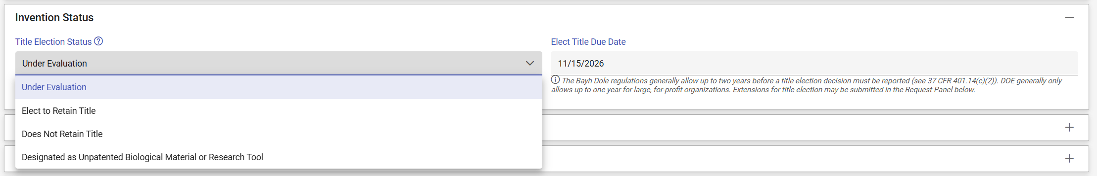
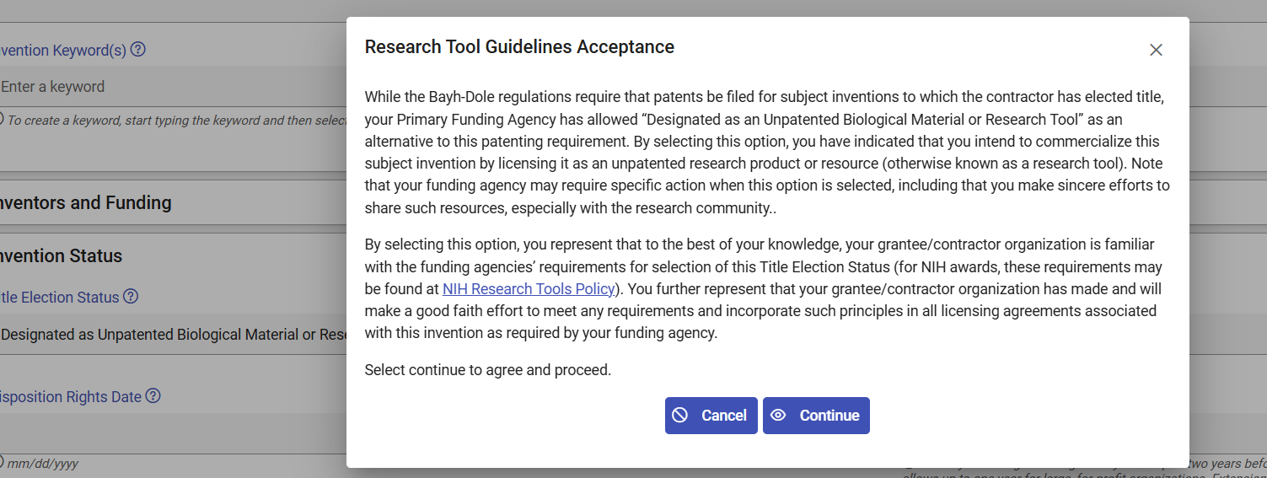

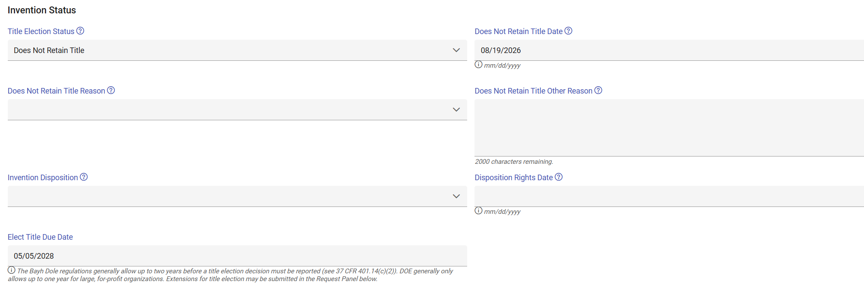
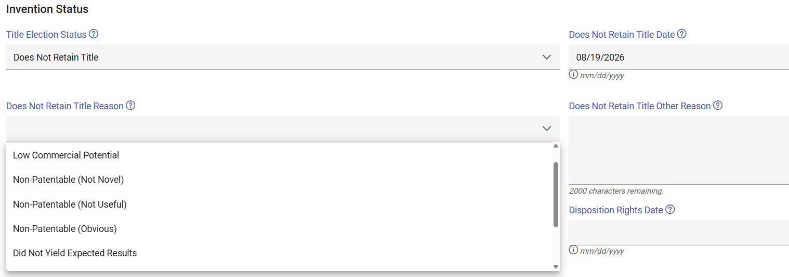
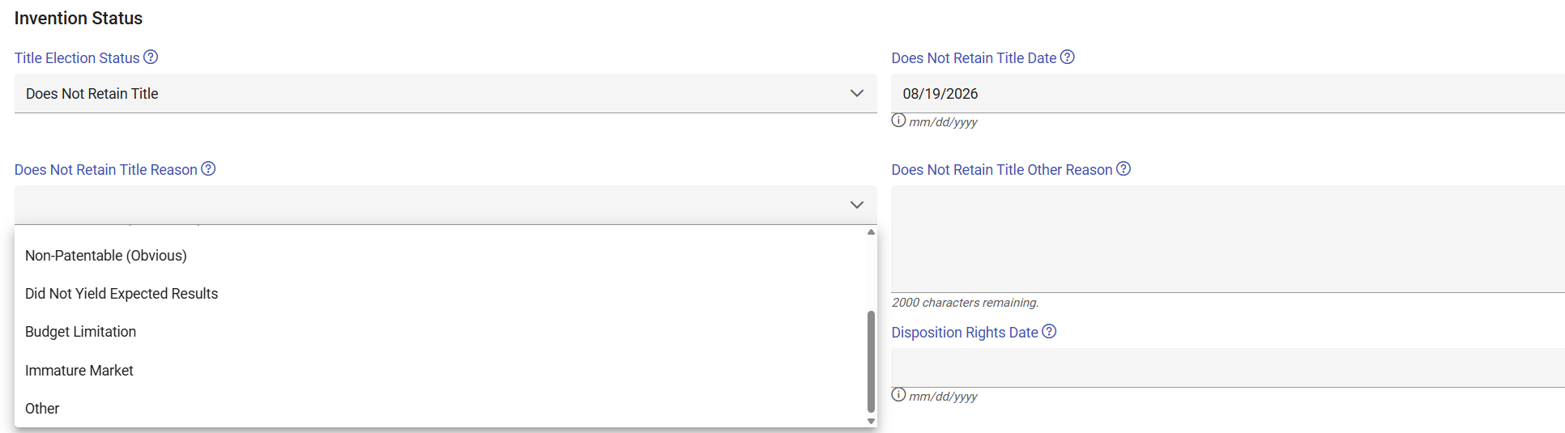
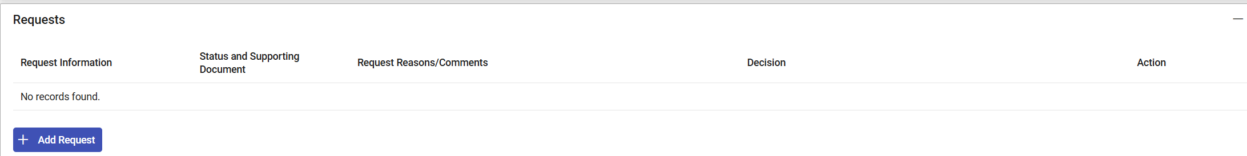
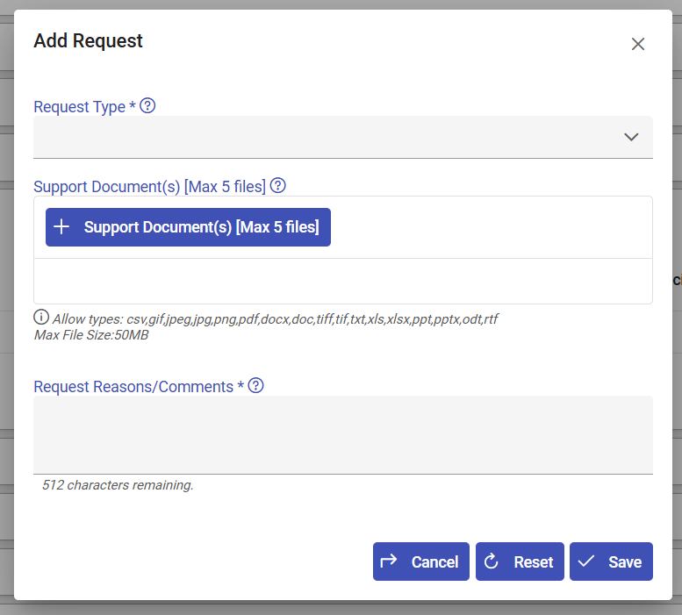
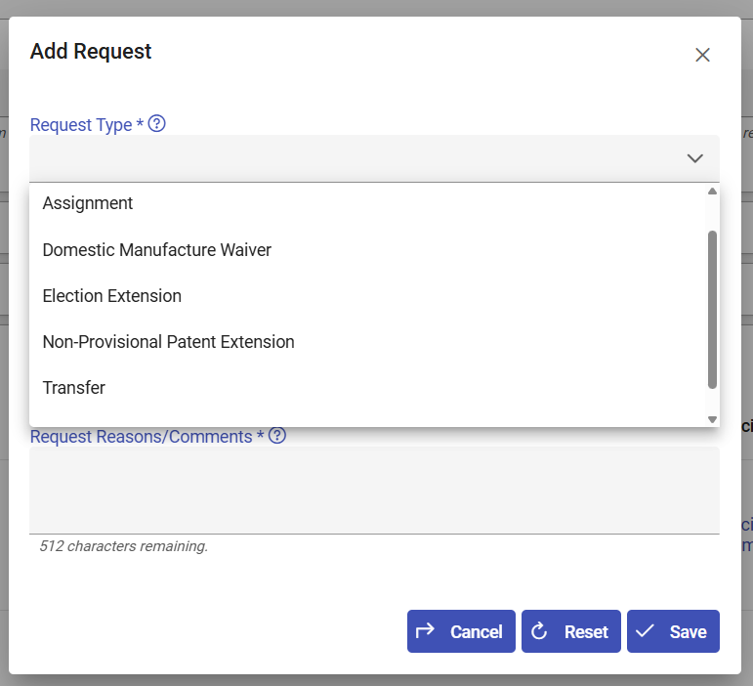
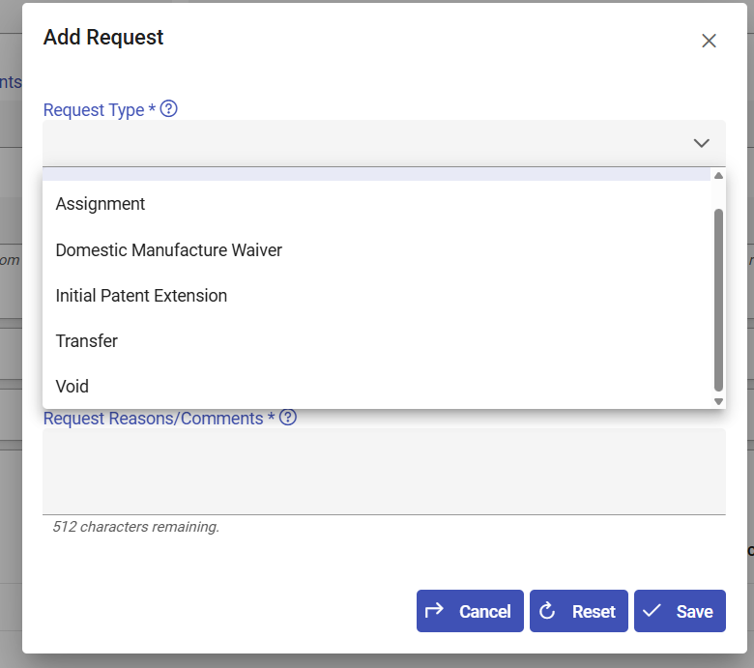
Depending on the status of the invention, there will be different request options available. Request types include assignments, domestic manufacturing waiver, election extension, non-provisional patent extension, initial patent extension, transfer, and void.
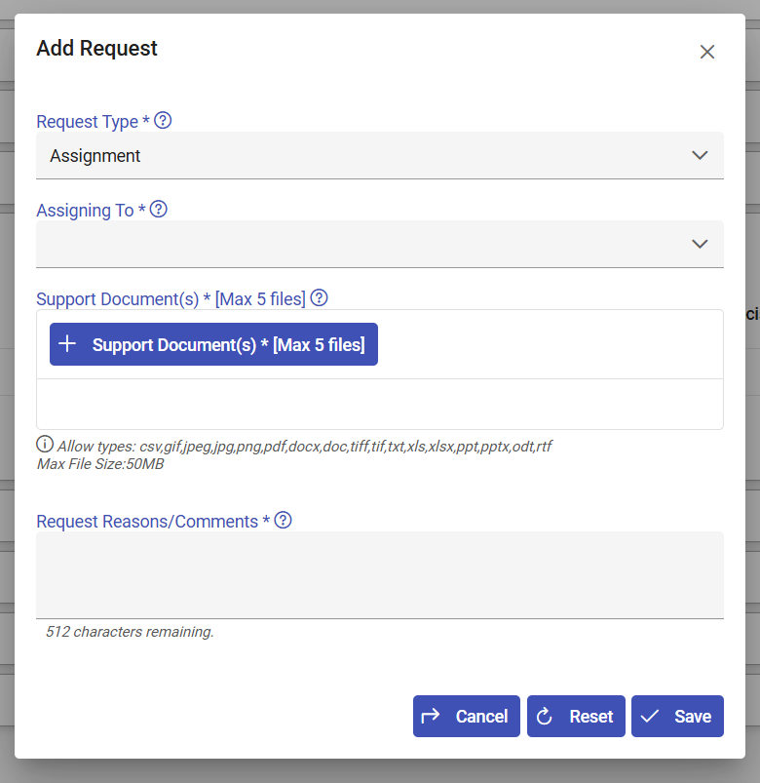
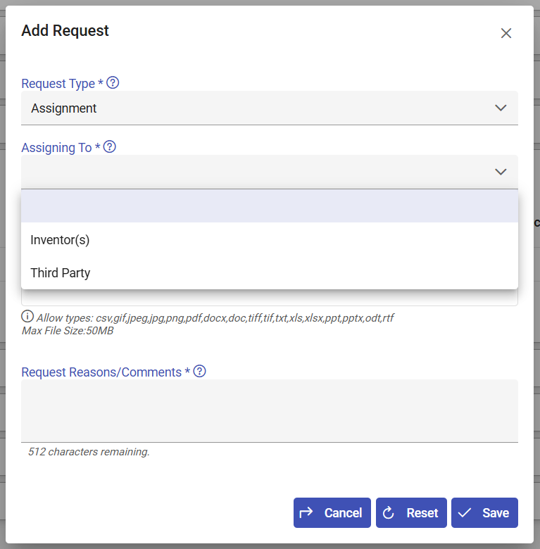
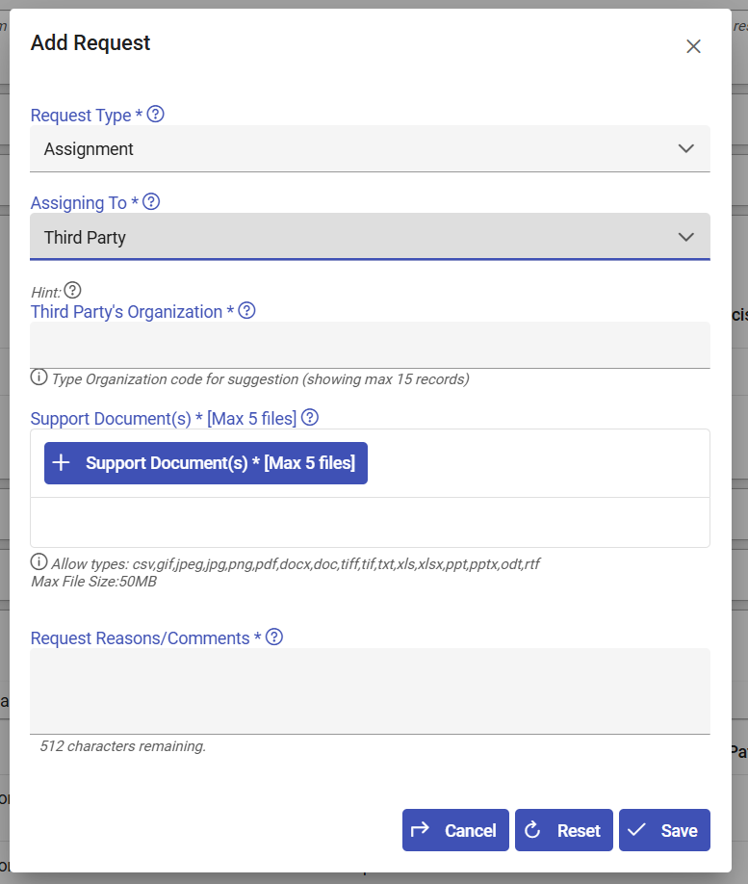
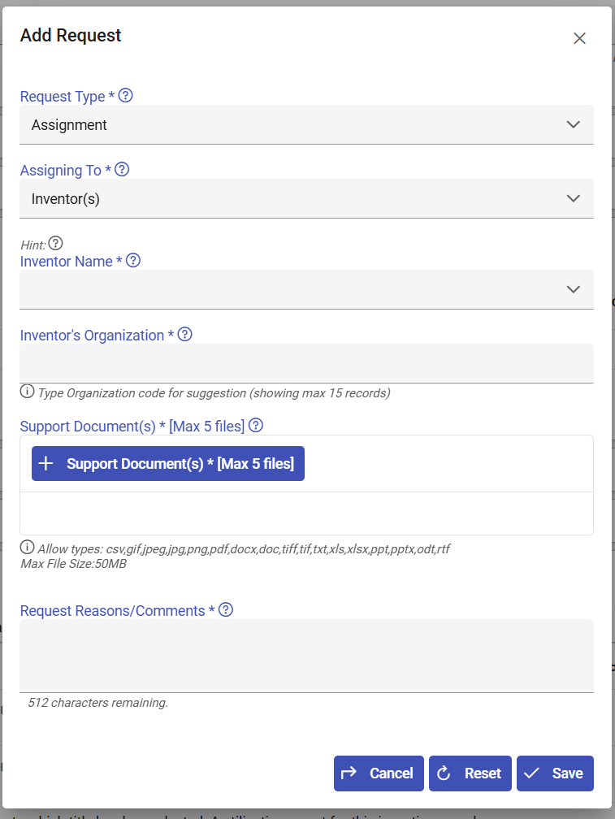
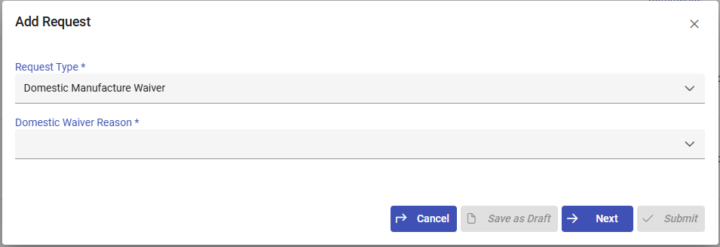
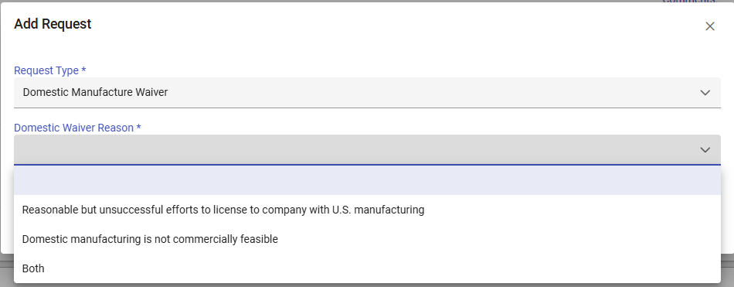
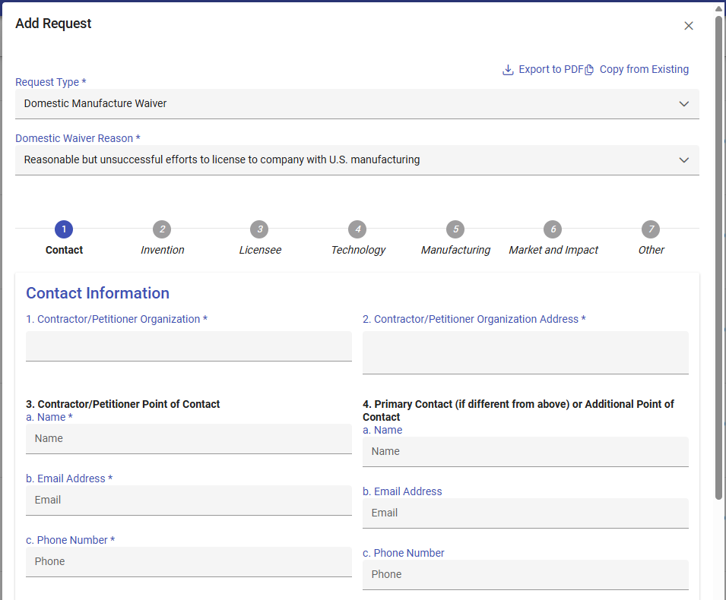
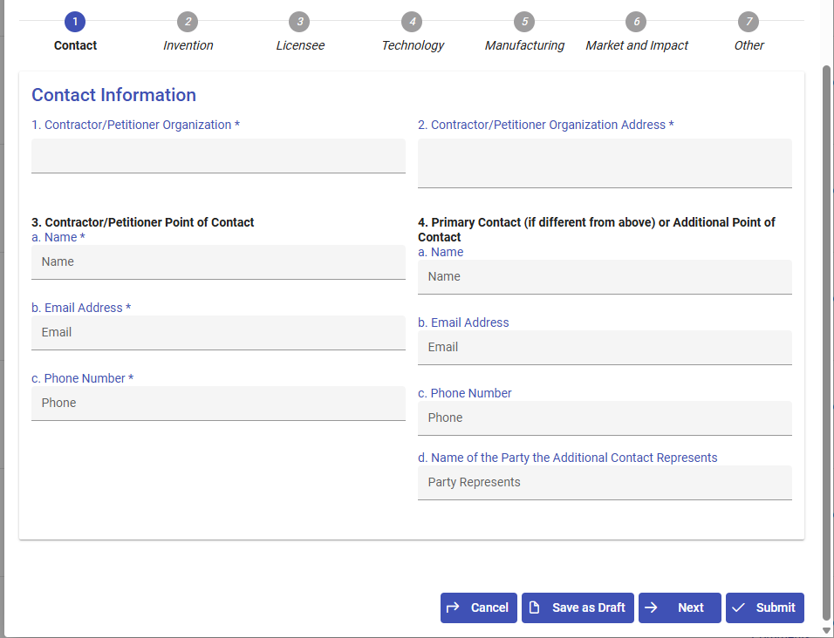

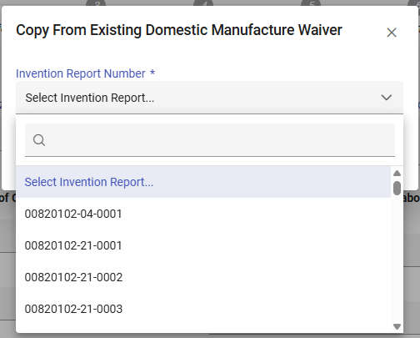
Please note that these options will vary by organization, but the organization/contractor selects an invention report to copy over a previous form.
