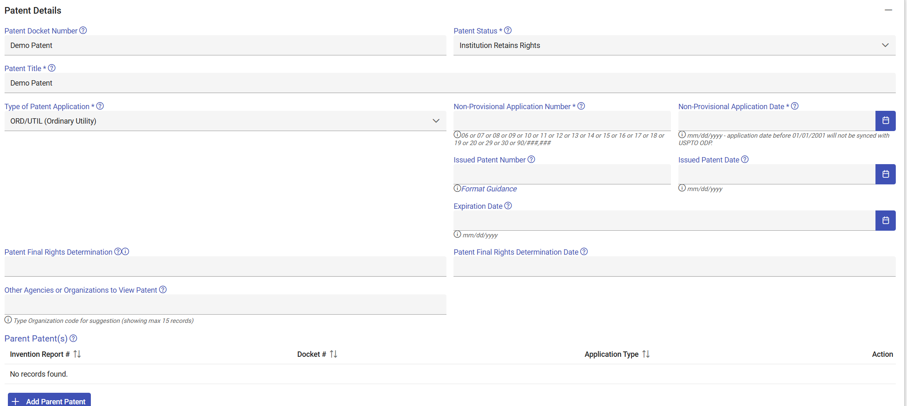

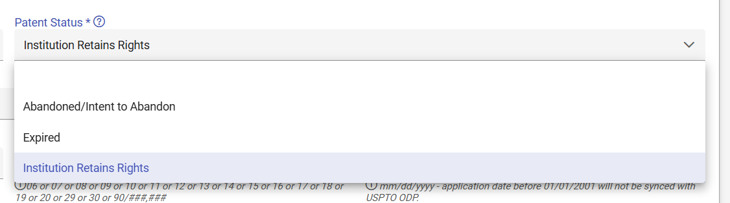
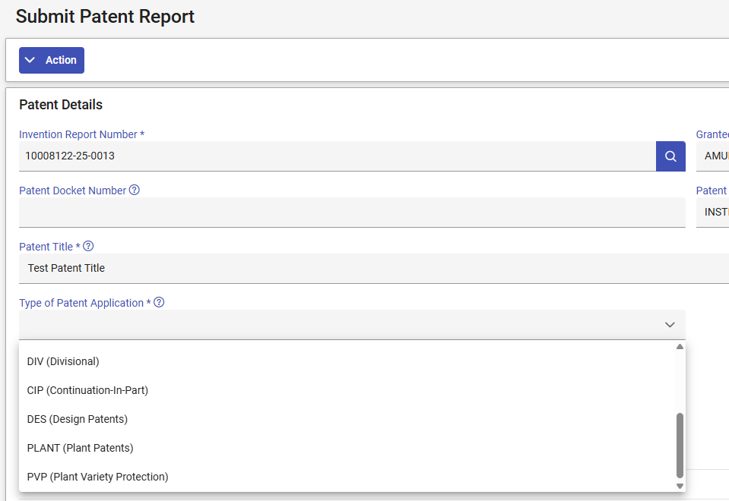
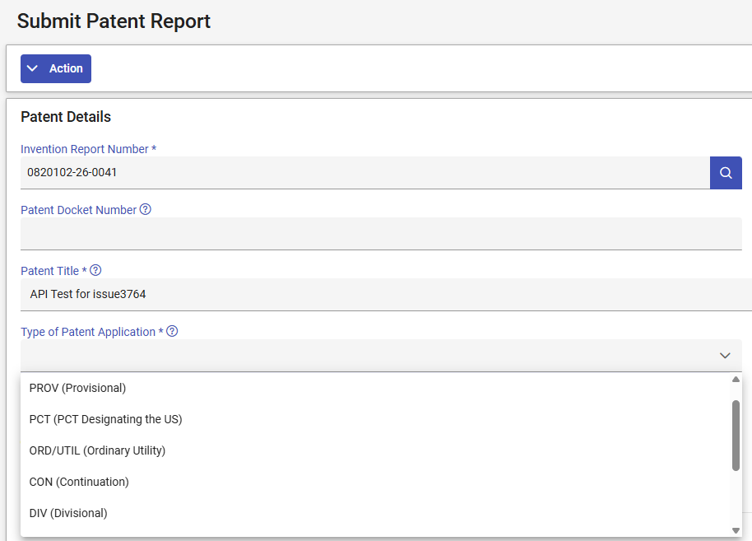
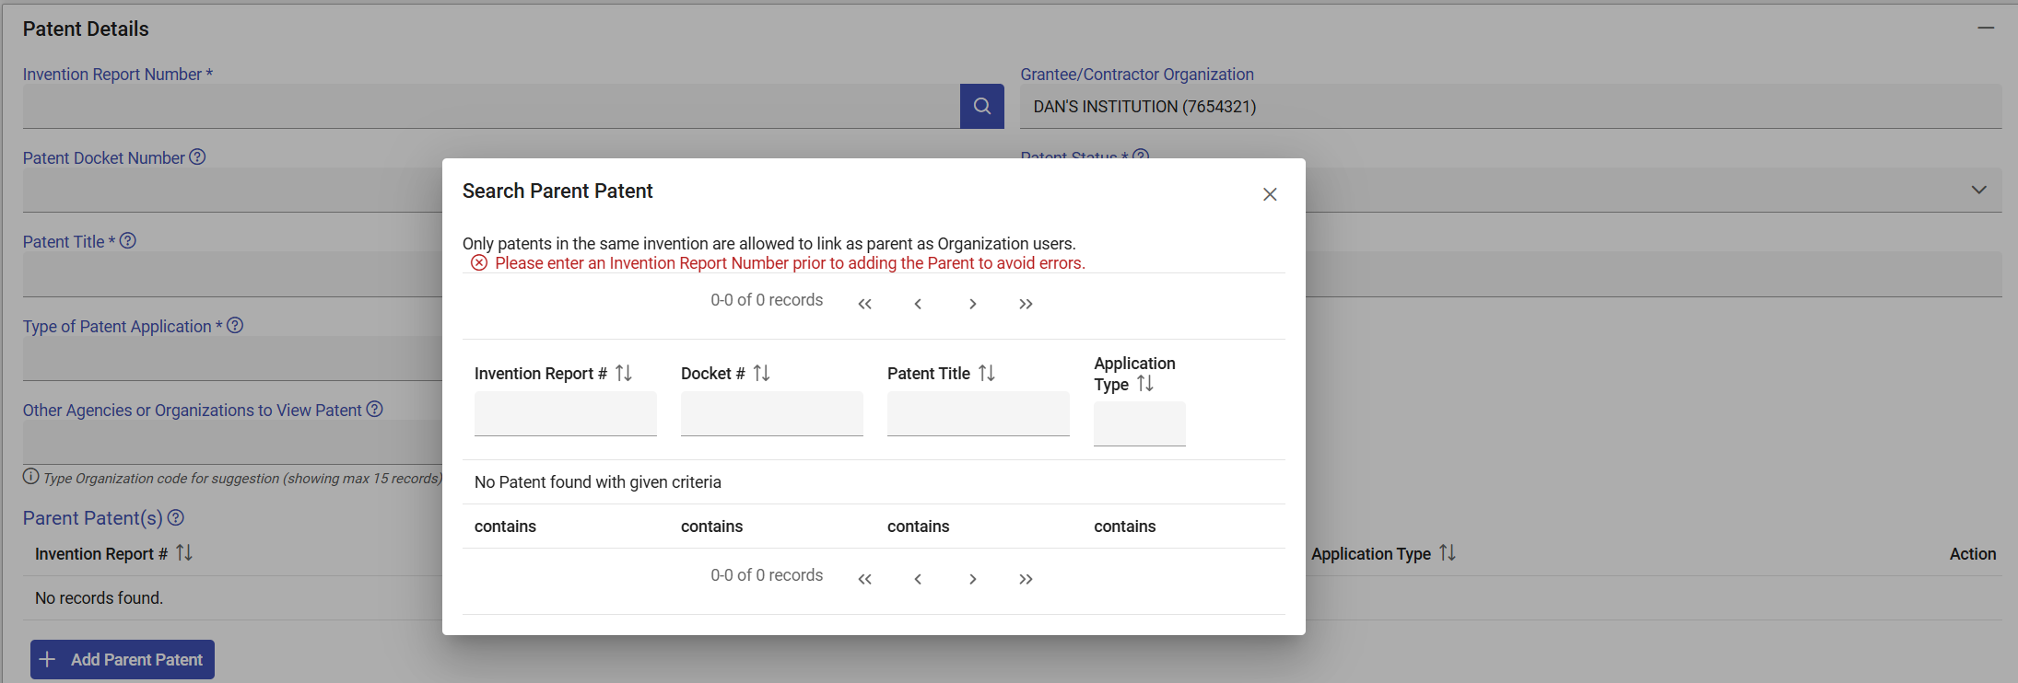
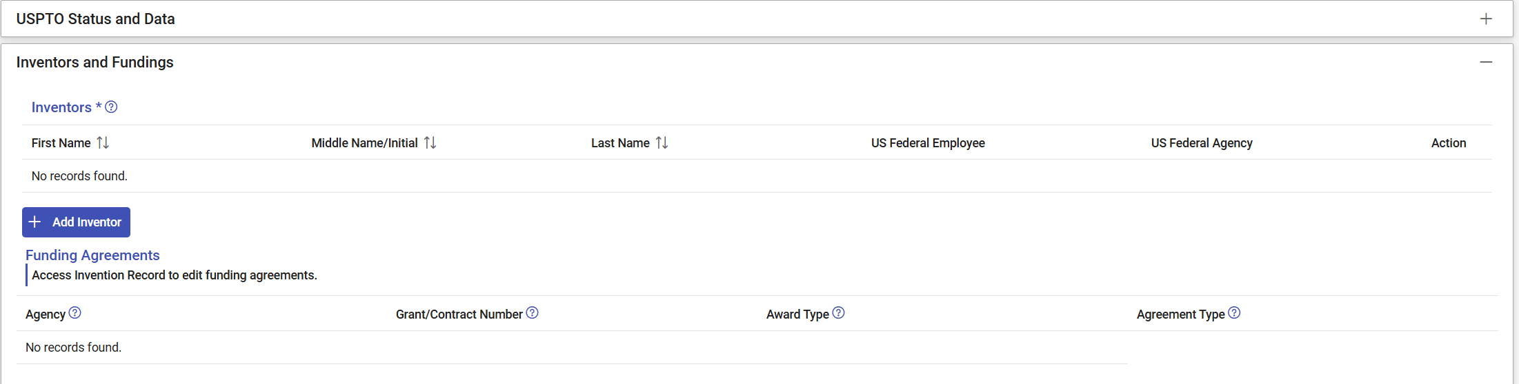
Funding agreement information will populate from the agreements listed in the invention report.
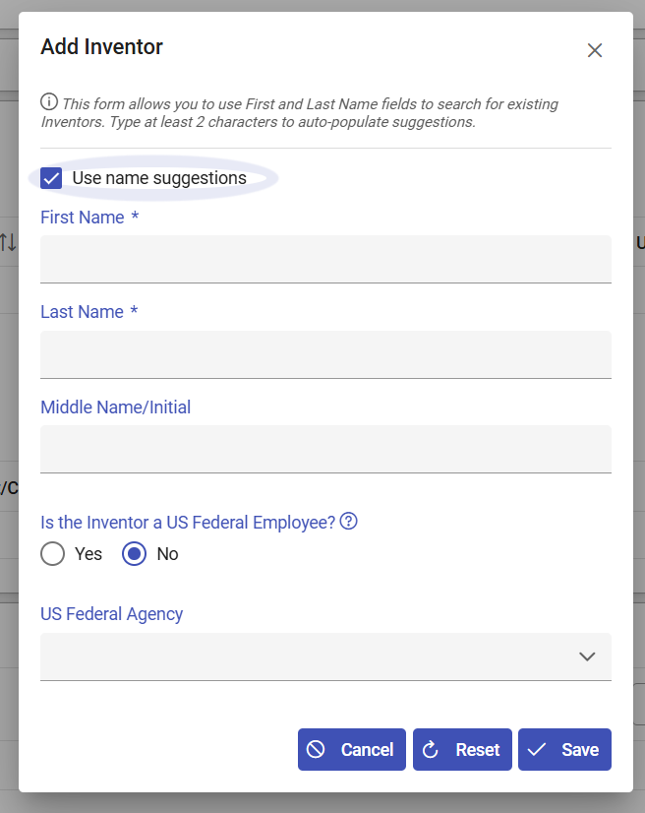
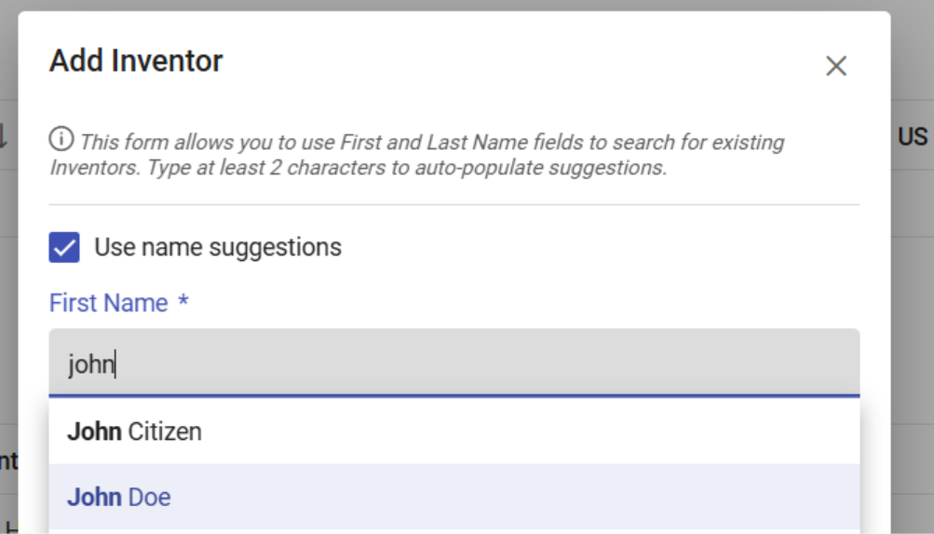
Please note that the names populated will vary by organization. The system saves previous inventor names, so the organization user can select from previously reported inventor names.
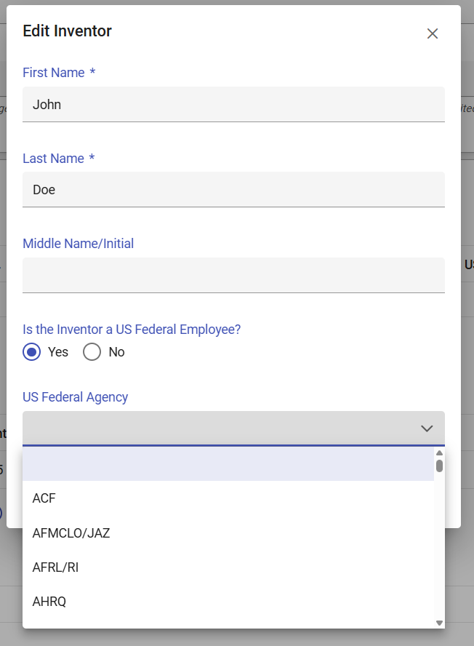
Below is the full list of “US Federal Agency:”
ACF | CIA | DOD-NAVY | HHS/FDA | MDA | NRS | SBA | VOA
DOD-AF/AFMCLO | CISA | DOD/DARPA | FDIC | MSHA | NSA | SEC | WHD
DOD-AF/AFRLRI | CMS | DOD/DMEA | FEMA | NARA | NSC | SSA
HHS/AHRQ | CNCS | DOD/DTRA | FHA | NASA | NSCEP | SSS
AMTRAK | CNPP | DOE | FHEO | DOD-NAVY/ONR | NSF | TSA
DOD-ARMY/ARL | COPS | DOI | FLETC | NCI | NTIA | US CERT
DOD-ARMY/ARO | CPSC | DOJ | FLRA | NCUA | NTSB | DOD-ARMY/USACE
DOD-ARMY/FUZE | DOC/Census | DOL | FMCSA | NEA | OCC | DOD-AF/AFOSR
DOD-ARMY/SMDC | DEA | DOS | FRA | NHIC | ODEP | USAID
DOD-ARMY/SSC | DFAS | DOT | FTA | NHTSA | OGE | USBR
HHS/ARPA-H | DOD-DHA/MRDB | DSCA | FTC | NIAID | OMB | USCIS
ATF | DHS | DTIC | FWS | NIDCR | ONDCP | USDA
HHS/ATSDR | DHS/ST | EAC | GSA | NIDILRR | OPM | USDA/AMS
HHS/BARDA | DIA | EBSA | HHS | HHS/NIH | OSERS | USDA/ARS
BEA | DISA | ED | HUD | NIJ | OSHA | USDA/FS
BEP | DLA | EDPUBS | IAQ | DOC/NIST | OTHER | USDA/NIFA
BIS | DOC | EEOC | ICE | NLRB | OVW | USGS
BLM | DOC/EDA | EERE | IER | DOE/NNSA | PBGC | USPS
BOP | DOC/ITA | EPA | HHS/IHS | DOC/NOAA | PCLOB | VA
BSEE | DOD | FAA | IRS | NPS | RFA | VBA
HHS/CDC | DOD-AF | FBI | LINCS | NRC | RFE/RL | VETS
CFTC | DOD-ARMY | FCC | MARAD | DOD-NAVY/NRL | RRB | VHA

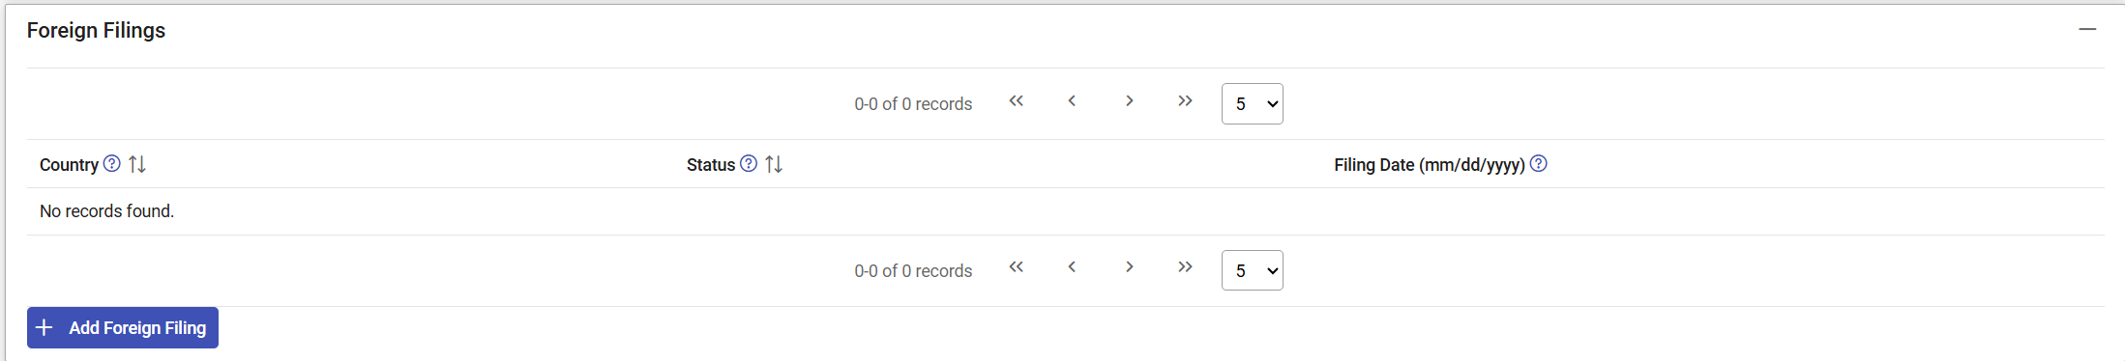
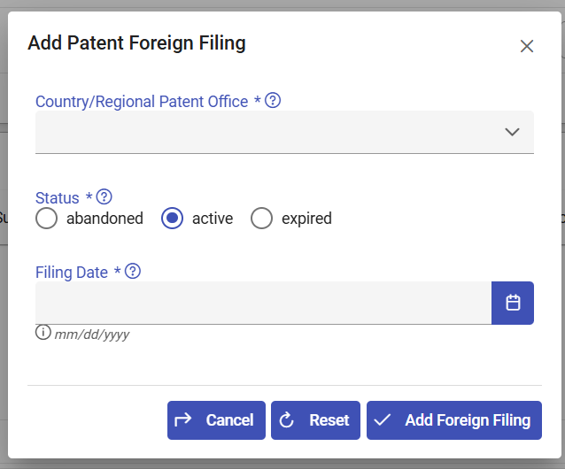
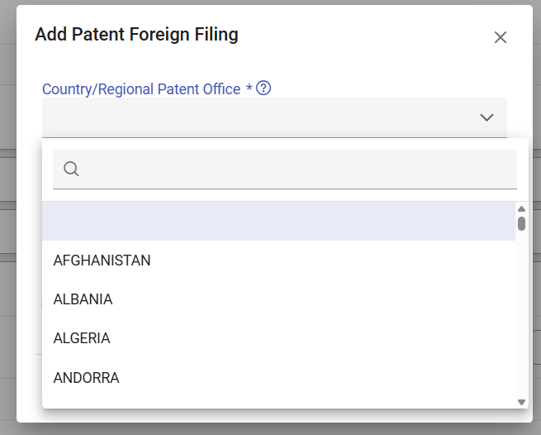

Below is the full list of “Country/Regional Patent Office:”
AFGHANISTAN | BOLIVIA | FRANCE | GAZA STRIP | LUXEMBOURG | NORWAY | SLOVAKIA | UKRAINE
ALBANIA | BOSNIA/HERZEG | FRENCH POLYNES | GERMANY | MACAU | OMAN | SLOVENIA | UNITED ARAB EM
ALGERIA | BOTSWANA | DJIBOUTI | GHANA | NORTH MACEDONIA | PAKISTAN | SOMALIA | UNITED KINGDOM
ANDORRA | BRAZIL | CONGO | IRAN | MADAGASCAR | PANAMA | SOUTH AFRICA | UNITED STATES
ANGOLA | BRITISH VI ISS | COSTA RICA | IRAQ | MALAWI | PAPUA N GUINEA | ZIMBABWE | BURKINA
ANGUILLA | BRUNEI | CROATIA | IRELAND | MALAYSIA | PARAGUAY | NAMIBIA | URUGUAY
ANTIGUA/BARBUD | CABO VERDE | CUBA | ISRAEL | MALDIVES | PERU | SPAIN | UZBEKISTAN
ARMENIA | CAYMAN ISLANDS | CYPRUS | ITALY | MALI | PHILIPPINES | SRI LANKA | VENEZUELA
ARGENTINA | CENTRAL AFR R | CZECH REPUBLIC | COTE D'IVOIRE | MALTA | POLAND | SUDAN | VIETNAM
ARUBA | CHAD | GIBRALTAR | JAMAICA | MAURITANIA | PORTUGAL | SURINAME | WEST BANK
AUSTRALIA | CHILE | GREECE | JAPAN | MAURITIUS | RUSSIA | ESWATINI | SAMOA
AUSTRIA | CHINA | GREENLAND | JERSEY | MOLDOVA | QATAR | SWEDEN | YEMEN
AZERBAIJAN | TAIWAN | GRENADA | JORDAN | MEXICO | ROMANIA | SWITZERLAND | YUGOSLAVIA
BAHAMAS | COLOMBIA | GUATEMALA | KAZAKHSTAN | MONACO | RWANDA | SYRIA | CONGO DEM REP
BAHRAIN | COMOROS | GUERNSEY | KENYA | MONGOLIA | ST KITTS/NEVIS | TAJIKISTAN | ZAMBIA
BANGLADESH | DENMARK | GUINEA | KIRIBATI | MONTSERRAT | ST HELENA | TANZANIA U REP | SENEGAL
BARBADOS | DOMINICA | GUINEA-BISSAU | KOREA PEO REP | MONTENEGRO | ST LUCIA | THAILAND | LATVIA
BELGIUM | DOMINICAN REP | GUYANA | KOREA REP OF | MOROCCO | ST VINCENT/GRN | TOGO | TIMOR-LESTE
BELIZE | ECUADOR | HAITI | KUWAIT | MOZAMBIQUE | SAN MARINO | TONGA | KOSOVO
BENIN | EGYPT | HONDURAS | KYRGYZSTAN | NAURU | SAO TOME/PRINC | TRINIDAD/TOBA | SOUTH SUDAN
BERMUDA | EL SALVADOR | HONG KONG | LAOS | NEPAL | SAUDI ARABIA | TUNISIA | African Intellectual Property Organization
BHUTAN | EQUATOR GUINEA | HUNGARY | LEBANON | NETHERLANDS | SERBIA | TURKMENISTAN | African Regional Intellectual Property Organization
BULGARIA | ESTONIA | ICELAND | LESOTHO | VANUATU | SEYCHELLES | TURKEY | Eurasian Patent Organization
MYANMAR | ERITREA | INDIA | LIBERIA | NEW ZEALAND | SIERRA LEONE | TURKS/CAICOS I | European Patent Organization
BURUNDI | ETHIOPIA | INDONESIA | LIBYA | NICARAGUA | SINGAPORE | TUVALU | Patent Office of the Cooperation Council for the Arab States of the Gulf
BELARUS | FALKLAND ISS | GABON | LIECHTENSTEIN | NIGER | SOLOMON ISS | UGANDA | Unitary Patent
CAMBODIA | FIJI | GEORGIA | LITHUANIA | NIGERIA
CAMEROON | FINLAND | GAMBIA
CANADA

