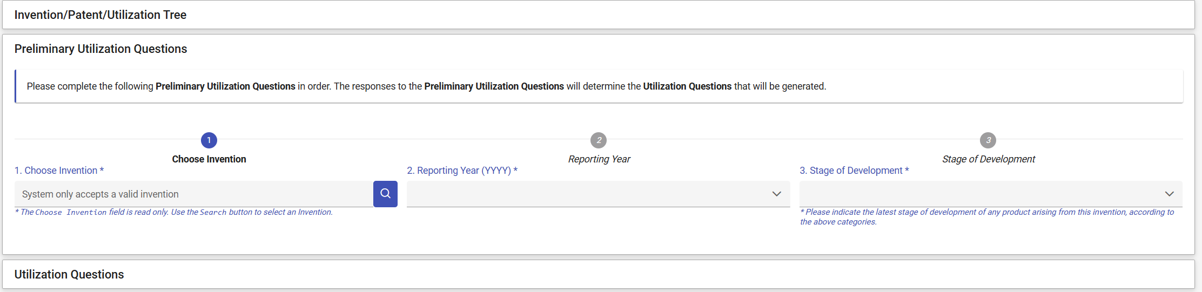

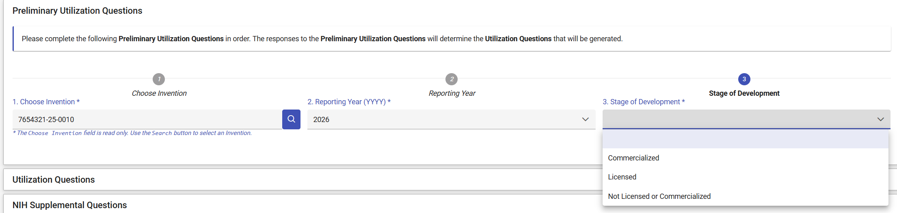

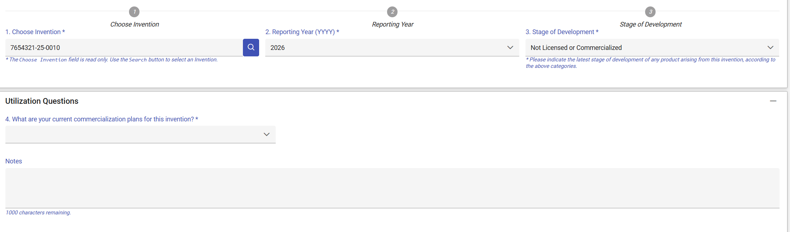
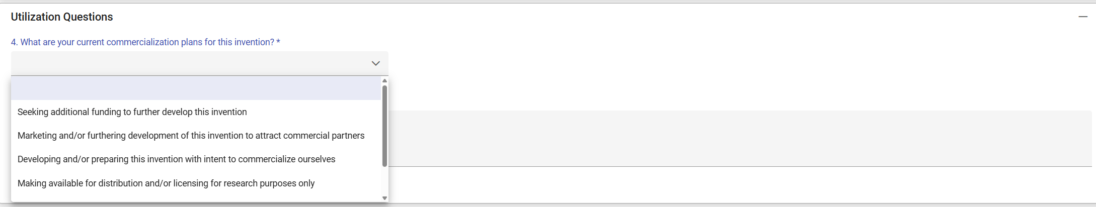
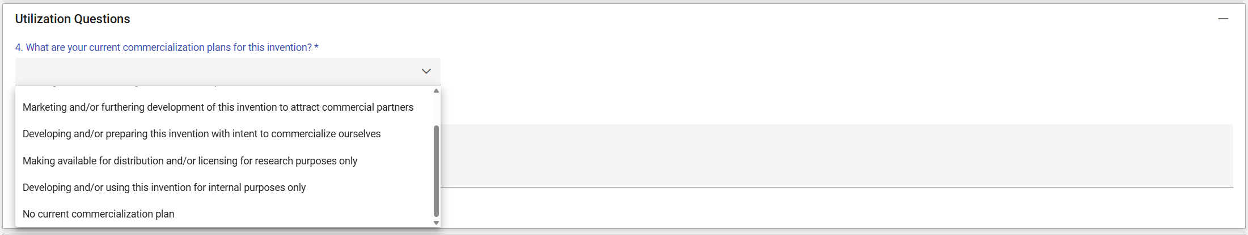
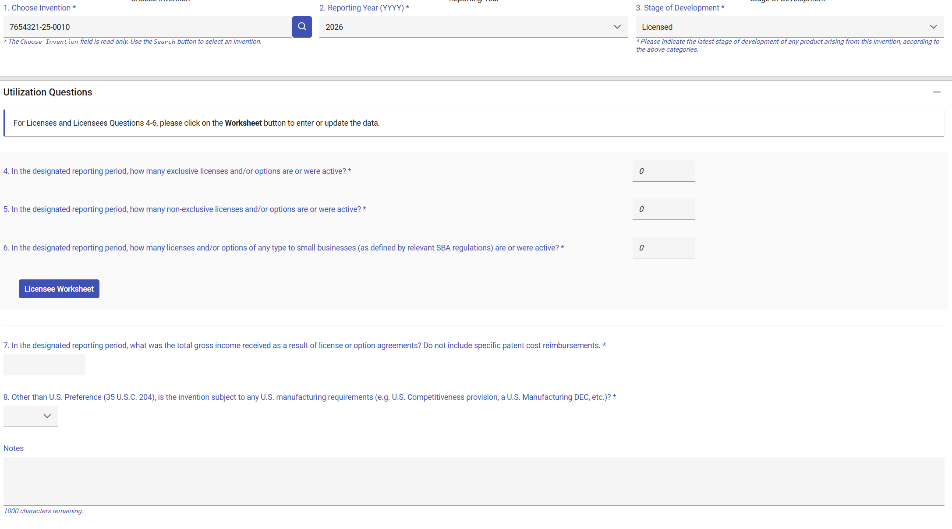
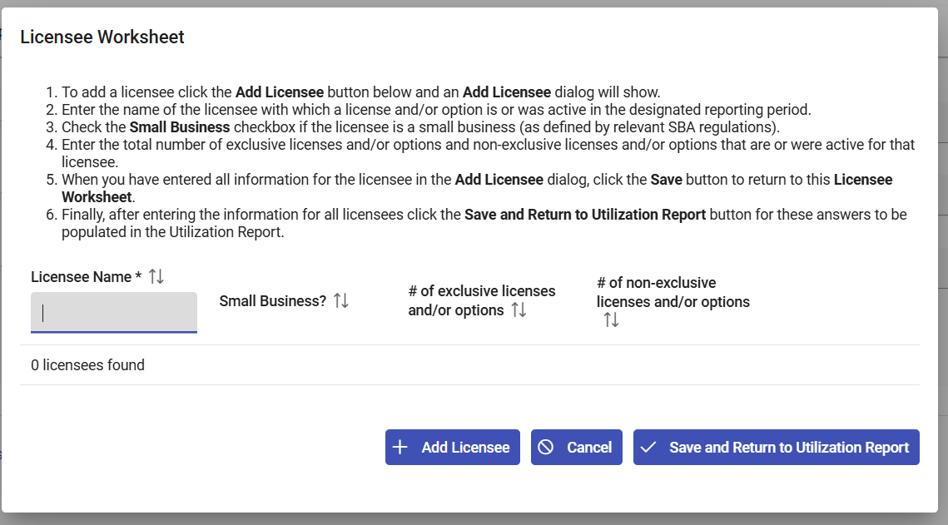
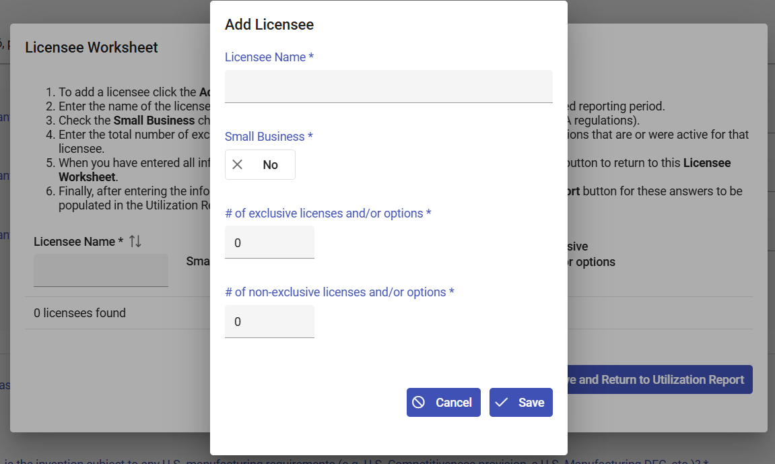
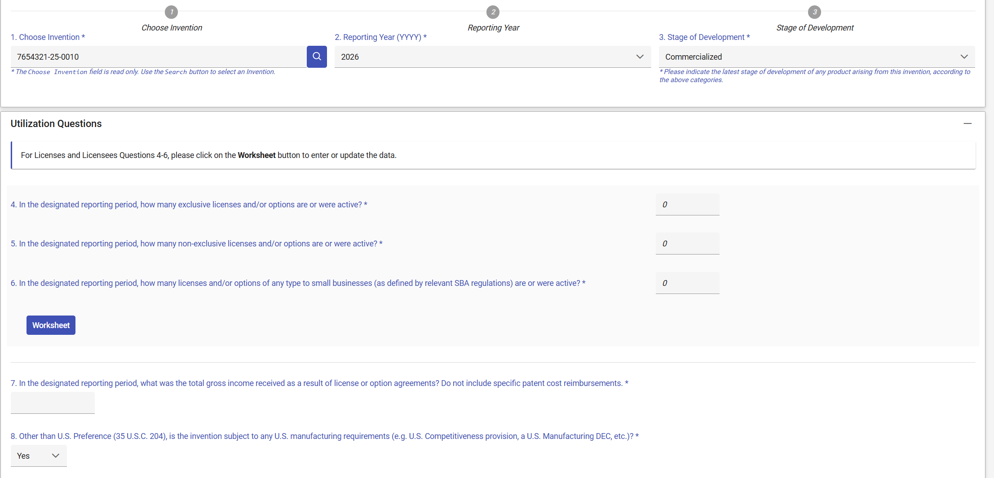
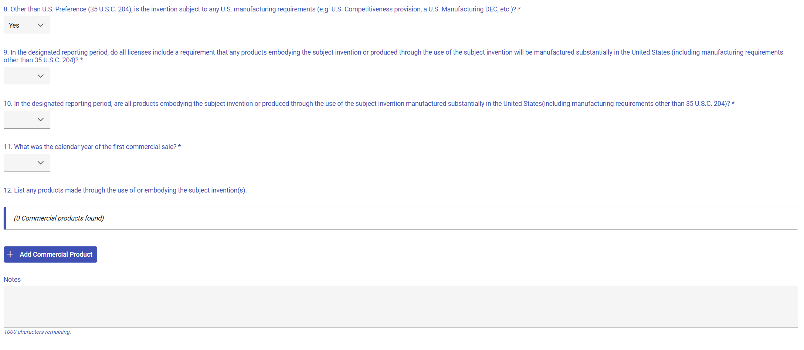
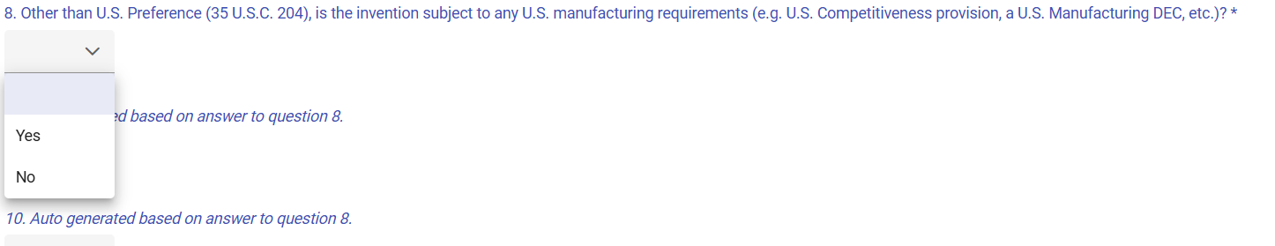
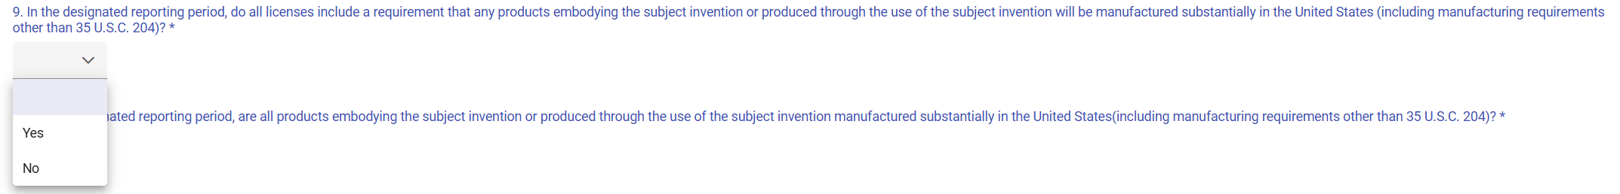
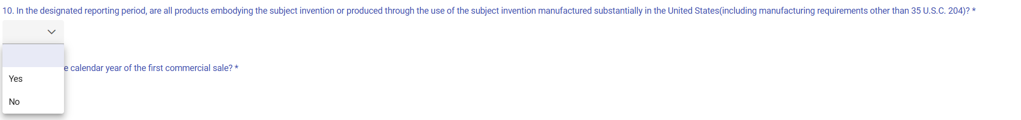
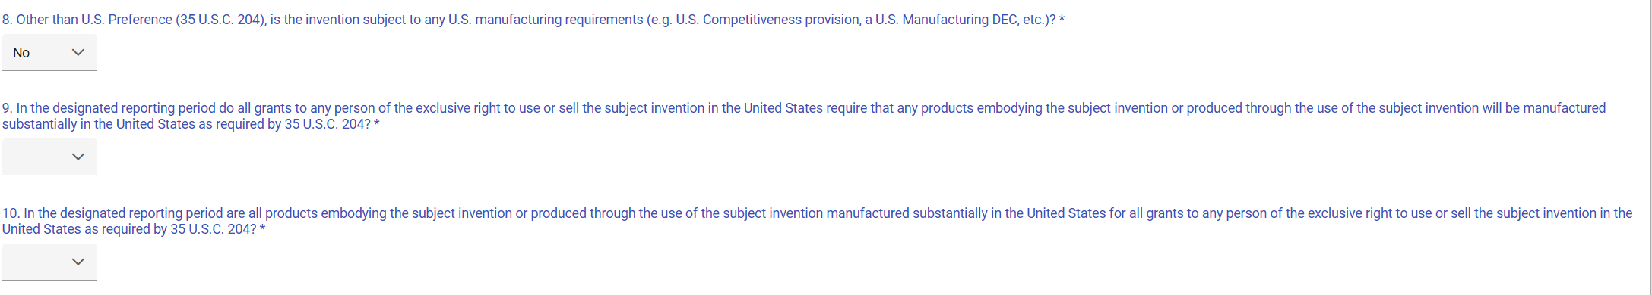
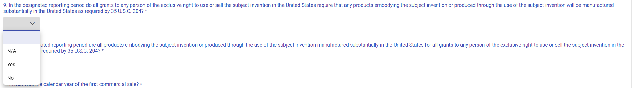

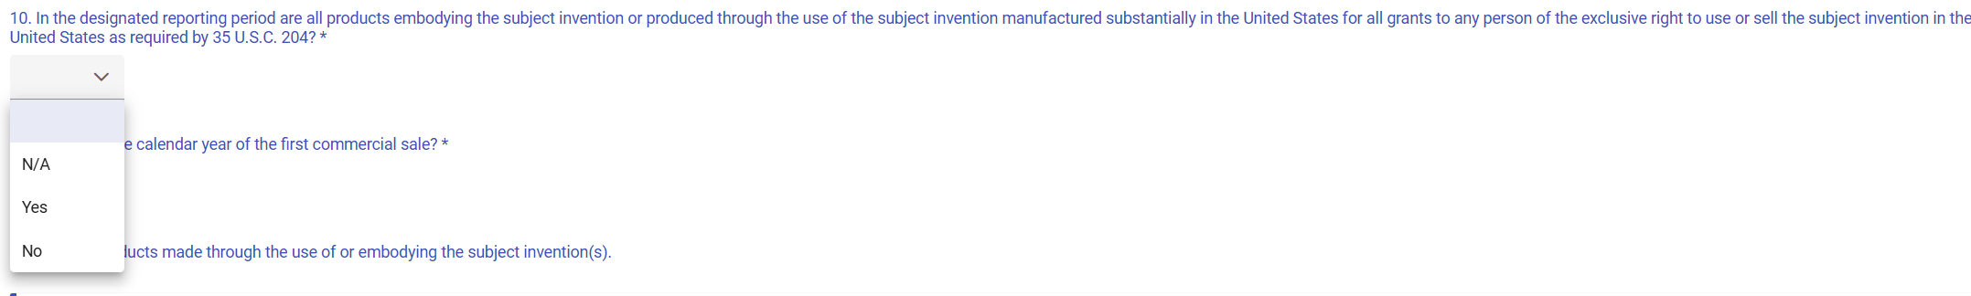
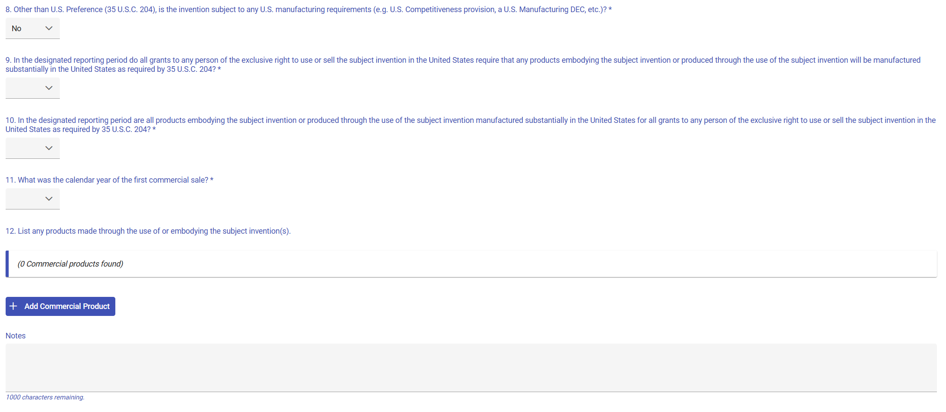

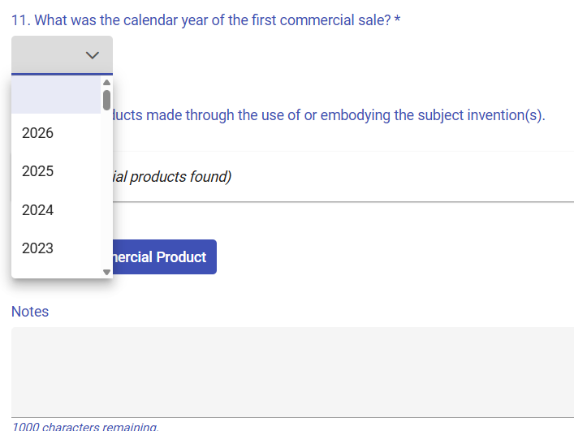

Below are the list of First Commercial Sale years:
1971 | 1990 | 2009
1972 | 1991 | 2010
1973 | 1992 | 2011
1974 | 1993 | 2012
1975 | 1994 | 2013
1976 | 1995 | 2014
1977 | 1996 | 2015
1978 | 1997 | 2016
1979 | 1998 | 2017
1980 | 1999 | 2018
1981 | 2000 | 2019
1982 | 2001 | 2020
1983 | 2002 | 2021
1984 | 2003 | 2022
1985 | 2004 | 2023
1986 | 2005 | 2024
1987 | 2006 | 2025
1988 | 2007 | 2026
1989 | 2008

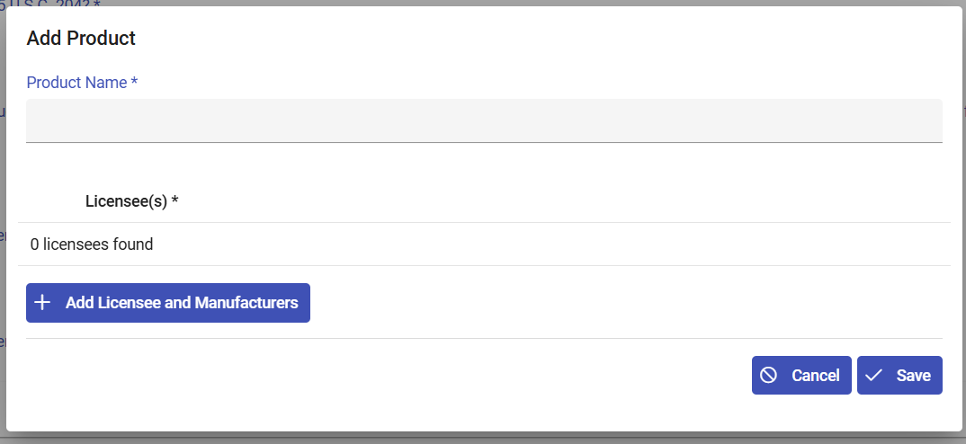
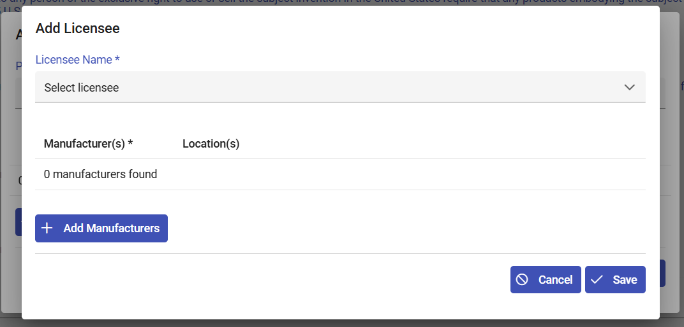
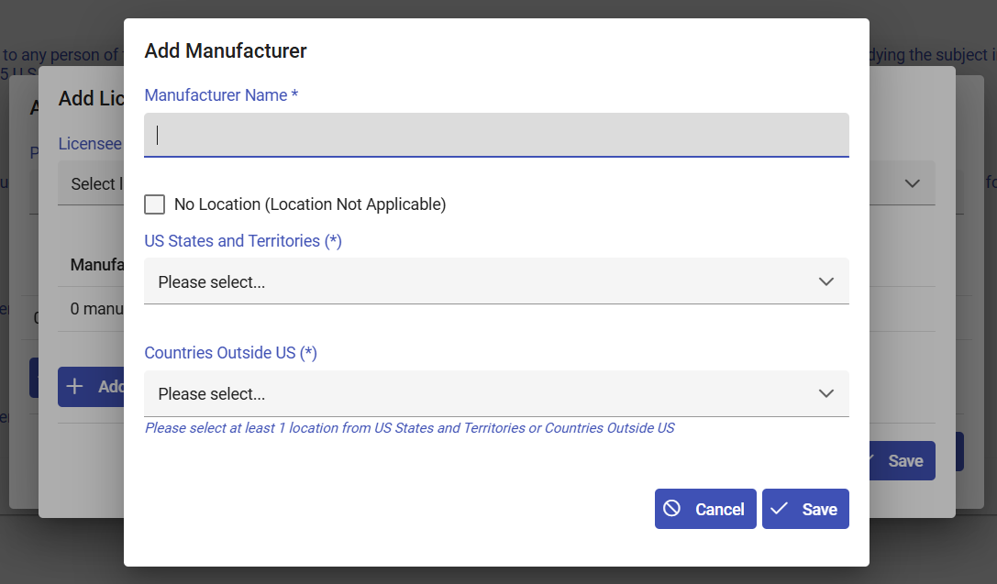

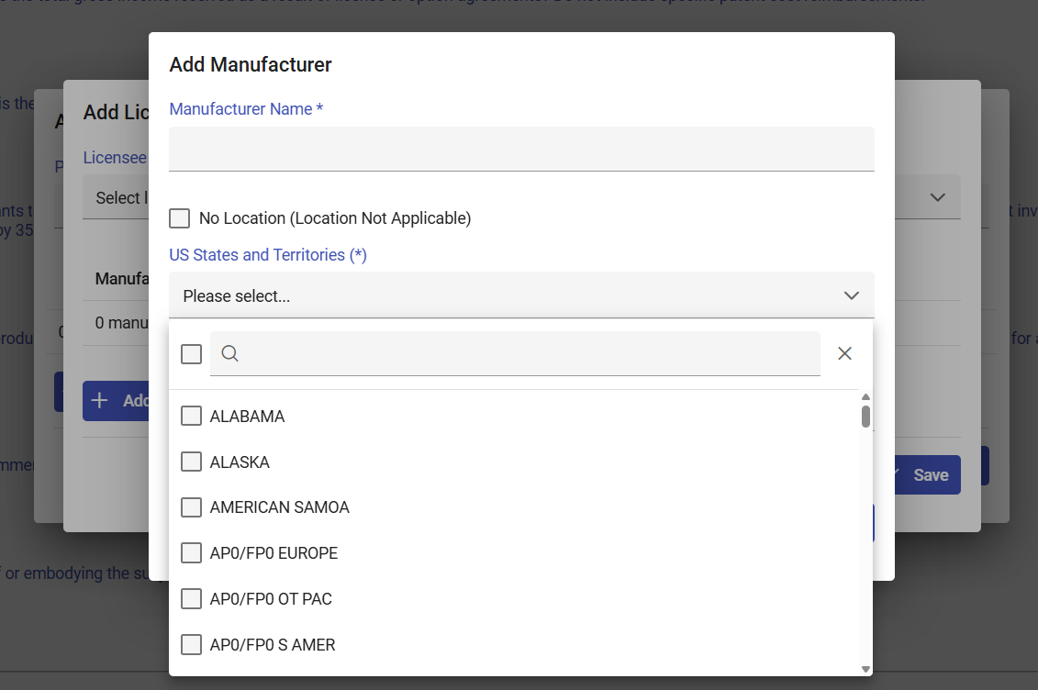
Below is the list of “US States and Territories:”
ALABAMA | MAINE | RHODE ISLAND | VIRGIN ISLANDS
ALASKA | MARYLAND | SOUTH CAROLINA | AP0/FP0 S AMER
ARIZONA | MASSACHUSETTS | SOUTH DAKOTA | AP0/FP0 EUROPE
ARKANSAS | MICHIGAN | TENNESSEE | AP0/FP0 OT PAC
CALIFORNIA | MINNESOTA | TEXAS | NAVASSA ISLAND
COLORADO | MISSISSIPPI | UTAH | BAKER ISLAND
CONNECTICUT | MISSOURI | VERMONT | HOWARD ISLAND
DELAWARE | MONTANA | VIRGINIA | JOHNSTON ATOLL
DIST OF COL | NEBRASKA | WASHINGTON | KINGMAN REEF
FLORIDA | NEVADA | WEST VIRGINIA | PALMYRA ATOLL
GEORGIA | NEW HAMPSHIRE | WISCONSIN | MIDWAY ISLANDS
HAWAII | NEW JERSEY | WYOMING | TRUST TER PACF
IDAHO | NEW MEXICO | AMERICAN SAMOA | WAKE ISLAND
ILLINOIS | NEW YORK | FED MICRONESIA
INDIANA | NORTH CAROLINA | GUAM
IOWA | NORTH DAKOTA | MARSHALL IS
KANSAS | OHIO | NORTHN MARIANA
KENTUCKY | OKLAHOMA | PALAU
LOUISIANA | OREGON | PUERTO RICO
 | PENNSYLVANIA | US MINOR OUTLY

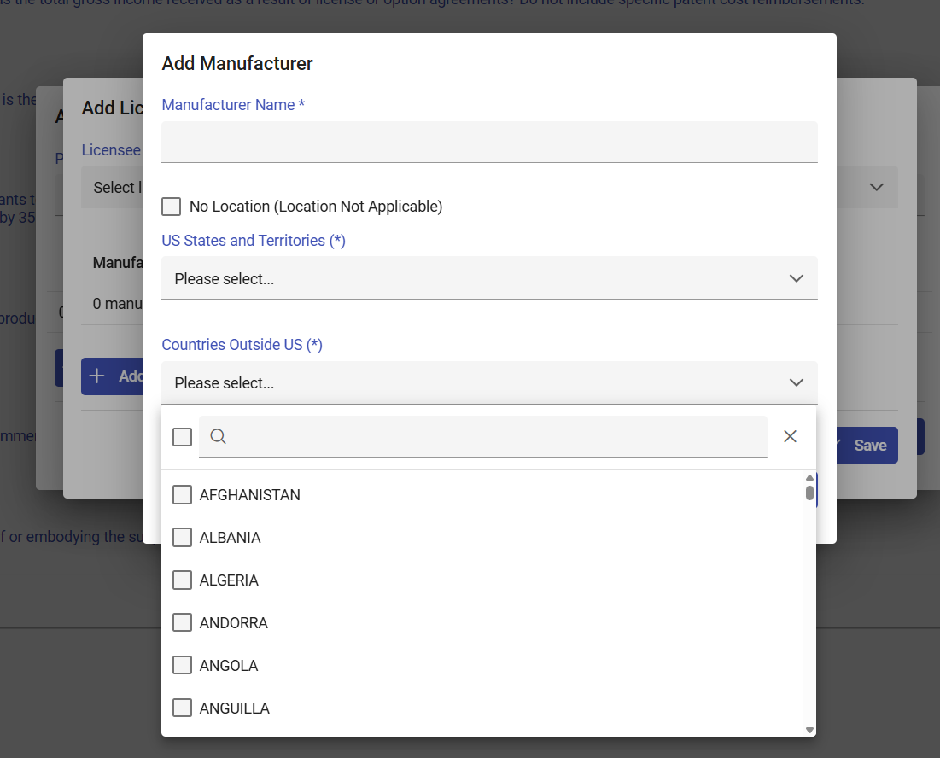
Below is the list of “Countries Outside US:”
AFGHANISTAN | BERMUDA | CHINA | FALKLAND ISS | GUYANA | KIRIBATI | MALTA
ALBANIA | BHUTAN | TAIWAN | FIJI | HAITI | KOREA PEO REP | MAURITANIA
ALGERIA | BOLIVIA | COLOMBIA | FINLAND | HONDURAS | KOREA REP OF | MAURITIUS
ANDORRA | BOSNIA/HERZEG | COMOROS | FRANCE | HONG KONG | KUWAIT | MOLDOVA
ANGOLA | BOTSWANA | CONGO | FRENCH POLYNES | HUNGARY | KYRGYZSTAN | MEXICO
ANGUILLA | BRAZIL | COSTA RICA | DJIBOUTI | ICELAND | LAOS | MONACO
ANTIGUA/BARBUD | BRITISH VI ISS | CROATIA | GABON | INDIA | LEBANON | MONGOLIA
ARMENIA | BRUNEI | CUBA | GEORGIA | INDONESIA | LESOTHO | MONTSERRAT
ARGENTINA | BULGARIA | CYPRUS | GAMBIA | IRAN | LIBERIA | MONTENEGRO
ARUBA | MYANMAR | CZECH REPUBLIC | GAZA STRIP | IRAQ | LIBYA | MOROCCO
AUSTRALIA | BURUNDI | DENMARK | GERMANY | IRELAND | LIECHTENSTEIN | MOZAMBIQUE
AUSTRIA | BELARUS | DOMINICA | GHANA | ISRAEL | LITHUANIA | NAURU
AZERBAIJAN | CAMBODIA | DOMINICAN REP | GIBRALTAR | ITALY | LUXEMBOURG | NEPAL
BAHAMAS | CAMEROON | ECUADOR | GREECE | COTE D'IVOIRE | MACAU | NETHERLANDS
BAHRAIN | CANADA | EGYPT | GREENLAND | JAMAICA | NORTH MACEDONIA | VANUATU
BANGLADESH | CABO VERDE | EL SALVADOR | GRENADA | JAPAN | MADAGASCAR | NEW ZEALAND
BARBADOS | CAYMAN ISLANDS | EQUATOR GUINEA | GUATEMALA | JERSEY | MALAWI | NICARAGUA
BELGIUM | CENTRAL AFR R | ESTONIA | GUERNSEY | JORDAN | MALAYSIA | NIGER
BELIZE | CHAD | ERITREA | GUINEA | KAZAKHSTAN | MALDIVES | NIGERIA
BENIN | CHILE | ETHIOPIA | GUINEA-BISSAU | KENYA | MALI | NORWAY
OMAN | SERBIA | TANZANIA U REP | WEST BANK | CORAL SEA ISS | REUNION
PAKISTAN | SEYCHELLES | THAILAND | SAMOA | EUROPA ISLAND | ST PIERRE/MIQU
PANAMA | SIERRA LEONE | TOGO | YEMEN | FAROE ISLANDS | WESTERN SAHARA
PAPUA N GUINEA | SINGAPORE | TONGA | YUGOSLAVIA | FRENCH GUIANA | SPRATLEY ISS
PARAGUAY | SOLOMON ISS | TRINIDAD/TOBA | CONGO DEM REP | FRENCH SO/ANT | SVALBARD
PERU | SLOVAKIA | TUNISIA | ZAMBIA | GLORIOSO ISS | TOKELAU
PHILIPPINES | SLOVENIA | TURKMENISTAN | SENEGAL | GUADELOUPE | TROMELIN IS
POLAND | SOMALIA | TURKEY | LATVIA | HEARD/MCDON IS | VATICAN CITY
PORTUGAL | SOUTH AFRICA | TURKS/CAICOS I | TIMOR-LESTE | IRAQ-SAUDI ARA | WALLIS/FUTUNA
RUSSIA | ZIMBABWE | TUVALU | KOSOVO | JAN MAYEN | NOT STATED
QATAR | NAMIBIA | UGANDA | SOUTH SUDAN | JUAN DE NOVA I | SOUTH GEORGIA
ROMANIA | SPAIN | UKRAINE | ANTARCTICA | MAN ISLE OF | FRANCE, METRO
RWANDA | SRI LANKA | UNITED ARAB EM | ASHMOR/CARTIER | MARTINIQUE | PALESTINIAN TR
ST KITTS/NEVIS | SUDAN | UNITED KINGDOM | BASSAS D INDIA | MAYOTTE | US MINOR ISLAN
ST HELENA | SURINAME |  | BOUVET ISLAND | NETHERLANDS AN | FED MICRONESIA
ST LUCIA | ESWATINI | BURKINA | BRITISH IOT | NEW CALEDONIA | REP OF PALAU
ST VINCENT/GRN | SWEDEN | URUGUAY | CLIPPERTON IS | NIUE | MARSHALL IS
SAN MARINO | SWITZERLAND | UZBEKISTAN | CHRISTMAS IS | NORFOLK IS
SAO TOME/PRINC | SYRIA | VENEZUELA | COCOS (KEELNG) | PARACEL ISS
SAUDI ARABIA | TAJIKISTAN | VIETNAM | COOK ISLANDS | PITCAIRN ISS

