DATE: August 6, 2026
TO: Desk Officer, Office of Management and Budget
FROM: HRSA Information Collection Clearance Officer; Office of Planning, Analysis and Evaluation
______________________________________________________________________________
Request: The Health Resources and Services Administration (HRSA), Bureau of Health Workforce (BHW) requests approval for non-substantive changes to the following BHW Application and Program Guidance related (APG) Information Collection Requests:
- National Health Service Corps Loan Repayment Programs (OMB #0915-0127, expiration date 5/31/2027)
  - Information Collection affected: NHSC LRP Application
- National Health Service Corps Scholarship Programs (OMB #0915-0146, expiration date 3/31/2029)
  - Information Collections affected: NHSC Scholarship Program Application, NHSC Students to Service Repayment Program Application.
- Nurse Corps Loan Repayment Program (OMB #0915-0140, expiration date, 11/30/2028)
  - Information Collection affected: Nurse Corps LRP Application.
- Nurse Corps Scholarship Program, (OMB #0915-0301, expiration date 12/31/2028)
  - Information Collection affected: Nurse Corps SP Online Application User Guide.
- Faculty Loan Repayment Program, (OMB # 0906-0082, expiration date 1/31/2027)
  - Information Collection affected: Faculty Loan Repayment Program Application (FLRP User Guide).
Upon approval of this non-substantive change memo, HRSA will update the corresponding application associated with the Pediatric Specialty Loan Repayment & Substance Use Disorder Treatment and Recovery Loan Repayment Programs (OMB #0906-0058, expiration date 8/31/2026).
Purpose: The purpose of this request is to make changes to the previously approved data collection method from the Office of Budget and Management (OMB) regarding the Statistical Policy Directive No. 15: Standards for Maintaining, Collecting, and Presenting Federal Data on Race and Ethnicity to align with other HRSA programs. These updates impact race and ethnicity demographic data that is collected during the pre-application and application process for new BHW APG related awards.
Changes: Changes to the previously approved instrument (via My BHW online application) that collects SPD-15 data include separating race and ethnicity into two categories and removing “Middle Eastern or North African” as a racial category. The instruments in ROCIS are APGs that provide guidance to applicants completing the My BHW online application.
These changes will take effect at beginning of fiscal year 2027 application cycle for all BHW loan repayment and scholarships with the necessary adjustments being made in the Business Management Information System Solution (BMISS) prior to the deployment of FY 2027 APGs.
Instruments: The demographics section as displayed in My BHW online application portal will be updated by removing the SPD-15 standards in BMISS to re-institute the prior method by which this data was previously collected in 2024. See images below.
Time Sensitivity: These changes must be completed in a timely manner to ensure that the proper data collection methods are in place for the upcoming FY 2027 application cycles. Approval of these changes is needed by August 17, 2026, to implement the changes in the data collection instrument housed in BMISS.
Burden: It is anticipated that the revisions included herein will not impact the burden of BHW APG related application process.

PROPOSED CLARIFICATIONS AND NON-SUBSTANTIVE CHANGES:
Current Method of Collection (SPD-15 Standard)
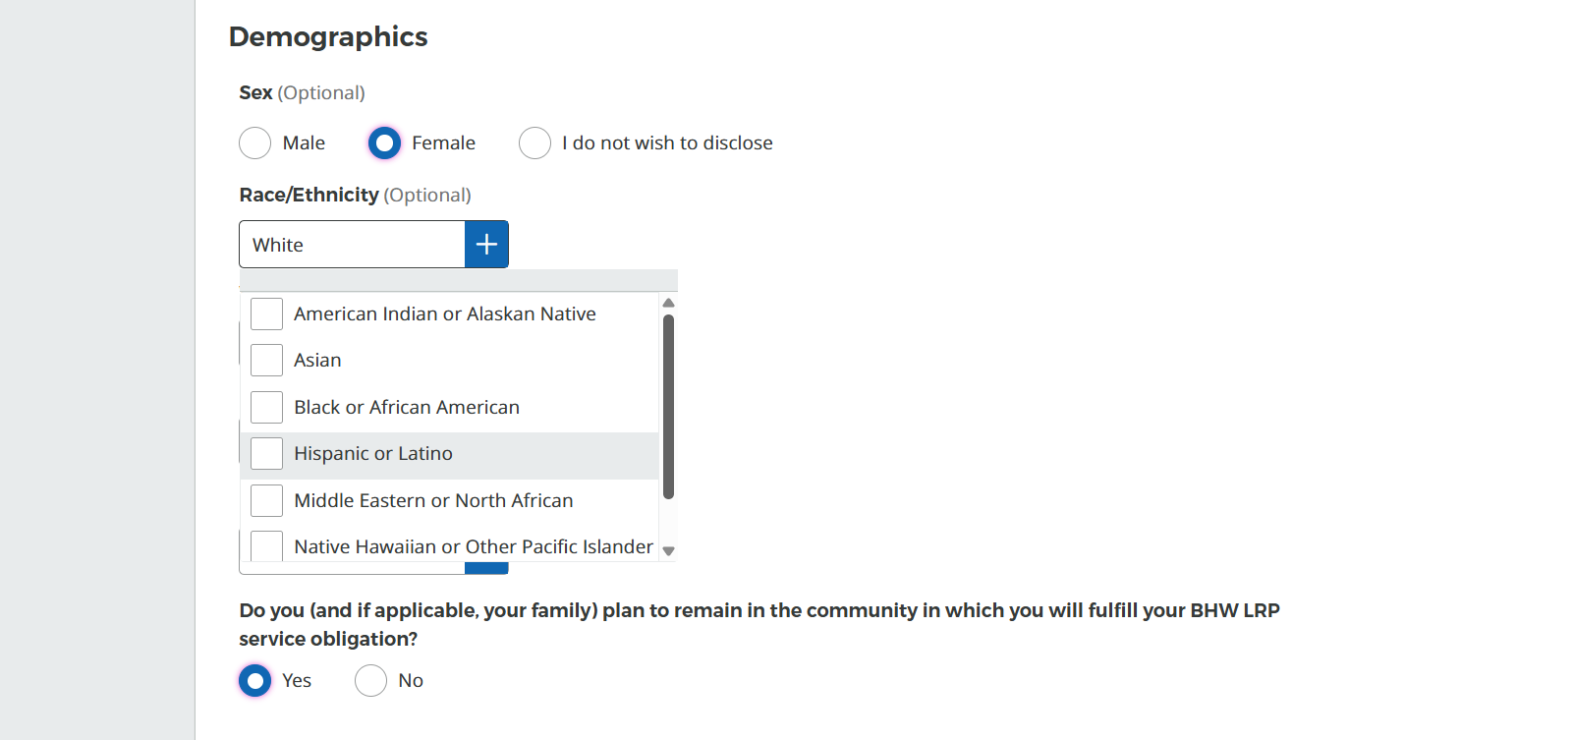
Revised Method of Collection (Pre-2024 SPD-15 Standard)
All BHW APG related applications will be updated to display race and ethnicity related questions in the following manner:

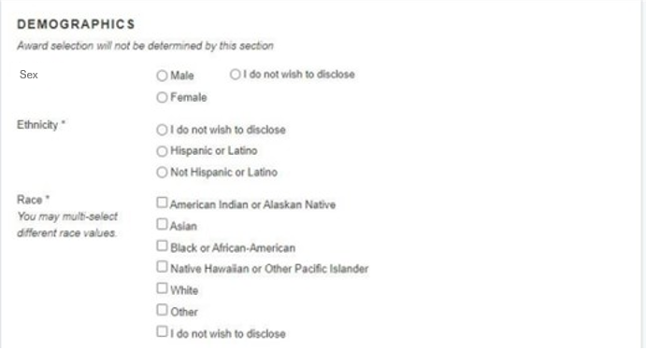
Specific changes to be made
OMB Control # | Information Collection Instrument | APG Page | Description of Change
0915-0127 | NHSC LRP Application | 21 | The demographics question will be adjusted to reflect the pre-2024 SPD-15 standard.
0915-0146 | NHSC Scholarship Program Application | 17 | The demographics question will be adjusted to reflect the pre-2024 SPD-15 standard.
0915-0146 | NHSC Students to Service Repayment Program Application | 9 | The demographics question will be adjusted to reflect the pre-2024 SPD-15 standard.
0915-0140 | Nurse Corps LRP Application | 18 | The demographics question will be adjusted to reflect the pre-2024 SPD-15 standard.
0915-0301 | Nurse Corps SP Online Application User Guide | 11 | The demographics question will be adjusted to reflect the pre-2024 SPD-15 standard.
0906-0082 | Faculty Loan Repayment Program Application | 14 | The demographics question will be adjusted to reflect the pre-2024 SPD-15 standard.

