In School Verification – Program Participant Entry

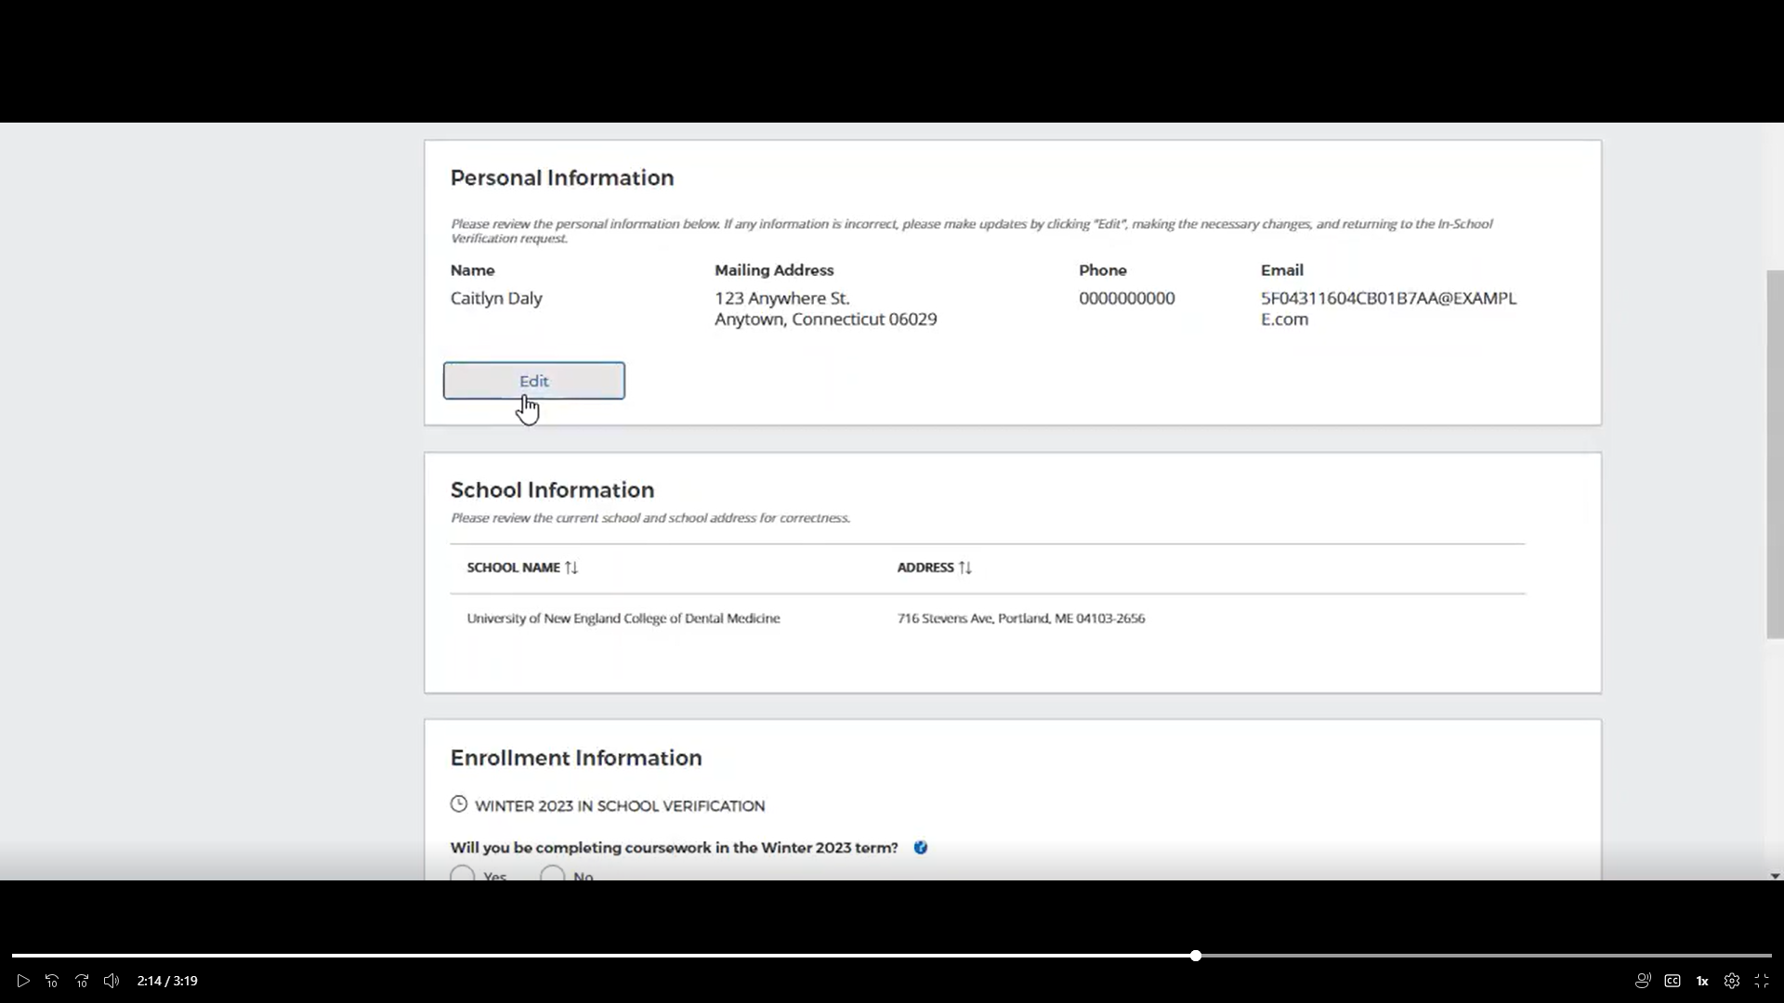

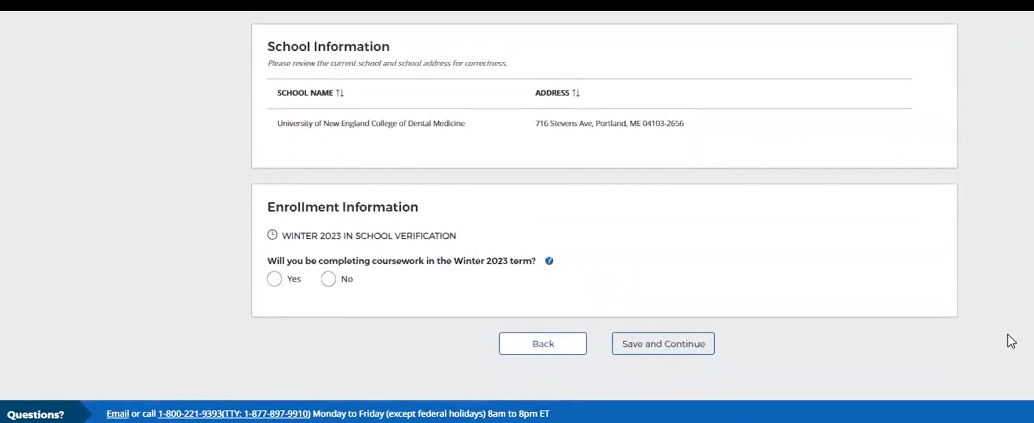

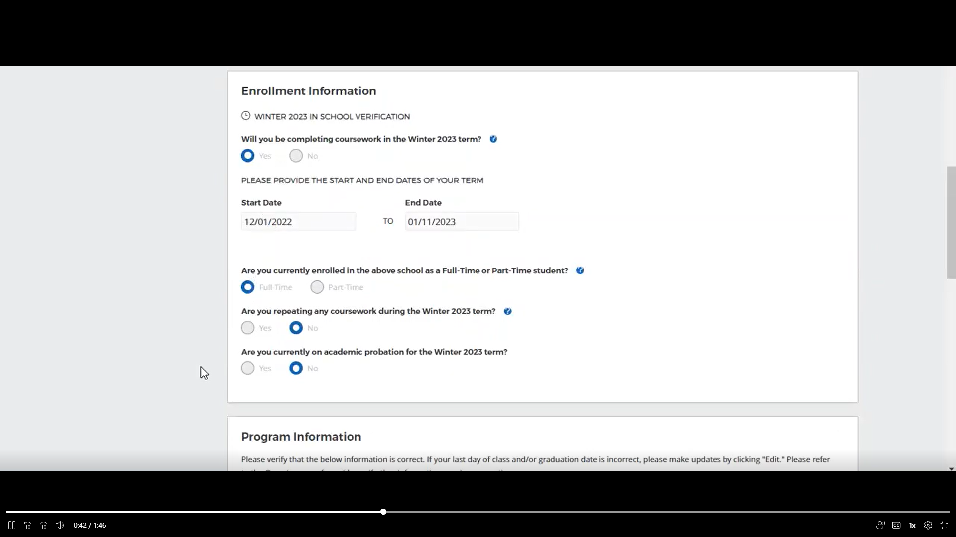

Select School Official who will review entered information and verify status
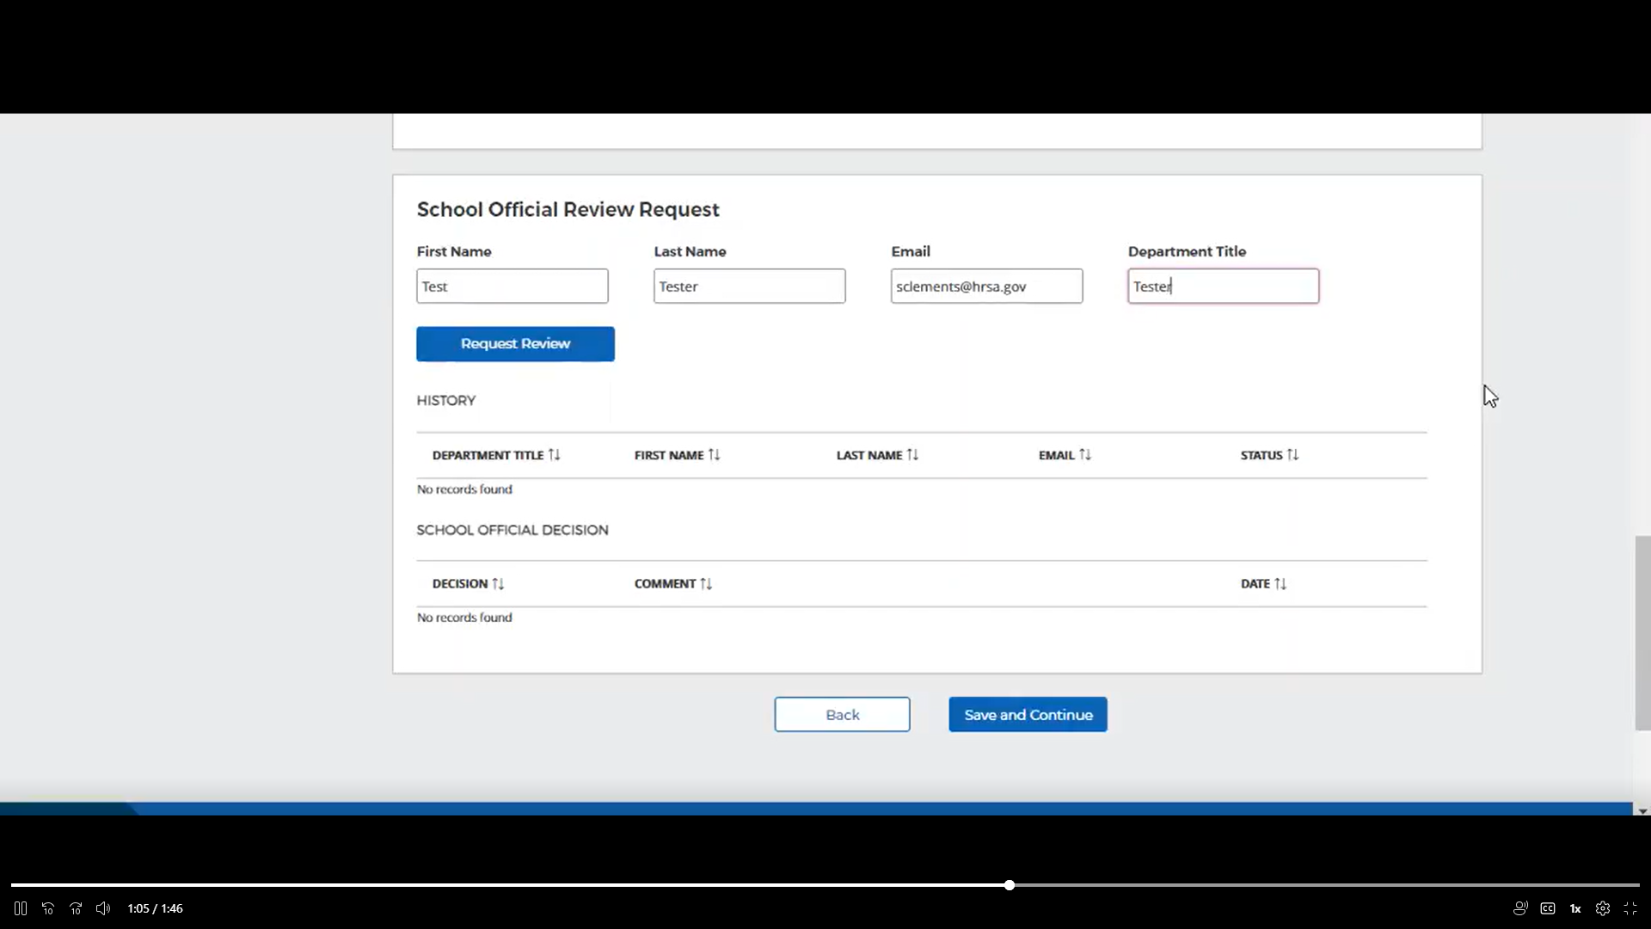

Participant entered information for review
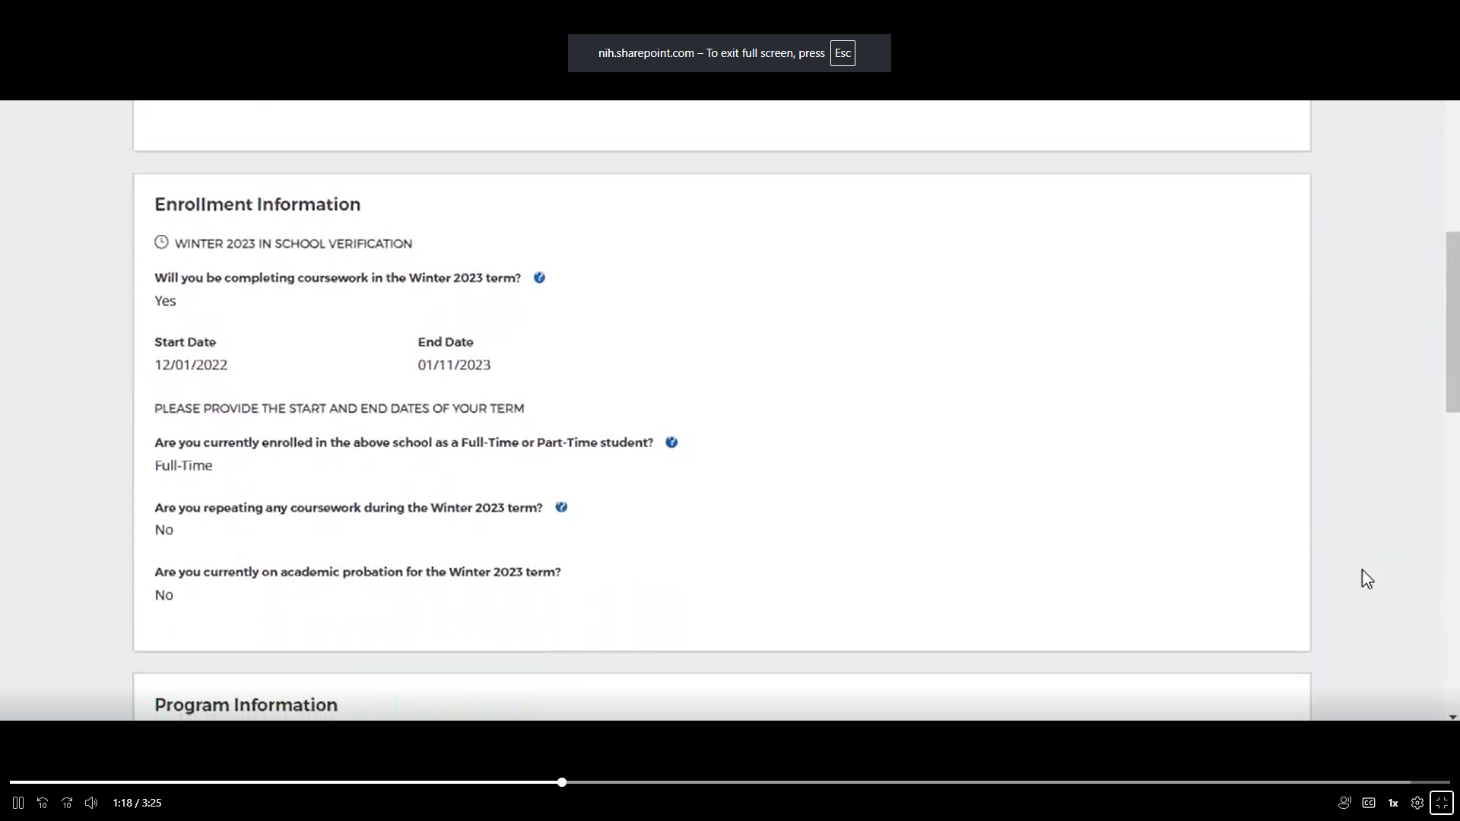
School official verifies, or requests correction.
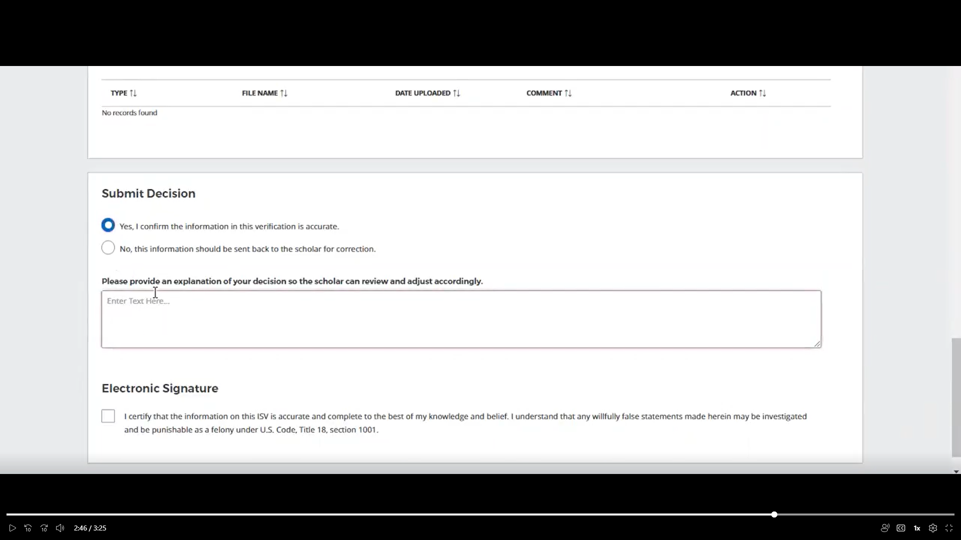

Public Burden Statement: The purpose of this information collection is to obtain information through the NHSC SP and the NHSC S2S LRP, that is used to assess an applicant’s eligibility, qualifications as well as monitor program participants’ enrollment in school, postgraduate training, and compliance with program requirements. An agency may not conduct or sponsor, and a person is not required to respond to, a collection of information unless it displays a currently valid OMB control number. The OMB control number for this information collection is 0915-0146 and it is valid until xx/xx/xxxx. This information collection is mandatory (Sections 338A-H of the Public Health Service Act [42 USC 254l-q], as amended). The information is protected by the Privacy Act, but it may be disclosed outside the U.S. Department of Health and Human Services, as permitted by the Privacy Act and Freedom of Information Act, to Congress, the National Archives, and the Government Accountability Office, and pursuant to court order and various routine uses as described in the System of Record Notice 09-15-0037. Public reporting burden for this collection of information is estimated to average xx hours per response, including the time for reviewing instructions, searching existing data sources, and completing and reviewing the collection of information. Send comments regarding this burden estimate or any other aspect of this collection of information, including suggestions for reducing this burden, to Health Resources and Services Administration Reports Clearance Officer, 5600 Fishers Lane, Room 14NWH04, Rockville, Maryland, 20857.

For questions on how/where to submit this form please contact the Customer Care Center at: 1-800-221-9393.

