In Service Verification Form (Screenshots)

Participant Verification

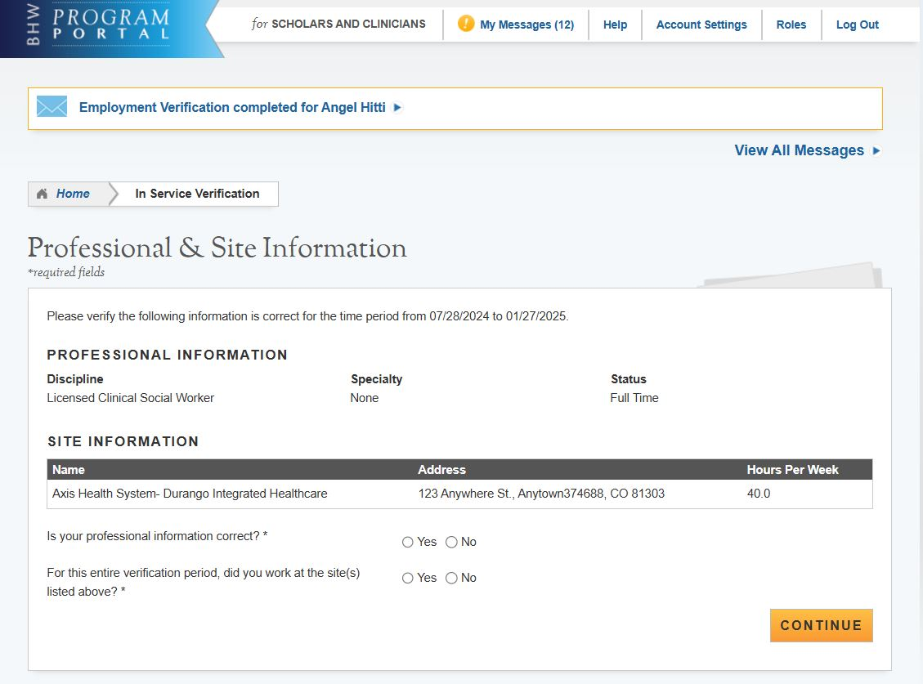

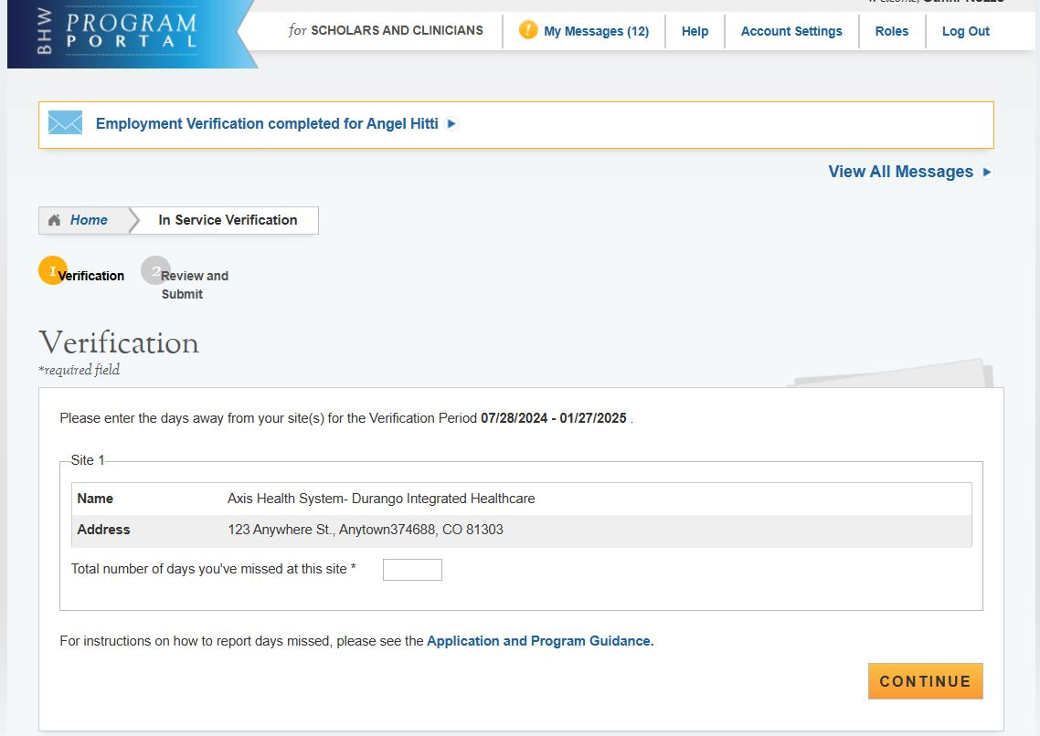

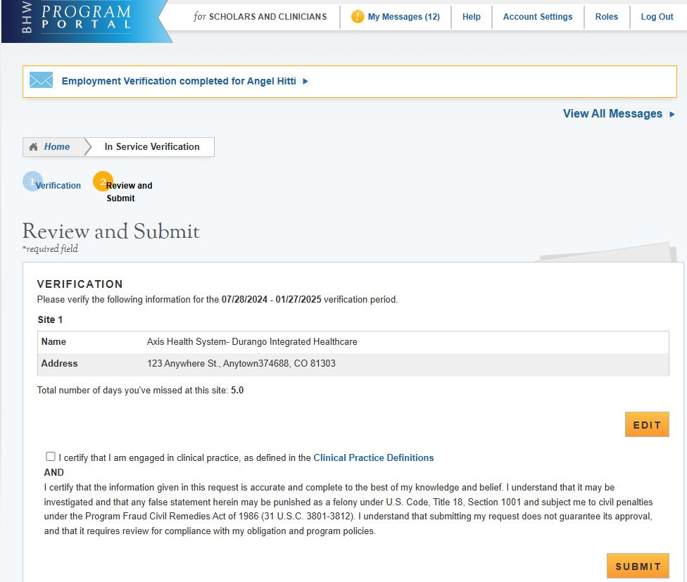

Site POC Verification

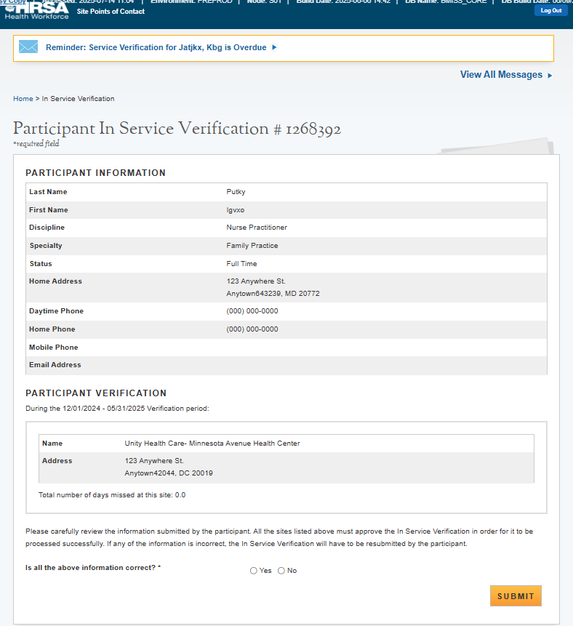

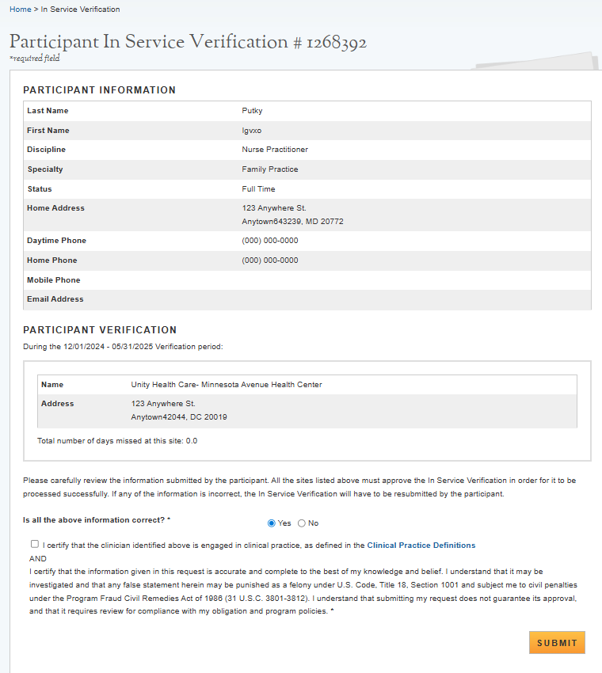

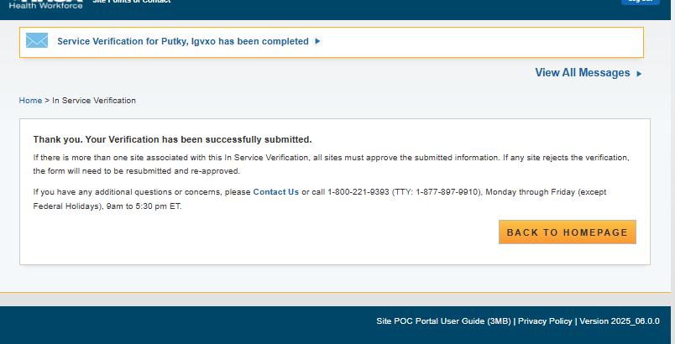

OMB No. 0915‐0140 Expiration xx/xx/xxxx
Public Burden Statement: The purpose of the Nurse Corps Scholarship Program (Nurse Corps SP) is to provide scholarships to nursing students in exchange for a minimum two-year full-time service commitment (or part-time equivalent), at an eligible health care facility with a critical shortage of nurses. The information that applicants supply is used to evaluate their eligibility, qualifications and to assess their continued compliance with the applicable standards for participation in the Nurse Corps SP. The OMB control number for this information collection is 0915-0301 and it is valid until xx/xx/xx. This information collection is required to obtain a benefit (Section 846(d) of the Public Health Service Act (42 United States Code 297n (d)), as amended). Data will be private to the extent permitted by the law. Public reporting burden for this collection of information is estimated to average approximately 36 minutes per response, including the time for reviewing instructions, searching existing data sources, and completing and reviewing the collection of information. Send comments regarding this burden estimate or any other aspect of this collection of information, including suggestions for reducing this burden, to HRSA Reports Clearance Officer, 5600 Fishers Lane, Room 14NWH04, Rockville, Maryland, 20857.

