Attachment 4n
Evaluating the Impact of Training and Technical Assistance (TTA) Programs on NCCCP Efforts - Focus Group Guide

Background

Focus Group Participants:
[Insert Group Name (Pacific Island Jurisdictions/Tribes/States; ACS/GWCC/Combined] and additional information as needed]

NCCCP TTA Evaluation Subquestions and Indicators to be Gathered Through the Focus Groups
- EQ2a: How are DP23-0017 TTA providers implementing TTA activities, including peer learning and communities of practice, to reach DP22-2202 funded recipients and cancer coalitions?
  - Successes and lessons learned, facilitator, and challenges implementing TTA activities to reach DP22-2202 recipients and cancer coalitions.
- EQ2b: How are DP23-0017 TTA providers communicating with DP22-2202 recipients, cancer coalitions, and the broader cancer prevention and control community to increase awareness of TTA resources?
  - Successes and lessons learned, facilitators and challenges communicating with DP22-2202 recipients, cancer coalitions, and others about TTA resources.
- EQ3a: To what extent did the TTA activities increase the knowledge and skills of the DP22-2202 recipients and coalitions?
  - DP22-2202 recipients’ and cancer coalitions’ perceptions about the specific areas of knowledge and skills that showed the most improvement as a result of the TTA.
- EQ3b: How did the TTA provided impact the formation and strengthening of partnerships among the DP22-2202 recipients and coalitions?
  - DP22-2202 recipients’ and cancer coalitions’ perceptions of their ability to form and strengthen partnerships as a result of TTA activities:
    - Contribute the most to improvements in their NCCCP- programmatic capacities.
    - Contribute the most to improvements in their NCCCP-funded programmatic outcomes.
    - Are core/essential to implementing their NCCCP strategies and activities.
- EQ3c: How did the TTA provided affect DP22-2202 recipients’ ability to effectively implement NCCCP strategies and activities?
  - DP22-2202 recipients’ and cancer coalitions’ perceptions about extent to which their strategies and approaches were initiated or enhanced as a result of the TTA provided:
    - evidence-based and promising practices
    - PSE change approaches
    - innovative interventions
    - health for all approaches
    - upstream social determinants of change approaches
  - DP22-2202 recipients’ and cancer coalitions’ perceptions about the extent to which TTA activities and topics are useful and relevant.
  - DP22-2202 recipients’ satisfaction with the quality of TTA received.
  - Topic areas in which DP22-2202 recipients and cancer coalitions report needing more training or support.
- EC3e: As a result, of the TTA provided, what measures did DP22-2202 recipients and coalitions take to ensure the sustainability of their programs?
  - DP22-2202 funded recipients’ and cancer coalitions’ perceptions about the extent to which TTA activities contributed (are contributing) to the sustainability of their programs

Welcome, Introduction, and Informed Consent
Hello, my name is [insert name] and I work for ICF, a consulting firm that is working under contract with the Division of Cancer Prevention and Control (DCPC) at the Centers for Disease Control and Prevention (CDC). Thank you for agreeing to speak with me today. As you know, we are conducting a series of focus groups with programs that receive training and technical assistance (TTA) from [TTA provider(s)]. The purpose of the focus groups is to learn more about your experiences with the TTA that your program has received from [TTA provider(s)] and is intended to help CDC improve the TTA that is provided to recipients of CDC’s National Comprehensive Cancer Control Program.
Please note that responses to these questions will not impact you or your program negatively in any way and will not impact your eligibility for future CDC funding. We are simply interested in learning more about your experiences with receiving TTA. Do you have any initial questions before we begin?
Great. You should have received a copy of the informed consent with the invitation for this interview. Please let me know if you did not receive it and we can resend it. I’m going to begin by briefly reviewing the informed consent.
The focus group should take no more than 90 minutes. Participation in this focus group is voluntary. If you do participate, you may choose not to respond to any question or to leave the focus group at any time. If you decide not to participate there will be no penalties of any kind. Your name will not be associated with the information that you share for the purpose of this project. Taking part in the focus group will cause no risk to you.
If you have questions about this project, please contact the ICF Project Manager, Amee Bhalakia at (404) 592-2182 or Amee.Bhalakia@icf.com. For questions regarding your rights related to this study you can contact ICF’s Institutional Review Board (IRB) representative Steve Ziemba at (608) 316-9267 or Steven.Ziemba@icf.com.
Do you agree to participate?
[If yes] Thank you!
[If no] Thank respondent for their time and invite them to leave the call.
Public reporting burden for this collection of information is estimated to average one and a half hours. An agency may not conduct or sponsor, and a person is not required to respond to a collection of information unless it displays a currently valid OMB control number 0920-1193. Send comments regarding this burden estimate or any other aspect of this collection of information, including suggestions for reducing this burden to: CDC/ATSDR Information Collection Review Office, 1600 Clifton Road NE, MS D-74, Atlanta, GA 30333; ATTN: PRA 0920-1193.

With your permission, we would also like to audio record the focus group. The recording will be professionally transcribed to aid in summarizing the findings from the discussion. We will not share the recording with anyone outside of our research staff and once the focus group is transcribed, we will delete the recording.
Do you agree to be recorded?
[If yes – start recording] Thank you for agreeing to participate and be recorded.
[If no] Thank respondent for their time and invite them to leave the call.

Section 1: Icebreaker and Introductions
To help make the focus group more engaging, we will use Mural.
Notetaker to Add Mural link to Teams chat.
Mural is a visual collaboration tool that provides a shared, interactive space to help capture key points and summaries of the discussion. Don’t worry if you haven’t used it before. We will manage the board and can show you how to use it as needed.
We will use the Mural board to note the things that you like to do outside of work to demonstrate how to use Mural.
Can everyone briefly describe their organization, their role in their organization, and tell the group one thing that you currently enjoy doing outside of work?
Moderator should start and then go around. Notetaker should use Mural to list the things that participants say they do outside of work or show participants how to do this.
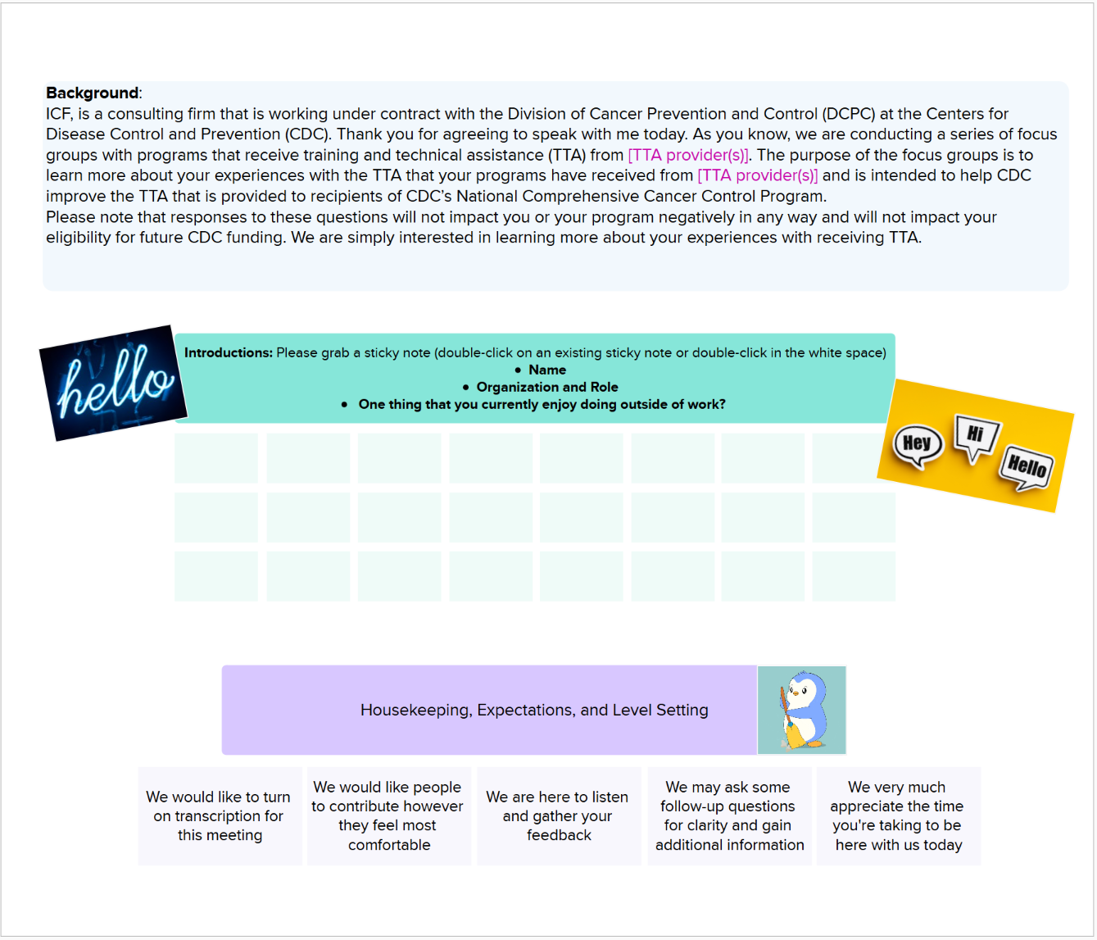

Great thanks for sharing. Now that we know each other a little better, let’s move into our first set of questions.

Section 2: Determining and Receiving Training and Technical Assistance
Let’s start with a few questions that will provide some context on your work related to CDC’s National Comprehensive Cancer Control Program (or NCCCP). Unless otherwise stated, when we ask about progress, we are referring to the last 12 months before this interview, [insert program year/dates].
- How does your organization or staff decide what kind of training and technical assistance, or TTA, is needed?
  - [After Y1] Is this different than the previous year?

- Now, I’d like to discuss the different types of TTA that your organization has participated in during [insert program year(s)]. (EQ2a)
  - What were some of the topics of the trainings that you participated in? (EQ2a)
  - What were some of the different types of formats or ways TTA was delivered (such as webinars, in--person training)? (EQ2a)
  - [After Y1] Were these trainings different than those attended in previous year(s)?
    - If yes, how?
Notetaker should list the items mentioned for 2a and 2b on the Mural; participants can add to the board or place “stickers” on the TTA topics or formats that they participated in.
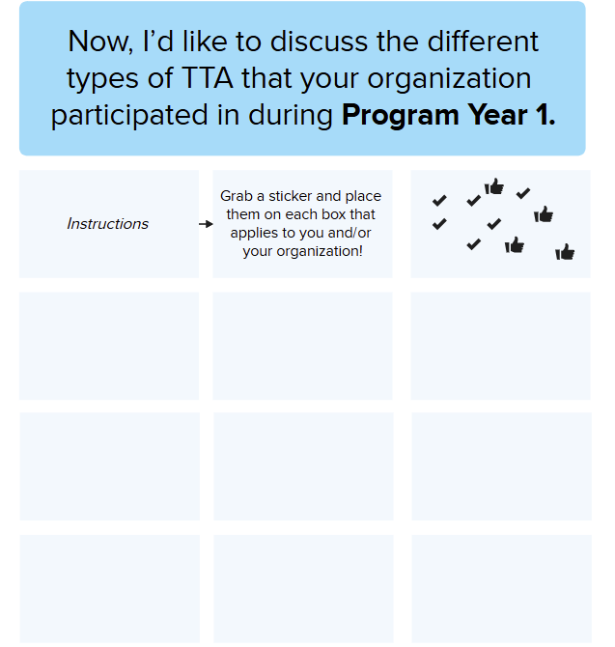

Section 3: Evaluating Training and Technical Assistance
Thank you for providing context on your work as it relates to CDC’s National Comprehensive Cancer Control Program (or NCCCP). Next, we would like to hear more about the TTA activities and topics that you have described.
Moderator Note: Participants may have addressed these questions in Section 2. If so, ask if they have anything to add.
- Of the TTA activities or topics that you participated in [insert program year(s)], which did you find the most helpful and why? (EQ3a, EQ3c)
  - [After Y1] Were these activities and topics more or less helpful than TTA from the previous year?

- Of the TTA activities or topics that you participated in [insert program year(s)], which did you find the least helpful and why? (EQ3a, EQ3c)

- What type of format of TTA was most helpful (for example: webinars, in-person training)? (EQ2a)
  - What was least helpful? (EQ2a)
- In general, what works well about receiving TTA in your jurisdiction?
- What is challenging about receiving TTA in your jurisdiction?

Section 4: Impact of Training and Technical Assistance on Program Capacity and Outcomes
Thank you for sharing how you learn about TTA opportunities. Next, we want to hear how TTA opportunities offered in [insert program year(s)] have helped you and your organization implement what you learned.
- To what extent do you think the TTA activities that you participated in [insert program year(s)], has helped enhance your ability to reach populations of focus? (EQ3a, EQ3c)
  - To what extent did TTA help with implementing or identifying evidence-based interventions (EBIs) or promising practices that directly engage your target audiences? (EQ3c)
By evidence-based interventions I mean scientifically proven strategies used to improve cancer prevention, early detection, treatment, and survivorship. When I say promising practices, I mean innovative strategies that show potential in effectively addressing cancer prevention and control.
  - To what extent did TTA help with implementing or identifying policy, system, and environmental (PSE) change approaches that directly engage your target audiences? (EQ3c)
By PSE I mean sustainable changes that support cancer prevention and control by modifying policies, systems, and environments to make healthy choices more accessible and reduce cancer risks factors.
Moderator Note: PSE change approaches focus on creating systemic and environmental changes, EBIs are well-established and scientifically proven strategies, and promising practices are innovative approaches that have being evaluated and found to be effective.

- Did any of these TTA activities help achieve your program’s goals? (EQ3a, EQ3b)
For example, improving partnerships to implement certain activities, improving engagement and outreach with populations of focus, improving understanding of implementing the evidence-based interventions (EBIs). As a reminder, by EBIs I mean scientifically proven strategies used to improve cancer prevention, early detection, treatment, and survivorship.

  - How has TTA contributed to your ability to form and strengthen partnerships? (EQ3b)
  - How have TTA activities helped the sustainability of your programs? (EQ3e)
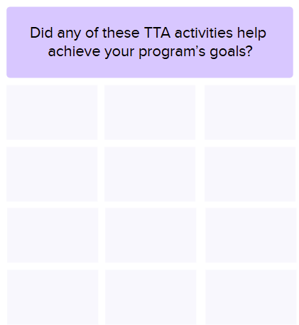
Moderator Note: Recap what TTA activities have been discussed so far from Mural board. Notetaker should then capture items mentioned for 8a; participants can add to the board if they like.

Section 5: Communication and Accessibility of Training and Technical Assistance
Next, we would like to hear more about how TTA opportunities/resources are communicated to you and your organization. Moderator Note: Participants may have addressed these questions in section 1 or 2. If so, ask if the participant has anything to add.
- What are the different ways that you learned about the TTA that offered in [insert program year(s)]? (EQ2b)
  - How do TTA providers communicate about the TTA being offered? (EQ2b)
    - [After Y1] Were there new ways that TTA providers communicated TTA opportunities to you in [insert program year]?
  - How effective are the ways that TTA offerings are communicated? (EQ2b)
  - Do you have recommendations for additional ways that would help you learn about TTA offerings? (EQ2b)
  - Please describe any barriers to accessing TTA, if any. (EQ2b)

Section 6: Future Training and Technical Assistance Needs
We’d like to end this focus group discussion by hearing more about your organization’s future TTA needs.
Moderator Note: Participants may have addressed these questions in previous sections. If so, ask if they have anything to add.
- What types of TTA would you like more of and why? (EQ3c)
Notetaker should list these activities on the Mural board; participants can add to the board as well.


Closing
- Is there anything else you would like to tell us about the TTA your organization has received?

Those are all the questions we have for you today. Thank you very much for taking the time to participate in this interview. We really appreciate your time.

