BNI006 – Special Enrollment Period (Initial View)
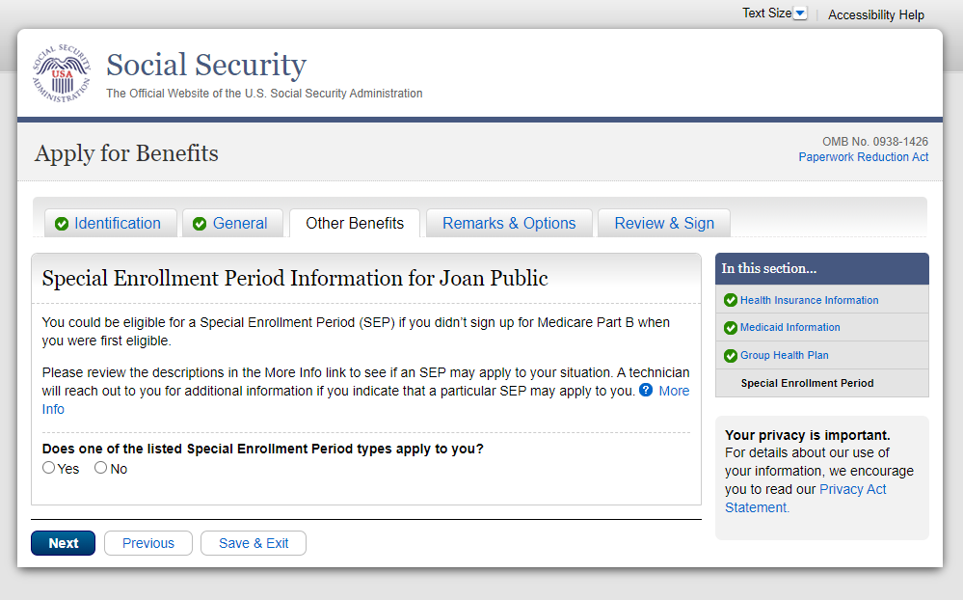
Note: When the user visit BNI006 for first time and have not answered anything, the dropdown is not presented on the page.

BNI006 – Special Enrollment Period (More Info Link)
To see more detailed information the user is encouraged to click on the More Info link.

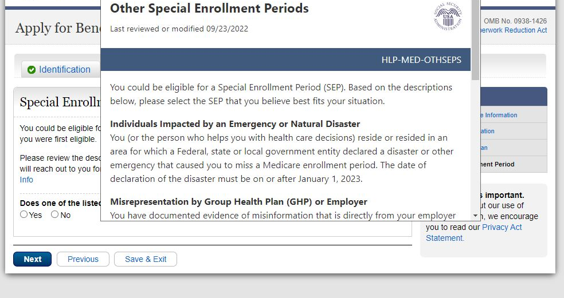
When the user clicks on the More Info link, they are presented with a pop-up window that shows detailed information about the SEP types.

Full view of More Info page:
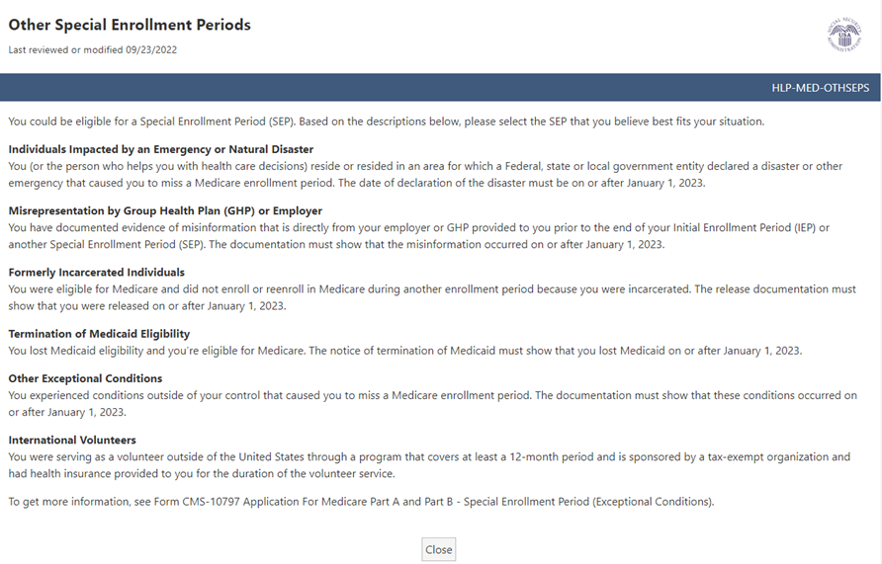

Full view of Other SEPs Privacy Act Statement:
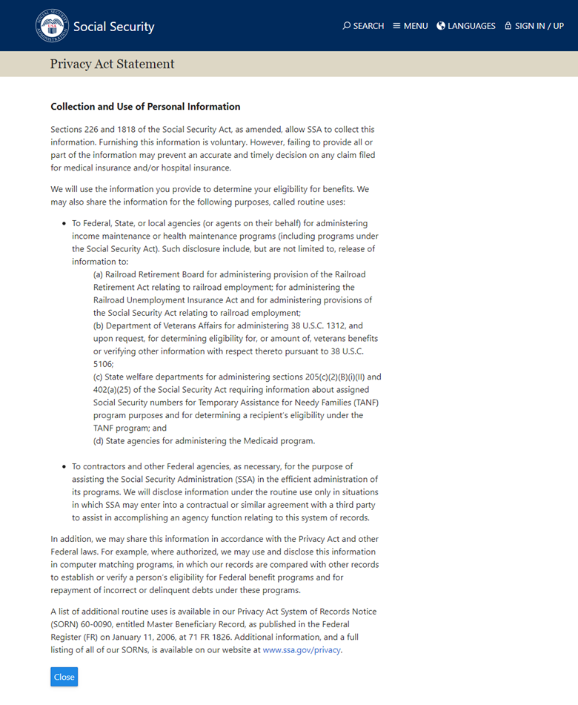

Full view of SEP Paperwork Reduction Act:
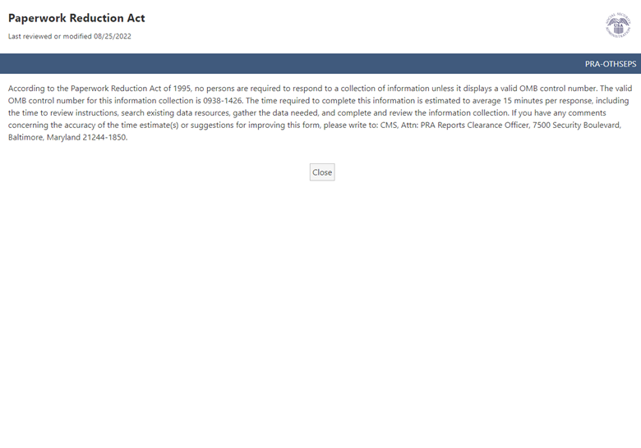

BNI006 – Special Enrollment Period - Dropdown View
If the user answers Yes to “Does one of the listed Special Enrollment types apply to you?” the dropdown will appear.
When user expands the dropdown, it will show the list of SEP types they can select from within iClaim.

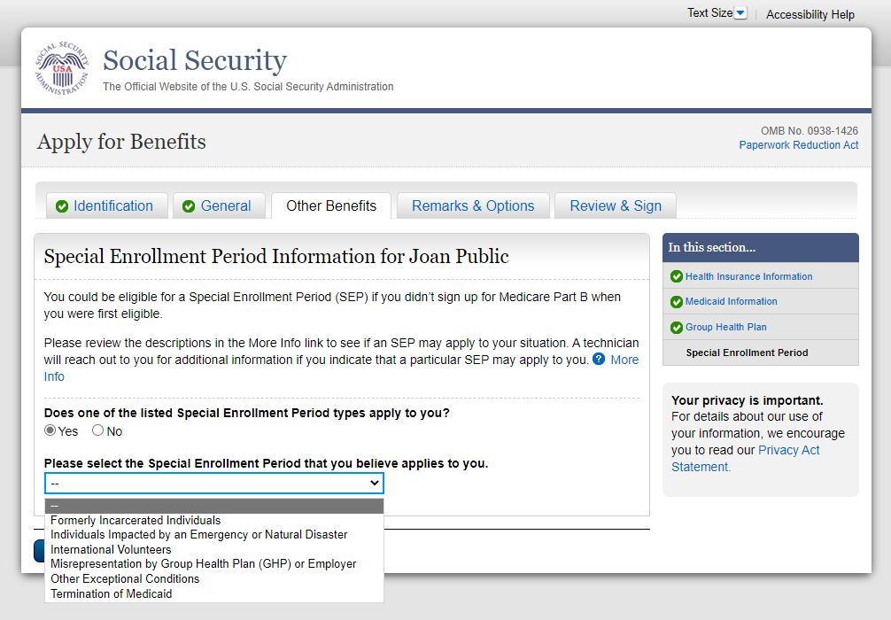

OVS001 - Overall Summary – Special Enrollment Period Information
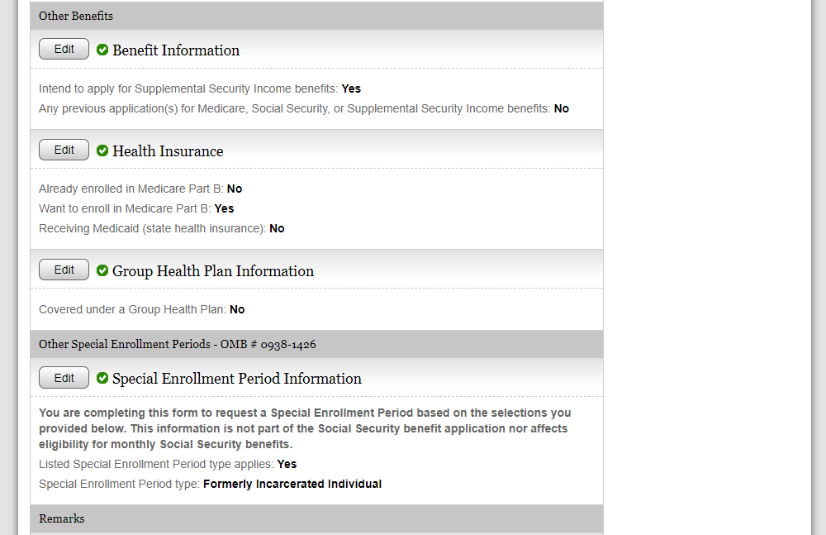

OVS001 - Overall Summary – Special Enrollment Period Information - Electronic Signature Agreement
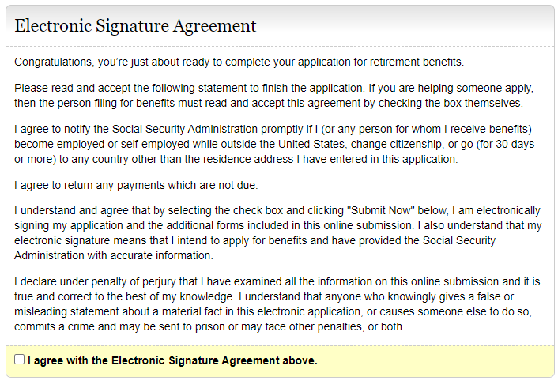

REC001 - Receipt – Special Enrollment Period Information
