Rural Health Transformation (RHT) Program:
A Guide to State Awardee Reporting

_______

Table of Contents
I. Introduction 3
II. RHT Program Reporting Requirements 4
III. Reporting Cadence & Periods 4
IV. Annual, Quarterly, and Final Reports 5
Annual Reporting 5
Quarterly Reporting 5
Final Report 5
V. Reporting Elements 6
VI. Completing Your Reports 6
VII. Getting Started – Submitting Your Initial Annual Report 7
Instructions 7
1. Initiative Forms 8
2. State Policy Actions Form 13
3. Obligated and Spent Funds Reporting Tabs 15
4. Additional Information Form 15
5. Submitting Evidentiary Documentation 19
6. Submitting Your Initial Annual Report 19
VIII. Subsequent Reporting - MDCT RHTP Platform 22
Instructions 22
1. General Information 23
2. Initiative Attachments 24
3. Initiatives 30
4. State Policy Action Commitments 35
5. Obligated and Spent Funds Reporting 36
6. Sustainability and Highlights 38
7. Review & Submit 40
IX. Appendix 42
A. Reporting Periods – Annual and Quarterly Reporting 42
B. Resources 43
C. State Progress Reporting Frequently Asked Questions (FAQs) 43
Reporting Submission Process (Initial Annual Reporting) 43
Evidentiary Documentation 44
State Reporting Non-Compliance 44
D. Table of Figures 45

Introduction
As partners in a Cooperative Agreement, we have a shared goal: the success of your State’s Rural Health Transformation (RHT) Program. Your core responsibility is to comply with all Terms and Conditions in your Notice of Award (NoA). Here’s what that looks like in practice:
- Fulfilling Requirements: Submit all required reporting as detailed in your NoA.
Resources & Support
We are here to help you succeed! To ensure seamless, coordinated support, please copy both your PO and GMS on all correspondence. Direct programmatic questions to your PO, and financial or award administration questions to your GMS.
- Managing Your Work Plan: Submit performance measures as agreed upon and submit subsequent revisions to your work plan for CMS approval.
- Staying Connected: Collaborate with your Project Officer (PO), and, as applicable, your Grants Management Specialist (GMS) to discuss progress and seek support on reporting activities as needed. An active partnership is key to success!
- Subrecipient Oversight: Confirm that your subrecipients, contractors, and partners are compliant with all administrative and policy requirements, including reporting. Note that the Terms and Conditions of the NoA flow down to subrecipients.
The primary goal of this guide is to equip you with the knowledge and tools needed to meet your post-award reporting responsibilities efficiently and effectively. Timely and accurate reporting is the principal way we measure progress, promote accountability, and document the incredible work being done. The information you provide is critical for demonstrating the value of the RHT Program and informing programmatic funding decisions.
For additional supplemental information and reference materials, please refer to the Appendix section.
After reviewing this guide, you will be able to prepare the following progress reports that meet RHT Program requirements:
- Annual Reports, including the Final Report
- Quarterly Reports

RHT Program Reporting Requirements
While this guide focuses on the successful preparation and submission of Annual and Quarterly Reports, as well as the Final Report, it is important to recognize that these reports are part of a broader landscape of post-award responsibilities. The full scope of federal reporting requirements, as detailed in the Notice of Funding Opportunity (NOFO), include:
- Non-Competing Continuation (NCC) Application
- Federal Financial Reports (FFR)
- Federal Funding Accountability and Transparency Act (FFATA) Reporting
- Work Plan Updates
- Progress Reports
- SAM.gov Records
- Payment Management System (PMS) Reports, and
- Audit Reporting
Please refer to the Program Terms and Conditions located within a State’s NoA, NOFO, and CMS website for additional information.

Reporting Cadence & Periods
State awardees are required to submit Annual and Quarterly Progress Reports along with a one-time Final Report. Progress reports must be submitted for all five budget periods (FY26-FY30). These reports are crucial for CMS to make funding decisions for subsequent budget periods.
The first Annual Report, which covers the reporting period from December 29th, 2025, to July 31st, 2026, is due August 31st, 2026. Quarterly reporting will commence in Budget Period 2 of the RHT Program. For a comprehensive table of reporting dates, refer to Appendix A.
Initial Annual Report
Due Date Change
Please note, the Terms and Conditions and previous communications stated that programmatic reporting is due on August 30. Because August 30, 2026 falls on a Sunday, the RHT Program initial Annual Report will be due by 11:59 PM EDT on Monday, August 31, 2026. This date aligns with the NCC Kit due date.

Annual, Quarterly, and Final Reports
The following section details each of the progress reports required throughout the RHT Program.

Annual Reporting
The Annual Report delivers a summary of programmatic progress over the reporting period. Specific components of the Annual Report will be scored and used to determine subsequent funding. Within this report, States will report on the following:
- Initiative Progress Narrative
- Initiative People Served
- Initiative Metrics
- Initiative Checkpoints
- State Policy Action (SPA) Commitments
- Obligated and Spent Funds
- Success Stories and Highlights
- Sustainability Planning
- Definition of Rural Area (only initial Annual report)

Quarterly Reporting
The Quarterly Report will encompass programmatic progress achieved during the specified quarter. The information from these quarterly reports will be used to progressively build and update the Annual Report throughout each budget period. The general reporting periods are as follows: August 1–October 30, October 31–January 30, and January 31–April 30. States should refer to Appendix A for a comprehensive view of all reporting periods and deadlines. Within this report, States will report on the following:
- Initiative Progress Narrative (optional)
- Initiative Checkpoints
- State Policy Action Commitments
- Metrics (optional)
- Obligated and Spent Funds
- Success Stories and Highlights (optional)

Final Report
Upon completion of the RHT Program, States are required to submit a one-time only Final Report, due February 27th, 2031. The Final Report serves to comprehensively document all programmatic activities and initiatives executed throughout the RHT Program's entire period of performance. More information regarding the Final Report will be disseminated closer to the end of the respective reporting period.

Reporting Elements
Across all progress reports, States document their progress across several key areas established by CMS. Although not all reported information is used for scoring, every element is essential for comprehensive oversight and support. The following components collectively demonstrate the operational progress, financial stewardship, and impact of the RHT Program.

Data elements that determine scoring will be your initiative checkpoints and progress towards State Policy Action Commitments. Detailed descriptions for each data element are provided below:
- Initiative Progress Narrative: Progress updates on milestones and the implementation of initiatives.
- Initiative People Served: Provides quantitative context to initiatives and the number of people served.
- Initiative Metrics: Quantitative updates on the metrics the State is tracking as part of its approved work plan.
- Initiative Checkpoints: Provides context on where each State is at with their progress towards the initiative-based score factors.
- State Policy Actions Commitments: Progress updates on the State awardee’s proposed policy actions as detailed in the approved work plan.
- Obligated and Spent Funds: Provides fiscal context on the State's RHT Program expenditures and subrecipients.
- Success Stories: Highlights success stories that came out of the State’s initiatives that showcase real-world impact of the RHT Program.
- Sustainability Planning: Updates on how the State plans to sustain successful initiatives after the RHT Program funding ends (after FY31).
- Definition of Rural: Provide the definition of 'rural area' that the State used to determine whether subrecipients were considered to be rural (only for initial Annual report).

Completing Your Reports
The following section details the submission procedures for the RHT Program's reporting cycle. The initial Annual Report utilizes an Excel-based template structured around four core components, represented as individual tabs. Comprehensive instructions for completing the Excel template for the initial year are detailed in Section VII. Getting Started – Submitting your Initial Annual Report.
Following the initial report, all subsequent reporting will transition to a web-based system housed within the Medicaid Data Collection Tool (MDCT), referred to as the MDCT RHTP platform. This platform provides States with a centralized workspace to submit updates, upload evidentiary documentation, and communicate with their POs. The first submission utilizing this new system will be the first Quarterly Report due on November 29th, 2026. Detailed instructions for navigating and completing reports via the MDCT RHTP platform are outlined in Section VIII. Subsequent Reporting – MDCT RHTP Platform.

Getting Started – Submitting Your Initial Annual Report
To facilitate a timely and accurate initial Annual Report submission, States should coordinate closely with their Project Officers (POs) to establish an ongoing, rolling review of the report's various components. Because revisions cannot be accommodated after the August 31st, 2026 submission deadline, this continuous collaboration is critical to confirm all elements are finalized, reviewed, and approved in a timely manner.
In the initial Annual Report, States are to provide the definition of 'rural area' that the State used to determine whether subrecipients were considered to be rural. States will use this same definition to determine rural entities throughout the duration of the RHT Program, therefore, the definition does not need to be included in subsequent reporting. States will report their definition of rural in the Additional Information Form.
For example, in this field, a State may report that they define rural using the following definition from the Health Resources & Services Administration (HRSA):
- Non-metropolitan counties
- Outlying metropolitan counties with no population from an urban area of 50,000 or more people
- Census tracts with Rural-Urban Commuting Area (RUCA) codes 4-10 in metropolitan counties
- Census tracts of at least 400 square miles in area with population density of 35 or fewer people per square mile with RUCA codes 2-3 in metropolitan counties

Instructions
The Excel Reporting Template is organized into four core sections:
- Initiative Reporting Section
  - Checkpoint Guidance Tab
  - Initiative Forms
- State Policy Actions Form
- Obligated and Spent Funds Reporting Section
  - Entity Type Guidance Tab
  - First-Tier Entities Form
  - Use of Funds Form
  - Downstream Reporting Form (not required for initial Annual Report)
- Additional Information Form
  - Success Stories
  - Sustainability Planning
  - Rural Definition
Important Formatting Note: Please do not alter the underlying structure of the Excel Reporting Template, though you may adjust row heights and column widths for readability. To streamline reporting, CMS will pre-populate certain fields—such as Initiative Name and Initiative Number in the Initiative Forms—based on your approved application. Please note that all forms (tabs), with the exception of the Downstream Reporting Form, must be fully completed for the initial Annual Report to be considered final. The Downstream Reporting Form will be required starting with the first Quarterly Report.
Alongside the Excel Reporting Template, States should submit all supporting evidentiary documentation directly to their PO for review, via email, to accompany the initial Annual Report. This submission should include any files demonstrating progress toward initiative checkpoints and State Policy Action Commitments. See the Submitting Evidentiary Documentation section below for more information. All forms (tabs) must be completed, with the exception of the Downstream Reporting Form, for the submitted initial annual report to be considered final.
The sections below provide additional details for each of the four main components of the Excel Reporting Template.

Initiative Forms
The purpose of the Initiative Forms is to report on the progress, metrics, and checkpoint completion for each approved State initiative.
In the Excel Reporting Template, there will be a separate Initiative Form (tab) for each initiative.
Figures 1 and 2 below show a draft Initiative Form completed with a hypothetical example to illustrate the required information.
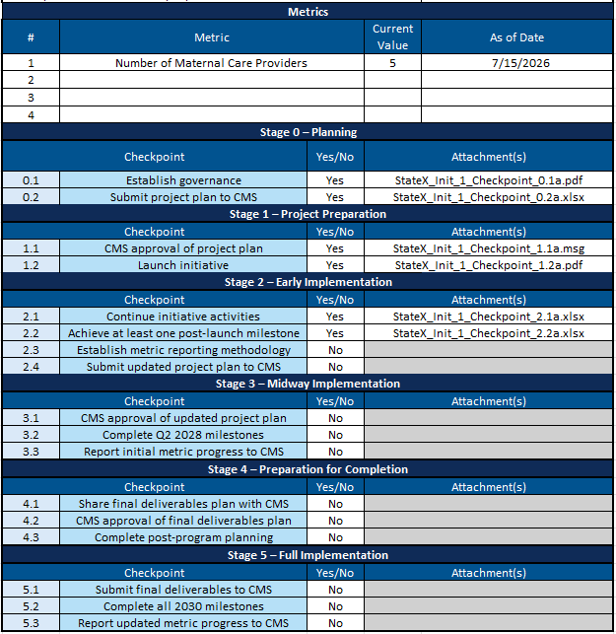
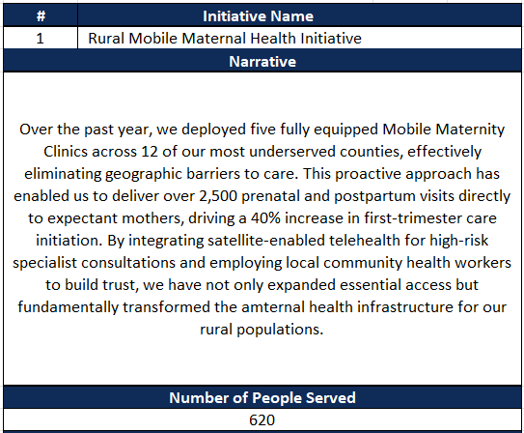
Figure 2: Initiative Form (Bottom)

Figure 5: State Policy Actions FormFigure 2: Initiative Form (Bottom)
Figure 1: Initiative Form (Top)

Figure 2: Initiative Form (Bottom)Figure 1: Initiative Form (Top)

Figure 3 below includes the relevant data fields in the Initiative Form, instructions for how to fill out each data field, and an example data value for each field. Please note, the examples below are notional and should only be used as a guide.
Figure 3: Initiative Form Instructions
Data Field | Instructions | Example
Initiative Number | This field will be pre-populated in the Excel Reporting Template. | 1
Initiative Name | This field will be pre-populated in the Excel Reporting Template. | Rural Maternal Mobile Health Clinic Initiative
Narrative | Provide a concise update on the progress of each initiative during the reporting period. Responses should focus on key activities completed, milestones reached, challenges encountered, and any notable outcomes or impacts to date.  This section is intended for progress reporting purposes only and should not repeat the full project narrative from the NCC Kit. Please focus on recent initiative progress and avoid including broad background information unless it is necessary for context.  States are encouraged to include any relevant updates that may be important for CMS to understand the status, implementation progress, or emerging results of the initiative.  Note: The Narrative is optional for quarterly reporting.  Please limit responses to 2,000 characters, or approximately 250–350 words. | Over the past year, we deployed five fully equipped Mobile Maternity Clinics across 12 of our most underserved counties, effectively eliminating geographic barriers to care. This proactive approach has enabled us to deliver over 2,500 prenatal and postpartum visits directly to expectant mothers, driving a 40% increase in first-trimester care initiation. By integrating satellite-enabled telehealth for high-risk specialist consultations and employing local community health workers to build trust, we have not only expanded essential access but fundamentally transformed the maternal health infrastructure for our rural populations.
Number of People Served | Provide your best estimate of the number of individuals who have benefited from the RHT Program funds during the reporting period. Estimates should be reasonable, supported by available data, and reflect the scope and reach of the initiative. For system-based initiatives that do not provide direct services (e.g., IT Systems, Health Information Exchanges) States may define the number of people served more broadly.  For example:  - For health system–level initiatives, the number served may reflect the total population served by the system.  - For statewide systems (e.g., HIEs), the number served may reflect the number of patients with data in the system or the total number of state residents.  - These estimates do not need to be de-duplicated and do not need to be limited to rural populations if the initiative has a broader reach.  - States should aim to provide the most accurate and justifiable estimate possible and may include brief context in the narrative section if helpful for CMS’s understanding.  Note: Number of People Served is only reported annually. | 620
Metrics | The metrics for each initiative will be pre-populated based on the information provided in your application or most current information available based on clarifications in your Initiative Information Report.  Note: Metrics are only required to be reported in the Annual reports and are optional to report in Quarterly reports.
Metric Current Value | The latest value for the corresponding metric. | 5
Metric As of Date | The date that the current value was measured in the following format: (XX/XX/XXXX). | 03/15/2026
Checkpoints | For each stage, the checkpoint number and description are pre-populated. | 0.1 Establish Governance
Yes/No | Select “Yes” if the checkpoint is complete; Select “No” if the checkpoint is not yet complete. | Yes
Attachment(s) | Paste in the attachment file names of the evidentiary documentation files that correspond to the relevant initiative and checkpoint.  Alternatively, States may compile evidentiary documentation into a Master Initiative Attachments PDF and reference the Initiative # and Stage/Checkpoint # section heading in the Master Initiative Attachments PDF. | StateX_Init_1_Checkpoint_0.1a.pdf  StateX_Init_1_Checkpoint_0.2b.xlsx  StateX_Init_1_Checkpoint_1.1c.msg  OR  “Initiative 1 Checkpoint 0.1 Evidentiary Documentation” section in the Master Initiative Attachments PDF

State Policy Actions Form
The State Policy Actions (SPA) Form is designed to capture the progress and status of the specific policy commitments established in a State's approved application. Please note that States are only eligible to receive credit for policy actions committed to in their initial application.
Figure 4 below shows a draft State Policy Action Commitments Form completed with a hypothetical example to illustrate the required information. Please note, there are additional fields in a section titled “CMS Review (CMS Use Only)” in the State Policy Actions Form (not pictured in Figure 5 below), which should not be populated by States.
Figure 4: State Policy Actions Form
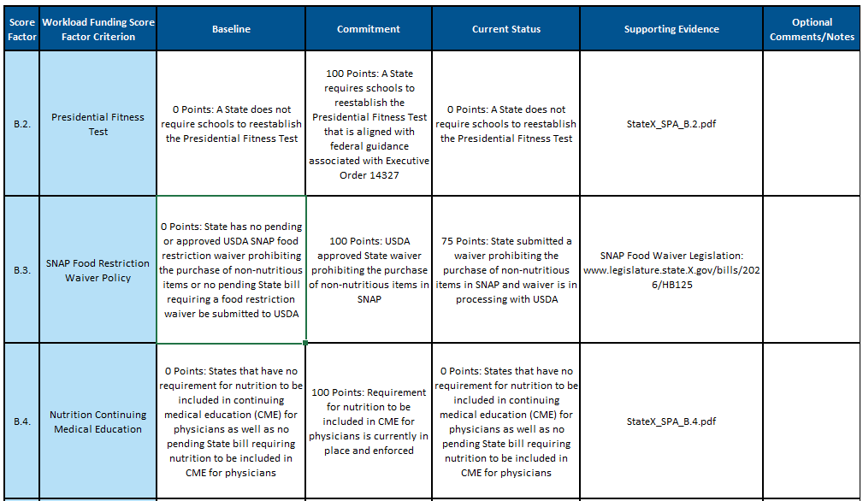
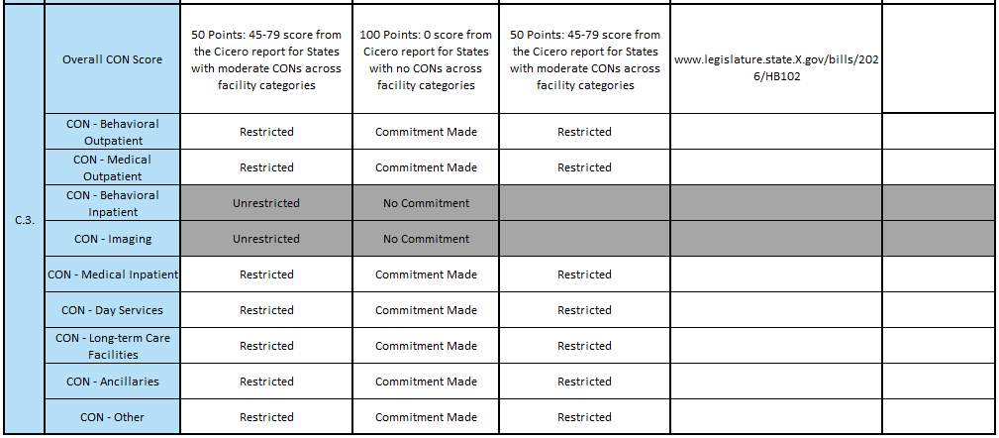
Figure 5 below outlines the data fields within the State Policy Action (SPA) Form, along with specific instructions for completing each field and illustrative examples. Note: These examples are strictly notional and are provided solely for guidance.
Figure 5: State Policy Actions Form Instructions
Data Field | Instructions | Example
Score Factor | This data field is pre-populated with the relevant score factor labels. | B.2.
Workload Funding Score Factor Criterion | This data field is pre-populated with the relevant score factor criterion. | Presidential Fitness Test
Baseline | This data field is pre-populated with a baseline value for each State Policy Action score factor. The baseline refers to the category of the baseline score for the State Policy Action score factor. | The baseline values are unique to each State Policy Action and will be consistent with the State's State Policy Action Commitment report. Examples include:  - No points (0)  - Partial points (1–99)  - Full points (100)
Commitment | This data field is pre-populated, and the value depends on if the relevant State Policy Action Commitment was made and approved by CMS. | If a State Policy Action Commitment was made in the application:  - Partial Points (1-99)  - Full points (100)  - Commitment Made  If State Policy Action Commitment was not made in application:  - No Commitment
Current Status | Select the current status from the dropdown menu (options reflect the scoring methodology in the NOFO and are dependent on the specific State Policy Action Commitment). If the State Policy Action Commitment was made, the Current Status cell for that Score Factor will appear white and the status can be indicated with the dropdown. If a State Policy Action Commitment was not made, the cell will be greyed out. | For State Policy Action Commitment B.3. (for example) dropdown options include:  - Not Yet Started  - 0 Points: No pending State legislation  - 25 Points: Active bill in the State legislative process  - 50 Points: State bill was passed to submit a USDA waiver  - 75 Points: Waiver is in processing with USDA  - 100 Points: USDA approved waiver  - Commitment abandoned  Note: Specific options will depend on each Score Factor.
Supporting Evidence | Provide any links to sources or attachments that confirm the status of the State Policy Action Commitment. | Examples may include:  - URL to policy on State website  - State legislation attachment
Optional Notes/Comments | Provide any additional context or details around the status of the State Policy Action Commitment, if needed. | The bill, titled “XYZ” was signed into law on July 15, 2026, and becomes effective January 1, 2027. See “Section 4 PA Licensure Compact” on Page 16 of the bill.

Obligated and Spent Funds Reporting Tabs
The purpose of the Obligated and Spent Funds Reporting tabs is to track RHT Program spending across initiatives, use of funds categories, and entities. Please refer to the Obligated and Spent Funds Reporting Guide for more information on how to populate the First-Tier Entities, Use of Funds, and Downstream Reporting tabs. Please note that States are not required to fill out the Downstream Reporting tab for the initial Annual Report.

Additional Information Form
The purpose of the Additional Information Form is to share qualitative updates on program successes, long-term sustainability planning, and the definition of rural, as defined by the State. Figures 6, 7, and 8 below show the Additional Information Form completed with a hypothetical example to illustrate the required information.

Figure 6: Success Stories
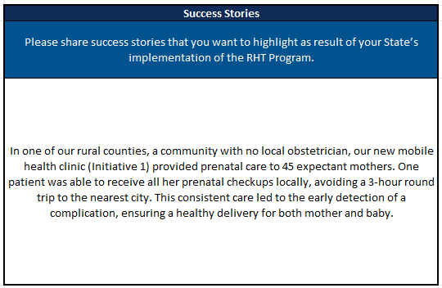
Figure 7: Sustainability Planning

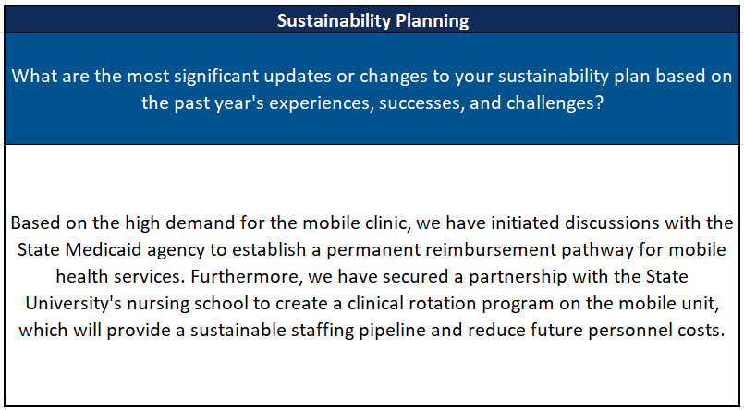

Figure 8: Rural Definition
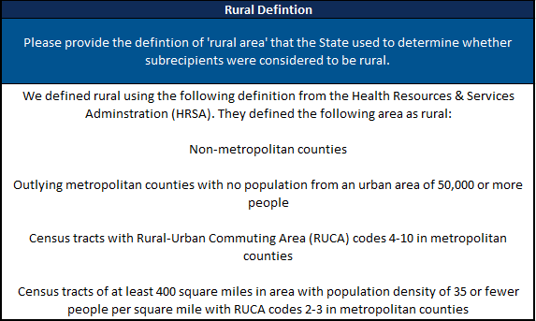
Figure 9 below outlines the data fields within the Additional Information Form, along with specific instructions for completing each field and illustrative examples. Note: These examples are strictly notional and are provided solely for guidance.
Figure 9: Additional Information Form Instructions
Data Field | Instructions | Example
Success Stories | Provide narrative example(s) of how the RHT Program has positively impacted rural communities in your State. Focus on specific, compelling stories that demonstrate the program's value.  Please limit responses to 3,000 characters, approximately 400–500 words. | In one of our rural counties, with no local obstetrician, our new mobile health clinic (Initiative 1) provided prenatal care to 45 expectant mothers. One patient was able to receive all her prenatal checkups locally, avoiding a 3-hour round trip to the nearest city. This consistent care led to the early detection of a complication, ensuring a healthy delivery for both mother and baby.
Sustainability Planning | Describe significant updates to your State's plan for continuing the program's impact after the grant period ends. This should be based on your experiences, successes, and challenges from the past year.  Please limit responses to 3,000 characters, approximately 400–500 words. | Based on the high demand for a mobile clinic, we have initiated discussions with the State Medicaid agency to establish a permanent reimbursement pathway for mobile health services. Furthermore, we have secured a partnership with the State University's nursing school to create a clinical rotation program on the mobile unit, which will provide a sustainable staffing pipeline and reduce future personnel costs.
Definition of Rural | Please provide the rural definition the State used to determine whether subrecipients were considered to be rural. | We defined rural using the following definition from the Health Resources & Services Administration (HRSA). They define the following areas as rural:  - Non-metropolitan counties  - Outlying metropolitan counties with no population from an urban area of 50,000 or more people  - Census tracts with Rural-Urban Commuting Area (RUCA) codes 4-10 in metropolitan counties  - Census tracts of at least 400 square miles in area with population density of 35 or fewer people per square mile with RUCA codes 2-3 in metropolitan counties

Submitting Evidentiary Documentation
For the initial Annual Report, States will submit all evidentiary documentation to their PO for review, via email. To allow ample time for review and feedback, States are strongly encouraged to provide documentation to their POs on a rolling basis prior to the final submission deadline.
Evidentiary documentation is only required for the following two components:
- Initiative Checkpoints: Documentation requirements vary depending on the specific checkpoint. States should provide evidence that directly corresponds to and demonstrates completion or progress for each individual checkpoint. Refer to the Checkpoint Guidance tab in the Excel Reporting Template for examples of acceptable evidence.
- State Policy Actions (SPAs) Form: For each SPA for which there is an update in the Current Status, States must provide evidentiary documentation or a direct URL (e.g., a link to legislation, regulation, or a state register) that demonstrates progress toward the policy commitment. States may include a hyperlink directly within the Excel Reporting Template or submit a corresponding file.
To assist your PO in understanding which pieces of evidentiary documentation apply to each checkpoint or State Policy Action, consider the following file name guidelines:
- The file name of each piece of evidentiary documentation should be clearly labeled with the State Name, Initiative Number, and Stage/Checkpoint Number or SPA that it corresponds to for ease of review (e.g., “StateX_Init_2_Checkpoint_0.1.pdf” or “StateX_SPA_B.2.pdf”).
- If multiple pieces of evidentiary documentation apply to the same initiative, States should indicate this using a, b, c, etc. at the end of the file name (e.g., “StateX_Init_2_Checkpoint_0.1a.pdf” and “StateX_Init_2_Checkpoint_0.1b.docx”).
- If one piece of evidentiary documentation applies to the same checkpoint across multiple initiatives, list the initiatives or provide a number range in the file name (e.g. “StateX_Init_1_2_Checkpoint_0.1.pdf” or “StateX_Init_2-7_Checkpoint_0.1.pdf”).

Submitting Your Initial Annual Report
For the initial Annual Report, States must:
- Complete the Excel Reporting Template;
- Submit all associated evidentiary documentation for all checkpoint and SPA commitment progress for the reporting period.
Prior to the submission deadline, States will compile and upload all required materials into GrantSolutions for official recordkeeping.

RHT Program Annual Reports will be submitted as an “Application Message” within the NCC kit application in GrantSolutions after the NCC application has been submitted. Each Application Message may include up to 5 files, with a maximum file size of 1 GB per file. States may submit multiple messages as needed. Supported file formats include: .bmp, .txt, .csv, .jar, .odt, .ods, .odp, .msg, .potx, .pptx, .ppt, .rtf, .tif, .gif, .jpeg, .png, .docm, .docx, .doc, .pdf, .jpg, .xlsx, .xltx, .xls, and .xml. Zip files and other compressed file formats are not accepted.

Given the evidentiary documentation requirements for each checkpoint and each initiative, some States may have dozens of individual pieces of evidence to submit. When uploading files to GrantSolutions, States may either (1) upload individual pieces of evidentiary documentation for each checkpoint or collection of checkpoints by sending multiple Application Messages, or (2) consolidate some or all their evidentiary documentation into a Master Initiative Attachments PDF. Additional implications of each option are described below.

Uploading Individual Attachments Across Multiple Application Messages

If a State chooses to upload individual files across multiple Application Messages, they should submit the Application Message with a standardized subject indicating the total number of messages, knowing that there is a maximum of 5 attachments per message. See below for examples of standardized subjects of Application Messages:

- RHT Program Annual Report_1 of 3
- RHT Program Annual Report_2 of 3
- RHT Program Annual Report_3 of 3
States are encouraged to group these messages based on what makes sense for the state. For example, organizing information by a common checkpoint (e.g. for checkpoint 0.2, submitting project plans for all initiatives as one file) or by initiative (e.g. for one initiative, submitting evidence for 0.1, 0.2, 1.1, 1.2, and 2.1 as one file).
Consolidating Evidentiary Documentation into a Master Initiative Attachments PDF
If a State chooses to consolidate evidentiary documentation into a Master Initiative Attachments PDF, States should submit the consolidated PDF in addition to the Excel Reporting Template in a single Application Message. This consolidated PDF should be ordered by initiative number and then by stage/checkpoint number, with headings added to the PDF that clearly indicate to which checkpoint each page is mapped.

If a States chooses this option, this will change how they fill out the “Attachments” section of the Initiative Form in the Excel Reporting Template. In the “Attachments” section of the Initiative tabs, States should reference the initiative number and stage/checkpoint number section heading of the Master Initiative Attachments PDF. If some evidentiary documentation is in Excel or another file format that is less conducive to PDF conversion, the State may choose to upload these other files separately and include the file name as a placeholder in the Master Initiative Attachments PDF.

Subsequent Reporting - MDCT RHTP Platform
Disclaimer: The structure and functionality of the MDCT RHTP platform may change between the publication of this guide and the first quarterly reporting period in which the MDCT RHTP platform will be used. The figures below are drafts; some of the content may differ when released to States than what is shown at the time of publication of this document. An updated guidance document will be distributed to States that reflects all changes made. For example, the naming convention originally “Use of Funds” has been changed to “Obligated and Spent Funds” which is not yet reflected in the figures within this section.

Following the initial Annual Report submission via the Excel Reporting Template, the RHT Program will transition subsequent reporting to the MDCT RHTP platform, beginning with the first Quarterly Report. To ensure a seamless transition, comprehensive training and technical assistance will be provided to support States in adopting the new platform.

For continuity and ease of use, data submitted from the initial Annual Report will be pre-populated within the MDCT RHTP platform, serving as a convenient baseline reference for all future reporting.
States should continue to collaborate closely with their POs to review and finalize report components within the platform. Please note that after submission, States will not be able to access their report for revision.
For any technical questions regarding access, functionality, or system issues with the MDCT RHTP application, please reach out to the MDCT Help Desk at MDCT_help@cms.hhs.gov. The help desk hours are 9am–5pm ET, Monday-Friday (excluding holidays).
The guidance below details the procedures for submitting both Annual and Quarterly Reports via the MDCT RHTP platform. Throughout subsequent reporting cycles, States should continue to leverage the Checkpoint Guidance and other supporting materials to complete their submissions.

Instructions
The platform's reporting interface consists of seven pages where States will input their progress data. The respective MDCT RHTP platform pages include:

- General Information
- Initiative Attachments
- Initiatives
- State Policy Action Commitments
- Obligated and Spent Funds
- Sustainability and Highlights
- Review & Submit

General Information
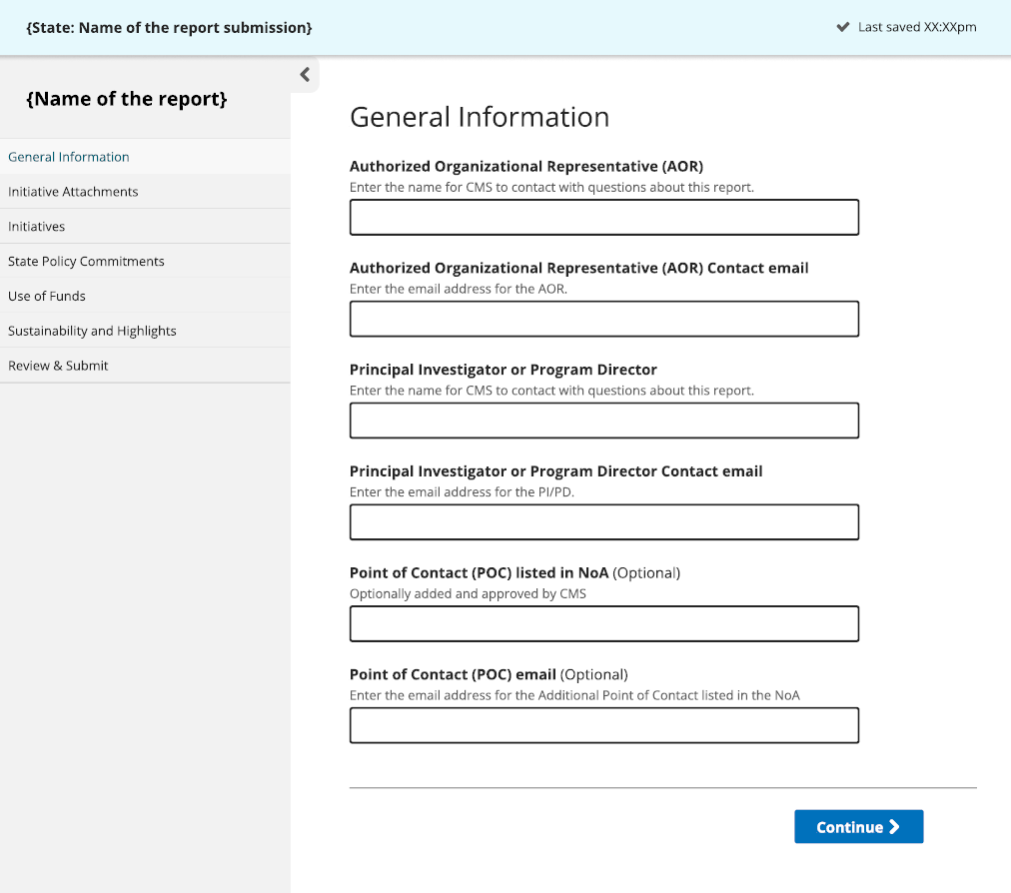
States will be required to provide general information including key personnel that can be contacted for any inquiries related to the report, as indicated in Figure 10 below.
Figure 10: General Information

Figure 11 below includes the relevant data fields on the General Information page. Instructions for how to fill out each data field, and an example data value, if needed, for each field. If there is a 3rd point of contact (additional Point of Contact as authorized in the NoA), please list them below. Please note, the examples are notional and should only be used as a guide.
Figure 11: General Information Instructions
Data Field | Instructions | Example
Authorized Organizational Representative (AOR) | Enter person’s name or a position title for CMS to contact with questions about this report. | Jane Smith
Authorized Organizational Representative (AOR) Contact email | A department or program-wide email address is acceptable. | JaneSmith@state.gov
Principle Investigator or Program Director | Enter person’s name or a position title for CMS to contact with questions about this report. | John Williams
Principle Investigator or Program Director Contact email | A department or program-wide email address is acceptable. | JohnWilliams@state.gov

Initiative Attachments
States may add, edit, or delete existing attachments (depending on their status), and add or respond to comments from their POs associated with specific attachments. Attachments that apply across multiple initiatives should be uploaded on this page, while initiative-specific attachments should be uploaded within the Initiatives page. Both informational attachments and attachments intended for rescoring may be submitted on this page.
This page also includes an Understanding Initiative Statuses section, which provides guidance on the various initiative statuses that may be encountered, including:
- Pending Review: This status is applied automatically when a new attachment is added. It lets CMS know the document is ready to be reviewed.
- Needs Revision: CMS uses this status when a document needs updates or corrections from the State. Please review CMS feedback and upload a revised version as needed.
- Locked for Scoring: CMS uses this status when a document has been locked for scoring.
- Informational: CMS or the State may use this status for documents that are for reference only. These documents are not used for scoring.
- Archived: CMS or the State may use this status for documents that are no longer part of the active submission but should be kept for records. Archived documents will not carry over from one report to the next.
Figure 12: Initiative Attachments
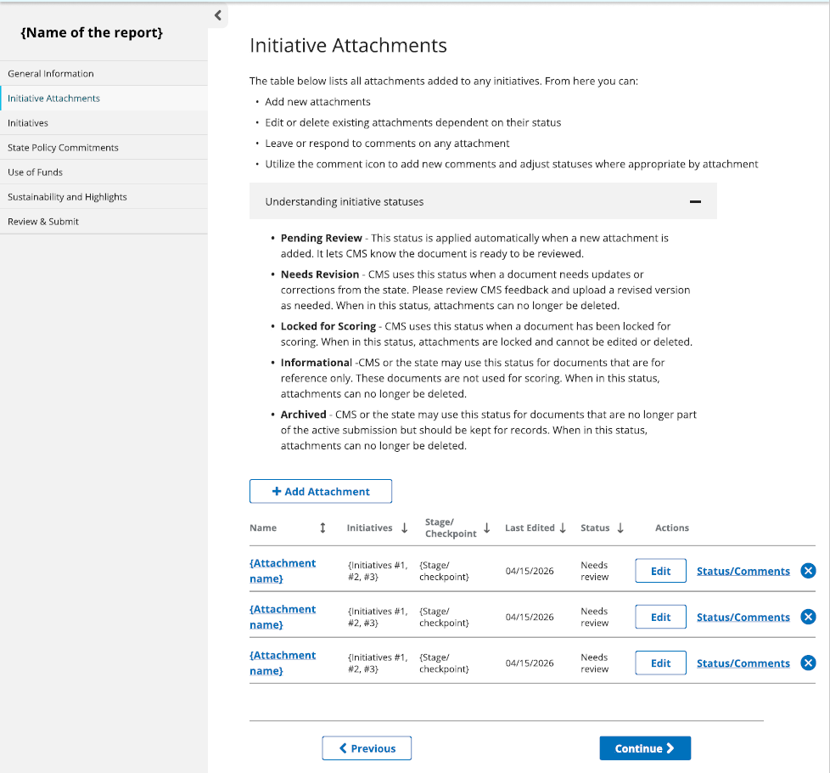

As shown above, the interface allows users to manage their uploaded attachments (via commenting, editing, or deleting) and upload new files as needed.
Figure 13 below includes the relevant data fields in the Initiative Attachments page, instructions for how to fill out each data field, and an example data value, if needed, for each field. Please note, the examples are notional and should only be used as a guide.
Figure 13: Initiative Attachment Instructions
Data Field | Instructions | Example
Add Attachment | Click on the icon to add attachments
Attachment name | Name of attachment will be populated based on the naming of the file being uploaded | StateX_Init_1_ Checkpoint_0.1
Initiatives | The screen will prompt States to check off which Initiatives the attachment applies to | 1,3,5
Stage/Checkpoint | The screen will prompt States to select which Stage/Checkpoint the attachment applies to | 0.1 Establish Governance

Relevant Initiative Actions
Below are guidelines for common questions that States may ask while viewing and uploading information to the Initiative Attachments page.
1. Uploading an attachment
To upload documentation, click the + Add Attachment icon located below the ‘Understanding Initiative Statuses’ section. A pop-up window will display checkboxes to designate which initiatives the file applies to. Below these checkboxes, use the dropdown menu to select the corresponding stage or checkpoint. Finally, drag files directly into the window or select them from a folder to complete the upload.

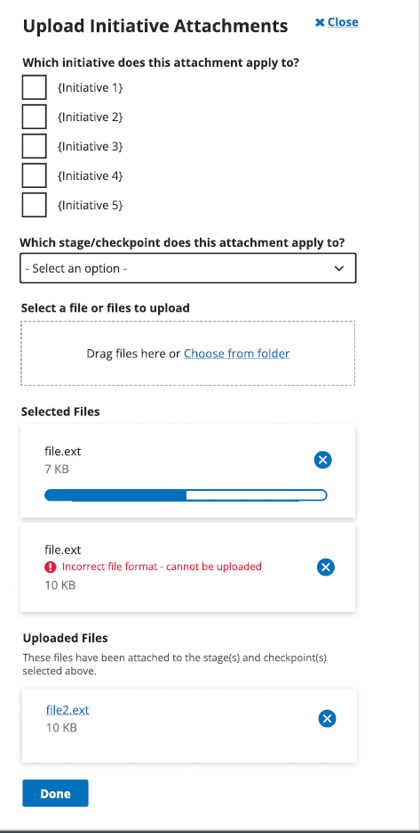
Figure 14: Upload Initiative Attachments
2. Adding a comment to an attachment
To leave a note for a Project Officer (PO)/ CMS, use the commenting feature within the MDCT RHTP platform. On the Initiative Attachments dashboard, click the “Status/comment” button next to the relevant attachment to add a message.

Figure 16: Add Comments to Attachments (Continued)
Figure 15: Add Comments to Attachments
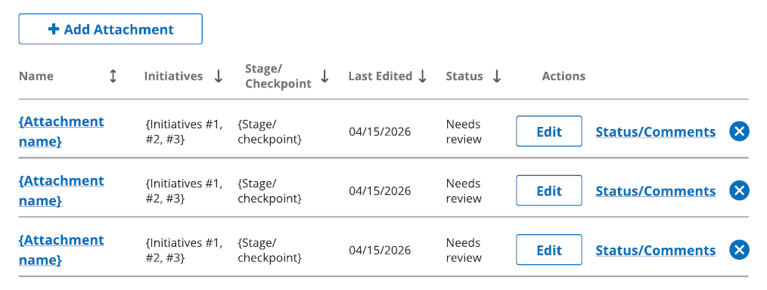
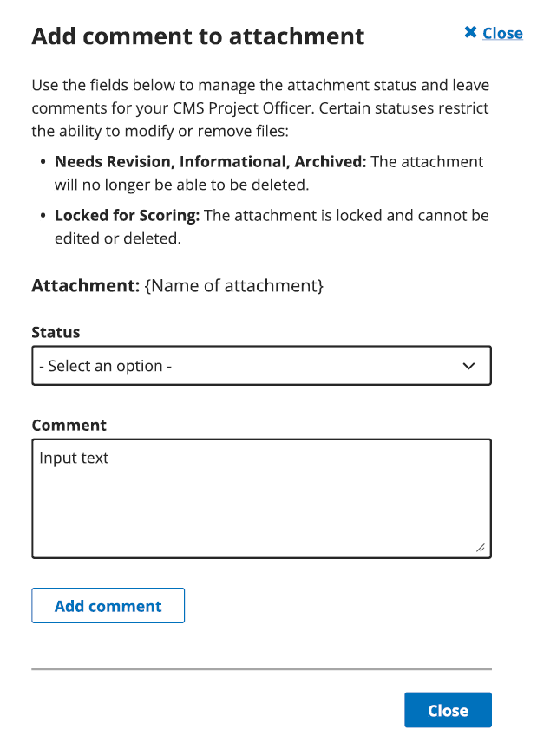

3. Editing attachments
If there are changes to attachment files or to the initiative(s) or checkpoint(s) the attachment applies to, you may update their selections. In the Actions column, select the “Edit” button. A pop-up window will appear displaying a list of initiatives with checkboxes. States can select or deselect the initiatives to indicate where the attachment applies.
Figure 17: Editing Attachments
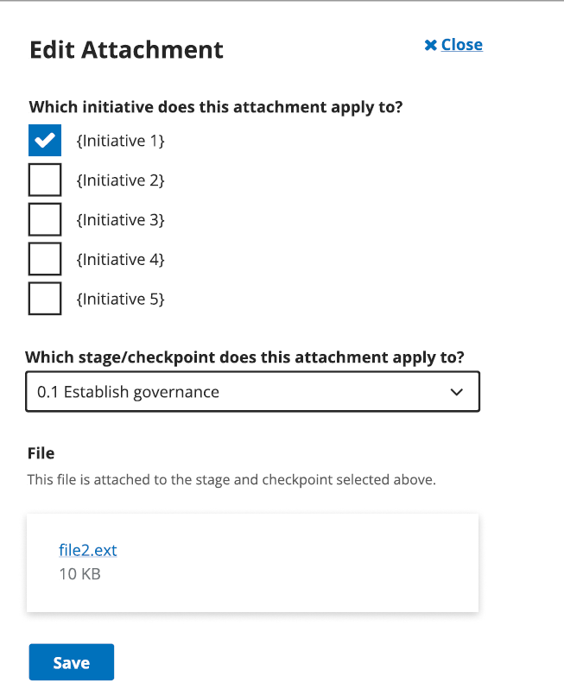

4. Viewing an attachment’s comments
In the Actions column, click the “Status/comment” button. A pop-up window will appear, allowing States to view a historical log of comments associated with the selected attachment. This log includes all comments provided by their PO on the uploaded attachment. States are also allowed to "Delete" an erroneous attachment if it is in “Pending Review” mode and has no comments. If there have been any additional actions taken on the attachment, it cannot be deleted and should be moved to "Archived".
Figure 18: Viewing Attachment Comments

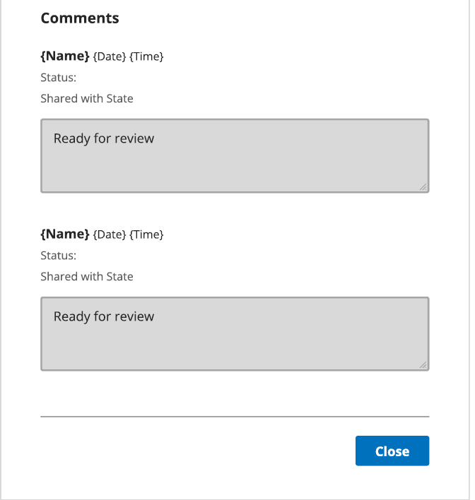

Initiatives
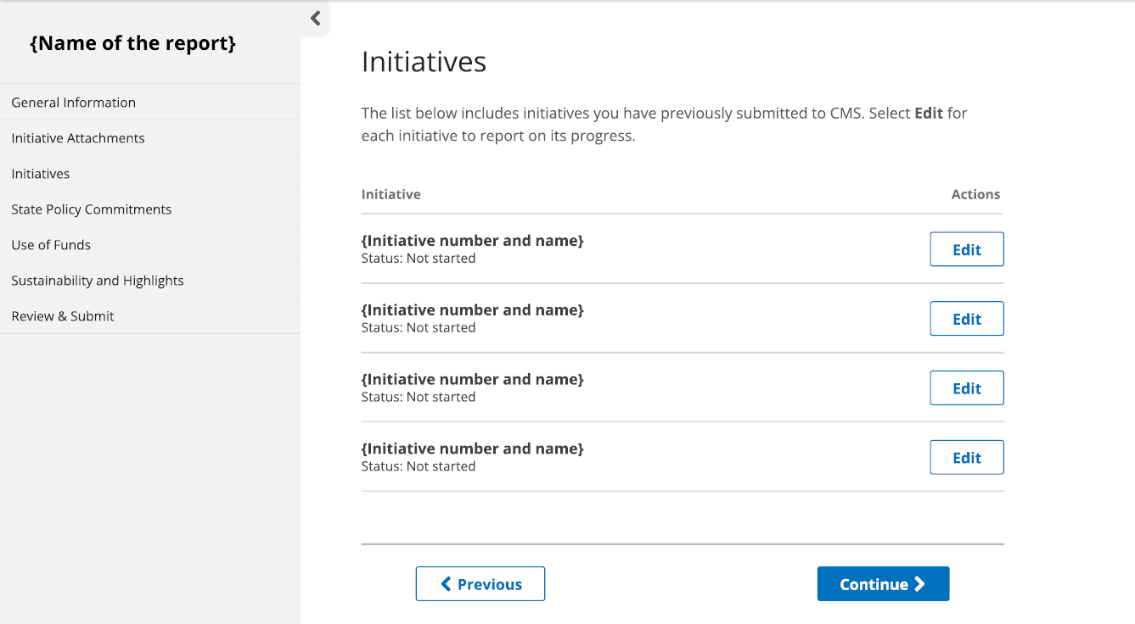
This page will be pre-populated with each Initiative’s number and name. Select the “Edit” button for each Initiative to begin reporting.
Figure 19: Initiatives

Figures 20, 21, and 22 below display the Initiative reporting page, including fields for entering a narrative summary, reporting metrics, and managing checkpoint status and attachments.

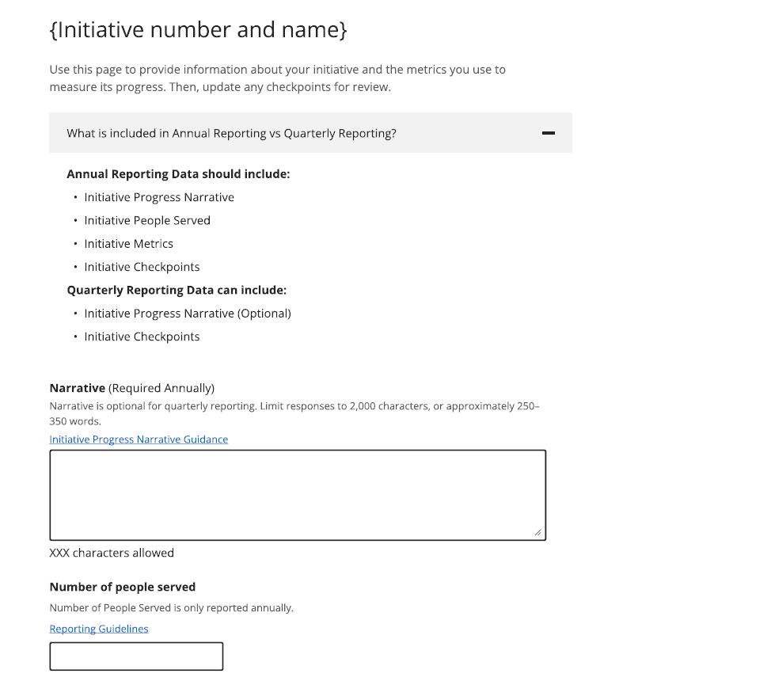
Figure 20: Initiative Number/Name

Figure 21: Metrics
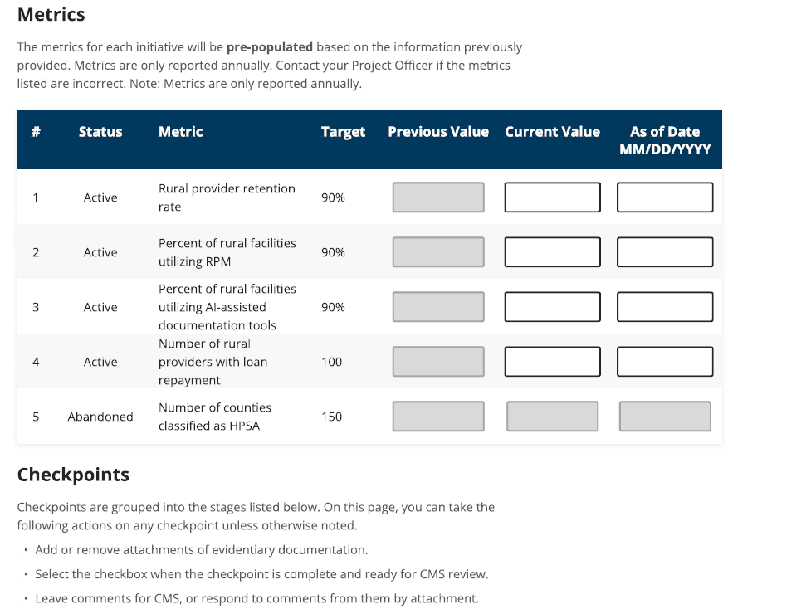

Figure 22: Checkpoint Stages
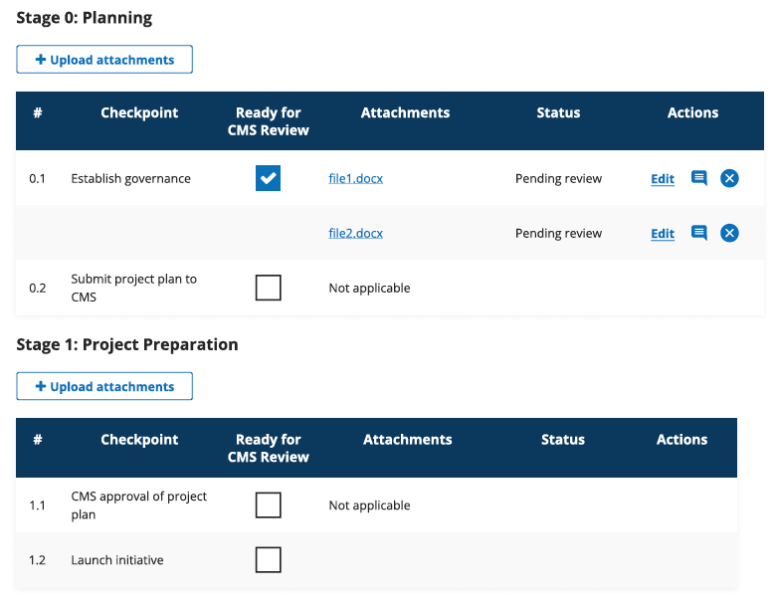

Figure 23 below includes the relevant data fields in the Initiative section, instructions for how to fill out each data field, and an example data value, if needed, for each field. Please note, the examples are notional and should only be used as a guide.
Figure 23: Initiative Progress Instructions
Data Field | Instructions | Example
Narrative | Provide a concise update on the progress of each initiative during the reporting period. Responses should focus on key activities completed, milestones reached, challenges encountered, and any notable outcomes or impacts to date.  This section is intended for progress reporting purposes only and should not repeat the full project narrative from the NCC Kit. Please focus on recent initiative progress and avoid including broad background information unless it is necessary for context.  States are encouraged to include any relevant updates that may be important for CMS to understand the status, implementation progress, or emerging results of the initiative.  Note: The Narrative is optional for quarterly reporting.  Please limit responses to 2,000 characters, or approximately 250–350 words. | Over the past year, we deployed five fully equipped Mobile Maternity Clinics across 12 of our most underserved counties, effectively eliminating geographic barriers to care. This proactive approach has enabled us to deliver over 2,500 prenatal and postpartum visits directly to expectant mothers, driving a 40% increase in first-trimester care initiation. By integrating satellite-enabled telehealth for high-risk specialist consultations and employing local community health workers to build trust, we have not only expanded essential access but fundamentally transformed the maternal health infrastructure for our rural populations.
Number of People Served | Provide best estimate of the number of individuals who have benefited from RHT Program funds during the reporting period. Estimates should be reasonable, supported by available data, and reflect the scope and reach of the initiative.  For system-based initiatives that do not provide direct services (e.g., IT systems, Health Information Exchanges), States may define the number of people served more broadly.  For example:  - For health system–level initiatives, the number served may reflect the total population served by the system.  - For statewide systems (e.g., HIEs), the number served may reflect the number of patients with data in the system or the total number of state residents.  - These estimates do not need to be de-duplicated and do not need to be limited to rural populations if the initiative has a broader reach.  - States should aim to provide the most accurate and justifiable estimate possible and may include brief context in the narrative section if helpful for CMS’s understanding.  Note: Number of People Served is only reported annually. | 500
Metric | The metric for each initiative will be pre-populated based on the information previously provided.  Note: Metrics are only required to be reported in the annual reports and are optional to report in quarterly reports. | 20
Metric Status | Metric status will be displayed with the following potential statuses:  - Active  - Abandoned | Active
Target Value (%) | Target values will be pre-populated and will be updated based on States’ information. The field will not be able to be edited. | 90
Previous Value | Previous values that States have reported will be displayed. The field will not be able to be edited. | 5
Metric Current Value | Enter the current value of each metric relevant to the reporting period. | 3
Metric as of Date (MM/DD/YYYY) | Enter the as of date of the metric. | 04/19/2026
Checkpoint Attachments Upload | Add or remove documentation attachments and leave comments or respond to comments for each checkpoint attachment.
Ready for CMS Review | Check the box once a checkpoint is ready for CMS Review. Leave unchecked if the checkpoint requires further editing.

State Policy Action Commitments
On this page, the SPA Form displays a list of policy commitments approved by CMS, as outlined in the State’s approved application. Each commitment can be expanded to update its status, evidence, and comments for the current reporting period.
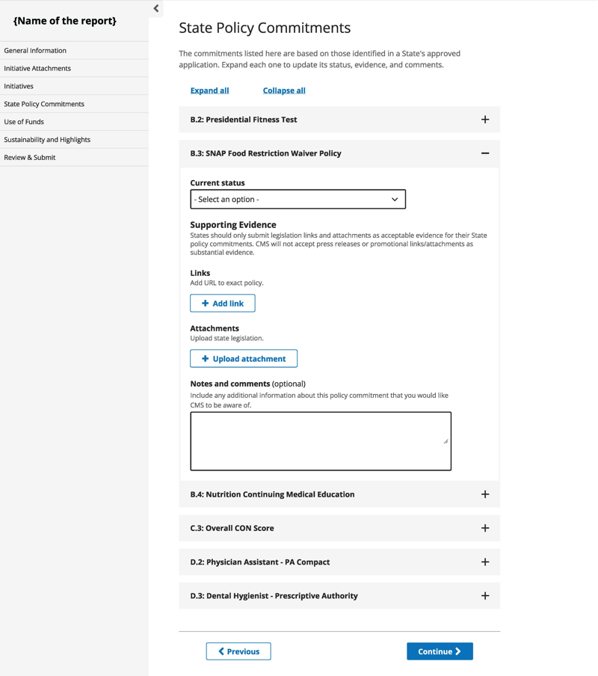
For each commitment, only legislation links and attachments are accepted as valid evidence demonstrating progress toward fulfillment of the policy commitment. Press releases and promotional links or attachments will not be accepted as sufficient evidence.
Figure 24: State Policy Action Commitments

Figure 25 below outlines the relevant data fields on the State Policy Action Commitments page, along with instructions for completing each field and illustrative example values, where applicable. Please note, the examples are notional and should only be used as a guide.
Figure 25: State Policy Action Commitment Page Instructions
Data Field | Instructions | Example
Current Status | Select from the drop down the corresponding status for each commitment during the reporting period. | TBD
Supporting Evidence: Links | Provide link(s) to State legislation that confirms the status of the State Policy Action Commitments. | Link to the exact policy
Supporting Evidence: Attachments | Upload State legislation attachments that confirm the status of State Policy Action Commitments. | State Legislation attachment and/or URL
Notes and Comments | Provide any additional context or details around the status of the State Policy Action Commitment, if needed. | The bill was signed into law on July 15, 2026, and becomes effective January 1, 2027.

Obligated and Spent Funds Reporting
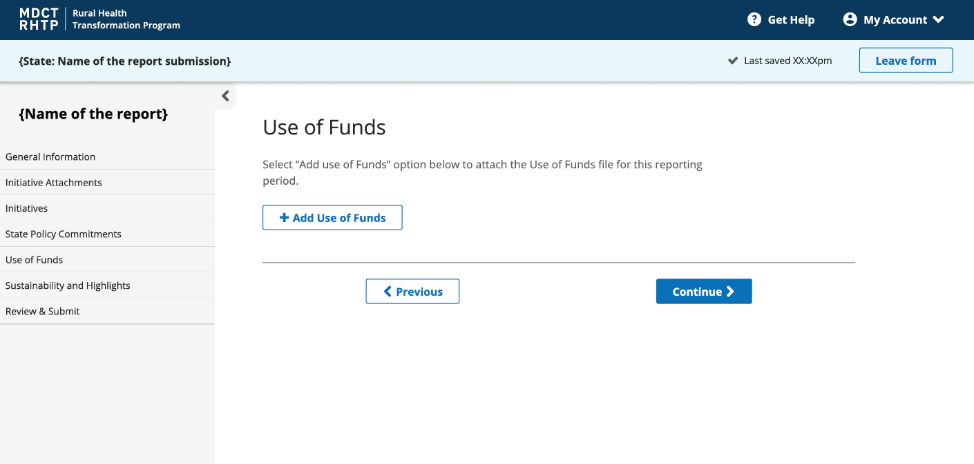
The Obligated and Spent Funds Form should be uploaded directly on this page using the “+ Add Obligated and Spent Funds” button, as shown below. Refer to the Obligated and Spent Funds Reporting Guide for detailed instructions on completing these forms. This form is a continuation of the Obligated and Spent Funds section of the Excel Reporting Template.
Figure 26: Obligated and Spent Funds

Sustainability and Highlights
On this page, qualitative updates on program successes and long-term sustainability planning may be shared.
Figure 27: Sustainability and Highlights

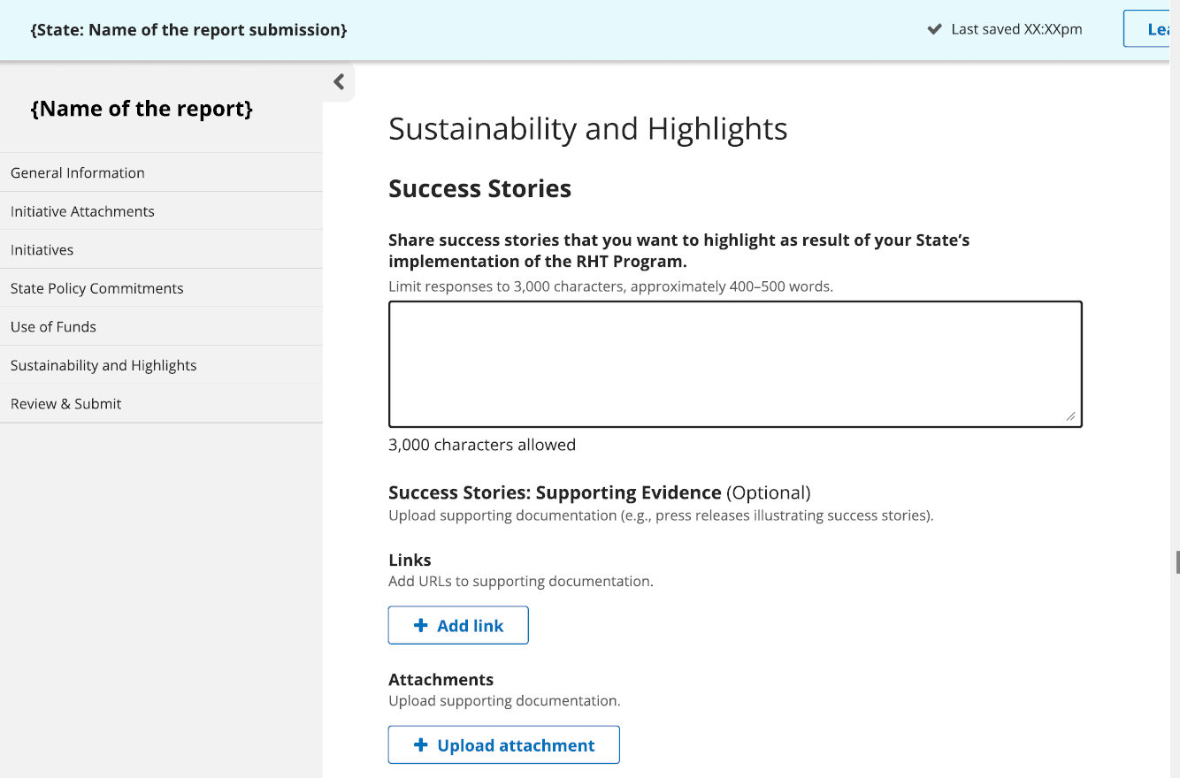

Figure 28: Changes to Sustainability Plan
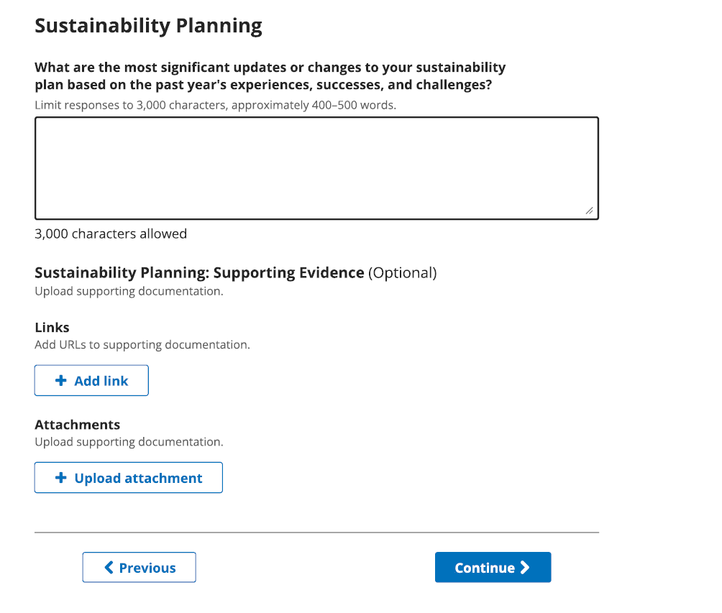

Figure 29 below outlines the relevant data fields on the Sustainability and Highlights page, along with instructions for completing each field and illustrative example values, where applicable. Please note, the examples are notional and should only be used as a guide.
Figure 29: Sustainability and Highlights Page Instructions
Data Field | Instructions | Example
Success Stories | Share success stories that you want to highlight as a result of your State’s implementation of the RHT Program.  Please limit responses to 3,000 characters, approximately 400–500 words. | In one of our rural communities, with no local obstetrician, our new mobile health clinic (Initiative 1) provided prenatal care to 45 expectant mothers. One patient was able to receive all her prenatal checkups locally, avoiding a 3-hour round trip to the nearest city. This consistent care led to the early detection of a complication, ensuring a healthy delivery for both mother and baby.
Sustainability Planning | What are the most significant updates or changes to your sustainability plan based on the past year’s experiences, successes, and challenges?  Please limit responses to 3,000 characters, approximately 400–500 words. | Based on the high demand for the mobile clinic, we have initiated discussions with the State Medicaid agency to establish a permanent reimbursement pathway for mobile health services. Furthermore, we have secured a partnership with the State University's nursing school to create a clinical rotation program on the mobile unit, which will provide a sustainable staffing pipeline and reduce future personnel costs.

Review & Submit
On this final page, all previously entered report information is displayed for review prior to submission. Carefully review all components to ensure accuracy and completeness. Two submission actions are available within MDCT RHTP:
- Submit for Review: This option allows you to share a draft report with your PO for review and feedback. When you select this option, you may add an optional comment for your PO to convey what elements of your report you would like your PO to review. The MDCT RHTP will become locked for further edits until your PO completes their review and unlocks the report. Contact your PO if you need the report to be unlocked.
- Submit Report: This option indicates that the report is being formally submitted. Once “Submit Report” is selected, the report becomes locked for editing within the system for the remainder of the reporting period. Your report must be submitted using this action before the reporting deadline for each Annual and Quarterly report.
After formal submission, export your reporting package, including all submitted data and evidentiary documentation from the MDCT RHTP platform, and upload to GrantSolutions for official recordkeeping.
Prior to the submission deadline, States will compile and upload all respective materials into GrantSolutions for official recordkeeping. For this final submission to GrantSolutions, you should:
- Note that some evidentiary files will need to be converted to PDF format prior to uploading.
- Keep the exact same base file name used in your original files (e.g., if you uploaded the native file StateX_Init_1_Checkpoint_0.2.xlsx to the MDCT RHTP, upload the converted version to GrantSolutions as StateX_Init_1_Checkpoint_0.2.pdf).
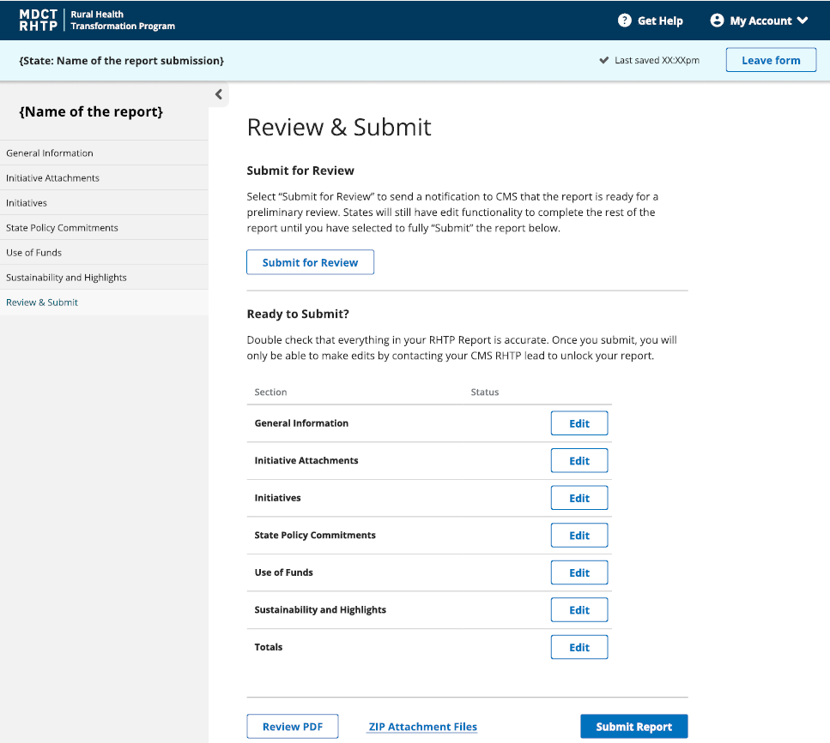
Figure 30: Review and Submission

Appendix

A. Reporting Periods – Annual and Quarterly Reporting
Figure 31: Reporting Periods
Report | Reporting Period Start Date | Reporting Period End Date | Due Date
Budget Period 1: December 29, 2025, to October 30, 2026 (10 months)
Annual Report # 1 | December 29, 2025 | July 31, 2026 | August 31, 2026
Quarterly Report # 1 | August 1, 2026 | October 30, 2026 | November 29, 2026
Budget period 2: October 31, 2026, to October 30, 2027
Quarterly Report # 2 | October 31, 2026 | January 30, 2027 | March 1, 2027
Quarterly Report # 3 | January 31, 2027 | April 30, 2027 | May 30, 2027
Annual Report # 2 | August 1, 2026 | July 31, 2027 | August 31, 2027
Quarterly Report # 4 | August 1, 2027 | October 30, 2027 | November 29, 2027
Budget period 3: October 31, 2027, to October 30, 2028
Quarterly Report # 5 | October 31, 2027 | January 30, 202 | February 29, 2028
Quarterly Report # 6 | January 31, 2028 | April 30, 2028 | May 30, 2028
Annual Report # 3 | August 1, 2027 | July 31, 2028 | August 31, 2028
Quarterly Report # 7 | August 1, 2028 | October 30, 2028 | November 29, 2028
Budget period 4: October 31, 2028, to October 30, 2029
Quarterly Report # 8 | October 31, 2028 | January 30, 2029 | March 1, 2029
Quarterly Report # 9 | January 31, 2029 | April 30, 2029 | May 30, 2029
Annual Report # 4 | August 1, 2028 | July 31, 2029 | August 31, 2029
Quarterly Report # 10 | August 1, 2029 | October 30, 2029 | November 29, 2029
Budget period 5: October 31, 2029, to October 30, 2030
Quarterly Report # 11 | October 31, 2029 | January 30, 2030 | March 1, 2030
Quarterly Report # 12 | January 31, 2030 | April 30, 2030 | May 30, 2030
Annual Report # 5 | August 1, 2029 | July 31, 2030 | August 31, 2030
Quarterly Report # 13 | August 1, 2030 | October 30, 2030 | November 29, 2030
Final Report | December 29, 2025 | October 30, 2030 | February 27, 2031
Please note: Any deadline falling on a weekend will revert to the next business day.

B. Resources
For additional information on RHT Program reporting, please refer to the resources below.
- Rural Health Transformation (RHT) Program | CMS
- Rural Health Transformation FAQ

C. State Progress Reporting Frequently Asked Questions (FAQs)
Below are FAQs that cover the Annual and Quarterly Reports, reporting submission process, evidentiary documentation, and State reporting noncompliance.

Reporting Submission Process (Initial Annual Reporting)
- How should States submit Annual Reports?
  - During the initial program year (covering a 10-month period from 12/29/25 – 7/31/26), States will receive a standardized Excel Reporting Template to complete the first Annual Report (due August 31, 2026). For all subsequent reporting, the program will transition to a web-based interface. The platform will be deployed prior to the first quarterly reporting deadline.
  - States should submit their completed Excel Reporting Template and evidentiary documentation by the reporting deadline via GrantSolutions.

Evidentiary Documentation
- Do States have to provide evidentiary documentation?
  - Yes, States are required to provide evidentiary documentation for each of the initiative checkpoints completed and for progress indicated for State Policy Action Commitments.
  - The type of evidentiary documentation that you should submit will vary depending on the checkpoint. Please refer to the Checkpoint Guidance tab in the Excel Reporting Template.
- How should States compile evidentiary documentation?
  - Please refer to Submitting Evidentiary Documentation section for more information and examples of acceptable evidentiary documentation.

State Reporting Non-Compliance
- What does it mean if a State fails to submit required reports?
  - Per the Program Terms and Conditions, failure to submit required reports is considered a violation of the terms of the Cooperative Agreement.
- Is there an opportunity for States to address non-compliance before further action is taken?
  - Yes. Per the Program Terms and Conditions, States will be issued a notice of non-compliance and provided a 90-day remediation period to correct the identified issues.
- What actions may CMS take if non-compliance is not remedied within the remediation period?
  - If non-compliance is not resolved, CMS reserves the right to take one or more of the following actions as stated in the Program Terms and Conditions:
    - Recover previously issued payments.
    - Withhold future payments, including both workload and baseline funding.
- Can non-compliance result in suspension or termination of the award?
  - Yes. Per the Program Terms and Conditions, significant performance issues—such as misuse of funds or failure to carry out approved activities—may result in suspension or termination of the award. In such cases, the State would be ineligible for further funding until the non-compliance is resolved.
  - Per the Program Terms and Conditions, at any time, CMS can decrease funding, recover funding, or terminate an award if a Recipient fails to fulfill the requirements of the award. The award may also otherwise be terminated to the extent authorized by law, if the agency determines the award no longer effectuates program goals or agency priorities.

D. Table of Figures
Figure 1: Initiative Form (Top) 9
Figure 2: Initiative Form (Bottom) 9
Figure 3: Initiative Form Instructions 10
Figure 4: State Policy Actions Form 13
Figure 5: State Policy Actions Form Instructions 14
Figure 6: Success Stories 16
Figure 7: Sustainability Planning 16
Figure 8: Rural Definition 17
Figure 9: Additional Information Form Instructions 18
Figure 10: General Information 23
Figure 11: General Information Instructions 24
Figure 12: Attachments 25
Figure 13: Initiative Attachment Instructions 26
Figure 14: Upload Initiative Attachments 28
Figure 15: Add Comments to Attachments 27
Figure 16: Add Comments to Attachments (Continued) 28
Figure 17: Editing Attachments 28
Figure 18: Viewing Attachment Comments 29
Figure 19: Initiatives 30
Figure 20: Initiative Number/Name 29
Figure 21: Metrics 29
Figure 22: Checkpoint Stages 32
Figure 23: Initiative Progress Instructions 32
Figure 24: State Policy Action Commitments 35
Figure 25: State Policy Action Commitment Page Instructions 36
Figure 26: Use of Funds 37
Figure 27: Sustainability and Highlights 38
Figure 28: Changes to Sustainability Plan 37
Figure 29: Sustainability and Highlights Page Instructions 37
Figure 30: Review and Submission 39
Figure 31: Reporting Periods 42

