To: Erica Zielewski
Office of Information and Regulatory Affairs (OIRA)
Office of Management and Budget (OMB)

From: William N. Parham III
Office of Strategic Operations and Regulatory Affairs (OSORA)
Centers for Medicare and Medicaid Services (CMS)

Date: August 14, 2026

Subject: Non-Substantive Change Request – Rural Health Transformation (RHT) Program Reporting (OMB No: 0938-1498; CMS-10949)

This memo requests approval of a non-substantive change to the approved information collection titled Rural Health Transformation (RHT) Program Reporting (OMB No: 0938-1498; CMS-10949)

Background
The Rural Health Transformation (RHT) Program reporting (CMS-10949) is completed annually and quarterly by all approved State awardees to track programmatic milestones, performance metrics, and funding expenditures. Grounded in the program's authorizing legislation under Section 71401 of Public Law 119-21 (the Working Families Tax Cut legislation), this data collection promotes robust oversight, fiscal accountability, and data-driven performance management. The data reported is used by CMS to monitor progress against state-specific workplan milestones and evaluate compliance with the terms of the award. This reporting captures the specific technical and performance-based metrics required by CMS to re-calculate each State’s technical score, which directly determines their workload funding allocations for subsequent budget periods.
While OMB was reviewing the package, ORHT identified several grammatical, typographical, and formatting inconsistencies in the supplementary guidance that must be remediated before sending to states.
Of note, the scope and nature of the information collection remain unchanged; the proposed modifications are strictly confined to refining the instructional verbiage and supplementary guidance to ensure State awardees understand how to complete the reporting requirements as intended.

Overview of Requested Changes
The Office of Rural Health Transformation (ORHT) in the Center for Medicaid & CHIP Services (CMCS) is requesting to make the following non-substantive edits to the currently approved information collection request. Please see the attached redline document for a visual illustration of the non-substantive edits to [Obligated and Spent Funds Reporting Guide 08.13.26_REDLINE changes since 08.11.26 version.docx]. The following changes have no impact on the currently approved burden for this information collection. No data elements have been added or removed. Please note, the page numbers below reference the clean version of the file, without redline tracked changes.
- Updated table of contents page numbers
- Added hyphen to “first tier” on page 2.
- Changed a typo “an local” to “a local” on page 3.
- Updated the below phrasing on page 5:
Original Text
  - Based on the subrecipient and contractor determinations in 2 CFR § 200.331, programmatic compliance requirements flow down to subrecipients, but they do not extend to contractors. As a result, awardees do not need to track "vendors of vendors" with the exception of large capital projects governed by the guidelines in the Federal Funding Accountability and Transparency Act (FFATA).
Updated Text
  - Awardees do not need to track "vendors of vendors" (subcontractors) with the exception of subcontractors who receive at least $30,000 of RHT Program funds. Any subcontractor who receives at least $30,000 of RHT Program funds should be added as a downstream entity of the contractor on the Downstream Reporting tab.
- Changed capitalization to “first Annual Report” on page 5.
- Updated the phrasing on page 5 to “the submitted values in the Excel Reporting Template during the first Annual Report will be used to populate a future BP1 Obligated and Spent Funds reporting workbook.” from:
- 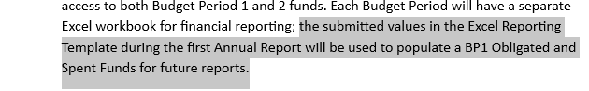
- Updated column letter to E in “will automatically populate the dropdown list in column E of the Use of Funds tab…” on page 6.
- Removed an extra space between “summary information” on page 6.
- The below language on page 6 was updated to: “The remaining reference columns on this tab are automatically populated based on values entered throughout the workbook and provide summary information about the first-tier entities. An example using the State XY scenario data is displayed in Figure 1.”
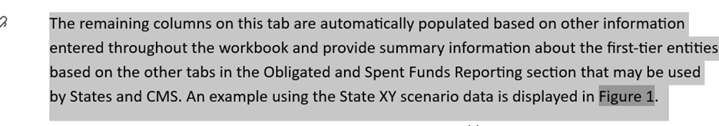
- Updated Figure 1 on page 6 to include the updated column header “Retained Disbursed Funds”
- On page 8, updated “the Sum of Downstream Transfers and Payments” to “the Sum of Downstream Disbursements”.
- On page 9, updated from two to three “the State must create at least three separate rows to accurately categorize these distinct funding pools (Figure 2).”
- Updated “column M” to “column N” on page 11
- Removed an extra space “…a direct…” on page 12
- Updated “from column B on of the First-Tier Entities tab” to “from column C” on page 12
- Added commitment to the following sentence on page 12. “The user should enter the legal name of the organization that is the recipient of the commitment, subaward, or contract described by the line item.”
- On page 13, updated “Sum of Downstream Disbursed” to “Sum of Downstream Disbursements”
- On page 13, updated “Sum of Downstream Transfers and Payments” to “Sum of Downstream Disbursements”
- Removed the word “But” from “But nowhere on this tab is the user required to indicate which funds are associated with each initiative.” from page 14.
- Removed extra spaces before “the XY Department of Education…” on page 16
- Updated from columns “F—L” to “E—L” on page 17.
- Updated Appendix page numbers

