NASA Visitor Management System (NVMS) Interaction Emails and Screens
As of 8-12-2026

Visitor Pre-Registration email
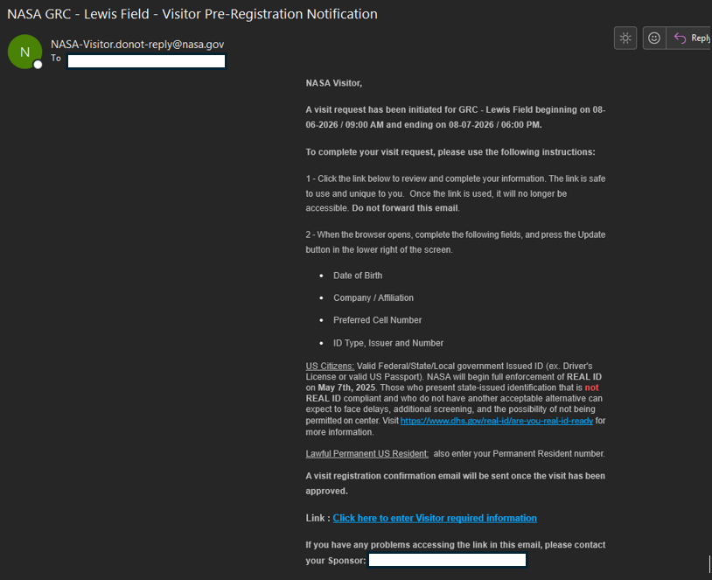

Visitor External Pre-Registration page (Embedded and Red outlined Privacy Act/PRA Statement are on last page)
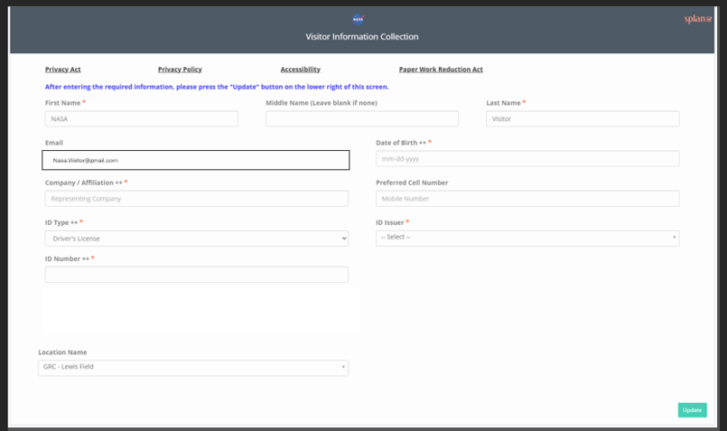
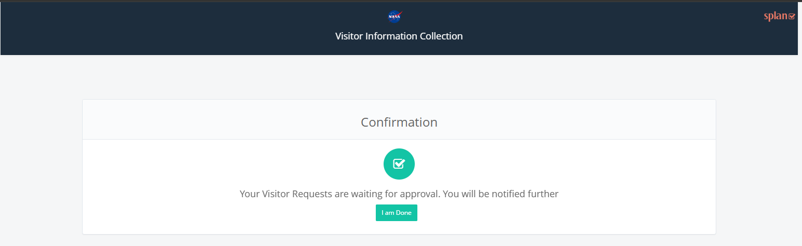

Visitor / Visit Confirmation email, with example Center specific directions.
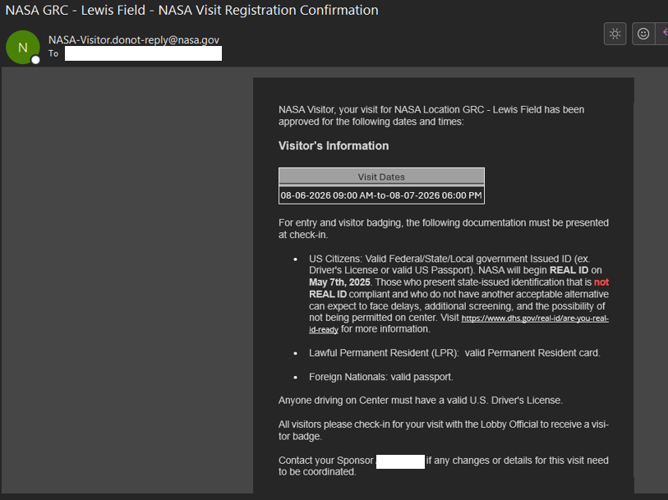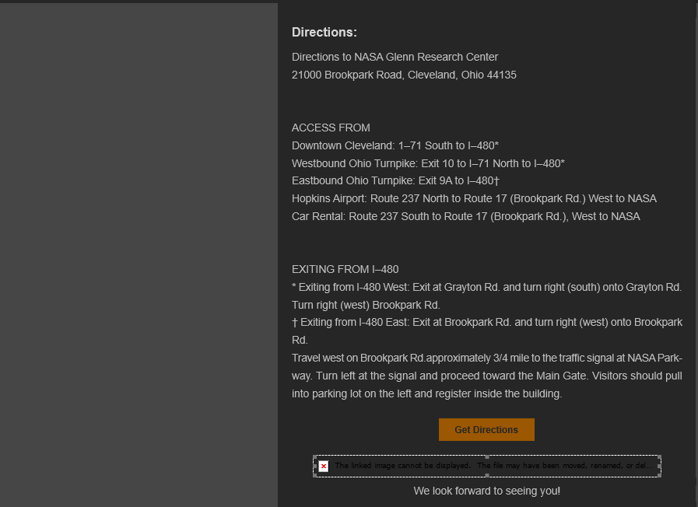

Visitor Kiosk Screens

Kiosk Check in Screens for Non-Escorted, US Citizens
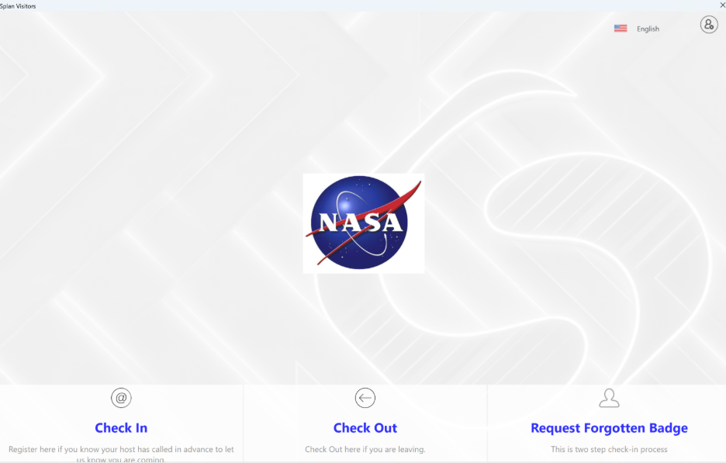

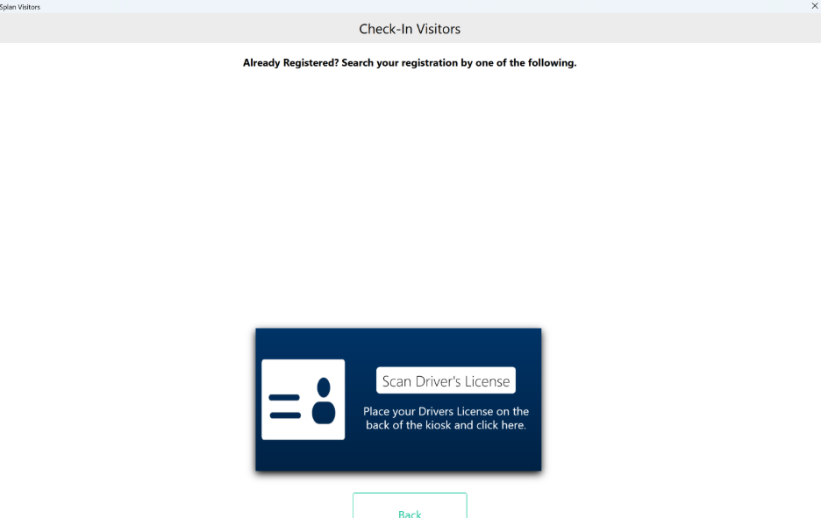
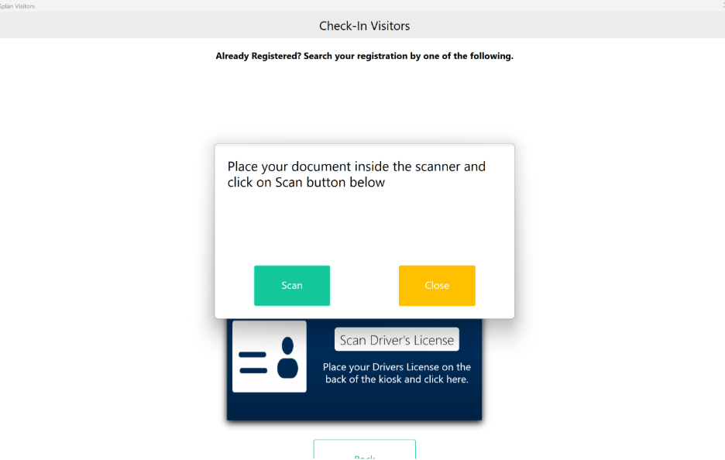
If visitor found with Registered visit
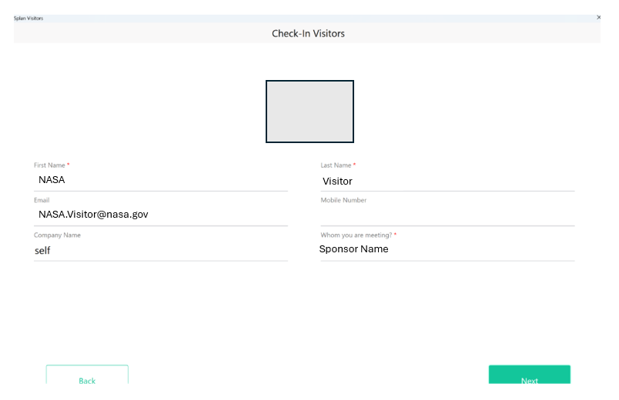

Prompts Visitor to take picture
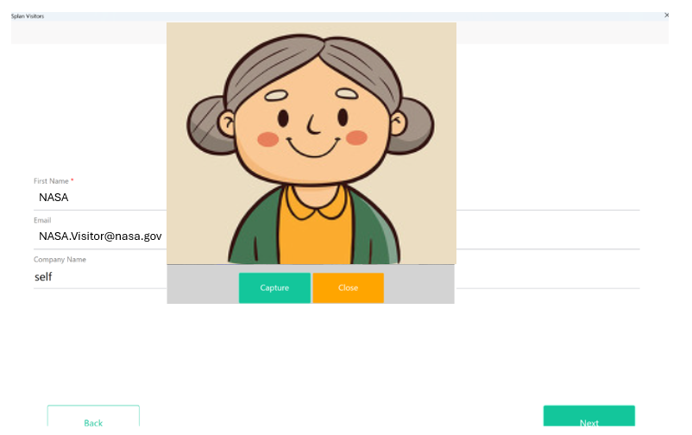
Prints badge and notifies they are checked in.
