White Paper
Non-Substantive Change
REQUEST FOR REMOVAL OF STATEMENT ON FORM
OMB Control Number 2900-0009
VA Form 28-1900

The Department of Veteran Affairs (VA) is requesting approval of a non-substantive administrative revision of the currently approved information collection under OMB Control Number 2900-0009.

At the time the currently approved information collection under OMB Control Number 2900-0009 was cleared and published, prior reapplication procedures were incorporated into the form. Since that time, VR&E Service has initiated development of updated reapplication procedures for Chapter 31.

Accordingly, VR&E Service requests removal of the note on the first page of the form and item “C” within the instructions (see figures 1 and 2 below). Continued display of this language on the VA.gov version of VAF 28-1900—the primary application platform for Veterans and Service members—may result in confusion or discourage individuals from submitting a reapplication.
Additionally, VR&E Service requests approval of a non-substantive change to Item #10, revising the language from “Number of Years of Education” to “Highest Level of Education Completed” (see figure 3 below) to ensure consistency with VA.gov content standards.
On the Instruction page 3 of the form, VR&E requests non-substantive changes to the language to limit any confusion (see figures 4, 5 and 6 below).

These changes are administrative in nature and do not modify information collected from respondents. No new data elements are added; no new questions are added; no existing data elements are removed; and no changes are made to reporting, recordkeeping, or disclosure requirements.

There is no change to respondent population, number of responses, frequency of collection, time per response, or approval burden hours.

Accordingly, VA has determined this update constitutes a non-substantive administrative revision and respectfully requests OMB approval.

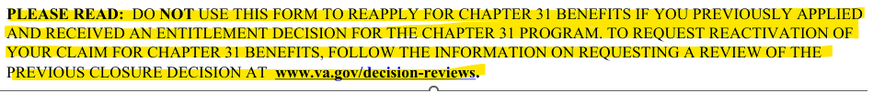
Figure 1
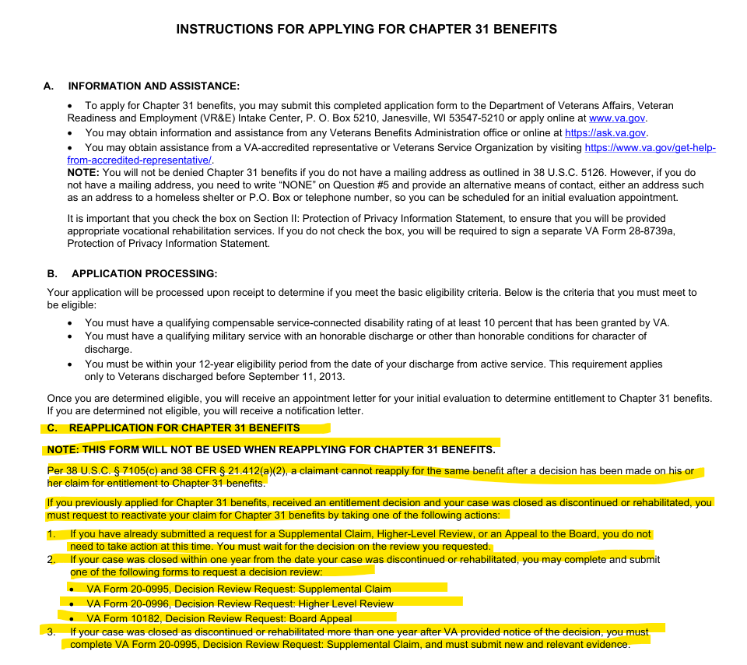
Figure 2
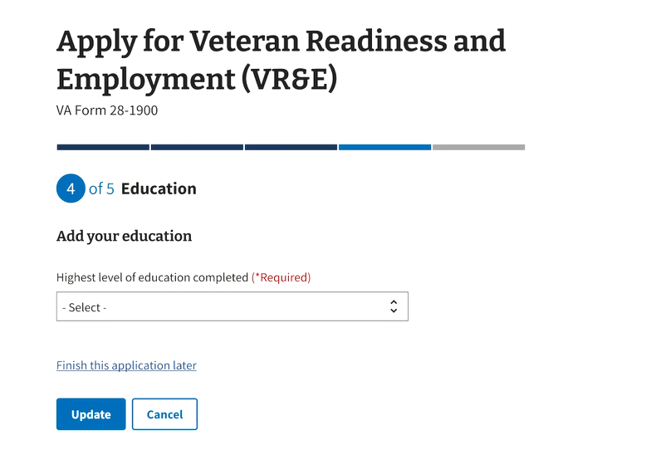
Figure 3
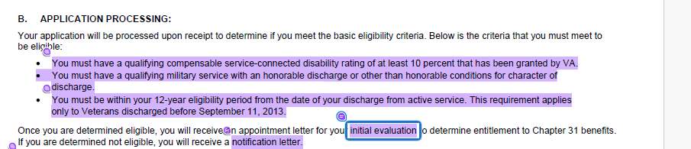
Figure 4

