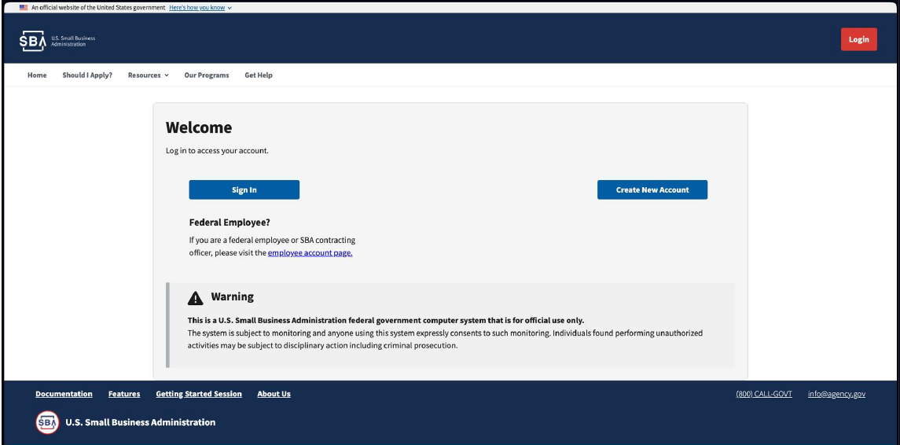

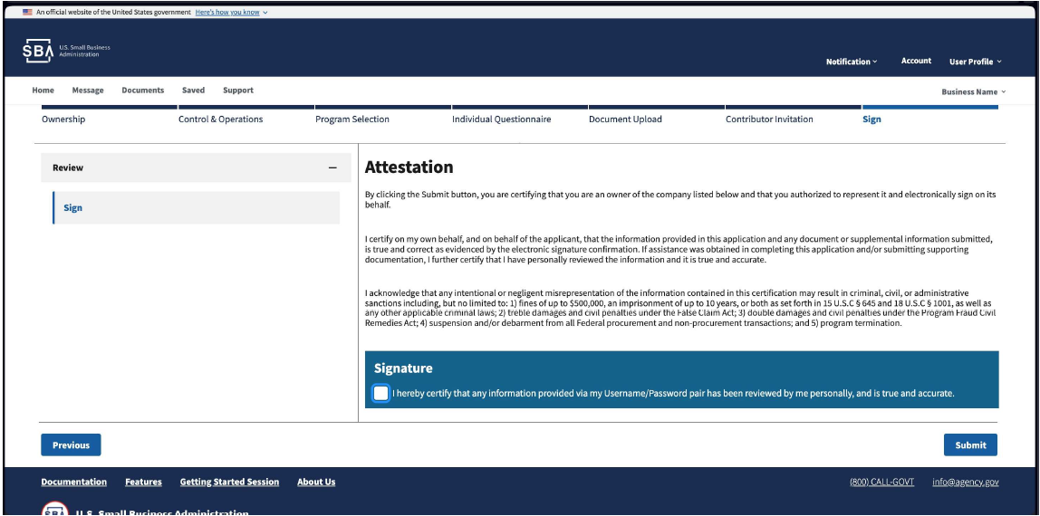

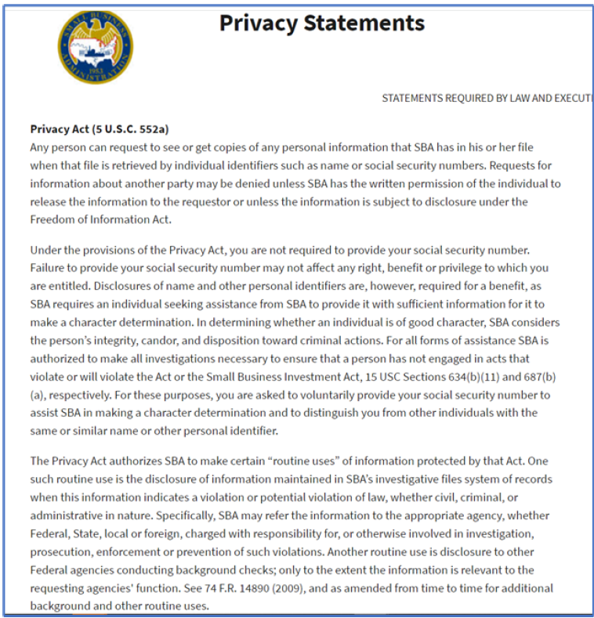
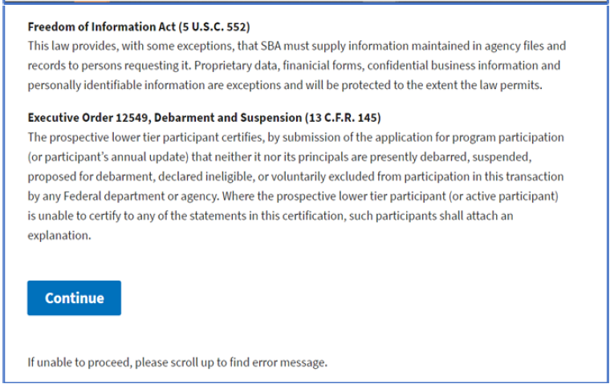

Section Ordinal | Question | Answer Choice | subquestion | answer type
1 | Who is preparing the application? | I am an owner of the applicant business  I am an authorized delegate of  the applicant business | no | radio
2 | Is the applying business registered in the Federal System for Award Management (SAM.gov)? | Yes, I have a Unique Entity Identifier and my SAM.gov registration is current and active.  No | no | boolean
 | Please provide the UEI number (12 characters, no spaces or dashes) | N/A | no | text
 | Please provide the CAGE code associated with the UEI listed above. | N/A | no | text
 | Please provide the TIN associated with the UEI listed above. | N/A | no | text
 | SAM.gov Bank Account Number (Enter this exactly as shown in  SAM.gov for the associated CAGE) | N/A | no | text
 | Is the information above/below correct? | Yes  No | no | boolean
 | Small Business Eligibility - Are the NAICS codes, industries, and size statuses shown above/below correct?  If any UEI is not correct, user needs to go to SAM to fix it. Add NAICS to Claim Your Business Interface | Yes No | no | boolean
3 | SBA Current Program Participation – Please confirm the following  certification information is correct: (display current certifications for this UEI with entry and exit dates, as applicable) | Yes No | no
 | Please confirm your business’ legal structure. The legal structure of your business is reflected in the filings you submitted to your state when you established your company. | Sole Proprietor Partnership (General Partnership or Limited Partnership)  Limited Liability Company (LLC)  Corporation | no
4 | Is the applicant business 51% or more owned by an American Indian Tribe (AIT), Alaska Native Corporation (ANC), Native Hawaiian Organization (NHO), Community Development Corporation (CDC), or Agricultural Cooperative? | Yes, my business is 51% or more owned by an AIT, ANC, NHO, CDC, or Agricultural Co- op.  No | no | boolean
1 | We will now collect information for the owner of the business. We use this information to determine eligibility for our various programs, so please be as complete as possible.  Following Questions repeated of each Owner/LLC Member | N/A | no | table
 | First Name | N/A | no
 | Last Name | N/A | no
 | Title/Position | N/A | no | text
 | Email | N/A | no | text
 | Phone number | N/A | no | text
 | Has this owner ever gone by another name? | Yes  No | no | boolean
 | Percent Ownership of the Business | N/A | no | text number
 | Citizenship | Yes  No | no | boolean

 | Marital Status | Married  Unmarried (includes Divorced) Legally Separated ... requires doc upload | main | select
 | If Married, is your spouse an owner, officer, board member, partner, or  employee of the applicant business? | Yes  No | yes | boolean
 | Sex | f (female) m (male) | no | select
 | Veteran | Not Applicable Veteran  Service-Disabled Veteran (Rated 0-100% by Dept. of  Veterans Affairs) | no | select
 | 8(a) Interest: Are you interested in the individually owned 8(a) Business Development program? | Yes  No | no | boolean
 | Type of Owner | Individual  Organization | no | select
 | If Organization, select type: | Tribal Government 501(c)  C-Corporation Cooperative  Employee Stock Ownership (ESOP)  Joint Venture Partnership  Sole Proprietorship Limited Liability Company (LLC)  Roll Over for Business Startup (ROBS)  401(k)  Trust | yes | select
1 | List any individual who is on the legal management team of your company but is not an owner since the information was previously provided. Please include any officers, directors from a board of  directors or board of managers, or members, as applicable. | grid | no | text
 | Prefix, Middle Name, Suffix
 | First Name | N/A | no | text

 | Last Name | N/A | no | text
 | Email | N/A | no | text
 | Title/Position | N/A | no | text
 | Principal Type | Principal Partner Member Officer  Board Member  Board Director Other | no | select
 | License Holder | Yes  No | no | boolean
 | It appears that the applicant may be eligible for the following certifications [system populates possible certifications based on responses in ownership table]  Please select the certification applications you would like to complete: | 8(a) WOSB EDWOSB  HUBZone VOSB SDVOSB  I have a Third Party Certification as a WOSB or EDWOSB and need to represent to SBA I have completed that process. | main | boolean
1 | If WOSB or EDWOSB: Is the applicant certified as a WOSB or EDWOSB by an SBA-approved Third-Party Certifier? | Yes No | yes | boolean
 | If yes, please select which Third-Party Certifier below and upload a copy of your certificate or certification letter. | Document Type for Upload  El Paso Hispanic Chamber of Commerce  Women’s Business Enterprise  National Council National Association of  Women’s Business Owners  U.S. Women’s Chamber of  Commerce | yes | file upload
 | If yes, Are you seeking EDWOSB status? | Yes  No | yes | boolean
2 | Has the applicant received a decision from the SBA – or a Third-Party certifier – in connection to an initial application denial, decertification, or protest-finding that the business does not qualify as {list applications that the applicant selected} in the last 90 days? | Yes No | no | boolean
3 | For any current SBA certifications, please identify the owner(s) who qualified for that certification. | grid:  Name,  Certifications (multi-select: 8(a), WOSB, EDWOSB, HUBZone, VOSB, SDVOSB) | no | table
1 | Has your business’ ownership, legal structure, or name changed in  the past two years? | Yes  No | no | boolean

 | Upload documentation of all prior owners, ownership percentages, and dates of ownership transfer within the last two years, and provide the buy/sell agreement, proof of payment, and evidence of  how the business was valued. | N/A | yes | document_upload
2 | Does the applicant business have a franchise agreement? | Yes  No | no | boolean
 | Upload your franchise agreement. | N/A | yes | document_upload
3 | Does your company share any of the following with another  business or organization? | N/A | main | boolean
 | Office Space and/or Location | Yes  No | yes | boolean
 | Employees | Yes  No | yes | boolean
 | Equipment | Yes  No | yes | boolean
 | Services | Yes  No | yes | boolean
 | Please explain the nature of the resources/services shared, including the name(s) of each business you share  resources/services with. | N/A | yes | text_area
4 | Does the company have any agreements or receive financial support that may impact ownership or control?  5/23/2024: Does your company have any agreements that may impact ownership or control? These may include:  - Joint Venture  - Mentor-Protégé  - Indemnity  -Consulting  - Distributorship  - Licensing  - Teaming  - Trust  - Franchise  - Management  - Certifications  - Permits  - Shared locations or other resources  - Ownership of another company  - Other financial support  - Lease with financial or familial interest  - Loans not from a commercial bank  - Buy/Sell Agreement  - Transmutual Agreement protecting your majority ownership (requested if you are married and living in a community property state/territory - Arizona, California, Idaho, Louisiana, Nevada, New Mexico, Texas, Washington, Wisconsin, Guam, Puerto Rico) | Yes No | no | boolean
 | Please enter a written explanation within the comment box. | N/A | yes | text_area
 | Upload a copy of the written agreement (executory agreement, voting trust, or other arrangements) with conditions. | N/A | yes | document_uploa d
 | Upload any applicable licenses which you have indicated are critical  to your business. |  | no | file upload
 | Upload your most recent six months of shareholder meeting  minutes detailing the election of the Board of Directors. |  | no | file upload
 | Upload your most recent six months of Board of Directors meeting  minutes detailing the election of Officers. |  | no | file upload

5 | Upload Minutes demonstrating or establishing the current operating practices. When  signed and dated, these legally serve as evidence of important actions such as:  - Election or appointments of officers  - Adoption/implementation of bylaws and voting agreements  - Business decisions  - Voting |  | no | file upload
6 | Is the applicant business doing business under an assumed, trade,  or fictitious name? | Yes  No | no | boolean
 | If yes, please list DBA's. |  | yes | text
7 | Fictitious Name Certificate or Certificate of Trade Name, as applicable |  | no | file_upload
8 | TPC Certificate |  | no | file upload
 | A DBA (Doing Business As) name is used when a person or company conducts business under a name other than the legal name. A DBA is also referred to as an "assumed name", "fictitious business name", or "trade name". If you are using a DBA, you will be required to upload your DBA Certificate. |  | no | file upload
9 | title: Upload proof of U.S. Citizenship or Naturalized Citizen.  description: Passport, Birth Certificate, or Naturalization paperwork of applicant |  | no | file upload
10 | title: 1040 Schedule C, or  IRS SS4 TIN issuance letter with correct name and EIN |  | no | file upload
 | title: Upload proof of U.S. Citizenship or Naturalized Citizen of any specific person or multiple applicants who make up 51% of status they’re trying to get .  description: Passport, Birth Certificate, or Naturalization paperwork of applicant |  | no | file upload
11 | title: Articles of Incorporation  description: The articles of incorporation -- or a certificate of incorporation -- is a comprehensive legal document that lays out the basic outline of your business. It's required by every state when you incorporate. The most common information included is the company name, business purpose, number of shares offered, value of shares, directors, and officers.  Please, upload the original document and most recent amendment (if applicable). |  | no | file upload
12 | title: Current Bylaws and related amendments  description: Bylaws (called "resolutions" for nonprofits) are the internal governance documents of a corporation. They define how key business decisions are made, as well as officers' and shareholders' duties, powers, and responsibilities. It's widely recommended to create one to protect yourself and your business, even if your state doesn't mandate it.  Please, upload the original document and most recent amendment (if applicable). |  | no | file upload

13 | title: Stock Ledger  description: A stock ledger lists all share-related transactions for a company. It states the name of the owner of each block of shares, as well as the number of shares owned by each investor, the type of shares purchased, and the date of each purchase and the amount paid. |  | no | file upload
14 | title: Operating Agreements (and the associated requirements and amendments), and  description: An operating agreement describes the structure of your company's financial and functional decisions. It defines how key business decisions are made, as well as each member’s duties, powers, and responsibilities. It's widely recommended to create one to protect yourself and your business, even if your state doesn’t mandate it.  Please, upload the original document and most recent amendment (if applicable). |  | no | file upload
 | The register of members and share ledger is designed to provide a  record of who the company shareholders are. |  | no | file upload
15 | title: Articles of Organization or Certificate of Organization/Formation (state dependent, names vary)  description: Articles of organization is a simple document that describes the basics of your LLC. It includes business information like the company name, address, member names, and the registered agent.  Please, upload the original document and most recent amendment (if applicable). |  | no | file upload
16 | title: Transfer Asset Agreement of Ownership (if applicable) within  last 2 years. |  | no | optional  file_upload
17 | A limited partnership agreement is an internally binding document between all partners that defines how business decisions get made, and each partner's duties, powers, and responsibilities. It's widely recommended to create one to protect yourself and your business, even if your state doesn’t mandate it. |  | no | file upload
1 | Are you applying for the 8(a) Program under the same primary NAICS code listed for your company on SAM.gov? The NAICS code identified as primary is XXXXXX – Industry Description.  5/23/2024: Are you applying for the 8(a) Program under the same primary NAICS code listed for your company on SAM.gov? | Yes No | no | boolean
2 | Has your business generated revenue in its primary NAICS in the last 2 years?  API description as of 5/21/24: Has the company ever generated revenue? | Yes No | main | boolean
 | Provide evidence that you have substantial business management  experience. | if answer = No for question  above: file upload | yes | file upload
 | Provide evidence that your business has technical experience in its  primary industry. | if answer = No for question  above: file upload | yes | file upload
 | Provide evidence of your business’ current financial position. | if answer = No for question  above: file upload | yes | file upload
 | Provide evidence that your business has a successful history of  performance in its primary industry. | if answer = No for question  above: file upload | yes | file upload

 | Provide evidence that your company will be able to perform on  contracts in the program. | if answer = No for question  above: file upload | yes | file upload
3 | Are 50% or more of your company’s assets from a former 8(a)  Participant? | Yes  No | no | boolean
 | Upload details of the assets, including the name of the prior 8(a) Program participant. | N/A | yes | file_upload
4 | Did you hire a consultant to help with your 8(a) application? | Yes  No | no | boolean
 | Do you need to request a waiver of the requirement of being in  business for at least two years? | Yes  No | no | boolean
5 | List up to 10 of the largest contracts or projects performed by your business in the last year. | grid (data entry): Award Date Customer Name NAICS Code Description of Work Total Contract Value Award Revenue  Action | no | table
6 | Are professional licenses or certificates required to operate [applicant  business]? | Yes  No | main | boolean
 | If yes, please note who holds the license(s) or certificate(s) | grid: Name,  License Name,  Explanation | yes | table
 | Is the information displayed correct?  Display:  -Full name  -DoB  -Country of birth  -Email  -Phone Number  -Home Address  -Marital status (only for Q.O)  -Gender identity  -Veteran status  -Ownership percentage of applicant  -Job title of applicant  -Owner type | Yes No | no
1 | Marital Status | Married  Unmarried (includes Divorced) Legally Separated | main | select
 | Spouse First Name |  | yes | text
 | Spouse Last Name |  | yes | text
 | Spouse Email |  | yes | text
3 | Date of Birth | N/A | no | date
4 | Country of Birth | N/A | no | text
5 | Social Security Number | N/A | no | text
 | First Name | N/A | no
 | Last Name | N/A | no
 | Email | N/A | no
6 | Best contact phone number | N/A | no | text

7 | Provide your current home address | Street Address City  State ZIP  Country  Dates of Residency | no | text
 | Ownership percentage of applicant (if applicable) | N/A
 | Owner type (if applicable) | N/A
8 | Has this owner ever gone by another name? | Yes  No | no | boolean
1 | Are you currently debarred, suspended, voluntarily excluded, or  otherwise rendered ineligible for assistance by any department or agency of the Federal government? | Yes No | no | boolean
2 | Are you currently past due on any federal taxes (or failed to file),  subject to any federal liens, or past due on any federally-backed loans? | Yes No | main | boolean
 | If yes, please provide the following details for EACH delinquency:  - Type of delinquency  - Status of delinquency (e.g., dismissed, satisfied)  - Proof of compliance with repayment plan if applicable  - Evidence of deferred payment status if applicable | grid:  - Type of Delinquency  - Status of Delinquency  - Proof of Compliance with a Repayment Plan  - Evidence of Deferred Payment Status | yes | table file upload
3 | Have you ever received an SBA loan? | Yes  No | main | boolean
 | If yes, provide loan status | Current Discharged Forgiven  Paid in Full | yes | select
4 | Are you, or is any member of your household, an SBA employee?  If yes, your application will need to be reviewed by the Standards of Conduct Committee before a final eligibility decision is made.  Reference 13 CFR 105.301- Assistance to officers or employees of other Government organizations. | Yes No | main | boolean
 | Provide an explanation of how it does not impact your full-time  devotion to the company applying for the 8(a) BD program. | If Yes to above, upload doc | yes | file_upload
5 | Is any member of your household a federal employee in a GS-13 position or above? | Yes No | no | boolean
 | If yes, provide a letter of no objection from the ethics official at the federal agency.  The Federal Acquisition Regulation Subpart 3.6 places restrictions on Federal Government employees which may prevent your business from acquiring contracts or create conflicts of interest. In addition, there are limitations on SBA’s ability to provide assistance to government employees.  Reference 13 CFR 105.301. | If Yes to above, upload doc | yes | file_upload
1 | Describe your managerial experience and qualifications to run or control this business. Please include any relevant educational background or experience that contributed to your ability to run or  control the business. | N/A | no | text_area
2 | Do you have ownership or management interest in any other  company | Yes  No | main | boolean

 | For Qualifying Owner:  If yes, please provide your title/role with the other business, business name, UEI (if applicable) and NAICS/primary industry, ownership percentage, and whether company has employees.  For Non-Qualifying Owner:  If yes, please provide your title/role with the other business, business name, UEI (if applicable) and NAICS/primary industry, and ownership percentage." | grid:  Title/Role, Business Name, UEI (if applicable),  NAICS/primary industry, Ownership %,  Does the company have employees?  Upload Proof of Ownership document if application_eligibility.intendi ng_to_apply_flag = T for 8a, Upload Federal Tax Returns for 3 Years if application_eligibility.intendi ng_to_apply_flag = T for 8a, Upload Year-To-Date Financial Statements if application_eligibility.intendi ng_to_apply_flag=T for 8a | yes | table
 | Please explain in as much detail as possible how you are able to devote the time and attention necessary to control the management and daily business operations of the applicant business while engaged  in the outside obligation(s) | N/A | yes | text_area
3 | Are you engaged in outside obligations such as holding another  job or ownership in another business? | Yes  No | main | boolean
 | Is this outside obligation employment by Small Business  Administration? | Yes  No | yes | boolean
 | Is this outside obligation employment by the federal government at a  GS-13 equivalent or above? | Yes  No | yes | boolean
 | Please provide your title/role with the other business, business name, UEI (if applicable) and NAICS/primary industry | grid:  Title/Role with Other Business,  Business Name, UEI (if applicable),  NAICS/primary industry, Ownership % (if applicable) | yes | table
 | Please explain in as much detail as possible how you are able to devote the time and attention necessary to control the management and daily business operations of the applicant  business while engaged in the outside obligation(s). | N/A | yes | text_area
4 | Are you or your ownership interest subject to any conditions or  agreements that could impact control or ownership, or cause ownership benefits to go to another person? | Yes No | no | boolean
 | Please enter a written explanation within the comment box. | N/A | yes | text_area
 | Upload a copy of the written agreement (executory agreement, voting trust, or other arrangements) with conditions. | N/A | yes | document_uploa d

5 | Please provide your previous employment experience. Only include work history that is directly relevant to your current role. | grid data:  Start Date (date), End Date (date), Title (text),  Brief Description of Responsibilities (text_area), Currently Held (Yes/No) | no | table
6 | List the Owners who have control of the business. | grid/table:  - First Name  - Last Name | no
7 | Do you manage or supervise the day-to-day operations of the business applying for certification? | Yes No | main
 | If yes, please provide details.  If no, please explain who supervises the day-to-day operations. | N/A | yes
1 | Do any of your immediate family members own a business that  conducts business with [applicant business]? | Yes  No | main | boolean
 | If Yes, if your immediate family members own a business that does business with your business, please provide the following:  - Family member name  - family member’s relationship to you  - family member’s role in the business that does business with your business  - Date of contractual relationship  - Business name  - Business UEI (If Applicable)  - Detail any common ownership or management of your business by the family member  - The nature of the relationship with the applicant business,  - Financial details (loan agreements or other agreements)  - Business revenues earned from the relationship or liabilities owed | N/A | yes | table
2 | Does the applicant business have financial relationships with outside companies that are owned or operated by friends, family  members, or former colleagues of this owner? | Yes No | main | boolean
 | If Yes, please provide the business name, the names of the business' owners and their ownership percentages, an explanation of the business relationship, an explanation of the personal relationship, and a brief description of what the business relationship provides. | N/A | yes | table
3 | Does the applicant business have any employee, officer, or  manager that formerly was your employer? | Yes  No | main | boolean
 | If yes, please explain the employment situation. | N/A | yes | text_area

4 | Are you a former employer of any of the qualifying owners? | Yes  No | main | boolean
 | If yes, please explain the employment situation. | N/A | yes | text_area
5 | Are you the former majority owner (51% or more) of the  applicant firm? | Yes  No | main | boolean
 | If yes, please upload all applicable details of the sale including:  - The terms and conditions of the transaction  - A copy of the agreement  - Explain the calculation of the sale price  - Evidence of compliance with the payment terms of the sales agreement | N/A | yes | file_upload
6 | Are you the highest compensated person in your company? | Yes No  N/A - Entity Owned | no | select
1 | Have any of your immediate family members ever owned a company  that was admitted to the 8(a) program? | Yes  No | main | boolean
 | If your immediate family members own a business that was admitted to the 8(a) Program, please provide the following:  -Business name.  -Business primary NAICS code during participation in 8(a) Program.  -Business UEI.  -Business relationship with your business.  -Detail of any common ownership or management of your business by the family member.  Immediate family members include your father, mother, husband, wife, son, daughter, brother, sister, grandfather, grandmother, grandson, granddaughter, father-in-law, and mother-in-law. | N/A | yes | table
 | Have you, or any company you owned, ever applied for certification in  the 8(a) program? | Yes  No | no | boolean
2 | Have you already used your one-time 8(a) eligibility to qualify a  business for the 8(a) program? | Yes  No | no | boolean
1 | Have you ever gone by any other names? | Yes  No | main | boolean
 | If yes, please provide detail of your other names. | N/A | yes | text
2 | Are you presently subject to an indictment, criminal information,  arraignment, or other means by which formal criminal charges are brought? | Yes No | main | boolean
 | If yes, upload evidence of the current status of the charges. | N/A | yes | file_upload
3 | Have you been arrested in the past six months/year for any criminal offense?  5/23/2024: Have you been arrested in the past six months for any criminal offense? | Yes No | main | boolean
 | If yes, upload an explanation including the current status of any  charges. | N/A | yes | file_upload
4 | For any criminal offense, other than a minor motor vehicle violations/including expunged records, have you ever been convicted, plead guilty, plead nolo contendere, been placed on pretrial diversion, been placed on any form of parole or probation (including probation before judgment)?  5/23/2024:  For any criminal offense, including expunged records:  - Been convicted  - Plead nolo contendere  - Been placed on pretrial diversion  - Been placed on any form of parole or probation (including probation of judgement) | Yes No | main | boolean

 | If yes, provide details including dates, locations, fines, sentences, misdemeanor or felony, dates of parole/probation, unpaid fines or penalties, name(s) under which charged, and any other pertinent  information. Include expunged records. | N/A | yes | table
1 | HUBZone Calculator Data and document upload storage
1 | Do you have 51% or more ownership in another business with Yes employees? No |  | no | boolean
 | If Yes, Provide details. | grid/table:  - Business Name (text)  - Ownership % (number)  - Are any of the shared employees key personnel? (Y/N)  - Do any of the employees of the applicant perform work for the affiliate? (Y/N)  - Do any of the employees of the affiliate perform work for the applicant? (Y/N)  - Do the businesses operate in the same or similar line of business? (Y/N)  - Do the businesses operate in the same geographic location? (Y/N)  - Do the businesses share customers? (Y/N)  - Have the businesses entered into any agreements together? (Y/N) | yes | table

2 | Does your business own or lease your principal office location? | - Own  - Lease | no | select
 | Does the deed identify the physical address of the principal office? | Yes No | yes | boolean

 | Upload property tax bill and/or insurance policy showing the physical address of the principal office. | N/A | yes | file_upload
 | Enter the start and end dates of the term of the lease as they appear in the lease agreement. | N/A | yes | text

 | Is the lease month-to-month? | Yes No | yes | boolean
 | Has the lease been amended? | Yes No | yes | boolean

 | Upload lease addendum. | N/A | yes | document_upload
 | Upload attestation from the landlord and proof of payment for 3 months leading up to the application date. | N/A | yes | document_upload

 | Does the lease provide that utilities are included in the rent? | Yes No | yes | boolean
 | Upload proof of rent payment for 3 months before application date. | N/A | yes | document_upload

 | Upload most-recent utility bill. | N/A | yes | document_upload
 | Enter the service dates of the utility bill. | N/A | yes | text

 | Is the lessor a business owned in whole or in part by an owner of the applicant business? | Yes No
 | Upload a copy of the master lease or deed, as applicable | N/A | yes | document_upload

3 | Is the principal office located at or within a residence? | Yes No | no | boolean
4 | Does the lease/deed list the firm's full legal name or the majority owner's full legal name as being the lessee or owner of the property? | Yes No | no | boolean

 | Please explain. | N/A | yes | text_area
Instruction | Social Disadvantage:  A Citizen may establish social disadvantage by first showing that during the Citizen’s lifetime, a governmental or private entity in the United States, including but not limited to any federal, state or local government, university or corporation, through any action, policy, rule, regulation, or other practice of any of its agencies, subsidiaries, or authorized agents, discriminated or was biased against a clearly definable racial, ethnic, or cultural group of which the Citizen is a member, or favored in any way a racial, ethnic, or cultural group of which the Citizen is not a member. In addition, the Citizen must establish that such discrimination, bias, or favoritism conferred material harm on the Citizen. | N/A | N/A | N/A
1 | Provide evidence that a governmental or private entity's action, policy, rule, regulation, or other practice favored other groups, excluding your group, or disadvantaged your group, or that the government or private entity took adverse actions against or otherwise disfavored your group. | N/A | No | text_area
2 | Upload | N/A | No | file_upload
3 | Personal Attestation: Were you a member of the impacted group at the time of the governmental or private entity's action or during the effective period of the relevant action, policy, rule, regulation, or other practice? | Yes  No | No | boolean
4 | Personal Attestation: Did you suffer material harm because of the action, policy, rule, regulation, or other practice you provided evidence of above? | Yes  No | No | boolean
1 | Detail the draws/distributions taken from the applicant firm in the last  three years | N/A | no | text_area
2 | Have you transferred any assets to any immediate family member for less than fair market value in the last two years? | Yes No | no | boolean
3 | Upload your Individual Income Tax Returns for the last three  completed tax years. Include all the Schedules and attachments. | N/A | yes | file_upload

4 | Upload your Wage and Tax Statements (W-2s) for the last three years. If you filed your tax return jointly with a spouse, upload your spouse's W-2s for the last three years, as well.  for Qualifying Owner and spouse for 8(a) & EDWOSB | N/A | yes | file_upload
5 | If you owed taxes, upload evidence of payment. (This may be a bank statement or IRS Tax Account Transcript)  for Qualifying Owner and spouse for 8(a) & EDWOSB and space for N/A option. | N/A | yes | document_upload
6 | As of Date | N/A | no | date
7 | Cash on Hand | N/A | no | number
8 | Savings Account(s) Balance | N/A | no | number
9 | Checking Account(s) Balance | N/A | no | number
10 | Salary | N/A | no | number
11 | Other Source Of Income | N/A | no | text_area
12 | Equity in applicant business | N/A | no | text
13 | Equity in other businesses | N/A | no | text
14 | Do you have any notes receivable from others? | Yes No | main | boolean

 | If yes, Enter notes receivable from others. | grid:  Name of Debtor (text), Current Balance (number) | yes | table
15 | Do you have a Roth IRA? | Yes  No | main | boolean
 | If yes, Enter Roth IRA details. | grid:  Type (text),  Total Value (number),  Name of Investment Company (text),  Upload Supporting Documents  (see dev notes) | yes | table
16 | Do you have any other retirement accounts? | Yes  No | main | boolean
 | Enter other retirement account details. | grid:  Type (text),  Total Value (number),  Name of Investment Company (text),  Upload Support Documents  (see policy notes) | yes | table
17 | Do you have any life insurance policy that has a cash surrender value? | Yes No | main | boolean
 | If yes, Enter life insurance policy details. | grid:  Name of Insurance (text), Case Surrender Value if applicable (number), Face Amount (number), Beneficiaries (text) | yes | table

18 | Do you have any loans against a life insurance policy? | Yes No | main | boolean
 | If Yes, What is the current balance of any loans against life insurance? | N/A | yes | number
19 | Do you have any stocks, bonds, or mutual funds? | Yes  No | main | boolean
 | If Yes, Enter stock, bond, or mutual fund details. | grid:  Type (text),  Name of Securities (text), Total Value (number), Number of Shares (number), Cost (number),  Market Value (number), Date of Quotation Exchange (date),  Interest & Dividends Received (number) | yes | table
20 | Do you own your primary residence? | Yes  No | main | boolean
 | What is the address of your primary residence? | N/A | yes | boolean
 | Is your primary residence jointly owned? | Yes  No | yes | boolean
 | Is your name on the mortgage? | Yes No  N/A - No Mortgage | yes | select
 | What is the current value of your primary residence? | N/A | yes | number
 | What is the mortgage balance on your primary residence? | N/A | yes | number
 | Is there a lien, 2nd mortgage or Home Equity Line of Credit on your primary residence? | Yes  No | yes | boolean
 | Do you receive income from your primary residence (rent, etc.)? | Yes  No | yes | boolean
21 | Do you own any additional real estate? | Yes  No | main | boolean

 | What type of Other Real Estate do you own? | Other Residential Commercial Industrial  Land  Other Real Estate | yes | select
 | What is the address of your other real estate? | N/A | yes | text
 | Is your Other Real Estate jointly owned? | Yes No | yes | boolean
 | Is your name on the mortgage? | Yes No  N/A - No Mortgage | yes | select
 | What is the current value of your Other Real Estate? | N/A | yes | number
 | What is the mortgage balance on your other real estate? | N/A | yes | number
 | Are there additional mortgages or home equity loans/lines of credit on your Other Real Estate? | Yes No | yes | boolean
 | Do you receive income from your Other Real Estate (rent, etc.)? | Yes No | yes | boolean
22 | Do you own any vehicles? | Yes  No | main | boolean
 | If Yes, Details of Automobiles Owned | grid:  Current Value (number), Loan Balance (number), Description of Asset (text) | yes | table
Question from API not in spreadsheet:
Auto loan
23 | Do you own any other personal property or assets? | Yes  No | main | boolean
 | If Yes, List Other Personal Properties or Assets. | grid:  Current Value (number), Loan Balance (number), Description of Asset (text) | yes | table

24 | Do you have any notes payable or other liabilities? | Yes No | yes | boolean
25 | Do you have any Assessed Taxes that were unpaid? | Yes  No | main | boolean
 | If yes, Details of unpaid assessed Taxes. | grid:  Payee (text), Amount (number), When Due (date),  Liened Property, if any (text), Total (number) | yes | table
 | Doc to upload:  1040 Schedule C, or  IRS SS4 TIN issuance letter with correct name and EIN; |  | no | file_upload
 | Doc to upload:  Partnership Agreement |  | no | file_upload
 | Doc to upload:  Operating Agreements (and the associated requirements and amendments), and  Articles of Organization or Certificate of Organization/Formation (state dependent, names vary)  If applicable: Transfer Asset Agreement of Ownership (if applicable) within last 2 years |  | no | file_upload

 | Doc to upload:  Articles of Incorporation, and  Current Bylaws and related amendments, plus Stock ledger (flag to be clear on what this looks like) If applicable / not included in above:  Minutes or resolutions which document:  - establishing the current operating practice (officers)  - Establishing current board members or elected officers  - And for unsigned bylaws, minutes that show adoption of bylaws |  | no | file_upload
 | Doc to upload:  Fictitious Name Certificate or Certificate of Trade Name, as applicable |  | no | file_upload
 | Doc to upload:  SAM.gov confirmation of NAICS code matching program requirements Must be registered with SAM.gov |  | no | file_upload
 | Doc to upload:  Passport, Birth Certificate, or Naturalization paperwork of applicant |  | no | file_upload
 | Doc to upload:  Passport, Birth Certificate, or Naturalization paperwork of any specific person or multiple applicants who make up 51% of status they’re  trying to get |  | no | file_upload
 | Doc to upload:  TPC Certificate |  | no | file_upload

Section  Ordinal | Section | Question | Answer Choice | Answer_type
1 | Economic Disadvantage | Has the Tribe previously established its economic disadvantaged status under  the 8(a) BD Program? | Yes, No | Radio Button
 | Economic Disadvantage | Upload copy of SBA determination | N/A | document_upload
2 | Economic Disadvantage | Does the Tribe or subsidiary of the Tribe own 50% or more of another business  other than the applicant business ? | Yes, No | Radio Button + Text Field
 | Economic Disadvantage | Identify the names of any other business concern(s), the primary NAICS code of the other business concern(s), and which (if any) of the other business  concerns have ever participated in the 8(a) BD Program. | N/A | text_area
3 | Economic Disadvantage | Does the Tribe own the applicant concern directly (rather than through  a subsidiary)? | Yes, No | Radio Button
4 | Economic Disadvantage | Does the Tribe own the applicant business through a subsidiary? | Yes, No, Text | Radio Button + Text Field
5 | Economic Disadvantage | Is a tribal member the highest officer or designated manager of the applicant  business? | Yes, No | Radio Button
 | Economic Disadvantage | Provide the following information to show that the tribe is economically disadvantaged:  - number of tribal members  - current tribal unemployment rate  - per capita income of tribal members, excluding judgment awards  - percentage of local Indian population living below the poverty level  - the tribe's access to capital  - the tribal assets as disclosed in a current tribal financial statement. The statement must list all assets including those which are encumbered or held in trust, but the status of those encumbered or in trust must be clearly delineated  - a list of all wholly or partially owned tribal enterprises or affiliates and the primary industry classification of each. The list must also specify the members of the tribe who manage or control such enterprises by serving as officers or directors. | Number of tribal members (text) Current tribal unemployment rate (%) Per capita income of tribal members,  excluding judgment awards percentage of local Indian population living below the poverty level (text)  The tribe's access to capital (text)  The tribal assets as disclosed in a current tribal financial statement. The statement must list all assets including those which are encumbered or held in trust, but the status of those encumbered or in trust must be clearly delineated (doc upload)  A list of all wholly or partially owned tribal enterprises or affiliates and the primary industry classification of each. The list must also specify the members of the tribe who manage or control such enterprises by serving as officers or directors. (text or doc upload?) | grid
 | Economic Disadvantage | Provide the following information to show that the NHO is economically disadvantaged:  - The number of Native Hawaiians in the community that the NHO intends to serve;  - The present Native Hawaiian unemployment rate of those individuals;  - The per capita income of those Native Hawaiians, excluding judgment awards;  - The percentage of those Native Hawaiians below the poverty level; and  - The access to capital of those Native Hawaiians. | The number of Native Hawaiians in the community that the NHO intends to serve; The present Native Hawaiian unemployment rate of those individuals;  The per capita income of those Native Hawaiians, excluding judgment awards; The percentage of those Native Hawaiians below the poverty level; and  The access to capital of those Native  Hawaiians. | grid
 | Common Business EO | Which type of entity owns the applicant company?  - American Indian Tribe (AIT)  - Alaska Native Corporation (ANC)  - Native Hawaiian Organization (NHO)  - Community Development Corporation (CDC) | American Indian Tribe (AIT) Alaska Native Corporation (ANC)  Native Hawaiian Organization (NHO) Community Development Corporation (CDC) | SELECT
 | Common Business EO | Please select the applicant company’s American Indian Tribe from the following drop-down list. | This would be a list of Tribes/ANC/NHO/CDC who have previously been approved (entities continue to be added as they’re approved) | SELECT
 | Common Business EO | Please select the applicant company’s Alaska Native Corporation from the following drop-down list. | This would be a list of Tribes/ANC/NHO/CDC who have previously been approved (entities continue to be added as they’re approved) | SELECT
 | Common Business EO | Please select the applicant company’s Native Hawaiian Organization from the following drop-down list. | This would be a list of Tribes/ANC/NHO/CDC who have previously been approved (entities continue to be added as they’re approved) | SELECT
 | Common Business EO | Please select the applicant company’s Community Development Corporation from the following drop-down list. | This would be a list of Tribes/ANC/NHO/CDC who have previously been approved (entities continue to be added as they’re approved) | SELECT
 | Common Business EO | Please provide the following for [AIT/ANC/NHO/CDC]:  - Name  - Address  - City  - County  - State  - Zip | Name Address City County State Zip | grid
 | Common Business EO | Does [AIT/ANC/NHO/CDC] own any current or past 8(a) or HUBZone participants? | Yes, No | Radio Button
 |  | If yes, please identify those participants:  - Name  - UEI  - EIN  - Percentage of the tribe’s ownership  - Primary NAICS code  - Current or former 8(a) participant. | N/A | text_area
 | Common Business EO | Does your [AIT/ANC/NHO/CDC] or any of its subsidiaries own 50% or more of any other companies? | Yes, No | Radio Button

 |  | . If yes, please provide the following information for all other companies owned by [AIT/ANC/NHO/CDC]:  - Name  - UEI  - EIN  - Percentage of [AIT/ANC/NHO/CDC] ownership  - Primary NAICS code  - Detail of any prior 8(a) participation | N/A | text_area
 | Common Business EO | Has the Tribe/ANC/NHO/CDC ever been an owner, stockholder or guarantor for a  concern which has received an SBA loan? | Yes, No | Radio Button + Text Field
 | Common Business EO | Does the Tribe own the applicant company through a subsidiary such as a holding  company or Section 17 Corporation? | Yes, No | Radio Button + Text Field
 | Common Business EO | Does the ANC/NHO/CDC own the applicant company applying for the 8(a)  Program through a subsidiary or holding company | Yes, No | Radio Button + Text Field
 | Common Business EO | Detail the ownership of the applicant company  More Information: If another person owns 20% or more of the company, they must complete their own section of the application. You will be prompted for contact information to invite additional contributors. | TEXT | text_area
 | Common Business EO | Detail the management of the applicant company  More information:  Include all management members (day-to-day manager, officers, directors, and key employees). A “key employee” is an employee who, because of his/her position in the concern, has a critical influence in or substantive control over the  operations or management of the concern. | TEXT | text_area
 | Common Business | Does the applicant company have any delinquent financial obligations or liens? | Yes, No, Text | Radio Button + Text Field
 | Common Business EO | When does the applicant company's fiscal year end? | Your company's fiscal year is the 12-month accounting period used for financial and tax  reporting purposes. | text_area
 | Program Specific | Does the applicant company have any assets from a former 8(a) Participant? | Yes, No, Text | Radio Button + Text Field
 | Program Specific EO | Has a consultant been hired to assist with this 8(a) application?  - Yes  - No  More information:  If yes, upload a signed Representatives and Fees Form and a copy of the consulting agreement. Outside consultants may include attorneys, accountants, appraisers, agents, or other representatives who assisted in preparing your application. | Yes, No, Text | Radio Button + Text Field
 | Program Specific | Has the applicant company’s ownership, legal structure, or name changed in the  past two years | Yes, No, Text | Radio Button + Text Field
 | Program Specific | Are professional licenses or certificates required to operate [applicant business]? | Yes, No, Text | Radio Button + Text Field
 | Program Specific | Does the applicant company have any agreements, or receive financial support, that may impact ownership or control? These may include:  - Shared Services Agreement  - Joint venture  - Mentor Protégé  - Indemnity  - Consulting  - Distributorship  - Licensing  - Teaming  - Trust  - Franchise  - Management  - Certifications  - Permits  - Shared locations or other resources  - Ownership of another company  - Other financial support  - Lease with financial or familial interest  - Loans not from a commercial bank | Yes, No, Text | Radio Button + Text Field
 | Program Specific AIT | Is the applicant company's highest officer or designated manager a tribal member?  More Information:  You must demonstrate that the Tribe can hire and fire those individuals, that it will retain control of all management decisions common to boards of directors, including strategic planning, budget approval, and the employment and compensation of officers, and that a written management development plan exists which shows how Tribal members will develop managerial skills sufficient to manage the concern or similar Tribally-owned concerns in the future. | More Information:  You must demonstrate that the Tribe can hire and fire those individuals, that it will retain control of all management decisions common to boards of directors, including strategic planning, budget approval, and the employment and compensation of officers, and that a written management development plan exists which shows how Tribal members will develop managerial skills sufficient to manage the concern or similar Tribally-owned concerns in the future. | text_area

 | Program Specific EO | Select the method used to demonstrate the applicant company's potential for success:  - It has been in business for at least two years, as evidenced by income tax returns (individual or consolidated) for each of the two previous tax years showing operating revenues in the primary industry in which the applicant is seeking 8(a)  BD certification; or  - The individual(s) who will manage and control the daily business operations of the firm have substantial technical and management experience, the applicant has a record of successful performance on contracts from governmental or nongovernmental sources in its primary industry category, and the applicant has adequate capital to sustain its operations and carry out its business plan as a Participant; or  - The Tribe, a tribally-owned economic development corporation, or other relevant tribally-owned holding company vested with the authority to oversee tribal economic development or business ventures has made a firm written commitment to support the operations of the applicant concern and it has the financial ability to do so. | It has been in business for at least two years, as evidenced by income tax returns (individual or consolidated) for each of the two previous tax years showing operating revenues in the primary industry in which the applicant is seeking 8(a) BD certification; or  The individual(s) who will manage and control the daily business operations of the firm have substantial technical and management experience, the applicant has a record of successful performance on contracts from governmental or nongovernmental sources in its primary industry category, and the applicant has adequate capital to sustain its operations and carry out its business plan as a Participant; or  The Tribe, a tribally-owned economic development corporation, or other relevant tribally-owned holding company vested with the authority to oversee tribal economic development or business ventures has made a firm written commitment to support the operations of the applicant concern and it has the financial ability to do so. | grid
 | Common Qualifying Own | Is the information displayed correct?  - Full name  - DOB  - Country of birth  - Email  - Phone Number  - Home Address  - Ownership percentage of applicant  - Job title in applicant  - Owner type | Yes, No, Text | Radio Button + Text Field
 | Common Qualifying Own | Please input your SSN or ITIN | Text | Text Field
 | Common Qualifying Own | Are you currently debarred, suspended, voluntarily excluded, or otherwise rendered ineligible for assistance by any department or agency of the Federal government? | Yes, No | Radio Button
 | Common Qualifying Own | Are you currently past due on any federal taxes (or failed to file), subject to any federal liens, or past due on any federally-backed loans?  a. Yes  a. If yes, please provide the following details and upload supporting documentation for EACH delinquency:  - Type of Delinquency  - Status of Delinquency (e.g. dismissed, satisfied)  - Proof of Compliance with repayment plan if applicable  - Evidence of Deferred payment status if applicable  b. No | Yes, No, Text | Radio Button + Text Field
 | Common Qualifying Own | Have you ever received an SBA loan?  a. Yes  a. If yes, is that loan current, discharged, forgiven, or paid in full (drop down menu) | Yes, No, Text | Radio Button + Text Field
 | Common Qualifying Own | Are you, or is any member of your household, an SBA employee? | Yes, No | Radio Button
 | Common Qualifying Own | Is any member of your household a federal employee in a GS-13 position or above? | Yes, No | Radio Button
 | Common Qualifying Own | Do you have ownership in another business?  More Information:  If yes, please provide your title/role with the other business, business name, UEI (if applicable), NAICS/primary industry, ownership percentage, and whether the company has employees | Yes, No, Text | Radio Button + Text Field
 | Common Qualifying Own | Are you engaged in outside obligations such as holding another job? | Yes, No, Text | Radio Button + Text Field
 | Common Other Individua | Is the information displayed correct?  - Full name  - DOB  - Country of birth  - Email  - Phone Number  - Home Address  - Ownership percentage of applicant  - Job title in applicant  - Owner type | Yes, No, Text | Radio Button + Text Field
 |  | Please input your SSN or ITIN | Text | Text Field
 | Common Other Individua | Are you currently debarred, suspended, voluntarily excluded, or otherwise rendered ineligible for assistance by any department or agency of the Federal government? | Yes, No | Radio Button
 | Common Other Individua | Are you currently past due on any federal taxes (or failed to file), subject to any federal liens, or past due on any federally-backed loans?  a. Yes  a. If yes, please provide the following details and upload supporting documentation for EACH delinquency:  - Type of Delinquency  - Status of Delinquency (e.g. dismissed, satisfied)  - Proof of Compliance with repayment plan if applicable  - Evidence of Deferred payment status if applicable  b. No | Yes, No, Text | Radio Button + Text Field

 | Common Other Individua | Have you ever received an SBA loan?  a. Yes  a. If yes, is that loan current, discharged, forgiven, or paid in full (drop down menu) | Yes, No, Text | Radio Button + Text Field
 | Common Other Individua | Are you, or is any member of your household, an SBA employee? | Yes, No | Radio Button
 | Common Other Individua | Is any member of your household a federal employee in a GS-13 position or above? | Yes, No | Radio Button
 | Common Other Individua | Do you have ownership in another business?  More Information:  If yes, please provide your title/role with the other business, business name, UEI (if applicable), NAICS/primary industry, ownership percentage, and whether the company has employees | Yes, No, Text | Radio Button + Text Field
 | Program Specific Qualifyi | Describe your managerial experience and qualifications to run or control this business? Please include any relevant educational background or experience  that contributed to your ability to run or control the business. | Text | Text Field
 | Program Specific Qualifyi | Please provide your previous employment experience. Only include work history  that is directly relevant to your current role. | Text | Text Field
 | Claim Business | Who is preparing the application?  a. I am an owner of the applicant business  b. I am an authorized delegate of the applicant business |  | Radio Button
 | Claim Business | "Is the applying business registered in the Federal System for Award Management (SAM.gov)?  a. Yes, I have a Unique Entity ID (UEI) and my SAM.gov registration is current and active. | Yes, No | Radio Button
 | Claim Business | Please provide the UEI assigned to the applicant (12 characters, no spaces or  dashes). | Text | Text Field
 | Claim Business | Please provide the CAGE code associated with the UEI listed above. | Text | Text Field
 | Claim Business | Please provide the TIN associated with the UEI listed above.  For sole proprietorships: You can use your Social Security Number (SSN) for business purposes. However, it is highly recommended that businesses obtain an Employer Identification Number (EIN). Applying for an EIN is simple and using your SSN for business can pose security and privacy risks. Please visit irs.gov to apply for an EIN. | Text | Text Field
 | Claim Business | SAM.gov Bank Account Number (Enter this exactly as shown in SAM.gov for  associated CAGE) | Text | Text Field
 | Claim Business | Is the information above/below correct? a.Yes  b.No | Yes, No | Radio Button
 | Claim Business EO | Small Business Eligibility - Are the NAICS Codes, industries, and size statuses  shown above/below correct? | Yes, No | Radio Button
 | Claim Business | SBA Current Program Participation – Please confirm the following certification information is correct:  (display current certifications for this UEI with entry and exit dates, as applicable) | Yes, No | Radio Button
 | Claim Business | Please confirm your business’ legal structure. The legal structure of your business is reflected in the filings you submitted to your state when you established your business.  - Sole Proprietorship  - Partnership (General Partnership or Limited Partnership) c.Limited Liability Company (LLC)  d.Corporation  Legal structure is not necessarily the same as your tax filing status. The legal structure of your business is established in the documentation filed with the state at time of formation.  If you are seeking to designate a joint venture with a certification, please return to the MySBA home page to proceed. |  | Radio Button
 | Claim Business | Is the applicant business 51% or more owned by an American Indian Tribe (AIT), Alaska Native Corporation (ANC), Native Hawaiian Organization (NHO),  Community Development Corporation (CDC), or Agricultural Cooperative  - Yes, my business is 51% or more owned by an AIT, ANC, NHO, CDC, or Agricultural Co-op.  - No | Yes, No | Radio Button

SBA Unified Certification Questions HUBZone Program

Section  Ordinal | Section | Question | Answer Choices
33 | Principal  Office | Does your business own or lease your principal office located? at [generate PO address as determined by  HUBZone Calculator]? | - Own  - Lease
34 | Principal  Office | Is the principal office located at or within a residence? | - Yes  - No
35 | Principal  Office | es the deed identify the physical address of the principal office? | - Yes  - No
36 | Principal  Office | Enter the start and end dates of the term of the lease as they appear in the lease agreement.
37 | Principal  Office | Does the lease/deed list the firm’s full legal name or the majority owner’s full legal name as being the lessee  or owner of the property? | - Yes  - No
38 | Principal  Office | Is the lease month-to-month? | - Yes  - No
39 | Principal  Office | Has the lease been amended? | - Yes  - No
40 | Principal  Office | Does the lease provide that utilities are included in the rent? | - Yes  - No
41 | Principal  Office | Enter the service dates of the utility bill.
42 | Principal  Office | Is the lessor a business owned in whole or in part by an owner of the applicant business? | - Yes  - No
43 | Payroll | Does your business have payroll records? | - Yes  - No (mostly-applies to sole proprietorships)
44 | Payroll | Are there any owners or officers of the business that do not appear on the payroll records? | - Yes  - No
45 | Payroll | Were any of the applicant business's employees obtained from a temporary employee agency, from a leasing  company or through a union agreement, or co-employed pursuant to a professional employer organization | - Yes  - No

Third Party Certification or Certification Letter
Upload a copy of the certificate or certification letter
Short Title
Description
Upload supporting documentation. Prior Ownership Documentation
Upload your franchise agreement. Franchise Agreement
Upload a copy of the written agreement (executory agreement, voting trust, or other arrangements) with conditions. Written Agreement
When signed and dated, these legally serve as evidence of important actions such as: Election or appointments of officers, Adoption/implementation of bylaws and voting agreements, Business decisions, Voting
Minutes Demonstrating Current Operating Practices
Fictitious Name Certificate or Certificate of Trade Name, as applicable. Fictitious Name Certificate
Fictitious Name Certificate or Certificate of Trade Name, as applicable. Fictitious Name Certificate
TPC Certificate Third Party Certification or Certification Letter
Passport, Birth Certificate, or Naturalization paperwork of applicant Proof of U.S. Citizenship or Naturalized Citizen
1040 Schedule C, or IRS SS4 TIN issuance letter with correct name and EIN 1040 Schedule C, or IRS SS4 TIN
The articles of incorporation - or a certificate of incorporation - is a comprehensive legal document that lays out the basic outline of your business. It's required
by every state when you incorporate. The most common information included is the company name, business purpose, number of shares offered, value of Articles of Incorporation shares, directors, and officers.

Bylaws (called resolutions for nonprofits) are the internal governance documents of a corporation. They define how key business decisions are made, as well
as officer and shareholders' duties, powers, and responsibilities. It's widely recommended to create one to protect yourself and your business, even if your state doesn't mandate it.
A stock ledger lists all share-related transactions for a company. It states the name of the owner of each block of shares, as well as the number of shares owned by each investor, the type of shares purchased, and the date of each purchase and the amount paid.
Stock Ledger

Current Bylaws and Related Amendments

An operating agreement describes the structure of your company's financial and functional decisions. It defines how key business decisions are made, as well
as each member's duties, powers and responsibilities. It's widely recommended to create one to protect yourself and your business, even if your state doesn't Operating Agreements mandate it.
Articles of organization is a simple document that describes the basics of your LLC. It includes business information like the company name, address, member Articles of Organization or Certificate of Organization/Formation
names, and the registered agent.

Transfer Asset Agreement of Ownership (if applicable) within last 2 years. Transfer Asset Agreement of Ownership
A limited partnership agreement is an internally binding document between all partners that defines how business decisions get made, each partner's duties, Partnership Agreement
powers, and responsibilities. It's widely recommended to create one to protect yourself and your business, even if your state doesn't mandate it.
Business Management Experience Evidence of Substantial Business Management
Technical Experience Evidence of Technical Experience in its Primary Industry
Business' Current Finances Current Financial Position Evidence
History of Business Performance Evidence of Successful History of Performance in its Primary Industry
Performance on Contracts Past Performance Evidence
A business is not eligible for the 8(a) Program if 50% or more of their assets are from a former 8(a) Participant. Business Assets and Name of the Prior 8(a) Participant
Upload a signed Representatives and Fees Form and consulting agreement. Signed Representatives and Fees Form and Consulting Agreement
Legal Separation Documentation Legal Separation Documentation
Proof of compliance with repayment plan if applicable. Proof of Compliance with a Repayment Plan
Evidence of deferred payment status if applicable. Evidence of Deferred Payment Status
The Federal Acquisition Regulation Subpart 3.6 places restrictions on Federal Government employees which may prevent your business from acquiring
contracts or create conflicts of interest. In addition, there are limitations on SBAï¿½s ability to provide assistance to government employees. Reference 13 CFR Letter of No Objection from the Ethics Official 105.301.
Proof of Ownership document Proof of Ownership

Upload Federal Tax Returns for the past 3 years. Federal Tax Returns
Upload Year-To-Date Financial Statements Year to Date Financial Statements
Executory agreement, voting trust, or other arrangements, plus conditions. Written Executory Agreement with Conditions
Upload all applicable details of the sale, including: the terms and conditions of the transaction; a copy of the agreement; an explanation of the calculation of Details of the Sale the sale price; evidence of compliance with the payment terms of the sales agreement.
Upload evidence of the current status of the charges. Evidence of the Current Status of Charges
Upload an explanation including the current status of any charges. Explanation of Current Status of Charges

Upload details including dates, locations, fines, sentences (misdemeanor or felony), dates of parole/probation, unpaid fines or penalties, name(s) under which charged, and any other pertinent information. Include expunged records.
HUBZone Calculator Data and document upload storage question. HUBZone Calculator Documentation

Document Containing Conviction Details

Upload property tax bill and/or insurance policy showing the physical address of the principal office. Property Tax Bill and/or Insurance Policy
Upload lease addendum. Lease Addendum
Upload attestation from the landlord and proof of payment for three months leading up to the application date. Attestation from the Landlord and Proof of Payment
Upload proof of rent payment for three months before application date. Proof of Rent Payment
Upload most recent utility bill. Utility Bill
Upload a copy of the master lease or deed, as applicable. Master Lease or Deed
Supporting documents Immediate Family Member Asset Transfer
Upload your individual Income Tax Returns for the last three completed tax years. Include all Schedules and attachments. Tax Returns

Upload your Wage and Tax Statements (W-2s) for the last three years. If you filed your tax return jointly with a spouse, upload your spouse's W-2s for the last three years as well.
This may be a bank statement or IRS Tax Account Transcript. Evidence of Payment for Owed Taxes

Wage and Tax Statements (W-2s)

Upload information on the terms and restrictions of the account(s). Supplying the most recent account statement from your IRA provider will suffice in most cases. SBA will not include the funds in calculating your net worth if the statement indicates that the funds are not available until retirement age without a significant penalty.
Upload information on the terms and restrictions of the account(s). Supplying the most recent account statement from your provider will suffice in most cases.
SBA will not include the funds in calculating your net worth if the statement indicates that the funds are not available until retirement age without a significant Other Retirement Account(s) Statements penalty.

Roth IRA Account Statement(s)

