Request for Nonsubstantive Change
ICR 0560-0236
August 5, 2026

FSA conducted a review of form FSA-2040 “AGREEMENT FOR USE OF PROCEEDS AND SECURITY” and requests approval for nonsubstantive changes.

The changes simplify the form by removing outdated language that no longer aligns with Agency policy. The changes do not affect loan processing time or burden.

FORM: FSA-2040 (AGREEMENT FOR USE OF PROCEEDS AND SECURITY) (7 changes)

Change 1: First paragraph of Page 1.
Remove the third sentence: “On (a) __________, I signed a Farm Business Plan (FBP) or FSA-2301 ‘Request for Youth Loan’ covering the (b) __________ production cycle(s). I worked with FSA to project the planned income and expenses of my farming operation in the FBP.”
Change the fourth sentence to state: “I am in agreement to make the following FSA scheduled payments from the following sources.”
CURRENT
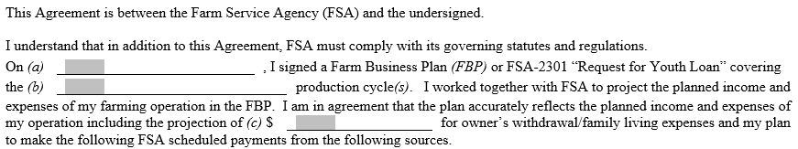
CHANGE
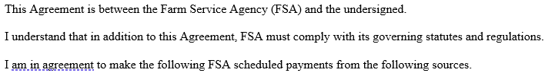

Change 2: Part 1 of Page 2.
Update the fifth paragraph to read: “I understand that the proceeds from the sale of normal income security must always be used to pay expenses and loan payments.”
CURRENT
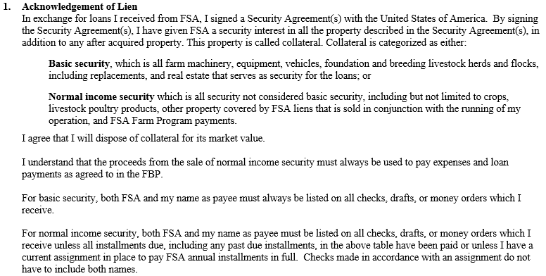
CHANGE
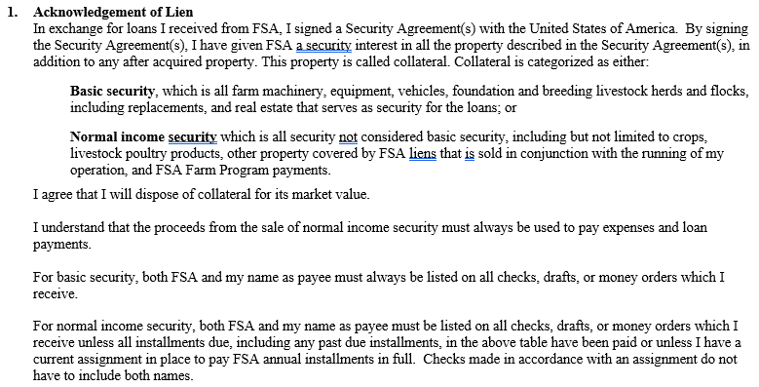

Change 3: Part 2 of Page 2.
Update language of first paragraph to read: “Yes. By signing this agreement, FSA and I have agreed on the source of income to pay FLP installments.”
Remove the second paragraph which states: “If the actual income and/or expenses are not in accordance with what we originally projected, FSA and I must discuss the changes and make any needed changes to the FBP and/or this agreement.”
Update language of the third paragraph to read: “I may request and report changes to the source of income to pay FLP installments by telephone, letter, or visit to the FSA office. A trip to the office is not always necessary. However, if my requested or reported changes would result in a major change in my operation, FSA may request that I attend a conference.”
CURRENT
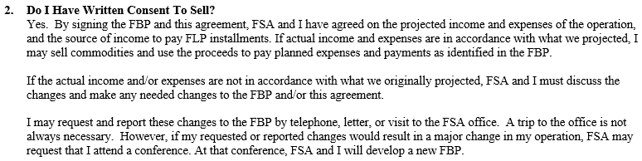
CHANGE
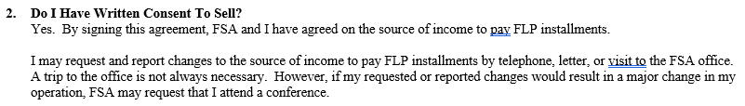

Change 4: Part 3 of Page 2.
Update language of first paragraph to read: “If FSA and I disagree on how to complete or make changes to this Agreement, FSA must send me a letter which describes the items on which we do not agree. The letter must explain why we do not agree. The letter must also tell me how I may appeal FSA’s decision.”
Update language of third paragraph to read: “When my appeal is decided, FSA may ask me to sign a revised Agreement reflecting the decision on the appeal.”
Update language of fourth paragraph to read: “If I do not sign, FSA will give me a copy of the revised agreement. FSA will consider the revised Agreement to be binding. If I violate this Agreement, FSA will take the actions described below in the Item 9, entitled, "What Happens if I Violate This Agreement?"
CURRENT
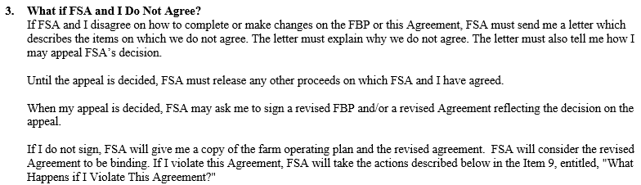
CHANGE
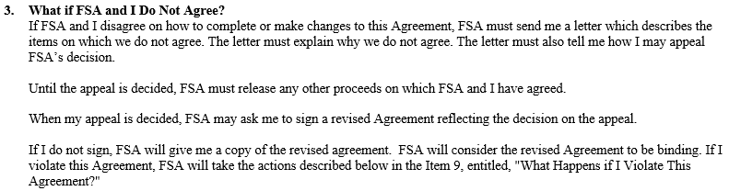

Change 5: Part 4 of Page 3.
Update language of first paragraph to read: “I understand that I must keep a record of collateral disposed of, and the proceeds thereof, in an approved record keeping system. I understand that if I sell normal income security, the proceeds will be applied to my FLP installments according to the table on page 1 or released to pay normal expenses and liens.”
Update language of item #2 in second paragraph replace “chattel” with “personal” to read: “Use the proceeds to purchase personal property suited to the needs of my operation provided FSA acquires a lien on the new property at least equal in value to the lien on the security sold.”
CURRENT
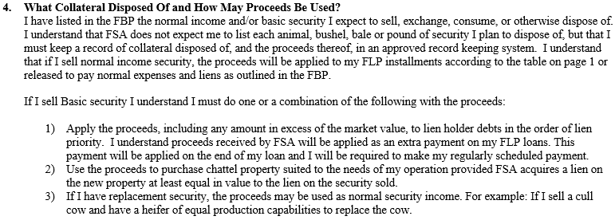
CHANGE
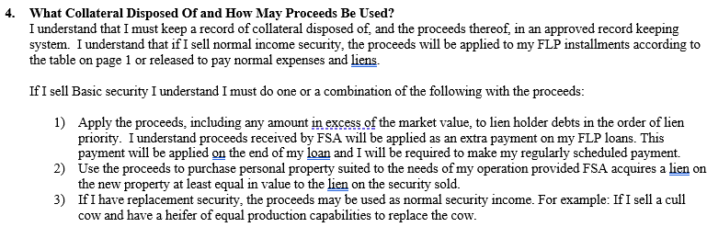

Change 6: Part 5 of Page 3.
Remove third sentence from the first paragraph so it reads: “FSA agrees to allow me to sell or exchange normal income security, such as crops, livestock, and livestock products marketed in the regular course of business so that I can pay essential family living and farm operating expenses. Essential expenses are those which are basic, crucial, or indispensable.”
CURRENT
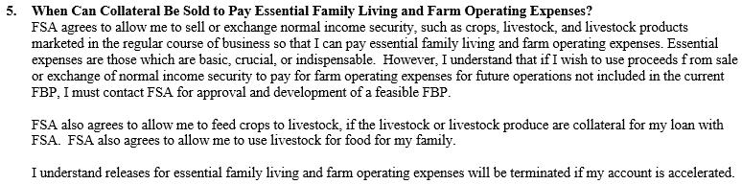
CHANGE
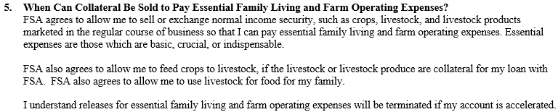

Change 7: Part 9 of Page 5.
Remove reference to “FBP” in first sentence of paragraph to read: “If I sell, exchange, or dispose of collateral for less than its present market value, or use the money in a way not listed in this Agreement without your permission, I will have violated this loan Agreement and your security interest in the collateral will not be released.”
CURRENT
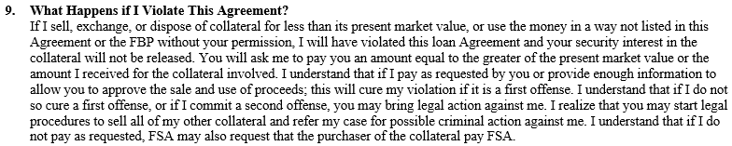
CHANGE
