Request for Nonsubstantive Change
ICR 0560-0230
ICR 0560-0236
July 28, 2026

FSA DAFLP - LSPMD conducted a review of FSA-2062, and Instructions. This is a request for approval of nonsubstantive changes.

The changes include terminology and instructions which are being made to align the form with corresponding policy changes that will simplify and streamline the subordination process. The changes do not affect response time and burden.

FORM: FSA-2062 “Application for Subordination of Security for Commercial Credit” (5 Changes)

Change 1: Changes to Part A, Item 1 “Borrower Request”

CURRENT
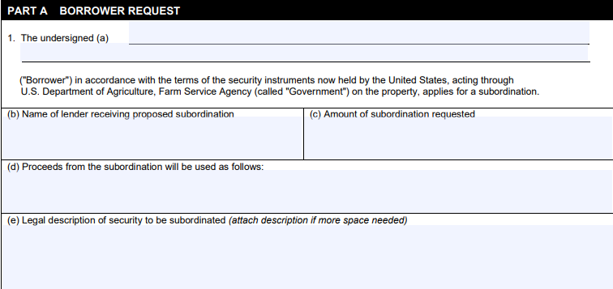

CHANGE
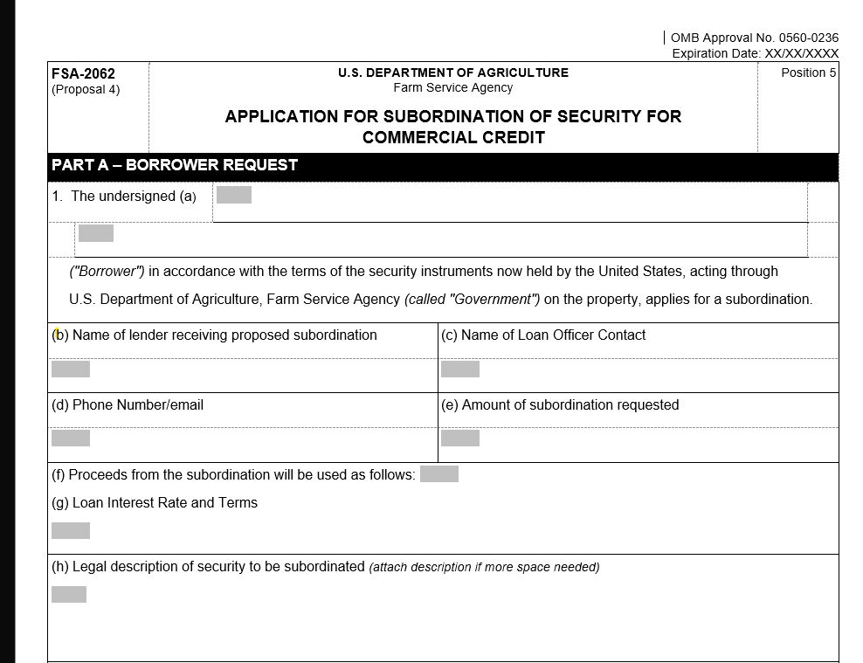
- Changed “(c) Amount of subordination requested” to “(c) Name of Loan Officer Contact”
- Changed “(d) Proceeds from the subordination will be used as follows:” to “(d) Phone number/email”
- Changed “(e) Legal description of security to be subordinated (attach description if more space needed)” to “(e) Amount of subordination requested”
- Moved “(c) Amount of subordination requested” to “(e) Amount of subordination requested”
- Moved “(d) Proceeds from the subordination will be used as follows:” to “(f) Proceeds from the subordination will be used as follows:”
- Added (g)”Loan Interest Rates and Terms”
- Moved “(e) Legal description of security to be subordinated (attach description if more space needed)” to “(h) Legal description of security to be subordinated (attach description if more space needed)”

Change 2: Shortened Part A Item 2 to 11 fillable rows

CURRENT
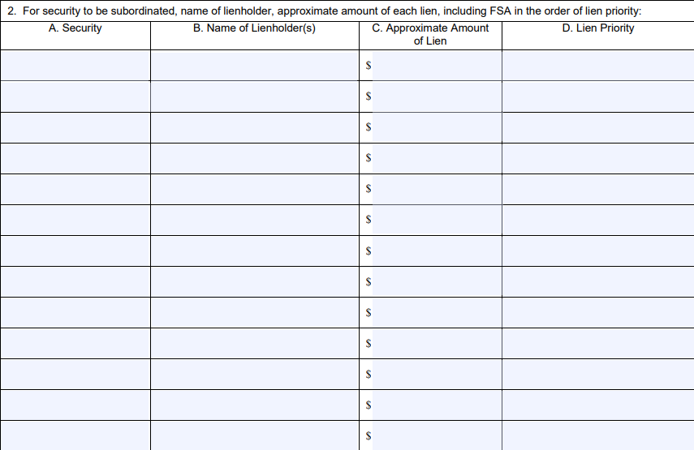

CHANGE
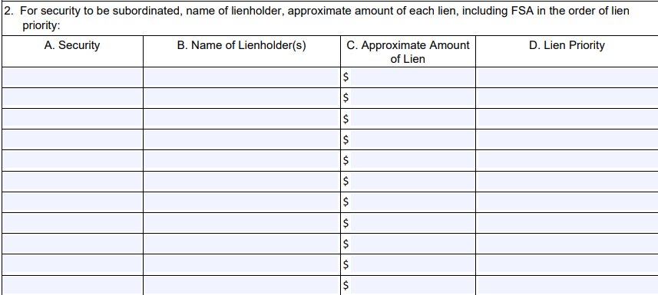

Change 3: Changes to Part A, Item 3

CURRENT
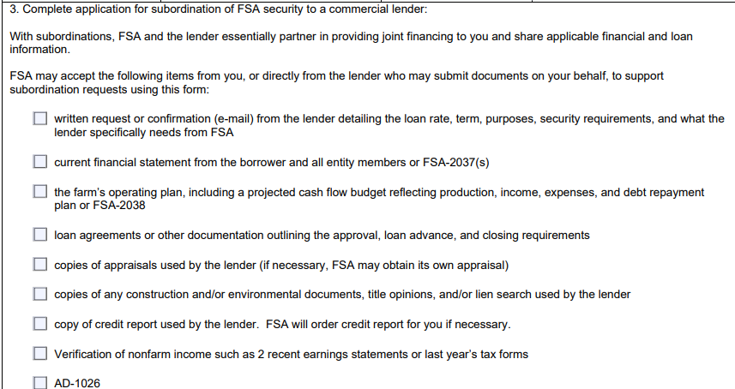

CHANGE
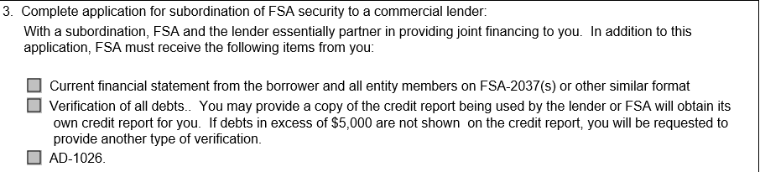

- Changed “With subordinations, FSA and the lender essentially partner in providing joint financing to you and share applicable financial and loan information. FSA may accept the following items from you, or directly from the lender who may submit documents on your behalf, to support subordination requests using this form:” to “With a subordination, FSA and the lender essentially partner in providing joint financing to you. In addition to this application, FSA must receive the following items from you:”
- Removed “written request or confirmation (e-mail) from the lender detailing the loan rate, term, purposes, security requirements, and what the lender specifically needs from FSA”
- Changed “current financial statement from the borrower and all entity members or FSA-2037(s)” to “Current financial statement from the borrower and all entity members on FSA-2037(s) or other similar format”
- Removed “the farm’s operating plan, including a projected cash flow budget reflecting production, income, expenses, and debt repayment plan or FSA-2038
- Removed “loan agreements or other documentation outlining the approval, loan advance, and closing requirements”
- Removed “copies of appraisals used by the lender (if necessary, FSA may obtain its own appraisal)”
- Removed “copies of any construction and/or environmental documents, title opinions, and/or lien search used by the lender”
- Removed “copy of credit report used by the lender. FSA will order credit report for you if necessary.”
- Added “Verification of all debts. You may provide a copy of the credit report being used by the lender or FSA will obtain its own credit report for you. If debts in excess of $5,000 are not shown on the credit report, you will be requested to provide another type of verification.”
- Removed “Verification of nonfarm income such as 2 recent earnings statements or last year’s tax forms”

Change 4 – Changes to Part B, “Notifications, Certifications, and Acknowledgement”
CURRENT
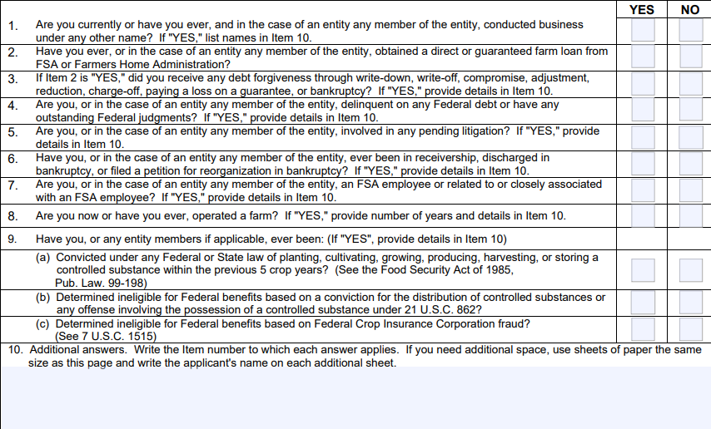
CHANGE
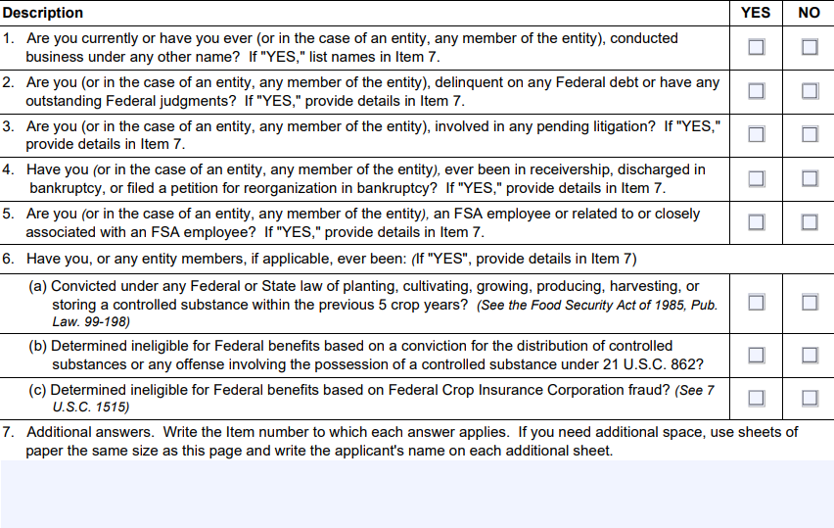
- Changed “Item 10” to “Item 7” in Part B. #1
- Removed “Have you ever, or in the case of an entity any member of the entity, obtained a direct or guaranteed farm loan from FSA or Farmers Home Administration?”
- Removed “If Item 2 is "YES," did you receive any debt forgiveness through write-down, write-off, compromise, adjustment, reduction, charge-off, paying a loss on a guarantee, or bankruptcy? If "YES," provide details in Item 10.”
- Changed “Item 10” to “Item 7” in Part B #2
- Changed “Item 10” to “Item 7” in Part B #3
- Changed “Item 10” to “Item 7” in Part B #4
- Changed “Item 10” to “Item 7” in Part B #5
- Changed “Item 10” to “Item 7” in Part B #6
- Renumbered 4,5,6,7,8,9,10,11,12,13,14,15 to 2,3,4,5,6,7,8,9,10,11,12.

Change 5 – Changes to Part C “Certification and Signatures”
CURRENT
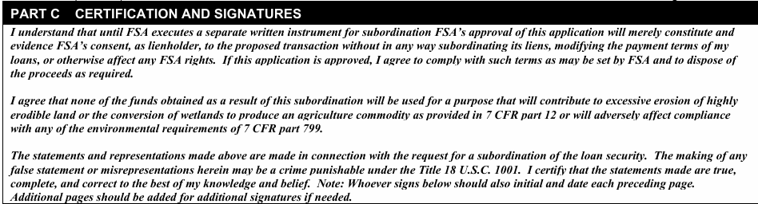

CHANGE
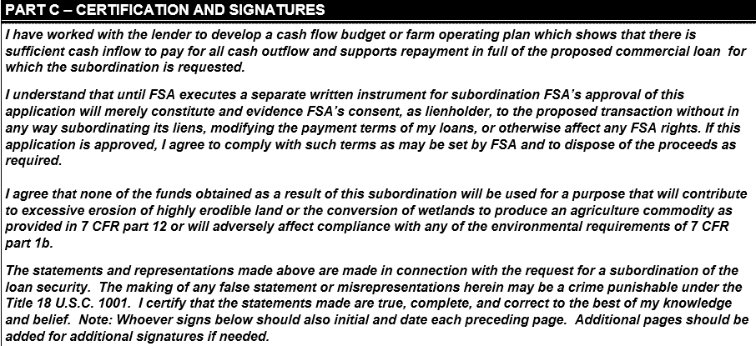

- Added “I have worked with the lender to develop a cash flow budget or farm operating plan which shows that there is sufficient cash inflow to pay for all cash outflow and supports repayment in full of the proposed commercial loan for which the subordination is requested.”
- Changed “7 CFR part 799” to “7 CFR part 1b”

