Attachment B1_Public Comment to the 60-Day Federal Register Notice and Program Response
- Public Comment
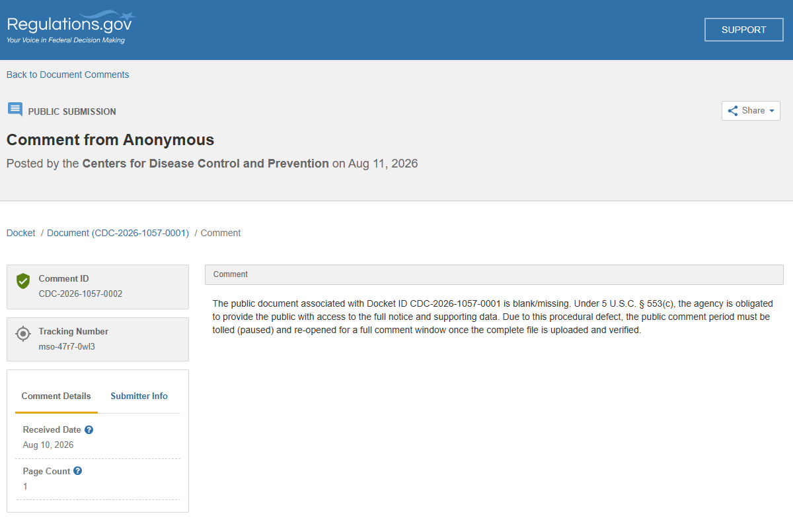
- Program Response to Comment
A 60d FRN was published on August 10, 2026 for the Application Form and Related Forms for the Operation of the National Death Index (NDI) (OMB Control No. 0920-0215)—Reinstatement—National Center for Health Statistics (NCHS), Centers for Disease Control and Prevention (CDC). One anonymous comment was received that indicated the FRN was posted incorrectly. However, both www.fdms.gov and www.regulations.gov indicated that the actions were taken correctly and that the Docket was made available for 60 days for public comment. The missing/blank document was the result of a system error. In response to the commenter, CDC posted a second 60d FRN and will respond to any comments received.

