Att 5b Instrument and Protocol Implementation Capacity Assessment (ICA)
Form Approve
OMB No: 0920-1425
Exp. Date: 12-31-2026

Public Reporting burden of this collection of information is estimated at .5 hours, including the time for reviewing instructions, searching existing data sources, gathering and maintaining the data needed, and completing and reviewing the collection of information. An agency may not conduct or sponsor, and a person is not required to respond to a collection of information unless it displays a currently valid OMB control number. Send comments regarding this burden estimate or any other aspect of this collection of information, including suggestions for reducing this burden to CDC/ATSDR Reports Clearance Officer, 1600 Clifton Road NW, MS D-74, Atlanta, GA 30333; Attn: PRA (0920-1425).

Recipient:
Reporting Period:
Contact Person:

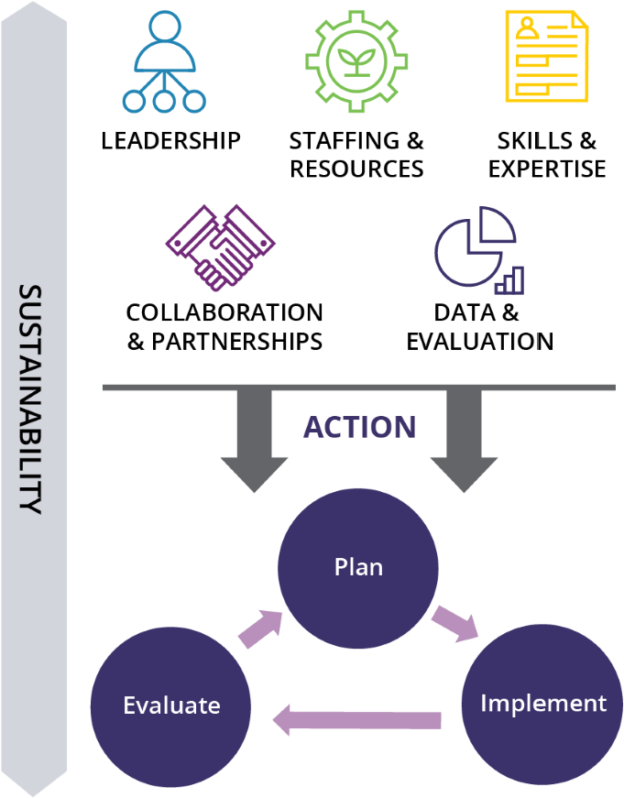
Organization Name:
Date of Assessment:
Your Capacity: The Big Picture
The General Capacity Assessment for Violence Prevention assessed five areas of capacity that your
organization might need to implement violence prevention interventions. This graph summarizes the
capacity scores for each area.
Overall Capacity:
Leadership
Staffing & Resources
Skills & Expertise
Collaboration & Partnerships
Data & Evaluation
How do I interpret my report?
This assessment is organized into five overarching domains: LEADERSHIP,
STAFFING, SKILLS, COLLABORATION, and DATA. These five sections are
key areas necessary for organizations to implement, evaluate, and sustain
violence prevention strategies (see Figure 1).
This report provides the overall score for each capacity area. The score
for each capacity area is given as a percentage. For example, the highest
possible score on LEADERSHIP is a 5. If your average score was a 3, your
organization received a 60% (or 3/5) of the maximum score. If your group
got a 4 in this area, you got 80%, and so on. Each section also includes a
record of the responses to individual questions within each section.
Note that there is no cutoff number for a “good score” or a “bad score.”
Scores are designed to identify areas with relatively high or low capacity.
The scores can serve as a tool to start conversations and help prioritize
areas to build capacity. You can leverage your organization’s strengths,
assets, and opportunities to implement and evaluate your violence
prevention efforts.
FIGURE 1
How do I use my report?

Once you have reviewed your Capacity Assessment Report, it may be helpful to prioritize capacity areas that you would like to focus on. Additionally, your organization or community may also want to implement capacity-building activities for areas with the lowest scores. It may also help to use this report to guide discussions among leadership and staff at your organizations. There are many important factors to consider as you plan your capacity-building efforts.
Capacity Assessment Report
- How important is this capacity area to the success of your prevention work? Is it an area that your organization or community values? Will it help enhance your community’s ability to implement prevention programming?
- How feasible is it to make changes in each capacity area? For example, are resources available to help build capacity in this area? Can those changes be made on a timeline that will benefit your organization?
Resources
Below is a link to resources that may help your organization build capacity for your violence prevention
efforts. The information provided is not intended to be comprehensive or applicable only to violence
prevention. The purpose of providing these resources is to provide you with tools and approaches that may
be relevant and appropriate for your work in building capacity to prevent, evaluate, and sustain prevention
efforts in your communities.
Capacity Area Resources:

https://vetoviolence.cdc.gov/apps/capacity-assessment-tool/resource
s
In addition, a more comprehensive list of resources can be found in the tool Violence Prevention in Practice
at
https://vetoviolence.cdc.gov/apps/violence-prevention-practice/resources
/

Notes

 Leadership
This domain assesses organizational leadership’s commitment and knowledge. Leadership is defined as a person or group of people who have the primary responsibility to be spokespeople and decision-makers. Questions also assess community leaders and their support for violence prevention efforts.
Scores in this area could range from 20% - 100%.
Overall Section Score:
My organization’s leaders are: | 1 | 2 | 3 | 4 | 5
Knowledgeable about violence prevention.
Committed to preventing violence.
Able to obtain the necessary financial resources for prevention.
Strong advocates for violence prevention.
Motivated to ensure that violence prevention strategies are a success.
Supportive of staff implementing violence prevention strategies.
Able to effectively communicate violence prevention messages to stakeholders.
Able to gain support from elected or appointed officials when needed.
Able to develop new opportunities for younger persons and newer staff to take on leadership roles.
My community leaders: | 1 | 2 | 3 | 4 | 5
Exhibit a strong commitment to violence prevention.
Are strong advocates for violence prevention.
Share a common vision or plan for violence prevention.
Understand cultural context and systemic factors that cause and perpetuate violence in their communities.
Notes

 Staffing & Resources
This domain assesses general organizational set-up, staffing, and management.
Scores in this area could range from 20% - 100%.
Overall Section Score:
Staff who work or will work on a violence prevention strategy: |  | 1 |  | 2 |  | 3 |  | 4 |  | 5
Are quick to ask for help and help one another when needed.
Know which activities to implement and how to implement them.
Collaborate well with other units/staff in my organization to accomplish common goals.
Resources: |  | 1 |  | 2 |  | 3 |  | 4 |  | 5
There are enough staff members at my organization to implement a violence prevention strategy.
Staff turnover at my organization does not interfere with implementing a violence prevention strategy.
My organization has the fiscal resources to implement a violence prevention strategy.
My organization includes violence prevention efforts in the annual budget.
My organization has multiple funding sources for violence prevention.
My organization has at least one staff position devoted to violence prevention efforts.
Staff time allocated to a violence prevention strategy is protected (i.e., staff members would not be pulled away to do other work).
 | Sustainability |  | 1 |  | 2 |  | 3 |  | 4 |  | 5
 | There will be or are opportunities for violence prevention to be integrated with other health-related prevention programs.
 | My organization is planning for the sustainability of our violence prevention strategies.
 | My organization is looking for other funding resources to support violence prevention.
 | My organization’s violence prevention strategies are likely to be sustained.
 | My organization is committed to the long-term goals of the community’s violence prevention strategies.
 | My organization’s violence prevention strategies are part of a collaborative effort with other agencies to prevent violence.
 | Violence prevention efforts supported by our community have demonstrated sustainability.

 Skills & Expertise
This domain assesses staff and leadership knowledge and experience related to violence prevention.
Scores in this area could range from 20% - 100%.
Overall Section Score:
My organization has staff who: | 1 | 2 | 3 | 4 | 5
Are knowledgeable about violence.
Are knowledgeable about evidence-based violence prevention programs.
Have skills in selecting and adapting prevention programs that reflect the needs of the population.
Are experienced in overseeing community-level prevention efforts.
Are encouraged to attend training specific to violence prevention.
Have the necessary skills to support violence prevention at the community level.
Are knowledgeable about when, why, and how to develop partnerships.
Have the ability to distinguish between levels of partnerships (i.e., communication, cooperation, coordination, and collaboration) and identify when each is appropriate in various circumstances.
Can effectively monitor the implementation and effectiveness of violence prevention programs and strategies.
Can influence laws and policies related to risk and protective factors for violence.
Understand the importance of developing and enhancing policy related to violence prevention.
Notes

 Collaboration & Partnerships
This domain assesses the type and level of partner relationships and community unity among key stakeholders involved with preventing violence. Community partnerships are important for success. Working together with partners to share ideas and resources can help make violence prevention efforts more effective.
Scores in this area could range from 20% - 100%.
Overall Section Score:
My organization has staff who: | 1 | 2 | 3 | 4 | 5
Are part of a network of organizations committed to preventing violence.
Have strong relationships with community leaders.
Share ideas or information about violence prevention with other organizations and groups.
Work with community groups in the area with a history of successful collaboration to address violence prevention.
Have community groups in the area with a history of successful collaboration to address violence prevention.
Have community groups that may disagree over ideas, but these disagreements do not typically lead to a breakdown in the progress of violence prevention efforts.
Have a community plan for violence prevention that guides the work of multiple organizations.
Are part of a community that can accomplish its violence prevention goals.
Are part of a community where groups do not have turf conflicts about violence prevention efforts.
Can demonstrate the existence of partnerships with diverse communities and those not usually involved in violence prevention.
Are part of a community where elected or appointed figures are supportive of violence prevention efforts.
Notes

 Data & Evaluation
This domain assesses staff knowledge and understanding of data collection, performance monitoring, and using data to inform organizational decisions and policies. An important part of identifying strategies that fit your community needs and tracking results is having access to local data on violence and the expertise and capacity for program evaluation. Data could include surveillance data, administrative or program data, evaluation results, interviews, and other pieces of available information.
Scores in this area could range from 20% - 100%.
Overall Section Score:
My organization has staff who: | 1 | 2 | 3 | 4 | 5
Have sufficient data on the needs and resources of the population being served.
Link our data system with other relevant agencies’ data systems.
Access data about violence outcomes and related risk and protective factors in the community.
Routinely share data across the public health system.
Use data to drive decisions about priorities, resources, and staffing.
Have processes in place to monitor implementation to ensure violence prevention activities are being carried out as they were intended.
Use data, evaluation results, and feedback to make adjustments when implementation challenges are identified or when intended effects are not obtained.
Support using staff time to evaluate the effectiveness of violence prevention strategies.
Notes

