Current IKN Desktop and Mobile Survey
Page 1
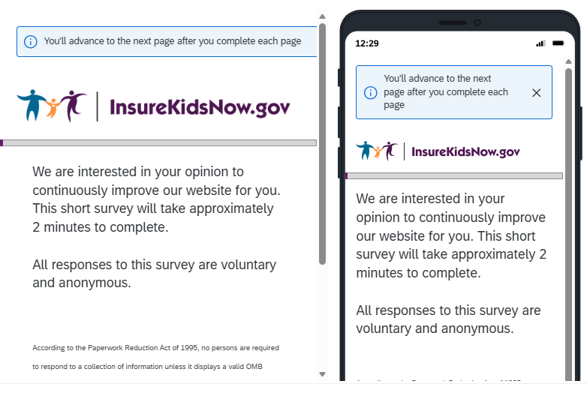
Page 2
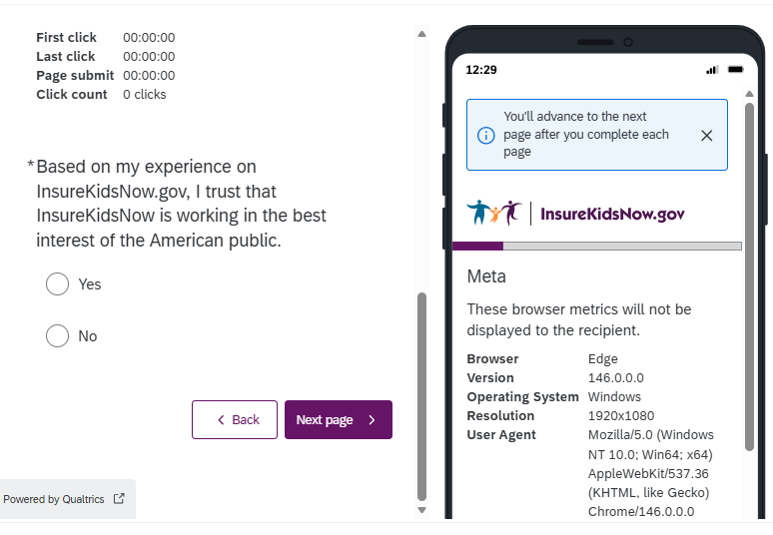

Page 3
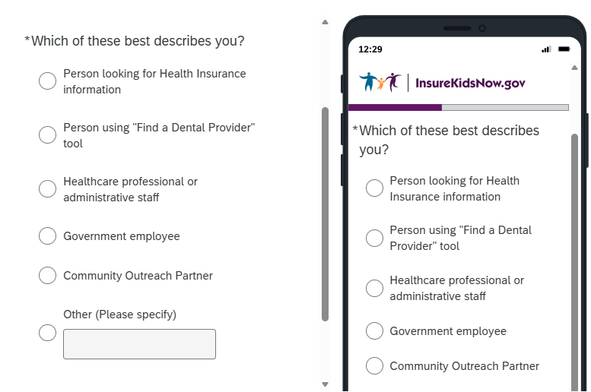
*note: if “Other” is selected, the user can enter free-text
Page 4
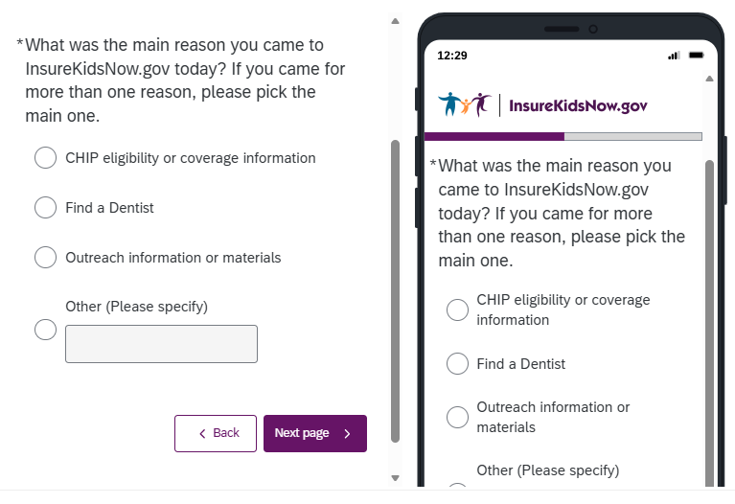
*note: if “Other” is selected, the user can enter free-text
Page 5
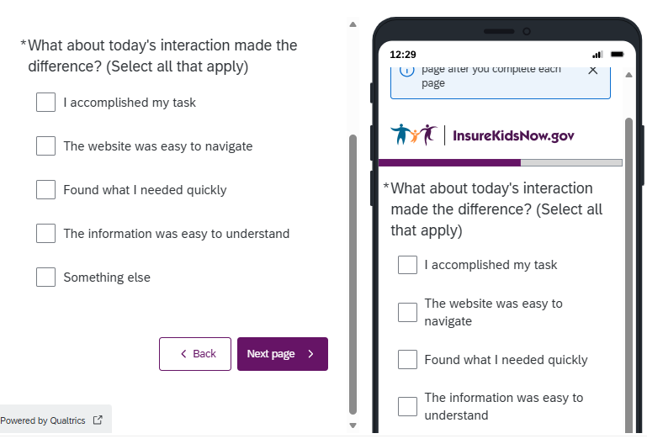
MINIMAL CHANGES TO WORDING
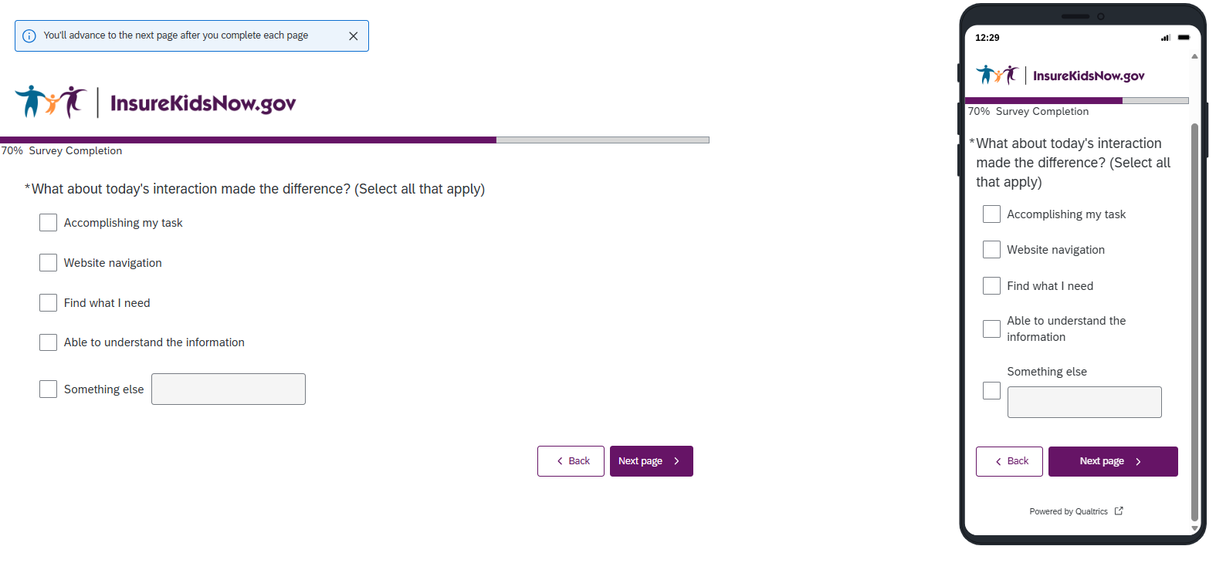

Page 6
REMOVING THIS QUESTION
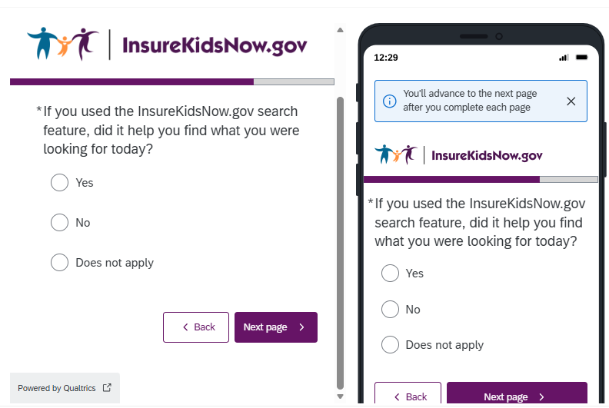
ADDING THIS QUESTION
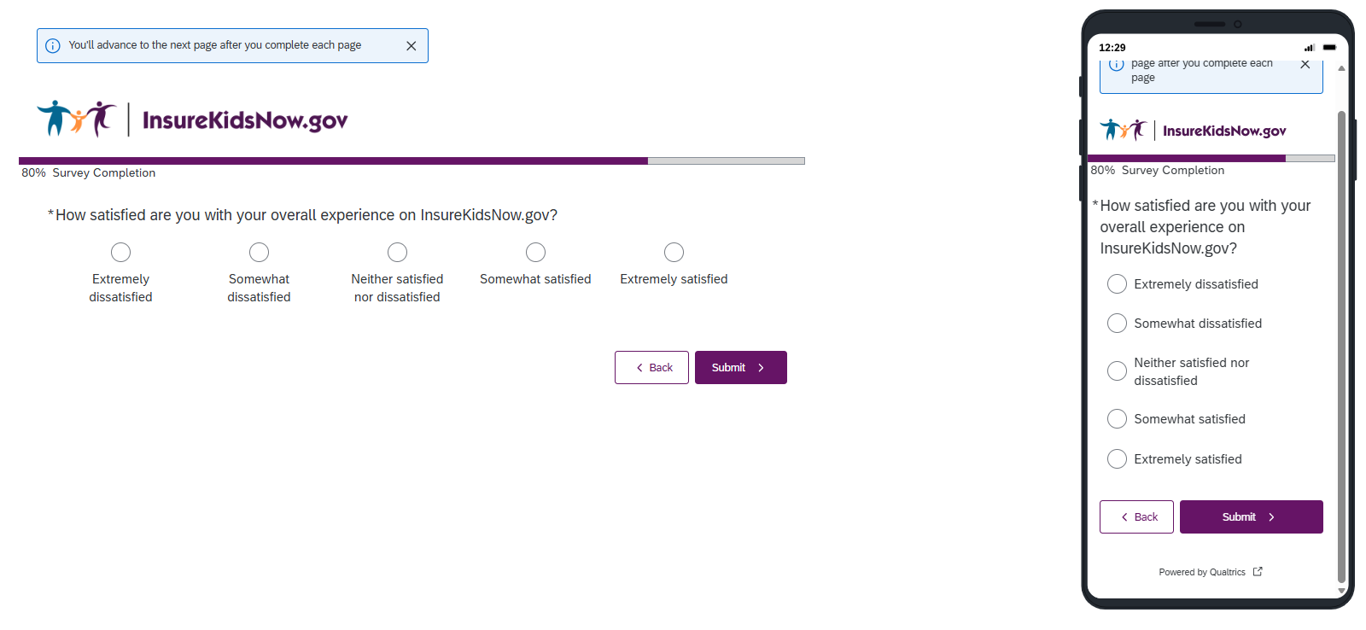

Page 7
