Current to Future Medicaid.gov Desktop and Mobile Survey
Page 1: Added line for comments to Medicaid_Feedback inbox
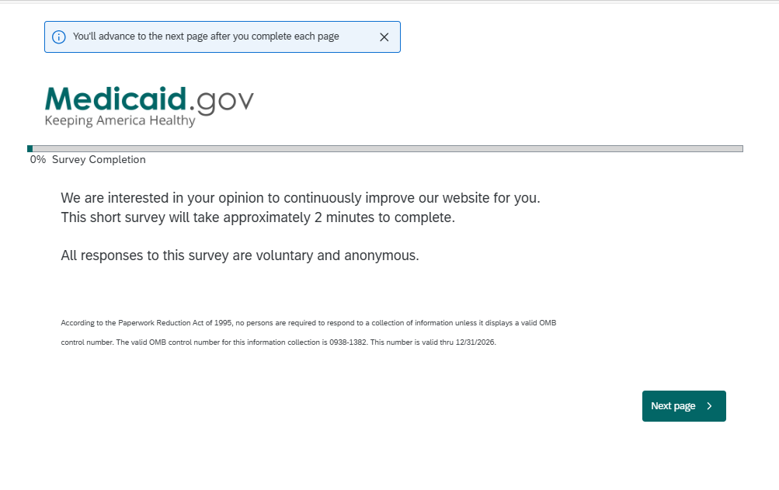
Please send comments about this survey to: Medicaid_Feedback@cms.hhs.gov.
Page 2: No change
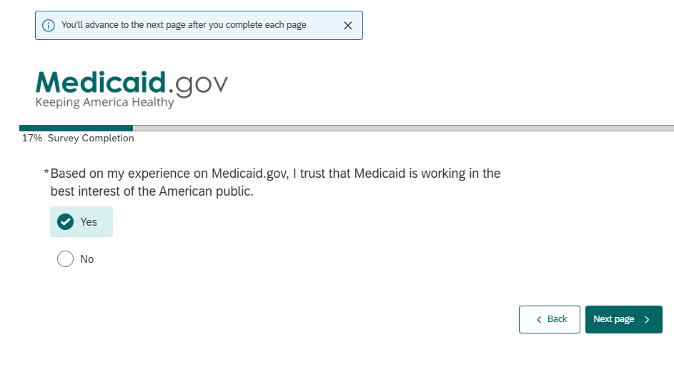
Page 3: Minor wording change
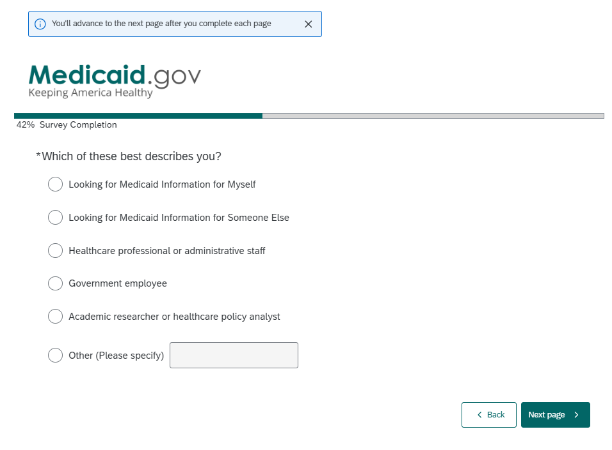
*note: selecting “Other” provides the opportunity to add free text
MINOR WORDING CHANGES TO EXISTING CATEGORIES
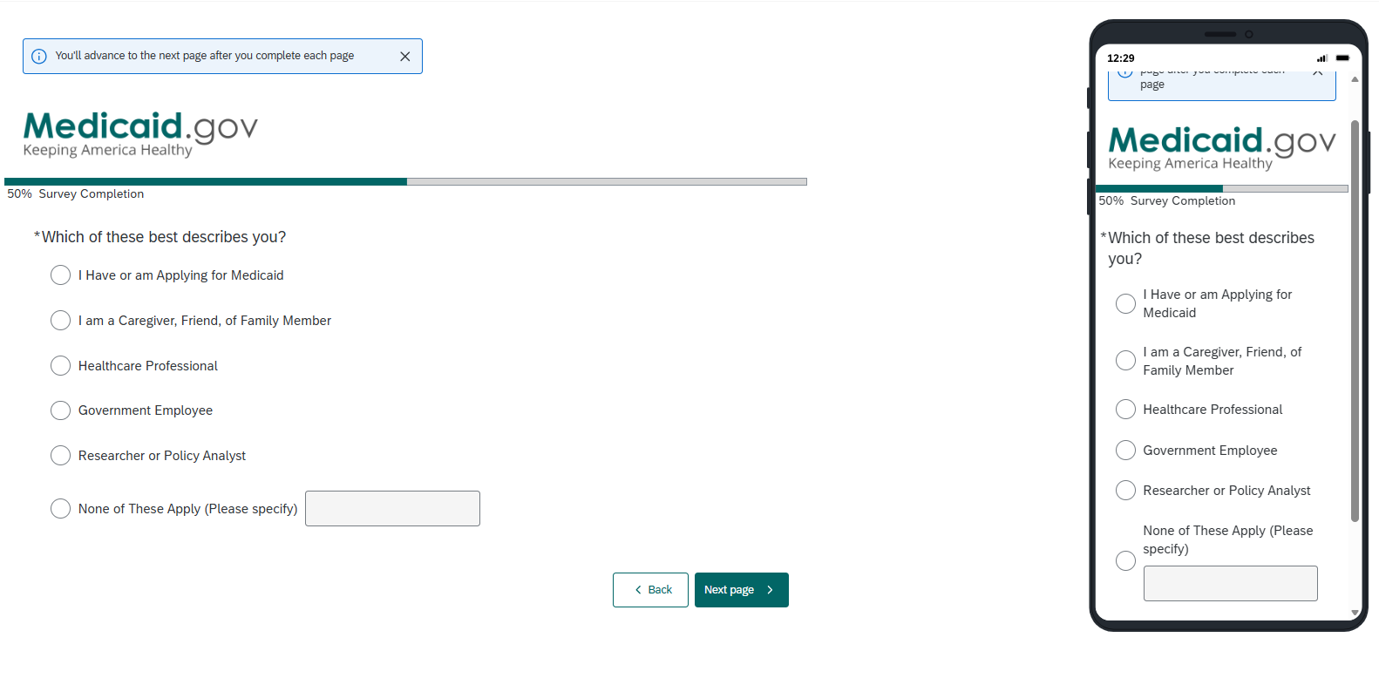
Page 4: No change
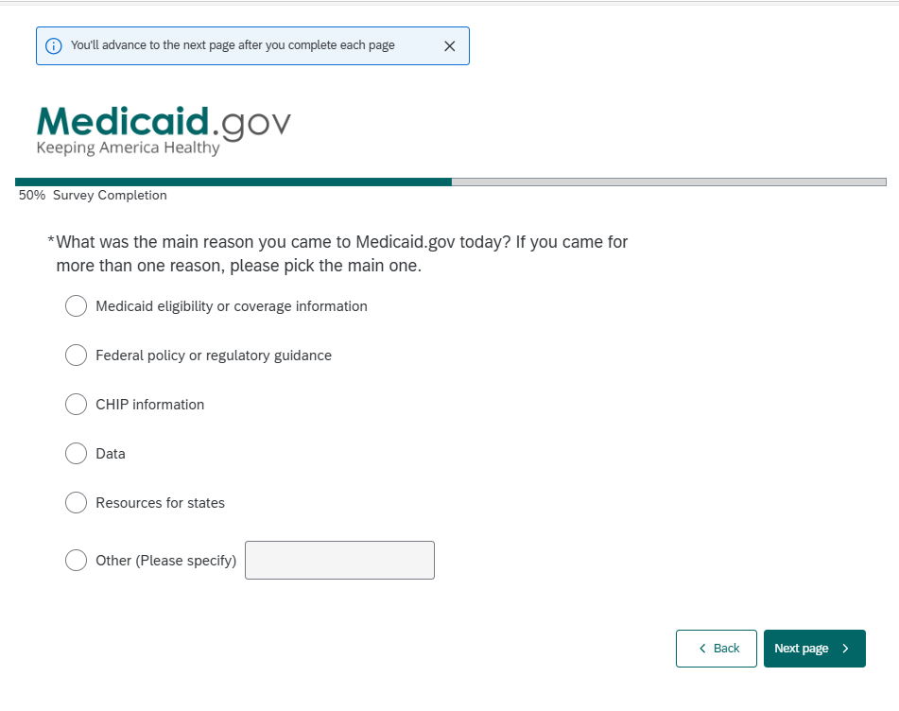
*note: selecting “Other” provides the opportunity to add free text

Page 5: Shown if the Trust Question is answered “Yes”
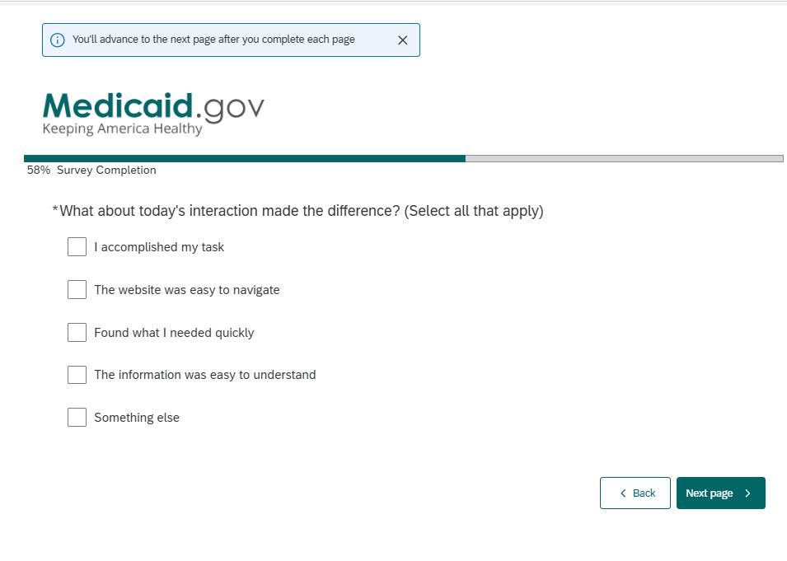
Page 5: Shown if the Trust Question is answered "No”
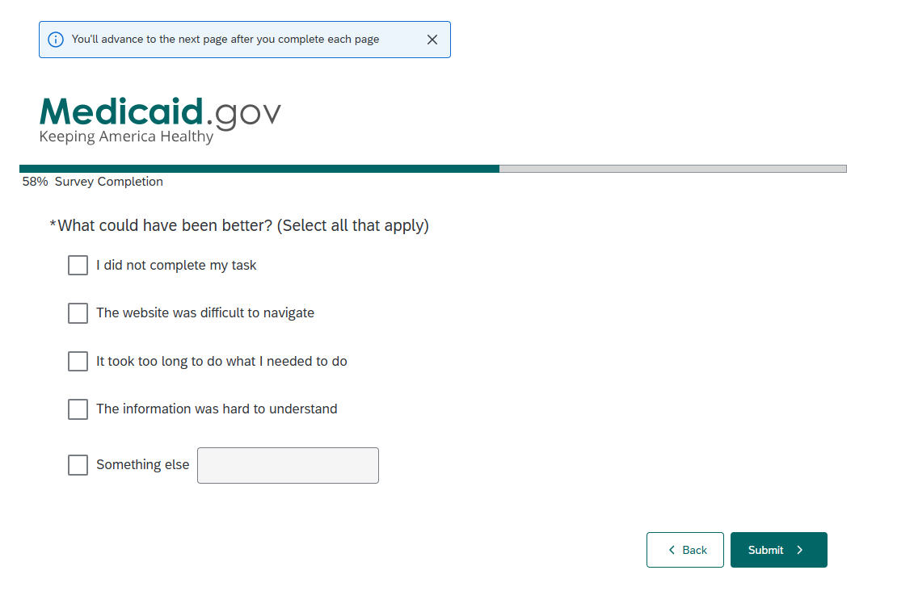
Page 6: Question deleted (no longer relevant)

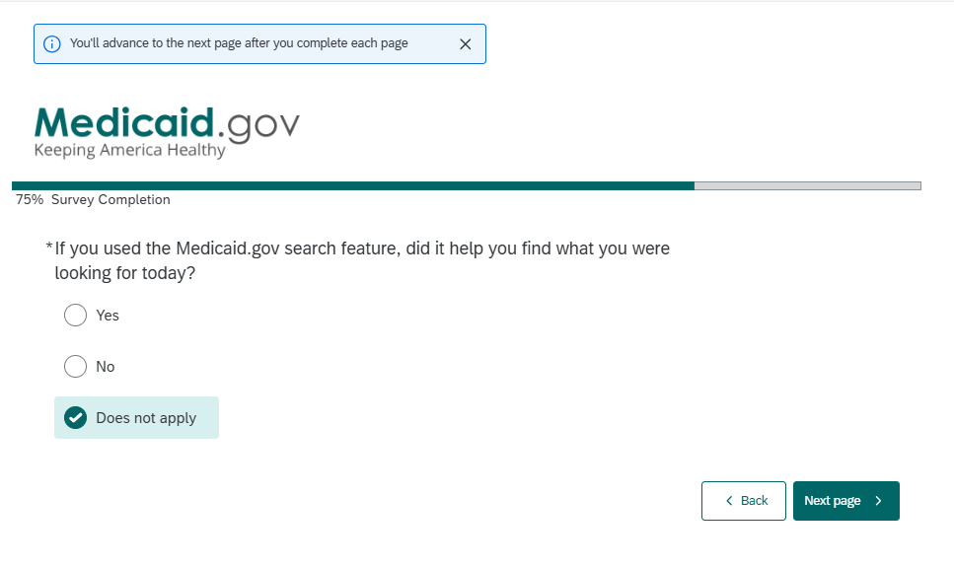

ADDING/Replacing with this question
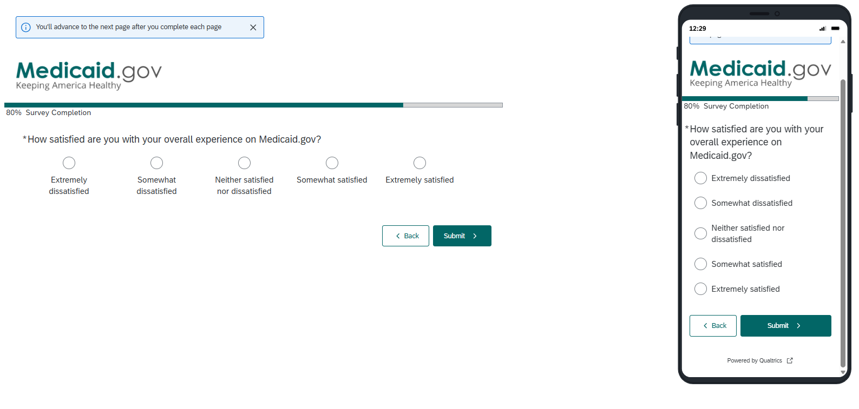
Page 7: Shown if the Trust question is answered “Yes”
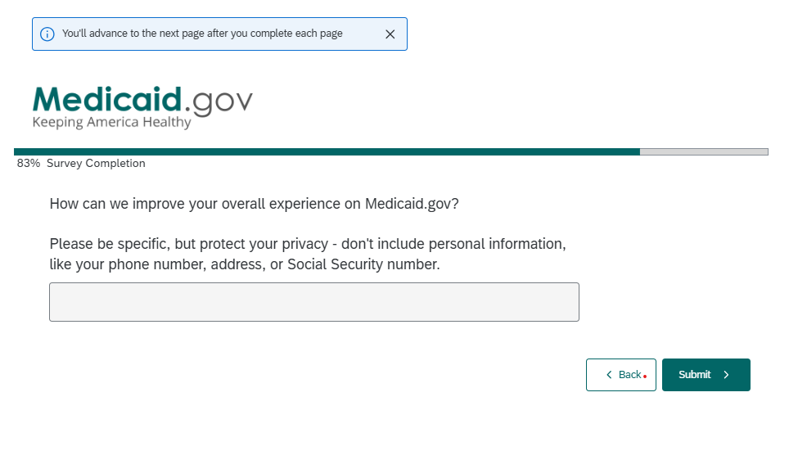
Page 7: Shown if the Trust question is answered "No”
