Critical Payment System (CPS): Screen Package

Table of Contents

- CPS Web App Home Page
- CPS Home Page – CPS Search Results
- CPS Payment Detail Screen
- CPS Payment Amount Screen
- CPS Payment Schedule Screen
- CPS Whom to Pay Screen
- CPS Payment Summary Screen
- CPS Statement of Claimant or Other Person (SSA-795) Screen (only for IP)
- CPS Confirmation Screen
- CPS Payment Approval Screens

CPS Web App Home Page

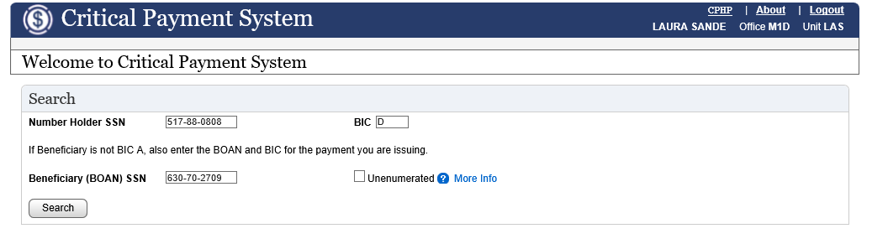

The Critical Payment Homepage (CPHP) searches for a claimant’s recent activities. A search is activated by entering the Beneficiary SSN or the Number Holder’s SSN (NHSSN) and the Beneficiary Identification Code (BIC).
CPS Home Page – CPS Search Results

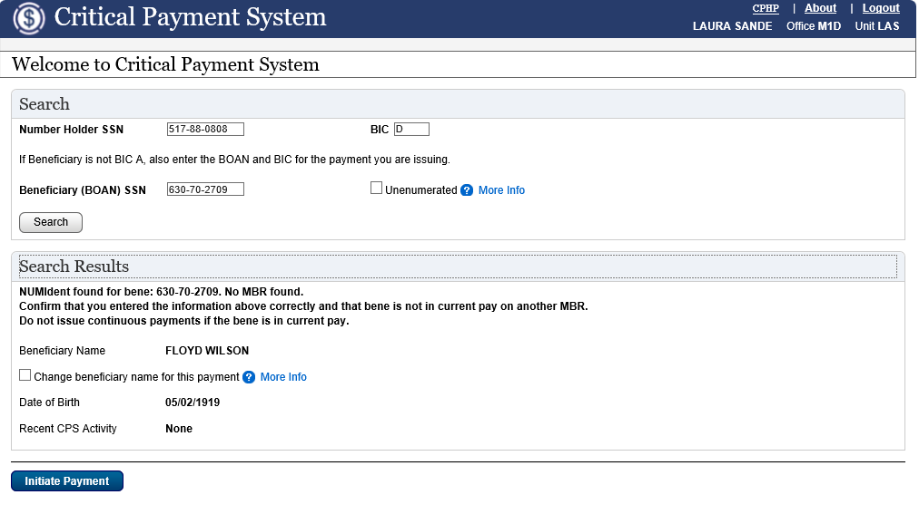

When Search Results are displayed on the Critical Payment Homepage (CPHP), the user may select the button that describes how they wish to begin a critical action for the beneficiary. For example, the user may initiate a payment.

CPS Payment Details Screen

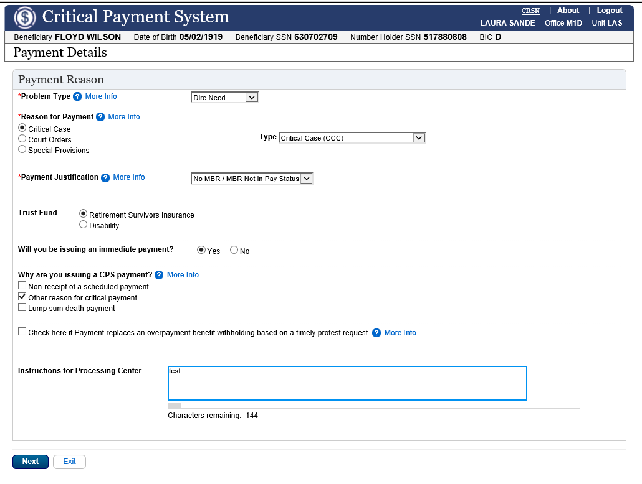

The Critical Payment Details (CRSN) web page:
- Identifies the payment type and reason.
- Indicates required processing (ex: payment from MBR).
- Provides the payment Trust Fund (ex: Disability) information.
- Indicates if an immediate payment (IP) will be issued.
- Provides the payment issue type (ex: non receipt of check).
- Indicates if a non-receipt and/or an overpayment is applicable, and Allows the user to enter pertinent instructions to the Processing Center (PC).

CPS Payment Amount Screen

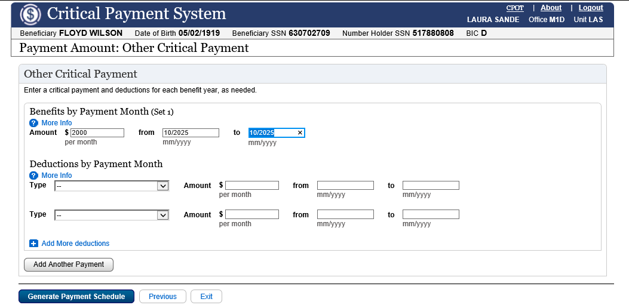

CPS Payment Schedule Screen

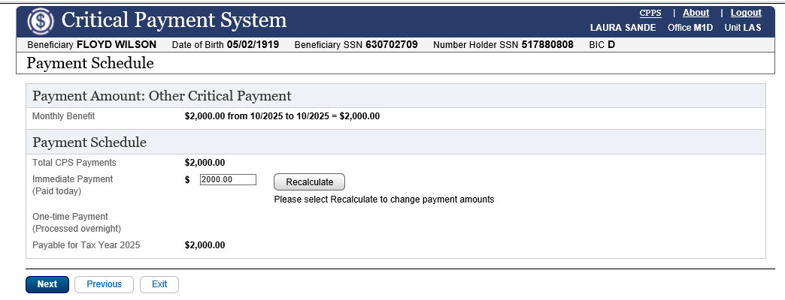

The Critical Payment Schedule (CPPS) web page allows users to see the total payments that are scheduled for payment. It also allows users to override the default Immediate Payment (IP) amount.
CPS Whom to Pay Screen – With ID Proofing

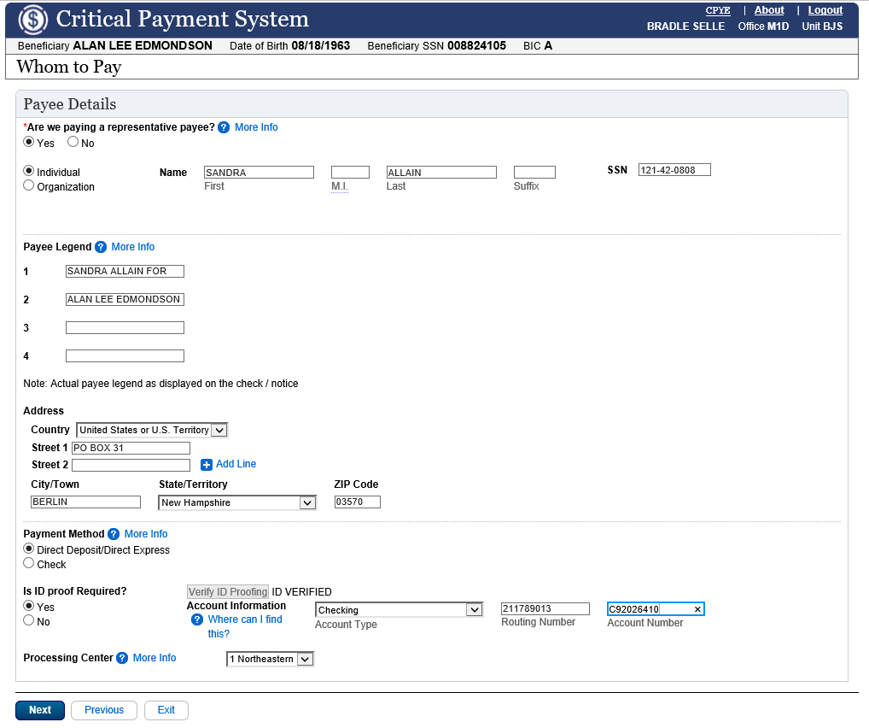

The Critical Payment Whom to Pay (CPYE) web page captures data for the following:
Representative Payee
The Representative Payee is the person receiving a CPS payment. The Representative Payee can be an Organization or an Individual. If there is no Representative Payee associated with the CPS payment, the beneficiary is the payee (Self). The Representative Payee name and address are recorded on the Critical Payment System Whom To Pay (CPYE) web page.
Payment Method
The payment method identifies the way the payment is issued. The CPS payment can be issued by Direct Deposit, Check, or Direct Express. Effective June 2025, users selecting ‘Direct Deposit/Direct Express’ for Payment Method must complete two verification steps:
- ID Verification for the beneficiary or individual representative payee
2. Verification of banking information

Processing Center: The Processing Center identifies the location of the Processing Center that is handling the CPS payment: Northeastern, Mid-Atlantic, Southeastern, Great Lakes, Western, Mid-America, ODO, or OIO.
CPS Whom to Pay Screen – Without ID Proofing
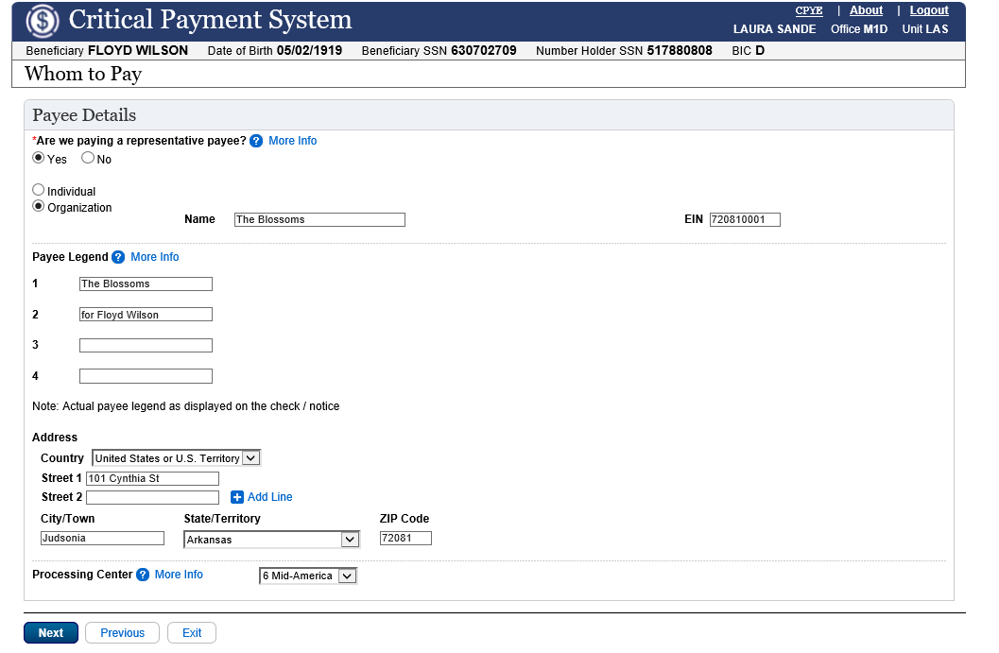
No verification of ID or banking information is required for immediate payments (IP).

CPS Payment Summary Screen

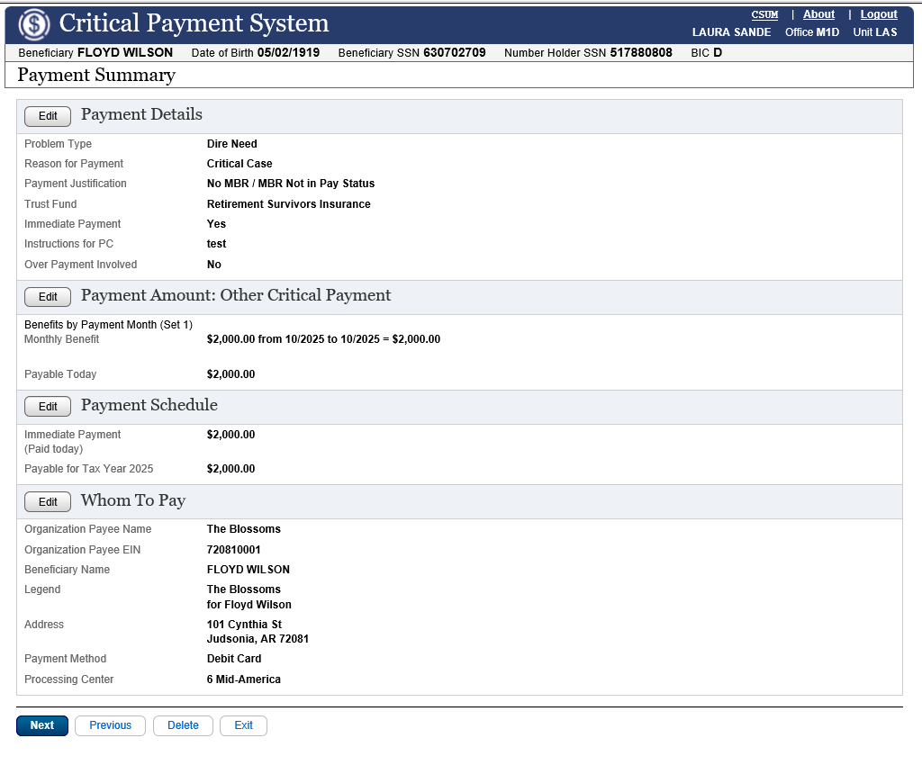

The Critical Payment System (CPS) Summary (CSUM) web page displays a synopsis of the transaction details. The user, based on the login credentials, can view and/or edit the transactions by navigating to different CPS application web pages.

CPS Statement of Claimant or Other Person (SSA-795) Screen

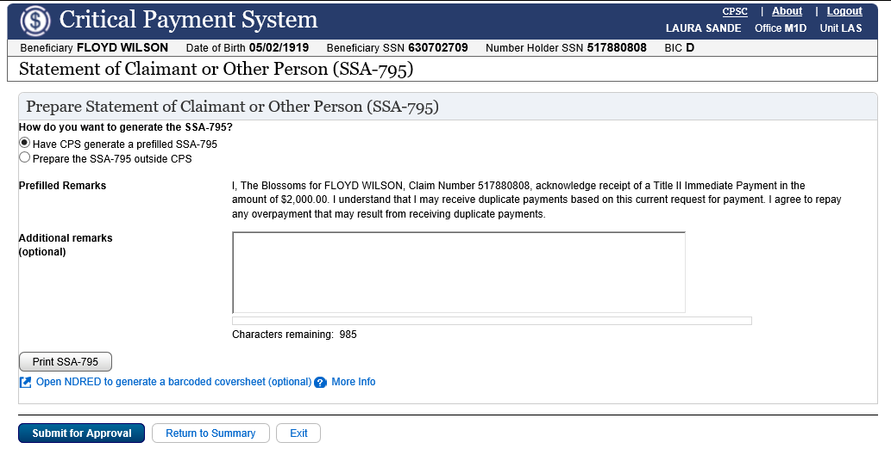
The Critical Payment System (CPS) Statement of Claimant or Other Person (SSA-795) (CPSC) web page appears in the screen path only when the user has answered “Yes” to the question “Will you be issuing an immediate payment” on the Payment Details web page.

CPS Confirmation Screen

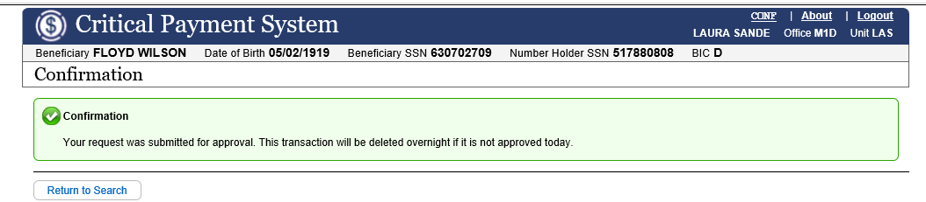

The overall purpose of the Confirmation (CONF) web page is to display confirmation and informational messages to the User after the User takes a Critical Payment System (CPS) action.
Confirmation and informational messages are not exception or edit messages. CPS will allow you to continue processing your transaction for approval. Also, depending upon the User’s actions, confirmation and informational messages can appear together on the same screen.

CPS Payment Approval Screens

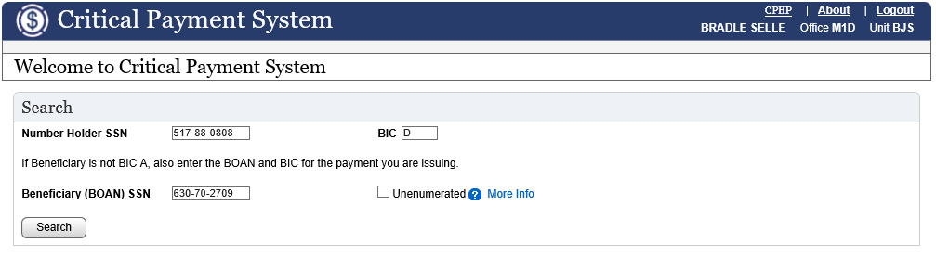

On the Critical Payment Homepage, enter the SSN and BIC (as well as the BOAN if the BIC is not ‘A’) of the CPS payment you are going to approve.

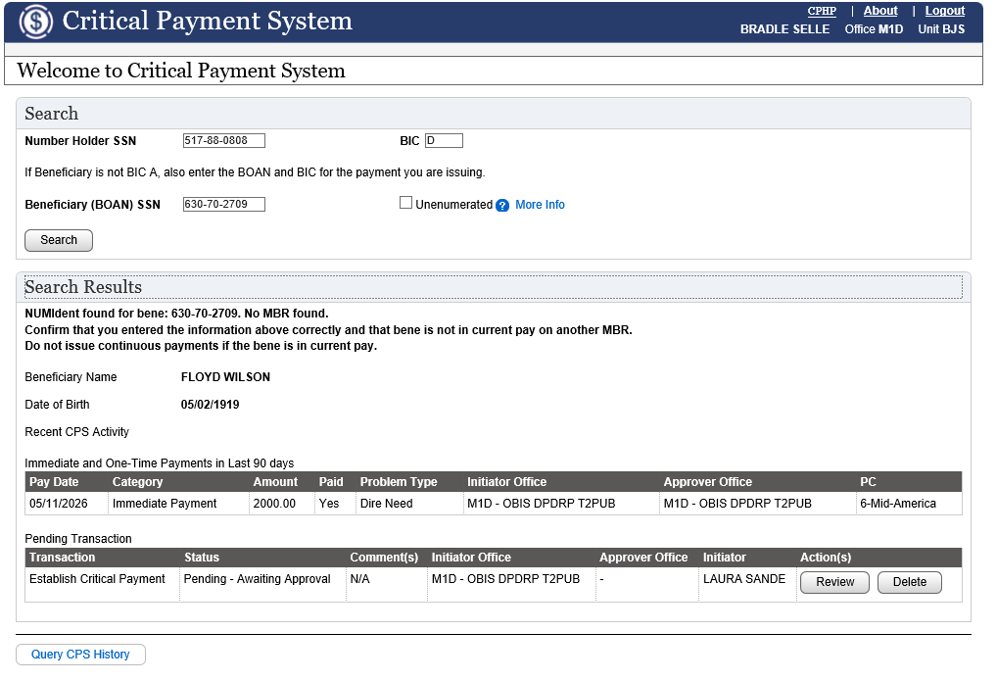

In the Search Results section of the Critical Payment Homepage (CPHP), you will see information for the pending critical payment with the status, ‘Pending – Awaiting Approval’. The available actions are ‘Review’ and ‘Delete’. Select ‘Review’.

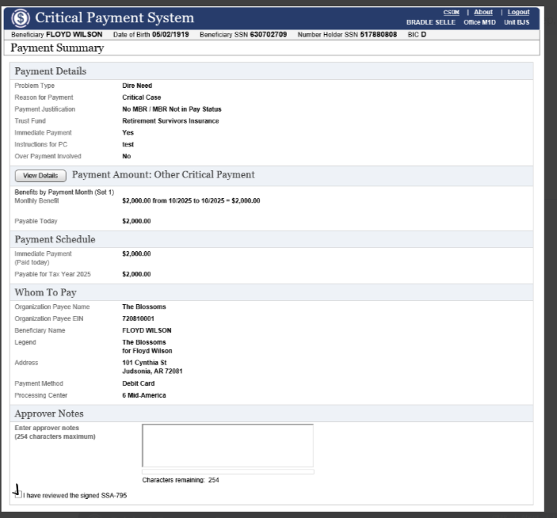

The Payment Summary screen is displayed. At the bottom of the page, check the box next to ‘I have reviewed the signed SSA-795’. Click ‘Next’.

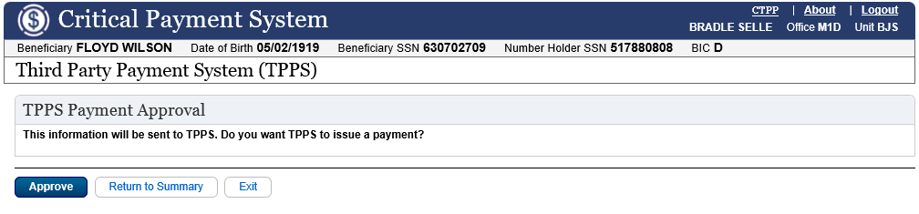

Select the “Approved” button on the Third Party Payment System (TPPS) web page to initiate the interface with the Third Party Payment System.

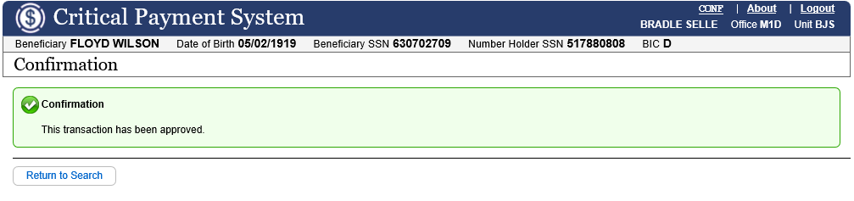

On the Confirmation page, you will see that the transaction has been approved.

