SSA-769 Request for Change in Time/Place of Disability Hearing
Upload Documents Conversational Q&A Format Screenshots

Your Information:
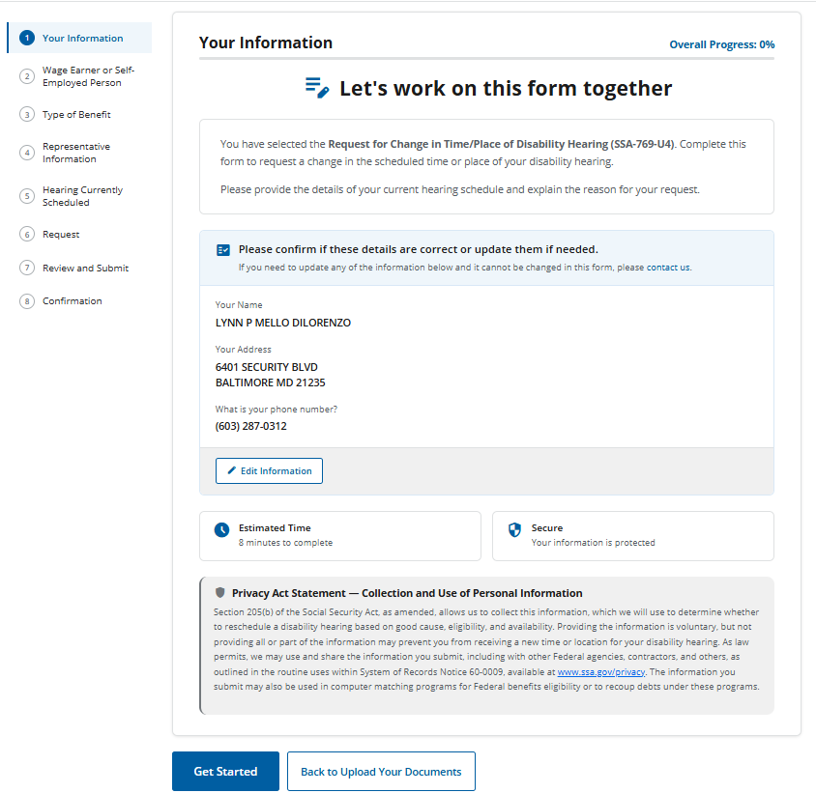

Wage Earner or Self-Employed Person:
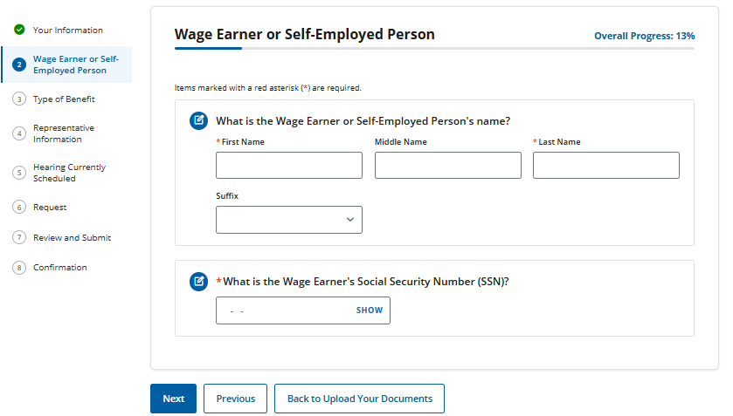

Type of Benefit – Title II Claim Only:
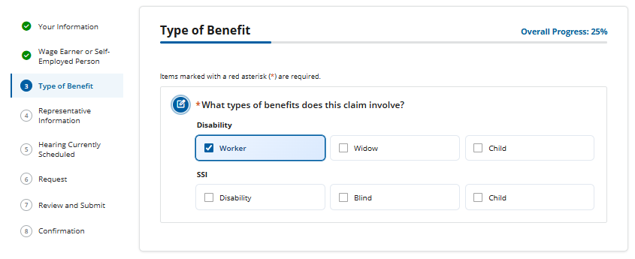

Type of Benefit: SSI claim involved:
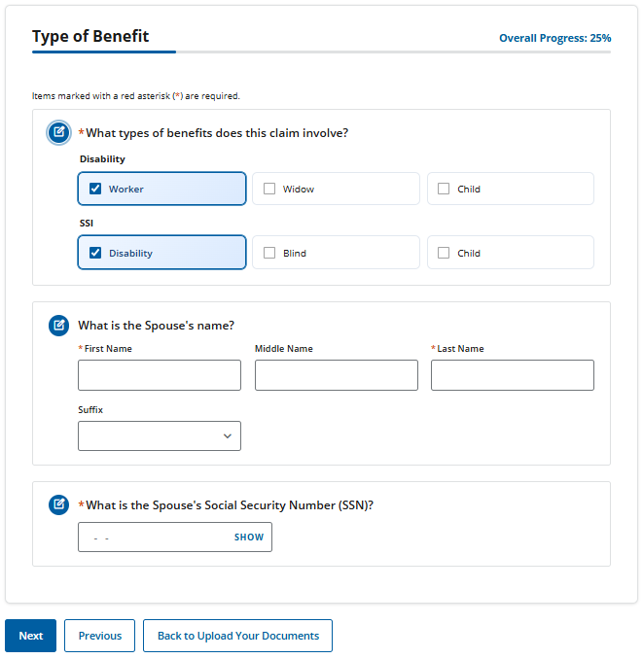

Representative Information: No Rep
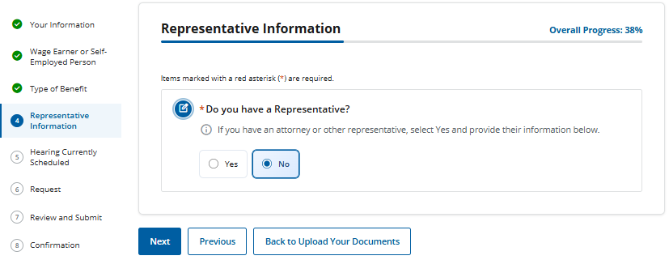

Representative Information: Yes Rep

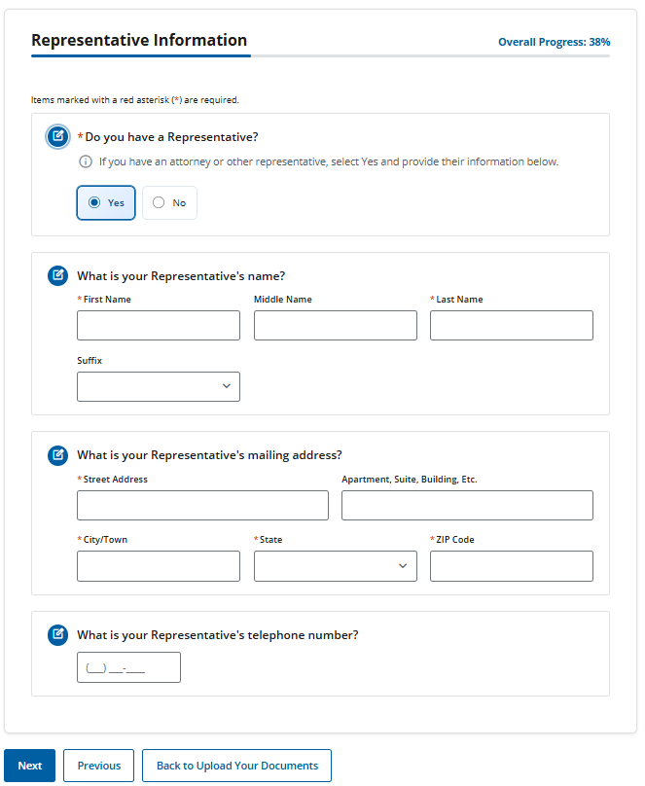

Hearing Currently Scheduled:
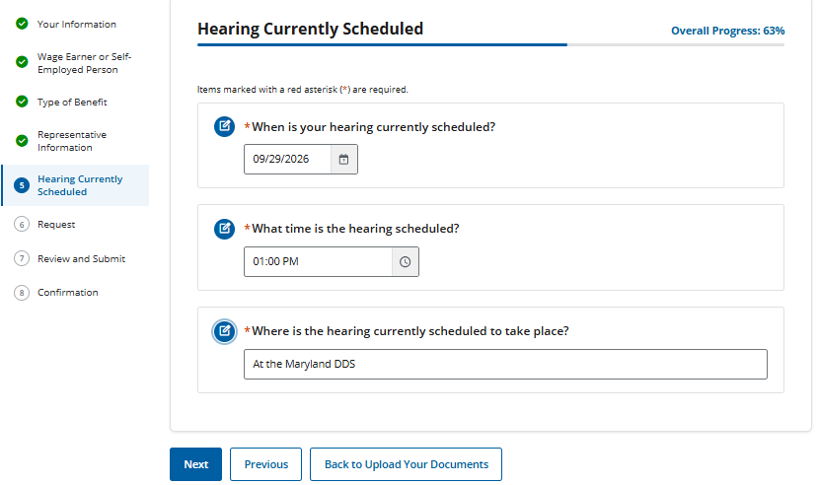

Request:
Change in Postponement (currently reads as postponement but this is a typo): No
Change in Hearing location: No
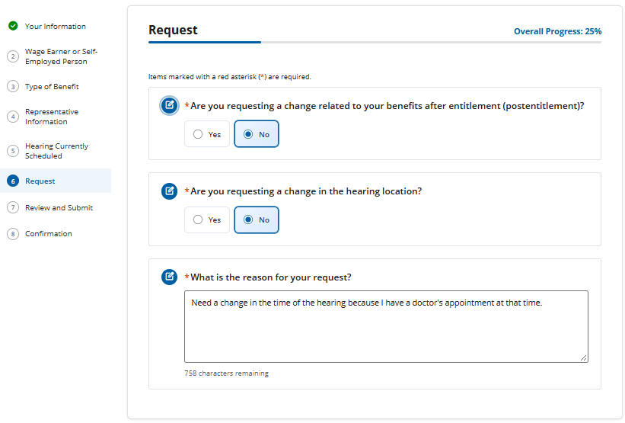

** Changing the question “Are you requesting a change related to your benefits are entitlement (postponement)?” to “Are you requesting a postponement of your hearing?”
Changing the question “How many days from the scheduled hearing date do you want this postponement change?” to “How many days from the scheduled hearing date do you want this postponement?”

Request:
Change in Postponement (currently reads as postponement, but this is a typo): Yes
Change in Hearing location: Yes
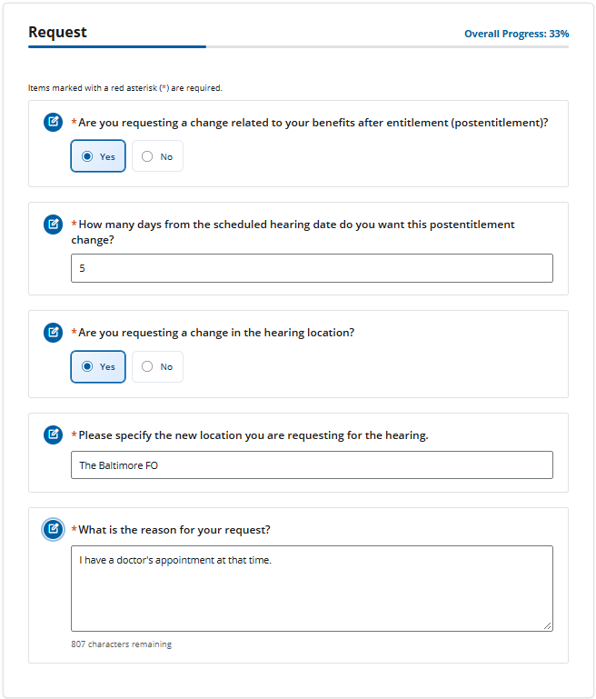
** Changing the question “Are you requesting a change related to your benefits are entitlement (postponement)?” to “Are you requesting a postponement of your hearing?”
Changing the question “How many days from the scheduled hearing date do you want this postponement change?” to “How many days from the scheduled hearing date do you want this postponement?”

Review and Submit:
