Non-Substantive Change Request
  - OMB Control Number: 3255-0005
  - FORM 14: ELECTRONIC SUBMISSION OF ALLEGATIONS AND DISCLOSURES
Date Submitted: August 28, 2026

Summary of Request
The United States Office of Special Counsel is making a non-substantive change request of an existing collection to include a new employment category created by Executive Order. These changes do not alter the burden on the user.

Description of Changes Requested
OSC seeks to add “Schedule C or Schedule P/C” to the list of categories for which we lack jurisdiction, and to add “Schedule P/C” as a menu option under “Employment Service Sub-Type” in OSC’s online filing portal. OSC seeks this change to bring the information collection into accord with Executive Orders (EO) 14171, Restoring Accountability to Policy-Influencing Positions Within the Federal Workforce and 14410, Implementing Schedule Policy/Career in the Excepted Service. These orders created a new category of federal employe, Schedule Policy/Career (P/C), over which OSC has no jurisdiction. The changes to OSC’s existing ICR will reflect this new category.
This request involves two non-material changes.
- Add a bullet following the last item on the list from the screenshot below, stating:
- Schedule C or Schedule P/C.
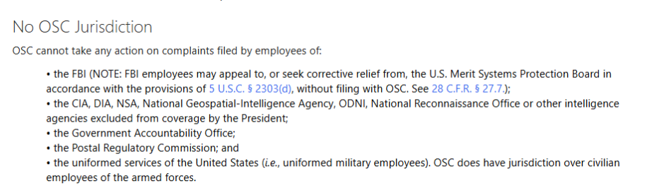
- Add “Schedule P/C” as a menu option under “Employment Service Sub-Type” in OSC’s online filing portal (screenshot of the relevant portal section below).
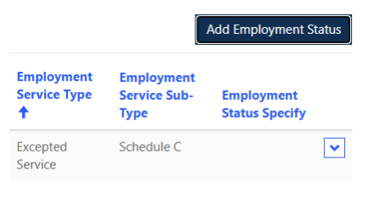
Request includes revision of an existing question.

Description of Changes to Burden
There is no change to the burden.

Other Considerations

