Pre-Screener Instrument

Commodity Flow Survey Respondent Login/Welcome Screen
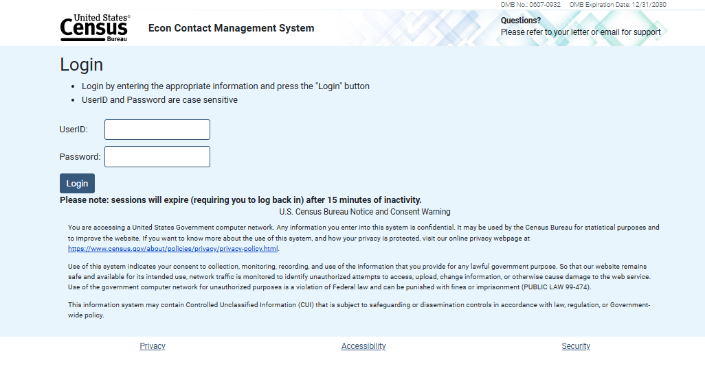

Inquiry on Shipping Status

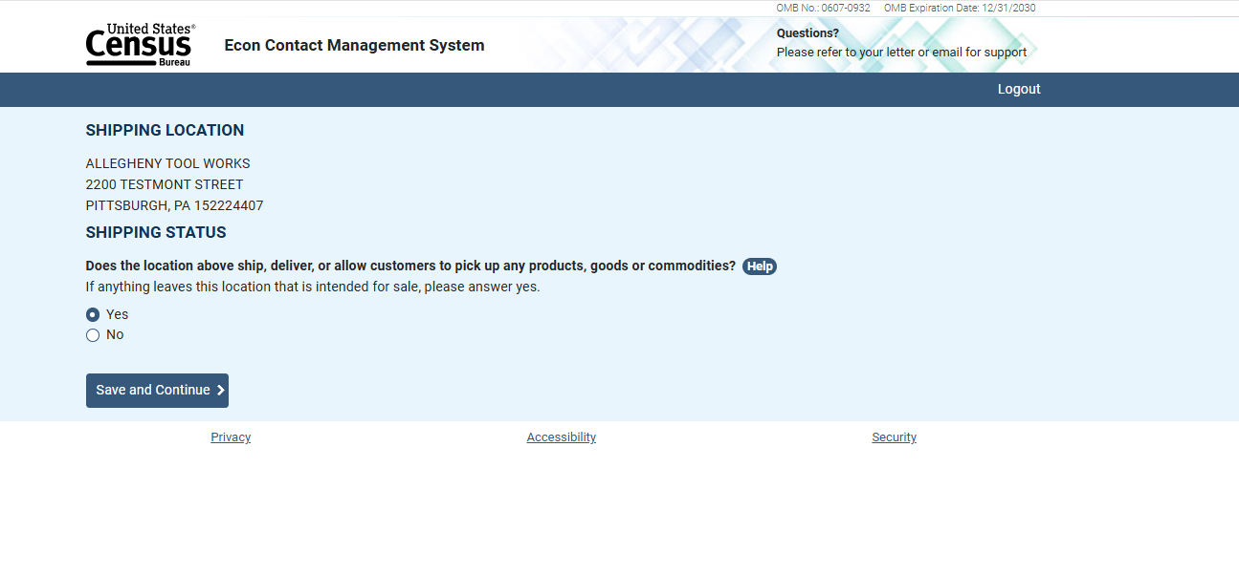

Contact Information

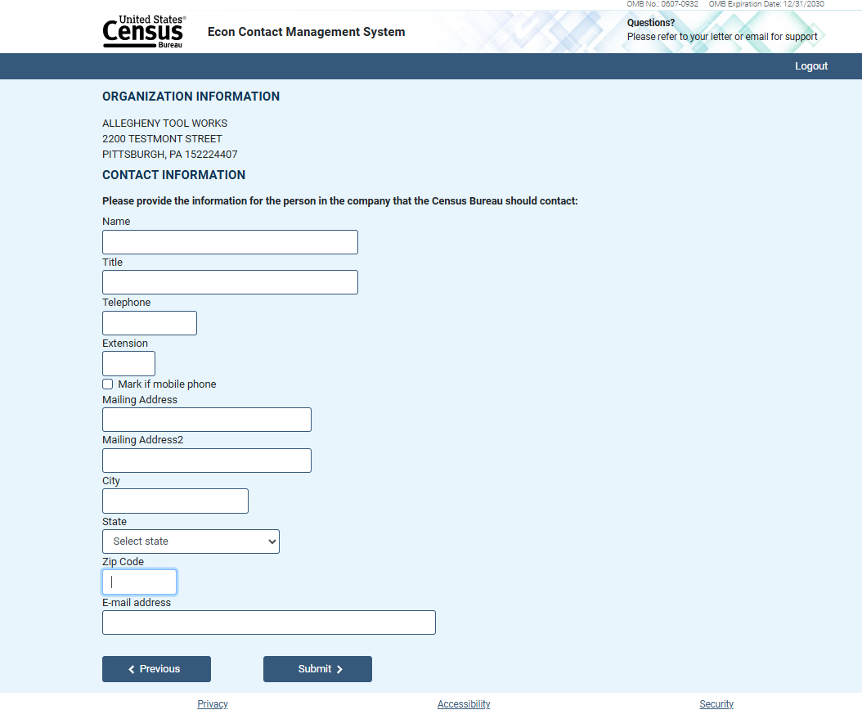

Submission Confirmation

